COVID-19
Māori Health Protection Plan
2021

Citation: Ministry of Health. 2021. COVID-19 Māori Health Protection Plan. Wellington: Ministry of Health.
Published in December 2021 by the Ministry of Health
PO Box 5013, Wellington 6140, New Zealand
ISBN 978-1-99-110010-8 (online)
HP 8012
This document is available at health.govt.nz
This work is licensed under the Creative Commons Attribution 4.0 International licence. In essence, you are free to: share ie, copy and redistribute the material in any medium or format; adapt ie, remix, transform and build upon the material. You must give appropriate credit, provide a link to the licence and indicate if changes were made.

Ihirangi
Contents
He whakarāpopoto | Executive summary v
Kōrero whakataki | Introduction 1
The delta variant of COVID-19 1
A safe and effective vaccine 2
The COVID-19 Protection Framework 3
Te Whakarite Hauora Māori | The Māori Health Response 5
Learning from the Māori Health Response so far 6
Issues that providers have experienced 7
Kei hea tātou ināianei? | Where we are now? 8
COVID-19 infection rates for Māori 8
Infection rates by district health board 9
Māori COVID-19 vaccination 10
COVID-19 hospitalisations for Māori 12
Te anga whakamua | Moving forward 13
Te Tiriti o Waitangi and Whakamaua: Māori Health Action Plan 2020–2025 continue to guide our response 13
COVID-19 Māori Health Protection Plan and actions 14
Monitoring our progress 19
Māori governance, leadership and engagement 21
Āpitihanga | Appendices 22
Appendix A: New Zealand COVID-19 Protection Framework 23
Appendix B: Overview of funding and key COVID-19 Māori health statistics 25
Appendix C: COVID-19 funding for the hauora Māori response (March 2020–October 2021) 27
Appendix D: Lessons learned from the COVID-19 Māori Health Response 2020–2021 32
Appendix E: Māori COVID-19 data and statistics 37
Appendix F: COVID-19 Māori Protection Plan 46
Appendix G: COVID-19 Māori Health Response governance arrangements 48

List of Figures
Figure 1: Confirmed and probable cases of COVID-19 among Māori in the recent delta variant outbreak, by vaccination status 3
Figure 2: Whakapapa of the COVID-19 Māori Health Protection Plan 5
Figure 3: Cumulative cases over time per 100,000 people by prioritised ethnicity 8
Figure 4: Rate of cases per 100,000 people by prioritised ethnicity and DHB, 26 February 2020 to 20 December 2021 9
Figure 5: Weekly cumulative sum of the first dose received per 1,000 people aged 12 years and over by prioritised ethnic group, 21 February to 20 December 2021 10
Figure 6: Weekly cumulative sum of the second dose received per 1,000 people aged 12 years and over by prioritised ethnic group, 21 February to 20 December 2021 11
Figure 7: Confirmed and probable cases of COVID-19 for Māori who have been hospitalised in the recent delta variant outbreak by vaccination status, 17 August 2021 to 20 December 2021 12
Figure 8: First dose COVID-19 vaccine uptake for Māori by DHB as at 20 December 2021 25
Figure 9: Māori delta cases geographic distribution as at 20 December 2021 26

He whakarāpopoto |
Executive summary
The COVID-19 Māori Health Protection Plan (the Protection Plan) builds on the progress made by the Initial COVID-19 Māori Response Action Plan and the Updated COVID-19 Māori Health Response Plan.

This Protection Plan provides an updated framework that is informed by Te Tiriti o Waitangi (Te Tiriti) to protect whānau, hapū, iwi and hapori Māori from the impacts of COVID-19 by preventing and mitigating those impacts. Other developments and information that have contributed to this Protection Plan are:
- insights and feedback from a broad range of stakeholders since the start of the COVID-19 response in March 2020
- the new context of the delta variant of COVID-19 in our community, which spreads more easily than previous strains of the virus and so is more challenging to stamp out
- the availability of a safe and effective vaccine, which is now being rolled out to the general population
- the increasing numbers and proportion of Māori contracting and being hospitalised with COVID-19, which is placing pressure on whānau and making pre-existing inequities worse
- the extended length of the COVID-19 pandemic, which is putting sustained pressure on communities and the providers who serve them.

We have adjusted our strategic approach and actions to respond to the experience of our stakeholders, so that we can stay in step with Aotearoa New Zealand’s evolving approach to COVID-19 and the changes that are occurring through the reform of the health and disability system.

The Protection Plan will build on progress made to date. It will help guide health and disability system actions for Māori through the next 3 to 12 months of the COVID-19 response by focusing on two key outcomes:
- protecting whānau, hapū, iwi and hapori Māori from the virus by increasing vaccination coverage
- building the resilience of Māori health and disability service providers and Māori whānau, hapū, iwi and hapori Māori to respond to the new environment of the delta variant, the incoming COVID-19 Protection Framework and the long tail of the impact of COVID-19 on the health and wellbeing of Māori.
The Protection Plan is aligned with and contributes to the broader health and disability COVID-19 response. It also aligns with the all-of-government response to COVID-19 in mitigating the social impact of COVID-19 on whānau, hapū, iwi and hapori Māori.

This Protection Plan together with Māori health activity focused on COVID-19 gives practical effect to the actions specifically related to COVID-19 in Whakamaua: Māori Health Action Plan 2020–2025 (Whakamaua). Whakamaua has been developed through an extensive consultation process and guides Māori health action over the next five years. Whakamaua gives practical effect to He Korowai Oranga: the Māori Health Strategy and its overarching vision of Pae Ora – healthy futures for Māori.

Contact details and more information
If you have any issues or queries, please contact: maorihealth@health.govt.nz.

For the latest updates and information on the COVID-19 response, please go to: https://covid19.govt.nz.

Kōrero whakataki |
Introduction
Up until late 2021, Aotearoa New Zealand’s approach to managing COVID-19 focused on an Elimination Strategy, which used tight border controls, an effective testing, contact tracing and isolation system, and a well-accepted and coherent Alert Level framework to apply when community cases of the virus emerged. Before the delta variant of COVID-19 (delta variant) arrived in Aotearoa New Zealand, we were able to rapidly implement restrictions for short periods to eliminate the virus whenever it appeared in the community.

The Elimination Strategy approach has helped Aotearoa New Zealand to have one of the lowest mortality rates for COVID-19 in the world and has allowed the population to live with fewer restrictions on freedoms for much of the past 18 months. Throughout the response, whānau, hapū, iwi and hapori Māori have mobilised quickly to identify gaps in the COVID-19 response for their communities and have worked collectively to mitigate them. Local hapū and iwi authorities continue to play key roles in sharing insights on what their people’s needs are and connecting them with services.

Throughout 2020 and the first half of 2021, the rate of infection for Māori was consistently around half the rate for non-Māori non-Pacific peoples. Similarly, the COVID-19 testing rate was 65.7 per 1,000 Māori, substantially higher than the non-Māori rate of 54.9 per 1,000 from the start of the pandemic until mid-June 2020. These achievements are significant, given that Māori have experienced more severe outcomes than other ethnic groups and the COVID-19 pandemic is making health inequities in the current system worse.

In the second half of 2021, however, the environment that providers and communities must respond to has changed significantly.

The delta variant of COVID-19
The arrival of the delta variant in Aotearoa New Zealand on 7 August 2021 resulted in a significant shift in the response landscape. On 17 August 2021, a community case of the delta variant was confirmed and, as a result, Aotearoa New Zealand went into lockdown to stop the spread of COVID-19 and save lives.

The delta variant spreads much more easily than previous variants, which is placing additional strain on communities and on the health system’s ability to respond. Incidents of the delta variant in the community are harder to stamp out, and high numbers of contacts are identified when cases occur. This additional pressure has made it even more important to achieve population immunity.

The Ministry of Health (the Ministry) closely monitors international evidence and responses to new variants. Other variants may continue to change the landscape that we need to respond to, such as the Omicron variant, which the World Health Organization designated as a variant of concern on 26 November 2021.

A safe and effective vaccine
Aotearoa New Zealand’s phased rollout of the Pfizer–BioNTech vaccine began in February 2021. The first vaccination efforts focused on protecting people working in the frontline health and border sectors.

Anyone in Aotearoa New Zealand aged 12 years and over is now eligible to be vaccinated, and vaccination is free, safe and effective. International evidence has shown that vaccinations significantly lower transmission, hospitalisation and mortality rates. Aotearoa New Zealand’s experience to date supports this evidence, including among Māori.

Of the confirmed and probable cases of COVID-19 among Māori in the current delta variant outbreak (4,698 Māori cases as at 20 December), nearly half have been 12 years or older and unvaccinated. Only 10 percent were Māori who had received both doses of the vaccine. Over a quarter of cases (29 percent) were in tamariki under 12 years old, which highlights why vaccination for people aged 12 years and over is so important in reducing the spread of the virus.

Figure 1: Confirmed and probable cases of COVID-19 among Māori in the recent delta variant outbreak, by vaccination status
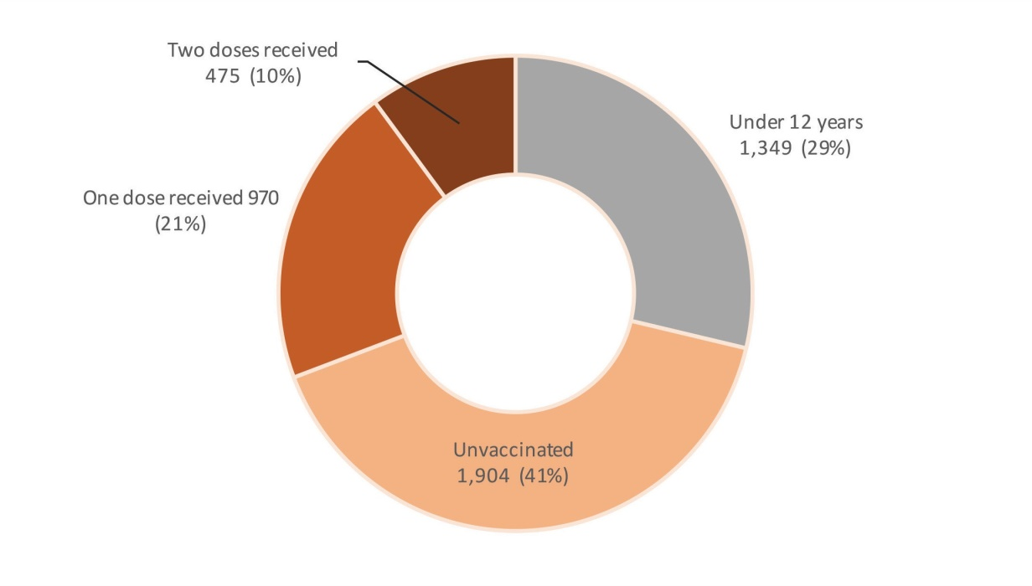
Source: ESR Episurv system and the COVID-19 Immunisation Register as at 20 December 2021.

A high level of vaccination in the population will help Aotearoa New Zealand to safely manage COVID-19 without relying on widespread lockdowns and with less intrusive public health controls. The increase in vaccination coverage has been a key part of the Government’s updated approach to managing COVID-19 in Aotearoa New Zealand, along with the introduction of the COVID-19 Protection Framework.

The COVID-19 Protection Framework
The introduction of the Government’s new COVID-19 Protection Framework marks a significant shift in how we manage community outbreaks.

The COVID-19 Protection Framework (Appendix A) outlines three levels:
- Green (Prepare) – a baseline level similar to pre-pandemic normal life but with widespread surveillance testing that could occur when cases are isolated or spreading only sporadically in the community
- Orange (Control) – a set of increased restrictions that we would rely on to control spread when active clusters are in the community
- Red (Reduce) – pitched at about Level 2.5 of our present Alert Level framework, to more actively reduce transmission when multiple active clusters are in the community and/or action is needed to protect the health system.

The operation of the framework relies on two key planks.
- High vaccination rates give a high level of community protection.
- Domestic COVID-19 vaccine certificates will be used as a tool to restrict or permit entry to particular employment settings (eg, for health and social care workers), venues (eg, nightclubs, festivals) and travel, depending on what level the country or a particular region is at (Red, Orange or Green).
- Health system has the readiness and resilience to respond to more cases of COVID-19 in the community.
- Effective test, trace, isolate and quarantine systems quickly identify cases and close contacts and take appropriate action to reduce the risk of spread. Community isolation models are used for people to isolate at home and in communities. MIQ will still be available for those who cannot safely isolate at home.

To support whānau, hapū, iwi and hapori Māori as Aotearoa New Zealand transitions to this new framework, we need to operate as a joined-up Māori health and social sector that has clear priorities, goals and responsibilities. This sector will support hauora Māori and other providers to pivot quickly to respond to needs of hapori Māori and whānau as they arise.

Te Whakarite Hauora Māori |
The Māori Health Response
Figure 2 gives an overview of the Ministry’s strategic COVID-19 Māori Health Response, which has led to the development of the COVID-19 Māori Health Protection Plan (Protection Plan).

Figure 2: Whakapapa of the COVID-19 Māori Health Protection Plan
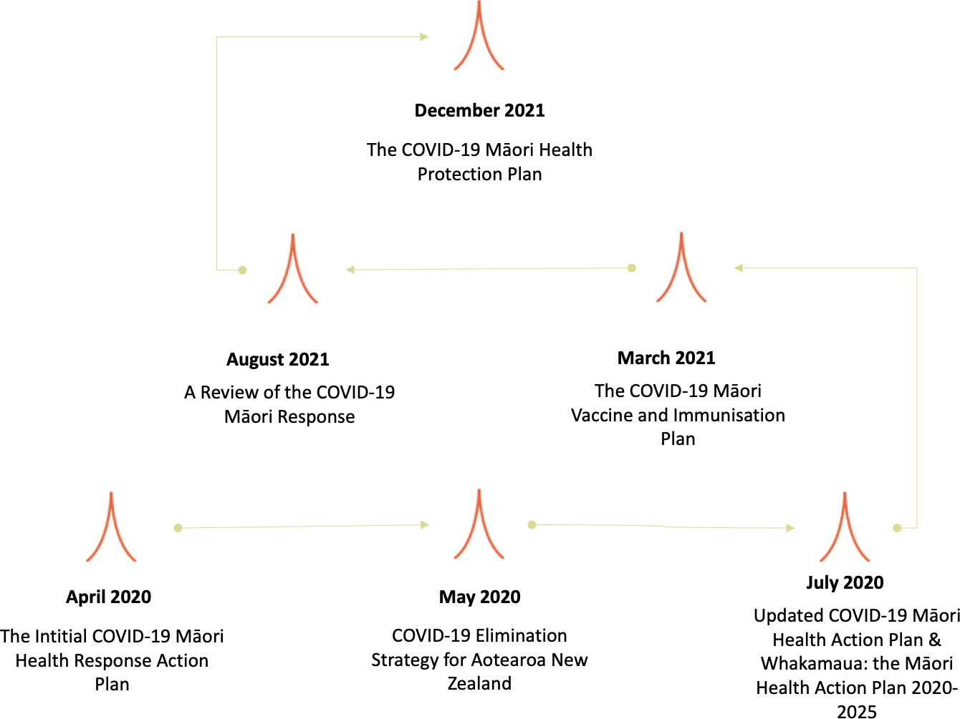

The July 2020 Updated COVID-19 Māori Health Response Plan provided guidance for the COVID-19 Māori Health Response by outlining several objectives that supported the Ministry’s obligations under Te Tiriti o Waitangi, as well as our strategic direction to prevent and mitigate the effects of the pandemic. These objectives have continued to guide the Ministry’s response, focusing on supporting mana motuhake (Māori authority over their wellbeing), equitable health outcomes for Māori and effective kaitiakitanga (stewardship) of the system. The ongoing COVID-19 Māori Health Response will build on the legacy of community resilience established through these plans.

The COVID-19 Māori Health Response has been a collective effort involving iwi, hapū, Māori communities, the Māori health workforce and the wider Māori health and disability provider network, along with the wider health and disability system and government.

To date, the Ministry has allocated $252 million of funding to support Māori health and social service organisations, including iwi and Māori organisations, to deliver for Māori. This total includes funds the Ministry transferred to be distributed through Te Puni Kōkiri, and joint funding between the Ministry, Te Puni Kōkiri and Te Arawhiti. Te Puni Kōkiri has contributed a further $2 million to support the delta outbreak response.

This is the most significant investment in Māori health providers in over 20 years. Funding has been intentionally flexible and permissive, covering activities related to COVID-19 specifically as well as wrap-around health and wellbeing supports. This approach recognises the evidence from previous outbreaks that taking a holistic, whānau-centred approach to service delivery has the greatest success in meeting the needs of diverse Māori communities.

For an overview of Ministry funding to date, see Appendix B. For more detailed information on this funding, including how the Ministry has allocated its $36 million in delta funding and targeted priority populations, see Appendix C.

Learning from the Māori Health Response so far
In July 2021, the Ministry undertook an internal review of the COVID-19 Māori Health Response. This review highlighted three key pillars that were essential to the response across 2020 and 2021, and through which funding has been allocated.
- Māori health sector investment and coordinated support is reflected in the agility of the Māori health sector to mobilise quickly to meet the demands of COVID-19 and pivot its services as needed.
- Localised communications have enabled whānau, hapū, iwi and hapori Māori to receive timely, meaningful information from trusted sources and through the right channels.
- Taking a whānau-centred approach is at the core of increasing delivery of outreach services and end-to-end holistic care to whānau. It is also integral to ensuring whānau can follow public health measures and requirements.

Issues that providers have experienced
Providers have reported a number of challenges in responding directly to COVID-19, as well as in supporting whānau to weather the indirect impacts of COVID-19. These challenges include:
- as lockdowns extend and our response becomes more complex, needs among whānau are increasing, which is worsening pre-existing inequities
- capacity of the Māori health sector and health workforce is stretched
- communications are not reaching all of the intended audiences.

These issues are complex and multi-faceted. The situation is often unique for particular whānau and the providers that serve them, depending on the community and how COVID-19 is affecting them at that time.

As the vaccination rollout progresses, we are likely to see an increasingly mixed risk profile for different whānau and communities. This becomes more important as we look to open regional borders and reconnect Aotearoa New Zealand with the world. Some Māori communities may be highly vaccinated so that the impact of COVID-19 and restrictions to manage its spread will be light for them. Other groups may have less protection for a range of reasons, increasing the risk of a severe impact. These groups will likely need greater levels of support to mitigate the impact they experience. These challenges will also impact a health workforce when it is already working at capacity.

These learnings and issues that we have identified to date have informed the Protection Plan. For more information, see Appendix D.

Kei hea tātou ināianei? |
Where we are now?
Whānau, hapū, iwi and hapori Māori have carried the greatest burden of the 2021 delta variant outbreak in the community. They have had higher rates of infection and lower rates of vaccination than non-Māori non-Pacific people, along with higher numbers of hospitalisations.

Given these demographics, Māori health providers are having to balance COVID-19 response activities (testing, tracing, case management, COVID-19 vaccinations and welfare services such as distributing kai packs) with providing other essential business-as-usual services. In doing so, they have honed their skills and expertise in providing the best care for their communities. However, fast-growing Māori case numbers, particularly among the unvaccinated, are having and will have a significant impact on their capacity to meet demand.

In this context, the impact on whānau, hapū, iwi and hapori Māori is significant.

COVID-19 infection rates for Māori
Up until the recent delta variant outbreak, the rate of COVID-19 infection for Māori had been consistently around half the rate for non-Māori non-Pacific peoples. This trend has now reversed: the overall Māori rate is well above the rate for non-Māori non-Pacific peoples. Figure 3 shows how the number of Māori cases per 100,000 Māori has spiked since the beginning of the delta variant outbreak. As at 20 December 2021, the Māori rate is more than four times greater than the non- Māori non-Pacific rate.

Figure 3: Cumulative cases over time per 100,000 people by prioritised ethnicity
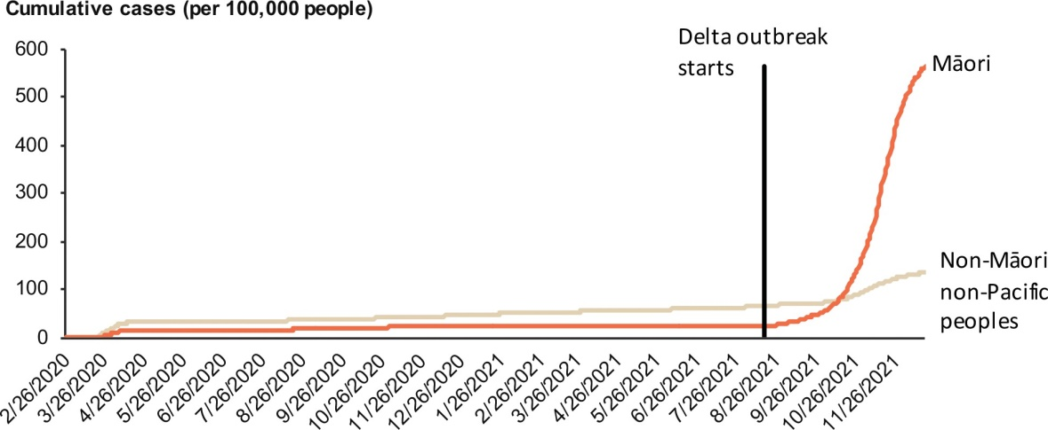
Source: ESR Episurv system as at 20 December 2021.

Infection rates by district health board
Figure 4 shows the rate of COVID-19 cases per 100,000 by district health board (DHB) since the beginning of the pandemic. This figure highlights the marked difference between the Auckland metro DHBs and the rest of New Zealand. Outside of the Auckland region, the rates of Māori infection remain low; however, within the Auckland metro area the rate of COVID-19 cases for Māori is around 1,999.7 per 100,000 Māori. It also highlights the significant equity gap in infection rates across the Auckland metro DHBs.

Figure 4: Rate of cases per 100,000 people by prioritised ethnicity and DHB, 26 February 2020 to 20 December 2021
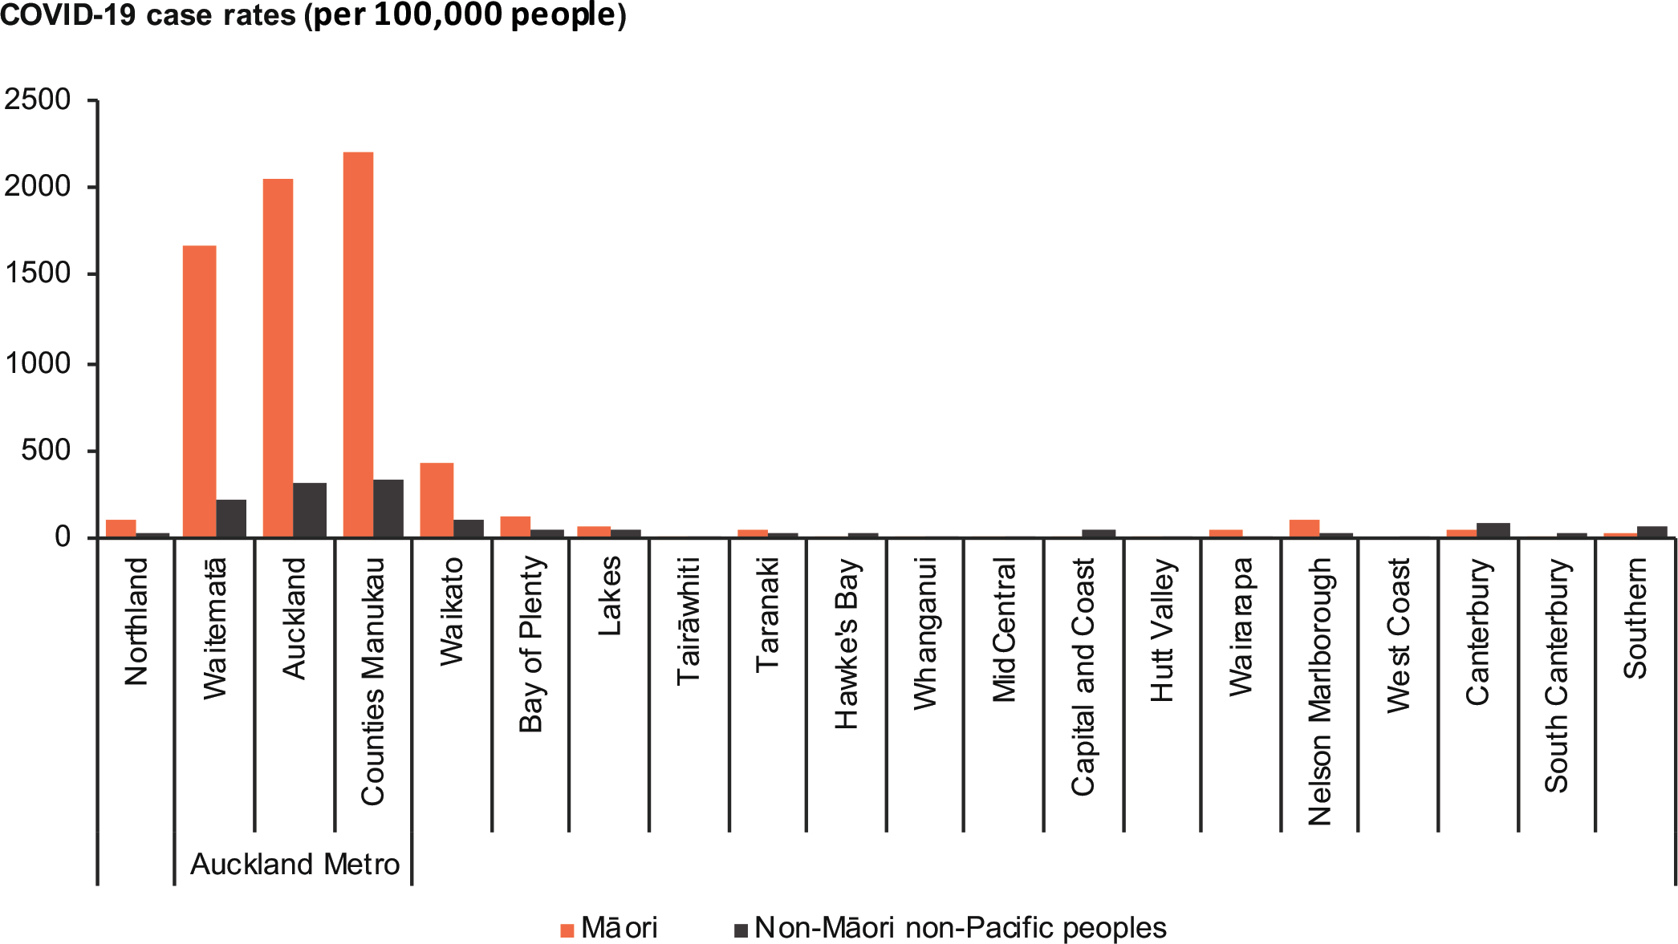
Source: ESR Episurv system as at 20 December 2021.

Māori COVID-19 vaccination
Figures 5 and 6 show that while vaccination rates for Māori have increased in recent weeks, they are still not as high as rates for other ethnic groups. As at 20 December 2021, the equity gap between Māori and non-Māori non-Pacific peoples for first dose vaccination uptake is 85.3 percentage points.

Figure 5: Weekly cumulative sum of the first dose received per 1,000 people aged 12 years and over by prioritised ethnic group, 21 February to 20 December 2021
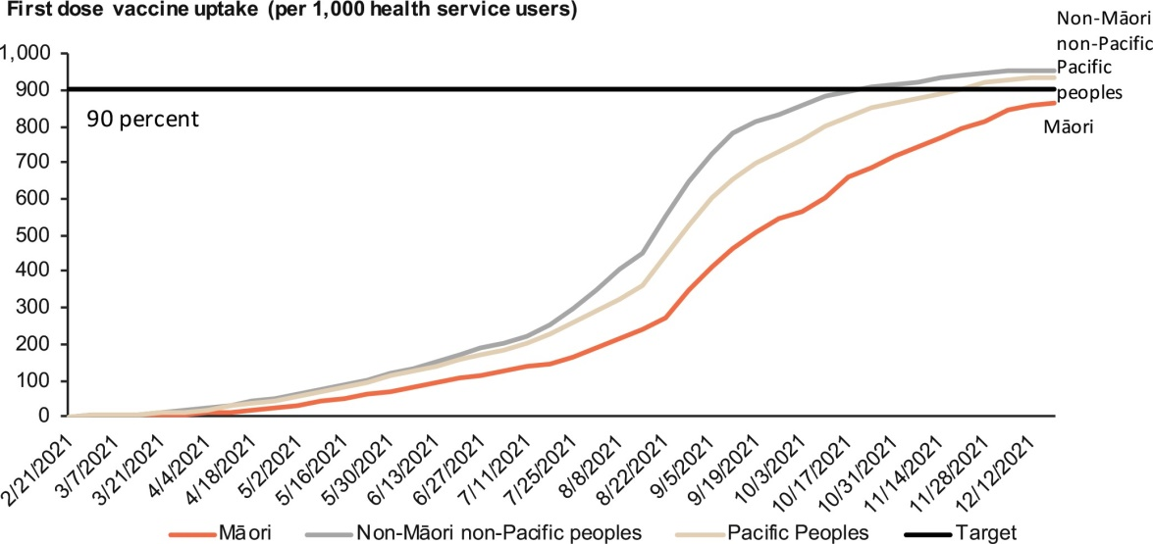
Source: COVID-19 Immunisation Register as at 20 December 2021.

Figure 6: Weekly cumulative sum of the second dose received per 1,000 people aged 12 years and over by prioritised ethnic group, 21 February to 20 December 2021
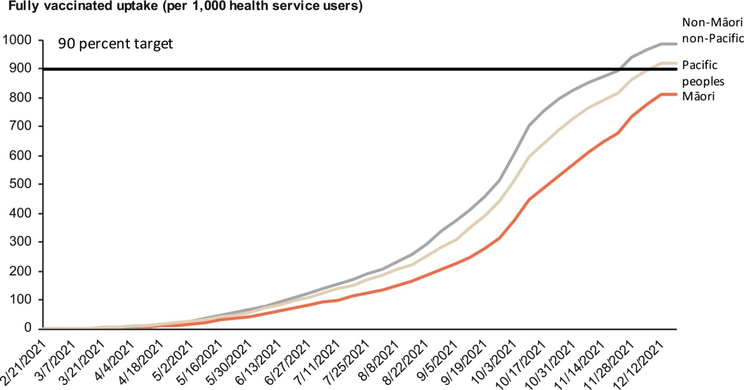
Source: COVID-19 Immunisation Register as at 20 December 2021.

COVID-19 hospitalisations for Māori
Since the start of the pandemic in early 2020, 222 Māori have been hospitalised with COVID-19 (202 of them during the recent delta variant outbreak) and 14 of them have been admitted to an intensive care unit. Among the 202 Māori hospitalised during the delta outbreak, 124 were unvaccinated (61 percent). In contrast, only 12 fully vaccinated Māori have required hospitalisation during the delta outbreak.

Figure 7: Confirmed and probable cases of COVID-19 for Māori who have been hospitalised in the recent delta variant outbreak by vaccination status, 17 August 2021 to 20 December 2021
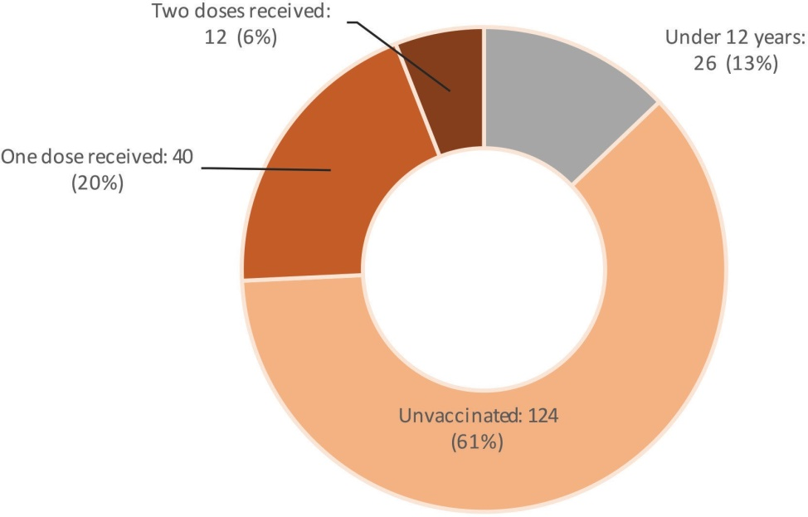
Source: ESR Episurv system and the COVID-19 Immunisation Register as at 20 December 2021.

For an overview of COVID-19 Māori health statistics, see Appendix B; for more detail, see Appendix E.

Te anga whakamua |
Moving forward

Te Tiriti o Waitangi and Whakamaua: Māori Health Action Plan 2020–2025 continue to guide our response
Demonstrating a commitment to Te Tiriti and the achievement of Māori health equity remains a critical priority in the response. Meeting Te Tiriti obligations requires collective effort at every level of the response. The Ministry sets out its commitment to and expression of Te Tiriti in the context of the health and disability system in Whakamaua: Māori Health Action Plan 2020–2025 (Whakamaua), which includes the Ministry’s Te Tiriti framework. Whakamaua sets a five-year direction for advancing Māori health by outlining the outcomes, objectives, priority areas and actions that will contribute to pae ora (healthy futures) for Māori.

Whakamaua includes two actions specific to COVID-19:
- Action 5.3: Support the cross-government COVID-19 response to mitigate the impacts of COVID-19 on whānau, hapū, iwi and Māori communities
- Action 6.5: Manage the protection of Māori health through the COVID-19 Māori health programme.

These actions speak specifically to the Whakamaua priority areas of cross-sector action and quality and safety. However, all of Whakamaua’s priority areas and objectives contribute to a safe, sustainable, equitable health and disability system that is working towards pae ora (healthy futures) for Māori.

Using the lessons learned in responding to COVID-19 over the past 18 months, it has been possible to develop approaches to the COVID-19 response that draw on kaupapa Māori and mātauranga Māori. The Protection Plan continues to support a kaupapa Māori approach, whānau-centred service delivery and whānau and community resilience in the COVID-19 response. It is a living document, subject to the COVID-19 operating environment, and will be updated with supplementary material on a quarterly basis. We will continue to refine the Protection Plan with stakeholders as we progress through the next stage of our response.

COVID-19 Māori Health Protection Plan and actions
This Protection Plan sets out the objectives and actions for the health and disability system, with the overarching goal to protect the health and wellbeing of whānau, hapū, iwi, and hapori Māori by preventing and mitigating the impacts of COVID-19 on their health and wellbeing. The Protection Plan sits alongside the COVID-19 Protection Framework, focusing specifically on the Māori population. This plan replaces and builds on the Updated COVID-19 Māori Health Response Plan (July 2020) and the Initial COVID-19 Māori Response Action Plan (April 2020).

The Protection Plan is a living document that will continue to adapt in response to the fast-evolving COVID-19 context and the Government’s Protection Framework. It will guide health and disability system action through the next phase of the COVID-19 response by focusing on two key outcomes:
- protecting whānau, hapū, iwi and hapori Māori from the virus by increasing vaccination coverage
- building the resilience of Māori health and disability service providers and whānau, hapū, iwi and hapori Māori to respond to the new environment of the delta variant, the Protection Framework and the long tail of the impact of COVID-19 on the wellbeing of Māori.

To achieve these outcomes, we will:
- contribute to meeting the Crown’s obligations under Te Tiriti o Waitangi through partnering with whānau, hapū, iwi and hapori Māori and with other agencies critical to the Māori COVID-19 response (Te Puni Kōkiri, Te Arawhiti and the Ministry of Social Development)
- prioritise equity in resource allocation so that we keep our focus on equitable health outcomes for Māori
- work across the health and disability system and social sectors to coordinate resources and decision-making, focusing on action that is centrally enabled, regionally supported and locally led.

For the next 3 to 12 months, the drivers of the COVID-19 Māori Health Protection Plan are:
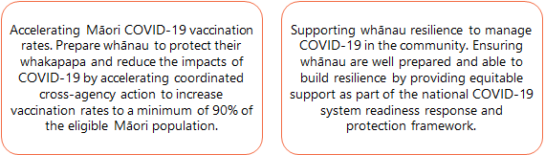

These drivers provide the basis for the actions in this plan and have two key system enablers to support them, as outlined below. Appendix F provides a strategic overview of the COVID-19 Māori Protection Plan drivers, enablers and actions.

Enabler 1: Target and localise information and education for whānau

Overview
- Increase the amount of localised, targeted information, education, guidance and key messages.
- Encourage whānau to have a detailed understanding of how effective the vaccine is in protecting their health and whakapapa.
- Enable whānau, hapū, iwi and hapori Māori to prepare for and manage COVID-19 in communities and at home with information provided through trusted Māori providers and other health professionals and services.
- Provide whānau, hapū, iwi and hapori Māori with the resources they need to exercise their rangatiratanga in responding directly to the health and wellbeing challenges across the COVID-19 response.

Purpose
This enabler will support the wellness of whānau, hapū, iwi and hapori Māori through targeted communications and timely information. This includes understanding any public health requirements and how COVID-19 is going to be managed in the community, such as through using vaccine certificates, vaccine mandates and continued requirements around contact tracing, and getting a COVID-19 test when unwell (even if fully vaccinated). It will also enable iwi- and Māori- led communications to deliver the right message, at the right time, through the right channels.

Actions
      - Invest in innovative, targeted communication and health promotion initiatives: The focus of this action will be on reaching rangatahi, as the most vaccine-hesitant age group, and other at-risk groups, including by providing targeted psychosocial support.
      - Expand the reach and coverage of public health advice and measures tailored for Māori through appropriate and trusted Māori communication channels: This includes expanding the reach and coverage of national communications that align with and reinforce localised communications.
      - Expand Māori telehealth service provision: This includes providing virtual support to whānau Māori isolating at home, ensuring they are well supported with timely health advice.
      - Make transparent the progress to strengthen ethnicity and iwi data: This includes monitoring information and evaluation evidence to support iwi and Māori organisations to have a better national and localised view of their communities so they can target their services.
      - Increase evidence and insights to address vaccine hesitancy and wider COVID-19 impacts for whānau Māori: Finalise and use research insights to improve understanding around factors that prevent Māori from choosing to get the COVID-19 vaccine, so that we can tailor our communications to better address concerns.

Why this matters
The shift to the COVID-19 Protection Framework brings a risk that our communication channels become flooded with different information related to COVID-19, including information on vaccines (and vaccination requirements), explanations of the new framework, and general baseline public health information. In addition, a significant amount of misinformation – particularly on the efficacy of the COVID-19 vaccine – remains and will continue to need addressing. Research indicates that balanced, educational information from trusted sources is best placed to address vaccine hesitancy.

Strengthened communications will also be needed to increase childhood immunisation rates, and improve equitable access to and uptake of screening programmes, oral health services and other essential protective health measures that help build whānau resilience.

Given the enormous amount of messaging that occurs, our communications approach will need to shift even more from being centrally led to locally driven and must be nuanced to respond in a timely way to the evolving conditions and public health measures of a particular community. Hapori Māori, providers and community groups are best placed to develop their own communications on aspects of the COVID-19 response that matter most to their local contexts and whānau.

Enabler 2: Increase integrated outreach health and social services for and with Māori

Overview
- Reduce and control the impacts of COVID-19 by enabling whānau, hapū, iwi, hapori Māori and Māori health and social service organisations to lead integrated, holistic and culturally appropriate outreach services to, with and for whānau.
- Support the health and disability system to prepare for and rapidly contribute to the COVID-19 response, and to deliver equitable outcomes for and with Māori across the response, working in national, regional and local partnerships.

Purpose
This enabler will build off the investment in outreach services over the COVID-19 response through delivering joined-up health and social services that mitigate the inequitable impacts of COVID-19 on Māori. It will look to empower and resource local communities to respond to outbreaks quickly and enable Māori health providers to offer tailored health and social services to support whānau through the different phases of the COVID-19 response, and support their broader health and wellbeing needs.

Actions
      - Establish and contribute to a coordinated cross-agency Māori response to COVID-19: This includes providing advice on resources and funding decisions as part of a senior Māori officials Steering Group (Te Puni Kōkiri, Te Arawhiti and Ministry of Health) reporting to a Māori Ministers Oversight Group to lift Māori vaccination rates and support community resilience. It will be important to identify synergies between health, education, welfare, housing and income services. This includes building on progress made to date under the Māori Communities COVID-19 Fund to embed interagency work that supports whānau resilience across the next stage of managing COVID-19.
      - Develop community-led models of care to support whānau to self-isolate at home and prepare to manage the effects of COVID-19 in their communities: This includes developing and implementing end-to-end holistic health and social services with appropriate clinical care integrated pathways and leadership from Māori organisations to support whānau to prepare for self-isolation at home with the support and resources they need.
      - Increase or, at a minimum, maintain investment and extend contracts for hauora Māori providers to the end of 2022, and maintain a flexible funding approach: This will support Māori health providers to be sustainable and the workforce to have the capacity to continue to deliver COVID-19 vaccinations and business-as-usual services, as well as to plan for how they will enable and support whānau resilience. This includes maintaining permissive and flexible service specifications and reporting.
      - Support DHBs to partner with iwi and Māori organisations in the delivery of the COVID-19 response: This will provide support and resource to iwi and Māori organisations currently delivering the vaccine to their populations. The initial focus will be on achieving a minimum of a 90% vaccination rate for Māori in each DHB region. This will provide a blueprint for wider responses, whānau resilience and Māori community protection planning between iwi and Māori organisations, local government and DHBs.
      - Support outreach programmes that take the vaccination to where Māori are: This will involve working with DHBs and providers to support place-based vaccinations, responding to events or areas where Māori are.
      - Prioritise investment in the Māori health workforce: This includes investing in Māori health workforce capacity and innovation and in the mental health and addiction workforce, as well as expanding Māori health workforce capability through the COVID-19 Vaccinator Working Under Supervision role. This training is in the final stages of becoming a micro-credential recognised by the New Zealand Qualifications Authority (NZQA). Exploratory work is also under way to consider how we expand and build on the successes of this role, including by introducing it to other aspects of vaccine administration and/or other immunisations, improving training and potentially adding other health functions that support the health workforce (eg, COVID-19 swabbing) to the role.
      - Enable Whānau Ora providers, iwi, hapū and Māori groups to develop localised plans tailored for their contexts: This will enable localised kaupapa Māori approaches to protect communities from the impacts of COVID-19 and support whānau resilience, including through using technology to meet needs.
      - Establish systems and infrastructure for an integrated immunisation system: This includes a focus on catch-up immunisations for influenza, measles, mumps and rubella; COVID-19 immunisations for children aged 5–11 years; and childhood immunisations and booster COVID-19 immunisations to protect whānau across the life course.

Why this matters
Moving forward, managing COVID-19 in Māori communities will rely on a growing number of locally led, kaupapa Māori and holistic integrated responses to COVID-19 outbreaks. These will be geared towards the most at-risk populations, including those who are unvaccinated, live with underlying conditions and co-morbidities, do not regularly engage with health or other government services, or experience significant impacts due to COVID-19 measures. Māori are over-represented in each of these groups.

This investment will be crucial both for providers that have been under immense pressure throughout the current outbreak, such as those in Tāmaki Makaurau, and for providers that are yet to experience an outbreak. It will contribute to both preparedness and sustainability through strengthened relationships, additional resourcing and increased capacity.

Work is under way on how we manage COVID-19 positive cases in the community, including by taking a whole-of-system welfare approach under the COVID-19 Protection Framework. At the regional level, DHBs have been commissioned to work with iwi and providers to develop Community Self-Isolation and Quarantine services to enable people to self-isolate at home. A key part of these services is to better connect and coordinate the welfare and health components. At a national level, work is progressing to ensure the key elements of this service are consistent across the motu – for example, the notification, public health assessment, monitoring and escalation pathways.
These services need an appropriate balance between applying a consistent approach and allowing variation in the approach to meet individual and whānau need, recognising that whānau must have the right supports to follow and comply with public health measures. To provide the support that whānau need, the health system’s response must be flexible so that service providers are able to innovate quickly and prioritise clinically safe and culturally responsive services.

The actions under this enabler directly support wider system resilience and planning, particularly the management of COVID-19 cases in the community. Ensuring that providers can address the broader health and social challenges that Māori face will better protect whānau wellbeing and mitigate the wider impacts of COVID-19. This investment supports the Māori health sector to sustain, extend and embed best practice and continue to deliver innovative outreach services and bolster community resilience.

Taking a holistic approach to how we invest in the hauora Māori sector, including with flexible funding arrangements, is consistent with the social determinants of health approach the Māori Health Authority is likely to adopt in the reformed system. The Māori Health Authority will have functions in commissioning and investing in kaupapa Māori and other innovative services tailored to Māori, and Māori provider and workforce development. The Ministry’s experience with contracting directly with providers throughout the response, as well as with establishing online learning to upskill kaimahi, can act as a blueprint for future contracting and workforce development arrangements the Māori Health Authority seeks to establish.

Māori providers who have honed their skills, clinical expertise and practice and who have built trust and capital with their communities will be the essential backbone for a successful system readiness and Māori community resilience response.

Monitoring our progress
Monitoring the COVID-19 Māori Health Response has been integral to making progress and achieving accountability. The Updated COVID-19 Māori Health Response Plan included a monitoring framework to focus us on the right things and guide us to do them well, and provided the basis for reporting to the Māori Monitoring Group. This updated monitoring framework in the COVID-19 Māori Vaccine and Immunisation Plan (July 2021) is included below to ensure the Ministry can track its progress in delivering on the actions and objectives outlined in this Protection Plan.

Monitoring framework
Monitoring component | Sources and type of data | Why this is important?
Surveillance | Ethnicity and geography data across:  - confirmed and probable cases  - testing – positive and negative  - close contact tracing  - economic and social support for people  - hospitalisations for COVID-19 specifically  - influenza vaccination access coverage | To maintain close oversight of the impact of COVID-19 on Māori communities  To inform internal strategy and planning of the COVID-19 Māori Health Response
Monitoring of system performance | Ethnicity and geography data across:  - use of inpatient and outpatient services, including:  - ambulatory sensitive hospitalisations  - attendances at emergency departments  - use of outpatient services  - missed appointment rates for outpatient services  - use of community care services (eg, pharmaceuticals, childhood immunisations)  - psychosocial insights | To maintain oversight of potential impact of COVID-19 on Māori access to services
Māori-specific COVID-19 actions | Insights from contracts, including outcomes and outputs  Qualitative insights from Māori communities and Māori health and disability service providers | To track the progress and impact of investment  To enable accountability to the Ministry for delivering on COVID-19 response actions
COVID-19 immunisation | Ethnicity, age and geography data across:  - number of COVID-19 immunisations delivered  - proportion of the population who has completed the first and second doses of the vaccine | To track the progress of the immunisation rollout for the Māori population

Māori governance, leadership and engagement
The Protection Plan brings together insights from our engagement with the Māori health and disability sector, iwi and communities, and other government agencies since the start of the response. Māori leadership in governance arrangements continues to be essential to guide decision- making and collaboration across the COVID-19 response. It also helps us to fulfil our obligations under Te Tiriti in practice, especially the principle of partnership.

The Māori Monitoring Group (MMG) has been a key Māori governance group for the Ministry since June 2020. The MMG has provided independent insights and advice to inform the Ministry’s wider COVID-19 response. It also acts as an accountability and monitoring mechanism to ensure the Ministry is actively responding to Māori health needs in the pandemic.

In addition, the Ministry has made use of insights from a broad range of stakeholders across the health and disability sector and other sectors, to help us understand the successes and challenges in the response to date. Engagement has included iwi bodies, Māori organisations, Tumu Whakarae (Māori General Managers of DHBs) and hauora Māori experts and clinicians. For an outline of our key governance and stakeholder touchpoints, see Appendix G.

Several other governance groups with Māori expert representation guide specific arms of the response, including the Immunisation Implementation Advisory Group, the COVID-19 Vaccine Steering Group, the Vaccine Taskforce and the Science and Technical Advisory Group. For more information on the groups that give strategic advice and guidance specifically for the COVID-19 Vaccination and Immunisation Programme, see https://www.health.govt.nz/our-work/diseases- and-conditions/covid-19-novel-coronavirus/covid-19-vaccines/covid-19-vaccine-strategy- planning-insights/covid-19-who-were-working.

The approach to governance and engagement will evolve along with the changing system through the Health and Disability Reform programme. With the establishment of the Māori Health Authority and Health New Zealand, various other groups will monitor and report on the Māori Health Response to COVID-19. These may include the Māori Health Advisory Committee, Iwi Māori Partnership Boards and other independent advisory groups as appropriate.

Āpitihanga |
Appendices

Appendix A: New Zealand COVID-19 Protection Framework
22
Factors for considering a shift between levels: vaccination coverage; capacity of the health and disability system; testing, contact tracing and case management capacity; and the transmission of COVID-19 within the community, including its impact on key populations. | Localised lockdowns: will be used as part of the public health response in the new framework across all levels, and there may still be a need to use wider lockdowns (similar to the measures in Alert Level 3 or 4). | Vaccination certificates: Requiring vaccination certificates will be optional for many locations. There are some higher-risk settings where they will be a requirement in order to open to the public. Some places won’t be able to introduce vaccination requirements, to ensure everyone can access basic services, including supermarkets and pharmacies.
GREEN | COVID-19 across New Zealand, including sporadic imported cases.  Limited community transmission.  COVID-19 hospitalisations are at a manageable level.  Whole of health system is ready to respond – primary care, public health and hospitals. | General settings  - Record keeping/scanning required  - Face coverings mandatory on flights, encouraged indoors | - Public facilities – open  - Retail – open  - Workplaces – open  - Education (schools, ECE, tertiary) – open | - Specified outdoor community events – allowed
 |  | No limits if vaccination certificates are used for:  - Hospitality  - Gatherings (eg, weddings, places of worship, marae) | - Events (indoor/outdoor)  - Close contact business | - Gyms
 |  | If vaccination certificates are not used the following restrictions apply:  - Hospitality – up to 100 people, based on 1m distancing, seated and separated  - Gatherings (eg, weddings, places of worship, marae) – up to 100 people, based on 1m distancing | - Events (indoor/outdoor) – up to 100 people based on 1m distancing, seated and separated  - Close contact businesses – face coverings for staff, 1m distancing between customers | - Gyms – up to 100 people, based on 1m distancing
ORANGE | Increasing community transmission with increasing pressure on health system.  Whole of health system is focusing on resources but can manage – primary care, public health and hospitals.  Increasing risk to at-risk populations. | General settings  - Record keeping/scanning required  - Face coverings mandatory on flights, public transport, taxis, retail, public venues, encouraged elsewhere | - Public facilities – open with capacity limits based on 1m distancing  - Retail – open with capacity limits based on 1m distancing | - Workplaces – open  - Education – open with public health measures in place  - Specified outdoor community events – allowed
 |  | No limits if vaccination certificates are used for:  - Hospitality  - Gatherings (eg, weddings, places of worship, marae) | - Events (indoor/outdoor)  - Close contact business | - Gyms
 |  | If vaccination certificates are not used the following restrictions apply:  - Hospitality – contactless only | - Gatherings (eg, weddings, places of worship, marae) – up to 50 people, based on 1m distancing | - Close contact businesses, events (indoor/outdoor) and gyms are not able to operate
RED | Action needed to protect health system – system face unsustainable number of hospitalisations.  Action needed to protect at-risk populations. | General settings  - Record keeping/scanning required  - Face coverings mandatory on flights, public transport, taxis, retail, public venues, recommended whenever leaving the house | - Public facilities – open with up to 100 people, based on 1m distancing  - Retail – open with capacity limits based on 1m distancing  - Workplaces – working from home encouraged | - Education – schools and ECE open with public health measures and controls  - Specified outdoor community events – allowed with capacity limits
 |  | No limits if vaccination certificates are used for:  - Hospitality – up to 100 people, based on 1m distancing, seated and separated  - Gatherings (eg, weddings, places of worship, marae) – up to 100 people, based on 1m distancing | - Events (indoor/outdoor) – up to 100 people, based on 1m distancing, seated and separated  - Close contact business – public health requirements in place | - Gyms – up to 100 people, based on 1m distancing  - Tertiary education – vaccinations required for onsite delivery, with capacity based on 1m distancing
 |  | If vaccination certificates are not used the following restrictions apply:  - Hospitality – contactless only  - Gatherings (eg, weddings, places of worship, marae) – up to 10 people, | - Close contact businesses, events (indoor/outdoor) and gyms are not able to operate  - Tertiary education – distance learning only

Appendix B:
Overview of funding and key COVID-19 Māori health statistics

Māori COVID-19 vaccinations
871.8 per 1,000 eligible Māori  - have received a first dose of the COVID-19 vaccine as at 20 December 2021.  - Māori first dose uptake is 85.4 per 1,000 people less than non-Māori non-Pacific peoples. | 813.8 per 1,000 eligible Māori  - are fully vaccinated with the COVID-19 vaccine as at 20 December 2021.  - Māori second dose uptake is 176.6 per 1,000 people less than non-Māori non-Pacific peoples.

Figure 8: First dose COVID-19 vaccine uptake for Māori by DHB as at 20 December 2021
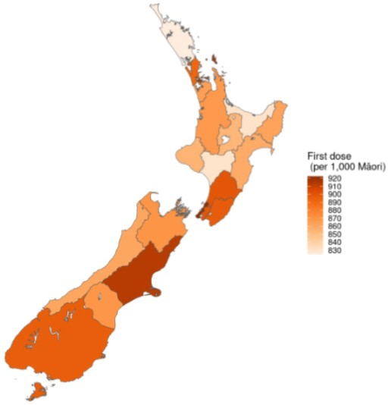

Funding
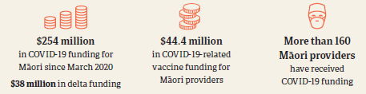

COVID-19 cases in the delta outbreak
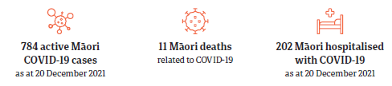

Figure 9: Māori delta cases geographic distribution as at 20 December 2021
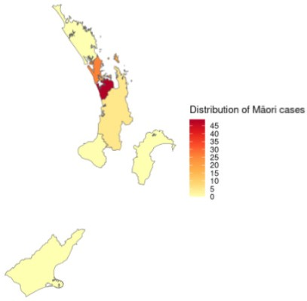

Appendix C:
COVID-19 funding for the hauora Māori response (March 2020–October 2021)
The figure below shows the $254 million in funding* broken down into funding tranches, compared against the Alert Level changes for New Zealand and Auckland since March 2020.

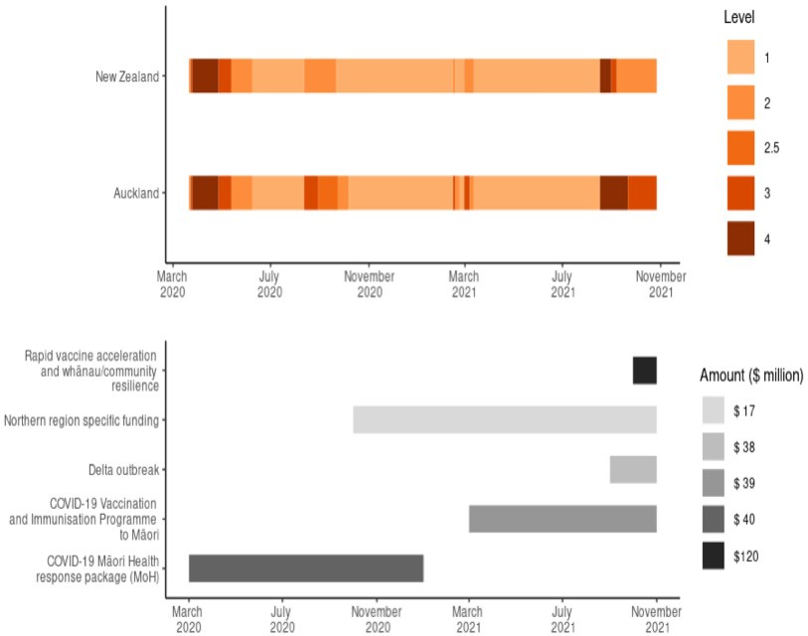

It is evident from this graph that the Ministry of Health has been proactive in ensuring Māori providers have access to funding to deal with the complications brought on from lockdown and prepare for the vaccination rollout.
* Combined funding to Māori health providers distributed by the Ministry, Te Puni Kōkiri and Te Arawhiti.

A total of $152.7 million in funding has been contracted directly to Māori Health Providers by the Ministry and DHBs through the Ministry of Health’s contract management system. The below figure shows the distribution of this funding by service type, as at 25 October 2021.
COVID-19 vaccination-specific funding makes up the majority of funding, followed by COVID-19 testing (which includes community-based assessment centres). More than 160 providers have received COVID-19 related funding, with 145 receiving support funding as part of the COVID-19 Māori Health Response package.

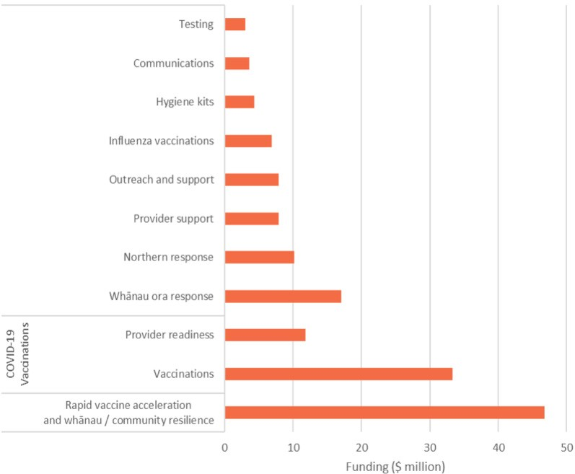

The map shows the first dose vaccination uptake for Māori overlaid with the approximate locations of Māori providers from stage one and two of the delta response funding. The blue dots represent a Māori provider involved in the delta response funding.

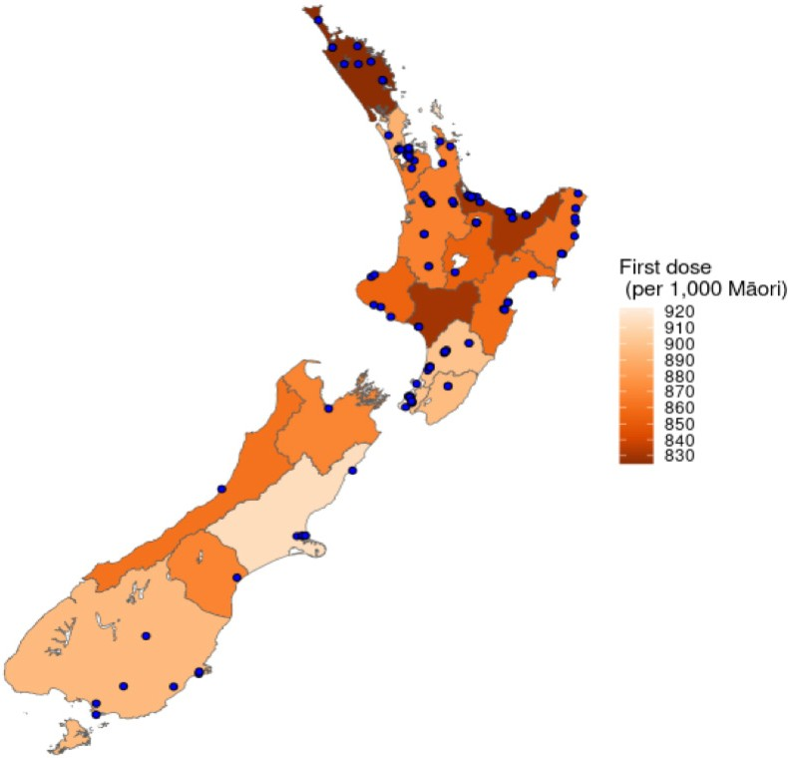

In September 2021, the Ministry of Health received $36 million to respond to the delta outbreak and support providers’ vaccination services. Funding was split into three stages:
- the first focused on supporting Māori providers involved in the COVID-19 vaccination rollout
- the second will focus on helping providers support whānau
- the third is a combination of the two stages with further focus on Māori providers supporting the vaccine rollout.

The first stage of funding has been distributed to 79 providers.
The second stage has been distributed to 31 providers.
The third stage is in the process of distributing funding to 46 providers.

Stage one – provider support
The Ministry conducted a survey from 6 October to 15 October 2021 to understand how providers aimed to implement the funding. There was a 100 percent response rate from the 53 contract- holding providers, reflecting the 79 providers funded.

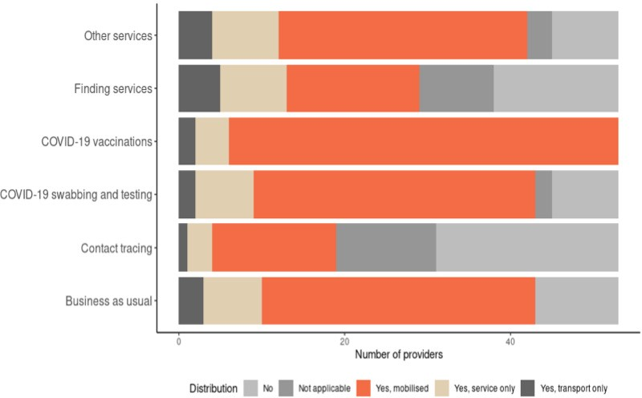

Focus on mobilisation
- 88.7 percent of providers reported mobilising their COVID-19 services, in particular, vaccination services.
- This also extended to business-as-usual services, with 62.3 percent of providers mobilising their usual services. These services include mental health, disability support services and general practices.

Priority groups for COVID-19 vaccination
The majority of providers highlighted rangatahi (aged 12–24 years) and whānau that are not well connected to health services as their priority populations.
A range of methods for connecting with priority groups is employed, including door-to-door service provision, working with schools, churches and other community services, and tapping into the relationships in the community from previous mahi (eg, distributing kai packages).
The most common theme from providers’ connection plans was the need to listen to, inform, and work with whānau to address the barriers they are facing in getting vaccinated.

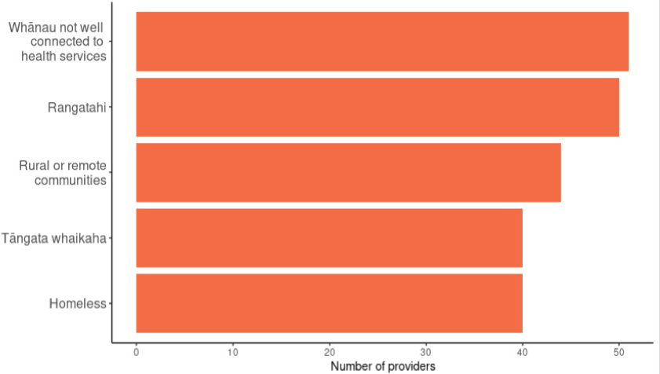

Appendix D:
Lessons learned from the COVID-19 Māori Health Response 2020–2021
In July 2021, the Ministry conducted an internal review of the COVID-19 Māori Health Response. This review highlighted three key pillars that were essential to the COVID-19 Māori Health Response across 2020 and 2021, and through which funding has been allocated.

Māori health sector investment and coordinated support
This priority area covered funding towards provider activities, including:
- covering additional operating costs such as transport, establishing remote working arrangements (including digital outreach support services and a dedicated telehealth service) and personal protective equipment (PPE)
- additional staff to manage demand over the period, including workforce development training and dedicated roles (eg, Māori Community Vaccine Champions)
- other costs as deemed necessary to ensure services were tailored to protect whānau Māori from the impacts of COVID-19 by preventing or mitigating those impacts.

Outcomes achieved
Provider reporting on this funding has indicated that:
62% used it for outreach services
36% put it towards transport costs
26% used it to hire backfill and temporary staff to manage demand.
By mid-2020, all Māori health and disability providers received extensions to their contracts, and/or guaranteed funding at existing levels, to help them plan for, and remain focused on, what whānau need.
Funding also provided training to potential COVID-19 vaccinators. This training is largely online, and prioritises applications from Māori and Pacific providers to help boost the number of vaccinators working in these settings. As at 3 November 2021, the proportion of Māori participating in the programme is 49%, and Pacific peoples is 11%. This indicates the training is achieving one of its key objectives – to create a pathway for people from diverse backgrounds to enter the workforce and upskill.
The COVID-19 vaccinator training is in its final stages of becoming an NZQA-recognised micro-credential, and exploration of expanding this training to include other parts of vaccine preparation, as well as other vaccines (eg, influenza), is under way.

Key lessons
- More permissive contracting arrangements, including multi-year contracts and guarantee funding for providers. This enables providers to focus on what they need to do to support whānau through the COVID-19 response (or other emergency responses).
- Training can be made accessible online and prioritise Māori and Pacific applicants to increase Māori and Pacific capacity in the workforce.

Localised communications
Consistent and targeted communications have been central to the COVID-19 Māori Heath Response. Funding for this priority area supported:
- A national Māori health communications campaign that is linked with the all-of-government COVID-19 communications campaign to deliver consistent messages around what alert levels mean for whānau.
- Regional approaches (Northern, Midland, Central and Southern) that have been designed in collaboration with Tumu Whakarae (DHB Māori General Managers) to extend the key messages into communities in a way that resonates with whānau at a local level. The videos centre around important and topical health issues such as mental health and wellbeing and good hygiene practices.
- A COVID-19 Vaccine Māori Communications Fund to assist groups to provide tailored regional and local Māori communication and support responses for whānau, hapū, iwi, and hapori Māori as part of the national vaccine rollout.

Outcomes achieved
As of 3 August 2021, the regional videos have been viewed over 3 million times.
From the COVID-19 Vaccine Māori Communications Fund, more than 40 organisations have been advised that they had a successful proposal. All contracts (with a total value of more than $1.9 million) are in place, with four pending signing by the provider.
The Panatahi series, featuring John Junior Panatahi Firmin communicating the COVID-19 ‘golden rules’ (September 2020), was immensely successful. The combined videos have been viewed more than 10 million times both in New Zealand and overseas.

Key lessons
- Readily available funding for communications means important information has faster reach.
- Leveraging existing networks between DHBs, providers, iwi and community organisations to share information means communications can be quickly circulated, and there is increased trust and transparency in information provided.
- Localised communication approaches supports reach of messaging and encourages communities to have ownership over the kaupapa.

Taking a whānau-centred approach
Providers understand the immediate and long-term needs of their communities best and are able to design and deliver bespoke services based on an understanding of needs and aspirations. Funding allocated for Māori community outreach has included:
- increasing outreach services for vulnerable Māori, particularly kaumātua, hapū māmā and whānau without access to care
- implementing the Māori Influenza Vaccination Programme. This funding enabled providers and district health boards to mobilise services (eg, buses), take holistic approaches to whānau need and build Māori workforce capability
- establishing Community-Based Assessment Centres in Māori communities. This provided a template for how community-based initiatives are an opportunity to capture whānau who might not otherwise engage with health services
- supporting Whānau Ora agencies through Te Puni Kōkiri’s Whakamahi i ngā Huanga a Whānau Ora (Commissioning Whānau Ora outcomes). This funding supported the establishment of food hubs, testing stations and call centres, and supported whānau who were referred to isolation facilities
- increasing whānau access to health and other services, including access to essential health services and medications, travel / delivery costs, and hygiene kits
- supporting whānau Māori mental health and wellbeing.

Outcomes achieved
An independent 2020 evaluation of the Māori Influenza Vaccination Programme, More Than Just a Jab, indicated that vaccination rates for Māori aged 65+ years were the highest on record, increasing from 46% in 2019 to 59% in 2020.
Whānau Ora has reported supporting 326,000 whānau, two-thirds of whom were new to accessing support, distributing 260,000 support packs and supplying 11,900 essential resources including kai, heating appliances and electricity bill payment.

Key lessons
- Easy access to funding through simplified processes meant that the resources providers need to support their communities could be readily accessed.
- Dedicated funding for a specific kaupapa (rather than prescriptive activities) helps ensure funding is not allocated elsewhere and delivers the services intended.
- Contracts that support mobilisation and outreach approaches and encourage co-planning with iwi and communities provides for choice and multiple ways to access services, greatly increasing uptake. The ability to backfill roles to free up staff, and contract flexibility in relation to non-COVID-19 contracts, are also integral to provider responsiveness.

Issues encountered by providers
Providers have reported a number of challenges in responding directly to COVID-19, as well as supporting whānau to weather the indirect impacts of COVID-19.

As lockdowns extend and our response becomes more complex, needs among whānau are increasing, which is worsening pre-existing inequities
- Whānau vary in their access to technology (for contact tracing purposes, for example, or virtual consultations with health services, e-learning).
- Whānau vary in their access to cross-government supports, which is further limited by a shortage of appropriate supports available to enable whānau resilience.

Capacity of the Māori health sector is stretched
- With competing priorities come competing demands on the Māori health workforce. Many providers are juggling testing, contact tracing and case management, vaccinations and business-as-usual services.
- This means trade-offs are made between responding to COVID-19 and delivering preventative health services to Māori. The health costs of delaying business-as-usual services, such as screening programmes, are likely to be significant.

Providers have also reported a number of non-Māori accessing Māori-specific services
- While these services are not exclusive to Māori, kaupapa Māori and Māori-targeted services are specifically designed and tailored to reach as many whānau Māori as possible, usually with a focus on hard-to-reach Māori communities.
- Responding to the needs of non-Māori may reduce provider capacity to do outreach or otherwise engage with key Māori populations including the vaccine hesitant, rough sleepers and tāngata whaikaha (disabled people).

Communications are not reaching some of our intended audiences
- The evolving nature of our response means key communications on new requirements are not consistently clear or delivered in a way that resonates with whānau Māori. Additionally, given the pace of the response, the Ministry has not had an opportunity to evaluate its communications approach to understand whether its messaging is leading to changed behaviour from intended audiences.
- This means there is a risk that whānau become more disengaged from the response, and that new campaigns developed do not have the cut-through that they are intended to have. Whānau may not always understand why changes have occurred or what they are required to do to keep themselves safe from COVID-19.

These issues are complex and multi-faceted. The situation is often unique for particular whānau and the providers that service them, depending on the community and how COVID-19 is affecting them at that time.

Appendix E:
Māori COVID-19 data and statistics
The situation for Māori as at the start of November 2021 has changed significantly. This change has occurred quickly over the period of the recent delta variant outbreak and has been mostly localised to the Auckland metro region.

Cases by report date
- As of 20 December 2021, there have been approximately 4,897 confirmed and probable COVID-19 cases amongst Māori overall, with 784 Māori cases currently active, 4,114 cases who have recovered and 16 deaths.
- The daily case numbers show that the direct COVID-19 case impact for Māori was limited in the initial outbreak in 2020.
- The current delta outbreak is where the majority of cases have occurred, accounting for approximately 95.7 percent of Māori cases. Māori cases reached a daily high of 123 on 17 November 2021.

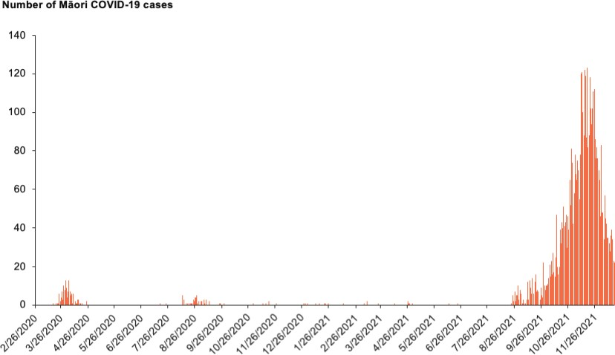
Source: ESR Episurv system as at 20 December 2021

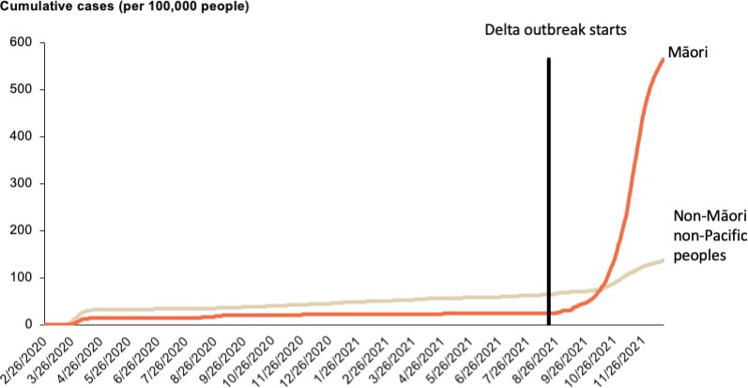

Cases by 100,000 population
Up until the recent delta outbreak, the rate of infection for Māori has been consistently around half the rate for non-Māori non-Pacific peoples.
This trend has now reversed: the overall Māori rate is well above the rate for non-Māori non-Pacific peoples.
The above figure shows how the number of Māori cases per 100,000 Māori since the beginning of the delta outbreak has spiked.
As at 20 December, the Māori rate is more than four times greater than the non-Māori non- Pacific rate (about 563 cases per 100,000 Māori and 136 cases per 100,000 non-Māori non-Pacific peoples).

The below figure shows the rate of COVID-19 cases per 100,000 people as at 1 November 2021. This highlights the marked difference between the Auckland metro DHBs and the rest of New Zealand.

Cases by DHB region
- Outside of the Auckland metro DHB regions, the rates remain low.
- However within the Auckland metro area, the rate of COVID-19 cases for Māori is around 1,999.7 per 100,000 Māori.
- The equity gap between Māori and non-Māori non-Pacific peoples reflects this difference, with Māori more than three times more likely to contract COVID-19 in the Auckland metro area.
- For the majority of the remaining DHBs, Māori are less likely to contract COVID-19 (Northland, Waikato, Bay of Plenty, Lakes, Taranaki, Wairarapa and Nelson-Marlborough DHBs are the exceptions).

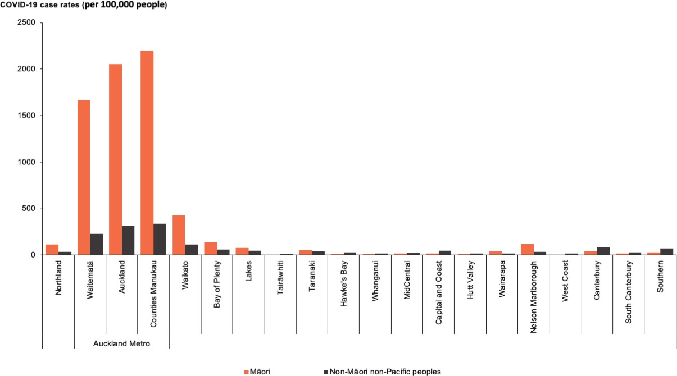
Source: ESR Episurv system as at 20 December 2021

Testing
Testing contributes significantly to our understanding of the characteristics of COVID-19 in Aotearoa and the likelihood of undetected disease. Similar to case rates, the testing rate for Māori shows a different story during the delta outbreak compared with the initial outbreak.

The Auckland metro DHB regions have the highest testing rates for Māori and non-Māori non- Pacific peoples, which reflects the delta outbreak location. Unlike in the first outbreak, Māori testing rates per 1,000 people are lower than the rates for non-Māori non-Pacific peoples in all district health boards.

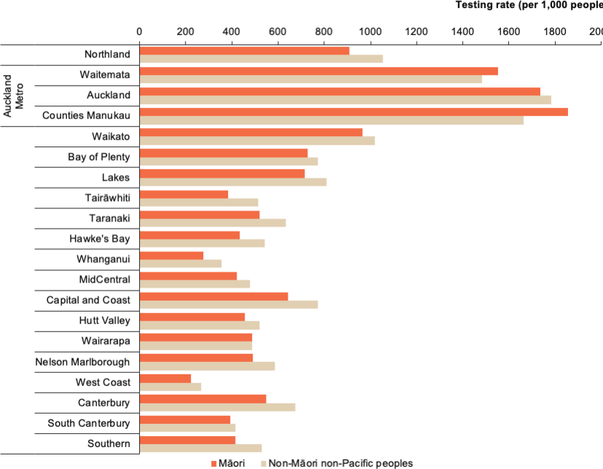

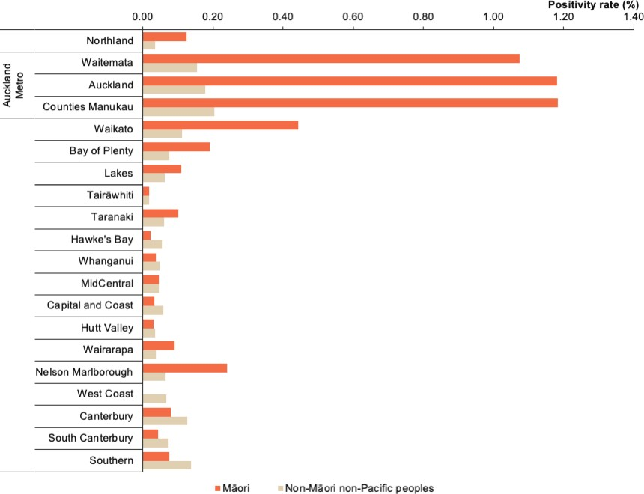

Positivity rate
Another useful tool in understanding the transmission rate of COVID-19 in the community is the positivity rate (percentage of tests that pick up a positive COVID-19 case). A higher positivity rate indicates there is potentially a greater amount of undetected community transmission.
The above graph shows the positivity rate as at 20 December 2021 for Māori and non-Māori non-Pacific peoples. This reiterates the focus on Māori in the Auckland metro area, as positivity rates have risen over 1.0 percent. This positivity rate reflects the greater number of Māori cases and lower testing rates for Māori as shown earlier.

The COVID-19 vaccination data below has been collated using ethnicity data sourced from the National Health Index in accordance with the Ministry’s data protocols. In this summary, the denominator used is the Health Service Utilisation (2020) population aged 12 and over.

Clear evidence shows that Maori experience significant barriers to health service utilisation and so this denominator will undercount them. These barriers mean that vaccination uptake rates, as seen below, are likely to be underestimated for Māori, more so than non-Māori non-Pacific peoples.

First dose uptake
This graph shows the weekly cumulative sum of the first dose uptake per 1,000 people aged 12 and over by prioritised ethnic group as at 20 December 2021. There is a clear inequity between Māori and non-Māori non-Pacific peoples in terms of their first dose vaccine uptake. The equity gap between Māori and non-Māori non-Pacific peoples steadily increased to 40.1 percent as at 22 August 2021. This increase was likely due to the younger age distribution for the Māori population compared with non-Māori non-Pacific peoples.

Since 29 August 2021 however, the equity gap between Māori and non-Māori non-Pacific peoples decreased from 40.1 percent on 22 August 2021 to 8.9 percent as at 20 December (week ending 19 December 2021).

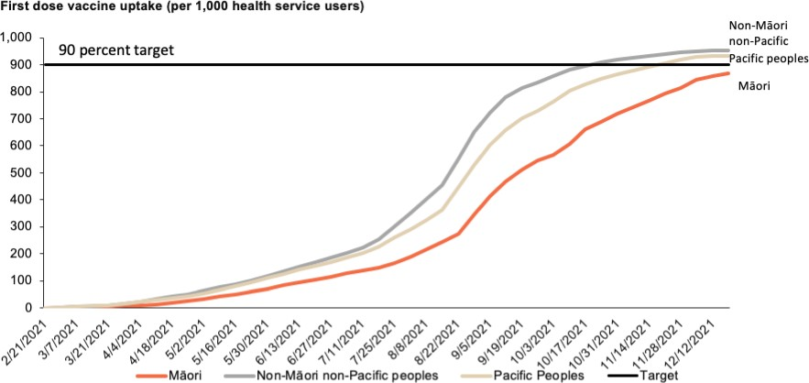

Fully vaccinated uptake
This figure shows the weekly cumulative sum of fully vaccinated uptake per 1,000 people aged 12 and over by prioritised ethnic group as at 20 December 2021. This figure follows the same pattern as the figure above, with the expected three- to six-week lag associated with the recommended wait period between first and second dose.

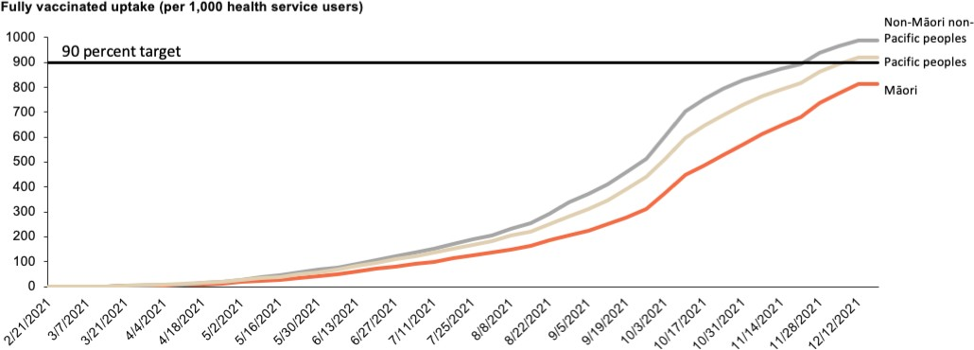

First dose uptake – Auckland metro
This graph shows the first dose COVID-19 vaccine uptake per 1,000 Māori health services users, as at 20 December 2021 in the Auckland metro region, compared with Māori in the rest of New Zealand.
This figure highlights the impact that the prolonged outbreak in the Auckland metro DHB regions has had on vaccination uptake. Māori rates in the Auckland region followed the rates across the rest of New Zealand up until the week from 19 September 2021, when Auckland metro rates began increasing at a faster rate than the rest of New Zealand.

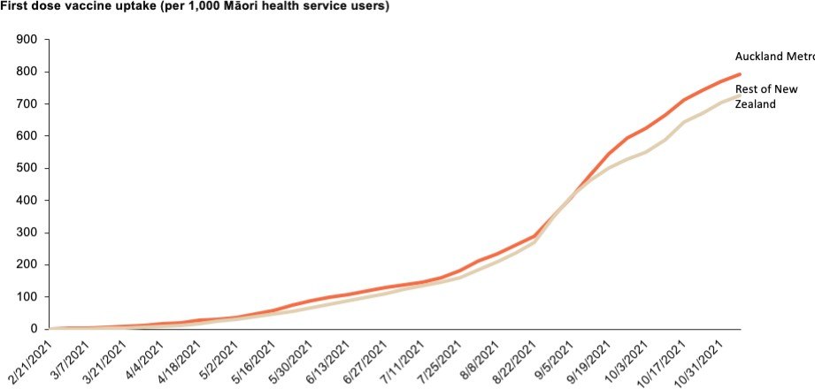

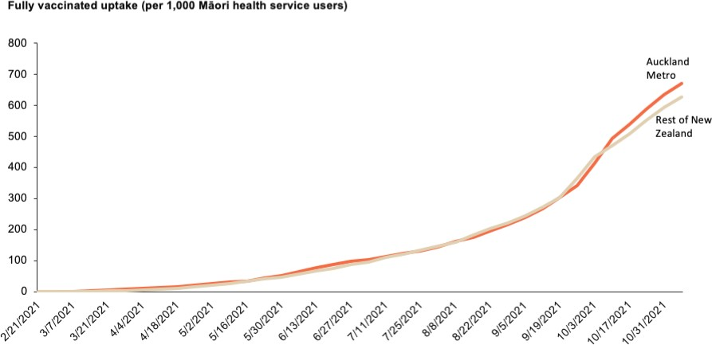

Fully vaccinated uptake – Auckland metro
Like the data comparing ethnic groups, the data comparing Māori in Auckland metro DHBs with those in the rest of New Zealand shows trends in uptake of the second dose were similar to uptake of the first dose, allowing for the expected three- to six-week lag associated with the recommended wait period between first and second dose.

2021 Māori Influenza Vaccination Programme
This programme of work began with a proactive flu vaccination programme that targets previously identified vulnerable groups, including Māori and Pacific peoples who are aged 65 years or above or have a pre-existing chronic condition, including respiratory conditions. The Māori Influenza Vaccination Programme was later expanded to include measles, mumps and rubella vaccinations, with $8.45 million in funding distributed to DHBs and Māori health providers to work collaboratively together to implement outreach vaccination initiatives.

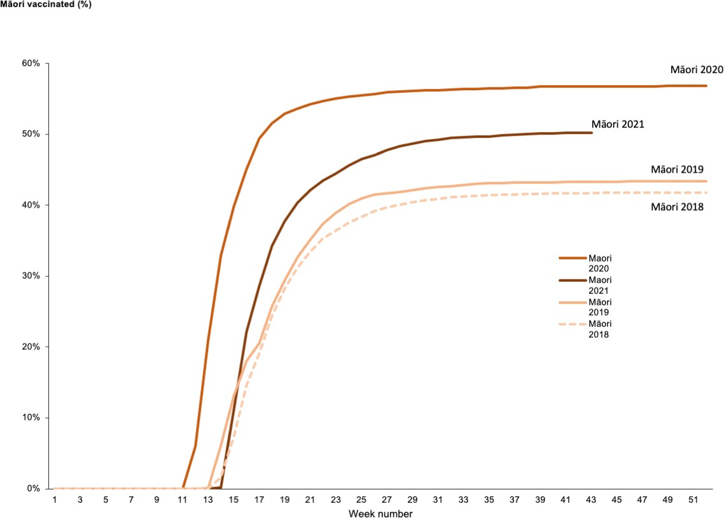

This figure shows immunisation rates for Māori aged 65 years and above between 2018 and 2021.

It is evident from this figure that the Māori Influenza Vaccination Programme had a positive impact on immunisation rates for Māori aged 65 years and above, as the immunisation rate was higher in 2021 than 2018 and 2019 (when there was no Māori immunisation programme in place). The funding pool significantly boosted opportunities for more Māori to receive the flu vaccination through innovative, coordinated DHB and Māori provider-led services.

However, the immunisation rate for Māori in 2021 is lower than the rate in 2020. This is believed to be due to the focus on the COVID-19 vaccination rollout in 2021.

Utilisation of community care services: childhood immunisations
Childhood immunisations are an essential service, protecting children against preventable and sometimes fatal diseases. The Ministry monitored Māori children at both the 18-month and 24-month milestone ages. Results presented here are a higher-level, quarterly view of vaccination coverage for these age groups. At around 15 months of age, children should have received most of the preschool immunisations on the national immunisation schedule, with only one immunisation due at age four. Given this, the 18-month milestone represents the 15-month target plus three months to deliver the immunisations. The 24-month milestone represents the 15-month target plus nine months to deliver the immunisations. This may also mean that when considering the 24-month milestone, the results reflect the situation six to nine months before.

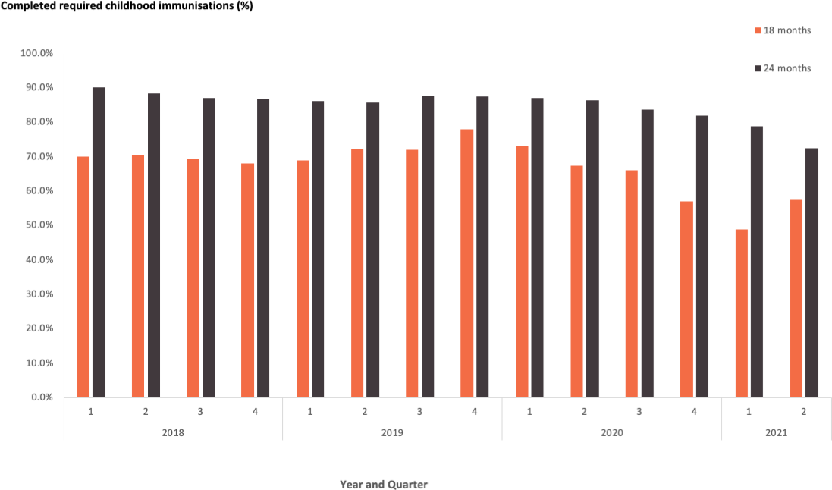

There was a significant decrease in the number of Māori children aged 18 months who received all their immunisations in 2020, compared with 2018 and 2019. This decrease has potentially continued into 2021.

The 24-month milestone indicates most Māori children that missed their vaccinations at the 18-month milestone over the lockdown quarters (quarters 1 and 2, 2020) did not catch up in the following six months, as evident from the decrease in vaccination coverage for Māori children aged 24 months in the first two quarters of 2021.

Appendix F:
COVID-19 Māori Protection Plan

Whakamaua Māori Health Action Plan 2020–2025: COVID-19 Actions
- Support the cross-government COVID-19 response to mitigate the impacts of COVID-19 on whānau, hapū, iwi and Māori communities.
- Manage the protection of Māori health through the COVID-19 Ministry work programme.

To protect Māori from the impacts of COVID-19 by preventing and mitigating those impacts

We want ...
- to contribute to the Crown meeting its obligations under Te Tiriti o Waitangi
- to prevent and mitigate inequities for Māori in the COVID-19 response
- a cohesive, all-of-government response for Māori
- to focus on action that is centrally enabled, regionally supported and locally led.

We will ...
- partner with Māori whānau, hapū, iwi, communities, social and other agencies (Te Puni Kōkiri, Te Arawhiti and the Ministry of Social Development) critical to the COVID-19 response
- prioritise those most in need and equity in resource allocation to maintain a focus on Māori in health and economic outcomes
- work across sectors to coordinate resources and decision-making.

Drivers for the next 3 to 12 months
Accelerate Māori COVID-19 vaccination rates  Prepare whānau to protect their whakapapa and reduce the impacts of COVID-19 by accelerating coordinated cross-agency action to increase vaccination rates to a minimum of 90% of the eligible Māori population. | Support whānau resilience to manage COVID-19 in the community  Ensure whānau are well prepared and able to build resilience by providing equitable support as part of the national COVID-19 system readiness response and protection framework.
Enablers
Target and localise information and education for whānau  Support the wellness of whānau, hapū, iwi and hapori Māori through targeted communications and timely information. This includes understanding any public health requirements and how COVID-19 is going to be managed in the community. It will also enable iwi- and Māori-led communications to deliver the right message, at the right time, through the right channels. | Increase integrated outreach health and social services for and with Māori  Deliver joined-up health and social services that mitigate the inequitable impacts of COVID-19 falling on Māori. Empower and resource local communities to respond to outbreaks quickly and enable Māori health providers to offer tailored health and social services to support whānau through the different phases of the COVID-19 response and support their broader health and wellbeing needs.
Actions
- Invest in innovative, targeted communication and health promotion initiatives.  - Expand the reach and coverage of public health advice and measures tailored for Māori through appropriate and trusted Māori communication channels.  - Expand Māori telehealth service provision.  - Make transparent the progress to strengthen ethnicity and iwi data.  - Increase evidence and insights to address vaccine hesitancy and wider COVID-19 impacts for whānau Māori. | - Establish and contribute to a coordinated cross-agency Māori response to COVID-19 (including through the Māori Communities COVID-19 Fund).  - Develop community-led models of care to support whānau to self- isolate at home and prepare to manage the effects of COVID-19 in their communities.  - Increase or, at a minimum, maintain investment and extend contracts for hauora Māori providers to the end of 2022, and maintain a flexible funding approach.  - Support DHBs to partner with iwi and Māori organisations in the delivery of the COVID-19 response.  - Support outreach programmes that take the vaccination to where Māori are.  - Prioritise investment in the Māori health workforce.  - Enable Whānau Ora providers, iwi, hapū and Māori groups to develop localised plans tailored for their contexts.  - Establish systems and infrastructure for an integrated immunisation system.
Monitoring
Monitoring the success of this plan will be integral to protecting Māori wellbeing. A new monitoring framework has been developed, building on the existing measures outlined in the COVID-19 Māori Vaccination and Immunisation Plan. | Monitoring components  - Surveillance  - Monitoring of system performance  - Māori-specific COVID-19 action  - COVID-19 immunisation

Appendix G:
COVID-19 Māori Health Response governance arrangements
Group | Background and role
Māori Monitoring Group (MMG) | - Established in June 2020 through the Updated COVID-19 Māori Health Response Plan. The MMG is independent from the Ministry.  - Purpose is to enable Māori leadership from across different sectors and communities to provide independent, timely and practical insights and advice to the Deputy Director-General Māori Health and Ministry on COVID-19. This includes surveillance and monitoring, clinical management of COVID-19 risk, technical and scientific matters, reports and evidence-based research on the international COVID-19 situation, and specific actions to protect Māori from COVID-19.  - The MMG has also provided feedback and advice on other matters outside the COVID-19 response, including immunisations, Whakamaua: Māori Health Action Plan 2020-2025, and Hui Whakaoranga.
Tumu Whakarae (Tumu) | - Comprises national General Managers Māori / Executive Directors Māori across the 20 district health boards.  - Provides Māori leadership at the DHB senior manager level in respect to achieving better health outcomes for Māori and reducing inequalities between Māori and non-Māori health status.  - Tumu have advised the Ministry on a range of matters throughout the COVID-19 response, including regional communications approaches, COVID-19 vaccinator workforce development, and the initial and updated COVID-19 Māori health response plans.
Immunisation Implementation Advisory Group (IIAG) | - Established as part of the COVID-19 Vaccine and Immunisation Programme (CVIP), the IIAG has been a core advisory group to the Ministry of Health in the rollout of the COVID-19 vaccine.  - The group has strong Pacific and Māori representation and has provided robust advice across CVIP, with a focus on ensuring the programme meets the needs of Māori communities.  - Advice has covered a range of areas including service and system design, logistics, clinical safety, cultural responsiveness and service delivery.
COVID-19 Vaccine Strategy Taskforce | - Cross-agency executive leadership group with the aim of ensuring safe, effective and sufficient quantities of COVID-19 vaccines are available in New Zealand.

https://www.health.govt.nz/publication/initial-covid-19-maori-response-action-plan
https://www.health.govt.nz/publication/updated-covid-19-maori-response-action-plan
https://covid19.govt.nz/alert-levels-and-updates/covid-19-protection/
https://www.health.govt.nz/our-work/populations/maori-health/whakamaua-maori-health-action-plan-2020-2025
https://www.health.govt.nz/our-work/populations/maori-health/he-korowai-oranga
Population immunity occurs when vaccine coverage is high, meaning an infectious case is unlikely to encounter susceptible contacts, so transmission stops.
The COVID-19 vaccination data has been collated using ethnicity data sourced from the National Health Index (NHI) in accordance with the Ministry’s data protocols. In the summary shown in Figures 5 and 6, the denominator used is the Health Service Utilisation 2020 population (HSU 2020) for people aged 12 years and over.
https://www.health.govt.nz/our-work/populations/maori-health/te-tiriti-o-waitangi
The original focus area of support for people in self-isolation and quarantine was based on the assumption that large numbers of people would be isolating in the community. This focus changed once elimination of the virus in the community was achieved.
The Ministry’s preference is for the neutral term ‘missed appointment’ rather than ‘did not attend’, which places sole responsibility on the service user.
The specific psychosocial survey has ended. However, this data will now be collected as part of the wider New Zealand Health Survey.

