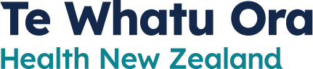
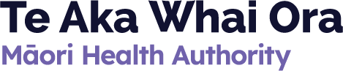

Te Pae Tata –

Interim New Zealand Health Plan
How the healthcare system will be made better for tāngata whaikaha / disabled people
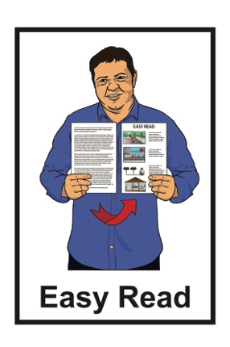

October 2022
What you will find in here

Page number:

Changes to our healthcare
system……………………………..….2
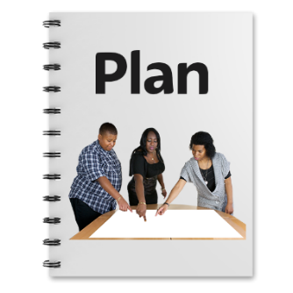

What is Te Pae Tata – Interim New Zealand Health Plan?...............5

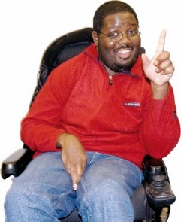
What does the interim plan say about disability?..........................7

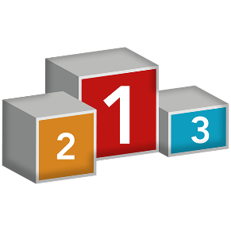
Principles………………….....……..…9

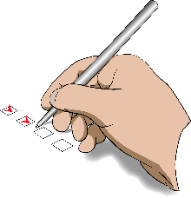
Priorities……………………………...15

Actions………………………….….…19

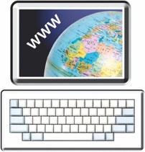
Where to find more information…....22
Changes to our healthcare system

There have been some changes to the way our healthcare system works in Aotearoa New Zealand.

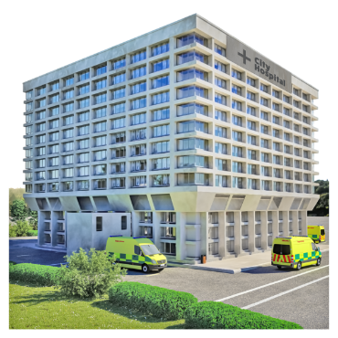

Healthcare system means lots of things like:

- hospitals

- doctors
- nurses

- midwives
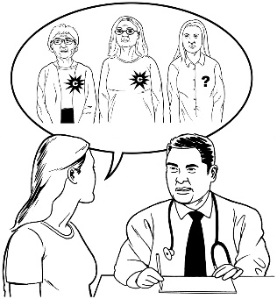
- specialists like:

  - cancer specialists

  - heart specialists.
The first of the changes to the healthcare system has been the setting up of:
- Te Whatu Ora – Health New Zealand
- Te Aka Whai Ora – Māori Health Authority.

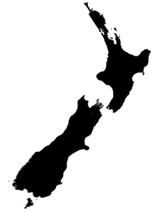

Te Whatu Ora – Health New Zealand means:

- there is now 1 healthcare system for the whole of Aotearoa New Zealand
- everyone will get good healthcare wherever they live in Aotearoa New Zealand.

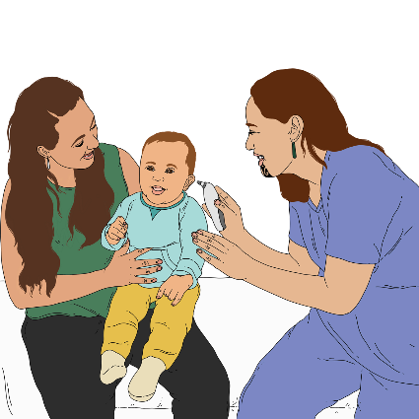
Te Aka Whai Ora – Māori Health Authority will make sure:

- Māori get better healthcare
- there are services that are a good fit for Māori.

What is Te Pae Tata –

Interim New Zealand Health Plan?
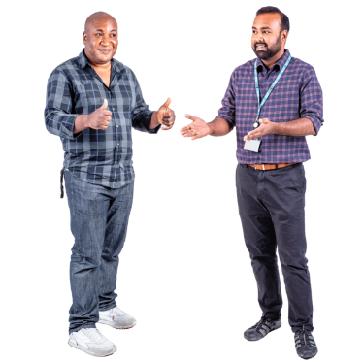

Making the healthcare system better for everyone is going to take time.

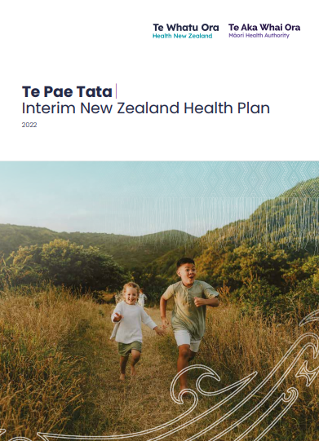
Te Pae Tata – Interim New Zealand Health Plan is a 2 year plan that will guide the work of:

- Te Whatu Ora – Health New Zealand

- Te Aka Whai Ora – Māori Health Authority.

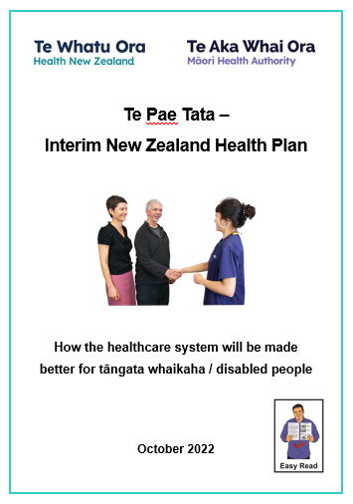

Interim means for a short time.

In this Easy Read document we will call Te Pae Tata – Interim New Zealand Health Plan the interim plan.
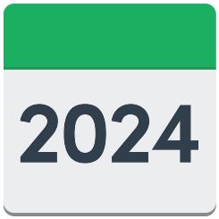
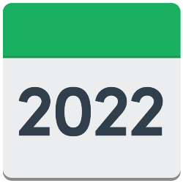
The interim plan outlines the:

- work that will be done between 2022 to 2024
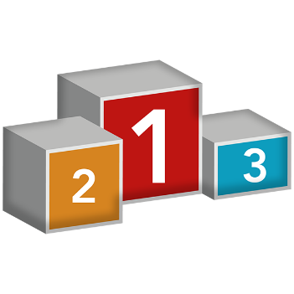
- things that need to be done first to make the healthcare system better for everyone.

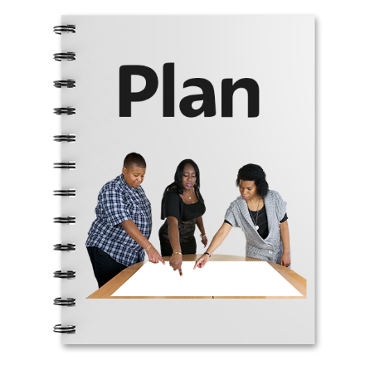
The Government is also writing the first full New Zealand Health Plan.

The New Zealand Health Plan will have information about how the healthcare system will work over the coming years.

This plan will be written by June 2024.

What does the interim plan say
about disability?

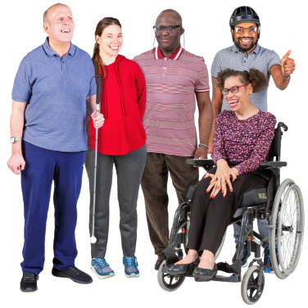
In the interim plan tāngata whaikaha / disabled people are seen as a priority group.

A priority group means they are seen as an important group in the new healthcare system.

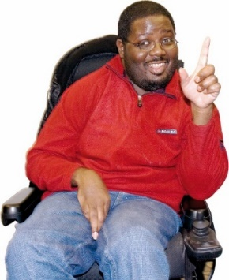
To make the new healthcare system better for tāngata whaikaha / disabled people the interim plan outlines important:

- principles

- priorities
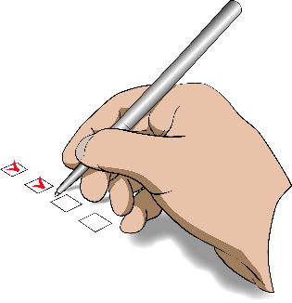
- actions.

Principles are the ideas that are important to the way the new healthcare system is set up.

Priorities are the most important things that the healthcare system needs to make better.

Actions are what changes will be made.

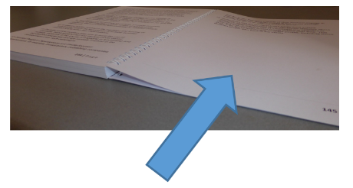
We will look at what these all are on pages 9 to 21.

Principles

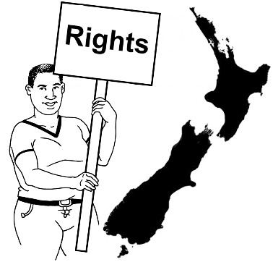
Principle 1: Human rights model of disability

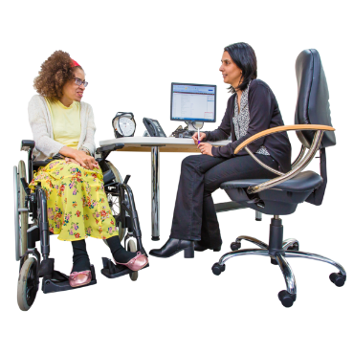
The new healthcare system will see the importance of understanding the human rights of tāngata whaikaha / disabled people.

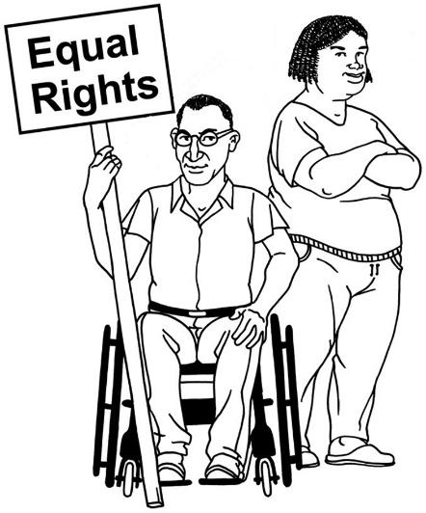
Human rights are rights to make sure everyone:
- is treated fairly
- has what they need to live a good life.

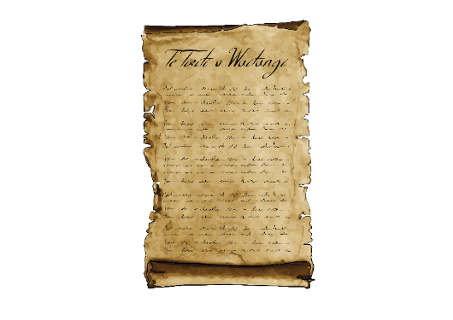
The healthcare system will also follow:

- Te Tiriti o Waitangi / The Treaty of Waitangi
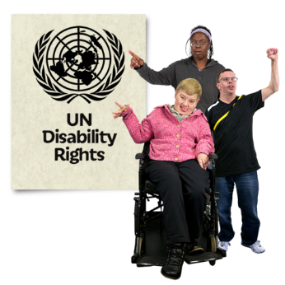
- the United Nations Convention on the Rights of Persons with Disabilities.

Te Tiriti o Waitangi / The Treaty of Waitangi is important to New Zealand.

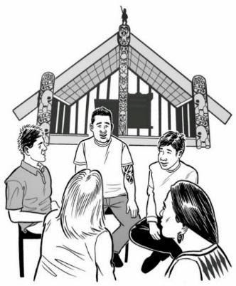
It is about Māori and the New Zealand Government:
- making decisions together
- protecting things that are important to Māori.

The United Nations Convention on the Rights of Persons with Disabilities is a law lots of countries have agreed to.

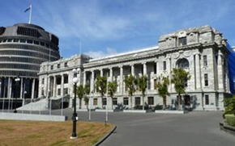
It says what governments must do to make sure disabled people get the same rights as everyone else.

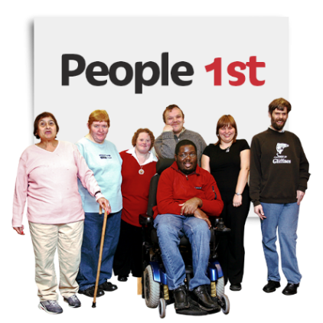
Principle 2: Nothing about us without us

Tāngata whaikaha / disabled people must be part of deciding how the new healthcare system will be better for everyone.

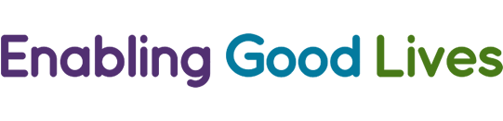
The Enabling Good Lives principles will also be used when making the healthcare system better for tāngata whaikaha / disabled people.

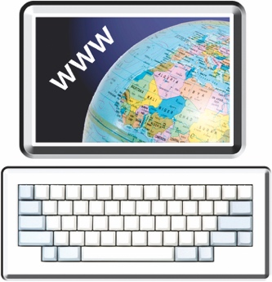
You can find more information about the Enabling Good Lives principles at this website:

www.enablinggoodlives.co.nz/about-egl/egl-approach/principles/

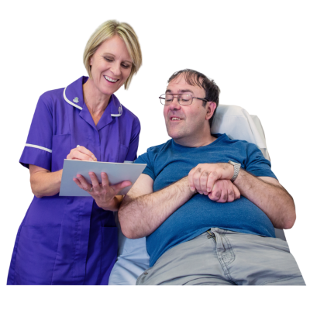
Principle 3: Holistic models of care

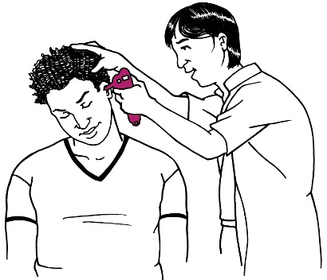
Holistic models of care means having a healthcare system that looks at the needs of the whole person.

This means thinking about their:
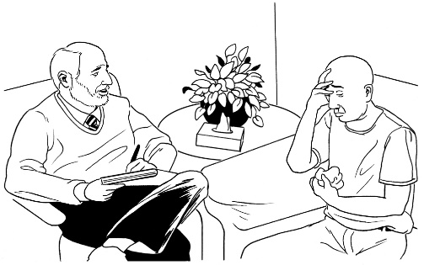
- physical needs – what is happening with their body

- emotional needs – how they are feeling
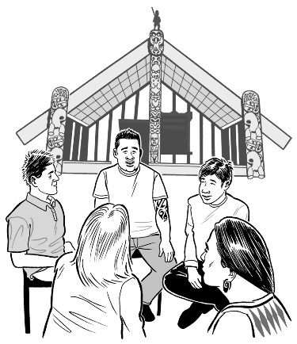
- social needs – friendships or being part of things they enjoy doing

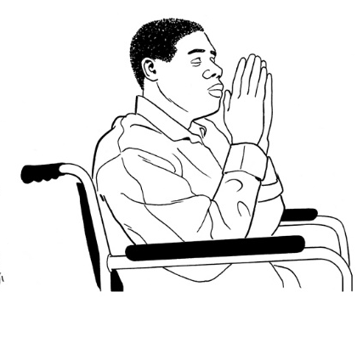
- cultural needs – things about their way of life that are important to them

- spiritual needs – things they believe in.

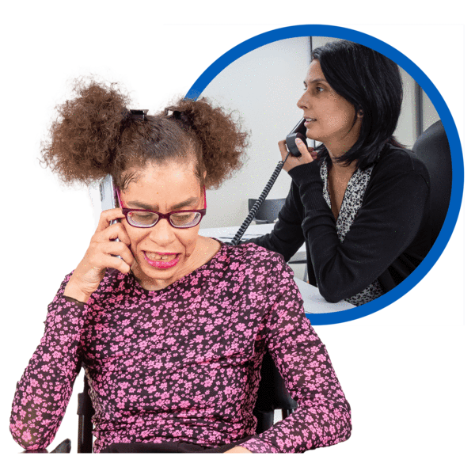
The new healthcare system will use data and digital technology to make it easier for tāngata whaikaha / disabled people to:

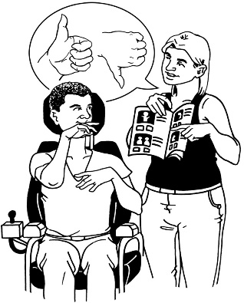
- say what they need

- get good healthcare no matter what service they are using.

Data and digital technology is equipment that is used in the healthcare system such as:
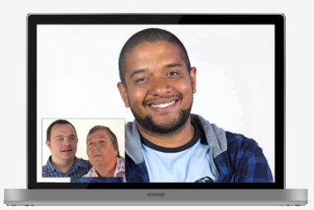
- computers / iPads to store health information

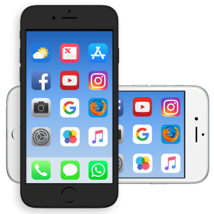
- video calls with doctors

- mobile phones to check heart rate or blood pressure.

Priorities

Priority 1: Make all health services for tāngata whaikaha / disabled people:

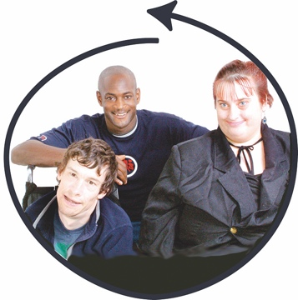
accessible

inclusive

equitable.

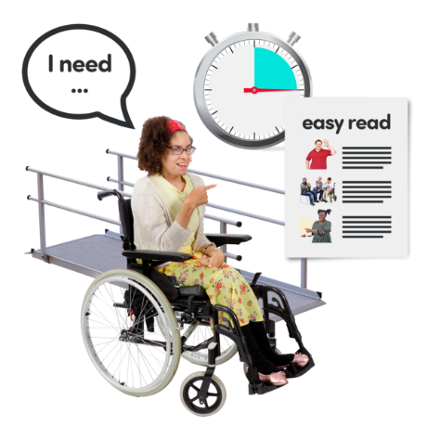

Accessible means there are no barriers that stop people from using healthcare services.

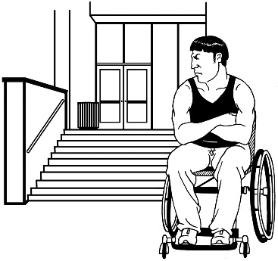
Barriers for tāngata whaikaha / disabled people might be things like:

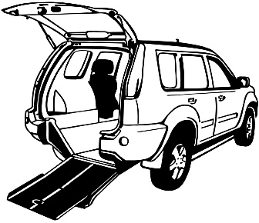
- not being able to get into or move around in buildings

- not having access to easy transport to their healthcare services
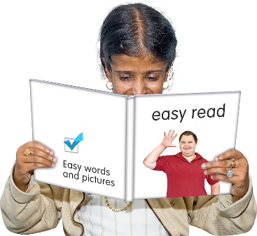
- not getting health information in ways that meet their needs like Easy Read.

Inclusive means that healthcare services understand the needs of tāngata whaikaha / disabled people.

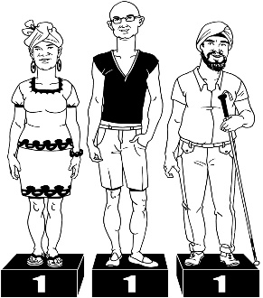

Equitable means a fair healthcare system for everyone.

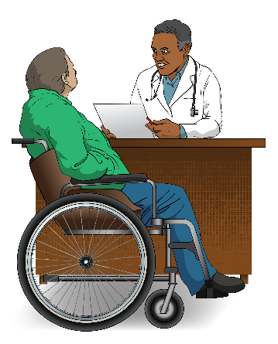
Priority 2: Have a healthcare system that has a twin track approach to services for tāngata whaikaha / disabled people.

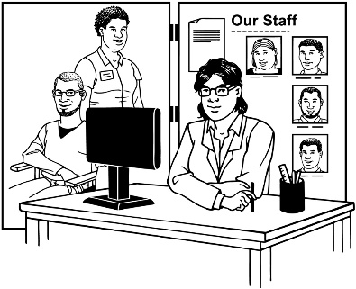
A twin track approach means there are 2 ways people can get support:

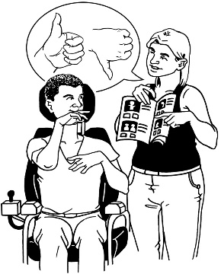
Twin track 1: This means being able to use mainstream services just like everyone else.

Twin track 2: This means having specialist services for tāngata whaikaha / disabled people.

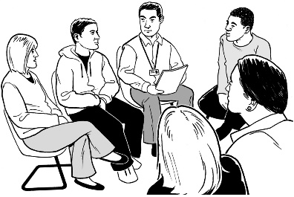
Mainstream services are services that everyone can use.

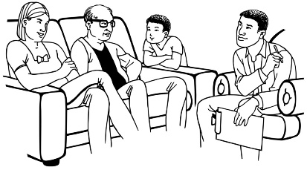
Specialist services are services that understand the needs of tāngata whaikaha / disabled people

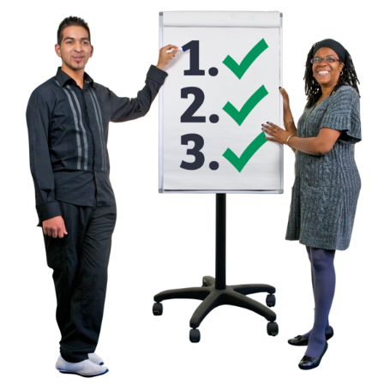
Priority 3: Commit to long term change

Commit means to work with tāngata whaikaha / disabled people for many years to come to make the healthcare system better for everyone.

Actions

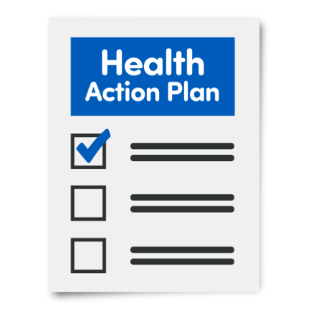
The interim plan has a list of actions that will make the healthcare system better for tāngata whaikaha / disabled people.

Some of the actions in the interim plan are:

- having accessible buildings / information
- teaching people who work in the healthcare system to better understand:

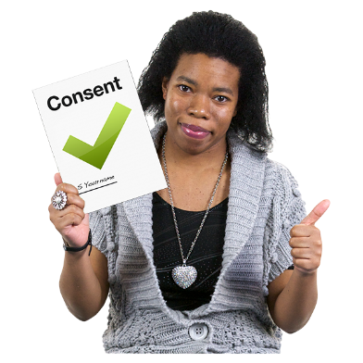
  - supported decision-making

  - informed consent.

Supported decision-making means having support to make decisions when you need it.

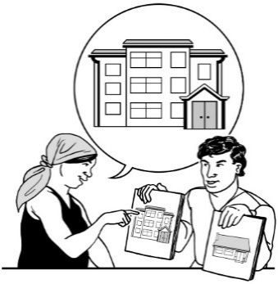
Supported decision-making may mean:

- having information in a way that you understand

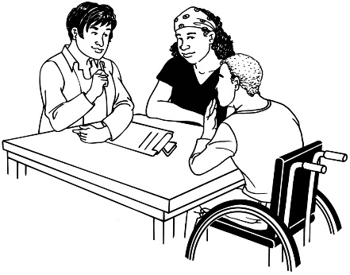
- having more time to make decisions

- talking things over with someone before making your decision.

Informed consent is when you:

- say yes to something

- understand what you are saying yes to.

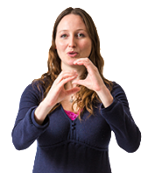
Another action in the interim plan is to make sure that the healthcare system has the things that tāngata whaikaha / disabled people need such as:
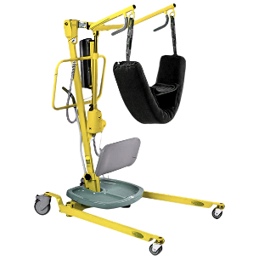
- access to New Zealand Sign Language interpreters

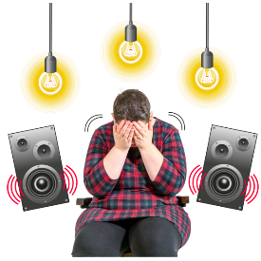
- equipment like hoists

- places that are not noisy or busy.

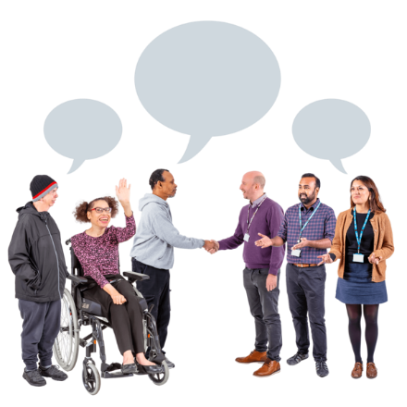
Another important action is that the healthcare system must set up ways that tāngata whaikaha / disabled people can:

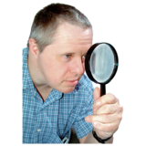
- give their ideas about what is needed to make their healthcare services better

- check the way the healthcare services have been made better.
Where to find more information

You can find the full interim plan on the Te Whatu Ora - Health New Zealand website:

www.tewhatuora.govt.nz/whats-happening/what-to-expect/nz-health-plan/

This information has been written by Te Whatu Ora – Health New Zealand.
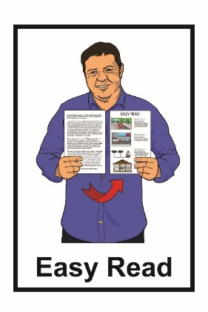
It has been translated into Easy Read by the Make it Easy service of People First New Zealand Inc. Ngā Tāngata Tuatahi.

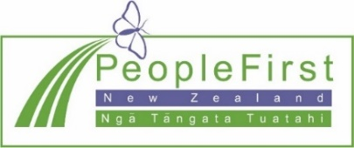
The ideas in this document are not the ideas of People First New Zealand Inc. Ngā Tāngata Tuatahi.
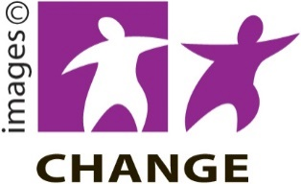
Make it Easy uses images from:

- Changepeople.org

- Photosymbols.com

- SGC Image Works

- Huriana Kopeke-Te Aho.

All images used in this Easy Read document are subject to copyright rules and cannot be used without permission.

