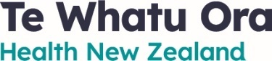

INITIATION OF BARGAINING
PUBLIC SERVICE ASSOCIATION (PSA)
& TE WHATU ORA / HEALTH NEW ZEALAND
NATIONAL OFFICE COLLECTIVE AGREEMENT
27 March 2023
Under section 43 of the Employment Relations Act 2000, Health New Zealand is required to bring to your attention the fact that the PSA has initiated bargaining for a Collective Agreement that covers your work.
The intended parties to the collective agreement are:

Union Party NZ Public Service Association: Te Pūkenga Here Tikanga Mahi Incorporated
Employer Party Te Whatu Ora – Health New Zealand

The intended coverage of the Collective Agreement is:
All employees of Te Whatu Ora who are members of the PSA, in non-clinical roles not covered by existing PSA Collective Agreements or PSA Collective Agreements currently in negotiation, within the following job families:

- Management, excluding the Chief Executive and members of the Executive Leadership Team, Regional Directors, and General Managers
- IT
- Finance and Audit
- Policy, Programmes and Projects
- Business Analysis and Support
- Information, Analytics and Research
- Communications
- Procurement/Supply Chain
- HR/P&C, excluding those who interpret and implement employment terms and conditions.

The notice has been posted on the Te Whatu Ora website. If you have any questions, please do not hesitate to contact Rosalie Webster Rosalie.webster@tas.health.nz in the first instance.
Yours sincerely
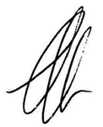
Jim Green
Interim Chief People Officer

