The Care and Support Workers
(Pay Equity) Settlement Act 2017
Information for people that use:
- Individualised Funding
- Enhanced Individualised Funding
- Enabling Good Lives.
Easy Read

Before you start
This is a long document.
While it is written in Easy Read it can be hard for some people to read a document this long.
Some things you can do to make it easier are:
- read it a few pages at a time
- have someone to assist you to understand it.
There are also some hard words in this booklet.
You can find out what the hard words mean in the List of hard words on page 20.

About the Pay Equity Act 2017
 | The Pay Equity Act 2017 is a law the New Zealand Government has made.
 | This law says the minimum rate that support workers must get paid.
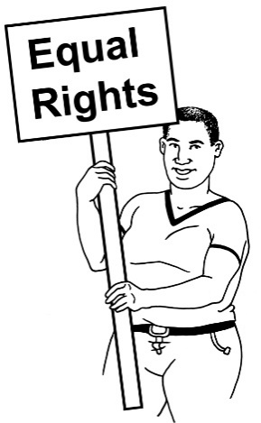 | The Pay Equity Act 2017 is also called the Care and Support Workers Settlement Act 2017.
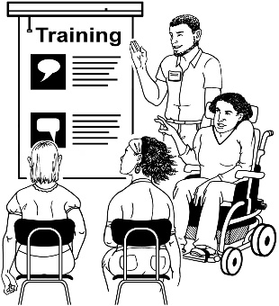 | The Pay Equity Act 2017 says you must:  - pay your support workers the right amount  - make sure the support workers that you pay can get qualifications.
From 1 July 2017 support workers must be paid the amounts in the Pay Equity Act 2017 if they are paid by people that use:
- Individualised Funding
- Enhanced Individualised Funding
- Enabling Good Lives Funding.
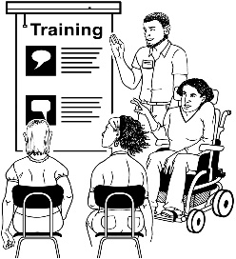 | From 1 July 2017 support workers must be supported to get qualifications if they are paid by people that use:  - Individualised Funding  - Enhanced Individualised Funding  - Enabling Good Lives Funding.
 | This website has more information about the care and support workers’ pay equity settlement:
www.health.govt.nz/new-zealand-health-system/care-and-support-workers-pay-equity-settlement

The right rate
You will get a bigger budget to pay your support workers the right rate if you use:
- Individualised Funding
- Enhanced Individualised Funding
- Enabling Good Lives.
You can pay your support workers more than the minimum rate.
You cannot pay your support workers less than the minimum rate.

How to work out the right rate
You must work out the right rate to pay your employee from:
- how many years they have worked for you
- qualifications they have.
You must talk to your employee to find out about:
- how many years they have worked for you
- what qualifications they have.
Ask your Host Provider if you need support to talk with your employee.
After 1 July these are the minimum rates you will need to pay the employees that already work for you:
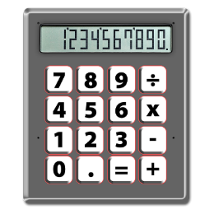

Time that they have already worked with you | Qualification level | Pay band | Minimum rate per hour
Less than 3 years | None | L0 | $19.00
 | Level 2 | L2 | $20.00
 | Level 3 | L3 | $21.00
 | Level 4 | L4b | $23.50
Between 3–8 years | None | L0 | $20.00
 | Level 2 | L2 | $20.00
 | Level 3 | L3 | $21.00
 | Level 4 | L4b | $23.50
Between 8–12 years | None | L3 | $21.00
 | Level 2 | L3 | $21.00
 | Level 3 | L3 | $21.00
 | Level 4 | L4 | $23.50
More than 12 years | None | L4b | $23.50
 | Level 2 | L4b | $23.50
 | Level 3 | L4b | $23.50
 | Level 4 | L4b | $23.50

 |  | The new amount you pay must be the amount that is best for your employee.
 |  | This means that if your employee has little or no qualifications but they have worked for you for a long time you must:
 | pay them the amount that goes with how many years they have worked for you
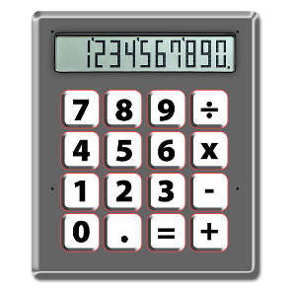 |  | OR
 |  | If your employee has only worked for you for a short time but they have good qualifications you must:
 | pay them the amount that goes with the level of study they have done.
 |  | More information about qualifications is on this website:
www.careerforce.org.nz/pay-equity/equivalencies
Here are 2 examples of the amount to pay an employee:
Example 1:
If your employee has worked for you for 1 year and has a level 4 qualification they must be paid at least $23.50 per hour.
This is band L4b.
Example 2:
If your employee has worked for you for 7 years but has no qualifications they must be paid at least $20.00 per hour.
This is band L2.

New employees
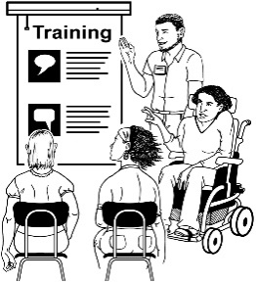 | If you have someone start working for you after 1 July 2017 you must look at the level of qualifications they have to find out how much to pay them.
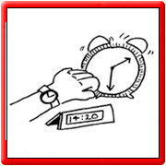 | If you have someone start working for you after 1 July 2017 you must not use how many years they have worked for you to find out how much to pay them.
These are the minimum rates you will need to pay any new employees who start work for you after 1 July 2017:

Qualification level | Minimum rate per hour
None | $19.00
Level 2 | $20.00
Level 3 | $21.00
Level 4 | $23.50

Your employees
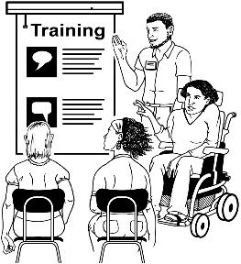 | You must do what you can to support your employees to get qualifications.
 | Ask your Host Provider if you need support to make sure your employee can get qualifications.

Your budget
 | On 3 July 2017 you will get more budget.
 | You will get the right amount of money to be able to pay your employees the rate they need.
 | The Ministry of Health will work with Host Providers to make sure they can give you good support.
No change | Carer Support and Ministry of Social Development rates will stay the same as they are now.
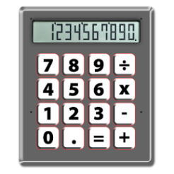 | In July 2017 the Ministry of Health will work out the budget for each person for:  - Individualised Funding Respite  - Enhanced Individualised Funding  - Enabling Good Lives Funding.
 | In July 2017 the Ministry of Health will give the new budgets to Host Providers.
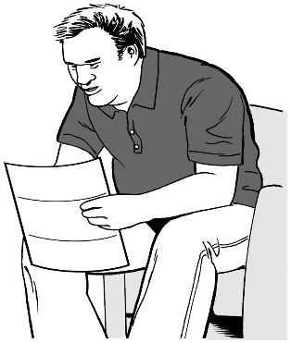 | Your Host Provider will tell you your new budget.

Your Host Provider
There will be changes to how Host Providers are paid for services.
You will not have to pay your Host Provider for the services that they have to give you.
The Ministry of Health will pay Host Providers directly for services they must give you, like:
- set up
- coaching along the way
- claiming funding from the Ministry.
You will have to pay from your budget for any other services you get from your Host Provider.
For example if you want to use a payroll service you must pay for that from your budget.
You can talk with the Host Provider to get more information about what services your Host Provider must give you that you do not have to pay for.
If you use a payroll service from your Host Provider you must tell your Host Provider how much money they need to pay your employee.

Employment agreements
For most employees their employment agreement will not need to change.
You should write a letter to your employee to let them know about the new rate they will be paid.
Ask your Host Provider if you do not know whether your employee agreements need to change.
Ask your Host Provider if you need support to write a letter to your employee to let them know about the new rate they will be paid.

Leave accruals
The Ministry of Health will:
- find out more about the rate to pay for leave accruals
- let you know about the rate to pay for leave accruals.

List of hard words
 | Budget is the money that you can use to pay your employees.
 | Employee is a person that you pay to work for you – for example your support worker.
Employment Agreement says the things an employee or worker has to do in their job.
It can also be called a contract.
 | Enabling Good Lives gives disabled people and their families / whānau more choice and control over their support.
Disabled people who use Enabling Good Lives will be given their funding for supports from:
- Ministry of Health
- Ministry of Education
- Ministry of Social Development.
The funding from these places will be put together.
The disabled person and their family / whānau can then have control over that funding and what they spend it on.
 | Enhanced Individualised Funding is money that disabled people can get from the Ministry of Health to pay for the supports they need to live a good life.
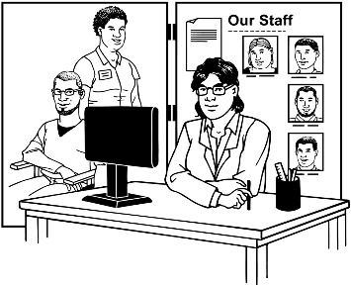 | Host Providers are organisations that can help disabled people and their families / whānau to manage the funding they have for support and the things they need.
Individualised Funding is money disabled people can get to pay for:
- Home and Community Support
- Respite services.
 | Leave accrual is how much time an employee has earned to take time off work.
 | Minimum rate is the lowest amount of money the law says you must pay your employee.
 | Payroll Service is a service you can use to make sure your employees get paid.
A qualification is given to someone that has passed a test after they have:
- studied
- trained.
 | Rate is the amount of money to pay your employee for the work they do.

This information has been translated into Easy Read by People First New Zealand Inc. Ngā Tāngata Tuatahi

