

Nelson Marlborough

Clinical Quality & Systems Review

23 July 2025

Citation: Health New Zealand | Te Whatu Ora. 2025. Nelson Marlborough Clinical Quality & Systems Review.   
Wellington: Health New Zealand | Te Whatu Ora.

Published in July 2025 by Health New Zealand | Te Whatu Ora  
PO Box 793, Wellington 6140, New Zealand

ISBN 978-1-991139-44-3



This document is available at [tewhatuora.govt.nz](https://www.tewhatuora.govt.nz/)

|  |  |
| --- | --- |
|  | This work is licensed under the Creative Commons Attribution 4.0 International licence. In essence, you are free to: share i.e., copy and redistribute the material in any medium or format; adapt i.e., remix, transform and build upon the material. You must give appropriate credit, provide a link to the licence and indicate if changes were made. |

# Contents

Contents 3

Executive Summary 4

Introduction 6

Methodology 6

Acknowledgements 6

Background 6

Key Findings 8

Clinical Quality and Safety 8

Access to Care 12

Workforce 13

Facilities and Infrastructure 16

Clinical cases 17

Key Recommendations 18

Clinical Quality and Safety 18

Access to Care 18

Workforce 18

Facilities and Infrastructure 19

Clinical cases 20

Action Plan 20

Conclusion 20

Glossary of Terms & Abbreviations 21

Appendix One: Review team 22

Appendix Two: Summary of clinical cases reviewed 23

# Executive Summary

1. This Clinical Quality & Systems Review of Nelson Marlborough was commissioned by Health New Zealand |Te Whatu Ora (Health NZ’s) Chief Clinical Officer, Dr Richard Sullivan, and the Interim Chief Executive, Dr Dale Bramley. A review panel was appointed and chaired by the Chief Clinical Officer.
2. Four domains were the key focus of this review: clinical quality and safety, access to care, workforce, and facilities and infrastructure.
3. The review panel and team members participating in this review were consistently impressed with the dedication and commitment of staff to providing patients and the Nelson Marlborough population with safe, high-quality care.
4. Nelson Marlborough is achieving good outcomes across a range of quality and safety measures despite significant challenges faced by the district. In particular, Nelson Marlborough’s in-hospital mortality is low (83) compared to all New Zealand hospitals (121) for the period April 2024 – March 2025.[1]
5. Clinical governance systems and processes need development and alignment with Te Tāhū Hauora Health Quality and Safety Commission (HQSC) national clinical governance guidance. Clinical governance needs to be more connected and visible to clinicians and services and used for escalation of issues. A regional clinical governance group that aligns with national guidance should be established.
6. There are delays in accessing timely care, both acute and planned care, due to capacity (both workforce and infrastructure) not keeping pace with the increased demand for services. Access to planned care has been impacted more significantly, as services appropriately prioritise acute care. Balancing acute and planned care is a challenge for all hospitals across New Zealand.
7. There are medical workforce issues in specific services, with many relating to a traditional model of care delivered primarily by senior medical officers. This model had served the hospital well, however it is no longer a sustainable model for a hospital of Nelson’s size and increasing complexity. A transition to a more contemporary, interdisciplinary model needs to be a priority.
8. The Senior Medical Officer (SMO) delivered model has led to under-investment in Resident Medical Officers (Registrars and House Officers) resulting in SMOs covering a lot of duties that would be undertaken by registrars in comparable sized hospitals/districts. It has also led to underinvestment in advanced practice roles in allied health and nursing professions compared to other centres.
9. Operational and clinical leadership structures have not evolved as the district has expanded and need to be reformed. In particular, there needs to be stronger clinical management partnership and collaboration, with more involvement of clinicians in decision-making.
10. Infrastructure issues include insufficient inpatient bed capacity,[2] an imbalance of spaces required by services, and spaces not designed for particular services. These issues are adversely impacting patient flow and patient and staff experience. There is a capital investment plan with a commitment of significant investment, which is being progressed.
11. Both workforce and infrastructure challenges will require significant investment and will take longer to address.
12. The aim of any improvement undertaken should be to ensure Nelson Marlborough has a workforce that is supported by the right infrastructure so that it can reliably deliver services in a timely fashion.

# Introduction

1. This Clinical Quality and Systems Review of Nelson Marlborough was commissioned by Health NZ’s Chief Clinical Officer, Dr Richard Sullivan, and the Interim Chief Executive, Dr Dale Bramley, following concerns raised by hospital staff, patients, community members and unions about staffing, waitlists, and patient safety and patient harm.
2. Four domains were identified as a key focus for the review: clinical quality and safety, access to care, workforce, and facilities and infrastructure.

## Methodology

1. A review panel was appointed by the Chief Clinical Officer to undertake this review. The details of the review panel and team members can be found in **Appendix One**. Four workstreams were established for each of the domains, led by a panel member.
2. A mixed methods approach was used for this review, which involved the review of data and relevant documents, and a series of key informant interviews and meetings over a period of three weeks.
3. The review panel was provided with nine patient cases to review, following reported concerns about delays in care causing harm. The nine cases included the following services: urology, the Emergency Department, gynaecology, cardiology, orthopaedic surgery, and vascular services.
4. The information collated by the workstreams was brought together, with themes identified to produce this report. This report sets out key findings and recommendations.

## Acknowledgements

1. The reviewers wish to acknowledge and thank everyone who engaged with, and contributed to, this process including senior leadership, administrative staff and frontline clinicians. Many of the themes and issues examined in this report are not unique to Nelson Marlborough, creating an opportunity to identify solutions that could have wider benefit.

## Background

1. The Nelson Marlborough district serves a population of approximately 165,700 people, according to the 2023 Census-based population estimates. Between 2019 and 2024, the district’s population grew by 5.4%, which is lower than the 6.4% growth recorded nationally over the same period. This growth is largely driven by a significant increase in the elderly population (aged 75 and over), which rose by 29%, outpacing the national increase of 22%. In contrast, the population of children (under 15 years) in the district declined by 5.4% during this period.
2. As of 2024, an estimated 24% of the district’s population is aged 65 and over, compared to just 17% nationally, reflecting the district’s older age structure.
3. Looking ahead, 2018 Census-based projections suggest that the Nelson Marlborough population is expected to grow by around 8% between 2023 and 2043 - again, notably lower than the 17% growth projected for New Zealand as a whole. However, this overall growth conceals sharp increases in the older population:
   * The number of people aged 65 and over is projected to increase by 48%
   * The 75+ age group is expected to grow by 86%
   * By 2043, nearly one-third (32%) of the Nelson Marlborough population is projected to be aged 65 or older, compared to 22% nationally.[3]
4. Nelson Marlborough has two hospital campuses: Nelson Hospital and Wairau Hospital, with 140 beds across the district. Under the local ‘one service two sites’model, clinicians regularly travel between both sites to provide a district-level service.
5. Nelson Marlborough has a long history of a senior medical staff delivered model of care which has its roots in the former District Health Board (DHB) structure. This approach is not mirrored in any other similar-sized health districts in New Zealand.
6. Many Nelson Marlborough staff feel that the district has consistently demonstrated fiscal prudence and good governance over decades, however, the outcome of this has been less investment in equipment and services over time. With the shift from District Health Boards (DHBs) to Health NZ, the district feels disadvantaged by this.
7. There is also a strong narrative that the process of transition from twenty DHBs to one national entity has not yet achieved integration and joined-up care, and there is a need for greater local leadership, accountabilities and decision making.

# Key Findings

## Clinical Quality and Safety

1. This part of the review focused on three of six domains of healthcare quality described by the U.S, Institute of Medicine[4]: safety, patient centred care and access to care; the domains of equity, effectiveness and efficiency were not examined in detail.

### Quality and Safety Data

### *Mortality*

1. Hospital diagnosis standardised mortality ratio (HDxSMR) is the ratio of observed to expected in-hospital deaths. A ratio greater than 100 means more deaths occurred than expected; a ratio less than 100 means the hospital’s mortality rate is below that expected.
2. Nelson Hospital’s HDxSMR for the 12 months April 2024 – March 2025 was 83; this was well below the HDxSMR of 121 for all New Zealand hospitals.

Nelson Hospital HDxSMR April 2024 – March 2025

### *Hospital Acquired Complications*

1. Nelson Hospital rates of hospital acquired complications show good outcomes (low rates) against similar peer hospitals for 10 of 16 measures. Higher rates compared to peers are seen in rates of pressure injuries, medication complications, delirium, incontinence, cardiac complications and neonatal birth trauma; these need further examination to understand contributing factors (e.g. quality of documentation, coding, and/or aspects of care).

### *Quality and Safety Alerts*

1. National quality alert reports are provided by Te Tāhū Hauora Health Quality and Safety Commission quarterly, with 14 measures[5] reported at a national, regional and district level. The most recent report for data to March 2025 show Nelson Marlborough is performing well in 12 measures, with two alerts for the most recent quarter: access to primary care and pressure injuries.
2. 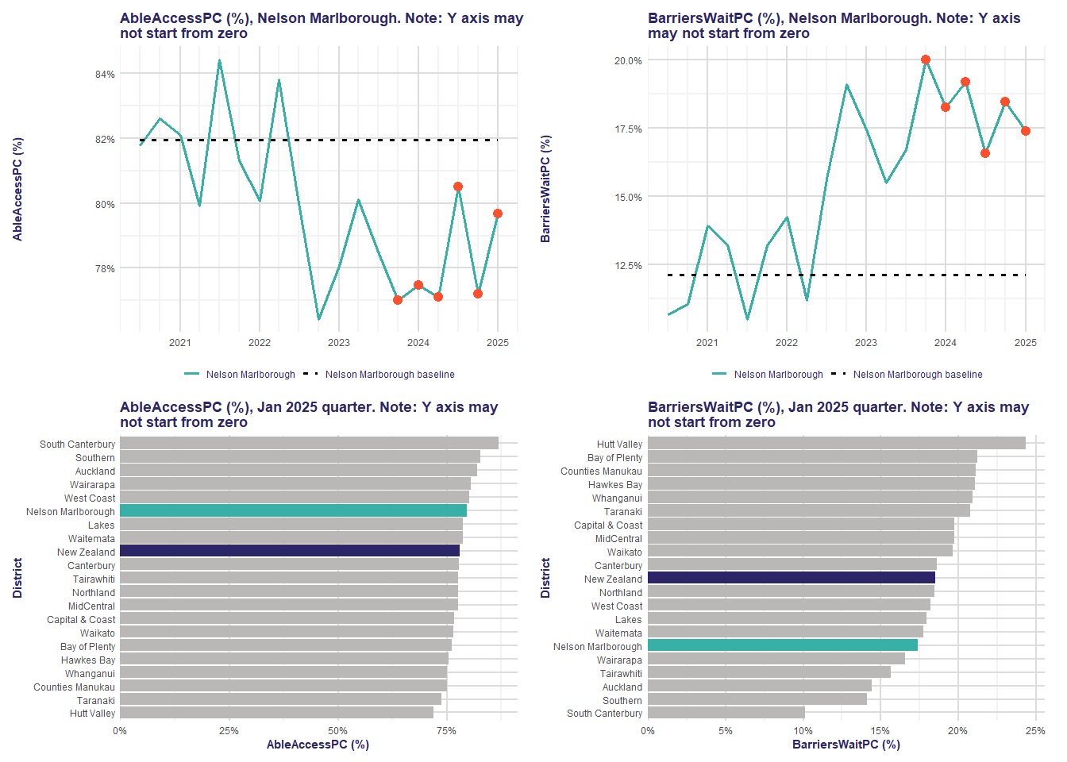Reduced access to primary care is experienced by patients and remains across almost all districts in New Zealand, primarily due to increasing reports on long wait-times to get appointments. Reports of reduced access have been sustained for an extended period, and in Nelson Marlborough can be attributed to cost pressures and long wait-times to get an appointment.[6]

Q1 2025, Nelson Marlborough, UPDATED GENERAL ALERT, Respondents to the primary care patient experience survey have reported ongoing difficulties in accessing care. Reports of reduced access have been sustained for an extended period. Reduced access can be attributed to long wait times to get an appointment.

1. Access to secondary (specialist and hospital) care is discussed below.
2. Nelson Marlborough hospital admission data shows hospital and non-hospital acquired pressure injuries have risen through time, aligning with audit results that show an increase in hospital acquired pressure injury and a reduction in risk assessment for patients.

Q1 2025, Nelson Marlborough, UPDATED GENERAL ALERT, Hospital admission data shows hospital and non-hospital acquired pressure injuries have risen through time, aligning with the audit results that reveal an increase in hospital acquired pressure injury and a reduction in risk assessment for patients. Concurrently, ACC accepted treatment injury claims for pressure injuries rose significantly in the same period.

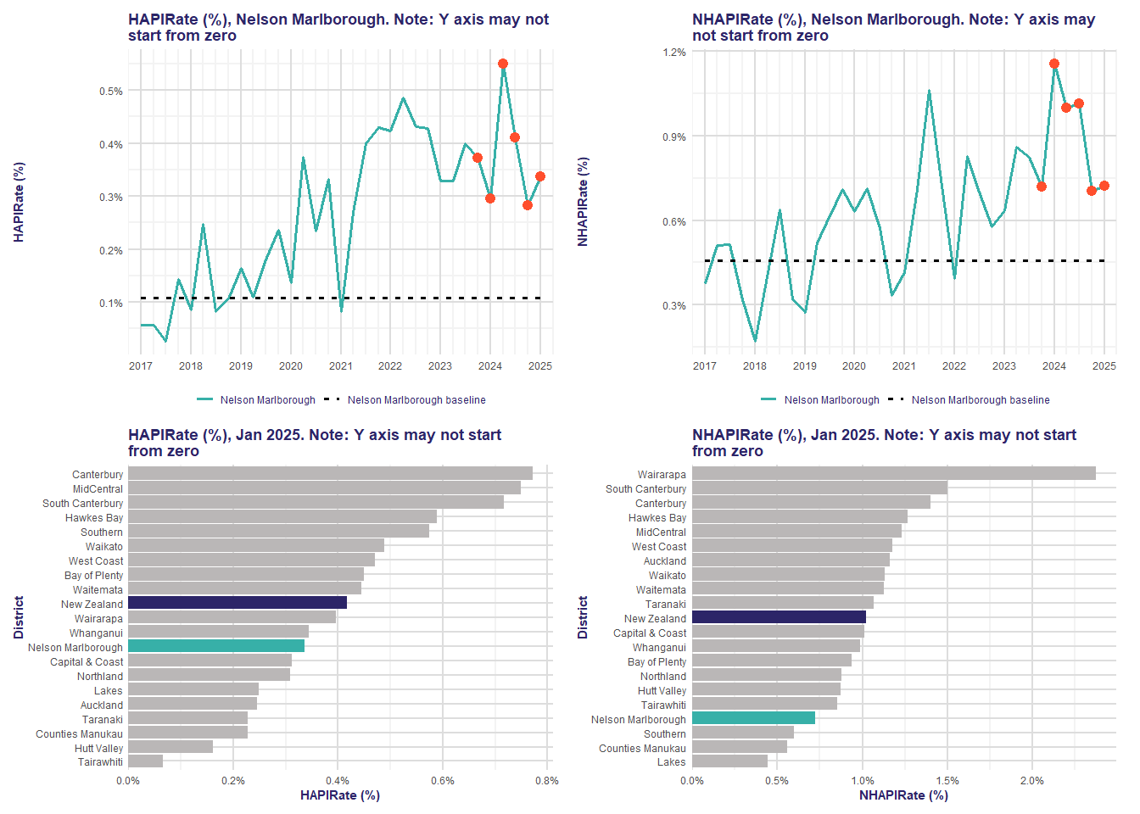

### 

### Clinical Governance

1. Clinical governance systems and processes are maturing but do not fully align to national clinical governance guidance published by HQSC. There are areas that need to be addressed.

### *Structure*

1. Nelson Marlborough’s Clinical Governance Group’s membership does not include frontline clinicians.
2. The Clinical Governance Group does not have formalised processes for services, for example Heads of Departments to share information and escalate issues.
3. Subcommittees reporting to the Clinical Governance Group lack consistent, standardised processes including terms of reference, annual plans, regular reporting, escalation and feedback processes.
4. Many staff are not aware of the existing clinical governance groups and committees they could access to escalate their concerns or clinical issues. The main mechanisms for raising issues are through conversations and submitting ‘I Have an Issue’ forms that many services and clinicians consider onerous to complete and do not result in any action.
5. There is no dedicated administrative support for the Clinical Governance Group, sub-committees, and working groups.
6. The Clinical Governance Support Team is a small and dynamic team, who work well together to support clinical quality and safety. However, the team faces challenges: the team’s functions are not visible or well understood by many staff; team roles have competing priorities within their workloads including responsibilities not related to core clinical quality and safety functions; and the team has lost key roles and full time equivalent (FTE) staff. In particular quality advisors,[7] quality improvement roles, and administrative support.
7. There is no regional clinical governance group for the Te Waipounamu region.

### *Core Functions – adverse events, consumer engagement and risk management*

1. Aspects of clinical quality and safety functions are working well, for example the controlled documents process.[8] There are areas that need to be addressed.
2. Adverse event reporting and review systems have limitations. There were issues identified with reporting culture, oversight of adverse events and adverse event review processes.
3. Consumer engagement and participation does not meet the Code of expectations for health entities’ engagement with consumers and whānau.[9] Nelson Marlborough does not have a consumer advisory group. Consumers are not involved in clinical governance structures and activities, decision-making, and improvement projects. There is no district-level budget to support consumer engagement, for example consumer reimbursement in line with the national policy.
4. Robust risk management is lacking. In general, staff were not familiar with the risk register and how to access it. The district Risk Manager role has been vacant for several months and efforts to recruit to the role have been unsuccessful. The absence of a dedicated Risk Manager has resulted in a lack of continuity, consistency and understanding of risk management practices.

### *Processes – data, credentialling and morbidity and mortality review*

1. Quality and patient safety reporting within the organisation is variable. For example, services use a variety of data, analytics and statistical methods for identifying variation; this data is not consistently evident within clinical governance meetings. There is no quality update on the Hospital and Specialist Services (HSS) leadership agenda. Services and Heads of Departments do not receive regular quality reports and do not have clear visibility of risks.
2. Credentialling policies and processes are in place for senior medical staff and there is a district credentialling committee. However, there is no standardised national process for credentialling of senior medical staff in Health NZ.
3. There is a lack of systematic reporting of credentialling activity to the Clinical Governance Group: the last credentialling report provided to the group was in August 2024. It is unclear if the full credentialling reports are shared with the service/department, or the how the recommendations are progressed and tracked.
4. Morbidity and mortality meetings (M&Ms) are held in most, but not all, services. There is some reporting of M&M activity to the Clinical Governance Group, but this is not consistent
5. M&M review processes are not standardised, many lack multi-disciplinary participation, and there is currently no formalised process in place to share learnings.

## Access to Care

1. [Access to urgent planned care is broadly very good as evidenced, in particular, by Faster Cancer Treatment time data. This strongly suggests clinicians are skilled at identifying clinical risk. There are, however, a few specialist services that are under significant pressure.](https://hauoraaotearoa-my.sharepoint.com/personal/penny_andrew_tewhatuora_govt_nz/Documents/Documents/SLT/July%202024%20Commissioner%20Change/Reset%20&%20Change%20Oct%202024/Tues%2010%20Dec/Change%20Documents%20JD%20etc/JD%20Examples/New%20PDs/Final/Group%20Manager%20Training%20Quality%20Improvement%20and%20Change%20final.docx?web=1)
2. As with all New Zealand hospitals, access to planned care is significantly impacted by the need to prioritise acute care.
3. Historically Nelson Marlborough has had a Senior Medical Officer (SMO) delivered care approach. This has led to under-investment in the registrar workforce, which is a factor in current access to care challenges
4. The over-reliance on SMOs to do work that could be done by Resident Medical Officers (RMOs) results in SMOs covering a lot of duties (including on-call and ward work) that are undertaken by RMOs in hospitals/districts of comparable-size and clinical complexity.
5. There is an opportunity to further expand new models of care and the use of advanced practice roles to safely free up SMO time.
6. Total waiting lists have been, at best, holding their position until recent investments in establishing greater outsourcing activity and first speciality assessment clinic capacity.
7. The challenges at First Specialist Assessment (FSA) are significant and will be affected by issues such as staffing, physical resources, demand growth and models of care.
8. Potential gains are possible in some specialties by adjustments to booking and scheduling practices.
9. There are some opportunities to flexibly schedule work between Nelson and Wairau Hospitals, but these are limited.
10. The lack of a fully digital health record is likely impacting efficiency.
11. Acute care (Emergency Department care) is challenged, in particular by insufficient bed capacity preventing timely admission to an inpatient bed and acute theatre access.

## Workforce

### *Structures and models of care*

1. National benchmarking indicates that Nelson Marlborough has specific shortfalls in some clinical services.
2. Fit for purpose local, district and regional models of care, service and workforce planning is not yet mature, and is a key focus for the wider Te Waipounamu region in 2025/26.
3. There are significant medical workforce issues in the following services:
   1. There appears to be a shortfall in the number of SMOs especially in general medicine, geriatrics, obstetrics and gynaecology, paediatrics and vascular
   2. General Medicine has insufficient Registrars and House Officers to meet their increasing clinical service demands
   3. Anaesthetic SMOs are having to support a back-up after hours anaesthetic roster as there is insufficient 24/7 RMO anaesthetic workforce
   4. There are insufficient Registrars and House Officers to provide service-specific 24/7 rosters for obstetrics and gynaecology, and paediatrics
   5. Nelson’s ED currently has 13 RMOs. Two are Registrars, one senior and one junior, with the remaining 11 RMOs being Senior House Officers. There is currently an inadequate skill mix to adequately care for patients, particularly overnight.
   6. Some services (such as vascular and spinal surgery) are fragile due to the low number of local SMOs and reliance on support for acute services from other districts.
4. The insufficient or unbalanced RMO workforces results in SMOs covering a lot of duties (including on-call work and outpatient clinics) that would be undertaken by Registrars in comparable-sized hospitals/districts. This can lead to SMO burnout and risks to patient safety[10] and is potentially impacting recruitment efforts as Nelson Hospital is not perceived as ‘an attractive place to work’.
5. The ongoing use of traditional models of care (i.e. senior doctor only or medical-led rather than inter-disciplinary), where evidence suggests other approaches would be better, is a major limiting step to workforce improvements.
6. The SMO-led model has led to underinvestment in advanced practice roles of allied health and nursing as well as RMOs.
7. There is a lack of advanced planning for known forthcoming vacancies (retirements and resignations).
8. Staff expressed concern about delays in recruitment due to local and national recruitment processes, with a lack of consistency between districts. Some of the processes causing delays do not occur in other districts.
9. There is a widely held belief by many staff, including some charge nurses, that inflexible approaches to part-time/less than full-time work is limiting the appointment of high calibre nursing staff living in the catchment area. The leadership team has clearly articulated this is not correct (flexible approaches can be considered).
10. Concerns were expressed by some nursing staff that staff who want to upskill are frequently turned down. However, there is an ongoing programme of upskilling that is benefitting both hospital and community services with 39 clinical nurse specialists, 10 nurse practitioners, seven allied health professionals working at advanced levels currently. There is a local desire by clinical leadership to do more.

### *Leadership*

1. The current leadership structure for Nelson Marlborough is no longer fit for purpose for an entity of its size. The review particularly highlighted the Group Director of Operations role that has 42 direct reports.
2. The current Nelson Marlborough clinical-management leadership partnership model lacks clarity about decision-making and accountability. There was strong feedback that some service managers and clinical staff are not working collaboratively.
3. The clinical leadership structure and roles are not perceived to be fit-for-purpose by many frontline staff. The clinical leadership model has not evolved over time as Nelson Hospital and the population it serves has expanded substantially.
4. There was a clearly expressed and repeated view, particularly from medical staff, that there is a ‘lack of confidence’ in leadership (clinical and managerial). Factors contributing to this view include multiple changes in leaders within the district and region; and multiple proposals and requests for support to leaders generated at all levels of the organisation over the past decade, which have been largely rejected with a lack of feedback about why, or accountability for these outcomes.
5. Longstanding concerns were expressed about unprofessional behaviour that have not been addressed, in particular relating to behaviours by senior clinical staff. This has impacted on the delivery of care and retention of staff, and contributed to staff burnout.
6. There are many keen and creative staff throughout the organisation that have the potential and energy to help move the organisation forward.

### *Communication*

1. There was a widespread sense of frustration expressed by frontline clinical staff that they do not receive adequate communication from the hospital executive team. Suggested causes include insufficient communication generally, communication tools that are not convenient for frontline staff, and lack of a consistent feedback process for decisions on submitted proposals.
2. The use of meetings as a feedback mechanism rather than forums for discussion, and the absence of a reliable means to catch up for those unable to attend, was also viewed as problematic.
3. The ‘I have an Issue’ process is not working effectively.

### *Culture*

1. There was feedback from staff about culture issues that have not been addressed evidenced by a lack of hope, and frustration with perceived inequalities relating to historic funding issues and staff arrangements.
2. There is a feeling among staff of a lack of autonomy and self-determination that has occurred since the formation of Health NZ, with the removal of district-level enabling functions. This has led to frustration and a sense of stagnation and a lack of decision-making, and amplified issues that were already present, especially those relating to infrastructure.
3. There are positive initiatives taking place in many areas with pockets of excellence and innovation throughout the district, and a very enthusiastic primary care service keen to collaborate and support new ways of working.
4. Despite good intentions from senior leadership, there is no district-wide culture of encouraging innovation and embracing changes (including new ways of working in clinical practice) partly due to removal of dedicated resourcing for this.
5. There is a clearly expressed willingness to explore and pursue greater regionalisation of services where clinically safe and appropriate, with recognition that ‘we cannot keep doing the same thing and expect the same things to improve’.

## Facilities and Infrastructure

### *Facilities*

1. There are insufficient inpatient beds in Nelson Hospital currently to consistently meet both acute care and planned care inpatient admission demand. Clinical service planning completed as part of the Inpatient Tower capital business case determined Nelson Hospital has a base-deficit of 16 adult acute inpatient beds, projected to increase to 30 beds (if no changes are made) in the next five years, before the inpatient tower development is complete.
2. Insufficient inpatient beds has a serious impact on patient flow and patient access to timely care, negatively impacting Health Target performance data for Nelson Hospital (in particular, for patients admitted to hospital from the Emergency Department), and negatively impacting staff morale.
3. Many acute care/emergency patients spend long periods in the Emergency Department waiting for an inpatient bed to become available following a clinical decision to admit. This can result in “access block” within the Emergency Department as fewer cubicles are available to see new emergency patient presentations.
4. During periods of high demand for acute care inpatient admissions, less urgent planned care admissions can be deferred. This is distressing and disruptive for patients and their families, and also results in inefficient use of the operating theatres.
5. There is an imbalance of clinic and procedure rooms required for efficient use of facilities. This can lead to minor procedures being performed in main operating theatres, reducing surgical capacity.
6. Medical Assessment and Planning Units (MAPUs) across New Zealand have been retrofitted into old facilities not designed for their function, impacting patient flow and quality of care.
7. There is a list of capital projects underway at Nelson Hospital. These projects are focused on increasing the capacity of the Emergency Department, ambulatory care and the mental health unit. Funding announced to complete the inpatient redevelopment will address bed capacity constraints with funding also allocated to install a temporary ward in 2026. These measures will address the immediate bed capacity gap while the new Inpatient Tower is completed.
8. Nelson Marlborough lacks a local LINAC (Linear Accelerator) service, requiring patients to travel long distances for their cancer treatment.

### *IT/Digital Systems*

1. There is a widespread perception among staff that an historical lack of regional IT investment for the district means legacy systems or non-digital solutions are the norm.
2. While there is now attention and urgency focussed on addressing the capital programme, the issues around use of last century, not fit-for-purpose IT is a serious clinical risk and failure to upgrade clinical information systems is significantly impacting productivity and safety.
3. Outdated and poorly connected digital systems were evident in the bookings and referral processes for surgery and First Specialist Appointments (FSAs). This has led to delays for patients accessing timely care.

## Clinical cases

1. Nine clinical cases and outcome data were provided to the review panel. These cases were selected due to concerns raised by Nelson Marlborough staff. A summary of the cases and findings is set out **in Appendix Two**.
2. The review panel and the clinical quality and safety workstream considered this information to identify any system and process failures that may have led to delays in access to care for these patients. There was an avoidable delay in five of the cases reviewed.
3. Concerns were also raised about an apparent recent increase in the number of amputations and hysterectomies. The data requires further analysis, which is already underway, to determine whether there has been a significant increase in these outcomes and, if so, the factors that may be contributing to an increase.

# Key Recommendations

### Clinical Quality and Safety

1. Implement a robust clinical governance structure aligned with the national clinical governance structure and clinical governance framework, which is supported by an appropriately resourced quality and safety team. The quality and safety team should have the skills and experience to support core quality and safety functions including patient safety, adverse event management, quality improvement, consumer engagement, risk management and controlled document management.
2. Implement a robust regional clinical governance structure.

### Access to Care

1. Implement the Acute Flow Operational Standards. The purpose of the Standards is to set national expectations for the management of acute flow from Emergency Departments, and in acute community mental health services, to inpatient discharges. The Standards aim to promote consistent application of resources and tools to improve patient flow.
2. Implement the Outpatient Waiting List Management Guidelines, April 2025. The guidelines provide a nationally consistent approach to inpatient and day patient waiting list administration to enable alignment of planned care services across the country.
3. Improve current regional service planning.

### Workforce

1. Develop a plan and then implement a sustainable medical workforce at Nelson Hospital.
2. Develop interdisciplinary models of care and innovative ways of working by learning from similar-sized districts e.g. increased use of multidisciplinary teams (MDTs), and greater use of allied scientific and technical colleagues to support workflows.
3. Continue to build South Island regional care service models that support better local and district delivery. Identify clinical services that should be prioritised for inclusion in regional clinical services capability planning, ensuring there is a focus on areas of high clinical risk including single SMO services, and specialties where low volumes of cases can impact quality of care and outcomes.
4. Develop and implement new operational and clinical leadership structures and implement a new clinical-management partnership model.
5. Seek greater collaboration with primary care leaders locally, i.e. consider co-ownership of discharge planning / admissions avoidance / out of hours cover /community-based consultant-led clinics.
6. Take steps to improve workforce experience and wellbeing including:
   1. Use national and regional HR approaches and processes to identify opportunities to reduce duplication and waste.
   2. Introduce more flexible patterns of working as part of a wider programme of work to retain staff, prioritising those who are nearing retirement or with health needs. Consult with teams transparently and start with pilot programmes in different areas.
   3. Engage the National Clinical Chief Wellbeing Officer to promote the widespread use of the Wellbeing Index App and increase engagement of staff with organisational and local health and wellbeing initiatives
   4. Establish new ways of engaging and communication that are driven by the staff, rather than done to them i.e. consult with staff about how they would like to have feedback – what modalities work for them.
7. Enhance public engagement by building on the existing community of over 200 citizens who are connected via the ‘Community Lecture Series’. Seek to re-energise and expand this self-selected citizen forum to unlock the potential it holds, thus increasing public engagement and advocacy for the district.

### Facilities and Infrastructure

1. Progress planning for the Nelson Hospital Redevelopment programme as announced in Budget 2025, inclusive of funding for a temporary ward.
2. Progress the programme business case that is already underway, seeking funding for the establishment of a LINAC service on the Nelson Hospital campus as identified in the Health Infrastructure Plan (HIP).
3. Progress provisions for Level 2 Percy Burnette ambulatory care spatial refurbishment following regional capital planning funding approval.
4. Senior leaders to engage with regional and national digital leaders to examine options for improving IT infrastructure that underpin the workforce challenges, both hardware and software. As a priority for this work, there should be a focus on digital solutions that will improve waitlist management and booking and scheduling of patients, which reduce manual handling, duplication and waste, and improve sharing and transparency of information within Nelson Marlborough and across Te Waipounamu region.

### Clinical cases

1. Undertake a multi-service adverse event review into Case three.
2. Complete an in-depth review of amputation rates and hysterectomy rates to determine whether there has been significant change and, if so, contributory factors (this review is underway). This should be presented to the Regional and National Clinical Governance Groups.

### Action Plan

1. Following approval of the review recommendations, develop an action plan that sets out the above recommendations, with a timetable and roles responsible and accountable for each action. The timetable should reflect consideration of actions that could be completed in the short, medium and long-term. The action plan should be developed locally and co-ordinated at a regional level. Progress against the plan should be reported locally to the Senior Leadership team, regionally to the Regional Clinical Governance Group and Regional Senior Leadership Team, and nationally to the Executive Leadership Team.

### Conclusion

1. The review panel and team members wish to acknowledge and commend Nelson Marlborough staff for their participation in this review and their willingness to explore opportunities to innovate and improve clinical care and services for their patients and the population. The district faces significant challenges, particularly with its workforce and infrastructure, which have not evolved to meet the needs of a growing, older population.
2. There is opportunity for significant improvement. Interdisciplinary models of care, along with innovative ways of working locally and regionally and enhanced clinician participation in decision-making, will improve clinicians’ work experience, reduce risk of burnout, and, consequently, will improve the quality and safety of care for patients and the Nelson Marlborough population.
3. The review panel acknowledges that many of the challenges and solutions identified will require significant resources and will take time to address.
4. Many of the challenges and opportunities identified are common across New Zealand’s hospitals and districts. The panel encourages other districts and regions to consider the findings and recommendations of this review and collaborate with Nelson Marlborough to find and share innovative ways to provide access to timely, quality healthcare for everyone.

# Glossary of Terms & Abbreviations

ASMS Association of Salaried Medical Specialists

ECHO Echocardiogram

ED Emergency Department

ELT Executive Leadership Team

FCT Faster Cancer Treatment

FSA First Specialist Appointment

FTE Full-time Equivalent

GDO Group Director Operations

GP General Practitioner

HDxSMR Hospital Diagnosis Standardised Mortality

Health NZ Health New Zealand |Te Whatu Ora

HIP Health Infrastructure Plan

HQSC Te Tāhū Hauora Health Quality & Safety Commission

HSS Hospital and Specialist Services

IIG Infrastructure Investment Group

LINAC Linear Accelerator

MAPU Medical Assessment and Planning Unit

MDT Multidisciplinary Team

M&M Morbidity & Mortality

MRI Magnetic Resonance Imaging

O&G Obstetrics and Gynaecology

RMO Resident Medical Officer

SMO Senior Medical Officer

ToR Terms of Reference

QI Quality Improvement

QPS Quality & Patient Safety

# Appendix One: Review Team

Chair: Dr Richard Sullivan, Chief Clinical Officer

Panel: Dame Helen Stokes-Lampard

Dr Pete Watson

Dr Sarah Jackson

Dr Andrew Connolly

Martin Keogh

*Quality and patient safety workstream*

* Dr Sarah Jackson, National Chief, Quality and Patient Safety
* Anne Pedersen, National Quality and Patient Safety Manager
* Carol McSweeney, Regional Quality and Patient Safety Lead – Te Waipounamu

*Workforce workstream:*

* Dame Helen Stokes-Lampard, National Chief Medical Officer
* Dr Peter Watson, Te Waipounamu Regional Strategic Advisor
* Emma Foster, Group Manager, Resident Doctors Support Service
* Anna McNaughton, Group Manager Organisational Culture Programmes
* Dr Jo Sinclair, National Clinical Chief Wellbeing Officer

*Performance workstream:*

* Dr Andrew Connolly, Chief Medical Officer, Counties Manakau
* Martin Keogh, Establishment Deputy Chief Executive, Te Waipounamu

*Infrastructure workstream:*

* Martin Keogh, Establishment Deputy Chief Executive, Te Waipounamu
* Dr Rob Ojala, Regional Head of Infrastructure Te Waipounamu
* Katherine Snook, Portfolio Director South Island Infrastructure Investment Group

# Appendix Two: Summary of clinical cases reviewed

Note: The review of these cases does not replace local adverse event/other review processes.

|  |  |  |
| --- | --- | --- |
| **Service** | **Finding** | **Local review(s) undertaken** |
| **Urology** | **Case one**  Large volume of patients needing urology appointments.  There was a delay in assessment and treatment, which requires further investigation. | Adverse event review in progress |
| **Emergency** | **Case two**  Staff reported this case. Insufficient staffing did not cause any direct harm to the patient.    **Case three**  Information withheld on the grounds of privacy. | Local review completed  Adverse event review in progress |
| **Gynaecology** | **Case four**  Capacity issues led to the patient not being seen within the appropriate time-frames and presenting acutely resulting in an emergency operation.  The department was not using an available waitlist prioritisation tool which could have prioritised a First Specialist Assessment earlier for this patient.  **Case five**  The patient had surgery cancelled due to strike action and was not offered another appointment at the time of cancellation. i.e. a non-acute clinical issue became acute and led to the patient requiring emergency treatment. The extended length of time in the Emergency Department was due to limited operating theatre capacity overnight. | Local review completed  Local review completed |
| **Cardiology** | **Case six**  There was a delay in the patient receiving an ECHO.  If the ECHO sonographer team was fully staffed, the ECHO would have been conducted earlier, which may have led to earlier treatment and intervention.  The national guideline was not being used due to insufficient capacity of sonographers.  **Case seven**  Patient informed long wait for ECHO. The ECHO was performed within a month. | Local review completed  No local review required |
| **Orthopaedic** | **Case eight**  Information withheld on the grounds of privacy. | Local review completed |
| **Vascular** | **Case nine**  Referred to vascular service multiple times. Vascular team has provided advice. Appropriately prioritised and waiting to be seen. | Further review not required |



1. In-hospital mortality is reported as the hospital diagnosis standardised mortality ratio (HDxSMR). It is calculated as a ratio between the observed number of in-hospital deaths and the predicted number of deaths. A HDxSMR of less than 100 means there are few deaths than expected.
2. Clinical service planning, completed as part of the Inpatient Tower capital business case, determined Nelson Hospital has a base deficit of 16 adult acute inpatient beds.
3. Sources: 2023 Census-based population estimates (2018–2024), standard release in Aotearoa Data Explorer (ADE); 2024 annual update of HNZ population estimates and projections. Stats New Zealand Tatauranga. See: [Aotearoa Data Explorer | Stats NZ](https://www.stats.govt.nz/tools/aotearoa-data-explorer/)
4. Institute of Medicine (US) Committee on Quality of Health Care in America. Crossing the Quality Chasm: A New Health System for the 21st Century. Washington (DC): National Academies Press (US); 2001. PMID: 25057539.
5. The 14 quality alert measures reported quarterly are: access to primary care, childhood ambulatory sensitive hospitalisation (ASH), post-operative deep vein thrombosis (DVT)/pulmonary embolus (PE), pressure injuries, equity, hand hygiene, falls with fracture neck of femur, patient deterioration, *Staphylococcus aureus* bacteraemia (SAB), surgical site infections (SSI) orthopaedic surgery, SSI cardiac surgery, pneumonia standardised mortality rate (pneumonia SMR), and hospital experience.
6. Te Tāhū Haoura Health Quality and Safety Commission Quality alert June 2025 for New Zealand (national level). (Data up to March 2025).
7. Most other districts’ quality and patient safety teams have dedicated Quality Advisors with clinical backgrounds, to partner with hospital and specialist services and support them with high quality adverse event reviews, Health and Disability Commissioner (HDC) complaints, and facilitate improvement activity from corrective actions/review recommendations.
8. Controlled documents are documents that are subject to certain controls to ensure its accuracy and completeness. At Health NZ, these include policies, procedures and protocols.
9. Code of expectations for health entities’ engagement with consumers and whānau: [**https://www.hqsc.govt.nz/resources/resource-library/code-of-expectations-for-health-entities-engagement-with-consumers-and-whanau/**](https://www.hqsc.govt.nz/resources/resource-library/code-of-expectations-for-health-entities-engagement-with-consumers-and-whanau/)
10. Chambers CNL, Frampton CMA, Barclay M,et al. Burnout prevalence in New Zealand’s public hospital senior medical workforce: across-sectional mixed methods study. BMJ Open 2016; 6:e013947. doi:10.1136/bmjopen-2016-013947. And, Nicholls M, Hamilton S, Jones P et al. Workplace wellbeing in emergency departments in Aotearoa New Zealand 2020. NZMJ 3 September 2021, Vol 134 No 1541. ISSN 1175-8716.