Te Whatu Ora Health New Zealand
Aotearoa Immunisation Register (AIR) Programme
Release 2

Privacy Impact Assessment
Date: 27 October 2022

Document creation and management
Document Approval
 | Name/Title | Sign-off date
Approved by Senior Responsible Officer | Astrid Koornneef
Approved by Business Owner | Loren Shand
Approved by Privacy Officer | Viv Kerr | 11/11/22
Version table
Date | Version number | Changes made | Version author
20/09/2022 | 0.1 | Initial Draft | Edwin Lau-Young
27/09/2022 | 1.0 | Final Feedback | Kim Stafford
14/10/2022 | 1.1 | Additional fields for AIR user for MHA integration | Kim Stafford
28/10/2022 | 1.2 | Added content for Release 2 | Kevin Barron

Disclaimer
This Assessment has been prepared to assist Te Whatu Ora to review the purposes for which information is collected for the Aotearoa Immunisation Register (AIR) and how that information can be used, and the privacy safeguards that are required to manage those purposes.
Every effort has been made to ensure that the information contained in this report is reliable and up to date. This Privacy Impact Assessment represents the current expectations of the way AIR will operate.
This Assessment is intended to be a ‘work in progress’ and may be amended from time to time as circumstances change or new information is proposed to be collected and used.

Contents
Section One - Executive Summary 4
Background 4
Section Two - Privacy Analysis 7
Purpose of Collection (Rule 1) 7
Source of Personal Information (Rule 2) 7
Information collection summary table Rules 1 & 2 8
Collection of information from individual (Rule 3) 9
Manner of Collection (Rule 4) 10
Storage and Security (Rule 5) 10
Access and Correction (Rules 6 & 7) 11
Accuracy and verification of information (Rule 8) 12
Retention (Rule 9) 12
Use, and Disclosure (Rules 10 & 11) 12
Disclosure of personal information outside New Zealand (Rule 12) 13
Unique identifiers (Rule 13) 13
Governance 14
Section Two - Privacy Risk Assessment 15
Risk Calculation Tables 20
Glossary 23

Section One - Executive Summary

Background
- Vaccinations are recognised by the World Health Organisation as one of the most important public health services in reducing the burden of infectious disease. An effective immunisation programme generates significant benefits at individual, governmental and economic levels.

- The National Immunisation Register (NIR) implemented in 2005, enabled the collection of information about childhood immunisation rates, but did not include people born prior to 2005. Consequently, it is difficult to understand overall immunisation coverage or to plan targeted interventions. A review of the NIR revealed that:
  - it is not easily configurable, user friendly, intuitive, or easy to change.
  - it is not available in some health care settings and vaccinators are not always able to use the system when and where they are engaging with the public.
  - it struggles with capacity issues with system outages occurring during high load periods.
  - it comprises inflexible reporting tools and processes, so information is not able to be tailored to the specific needs of planners; and
  - it is no longer supported by the vendor.

- These issues and inefficiencies meant Te Whatu Ora did not have the information system and tools to support a population health approach to improving immunisation coverage across New Zealand and address inequities within that coverage.

- On 13 October 2020 the National Immunisation Register (NIR) Replacement single-stage business case was approved to replace the NIR with a scalable, integrated technology. Three investment objectives were identified as part of the Business Case:
- Ensure all vaccinators have anytime/anywhere access to immunisation health records and update capability. This included the priority to develop COVID-19 immunisation functionality (the COVID-19 Immunisation Register (CIR)).
- Ensure an individual’s whole-of-life immunisation data is stored centrally and can be integrated with all other government datasets relevant to that individual. This data needs to be available to providers of healthcare and consumers with a focus on improving customer experience.
- Improve capacity to monitor, analyse and report on population immunisation status and identify where there is inequity.
- The Ministry set up the COVID-19 Immunisation Register (CIR) as a response to the functional limitations of the National Immunisation Register (NIR) for effectively administering the COVID-19 Vaccine and Immunisation Programme (CVIP). The Ministry needed to ensure that it had a robust and nationally available digital recording solution that supported the safe and accurate administration of immunisations.

- The future state of AIR is to replace the NIR, and supersede the CIR.

- The Aotearoa Immunisation Register will consist of two layers:
  - Experience Layer: ISD (Immunisation Service Delivery, or Vaccinator Portal) and the ISM (Information Service Management, or Admin Portal)
  - Services Layer: Immunisation Source of Truth (ImmSOT) and Reporting

- The diagram below is an illustrative view of the future AIR solution. For the following assessment we will only be dealing with the AIR ISD (Vaccinator Portal) and ISM (Admin Portal) in the experience layer for the November release.
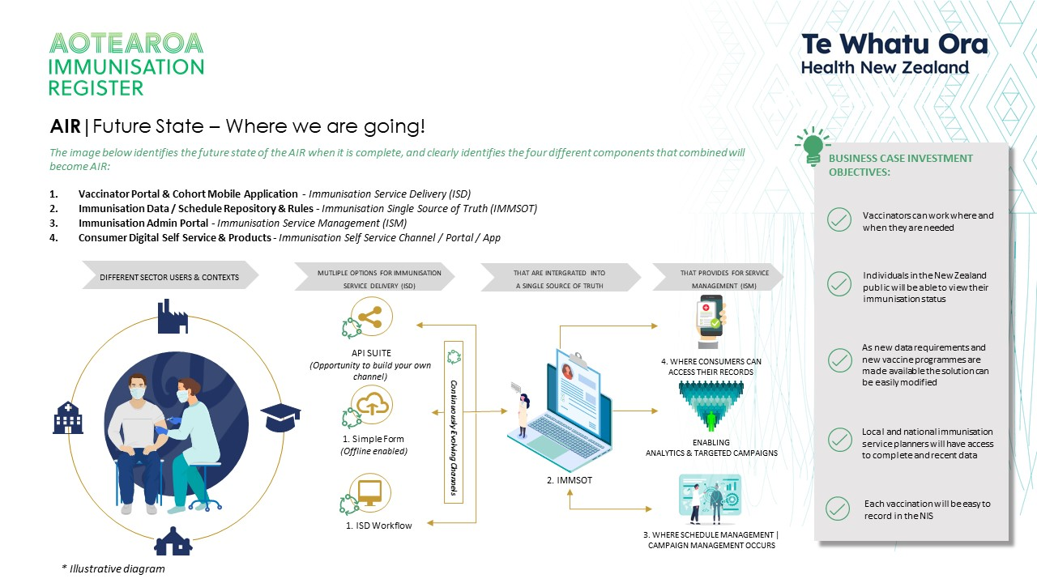

- The development of AIR will happen in stages. Outlined below are the stages that have occurred thus far.

  - On 1 April 2022 a tactical solution was deployed in support of the Flu Vaccination Programme (FVP), Flu vaccinations were captured through the Covid Immunisation Register (CIR) and stored in the NIS Information Service Management (ISM).
  - In June 2022 NIS was renamed to the Aotearoa Immunisation Register (AIR) as part of Te Whatu Ora.
  - On 28 September 2022 the Immunisation Service Delivery (ISD) was rolled out to a Pilot group to capture MMR vaccinations.

- On 09 November 2022 the ISD will be extended to record additional vaccine types and return immunisation history information for consumers currently available in NIR, CIR and AIR. Additionally, the AIR onboarding workflow for users of ISD\ISM will also be included in this release.

- This release of the AIR ISD will replace the use of the NIR web application called ImmuniseNow. ImmuniseNow is currently what Pharmacy are required to use to view vaccination history from the NIR and record vaccinations administered in Pharmacies to the NIR. In December ImmuniseNow will be closed, following the successful completion of pharmacy onboarding.

Out of Scope
This Assessment will not cover the systems that the AIR will be connecting to (such as the HPI, NES, MHA and NHI (see glossary)) because they are covered by their own individual Privacy Act Assessments. Key data sharing details will be consistent with their approved PIAs.

The NHI will be used to establish the health identity of Consumers for the purpose of recording the immunisation record and the HPI will be used to manage Vaccinators for the purposes of monitoring and recording the Immunisation.

The NHI, combined with the NES can be used to identify the general practitioner or practice a Consumer is enrolled with to send an electronic notification of the immunisation event via HealthLink (a secure password protected messaging system already used by health providers to send messages to and from Te Whatu Ora for CIR and NIR).

My Health Account is a digital identity tool and a way for the health workforce to access Te Whatu Ora applications securely. MHA will be used in the onboarding workflow to establish the verified identity and CPN attribute for some of AIR users. These credentials will be used in the initial account set-up and once that has been established users will be able to use their MHA to log into AIR.

In ScopeThe Aotearoa Immunisation Register (AIR) is an evolving solution. The subject of this Assessment is the AIR programme release two and is intended to be the next step of a transition from the legacy NIR application to the new AIR. This Assessment covers the collection, security, use and disclosure of personal information across the evolution of the ISD to record additional vaccine types and view immunisation history for a consumer. In addition to the AIR onboarding workflow for users.

Below outlines the existing scope and the new inclusions of the AIR programme Release 2;

Functionality
Existing | - Record vaccination (MMR)
New | - Record vaccination (additional vaccine types)  - Onboarding of users  - Immunisation history

Authorised users for accessing the ISD and ISM will be vaccinators and administration staff who are involved with the process of administering the Vaccines to be recorded in the ISD. AIR Administrators (former NIR Administrators) will be given access to provide support via Information Service Management (ISM) function. Vaccinators and AIR Administrators will be onboarded using AIR’s onboarding workflow, that includes the use of My Health Account for some AIR users.

Further Privacy Impact Assessments will be carried out for the establishment of the AIR beyond this release. It is anticipated that there will be a coexistence/transition period through to December 2022 whereby AIR, NIS, CIR and NIR will be operating at the same time. The existing privacy guidelines for NIR, CIR and NIS will continue to apply during this transition period.

Section Two - Privacy Analysis
The potential privacy impacts resulting from this project are analysed below. The analysis has been completed against the 13 rules of the Health Information Privacy Code 2020/Privacy Act 2020.
Te Whatu Ora has conducted its analysis under the Health Information Privacy Code as the information is about the public and their health services. Under clause 4(1)(e) it is considered that this is information about an ‘individual which is collected before or in the course of, and incidental to, the provision of any health service or disability service to that individual’.

Purpose of Collection (Rule 1)
Section 1(3)(a) of the Pae Ora (Healthy Futures) Act 2022 provides that one of the purposes of the Act is to protect, promote, and improve the health of all New Zealanders. Te Whatu Ora coordinating the national immunisation programme is consistent with this legislation and purpose.

The overall purpose of AIR is as a tool to:
- benefit individuals by facilitating the delivery of immunisation services and providing an accurate record of their immunisation history to consumers (individual gain);
- provide national and regional level information on the immunisation coverage of the specified population and assist in achieving New Zealand coverage targets, thus improving individual and population health through the control or elimination of vaccine preventable diseases (public health gain).

The tool will collect identifying information of the Consumer receiving the vaccine, and the Vaccinator providing the vaccination service to allow AIR to serve as a clinical record of vaccinations provided to Consumers. Clinical input has determined the necessary fields to be collected for immunisation, and the AIR is aligned with this information.

AIR will be operating in effect as a clinical system for vaccination providers recording the administration of vaccines supported by the system to Consumers. It will also provide the consumer’s immunisation history.

Source of Personal Information (Rule 2)
Biographical information on consumers will be sourced from the NHI on demand when they are interacting with a vaccination provider. This ensures the accuracy of the record and supports clinical safety in ensuring that the correct person is being vaccinated.

The pilot group vaccinator details were requested from users via their employer. In selecting providers to work with during the pilot, we confirmed their employment checks to verify information. Onboarding using MHA will be the option for the future. In the interim state, there will be an alternative to MHA which will require different verification.

Consumers will provide their own data when they present themselves for vaccination.

Vaccination history will be available and this data will be sourced from the Immunisation History Cache (which in turn will be data sourced from the National Immunisation Register (NIR), COVID (CIRFlu and MMR
Compliance with the requirement for the AIR to source information directly from Consumers would prejudice the purposes of collection (Rule 2(2)(c)(ii)) as it would not be possible to obtain a comprehensive list as the AIR could not identify those individuals to request the supply of relevant information. It is also not reasonably practicable in these circumstances to source the information directly from the individual (Rule 2(2)(d)).

Information collection summary table Rules 1 & 2
Personal Information | Purpose | Source | Legal authority
Person Record (records health identity):  - NHI  - Surname  - Given Names  - Date of Birth  - Gender  - Ethnicity  - Address information | Identification of individual (and ability to link to relevant NHI).  All individuals who are to receive a vaccine must have a person (NHI) record.  Other person record details are required for planning and reporting purposes.  Vaccinators will be required to check at a minimum the name, date of birth and contact details prior to giving a vaccine to an individual (to assist with accuracy and ensuring the correct person receives the vaccine). | NHI Register | Required to provide health services under the Pae Ora (Healthy Futures) Act 2022.
Immunisation Task:  NHI and all the vaccine details including medicine type, batch number, dilutant and needle size, dates, vaccinator of record etc | The record of administration of a single vaccine for a single person.  This will be reported to the practitioner the Consumer is enrolled with. | Vaccinator | Required to provide health services under the Pae Ora (Healthy Futures) Act 2022.
AIR User:  From MHA  - First Name  - Middle Name  - Family Name  - Mobile Number  - Email  - Confidence Level  - CPN  Independent verification process:  - First Name  - Middle Name  - Family Name  - CPN  - ImmuniseNow user name  - CIR login user name  IN AIR  - Login Details | Identification of AIR users and audit purposes.  MHA can be used to authenticate onto AIR. If the following details are held by MHA these will be passed to AIR for Identity Authentication.  These details will only be passed with the MHA account holder’s consent.  For those that do not or cannot use MHA, at least one of the following forms of identity verification and authentication must be collected to be onboarded onto AIR – CPN, ImmuniseNow, CIR. | AIR User | Required to provide health services under the Pae Ora (Healthy Futures) Act 2022.
AIR Organisations:  - HPI, contact information | Identification of AIR Organisations and Facilities. | Organisation & Facilities | Required to provide health services under the Pae Ora (Healthy Futures) Act 2022.

Collection of information from individual (Rule 3)
Te Whatu Ora will take a number of steps to ensure that Consumers, Facilities and Vaccinators have access to appropriate materials that comprehensively address the Rule 3 collection processes, including:
- what information is being collected;
- the purposes of the collection and the intended use, and users of the information;
- the retention time frame for the information.
Information will be provided through training and communications activities with the pilot users to ensure their understanding of the purpose of data collection and use in AIR. AIR will have a Privacy Statement, updated if required for every major release of functionality or change of use. This and this PIA will be accessible to any vaccination provider using the system, and made publicly available on the Te Whatu Ora website.

The individual will also be made aware:
- of the name and address of the collecting agency and the agency that will hold the information (Te Whatu Ora);
- the right of access to and ability to seek correction of their information.

Manner of Collection (Rule 4)
AIR users are expected to be guided by Standard Operating Procedures in their use of the system. The processes involved will not collect personal information by unlawful, unfair, or unreasonably intrusive means.

The only personal data which can be collected in ISD and ISM that is not pre-populated form source systems is details about the vaccination received.

Information will be captured about users of the system. Their logins and activity will be recorded on the portal so that it is auditable.

Storage and Security (Rule 5)
All data collected from all sources (other systems and people) will be hosted on the MoH Amazon Web Services (AWS) tenancy, hosted in Sydney.

The sources of information include:
- All information collected for ISD (will be stored in the [ISM or ImmSOT])
- Immunisation History Cache (IHC)
- Population Salesforce Org data related to immunisations.

The information held via AWS is personal information being held by AWS as agent for the Ministry in accordance with section 11 of the Privacy Act 2020. Data stored within AWS is encrypted. The Ministry controls access to the encryption keys and the data. The information is not to be used or disclosed for any purposes other than those directly permitted by the ISM and ISD.

Information stored in AIR will be covered by the NSS Data Policy. This aligns with the relevant HISO standards, including HISO 10029:2015 Health Information Security Framework, and the New Zealand Information Security Manual.

Consumer access to personal information within the AIR will be managed by the standard Te Whatu Ora processes regarding information access requests, using the hnzprivacy@health.govt.nz email address. The oiagr@health.govt.nz email address will also be available for the public to make information requests.

The AIR users will have to have their identity verified and authenticated to gain access to AIR. Users will either onboard through MHA or an independent identity verification process. Vaccinators will have their credentials verified against their CPN.

Access and Correction (Rules 6 & 7)
Users will only be able to access AIR with a unique logon and password and all access will be tracked and audited as outlined in the AIR Security section below. Key users will be:
- Vaccinators using the ISD;
- Te Whatu Ora Administration staff with responsibility to support the AIR (for upload of the user cohort for ISD, error correction and troubleshooting); and Te Whatu Ora (for non-identifiable reporting activities).

Statistical information collected about the use of the platform will be accessible to relevant Health NZ staff, to make decisions about the features and functionality of future AIR. This information will not identify any individual Consumer, nor will Consumer personal information be accessible in this way.

Te Whatu Ora applications such as Snowflake and Qlik will be used for reporting purposes and there are separate PIAs covering all Te Whatu Ora applications which will be used. Standard Te Whatu Ora tools and processes for reporting (including data access controls) will be adhered to.

AIR will not be sending emails that contain Personal Information.

AIR information is Medical-In-Confidence.

The standard Te Whatu Ora Data Access Policy and procedure for individuals wanting to access their own information applies. It states:

"Under the Privacy Act 2020 you are able to request a copy of any data held about you. Should you wish to do this, please email hnzprivacy@health.govt.nz with the specific information you would like as well as your contact details and we will be in touch. Before releasing personal information, we need to confirm your identity. We do this by asking you a standard set of questions."

Te Whatu Ora will have a national contact point for consumers to make contact about their information hnzprivacy@health.govt.nz. This will be incorporated into Privacy Statement materials.

A Consumer can request correction of their personal information held in AIR (including updating address and contact details) directly with the Vaccinator. The vaccinator will be able to request changes to biographic information held on behalf of the consumer via the current NHI processes (not directly in AIR). Updates to details mastered in the NHI can continue to be made directly in PC Access or Health UI.

Standard Te Whatu Ora policies will still apply in regard to access to, and the correction of, personal information.

Future enhancements
If it is a clinical record (e.g. a record of a vaccination event), however, it is essential that the integrity of these records is maintained. The current process for responding to requests to correct clinical information will also apply. This may need to be further refined to include referral to an AIR clinical governance team if there is any possibility of a systemic error identified in source system data. If an error is identified by a vaccinator in the pilot, AIR Administrators will be able to support the correction of this information about the consumer. No other clinical information will be held in the AIR during the pilot so there will not be a situation where other clinical information could need correction (consumer information is limited to biographical information from the NHI, and details of a vaccination event, recorded through the ISD interface).

Accuracy and verification of information (Rule 8)
The Consumer’s data held in AIR will be checked with the Consumer at each vaccination event to ensure that their name and address details align with the Consumer presenting for their vaccination.
If the information contained within AIR is found to be inaccurate at this point, the vaccinator will initiate the process for that information to be updated in a separate application (Health UI) connected to the NHI system.

The NHI System is the Source of Truth for Health Identity information

Operational controls will be contained in Terms of Use and in training for use of AIR.

Retention (Rule 9)
Any ‘health record’ details will be stored in accordance with the Health (Retention of Information Retention) Regulations 1996. It is noted that records may need to be retained for some time into the future as a resource to confirm who has or has not been vaccinated, and with which vaccine.

Te Whatu Ora Data Governance Group will be responsible for ensuring that personal contact details and any other data is securely deleted once legally able to be disposed of. Retention is likely to be aligned to national dataset collections and may be retained indefinitely (as implications for individuals into the future may require retention of a full record of what immunisation was provided and when).

Use, and Disclosure (Rules 10 & 11)
It is expected that the development of the Privacy Statement materials will clearly describe for Consumers the purposes for which the information collected by the AIR may be used:

- Managing Consumer health
- Keeping Consumers and others safe
- Planning and funding future health services
- Carrying out authorised research
- Training health care professionals
- Preparing and publishing statistics
- Improving government services
- Enabling broader health and social support services

Function creep is a risk that the AIR must guard against. This can be supported by technical controls, limiting users for example, or features that can be accessed (such as non-identifiable reporting for Te Whatu Ora except where identifiable information is essential). A key control will however be a data governance strategy that will require oversight of any proposed changes to uses of the AIR information or expansion of users.

Disclosures associated with AIR will occur in relation to authorised users in the performance of their roles. Other disclosures will be in accordance with the purposes for which the information was obtained (Rule 11(1)(c)). This is intended to include the disclosure to the person's general practitioner (if they are enrolled in a PHO), to ensure that any future clinical decisions made around vaccinations can be made safely with the complete and correct information about the consumer’s vaccination history.

The Governance Group established to govern the operation of the AIR will provide oversight of the use of the data to ensure that use matches the purpose.

Disclosure of personal information outside New Zealand (Rule 12)

Access to AIR will require multifactor authentication, via a log-in and password for registered users who reside in New Zealand. Access will only be permitted to the functions and data required to do their job – e.g., recording a vaccination.

The role-based access for vaccinators and administrators will be able to be tracked and monitored. It is anticipated that proactive tracking and monitoring will take place, rather than it being implemented retrospectively once a risk has been realised. User activity will be logged and audit logs will be available for viewing and extraction.

The solution supports the New Zealand Government authentication standards. And data held external to the Agency’s network is encrypted both at rest and in transit.

Unique identifiers (Rule 13)
It is necessary to use the NHI, CPN, and HPI as part of the AIR processes to uniquely identify the individuals and providers concerned as the AIR will be recording the administration of clinical services, and these identifiers are necessary to enable the AIR functions to be carried out efficiently and accurately.

The agencies involved in the AIR are authorised to assign the NHI (rule 13(3)) and the HPI CPN (rule 13(4)).

NHI will be established by providers of vaccination services using Health UI and other systems at their disposal.

CPNs are issued on receipt of health practitioner data supplied to the HPI by the Responsible Authorities who have signed a Data Provision Agreement.

Providers will be required to take reasonable steps to ensure accuracy of NHI, CPN and HPI details submitted to the Register.

Governance
The AIR programme is governed by the NIP Programme Leadership Group (PLG). This group is supported in their decision making by the NIP Technical Steering Group and through other technical governance groups like Programme Architect Group (PAG) and Design Authority Group (DAG).

Requests for use of immunisation data held in AIR will go through the NIP Data Sharing and Engagement Team. This team has established data sharing processes and oversight procedures via the Data Sharing Working Group, Data Governance Group and Programme Leadership Group.

Section Two - Privacy Risk Assessment
Risk Reference Number | Privacy Risk Description | Raw Risk Rating  Consequence / Likelihood | Existing Controls | Current Risk Rating  Consequence / Likelihood | Planned Controls | Target Risk Rating  Consequence / Likelihood | Rationale for Target Risk Rating
R01 | Describe the potential harm to the individual and/or Te Whatu Ora with any privacy risk using the following format:  Source: what is the action or event that could lead to the risk?  Risk: what may happen?  Effect: what would the impact be to the individual and/or your objective and/or on Te Whatu Ora if the risk occurred? | E.g., High (17)  Moderate / Highly Probable | In this part of the template put the controls (if any) that are already in place. | High (17)  Moderate / Highly Probable | In this part of the template put the control title. In the next table list and describe the controls in detail (Section 5.2).  E.g.,  PIA01 – Access controls  PIA02 – Authorisation | E.g, Medium (6)  Almost Never / Moderate | Explain why you have rated the risk the way you have, noting whether the controls will mitigate consequences and/or likelihood of the risk being realised  Future mitigations: describe any additional mitigations that will be implemented after the go-live, when they will be implemented, who is responsible and what impact this will have on the risk rating.
1 | That the reason for storing information is questioned by consumers. | Low / Low |  | Low / Low | The information fields to be recorded have a clinical and identity basis and are aligned to other similar medical records. | Low / Low
2 | Consumers object that data is sourced from systems not from consenting individuals. | Low / Low | Consumers will be directly identified by the Vaccinator or administration staff before receiving the vaccination.  During the vaccination processes the Vaccinator will be required to verify contact and identification details directly with the Consumer. This will be recorded by the Vaccinator in AIR when verification has occurred. | Low / Low | This will be reinforced during training. | Low / Low
3 | Consumers are concerned about a lack of transparency as to how their data is handled | Low / Low | A simple privacy statement will be available e.g. on posters and within Facilities), with links provided to the Ministry website for a more detailed explanation. The Privacy Statement would also link to this Assessment.  Consent will be obtained from each Consumer before administering the  vaccination. | Low / Low |  | Low / Low
4 | Consumers are concerned that personal information is collected by unlawful, unfair or unreasonably intrusive means | Low / Low | AIR users will be guided by Standard Operating Procedures.  Where data for young people is involved, there are steps to ensure appropriate consents are obtained (both in terms of authorisation for immunisation and also collection of information). | Low / Low |  | Low / Low
5 | Offshore data storage with AWS is not secure. | Low / Low | Personal information is held and managed in accordance with the Privacy Act 2020 and Health Information Privacy Code 2020. The data storage arrangements are used by other parts of Te Whatu Ora and have undergone stringent testing.  All access will be restricted to credentialed users and the access will be traced and audited. | Low / Low | Information on AIR will be encrypted in transit and all personally identifiable and clinical data is encrypted in storage.  Appropriate security testing of AIR will be performed before go live.  A backup facility for AIR will provide appropriate business continuity. | Low / Low
6 | Concern is raised about who can access consumer data. | Low / Low | Consumers can obtain confirmation from Te Whatu Ora around individual data holdings and how to access their information.  Consumers are covered by the Privacy Act of 2020. | Low / Low | Te Whatu Ora will have a national contact point for Consumers to make contact and request access to their information.  Controls will be put in place to prevent unauthorised access and to monitor for inappropriate use of data. | Low / Low
7 | Consumers cannot correct mistakes in data held about them. | Medium / Medium | Standard Te Whatu Ora policies will apply about access to and correction of personal information. | Medium / Medium | Corrections to consumer data can be made via an AIR Administrator, but can be requested via a vaccinator. | Low / Medium
8 | Concern is expressed about accuracy of information held about a consumer | Low / Medium | New NHIs can be requested through current processes for individual Consumer registration, as the source of Consumer information will come from the NHI database.  AIR will have minimal free text manual entry fields to help with accuracy. | Low / Medium | The vaccinator will identify the individual before vaccination. | Low / Medium
9 | Data is retained when it should not be. | Low / Low | Data will be retained in accordance with the Health (Retention of Information Retention) Regulations 1996.  Data is retained for the purposes of clinical safety. | Low / Low | The Te Whatu Ora Data Governance Group will be responsible for ensuring that personal contact details and any other data is securely deleted once legally able to be disposed of.  Retention is likely to be aligned to national dataset collections and may be retained indefinitely (as implications for individuals into the future may require retention of a full record of what immunisation was provided and when). | Low / Low
10 | Information is not used for the purpose it was obtained. | Low / Low | The Privacy Statement describes for Consumers the purposes for which the information collected by AIR may be used. | Low / Low | The Governance Group established to govern the operation of the NIS will provide oversight of the use of the data to ensure that use matches the purpose. | Low / Low

Risk Calculation Tables
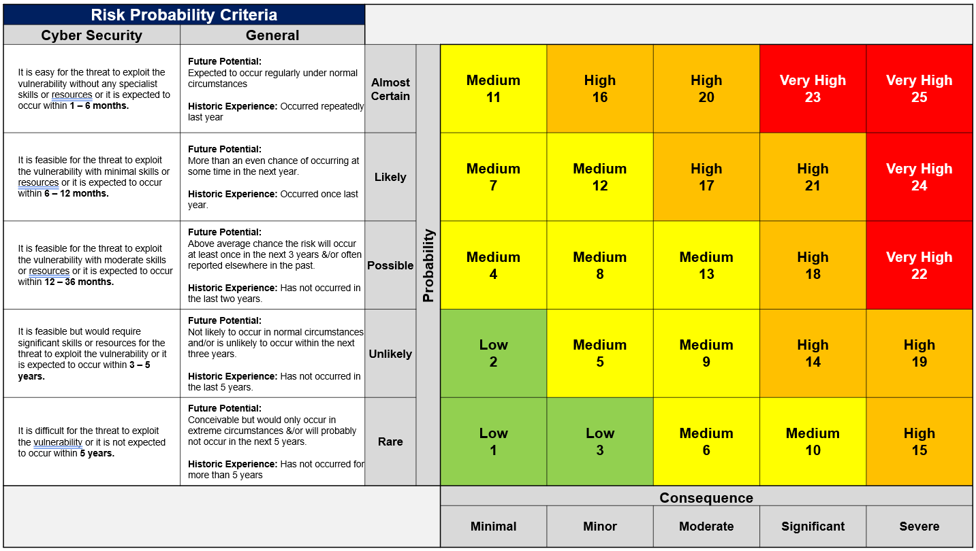
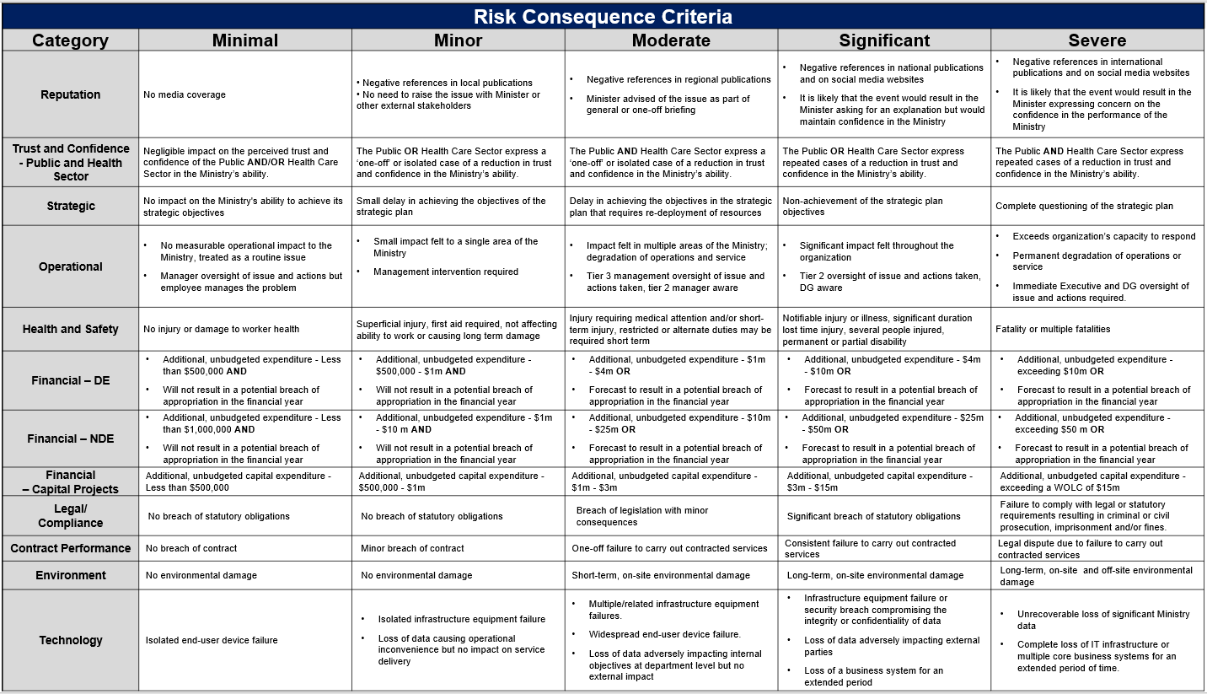
When calculating the above, consider the impact on the person or persons whose information is involved. The higher the impact on an individual, and/or the higher the number of individuals affected, the greater the consequences will be for Te Whatu Ora. Consider, for example, reputational damage or impact on trust in the health system; the business impact of staff being redeployed to manage an incident; and potential for litigation, adverse action by the Office of the Privacy Commissioner, and/or compensation to be paid.
For most privacy impacts, the areas affected for Te Whatu Ora will be Reputation and Trust and Confidence. Major incidents involving information about a large number of people could also impact Financial, and incidents involving staff information could have an impact under Health & Safety.
The impact only has to be in one area for the rating to apply. Below is a guide based on the categories of harm in s69(2)(b) of the Privacy Act 2020.
Impact on affected individual(s)
Rating | Description | Loss, damage, or injury | Rights and interests | Reputation and feelings
5 | Severe | Major incident or health impact involving loss of life or severe physical injury with permanent serious physical and/or psychological effect | Access to health services irreparably denied to one or more individuals, or significant lost benefit or opportunity or financial harm/loss to a large number of individuals or a community | Significant ongoing humiliation, loss of dignity, or damage to reputation of a large number of individuals or a community
4 | Significant | Serious incident or health impact with long-term physical and/or psychological effects and/or impact on quality of life for one or more people | Lost benefit or opportunity, significant financial harm/loss, or access to health services delayed for an extended period for a large number of individuals or a community | Significant humiliation, loss of dignity, or damage to reputation of a large number of individuals or a community
3 | Moderate | Incident involving injury or health impact requiring medical attention | Lost benefit or opportunity, significant financial harm or loss, or access to health services delayed for an extended period for one or a few individuals | Significant humiliation, loss of dignity, or injury to feelings of one or a few individuals
2 | Minor | Incident involving minor injury or health impact to one or a few people not requiring medical attention | Minor limited or short-term financial harm or access to health services or to a health benefit or opportunity for one or a few individuals delayed for a limited period | Limited humiliation, loss of dignity, or injury to feelings of one or a few individuals
1 | Minimal | Health impact or injury made possible but avoided | Short-term delayed access to a health benefit or opportunity for one or a few individuals | Minor embarrassment or injury to reputation or feelings of one or a few individuals

Glossary
The following are definitions used in this Assessment:
Term |  | Description
AWS | Amazon Web Services
CIR | COVID-19 Immunisation Register
Cohort | A few people grouped by a common attribute
CPN |  | Consumer Practitioner Number
FVP | Flu Vaccination Programme (FVP)
GP Notification | A general term for a message going back to the GP, currently supported by HealthLink over Connected Health in the form of HL7 Messages
Health UI | A Web Based user interface for the NHI, used in a swivel chair fashion.
HealthCloud | Salesforce Data Model and associated accelerators for Health
HISO |  | Health Information Standards Organisation
HNZ |  | Health NZ
HPI |  | Health Practitioner Index
Immunisation Handbook |  | The “manual” for immunisation in New Zealand. Much of what we are supporting is encompassed in here. https://www.health.govt.nz/publication/immunisation-handbook-2020
Immunisation history | An individual’s Immunisation history limited by the information HealthNZ hold in NIR and in Salesforce (CIR, Flu)
ISD |  | Information Service Delivery - Vaccinator Portal
ISM |  | Information Service Management – Admin Portal, tool for AIR Admins
MHA | My Health Account. A Ministry of Health service that connects you to your health information and online health services.
Ministry |  | The Ministry of Health
NES |  | National Enrolment System to a General Practitioner.
NHI |  | National Health Index – this is the unique identifier that is assigned to every person who uses health and disability support services in New Zealand.
NIR |  | National Immunisation Register
NIR Admin | Refer to the users of NIR made up of staff across the Country within DHBs
NIS | National Immunisation Register (now referred as Aotearoa Immunisation Register)
Opted IN/OUT | Currently you can opt in or out of the schedule. There is also opting in and out of correspondence.
PMS Provider | Provider of Practice Management System used by GPs
Provider | The term related to an entity providing vaccination services
Schedule |  | Currently has multiple meanings and concepts. We are preparing a model to articulate this.
Vaccination Record |  | Refers to the actual vaccination record, which is realised as either an entry from ISD, ImmuniseNow or GP. A vaccination event is the act of giving a vaccination.

http://www.legislation.govt.nz/regulation/public/1996/0343/latest/DLM225616.html

