



Clinical Performance Metrics

### 1 April – 30 June 2023

Citation: Te Whatu Ora – Health New Zealand. 2023. *Clinical Performance Metrics:*. Wellington: Te Whatu Ora – Health New Zealand.

Published in October 2023 by Te Whatu Ora – Health New Zealand  
PO Box 793, Wellington 6140, New Zealand

ISSN 3021-1433



This document is available at [tewhatuora.govt.nz](https://www.tewhatuora.govt.nz/)

|  |  |
| --- | --- |
| CCBY | This work is licensed under the Creative Commons Attribution 4.0 International licence. In essence, you are free to: share i.e., copy and redistribute the material in any medium or format; adapt i.e., remix, transform and build upon the material. You must give appropriate credit, provide a link to the licence and indicate if changes were made. |

# Tracking one year on

In these metrics, the final for the 2022/23 financial year, we provide more information about the data and information on the past year’s performance.

Our workforce and the capacity of our primary care and hospital system are still feeling the ripple effects of COVID-19. The pandemic had a significant impact on our waitlists and our workforce, as it did globally. During the pandemic our operation and procedure numbers were lower than usual and our waitlists grew. People weren’t often seen as quickly as they had been pre-COVID due to isolation measures to protect our most vulnerable and more sickness in our workforce. Workaround logistics to keep people safe meant the system had to adapt to an unprecedented situation, at pace.

As Aotearoa recovers from COVID-19 we have seen an increase in planned care to ensure those people who have been waiting more than 365 days receive the care they need. We have delivered more planned care, we have seen more people for first specialist assessment, seen more people in our Emergency Departments and more use of acute beds in our hospitals.

Our immediate focus is on urgent patients and those who have been waiting the longest for treatment, and we know this is making a difference.

# Clinical Performance Metrics

Data presented in this document shows information on 11 out of 12 clinical metrics for Te Whatu Ora for the period April to June 2023 compared with April to June 2022. It is presented in visual bar-graph form to enable ease of comparison between years. Seven of the 12 clinical metrics are performance measures included in our accountability documents (Statement of Intent/Statement of Performance Expectations), so these measures are also presented in Te Whatu Ora’s substantive quarterly performance reports (also published on our website), specifically:

1. Immunisation Coverage at 24 Months

2. Ambulatory Sensitive Hospitalisations (ASH) 0-4 Years

3. Ambulatory Sensitive Hospitalisations (ASH) 45-64 Years

4. Mental Health Wait Times

5. Acute Bed Days

6. ESPI 2 – Patients Waiting Longer than 4 Months for their First Specialist Assessment

7. ESPI 5 – Patients Given a Commitment to Treatment but not Treated within 4 Months

The remaining five clinical performance metrics are:

8. Emergency Department Presentations

9. Shorter Stays in Emergency Departments

10. Faster Cancer Treatment 31-day indicator

11. Planned Care Waiting >365 days

12. Emergency Department Admissions

Clinical metric 12 is not published in this report due to ongoing challenges with validating the data used to produce this metric. We are working to gain consensus on a meaningful definition for this metric, to ensure it is applied consistently across the districts.

The 12 clinical performance metrics aim to measure how well the health care system across the country is performing, providing the opportunity to develop local health solutions to address local health issues.They also include metrics for cancer, acute and planned care. The metrics allow us to measure performance over time with consistency. Where possible the data is published across all regions and districts.

This report now includes breakdowns by ethnicity where possible. Ethnicity data is sourced from prioritised ethnicity in the National Health Index system, and for Ambulatory Sensitive Hospitalisations and Acute Bed Day rates, matched to prioritised ethnicity in Stats NZ Usual Resident Population projections.

All performance data provides a snapshot in time and there will be variances depending on when data is uploaded on any given day. An explanation of each data set is contained within the graphs provided.

Data presented in this report is collected at district level, and fed through various national collections and applications to a national data platform to create a set of national data. Graphs are created from the data platform. Data is checked at a national level, and then a district level (by clinical and data teams), then checked again by national level subject matter experts. Additional checks are also made by all those involved in the creation of the report.

The term “district” is used in this report, and refers to the geographic boundaries covered by former District Health Boards (DHB). Te Whatu Ora aims to provide geographic breakdowns, where possible, to enable people to compare results across the country and we are currently working with inherited datasets that are aligned to former DHBs.  As we move ahead, Te Whatu Ora will give further consideration to the best groupings and catchments of data, within the context of a single organisation, including what terminology is best to use.

## 1 Immunisation Coverage at 24 Months

Coverage is calculated as the percentage of children who turned two years of age during the period who are recorded as fully immunised for age on the National Immunisation Register (NIR), including all scheduled vaccines due between birth and age two years. This measure excludes children for whom vaccination has been declined by parents or guardians, or those that have opted off the national immunisation register.[1]

**Children fully immunised for age at 24 months by district of service**

|  |  |
| --- | --- |
| **Children fully immunised for age at  24 months - National 2022/23 Q4** | **Children fully immunised for age at  24 months - National 2021/22 Q4** |
| 83.1% | 82.9% |

**Children fully immunised for age at 24 months by prioritised ethnic group**

In April 2023, the National Immunisation Taskforce released a [report](https://www.tewhatuora.govt.nz/publications/initial-priorities-for-the-national-immunisation-programme-in-aotearoa/), Initial Priorities for the National Immunisation Programme in Aotearoa, identifying systemic issues across various parts of the immunisation system that could work better to deliver immunisations to children. The key goal of the Taskforce is to build a system that delivers immunisations on-time and works for Māori, who are more at risk of vaccine preventable disease. Several significant pieces of work are currently underway.

Te Whatu Ora is working in partnership with Te Aka Whai Ora, regions, and providers to reach the national target of 90% immunisation coverage for tamariki at 24 months, by   
30 June 2024. A national action plan (alongside four regional action plans) has been developed to provide a pathway for delivering the recommendations and reaching the target.

Childhood immunisation rates in Aotearoa New Zealand for children at 24 months have shown a small improvement in the quarter April to June 2023 compared to the same quarter in 2022 (83.1% versus 82.9%), with gains showing for Māori.

Seven districts (Northland, Waitematā, Auckland, Lakes, Capital and Coast, Hutt Valley, and South Canterbury) show improvement.

**Note**: Source of data is the National Immunisation Register database.

## 2 Ambulatory Sensitive Hospitalisations, 0-4 years

Ambulatory sensitive hospitalisations (ASH) are acute admissions that are considered potentially reducible through interventions deliverable in a primary care setting. Results are presented as a rate per 100,000 population, i.e. the number of ASH admissions to hospital for children aged between 0 and 4 years divided by the number of children aged between 0 and 4 years in the population x 100,000.

**Ambulatory Sensitive Hospitalisations (ASH) per 100,000 Children (age 0-4) by district of domicile**

|  |  |
| --- | --- |
| **Ambulatory Sensitive Hospitalisations (ASH) per 100,000 Children (age 0-4) - National 12 months to June 2023** | **Ambulatory Sensitive Hospitalisations (ASH) per 100,000 Children (age 0-4) - National 12 months to June 2022** |
| 7,752 | 5,725 |

**Ambulatory Sensitive Hospitalisation (ASH) events per 100,000 children (age 0-4) by prioritised ethnicity**

Nationally the rate of ambulatory sensitive hospitalisations for 0-4 year olds has increased significantly (35%) between the year to June 2022 and the year to June 2023. Very large increases were seen in Te Toka Tumai - Auckland (66%) and Waitematā (65%).

There has been a particular increase in the rate of admissions for asthma, pneumonia, upper respiratory and ear, nose and throat infections, gastroenteritis/dehydration and cellulitis over the 2022/23 year - the first full year with no COVID-19 lockdowns in place.

Notable is the large increase in ASH rates for Pacific people of 45%. The rate had decreased during the COVID-19 period more than the rates for other ethnic groups. As the ASH rates have now increased to above pre-Covid levels, the change in Pacific rates is more noticeable when comparing 2023 and 2022.

**Note**: Source of data is the national collections NMDS (inpatient events) compared to the population (Stats NZ population projections). This metric is not yet available with an ethnicity breakdown that includes Asian.

## 3 Ambulatory Sensitive Hospitalisations, 45-64 years

Ambulatory sensitive hospitalisations (ASH) are acute admissions that are considered potentially reducible through interventions deliverable in a primary care setting. Results are presented as a rate per 100,000 population, i.e. the number of ASH admissions to hospital for adults aged between 45 and 64 years divided by the number of adults aged 45-64 years in the population x 100,000.

**Ambulatory Sensitive Hospitalisations (ASH) per 100,000 adults (age 45-64) by district of domicile**

|  |  |
| --- | --- |
| **Ambulatory Sensitive Hospitalisations (ASH) per 100,000 Adults (Age 45-64) - National 12 months to June 2023** | **Ambulatory Sensitive Hospitalisations (ASH) per 100,000 Adults (Age 45-64) - National 12 months to June 2022** |
| 3,739 | 3,556 |

**Ambulatory Sensitive Hospitalisations (ASH) per 100,000 adults (age 45-64) by prioritised ethnicity**

Nationally the aged-standardised ASH rate for 45-64 year olds increased by 5% when compared between the year to June 2022 and June 2023. The rate increased for almost all districts except Waikato, Taranaki and Hawkes Bay. Whanganui has the highest ASH rates for 45-64 year olds at a rate of 6,108 per 100,000 adults.

The largest increases in ASH rates for this age group were experienced in smaller and rural hospitals: Northland (13%), Nelson Marlborough, South Canterbury, and West Coast (12%).

**Note**: Source of data is the national collections NMDS (inpatient events) compared to the population (Stats NZ population projections). This metric is not yet available with an ethnicity breakdown that includes Asian.

## 4 Mental Health Wait Times

This measure reports the proportion of young people (aged under 25) who have been referred to and seen by a specialist mental health service within three weeks of referral. Waiting times are counted from the time the first referral is received, either by a Te Whatu Ora service or community provider, to first face-to-face contact with a mental health professional.

**Under 25 year olds accessing specialist mental health services within 3 weeks of referral by district of service**

|  |  |
| --- | --- |
| **Under 25 year olds accessing  specialist mental health services  within 3 weeks of referral - National  12 months to June 2023** | **Under 25 year olds accessing  specialist mental health services  within 3 weeks of referral - National  12 months to June 2022** |
| 68.3% | 72.4% |

**Under 25 year olds accessing specialist mental health services within 3 weeks of referral by prioitised ethnicity**

The number of young people needing mental health support is increasing faster than the population. This has been particularly noticed post COVID-19. The development of both primary and specialist mental health services will be essential to meet this demand.

Overall the proportion of young people accessing specialist mental health services within three weeks of referral has decreased slightly in the year to June 2023 compared to the previous year (from 72.4% to 68.3%). The decrease has occurred for all ethnic groups, with the largest decrease being for Pacific people.

While the majority of districts showed a decrease in the proportion of young people accessing services within three weeks, five districts (Taranaki, Hawke’s Bay, Whanganui, Nelson Marlborough and Canterbury) showed improvement in the time to first assessment in the year to June 2023 compared to the previous year.

## Note: Source of data is the mental health national collection PRIMHD.

## 5 Acute Bed Days

Acute bed days are number of days a person spends in hospital, following an acute admission. The acute bed days rate is presented as the number of bed days for acute hospital stays per 1,000 population, age standardised. This measure is intended to reflect demand for acute inpatient services on the health system.

**Acute bed day rate per 1,000 population by district of domicile**

|  |  |
| --- | --- |
| **Acute Bed Days per 1,000 population - National 12 months to June 2023** | **Acute Bed Days per 1,000 population – National 12 months to June 2023** |
| 440 | 407 |

**Acute bed day rate per 1,000 population by prioritised ethnicity**

Nationally, the number of acute bed days per 1,000 population has increased by 8% in the year to June 2023, compared to the year to June 2022. The two districts with the largest increase were Tairawhiti (13%) and Lakes (12%). The increase is shown across all ethnic groups with Pacific people showing the greatest increase of 12%.

**Note:** Source of data is the national collections NMDS (inpatient events) compared to the population (usual resident population from Stats NZ). This metric is not yet available with an ethnicity breakdown that includes Asian.

## 6 Planned Care ESPI 2 - Patients Waiting Longer Than 4 Months for First Specialist Assessment (FSA)

Elective Services Patient Flow Indicators (ESPI) measure whether districts are meeting the required performance standard at a number of key decision or indicator points on the person’s journey through the Planned Care system. ESPI 2 refers to patients waiting longer than four months for their first specialist assessment (FSA).

**ESPI 2 - Patients waiting longer than 4 months for first specialist assessment (FSA) by district of service**

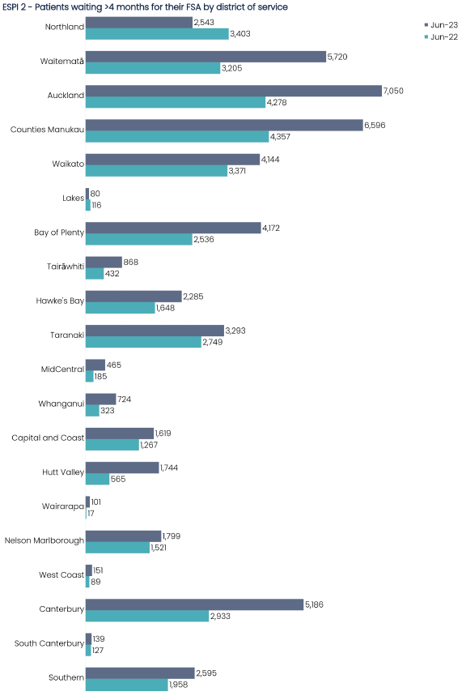

|  |  |
| --- | --- |
| **ESPI 2 - Patients waiting longer than  4 months for their FSA - National  June 2023** | **ESPI 2 - Patients waiting longer than 4 months for their FSA - National  June 2022** |
| 51,274 | 35,080 |

Demand for first specialist appointments continues to grow. Some contributing factors include our growing population, which is also aging, and a hangover from COVID-19 when people may have delayed seeking care. Longer term, our goal remains that all patients accepted for surgery receive that treatment within four months.

Nationally there has been an increase in the number of patients waiting more than four months for first specialist assessment (from 35,080 in June 2022 to 51,274 in June 2023). Two districts, Northland and Lakes, have shown improvement on this measure.

## Note: Source of data is the National Collection for ESPI2 which is not at patient level; we cannot provide an ethnicity breakdown of this measure from this collection.

## 7 Planned Care ESPI 5 - Patients Given a Commitment to Treatment but not Treated within 4 Months

Elective Services Patient Flow Indicators (ESPI) measure whether districts are meeting the required performance standard at a number of key decision or indicator points on the person’s journey through the Planned Care system. ESPI 5 refers to patients given a commitment to treatment but not treated within 4 months. The goal is to ensure no patients with this status remain untreated after 4 months.

**ESPI 5 - Patients given a commitment to treatment but not treated within 4 months by district of service**

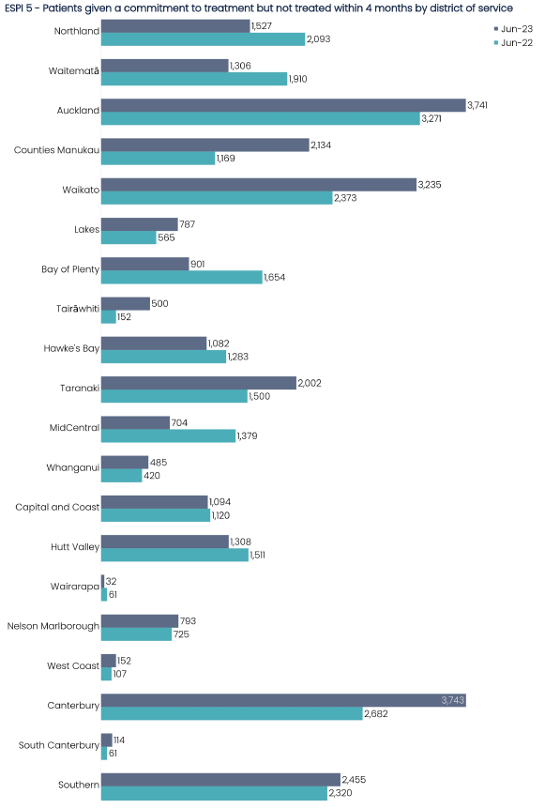

|  |  |
| --- | --- |
| **ESPI 5 - Patients given a commitment to treatment but not treated within 4 months - National June 23** | **ESPI 5 - Patients given a commitment to treatment but not treated within 4 months - National June 22** |
| 28,095 | 26,356 |

Overall the number of patients waiting longer than four months for treatment has increased from 26,356 in June 2022 to 28,095 in June 2023.

## Note: Source of data is the national collection National Booking Reporting System (NBRS). There are known issues in NBRS for Taranaki and therefore data has been withheld. We cannot provide an ethnicity breakdown of this measure for this reason.

**8 Emergency Department Presentations**

Emergency Department (ED) presentations reflects the number of people who present to an emergency department.

**Emergency Department presentations by distict of service**

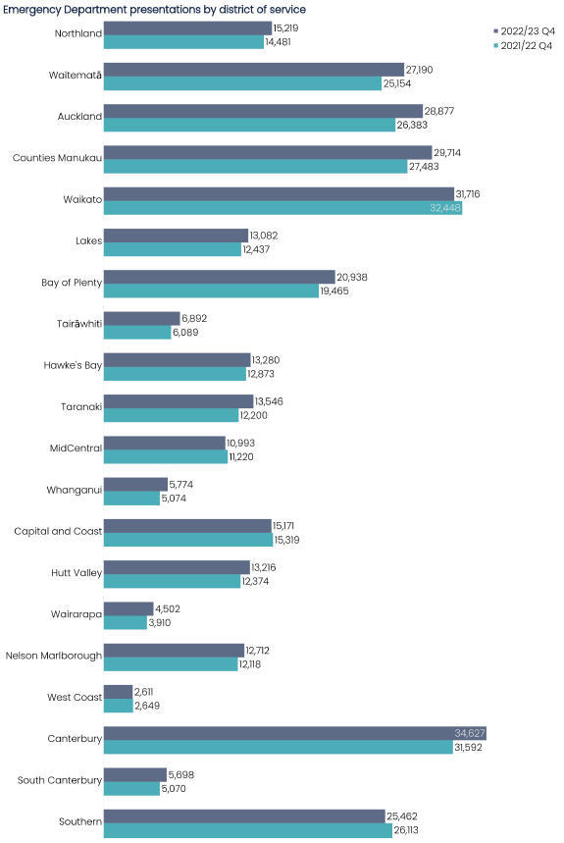

|  |  |
| --- | --- |
| **Emergency Department presentations - National 2022/23 Q4** | **Emergency Department presentations - National 2021/22 Q4** |
| 331,220 | 314,452 |

**Emergency Department presentations by prioritised ethnicity**

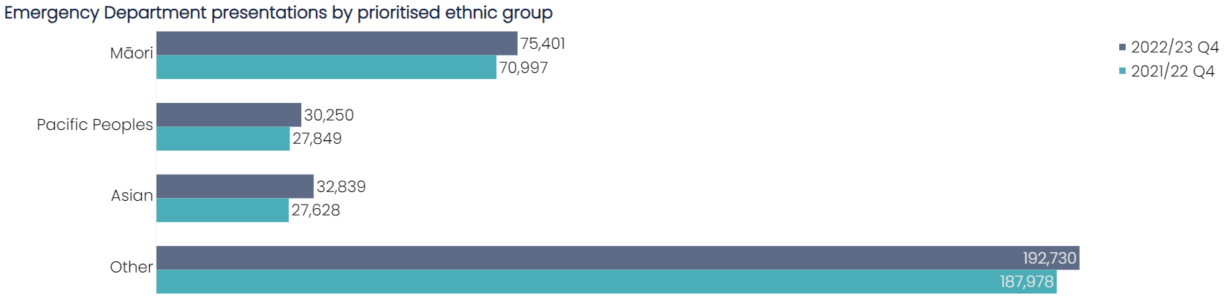

# A range of initiatives to reduce the demand for emergency departments have been trialled over winter and evaluation of these initiatives is currently underway. We know that pharmacists treating minor ailments have reduced the stress on our emergency departments and General Practitioners. Strategies are tailored to local circumstances, for example, early supported discharge, or telehealth support to rural patients to prevent transfer to hospital.

# Nationally, Emergency Department presentations have increased by 5% between the two periods (from 314,452 to 331,220). Almost all districts have shown an increase except Waikato, MidCentral, Capital and Coast, West Coast and Southern.

# Large urban hospitals; Auckland, Counties, Waitemata and Canterbury, have shown the largest increases.

**Note**: Source of data for all districts is the National Non-admitted Patient Collection (NNPAC). This measure excludes patients presenting directly to an Acute Assessment Unit (AAU) or via ED where the only input in ED was triage and patients who did not wait to be seen.

**9 Shorter Stays in Emergency Departments (EDs)**

This measure reports the proportion of patients who were admitted, discharged, or transferred from an Emergency Department (ED) within six hours. This measure excludes those people who presented to ED in error as well as those who did not wait to be seen.

**Shorter stays in Emergency Departments (<6 hours) by district of service**

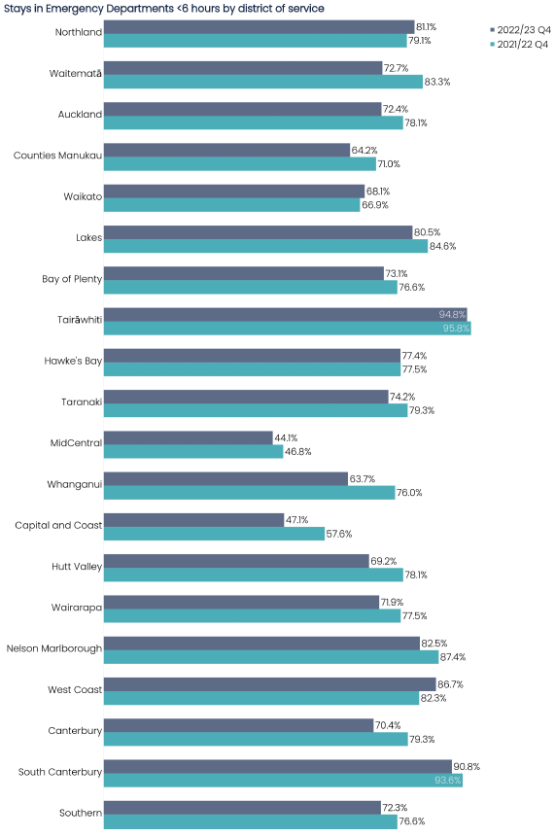

|  |  |
| --- | --- |
| **Stays in Emergency Departments <6 hours - National 2022/23 Q4** | **Stays in Emergency Departments <6 hours - National 2021/22 Q4** |
| 71.2% | 75.9% |

**Shorter stays in Emergency Departments (<6 hours) by prioritised ethnicity**

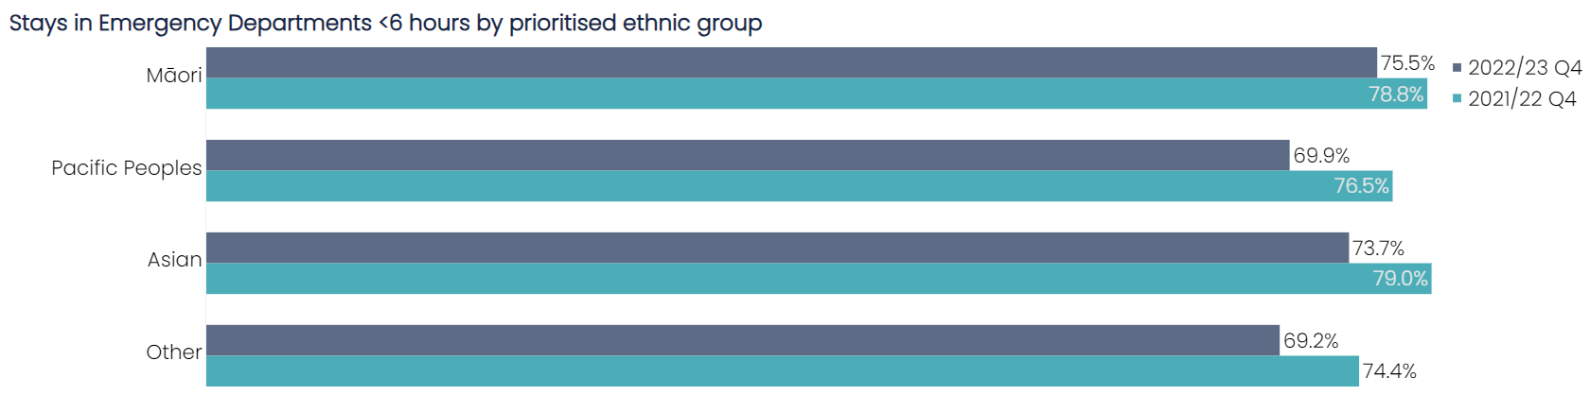

Nationally, the proportion of ED stays under six hours decreased by 4.7% (compared to April to June 2022). While performance deteriorated for most districts, three (Northland, Waikato and West Coast) showed improvement.

The deterioration affected all ethnic groups, the deterioration in performance was 3.3% for Māori, 6.6% for Pacific, 5.3% for Asian and 5.2% for other ethnicities.

**Note**: Source of data is National Non-admitted Patient Collection (NNPAC). This measure excludes patients presenting directly to an Acute Assessment Unit (AAU) or via ED where the only input in ED was triage and patients who did not wait to be seen.

**10 Faster Cancer Treatment**

This measure shows the proportion of eligible cancer patients who receive their first treatment within 31 days of a decision to treat by a health professional. The days are counted from the decision to treat date to the delivery of their first treatment.

**Faster Cancer Treatment (FCT) within 31 days of clinical decision to treat by district of service**

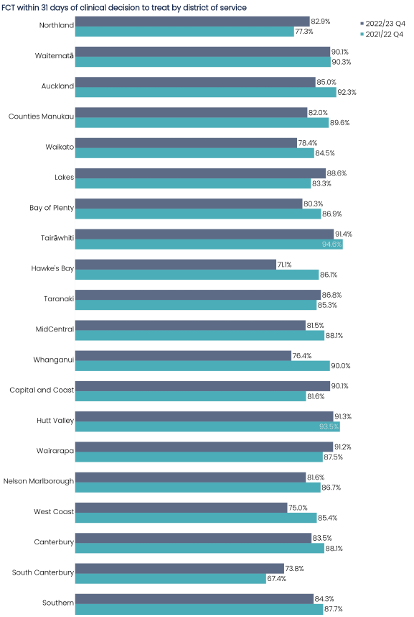

|  |  |
| --- | --- |
| **Faster Cancer Treatment (FCT) within 31 days of clinical decision to treat - National 2022/23 Q4** | **Faster Cancer Treatment (FCT) within 31 days of clinical decision to treat - National 2021/22 Q4** |
| 84.0% | 87.1% |

**Faster Cancer Treatment (FCT) within 31 days of clinical decision to treat by prioritised ethnicity**

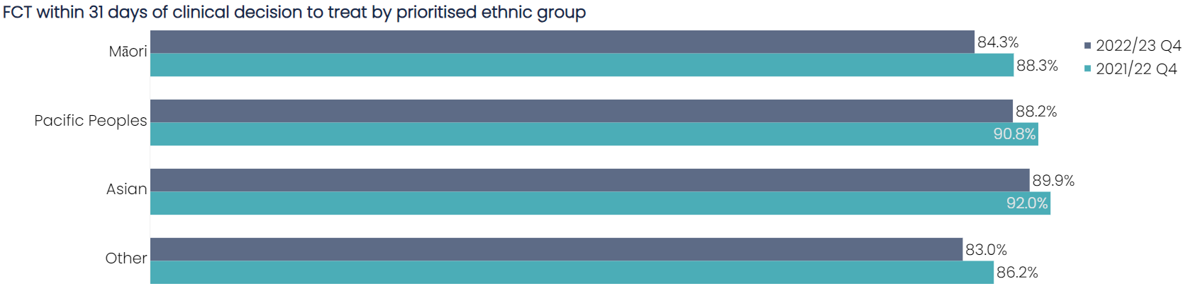

Work is underway to build a national Cancer Service Delivery Improvement Programme aimed at improving and implementing better cancer services. This includes establishing the National Clinical Cancer Network, which will see Te Aka Whai Ora, Te Whatu Ora, and Te Aho o Te Kahu work in partnership to ensure there is collaboration across all levels of care. Workforce, diagnostics and equipment are key areas of focus to improving our timely cancer service delivery.

Classification number: (Review date: )

Classification number: (Review date: )

Six districts (Northland, Lakes, Taranaki, Capital and Coast, Wairarapa and South Canterbury) showed improvement in time to first treatment for cancer (from decision to treat) with a decrease in time to first treatment in the quarter April to June 2023 compared to the quarter April to June 2022.

Nationally, performance against this cancer target has deteriorated overall between the two periods (between April to June 2022 and April to June 2023), from 87.1% to 84.0%. Performance for this metric (percent treated within 31 days) is similar across ethnic groups (i.e. there is no difference in performance by ethnic group).

**Note:** Source of data for all districts is Faster Cancer Treatment (FCT) national collection. Reporting is for a three-month period rather than a rolling six months as previously reported.

**11 Planned Care: Long wait times for treatment**

This measure reports the total number of people in each district who have been waiting on a planned care waitlist for a procedure for more than 365 days from the time they were ready for treatment.

**Long wait times (> 12 months) for treatment by district of service**

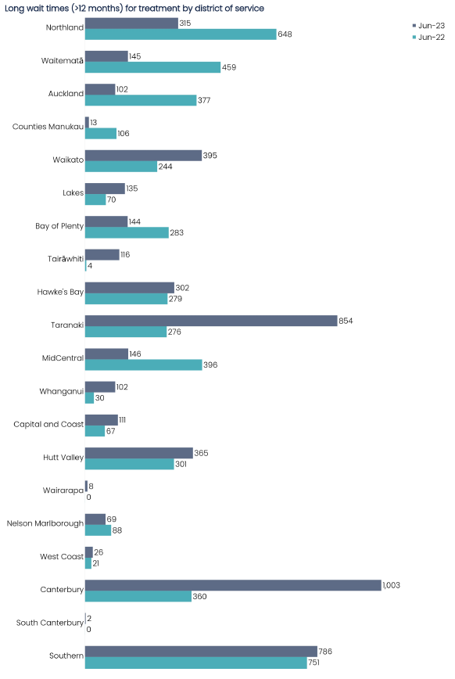

The Planned Care Taskforce was set up in May 2022 to provide advice on actions to improve equity, increase access and reduce waiting lists for planned care. In October a multi-year implementation programme commenced, to implement recommendations on reducing waitlists, managing this in an equitable way and ensuring national consistency of clinical prioritisation.

There has been focused effort to deliver more planned care through our public hospital, private hospital and primary settings. This has been supported by collaboration across regions and districts, and other targeted initiatives to increase planned care capacity.

**Note**: Source of data is the national collection National Booking Reporting System (NBRS). There are known issues in NBRS for four districts for June 2023: Taranaki, Midcentral, Whanganui and Southern, and therefore data has been withheld. A national total has not been provided for this reason.

1. The information contained in this report has been derived from the National Immunisation Register database. While Te Whatu Ora has taken all reasonable steps to ensure the information contained in this report is accurate and complete, it accepts no liability or responsibility for the manner in which the information is used or subsequently relied on.