Report of the Parliamentary Review Committee Regarding the National Cervical Screening Programme

December 2022

Kua tawhiti kē to haerenga mai kia kore e haere tonu; he nui rawa o mahi kia kore e mahi tonu | You have come too far not to go further; you have done too much not to do more.

Sir James Henare
Commissioned by the New Zealand Government
Foreword
“Me aro koe ki te hā o Hineahuone. Mai te tīmatanga, ko Papatūānuku, te whaea whenua, ko Hineahuone te ira tangata tuatahi, he wāhine. Tīhei Mauriora.”
Women lie at the heart of whānau and are the heart of the cervical screening programme. We hold up half the sky, we nurture, inspire, provoke and make significant contributions to the world. Ensuring the wellbeing of women is essential to the wellbeing of communities.
All screening programmes are important as they enable early detection of changes or disease and open up options for treatment, recovery and improved survival.
We acknowledge all the people we have lost to cervical cancer. We acknowledge their whānau, their friends and the impact on communities. We acknowledge the survivors of cervical cancer and those who are currently navigating treatment. We acknowledge those who work across the screening pathway committed to upholding Te Tiriti o Waitangi and pursuing health equity.
This parliamentary review of the National Cervical Screening Programme (NCSP) is an opportunity to reflect and reconsider. It has been said before, if we want equitable outcomes from the screening programme, we need to value women’s lives and provide a free screening and treatment pathway. This remains the overarching message from the 2022 Parliamentary Review Committee (PRC).
The whakapapa of the cervical screening programme includes pain, hurt and systemic inequities. It is time to step into the light, embrace equity and reorient to a place of hope and possibility. The PRC expects the programme to explicitly uphold Te Tiriti o Waitangi and be mana-enhancing. For this to occur we need communication, collaboration, and everyone within the sector taking responsibility for ensuring equitable outcomes. Business as usual (and business for profit) will maintain the current inequities, and enable institutional racism and further breaches of Te Tiriti.
Within this report we have tried to embrace the use of gender-neutral language while honouring the history of this programme. The world is changing and while the majority of people accessing the cervical screening programme are women, we recognise the programme now also needs to
engage other people with a plurality of gender identities. It is important that this programme delivers culturally appropriate care for all eligible people.
As members of the PRC, we have appreciated the opportunity to be part of this review and contribute to this important kaupapa. We thank the people who gave their time to the PRC to share their stories, critical feedback and aspirations. We appreciate your commitment to the screening programme and the elimination of cervical cancer. We share your aspirations and encourage the sector to engage and mobilise around these recommendations.
Many thanks to Maria Baker, Kirimatao Paipa, Rolinda Karapu and Ai Ling Tan for their peer review of the document; and to Miriam Gioia Sessa, Lily-Kay Ross and Ngamata Skipper for their practical assistance and tautoko throughout the review process. Thank you to the National Screening Unit (NSU) team for your support and guidance.

Heather Came
Chair, Parliamentary Review Committee

About the Parliamentary
Review Committee

Ms Liane Penney (Ngāpuhi) is the Director of Kiwikiwi Services Limited, a research, evaluation, project and change management consultancy. Liane is a public health professional with expertise in Māori health and equity development. She has extensive experience in service innovation and change management, research, evaluation and health service operational management. Liane was previously the Northland Health Services Plan Portfolio Manager and, in that role, managed the implementation of a number of strategic projects across both primary and secondary health care. In her role as the Service Planning Manager, Māori Health Directorate, Health Funding Authority, she led the design and implementation of national Māori health services. Liane has been a member of many governance groups, expert panels and research committees, including the 2018 PRC.

Dr Georgina McPherson is and New Zealand born Cooker (Ngāti Kao, Ngāti Tane). Georgina is a Women’s Health Nurse Practitioner and has been a practising colposcopist since 2000, developing the first nurse colposcopist training programme in Aotearoa. She has undertaken many quality improvement initiatives to improve access and utilisation in the colposcopy field. In 2018 Georgina was awarded the Waitematā overall clinical excellence award along with a clinical leadership prize for her work in colposcopy. She was the clinical lead at Waitematā Te Whatu Ora colposcopy service for seven years and recently stepped down to pursue
other opportunities. Georgina has been a member of governance, clinical guidelines and research groups. She is currently on the professional advisory board of the Human Papilloma Virus (HPV) Project; a committee member of the Australian Society of Colposcopy and Cervical Pathology; and the Medical Advisory Board of Talk Peach. Georgina has an interest in Pacific health research and completed her doctoral thesis on Pacific women navigating colposcopy services. She is a co-investigator on the HPV self-testing studies in the Auckland region and is leading a Health Research Council (HRC) funded research team investigating Māori and Pacific women’s pre-diagnostic experiences of endometrial cancer using a kaupapa Māori and talanoa approach.

Dr Heather Came is a seventh generation Pākehā New Zealander. She has worked for three decades in public health and has a long involvement in social justice activism. Heather is a founding member and co-chair of STIR: Stop Institutional Racism, and chair of the AUT branch of the NZ Public Health Association. As an activist scholar she has prepared evidence for the Waitangi Tribunal, has led shadow reports to United Nations human rights committees and is co- convenor of Te Tiriti based futures series of open-access virtual anti-racism gatherings. She works at Auckland University of Technology and in 2022 she won a Vice Chancellor’s Teaching Excellence Award. In 2021 she was joint winner of Kāhui Hauora Tūmatanui Public Health Champion Award for her lifetime contribution to public health. She is currently co-Principal Investigator on a Marsden grant focussing on re-imagining anti-racism theory. Her research focuses on critical policy analysis, Te Tiriti o Waitangi, anti-racism and institutional racism in the health sector.

Contents
Foreword 3
About the Parliamentary Review Committee 5
Executive Summary 12
2022 Parliamentary Review Recommendations 16
Te Tiriti o Waitangi 16
Accessibility 16
Elimination of Cervical Cancer 17
Integration 17
Effectiveness of Monitoring and Evaluation 18
Co-Governance and Clinical Governance 19
Clinical Quality Assurance in Colposcopy Services 20
Workforce Capacity and Capability 20
Introduction 22
The 2022 Parliamentary Review 22
Methodology 23
Background and Context 25
The NCSP Pathway 25
Move to Primary HPV Screening 26
Impact of COVID-19 27
Health Reforms 28
Health Inequities 29
HPV Vaccination 29
Cervical Screening Coverage 30
Colposcopy 31
Primary Care: Historical Test of Cure 35
Cervical Cancer Incidence 35
Cervical Cancer Mortality 37
Te Tiriti o Waitangi 39
Recommendation 1 39
Recommendation 2 39
Accessibility 45
Recommendation 3 45
Recommendation 4 46
Recommendation 5 49
Recommendation 6 51
Recommendation 7 51
Elimination of Cervical Cancer 54
Recommendation 8 54
Integration 56
Integrated Community-Based Screening 56
Recommendation 9 56
Recommendation 10 60
Integration of Primary Care and Colposcopy Services 61
Recommendation 11 61
Recommendation 12 62
Effectiveness of Monitoring and Evaluation 64
Recommendation 13 64
Recommendation 14 68
Recommendation 15 69
Recommendation 16 70
Recommendation 17 70
Co-Governance and Clinical Governance 73
Co-Governance 73
Recommendation 18 73
Recommendation 19 74
Recommendation 20 76
Clinical Governance 78
Clinical Quality Assurance in Colposcopy Services 80
Recommendation 21 80
Recommendation 22 80
Recommendation 23 82
NCSP Audit Programme 82
Workforce Capacity and Capability 85
Recommendation 24 85
Recommendation 25 85
Recommendation 26 85
Recommendation 27 86
Recommendation 28 87

Colposcopy Workforce Capacity and HPV Primary Screening 92
Recommendation 29 92
Recommendation 30 92
Recommendation 31 95
Progress on 2018 Parliamentary Review Recommendations 97
References 112
Appendix 1: 2022 National Cervical Screening Programme Parliamentary Review – Terms of Reference 118
Appendix 2: Interviews conducted by the Parliamentary Review Committee 122
Appendix 3: 2022 National Cervical Screening Programme Parliamentary Review – Committee Interview Questions 124

List of Figures
Figure 1: 30
Final Dose HPV Immunisation Coverage All DHBs: girls born between 1990 and 2003
Figure 2: 31
NCSP coverage % of women aged 25-69 years in the six years ending 31 March 2022 by ethnicity
Figure 3: 32
Trends of the proportion of people with a high-grade cytology report (no suspicion of invasive disease) seen within 4 weeks (20 working days), by ethnicity
Figure 4: 33
Percentage of people with a high-grade cytology (no suspicion of invasive disease) with a colposcopy visit within 20 and 40 working days, by ethnicity
Figure 5: 33
Trends in the proportion of people with high-grade cytology who have follow-up within 90 days recorded on the NCSP Register, by ethnicity
Figure 6: 34
Trends in the proportion of people with high-grade cytology who have follow-up within 180 days recorded on the NCSP Register, by ethnicity
Figure 7: 34
Trends in proportion of people with persistent LG cytology or LG cytology and positive hrHPV test and an accepted referral for colposcopy who have a colposcopy visit recorded within 26 weeks of the date the referral was accepted, by ethnicity
Figure 8: 36
Trends in the proportion of eligible people with squamous high-grade abnormality more than 3 years ago, for whom a Round 1 historical test is recorded on the NCSP Register, by ethnicity
Figure 9: 36
Proportion of eligible people with squamous high-grade abnormality more than 3 years ago for whom an historical test is recorded on the NCSP Register, by ethnicity at 31 December 2020.
Figure 10: 37
Age-standardised cervical cancer incidence rates, 2011–2019, by ethnicity
Figure 11: 37
Age-standardised cervical cancer mortality rates, 2010–2018, by ethnicity. Vertical bars represent 95 percent confidence intervals. Note: no deaths were recorded for Asian women in 2011.
Figure 12: 66
National Cervical Screening Governance Structure as of May 2022

Executive Summary
The 2022 Parliamentary Review Committee (PRC) was established by the Associate Minister of Health Dr Ayesha Verrall in accordance with the Health Act 1956 (Part 4A, Section 112O), which states that a review of the National Cervical Screening Programme (NCSP) must occur every three years. This report is a summary of the 2022 PRC’s assessment of the current programme and their recommendations for continuous quality and equity improvements, with a view to further reducing the incidence and mortality of cervical cancer in Aotearoa, particularly for Māori and Pacific people who currently carry an inequitable burden of cervical cancer.
The scope of the 2022 parliamentary review of the NCSP included the following eight areas:
- responsibilities to Te Tiriti o Waitangi
- monitoring and improving equity
- integration of services across the screening and treatment pathway
- assessment of workforce capacity and capability
- assessment of programme monitoring, evaluation and governance
- reporting on clinical quality assurance in colposcopy
- reviewing progress on the 2019 recommendations
- providing recommendations to:
- improve accessibility to screening and treatment services
- strengthen collaborative systems between primary healthcare and colposcopy services to bridge the gap between participants being screened and follow-up services.

The NCSP, which was established in 1990, has been considered successful by many as it has reduced overall cervical cancer incidence and mortality. Although there has been a reduction in overall incidence and mortality and a narrowing of inequities, there remain unacceptable inequities between different population groups. Māori women are 1.5 times more likely to be diagnosed with cervical cancer, and 2.3 times more likely to die from it compared to European and other women. Cervical cancer disproportionately affects young Māori women, being the second leading cause of cancer death in Māori women aged 25-44 years.
While there has been steady improvement in cervical cancer incidence and mortality rates since the programme’s inception, the last few years have seen results plateau and, in some areas, even decline. Screening coverage for Māori and Pacific women was declining prior to the COVID-19 pandemic and has worsened since, suggesting the programme needs to find more effective means of engaging with Māori and Pacific communities. The programme has seen additional barriers for people to accessing cervical screening and colposcopy services and a decrease in HPV vaccination rates, due to the impact of COVID-19.
There is a need to reorient the programme and do things differently in order to achieve the outcome of cervical cancer elimination. To address declining screening coverage rates and inequitable cervical cancer outcomes across our communities, an elimination strategy needs to be tailored and relevant to the Aotearoa context, prioritising Māori and Pacific people who carry the burden of cervical cancer incidence and mortality.
This report makes a number of recommendations designed to increase engagement with underserved communities and improve clinical outcomes. They include a commitment to centring Te Tiriti o Waitangi in cervical screening policy, governance and practice, including proactive appointment of senior Māori staff in strategic roles.
The health system in Aotearoa is currently undergoing a number of large-scale reforms. This includes the establishment of two national health authorities: Te Aka Whai Ora – the Māori Health Authority and Te Whatu Ora – Health New Zealand. The partnership model between the two agencies is intended to drive improved outcomes for our communities.
The PRC welcomes the establishment of Te Aka Whai Ora and anticipates future parliamentary reviews will gain useful insights through engagement with this key Crown entity. The PRC expects to see greater investment in Māori providers under their leadership and welcomes investment in an integrated and accessible model of community-based cervical screening.
The NCSP is also currently undergoing a significant change to the testing pathway, transitioning to an HPV primary screening programme which will include self-testing options. For this reason, the committee has focused on recommendations regarding accessibility and integrated services in an HPV primary screening environment.
The health system in Aotearoa is currently undergoing a number of large-scale reforms. This includes the establishment of two national health authorities: Te Aka Whai Ora – the Māori Health Authority and Te Whatu Ora – Health New Zealand. The partnership model between the two agencies is intended to drive improved outcomes for our communities.
The PRC welcomes the establishment of Te Aka Whai Ora and anticipates future parliamentary reviews will gain useful insights through engagement with this key Crown entity. The PRC expects to see greater investment in Māori providers under their leadership and welcomes investment in an integrated and accessible model of community-based cervical screening.
The NCSP is also currently undergoing a significant change to the testing pathway, transitioning to an HPV primary screening programme which will include self-testing options. For this reason, the committee has focused on recommendations regarding accessibility and integrated services in an HPV primary screening environment.
The 2022 PRC found a number of gaps in the current programme, particularly around accessibility, clinical governance, monitoring, evaluation and Te Tiriti responsibilities. Systemic breaches of Te Tiriti o Waitangi across the entire health sector as documented in the WAI 2575 report manifest as higher incidence and mortality rates for Māori. Complex barriers faced by the rainbow community, disabled people and those living with behavioural health conditions and trauma histories leave these communities with poor access to the programme.
These groups, as well as Pacific and Asian people, have historically been underserved by the health system and have experienced lower cervical screening coverage rates compared to other people. Cervical screening rates have been declining for Māori and Pacific people since 2017, which is an area of particular concern. The over-representation of Māori and Pacific people not accessing timely follow-up for assessment also indicates there are systemic barriers to accessing colposcopy services.
Every person eligible to be part of the cervical screening programme should have access to clinically and culturally safe care. The current system is not working consistently, especially for Māori and Pacific communities. Further work is required to support an inclusive approach and better access to the cervical screening pathway. By centring underserved communities in NCSP research and system design processes, we can work to improve health outcomes.
This report makes a number of recommendations that seek to address systemic racism and strengthen Māori leadership and co-governance across all levels of the programme. The PRC recommends everyone across the programme needs to play an active part in eliminating racism. Te Tiriti requires investment in Māori-led solutions, service delivery, coordination and governance to improve Māori health outcomes.
The recommendations put forward in this report represent the PRC’s recommendations for continuous improvements in the NCSP pathway. The aim of these recommendations is to create a more integrated system across the NCSP pathway that improves accessibility, addresses ethnic inequities in healthcare outcomes, and ensures that the health sector meets its responsibilities under Te Tiriti.
The PRC investigated colposcopy services regarding waiting times, referral patterns, clinic volumes, the number of colposcopists on staff and any capacity problems that were found. An assessment of clinical quality assurance in colposcopy was also undertaken, and identified variable clinical quality assurance practices across the country.
Finally, this report acknowledges that there is work still needing to be done in improving data access, knowledge-sharing, and effective use of monitoring and evaluation data. The PRC believes that this next generation of improvements will be a significant step towards improving cervical cancer outcomes and the goal of elimination.

2022 Parliamentary Review Recommendations
Te Tiriti o Waitangi
Te Tiriti o Waitangi needs to be central to cervical screening policy, governance and practice. There is currently patchy and inconsistent engagement with Te Tiriti across the programme.
The PRC has made Te Tiriti recommendations across this report regarding Te Tiriti responsibilities related to accessibility, integration, monitoring and evaluation, governance and workforce capacity and capability. These recommendations aim to strengthen Māori leadership and co-governance across all levels of the programme. It is envisaged that Māori-led service delivery and coordination will enable Māori providers, minimise racism and improve Māori health outcomes. Introduction of a kaupapa Māori evaluation culture will strengthen Māori advancement and inform equity efforts. The programme will be strengthened through engagement with Te Ao Māori and a tailored workforce development programme around Te Tiriti, equity, cultural safety and anti-racism.
- The PRC recommends the proactive appointment of senior Māori staff in alignment with the NSU’s strategic priorities.

Accessibility
- The cost of screening has been consistently identified as a major barrier to achieving the aims of the NCSP. Cost barriers perpetuate cervical cancer inequities that breach Te Tiriti o Waitangi responsibilities. The 2022 PRC reaffirms the recommendation of the 2018 PRC that all people should receive free cervical screening to align it with all other cancer screening programmes in Aotearoa and recommends appropriate funding processes are pursued to achieve a fully-funded cervical screening programme by 2024.

- Investment in an integrated, accessible model of community-based cervical screening is recommended. The new model should be the first line of screening for all eligible people rather than a support service that picks up those who have been missed by general practice. It should be designed to meet the needs and preferences of Māori, and others such as Pacific and Asian communities who have historically been unscreened or under-screened. This will strengthen Māori leadership and influence over the programme and benefit all eligible communities. (Recommendation 9 elaborates further).

- Improved accessibility to treatment services is required, particularly for Māori and Pacific people. Delivery of colposcopy services should be co-designed to meet the needs and preferences of Māori and Pacific people who historically experience delays in accessing assessment and treatment.

- The PRC recommends the NSU thoroughly explore opportunities for a change in the test of cure pathway to enable laboratories to perform HPV testing similar to the reflex HPV triage process. This would ensure access to this test for people who need it, and would not rely on the sample taker indicating the test was required on the laboratory form.

- Racism is embedded across the screening pathway and is a modifiable determinant of health inequities. Anti-racism education has proven effective to moderate racism and it seems likely that upholding Te Tiriti o Waitangi will minimise racism against Māori. Systemic racism however is a wicked problem that is not going to spontaneously stop. We recommend the NSU co-design an anti-racism plan for the sector to coordinate, consolidate and strengthen existing efforts.

Elimination of Cervical Cancer
- The PRC recommends the development of a national strategy for cervical cancer elimination. Consideration should be given to the World Health Organization (WHO) Global Strategy but must take into account Te Tiriti and the Aotearoa context. Specifically, we need an elimination strategy that prioritises Māori and Pacific people who carry the burden of cervical cancer incidence and mortality.

Integration
- To achieve an integrated, accessible model of community-based cervical screening it is recommended that current NCSP coordination, register coordination, support to services and free screening service specifications are combined into one integrated NCSP service specification for commissioning the existing network of Māori and Pacific providers. In localities where the NSU does not currently contract with Māori and/or Pacific providers new commissioning arrangements should be established. This reorientation is likely to minimise racism and other systemic barriers.

- The PRC recommends investing in research to understand the barriers to accessing the cervical screening pathway for people with physical or intellectual disability, members of rainbow communities, those with trauma histories and/or experiencing mental distress, and those who are incarcerated.

- To improve integration between primary care and colposcopy services there needs to be strong relationships developed between the new integrated model of community-based cervical screening and colposcopy services. The NCSP needs to support these relationships to reduce a siloed approach to the cervical screening pathway.

- To enable effective integration of HPV vaccination, the NCSP should collaborate with the National Immunisation Register (NIR) services to ensure providers along the cervical screening and treatment pathway can access information on the NIR to enable opportunistic HPV vaccination. Future information technology developments should include linked HPV vaccination data with the NCSP Register.

Effectiveness of Monitoring and Evaluation
- Evaluation is a valuable mechanism to enable continuous quality improvement, Māori and Pacific advancement and equity. A key finding of the PRC was the variability in the use of monitoring and evaluation data and reports to drive improvements. We recommended the introduction of a kaupapa Māori evaluation culture to drive improvements in Māori health outcomes. We also recommend the NSU provide advice to the sector on best practice examples for utilising equity monitoring data for improved performance.

- Consideration needs to be given to disaggregating Pacific data to monitor and evaluate cervical screening coverage for Pacific people. This should be done in collaboration with a Pacific data sovereignty group to ensure the data is used for the benefit of Pacific people. Disaggregation of Pacific data may provide the opportunity to provide more culturally tailored approaches to engagement and development of resources to improve cervical screening coverage.

- The 2018 PRC made two recommendations for improved monitoring of equity. The first proposed the Independent Monitoring Report brings together a synthesis of equity data, the second proposed the NSU work with other stakeholders to explore opportunities for measuring access to national screening services for people with disability, mental health service users, incarcerated people and rainbow communities. This PRC recommends this work be advanced with the relevant communities.

- With the re-structured health sector and a move to locality leadership of service planning, monitoring and evaluation, this leadership group, and particularly Iwi-Māori Partnership Boards, will be a key audience of NCSP monitoring reports. The provision of reports in a form that is accessible and useful for Māori monitoring groups and health providers is recommended.

- To strengthen monitoring the PRC recommends the formation of an independent, Māori-led, Māori-designed monitoring framework and resourced rōpū.

Co-Governance and Clinical Governance
- Effective co-governance requires clear communication, robust relationships, trust and role clarity. The NSU has commissioned a high-level working group to examine co-governance across the entire suite of screening programmes. The PRC supports the establishment of co-governance. We encourage the next parliamentary review to examine its effectiveness using Critical Tiriti Analysis.

- Whanaungatanga is critical to building trust. Highly regarded by all providers is the opportunity to network regionally and nationally as part of strengthening the NCSP. Where this is not occurring regionally, we recommend the NSU reinstate these networks. National networking opportunities should be facilitated by the NSU on a regular basis.

- The NCSP needs strong relationships between the NSU and all advisory and leadership groups such as the National Kaitiaki Group and the Māori Equity and Monitoring Group. Clarity of the role and function of each group based on their terms of reference would likely go some way to improving relationships, as would equitable treatment and funding. Deeper engagement with tikanga by NSU staff is also likely to strengthen these connections.

Clinical Quality Assurance in Colposcopy Services
- Clinical quality assurance reporting needs to be prioritised with a matter of urgency within Te Whatu Ora colposcopy services. Individual colposcopist performance should be measured against key clinical indicators annually and benchmarked data should be provided to colposcopists. This should occur prior to the implementation of the primary HPV screening programme to provide the NCSP with a baseline on clinical quality assurance data.

- There needs to be communication with Te Whatu Ora lead colposcopists and service managers that they have a responsibility to annually review individual colposcopists’ practice.

- Priority is given to utilising e-colposcopy data as a mechanism of feedback to Te Whatu Ora colposcopy services. This should also be extended to private providers.

Workforce Capacity and Capability
- Understanding, competence and commitment to Te Tiriti o Waitangi, equity, cultural safety and anti-racism appears inconsistent across the programme. The PRC recommends investment in mandatory stair-cased Te Tiriti, equity, cultural safety and anti-racism workforce development across the programme, including the NSU, to strengthen baseline competencies.

- The PRC recommends investment in workforce development in the area of kaupapa Māori evaluation.

- Workforce capacity in general practice is severely compromised and not expected to improve in the short term. Equitable cervical screening coverage will rely on a new model as described in Recommendation 4 and Recommendation 9. NCSP policy and guidelines will need to be reviewed to provide advice to general practice on effective engagement with the new model of cervical screening for the benefit of service users.

- The current training of sample takers requires review, and consideration should be given to delivering the training outside of the current New Zealand Qualification Authority (NZQA) framework. Local training and credentialing of sample takers could provide a more accessible option to training and improve accessibility for Māori and Pacific sample takers.

- Consideration also needs to be given to strengthening the ability of the sector to engage effectively with traditionally underserved groups such as Asian, disabled and rainbow communities, and those with a history of trauma and/or mental illnesses.

- The NCSP should with some urgency engage with Te Whatu Ora colposcopy services to discuss the revised modelling data regarding colposcopy referral volumes, to assist colposcopy services in their workforce planning.

- The PRC recommends the NCSP urgently identify strategies to manage the increased workload and work with Te Whatu Ora colposcopy services to support these strategies.

- To manage workforce capacity in the new programme, monthly monitoring of referral data to colposcopy services along with key indicators should be implemented. Reporting should be undertaken by Te Whatu Ora colposcopy services to ensure there is close monitoring of referral trends and the impact on waiting times for first specialist assessment and treatment

Introduction
The 2022 Parliamentary Review
Under the Health Act 1956 (Part 4A, Section 112O), the Minister of Health must establish a committee of up to three people to review the NCSP at least once every three years. According to the legislation, the review committee must focus on the continuous quality improvement of NCSP systems, with a view to reducing the incidence and mortality rates of cervical cancer.
This is the fourth parliamentary review of the NCSP. The Associate Minister of Health appointed the PRC in December 2021. The PRC’s remit is defined in their terms of reference (see Appendix 1). Prior to commencing their review, the committee developed a review plan which was approved by the Associate Minister of Health in May 2022. Part of this involved evaluating the progress made on recommendations from the third parliamentary review (Ministry of Health, 2019b).
The NCSP is currently transitioning to a HPV primary screening programme, offering self-testing and updating the screening pathway. For this reason, the 2022 Parliamentary Review had a limited scope, which focused on the evaluation of:
- responsibilities to Te Tiriti o Waitangi
- monitoring and improving equity
- integration of services across the screening and treatment pathway
- assessment of workforce capacity and capability
- assessment of programme monitoring, evaluation and governance
- reporting on clinical quality assurance in colposcopy
- reviewing progress on the 2019 recommendations
providing recommendations to:
- improve accessibility to screening and treatment services
- strengthen collaborative systems between primary healthcare and colposcopy services to bridge the gap between participants being screened and follow-up services.

The PRC’s terms of reference specified areas deemed outside the scope of the review. Where the PRC identified areas of concern or opportunities for the future direction of the programme that went beyond the main themes of the review, in accordance with its terms of reference, the PRC included these observations and opportunities in this report. In addition, where similar feedback was received from multiple interviewed sources, direct quotes from some key interviewees have been included to support the discussion and findings of the report.

Methodology
The PRC used qualitative research methods and quantitative data to inform its findings. The PRC conducted 42 interviews with key informants and stakeholders taking particular care to reach out to Māori and other underserved communities (see Appendix 2). The interviews were conducted online over a four-month period (May to August 2022).
The PRC engaged with:
- the NSU
- Te Whatu Ora cervical screening programmes
- Te Whatu Ora colposcopy services
- Māori and Pacific providers
- non-governmental organisations
- primary health organisations
- support to services providers
- NSU governance and advisory
- disability community advocates
- rainbow community advocates.

After whanaungatanga, indicative questions (see Appendix 3) were used to help guide the discussion to the PRC terms of reference. The questions were usually sent out prior to the interviews, and all interviewees were invited to share anything not addressed in their meeting via email.
The PRC notes that it was difficult to secure interviews with colposcopy services, general practice clinics and PHOs as a result of COVID-19 and flu season-related workforce capacity issues. Some staff who had planned to participate in interviews were unable to attend, while some sites were unable to take time away from clinical work and other duties.
The PRC reviewed all documentation related to the NCSP that was provided by the Ministry, including completed Designated Audit Agency (DAA) colposcopy audits. It also took into consideration the findings of the previous parliamentary reviews (Ministry of Health, 2011, 2015, 2019b) and the Committee of Inquiry into Allegations Concerning the Treatment of Cervical Cancer at National Women’s Hospital and into Other Related Matters (the Cartwright Inquiry) (1988).
This report draws on a number of publicly available reports, as well as non-publicly available reports and information. Data has been taken from the following:
- the most recent NCSP incidence and mortality report (Ministry of Health, 2022b), which reports on the incidence and mortality of cervical cancer in Aotearoa and compares the data from 2018 to 2019 with previous annual reports
- the most recent independent monitoring report (No. 53), which gives data on programme coverage and indicators in the period of three years to 31 December 2020 (Smith et al., 2022) the NCSP all DHB coverage reports for the periods ending 31 March 2019 and 31 March 2022 (Ministry of Health, 2019a, 2022a).

Treatment services provided the PRC with an update on current waiting times, referral trends, clinic volumes, colposcopist workforce and any identified capacity issues. The NCSP provided additional confidential information to the PRC to assist with the review; this included the DAA colposcopy audit reports and six-monthly colposcopy waiting time data. In addition the PRC assessed evidence from Aotearoa and international sources, including peer-reviewed scientific literature, policy documents, standards and guidelines, strategic assessments, audits, health strategies, and specific reports. A full reference list of material cited is available at the end of the report.

Background and Context
The NCSP was established in 1990 following recommendations from the Cartwright Inquiry (1988) to deliver a national cervical screening programme. Since the inception of the programme there has been a considerable reduction in the incidence and mortality rates of cervical cancer for some populations. In 2019 the incidence of cervical cancer was 6.7 per 100,000, and in 2018 there were 69 deaths due to cervical cancer, which is a mortality rate of 1.9 per 100,000 (Ministry of Health, 2022b). Overall, between 1996 and 2019 the age-standardised rate of cervical cancer incidence declined from 10.5 to 6.7 per 100,000 for all ethnicities, and from 25.0 to 7.8 per 100,000 for Māori (Ministry of Health, 2022b). Research has identified that approximately 80% of people who develop cervical cancer in Aotearoa either have never been screened or have been inadequately screened (Sykes et al., 2019).

The NCSP Pathway
The current NCSP pathway encompasses a range of services and includes health promotion, NCSP Register services, regional coordination, cervical screening, support to services, laboratories and colposcopy services. Cervical screening is provided largely in the primary care setting and delivered by a number of providers such as practice nurses, general practitioners, nurse practitioners, non-governmental organisations and Māori and Pacific health providers. The current screening test is liquid-based cytology, and in people over 30 reflex HPV testing is utilised to triage low-grade abnormalities.
Support to services provide support to participants for both screening and colposcopy and are delivered by Te Whatu Ora services, NGOs and Māori and Pacific health providers. These services are funded by the NCSP. Currently some areas do not have access to NCSP funded support for screening and colposcopy (Shea et al., 2021).
Following an abnormal result, participants are referred to colposcopy services which are delivered by secondary care services or by private providers. Colposcopy is the examination of the cervix using a magnifying instrument (the colposcope). It is used to investigate screen-detected cervical abnormalities. During colposcopy, a cervical biopsy may be taken for histopathology. If significant pre-cancerous cervical abnormalities are detected, then the cervix is treated to remove the abnormal cells, thus preventing the development of cervical cancer.
The results of all cytology, HPV tests, histopathology and colposcopy visits are recorded on the NCSP Register. This information is used to ensure that appropriate reminders and follow-up occur following an abnormal test result. The NCSP Register provides an important ‘safety net’ function for those participating in the programme and enables monitoring and evaluation of the NCSP.
In addition to the NCSP pathway there is the HPV immunisation programme. HPV vaccination is an essential primary prevention strategy in the elimination of cervical cancer (World Health Organization, 2020). Gardasil® 9 HPV vaccination is currently part of the immunisation schedule and has been fully funded for everyone aged 9–26 years since January 2017.

Move to Primary HPV Screening
In May 2014, the then Associate Minister of Health approved changing the primary screening test from liquid-based cytology testing to HPV testing, in line with similar changes in other countries (Ministry of Health, 2021a). In 2015, the NCSP undertook a public consultation in preparation for implementing HPV primary screening (Ministry of Health, 2016a). Between 2015 and 2021 budget bids were put forward for HPV primary screening but were unsuccessful. The 2015 and 2021 parliamentary review committees and Te Rōpū Whakakaupapa Urutā, the National Māori Pandemic Group (Bartholomew et al., 2021) recommended that the HPV primary screening programme, including self-testing, be funded and implemented as a matter of urgency. In 2021, the government (Little & Verrall, 2021) announced funding for the NCSP to move to primary HPV screening, with the option of self-testing, from July 2023.
The new programme will offer people the opportunity to have a vaginal swab which can be performed by the individual as a self-test or by a clinician. There is also the option for a clinician-taken sample using a speculum to be taken using liquid-based cytology, this allows reflex cytology to be performed if the HPV test is positive. The latter will be recommended in those who require both HPV and cytology tests, such as those who are symptomatic (for example: abnormal vaginal bleeding), those who require a test of cure, and also those who require a speculum examination to exclude clinical causes for symptoms. A liquid-based cytology sample will also be recommended during follow-up testing after an initial screening HPV positive test result.

Impact of COVID-19
The COVID-19 pandemic brought about sudden changes in healthcare systems. Although screening was considered a priority health service during the pandemic, in primary care non-urgent healthcare was not prioritised due to capacity and safety issues. This has resulted in the continuing decline of cervical screening coverage (Ministry of Health, 2022a). Now, over two years into the pandemic, approximately half of general practice clinics are not enrolling new patients. Enrolled patients are subjected to extensive waiting times as clinical staff struggle with winter illness and COVID-19 infections, both of which contribute to short-staffing and an influx of patients. This will impact the ability of primary care to deliver screening services. The NCSP is currently undertaking a catch-up programme to improve cervical screening coverage
An international survey of laboratories has identified supply shortages, staffing issues and delays in ordering supplies and consumables for HPV testing (Poljak et al., 2021). COVID-19 polymerase chain reaction testing is competing with the ability to provide HPV testing, due to the same consumables and reagents being required to perform the tests. Laboratories have signalled to the NSU that this is a potential problem, but not an actual problem at this stage. Ongoing this has the potential to impact the delivery of HPV testing in cytology-based and primary HPV screening programmes (Poljak et al., 2021). This was noted to be an issue for one of the self-testing studies in regard to consumables and reagents required which resulted in delays (Personal communication).
It is important to note there has been a considerable impact on delivering the HPV vaccination programme during the COVID-19 pandemic with approximately 30,000 young people missing out on the HPV vaccination. In 2019 there was a decrease of 53,000 vaccines delivered compared to 2021, and over two years there has been a reduction of approximately 78,000 doses (Stephenson & Kooperberg, 2022). The vaccination programme was affected considerably during alert level lockdowns and schooling from home. In addition, public health nurses were redeployed to deliver the COVID-19 vaccination roll out. The potential of missed vaccinations will likely impact on the cervical screening programme and disease prevention in later years if not addressed (Stephenson & Kooperberg, 2022). The National Immunisation Programme is currently investigating how a catch-up programme can be delivered through high schools and primary care.
Colposcopy services were also affected, cancelling clinics and prioritising urgent work to ensure those most at risk were seen and treated during lockdown periods. Colposcopy services continued to accept referrals, however during lockdown periods there was considerable reduction in referrals as screening decreased in the community. Redeployment of nursing and medical staff during the COVID-19 response has impacted capacity in some services. The six-monthly NCSP waiting time data (unpublished) by DHB has shown delays for people referred with low-grade abnormalities in a number of clinics, however this has not occurred in all services.
The NCSP team within the NSU has experienced challenges with redeployment of staff into the COVID-19 response team. This has greatly affected their ability to undertake business as usual, however in the last six months this situation has improved and is not an ongoing issue for the NSU. During the changing parameters of the COVID-19 pandemic, the NCSP provided guidance on operating within the alert level settings to cervical screening and colposcopy services. This meant services could upscale depending on the DHB alert level and some colposcopy services were able to be operational, taking into account social distancing and staffing availability.

Health Reforms
Aotearoa is currently undergoing significant health system reform with the establishment of Te Aka Whai Ora – the Māori Health Authority and Te Whatu Ora – Health New Zealand. The establishment of these new health entities is set in legislation through the passage of the Pae Ora Act 2022. The Ministry of Health will maintain the role of chief steward of the health system and lead advisor to the Government. Te Aka Whai Ora and Te Whatu Ora will work alongside each other at national, regional and local levels.
Te Aka Whai Ora will function at a regional level through four divisions. District funders, localities and Iwi- Māori Partnership Boards will ensure communities have access to primary and community care based on their aspirations and needs. Tō tātou waka hourua – the double-hulled waka (Te Aka Whai Ora, 2022) has been adopted as the partnership model between the two Crown agencies. The fundamental premise of the analogy is to bring together two groups and draw equally on the skills, talents, attributes and leadership of each to drive improved outcomes for our communities. The aim of utilising this model is to drive transformational change and more equitable health outcomes.
Te Whatu Ora reforms take a place-based approach to planning and delivering health and wellbeing services by establishing localities across Aotearoa. During this phase of transition and transformation a three-year locality plan will be developed in collaborationwith the locality partnership, Iwi-Māori Partnership Boards, Te Aka Whai Ora and Te Whatu Ora. These locality plans will detail how the goals set for a locality will be achieved. The plans will drive procurement of services and be the basis for equity monitoring.

Health Inequities
Māori, Pacific and Asian people, the rainbow community, and those living with disability, behavioural health conditions or trauma histories have historically been underserved by the health system (Gatos, 2018; Sheikhnezhad et al., 2022; Sykes et al., 2019; Talamaivao et al., 2020). While they are presented as distinct groups, an intersectional analysis (Crenshaw, 1989, 1991; Else-Quest et al., 2022) spotlights the complex barriers faced by the people whose identities span multiple categories.
The WAI 2575 Waitangi Tribunal (2019) report and the NCSP incidence and mortality report (Ministry of Health, 2022b) have exposed systemic breaches of Te Tiriti across the entire health sector, including the cervical screening programme. These breaches manifest as Māori being 1.5 times as likely to be diagnosed with cervical cancer, and 2.3 times more likely to die from cervical cancer compared to other ethnic groups. Cervical cancer remains the second leading cause of preventable cancer death in Māori women aged 25–44 years. This reflects the failure of the screening programme to effectively engage with these communities. These statistics reflect the human consequences of the legacies of colonisation and institutional racism (Moewaka Barnes & McCreanor, 2019). Historical and current mechanisms of colonisation undermine tino rangatiratanga and mana motuhake as whānau, hapū and iwi continue to resist injustice and social inequity (Reid et al., 2018)

HPV Vaccination
HPV vaccination is a key primary prevention strategy against cervical cancer (World Health Organization, 2020). Immunisation coverage among Māori has been consistently below the target of 75% (Figure 1). More recent data from the National Immunisation Programme for the age cohort 2008 for all rangatahi has shown considerable decreases in coverage for Māori (48.5%) and Pacific people (46.2%) when compared to others (57.2%). The more recent decreases are due to the impact of COVID-19 disruptions (ref).

Figure 1 – Final Dose HPV Immunisation Coverage All DHBs: girls born between 1990 and 2003. (Ministry of Health, 2021b)
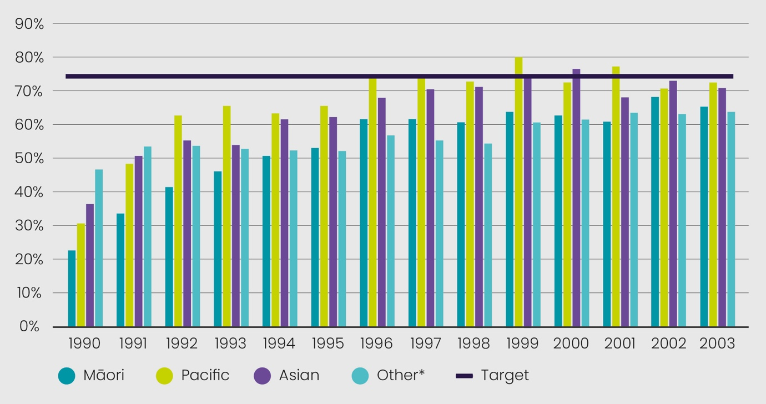
*Other includes all ethnicities except Māori or Pacific or Asian.

Cervical Screening Coverage
Māori, Pacific and Asian people have experienced lower cervical screening coverage rates compared to other people. Cervical screening rates have been declining for Māori and Pacific people since 2017 as reported in Figure 2; decline for Asian participants is likely due to COVID-19 disruption (Ministry of Health, 2019a, 2022a). Declining cervical screening coverage for Māori and Pacific people has been occurring over a number of years. Māori and Pacific people encounter a number of barriers, which reduce their likelihood of participating in cervical screening. These barriers include previous negative cervical screening experiences, cost, inadequate provision of health information, transport and lack of cultural competence (Cook et al, 2014; McPherson et al., 2019; Scott-Melton, 2019).

Figure 2 – NCSP coverage % of women aged 25-69 years in the six years ending 31 March 2022 by ethnicity. (Ministry of Health, 2019a, 2022a)
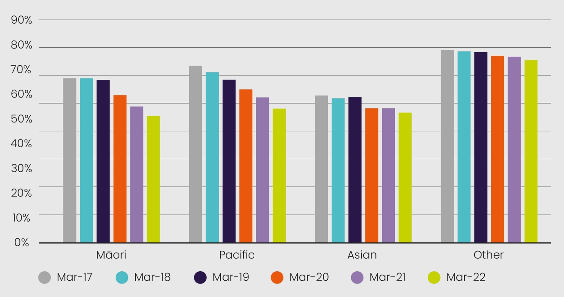

Colposcopy
Māori, Pacific and Asian people experience delays to colposcopy assessment following high-grade cytology. These delays occur at different time points and over time, engagement with colposcopy services improves. The independent monitoring report (Smith et al., 2022) measures timeliness of colposcopy assessment following high-grade cytology at 20, 40, 90 and 180 days. This is measured either from the date of referral or date of screening. Due to measuring different time points there is a difference in timeliness to assessment. There are lower attendance rates at 90 days when compared to 40 days, as these use different time points to measure. For example, the 90-day time point is measured from the time of screening. This may represent delays at the primary care interface prior to referral to colposcopy.
The current independent monitoring report (Smith et al., 2022) does not establish why delays occur in the current pathway as this information is not collected. The six-monthly colposcopy services report provided to the NCSP documents reasons for delays but not by ethnicity.
Māori, Pacific and Asian people experience delays in the first assessment at each of the time points. A considerable proportion of Pacific people experience delays between referral and the 20-day waiting time. There was improvement in the 2019 data for Pacific people, however there is still a considerable disparity in accessing colposcopy services when compared to the European/ other group (Smith et al., 2022). These disparities highlight the systemic barriers Māori and Pacific people face accessing colposcopy services. Barriers are complex and multifactorial and include cost of accessing services such as parking, taking time off work and transport costs. Lack of choice about the gender of the colposcopist, inadequate provision of health education/information, poor cultural competence of providers, fear and concern about the examination, and accessibility of services (Adcock et al., (2021); McPherson, 2020).
The 2020 data reports improvement with access at 40 days. However, more than a quarter of Pacific people have not been seen within 40 days and this is slightly less for Māori and Asian, but still not comparable to European/other participants.
Pacific people continue to experience delays in accessing colposcopy services at 90 and 180 days. This indicator is measured from the time of cytology rather than time from referral. The gap is closing between Māori and Asian participants when compared to European/other. There is an improvement in attendance in all groups by 180 days which is positive, however Pacific engagement is still behind (Figure 5). It is important to note the NCSP Register team tracks all high-grade cytology referrals to ensure there is a plan in place for assessment

Figure 3 – Trends of the proportion of people with a high-grade cytology report (no suspicion of invasive disease) seen within 4 weeks (20 working days), by ethnicity.
(Smith et al., 2022)
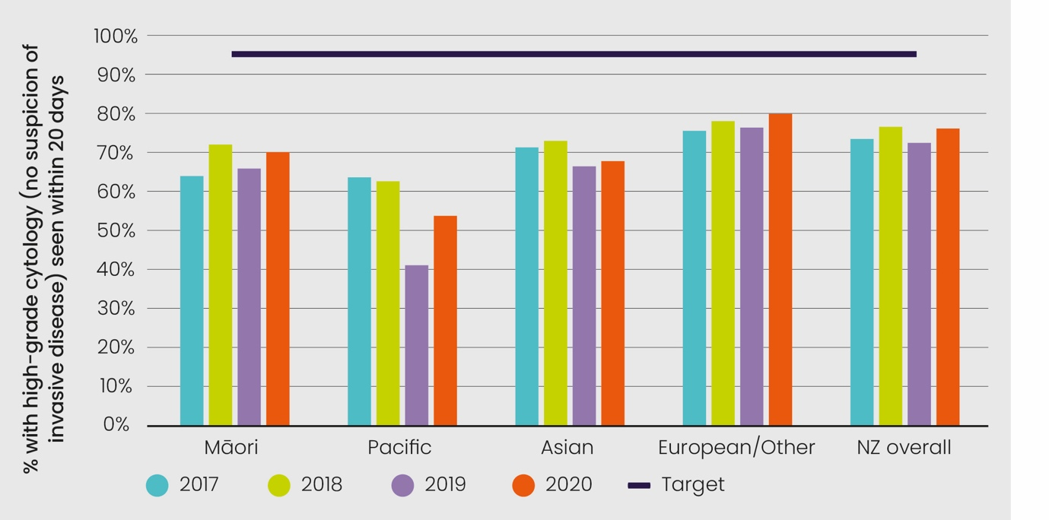

Figure 4 – Percentage of people with a high-grade cytology (no suspicion of invasive disease) with a colposcopy visit within 20 and 40 working days, by ethnicity.
(Smith et al., 2022)
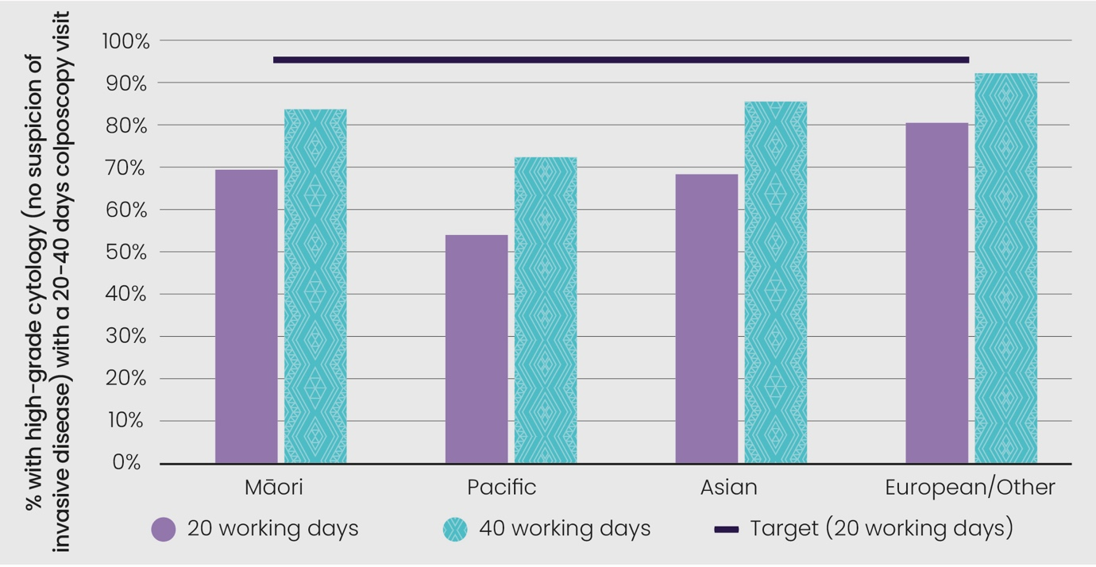
Māori and Pacific people experience delays in the assessment of low-grade abnormalities. While the risk of cancer is extremely low among this group, the data identifies the inequities for Māori and Pacific people in Figure 7.
The PRC received feedback that the use of the term colposcopy was a barrier for women engaging with the programme. We encourage the discussion about new terminology in the co-design process.

Figure 5 – Trends in the proportion of people with high-grade cytology who have follow-up within 90 days recorded on the NCSP Register, by ethnicity.
(Smith et al., 2022)
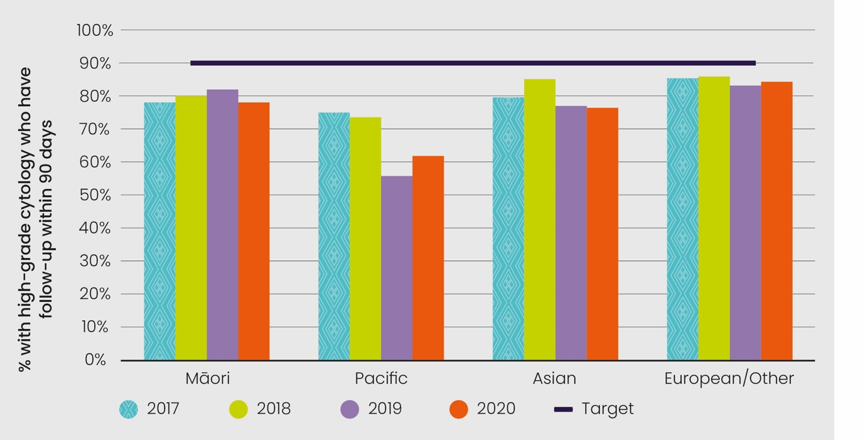

Figure 6 – Trends in the proportion of people with high-grade cytology who have follow-up within 180 days recorded on the NCSP Register, by ethnicity.
(Smith et al., 2022)
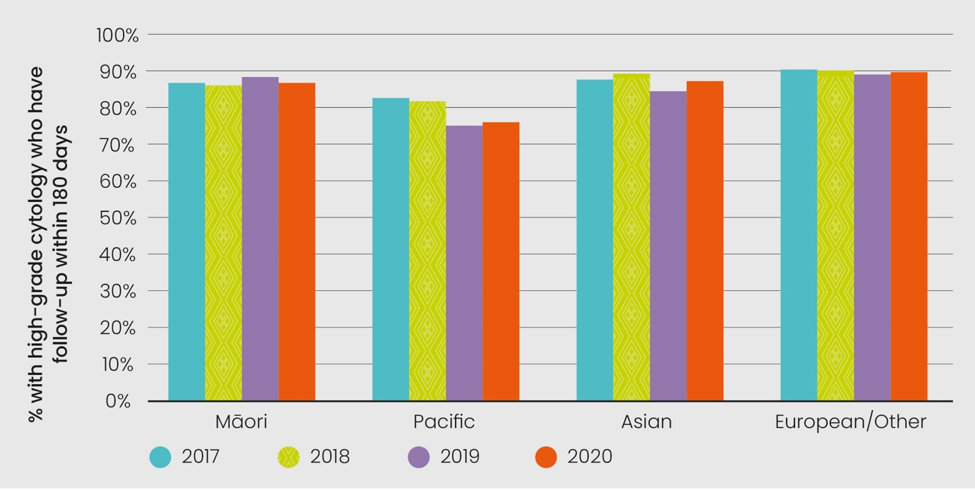

Figure 7 – Trends in proportion of people with persistent LG cytology or LG cytology and positive hrHPV test and an accepted referral for colposcopy who have a colposcopy visit recorded within 26 weeks of the date the referral was accepted, by ethnicity.
(Smith et al., 2022).
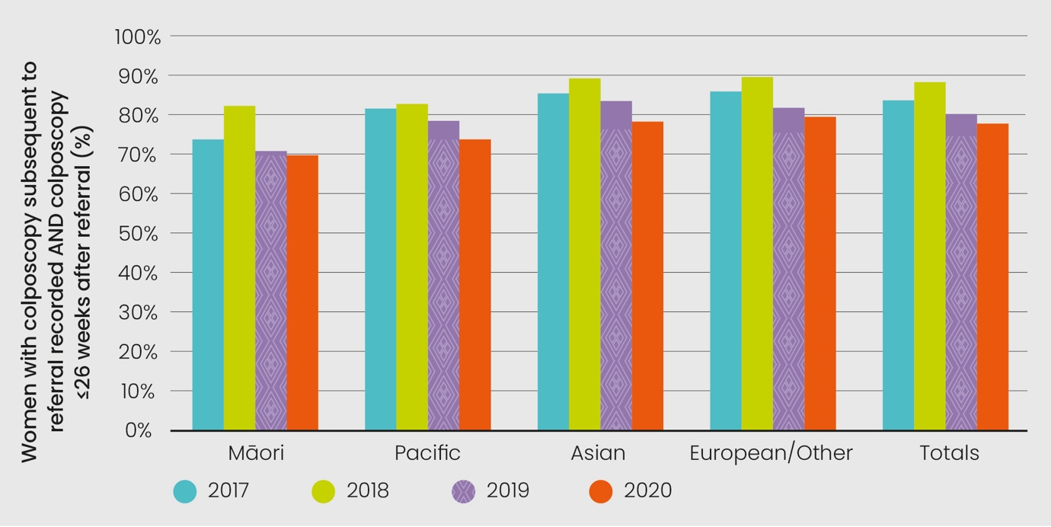

Primary Care: Historical Test of Cure
Following treatment of high-grade abnormalities, a test of cure pathway is undertaken to ensure there is no residual disease and participants can safely return to three-yearly screening. It is recommended cytology and HPV testing be taken 12 months apart, and following two negative test results participants can return to three-yearly screening. Annual screening is recommended until the test of cure pathway is complete. Participants treated more than three years ago can complete an historical test of cure. The sample taker requests HPV testing at the time of cervical screening and this does not appear to occur for all women. The independent monitoring report shows improving trends in the historical test of cure HPV testing pathway (Smith et al., 2022). However, Figure 8 shows Māori, Pacific and Asian people are less likely to have an HPV test requested for a test of cure in primary care following treatment. The PRC was unable to determine why Māori, Pacific and Asian people are less likely to have the HPV test requested.
Figure 9 indicates there is a drop-off when a second Test of Cure is required for all participants. This appears to be greatest for Māori and Pacific people.

Cervical Cancer Incidence
Māori and Pacific people experience a higher incidence of cervical cancer when compared to Asian and others. There is an increasing incidence of cervical cancer among Pacific people. While the cervical cancer incidence has decreased for Māori, in 2019 the incidence was twice that of the WHO strategy goal for the elimination of cervical cancer (Ministry of Health, 2022b; World Health Organization, 2020).

Figure 8 – Trends in the proportion of eligible people with squamous high-grade abnormality more than 3 years ago, for whom a Round 1 historical test is recorded on the NCSP Register, by ethnicity.
(Smith et al., 2022)
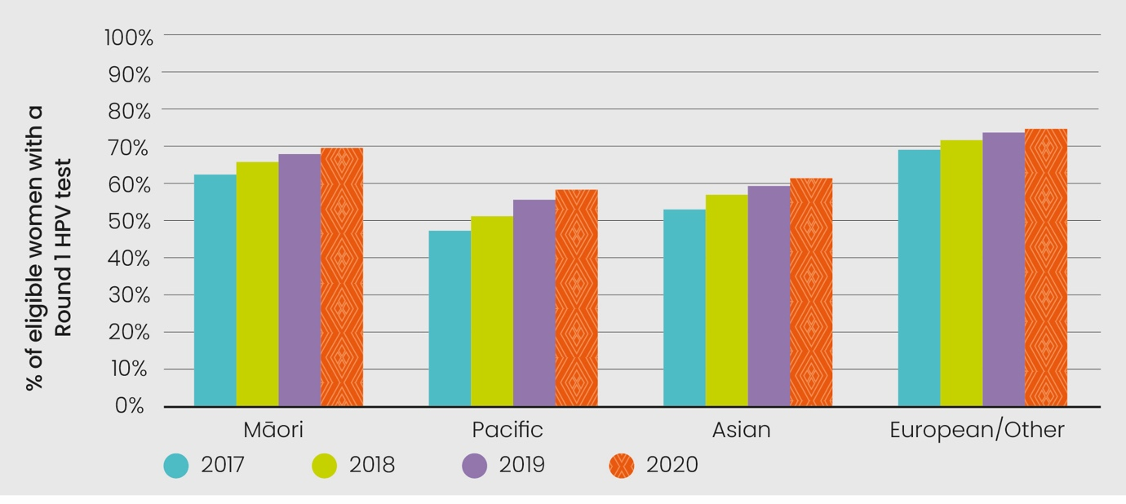

Figure 9 – Proportion of eligible people with squamous high-grade abnormality more than 3 years ago for whom an historical test is recorded on the NCSP Register, by ethnicity at 31 December 2020.
(Smith et al., 2022)
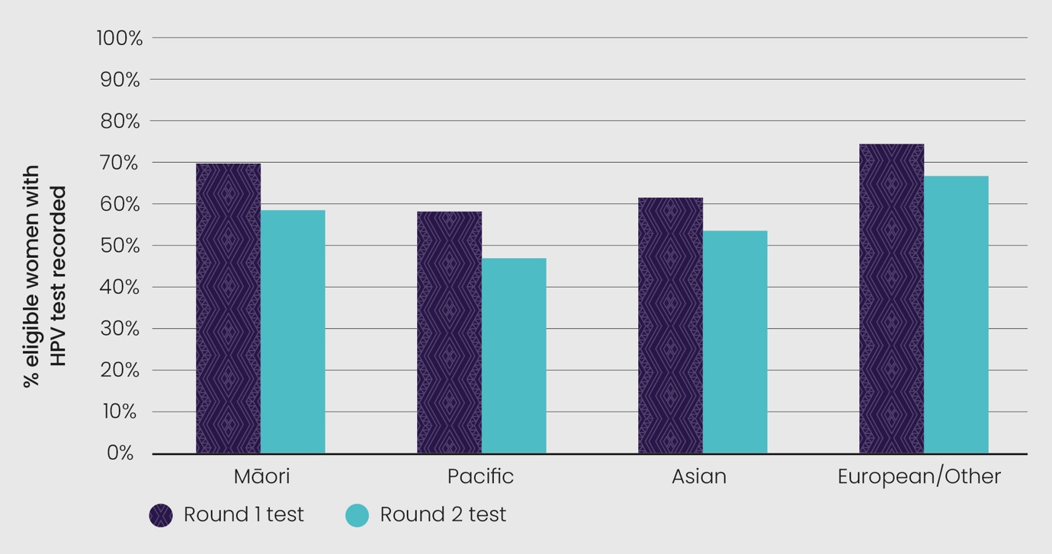

Figure 10 – Age-standardised cervical cancer incidence rates, 2011–2019, by ethnicity.
(Ministry of Health, 2022b)
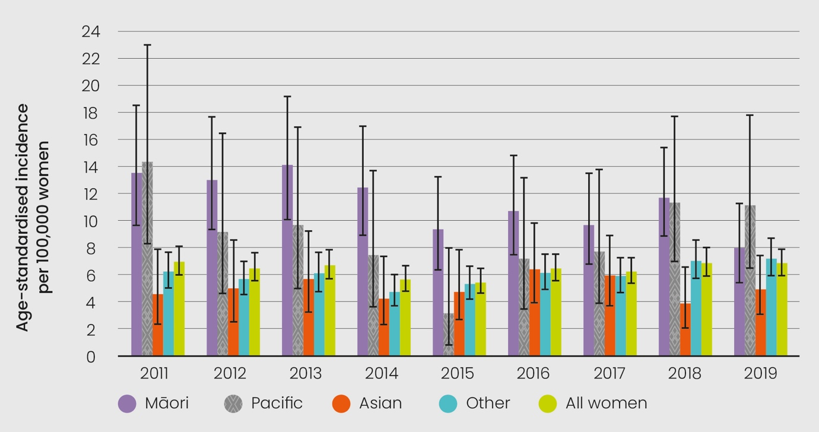
Cervical Cancer Mortality
The age-standardised cervical cancer mortality is higher among Māori and Pacific people. In 2018, there were 69 deaths due to cervical cancer, or an age-standardised rate of 1.9 cervical cancer deaths per 100,000. Figure 11 shows cervical cancer mortality rates overall and by ethnicity (these are 4.5 for Māori, 3.5 for Pacific, 0.7 for Asian and 1.6 for others) (Ministry of Health, 2022b). The disparity Māori and Pacific people experience accessing cervical screening and colposcopy services negatively impacts on both the cervical cancer incidence and mortality rates.

Figure 11 – Age-standardised cervical cancer mortality rates, 2010–2018, by ethnicity. Vertical bars represent 95 percent confidence intervals. Note: no deaths were recorded for Asian women in 2011.
(Ministry of Health, 2022b).
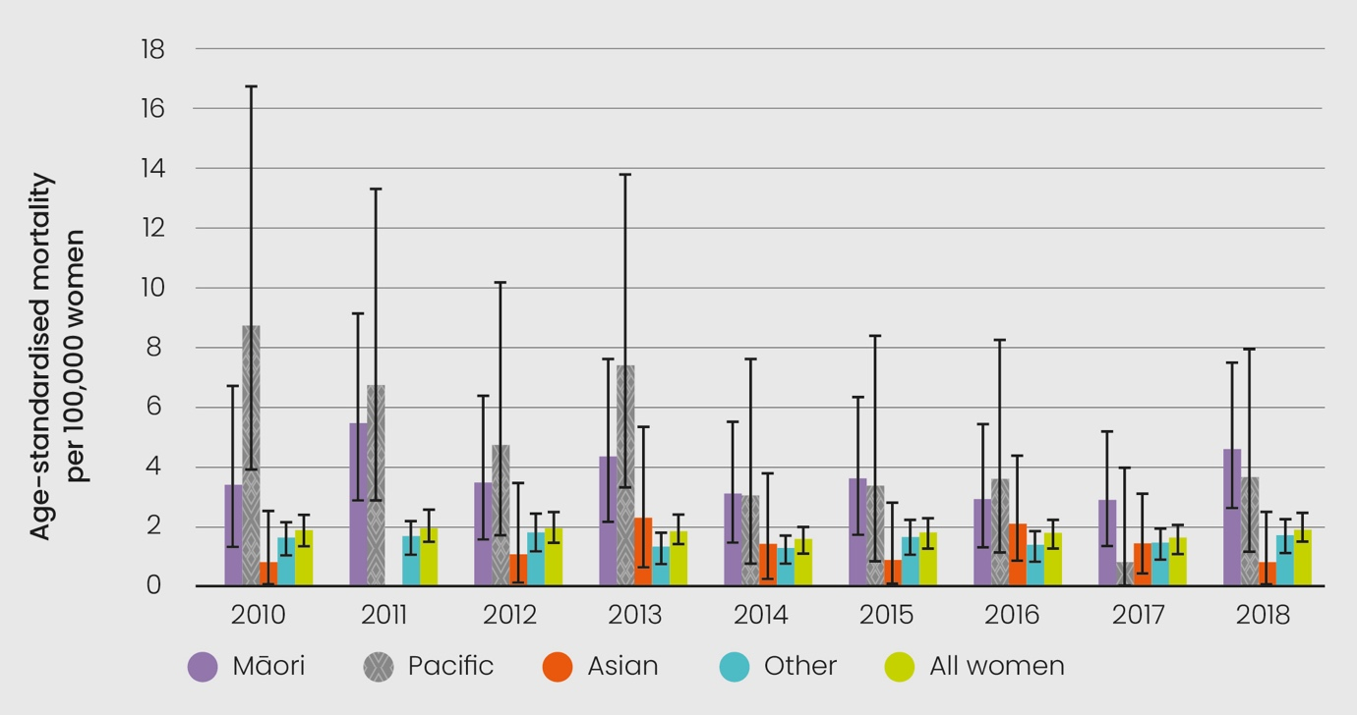

Te Tiriti o Waitangi
Recommendation 1
Te Tiriti o Waitangi needs to be central to cervical screening policy, governance and practice. There is currently patchy and inconsistent engagement with Te Tiriti across the programme.

The PRC has made Te Tiriti recommendations regarding accessibility, integration, monitoring and evaluation, governance and workforce capacity and capability. Collectively these recommendations aim to strengthen Māori leadership and co-governance across all levels of the programme. It is envisaged that Māori-led service delivery and coordination will enable Māori providers, minimise the impact of racism and improve Māori health outcomes. Introduction of a kaupapa Māori evaluation culture will strengthen Māori advancement and inform equity efforts. The programme will be strengthened through engagement with Te Ao Māori and a tailored workforce development programme around Te Tiriti, equity, cultural safety and anti-racism.

Recommendation 2
The PRC recommends the proactive appointment of senior Māori staff in the NSU in alignment with the NSU’s strategic priorities.

Case for change
Te Tiriti is considered by many to be the foundation of health policy and practice in Aotearoa. It is a responsibility of the Crown to protect and promote Māori health (Cabinet office, 2019). Ongoing breaches of Te Tiriti continue to impact negatively on hauora Māori (Reid et al., 2018). These breaches can be mediated, but public health advocacy is also required to build public policy infrastructure to mitigate this systemic disadvantage.
A robust way of assessing engagement with Te Tiriti is to ask specific questions about engagement with the five elements of Te Tiriti o Waitangi (the Māori text) (Came et al., 2020; O’Sullivan et al., 2021). The PRC consistently asked key informants specific Tiriti questions and conducted a high-level review of strategic and operational documents for evidence of engagement with Te Tiriti. Recommendations informed by this analysis appear across the entire parliamentary review report but are also presented in this dedicated Te Tiriti section.
Across the key informant interviews Māori providers and practitioners demonstrated strong, consistent commitment to Te Tiriti. Tauiwi engagement had more gaps or was absent. Māori colleagues reported having to advocate to get Māori aspirations in the strategic priorities of the programme. The underfunding of the programme makes it harder, but not impossible, to achieve equitable outcomes.

Preamble
The PRC noted the incongruence of claims of strong relationships from some
non-Māori stakeholders alongside clear counter narratives of more difficult and challenging relationships from Māori. In the context of Te Tiriti it seems useful to privilege Māori perceptions of the quality of relationships and collaboration; rather than Tauiwi self-auditing the quality of relationships, Māori should be able to make that determination.
The Waitangi Tribunal (2019, p. 92) has outlined the following expectation in relationship to engagement with Māori: “Crown agents need to be wholly conversant with the process and manner in which their partner wants, and needs, to engage with them.” This is an area of development for many across the screening pathway who need to deepen and expand their relationship with Māori.
The PRC encourages a renewed commitment to whanaungatanga – the active process of relationship building – across the sector. Some of this can occur organically at a local level, but it could be enabled through deliberate investment in regional/national hui. This whanaungatanga needs to extend between the NSU and its advisory groups; some of these rōpū would benefit from greater manaaki and role clarity (see Recommendation 9).

Kāwanatanga
It is clear to the PRC that the NSU has been deeply considering their Te Tiriti responsibilities. This commitment does not appear to be reflected in their appointment of Māori staff within the NSU. There are Māori in advisory roles across the screening/treatment pathway, some of whom seem to carry a disproportionately high burden of responsibility for outcomes for the programme. The proactive appointment of staff including senior Māori staff would align with the NSU’s strategic priorities. Māori leadership is needed to reach under-screened and unscreened populations.
When asked about Te Tiriti engagement Tauiwi frequently named Māori colleagues rather than articulated their own contributions. The PRC recommends investment in stair-cased Te Tiriti, equity, cultural safety and anti-racism workforce development opportunities across the programme, including the NSU, to strengthen baseline competencies (see Recommendation 24). National leadership is needed around Te Tiriti implementation, as well as proactive local planning and engagement around the five elements of Te Tiriti – preamble, three written articles and the oral article. Fundamental to Te Tiriti implementation is honest assessment of where engagement is at, setting aspirational targets of where one wants to be and realistic next steps ideally ed and/or designed with Māori.
The PRC understands there is a high-level working group looking at co-governance across all the screening programmes. A Māori governance lens overseeing the system is likely to strengthen Te Tiriti compliance. The PRC supports the establishment of Tiriti based co-governance for screening programmes and encourages the next parliamentary review to examine the success of its establishment and implementation with a tool such as Critical Tiriti Analysis (Came, O’Sullivan, & McCreanor, 2020) (see Recommendation 18).

Tino rangatiratanga
The Waitangi Tribunal (2014) ruled that Ngāpuhi never ceded tino rangatiratanga. The implications of this remain largely unexamined in the context of the health sector. Wihongi (2010, p. i) has described tino rangatiratanga as “a complex, fluid, multi-faceted and context related concept” that encompasses sovereignty, self-determination and positive Māori development. She maintains the enactment of tino rangatiratanga within the screening programme requires Māori leadership at national, regional and local levels. She noted most cervical screening services are owned and operated by Crown agencies and that the Crown controls policy processes and thereby health outcomes.
Māori sovereignty and self-determination appears limited within the current configuration of the screening programme. An exception is Māori control over the access to Māori data through the National Kaitiaki Group.
Māori providers are an active expression of tino rangatiratanga. They are often hapū based, draw on mātauranga Māori such as rongoā and provide holistic whānau ora services. They provide services which are both clinically and culturally safe but are burdened with underfunding (Waitangi Tribunal, 2019) and racism embedded within contracting processes (Came et al., 2018; Eggleton et al., 2021). The Waitangi Tribunal (2019, p. 167) has recommended an urgent and thorough review of the underfunding of Māori health. The PRC recommends immediate and increased investment in Māori health providers to improve Māori health outcomes. Māori leadership is needed to engage with Māori who are under-screened or not yet screened.
The PRC welcomes the establishment of Te Aka Whai Ora and anticipates future parliamentary reviews will gain useful insights through engagement with this key Crown entity. The PRC expects to see greater investment in Māori providers under their leadership. Given this significant development the PRC recommends close scrutiny and tracking of screening investment into Māori providers going forward and that this be examined by future parliamentary reviews.

Ōritetanga
Equity is a strategic priority for the programme. Considerable energy is being invested across the sector in achieving equity targets and establishing mechanisms to prioritise and centre this work. The bulk of the resources within the screening programme however continue to be invested in delivering screening and treatment to all eligible people. Business as usual has not disrupted systemic ethnic inequities, so the needs of Māori and Pacific communities and other underserved communities need to be prioritised (see Recommendation 2).
Universalism is important for all population-level screening programmes. Unfortunately, the current configuration of the cervical screening programme is benefiting some groups and disadvantaging others (Mcleod et al., 2011; Sykes et al., 2019). Research confirms Māori frequently experience racism when accessing health and other essential social services (Smith et al., 2021; Talamaivao et al., 2020). Racism manifests as Māori experiencing less quality and quantity of care, which often results in poorer health outcomes. With one in three Māori living with a disability (Hickey & Wilson, 2017), purposeful engagement with the disability community remains an important equity issue.
The PRC encourages consideration of proportionate universalism (Francis- Oliviero et al., 2020) and Māori leadership to address the historic inequities within the programme. Going forward the PRC recommends a reorientation of the programme and the development of a community-based approach to screening and treatment services to permanently address systemic inequities (see Recommendation 2).
The sector is optimistic about the possibilities of self-screening making a real impact on reducing inequities. Initial local research shows that the option of self-testing is highly acceptable to Māori, and provides an opportunity for bodily autonomy (Adcock et al., 2021; Sherman et al., 2022). Some key informants identified, however, that a concurrent change to the programme delivery model would be necessary to reduce the inequities. Simply implementing a new test without a new delivery model would not be sufficient to close the equity gap (see Recommendation 2).
Māori have a right to monitor the Crown (Reid & Robson, 2007). Within the screening programme there is a Māori Monitoring and Equity Group. Structurally they are an advisory group and “…they alone are not able to give expression to Māori rights and expectations under Te Tiriti” (Baker & Talamaivao, 2022, p. 3). To strengthen Māori monitoring the PRC recommends the formation of an independent, Māori-led, Māori-designed monitoring framework and resourced rōpū. The introduction of a kaupapa Māori informed evaluation culture across the sector would help monitor the overall equity focus of the programme. The PRC noted the efficacy, usefulness and relevance of kaupapa Māori evaluation approaches (Cram et al., 2018) and recommends investment in workforce development in this area (see Recommendation 17).
Stronger ethnicity data collection would provide more robust data and allow more tailored interventions and follow-up across the screening pathway with priority communities. Current data quality falls short of Māori data expectations. Ideally ethnicity data should be able to be broken down to iwi/hapū level. The PRC recommends a continued focus on improving ethnicity data collection in partnership with the Ministry’s Māori data sovereignty group and provision of reports in a form that is accessible and useful for Māori monitoring groups and health providers. Māori providers need the same access to screening data as their Crown-owned agency colleagues. Further, Māori providers should be resourced to access and analyse this data and support whānau to access their own data.

Tikanga and wairua
The health and wellbeing of wāhine is central to the health and wellbeing of whānau, hapū and iwi (Pihama, 2001). Te whare tangata is sacred and wāhine have a unique role to play in preserving whakapapa and nurturing the next generation (Adcock et al., 2021). Mana wāhine is a celebration and recognition of the strength of Māori women. These deep mātauranga understandings need to inform the design and delivery of screening and treatment services. Māori consistently raised with the PRC their desire for the programme to honour the mana of wāhine Māori.
Durie (1998) has always argued that engagement with tikanga and more specifically wairua is central to wellbeing for Māori. Under Te Tiriti, Māori have the right to manage their own affairs in accordance with tikanga. The Waitangi Tribunal (2019) has ruled that “…publicly funded health institutions must respect tikanga Māori” and that funding arrangements need to ensure Māori providers (p. 31) “…can design and deliver health care services to Māori patients using a tikanga Māori framework” (p. 58).
Screening documents reviewed by the PRC emphasised the importance of cultural appropriateness. The detail of what is culturally appropriate is not clearly articulated. Current scholarship recommends centring cultural safety as opposed to cultural appropriateness (Curtis et al., 2019). Cultural safety centres Te Tiriti, recognises institutional racism and demands a nuanced analysis of power (Wepa, 2015). Cultural safety also involves warmth, connection, humility and self-awareness. Critically, the user of any service and their whānau make the determination of appropriateness/safety (see Recommendation 24).
The PRC recommends the programme strengthens its engagement with tikanga and wairua. Given the sensitivity of cervical screening, all those associated with the programme need a base-level proficiency in tikanga and cultural safety. Stair-cased and tailored workforce development opportunities need to be made available for Tauiwi and Māori. The PRC also recommends audit standards for screening and colposcopy services to address their current silence in relation to tikanga and wairua.

Accessibility
Recommendation 3
The cost of screening has been consistently identified as a major barrier to achieving the aims of the NCSP. Cost barriers perpetuate cervical cancer inequities that breach Te Tiriti o Waitangi responsibilities. The 2022 PRC reaffirms the recommendation of the 2018 PRC that all people should receive free cervical screening to align it with all other cancer screening programmes in Aotearoa and recommends appropriate funding processes are pursued to achieve a fully-funded cervical screening programme by 2024.

Case for change
The 2022 PRC considers the evidence provided by the previous three parliamentary review committees as sufficient evidence that cost barriers perpetuate cervical cancer inequities that breach Te Tiriti o Waitangi responsibilities (Ministry of Health, 2011, 2015, 2019b). The 2011 PRC stated “The fact that most new cases and deaths occur in women from ethnic and vulnerable groups represents inequitable access to service – an urgent issue that must be addressed” (Ministry of Health, 2011, p. 30). The 2015 PRC acknowledged NCSP efforts in achieving screening for 76.4% of the eligible population, and stated that to improve coverage the cost of screening must not be a barrier for high-priority people (Ministry of Health, 2015). The 2018 PRC identified the cost of screening as a major barrier and all eligible people should receive fully-funded cervical screening, to align cervical screening with all other cancer screening programmes (Ministry of Health, 2019b). During this parliamentary review key informants consistently advocated for a fully-funded programme:

“What will enhance cervical screening the most will be if it was fully funded
and free at the point of care. The biggest barrier is you cannot just go to your general practitioner and get your population health screening programme for free like you can for bowel and breast. So, why not the cervix?”

“Again, that’s because we are still charging people to have their smears taken. By moving to self-testing with HPV screening, that would remove one of the big barriers. But we still need to stop charging people for smears.
I mean, we’ve got free bowel screening, we’ve got free mammograms, why haven’t we got free cervical screening?”

Inadequate funding for the programme exacerbates systemic, organisational and individual barriers for both the people accessing, and those delivering services across the cervical screening, prevention and treatment pathway (Armstrong & Murphy, 2008; Best Practice Advocacy Centre New Zealand, 2009; Gao et al., 2008; Jameson, 2010; McLeod et al., 2011; Pacific Research and Policy Centre, 2016).
Currently available free screening funding falls short of requirements to reach all priority people, and the method of allocation creates confusion for some service providers. Funding is not provided equitably to providers across Aotearoa. Priority group people are generally unaware they may be eligible for free screening. These factors lead to inconsistent access to free screening.

“We took a position a number of years ago that we would focus our free
priority screening to Māori and Pacific women… what we found over the last
couple years, it’s really quite difficult for primary care to be able to still deliver that. So even though we’ve said “Well, here’s the funds, we’re taking it to this area,” that doesn’t mean that everybody is equipped to do that.”

The World Health Organization (WHO) cervical cancer elimination strategy (2020) identifies political support and equitable access as key requirements for a country to achieve an elimination strategy (see Recommendation 8). The 2022 PRC considers it important for this and future governments to ensure all eligible people receive free cervical screening and recommends appropriate funding is pursued and achieved by budget 2024.

Recommendation 4
Investment in an integrated, accessible model of community-based cervical screening is recommended. The new model should be the first line of screening for all eligible people rather than a support service that picks up those who have been missed by general practice. It should be designed to meet the needs and preferences of Māori, and others such as Pacific and Asian communities who have historically been unscreened or under-screened. This will strengthen Māori leadership and influence over the programme and benefit all eligible communities. (Recommendation 9 elaborates further).

Case for change
Every person eligible to be part of the cervical screening programme should have access to clinically and culturally safe care. The current system is not consistently working, especially for those communities who are unscreened and under-screened (Mcleod et al., 2011; Shea et al., 2021; Sykes et al., 2019). Key informants during the review indicated that where the system appears to be working for priority people, its functionality is not by design, but instead due to the efforts of individuals working along the continuum of cervical screening pathway learning, adapting and responding to their respective communities.

“You can have some pockets of really fantastic practice where people
are doing really proactive, whanau centred care, or they’re providing
really accessible care. But it’s not systematised. So it relies on individual
initiatives, or the support that can be put in place, or this great collaboration,
but it’s not across the board. And nothing in our current system requires it to be across the board in the way that it should be. So we still have patches of great practice and some workarounds, but they’re not embedded sufficiently to be able to say, ‘Yeah, we feel like we’re really tackling this.”

The impact of mono-cultural practices, culturally unsafe delivery, and institutional racism in health funding has been documented (Came et al., 2018; Harris et al., 2012a, 2012b). The 2022 PRC heard a range of practices across Te Whatu Ora localities, which varied from culturally safe practice to a lack of safety and awareness. The Professional Association for Transgender Health Aotearoa (PATHA) informed the 2022 PRC of positive examples of formalised, transgender peer support services as part of gender-affirming healthcare pathways:

“In a couple of the DHBs, there is a formalised transgender peer support
service as part of the gender affirming health care pathway. So in the northern DHBs and Canterbury, I think are the two places at the moment.
And that’s… a service where essentially trans people can access a peer worker to talk through anything to do with their gender.”

These specialists indicate further work is required to support an inclusive approach and access to the cervical screening pathway for those with diverse gender identities and sex characteristics. However, they highlighted the lack of funding available to scale up such programmes. This is one example of what is required for the cervical screening prevention, treatment and cure pathway to become culturally safe.
Currently, general practices are the main providers of cervical screening and referrals for specialist assessment and treatment. The cost of providing screening in this setting is covered by general practice capitation funding and patient co-payments. Some general practices access some of the limited free screening funding pool for Māori, Pacific people and others who are unscreened or under-screened.
To access capitation funded cervical screening, patients must be enrolled with a general practice, otherwise they will be required to pay the full cost. About 6% of eligible people were not enrolled in a general practice in 2019, and enrolments remain below full population coverage with ethnic, socio-demographic and geographic inequities (Irurzun-Lopez et al., 2021). Those who are not enrolled in a general practice may be unable to secure an appointment as a casual patient, nor afford the full cost of screening.
The general practice model of service delivery has contributed to access issues that impact on both cervical screening coverage and treatment outcomes. These issues include cost, appointment availability, opening hours, fixed location of service delivery, and racism (Jatrana & Crampton, 2021). Māori and Pacific owned practices, which tend to have an integrated whānau-centred healthcare model, are often proactive in accessing free screening funding and many do provide out of hours and outreach clinics to improve access.
Within the current service delivery model, support to services was created as a mitigation to systemic failure within the current system. The evaluation of the support to services model identified the significant value of these services in identifying and reducing access barriers (Shea et al., 2021). Accessing support to services however is most often via a referral from general practices or colposcopy services and most people who would benefit from it do not receive it. This is a problem of service fragmentation.
Internationally, governments are trying to address and overcome fragmentation of services through the development of integrated care initiatives. A common definition of integrated care is “a coherent set of methods and models on the funding, administrative, organisational, service delivery and clinical levels designed to create connectivity, alignment and collaboration within and between the cure and care sectors” (Kodner & Spreeuwenberg, 2002, p. 3). Calciolari et al. (2022) have been working on how to achieve service integration across seven domains, to achieve simultaneous innovation at the macro, meso, and micro level. Addicott (2014) has been exploring new models of commissioning and contracting clinical services, while examining fragmentation within the health sector. Commissioning and contracting are key systemic levers, attributed to both fragmentation of services as well as integration.
The 2022 PRC considers the NSU has a unique opportunity within the current health reforms, under the leadership of Te Aka Whai Ora and Te Whatu Ora, to review the current contracting model and reorient funds towards the investment in an integrated and accessible model of community-based cervical screening. Systems and services need to be designed to eliminate inequities, and the NSU has a key role to play as the main funder and commissioner.
One of Calciolari et al.’s (2022) seven domains to achieve integrated care and innovation is person-centred care, described as improving someone’s holistic wellbeing through the active engagement of service users as partners in care. Within the context of the screening pathway, the integrated service needs to partner with Māori, Pacific and Asian communities and others who have historically been unscreened or under-screened to design services that meet their needs and preferences.
Procurement and contracting needs to be explored within the Te Aka Whai Ora and Te Whatu Ora partnership, so that Te Tiriti o Waitangi is embedded at all levels of governance and delivery. The integrated services should be fully funded and designed to meet the needs of those in their communities with the highest inequitable health outcomes. Māori and Pacific health and social service providers are already demonstrating leadership in this space, so the 2022 PRC recommends investing in these services to lead local cervical screening programme coordination and delivery, with the aim to reduce well documented persistent inequities across the pathway.

Recommendation 5
Improved accessibility to colposcopy services is required particularly for Māori and Pacific people. Delivery of colposcopy services should be co-designed to meet the needs and preferences of Māori and Pacific people who historically experience delays in accessing colposcopy assessment and treatment.

Case for change
The NCSP independent monitoring reports have consistently reported Māori, Pacific and Asian people experience delays in accessing colposcopy services following high-grade cytology (Ministry of Health, 2022b; Sykes et al., 2019). One third of people screened prior to diagnosis of cervical cancer had an abnormal screen in the preceding 6-84 months. Māori and Pacific people were over-represented in this group, with 40% of Māori and 53% of Pacific people who were screened having a high-grade cervical cytology compared to 16% for Europeans (Sykes et al., 2019). In addition to these findings there is evidence that the social determinants of health result in delayed assessment for Pacific people attending colposcopy services (McPherson et al., 2021).
The over-representation of Māori and Pacific people not accessing timely follow-up for assessment indicates there are systemic barriers to accessing colposcopy services. Adcock et al. (2021) have highlighted that care must be taken when engaging Māori accessing colposcopy following a positive HPV self-sample test. Māori had a preference to be seen by female colposcopists, delivery of health information and results needed to be delivered in a sensitive and timely manner, and a supportive environment and assistance with transportation and petrol vouchers assisted engagement with colposcopy services for some. Research with Pacific people led by McPherson (2020) echoed these findings, but this community also wanted cultural support to navigate healthcare systems, free hospital parking, out of hours options, patient-focused booking, community-based colposcopy services and improved communication from providers (McPherson, 2020).
The PRC did identify some excellent examples of integrated approaches that enabled accessibility to colposcopy. Some Māori providers indicated they facilitated navigation of colposcopy services through pre-colposcopy orientation visits and providing culturally appropriate education and support. What was evident to the PRC is that this work is often time intensive and requires adequate funding. It is also reliant on individuals to develop relationships between different providers rather than a systemised approach.

“We’ve had a wonderful relationship with the Capital Coast DHB lead
colposcopy nurse for over 18 years now. So, what that means for us is
that we have a really great referral system from them. They understand
who we are, and what we do, and they value what we do, and that’s to
bring the wāhine that don’t want to go to colposcopy into colposcopy. We
can educate them… and even to the point where we are allowed to bring
that back in there and to orientate her own self and get familiar with the
surroundings before she actually goes for her appointment.”

The PRC recommends developing a co-designed approach to delivering colposcopy services that provides the opportunity to have a nationally strategic approach which meets the needs and preferences of Māori and Pacific people to reduce inequities. In the co-design, decision making needs to be shared between government, clinical specialists and Māori and Pacific community leaders.

Recommendation 6
The PRC recommends the NSU thoroughly explore opportunities for a change in the test of cure pathway to enable laboratories to perform HPV testing similar to the reflex HPV triage process. This would ensure access to this test for people who need it, and would not rely on the sample taker indicating the test was required on the laboratory form.

Case for change
Independent monitoring data and key informants’ interviews show the current test of cure pathway is not equitable for Māori, Pacific and Asian people. Barriers to accessing HPV tests of cure are evident. This may be due to the sample taker not requesting the test on the laboratory form. The simple solution is for laboratories to apply the HPV test of cure as a matter of course for eligible people. The PRC understands this issue is known to the NSU, which has to date not been able to influence change in laboratory practice due to questions of informed consent. The PRC believes the NSU should undertake more work to resolve this access issue which impacts disproportionately on Māori, Pacific and Asian people.

Recommendation 7
Racism is embedded across the screening pathway and is a modifiable determinant of health inequities. Anti-racism education has proven effective to moderate racism and it seems likely that upholding Te Tiriti o Waitangi will minimise racism against Māori. Systemic racism however is a wicked problem that is not going to spontaneously stop. We recommend the NSU co-design an anti-racism plan for the sector to coordinate, consolidate and strengthen existing efforts.

Case for change
Racism is a critical modifiable determinant of health inequity (Paradies et al., 2015). The PRC received anecdotal evidence of racism across the screening/ treatment pathway.

“It’s just that continued lack of contextuality, systemic accountability
to racism, colonisation—it’s a very deficit and siloed approach that
actually got this paternal aspect that it’s kind of like a woman’s lack of
access. And you know, it kind of puts it back on them, back on whānau, rather than actually power shifting.”

“The NCSP quarterly reporting, which is just general business, causes
continued harm, because the narrative is about the deficit approach. And it is through continuing that kōrero that’s perpetuated through everything. And it’s got to stop. These are the basic things about racism and colonisation people need to know.”

Institutional racism is often described as a “wicked problem” (Came & Griffith, 2018). Wicked problems are complex problems that are highly resistant to solutions. Racism has been defined as “an organised system, rooted in an ideology of inferiority that categorises, ranks, and differentially allocates societal resources to human population groups” (Williams & Rucker, 2000, p. 76). Racism has been firmly established as an important determinant of health, and an underlying cause of ethnic health inequities (Talamaivao et al., 2020). It is a dynamic system of power that endures and adapts over time, because it influences multiple mechanisms, policies, practices and pathways that ultimately affect health.
At a policy and practice level mono-cultural practice and institutional racism targeting Māori have been identified as normalised within the public sector since the 1980s (Ministerial Advisory Committee on a Māori Perspective for the Department of Social Welfare, 1988). Came (2014) has identified modifiable sites of racism in policy making and within health advisory groups (Came et al., 2019). She acknowledges that racism is widespread but maintains sites of racism can be mapped within a particular area of practice, such as human resource practice. You can then drill down further to determine how the racism operates and attempt an intervention – whether it be a policy change, training, or a new monitoring tool etc. Anti-racism practice is about analysing power, building relationships, and pragmatically it is also about having a go, reflecting and having another go. Anti-racism is not a feeling, it is a process and an action.
Addressing the problem of racism in a colonial context demands nuanced understandings of the impact of colonisation on Māori and other colonised people’s health, wellbeing and self-determination. Pihama et al. (2020) developed a kaupapa Māori analysis of determinants for population social outcomes. They present colonialism, as it manifests within historical, intergenerational and internal contexts, as well as state policy and practice, as an important determinant.

“Anti-racism is the art and science of naming, reducing, disrupting,
preventing, dismantling and eliminating racism. It takes a multiplicity of forms but centres around solidarity with those targeted by racism, an analysis of power and a commitment to reflective, transformative practice. In the context of Aotearoa it involves engagement with Te Tiriti o Waitangi”
(STIR & Public Health Association, 2021, p. 9).

Organisational engagement with anti-racism requires robust relationships with Māori, Pacific and Asian partners, stakeholders and colleagues. Dialogue and accountability need to be maintained with those targeted by racism to ensure anti-racism work is safe, appropriate and effective. Mechanisms need to be established so that sites of racism can be identified and disrupted through a planned action research and systems change approach (Came, 2014; Griffith et al., 2007).
The PRC acknowledges that assorted parts of the public sector are currently attempting to address systemic racism including work led by the Ministry of Health. The committee recommends alignment and engagement with this high-level work, but encourages the NSU to co-design an anti-racism plan with the sector which would contribute to coordinating, extending and consolidating existing ad hoc efforts. The co-design process should reflect Te Tiriti o Waitangi. Within the co-design process, the ultimate decision-making power needs to be held by Māori and others targeted by racism. This agile and comprehensive plan could not only enable coordinated sector action, but also accommodate local nuances and aspirations.

Elimination of Cervical Cancer
Recommendation 8
The PRC recommends the development of a national strategy for cervical cancer elimination. Consideration should be given to the World Health Organization (WHO) Global Strategy but must take into account Te Tiriti and the Aotearoa context. Specifically, we need an elimination strategy that prioritises Māori and Pacific people who carry the burden of cervical cancer incidence and mortality.

Case for change
The PRC key informant interviews and document review found the NCSP does not have a national strategy to eliminate cervical cancer. The NCSP annual report (Ministry of Health, 2022b) has a target for cervical cancer mortality of no more than 2.8 per 100,000 when age-standardised to the WHO Standard Population. However, we were unable to identify targets for cervical cancer incidence.
Previously, NCSP commissioned modelling has shown there could be considerable gains in reducing cervical cancer incidence and mortality inequities for Māori, by ensuring a coordinated approach to HPV vaccination, primary HPV screening and follow-up treatment (Kaljouw et al., 2021). The PRC noted there did not appear to be strong linkages between the current HPV vaccination programme and the NCSP to drive a coordinated approach for cervical cancer elimination.

“There are 250 people from all around the Indo-Pacific talking about elimination of cervical cancer… Everyone presents their work, as they
start to bring their HPV self-testing and the vaccination together… And
I think that we should really ratify the WHO elimination of cervical cancer [Strategy], but we need to do it equitably… we need to do it for all groups, particularly for Māori. Because we can’t actually achieve population elimination without equitable elimination. And if we don’t keep stressing that, we’ll end up with people saying “success!” and the rest of us will be a failure.”

In 2020 WHO released the Global Strategy to Accelerate the Elimination of Cervical Cancer as a Public Health Problem (2020). According to the Strategy, eliminating cervical cancer requires (i) political support from international and local leaders; (ii) coordinated cooperation among multi-sectoral partners; (iii) broad support for equitable access in the context of universal health coverage; (iv) effective resource mobilisation; (v) health system strengthening; and (vii) vigorous health promotion.
To eliminate cervical cancer countries must work towards an incidence below 4 per 100,000 people. To reach that goal, high coverage targets for HPV vaccination, screening and treatment of precancerous lesions, and management of cancer must be achieved by 2030 and maintained at this level to achieve ongoing elimination (World Health Organization, 2020).
The PRC recommends the development of a national strategy for cervical cancer elimination. The WHO global strategy (2020) was developed to eliminate cervical cancer and careful consideration needs to be given to how this applies to Aotearoa and benefits Māori and Pacific people. In Aotearoa, the intersection of colonisation, gender, racism and health marks the strategic focus for interventions. Progress towards the elimination of cervical cancer in Aotearoa hinges on developing an Indigenous-led and inclusive national strategy.

Integration
Integrated Community-Based Screening
Recommendation 9
To achieve an integrated, accessible model of community-based cervical screening it is recommended that current NCSP coordination, register coordination, support to services and free screening service specifications are combined into one integrated NCSP service specification for commissioning the existing network of Māori and Pacific providers. In localities where the NSU does not currently contract with Māori and/or Pacific providers new commissioning arrangements should be established. This reorientation is likely to minimise racism and other systemic barriers.

Case for change
Earlier in this report the PRC presented the case for a fully-funded cervical screening programme, and outlined fragmentation of current cervical screening services contributing to service inaccessibility. Evidence from previous parliamentary reviews (Ministry of Health, 2011, 2015, 2019b) has already presented the need for greater service integration. The 2011 PRC recommended there be greater communication and consultation with partners, stakeholders and decision-makers to optimise the benefit of scarce resources, avoid duplication and provide meaningful services (Ministry of Health, 2011). The 2015 PRC indicated that steps had been taken to improve regional coordination with providers, and recommended further strategies must be identified to rectify remaining issues of coordination and communication with regional providers (Ministry of Health, 2015). The 2018 PRC identified the need for current health investment to achieve long-term health goals and must be flexible so the system can respond to changing needs and evidence to ensure systems do not contribute to inequities for groups and individuals in accessing services (Ministry of Health, 2019b). What was also noted is the current NCSP Register technology is inflexible, and lacked the capacity to integrate and support a new HPV clinical pathway (Ministry of Health, 2019b).
During interviews with key informants the 2022 PRC continued to hear that the current cervical screening programme is fragmented. Te Whatu Ora and the NSU provide health promotion initiatives, Te Whatu Ora and Primary Health Organisations provide regional and local programme coordination, sample takers across multiple different organisations (individual GPs, Māori, Pacific and other NGO providers) are responsible for invitation and recall, and Te Whatu Ora colposcopy services diagnose and treat abnormalities. Support to services are provided by a range of NGOs Māori and Pacific providers and Te Whatu Ora. Support to services are not formally integrated into the screening pathway.

“Throughout Aotearoa there is great variability in access and equity, we could take those learnings and better apply them where their successes
are not happening. It seems that relationship with the NSU and that ability
to be more flexible and tweak these things doesn’t seem to happen. You could have a systemic approach to criteria, or we have timeliness, say to
colposcopy. And you could include with that, some of the other criteria that is equally significant as clinical criteria, and could systemise that across
the country. There are opportunities because we… we learn all the time but
we don’t seem to enact those learnings.”

The 2022 PRC also heard of the fragmentation of information and technology systems as well as limited communication and knowledge management strategies.

“And we’ve got an IT system that’s no longer fit for purpose, and can’t do all
of the monitoring activities that you would require in a programme like
this in the world that we live in right now. So we don’t have full visibility of
all of the parameters from one end of the pathway to the other, we can
only measure parts of the pathway with any degree of depth. So that’s a
significant issue that would be able to be addressed within the National
Screening Solution that we’re building.”

Many key informants involved in the development of the new National Screening Solution seemed to have taken into consideration input from previous reviews and engagement with key stakeholders. A common thread was the hope that this new information and technology system, and the way it operates, would fix many of the issues regarding fragmentation and eliminate the need for general practices to make referrals and support people to access the service they need.

“And yeah, lots and lots of opportunities and the new register actually could,
could really support that, you know, just a little bit of good IT could definitely
resolve some stuff. So, you know, with good operational reporting, that
happens to colposcopy units and to primary care or sample takers… non
primary care sample takers, we can really improve the visibility of where
women and people are in their journey. And that certainly enables a more
collaborative approach.”

Within the context of the cervical screening programme there is a lack of investment to deliver a fully-funded programme (see Recommendation 3), as well as NSU’s lack of influence and accountability, through contractual obligations, across parts of the service delivery that sit within primary care. In Recommendation 4 the 2022 PRC identified the current funding and contracting model as a key contributor to the fragmented system.
The 2018 PRC (Ministry of Health, 2019b) noted contracting as a contributor to the fragmented system. In seeking alignment with the New Zealand health strategy, they referenced a review of New Zealand’s health funding system (Ministry of Health, 2016b). They noted ways in which funding arrangements sometimes prevent resources from being used to achieve the best possible outcomes:
- inequitable funding for Māori health services, and the importance of the relationship between Māori and the Crown under Te Tiriti o Waitangi
- current funding arrangements may not clearly show the results that we get from health spending, making it hard to prioritise funding or take into account long-term, cross-sectoral benefits from investment
- the funding and contracting model does not enable adaptability of health service design to meet community needs. This encourages health services to keep doing things as they have always done them, instead of allowing them to work differently
- some funding arrangements contribute to disparities between groups in their access to services, and sometimes they widen the gap in unmet need “…tailored approaches are needed for some individuals and population groups so they can access the same level of service and enjoy the same outcomes as others…” (p. 92).

The establishment of Te Aka Whai Ora – the Māori Health Authority and a new national health system, Te Whatu Ora aims to deliver health and wellbeing services by establishing localities across Aotearoa and a three-year locality plan. There is an opportunity with this reform to address what this key informant described:

“Because we’ve got 20 Different DHBs with 20 different ways of doing things, and some areas have screening support services, and some don’t… maybe the move to Health New Zealand might enable a more streamlined way of doing that in the future… the programme will need to ensure that screening support is available across all of the regions to do that.”

New models of commissioning and contracting clinical services are being explored to achieve equity in outcomes, interagency and cross-agency partnerships, genuine collaboration and a drive for efficiency, effectiveness and innovation (Addicott, 2014; Glasby, 2012; Rees, 2014). Investing appropriately in the cervical prevention, screening and cure services to achieve outcomes requires the ability of the NSU to have the political, technical, and financial ability to implement strategic commissioning and requires the NSU to develop trusting relationships with providers and hold the long-term vision to support and realise an equitable elimination strategy (Boulton et al., 2018; Oakden et al., 2021).
The proposed approach with locality partnership, Iwi-Māori Partnership Boards, Te Aka Whai Ora and Te Whatu Ora, with plans that will detail how the goals set for a locality will be achieved, will influence procurement of services and be the basis for equity monitoring.
The 2022 PRC considers the NSU has a unique opportunity within the current health reforms, under the leadership of Te Aka Whai Ora and Te Whatu Ora, to reorient the programme delivery to place at the centre those who have been historically under-screened and unscreened.
This reorientation requires Te Tiriti to be the foundation of health policy and practice, drawing on mātauranga Māori and Tauiwi knowledges. Hauora is often conceptualised as encompassing a holistic understanding of physical, emotional, psychological, spiritual, and social wellbeing (Durie, 1998). If cervical screening services are to be culturally safe, individuals should not be reduced to body parts, and need to be instead considered part of their broader whānau and community. The integrated cervical screening service needs to be fully resourced, free for all eligible people. It should bring together the services specified under the current NCSP coordination, register coordination, support to services and free screening services.
There is an experienced and effective network of Māori and Pacific community-based primary care services that provide robust clinical and social services across Aotearoa. These networks already embody integrated health and social services, and should be central to the new model of integrated service. The PRC recognises the importance and centrality of kaiāwhina as navigators across the screening and treatment pathway. They have unique expertise in engaging with under-screened and unscreened populations.
An integrated NCSP service should bring together resources currently applied to NCSP coordination, register coordination, support to services and free screening. It needs to be fully resourced, free for all eligible people and maintain the capacity to innovate, adapt and learn. The holistic service should provide:
- culturally safe practice
- proactive community outreach
- patient-focused booking systems
- services that meet the needs of the disability and rainbow communities
- transgender and intersex specialist support services to promote a gender-affirming and diverse sex characteristics pathway
- services that meet the needs of people who have experienced mental illness, family and sexual violence.

Recommendation 10
The PRC recommends investing in research to understand the barriers to accessing the cervical screening pathway for people with physical or intellectual disability, members of rainbow communities, those with trauma histories and/or experiencing mental distress, and those who are incarcerated.

Case for change
There is a lack of comprehensive New Zealand research into the barriers for people with physical or intellectual disability, members of rainbow communities, and those with trauma histories and/or experiencing mental distress to access the cervical screening pathway. This contributes to the lack of visibility and tailored service delivery.
A recent report has identified cervical screening is available in the prison environment, however it also highlighted there are barriers for those who are incarcerated accessing gynaecological care. People are declining medical care due to the lack of privacy, use of restraints and correctional department strip search policy (Office of the Inspectorate – Te Tari Tirohia, 2021). There is a lack of data and research evaluating cervical screening coverage and access to treatment for those who are incarcerated. There needs to be robust systems in place to ensure those who are incarcerated are receiving appropriate screening and medical treatment.
One sector, trying to answer similar research questions that are being recommended by the 2022 PRC, partnered with communities so that the research was done by the community, for the community. From there good practice guidelines were developed collaboratively for frontline workers (Wharewera-Mika & McPhillips, 2016).
Such research would provide opportunities to develop community leadership and cross-sectoral collaboration, which would improve and address the fragmented system of programme delivery as well as access barriers to achieve equitable health outcomes.
- The sexual violence prevention and response sector under the leadership of Te Ōhaaki ā Hine – National Network Ending Sexual Violence Together.

Integration of Primary Care
and Colposcopy Services
Recommendation 11
To improve integration between primary care and colposcopy services there needs to be strong relationships developed between the new integrated model of community-based cervical screening and colposcopy services. The NCSP needs to support these relationships to reduce a siloed approach to the cervical screening pathway.

Case for change
The NCSP Policies and Standards (Ministry of Health, 2013) requires colposcopy services to deliver cultural competence throughout their service and be responsive to the diverse needs of people of all ages and sexual orientations. Colposcopy services must utilise Māori, Pacific and Asian support services, where they are available, to assist in locating, supporting and following up those referred for colposcopy.
From the interviews, the PRC identified colposcopy services were utilising different approaches to support people attending their clinic appointments. Some colposcopy services were proactive and offered support to Māori and Pacific people prior to their colposcopy appointment, as a way of removing health system barriers. In contrast, other colposcopy services instigated a referral to support services when people did not attend. These varying approaches were also noted in DAA audit reports.

“I think one of the things that really disappoints me in the current way
of working is that we tend to get an abnormal result, refer to colposcopy
and wait for a woman to Did not attend (DNA)… we don’t necessarily take a
proactive systems approach to go “right, find the practice nurse, and I know that my patient I’m referring actually has got six kids and works night shift and doesn’t have transport right now”, then why wait for her to DNA?”

There is a lack of visibility when people are referred to colposcopy, and support to services referrals are dependent on individuals and local service practices. There is an opportunity with the new register to make the pathway visible and for a new integrated approach that does not require referral between providers. The information could be available to community providers to support all Māori and Pacific people when a referral is received by colposcopy services, during follow-up and when people are discharged. The new IT system would require integration with Te Whatu Ora booking and scheduling systems to ensure visibility of appointments to support this approach.
The PRC noted some examples of excellent collaborative relationships between Māori providers and colposcopy services which ensured people received effective support. These included providers meeting or maintaining regular contact to ensure there was an integrated approach. There were also examples of providers collaborating with communities to deliver colposcopy in community clinics or mobile units. These came about as a result of monitoring data showing low attendance from identified demographic or geographic communities.

Recommendation 12
To enable effective integration of HPV vaccination, the NCSP should collaborate with NIR services to ensure providers along the cervical screening and treatment pathway can access information on the NIR to enable opportunistic HPV vaccination. Future information technology developments should include linked HPV vaccination data with the NCSP Register.

Case for change
Māori disproportionately have lower rates of HPV vaccination as outlined earlier in the document and this has been affected considerably by COVID-19. A key opportunity to improve coverage of HPV vaccination is to ensure integration between the NCSP Register and the NIR. People do not always know or remember their vaccination status. This integrated information would enable practitioners and kaiāwhina across the cervical screening pathway to routinely check HPV vaccination status, and then offer HPV vaccination as part of cervical screening and treatment.

Effectiveness of Monitoring
and Evaluation
Recommendation 13
Evaluation is a valuable mechanism to enable continuous quality improvement, Māori and Pacific advancement and equity. A key finding of the PRC was the variability in the use of monitoring and evaluation data and reports to drive improvements. We recommended the introduction of a kaupapa Māori evaluation culture to drive improvements in Māori health outcomes. We also recommend the NSU provide advice to the sector on best practice examples for utilising equity monitoring data for improved performance.

Case for change
Ongoing systematic monitoring is a requirement of a screening programme committed to quality assurance. Monitoring is carried out over a set of quality indicators which cover all aspects of the screening pathway, including participation, clinical outcomes, provider performance and the overall performance of the programme. The governance of the NCSP is supported by a range of monitoring, review and audit activities that provide a comprehensive view of all aspects of the screening pathway. Reports produced include:
- ongoing online monthly screening coverage reporting, using an interactive coverage data tool
- Te Whatu Ora quarterly reports monitoring screening coverage
- independent monitoring annual reports, monitoring a range of indicators across the screening, assessment and treatment pathway
- periodic independent reviews of cervical cancer occurrences in relation to screening history
- colposcopy audits
- register reports providing histories to support the provision of services and statistical data across the screening and treatment pathway
- PRC reports
- planning is underway to implement a prospective audit of cervical cancer cases.

In addition to the above reports, primary healthcare organisations produce various screening coverage reports to assist general practices to review their screening coverage and treatment follow-up. Contracted services providing NCSP coordination, register coordination, support to services and colposcopy provide quarterly or six-monthly monitoring reports to the NSU. Both quantitative and qualitative reporting enables the NSU to monitor provider performance against a range of planning, financial and service provision measures.
Two external evaluations have been conducted in recent years to inform improvements to the programme (Shea et al., 2021; Smith et al., 2022). One of them assessed the effectiveness of NSU contracted breast and cervical cancer screening support services (Shea et al., 2021). Shea et al. (2021) found that data at the population and national programme level indicates enduring disparities. Overall, the screening process falls short of the needs of priority group women and must continue to improve in order to produce fair results. Inequities still exist, which is largely why support to services exist. Recommendation 4 refers to these findings. Smith et al.’s (2022) report provides data on performance indicators of the NCSP for the period 1 January to 31 December 2020. Discussed earlier in the report the PRC notes that the current independent monitoring report (Smith et al., 2022) does not establish why delays occur.
External and internal governance groups and individuals review monitoring and evaluation reports to recommend programme improvements. The programme governance is shown in Figure 12.

Primary Care Monitoring and Evaluation
The focus of primary care monitoring tends to be on screening coverage with limited attention to other aspects of the primary care role across the screening pathway. For example, while there is close monitoring of timeliness to colposcopy assessment, there are no reports assessing timeliness of referral from primary care to colposcopy following an abnormal cervical screen that would monitor the primary and secondary care interface.
It is evident to the PRC that while there are some mechanisms to monitor and evaluate the NCSP cervical screening pathway, there is variability in the use of that data and reports to drive improvements. The PRC was told of a positive example where data was shared with a Māori health provider, which led to a local initiative resulting in approximately 100 people being screened in Murupara:

“Some PHOs have done an incredible job of developing really clever tools,
intuitive practice intelligence tools to be able to… see where the gaps are, where the areas for improvement are. But we have whole DHBs where the regional coordinator doesn’t believe that those reports are useful. So they’re not even utilised. So, I think when I look back at it, there was a real lost opportunity of how we can use this new level of data to one, improve equity, two, improve coverage, three, improve the quality of information on the register, so that’s, that’s a real sort of systems gap there.”

Figure 12 – National Cervical Screening Governance Structure as of May 2022.
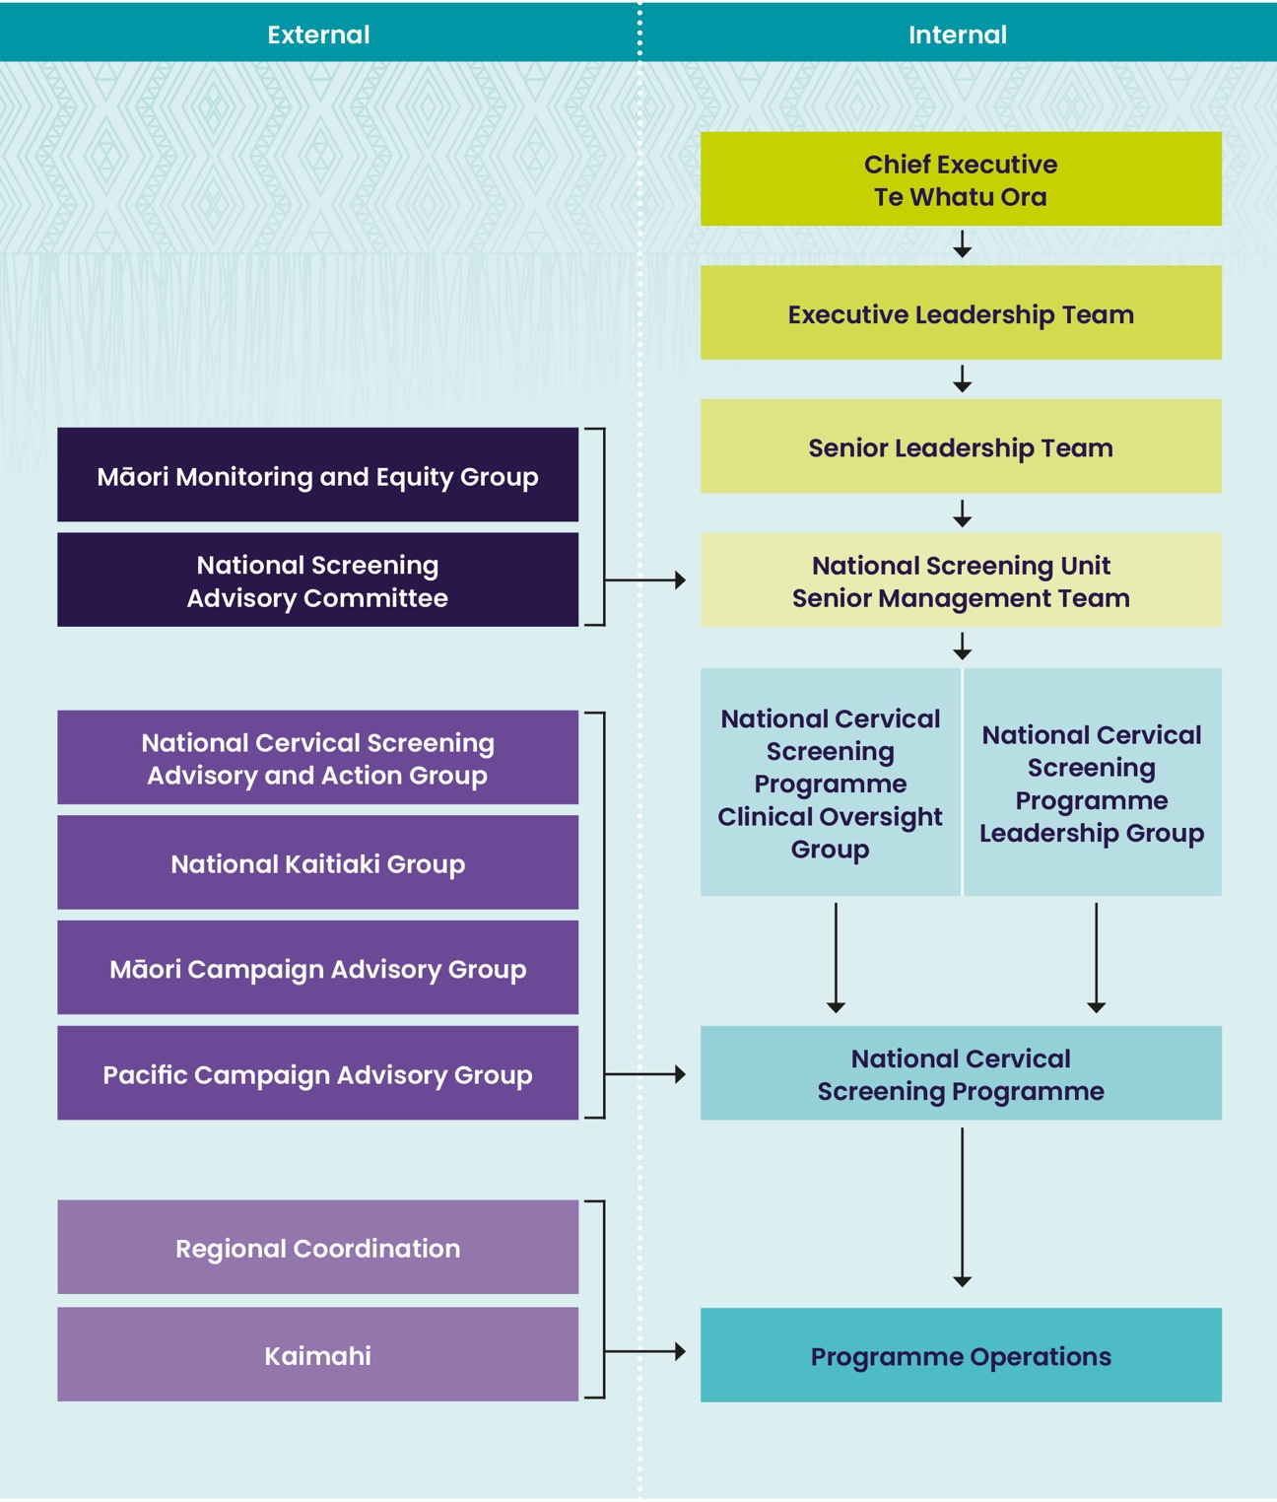
Many of the key informants identified limitations with the current data matching and management tools. These included:
- the data does not include non-enrolled eligible people
- time delays in data availability resulting in ineffective monitoring and responsiveness
- managing data sets can be time intensive
- time consuming to locate data in PHO reporting systems
- at times there is difficulty for Māori health providers to access PHO reports.

Colposcopy Monitoring and Evaluation
There were a number of examples of monitoring and evaluation of colposcopy services at both a local and NCSP level. The examples available to the PRC were through key informant interviews, the six-monthly reports provided to the NCSP (monitoring timeliness of colposcopy assessment and treatment) and the independent monitoring report. The colposcopy services also undergo three-yearly audits.
At a local level the PRC saw examples of outreach colposcopy services being developed as a result of monitoring data showing low attendance from identified demographic or geographic communities. This has resulted in more responsive approaches to service delivery and improved access to care. Some services are using colposcopy attendance data over time to track improvements following new strategies to support people to colposcopy such as patient-focused booking.

“We have reduced our DNA rate by doing patient-focused bookings, so
that we organise with the women when it’s suitable for them to come”

The NCSP utilise six-monthly colposcopy reports to monitor waiting times in the colposcopy services for timeliness of first assessment and treatment. It was evident from the interviews with colposcopy services that there was not always a feedback loop to the colposcopy services in regard to this monitoring. The data is retrospective because there is a time lag that may influence the ability of the NCSP to identify delays in the sector which may require intervention.
It became evident to the 2022 PRC that NCSP monitoring and evaluation was not always responsive when there were changes to clinical guidelines. An example was the change in the test of cure pathway in 2020. The PRC recommends a more responsive approach to monitoring when clinical guidelines change, to ensure there are no unintended consequences and ensure best practice is occurring.

“The NCSP aren’t feeding back to us whether our treatment was successful.
I’m the first to say it was a completely unnecessary colposcopy that they were having done at six months, and all the evidence shows they should be going back to primary care for a Test of Cure. But the way it is now we just discharge them at the time of the LLETZ and there is no feedback loop to us”

The independent monitoring reports provide a number of colposcopy indicators. It became apparent to the PRC that these were not utilised by colposcopy services for external quality control purposes or monitoring, as the information was out of date or they were unaware of the report. At the time of the PRC the last monitoring report was published nearly two years after the time period reported. The 2018 PRC (Ministry of Health, 2019b) recommended interim reports should be made available when the NCSP monitoring report transitioned to an annual report. This has occurred for laboratory monitoring but not for colposcopy. Interim colposcopy reporting should occur as a matter of urgency to strengthen monitoring and evaluation of colposcopy services.
Availability and timeliness of monitoring data across primary care and colposcopy services impedes providers in utilising the information to improve service delivery or provide for priority communities. There is duplication across monitoring and evaluation, particularly for colposcopy services, and there is the opportunity to streamline these approaches. Consideration needs to be given to who is responsible for the different aspects of monitoring and evaluation to avoid duplication. The new register presents an opportunity to strengthen monitoring and evaluation across the screening pathway.

Recommendation 14
Consideration needs to be given to disaggregating Pacific data to monitor and evaluate cervical screening coverage for Pacific people. This should be done in collaboration with a Pacific data sovereignty group to ensure the data is used for the benefit of Pacific people. Disaggregation of Pacific data may provide the opportunity to provide more culturally tailored approaches to engagement and development of resources to improve cervical screening coverage.

Case for change
Pacific data has been routinely aggregated for cervical screening coverage which makes it difficult to determine differences in coverage among Pacific communities. Disaggregated Pacific data examining rates of high-grade cytology reported Tongan and Samoan people’s rates were considerably less when compared to population data, whereas, Cook Island Māori rates were comparable. These findings suggest either screening coverage is lower or the prevalence of disease is less among Tongan and Samoan people (McPherson, 2019).
During the COVID-19 response disaggregated data was used successfully to develop Pacific specific vaccination approaches. Consistent access to disaggregated data could enable a more culturally tailored approach to delivering communication and messages to Pacific groups. This should be done in collaboration with a Pacific data sovereignty group to ensure the data is used for the benefit of Pacific people. It is important to minimise Pan- Pacific framings, and to understand that different Pacific peoples will need different support in a system that offers them equitable access to healthcare (Ministry for Pacific Peoples, 2020).
- LLETZ stands for large loop excision of the transformation zone. It is a treatment to remove cell changes (abnormal cells) from the cervix.

“We can’t always take a Pan-Pacific approach to Pacific health… There are
different providers that may be sort of more Tongan specific or Samoan
specific… and they can run and host culturally appropriate events.”

The 2018 PRC (Ministry of Health, 2019b) recommended the independent monitoring report bring together a synthesis of equity data to ensure there is visibility across the programme. It was evident at the PRC interviews that there was a lack of visibility of the inequities for Māori and Pacific people accessing colposcopy services, despite being reported in the independent monitoring report. Pulling together all of the equity measures will enable visibility of equity across the screening pathway.

Recommendation 15
The 2018 PRC made two recommendations for improved monitoring of equity. The first proposed the independent monitoring report brings together a synthesis of equity data, the second proposed the NSU work with other stakeholders to explore opportunities for measuring access to national screening services for people with disability, mental health service users, incarcerated people and rainbow communities. This PRC recommends this work be advanced with the relevant communities.

Recommendation 16
With the re-structured health sector and a move to locality leadership of service planning, monitoring and evaluation, this leadership group, and particularly Iwi-Māori Partnership Boards, will be a key audience of NCSP monitoring reports. The provision of reports in a form that is accessible and useful for Māori monitoring groups and health providers is recommended.

Recommendation 17
To strengthen monitoring the PRC recommends the formation of an
independent, Māori-led, Māoridesigned monitoring framework and resourced rōpū.

Case for change
The 2018 PRC (Ministry of Health, 2019b) found that no document provided a synthesis of all equity-relevant NCSP data. In the 2022 PRC’s review of the 2018 recommendation this had not been addressed, and the regularly published NCSP monitoring and evaluation reports are still not providing this data. At the time of the 2018 PRC, Breast Screen Aotearoa was producing equity-related data reports, and the Māori Monitoring and Equity Group was in support of this approach.
As mentioned earlier in the report, Te Whatu Ora reforms take a place-based approach to planning and these locality plans will detail how the goals set for a locality will be achieved. The plans will drive procurement of services and be the basis for equity monitoring. It is important that the NCSP draw on a number of sources of information to provide a comprehensive equity lens over the programme. Key informants noted that the analysis and interpretation of the data needs to be informed by the communities themselves, to avoid deficit narratives.

“It is important to note that some of the data that is being presented
demonstrates that Māori women are getting a poor service, but it adopts
a deficit approach. And so one of the things that we have been advocating for is the narrative in these reports to start talking about the colonisation impact on Māori and how that is why we’re getting all these sorts of disparities.”

As mentioned in Recommendation 10, it is also important to work with different community groups to ensure the NCSP is collecting data in a way that the community can see themselves reflected in the numbers, analysis and narrative.

“The National Kaitiaki Group is a ministerial appointed rōpū, established to give effect to the Health Cervical Screening Kaitiaki Regulations 2021. In particular, we are Kaitiaki over the access and use of Māori women’s data sitting in the national cervical screening database. In decisions about the data, we are guided by the principles of the sanctity of Te Whare Tangata, the need for culturally appropriate protection, and the taonga of the data. These decisions are influenced by the Treaty of Waitangi, New Zealand Privacy Act 2020 and the New Zealand Health Information Code 2020.”

“What has been missed is the opportunity for us to actually use the Māori women’s data to support a quality control mechanism within the NSU so that they can focus more precisely on how they’re going to do things differently. So that Māori women’s outcomes will improve. And that’s been kind of the lost opportunity for me. The key thing for us is to ensure that the data is used, to benefit Māori women, as well as those other criteria.”

The importance of the work of the National Kaitiaki Group was evident to the 2022 PRC, and the committee encourages the NCSP to continue to strengthen the relationship with this rōpū and to work in partnership to develop the reporting around equity data. Here the 2022 PRC sees that it is important to strengthen monitoring within NCSP and recommends the formation of an independent, Māori-led, Māori-designed monitoring framework. Adequate resourcing and sovereignty need to be provided to this group.
Consultation with other communities is also recommended to ensure there is cross-sectoral collaboration, so learnings can be made and consultation stress is reduced on those under-resourced communities.

“We are aware that the counting of the LGBTQIA+ community and the disabled community is really unsatisfactory. So, we don’t know what the denominator population is. Therefore, we don’t know how equitable coverage is. We just have to make assumptions about inequities based on the general literature on health and wellbeing of those communities.”

It is important to work alongside diverse groups to ensure NCSP data is relevant and respectful to these communities. Initially, the 2022 PRC suggests exploring how to collect data for the following:
- to capture the diverse gender identities and sex characteristics of people who are eligible to be part of the programme
- to provide disaggregated ethnic data to understand specific cultural and linguistic needs
- to capture data regarding those living with disabilities who are eligible to be part of the programme.

The 2022 PRC recommends that a synthesis of equity data and an analysis through an equity lens occurs on a routine basis in a regular monitoring report. Thought regarding the way the information is distributed and socialised is also important, as it is important for reports to be in a form that is accessible and useful for Māori monitoring groups, health providers and community leaders.

Co-Governance and Clinical Governance
Co-Governance
Recommendation 18
Effective co-governance requires clear communication, robust relationships, trust and role clarity. The NSU has commissioned a high-level working group to examine co-governance across the entire suite of screening programmes. The PRC supports the establishment of co-governance. We encourage the next parliamentary review to examine its effectiveness using Critical Tiriti Analysis.

Case for change
Governance bodies provide strategic direction for an organisation rather than operational leadership. Good Tiriti based co-governance remains both contested and unfolding. Dodson (2014) describes co-governance as arrangements in which ultimate decision-making authority resides with a collaborative body exercising devolved power – where power and responsibility are shared between government and other stakeholders.
The ability of the NSU to engage in genuine co-governance is compromised as they are not autonomous and are embedded within a larger Crown entity, which in turn is led by Crown Minister(s). The Crown however has clear responsibilities to engage with Te Tiriti (Cabinet Office, 2019). The PRC recommends developing a co-governance structure based around Te Tiriti (the Māori text) informed by the preliminary work of Baker and Talamaivao (2022).

“That Māori governance needs to be over NSU, not within the NSU, because
they can strip the power away from Māori governance at any time.”

The PRC encourages the NSU to investigate the co-governance relationship model between Hei Āhuru Mōwai (the Māori cancer leadership rōpū) and Te Aho o Te Kahu (the Cancer Control Agency). This model enables Hei Āhuru Mōwai to influence strategic direction, policy and practice. The relationship relies on numerous levels of interrogation of Te Aho strategic direction and operations, thereby providing a possible model for a relationship towards tino rangatiratanga and mana motuhake.
Hei Āhuru Mōwai have embedded mechanisms such as 50% Māori members on Te Aho o Te Kahu council; participating in senior recruitments; sharing Māori clinical expertise and members; scheduled CEO to CEO and co-chair to CEO meetings; and often reviewing documents before they are released. An ongoing tension in these arrangements remains the limited capacity of Hei Āhuru Mōwai due to their small resource base. Hei Āhuru Mōwai describes the relationship as valuable, where Māori can influence every level of the organisation, but would describe Te Aho o Te Kahu as at the beginning of their journey. Hei Āhuru Mōwai seem to view themselves as a critical hoa and suggest tension is healthy given the continuing existence of inequities.
The 2022 PRC supports the establishment of co-governance and recommends the NSU continue to build on their current work in this area and strengthen communication, robust relationships, trust and role clarity across the entire suite of screening programmes. We encourage the next parliamentary review to examine its effectiveness using Critical Tiriti Analysis. Critical Tiriti Analysis is an evaluation tool used to examine engagement with the five elements of Te Tiriti (Came, O’Sullivan, McCreanor, 2020). It involves a robust five-stage process that centres Māori perspectives and involves both critique and identifying how to strengthen policy or practice.

Recommendation 19
Whanaungatanga is critical to building trust. Highly regarded by all providers is the opportunity to network regionally and nationally as part of strengthening the NCSP. Where this is not occurring regionally, we recommend the NSU reinstate these networks. National networking opportunities should be facilitated by the NSU on a regular basis.

Case for change
Whanaungatanga and building and sustaining relationships of trust across institutions, at multiple levels, will strengthen the NSU and service delivery. It provides an opportunity to share knowledge and innovations. Viewing relationship building as essential to the work needs to be embedded within contractual agreements, so resources for engagement and collaboration are available.

“I think that it would be useful for the NCSP to put more resource into
building relationships. Relationship building needs to be resourced,
and then share resources and reward relationship building. Then
eventually in the long term, will create efficiencies and benefits. Obviously,
we want to prevent cancer, but creating efficiencies long term is also worthwhile.”

Whanaungatanga needs to be central to the new integrated model discussed earlier in the report, as it is critical to building trust. It is also important for all providers to have the opportunity to network regionally and nationally as part of learning from each other, strengthening practice and developing innovation. Where this is not occurring regionally, we recommend the NSU reinstate these networks. National networking opportunities should be facilitated by the NSU on a regular basis.
The COVID-19 pandemic highlighted the importance of relationships and networking at a community, regional and national level. Key informants that had strong community and regional networks were able to rely on those close relationships throughout the pandemic disruption.

“So, we actually have a really good relationship with the support to service providers. And up until just before COVID, we were regularly meeting and looking at ways in which to improve the numbers for Māori because they are low. What makes it work is good communication between the sectors. And I think for, certainly for the last two years with COVID, iwi providers have been exceedingly busy with COVID for the last two years, but our strong relationships have helped us be able to focus on Māori women who find it difficult to attend.”

Other key informants also shared some of the positive unintended consequences of COVID-19:

“We’ve had some really good success with, I guess, learning from COVID, it’s one of the first times within the industry that we’ve been actually able to just collaborate without worrying about contracts, or feeling like we were stepping on people’s toes. We’ve come out the other side of that having built some great relationships.”

Many key informants expressed a lack of centralised coordination for networking and the lack of resources available for this, as well as the need to experience a more joined-up sector. This is an example of some work that is occurring:

“I think more collaboration across our regional coordinators and our support
to screening teams. We’ve started having monthly Zoom or Teams hui with the regional coordinators and the support to screening and they have been awesome because alongside updates we have open kōrero which is what just majority of that time, so that everyone can hear about what’s going on across the country.”

Recommendation 20
The NCSP needs strong relationships between the NSU and all advisory and leadership groups such as the National Kaitiaki Group and the Māori Equity and Monitoring Group. Clarity of the role and function of each group based on their terms of reference would likely go some way to improving relationships, as would equitable treatment and funding. Deeper engagement with tikanga by NSU staff is also likely to strengthen these connections.

Case for change
Since the 2011 PRC (Ministry of Health, 2011, 2015, 2019b) it has been identified that a close and collaborative working relationship between the NSU, the National Kaitiaki Group, the Māori Monitoring and Equity Group and other leadership groups will be critical in achieving improved coverage rates and reducing the inequitable burden of disease.
The 2022 PRC has heard of the work already being conducted, and the desire to shift and transform the way the NCSP is working. The NCSP acknowledge they are on a learning journey, as one key respondent reflected on their experience bringing their whole self to work within the learning opportunities provided:

“We are trying to shift our way of working... Like, the stories. We’re getting a lot of that lately. And it is the only way forwards because stories make things real. People can really relate to this. And we’ve always known that, but we don’t always follow through because we get into this very professional mode. And, yeah, so we’re trying to move in a different space, and the ako series is supporting us.”

These are important steps which support Tauiwi professionals to engage in the journey decentring Pākehā culture and becoming open to a Te Ao Māori worldview.
What the 2022 PRC did hear was inconsistent clarity regarding role, function, accountability and engagement protocols between the NSU and all the advisory and leadership groups. Where relationships were working there were either clear legislations, or it was reliant on individuals.

“I just feel like it should be more consistent and sustainable. It shouldn’t depend on that one person. There should be a system in place that values relationships, and then go from there, you know.”

Key Māori informants reported ongoing difficulties engaging with the NSU and the lack of equitable resources for their rōpū. Others noted issues regarding the terms of engagement:

“On that thread, our rōpū has the terms of reference, and we are continually being introduced to pieces of work that aren’t necessarily strictly covered by our terms of reference.”

This can be summarised as operational marginalisation, which is the routine lack of involvement of Māori advisory groups in the day to day running of the unit. Operationalising Te Tiriti engagement for all staff in the NSU would support alleviating the additional emotional and relational workload Māori are required to do in these spaces (Smith et al., 2021).
Additionally, experiences of lack of Te Tiriti and cultural competence were also reported:

“I think it has been particularly challenging the number of documents that come across to us, that have no Te Tiriti lens run over them. There is just no Te Tiriti assessment on documents like policy or outcomes, or how what they are presenting is in line with strategic documents.”

Working in ways that aligns with Te Tiriti o Waitangi is a cultural paradigm shift, and requires NSU staff to engage with learning tikanga and to have values like manaakitanga and whanaungatanga central to everyone’s daily work practice. This is likely to create a greater sense of appreciation of Māori values by Tauiwi and Pākehā staff and contribute to strengthening these connections. The NSU, in partnership with the Māori advisory groups, could start by developing clarity of the role and function of each group based on their terms of reference. This clarity, as well as equitable funding, would foster more positive Te Tiriti relationships.

Clinical Governance
It became apparent during the PRC’s interviews that the clinical governance arrangements, and capacity and capability to review performance data and implement quality improvement initiatives are variable. There are instances of robust, quality auditing processes, data analysis and monitoring of performance in some services, while there are limited or no processes evident in others. This was also evident in the completed DAA group colposcopy audit reports. Three of seven colposcopy services audited had no internal quality control systems, and two required a more formalised approach to quality improvement. The PRC did not review private colposcopy services.
For consistency, the PRC utilised the 2018 PRC clinical governance definition. Halligan & Donaldson (2001) describes clinical governance as:
- systematically joining up of clinical initiatives to improve quality
- setting standards and ensuring they are met
- monitoring performance and implementing interventions where clinical quality falls short of the standards or expected outcomes.

The PRC considered the three key clinical governance principles:
- The systematic joining up of clinical initiatives to improve quality
The example reports and key informant interviews showed few references to the clinical quality of colposcopy services. Practices across Te Whatu Ora districts were inconsistent.

- Setting standards and ensuring they are met
The NCSP has a range of clinical standards for colposcopy that Te Whatu Ora districts have responsibility and accountability for performing against. The PRC found limited examples of how these standards are monitored and few strategies to ensure clinical standards are met. The only standards consistently met were related to the timeliness of colposcopy assessment and treatment.

- Monitoring performance and implementing interventions where clinical quality falls short of the standards or expected outcomes
The monitoring of performance and implementation of interventions to improve colposcopy outcomes is a Te Whatu Ora responsibility. In some services, these processes appeared to be well managed by the lead colposcopists. However, other services do not appear to prioritise audit and review. The variability of clinical oversight in colposcopy services enables inconsistent practice across the country and this does not appear to be dependent on the size of the service.
The introduction of the new programme (which has more complex referral algorithms) will require ongoing monitoring of service quality. The NCSP is optimistic the new register will provide the opportunity to undertake more complex evaluation and monitoring.

Clinical Quality Assurance in Colposcopy Services
The delivery of a high-quality cervical screening programme requires robust clinical quality assurance systems to monitor and evaluate the effectiveness of the programme. The NCSP Policies and Standards (Ministry of Health, 2013) states that colposcopy services must have documented internal quality control systems that will cover all their activities, and:
- provide the means of identifying potential sources of error in the colposcopy service operation
- implement controls to detect and minimise errors
- identify ways of improving the quality of services
- provide a framework for remedial action to improve operational processes when a problem is identified.

Examples of internal quality control activities may include systems for:
- reviewing post-treatment recurrences
- follow-up and review following positive cytology and negative histology results
- ongoing monitoring against standards
- use of own data to monitor internal quality control.

Recommendation 21
Clinical quality assurance reporting needs to be prioritised with a matter of urgency within Te Whatu Ora colposcopy services. Individual colposcopist performance should be measured against key clinical indicators annually and benchmarked data should be provided to colposcopists. This should occur prior to the implementation of the primary HPV screening programme to provide the NCSP with a baseline on clinical quality assurance data.

Recommendation 22
There needs to be communication with Te Whatu Ora lead colposcopists and service managers that they have a responsibility to annually review individual colposcopists’ practice.

Case for change
It became evident through the PRC’s interviews with colposcopy services that clinical quality assurance is variable across districts colposcopy services. In some colposcopy services there were robust mechanisms in place to support clinical quality assurance and monitoring of individual colposcopist practice. In other services there was limited or no clinical quality assurance undertaken to assess individual practice. In addition, interviews with the NCSP team identified there was a gap in the oversight of clinical quality assurance of colposcopists within the programme. Colposcopists interviewed identified the importance of attending multidisciplinary meetings for peer review purposes, an important internal quality control mechanism.
There was a lack of clarity from some lead colposcopists on what measures would be useful to assess clinical quality assurance. Te Toka Tumai Auckland measures individual practice and has utilised key indicators developed by the British Society of Colposcopy and Cervical Pathology. One service indicated they would like the NCSP to provide clinical quality assurance indicators. The PRC is aware that the NCSP is undertaking work to finalise key clinical indicators in the new policy and quality standards for colposcopy services in a HPV primary screening programme. In addition, the PRC notes the work being undertaken by the Royal Australian and New Zealand College of Obstetricians and Gynaecologists (RANZCOG) (2021) Cervical Quality Improvement Programme to develop key indicators for clinical quality assurance.
The PRC understands that the lead colposcopists at each Te Whatu Ora district are responsible for ensuring internal quality controls are in place. Some lead colposcopists identified difficulty in undertaking clinical quality assurance due to capacity and/or capability of the current IT systems. Lead colposcopists and service managers are responsible for any remedial action of colposcopists not achieving the clinical quality performance indicators. It was not apparent to the PRC that there were clear processes or policies to undertake remedial action of colposcopists who were not performing. However, the PRC assumes that Te Whatu Ora districts will have human resource policies in place to manage any concerns regarding performance management. It was evident to the PRC that some lead colposcopists and service managers were not aware of their requirement to review individual colposcopist performance.
A mandatory colposcopy data set is collected using Gynae Plus, a colposcopy database used by all colposcopy services. The current database allows users to extract visit data from the colposcopy database to undertake clinical quality assurance. It was evident that some colposcopy services do not utilise this functionality of the database. The PRC recommends the NCSP support colposcopy services to utilise the data available to them through the current solutions plus the colposcopy database. There are colposcopists and IT teams who have expertise using the database and could assist other services by sharing their expertise.
Any future monitoring and clinical quality assurance reports should be developed so they are easily generated within colposcopy services. This enables colposcopy services to undertake clinical quality assurance and reduce the time burden of reporting on services. Annual reports are recommended rather than six-monthly reports to ensure smaller services have sufficient numbers to measure performance.

Recommendation 23
Priority is given to utilising e-colposcopy data as a mechanism of feedback to Te Whatu Ora colposcopy services. This should also be extended to private providers.

Case for change
The 2018 PRC recommended the NCSP send regular benchmarked reports (six-monthly) on colposcopy performance to individual colposcopists, using the e-colposcopy data within the NCSP Register. Due to data quality issues the NCSP has been unable to implement this recommendation. It appears there have been long-standing issues with providing data back to colposcopy services, as this has been highlighted in both the 2015 and 2018 parliamentary reviews. It has also been identified by colposcopists as being an issue that services provide data via e-colposcopy and there is no mechanism of feedback to the services. In addition, data requests from the NCSP of colposcopy services have been identified as frustrating when the data is provided by e-colposcopy.

“It would be good if the NCSP could actually feedback all the data we send.
We don’t get much back from the NCSP.”

NCSP Audit Programme
The NCSP audit programme provides the opportunity for colposcopy services to be audited and is a quality improvement mechanism. The DAA group has been contracted to undertake the current round of colposcopy audits. All colposcopy service providers contracted to the NCSP are audited against the indicators defined in the NCSP Policies and Standards (Ministry of Health, 2013) and in their contracts (Schedule 1 of the Agreement).
The DAA audit measures outcomes against the defined DAA audit tool and any partially or unattained criteria will generate a corrective action that requires actioning within a defined time period. This is done according to the severity of the risk to consumer safety. In addition to corrective actions, recommendations are also made to services where strengthening of service delivery could occur, and they commend exemplary practices. The audits are undertaken by a lead auditor and a technical expert assessor.
Seven completed DAA audits were provided to the PRC at the time of the review. Two colposcopy services met all of the requirements set out in the DAA audit tool, which is commendable. The remaining five services had a number of corrective actions due to only partially attaining the audit standards in a variety of areas. It was noted by the PRC there were no critical or high-risk clinical issues identified in the completed audits provided to the PRC.
Follow-up audits were planned for colposcopy services that have completed their DAA audits. The NCSP is planning to refocus the follow-up audits to be a readiness assessment of colposcopy services for the new programme. Following implementation of the new programme, follow-up audits will assess how colposcopy services have bedded in the new processes. The PRC recommends communication needs to occur with colposcopy services now, so they can understand what is required to be prepared for the changes in the programme.
The colposcopy audits provide an excellent opportunity to review quality assurance within colposcopy services. The PRC recommends that the DAA audit reports specify the specific clinical quality assurance activities that have been undertaken and indicate if individual practice is evaluated, to provide clear oversight to the NCSP of what clinical quality assurance activities are being undertaken by colposcopy services.
As identified by the 2018 PRC (Ministry of Health, 2019b), there is duplication of NCSP monitoring data in the DAA audit tool measures. These include, for example, waiting time data, DNA rates, colposcopist volumes and timeliness of treatment. Colposcopy services currently provide six-monthly waiting time data to the NCSP. The NCSP should be able to measure other indicators that are submitted via e-colposcopy more frequently. The duplication of audit processes results in unnecessary burden on colposcopy services. It was apparent at some of the colposcopy interviews that the audit preparation process is time consuming, which has been particularly difficult during COVID-19. This difficulty was acknowledged by the NCSP and a review of the audit tool needs consideration as previously identified by the 2018 PRC (Ministry of Health, 2019b).
It was identified that the technical expert assessor on four of the seven DAA audits shared with the PRC was not a colposcopist or colposcopy nurse. The DAA defines the technical expert assessor as having knowledge and skills as they have worked, and do work currently, in the cervical screening programme, holding registration with their relevant professional body and having a current annual practising certificate. The PRC recommends that the technical expert assessors should be a colposcopist or colposcopy nurse to ensure they have the appropriate level of technical expertise. There is some risk with the current approach of not identifying any deviations to current clinical practice guidelines. In addition, the use of cultural expertise should be made a priority on the audit team assessing screening and treatment services.
The three-yearly schedule to undertake the colposcopy audits appears to have been delayed with the last set of audits being undertaken between five and six years ago for some colposcopy services. The delays were due to the renegotiation of a NSU wide audit contract. For effective monitoring of colposcopy services, the PRC recommends a three-yearly audit schedule should be maintained.

Workforce Capacity and Capability
Recommendation 24
Understanding, competence and commitment to Te Tiriti o Waitangi, equity, cultural safety and anti-racism appears inconsistent across the programme. The PRC recommends investment in mandatory stair-cased Te Tiriti, equity, cultural safety and anti-racism workforce development across the programme, including the NSU, to strengthen baseline competencies.

Recommendation 25
The PRC recommends investment in workforce development in the area of kaupapa Māori evaluation.

Case for change
Across the country there are approximately 7300 sample takers (mostly general practitioners and nurses) and seven laboratories providing cytology, HPV and histology testing services to the programme. Te Whatu Ora provides the majority of colposcopy services. Te Whatu Ora provides fifteen regional NCSP services, including regional coordination of NCSP services, health promotion and liaison with key organisations and people relevant to cervical screening. Thirteen regional services provide NCSP Register services. The NSU also contracts twelve independent service providers to provide screening support services for those who need additional support to be screened or attend colposcopy services.
Placing under-screened and unscreened people at the centre of the design process will involve upskilling colleagues to work fluidly within this system, to foster a programme that embraces Te Tiriti, equity and cultural safety. Co-design will be critical to enabling collaboration between various providers across the screening and treatment pathway (see Recommendation 4).

Recommendation 26
Workforce capacity in general practice is severely compromised and not expected to improve in the short term. Equitable cervical screening coverage will rely on a new model as described in Recommendation 4 and Recommendation 9. NCSP policy and guidelines will need to be reviewed to provide advice to general practice on effective engagement with the new model of cervical screening for the benefit of service users.

Case for change
Workforce capacity in general practice is severely compromised and not expected to improve in the short term. General practices will likely continue to provide cervical screening services to their enrolled population members for whom their practice model suits. Equitable cervical screening coverage will rely on a well-resourced Māori and Pacific provider sector to deliver a new integrated, accessible model of community-based cervical screening.

“While some practices still focus effort on achieving high and equitable cervical screening coverage, since cervical screening was removed from the national primary care targets, most
general practices rely on women to take up reminders for screening without any additional support, special concessions or referral to community services.”

Recommendation 27
The current training of sample takers requires review, and consideration should be given to delivering the training outside of the current NZQA framework. Local training and credentialing of sample takers could provide a more accessible option to training and improve accessibility for Māori and Pacific sample takers.

Case for change
Sample taker training is a well-established NZQA training pathway which is delivered by a small number of providers such as the Family Planning Association and Well Women and Family Trust. It was evident to the PRC there are many barriers for nurses accessing the current model of sample taker training, particularly for Māori and Pacific nurses. The barriers identified by key informants included course availability, cost and time off work.

“Access to training for screening is quite challenging… we’ve just got three nurses that started with us at the end of last year… all of them have had to wait months to be able to actually even enter the screening training… that’s a real challenge. And it’s the cost as well… But just the unavailability of courses, and one had to go down to Wellington to be able to access that course.”

The PRC recognises the NCSP has made training for Māori and Pacific sample takers a priority and it was evident some PHOs had also made this a priority.
The current NZQA sample taking training standards were developed several years ago to ensure there was a formalised training programme for nurses. There have been considerable changes to training and credentialing processes for registered nurses without requiring a NZQA accredited course. Nurses can undertake a range of activities that have non-NZQA based training and credentialing to ensure competence. In some cases, training and credentialing may be provided by employers. Some examples include insertion of intrauterine contraceptive devices, Immunisation Advisory Centre vaccination training and acute orthopaedic plaster casting.
While it is recognised by the 2022 PRC that less sample takers will be required in the new programme, there needs to be accessible training for all providers going forward. There is a risk that if this is not accessible, then there will not be sufficient sample takers to complete clinician-based cytology samples.
The current training programme needs reconfiguration to include HPV self-testing and the role of kaiāwhina in delivering self-testing. The PRC recommends the NCSP commission a review of the current training pathway for sample takers. There also needs to be consideration of quality assurance reports for sample takers.

Recommendation 28
Consideration also needs to be given to strengthening the ability of the sector to engage effectively with traditionally underserved groups such as Asian, disabled and rainbow communities, and those with a history of trauma and/or mental illnesses.

Case for change
An equitable NCSP must be equipped and competent to work with those from diverse communities to ensure their services are accessible and inclusive. There is the need for a workforce that can centre the needs of a wahine and her whānau, as well as being able to tailor service delivery to the needs of other communities. The 2022 PRC notes that culturally safe practice needs to be developed for the following people and communities: Asian and rainbow communities; those living with disabilities, behavioural health conditions, and histories of trauma.
Part of developing culturally safe practice is to develop an understanding and analysis of issues faced by diverse groups. Training will then be needed for all workers across the NCSP programme and services must be empowered to transform practice to meet the unique needs of particular groups. Here we offer a brief overview of some the specific needs highlighted during interviews with key informants, and through the review of literature.
From a Statistics New Zealand perspective, the ethnic grouping of Asian includes people with origins in the Asian continent, from Afghanistan in the west to Japan in the east and from China in the north to Indonesia in the south. Asian New Zealanders largely comprise Chinese and Indians, who have long histories of settlement in Aotearoa. ‘Asian’ includes a vast range of nations, ethnicities, migration and resident histories, languages and spiritual beliefs. Historically these communities experience significant inequity and barriers to accessing screening within the NCSP. Gao et al. (2008) found that barriers for Chinese women accessing the screening pathway were associated with age, immigration status and knowledge of health systems in the new country of residence. Equity for Asian populations requires community-based, culturally sensitive and linguistically tailored healthcare delivery systems (Gao et al., 2008).

“It is important for us to remember that Indians don’t know about pap smear, cervical smear, because they don’t do it at all in India. That is why it is highly recommended more awareness here in New Zealand about the cervical smear, especially for other ethnicity women who do not know about this test.”

“I would like to share the Chinese community in relation to the cervical
smear programme in New Zealand there are two distinct groups, one is the older migrants one is the new migrants. So, for the new migrants they understand cervical smear test is important because in China, there is health promotion in the media, so they know it is important. So, when we do the recalling in for them to come do the smear they’re quite happy. For the older migrant women, there are gaps in knowledge for the cervical smear tests. They don’t know why need to do every three years. They think that if you do it once it is forever. Or they think if after menopause don’t need to do the smear. So yeah, that’s for the Chinese, the community.”

“I would also like people to know that awareness is important and it’s not same for all ethnic people, it is different for different people. They need to know why they are doing it, and why they have to do every three years. The first test is really important, when you give knowledge during when they do their first test, it is highly possible that they will go regularly. The second thing is considering all cultural aspects with different ethnic people is important.”

Rainbow communities include people whose sexual orientation, gender identity and expression, and sex characteristics do not fit dominant social-cultural norms. Rainbow communities often share a history of marginalisation which can limit access to healthcare (Taskiran Eskici et al., 2021). Rainbow identities exist within Indigenous, white and non-white cultures, for example takatāpui in Te Ao Māori (Kerekere, 2017) and fa’afafine in Samoan culture (Schmidt, 2017).
Gender identity, sexual orientation and diverse sex characteristics create specific, complex barriers to accessing the screening pathway (Haviland et al., 2020). Many transgender men and non-binary people with female sex characteristics retain their cervixes. Health promotion often prioritises cis-gender women and deploys gendered language, which can exclude transgender men and non-binary people (Gatos, 2018). Thus, they experience under-screening within healthcare systems that often lack adequate competency and provision for gender affirming healthcare (Little, 2022). However, there are a range of gender affirming medical interventions which could be tailored to an individual’s needs and thus support access to cervical screening (Gatos, 2018).
Intersex populations also face unique obstacles to healthcare (Sanchez et al., 2017). Intersex is an umbrella term used to describe innate variations in genitalia, hormones, internal anatomy or chromosomes. Intersex people may be assigned a sex at birth, and may undergo medical interventions in childhood. Their assigned sex may not align with their gender identity, and they may seek gender affirming healthcare later in life. Many intersex people identify as cis-gendered and heterosexual. Some key informants let us know:

“I think if it was done with the rainbow communities it would be amazing, I think, especially if we could hold space for trans masculine men where they felt comfortable. It is also important to mention is the need for intersex people to be included in this as well. Especially educate GPs for intersex people who might not have anatomy that looks “normal”, and that kind of stuff. But I think that… I genuinely think that would be a success if it’s done with the community, with informed doctors, but it has to be done with the community.”

“There is some work being done regarding Rainbow competencies for helping professionals through an organisation called Te Ngākau Kahukura, it would be good for the screening programme to work with them.”

“We know, really across the range of health services across any health service that trans people need to access, research indicates that we are less likely to be able to access healthcare when it’s needed more likely to delay or avoid access because of anticipated discrimination, more likely to receive unsatisfactory care. And the cervical screening program, I guess, is no exception to that.”

The marginalisation of people who live with disabilities can involve infantilisation and mislabelling them as asexual. For this reason, their sexual and reproductive health is routinely overlooked (Campbell, 2017). To achieve equity, it is important to consider methods for reducing physical access barriers and ensuring effective communication strategies to reach people with diverse cognitive and sensory abilities. Building a system that meets the needs of this diverse population requires tailored system design and upskilling healthcare professionals’ knowledge of and responsiveness to their diverse needs (Hanlon & Payne, 2017).

“And as a disabled person, I’ve had to have space to advocate for myself to
be able to get the medical care I need.”

“There are some key adjustments workers need to make when working
with someone who is living with a disability, the first step is to have time
to ask what their access needs are and then think through how to adapt the
service to meet the person’s needs.”

“Visibility of us on promotional material is important for disabled
people, and that there is a diversity of representation, not just people on a
wheelchair. It is also important to be ready to answer questions like, what
happens if you have no sensation? You know, all these kinds of questions.
It’s that patient first thing.”

People who live with behavioural health conditions, mental health issues and experiences of trauma may encounter barriers to accessing screening pathways (Gibson et al., 2021). For victims/survivors of sexual violence, anything connected to sexual and reproductive health can be experienced as whakamā, or trigger distress (Madden et al., 2022). For those living with intimate partner violence, sexual health and reproductive control can impact access to healthcare (Sheikhnezhad et al., 2022). Mental distress, behavioural health conditions and trauma intersect with other forms of marginalisation. Culturally attuned and trauma informed care can make a significant difference in achieving equity for this group (Pihama et al., 2020). Some key informants let us know:

“What made me comfortable is doing my last smear was I have a really good relationship with my GP, she explained it step by step, she knows my health history really well, gave it time and space. Also, the other thing she did is at every step of the way, she was encouraging and told me exactly what was happening and stuff like that. And, you know, as a survivor of violence, that’s really important as well. And I think that, you know, there’s so many reasons why people don’t get screening done.”

Unintentional harm can be created by culturally unskilled and unsafe workers, which will impact the effectiveness of the NCSP programme to achieve equitable outcomes for all eligible people. Whanaungatanga and partnerships are recommended with these communities to strengthen the ability of the sector to engage effectively with traditionally under-serviced groups.

Colposcopy Workforce Capacity and HPV Primary Screening

Recommendation 29
The NCSP should with some urgency engage with Te Whatu Ora colposcopy services to discuss the revised modelling data regarding colposcopy referral volumes, to assist colposcopy services in their workforce planning.

Recommendation 30
The PRC recommends the NCSP urgently identify strategies to manage the increased workload and work with Te Whatu Ora colposcopy services to support these strategies.

Case for change
To provide an assessment of the workforce capacity of colposcopy services to implement the new HPV primary screening programme, the PRC requested a snapshot of data from colposcopy services as of 30 April 2022 to provide an up-to-date picture on referral trends and waiting times. Colposcopy services also provided commentary on the issues with workforce capacity and the number of colposcopists practising within Te Whatu Ora.

It was noted in the referral data that during lockdown periods (August and September 2021) referral trends decreased considerably in the Auckland region. This was also seen in other regions. During lockdown colposcopy clinics were cancelled and services only undertook urgent work. Redeployment of nursing staff during the COVID-19 response impacted capacity in some services. Waitematā had their colposcopy clinic space at North Shore Hospital closed to allow the DHB to set up a standalone COVID-19 hospital, which has had a considerable impact on service delivery. Some services were unable to run additional clinics due to lack of nursing staff to support clinics and senior medical officer availability. It was evident from the interviews that colposcopy staff felt concerned about the impact of COVID 19 on the delivery of services and the new programme.

“My concern is just how much we’re struggling with everything at the moment with COVID. We have kept colposcopy going. But within, you know, the DHB on occasions, there are calls for us to do extra colposcopy clinics… So my general very broad comment is, I feel like the health system’s on the brink of collapse and how it’s all going to fit within that, and also an incredibly burnt-out health workforce”

The waiting times for some colposcopy services did appear to be impacted by COVID-19. The NCSP six-monthly colposcopy waiting time data provided to the PRC identified some services that have had difficulty managing assessment of people referred with low-grade abnormalities within the recommended time frame of 26 weeks, in the last period of reporting between July and December 2021. The current waiting time data as of the 30th of April 2022 provided to the PRC notes there have been some improvements in current waiting times for low-grade assessment.

For people referred with low-grade abnormalities, current waiting times show only one service has a considerable backlog (Waitematā). Six services have waiting times close to the 26-week time frame and any additional increase in referrals may be problematic. People with high-grade abnormalities appear to be prioritised and are seen within 20 working days by the majority of services which is commendable. One service has a considerable waiting time for high-grade assessment (Counties Manukau). There are ongoing challenges for services, and any catch-up programme for cervical screening is likely to impact on colposcopy services in the interim.

The introduction of HPV primary screening will lead to an increase in colposcopy referrals due to the improved sensitivity of HPV testing (Aitken et al., 2019; Rebolj et al., 2019; Smith et al., 2019). Ongoing research and evaluation of HPV primary screening is evolving, and the use of partial genotyping and reflex cytology assists in risk stratification to ensure clinical safety and reduce unnecessary colposcopy (Gilham et al., 2019; Smith et al., 2022; RANZCOG, 2021). While there will be an initial increase in colposcopy referrals, evidence suggests with subsequent rounds of HPV primary screening there will be a decrease in referrals, due to increased disease detection after the initial rounds of screening (Castañon et al., 2018; Rebolj et al., 2019; Veijalainen et al., 2019).

The NCSP has commissioned modelling work to assess the impact of primary HPV screening on colposcopy referrals due to the impact of COVID-19. The modelling data was not available to the PRC at the time of the review. Based on previous modelling work, the NCSP predicts there could be an increase of colposcopy referrals of up to 40%. The NCSP acknowledged the difficulties of modelling data and predictions, due to the complexity of the impact of COVID-19 on cervical screening coverage. It was also noted by the NCSP it is likely there will be regional variations and any increase is likely to impact the services with larger populations. This will have a significant impact on the larger colposcopy services and these increases will be difficult for services to manage.

The sector had concerns about the projected increase in colposcopy referrals and impact on workforce capacity. A number of key informants identified there was a lack of communication from the NCSP. Some services identified there will be capacity issues managing increased referrals of more than 30%. The PRC understands the NCSP has a plan to communicate with colposcopy services as part of their HPV primary screening workstream, and has undertaken work to assess the impact of OVID-19 and the transition into HPV primary screening.

A stocktake of Te Whatu Ora colposcopy services was undertaken by the PRC and identified there are 157 practising colposcopists within DHB services. This consists of senior medical officers (144), medical officers (3), nurse practitioners (4), clinical nurse specialists (3), and registrars (3). There are two trainee nurse colposcopists and one senior medical officer completing training at present. A limitation of the data collected is that the FTE allocation is unknown, which will be variable particularly among the senior medical officer group.

The NCSP is considering the use of the private practice workforce to provide additional capacity in managing the increased colposcopy volumes. There are currently 61 private practitioners performing colposcopies, an increase from 42 since the last PRC in 2018. In 2020 private providers undertook 12.2% of the colposcopies reported on the NCSP Register (Smith et al., 2022). Monitoring of private providers by the NCSP is limited, however it is important to note some private practitioners currently work in Te Whatu Ora colposcopy services. The PRC recommends clinical quality assurance and service provision assessment of private providers is required prior to any outsourcing of Te Whatu Ora colposcopy contracts to private practice, to ensure they meet the same policy and quality standards as Te Whatu Ora colposcopy services. There needs to be clear documentation of handover and follow-up responsibilities between private providers and Te Whatu Ora colposcopy services.

Some colposcopy services reported that the development of the nurse colposcopist role will assist in managing the future workforce challenges. A clinical nurse specialist at Te Whatu Ora Te Matau a Māui, Hawke’s Bay has recently gained certification as a colposcopist and her service manager envisages her appointment will assist in managing increased referral volumes with the implementation of HPV primary screening. Dunedin and Waitematā districts have plans to increase their nurse colposcopist workforce to manage backlog and any increased referral volumes. Some key informants recommended funding of nurse colposcopists to be undertaken as a matter of urgency to ensure workforce readiness for the implementation of HPV primary screening.

“We will really struggle and would need to significantly increase our workforce. I have read some things that it would not necessarily be gynaecologists, but then we would need to train good colposcopists”

Whilst there appears to be a reasonable number of colposcopists practising in Te Whatu Ora colposcopy services, it was evident to the PRC there are challenges around SMO and nursing workforce capacity to deliver services. The PRC notes it is commendable that some colposcopy services are already making provision to meet the increased demand with the utilisation of nurse colposcopists. It takes up to six months to train colposcopists and utilising overseas locum doctors has challenges as they also need time to assimilate to practice within Aotearoa. It would appear there will be challenges for colposcopy services in meeting the demand in the short to medium term, and serious consideration needs to be given to colposcopy workforce development.

Recommendation 31
To manage workforce capacity in the new programme, monthly monitoring of referral data to colposcopy services along with key indicators should be implemented. Reporting should be undertaken by Te Whatu Ora colposcopy services to ensure there is close monitoring of referral trends and the impact on waiting times for first specialist assessment and treatment.

Case for change
Current monitoring and reporting of colposcopy waiting times is undertaken six-monthly and is retrospective, resulting in time lag. Reporting of referral trends should be undertaken by colposcopy services to ensure there is close monitoring of referral trends and the impact on waiting times for first specialist assessment and treatment. Reporting should be developed with solutions to reduce the reporting burden placed on colposcopy services, and should be generated by colposcopy services to ensure service managers are actively engaged and responsive to any increase in referrals or delays. The current six-monthly colposcopy reports will not be responsive to changes due to the retrospective nature of the reporting.

Progress on 2018 Parliamentary Review Recommendations
CATEGORY | # | RECOMMENDATION | NSU VIEW PROGRESS AS AT JUNE 2021 | 2022 PRC VIEW PROGRESS AUGUST 2022
Primary recommendation | 1 | Primary HPV screening, including self-sampling, should be funded and implemented as a matter of urgency. Delay in the implementation of the primary HPV screening programme will result in a significant number of preventable cervical cancers in New Zealand women and continuing inequities. | Funding to implement HPV primary screening has been approved with an estimated implementation time from June 2023. | Closed: HPV primary screening will be implemented from June 2023.
Primary recommendation | 2 | As the cost of screening was consistently identified as a major barrier, cervical screening should be fully funded for all eligible women, to align cervical screening with all other New Zealand cancer screening programmes.  Initially, priority for fully funded screening should be given to priority group women with a strategic objective of including all eligible women. | Consideration has been given to this recommendation as part of implementation of HPV primary screening with the option of self-testing and equity-supporting initiatives.  The estimated implementation time for HPV primary screening is from June 2023. | Open: Unresolved, further advocacy required.
Primary recommendation | 3 | The NCSP, in their oversight and stewardship capacity, should lead District Health Boards (DHBs) and Primary Health Organisations (PHOs) in monitoring, auditing and reviewing local delivery of reminder, recall and referral processes against the NCSP policy, standards and guidelines and develop a toolkit of support for providers to ensure consistent, quality practices. | This is an ongoing process for the NSU.  The NSU continues to undertake regular monitoring reporting which is published on the website.  A new audit programme has commenced across the NSU and includes DHB colposcopy audits.  The laboratory NCSP audit process has been reviewed and will re-commence in 2021.  The NSU is reviewing sector toolkits such as PHO coverage reporting and web-based reporting that will support quality improvement initiatives. | Open: No evidence of toolkits.  2022 PRC has made additional recommendations in this domain.
Primary recommendation | 4 | A continuous prospective audit should be undertaken of all cervical cancer diagnoses in New Zealand, including a review of cervical screening-related tests and investigations (HPV, cytology, histopathology and colposcopy) with audit findings translated into quality improvement initiatives. | The NCSP is undertaking a further retrospective audit of the 2018–2020 period.  The NSU has set up a project team and has completed the business case for a prospective audit of all invasive cervical cancers.  Funding for one year has been approved by the Business Board. The audit will examine each step of the clinical pathway from screening to treatment referral. | Open: Work is in progress to implement the prospective cancer case review.
Primary recommendation | 5 | The National Screening Unit and Cervical Screening Team is adequately and specifically resourced (human and financial) to enable an effective and efficient transition to the new HPV screening programme, especially as the magnitude of the multiple and complex changes required should not be underestimated. | Funding to implement HPV primary screening has been approved with an estimated implementation time from June 2023. | Closed: resourcing for HPV primary screening is funded.
Primary recommendation | 6 | A comprehensive, culturally appropriate communication and education/training strategy should be developed as a key project of the primary HPV screening implementation strategy: for the public and programme providers. | Communication and training requirements are included in the planning for implementing HPV primary screening. Funding to implement HPV primary screening has been approved with an estimated implementation time from June 2023. | Closed: This is a core workstream of HPV primary screening implementation.
Equity | 8 | Equity analysis is included in the routine NCSP Independent Monitoring Reports, providing a synthesis of all NCSP equity data. This analysis should inform strategies to improve access and remove barriers to participating in the programme. | The NCSP provides equity performance measures as part of published DHB reporting.  As part of the HPV primary screening implementation, a review of all NCSP monitoring indicators will be undertaken and revised indicators will be in place from go-live. The revised indicators will be developed in partnership with a new Māori Data Governance Group that will be established under the NSU’s Te Tiriti workstream. | Open: The 2022 PRC has made recommendations in this domain.
Equity | 9 | Strengthening of Support to Screening Services to ensure availability across all DHBs and their effective use as standard best practice by all general practices and colposcopy services.  The PRC supports the planned 2019 Support to Screening Services evaluation. | Support to Screening Services evaluation was published and found that overall, screening support services are working well and are enabling people to access screening services.  The report acknowledges that these services operate within a broader context and notes that breast and cervical screening services are not currently meeting the needs of Māori, Pacific, and Asian people.  The report identifies the importance of making broader systemic changes across breast and cervical screening services to meet Te Tiriti responsibilities and to make services more equitable.  The NSU is working through recommendations from the review. | Open: The 2022 PRC has made recommendations in this domain.  Redesign the system so this service isn’t an equity backup.
Equity | 10 | There should be a focus on investment and development of strategies to improve coverage of priority group women in metropolitan DHBs. | Support to Screening Services evaluation identifies the importance of making broader systemic changes across breast and cervical screening services to meet Te Tiriti responsibilities, and to make services more equitable. The NSU are working through recommendations from the review.  Social marketing campaigns are being developed that will use a range of media, including social media, to target messages to eligible Māori and Pacific participants about the importance of cervical screening, for their own health and for the wellbeing of their whānau. | Open: No tailored response to recommendation.
Equity | 11 | The NCSP should provide support to DHBs and PHOs to enable a standard, best practice approach to the use of the data matching tools, to ensure optimum matching of data between the NCSP-R and General Practice, Practice Management Systems (PMS). | Data matching tools are provided to PHOs. The NSU is undertaking a review to strengthen the reporting approach to fit with provider needs.  Monitoring and reporting are a key workstream within HPV implementation and direct look-up access to the Register for providers will be enabled as part of the change. | Open: The 2022 PRC has made recommendations in this domain.
Governance | 23 | The NSU supports and partners with the clinical leads to clearly articulate, both within the NSU and externally to the relevant sectors, the clinical leads’ responsibilities in maintaining clinical quality for the current programme and leading the clinical implementation of primary HPV screening to ensure quality and consistency of clinical practice across the country. | The NSU works in a clinical and operational partnership model with supporting governance structures.  The clinical leads are in consultation with colposcopy and pathology workforces to support the change process to HPV, this includes the development of standards and guidelines agreed by the sector.  The project steering group and governance operates on a clinical and operational partnership model to ensure clinical risk management is central to the change process.  In the interim, audit is continuing against the previous as a means to continue to engage the sector. Readiness assessments will be undertaken prior to HPV go-live. | Open: The 2022 PRC has made recommendations in this domain.
Governance | 30 | The NCSP should review contractual arrangements with DHBs. The aim of the review would be to strengthen accountability for participation and to establish nationally consistent performance measures, reporting requirements and expected outcomes.  This review should also include reporting of colposcopy performance and quality improvement initiatives implemented by DHBs. | Funding was secured in Budget 2021 which will have an impact across services.  An initial impact assessment was completed in December 2021, which will inform the change management plan for implementing HPV primary screening.  Policy and performance measures are part of existing reporting, and contracts will be reviewed to meet the new HPV requirements as part of the project change. | Open: This will be undertaken as part of HPV primary screening implementation.  The 2022 PRC has made recommendations in this domain.
Communications | 33 | The NCSP complaints management processes and reporting requirements should cover the entire clinical pathway, including at DHB and PHO level, as well as those received by the Register.  Review of complaints should include actions that result in the development and implementation of quality improvement initiatives that align with best-practice consumer-focused care. | All NSU cervical screening, laboratory and colposcopy providers are expected to adhere to the NSU Policies and Standards and the NZ Health and Disability Sector Standards (HDSS), including the Code of Health and Disability Services Consumers’ Rights complaints process.  Clear policies are in place for staff managing the NCSP Register related to the management of complaints from participants. The NSU audit programme has commenced and the complaints process is included in the scope of the audit. | Open
Equity | 7 | A set of NCSP equity indicators should be included in the new Health Measures. | The NCSP provides equity performance measures as part of published DHB reporting. Further review of the equity reporting is being undertaken as part of a wider NSU equity plan. | Closed
Equity | 12 | The NSU should work with the relevant Ministry of Health Directorates to explore opportunities for measuring access to national screening services for disability and mental health service users, as well as the LGBTQI community. | Opportunities to measure access to national screening services for specific population groups will depend on the information available inpatient management systems, and whether population groups have all necessary indicators to create a combined measure.  No further actions can be taken at this point because of data quality issues in primary care patient management systems. | Closed
Monitoring and evaluation | 13 | Independent monitoring reports should be carried out annually, and not six-monthly. Interval monitoring data reports of key standards can be developed internally by the NSU. | Moving from six-monthly to annual independent monitoring is planned in 2021.  Interval monitoring is already in place via a DHB coverage application. Work is progressing to develop an interval laboratory report and an interval colposcopy report. | Closed
Monitoring and evaluation | 14 | The NCSP Independent Monitoring Reports, provided by independent external experts, should be continued for the foreseeable future including the transition to and implementation of the new primary HPV screening programme.  The NCSP will benefit by having continued independent, robust and transparent evaluation of the programme. | Independent Monitoring Reports are in place in the current programme. Actions required to further achieve the outcome are already in scope as part of implementing HPV primary screening.  Funding to implement HPV primary screening has been approved with an estimated implementation time from June 2023. | Closed: This is included as a key workstream of HPV primary screening implementation.
Monitoring and evaluation | 15 | The NCSP should implement processes to monitor – ideally monthly – the timeliness of cytology reporting in the lead-up to HPV screening, so that indications and early trends of capacity constraints might be identified. | This will be considered as part of HPV primary screening implementation.  Funding to implement HPV primary screening has been approved with an estimated implementation time from June 2023. | Closed: Monitoring is in place.
Monitoring and evaluation | 16 | The recommended timelines for ‘referral to colposcopy’ should be reviewed to ensure that they are appropriate, realistic and safe. | This will be reviewed as part of HPV primary screening implementation.  Funding to implement HPV primary screening has been approved with an estimated implementation time from June 2023. | Closed: This will be undertaken as part of HPV primary screening implementation.
Monitoring and evaluation | 17 | The targets for indicators currently included in the independent monitoring reports should be reviewed for the implementation of primary HPV screening, and some new indicators regarding HPV testing will be required. | This work has commenced and is part of implementation for HPV primary screening.  Funding to implement HPV primary screening has been approved with an estimated implementation time from June 2023. | Closed: This will be undertaken as part of HPV primary screening implementation.
Monitoring and evaluation | 18 | The three-yearly audit of DHB contracted colposcopy services should continue, albeit in a modified form, with emphasis on areas not covered by e-colposcopy data reporting, such as those noted in Section B of the Audit Report.  A definition of the risk matrix with identified timelines for correction should be included in any report. | The NSU has contracted an independent quality assurance auditing agency to audit service providers.  The audit programme commenced in March 2021 and includes colposcopy services. NSU induction and training on quality assurance audit for NSU staff and screening providers is continuing. | Closed
HPV primary screening | 19 | Self-sampling should be included in the implementation of the primary HPV programme.  The PRC believe it is essential that self-sampling be included in the initial implementation of the new programme, as this will lead to improved equity and increased participation for Priority Group Women. | Implementing of HPV primary screening includes the option of self-testing for all people.  Funding to implement HPV primary screening has been approved with an estimated implementation time from June 2023. | Closed: This will be undertaken as part of HPV primary screening implementation.
HPV primary screening | 20 | A pilot programme should be developed to examine the feasibility of whole population self-sampling for cervical screening. | Policy decision includes self-testing as an option for all participants as part of HPV primary screening.  Funding to implement HPV primary screening has been approved with an estimated implementation time from June 2023. | Closed
HPV primary screening | 21 | The draft Clinical Practice Guidelines for Cervical Screening in New Zealand should be reviewed, including the development of a clinical management pathway for women who have HPV detected in a self-sample. | Draft guidelines for HPV primary screening have been completed. Sector consultation has commenced on the self-testing clinical pathway as part of HPV primary screening.  Consultation on the draft guidelines will commence in the lead up to implementing HPV primary screening.  Funding to implement HPV primary screening has been approved with an estimated implementation time from June 2023. | Closed
HPV primary screening | 22 | As part of implementing HPV primary screening, it will be important to incorporate the lead-in time required by pathology laboratories to commence HPV primary screening.  The NSU should continue close collaboration and discussion with laboratories regarding the maintenance of a cytology workforce up to and after implementation of the new HPV screening programme. This includes providing early advice regarding the confirmed date of implementation of the new programme. | This is part of HPV primary screening implementation. The programme will continue to work closely with laboratory service providers.  Funding to implement HPV primary screening has been approved with an estimated implementation time from June 2023. | Closed: This will be undertaken as part of HPV primary screening implementation.
Governance | 24 | There should be a review of governance (both clinical and operational) and advisory committees to maximise efficiency of the committees and minimise potential duplication of work.  There should be a focus on the multi-disciplinary requirements of committees leading this important population screening programme and the balance required between population screening and practising clinical expertise. | Internal governance structures were reviewed in 2019. The NCSP Advisory Group has broad representation from across the clinical screening pathway and includes Māori and Asian representation.  The TRG has wide clinical representation from laboratories, universities, and colposcopy services, and includes Māori and Pacific representation. | Closed
Governance | 25 | To facilitate the transition to the new screening pathway, it would be of benefit for the NSU to articulate their expectations of members of the NCSP Advisory Group in leading and disseminating advice to their relevant sectors in the implementation of the new screening pathway. | Evaluation of the current programme’s advisory groups is being undertaken to ensure representation and expectations to support the programme change to HPV primary screening. | Closed
Governance | 26 | There is a need to establish a process that will ensure national quality and consistency of colposcopy performance, review processes, and clinical services across DHBs’.  Development of a system, led by the NCSP, for clinical expert, consistent oversight of DHBs colposcopy clinical services including benchmarking and the development of Quality Improvement plans, should be established to ensure appropriate and independent monitoring of clinical practice. This should include processes for identification of, and remediation for, colposcopists who are not meeting the national standard, and whose performance may be masked by the overall performance of the colposcopy service. | The NCSP colposcopy standards are subject to audit. DHB service managers and lead colposcopists have access to individual performance data and this should be part of annual performance evaluation led by the DHB. | Closed
Governance | 27 | In addition to Recommendation 31, in order to facilitate quality improvement, the NCSP is encouraged to send regular benchmarked reports (suggest six-monthly) on colposcopy performance to individual colposcopists using the e-colposcopy data within the NCSP-R.  The colposcopy data held in Datamart needs analysis and work to determine the best ‘fit for purpose’ reporting tool for quality improvement purposes. The PRC 2018 urges the NSU to make this a priority activity. | Colposcopists’ performance is measured against current standards and will continue to be measured against new standards as part of HPV screening implementation.  Professional performance reviews need to be undertaken by employers as the initial step and any issues in performance found are then reported to the Ministry. | Closed  March 2022
Governance | 28 | Work to define new standards for pathology and colposcopy should be completed well in advance of the introduction of primary HPV screening so that systems can be developed that will enable reporting against the new standards. | This will be undertaken as part of HPV primary screening implementation.  Funding to implement HPV primary screening has been approved with an estimated implementation time from June 2023. | Closed: This will be undertaken as part of HPV primary screening implementation.
Governance | 29 | Funding for NCSP colposcopies should be reviewed to ensure that pricing supports the maintenance of quality services. | Cost pressure funding has been approved as part of Budget 2021 and will be applied to the 2021–22 contracts. | Closed
Communications | 31 | In addition to Recommendation 1, comprehensive communications for women and service providers should be developed to answer questions, allay fears and provide reassurance about the new HPV test, the later starting age (25 years) for screening, the five-year screening interval, the predicted transient early rise in cervical cancer diagnoses and the importance of examination and assessment of symptomatic women at any age.  Emphasis should be given to a co-design approach with priority group women and service providers to ensure any communications reach all intended audiences. | A communications plan will be developed as part of the programme change to HPV primary screening.  Funding to implement HPV primary screening has been approved with an estimated implementation time from June 2023. | Closed: This will be undertaken as part of HPV primary screening implementation.
Communications | 32 | A coordinated national training and education campaign regarding HPV infection, cervical cancer, HPV vaccination, and HPV cervical screening is needed for women and service providers – including colposcopists – prior to, and during the implementation of the primary HPV screening programme. Emphasis should be given to ensuring the availability of culturally appropriate information for Māori, Pacific and Asian women. | This is planned as part of HPV primary screening implementation.  Funding to implement HPV primary screening has been approved with an estimated implementation time from June 2023. | Closed: This will be undertaken as part of HPV primary screening implementation.
NCSP Register | 34 | The development of the new National Cervical Screening Programme Register (NCSP-R), as part of the National Screening Solution (NSS), should occur in parallel with the National Bowel Screening Programme Register, if this is logistically possible, and not be delayed until after the NBSP-R is developed. This would reduce the risk of unnecessary further delay to implementation of the new HPV screening programme. | The National Screening Solution (NSS) for the National Bowel Screening Programme was deployed on 30 August 2020 in advance of implementing HPV primary screening.  Funding to implement HPV primary screening has been approved with an estimated implementation time from June 2023. This work will be undertaken as part of programme implementation. | Closed: This will be undertaken as part of HPV primary screening implementation.
NCSP Register | 35 | Effective and appropriate integration of Practice Management Systems (PMS) must be considered as part of any design for a new technology solution for cervical screening. This will enable real-time access to cervical screening data to optimise clinical decision-making. | This will be considered as part of HPV primary screening implementation.  Funding to implement HPV primary screening has been approved with an estimated implementation time from June 2023. | Closed: This will be considered as part of HPV primary screening implementation.

References
Adcock, A., Stevenson, K., Cram, F., MacDonald, E. J., Geller, S., Hermens, J., & Lawton, B. (2021). He Tapu Te Whare Tangata (sacred house of humanity): Under-screened Māori women talk about HPV self-testing cervical screening clinical pathways. International Journal of Gynaecology and Obstetrics, 155(2), pp.275–281. https://doi.org/10.1002/ijgo.13873
Addicott, R. (2014). Commissioning and contracting for integrated care. London: The Kings Fund.
Aitken, C. A., van Agt, H. M. E., Siebers, A. G., van Kemenade, F. J., Niesters, H. G. M., Melchers, W. J. G., Vedder, J. E. M., Schuurman, R., van den Brule, A. J. C., van der Linden, H. C., Hinrichs, J. W. J., Molijn, A., Hoogduin, K. J., van Hemel, B. M., & de Kok, I. M. C. M. (2019). Introduction of primary screening using high-risk HPV DNA detection in the Dutch cervical cancer screening programme: A population-based cohort study. BMC Medicine, 17(1), pp.1-14. https://doi.org/10.1186/s12916-019-1460-0
Armstrong, N., & Murphy, E. (2008). Weaving meaning? An exploration of the interplay between lay and professional understandings of cervical cancer risk. Social Science and Medicine, 67(7), pp.1074–1082. https://doi.org/10.1016/j.socscimed.2008.06.022
Baker, G., & Talamaivao, N. (2022). Te Tiriti o Waitangi, (co-) governance and the National Screening Unit. Wellington, New Zealand; Ministry of Health. https://www.health.govt.nz/our-work/preventative-health-wellness/screening
Bartholomew, K., Lawton, B., Sherman, S. M., Bromhead, C., Grant, J., McPherson, G., Maxwell, A., Saville, M., Crengle, S., & Scott, N. (2021). Recommendations for implementing HPV self-testing in Aotearoa. New Zealand Medical Journal, 134(1535), pp.11–16.
Best Practice Advocacy Centre New Zealand. (2009). Cervical smears-achieving equity Key concepts. Best Practice Journal, 23(September), 46-55.
Boulton, A., Gifford, H., Allport, T., Research, W., & White, H. (2018). Delivering on diversity: The challenges of commissioning for Whānau Ora. Journal of Indigenous Wellbeing, 3(1), pp.45–56.
Cabinet Office. (2019). Te Tiriti o Waitangi/Treaty of Waitangi guidance. Wellington, New Zealand: Cabinet Office.
Calciolari, S., González Ortiz, L., Goodwin, N., & Stein, V. (2022). Validation of a conceptual framework aimed to standardize and compare care integration initiatives: the project INTEGRATE framework. Journal of Interprofessional Care, 36(1), pp.152–160. https://doi.org/10.1080/13561820.2020.1864307
Came, H. (2014). Sites of institutional racism in public health policy making in New Zealand. Social Science and Medicine, 106(April), 214–220. https://doi.org/10.1016/j.socscimed.2014.01.055
Came, H., Doole, C., McKenna, B., & McCreanor, T. (2018). Institutional racism in public health contracting: Findings of a nationwide survey from New Zealand. Social Science and Medicine, 199(February), pp.132–139. https://doi.org/10.1016/j.socscimed.2017.06.002
Came, H., & Griffith, D. (2018). Tackling racism as a “wicked” public health problem: Enabling allies in anti-racism praxis. Social Science and Medicine, 199(February), pp.181–188. https://doi.org/10.1016/j.socscimed.2017.03.028
Came, H., McCreanor, T., Haenga-Collins, M., & Cornes, R. (2019). Māori and Pasifika leaders’ experiences of government health advisory groups in New Zealand. Kotuitui, 14(1), pp.126–135. https://doi.org/10.1080/1177083X.2018.1561477
Came, H., O’Sullivan, D., Kidd, J., & Mccreanor, T. (2020a). The Waitangi Tribunal’s WAI 2575 Report: Implications for Decolonizing Health Systems. Health and Human Rights Journal, 22(1), pp.209–220.
Came, H., O’Sullivan, D., & McCreanor, T. (2020b). Introducing critical Tiriti policy analysis through a retrospective review of the New Zealand Primary Health Care Strategy. Ethnicities, 20(3), pp.434–456. https://doi.org/10.1177/1468796819896466
Campbell, M. (2017). Disabilities and sexual expression: A review of the literature. Sociology Compass, 11(9), pp.1-19. https://doi.org/10.1111/soc4.12508
Castañon, A., Rebolj, M., & Sasieni, P. (2018). Is a delay in the introduction of human papillomavirus-based cervical screening affordable? Journal of Medical Screening, 26(1), pp.44-49. https://doi.org/10.1177/0969141318800355
Committee of Inquiry into Allegations Concerning the Treatment of Cervical Cancer at National Women’s Hospital and into Other Related Matters. 1988. Report of the Committee of Inquiry into allegations concerning the treatment of cervical cancer at National Women’s Hospital and into other related matters. Wellington, New Zealand: Government Printing Press.
Cook, C., Clark, T., & Brunton, M. (2014). Optimising cultural safety and comfort during gynaecological examinations: Accounts of indigenous Māori women. Nursing Praxis in New Zealand, 30(3), 19–30.
Cram, F., Pipi, K., & Paipa, K. (2018). Kaupapa Māori Evaluation in Aotearoa New Zealand. New Directions for Evaluation, 2018(159), pp.63–77. https://doi.org/10.1002/ev.20331
Crenshaw, K. (1989). Demarginalizing the intersection of race and sex: A black feminist critique of antidiscrimination doctrine, feminist theory and antiracist politics. University of Chicago Legal Forum, 1989(1), pp.139–167.
Crenshaw, K. (1991). Mapping the Margins: Intersectionality, Identity Politics, and Violence against Women of Color. In Source: Stanford Law Review, 43(6), pp.1241-1299.
Curtis, E., Jones, R., Tipene-Leach, D., Walker, C., Loring, B., Paine, S. J., & Reid, P. (2019). Why cultural safety rather than cultural competency is required to achieve health equity: A literature review and recommended definition. International Journal for Equity in Health, 18(1), pp.1-17. https://doi.org/10.1186/s12939-019-1082-3
Dodson, G. (2014). Co-Governance and Local Empowerment? Conservation Partnership Frameworks and Marine Protection at Mimiwhangata, New Zealand. Society and Natural Resources, 27(5), 521–539. https://doi.org/10.1080/08941920.2013.861560
Durie, M. (1998). Whaiora: Maori health development
(2nd ed.). Auckland, New Zealand: Oxford University Press.
Eggleton, K., Anderson, A., & Harwood, M. (2021). The whitewashing of contracts: Unpacking the discourse within Māori health provider contracts in Aotearoa/New Zealand. Health and Social Care in the Community, 14(1), pp.109-115. https://doi.org/10.1111/hsc.13691
Else-Quest, N. M., French, A. M., & Telfer, N. A. (2022). The intersectionality imperative: Calling in stigma and health research. Stigma and Health, Published Ahead of Print. https://doi.org/10.1037/sah0000397
Francis-Oliviero, F., Cambon, L., Wittwer, J., Marmot, M., & Alla, F. (2020). Theoretical and practical challenges of proportionate universalism: A review. In Revista Panamericana de Salud Publica/Pan American Journal of Public Health, 44, pp.1-11. tps://doi.org/10.26633/RPSP.2020.110
Gao, W., Paterson, J., Desouza, R., & Lu, T. (2008). Demographic predictors of cervical cancer screening in Chinese women in New Zealand. The New Zealand Medical Journal, 121(1277), 1-10. http://www.nzma.org.nz/journal/121-1277/3135/
Gatos, K. C. (2018). A Literature Review of Cervical Cancer Screening in Transgender Men. Nursing for Women’s Health, 22(1), pp.52–62. https://doi.org/10.1016/j.nwh.2017.12.008
Gibson, A. F., Drysdale, K., Botfield, J., Mooney-Somers, J., Cook, T., & Newman, C. E. (2021). Navigating trans visibilities, trauma and trust in a new cervical screening clinic. Culture, Health and Sexuality, 10(September), pp.1-14. https://doi.org/10.1080/13691058.2021.1952307
Gilham, C., Sargent, A., Kitchener, H. C., & Peto, J. (2019). HPV testing compared with routine cytology in cervical screening: Long-term follow-up of ARTISTIC RCT. Health Technology Assessment, 23(28), pp.1–43. https://doi.org/10.3310/hta23280
Glasby, J. (2012). Commissioning for health and wellbeing – an introduction. The Policy Press.
Griffith, D. M., Mason, M., Yonas, M., Eng, E., Jeffries, V., Plihcik, S., & Parks, B. (2007). Dismantling institutional racism: Theory and action. American Journal of Community Psychology, 39(3–4), pp.381–392. https://doi.org/10.1007/s10464-007-9117-0
Halligan, A., & Donaldson, L. (2001). Implementing Clinical Governance: Turning Vision Into Reality. British Medical Journal, 322(7299), pp.1413–1417. https://www.jstor.org/stable/25467127
Hanlon, E., & Payne, D. (2017). Cervical screening for women with physical disabilities. Kai Tiaki Nursing New Zealand, 23(11), pp.22–44.
Harris, R., Cormack, D., Tobias, M., Yeh, L. C., Talamaivao, N., Minster, J., & Timutimu, R. (2012a). The pervasive effects of racism: Experiences of racial discrimination in New Zealand over time and associations with multiple health domains. Social Science and Medicine, 74(3), 408–415. https://doi.org/10.1016/j.socscimed.2011.11.004
Harris, R., Cormack, D., Tobias, M., Yeh, L. C., Talamaivao, N., Minster, J., & Timutimu, R. (2012b). Self-reported experience of racial discrimination and health care use in New Zealand: Results from the 2006/07 New Zealand Health Survey. American Journal of Public Health, 102(5), 1012–1019. https://doi.org/10.2105/AJPH.2011.300626
Haviland, K. S., Swette, S., Kelechi, T., & Mueller, M. (2020). Barriers and Facilitators to Cancer Screening Among LGBTQ Individuals With Cancer. InOncology nursing forum 47(1), pp. 44–55). https://doi.org/10.1188/20.ONF.44-55
Hickey, H., & Wilson, D. (2017). Whānau hauā: Reframing disability from an Indigenous perspective. MAI Journal: A New Zealand Journal of Indigenous Scholarship, 6(1), pp.82-94.https://doi.org/10.20507/maijournal.2017.6.1.7
Irurzun-Lopez, M., Jeffreys, M., & Cumming, J. (2021). The enrolment gap: who is not enrolling with primary health organizations in Aotearoa New Zealand and what are the implications? An exploration of 2015–2019 administrative data. International Journal for Equity in Health, 20(1), pp.1-11. https://doi.org/10.1186/s12939-021-01423-4
Jameson, A. (2010). Ethnic inequalities exist in cervical screening rates. Best Practice Journal, 32, pp.49-53.
Jatrana, S., & Crampton, P. (2021). Do financial barriers to access to primary health care increase the risk of poor health? Longitudinal evidence from New Zealand. Social Science and Medicine, 288 (volume), pp.1-9. https://doi.org/10.1016/j.socscimed.2020.113255
Kaljouw, S., Jansen, E. E. L., Aitken, C. A., Harrijvan, L. M., Naber, S. K., & de Kok, I. M. C. M. (2021). Reducing unnecessary referrals for colposcopy in hrHPV-positive women within the Dutch cervical cancer screening programme: A modelling study. Gynecologic Oncology, 160(3), pp.713–720. https://doi.org/10.1016/j.ygyno.2020.12.038
Kerekere, E. (2017). Part of The Whānau: The Emergence of Takatāpui Identity He Whāriki Takatāpui [Doctoral dissertation, Victoria University of Wellington]. Victoria Research Online. https://researcharchive.vuw.ac.nz/xmlui/handle/10063/6369
Kodner, D. L., & Spreeuwenberg, C. (2002). Integrated care: meaning, logic, applications, and implications–a discussion paper. International Journal of Integrated Care, 2(14), pp.1–6. http://www.ijic.org/
Little, M. (2022). Is banning conversion therapy enough ? Aotearoa New Zealand and access to gender-affirming healthcare. Aotearoa New Zealand Social Work, 34(1),
132-138.
Little, A. & Verrall A. (2021, 9 May). Budget delivers improved cervical and breast cancer screening [Press release]. https://www.beehive.govt.nz/release/budget-delivers-improved-cervical-and-breast-cancer-screening
Madden, K., Vosper, J., Evangeli, M., & Gibson, S. (2022). Understanding the relationship between sexual assault and cervical screening uptake. European Journal of Health Psychology, Published Ahead of Print, pp.1-11. https://doi.org/10.1027/2512-8442/a000109
Mcleod, M., Cormack, D., Harris, R., Robson, B., & Sykes, P. (2011). Achieving equitable outcomes for Māori women with cervical cancer in New Zealand: health provider views. Journal of the New Zealand Medical Association, 124(1334), pp.2–11.
McPherson, G. (2020). Pacific women navigating colposcopy services: A concurrent transformative mixed methods approach utilising Talanoa [Unpublished Doctor of Health Science]. Auckland, New Zealand: Auckland University of Technology.
McPherson, G. S., Fairbairn-Dunlop, P., & Payne, D. (2019). Overcoming Barriers to Cervical Screening among Pacific Women: A Narrative Review. In Health Equity 3(1), pp. 22–29. https://doi.org/10.1089/heq.2018.0076
McPherson, G. S., Parmar, P., Payne, D., & Fairbairn-Dunlop, P. (2021). Which demographic factors influence Pacific women’s attendance at colposcopy clinics in New Zealand? The New Zealand Medical Journal, 134(1543), pp.69-78.
Ministerial Advisory Committee on a Māori Perspective for the Department of Social Welfare. (1988). Puao-te-ata-tu: the report of the Ministerial Advisory Committee on a Māori Perspective for the Department of Social Welfare. Wellington, New Zealand: Department of Social Welfare.
Ministry of Health. (2011). Report of the Parliamentary Review Committee regarding the New Zealand Cervical Screening Programme. Wellington, New Zealand: Ministry of Health.
Ministry of Health. (2013). National Cervical Screening Programme Policies and Standards: Section 6 – Providing a Colposcopy Service. Wellington, New Zealand: Ministry of Health.
Ministry of Health. (2015). Report of the Parliamentary Review Committee regarding the New Zealand Cervical Screening Programme. Wellington, New Zealand: Ministry of Health.
Ministry of Health. (2016a). National Cervical Screening Programme: Changing the primary laboratory test: Public consultation submission summary. Wellington, New Zealand: Ministry of Health.
Minister of Health. (2016b). New Zealand Health Strategy: Future direction. Wellington, New Zealand: Ministry of Health.
Ministry of Health. (2019a). NCSP New Zealand District Health Board Coverage Report: period ending 31 March 2019. Wellington, New Zealand: Ministry of Health.
Ministry of Health. (2019b). Report of the Parliamentary Review Committee regarding the National Cervical Screening Programme: April 2019. Wellington, New Zealand: Ministry of Health.
Ministry of Health. (2021a). National Cervical Screening Programme: HPV Primary Screening Clinical Pathway to Introduce Self-Testing: Public consultation. Wellington, New Zealand: Ministry of Health.
Ministry of Health. (2021b). HPV immunisation programme. Wellington, New Zealand: Ministry of Health. https://www.health.govt.nz/our-work/preventative-health-wellness/immunisation/hpv-immunisation-programme
Ministry of Health. (2022a). NCSP New Zealand District Health Board Coverage Report: period ending 31 March 2022. Wellington, New Zealand: Ministry of Health.
Ministry of Health. (2022b). National Cervical Screening Programme Incidence and Mortality Report 2018 to 2019. Wellington, New Zealand: Ministry of Health.
Moewaka Barnes, H., & McCreanor, T. (2019). Colonisation, hauora and whenua in Aotearoa. Journal of the Royal Society of New Zealand, 49(sup1), pp.19–33. https://doi.org/10.1080/03036758.2019.1668439
Oakden, J., Walton, M., & Foote, J. (2021). Contracting public health and social services: insights from complexity theory for Aotearoa New Zealand. Kotuitui: New Zealand Journal of Social Sciences, 16(1), pp.180–195. https://doi.org/10.1080/1177083X.2020.1822422
Office of the Inspectorate – Te Tari Tirohia. (2021). Thematic Report: The Lived Experience of Women in Prison. Wellington, New Zealand: Ara Poutama Aotearoa - Department of Corrections.
O’Sullivan, D., Came, H., McCreanor, T., & Kidd, J. (2021). A critical review of the Cabinet Circular on Te Tiriti o Waitangi and the Treaty of Waitangi advice to ministers. Ethnicities, 21(6), pp.1093–1112. https://doi.org/10.1177/14687968211047902
Pacific Research and Policy Centre. (2016). Barriers to cervical screening amongst Pacific women in New Zealand (Policy Brief No 6). Massey University.
Paradies, Y., Ben, J., Denson, N., Elias, A., Priest, N., Pieterse, A., Gupta, A., Kelaher, M., & Gee, G. (2015). Racism as a determinant of health: A systematic review and meta-analysis. PLoS ONE, 10(9). pp.1-48. https://doi.org/10.1371/journal.pone.0138511
Pihama, L. (2001). Tīhei mauri ora - Honouring our voices [Unpublished Doctor of Philosophy in Education]. Auckland, New Zealand: University of Auckland.
Pihama, L., Smith, L. T., Cameron, N., te Nana, R., Kohu Morgan, H. R., Skipper, H., & Mataki, T. (2020). He oranga ngākau: Māori approaches to trauma informed care. Hamilton, New Zealand: Te Kotahi Research Institute.
Poljak, M., Cuschieri, K., Waheed, D. E. N., Baay, M., & Vorsters, A. (2021). Impact of the covid-19 pandemic on human papillomavirus–based testing services to support cervical cancer screening. Acta Dermatovenerologica Alpina, Pannonica et Adriatica, 30(1), pp21–26.
Rebolj, M., Brentnall, A. R., Mathews, C., Denton, K., Holbrook, M., Levine, T., Sargent, A., Smith, J., Tidy, J., Tyler, X., & Kitchener, H. (2019). 16/18 genotyping in triage of persistent human papillomavirus infections with negative cytology in the English cervical screening pilot. British Journal of Cancer, 121(6), pp. 455–463. https://doi.org/10.15570/actaapa.2021.5
Rees, J. (2014). Public sector commissioning and the third sector: Old wine in new bottles? Public Policy and Administration, 29(1), 45–63. https://doi.org/10.1177/0952076713510345
Reid, P., Cormack, D., & Paine, S.-J. (2018). Colonial histories, racism and inequity – the experience of Māori in Aotearoa New Zealand. The European Journal of Public Health, 28(supplement 1), pp.3–4. https://doi.org/10.1177/1468796804045237

Reid, P., & Robson, B. (2007). Understanding health inequities. In B. Robson & R. Harris (Eds.), Hauora: Māori Standards of Health IV. A study of the years 2000-2005 (pp. 3–10). Wellington, New Zealand: Te Rōpū Rangahau Hauora a Eru Pōmare.
Sanchez, A. A., Southgate, E., Rogers, G., & Duvivier, R. J. (2017). Inclusion of Lesbian, Gay, Bisexual, Transgender, Queer, and Intersex Health in Australian and New Zealand Medical Education. LGBT Health, 4(4), pp.295–303. https://doi.org/10.1089/lgbt.2016.0209
Scally, G., & Donaldson, L. J. (1998). Clinical Governance and the Drive for Quality Improvement in the New NHS in England. British Medical Journal, 317(7150), pp.61–65. https://www.jstor.org/stable/25179730
Schmidt, J. M. (2017). Translating transgender: Using Western discourses to understand Samoan fa’afāfine. Sociology Compass, 11(5), pp.1-17. https://doi.org/10.1111/soc4.12485
Scott-Melton, F. (2019). Cervical screening communications or young Māori, Pacific and Asian women: Key findings and implications. Wellington:
Allen and Clarke.
Shea, S., Cragg, M., Ioane, J., Atkinson, M., & McGregor, S. (2021). Me aro ki te hā o Hineahuone – a national evaluation of breast and cervical Screening Support Services. Auckland: Shea Pita & Associates Ltd.
Sheikhnezhad, L., Hassankhani, H., Sawin, E. M., Sanaat, Z., & Sahebihagh, M. H. (2022). Intimate partner violence in women with breast and gynaecologic cancers: A systematic review. Journal of Advanced Nursing, Published Ahead of Print, pp.1-14. https://doi.org/10.1111/jan.15285
Sherman, S. M., Brewer, N., Bartholomew, K., Bromhead, C., Crengle, S., Douwes, J., Foliaki, S., Grant, J., Maxwell, A., & Mcpherson, G. (2022). Human Papillomavirus ( HPV ) self-testing among un- and under-screened Māori , Pasifika , and Asian women in Aotearoa New Zealand: a preference survey among responders and interviews with clinical-trial non-responders. MedRxiv, Preprint, pp.1–21. https://doi.org/https://doi.org/10.1101/2022.03.29.22273037
Smith, C., Tinirau, R., Rattray-Te Mana, H., Tawaroa, M., Moewaka Barnes, H., Cormack, D., & Fitzgerald, E. (2021). Whakatika: a survey of Māori experiences of racism. Whanganui, New Zealand: Te Atawhai o Te Ao Charitable Trust.
Smith, M., Hammond, I., & Saville, M. (2019). Lessons from the renewal of the national cervical screening program in Australia. Public Health Research and Practice, 29(2), pp. 1-6. https://doi.org/10.17061/phrp2921914
Smith, M., Sherrah, M., Kumar, V., Rumlee, L., & Canfell, K. (2022). National Cervical Screening Programme Monitoring Report Number 53 (2020 Annual Report). Wellington, New Zealand: National Screening Unit.
Stephenson, C., & Kooperberg, R. (2022, March). New Zealand school children missing out on human papillomavirus vaccine. New Zealand Doctor. https://www.nzdoctor.co.nz/clinical-news-HPV
STIR, & Public Health Association. (2021). Briefing paper on the forthcoming National Action Plan against Racism. Auckland, New Zealand: STIR: Stop Institutional Racism and NZ Public Health Association.
Sykes, P., Williman, J., Innes, C., & Hider, P. (2019). Review of Cervical Cancer Occurrences in relation to Screening History in New Zealand for the years 2013-2017. Christchurch, New Zealand: Otago University.
Talamaivao, N., Harris, R., Cormack, D., Paine, S.-J., & King, P. (2020). Racism and health in Aotearoa New Zealand: a systematic review of quantitative studies. New Zealand Medical Journal, 133(1521), pp.55-68.
Taskiran Eskici, G., Alan, H., Eskin Bacaksiz, F., Gumus, E., Cakir, H., & Harmanci Seren, A. K. (2021). Under the same rainbow: A study on homophobia and discrimination among private sector health care professionals. Journal of Nursing Management, 29(1), pp. 3–15. https://doi.org/10.1111/jonm.13167
Te Aka Whai Ora. (2022). Establishment Plan. Wellington, New Zealand: Te Aka Whai Ora.
The Royal Australian and New Zealand College of Obstetricians and Gynaecologists. (2021). Cervical Quality Improvement Program. https://ranzcog.edu.au/cquip/#waypoint=certification
Veijalainen, O., Kares, S., Kujala, P., Vuento, R., Osuala, V., Tirkkonen, M., Luukkaala, T., Kholová, I., & Mäenpää, J. (2019). Implementation of HPV-based cervical cancer screening in an organised regional screening programme: 3 years of experience. Cytopathology, 30(2), pp.150–156. https://doi.org/10.1111/cyt.12652
Waitangi Tribunal. (2014). He Whakaputanga me te Tiriti - the Declaration and the Treaty. Wellington, New Zealand: Waitangi Tribunal.
Waitangi Tribunal. (2019). Hauora: report on stage one of the Health Services and Outcomes Kaupapa Inquiry. Wellington, New Zealand: Waitangi Tribunal.
Wepa, D. (2015). Cultural Safety in Aotearoa
New Zealand (2nd ed.). Auckland, New Zealand: Cambridge University Press.
Wharewera-Mika, J. M. & McPhillips, J. M. (2016).
Guidelines for mainstream crisis support services for survivors (round two): Good Practice Responding to Sexual Violence. Wellington, New Zealand: Te Ōhakii
ā Hine - National Network Ending Sexual Violence
Together - Tauiwi Caucus.
Wihongi, H. A. (2010). Tino rangatiratanga in health policies and practises Unpublished Thesis, Doctor of Philosophy ]. Hamilton, New Zealand: University of Waikato.
Williams, D. R., & Rucker, T. D. (2000). Understanding and addressing racial disparities in health care. Health Care Financing Review, 21(4), pp.75–90.
World Health Organization. (2020). Global strategy to accelerate the elimination of cervical cancer as a public health problem. http://apps.who.int/bookorders

Appendix 1: 2022 National Cervical Screening Programme Parliamentary Review – Terms of Reference

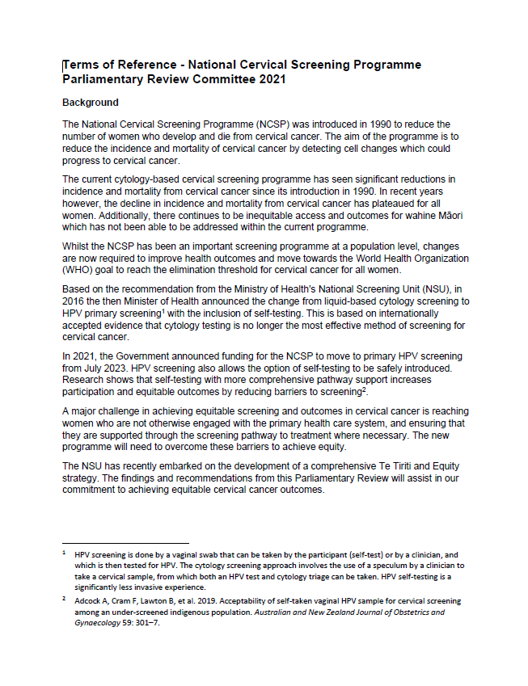

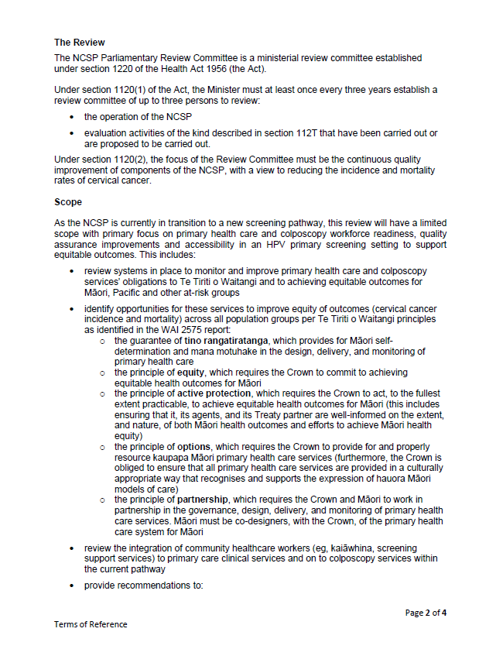

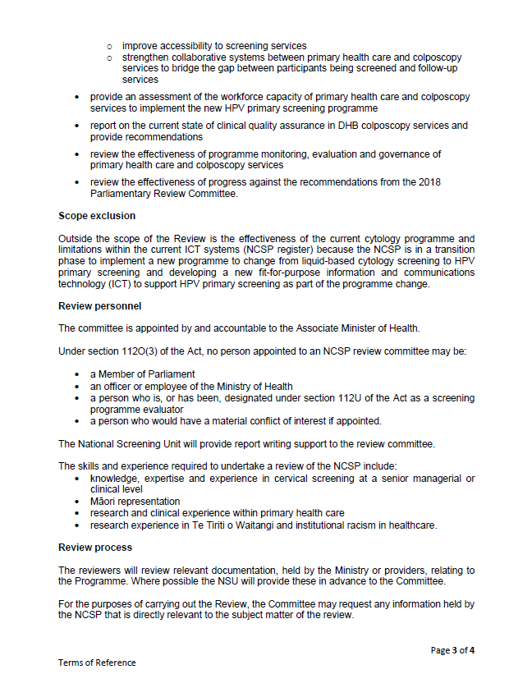

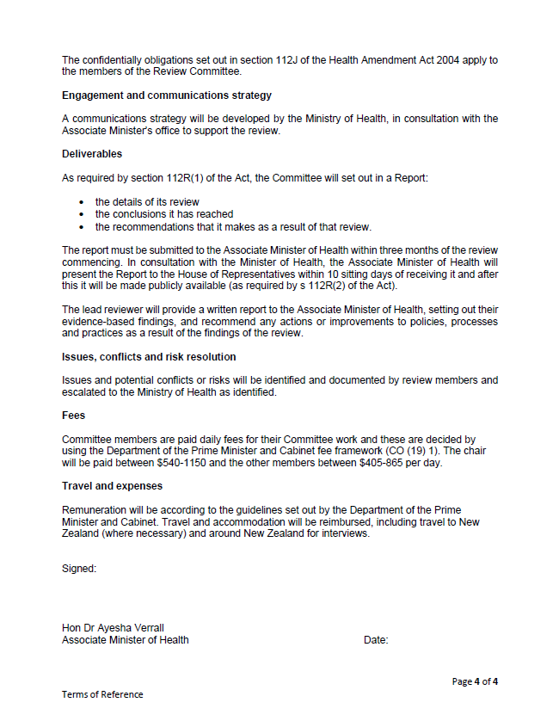
Appendix 2: Interviews conducted by the Parliamentary Review Committee
ORGANISATION
Te Whatu Ora National Cervical Screening Programme | Clinical Director, NSU  Manager, NCSP  Senior Portfolio Manager, NCSP  Public Health Physician, NSU – Equity  Public Health Physician, NSU  Clinical Leader, NCSP – Pathology  Clinical Leader, NCSP – Colposcopy  Primary Care Advisor, NSU
National Kaitiaki Rōpū
Māori Monitoring and Equity Group (MMEG) | Chair
Te Whatu Ora Locations | Wairarapa (Colposcopy Service)  Taranaki (Acting Regional Programme Manager and Colposcopy Service)  Northland (Lead Colposcopy Nurse; Gynaecologist)  Auckland (Gynaecological Oncologist; Director of Health Outcomes)  Waitamatā (Director of Health Outcomes)  Hawkes Bay (Register Coordinator; Smear takers; Colposcopy Nurse; Support to Services Lead)  Southern (Regional Coordinator; Health Promoter)  Waikato (NCSP Regional Coordinator)  Bay of Plenty (Population and Women’s Health)  Canterbury (Clinical Director Obstetrics and Gynaecology; Lead Colposcopy Nurse; Lead for Colposcopy and Hystology Triage)
NCSP Regional Coordinators and Managers/PHO NCSP Leads | Hutt Valley Te Whatu Ora (Regional Screening Manager)  Waikato Te Whatu Ora (Specialty Clinical Nurse/Regional Coordinator)
Leads | Hauraki PHO (Programme Lead)  Auckland and Waitematā Te Whatu Ora (Senior Programme Manager, Women’s Health)  Pinnacle Midlands PHO (Programme Lead)  MidCentral Te Whatu Ora (Equity and Bicultural Practice Programme Lead, Cancer)  Bay of Plenty Te Whatu Ora (NCSP Regional Coordinator)
Te Tātai Hauora o Hine – National Centre for Women’s Health Research Aotearoa | Director
Hei Āhuru Mōwai | Co-Chairs  Chief Executive Officer
Kokiri Mana Wāhine Support to Services | General Manager  Clinical Lead Nurse
Independent Māori Women’s Health Consultant
Think Hauora – Primary Health Organisation | General Manager  Clinical Quality Manager
Northland Support to Services Lead Coordinator | Te Hiku Hauora (Whakapiri Ora Manager)
Alliance Health Plus – Primary Health Organisation | Clinical Director  Nurse Lead
Well Women & Family Trust | General Manager  Manager Asian Health  Indian Health Promoter
Family Planning | National Medical Advisor  Clinical Information Systems Advisor  Central Nurse Advisor
The Woman’s Health Bus – Te Waka Wahine Hauora | Gynaecologist and Co-Director
Palms Medical Centre | Practice Manager
Disability Advocate
Rainbow Communities Advocate
Professional Association for Transgender Health Aotearoa | Vice President  Executive Committee  Policy and Advocacy Committee
Royal New Zealand College of General Practitioners | Primary Care
Otago University | Senior Lecturer, Obstetrics and Gynaecology  Senior Lecturer, Women’s Health

Appendix 3: 2022 National Cervical Screening Programme Parliamentary Review – Committee Interview Questions

- Can you tell us how you are involved in cervical cancer screening? (Please check all that apply – please number each in order of priority)
Scientist
Nurse Practitioner
General Practitioner
Practice Nurse
Screening Participant
Advisory Committee
Health Promotion
Public Health
Specialist Physician
Colposcopy
OBGYN
Scientist
Kaiawhina/Community Health Worker
Whānau Ora Navigator
Community Nurse
Service Manager

- What are the most important matters for the Review Committee to understand about cervical screening in Aotearoa New Zealand?
- What can you tell us about systems in place to monitor and improve the accessibility and quality of a) primary care and/or b) colposcopy services, to achieve equitable outcomes (cervical cancer incidence and mortality)?
- What is your opinion as to the success of these systems and any improvements you have observed?
- In your opinion, what are the challenges for improving accessibility to cervical screening and treatment services in Aotearoa New Zealand?

- What can you tell us about how a) primary health care and/or b) colposcopy services draw on health system obligations under Te Tiriti o Waitangi to improve their services to achieve more equitable outcomes across the NCSP?
- What intentional collaborative relationships does your rōpū have with hapū / Māori / iwi providers?
- How are your processes, actions and decision-making informed and shaped by Māori worldviews/perspectives?
- How are you supporting Māori-led processes, actions and decision-making through sharing power and resources?
- What specific actions are you undertaking to ensure equitable outcomes for Māori?
- How do you ensure tikanga Māori and values are present in your work and workplace?

- What can you tell us about any integration of kaiāwhina or community support services with primary care and colposcopy services within the current NCSP pathway?
- In your opinion, what are the successes and challenges with any integration of kaiāwhina or community support services with primary care and colposcopy services that you have observed across the NCSP pathway?
- What can you tell us about the collaborative systems between primary healthcare and colposcopy services to bridge the gap between participants being screened and followed up?
- What is your opinion as to the success of these systems and any improvements you have observed?
- What can you tell us about the primary health care workforce capacity and capability to implement the new HPV primary screening programme?
- What can you tell us about colposcopy workforce capacity and capability to implement the new HPV primary screening programme?
- What can you tell us about the processes you have in place to monitor clinical quality assurance within your colposcopy service?
- How do you measure individual colposcopists’ performance? Can you tell us how you manage remediation of individual colposcopists who are not meeting performance measures?

- What can you tell us about the effectiveness of monitoring, evaluation and governance of the primary health care role in the cervical screening programme?
- What can you tell us about the effectiveness of monitoring, evaluation and governance of colposcopy services role in the cervical screening programme?

Thank you for your time and contribution.

If you later have anything else you wish to share with the Review Committee, please feel free to notify us by contacting:

Dr Heather Came (Chair)

DAA audit reports provided to the PRC.
The sexual violence prevention and response sector under the leadership of Te Ōhaaki ā Hine – National Network Ending Sexual Violence Together.
LLETZ stands for large loop excision of the transformation zone. It is a treatment to remove cell changes (abnormal cells) from the cervix.

