Health New Zealand Employed Workforce Quarterly Report

Quarter Four 2024/25

Citation: Health New Zealand | Te Whatu Ora. 2025. *Health New Zealand Employed Workforce Quarterly Report, Quarter Four 2024/25*.   
Wellington: Health New Zealand | Te Whatu Ora.

Published in September 2025 by Health New Zealand | Te Whatu Ora  
PO Box 793, Wellington 6140, New Zealand

ISSN 3021-4564 (online)



This document is available at [tewhatuora.govt.nz](https://www.tewhatuora.govt.nz/)

|  |  |
| --- | --- |
|  | This work is licensed under the Creative Commons Attribution 4.0 International licence. In essence, you are free to: share i.e., copy and redistribute the material in any medium or format; adapt i.e., remix, transform and build upon the material. You must give appropriate credit, provide a link to the licence and indicate if changes were made. |

# Health Workforce Information

The Health Workforce Information Programme (HWIP) is a well-established programme within Health New Zealand | Te Whatu Ora (Health NZ). The programme collects base information on employee demographics, competencies and describes the current composition of the Health NZ workforce.

## Changes to Reporting

This report includes employees from 20 Districts and the following former agencies:

* Hauora Māori (Te Aka Whai Ora)
* NZ Health Partnership
* Health Alliance
* HealthSource
* HealthShare
* Northern Regional Alliance (NRA)
* TAS Kāhui Tuitui Tāngata
* Te Whatu Ora | Health New Zealand National Office

In this report, the data from these former agencies is combined and referred to as ‘National Payrolls’ data. At this stage National Payrolls employee data has been coded to HWIP Occupation Group ’Corporate and Other’ in this report. This may undercount national clinical roles, and work is underway to review the treatment of these roles in future reports to provide the most accurate representation of the whole of the Health NZ workforce.

## Purpose of the Report

This report covers all Health NZ employees for the period 01 April 2025 to 30 June 2025 and is a snapshot in time as at 30 June 2025. The report provides information on the general make up and characteristics of the Health NZ workforce to help inform further data analysis and workforce planning. The format of the report is to provide tables and graphs on the demographics of the workforce aligned to the seven HWIP occupational groupings. These HWIP groupings are:

* Senior Medical Officer (SMO)
* Resident Medical Officer (RMO)
* Nursing
* Midwifery
* Allied & scientific (the amalgamation of Allied Health and Technical and Scientific)
* Care and support
* Corporate and other

**Note that totals in this report are not directly comparable to District Quarterly reports, due to the** **inclusion of the Non District agencies.**

## Data Extraction

The data extract used for this report covers the period 01 April 2025 to 30 June 2025 inclusive and is a snapshot taken by the Districts on 30 June 2025.

## Disclaimer

While reasonable care has been taken to prepare this material, we give no guarantee that it is free from errors or defects. It is the best available data.

This report is created as at a point in time. Minor revisions may be implemented in the underlying datasets, and subsequent data extracts, after publication.  
  
Contact: [WorkforceInformation@tewhatuora.govt.nz](mailto:WorkforceInformation@tewhatuora.govt.nz)   
Data source: Workforce Information, held by Health New Zealand | Te Whatu Ora

Contents

Health Workforce Information 3

Changes to Reporting 3

Purpose of the Report 3

Data Extraction 4

Disclaimer 4

Table of Figures 6

Table of Tables 6

Overview 7

Health NZ workforce at a glance 7

Distribution of employees 8

Inclusions and exclusions 10

Employee count and FTE by occupation group 11

Tables and charts by occupation grouping 12

Employee count and FTE by occupation grouping and gender 12

Employee count by occupation group and ethnicity 13

Ages and length of service 15

Tables and charts by District including national payrolls 16

Employee count and mean FTE by gender 16

Mean ages and mean length of service by district and gender 18

Ethnicities by District including national payrolls 20

Analysis by District and occupation group 22

Length of service by occupation group and District 22

Analysis by sick leave and annual leave 24

Sick leave by District including national payrolls, occupation group, age group and ethnicity by gender 24

Ratio of annual leave balance and annual leave entitlement by District including national payrolls, occupation group and ethnicity by gender 27

Analysis by population 29

Distribution of overall District employees by age, with national employee data 29

Ethnic representation of workforce to resident population 30

Population density by occupational group and District 31

## Table of Figures

Figure 1: Count of individual employees 8

Figure 2: Occupation group distinct employee count and mean FTE by gender 12

Figure 3: Proportion of ethnicities by occupation group 13

Figure 4: Proportion of identifiable ethnicities for all Health NZ employees 14

Figure 5: Proportion of identifiable ethnicities for projected population data at 30 June 2025 15

Figure 6: Mean ages and length of service by occupation group and gender 15

Figure 7: Employee Count and mean FTE by gender and District 17

Figure 8: Mean ages and mean length of service by District and gender 19

Figure 9: Proportion of reported ethnicities by District 20

Figure 10: Mean length of service by occupation group and District 26

Figure 11: Average annualized sick leave hours per FTE by District 26

Figure 12: Average annual sick leave hours per FTE by occupational group 26

Figure 13: Average annual sick leave hours per FTE by age group by gender 27

Figure 14: Average annual sick leave hours per FTE by ethnicity by gender 28

Figure 15: Ratio of annual leave balance to annual leave entitlement hours per FTE by District 28

Figure 16: Ratio of annual leave balance to annual leave entitlement hours per FTE by occupational group 29

Figure 17: Ratio of annual leave balance to annual leave entitlement hours per FTE by ethnicity by gender 30

Figure 18: Distribution of overall District employees by age, with national employee data 30

Figure 19: Population density of Nurses by District 32

Figure 20: Population density of Corporate & Other by District 31

Figure 21: Population density of Allied & Scientific by District 32

Figure 22: Population density of Care & Support by District 32

Figure 23: Population density of Senior Medical Officer (SMO) by District 33

Figure 24: Population density of Resident Medical Officer (RMO) by District 33

Figure 25: Population density of Midwives by District 34

Figure 26: Population density of all District staff by District 34

## Table of Tables

Table 1: Distribution of employment types 8

Table 2: Employee count and FTE by District and occupation group 11

Table 3: Occupation group employee count and mean FTE by gender 12

Table 4: Employee Count and proportion of ethnicities by occupation group 14

Table 5: Mean ages and length of service by occupation group and gender 16

Table 6: Employee Count and mean FTE by gender and District 17

Table 7: Mean ages and mean length of service by District and gender 19

Table 8: Distribution of reported ethnicities by District and Employee Count 20

# Overview

## Health NZ workforce at a glance

For data to 30 June 2025, only those employed with contracted hours greater than zero are included in the analysis except for the tables and charts that explicitly report on ‘Other’ employees on page 5. ‘Other’ includes those on maternity / parental leave, and those who have not been reported with an employment status code.

|  |  |  |
| --- | --- | --- |
| **Total employees 91,0711,2 in 92,183 positions 70,563 Female 20,514 Male 45 Another/Not Stated Gender Other employees 8,8273** | **78,540 FTE4 59,590 FTE4 Females 18,880 FTE4 Males 39 FTE Another/Not Stated Gender4** | **Largest HWIP occupation group: Nursing - 35,137 employees in 35,755 positions Smallest HWIP occupation group: Midwifery - 1,743 employees in 1,796 positions** |
| **District employee average age 44.8 years 44.8 years for females 44.7 years for males** | **Oldest male HWIP occupation group: SMO (mean age 51.3 years) Youngest male HWIP occupation group: RMO (mean age 31.6 years)** | **Oldest female HWIP occupation group: Corporate and other (mean age 50.1 years) Youngest female HWIP occupation group: RMO (mean age 31.2 years)** |
| **Mean FTE rate 0.86 per employee Mean FTE rate for females 0.84 Mean FTE rate for males 0.90** | **Longest Length of Service HWIP occupation group: SMO (mean 10.4 years) Shortest Length of Service HWIP occupation group: RMO (mean 1.6 years)** | **Employee reported ethnicities:   Other5 - 55.7% Asian - 30.1% Māori - 9% Pacific - 5.2%5** |
| 1The count of employees is a distinct count of individual employees. | | |
| 2Total employees are those with contracted hours greater than 0. | | |
| 3Other employees are those without contracted hours and includes employees on maternity/parental leave and Leave without Pay. | | |
| 4Contracted FTE is using a 2086-hour annual contract: N.B. Interpretations of a ‘full time equivalent’ can vary. For example, a sonographer may be classed as 1.0 full time employee in one District where they are contracted to work 35 hours per week, whereas another sonographer in a different District may be classed as 1.0 full time employee where they are contracted to work 40 hours per week. The Contracted FTE definition used here allows a comparison to be made across Districts and occupations through a universal standard. | | |
| 5To allow direct comparisons with reported ethnicity data from Statistics New Zealand, we have amalgamated ethnicities not associated with Asian, Māori or Pacific into the group ‘Other’. This total also includes ‘Unknown’/Not Stated. | | |

## Distribution of employees

This chart shows the number of Health NZ employees (a distinct count of employee numbers) who are classed as either Employees (contracted hours greater than zero) or ‘Other’ (all others including those on maternity / parental leave, and those who have not been reported with an employment status code). If an individual has already been included in the Employed total but also holds a casual contract, they have not been counted again in the Others column. The chart has been ordered in descending order of workforce size. The table below the chart gives the actual count of employees.

Figure 1: Count of individual employees

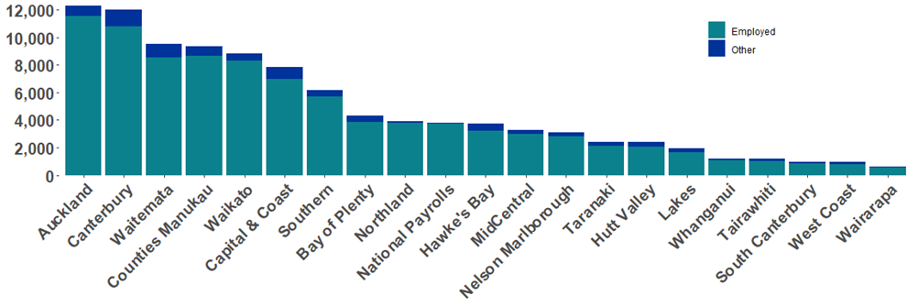

Table 1: Distribution of employment types

| **Health New Zealand (Health NZ)** | **Employed** | **Others** | **Total** | **Proportion of District   Workforce** |
| --- | --- | --- | --- | --- |
| **Auckland** | 11,518 | 783 | 12,301 | 12.3% |
| **Canterbury** | 10,810 | 1,169 | 11,979 | 12.0% |
| **Waitemata** | 8,554 | 977 | 9,531 | 9.5% |
| **Counties Manukau** | 8,638 | 732 | 9,370 | 9.4% |
| **Waikato** | 8,278 | 574 | 8,852 | 8.9% |
| **Capital & Coast** | 6,994 | 819 | 7,813 | 7.8% |
| **Southern** | 5,705 | 464 | 6,169 | 6.2% |
| **Bay of Plenty** | 3,848 | 474 | 4,322 | 4.3% |
| **Northland** | 3,779 | 118 | 3,897 | 3.9% |
| **National Payrolls** | **3,752** | **38** | **3,790** | **3.8%** |
| **Hawke's Bay** | 3,208 | 539 | 3,747 | 3.8% |
| **MidCentral** | 3,013 | 279 | 3,292 | 3.3% |
| **Nelson Marlborough** | 2,799 | 326 | 3,125 | 3.1% |
| **Taranaki** | 2,101 | 317 | 2,418 | 2.4% |
| **Hutt Valley** | 2,088 | 318 | 2,406 | 2.4% |
| **Lakes** | 1,657 | 292 | 1,949 | 2.0% |
| **Whanganui** | 1,080 | 137 | 1,217 | 1.2% |
| **Tairawhiti** | 1,026 | 153 | 1,179 | 1.2% |
| **South Canterbury** | 842 | 110 | 952 | 1.0% |
| **West Coast** | 803 | 148 | 951 | 1.0% |
| **Wairarapa** | 578 | 60 | 638 | 0.6% |
| **Total** | **91,071** | **8,827** | **99,898** | **100.0%** |

**NOTE:** Prior to June 2021, this table was based on a count of positions, which had the potential to count individual employees more than once if they held multiple positions with a District. Individuals may still be counted more than once if they hold positions with multiple Districts.

## Inclusions and exclusions

Specific caveats and definitions relevant to charts and tables have been provided throughout the report and should be noted. Additionally, all charts and tables that follow in this document are derived from data using the following caveats:  
  
Inclusions:

* Only employees who have positive contract hours have been included; those with zero contract hours or are classified as on parental leave or leave without pay have been excluded.
* Charts containing ‘Age’ include all employees who have a calculated age between 15 and 99.
* All Health NZ employees are included unless specifically stated otherwise.

Exclusions:

* Data has been excluded when it does not match the reporting variable standard format (i.e. if a gender code has not been assigned then the employee will be excluded from that chart or table).
* For privacy reasons some data has been suppressed for numbers less than ten.
* Any employee who has an employment end date entered (before or during the reporting quarter) has also been excluded since they left employment before the end of the reporting quarter.
* Charts containing ‘ethnicity’, exclude employees who do not have a valid ethnicity code.
* Analysis by population does not include National and Enabling data because there is no specific population associated with the National and Enabling data.
* National and Enabling length of service data is excluded due to low data quality.

Calculations:

* Percentage sick leave hours is calculated by dividing the number of sick leave hours taken by the contracted hours (excluding those with zero contracted hours). It excludes staff who started or terminated employment in the reporting quarter.
* Annual leave balance to entitlement calculations exclude staff who started or terminated employment in the reporting quarter and those staff who have no reported entitlement to annual leave.
* Because of the way start dates are reported the length of service is most likely to be based on the length of service within the District rather than the length of service of the reported position. When a person is reported under multiple positions for a single occupation group, the greatest length of service value is used for the individual

## 

## Employee count and FTE by occupation group

The following table shows the distinct count of employees by their occupation grouping and District. It also includes columns for full-time equivalent counts (Contracted FTE, using a 2086 hour annual contract) and mean FTE (the average FTE calculation for all employees). Employees who do not have a contract of more than zero hours are excluded.

Table 2: Employee count and FTE by District and occupation group

|  | **Nursing** | | | **Corporate and Other** | | | **Allied and Scientific** | | | **Care and Support** | | | **Senior Medical Officer (SMO)** | | | **Resident Medical Officer**  **(RMO)** | | | **Midwifery** | | |
| --- | --- | --- | --- | --- | --- | --- | --- | --- | --- | --- | --- | --- | --- | --- | --- | --- | --- | --- | --- | --- | --- |
| **Health New Zealand (Health NZ)** | **Employee Count** | **FTE** | **Mean FTE** | **Employee Count** | **FTE** | **Mean FTE** | **Employee Count** | **FTE** | **Mean FTE** | **Employee Count** | **FTE** | **Mean FTE** | **Employee Count** | **FTE** | **Mean FTE** | **Employee Count** | **FTE** | **Mean FTE** | **Employee Count** | **FTE** | **Mean FTE** |
| **Auckland** | 4,370 | 3,859.3 | 0.88 | 2,067 | 1,915.3 | 0.93 | 2,155 | 1,942.8 | 0.90 | 856 | 804.4 | 0.94 | 1,214 | 1,023.7 | 0.84 | 675 | 669.0 | 0.99 | 197 | 157.1 | 0.80 |
| **Bay of Plenty** | 1,583 | 1,248.4 | 0.79 | 631 | 547.6 | 0.87 | 585 | 488.7 | 0.84 | 457 | 383.1 | 0.84 | 277 | 225.4 | 0.81 | 229 | 225.9 | 0.99 | 86 | 58.5 | 0.68 |
| **Canterbury** | 4,264 | 3,512.0 | 0.82 | 2,027 | 1,768.7 | 0.87 | 1,806 | 1,487.6 | 0.82 | 1,182 | 963.5 | 0.82 | 733 | 599.5 | 0.82 | 616 | 595.5 | 0.97 | 182 | 117.8 | 0.65 |
| **Capital & Coast** | 3,021 | 2,585.7 | 0.86 | 1,174 | 1,094.1 | 0.93 | 881 | 767.3 | 0.87 | 686 | 596.4 | 0.87 | 507 | 442.1 | 0.87 | 655 | 638.8 | 0.98 | 98 | 73.4 | 0.75 |
| **Counties Manukau** | 3,359 | 2,955.1 | 0.88 | 1,479 | 1,299.4 | 0.88 | 1,273 | 1,128.2 | 0.89 | 1,138 | 976.3 | 0.86 | 643 | 592.7 | 0.92 | 498 | 485.4 | 0.97 | 259 | 196.5 | 0.76 |
| **Hawke's Bay** | 1,249 | 978.0 | 0.78 | 609 | 532.6 | 0.87 | 509 | 435.0 | 0.85 | 418 | 346.5 | 0.83 | 198 | 159.6 | 0.81 | 189 | 185.2 | 0.98 | 43 | 32.5 | 0.76 |
| **Hutt Valley** | 896 | 736.3 | 0.82 | 399 | 352.0 | 0.88 | 295 | 247.9 | 0.84 | 258 | 219.3 | 0.85 | 176 | 136.6 | 0.78 | 8 | 7.8 | 0.98 | 57 | 38.9 | 0.68 |
| **Lakes** | 693 | 552.7 | 0.80 | 308 | 270.8 | 0.88 | 228 | 194.8 | 0.85 | 187 | 160.0 | 0.86 | 107 | 86.0 | 0.80 | 105 | 103.1 | 0.98 | 29 | 19.0 | 0.66 |
| **MidCentral** | 1,317 | 1,064.6 | 0.81 | 472 | 428.3 | 0.91 | 444 | 383.4 | 0.86 | 346 | 280.0 | 0.81 | 186 | 164.9 | 0.89 | 192 | 189.9 | 0.99 | 56 | 39.5 | 0.71 |
| **National Payrolls** | 0 | 0.0 | 0.00 | 3,752 | 3,655.1 | 0.97 | 0 | 0.0 | 0.00 | 0 | 0.0 | 0.00 | 0 | 0.0 | 0.00 | 0 | 0.0 | 0.00 | 0 | 0.0 | 0.00 |
| **Nelson Marlborough** | 969 | 752.8 | 0.78 | 575 | 488.0 | 0.85 | 388 | 308.4 | 0.79 | 541 | 408.5 | 0.76 | 175 | 139.2 | 0.80 | 104 | 103.6 | 1.00 | 58 | 41.8 | 0.72 |
| **Northland** | 1,520 | 1,224.3 | 0.81 | 619 | 542.7 | 0.88 | 560 | 484.6 | 0.87 | 538 | 413.6 | 0.77 | 258 | 237.8 | 0.92 | 190 | 185.2 | 0.97 | 94 | 54.4 | 0.58 |
| **South Canterbury** | 377 | 306.7 | 0.81 | 131 | 109.1 | 0.83 | 122 | 98.7 | 0.81 | 94 | 70.8 | 0.75 | 63 | 53.3 | 0.85 | 30 | 29.7 | 0.99 | 28 | 21.8 | 0.78 |
| **Southern** | 2,505 | 2,019.4 | 0.81 | 952 | 849.1 | 0.89 | 831 | 708.6 | 0.85 | 560 | 455.7 | 0.81 | 389 | 334.9 | 0.86 | 372 | 363.6 | 0.98 | 96 | 63.2 | 0.66 |
| **Tairawhiti** | 419 | 335.7 | 0.80 | 228 | 204.1 | 0.90 | 140 | 114.3 | 0.82 | 119 | 105.4 | 0.89 | 61 | 52.1 | 0.85 | 35 | 34.5 | 0.99 | 24 | 15.9 | 0.66 |
| **Taranaki** | 834 | 654.1 | 0.78 | 424 | 374.5 | 0.88 | 314 | 258.4 | 0.82 | 238 | 196.0 | 0.82 | 155 | 130.2 | 0.84 | 105 | 103.6 | 0.99 | 34 | 24.4 | 0.72 |
| **Waikato** | 3,442 | 2,930.2 | 0.85 | 1,480 | 1,342.0 | 0.91 | 1,171 | 1,016.0 | 0.87 | 1,034 | 884.2 | 0.86 | 518 | 453.2 | 0.87 | 518 | 503.5 | 0.97 | 118 | 81.4 | 0.69 |
| **Wairarapa** | 285 | 214.0 | 0.75 | 108 | 91.0 | 0.84 | 66 | 51.5 | 0.78 | 73 | 48.1 | 0.66 | 28 | 25.1 | 0.90 | 0 | 0.0 | 0.00 | 22 | 15.5 | 0.70 |
| **Waitemata** | 3,231 | 2,772.8 | 0.86 | 1,402 | 1,204.4 | 0.86 | 1,437 | 1,245.5 | 0.87 | 1,241 | 1,107.6 | 0.89 | 625 | 568.1 | 0.91 | 405 | 389.7 | 0.96 | 213 | 128.2 | 0.60 |
| **West Coast** | 312 | 260.3 | 0.83 | 207 | 170.4 | 0.82 | 87 | 76.8 | 0.88 | 129 | 100.7 | 0.78 | 45 | 34.4 | 0.76 | 6 | 5.5 | 0.92 | 17 | 12.7 | 0.75 |
| **Whanganui** | 491 | 394.6 | 0.80 | 173 | 157.8 | 0.91 | 153 | 127.7 | 0.83 | 127 | 105.4 | 0.83 | 55 | 50.5 | 0.92 | 49 | 49.0 | 1.00 | 32 | 23.9 | 0.75 |
| **Total** | **35,137** | **29,357** | **0.84** | **19,217** | **17,397** | **0.91** | **13,445** | **11,566.2** | **0.86** | **10,222** | **8,625.5** | **0.84** | **6,413** | **5,509.3** | **0.86** | **4,981** | **4,868.5** | **0.98** | **1,743** | **1,216.4** | **0.70** |

**Note:** At this stage National Payrolls employee data has been coded to HWIP Occupation Group ’Corporate and Other’ in this report. This may undercount national clinical roles, and work is underway to review the treatment of these roles in future reports to provide the most accurate representation of the whole of the Health NZ workforce.

# Tables and charts by occupation grouping

## Employee count and FTE by occupation grouping and gender

The bars represent the distinct count (left hand axis) of employees by gender and  
occupation grouping, and the triangles represent the average FTE for those employees  
(right hand axis), also by gender and occupation grouping. As some employees may have  
roles across multiple Occupation Groups, they may be counted more than once in the  
group totals, but only once in the Grand Total row in Table 3.

Figure 2: Occupation group distinct employee count and mean FTE by gender

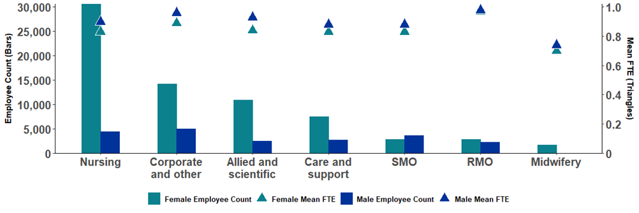

Table 3: Occupation group employee count and mean FTE by gender

|  | **Female** | | **Male** | | **Another Gender** | | **Total** | |
| --- | --- | --- | --- | --- | --- | --- | --- | --- |
| **Occupation Group** | **Employee Count** | **Mean FTE** | **Employee Count** | **Mean FTE** | **Employee Count** | **Mean FTE** | **Employee Count\*** | **Mean FTE** |
| **Nursing** | 30,645 | 0.83 | 4,465 | 0.90 | 13 | 0.82 | 35,137 | 0.84 |
| **Corporate and other** | 14,233 | 0.89 | 4,967 | 0.96 | <15 | 0.86 | 19,217 | 0.91 |
| **Allied and scientific** | 10,902 | 0.84 | <2,535 | 0.93 | <10 | 0.98 | 13,445 | 0.86 |
| **Care and support** | <7,490 | 0.83 | <2,730 | 0.88 | <10 | 0.86 | 10,222 | 0.84 |
| **SMO** | <2,790 | 0.83 | 3,620 | 0.88 | <10 | 0.90 | 6,413 | 0.86 |
| **RMO** | <2,780 | 0.97 | <2,200 | 0.98 | <10 | 0.93 | 4,981 | 0.98 |
| **Midwifery** | <1,735 | 0.70 | <10 | 0.74 | <10 | 0.65 | 1,743 | 0.70 |
| **Total** | **70,563** | **0.84** | **20,514** | **0.90** | **45** | **0.86** | **91,071** | **0.86** |
| *The sum of columns in the table do not add up to the total column because the gender breakdowns exclude employees with no data available and those reported as gender ‘Not Stated’. | | | | | | | | |

## Employee count by occupation group and ethnicity

This chart shows the proportion (not the actual count of employees) of ethnicities reported  
within each occupation group. The table below details the distinct count of employees for  
whom an ethnicity was reported. As some employees may have roles across multiple  
Occupation Groups, they may be counted more than once in the group totals, but only  
once in the Grand Total row in Table 4.

The pie chart, on the next page, shows the distribution of all reported ethnicities for all Districts.

Figure 3: Proportion of ethnicities by occupation group

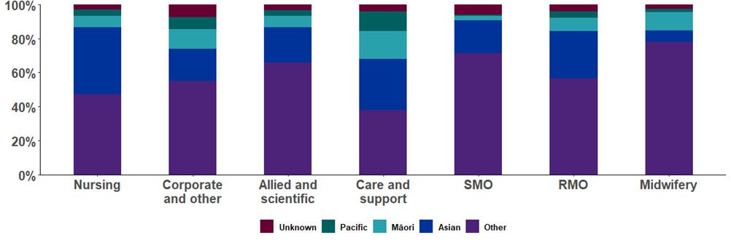

Table 4: Employee Count and proportion of ethnicities by occupation group

| **Occupation Group** | **Other1** | | **Asian** | | **Māori** | | **Pacific** | | **Unknown** | | **Total** |
| --- | --- | --- | --- | --- | --- | --- | --- | --- | --- | --- | --- |
| **Nursing** | 16,495 | 46.9% | 13,888 | 39.5% | 2,339 | 6.7% | 1,301 | 3.7% | 1,114 | 3.2% | 35,137 |
| **Corporate and other** | 10,589 | 55.1% | 3,605 | 18.8% | 2,203 | 11.5% | 1,388 | 7.2% | 1,433 | 7.5% | 19,217 |
| **Allied and scientific** | 8,827 | 65.7% | 2,819 | 21.0% | 902 | 6.7% | 433 | 3.2% | 464 | 3.5% | 13,445 |
| **Care and support** | 3,856 | 37.7% | 3,099 | 30.3% | 1,681 | 16.4% | 1,165 | 11.4% | 421 | 4.1% | 10,222 |
| **SMO** | 4,566 | 71.2% | 1,244 | 19.4% | 164 | 2.6% | 64 | 1.0% | 375 | 5.8% | 6,413 |
| **RMO** | 2,807 | 56.4% | 1,400 | 28.1% | 390 | 7.8% | 177 | 3.6% | 207 | 4.2% | 4,981 |
| **Midwifery** | 1,359 | 78.0% | 118 | 6.8% | 185 | 10.6% | 35 | 2.0% | 46 | 2.6% | 1,743 |
| **Total** | **48,437** | **53.2%** | **26,163** | **28.7%** | **7,856** | **8.6%** | **4,561** | **5.0%** | **4,055** | **4.5%** | **91,071** |
| 1‘Other’ is a group amalgamation of all ethnicities that do not fall into the groups Asian, Māori or Pacific. Employee counts in the Grand Total line are slightly lower than the sum of the Occupation Groups, as some individuals may be represented in more than one Occupation Group. | | | | | | | | | | | |

This pie chart is based on the 87,017 permanent distinct employees who declared their  
ethnicity as Asian, Māori, Pacific or Other. Below this is a similar pie chart of ethnicity  
proportions in the New Zealand population based on projections of population data by  
Statistics New Zealand for 30 June 2025.

Figure 4: Proportion of identifiable ethnicities for all Health NZ employees

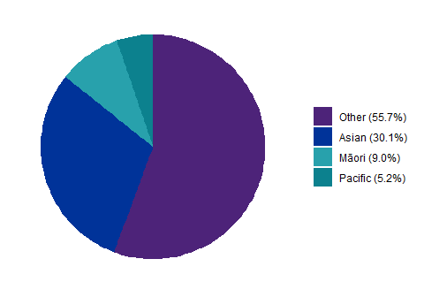

Figure 5: Proportion of identifiable ethnicities for projected population data at 30 June 2025

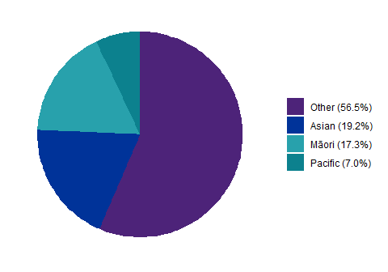

## Ages and length of service

**National Payrolls data is not included in the following figures and tables.**  
  
The bars in this chart show the average age (left hand axis) for each occupation group by  
gender. The triangles represent the average length of service (right hand axis), also by  
occupation group and gender. The following table gives the actual figures behind the chart.

Figure 6: Mean ages and length of service by occupation group and gender

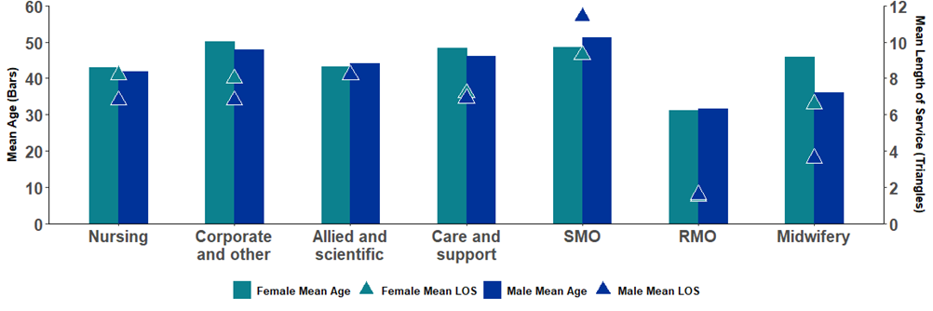

Table 5: Mean ages and length of service by occupation group and gender

|  | **Female** | | **Male** | | **Total** | |
| --- | --- | --- | --- | --- | --- | --- |
| **Occupation Group** | **Mean Age** | **Mean Length of Service** | **Mean Age** | **Mean Length of Service** | **Mean Age** | **Mean Length of Service** |
| **Nursing** | 42.9 | 8.2 | 41.9 | 6.8 | 42.7 | 8.0 |
| **Corporate and other** | 50.1 | 8.0 | 47.9 | 6.8 | 49.5 | 7.7 |
| **Allied and scientific** | 43.2 | 8.2 | 44.1 | 8.2 | 43.4 | 8.2 |
| **Care and support** | 48.4 | 7.2 | 46.2 | 6.9 | 47.8 | 7.1 |
| **SMO** | 48.6 | 9.3 | 51.3 | 11.4 | 50.1 | 10.4 |
| **RMO** | 31.2 | 1.5 | 31.6 | 1.6 | 31.3 | 1.6 |
| **Midwifery** | 46.0 | 6.6 | 36.1 | 3.6 | 45.9 | 6.6 |
| **Total** | **44.8** | **7.8** | **44.7** | **7.2** | **44.8** | **7.7** |

# Tables and charts by District including national payrolls

This section looks at the same statistics given in the first section but broken down by District rather than occupation group. Page 7 has a table of figures for FTE and headcount which looks at both District and occupation grouping.

## Employee count and mean FTE by gender

This chart examines the distinct count of employees by gender and District (left hand axis).The Districts have been ordered in descending size of total employee count. The right-hand axis refers to the mean FTE for all positions (by District and gender). The following table shows the employee count and mean FTE by gender for each District. Staff identified as Another Gender have not been included in these charts, due to the overall low numbers of people.

Figure 7: Employee Count and mean FTE by gender and District

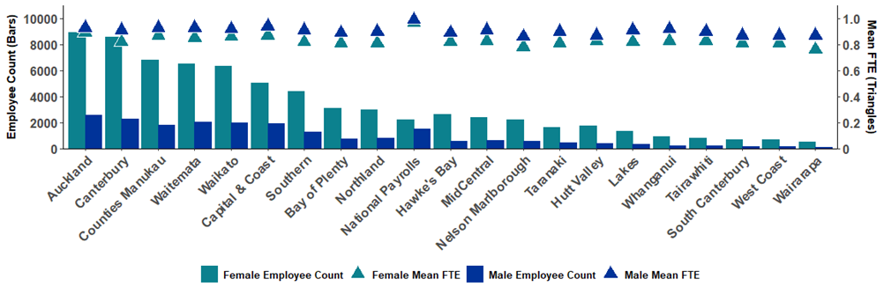

Table 6: Employee Count and mean FTE by gender and District

|  | **Female** | | **Male** | | **Total** | |
| --- | --- | --- | --- | --- | --- | --- |
| **Health New Zealand (Health NZ)** | **Employee Count** | **Mean FTE** | **Employee Count** | **Mean FTE** | **Employee Count** | **Mean FTE** |
| **Auckland** | 8,937 | 0.89 | 2,579 | 0.93 | 11,518 | 0.90 |
| **Canterbury** | 8,557 | 0.82 | 2,245 | 0.91 | 10,810 | 0.84 |
| **Counties Manukau** | 6,819 | 0.87 | 1,816 | 0.93 | 8,638 | 0.88 |
| **Waitemata** | 6,497 | 0.85 | 2,056 | 0.93 | 8,554 | 0.87 |
| **Waikato** | 6,328 | 0.86 | 1,950 | 0.92 | 8,278 | 0.87 |
| **Capital & Coast** | 5,060 | 0.87 | 1,921 | 0.94 | 6,994 | 0.89 |
| **Southern** | 4,422 | 0.82 | 1,273 | 0.91 | 5,705 | 0.84 |
| **Bay of Plenty** | 3,105 | 0.81 | 741 | 0.89 | 3,848 | 0.83 |
| **Northland** | 2,983 | 0.81 | 795 | 0.90 | 3,779 | 0.83 |
| **National Payrolls** | **2,236** | **0.97** | **1,509** | **0.99** | **3,752** | **0.97** |
| **Hawke's Bay** | 2,619 | 0.82 | 585 | 0.89 | 3,208 | 0.83 |
| **MidCentral** | 2,411 | 0.83 | 601 | 0.91 | 3,013 | 0.85 |
| **Nelson Marlborough** | 2,220 | 0.78 | 579 | 0.86 | 2,799 | 0.80 |
| **Taranaki** | 1,652 | 0.81 | 423 | 0.90 | 2,101 | 0.83 |
| **Hutt Valley** | 1,715 | 0.83 | 373 | 0.87 | 2,088 | 0.83 |
| **Lakes** | 1,331 | 0.82 | 325 | 0.91 | 1,657 | 0.84 |
| **Whanganui** | 894 | 0.83 | 184 | 0.92 | 1,080 | 0.84 |
| **Tairawhiti** | 830 | 0.83 | 196 | 0.90 | 1,026 | 0.84 |
| **South Canterbury** | 709 | 0.81 | 133 | 0.87 | 842 | 0.82 |
| **West Coast** | 655 | 0.81 | 148 | 0.87 | 803 | 0.82 |
| **Wairarapa** | 511 | 0.76 | 67 | 0.87 | 578 | 0.77 |

## Mean ages and mean length of service by district and gender

**National Payrolls data is not included in the following figures and tables.**  
  
This chart shows the mean age of employees in each District by gender (left hand axis) and has been ordered by descending mean age. The triangles represent the mean length of service (right hand axis) by gender and District. This has been calculated on an employee count basis, using the maximum reported length of service for each individual staff member across all relevant roles.

Figure 8: Mean ages and mean length of service by District and gender

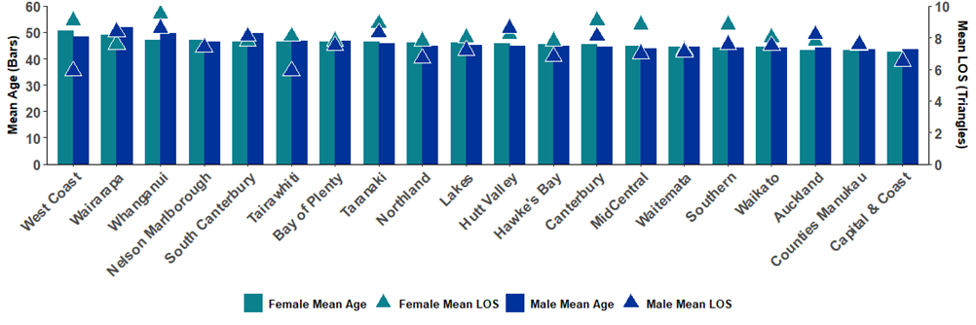

Table 7: Mean ages and mean length of service by District and gender

|  | **Female** | | **Male** | | **Total** | |
| --- | --- | --- | --- | --- | --- | --- |
| **Health New Zealand (Health NZ)** | **Mean Age** | **Mean Length of Service** | **Mean Age** | **Mean Length of Service** | **Mean Age** | **Mean Length of Service** |
| **West Coast** | 50.5 | 9.1 | 48.4 | 5.9 | 50.1 | 8.5 |
| **Wairarapa** | 49.1 | 7.6 | 51.9 | 8.4 | 49.4 | 7.7 |
| **Whanganui** | 47.1 | 9.5 | 49.5 | 8.6 | 47.5 | 9.3 |
| **Nelson Marlborough** | 47.2 | 7.4 | 46.5 | 7.4 | 47.1 | 7.4 |
| **South Canterbury** | 46.4 | 7.8 | 49.5 | 8.1 | 46.9 | 7.8 |
| **Tairawhiti** | 46.5 | 8.1 | 46.8 | 5.9 | 46.5 | 7.7 |
| **Bay of Plenty** | 46.3 | 7.8 | 46.8 | 7.5 | 46.4 | 7.7 |
| **Taranaki** | 46.3 | 8.9 | 45.8 | 8.3 | 46.1 | 8.7 |
| **Northland** | 46.2 | 7.8 | 45.0 | 6.7 | 46.0 | 7.6 |
| **Lakes** | 46.0 | 8.0 | 45.1 | 7.2 | 45.9 | 7.8 |
| **Hutt Valley** | 45.9 | 8.2 | 45.0 | 8.6 | 45.7 | 8.3 |
| **Hawke's Bay** | 45.6 | 7.8 | 44.7 | 6.8 | 45.4 | 7.6 |
| **Canterbury** | 45.6 | 9.1 | 44.5 | 8.1 | 45.3 | 8.9 |
| **MidCentral** | 45.0 | 8.8 | 43.9 | 7.0 | 44.8 | 8.4 |
| **Waitemata** | 44.6 | 7.2 | 44.4 | 7.1 | 44.5 | 7.1 |
| **Southern** | 44.3 | 8.8 | 44.3 | 7.6 | 44.3 | 8.5 |
| **Waikato** | 44.4 | 8.0 | 44.1 | 7.5 | 44.3 | 7.8 |
| **Auckland** | 43.1 | 7.8 | 44.1 | 8.2 | 43.3 | 7.9 |
| **Counties Manukau** | 43.2 | 7.5 | 43.7 | 7.6 | 43.3 | 7.5 |
| **Capital & Coast** | 42.7 | 6.5 | 43.4 | 6.5 | 42.9 | 6.5 |
| **Total** | **44.8** | **7.8** | **44.7** | **7.2** | **44.8** | **7.7** |

## Ethnicities by District including national payrolls

The following chart shows the proportion of ethnicities within each District employee  
population (ordered by descending proportion of ‘unknown’ ethnicities). It does not  
represent the actual number of people by each ethnicity; this is detailed in the table further  
below.

Figure 9: Proportion of reported ethnicities by District

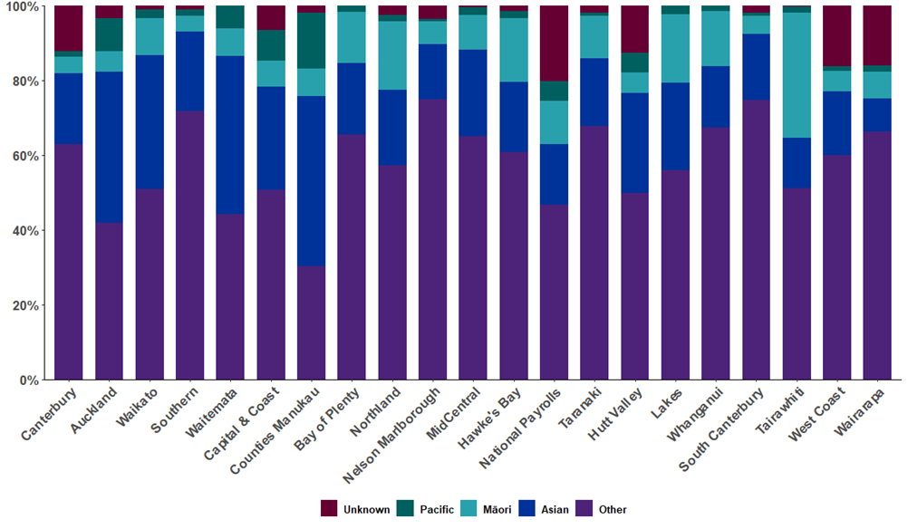

Table 8: Distribution of reported ethnicities by District and Employee Count

| **Health New Zealand (Health NZ)** | **Other1** | **Asian** | **Māori** | **Pacific** | **Unknown** | **Total2** |
| --- | --- | --- | --- | --- | --- | --- |
| **Canterbury** | 6,803 | 2,049 | 472 | 168 | 1,319 | 10,810 |
| **Auckland** | 4,823 | 4,661 | 621 | 1,025 | 388 | 11,518 |
| **Waikato** | 4,207 | 2,970 | 813 | 206 | 82 | 8,278 |
| **Southern** | 4,091 | 1,212 | 248 | 89 | 65 | 5,705 |
| **Waitemata** | 3,783 | 3,620 | 627 | 524 | 0 | 8,554 |
| **Capital & Coast** | 3,539 | 1,934 | 490 | 575 | 456 | 6,994 |
| **Counties Manukau** | 2,619 | 3,923 | 639 | 1,281 | 176 | 8,638 |
| **Bay of Plenty** | 2,517 | 734 | 532 | 62 | 3 | 3,848 |
| **Northland** | 2,163 | 765 | 694 | 62 | 95 | 3,779 |
| **Nelson Marlborough** | 2,096 | 413 | 169 | 22 | 99 | 2,799 |
| **MidCentral** | 1,958 | 699 | 280 | 60 | 16 | 3,013 |
| **Hawke's Bay** | 1,952 | 601 | 546 | 59 | 50 | 3,208 |
| **National Payrolls** | **1,754** | **602** | **441** | **198** | **757** | **3,752** |
| **Taranaki** | 1,421 | 383 | 237 | 21 | 39 | 2,101 |
| **Hutt Valley** | 1,042 | 557 | 113 | 110 | 266 | 2,088 |
| **Lakes** | 926 | 387 | 305 | 39 | 0 | 1,657 |
| **Whanganui** | 727 | 177 | 159 | 17 | 0 | 1,080 |
| **South Canterbury** | 628 | 150 | 40 | 7 | 17 | 842 |
| **Tairawhiti** | 524 | 138 | 345 | 16 | 3 | 1,026 |
| **West Coast** | 481 | 137 | 44 | 10 | 131 | 803 |
| **Wairarapa** | 383 | 51 | 41 | 10 | 93 | 578 |
| **Total** | **48,437** | **26,163** | **7,856** | **4,561** | **4,055** | **91,071** |
| 1‘Other’ is a group amalgamation of all ethnicities that do not fall into the groups Asian, Māori or Pacific.  2Totals may not add up as some individuals are associated with more than one ethnicity. | | | | | | |

# Analysis by District and occupation group

## Length of service by occupation group and District

**National Payrolls data is not included in the following figures and tables.**  
  
The following table shows the mean length of service for each occupation group by District. To read this table, look at the occupation column. The deeper blue colours represent a longer than national average length of service, the lighter blue colours are close to the national average (7.7 years), while the maroon colours are lower than the national average. The final column (all staff) has ordered the Districts by longer to shorter lengths of service. Length of service is based on reported time employed in the current position, so if an employee is reported with multiple positions, this metric picks up the maximum length of service across their positions.

Table 9: Mean length of service by occupation group and District

| **Health New Zealand (Health NZ)** | **Nursing** | **Corporate and other** | **Allied and scientific** | **Care and support** | **SMO** | **RMO** | **Midwifery** | **Grand Total** |
| --- | --- | --- | --- | --- | --- | --- | --- | --- |
| **Whanganui** | 9.9 | 9.8 | 10.1 | 8.7 | 9.1 | 1.0 | 8.5 | 9.3 |
| **Canterbury** | 9.4 | 8.5 | 9.7 | 8.6 | 11.6 | 2.5 | 7.5 | 8.9 |
| **Taranaki** | 9.7 | 9.7 | 8.5 | 8.2 | 8.9 | 1.3 | 7.3 | 8.9 |
| **Southern** | 9.1 | 9.2 | 8.7 | 6.9 | 11.0 | 2.7 | 6.4 | 8.5 |
| **West Coast** | 8.7 | 8.1 | 8.5 | 9.7 | 6.4 | 2.0 | 7.6 | 8.5 |
| **MidCentral** | 9.3 | 9.3 | 9.5 | 5.9 | 9.3 | 1.5 | 7.0 | 8.4 |
| **Hutt Valley1** | 7.6 | 9.7 | 8.1 | 8.2 | 10.0 | 0.9 | 5.6 | 8.2 |
| **Auckland** | 7.5 | 8.7 | 8.5 | 8.3 | 10.7 | 0.8 | 6.2 | 7.9 |
| **Lakes** | 9.0 | 8.9 | 7.1 | 5.3 | 9.1 | 1.2 | 7.5 | 7.8 |
| **South Canterbury** | 8.6 | 8.5 | 7.7 | 6.5 | 8.7 | 0.9 | 3.3 | 7.8 |
| **Waikato** | 8.0 | 9.1 | 8.0 | 6.7 | 10.9 | 2.1 | 7.0 | 7.8 |
| **Bay of Plenty** | 8.4 | 8.5 | 7.9 | 6.7 | 9.2 | 1.6 | 7.2 | 7.7 |
| **Tairawhiti** | 9.2 | 7.1 | 7.3 | 6.6 | 6.0 | 1.2 | 7.4 | 7.7 |
| **Wairarapa** | 7.6 | 7.5 | 9.5 | 6.7 | 8.8 | 0.0 | 5.3 | 7.7 |
| **Hawke's Bay** | 8.1 | 8.2 | 8.1 | 6.4 | 9.1 | 1.6 | 8.0 | 7.6 |
| **Northland1** | 8.2 | 9.3 | 7.4 | 5.8 | 8.6 | 1.8 | 6.6 | 7.6 |
| **Counties Manukau** | 7.3 | 9.2 | 7.3 | 7.2 | 11.4 | 0.8 | 6.4 | 7.5 |
| **Nelson Marlborough** | 7.6 | 8.1 | 7.3 | 6.8 | 10.7 | 1.3 | 5.2 | 7.4 |
| **Waitemata** | 6.8 | 7.8 | 8.1 | 6.7 | 10.6 | 0.7 | 5.6 | 7.1 |
| **Capital & Coast** | 6.5 | 7.5 | 6.3 | 6.4 | 10.0 | 1.7 | 7.0 | 6.5 |
| **Total** | **8.1** | **7.7** | **8.2** | **7.1** | **10.4** | **1.6** | **6.6** | **7.7** |

1Wairarapa and 1Hutt Valley are moving away from directly employing RMOs and will in future use RMOs that are employed by Capital and Coast.

# Analysis by sick leave and annual leave

## Sick leave by District including national payrolls, occupation group, age group and ethnicity by gender

The following radar chart shows the dispersion of sick leave by District by looking at the average annualised sick leave hours per contracted FTE. It is based on all contracted employees not on long term leave and excluding those who commenced employment during the reporting quarter, regardless of the amount of sick leave taken during this reporting quarter. The process of annualising the quarter’s reported sick leave hours may amplify the impact of outlier events, whether these are negative values (reported to correct an over-statement in a previous quarter) or a potential over-reporting, where a person reportedly took more sick leave than we would expect them to have worked based on their contracted FTE.  
  
To read this graph, the blue line indicates the median (50%) sick leave hours per FTE; i.e. 50% of staff took sick leave hours (per FTE) at or below this value. The yellow line indicates the 3rd quartile (75%) sick leave hours per FTE; i.e. 75% of staff took sick leave hours (per FTE) at or below this value. The order of least sick leave hours per FTE to the most sick leave hours per FTE taken runs clockwise from 12 o’clock.  
  
For example, the data for Auckland shows that (if the June quarter is indicative) 50% of staff would have taken 64 hours sick leave or less (note comments on negative sick leave values above) per FTE over the course of a year, and 75% of staff would have taken 144 hours or less of sick leave per FTE over the course of a year.

Table 10: Average annualized sick leave hours per FTE by District

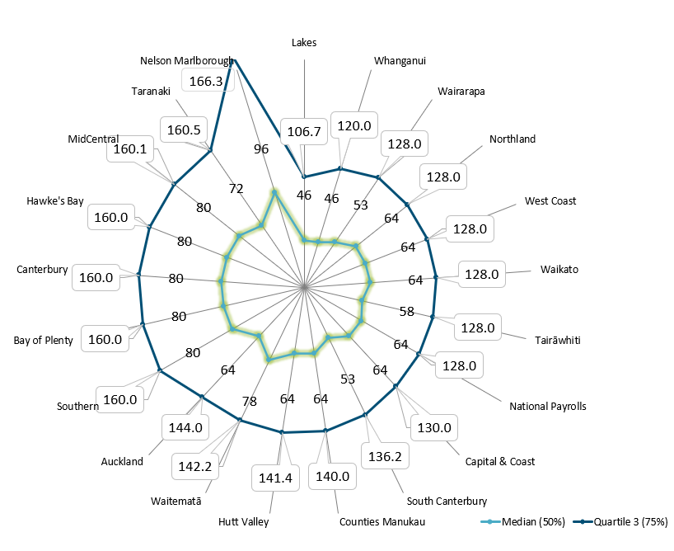

Figure 10: Average annual sick leave hours per FTE by occupational group

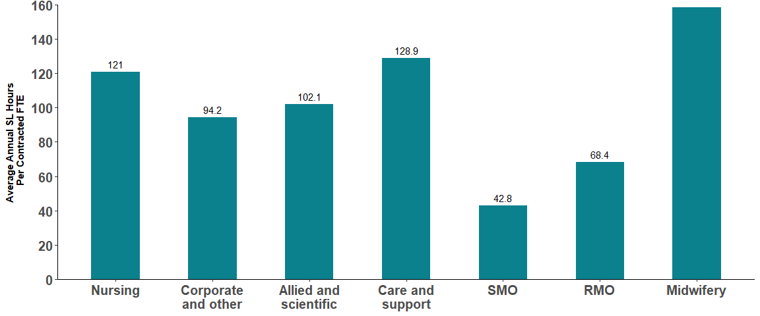

Figure 11: Average annual sick leave hours per FTE by age group by gender

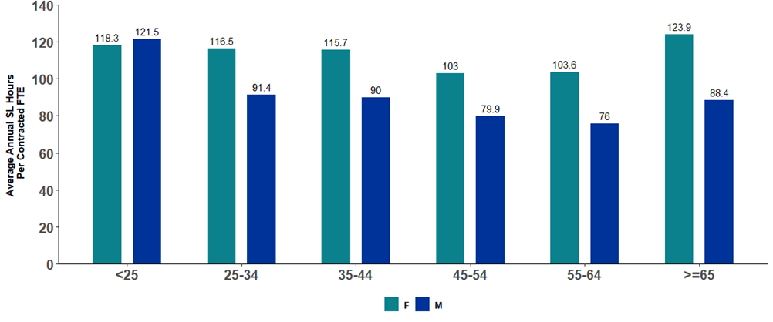

Figure 12: Average annual sick leave hours per FTE by ethnicity by gender

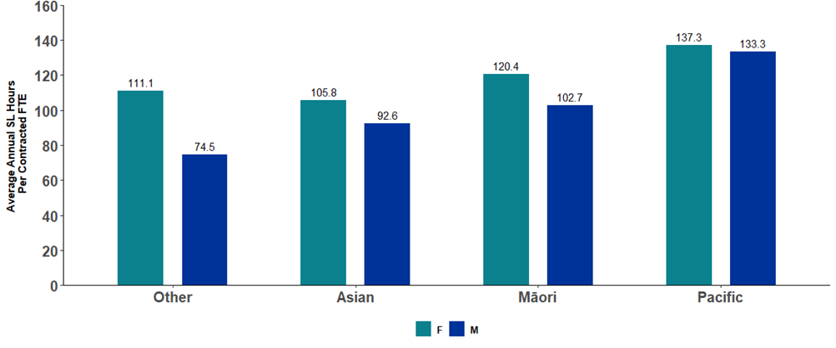

## Ratio of annual leave balance and annual leave entitlement by District including national payrolls, occupation group and ethnicity by gender

In the first chart, the bars represent the ratios of annual leave balance to annual leave  
entitlement and the blue dotted line represents the national average. For example, a value  
of 100% means that on average the District employees have an annual leave balance  
equal to their annual leave entitlement. The chart shows that for the first fourteen Districts,  
on average their employees have more annual leave balance than annual leave  
entitlement.

The other two charts on page 19 display the ratio of annual leave balance to entitlement  
per FTE at the national level, grouped by both Occupation Group and Ethnicity (with  
gender split).

Figure 13: Ratio of annual leave balance to annual leave entitlement hours per FTE by District

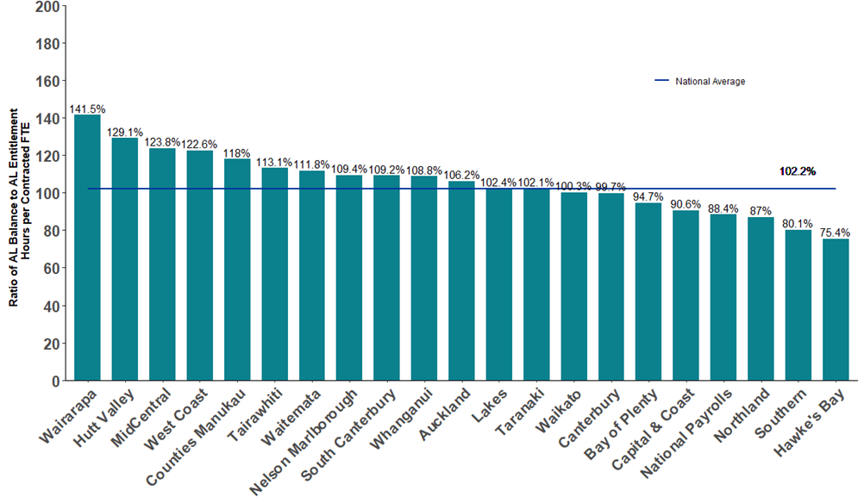

Figure 14: Ratio of annual leave balance to annual leave entitlement hours per FTE by occupational group

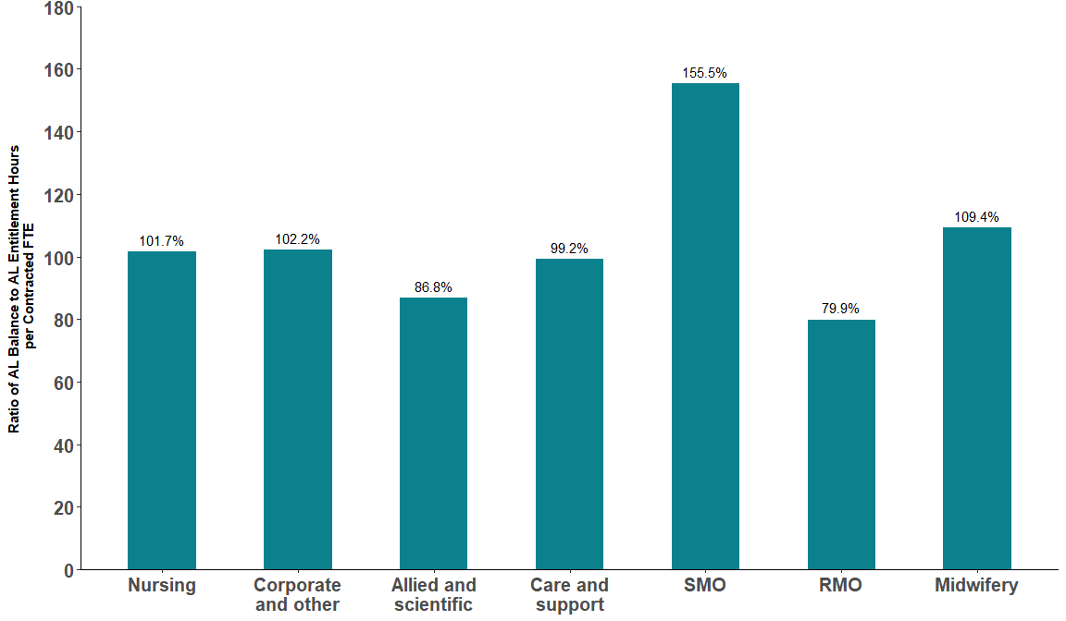

Figure 15: Ratio of annual leave balance to annual leave entitlement hours per FTE by ethnicity by gender

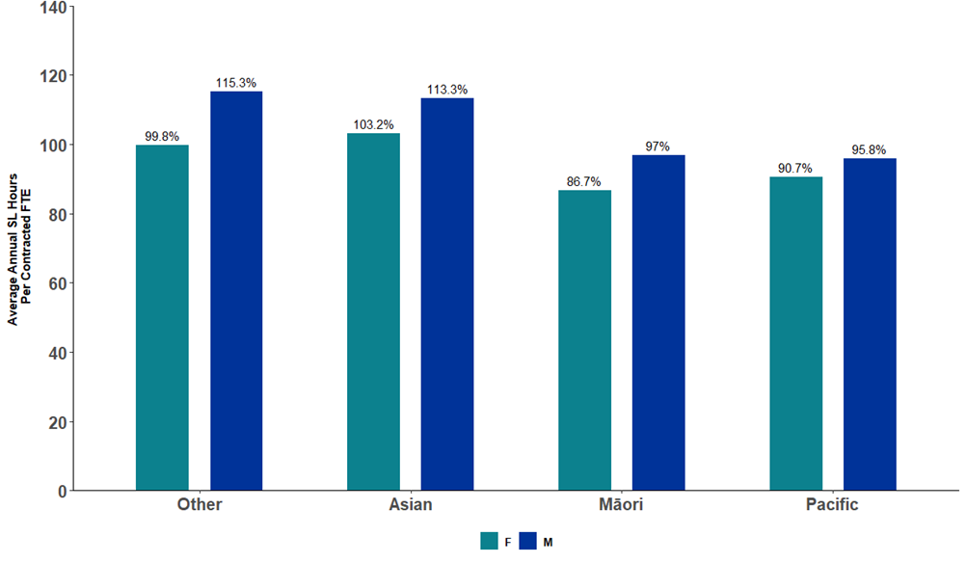

# Analysis by population

## Distribution of overall District employees by age, with national employee data

**National Payrolls data is excluded from the analysis by population as there is no  
specific population associated with the National Payrolls.**

The following chart shows the distribution of ages of District employees (histogram with light orange outline). The District employee distribution is on a position basis. The staggered dark orange line is the distribution of all New Zealand employees for the June 2025 quarter as reported in the Household Labour Force Survey (HLFS) by Statistics New Zealand.

Figure 16: Distribution of overall District employees by age, with national employee data

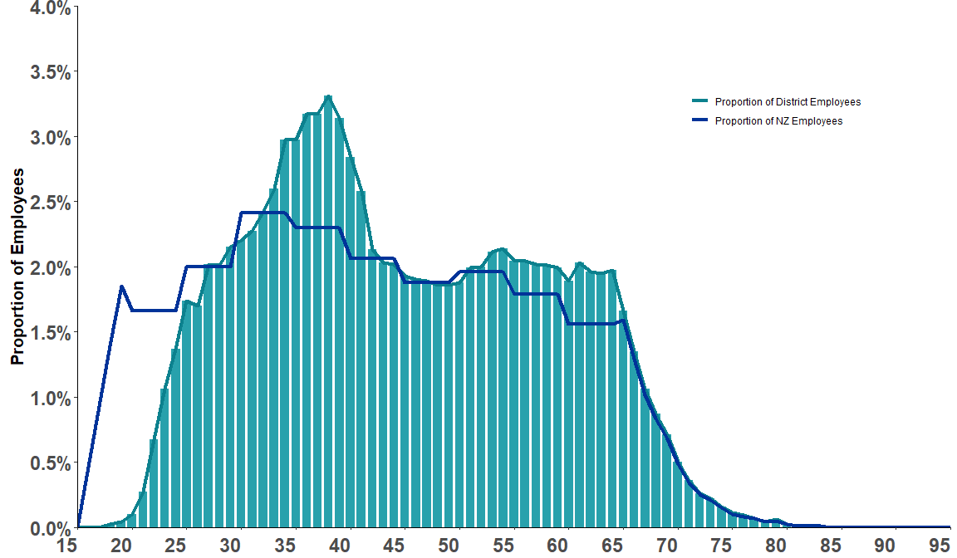

## Ethnic representation of workforce to resident population

The following charts look at the ethnic representation of District staff to the resident population.

The calculations look at the percentage of staff with a known ethnicity and compare it to the percentage of District residents with a known ethnicity. This latter data has been interpolated from data produced by Statistics New Zealand and is representative for the quarter being reported on. The proportion of staff with a known ethnicity this quarter is 99.1 percent, compared to 92.4 percent in June 2018. This comparison is on a position count level, as we do not have comparable distinct employee counts for 2018.

The four ethnicity groups used are: Other, Asian, Māori and Pacific – ‘Other’ is an amalgamation of all other ethnicities but is primarily European including the ’New Zealander’ ethnicity. Throughout these charts this is the order of presentation.

When a bar on a chart is green it means the proportion of that ethnicity in the District workforce is greater than the population. If a bar is red then the proportion of the District workforce is less than that of the resident population. All charts use the same axis scale (as these are spark lines the numbers are not written against the axes), which range from -24% to +25% - so comparisons between Districts are possible. The data for 2018 has also been added to show any changes over the last six years.

It is important to note that some Districts have very small counts by ethnicity; for example, West Coast has a very low number of employees who have identified their ethnicity as Pacific. This means the data can be quite volatile. Also, those Districts that are heavily weighted towards a particular ethnicity in their population such as Pacific people in Counties Manukau or Māori in Waikato, will tend to show greater deviations between the District workforce ethnicities and the resident population.

For some Districts the ethnic distribution of their staff closely mirrors that of the resident population, such as Auckland. Nationally, the distributions have changed only slightly between 2018 and 2024; the ‘Other’ ethnicities have reduced closer to zero (from eight down to two percentage points difference), whereas Māori and Pacific have less under- representation (from negative nine to negative eight, and negative 2.5 to negative 1.2, percentage points difference, respectively).

Table 11: Ethnic representation of Workforce to Resident Population by District

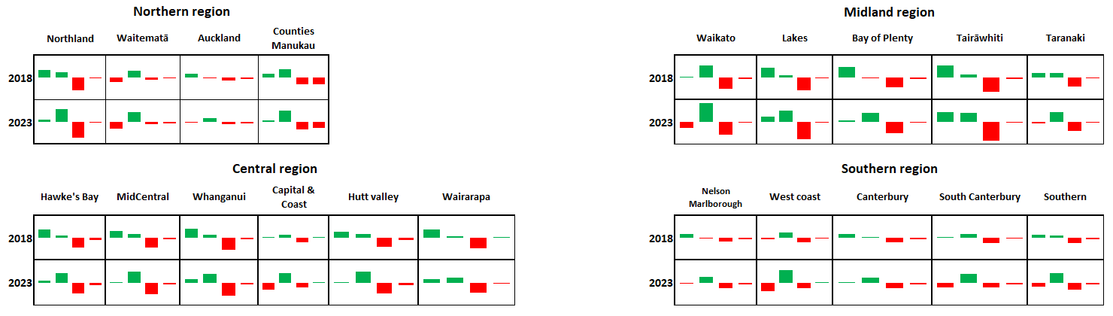

**Note: The four bars are ordered as: Other, Asian, Māori and Pacific.**

## Population density by occupational group and District

This section looks at the number of staff per resident population. Staff numbers are contracted FTE figures and they are compared to every 100,000 resident population. Midwives has been compared to the fertile female population (aged 15-49). The important factor to consider in this section is that each District may have different models of care (the way services are delivered to the population). For example, only six Districts provide radiation therapy services, so they may appear to have more staff per head of population but they are actually serving the population from many other Districts.

Figure 17: Population density of Nurses by District

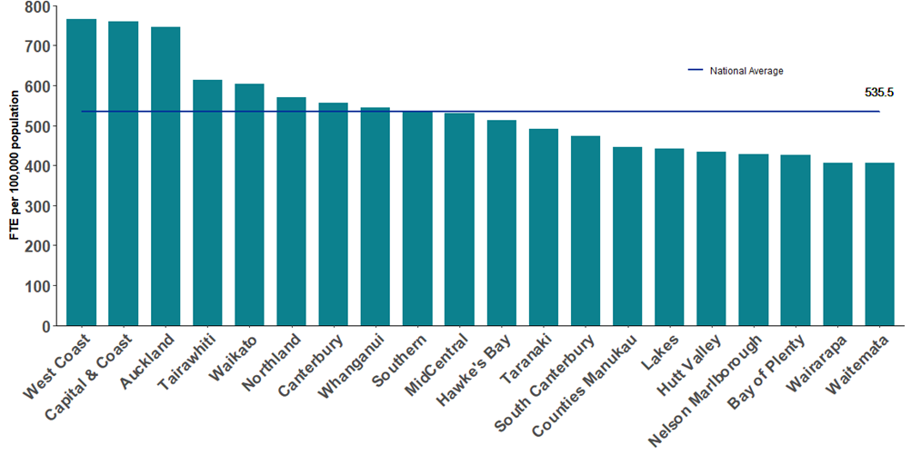

Figure 18: Population density of Corporate & Other by District

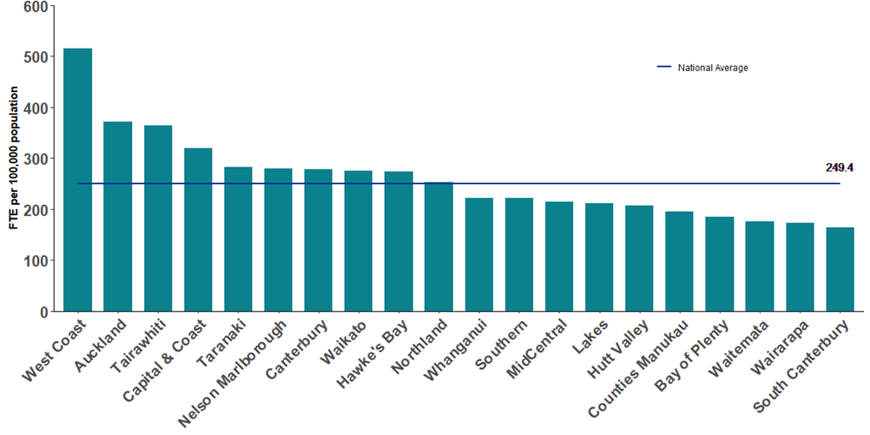

Figure 19: Population density of Allied & Scientific by District

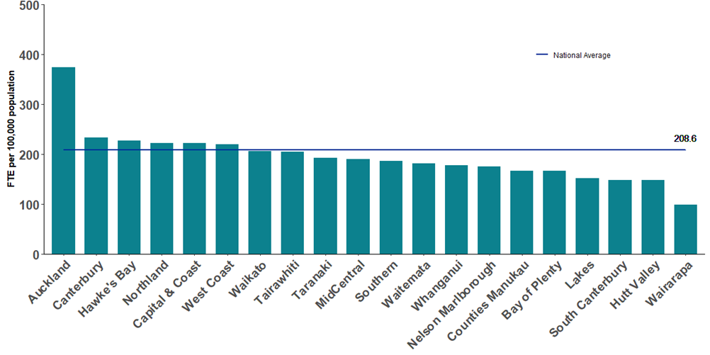

Figure 20: Population density of Care & Support by District

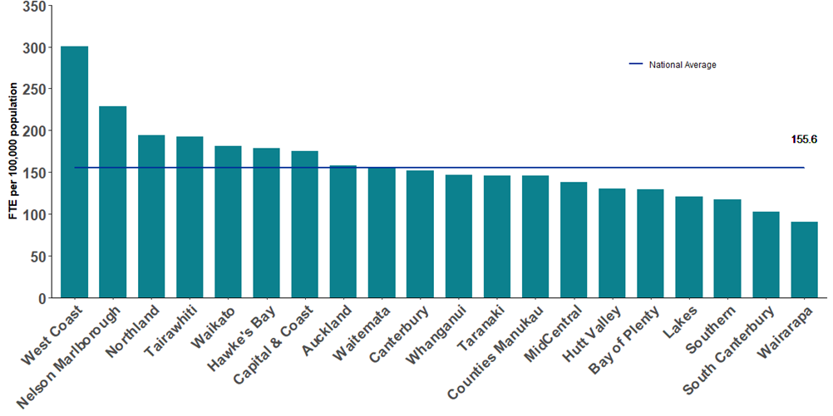

Figure 21: Population density of Senior Medical Officer (SMO) by District

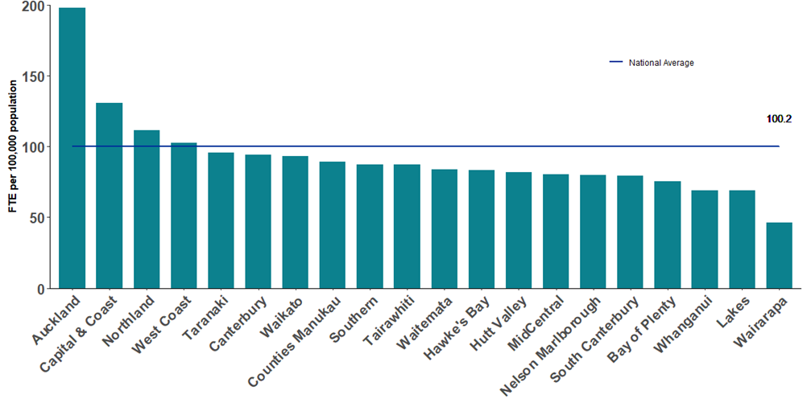

Figure 22: Population density of Resident Medical Officer (RMO) by District

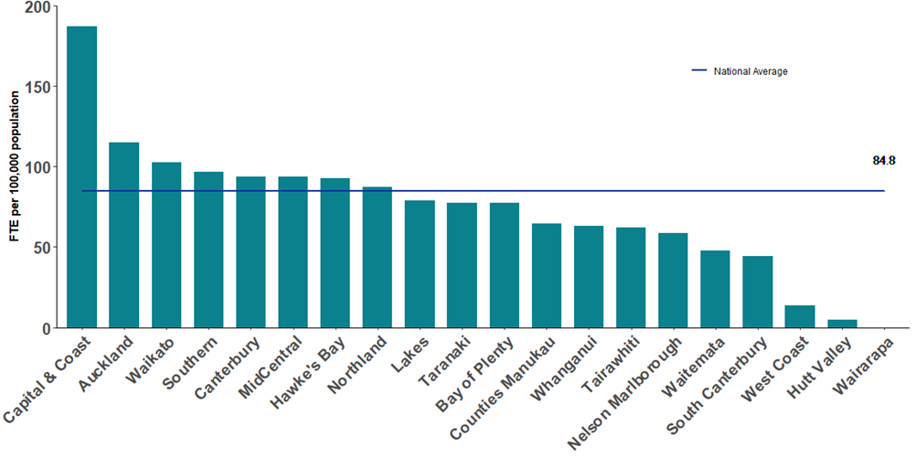

**\*Wairarapa and Hutt Valley are moving away from directly employing RMOs and will in future use RMOs who are employed by Capital and Coast.**

Figure 23: Population density of Midwives by District

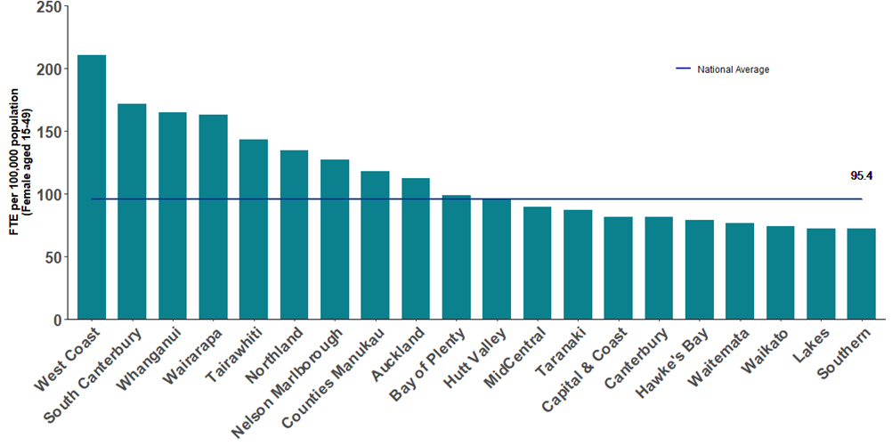

Figure 24: Population density of all District staff by District

