Review of Neonatal BCG Immunisation Services in New Zealand in 2006
The author of this document is Dr Jillian Sherwood,
Public Health Medicine Registrar
Citation: Ministry of Health. 2007. Review of Neonatal BCG Immunisation
in New Zealand. Wellington: Ministry of Health.
Published in December 2007 by the
Ministry of Health
PO Box 5013, Wellington, New Zealand
ISBN 978-0-478-31241-6 (print)
ISBN 978-0-478-31244-7 (online)
HP 4496
This document is available on the Ministry of Health’s website:
http://www.moh.govt.nz

Contents
Executive Summary v
1 Introduction 1
1.1 Background to the review 1
1.2 Objectives of the review 1
2 Methodology 2
2.1 Background 2
2.2 District Health Board survey 2
2.3 Review of notification and hospitalisation data 3
3 Background 4
3.1 Epidemiology of tuberculosis 4
3.2 Immunisation as a tuberculosis control strategy 6
3.3 Contractual arrangements for neonatal BCG service 11
3.4 National Immunisation Register 13
3.5 Maternity services 13
3.6 Ethnicity classification system 14
4 Results 15
4.1 Survey results 15
4.2 Review of hospitalisation and notification data 29
5 Discussion 36
5.1 Current BCG immunisation service 36
5.2 Effectiveness and relevance of the current BCG service 38
5.3 Limitations of this review 39
5.4 Recommendations arising from the review 39
Appendix: District Health Board Neonatal BCG Immunisation Questionnaire 41
References 46

List of Tables
Table 1: Live births in New Zealand recorded by ethnicity of mother and child, 2004 and 2005 14
Table 2: BCG immunisation service provided in maternity units in 2006 15
Table 3: When BCG immunisation service is available in maternity units 16
Table 4: BCG immunisation service provision and availability in the community 17
Table 5: Risk assessment summary 19
Table 6: Referral for administration of BCG vaccine 21
Table 7: Administration of the BCG immunisation 22
Table 8: Education and promotion of the BCG immunisation service 24
Table 9: Monitoring data collected and analysed, by District Health Board 26
Table 10: Pacific live births reported to have received neonatal BCG immunisation, by District Health Board, 2004 and 2005 27
Table 11: BCG status for extrapulmonary tuberculosis notifications in children aged 0–14 years, 1997–2005 34
Table 12: BCG immunisation status in cases notified with a site indicating meningeal or miliary tuberculosis 34

List of Figures
Figure 1: New Zealand crude tuberculosis incidence rates by District Health Board, 2005 5
Figure 2: New Zealand notifications of tuberculosis in children aged under 15 years, 1985–2005 30
Figure 3: Cases of tuberculosis in children aged 0–14 years, by ethnicity, 1985–89 to 2002–05 in New Zealand 31
Figure 4: New Zealand miliary and meningeal tuberculosis admissions, by age group, 1971–2005 32
Figure 5: New Zealand extrapulmonary tuberculosis in children aged 0–14 years, by ethnicity, 1990–2005 33
Figure 6: Extrapulmonary tuberculosis and BCG immunisation status in children aged 0–14 years in New Zealand, 1997–2005 35

Executive Summary

Background
Tuberculosis (TB) remains a significant problem worldwide. Bacille Calmette-Guérin (BCG) immunisation is used in many countries as part of their TB control programme. The efficacy of BCG immunisation in preventing TB in adults is unclear, but its efficacy in preventing serious extrapulmonary disease in infants is widely accepted. There are disadvantages to BCG immunisation because it affects the usefulness of tuberculin skin testing in the diagnosis of TB and has the potential for adverse effects. The International Union against Tuberculosis and Lung Disease (IUATLD) has established criteria for discontinuing universal BCG immunisation programmes and recommends that countries with a low incidence of TB, such as New Zealand, use selective programmes instead.

Selective neonatal BCG immunisation is one strategy used in New Zealand for controlling TB with the specific aim of reducing the risk of severe, disseminated disease in young children. The target groups were last reviewed in 2002 and a goal was of 80% coverage by 2005 was set for these high-risk groups. However, concern exists that many neonates and infants are not being assessed for their eligibility to receive the BCG immunisation.

Aims and objectives of the review
This review, for the Communicable Diseases Team, evaluates the neonatal BCG immunisation service in New Zealand.

The review’s objectives were to:
- describe the neonatal BCG immunisation services offered and methods of delivery
- review the tuberculosis notification and hospitalisation data
- identify any imbalance between current policy and services
- review monitoring and make recommendations on the future monitoring of the service.

Methodology
A literature review of the relevant published and unpublished literature was undertaken using standard bibliographic databases, reputable standard text books, a manual search of archived material held by the Auckland Regional Public Health Service, and key websites.

Key informants were informally interviewed and all District Health Boards (DHBs) were surveyed about the components of their neonatal BCG service. New Zealand notification and hospitalisation data for TB was extracted into MS Excel tables and reviewed to assess the relevance and effectiveness of the current policy and delivery of the service.

Results
Although the incidence and total number of cases of TB in New Zealand has remained stable over the past 20 years, the ethnic categories most affected have changed. Increasing rates of TB are seen in immigrants and refugees from high-risk Asian and African countries, as well as in recent arrivals from Pacific countries and territories and those connected with them.

All 21 DHBs responded to the survey, but the responses indicated a wide variability about how the BCG immunisation service is offered in New Zealand. Monitoring of the service is patchy and only a few DHBs collect data on the number of TB risk assessments performed on babies. This means that, in general, coverage rates cannot be calculated because the total number of eligible babies is not known. A lack of service specifications, unclear areas of responsibility and a lack of dedicated funding are seen as barriers to an effective service. Concerns exist in DHBs about the lack of education about TB risk and the inadequate promotion of the service to health providers and parents. Responsibility needs to be assigned and resources (including funding) provided for this aspect of the service.

It is difficult to conclude whether the current policy and eligibility criteria remain the most appropriate. Incomplete notification data hampers an assessment of the effectiveness of BCG immunisation in reducing the severe, disseminated forms of TB in children and interpretation of the ethnic-specific rates of TB in children and their communities. However, the limited information about these rates appears to support the ongoing targeting of Pacific babies and babies with exposure to adults from a high-risk country, but whether the programme should be extended to Māori babies and/or be confined to specific geographic areas is less clear.

Conclusion
The highest priority strategies to improve the effectiveness of the BCG immunisation service and inform future reviews of the policy are to:
- institute a systematic approach to delivering the BCG immunisation service in all DHBs
- improve the quality of the monitoring of the BCG immunisation service
- improve the completeness of notification data.

Limitations of the review
The conclusions that can be drawn from this review are limited by:
- changes to the ethnicity classification system
- the relatively small numbers of children with TB
- problems with the quality of the data, particularly incomplete notification data.

Recommendations arising from the review
Recommendations arising from the review have been separated into four areas; contracts, monitoring, resources and surveillance.

Contracts
- A core set of specifications for the neonatal BCG immunisation service could be developed in consultation with medical officers of health and included in contracts in every DHB area.
- Contracts could require DHBs to ensure staff involved in providing the BCG immunisation service receive support and training.

Monitoring
- Monitoring requirements and quality indicators for the BCG immunisation service could be set for DHBs and public health services, and include monitoring of the percentage of mothers assessed for their baby’s TB risk and the percentage of babies assessed as high risk who are vaccinated.
- The feasibility and acceptability of adding a TB risk assessment to the BCG immunisation field in the National Immunisation Register could be investigated.

New resources
- New resources for primary care providers, lead maternity carers (LMCs) and Well Child-Tamariki Ora providers to provide more general education about, and to promote, the service.
- The Ministry of Health, in consultation with medical officers of health and LMC representatives, could develop a standard maternity record and/or assessment form for LMCs and Well Child-Tamariki Ora providers to use when undertaking risk assessments.

Surveillance
- The Ministry of Health, the Institute of Environmental and Scientific Research and other key stakeholders could investigate methods to achieve more complete surveillance data.
- Annual reports of TB surveillance data could provide information relevant to the IUATLD criteria, including the incidence of sputum-positive disease for people of all ages, of tuberculous meningitis for people aged 0–4 years, and provide this information by ethnicity and by DHB area.

1 Introduction

1.1 Background to the review
Bacille Calmette-Guérin (BCG) immunisation is part of the World Health Organization (WHO) Expanded Programme on Immunisation and is used in most countries as part of their tuberculosis (TB) control programme. Although the efficacy of BCG immunisation in preventing TB in adults is unclear, its efficacy in preventing serious extrapulmonary disease in infants is widely accepted (Ministry of Health 2006; Nelson et al 2001).

BCG immunisation has been part of the TB control programme in New Zealand since 1948. As the programme developed it was extended to all adolescents but this was discontinued, initially in the South Island and then by phases in the North Island, as the incidence of TB declined (Ministry of Health 2003). A neonatal BCG immunisation programme was introduced in 1976 to target high-risk neonates and infants (Ministry of Health 2006). The target groups were last reviewed in 2002 (Ministry of Health 2003) and a policy decision was made that coverage in high-risk groups should be increased to 80% by 2005 (National Immunisation Programme 2003).

Ongoing concern exists that the neonatal BCG programme has been variably implemented across District Health Board (DHB) areas and infants are not being assessed systematically for their eligibility to receive the BCG immunisation (Ministry of Health 2003).

The need to evaluate the effectiveness of the vaccine’s delivery and whether the 2002 target of immunisation coverage of 80% of eligible infants was being met was identified as a supporting strategy milestone in 2003 (National Immunisation Programme 2003).

This report is the result of the Communicable Diseases Team’s evaluation of the national neonatal BCG immunisation service in New Zealand.

1.2 Objectives of the review
The review’s objectives were to:
- describe the neonatal BCG immunisation services offered and methods of delivery
- review the tuberculosis notification and hospitalisation data
- identify any imbalance between current policy and services
- review monitoring and make recommendations on the future monitoring of the service.

2 Methodology

2.1 Background
A review was undertaken to provide background information on the epidemiology of TB (nationally and internationally), efficacy of BCG immunisation, adverse effects from immunisation, and evidence and recommendations for using BCG immunisation as part of a TB control programme. The following information sources were used.
- Published articles were identified using a systematic literature search of the bibliographic database Ovid Medline, Cochrane Database, American College of Physicians Journal Club, and Database of Abstracts of Reviews of Effectiveness. Further articles were obtained by searching the reference lists in relevant articles. The key words and general medical subject headings used were BCG vaccines, adverse effects, experimental vaccines, efficacy, long-term studies, immunity, longitudinal studies, immunisation, tuberculosis, and communicable disease control. Articles had to be written in English and published from 1996 to 2006. Searches were combined using the Boolean operators ‘and’ or ‘or’ where appropriate.
- Reputable standard text books were used for background information on TB, TB control and BCG.
- Archived material held by the Auckland Regional Public Health Service was searched manually for information about the development, and evaluations, of its in-hospital and community BCG immunisation programme.
- Key websites were searched for information on TB, BCG programmes and TB control. These included the websites of WHO, Centers for Disease Control and Prevention, Ministry of Health, and Institute of Environmental and Scientific Research (ESR).
- Key stakeholders were consulted about specific aspects of the programme, including how the service is purchased.
- New Zealand hospitalisation data from New Zealand Health Information Service (NZHIS) and notification data from ESR was analysed to determine epidemiology of TB in New Zealand (for details see 2.3).

2.2 District Health Board survey
The survey questionnaire (see the Appendix) was designed to assess the level of service and methods of delivery for neonatal BCG immunisation in New Zealand. The necessary and possible components of the service were decided by:
- reviewing the eligibility criteria and policy as written in Guidelines for Tuberculosis Control in New Zealand 2003 (Ministry of Health 2003) and Immunisation Handbook 2006 (Ministry of Health 2006)
- reviewing the flowcharts and protocols the Auckland Regional Public Health Service developed for its BCG immunisation service (ARPHS 2003)
- discussing the components with medical officers of health and Ministry of Health staff.

Survey questions were chosen to collect information on the operation of each component of the service, including the monitoring carried out and barriers to the effective operation of the service.

The survey was piloted with two public health services (PHSs) by arrangement with two local medical officers of health, Dr Annette Nesdale and Dr Lester Calder. The questionnaire was then modified and sent to all DHBs.

Responses were collated and summarised. Where monitoring data was provided, it was entered into an MS Excel spreadsheet and reviewed.

2.3 Review of notification and hospitalisation data
Hospitalisation data was extracted from NZHIS’s National Minimum Dataset (Hospital Events), which records data on all publicly funded hospitalisations.

Hospital discharges for 1970–2005 with any diagnosis of ICD 10 codes A15–19, O98.0 or P37.0 were extracted. ICD 9 data was mapped forward into ICD 10.

The data was provided, in the form of a spreadsheet in MS Excel, by year of discharge, DHB, gender, age, age band, ethnicity, and first admission status. First admissions were determined, where possible, by using National Health Index numbers and excluding repeat admissions.

The data was used to create pivot tables and charts to analyse admissions for total TB cases and for miliary and meningeal TB cases, by ethnicity, age and ethnicity, and DHB.

Notification data was requested from ESR for all notified cases of new and reactivated TB for 1970–2005. Data was obtained for 1985–2005 for a range of parameters, including report year, report date, DHB, age band, date of birth, ethnicity, whether born outside New Zealand, contact with confirmed case of TB disease, current or recent residence in household with person born outside New Zealand, BCG immunisation status, site of disease (pulmonary or extrapulmonary), and specific site if extrapulmonary disease. The data was provided in an MS Excel spreadsheet that was used to construct pivot tables and charts for notifications in children aged under 15 years by ethnicity, DHB, site of disease and BCG immunisation status. Ethnic-specific rates for extrapulmonary TB in children aged under 15 years were calculated for 1998–2005 using notification data and Statistics New Zealand 2001 census data. Ethnic-specific rates for 1990–98 were obtained from information in Immunisation Handbook 2006 (Ministry of Health 2006).

The hospitalisation and notification data was used to inform the background epidemiology of TB in New Zealand and the specific epidemiology relevant to the review of the effectiveness and relevance of the current policy on BCG immunisation.

3 Background

3.1 Epidemiology of tuberculosis

International epidemiology of tuberculosis
One-third of the world’s population is infected with the tubercle bacillus. This equates to about 2 billion people (Nelson et al 2001). Worldwide there were more than 8.8 million new cases of TB and an estimated 1.6 million deaths caused by TB in 2005 (WHO 2007). Although the estimated global incidence has been slowly declining over the past decade, TB remains ‘one of the most prevalent and deadly infections on Earth’ (Nelson et al 2001).

Population growth means the number of new cases each year is increasing and WHO estimates that South-East Asia accounted for 34% of the new cases globally in 2005, although incidence and mortality per capita are highest in the African region (WHO 2007). The burden of disease has remained high in developing countries, but industrialised countries experienced a rapid decline in incidence after the Second World War. However, there has been a resurgence of TB in many developed countries since the 1980s, with increasing prevalence in specific populations, such as people who are sero-positive for HIV and certain refugee and immigrant groups (Infuso and Falzon 2006; Nelson et al 2001).

Epidemiology of tuberculosis in New Zealand
The overall incidence of TB (new and reactivated cases) in New Zealand has been stable since the early 1980s at about 10 per 100,000 population, with the total number of cases notified per year, since 1997, ranging from 321 to 446 (NZPHO 2007). There has, however, been a gradual shift in the ethnic-specific incidence rates and numbers of new cases. The results are large and there are persisting differences between the low incidence in the European population compared with much higher incidences in other ethnic groups.

In 2005 the incidence of TB was 81.7 per 100,000 population (204 cases) for the group ‘Other’, 23.5 per 100,000 population (47 cases) for Pacific people, 8.9 per 100,000 population (47 cases) for Māori and 1.7 per 100,000 population (44 cases) for Europeans (ESR 2005). Cases in the ‘Other’ category are primarily in recent immigrants and refugees from Asian and African countries. A recent analysis suggests that these cases, along with those in recent immigrants from Pacific countries and territories, are now the predominant source of new notifications of TB in New Zealand (Das et al 2006b). This explains the high rate of new cases reported in people who were born outside New Zealand or known to reside with someone who was born outside New Zealand (Das et al 2006a). In 2006 these latter two groups accounted for 77.3% (225 out of 291) of the cases this information was recorded for, or 66.8% of all new cases for the year (ESR 2007).

There is a consistent geographical pattern to the burden of TB disease in New Zealand with crude incidence rates for TB over the past five years above the national average in Auckland, Counties Manukau, Capital & Coast, Hawke’s Bay, Waitemata and Hutt Valley DHBs (Das et al 2006a). This is illustrated in Figure 1, which shows rates based on the 2005 notification data from ESR (no rates are recorded where the number of cases in the DHB was less than five). The national average incidence rate for 2005 was 9.3 cases per 100,000 population (ESR 2005).

In most of these DHB areas the rates in New Zealand-born people were less than 10 per 100,000, apart from in the Hawke’s Bay DHB area. The elevated rate seen in Hawke’s Bay may reflect the large outbreak reported in that region in 2002 (Das et al 2006a; McElnay et al 2004).

The number of cases of TB in children under 15 years has remained relatively stable in the past 10 years with an average of 39 cases per year. Since 1985, the number of TB cases in European children in New Zealand has decreased, whereas the number of cases in Pacific people and ‘Other’ ethnicities has increased, with the number for Māori remaining steady (ESR 2007). Further details are in section 3.2.

The New Zealand notification numbers are interesting compared with those in Australia, which in 2004 had only 38 notifications for children aged under 15 years in a population of 20.1 million people (Australian Bureau of Statistics 2004), compared with a population of about 4 million in New Zealand. Most of the cases in Australian children were children born overseas (23), with the remainder being non-indigenous children (Roche 2006).

Figure 1: New Zealand crude tuberculosis incidence rates by District Health Board, 2005
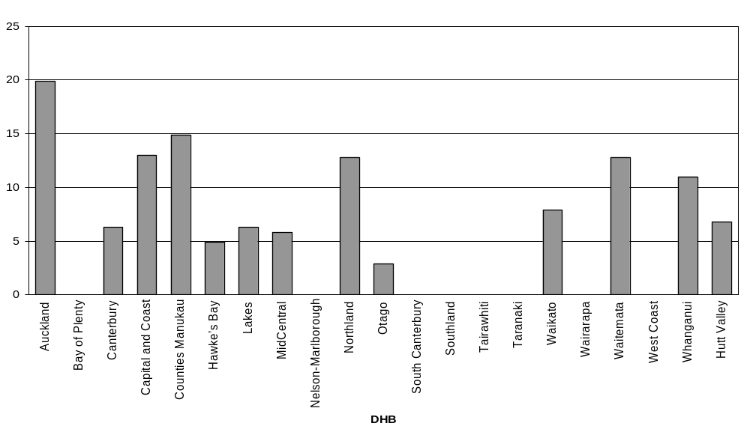
Source: ESR Annual Surveillance Summary 2005 (ESR 2006)
Note: No rates were recorded if the number of cases in the District Health Board was less than five.

Surveillance systems
Routinely collected data pertinent to national TB epidemiology, such as that presented in Figure 1, is available from two surveillance or information systems.

Notification data
New cases and reactivations of TB are notifiable conditions to the local medical officer of health under the Tuberculosis Act 1948. The notification data feeds into the communicable disease surveillance system co-ordinated by ESR. Standard demographic information is collected, including ethnicity, as well as information on risk and protective factors, such as country of birth, current or previous residence with people born outside New Zealand and BCG immunisation status. Additional clinical details are also requested as to the site of disease with fields for ‘pulmonary’ and ‘extrapulmonary’ but note that these two categories are not exclusive. A specific site is requested if the extrapulmonary category is selected and generally this was completed in the 1989–2005 data reviewed. However, this category is not a reliable marker of miliary and meningeal TB unless individual line data is examined to remove other sites of extrapulmonary disease such as nodes, pleura or abdominal sites. Changes in case definitions, the method of identifying ethnicity and in recording a single ethnicity to prioritised ethnicity and, more recently, total ethnicity, means there may be inconsistencies when analysing the data sets across time. BCG immunisation status was not requested on the case report form as part of notification until 1996, so this status is not available in the notification data until 1997.

Hospitalisation data
NZHIS collects hospitalisation data as part of the National Minimum Dataset, which provides information on specific diagnoses by linking the discharge coding data to demographic information of all cases admitted to hospital. All children are admitted to hospital for their initial treatment of TB, so a count of all ‘new’ admissions should capture all cases notified, irrespective of the site of disease. A review of paediatric TB cases in nine health districts in 1992–2001 indicated 4% of TB cases hospitalised had not been notified (Howie et al 2005).

3.2 Immunisation as a tuberculosis control strategy
TB control depends on a combination of strategies that can be broadly summed up as case detection, adherence to treatment, and public health action to prevent or halt outbreaks. Public health action requires attention to the detection and cure of cases, ensuring adherence to the treatment regime, demonstrating ‘cure’, and rapid notification to enable contact tracing and management. Selective BCG immunisation is generally accepted as a useful adjunct to these strategies in low-risk countries, while universal BCG immunisation is part of the WHO Expanded Programme for Immunisation in high-risk countries (Nelson et al 2001). Improvements in socioeconomic conditions, particularly for high-risk populations, will provide a longer term solution to TB control.

Efficacy and benefits of BCG immunisation
Immunisation with BCG appears to have no significant impact on the overall incidence of TB. Efficacy trials have shown a range of outcomes from a 0% to 90% reduction in the incidence of new cases (Ministry of Health 2006). A meta-analysis of the published literature concluded that the vaccine significantly reduced the risk of active TB disease by 50% and that the risk reduction was higher for protection against miliary and meningeal TB than against other forms of TB (Colditz et al 1994). A more recent review concluded that BCG immunisation is most effective when given at a young age and affords greatest protection against disseminated disease (Rieder 2002). A recent study showed a persistence of BCG vaccine efficacy for up to 50–60 years (Aronson et al 2004).

Studies suggest that BCG immunisation offers protection against leprosy and may reduce the risk of atopy, asthma and intestinal nematodes in children (Rieder 2002). These potential benefits are not particularly relevant in New Zealand, although immunisation for children with a high risk of atopy and asthma is sometimes requested (ARPHS 2003). There has also been research into and reports on the use of the BCG immunisation in the treatment of bladder cancer (Rieder 2002).

Complications of BCG immunisation
After a BCG immunisation, local adverse reactions may occur, usually within two to six weeks of the immunisation (Ministry of Health 2006). The risk of severe localised, multiple or generalised lesions is extremely low and varies with the type of vaccine and the person’s age at immunisation (Rieder 2002). More severe reactions at the immunisation site may be caused by poor injection technique and placement (Ministry of Health 1996b). A recent study concluded that local reactions from BCG immunisations and keloid scarring were reduced after a vaccinator training programme was implemented and the batch of vaccine was changed (Daoud 2003).

International recommendations for BCG immunisation

World Health Organization
WHO recommends the BCG immunisation:
- as soon as possible after birth, for infants living in areas where TB is highly endemic
- for infants and children at particular risk of TB exposure in otherwise low endemic areas.

WHO notes that some low prevalence countries may choose to replace BCG immunisation with intensified case detection and supervised early treatment, and that other countries may be reconsidering their BCG immunisation policy because of changing epidemiology (WHO 2004). WHO highlights the IUATLD criteria defining ‘low endemicity’ (see the next subsection) and the need for an efficient surveillance system to support timely public health action and inform future policy changes before moving from a general to a ‘selective’ immunisation approach.

International Union against Tuberculosis and Lung Disease
The IUATLD supports WHO recommendations for BCG immunisation and has developed criteria countries should use when deciding whether to discontinue or implement a universal BCG immunisation (IUATLD 1994). These criteria focus on whether the country (or geographical area) can be defined as being of ‘low endemicity’.

The criteria for low endemicity are an average annual:
- notification rate of smear-positive pulmonary TB cases below 5 per 100,000
- notification rate of meningeal TB in children aged under 5 years below 1 per 10 million population during the previous 5 years
- risk of tuberculous infection below 0.1%.

The IUATLD notes that three key factors form the basis for this decision in any given location: the protection gained from the BCG immunisation in the location (efficacy and effectiveness); the incidence of miliary and meningeal TB relative to the incidence of adverse reactions from the vaccine; and the value attached to using tuberculin skin tests as a diagnostic tool (Rieder 2002).

Approaches to, and experience with, BCG immunisation in selected countries

Australia
Australia does not recommend universal BCG immunisation, but targets neonates at high risk for TB exposure (based on ethnicity and travel to high-risk countries) and those at high risk of exposure to leprosy.

Europe
A 2005 survey of 30 European countries found 12 countries had a universal neonatal programme, five had a universal programme for older children, and 10 had a targeted programme for high-risk children (based on place of origin, TB contact or travel). Seven countries did not have a systematic programme (Infuso and Falzon 2006).

The countries with universal neonatal immunisation generally had high coverage rates (83.0%–99.9%). Coverage rates were variable or unknown in countries with a targeted programme. In the countries that collected information on BCG immunisation status as part of TB notification, this information was often incomplete. However, data did indicate that coverage was generally lower in groups identified as high risk in countries with a targeted programme than in countries with a universal programme (Infuso and Falzon 2006).

After undertaking modelling to estimate the impact of changing from a universal infant programme to a targeted programme (with two possible levels of vaccine coverage) or discontinuation, public health authorities in France recently elected to adopt a BCG immunisation programme targeting high-risk children and to strengthen other TB control measures (Levy-Bruhl 2006).

United Kingdom
The United Kingdom has a selective neonatal BCG immunisation programme but no monitoring of service delivery. An audit carried out over a three-year period in one county suggested only 51% of eligible infants had received the immunisation. Recommendations from audit included amending the pregnancy record to collect specific information on risk; including an eligibility question at the time of first appointment; and commencing a system of notification to general practitioners and health visitors of unvaccinated eligible infants (Deshpande 2004).

Canada
Canada had a selective neonatal BCG immunisation programme targeting First Nations and Inuit communities for many years. However, due to decreasing annual incidences in many communities, the programme was being gradually phased out in some provinces. More recent recognition that the rate of disseminated BCG disease in First Nations children is far higher than the highest global estimate in other populations has led the Canadian Advisory Committee on Immunization to alter its general recommendation for the routine immunisation of all infants in First Nation and Inuit communities (Public Health Agency of Canada 2004). The policy is to be individualised for each community on the basis of the community having an:
- average annual rate of smear-positive pulmonary TB greater than 15 per 100,000 (all ages during previous three years); or
- annual risk of TB infection of more than 0.1% if early identification and treatment of TB infection is not available.

New vaccines
Research to develop new TB vaccines that will offer better protection than the BCG immunisation does, particularly against pulmonary disease, is ongoing. Several categories of potential vaccine have been tested, with some close to, or at, the clinical trial stage (Martin 2006; Orme 2005). A new, more effective vaccine could be available by 2015 (Young and Dye 2006), although some researchers are sceptical about this timeframe because the pathogenesis of TB is still not well understood (Nagelkerke et al 2005). Other researchers have used mathematical models to show that a highly effective vaccine that can be used before and after exposure is needed to substantially reduce the number of continuing high-incidence epidemics of TB (Ziv et al 2004).

History of BCG immunisation in New Zealand
BCG immunisation was introduced to New Zealand in 1948, and later extended to all adolescents. This programme was discontinued in the South Island in 1963 and phased out in the North Island by 1990 because the incidence of TB had declined to a point where the advantages of a universal programme were outweighed by the disadvantages.

BCG immunisation of neonates was introduced in New Zealand in 1976, initially in high-risk districts, and has been variably implemented throughout New Zealand DHB areas.

The Auckland Area Health Board Tuberculosis Working Party highlighted concerns about the low BCG immunisation coverage rate in 1994. This led to a series of recommendations for the immunisation of high-risk individuals, including neonatal immunisation for high-risk infants, preferably before leaving hospital after birth (Tuberculosis Working Party 1992). The initial eligibility criteria were published in Guidelines for Tuberculosis Control in New Zealand 1996 (Ministry of Health 1996a).

Eligibility and administration of neonatal BCG immunisation in New Zealand
The current New Zealand policy is that all pregnant women should be assessed by their LMC during the antenatal period for the risk of TB for their baby. The babies identified as at risk are eligible for the BCG immunisation, which should be given at birth (ideally) or, if missed, may be given up to five years of age.

Infants at risk for TB are those who:
- will be living in a house or with family or whānau where a person has TB or a history of TB
- have one or both parents who are of Pacific ethnicity
- have parents or household members who, within the past five years, lived for a period of six months or longer in a country with a high incidence of TB
- during their first five years will be living for three months or longer in a country with a high incidence of TB.

Only gazetted BCG vaccinators may administer BCG immunisations in New Zealand. They must undergo training and administer a minimum number of immunisations annually to maintain their status as ‘gazetted’. Criteria for being gazetted as a BCG vaccinator can be found in Technical Guidelines for Tuberculin Testing and BCG Vaccination 1996 (Ministry of Health 1996b).

3.3 Contractual arrangements for neonatal BCG service
Funding for neonatal BCG immunisations comes from several sources and through several routes.
- Contracts with each regional PHS are negotiated by the portfolio managers in Public Health Operations, Ministry of Health. These contracts are based on the service specifications in the Public Health Service Handbook (Ministry of Health 2004) but are different for each PHS.
- The provision of the actual immunisations is covered by each DHB through ‘personal health services’ contracts.

Public Health Service Handbook

Service specifications generally
The Public Health Service Handbook (Ministry of Health 2004) contains 12 service categories, one of which is communicable diseases, within which immunisation is a subcategory.

The rationale section for immunisation notes that defining who is responsible for providing services is in transition, but DHBs are responsible for the population health outcomes of their districts. Service objectives have been set to support the DHBs to meet their population health targets. Objectives include ensuring:
- promotion of immunisation, and co-ordination and linkages of services between Well Child-Tamariki Ora services, LMCs and primary care services
- Well Child-Tamariki Ora providers receive education and training
- delivery of control programmes including immunisation and mass immunisation campaigns.

Service specifications for immunisation are grouped under four types of provider:
- designated services
- immunisation co-ordination and facilitation services
- immunisation promoters
- vaccine purchasers and vaccine storage and distribution services.

Service specifications for designated services
The service specifications for designated services are to:
- identify, recruit and train an appropriate workforce
- promote and use the National Immunisation Register
- operate an effective local or regional surveillance system to inform prevention and control activities and initiate investigation and research
- undertake promotion and education for Well Child-Tamariki Ora providers and LMCs about the importance of effective service provision to deal with high-risk babies (because the handbook states that babies at risk of TB are to receive the BCG immunisation at birth and this is to be recorded on the National Immunisation Register).

Service specifications for immunisation co-ordination and facilitation services
The service specifications for immunisation co-ordination and facilitation services are to:
- identify, recruit and train an appropriate workforce
- promote and use the National Immunisation Register, and ensure services work closely with DHBs, Public Health Units (PHUs), other immunisation providers, outreach immunisation services and Well Child-Tamariki providers to address gaps and develop methods of identifying children who are missing out on services
- provide support and appropriate resources for immunisation providers and information sharers, including Well Child-Tamariki Ora providers and LMCs (including information on the need for following up those who miss immunisation)
- promote immunisation to parents and caregivers, including through antenatal services
- assist with the referral of unimmunised children
- undertake education for Well Child-Tamariki providers and LMCs about the importance of effective service provision to deal with high-risk babies, and for babies at risk of TB to receive the BCG immunisation at birth.

Service specifications for immunisation promoters
The service specifications for immunisation promoters are to:
- identify, recruit and train an appropriate workforce
- promote and use the National Immunisation Register
- provide support and appropriate resources for immunisation providers and information sharers, including Well Child-Tamariki Ora providers and LMCs
- support communities and parents and caregivers, including promoting immunisation at antenatal services
- promote accurate immunisation messages in community settings and identification and support of community leaders to promote immunisation.
- assist with the referral of unimmunised children.

Service specifications for vaccine purchasers and vaccine storage and distribution services
The service specification for vaccine purchase, storage and distribution services is to contract ESR to purchase and store the BCG vaccine.

Public health service contracts
The exact service components differ between each PHS or immunisation co-ordinator and contracts may not include all of the specifications listed in the Public Health Service Handbook (Ministry of Health 2004).

Several interviewees (medical officers of health, an immunisation co-ordinator and PHS management personnel) said the provision of a BCG immunisation service was not specified in their contract. At least some contracts use wording from the service specifications: ‘babies at risk of TB to receive BCG at birth’ and ‘undertake promotion and education to Well Child-Tamariki Ora providers (LMC and well child) as to the importance of effective service facilitation’. Generally, the contracts do not include specifications for delivering or monitoring the service. More details are in section 4.

3.4 National Immunisation Register
Immunisation information for babies at risk for contracting TB is recorded in the National Immunisation Register. This consists of a record of when immunisation with BCG occurred. This commenced as a manual recording system in 2005.

3.5 Maternity services
Service specifications for LMCs are covered in a Notice Pursuant to Section 88 of the New Zealand Public Health and Disability Act 2000. This states that at registration (when a woman selects her LMC), a comprehensive assessment should be conducted that includes an assessment of the woman’s general health and family history and a Care Plan should be started. The Care Plan should include screening for infectious diseases and deciding on requirements for postnatal care. Services after birth are to include ‘provision of Ministry of Health information on immunisation’ and ‘provision of or access to services as outlined in the Well Child-Tamariki Ora National Schedule’. This schedule lists ‘BCG if indicated, per national TB guidelines’ as a requirement under the heading ‘within 24 hours of birth’.

Midwifery and Maternity Provider Organisation Ltd provides forms that at least 50% of midwives use for recording their maternity notes. The organisation’s maternal history form was referred to by two DHBs as the place where the TB risk assessment for the baby was recorded. On the form there are two boxes to record the mother’s TB risk (high or low), but no obvious place to record ethnicity for either parent or the TB risk for the neonate.

3.6 Ethnicity classification system
The definition of ethnicity and the methods for collecting and reporting this information have changed over time. It is important to appreciate these changes when interpreting ethnic-specific data. Statistics New Zealand commenced using self-identified ethnicity with the 1996 census. However, other institutions were slower to make this change, which means there is often inconsistency between the numerator and denominator data used in analyses of health issues. If the numbers are large, this is of less importance (as in many denominators) but when the numbers are small (as in the numerators for many age- or ethnic-specific groups for TB) it is more difficult to draw conclusions from the data.

The use of prioritised ethnicity as an output captures Māori ethnicity more effectively than the previous single output did, but has made it difficult to analyse data when knowing Pacific ethnicity accurately is important. This is relevant for monitoring BCG immunisation because Pacific ethnicity in either parent is a criterion for eligibility for neonatal immunisation. More recently, the use of prioritised ethnicity as an ‘output’ has been discontinued, and multiple ethnicities are now the usual output.

It is also now understood that ethnicity is not fixed; changes in response (known as ‘mobility’) may occur as the social environment changes. The response may also change in different contexts, depending on why the information is being collected (eg, a benefit application, the census or when attending a health care provider).

The recording of ethnicity for children is a special case. The LMC, doctor or hospital assign neonates their mother’s ethnicity for the initial birth notification to Statistics New Zealand (within five days of birth). The mother or parents identify the baby’s ethnicity when they complete the full birth registration. Since 1 September 1995, multiple ethnicities may be chosen for a baby. Thus, the ethnicity recorded for a baby may differ in the final registration compared with the initial notification, and an undercount of births in specific ethnic groups may occur if initial birth notification data is used. Data from 2004 and 2005 is presented in Table 1 to illustrate this. This pattern is seen across all ethnic groups.

Table 1: Live births in New Zealand recorded by ethnicity of mother and child, 2004 and 2005
Year |  | Ethnicity as recorded at registration |  |  |  |  | Total live births
Year |  | Māori | Pacific | Asian | European | Other | Total live births
2004 | Mother – total output recorded on initial birth registration | 13,066 | 6,690 | 5,739 | 38,615 | 752 | 58,073
2004 | Child – total output recorded on final birth registration | 16,259 | 8,671 | 6,226 | 40,307 | 892 | 58,073
2005 | Mother – total output recorded on initial birth registration | 13,092 | 6,553 | 5,662 | 38,573 | 772 | 57,745
2005 | Child – total output recorded on final birth registration | 16,437 | 8,605 | 6,168 | 40,375 | 951 | 57,745
Note:
* The number of total live births is lower in each year than the sum of those recorded for each ethnicity because total outputs are recorded for ethnic classification (as opposed to single outputs), thus allowing a birth to be recorded in more than one ethnic category.

4 Results

4.1 Survey results
There was a 100% response rate to the survey, although one completed questionnaire covered two DHBs that have a shared PHS.

The questions in the DHB survey are reproduced in the Appendix.

Overall neonatal BCG immunisation service in each DHB region

Service provision in maternity units
Ten DHBs reported a neonatal immunisation service in every hospital or community unit that provided maternity services in their region. Eleven DHBs reported that they did not have services based in all maternity units in their regions, but only three of these DHBs reported no services in any of their maternity units. Among the 11 DHBs that reported no BCG immunisation service in all in-hospital and birthing unit services, at least 13 maternity units were without the service. Across all the DHBs 33 maternity units were listed as having a neonatal BCG immunisation service. However, it was not clear whether immunisations occurred in all of these units or whether some were for assessment and referral with the immunisation provided in a community or an outpatient clinic. This information is presented in Table 2.

Table 2: BCG immunisation service provided in maternity units in 2006
 | BCG immunisation service available in maternity units in district
 | All units | Some units | No units
Number of District Health Boards | 10 | 8 | 3
Number of maternity units | 33 |  | ≥ 13

Staff
Seventeen DHBs reported that PHS staff provided the immunisation service, but in five of these DHBs this was in combination with other health care providers: six DHBs reported DHB maternity staff as well as PHS staff; three included LMCs; and one included a paediatrician. One DHB reported that the service was provided by a paediatrician alone. Three DHBs did not report because they did not provide a service in any maternity units. It was not clear if all DHBs reported all health care providers involved in the different aspects of the service or whether they might be referring to the ‘vaccinator’ only.

Availability of BCG immunisation service in maternity units
Of the 18 DHBs that provided a service within maternity units, 10 provided the service on an ‘as-needed’ basis on five, seven or an unspecified number of days per week. Two DHBs provided the service for 2–6 hours per day four days per week, another two DHBs provided the service for four hours seven days per week, and four DHBs provided the service for 4–8 hours 5 days per week (see Table 3.)

Table 3: When BCG immunisation service is available in maternity units
When BCG immunisation service provided |  | Number of District Health Boards
On an as-needed basis | Unspecified number of days per week | 5
On an as-needed basis | 5 days per week | 3
On an as-needed basis | 7 days per week | 2
2–6 hours 4 days per week |  | 2
4 hours 7 days per week |  | 2
4–8 hours 5 days per week |  | 4
Total number of District Health Boards offering service in all or some maternity units |  | 18

Service provision in the community
Nineteen DHBs provided a neonatal immunisation service based in the community. Eight DHBs reported that they provided this immunisation service for eight hours per day five days per week, with five of these DHBs noting that this was on an ‘as-needed’ basis. Eight DHBs reported they provided the community service on an ‘as-needed’ basis, with hours ranging from two hours per month to eight hours per week (in one DHB this applies in part of the district only). One DHB reported providing a service for 2–5 hours on 4–5 days per week, and one DHB ran clinics five days per month. One DHB was running ‘catch-up’ clinics as its service had been temporarily discontinued for six months from November 2004, but it did not specify the times for these clinics. The availability of services in each DHB is summarised in Table 4.

Two DHBs did not have a community service. One of these provided a hospital-based service and the other planned to provide a community service on two days per month.

Table 4: BCG immunisation service provision and availability in the community
Type of community service provision | Time vaccinator available | Number of District Health Boards
Set clinics | 2 hours per month* | 1
Set clinics | 4 hours per month | 1
Set clinics | 2 hours per fortnight† | 1
Set clinics | 5 days per month | 1
Set clinics | 4 hours 1 day per week* | 1
Set clinics | 2–5 hours 4–5 days per week | 1
Set clinics | 8 hours 5 days per week | 3
As needed | Unspecified | 4
As needed | 2 hours 4 days per week | 1
As needed | 7–8 hours 5 days per week | 5
Total number of District Health Boards offering community service |  | 19
Notes:
* Service also provided as needed.
† Service also provided as needed in one part of the district.

Risk assessment in District Health Board regions

Staff
Nineteen DHBs reported who carried out TB risk assessments in their regions, with a range of personnel used to carry out the assessments (see Table 5).

LMCs were listed in all 19 of these DHBs with their contribution to assessments ranging from 20% to 90%. PHS staff were reported as carrying out risk assessments in 10 DHBs, with their contribution to assessments ranging from 5% to 10%. DHB maternity staff were reported to carry out assessments in three DHBs where they performed up to 33.3% of assessments. General practitioners and practice nurses were reported to carry out 10%–80% of the risk assessments in four DHBs. Plunket nurses and well child providers were reported to perform risk assessments in two DHBs and along with general practitioners and practice nurses were reported to be providing up to 25% of assessments in these regions.

In the DHB with no current service it was expected that LMCs would perform risk assessments on all newborns and PHS staff would assess infants in the community (required as part of the ‘catch-up’ process).

Timing of risk assessments
Nine DHBs reported that risk assessments were carried out antenatally, seven after birth and four a combination of antenatally and after birth (see Table 5).

Recording of risk assessments
Eight DHBs reported that all risk assessments were recorded, 12 DHBs reported that not all risk assessments were recorded, and 1 DHB reported it recorded in only one area of its region (see Table 5). In the DHBs that reported all risk assessments as being recorded, this was on a separate TB high-risk assessment or eligibility form in four DHBs, on a similar form that was part of the case file in two DHBs, and as part of the maternal history in two DHBs (as mother’s TB risk on the midwifery form (from the Midwifery and Maternity Provider Organisation Ltd) or as a family history of TB). One DHB did not send information on the format in which the information was recorded. The DHB planning a new service reported it was developing a form with input from LMCs.

The outcome of the risk assessments in infants found to be at high risk for TB was reported to be recorded by 15 DHBs, not recorded by five DHBs, and one DHB did not answer (see Table 5). Of the 15 DHBs that reported recording the risk assessments for high-risk infants, five DHBs provided a copy of their high-risk assessment form that they fill out. One DHB reported that this information was recorded in the antenatal booking form, two other DHBs reported that it was recorded in the clinical or medical notes, and two DHBs reported that it was recorded on a spreadsheet of all births. The remaining five DHBs (from the 15) did not provide information in response to this question.

What happens to the risk assessment record varies across the DHBs (see Table 5). The TB risk assessment information was reported to become part of the antenatal record for all babies in two DHBs as well as in two areas of a further two DHBs. The risk assessment becomes part of the antenatal record for those babies determined to be eligible for the vaccine (high risk) in a further seven DHBs, as well as in the other parts of the two DHBs noted above. The information was reported to be recorded in some cases in one DHB. The TB risk assessment information was reported as not being recorded in the antenatal record in seven DHBs and two DHBs provided no answer to this question.

The TB risk assessment information was reported to become part of the postnatal record for all babies by one DHB and one area in another one DHB. Twelve DHBs reported that the risk assessment information was recorded as part of the postnatal record for all babies assessed as eligible for immunisation (high risk) and a further two DHBs reported that this occurred for some eligible babies in their regions. However, five DHBs and the remaining area of the DHB referred to above reported that they do not record the TB risk assessment for eligible babies as part of the postnatal record.

Table 5: Risk assessment summary
Risk assessment |  | Number of District Health Boards | Percentage of assessments (%)
Staff undertaking risk assessment | Lead maternity carers | 19 | 20–90
Staff undertaking risk assessment | Public health service | 10 | 5–10
Staff undertaking risk assessment | District Heath Board maternity service | 3 | ≤33
Staff undertaking risk assessment | General practitioners and practice nurses | 4 | 10–80
Staff undertaking risk assessment | Plunket, Well Child-Tamariki Ora, primary care providers | 2 | Up to 25
Timing of risk assessment | Antenatal | 9
Timing of risk assessment | Postnatal | 7
Timing of risk assessment | Combination of antenatal and postnatal | 4
Recording of risk assessment | Recorded for all babies assessed | 8 + 1 region of one district
Recording of risk assessment | High-risk babies recorded | 15
Recording of risk assessment | Part of antenatal record | 11*
Recording of risk assessment | Part of postnatal record | 12
Information sharing of risk assessment eligible babies | BCG immunisation service (provided by public health services in 13 District Health Boards) | 16†
Timing of sending information | Before birth | 0
Timing of sending information | After birth | 14
Notes:
* Two of these District Health Boards reported this occurred in part of their district only.
† Includes eligible babies who miss immunisation in the maternity unit in one District Health Board.

Information sharing about risk assessments
Risk assessment information is reported to be sent to the BCG immunisation service for all eligible babies in 14 DHBs, for all babies in one DHB, and for eligible babies who miss immunisation in the maternity unit in one DHB. The remaining five DHBs reported that this information was not sent to the service.

In the DHBs that reported sending the risk assessment information to the BCG immunisation service, 14 DHBs sent this after birth and one reported sending it either before or after birth.

Fourteen DHBs reported that risk assessment information was either sent to the PHS or collected by the PHS for eligible babies. One DHB reported this information was sent to the PHS for all babies whereas five DHBs reported that risk information was not sent to the PHS. One DHB did not answer this question.

Of the DHBs that reported sending risk assessment information to their PHS, 13 reported sending this information after birth, one reported sending it either before or after birth, and one gave no answer.

Responses to this set of questions suggest that PHSs are the provider of the BCG immunisation service in most DHBs. This was specifically noted by 13 DHBs.

Thirteen DHBs reported that LMCs informed the PHS about risk assessments. Two DHBs reported that LMCs informed both the PHS and the BCG immunisation service (but did not specify whether the PHS provided the BCG immunisation service with the information). Two DHBs reported that LMCs or the maternity service informed the BCG immunisation service, and one DHB reported that the LMCs informed the immunisation co-ordinator about risk assessments. One DHB noted that there was no link between the risk assessment information and the BCG immunisation service, one DHB had no service, and one DHB did not answer this question.

Referral for neonatal BCG immunisation
A range of people make referrals for BCG immunisation within and between DHBs (see Table 6). All 21 DHBs reported that LMCs may refer eligible infants for immunisation. In 12 of these DHBs, DHB maternity staff may also make the referral. Referrals are also reported as being made by general practitioners in eight DHBs, practice nurses in two DHBs, public health nurses in five DHBs, and Plunket nurses in three DHBs.

Self-referrals were reported in two DHBs and one DHB reported a referral from each of a paediatrician, a DHB immunisation co-ordinator or neonatal unit staff.

The majority of DHBs (14) reported that referrals for immunisation were made within 24 hours of birth (five DHBs), within the first postnatal week (six DHBs), and within either category (three DHBs). One DHB reported that the referral may be made antenatally or within the first postnatal week and another reported that referrals were usually within the first postnatal week but were occasionally made antenatally or later than the first postnatal week.

Two DHBs reported that referrals were made up to six weeks postnatally or at the six-week check, and another two DHBs reported that referrals might take up to three months postnatally. One DHB did not answer this question.

Table 6: Referral for administration of BCG vaccine
 |  | Number of District Health Boards
Who referral may be made by | Lead maternity carer | 21
Who referral may be made by | District Health Board maternity staff | 12
Who referral may be made by | General practitioner | 8
Who referral may be made by | Practice nurse | 2
Who referral may be made by | Public health nurse | 5
Who referral may be made by | Plunket nurse | 3
Who referral may be made by | Self-referral | 2
Who referral may be made by | Other | 3
Usual period in which referral is made | Within 24 hours of birth | 5
Usual period in which referral is made | Within first postnatal week | 10
Usual period in which referral is made | Up to 6 weeks postnatally | 2
Usual period in which referral is made | Up to 3 months postnatally | 2
Usual period in which referral is made | Not recorded | 1

Provision of neonatal BCG immunisation

Location of immunisation services
Eleven DHBs reported that the majority of immunisations were provided in a community setting, ranging from 70% to 100% of all current immunisations in their area (see Table 7). Two other DHBs reported separate systems in two different geographical areas within their regions, with 75%–100% of immunisations provided in the community in one of these areas in each DHB. Only two of the 11 DHBs reported that all immunisations were provided in the community.

Eight DHBs reported that the majority of immunisations were provided in a hospital setting, ranging from 60% to 100% of all current immunisations (see Table 7). In the two DHBs that reported separate systems in different geographical areas, all immunisations were provided in a hospital in one of these areas in each DHB. Two DHBs out of these eight reported that all immunisations were provided in a hospital.

Contracts for service in maternity units
Several of the responses noted that no specific contract existed for this service, or it was unclear who held the contract, but the PHS delivered the service ‘by default’.

Seventeen DHBs reported that the PHS was contracted to provide the immunisation service. In one of these DHBs, a paediatrician delivered the immunisation and another DHB reported that in a sub-region a paediatrician was the vaccinator.

One DHB reported that a paediatrician had the contract to deliver the service.

Two DHBs reported that maternity unit staff vaccinated. One of these DHBs noted this was done within the staff’s current employment with no contract, and the other DHB reported that the immunisations were done ‘when able’.

One DHB reported there was no specific contract but the paediatric outreach nurse usually performed immunisations. This DHB also reported that most immunisations occurred in the community where the PHS held the contract.

Contracts for service in the community
Twenty DHBs reported that the PHS was contracted to provide BCG immunisation services in the community, with the remaining DHB reporting a paediatrician had this contract.

Follow-up of non-attenders
Seventeen DHBs reported that they had a system to follow up those assessed as eligible for BCG immunisation but who ‘miss’ their immunisation. Another two DHBs said they did not follow up non-attenders (see Table 7). Two DHBs reported that this was not applicable to them as all those assessed as eligible and referred were vaccinated. (One of these DHBs noted that the PHS doubted that all those who were eligible were referred for immunisation.)

The 17 DHBs that reported following up those assessed as eligible but who had not been vaccinated reported a variety of ways in which the follow-up occurred. Many of these DHBs used more than one strategy, the most common being phone calls, letters and follow-up by the public health nurse, which might also involve a home visit. Two DHBs reported that they might use LMCs and Plunket nurses to follow up the non-attendees.

Table 7: Administration of the BCG immunisation
 |  | Number of District Health Boards | Percentage (%)
Location of immunisation | Hospital or birthing unit | 10* | 60–100†
Location of immunisation | Community | 13* | 70–100‡
Follow-up for non-attenders assessed as eligible | Follow-up system in place | 17
Vaccinator issues | Insufficient vaccinators gazetted | 16§
Vaccinator issues | Problems covering leave | 2
Vaccinator issues | Insufficient funds reported | 6
Vaccinator issues | Low numbers – difficulty acquiring or maintaining competence | 2
Vaccinator issues | Difficulty recruiting | 3
Notes:
* Includes two District Health Boards (DHBs) where this refers to one region in their district only.
† Two DHBs reported all immunisations occurring in hospital.
‡ Two DHBs reported all immunisations occurring in the community.
§ One DHB reported this as insufficient in one region of the district and insufficient for an in-hospital service.

Vaccinators
Issues pertinent to vaccinators are summarised in Table 7. Sixteen of the DHBs reported they had sufficient numbers of gazetted vaccinators in their region. One of these noted the number was insufficient for in-hospital immunisations, and another that there were insufficient in one sub-region. Two DHBs noted a difficulty providing the service when the usual vaccinator was on leave. Four DHBs reported an insufficient number of gazetted vaccinators and one did not answer this question.

Six DHBs reported insufficient funds as a reason for not having sufficient numbers of gazetted vaccinators. Two DHBs reported that the low numbers of BCG immunisations required in their regions meant it was difficult for the gazetted vaccinator to maintain skill levels or for a new vaccinator to become proficient. Two DHBs reported a difficulty recruiting vaccinators, and another noted it had not explored recruiting from among hospital midwives.

Health promotion and education about the neonatal BCG immunisation service
A summary of the DHB responses is presented in Table 8. Note that these responses do not cover education and promotion of the service by LMCs and other primary care providers.

Promotion and education aimed at lead maternity carers and health care providers
Thirteen DHBs reported promotion of and education about the service to LMCs and health providers within their region. Although seven DHBs reported not providing such promotion or education to health care providers, two of these DHBs had answered the question about who provided education about and promotion of the service. These responses are included in the following numbers.

Thirteen DHBs reported that promotion and education about the service was provided by PHS staff, with two DHBs reporting that the immunisation co-ordinator was also involved and two DHBs reporting that the immunisation co-ordinator was the sole provider of the education and promotion. One DHB noted it had inadequate numbers of staff to do a satisfactory job, and one DHB reported that it was overdue to provide another education session.

Two DHBs reported plans for the PHS to promote the BCG immunisation service with LMCs.

One DHB reported that it thought education and promotion were provided by the midwife section at the regional polytechnic.

Promotion and education aimed at the public
Six DHBs reported that they provided education and promotion about the BCG immunisation service to the public. Of these six, one DHB noted that this was ‘minimal’ and one that this was in only one area of their region. In five of the six DHBs, PHS staff were reported to provide this education and promotion. The immunisation co-ordinator provided this service through antenatal classes in the sixth DHB.

Several DHBs noted that DHB maternity staff helped with educating the public by providing information to parents of babies assessed as eligible and by asking new parents to ‘spread the word’ about immunisation within their communities and families.

Three DHBs that reported that they did not provide education or promotion about the immunisation service to the public did note that they relied on LMCs to do so, and one of these DHBs reported that it sent educational material to medical practices and LMCs who requested it.

Table 8: Education and promotion of the BCG immunisation service
 |  | Number of District Health Boards
Education or promotion of the BCG immunisation service to health care providers | Service provided | 13
Personnel providing education or promotion about the BCG immunisation to health care providers | Public health service staff | 13*
 | Immunisation co-ordinator | 4
Education or promotion of the BCG immunisation service to the public or parents | Service provided | 6†
Personnel providing education or promotion of the BCG vaccination to the public or parents | Public health service staff | 5
 | Immunisation co-ordinator | 1
 | District Health Board maternity staff | 2
 | Lead maternity carer | Unknown
Notes:
* One District Health Board (DHB) noted this service was provided in one region of the district only.
† One DHB noted this service was minimal and in only one region of the district. It is likely to be an undercount because this is the DHB response only, so does not account for education or promotion undertaken by lead maternity carers or other primary care providers.

Monitoring of the neonatal BCG immunisation service by each District Health Board
One DHB reported that it had some coverage data available as part of work being undertaken by a working group considering the BCG immunisation service in its region. This data was provided and considered in the discussion of findings but is not referred to in the answers below as it does not ‘match’ the specific questions asked. All other DHB responses are summarised in Table 9. However, it is noted that these responses did not always match the data provided by the DHB because some DHBs provided more data than was apparent from the response to this section. This may be because the person who completed this section of the questionnaire was not the same person who completed the data section.

Risk assessment data collection and analysis
No DHB reported collating the numbers or percentages of mothers or infants assessed for TB risk.

Three DHBs reported that they collated the numbers of those assessed for TB risk who were found to be eligible but only one of these then calculated the percentage of those assessed who were found to be eligible.

Immunisation data collection and analysis
Eight DHBs reported that they collated the numbers of those eligible for the BCG immunisation who received immunisation. Of these, one DHB reported that this was only for one area of their region, and another DHB noted that its system of collation needed improving. Only one DHB reported that it calculated the numbers who received immunisation as a percentage of those found to be eligible for BCG immunisation.

Analysis of data on those not assessed
Two DHBs reported that they had information on the ethnicity of babies not assessed for TB risk, but the data they provided was for all live births (ie, it was not broken down into those assessed and those not assessed).

No other DHBs reported analysing data on the location of birth or any other factors for those babies not assessed for TB risk.

Analysis of data on those eligible but not vaccinated
One DHB reported that it analysed data on those found to be eligible who were not vaccinated. Specifically, this DHB and one other reported that they collected information on the numbers who declined immunisation.

One DHB reported it had information on the numbers of those found to be eligible who did not attend for immunisation.

Table 9: Monitoring data collected and analysed, by District Health Board
 |  | Number of District Health Boards that collect or analyse the data
Data collected | Risk assessments of all babies | 0
Data collected | Risk assessments of babies assessed as eligible | 3
Data collected | Immunisations administered | 8
Data collected | Non-attenders or those who decline immunisation | 3
Data analysed | Percentage of all babies assessed | 0
Data analysed | Percentage of those assessed found to be eligible | 1
Data analysed | Percentage of those eligible who are vaccinated | 1
Data analysed | Ethnicity of those babies not assessed | 2*
Data analysed | Other demographic information of those babies not assessed | 0
Note:
* The data provided from these two District Health Boards was for the ethnicity of babies for all live births and was not broken down into babies assessed and not assessed.

Provision of 2004 and 2005 data as part of the survey
Sixteen DHBs provided some data in response to the survey, but the majority only provided data on the number of live births and the numbers vaccinated. Some DHBs also provided data on the number of those assessed who were found to be eligible. In general, this data was categorised by ethnicity.

Two DHBs provided data on the number of risk assessments carried out, but this information was for 2004 only.
- West Coast DHB recorded that all live births were assessed for TB risk (BCG eligibility) and that all those assessed as eligible were vaccinated. No babies (live births) were recorded with Pacific ethnicity.
- Counties Manukau DHB recorded that 60.8% of live births were assessed for TB risk. Risk assessments were distributed across ethnic groups:
- European, 36.6%
- Māori, 49.7%
- Pacific, 78.6%
- Other, 78.1%.

Eight DHBs provided data on live births and numbers vaccinated broken down by ethnicity for one or both years. This allowed the numbers of those vaccinated recorded as being of Pacific ethnicity to be calculated as a percentage of live births also recorded as being of Pacific ethnicity. This information is presented in Table 10.

Table 10: Pacific live births reported to have received neonatal BCG immunisation, by District Health Board, 2004 and 2005
District Health Board | Pacific neonates and infants
District Health Board | 2004 |  |  | 2005
District Health Board | Number vaccinated | Number of live births | Percentage vaccinated (%) | Number vaccinated | Number of live births | Percentage vaccinated (%)
Northland | 7 | 24 | 29.0 | 6 | 20 | 30.0
Counties Manukau | 1623 | 2135 | 76.0
Bay of Plenty | 16 | 48 | 33.3 | 9 | 36 | 25.0
Hawke’s Bay |  |  |  | 47 | 101 | 46.5
Hutt | 109 | 198 | 55.0 | 284 | 165 | 172.1*
Capital & Coast |  |  |  | 524 | 368 | 142.4*
Otago | 2 | 46 | 4.3 | 2 | 31 | 6.5
Southland |  |  |  | 1 | 23 | 4.3
Note:
* These values are higher than expected, even allowing for the expected undercount of the denominator of live Pacific births because this is a count based on the mother’s ethnicity rather than the baby’s ethnicity (see section 3.6). The reason for this is unknown and the service provider is reviewing the monitoring data.

Barriers to neonatal BCG immunisation, resulting in those assessed as eligible not being vaccinated
Fourteen DHBs responded to this question. The main themes identified in the responses to this section may be grouped under the headings of:
- parental concerns and issues
- funding and contract issues
- problems due to the structural arrangements in the service
- lack of assessments leading to the under-referral of those eligible
- lack of education of LMCs, health providers and parents.

Parental concerns and issues
Four DHBs noted parental concerns and issues. These ranged from disinterested parents, parents not convinced their child was high risk, parents not convinced of the efficacy of the vaccine, and language difficulties.

Funding and contract issues
One DHB felt having the contract held by the regional PHS was potentially causing problems and was about its lack of control over the type of service provided. Four other DHBs noted concerns about the limitations of the service in terms of time constraints, which meant not all babies were seen in the maternity units.

Problems due to the structural arrangements in the service
Six DHBs noted that not providing the service in the maternity unit meant the service was fragmented and some babies were ‘lost’ to follow up. Follow-up of these babies in the community might be a problem because of a mobile population, the baby’s family name being different from that listed as the ‘birth’ family name, and new mothers finding it difficult to attend an outpatient or a community clinic.

Lack of assessments leading to the under-referral of those eligible
Six DHBs noted concerns about a lack of assessments and/or referral of all eligible babies.

Lack of education of lead maternity carers, health providers and parents
Five DHBs noted a lack of education within health service providers and had concerns that LMCs were not providing information about TB risk or the immunisation service available.

Factors affecting the success of the immunisation service
Fourteen DHBs responded to this question. The main themes can be grouped into those with a negative impact and those with a positive impact.

Factors with a negative impact
DHBs noted the following factors that negatively affected the immunisation service.

Six DHBs noted service co-ordination problems, including a lack of knowledge and co-ordination of the service in primary care and/or a lack of awareness of the service because of high staff turnover and too few gazetted vaccinators. Several DHBs noted that the small numbers of immunisations required in some areas made it difficult to gazette a vaccinator.

One DHB listed difficulties of access because of language difficulties, transport problems, poor phone access and an itinerant population.

One DHB noted that the screening criteria were complicated and confusing and suggested this arose from a lack of education to health care providers and the public.

Seven DHBs noted structural and process issues within the service, including:
- a daily service was needed but was not cost-effective
- early discharge from maternity units meant less time to present the service to parents and obtain their consent
- a lack of a systematic approach meant assessments were not documented (four DHBs)
- having the immunisation co-ordinator sitting outside the DHB was not helpful (one DHB).

Three DHBS noted funding concerns and confusion about contractual arrangements.

Factors with a positive impact
DHBs noted the following factors that positively affected the immunisation service.

Five DHBS noted good communication, linkages and relationships were important in ensuring an efficient and successful service.

Four DHBs noted a systematic approach or documentation of assessments and referrals were important. One DHB commented that having a specific BCG immunisation nurse had helped to improve its service.

Two DHBs noted a commitment by the health care providers was important.

Two DHBs noted a flexible system that takes into account the small numbers needing immunisation and needs of parents was important.

One DHB noted that having specifications for the BCG immunisation service as part of PHS contracts was important.

4.2 Review of hospitalisation and notification data
The data for this section was obtained from ESR and NZHIS (as discussed in sections 2.3 and 3.1).

The number of cases of TB in children aged under 15 years has remained relatively stable in the past 15 years with an average of 39 cases per year (see Figure 2). In 2005, there were 14 cases in people aged under five years and 17 cases in people aged 5–14 years. In 2006, there were 13 cases in people aged under five years, and 22 cases in people aged 5–14 years (ESR 2007).

Figure 2: New Zealand notifications of tuberculosis in children aged under 15 years,
1985–2005
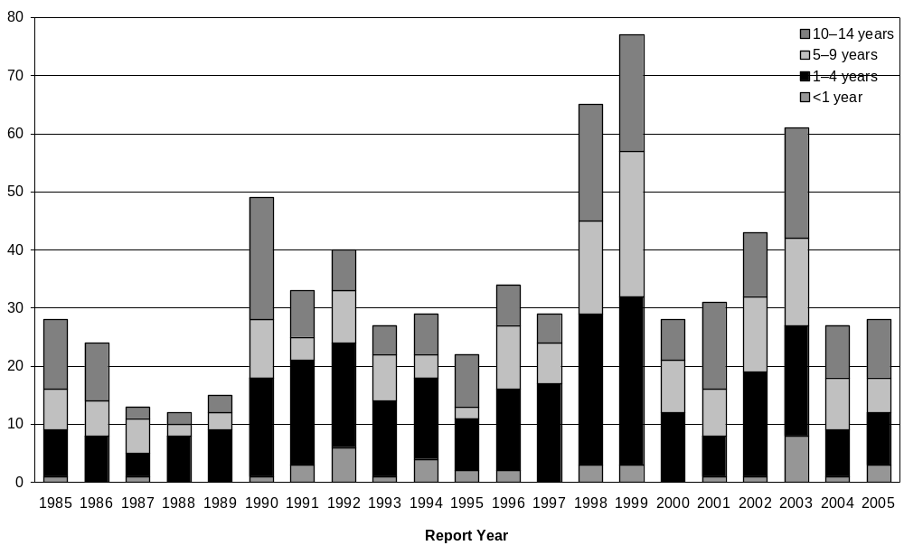
Source: ESR Notification data

Since 1985, the number of TB cases in European children in New Zealand has decreased, whereas the numbers of cases in Pacific and ‘Other’ children have increased. The number of Māori children with TB has remained steady over the same period. This is illustrated in Figure 3.

Figure 3: Cases of tuberculosis in children aged 0–14 years, by ethnicity, 1985–89 to
2002–05 in New Zealand
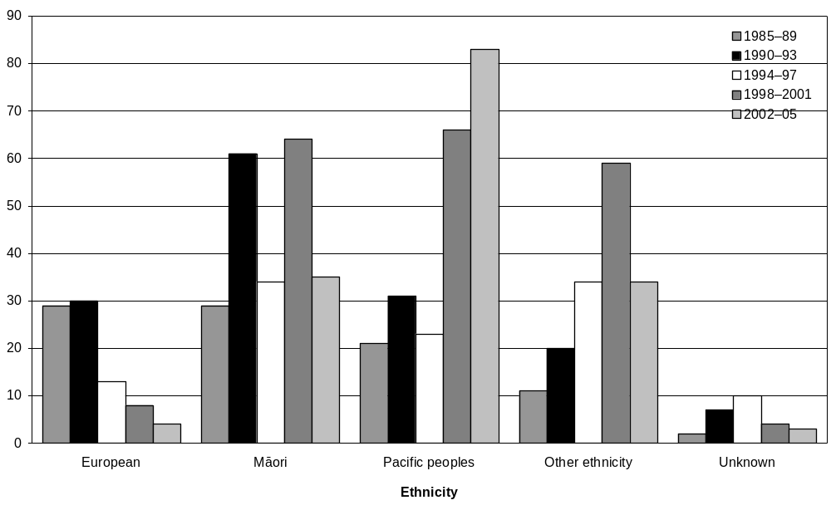
Source: ESR notification data

The number of hospital admissions for meningeal and miliary TB in children aged under 15 years has decreased since the 1970s and remained stable from about 1980 to 2002. There was a marked increase in cases recorded for 2003–04, particularly in those aged under five years, with 15 cases recorded in 2004 and nine cases in 2005 for this age group. The numbers dropped again in 2005, but it is not yet clear if this rise is part of a trend or merely a chance variation (see Figure 4).

Meningeal TB hospitalisations in children aged 0–4 years for the five-year period
2001–05 show three admissions of Māori children and four admissions of Pacific children. This gives average annual incidence rates for this age group over the five-year period of 88.8 per 10 million for Māori and 329.2 per 10 million for Pacific – well above the IUATLD criterion for discontinuing ‘universal’ immunisation of less than one per 10 million. However, the small numbers mean these rates cannot be considered robust or stable. The notification data for the same period records only two cases of meningeal TB (one Māori, one Pacific), which suggests incomplete data fields in the case reports. All of these cases were reported from Northland, Waitemata or Counties Manukau DHB.

Figure 4: New Zealand miliary and meningeal tuberculosis admissions, by age group,
1971–2005
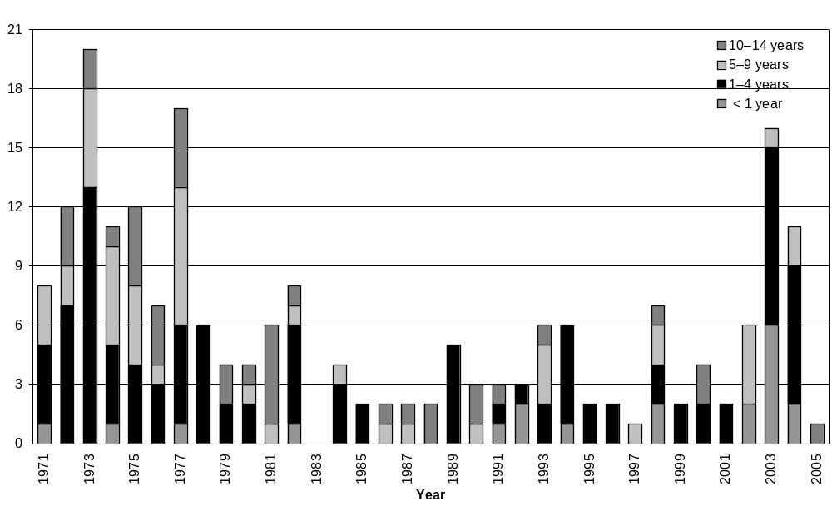
Source: NZHIS data

Ethnic-specific rates for extrapulmonary disease in children aged under 15 years for 1990–2005 show a stable, very low rate in European children, a stable rate around 12 per million in Māori children, and increasing rates for both Pacific and Other children, now well over 30 per million for both groups (see Figure 5). The use of cases classified as extrapulmonary disease as a proxy for disseminated TB in children may, however, be misleading. A review of the ‘sites’ specified in the 1997–2005 notification data for these cases showed that out of 64 cases classified as having extrapulmonary disease, only 16 had a site recorded that indicated meningeal or miliary TB. The majority of the remaining cases recorded as having extrapulmonary disease had nodal or joint involvement. Out of the total 389 notified cases there were also 105 cases where the presence of extrapulmonary disease was said to be ‘unknown’.

Figure 5: New Zealand extrapulmonary tuberculosis in children aged 0–14 years, by ethnicity, 1990–2005
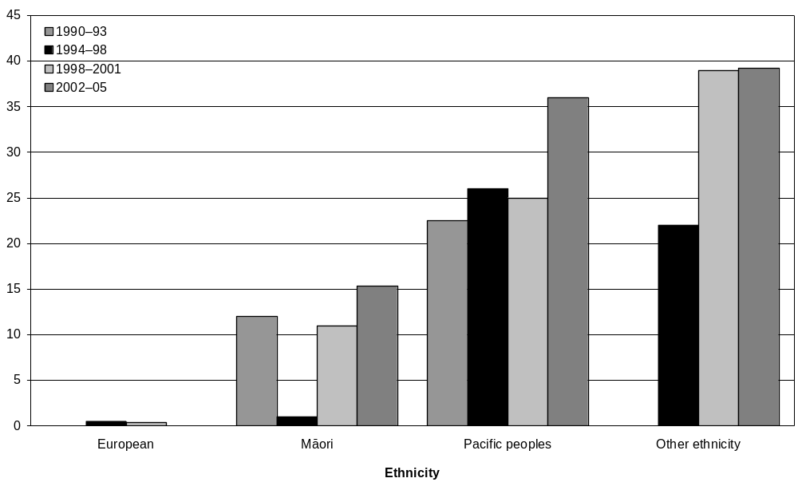
Source: Ethnic-specific rates for extrapulmonary TB in children aged under 15 years were calculated for 1998–2005 using notification data from ESR and Statistics New Zealand 2001 census data.

BCG immunisation status has been requested and reported as part of the notification process since 1997. Table 11 presents the data showing BCG immunisation status and whether extrapulmonary disease was recorded in the notification for those aged under 15 years. Out of the total 64 cases notified in this age group with extrapulmonary disease, 15 were reported as having been vaccinated and 34 as not vaccinated, leaving 15 further cases with an ‘unknown’ immunisation status. This latter group is large enough to render tests of significance for a protective effect from the immunisation against extrapulmonary disease inconclusive. In the group aged under five years, 20 out of 26 cases recorded with extrapulmonary disease had not been vaccinated compared with 51 out of 98 unvaccinated in the group recorded as not having extrapulmonary disease. In this same age group, there were also 19 cases with an unknown immunisation status and 41 cases where it was unknown whether they had extrapulmonary disease. Again, this means tests of significance for a protective effect from the vaccine are inconclusive due to this large proportion of ‘unknowns’.

Table 11: BCG status for extrapulmonary tuberculosis notifications in children aged 0–14 years, 1997–2005
Tuberculosis notifications |  | Extrapulmonary disease | No extrapulmonary disease | Unknown whether extrapulmonary disease | Total cases
0–4 years | Vaccinated | 2 | 38 | 14 | 54
0–4 years | Not vaccinated | 20 | 51 | 21 | 92
0–4 years | Unknown | 4 | 9 | 6 | 19
0–4 years | Total cases | 26 | 98 | 41 | 165
5–14 years | Vaccinated | 13 | 64 | 17 | 94
5–14 years | Not vaccinated | 14 | 47 | 23 | 84
5–14 years | Unknown | 11 | 24 | 11 | 46
5–14 years | Total cases | 38 | 135 | 51 | 224
0–14 years | Vaccinated | 15 | 102 | 31 | 148
0–14 years | Not vaccinated | 34 | 98 | 44 | 176
0–14 years | Unknown | 15 | 20 | 30 | 65
0–14 years | Total cases | 64 | 220 | 105 | 389

After removing those cases unlikely to be meningeal or miliary TB (by reviewing the specific sites listed in the notification data for extrapulmonary cases), analysis of the remaining, assumed ‘definite’ meningeal or miliary TB, cases is even more problematic due to the even higher proportion with unknown BCG immunisation status (see Table 12).

Table 12: BCG immunisation status in cases notified with a site indicating meningeal or miliary tuberculosis
BCG immunisation status | Meningeal or miliary tuberculosis recorded in notification data*
BCG immunisation status | 0–4 years | 5–14 years | Total
Vaccinated | 1 | 3 | 4
Not vaccinated | 4 | 4 | 8
Unknown | 0 | 4 | 4

The difficulty resulting from the incomplete data for immunisation status and disease classification is presented in Figure 6 where the unknown bar for BCG immunisation status is similar to, or larger, than the difference between those positive and negative for BCG immunisation in cases recorded as not having extrapulmonary disease (‘no’), ‘unknown’ or having extrapulmonary disease (‘yes’).

Figure 6: Extrapulmonary tuberculosis and BCG immunisation status in children aged 0–14 years in New Zealand, 1997–2005
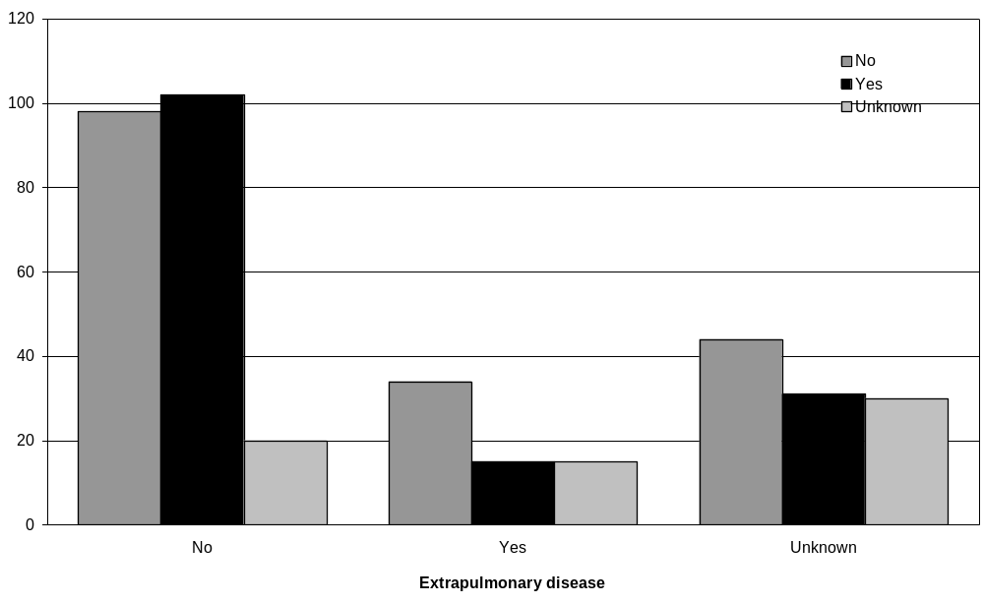
Source: ESR notification data

5 Discussion
Although TB remains a significant problem worldwide, the overall incidence and number of cases of TB in New Zealand remains fairly low and stable. However, the ethnic groups most affected in New Zealand have changed, with increasing rates associated with immigrants and refugees from high-risk Asian and African countries as well as with more recent arrivals from Pacific countries and territories and their families.

Selective neonatal BCG immunisation is one strategy used in New Zealand to control TB with the aim of reducing the risk of severe, disseminated disease in children, particularly those aged under five years. This policy is similar to that in many other low-risk countries. There are disadvantages to immunisation because it affects the usefulness of tuberculin skin testing in the diagnosis of TB and has potential adverse effects, which are uncommon but may be severe. Therefore, there are international recommendations for when immunisation programmes should be discontinued (or implemented).

5.1 Current BCG immunisation service

Service provision
The responses to the survey of DHBs indicate wide variability in how neonatal BCG immunisation is provided throughout the country. Variation occurs as to whether the service is hospital or community based; which staff provide the service; when the service is available; the education and promotion offered to LMCs and the public; the method of carrying out the TB risk assessment; the process for recording the risk assessments and providing immunisation for those found to be eligible; and the monitoring carried out. In most DHBs the ‘service’ is reported as being run by the PHS but it was not clear in many of the responses whether this referred to a complete service, including risk assessment, referral for immunisation, the immunisation itself, data collection and monitoring, or to only some components.

A lack of complete monitoring data meant a detailed assessment of different models of service delivery against vaccine coverage was not possible. However, the three DHBs that had systematic hospital-based services run by their regional PHS reported the highest immunisation coverage rates for Pacific neonates (Counties Manukau, Hutt Valley and Capital & Coast). However, such systems may be more costly than community-based systems. A recent review of the Auckland Regional Public Health Service found that the costs for a hospital-based service were three times higher than those for a community-based service (Herman and Thornley 2005).

Risk assessment
Variability in the format in which risk assessments were recorded highlighted that some health care providers appeared not to be following the eligibility criteria and/or did not appreciate that the mother’s TB risk was not the same as her baby’s TB risk.

Only two DHBs provided data that showed the number of risk assessments they had done. West Coast DHB has a population at low risk of TB and recorded no Pacific live births in 2004–05. Counties Manukau DHB has relatively high rates of TB and a high proportion of its population with Pacific ethnicity. However, only 60.8% of live births were reported as having had a risk assessment done. The proportion was higher for Pacific live births, at 78.6%, but as the live birth data reported by DHBs is most likely that collected from the initial birth registration (when each baby is assigned its mother’s ethnicity), the actual numbers of neonates with any Pacific ethnicity is likely to be higher than reported, so the proportion assessed will be lower than is presented here.

The lack of monitoring data on the number of TB risk assessments done meant there was no baseline against which to assess the adequacy of the service in the other DHBs. The importance of undertaking risk assessments of all mothers and babies and of recording the result to use as the denominator cannot be over-stressed and is not a new recommendation (Howie et al 2005; Ministry of Health 2003).

Contractual issues
Contracting issues were seen as a barrier to the provision of BCG immunisation services. The main concerns were the lack of clear specifications, the need to assign responsibility for monitoring the service, and the need to provide dedicated funding to ensure adequate staffing to provide the components and specific activities required for the service. For the majority of DHBs and PHSs no funding is specifically designated for a neonatal BCG immunisation programme or service, but the Auckland region is an exception to this. The Auckland Regional Public Health Service is contracted to provide a comprehensive hospital-based service at Middlemore Hospital and a community-based service for the wider Auckland region. The Ministry of Health’s TB guidelines recommend that medical officers of health and other health care providers ‘liaise’ with each other to ensure the service is delivered and documented, and that each district records sufficient data to measure coverage. They should also ensure adverse events are documented and monitored (Ministry of Health 2003).

Monitoring and coverage
Monitoring and coverage are clearly an area of concern, highlighted by the incomplete or absent responses by many DHBs to the request for data in the survey. The lack of monitoring data meant coverage (the percentage of eligible babies receiving immunisation) could not be accurately calculated. The percentage of live births recorded with Pacific ethnicity who received immunisation was used as guide for how the service is functioning and showed percentages ranging from 4.3% to 172.1% (see Table 10). This latter figure seems surprising, but may reflect the use of prioritised single ethnicity for the mother (and hence for the initial birth registration information) and total output (possibly multiple ethnicities) for the baby when assessed for TB risk. It is impossible to assess accurately whether the goal of 80% coverage for eligible neonates is being achieved throughout the country, but it would appear unlikely. The Middlemore service may be seen as a successful model, because it is reported as vaccinating 80% of neonates assessed as eligible, but it also reports assessing only 79% of neonates (Herman and Thornley 2005). This type of service may not be feasible or practical in smaller hospitals with limited funding and staff. However, this should not preclude requiring all DHBs to adopt a systematic approach to BCG immunisation, with the collection and collation of data on the number of live births, number of assessments carried out, number assessed as eligible and number vaccinated, categorised by ethnicity and reason for immunisation.

Education and promotion of the service
There are concerns about a lack of education about and promotion of the service in many areas, so not all LMCs and primary care providers are aware of the service and are not providing information about TB risk and the availability of the immunisation service to parents. Allocated responsibility and the associated resources and funding for the provision of education and promotion of the service to health professionals and the public are required.

Other barriers and possible solutions
Problems with mobile populations, changing names and short hospital and birthing unit stays all need to be addressed. The National Immunisation Register may be useful as a backup check for babies ‘missed’ for assessment or immunisation at birth. This would require more information being entered than just when a BCG immunisation is administered. If a risk assessment field had to be completed for all babies, then it would be obvious to Well Child-Tamariki Ora providers when the assessment had not been done. This would also make monitoring of this basic step of the service easy and would also provide the denominator data for subsequent steps such as monitoring of the service.

5.2 Effectiveness and relevance of the current BCG service
It is difficult to conclude whether the current policy of selected neonatal BCG immunisation and eligibility criteria remains the most appropriate. The ethnic–specific rates of extrapulmonary disease suggest that Pacific babies and babies with exposure to adults from a high-risk country should continue to be targeted. However, it must be recognised that the incomplete nature of the notification data hampers this interpretation. Assessing the effectiveness of the BCG immunisation in reducing the severe, disseminated forms of TB in children is similarly hampered by incomplete notification data. Concern has been expressed that Māori babies in some areas should also be targeted (De Zoysa et al 2001). The small numbers of children aged under five years with tuberculous meningitis means assessing the need for immunisation, especially in particular ethnic groups using the second IUATLD criterion for discontinuation of immunisation, is problematic. It would be more useful to monitor the incidence rates for sputum-positive TB by ethnicity and geographic location on a regular basis. However, meaningful ethnic-specific rates by DHB may be inaccurate due to the small numbers in many DHBs, especially once the data is broken down by ethnicity and/or is incomplete. Incomplete data may have a large effect on whether trends or significance can be determined.

The stable rate of TB in the total New Zealand population, along with the ongoing stable number of cases of meningeal and miliary TB cases in children reported in the hospitalisation data, support a continuation of selective, targeted neonatal BCG immunisation services at this time. The increasing rates in the Pacific and Other ethnic groups and the increasing proportion of new TB cases associated with New Zealand residents born outside New Zealand support the continuation of the current eligibility criteria for targeting.

It has been said that ‘any case of military TB or tuberculous meningitis in a child could be seen as a failure of the system to detect and protect at risk children’ (Chappel 1994). Improving the completeness of the notification data and quality of the monitoring of the BCG immunisation service in all DHBs should be a priority if service delivery is to be improved and future reviews of the policy are to be informed.

5.3 Limitations of this review
Changes to the ethnicity classification system affect the ability to follow trends in ethnic groups (especially non-European groups) across time. The relatively small numbers in the numerators exacerbate problems associated with ethnicity classification. Data quality issues, particularly incomplete notification data, limit the conclusions that may be drawn and consequently the recommendations that may be made. The lack of data on BCG immunisation status for all childhood TB cases and ethnicity for all TB cases are of greatest concern.

5.4 Recommendations arising from the review
Recommendations arising from the review have been separated into four areas; contracts, monitoring, resources and surveillance.

Contracts
- A core set of specifications for the neonatal BCG immunisation service could be developed in consultation with medical officers of health and included in contracts in every DHB area.
- Contracts could require DHBs to ensure staff involved in providing the BCG immunisation service receive support and training.

Monitoring
- Monitoring requirements and quality indicators for the BCG immunisation service could be set for DHBs and public health services, and include monitoring of the percentage of mothers assessed for their baby’s TB risk and the percentage of babies assessed as high risk who are vaccinated.
- The feasibility and acceptability of adding a TB risk assessment to the BCG immunisation field in the National Immunisation Register could be investigated.

New resources
- New resources for primary care providers, lead maternity carers (LMCs) and Well Child-Tamariki Ora providers to provide more general education about, and to promote, the service.
- The Ministry of Health, in consultation with medical officers of health and LMC representatives, could develop a standard maternity record and/or assessment form for LMCs and Well Child-Tamariki Ora providers to use when undertaking risk assessments.

Surveillance
- The Ministry of Health, the Institute of Environmental and Scientific Research and other key stakeholders could investigate methods to achieve more complete surveillance data.
- Annual reports of TB surveillance data could provide information relevant to the IUATLD criteria, including the incidence of sputum-positive disease for people of all ages, of tuberculous meningitis for people aged 0–4 years, and provide this information by ethnicity and by DHB area.

Appendix: District Health Board Neonatal BCG Immunisation Questionnaire
Please complete one questionnaire for each DHB, including in areas where public health services to several DHBs are provided by one public health unit.

1. The following questions relate to the overall neonatal BCG immunisation service in your DHB region.
Is there a neonatal BCG service in every hospital/unit providing maternity services in your DHB region?  If no, please specify which units do not have a BCG service. |  | Yes | No
Who provides the BCG service in these maternity units? |  | DHB maternity staff | LMC | PHS staff
If more than one unit please identify and list separately.  If more than three units please record manually or in the text box for Unit 3. | Unit 1  Unit 2  Unit 3 | DHB maternity staff | LMC | PHS staff
How many hours per day and days per week is the BCG service available in the maternity units? | Unit 1  Unit 2  Unit 3 | Hours/day | Days/week
Is there a community-based BCG service provided for infants who are eligible for neonatal immunisation? |  | Yes | No
How many hours per day and days per week (or month) is this BCG service available in the community? |  | Hours/day | Days/week | Days/month

2. The following questions relate to risk assessment in your DHB region.
Who carries out the assessment to identify infants at increased risk of TB as recommended in the TB Guidelines?  If more than one, please estimate percentage of risk assessments carried out by each group of health care providers. | LMC | PHS staff | Other  (please specify)
When does the TB risk assessment usually occur? | Antenatally | After birth
Is the TB risk assessment recorded for all babies (those needing BCG as well as those who don’t)?  If yes, please send us a copy of the format used. | Yes | No
Is the TB risk assessment information recorded for infants identified as eligible for neonatal BCG immunisation?  If yes, please send us a copy of the format used. | Yes | No
Does the TB risk assessment information become part of the antenatal record? | Yes, for all babies | Yes, but only for babies requiring BCG | No
Does the TB risk assessment information become part of the postnatal record? | Yes, for all babies | Yes, but only for babies requiring BCG | No
Is the TB risk assessment information sent to the local BCG service?  If yes, when is this information sent? | Yes, for all babies  Before birth | Yes, but only for babies requiring BCG  After birth | No
Is the TB risk assessment information sent to the public health service?  If yes, when is this information sent? | Yes, for all babies  Before birth | Yes, but only for babies requiring BCG  After birth | No
How are the birth information and the TB risk assessment information linked after birth (ie, how is the provider of the service informed?) | LMC informs BCG service | LMC informs regional PHS | Other  (please specify)

3. The following questions relate to referral for neonatal BCG immunisation.
If the risk assessment determines the infant is eligible for immunisation, who refers the infant for immunisation? | LMC | DHB maternity staff | Other  (please specify)
When is the referral made? | Before birth | Within 24 hours after birth | 1st postnatal week | Other  (please specify)

4. The following questions relate to the neonatal BCG immunisation.
Where is the BCG immunisation provided?  Please estimate percentages. | Hospital | Community
Who is contracted to provide the neonatal BCG immunisation service in the hospital(s)? | Public health service | Other  (please specify)
Who is contracted to provide the neonatal BCG immunisation service in the community | Public health service | Other  (please specify)
Is there follow up for those infants referred but who do not attend for immunisation?  If yes, please explain how this occurs. | Yes | No
Are there a sufficient number of BCG gazetted vaccinators in your DHB to provide neonatal BCG immunisations as well as BCG to others? | Yes | No
If no, do you know why there are not enough? | Difficulty recruiting | Insufficient funds | Other  (please specify)

5. The following questions relate to health promotion and education about the neonatal BCG service in your DHB region.
Is there specific promotion of, and education about, the neonatal BCG service with LMCs and other providers? | Yes | No
Who provides this promotion/education for LMCs and other health care providers? | Public health services | Other  (please specify)
Is there specific promotion of, and education about, the neonatal BCG service with the public? | Yes | No
Who provides this promotion/education for the public? | Public health services | Other  (please specify)

6. The following questions relate to monitoring of the neonatal BCG service by the DHB (see also Question 7)
Does the DHB collate the numbers of pregnant mothers/infants assessed for TB risk?  Does the DHB collate the percentage of mothers/infants assessed for TB risk? | Yes  Yes | No  No
Does the DHB collate the numbers of those assessed for risk who are determined as eligible for BCG (ie, as defined in the TB Guidelines and Immunisation Handbook)?  Does the DHB collate the percentage of those assessed and found to be eligible for BCG? | Yes  Yes | No  No
Does the DHB collate the numbers of those found to be eligible who then receive BCG immunisation?  Does the DHB collate the percentage of those eligible who then receive BCG immunisation? | Yes  Yes | No  No
Does the DHB analyse data on those babies not assessed for TB risk?  If yes, is there information on? | Yes  Ethnicity  Yes No | No  Location of birth  Yes No | Other  (please specify)
Does the DHB analyse data on those assessed as eligible who are not vaccinated?  If yes, is there information on? | Yes  Numbers who decline immunisation  Yes No | No  Numbers who do not attend  Yes No | Other  (please specify)

7. Please provide data from your DHB for 2004 and 2005 if available (please enter N/A if data is not available).
 | 2004 |  |  |  | 2005
 | European | Māori | Pacific | Other | European | Māori | Pacific | Other
Live births: number
Number
% of live births
Number
% of those who were assessed
Number
% of those assessed as eligible
% of live births
Number
% of those vaccinated
Number
% of those vaccinated
Number
% of those who were assessed

8. If the infants vaccinated do not equal those assessed as eligible do you know what the barriers are to neonatal BCG immunisation?

9. What factors affect success of the service (eg, reasons that not every mother/infant is assessed for risk; reasons why maternity units have not started, or have stopped, a neonatal BCG service)?

References

This indication is not absolute. Vaccination is usually advisable if the adult is foreign born and has spent at least six months in a high incidence country within the past five years. The decision is not so clear cut when the adult is a New Zealand resident who has travelled to a high incidence country. The vaccinator must assess the adult’s risk of exposure to TB during the past five years. For example, it is reasonable not to vaccinate the baby of a business person who has spent a year working in a Hong Kong bank with a low risk of TB exposure. On the other hand, a baby living with a person who has returned recently from six months’ volunteer work in a poor, rural Indian community should be vaccinated. Vaccination may be appropriate for a baby living with an adult who has travelled to a high-risk setting (eg, providing patient care in a hospital in a high incidence country) for less than six months in the past five years). If it is difficult to assess the level of risk, advice should be sought from a medical officer of health.
Any country other than Australia, Austria, Belgium, Canada, the Czech Republic, Denmark, Finland, France, Germany, Greece, Holland, Iceland, Ireland, Israel, Italy, Luxembourg, Malta, Monaco, New Zealand, Norway, Slovakia, Sweden, Switzerland, the United Kingdom and the United States.
See note 2.

