Greenhouse Gas Emissions Inventory Report - FY2022/23
Baseline year
CCDHB Department

Document title
Two lines
Sub heading

Prepared in accordance with ISO 14064-1:2018

Prepared by (lead author): Margriet Geesink, Sustainability Lead, Te Tai Tokerau
Approved by: Vicktoria Blake, Head of Sustainability

The Head of Sustainability in the Office of the Chief Executive is responsible for this report. Inquiries on the GHG emissions inventory report can be made to hnzsustainability@health.govt.nz.
Dated: 13 September 2023

Verification status: Reasonable for all categories except category 3 CME travel. Limited for category 3 CME travel.

Measurement period: 01 July 2022 to 30 June 2023
Base year period: 01 July 2022 to 30 June 2023

Approved for release by:
Vicktoria Blake
Interim Head of Sustainability
Te Whatu Ora – Health New Zealand

Availability
This report will be used to inform the 1 July 2022 – 30 June 2023 Te Whatu Ora Annual Report. Reviewed by the Executive Leadership Team and Board, this report will be available to internal and external stakeholders through Te Whatu Ora’s website publications. This report's findings will guide the organisation’s sustainability work programme and inform Te Whatu Ora’s inaugural Emissions Reduction Plan.

Report Content and Structure
The Emissions Inventory Report contains a complete and accurate quantification of the amount of GHG emissions and removals that can be directly attributed to the organisation’s operations within the declared boundary and scope for the specified reporting period. This report has been prepared in accordance with the Greenhouse Gas Protocol: A Corporate Accounting and Reporting Standard (2004) and ISO 14064-1:2018 Specification with Guidance at the Organization Level for Quantification and Reporting of Greenhouse Gas Emissions and Removals. Where relevant, the inventory reporting aligns with industry or sector best emissions measurement and reporting practices.
The inventory summary contains a high-level summary of this year’s results. Chapter 1 provides information on the organisation, the organisational boundaries and the sources included and excluded in the inventory, followed by information on the emission sources, data collection and more detailed emission results. Chapter 2 briefly describes initiatives in place to reduce organisational emissions.

Contents
Availability 3
Report Content and Structure 3
Contents 4
Table of Tables 5
Table of Figures 5
Table of Abbreviations/Glossary 5
Executive Summary 6
Chapter 1: Emissions Inventory Report 8
1.2. Emissions Inventory Results 8
1.3. Organisational Context 11
1.4. GHG emissions sources 15
1.5. Liabilities 18
1.6. Land-use change 19
1.7. Supplementary results 19
1.8. Data collection and uncertainties 20
1.9. Disclosure 21
Chapter 2: Emissions Management Report 22
2.1. Organisational emissions reduction targets 22
2.2. Key performance indicators 22
2.3. Initiatives 22
2.4. Engagement and communication 23
2.5. Monitoring and reporting 24
References 24
Appendix A emissions inventory and total Units of Measure (UOM) 25
Appendix B Emissions per Supplier 29
Appendix C Overview per CNGP activity group 31
Appendix D Overview of locations/sites 32
Appendix E Fleet composition of Te Whatu Ora 35
Appendix F Emissions sources, data collection and uncertainty overview per category 36

Table of Tables

Table 1: Gross organisational GHG emissions by category and activity 7
Table 2: Direct and indirect emission summary 9
Table 3: Direct GHG emissions quantified per gas 10
Table 4: Subsidiary Exclusions 15
Table 5: Summary of emission activities included in this reporting year 17
Table 6: Emission activities excluded from this reporting year 18
Table 7: GHG estimated stock liability per holding 19
Table 8: Summary of custom-created or derived emissions factors 20
Table 9: Skyline Aviation aircraft custom emissions factors per hour flown 21
Table 10: Refrigerant GWP emissions 21
Table 11: Emissions per intensity metric 22

Table of Figures
Figure 1: Top 10 emission sources 6
Figure 2: Top 10 emissions by emission factor 8
Figure 3: Emissions per region and category 9
Figure 4: Top 10 emissions per region 10
Figure 5: Te Whatu Ora Regions and Districts 12
Figure 6: Te Whatu Ora sustainability interim work programme priority areas 13
Figure 7: New Zealand health system 14
Figure 8: Organisational boundary for Te Whatu Ora 14
Figure 9: Phased emission reporting approach 16
Figure 10: Sustainability year overview 23

Table of Abbreviations/Glossary
CNGP | Carbon Neutral Government Programme
CME | Continuing Medical Education
DHBs | District Health Boards
EECA | Energy Efficiency and Conservation Authority
GHG | Greenhouse Gas
GJ | Gigajoule
GWP | Global Warming Potential
kWh | Kilowatt-hour
IIG | Infrastructure and Investment Group
LFGR | Landfill Gas Recovery
MfE | Ministry for the Environment
NTA | National Travel Assistance
1.5-degree pathway | Setting targets in line with limiting the global average temperature increase to 1.5 degrees Celsius above pre-industrial levels.
PPN | Per person night
PKM | Passenger-kilometre
tCO₂e | Tonnes of carbon dioxide equivalent, the common unit of measure for combined greenhouse gases

Executive Summary
This is the first Emissions Inventory Report for Te Whatu Ora – Health New Zealand. The measurement period covers the first financial year since the organisation’s establishment, from 1 July 2022 to 30 June 2023. This will be the baseline year of emissions reporting for the organisation.
The findings will inform Te Whatu Ora’s sustainability work programme and assist in meeting the directions of the Carbon Neutral Government Programme (CNGP).
Te Whatu Ora’s total greenhouse gas (GHG) emissions for the reporting year 1 July 2022 to 30 June 2023 were 237,822 tCO₂e.

Figure 1: Top 10 emission sources
Table 1: Gross organisational GHG emissions by category and activity
Te Whatu Ora Emissions Profile by Category |  | tCO2e
1 | Natural gas | 52,909
 | Coal | 20,491
 | Medical Gases - CO2, N2O, CH4, Acetylene | 15,097
 | Fleet Fuels | 9,213
 | Stationary Diesel | 1,660
 | Refrigerants | 1,424
 | LPG | 1,014
 | Anaesthetic Vapours - Desflurane, Isoflurane, Sevoflurane | 599
 | Biomass - CH4, N2O | 5
2 | Category 1 Total |  | 102,413
 | Electricity | 27,367
 | Purchased steam from coal | 14,337
 | Purchased steam from biomass and landfill gas | 1
3 | Category 2 Total |  | 41,705
 | Staff air travel | 48,412
 | Patient travel by air - Medical plane | 9,321
 | Patient travel by road - Patient travel claims (NTA) | 7,728
 | Patient travel by road - Ambulances | 4,540
 | Patient travel by air - Airline | 4,534
 | Patient travel by air - Helicopter | 3,517
 | Accommodation Patients | 1,167
 | Accommodation Staff | 689
 | Staff travel other - taxis, rental vehicles | 437
4 | Category 3 Total |  | 80,343
 | Waste to landfill | 6,192
 | Transmission and distribution losses gas and electricity | 5,127
 | Wastewater | 1,651
 | Distributed Energy | 169
 | Waste incinerated | 102
 | Water | 120
 | Category 4 Total |  | 13,361
 | Total gross emissions (tCO2e) | 237,822
 | Biogenic Emissions (tCO2) |  | 20,154

Chapter 1: Emissions Inventory Report
  - Introduction
This is Te Whatu Ora – Health New Zealand’s first annual greenhouse gas emissions inventory report. The emissions inventory is a complete and accurate quantification of the emissions directly attributed to the organisation’s operations within the declared boundary and scope for the reporting period 1 July 2022 – 30 June 2023. Any exclusions from reporting have been documented and justified.
The inventory has been prepared in accordance with the requirements of the following:
- Greenhouse Gas Protocol: A Corporate Accounting and Reporting Standard (2004)
- ISO 14064-1:2018 Greenhouse Gases – Part 1: Specification with Guidance at the Organization Level for Quantification and Reporting of Greenhouse Gas Emissions and Removals
- Carbon Neutral Government Programme Direction and Guidance.

Emissions Inventory Results
Te Whatu Ora’s top 10 emissions by emissions source for the reporting period 1 July 2022 - 30 June 2023 is illustrated in Figure 2, with a further summary provided in Table 1.

Figure 2: Top 10 emissions by emission factor

Table 2: Direct and indirect emission summary
 | Category | tCO2e | Sum
Direct Emissions | Category 1 | 102,413 | 102,413
Indirect Emissions | Category 2 | 41,705 | 135,409
 | Category 3 | 80,343
 | Category 4 | 13,361
 | Category 5 | -
 | Category 6 | -

Figure 3: Emissions per region and category

Figure 4: Top 10 emissions per region
Table 3: Direct GHG emissions quantified per gas
Direct emissions per GHG |  | tCO₂e | tCO₂ | tCH₄ | tN₂O
Stationary combustion | Coal bituminous | 3,280.1 | 3,279.7 | 0.3 | 0.0
 | Coal Sub-bituminous | 17,210.9 | 17,209.0 | 1.8 | 0.2
 | Natural gas Industrial | 52,909.3 | 52,860.9 | 24.8 | 23.5
 | LPG | 1,014.2 | 1,013.3 | 0.5 | 0.4
 | Biomass | 5.2 | - | 4.5 | 0.7
 | Diesel | 1,660.1 | 1,650.2 | 6.3 | 3.6
Transport fuels | Diesel | 1,776.9 | 1,749.6 | 2.6 | 24.7
 | Petrol | 7,105.5 | 6,810.5 | 89.5 | 205.4
 | Petrol premium | 330.4 | 316.7 | 4.2 | 9.5
Medical gases | Carbon Dioxide | 45.8 | 45.8 | - | -
 | Nitrous Oxide | 15,051.2 | - | - | 15,051.2
 | Methane | 0.3 | - | 0.3 | -
 | Acetylene | 0.2 | - | - | -
Anaesthetic vapours | Desflurane | 100.2 | - | - | -
 | Sevoflurane | 467.1 | - | - | -
 | Isoflurane | 31.8 | - | - | -
Refrigerants | Substances controlled by the Montreal Protocol | 275.4 | - | - | -
 | Hydrofluorocarbons | 1,004.4 | - | - | -
 | Refrigerant blends: Zeotropes | 131.2 | - | - | -
 | Refrigerants other | 12.8 | - | - | -
 | Total Category 1 | 102,413 | 84,936 | 135 | 15,319
A detailed breakdown of all emission sources is included in Appendix A.
Appendix B lists the emissions per supplier per group to identify supplier source files with significant emissions.
Appendix C summarises emissions for each CNGP activity.

Organisational Context

Organisational Description
Te Whatu Ora was established on 1 July 2022 and leads the day-to-day running of the publicly funded health system across Aotearoa New Zealand, with functions delivered at local, district, regional and national levels. It weaves the functions of the former District Health Boards (DHBs) into its regional divisions and district offices (see Figure 4), ensuring continuity of services in the health system. Te Whatu Ora is responsible for improving services and outcomes across the health system in partnership with Te Aka Whai Ora | Māori Health Authority.
Te Whatu Ora is a large organisation with approximately 75,000 FTE managing all publicly funded health services, including hospital and specialist services. The organisation has a significant infrastructure portfolio distributed across the motu, consisting of approximately 1,200 clinical and corporate buildings. Emissions are generally concentrated at around fifty hospital campuses.
The organisation has a range of national functional and support services, including the National Public Health Service, finance, data and digital, and procurement services, and is supported by eleven subsidiary companies.

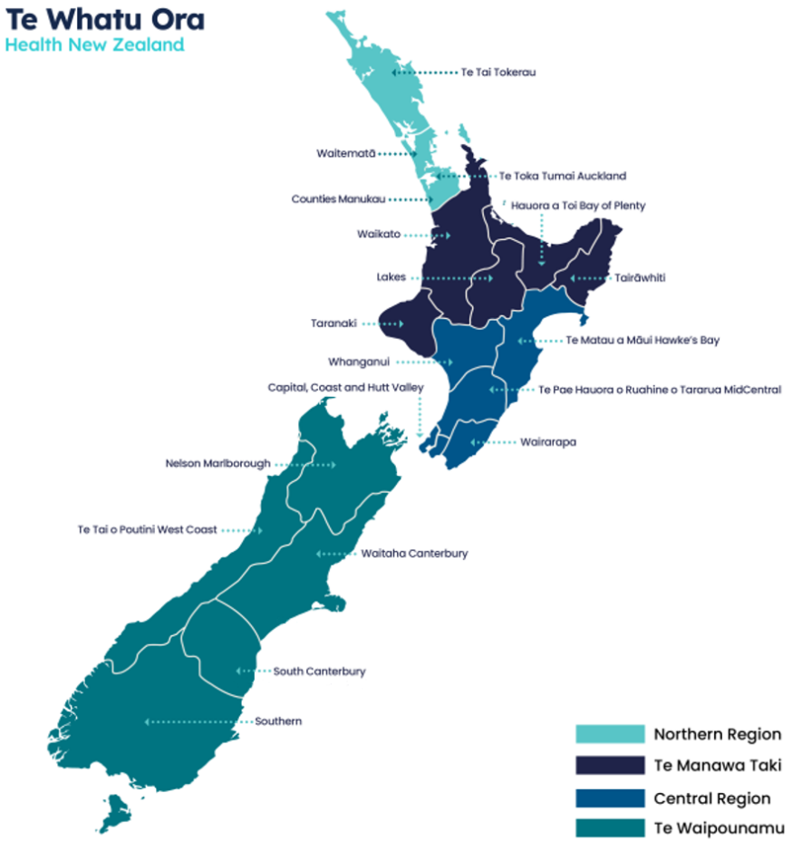
Figure 5: Te Whatu Ora Regions and Districts
Section 7 of the Pae Ora (Healthy Futures) Act 2022 requires that Te Whatu Ora address the wider determinants of population health and wellbeing, including effects that adversely impact population health, such as climate change. Te Whatu Ora recognises that its operations directly impact the environment and that increased environmental sustainability and climate resilience are necessary to continue creating a positive impact on the population's health.
In 2022, Te Whatu Ora created an interim work programme leading to 2025, outlining the following work streams:
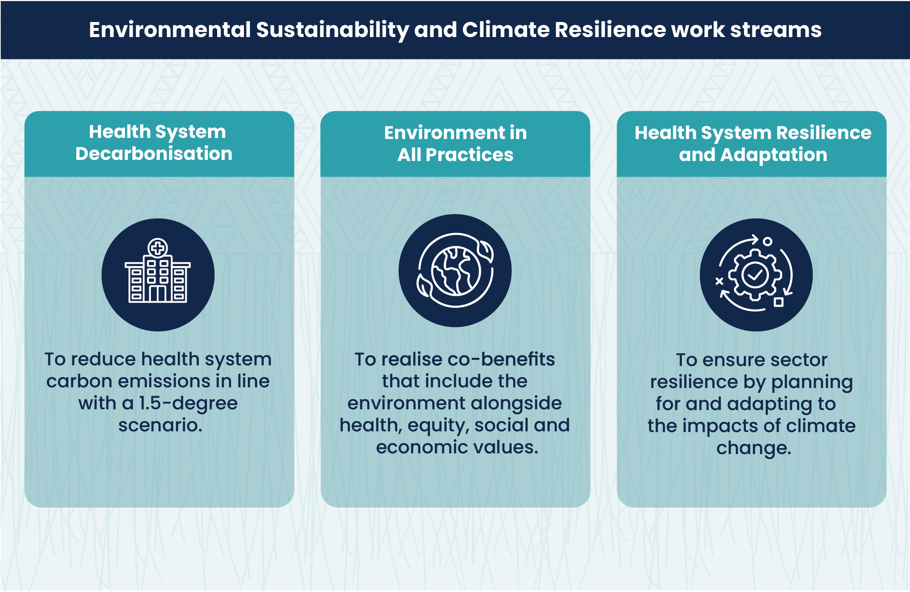
Figure 6: Te Whatu Ora sustainability interim work programme priority areas
This report is a key outcome of the health system decarbonisation work stream, assisting the organisation in complying with requirements under CNGP, and establishing a reputation as an environmentally responsible organisation, contributing toward national emissions reduction targets. This work is strongly supported and complemented by the other interim work streams. Te Whatu Ora recognises emissions reduction as an opportunity to take a whole-of-system approach.

Statement of intent
This inventory forms part of Te Whatu Ora’s commitment to measure and manage its emissions and report in line with CNGP directions. The report outlines Te Whatu Ora’s baseline year for emissions reporting, upon which the organisation will continue to report annually. The inventory has been third-party verified by Toitū Envirocare to a reasonable assurance level for all categories except category 3 CME travel. Category 3 CME travel received a limited assurance level.

Reporting Period
The emissions reporting period is from 1 July 2022 to 30 June 2023, aligning with CNGP requirements and Te Whatu Ora’s financial year. This is the first emissions report for Te Whatu Ora and will become the baseline of emissions reporting for the organisation.

Organisational structure and boundary
The highlighted box in Figure 7 shows the organisational boundary for Te Whatu Ora within the national health system. This encompasses all previous organisations transferred to Te Whatu Ora, including all DHBs, Public Health Units and services transferred to Te Whatu Ora from Manatū Hauora (Ministry of Health).
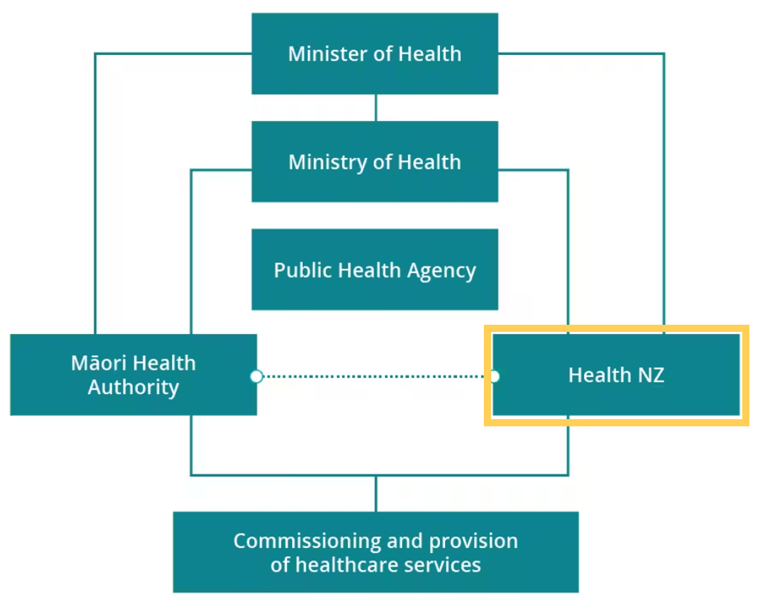
Figure 7: New Zealand health system
Figure 8 sets out Te Whatu Ora’s organisational boundary. The organisation uses the operational control consolidation methodology, which allows a focus on the emissions that Te Whatu Ora can control, and thereby have the greatest level of influence through emissions reduction measures.
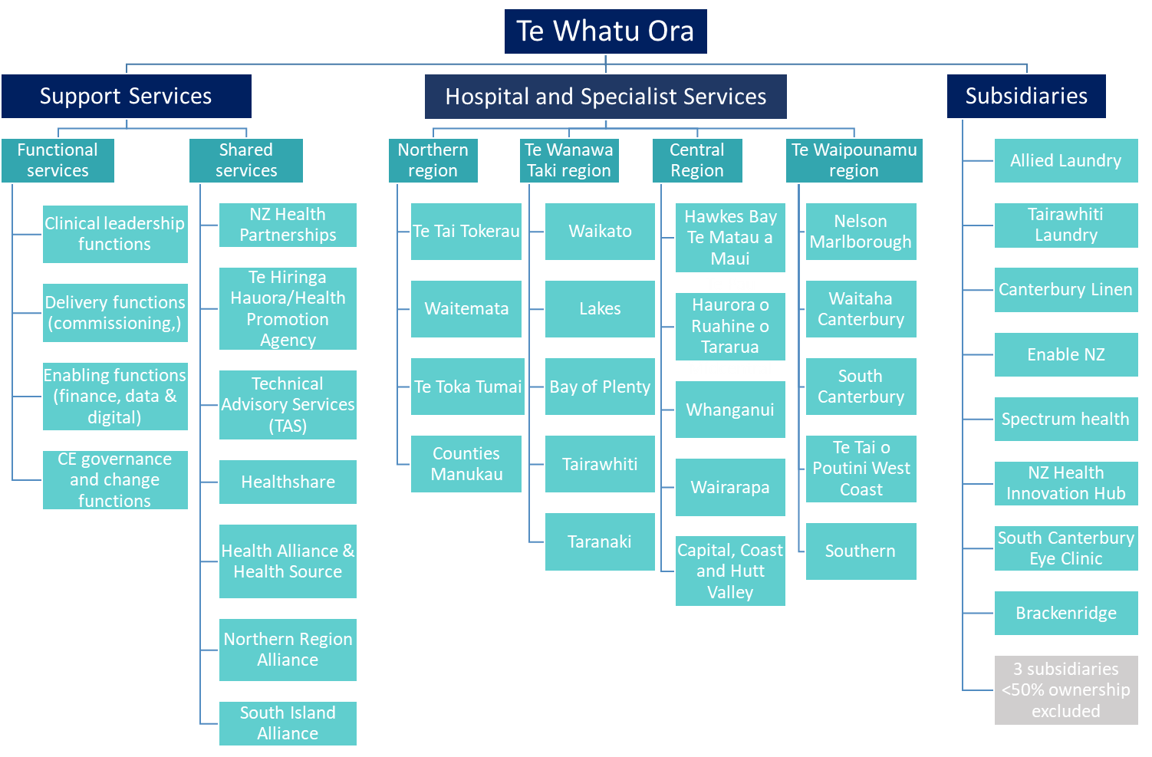
Figure 8: Organisational boundary for Te Whatu Ora
A breakdown of the hospitals, specialist services and office locations are included in Appendix D.
It is difficult to ascertain the boundaries of several hospital sites regarding contracted services and leased spaces within hospital campuses. Therefore, all onsite laundries (whether operated in-house, as a subsidiary or as a contracted service), retail spaces and clinical spaces shared with external organisations are included in the inventory.
Due to the transfer of several functions from Manatū Hauora to Te Whatu Ora (including staff and leased office space from the former), this inventory accounts for these emission activities, from the point the contracts were transferred to Te Whatu Ora.
Where relevant, boundary details specific to emissions sources are detailed in Appendix F.

Business units excluded from inventory
Te Whatu Ora works collaboratively with local primary health, wellbeing, and community-based services to improve community health, however, has no operational control over these services; therefore, these are excluded from the inventory.
Table 4 outlines the subsidiary exclusions. Companies of which Te Whatu Ora does not hold a majority share have been excluded due to a lack of operational control. The other excluded subsidiaries are insignificant due to their size and operation.

Table 4: Subsidiary Exclusions
Subsidiary | Reason for Exclusion
Opotiki Health Centre Ltd | 15% share of ownership
Tlab Ltd | 50% share of ownership
Health one Ltd | 50% share of ownership
Brackenridge Services Ltd | De minimis
Spectrum Health Ltd | De minimis
South Canterbury Eye Clinic Ltd | De minimis
NZ Health Innovation Hub | A virtual subsidiary with no emissions associated with its activity

GHG emissions sources

Emissions sources included
The emissions sources included in this inventory were identified with reference to the methodology in the GHG Protocol and ISO 14064-1:2018 standards.
The health system in Aotearoa New Zealand has been undertaking emissions reporting for several years across some of the larger DHBs, albeit using somewhat inconsistent methodologies.
An emissions reporting working group was established in December 2021 to standardise emissions reporting across DHBs. A product of this work was the Te Whatu Ora Emissions Reporting Framework, which guides and supports this baseline inventory.
The framework provides a robust and standardised means of capturing and reporting on emissions, in response to the CNGP requirements for emissions measurement and reporting. It also provides parameters to improve consistency, reporting optimisation and practical support on data collection.
Due to the significant change within the publicly funded health system during its first financial year and the scale of emissions data gathering for all newly combined entities, the Te Whatu Ora framework embarks on a phased approach to emissions reporting. This allows the organisation to grow its maturity in emission reporting and work on known data gaps over time. Figure 9 illustrates the phased delivery approach.

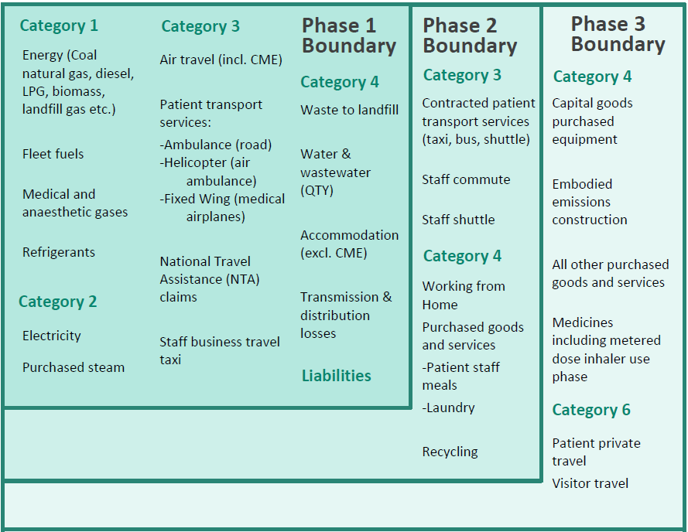

Figure 9: Phased emission reporting approach

A summary overview of the emissions included in this year’s inventory based on phase one is given in Table 5:

Table 5: Summary of emission activities included in this reporting year
 | Emission activities in scope
Category 1 | Coal, natural gas, LPG, diesel stationary, biomass, refrigerants, medical gases (N₂O, Entonox, CO₂, CH₄, Acetylene), Anaesthetic vapours (Desflurane, Isoflurane, Sevoflurane), fleet fuels, refrigerants
Category 2 | Electricity, purchased steam from coal, biomass and landfill gas
Category 3 | Staff air travel, taxi travel and rental cars. Patient air travel by airline, helicopter and medical aeroplanes. Patient travel by ambulance. Patient National Travel Assistance claims (mileage, air travel, public transport, accommodation). Accommodation for staff and patients
Category 4 | Waste to landfill, incinerated waste, transmission and distribution losses gas and electricity, distributed energy, water and wastewater.

Emissions sources excluded
Activities that contribute significantly to Te Whatu Ora’s total emissions and are not included in this baseline inventory include staff commute, private patient travel, procurement activities, and food. These sources have not been included in phase one reporting due to a lack of available data. Table 6 lists the emissions sources that have been identified and excluded. De minimis sources will be reviewed after establishing the baseline year inventory.
Te Whatu Ora recognises its value chain emissions are significant. The Emissions Reporting Framework guides the progression and maturity of reporting by developing methodologies to gather missing data and include sources not currently within this reporting year's scope. Furthermore, increased engagement with suppliers will improve data availability and quality.

Table 6: Emission activities excluded from this reporting year
 | Emission exclusions
Category 1 | -
Category 2 | -
Category 3 | Staff commute  Staff working from home  Staff travel related reimbursement claims other than air travel (mileage, rental cars, taxi, public transport)  Contracted patient services (taxi, shuttle, bus services)  Staff transport services  Accommodation in staff reimbursement claims  Freight
Category 4 | Purchased goods and services (e.g. staff and patient meals, laundry, all products purchased)  Embodied emissions from construction
Category 6 | Patient private travel  Visitor travel

It should also be noted that the Christchurch Energy Centre is under operational control of Te Whatu Ora; however, the energy is also purchased by the University of Otago. To avoid double counting of emissions from CNGP participants, energy on-charged to the university is excluded from the inventory.

Liabilities
HFCs, PFCs and SF₆ represent GHGs with high global warming potentials. Other GHG stocks, including coal, stationary diesel, medical gases and biomass, are held on several Te Whatu Ora sites. Their accidental release could result in a large increase in emissions for the reporting period.
Te Whatu Ora is working on establishing a baseline for all liabilities present at its sites. Table 7 provides an initial stocktake from sites where data was available for liabilities from different holdings. Based on the significance of refrigerants and diesel holdings, further work will be undertaken to gain more detailed insights into holdings per site to assist in implementing procedures to minimise the risk of accidental release.

Table 7: GHG estimated stock liability per holding
Holdings | Quantity | Unit | Potential liability
Refrigerants HFCs | 26,690 | Kg | 34,329
Refrigerants blends | 6,380 | Kg | 12,447
Refrigerants controlled by the Montreal protocol | 4,554 | Kg | 2,426
Refrigerants other | 1,329 | Kg | 1,720
Diesel | 1,230,593 | Litres | 3,298
Medical gases | - | Kg | 2,107
Coal | 142,000 | Tonne | 284
LPG | 36,167 | Kg | 107
Anaesthetic vapours | - | Kg | 101
Biomass | 362,000 | Tonne | 5
Total potential liability tCO₂e |  |  | 56,825

Land-use change
Organisations that own land subject to land-use change may achieve sequestration of carbon dioxide through a change in the carbon stock on that land. Where a sequestration is claimed, then this also represents a liability in future years should fire, flood, or other management activities release the stored carbon.
Land-use change has not been included in this inventory as Te Whatu Ora does not own land subject to significant land use change.

Supplementary results
Holdings and transactions in GHG-related financial or contractual instruments such as permits, allowances, renewable energy certificates or equivalent, verified offsets or other purchased emissions reductions from eligible schemes recognised by the Programme are reported separately here.
Contractual instruments are any type of contract between two parties for the sale and purchase of energy bundled with attributes about the energy generation, or for unbundled attribute claims. This includes Renewable Energy Certificates.
- Contractual instruments are not applicable for this reporting period.
- No offsets have been purchased for this reporting period.

Data collection and uncertainties
The following approaches were used during data gathering:
- National data collection – involving engagement with companies holding contracts or providing services to several Te Whatu Ora sites to provide activity data such as waste to landfill, electricity or fuel consumption.
- Regional and local data collection – involving engagement with key contacts at regional and local sites and companies where national data collection was not possible, to provide activity data such as refrigerant, stationary diesel, liabilities and top-ups.
Emissions are calculated by multiplying emissions activity data with appropriate emissions factors. Most emission factors are sourced from the Te ine tukunga: He tohutohu pakihi – Measuring emissions: A guide for organisations (Ministry for the Environment [MfE], 2023). Custom emission factors were created or derived where not available in the MfE guide and recorded in the Te Whatu Ora emission conversions and calculation documentation. Tables 8, 9 and 10 summarise the custom emission factors used in this inventory. Unless otherwise specified, all calculations in this report are expressed in total tonnes of carbon dioxide equivalent (tCO2e).

Table 8: Summary of custom-created or derived emissions factors
Created custom or derived factor name | Unit | Emission factor kgCO2_{e}/ unit
TWO Biomass (CH₄-N₂O) - Wood chip Industry - GJ | GJ | 0.023
TWO Biogenic (CO₂) - Wood chip Industry - GJ | GJ | 89.47
TWO Coal - Bituminous - Industrial Use - GJ | GJ | 89.1405
TWO Coal - Sub-Bituminous - Industrial Use - GJ | GJ | 92.0005
TWO Biogas - Landfill Gas - GJ | GJ | 0.00000072
TWO HFE-236ea2 (Desflurane) - Bottle | Bottle | 630.31
TWO HCFE-235da2 (Isoflurane) - Bottle | Bottle | 183.634
TWO HFE-347mmz1 (Sevoflurane) - Bottle | Bottle | 82.242
TWO Public Transport - $ | $ | 0.649
TWO Medical waste – Kg | Kg | 0.442
TWO Cytotoxic waste – Kg | Kg | 0.879
TWO Acetylene - kg | Kg | 3.385

Table 9: Skyline Aviation aircraft custom emissions factors per hour flown
Created custom or derived factor name | Aircraft Reg / type | Fuel litres/ hour | Jet A1 EF | kgCO₂e/ hr
TWO Aviation fuels - B350 - hours | B350 | 450 | 2.56 | 1,152
TWO Aviation fuels - B200 - hours | B200 | 380 | 2.56 | 973
TWO Aviation fuels - C90 - hours | C90 | 3,330 | 2.56 | 8,525
TWO Aviation fuels – Mustang - hours | Mustang | 400 | 2.56 | 1,024
TWO Aviation fuels - 400XT - hours | 400XT | 600 | 2.56 | 1,536
TWO Aviation fuels – Sovereign - hours | Sovereign | 950 | 2.56 | 2,432

Table 10: Refrigerant GWP emissions
Refrigerant name | GWP
R448a | 1,273
R412A | 2,286
R449A | 1,282
R508 | 13,214
R132A | 338
R170 | 10.2
R1324 | 338
R438A | 2,265
R455A | 146

Appendix F lists the data sources, collection methods, uncertainties and assumptions for each emissions source and factor. Te Whatu Ora utilises the ‘Accelerate to Zero’ emission reporting tool, developed by Deloitte, for emissions data management, monitoring, reporting and planning.

Disclosure
The GHG inventory has been third-party verified by Toitū according to ISO 14064-1:2018.
Base year – 01 July 2022 to 30 June 2023
Level of assurance – Reasonable for all categories except category 3 CME travel. Limited for category 3 CME travel
From the analysis conducted, the inventory is classified as: Good
As part of the audit the organisational boundaries, GHG Emissions Inventory Report and application of accounting principles were reviewed and classified as: meets the requirements

Chapter 2: Emissions Management Report

Te Whatu Ora has commenced its journey in emissions management, not least of which is creating its emissions baseline. This section aims to discuss with more detail progress and intentions.

Organisational emissions reduction targets
Over the next financial year, Te Whatu Ora will create its first organisation-wide Emissions Reduction Plan in line with CNGP directions. This will include a formalised reporting and governance structure, with quarterly reporting mechanisms and updates on key projects and investments.
The reported baseline from this inventory will be used to set emission reduction targets in line with a 1.5-degree pathway.
The three focus areas set through the interim work programme (Figure 5) will continue to guide work until a broader sustainability approach is created and the formal Emissions Reduction Plan is in place.

Key performance indicators
To be able to compare emissions across organisations and industries, and to comply with CNGP and ISO standards, Te Whatu Ora considers its emissions against funding received and FTE. Average daily bed occupancy is also used as an intensity metric to enable benchmarking against other healthcare facilities globally. It is a metric recommended in Global Green and Healthy Hospitals reporting initiatives.
The baseline year’s emissions per intensity metrics are defined in Table 11.
Table 11: Emissions per intensity metric
Emission intensity metric | Intensity Unit |  | tCO₂e per unit
Expenditure | $24.6 billion | 9.67 |  | tCO₂e / M$
FTE | 74,971 | 3.17 |  | tCO₂e / FTE
Average daily bed occupancy | 8,411 | 28.28 |  | tCO₂e / bed

Initiatives
While Te Whatu Ora has yet to set emission reduction targets, several operational and strategic initiatives have taken place over the past year to achieve emission reductions and set direction. Figure 10 outlines the primary initiatives and achievements that have taken place during this reporting year.
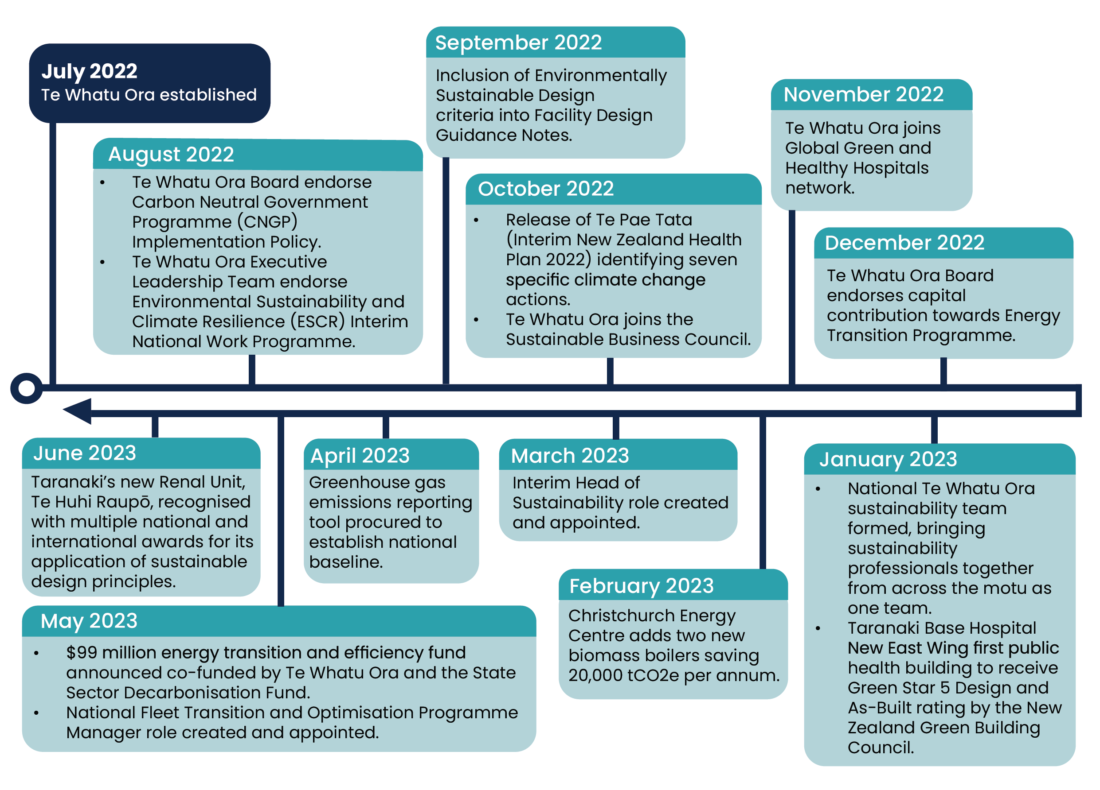
Figure 10: Sustainability year overview
Sustainability work has taken a national approach since the implementation of Te Whatu Ora, which will benefit the work undertaken in prioritised areas such as infrastructure, procurement and supply chain, and circular economy and waste.
One example of the national approach is the transition and optimisation of Te Whatu Ora’s fleet. The current fleet composition is outlined in Appendix E, with the transition to battery electric vehicles expected to improve over the coming year.

Engagement and communication
Te Whatu Ora is a proud member of the Sustainable Business Council and the Global Green and Healthy Hospitals international network, as well as being connected across the motu through engagement with networks such as Sustainable Healthcare Aotearoa and OraTaiao Climate and Health Council.
Te Whatu Ora has an internal sustainability network of over 340 kaimahi. This network is updated via webinar on a bi-monthly basis of progress against the interim work programme and is regularly invited to share its issues and ideas.

Te Whatu Ora has also recently joined WasteMINZ. As a WasteMINZ member, Te Whatu Ora can actively support discussions and initiatives that deliver circular economy outcomes, and waste minimisation benefits, and promote waste education and awareness.

Monitoring and reporting
Te Whatu Ora’s sustainability reporting aligns with CNGP guidance, Aotearoa New Zealand Climate Standards, ISO 14064-1:2018 and the Greenhouse Gas Protocol, and is verified by Toitū Envirocare.
This inventory report forms the baseline year for the organisation. It will be followed by annual emission reports, which will establish how the organisation is progressing toward targets from the impending Emissions Reduction Plan.

References
Greenhouse Gas Protocol Corporate Accounting and Reporting Standard https://ghgprotocol.org/sites/default/files/standards/ghg-protocol-revised.pdf
International Organization for Standardization. 2018. Greenhouse gases — Part 1: Specification with guidance at the organization level for quantification and reporting of greenhouse gas emissions and removals (ISO Standard No.14064-1:2018). (Standard on file)
Pae Ora (Healthy Futures) Act 2022 https://www.legislation.govt.nz/act/public/2022/0030/latest/LMS575484.html
Te Whatu Ora. 2022. Te Whatu Ora – Health New Zealand Emissions Reporting Framework – A guide to measuring and reporting greenhouse gas emissions for Te Whatu Ora (framework on file)
Te ine tukunga: He tohutohu pakihi | Measuring emissions: A guide for organisations, 2023 detailed guide , Manatū Mō Te Taiao | Ministry for the Environment https://environment.govt.nz/assets/publications/Measuring-Emissions-Guidance_DetailedGuide_2023_ME1764.pdf
Carbon Neutral Government Programme: A guide to managing your greenhouse gas emissions – measuring, reporting, target-setting and reduction planning. Version 3.0 May 2023, Manatū Mō Te Taiao | Ministry for the Environment
Carbon Neutral Government Programme: A guide to measuring and reporting greenhouse gas emissions | Ministry for the Environment

Appendix A emissions inventory and total Units of Measure (UOM)
Emission source | Unit Measure | Factor | Total QTY | Total KgCO2e
Nat Gas - Industrial - GJ | GJ | 53.658 | 986,048 | 52,909,278
Electricity - Kwh | Kwh | 0.074 | 368,940,973 | 27,367,175
Coal - Sub-Bituminous - Industrial Use - GJ | GJ | 92.001 | 187,074 | 17,210,920
Long-haul (>3700km) - Business class - With Radiative Forcing | Passenger Kms | 0.429 | 33,658,510 | 14,433,442
Purchased Steam from coal - GJ | GJ | 92.001 | 155,838 | 14,337,215
Air travel Default - KgCO2-e | KgCO2-e direct | 1.000 | 13,557,595 | 13,557,595
Air travel Default - tCO2-e | tCO2-e direct | 1,000.000 | 12,440 | 12,440,000
Nitrous oxide | Kg | 265.000 | 46,594 | 12,347,505
Petrol - Default* - Petrol - Default* - litre | Litre | 2.455 | 2,894,087 | 7,105,477
Domestic - National average - With Radiative Forcing | Passenger Kms | 0.306 | 21,842,852 | 6,681,580
Passenger Vehicle - Petrol Vehicle - Default - Km (NTA) | Km | 0.252 | 23,045,362 | 5,801,806
Aviation fuel (Kerosene) - litre (Cat 3) | Litres | 2.561 | 1,842,095 | 4,716,909
Waste with gas recovery (unknown composition) - General Waste - Kg | Kg | 0.232 | 16,911,330 | 3,919,565
Passenger Vehicle - Diesel Vehicle - 2000–<3000 cc - Post 2015 - Km | Km | 0.223 | 16,498,968 | 3,675,194
Helicopter Eurocopter AS350B3 Squirrel - Hrs | Hours | 482.740 | 7,285 | 3,516,693
Coal - Bituminous - Industrial - GJ | GJ | 89.141 | 36,797 | 3,280,060
Electricity T&D - kWh | Kwh | 0.009 | 368,940,973 | 3,173,454
Entonox | Kg | 153.435 | 17,621 | 2,703,728
Aviation fuel (Kerosene) - Aviation fuel (Kerosene) - C90 - hours | Hours | 8,526.870 | 294 | 2,506,047
Clinical/medical / sharps waste autoclaving and landfilling - Kg | Kg | 0.442 | 4,688,539 | 2,072,334
Natural Gas T&D - GJ | GJ | 1.981 | 986,048 | 1,953,188
Long-haul (>3700km) - Economy class - With Radiative Forcing | Passenger Kms | 0.148 | 12,579,947 | 1,860,197
Long-haul (>3700km) - Premium economy class - With Radiative Forcing | Passenger Kms | 0.237 | 7,630,143 | 1,805,216
Diesel - Diesel - litre | Litre | 2.715 | 654,510 | 1,776,910
Diesel - Commercial use - litre | Litre | 2.689 | 617,326 | 1,660,075
Domestic - Avg Wastewater Treatment Plants (Unit m3) - m3 | m3 | 0.508 | 3,251,780 | 1,650,826
Public Transport $ (NTA) | $ | 0.649 | 2,457,823 | 1,595,127
Aviation fuel (Kerosene) - Aviation fuel (Kerosene) - B200 - hours | Hours | 973.036 | 1,498 | 1,457,316
New Zealand - MfE (Cat 4) | Room Per Night | 9.400 | 109,334 | 1,027,739
LPG - Commercial use - kg | Kg | 2.972 | 341,282 | 1,014,167
HFC-134a (R-134a) - Kg | Kg | 1,300.000 | 767 | 996,840
Short-haul (<3700km) - Economy class - With Radiative Forcing | Passenger Kms | 0.151 | 6,301,646 | 951,675
Vehicle KgCO2e direct | KgCO2-e direct | 1.000 | 943,330 | 943,330
Domestic - National average - With Radiative Forcing (NTA) | Passenger Kms | 0.306 | 3,015,965 | 922,563
New Zealand - MfE | Room Per Night | 9.400 | 69,213 | 650,602
Aviation fuel (Kerosene) - Aviation fuel (Kerosene) - B350 - hours | Hours | 1,152.280 | 455 | 523,711
HFE-347mmz1 (Sevoflurane) - Bottle | Bottle | 82.242 | 5,680 | 467,135
Taxi travel - regular - dollars spent ($3.20/kilometre) - $ (NTA) | $ | 0.051 | 6,440,824 | 331,058
Premium Petrol - Premium Petrol - litre | Litre | 2.457 | 134,463 | 330,402
Taxi travel - regular - dollars spent ($3.20/kilometre) - $ | $ | 0.051 | 5,793,343 | 297,778
HCFC-22 (R-22) - Kg | Kg | 1,760.000 | 157 | 275,440
Aviation fuel (Kerosene) - Aviation fuel (Kerosene) - Mustang - hours | Hours | 1,024.249 | 256 | 261,798
Distributed energy - Electricity | kWh | 0.074 | 2,281,634 | 169,246
Waste without gas recovery (unknown composition) - General Waste - Kg | Kg | 0.724 | 259,944 | 188,274
Water Supply Emission Factors (Unit m3) - m3 | m3 | 0.037 | 3,251,780 | 120,104
Cytotoxic waste incineration - Kg | Kg | 0.879 | 116,335 | 102,259
HFE-236ea2 (Desflurane) - Bottles | Bottle | 630.309 | 159 | 100,219
Average - MfE | Room Per Night | 20.000 | 4,619 | 92,380
Short-haul (<3700km) - Business class - With Radiative Forcing | Passenger Kms | 0.227 | 352,852 | 79,928
Australia - MfE | Room Per Night | 38.900 | 1,694 | 65,897
404A - Kg | Kg | 3,943.000 | 15 | 59,500
Aviation fuel (Kerosene) - Aviation fuel (Kerosene) - 400XT - hours | Hours | 1,536.373 | 37 | 57,153
Passenger Vehicle - Petrol Vehicle - Rental - Km | Km | 0.186 | 302,892 | 56,245
410A - Kg | Kg | 1,923.500 | 28 | 53,858
Carbon dioxide | Kg | 1.000 | 45,778 | 45,778
HCFE-235da2 (Isoflurane) - Bottle | Bottle | 183.634 | 173 | 31,769
407C - Kg | Kg | 1,624.210 | 11 | 17,866
Refrigerants - Kg Co2e direct - Kg | Kg Co2-e Direct | 1.000 | 12,820 | 12,820
Waste with gas recovery (unknown composition) - Office Waste - Kg | Kg | 0.666 | 17,596 | 11,716
Short-haul (<3700km) - Average passenger - With Radiative Forcing | Passenger Kms | 0.154 | 57,956 | 8,898
HFC-32 (R-32) - Kg | Kg | 677.000 | 11 | 7,609
United States - MfE | Room Per Night | 19.800 | 327 | 6,475
Biomass - Wood & Residuals - GJ | GJ | 0.023 | 225,262 | 5,181
Passenger Vehicle - Diesel Vehicle - 2000–<3000 cc - 2010 to 2015 - Km | Km | 0.238 | 14,944 | 3,560
Fiji - MfE | Room Per Night | 54.800 | 55 | 3,014
Aviation fuel (Kerosene) - Aviation fuel (Kerosene) - Sovereign - hours | Hours | 2,432.591 | 1 | 2,676
Singapore - MfE | Room Per Night | 28.500 | 49 | 1,397
United Kingdom - MfE | Room Per Night | 13.400 | 91 | 1,219
Indonesia - MfE | Room Per Night | 88.200 | 9 | 794
India - MfE | Room Per Night | 66.000 | 11 | 726
United Arab Emirates - MfE | Room Per Night | 95.900 | 7 | 671
Netherlands - MfE | Room Per Night | 21.200 | 31 | 657
Purchased Steam from woodchips - GJ | GJ | 0.023 | 26,666 | 613
Canada - MfE | Room Per Night | 17.100 | 34 | 581
Japan - MfE | Room Per Night | 54.700 | 10 | 547
Germany - MfE | Room Per Night | 18.200 | 30 | 546
Thailand - MfE | Room Per Night | 55.900 | 8 | 447
Philippines - MfE | Room Per Night | 62.900 | 7 | 440
Passenger Vehicle - Diesel Vehicle - Rental - Km | Km | 0.181 | 1,905 | 345
Methane - Kg | Kg | 28.000 | 11 | 307
Spain - MfE | Room Per Night | 16.300 | 17 | 277
Italy - MfE | Room Per Night | 23.900 | 11 | 263
Israel - MfE | Room Per Night | 51.800 | 5 | 259
Switzerland - MfE | Room Per Night | 7.400 | 23 | 170
South Africa - MfE | Room Per Night | 56.600 | 3 | 170
Custom Acetylene - Kg | Kg | 3.385 | 47 | 159
France - MfE | Room Per Night | 7.500 | 10 | 75
Austria - MfE | Room Per Night | 11.900 | 5 | 60
Colombia - MfE | Room Per Night | 11.000 | 2 | 22
Belgium - MfE | Room Per Night | 11.600 | 1 | 12
Isobutane(R-600a) - Kg | Kg | 3.000 | 3 | 9
Passenger Vehicle - Electric Vehicle - Rental - Km | Km | 0.017 | 64 | 1
Biogas - Landfill Gas - GJ (CAT2) | GJ | 0.0000007 | 51,182 | 0
Grand Total |  |  |  | 237,822,265

Appendix B Emissions per Supplier
Emission Source | Supplier | Total Emissions KgCO2e
Fuel | Allied Petroleum | 35,060
 | Birchfield | 6,074,147
 | BOC | 18,053
 | BP Fuel Cards | 8,961,986
 | Canterbury District Energy Inputs | 14,420,910
 | District Inputs | 2,652,611
 | Genesis | 54,862,467
 | Kiwi Fuel Cards | 7,594
 | Mobil | 140,130
 | NZ Fuel Cards | 53,374
 | Subsidiary Inputs | 19,328
Medical Gases, Refrigerant & Other | Air Liquide | 4,582,303
 | Baxter | 599,122
 | BOC | 10,515,174
 | District Inputs | 1,423,943
Purchased Energy | Canterbury District Energy Inputs | - 188,872
 | Contact (Simply Energy) | 27,836,095
 | District Inputs | 33,540
 | Genesis | 693,049
 | Mercury | 11,192
 | Nelson City Council | 0
 | Pioneer Energy | 14,337,829
 | Smart Power | 17,276
 | Subsidiary Inputs | 207,295
 | Meridian | 1,931,055
Travel Vehicle | District Inputs | 297,778
 | FcM | 24,603
 | Free Wellington Ambulance | 861,048
 | National Travel Assistance Programme (NTA) | 1,926,185
 | Orbit (House of Travel) | 82,282
 | Pro Med | 3,560
 | St John | 3,675,194
Travel Air | Air Gisborne | 567,666
 | Air Napier | 34,414
 | Air Wanganui | 948,359
 | AirNZ (Direct) | 12,440,000
 | Corporate Office Inputs | 94,851
 | District Inputs | 21,675,118
 | FcM | 4,683,205
 | Garden City Helicopters | 1,502,908
 | HNZ National Ambulance Services Office (NASO) | 3,516,693
 | LifeFlight | 1,058,561
 | Mainland Air | 44,340
 | National Travel Assistance Programme (NTA) | 922,563
 | Orbit (House of Travel) | 8,874,390
 | Philips Search and Rescue | 428,754
 | Skyline Aviation | 4,808,702
 | Stewart Island Flights | 6,268
 | Subsidiary Inputs | 4,941
 | Sunair | 125,638
 | Tandem | 3,888,788
 | You Travel | 157,237
Materials & Waste | District Inputs | 311,771
 | Envirowaste | 1,308,155
 | Interwaste | 1,550,089
 | Northland Regional Landfill | 86,224
 | Northland Waste | 40,894
 | Subsidiary Inputs | 15,994
 | Waste Management | 2,981,021
Wastewater & Water Supply | AZ - Supplier (Uncategorized) | 1,770,930
Hotel Stay | Corporate Office Inputs | 4,266
 | FcM | 265,376
 | National Travel Assistance Programme (NTA) | 6,829,545
 | Orbit (House of Travel) | 431,371
 | Tandem | 134,564
 | You Travel | 24,111

Appendix C Overview per CNGP activity group
CNGP Activity Groups | tC02_{e}
Scope 1 - Agriculture (all emissions) | -
Scope 1 - Biofuel (fossil fuel emissions N2O & CH4 for biofuel portion) | -
Scope 1 - Biomass (fossil fuel emissions N2O & CH4 for biofuel portion) | 5
Scope 1 - Forestry - harvest/deforestation | -
Scope 1 - Refrigerants, medical and other gases | 17,121
Scope 1 - Other | -
Scope 1 - Stationary combustion - coal | 20,491
Scope 1 - Stationary combustion - natural gas and LPG | 53,923
Scope 1 - Stationary combustion - other (e.g., diesel) | 1,660
Scope 1 - Transport fuels - aviation | -
Scope 1 - Transport fuels - other (e.g., shipping fuel) | -
Scope 1 - Transport fuels - vehicle fleet | 9,213
Scope 2 - Electricity | 27,367
Scope 2 - Other (e.g., purchased steam) | 14,338
Scope 3 (mandatory) - Air travel domestic | 24,508
Scope 3 (mandatory) - Air travel international | 23,904
Scope 3 (mandatory) - Business travel other (e.g., taxi, hotel, rental cars) | 1,125
Scope 3 (mandatory) - Freight | -
Scope 3 (mandatory) - Staff working from home | -
Scope 3 (mandatory) - Transmission and distributions losses (electricity) | 3,173
Scope 3 (mandatory) - Transmission and distributions losses (natural gas) | 1,953
Scope 3 (mandatory) - Waste (to landfill) | 6,294
Scope 3 (mandatory) - Wastewater | 1,651
Scope 3 (mandatory) - Water | 120
Scope 3 (other material) - Emissions from purchased goods and services | 21,911
Scope 3 (other material) - Emissions from purchased capital goods | -
Scope 3 (other material) - Other (e.g., staff commuting, investments, leased assets) | 9,064
Scope 1 Biogenic emissions - Biofuel CO2 component (considered carbon neutral) | -
Scope 1 Biogenic emissions - Biomass CO2 component (considered carbon neutral) | 20,154
Removals - Forest growth removals | -

Appendix D Overview of locations/sites

Included locations in the emissions inventory
National | Northern Regional Alliance Ltd | Auckland, Penrose, Level 2, 650 Great South Road
 | Central Region’s Technical Advisory Services Limited (TAS) | Auckland, Takapuna, Level 3, Barrys Point Road
 |  | Wellington, 69 Tory Street
 | HealthShare | Hamilton, 16 Clarence Street
 | New Zealand Health Partnerships (NZHP) | Auckland Ellerslie, Level 1, Building 7, Central Park, 666 Great South Road
 | Health Alliance & Health Source | Auckland, Penrose, 581-585 Great South Road
 | South Island Alliance | Business Unit within Canterbury district
 | Te Hiringa Hauora/ Health Promotion Agency | Auckland, Ellerslie, Level 2, Ascot Central, 7 Racecourse Drive
 |  | Wellington, The Terrace, Level 14/15/16 101
 |  | Christchurch, BNZ Building Hereford Street
 | National offices | Whanganui, Level 2, 179 Hill Street
 |  | Wellington, Level 5-6, 42-52 Willis Street (Spark Central)
 |  | Wellington, Levels 4-7, 83 Molesworth Street (Shamrock House)
 |  | Wellington, 133 Molesworth Street (Manatū Hauora)
 |  | Christchurch, Level 2, 48 Hereford Street
 |  | Dunedin, Level 9, 481 Moray Place
 |  | Auckland Manukau, Level 4, Kotuku House, 4 Osterley Way
Northern region | Te Tai Tokerau | Bay of Islands Hospital
 |  | Dargaville Hospital
 |  | Kaitaia Hospital
 |  | Whangarei Hospital
 |  | Various community locations
 | Waitematā | Mason Clinic
 |  | North Shore Hospital
 |  | Waitakere Hospital
 |  | Various community locations
 | Te Toka Tumai | Auckland City Hospital
 |  | Greenlane Clinical Centre
 |  | Auckland Spinal Rehabilitation
 |  | Various community locations
 | Counties Manukau | Middlemore Hospital
 |  | Manukau Surgery Centre
 |  | Pukekohe
 |  | Various community locations
Te Manawa Taki region | Waikato | Matariki Hospital
 |  | Rhoda Read Hospital
 |  | Thames Hospital
 |  | Tokoroa Hospital
 |  | Waikato Hospital
 |  | Various community locations
 | Lakes | Rotorua Hospital
 |  | Taupo Hospital
 |  | Various community locations
 | Hauora a Toi Bay of Plenty | Tauranga Hospital
 |  | Whakatane Hospital
 |  | Various community locations
 | Tairāwhiti | Gisborne Hospital
 |  | Various community locations
 | Taranaki | Hawera Hospital
 |  | Taranaki Base Hospital
 |  | Various community locations
Central Region | Te Pae Hauora o Ruahine o Tararua MidCentral | Horowhenua Hospital
 |  | Palmerston North Hospital
 |  | Various community locations
 | Whanganui | Whanganui Hospital
 |  | Various community locations
 | Capital Coast | Kenepuru Hospital
 |  | Wellington Hospital
 |  | Various community locations
 | Hutt Valley | Hutt Valley Hospital
 |  | Various community locations
 | Te Matau a Māui Hawke's Bay | Hawkes Bay Hospital
 |  | Various community locations
 | Wairarapa | Wairarapa Hospital
 |  | Various community locations
Te Waipounamu region | Waitaha Canterbury | Ashburton Hospital
 |  | Burwood Hospital
 |  | Christchurch Hospital
 |  | Hillmorton Hospital
 |  | Kaikoura Integrated Family Health Centre
 |  | Princess Margaret Hospital
 |  | Various community locations
 | Te Tai o Poutini West Coast | Grey Base Hospital
 |  | Various community locations
 | Nelson Marlborough | Mental Health Admissions Unit - Nelson
 |  | Nelson Hospital
 |  | Wairau Hospital
 |  | Various community locations
 | South Canterbury | Timaru Hospital
 |  | Various community locations
 | Southern | Dunedin Hospital
 |  | Lakes District Hospital
 |  | Southland Hospital
 |  | Wakari Hospital
 |  | Various community locations
Subsidiaries | Allied Laundry Services Ltd | Allied Laundry Services Ltd
 | Tairāwhiti Laundry Services Ltd | Tairāwhiti Laundry Services Ltd
 | Enable New Zealand Ltd | Enable New Zealand Ltd
 | Canterbury Linen Services Ltd | Canterbury Linen Services Ltd

Appendix E Fleet composition of Te Whatu Ora
As at 30 June 2023, Te Whatu Ora has the following fleet composition.
This includes light fleet, heavy fleet including mobile clinics, trailers, and other specialist vehicles.

District | Total fleet | BEVs | PHEVs | Hybrids | ICE
Te Toka Tumai Auckland | 338 |  |  | 39 | 299
Counties Manukau | 418 | 80 |  |  | 338
Te Tai Tokerau | 375 | 113 | 36 |  | 255
Waitemata | 451 | 85 | 2 | 1 | 363
Hauora a Toi Bay of Plenty | 320 | 32 |  | 28 | 260
Lakes | 92 |  |  | 60 | 32
Tairawhiti | 108 | 39 | 6 |  | 58
Taranaki | 116 |  |  | 41 | 75
Waikato | 165 | 8 |  |  | 165
Capital Coast & Hutt Valley | 404 | 7 |  | 300 | 160
Te Matau a Māui Hawkes Bay | 175 | 7 |  | 147 | 21
Whanganui | 76 |  |  |  | 76
Te Pae Hauora o Ruahine o Tararua Mid Central | 174 | 41 | 2 | 81 | 50
Wairarapa | 41 | 20 |  |  | 21
Waitaha Canterbury | 356 | 33 |  | 3 | 284
Nelson Marlborough | 237 | 8 |  | 50 | 229
South Canterbury | 72 | 1 |  | 52 | 19
Southern | 299 | 5 | 14 | 136 | 154
West Coast | 151 |  | 6 | 45 | 100
 | 4,368 | 479 | 66 | 983 | 2,959

Note: BEV – battery electric vehicle, PHEV – plug-in hybrid electric vehicle, ICE – internal combustion engine

Appendix F Emissions sources, data collection and uncertainty overview per category
Emissions sources, data collection and uncertainty overview per category
Category 1
Source | Data source | UOM | Emission factor |  | Boundary or dataset comments | Uncertainty
Coal | Canterbury district Inputs | GJ | Custom Coal -Sub-bituminous - Industrial- GJ |  | Steam generated at Christchurch Hospital is delivered and sold to Otago University School of Medicine (SoM). As CNGP participant consumption by the university is deducted from Christchurch hospital consumption. Other site Ashburton Hospital | High quality - Based on delivered coal on invoice in tonnes and caloric value testing to calculate consumption in GJ
 | Birchfield |  | Custom Coal -Bituminous - Industrial- GJ  Custom Coal -Sub-bituminous - Industrial- GJ |  | Nelson Marlborough and Westcoast sites | High quality - Based on delivered coal on invoice in tonnes and caloric value testing to calculate consumption in GJ
Biomass CH₄-N₂O | Southern district inputs | GJ | Custom Biomass CH₄ - N₂O CAT1 - GJ |  | Wakari Hospital (Lumber) | High quality - It is assumed the supplier reports are complete and accurate
 | Canterbury district Inputs |  |  |  | Christchurch Hospital changed over from coal to biomass in February 2023. Other sites, Hillmorton and Burwood Hospital | High quality - Based on delivered energy in GJ from invoices
Natural gas | Genesis | GJ | Natural Gas - Industrial use - GJ |  | Includes all ICPs under contract of Te Whatu Ora. Includes ICPs of leased buildings, included as CAT1 emissions under operational control. Auckland Hospital Co-gen plant is no longer in operation, no deduction or adjustment is required in the gas/electricity bill from Simply and Genesis. Subsidiary Allied Laundry has dedicated natural gas ICP, but ICP is billed under Mid-Central # ICP 0001426078QT-A51. Tairawhiti Laundry is a 100% subsidiary. Energy use is included under Tairawhiti District. Waikato Hospital supplies steam to the onsite hospital laundry operated by Taylors for the hospital. Consumption included under Waikato Hospital. 25 TOU ICPS around 95% consumption, 53 NHH ICPs 5% consumption | High quality - Meter readings. It is assumed the supplier reports are complete and accurate.
Diesel stationary | District inputs, various suppliers | L | Diesel - Commercial Use - litre |  |  | High quality - It is assumed the district staff inputs are complete and accurate and based on invoiced deliveries
LPG | District inputs, various suppliers | kg | Stationary fuels - LPG Commercial use - Kg |  | Christchurch has reticulated LPG measured in GJ, converted to kg | High quality - It is assumed the district staff inputs are complete and accurate
Medical gases | BOC | kg | CO₂ - kg  N₂O - kg  Custom Acetylene - kg  LPG - kg  CH₄ - kg |  | Datasets supplied by BOC record kgs and only include the GHG emissions of the relevant medical gas where these are mixtures. This means the kg data for Entonox is the KGs of N₂O of that bottle size, not the full KG content of the Entonox bottle. Column N displays Entonox and Nitrous Oxide as contained GHG, but both are the KGs of N2O, not Entonox's KG. BOC also supplies some LPG. | High quality - It is assumed the supplier reports and conversions based on bottles sold are complete and accurate
 | Air Liquide |  | CO₂ - kg  N₂O - kg  Entonox - kg |  | Data in the tool converted from bottles to kg GHG per bottle | High quality - It is assumed the supplier reports and conversions based on bottles sold are complete and accurate
Anaesthetic vapours | Baxter | kg | Custom HFE-347mmz1 (Sevoflurane) - Bottle;  Custom HFE-236ea2 (Desflurane) - Bottle;  Custom HCFE-235da2 (Isoflurane) - Bottle |  | Custom emission factors were created to record emissions per bottle sold | High quality - It is assumed the supplier reports based on bottles sold are complete and accurate
Fleet fuels | BP fuel cards | L | Diesel - Diesel - litre;  Regular Petrol - litre;  Premium Petrol - litre; |  | All districts | High quality - It is assumed the supplier reports based on fuel card transactions are complete and accurate
 | Mobil Fuel cards |  |  |  | Te Tai Tokerau and Nelson Marlborough districts only
 | Allied petroleum |  |  |  | BOP and West Coast districts only
 | Leaseplan (Mobil) |  |  |  | Midcentral district only
 | NZ fuel cards |  |  |  | BOP district only
 | Kiwi fuel cards |  |  |  | Corporate
Refrigerants | District Inputs, various suppliers | kg | Various refrigerants AR5 |  | Includes refrigerants of district hospital sites. Leased offices or smaller community buildings are excluded. | Medium to low quality. Not all sites report on refrigerant top-ups, had no data available or had to make assumptions. Recorded data likely underestimates real leakage.
Category 2
Source | Data source | UOM | Emission factor |  | Boundary or dataset comments | Uncertainty
Electricity AoG TOU and NHH contract | Simply Energy | kWh | Electricity - kWh |  | Includes all ICPs under contract of Te Whatu Ora. Includes ICPs on our account of leased buildings and are included as CAT2 emissions under operational control. Consumption is booked in the previous month of invoice month. ICP 0007195596RN638 belongs to Subsidiary Canterbury Linen. Christchurch Hospital invoices electricity on to the University of Otago, booked as cat 4. About 139 TOU ICPS with consumption of around 90%-95% of electricity. | High quality - Meter readings. It is assumed the supplier reports are complete and accurate.
 | Genesis |  |  |  | Per May Counties Manukau changed TOU meters from Simply to Genesis.
 | Meridian |  |  |  | For NHH electricity ICPs where the invoice and consumption period doesn't match the monthly invoice bill (e.g., ICP invoice period 12 April to 11 May), the consumption data is included in the previous month of the monthly invoice. Total around 760 ICPS. In April, several ICPs of Whanganui changed from Simply to Meridian.
Electricity other contracts | Mercury |  |  |  | NZHP leased office building. No charges for level 1 for Sep and October, as no ICP was in place. Level 1 ICP consumption is for the full floor; NZHP occupies half. Full consumption was reported, but insignificant impact.
 | Smart Power |  |  |  | Accounts from Smartpower were transferred from MoH to Te Whatu Ora at the end of January 2023. MoH will include consumption for emissions inventory when still invoiced to MoH, Te Whatu starts including these emissions at start of contract transfer and invoicing going forward.
 | Corporate or shared services direct inputs |  |  |  | Two corporate offices where electricity consumption is on charged and not available have been included with estimations of 200kWh/leased m2
Purchased Landfill gas | Nelson City Council | GJ | Custom Biogas - Landfill Gas - GJ |  | Nelson Hospital. Nelson Marlborough District owns the landfill gas boiler house and operates the boiler, but Nelson Council owns the boiler assets. Purchased from Pioneer Energy in November. Included as CAT2. | Medium quality - based on tonnes of steam recorded and conversion to GJ
Purchased heat and steam | Pioneer Energy | GJ | Custom Coal -Sub-bituminous - Industrial- GJ |  | Dunedin and Southland sites. Steam generated by sub-bituminous coal. Dunedin Energy Centre: Pioneer owns both the boiler house and associated assets. The land on which the boiler house is located is leased from Southern to Pioneer. Southland Hospital Energy Centre: The boiler house and the assets are leased to Pioneer. Both emissions reported under CAT2 purchased steam as Pioneer has operational control over both energy centres. Dunedin Hospital changed over from coal to biomass in May 2023 | High quality - Based on used coal and steam sold. It is assumed the supplier reports are accurate. Based on caloric value testing to calculate consumption in GJ
 |  | GJ | Custom Biomass CH₄ - N₂O CAT2 - GJ |  | Dunstan and Dunedin sites. Dunstan Hospital Energy Centre: The land is leased but Pioneer owns assets. Included as Cat2. In May 2023, the coal boiler of Dunedin Energy Centre was converted from coal to biomass woodchip.
Category 3
Source | Data source | UOM |  | Emission factor | Boundary or dataset comments | Uncertainty
Air travel staff (contracted providers) | Orbit - House of Travel | kgCO₂e |  | Direct KgCO₂e | Some districts have separate patient accounts. Different codes are to be allocated to patient travel. Waikato, Hawkes Bay, Canterbury and Nelson Marlborough have separate accounts. Internal patient codes in other sets: South Canterbury and West Coast no patient flights. Southern purchase order code 480 6816250 4960 00000 (not seen or used in the dataset). Capital Coast purchase order column codes 4960, 4961,4962, and 4963. Wairarapa purchase order code 4960.00000. Capital Coast code 4962 occasionally has some staff members escorting patients, but code is booked as patient and considered de minimis. Per June 2023, Orbit supplies separate datasets for patients and staff flights | High quality - It is assumed the supplier reports are complete and accurate.
 | FcM
 | Tandem | pkm |  | Domestic - National average - With Radiative Forcing;  Short-haul (<3700km) - Economy, Business class - passenger - With Radiative Forcing;  Long-haul (>3700km) - Economy, Premium, Business class passenger - With Radiative Forcing | Air travel still has some cost centres booked under MoH in 2022 that are now part of Te Whatu Ora. Included in MoH inventory. Considered de minimis. Tandem datasets also contain patient flights (including patient NTA Whanganui) and Te Aka Whai Ora.
 | You Travel - local provider. |  |  |  | Short-haul premium economy flights linked to short-haul - Business class EF
 | Air NZ - direct | tCO₂e |  | Custom AirNZ's default tCO₂e. | Currently, Air NZ can only provide quarterly tCO₂e reports. Carbon neutral report summarises emissions from domestic and international and different classes of travel combined. There is no further breakdown this year, but as they are implementing a new software system, we can do this for next year and backtrack for this financial year.
 | Sunair | L |  | Aviation fuel (kerosene) / Jet A1 - litre | Doctor flights Te Tai Tokerau district | High quality - based on trips, flight hours and plane fuel consumption
 | Air Napier |  |  |  | Doctor flights Hawkes Bay district
 | Mainland air |  |  |  | Doctor flights Southern District.
Air travel staff reimbursed claims. | Through District reimbursement claims, finance and payroll extracts | $ (translated to pkm estimate) |  | Domestic - National average - With Radiative Forcing;  Short-haul (<3700km) - Economy, Premium (Average), Business class - passenger - With Radiative Forcing;  Long-haul (>3700km) - Economy, Premium, Business class passenger - With Radiative Forcing | No actual flight data is available for most Districts. Emissions are based on expenditure data and translated into estimates for PKM per flight type. | Low quality - The flight expenditure within staff reimbursement claims is often not extractable in the various finance systems, and flight data is mostly not collected. For several Districts, assumptions must be made to estimate % flight expenditure within total staff reimbursed expenditure. Estimated breakdown PKM for different air travel sources is based on the % breakdown of a small set of actual flight data available. A large set of assumptions must be made based on a small dataset of available flight data to estimate emissions.
Taxi travel staff | District and national inputs - taxi cards and vouchers | $ |  | Taxi travel - dollar spent - $ | This only includes data from contracted Taxi services and taxi cards. It excludes data from staff reimbursement claims; for some districts, patient data is included in the dataset. Some estimations had to be made on this percentage, or patient data is included. | Medium quality - uncertainties and variability on patient taxi inclusion.
Rental cars AoG | FcM | km |  | Passenger Vehicle - Petrol Vehicle - Rental - Km  Passenger Vehicle - Diesel Vehicle - Rental - Km  Passenger Vehicle - Electric Vehicle - Rental - Km | Inventory only includes rental car data from AoG travel providers. It excludes data from staff reimbursement claims or other contracts with rental car providers. Where no km data is available, a default value of 50 km per rental day is used (Source FcM car rental files) | High quality - It is assumed the supplier reports are complete and accurate.
 | Tandem |  |  | Passenger Vehicle - Petrol Vehicle - Rental - Km
 | Orbit |  |  | Vehicle KgCO2e direct
Ambulance - patients | St John | km |  | Passenger Vehicle - Diesel Vehicle - 2000–<3000 cc - 2015 to 2020 - Km | Data based on E-road emission extract of vehicles providing frontline services. Includes Emergency (EAS) and patient transfer services (PTS) for Te Whatu Ora. ACC trips cannot not be filtered out for EAS. % deduction in mileage based on joint funding agreement with ACC and Te Whatu Ora. EAS split 46 % ACC and 54% Te Whatu Ora. PTS is 100% Te Whatu Ora | High quality - It is assumed the supplier reports are complete and accurate. Small uncertainty over the allocation of KM to ACC
 | Free Wellington Ambulance | kgCO₂e |  | kgCO₂e | Data based on E-road emission extract of vehicles providing frontline services. Includes Emergency and patient transfer services for Te Whatu Ora. Distribution over districts based on % on number of jobs. | High quality - It is assumed the supplier reports are complete and accurate.
 | Pro Med | km |  | Passenger Vehicle - Diesel Vehicle - 2000–<3000 cc - 2010 to 2015 - Km | Southern District only
Patient National Travel Assistance (NTA) Claims | Te Whatu Ora- SOS | km |  | Private car default - petrol- km | NTA mileage reimbursement claim is 28 cents per total km travelled using the distance calc and is exclusive of GST. Units to the whole are return trips, .5 reflects a one-way, 1 is a return. NTA expenditure is ex GST, too. | High quality - It is assumed the NTA reports are complete and accurate.
 |  | Pkm |  | Domestic - National average - With Radiative Forcing; | Air travel Minor expenditure within NTA claims. Air Travel reimbursement of dollar value. Currently included as 1 km flown domestically per $. Requires further refinement
 |  |  |  | Taxi | Reimbursement of taxi claims. Data is ex-GST
 |  | $ |  | Custom emission factor - Public transport - $ | Public Transport: Bus, Ferry, and train on providing a receipt. This also includes transport providers like St. Johns, Driving Miss Daisy, and Shuttle services that aren't taxi services.
 |  | ppn |  | Accommodation domestic - nights | Accommodation. NTA accommodation numbers are based on the number of units in the data extract. Whole units are one night of accommodation at a reimbursement rate of $100 per night. Anything over this, the client will need to pay
Helicopter - patients | HNZ National Ambulance Services Office (NASO) | Hrs |  | Helicopter Eurocopter AS350B3 Squirrel - Hrs | Helicopter hours include all hours paid by Te Whatu Ora. National contract, which includes subcontracted services. Data inputs on the District/department that commissioned the flight, not on retrospective flight billing. Hours of SOSO - skids off, skids on | High quality - It is assumed the provided reports are complete and accurate.
Patient air travel – Fixed Wing and airlines | Skyline Aviation | Hrs |  | TWO Aviation fuels - B350 - hours | Flights for ACC, MoH, Organ donation, and transport are filtered out of datasets as they are not invoiced to Te Whatu Ora. | High quality - It is assumed the supplier reports are complete and accurate.
 |  |  |  | TWO Aviation fuels - B200 - hours
 |  |  |  | TWO Aviation fuels - C90 - hours
 |  |  |  | TWO Aviation fuels - 400XT - hours
 |  |  |  | TWO Aviation fuels – Sovereign - hours
 |  |  |  | TWO Aviation fuels – Mustang - hours
 | Life Flight Trust | Litres |  | Aviation fuel (kerosene) - litre (CAT3) | Patient data is divided by the number of patients on the flight and disaggregated into districts based on domicile.
 | Stewart Island Flights | Litres |  | Aviation fuel (kerosene) - litre (CAT3) | All flights recorded as 0.85 hours
 | Garden City Aviation |  |  |  | ACC and training flights were removed. Some flights do not have district charges entered, so some assumptions made based on airport codes to allocate to district-level
 | Philips Search and Rescue |  |  |  | Receive aggregated totals for each quarter, not individual flights. Monthly data is the quarterly data divided by the number of months.
 | Air NZ - direct patient credit cards | tCO₂e |  | AirNZ's tCO₂e number.
 | Tandem- Te Whatu Ora patients NTA | pkm |  | Domestic - National average - With Radiative Forcing;  Short-haul (<3700km) - Economy, Premium, Business class - passenger - With Radiative Forcing;  Long-haul (>3700km) - Economy, Premium, Business class passenger - With Radiative Forcing | Patient data is included in Tandem set with staff data.
 | Orbit - Patients | kgCO₂e |  | Direct KgCO₂e | Patient data included in Tandem set with staff data
 | Air Wanganui | Litres |  | Aviation fuel (kerosene) - litre (CAT3) | July 22 not received, so it is estimated based on the average of other months.
 | Air Gisborne | Litres |  | Aviation fuel (kerosene) - litre (CAT3) | Tairawhiti District only
Accommodation Travel contracts | Orbit - House of Travel | ppn |  | Accommodation factors MfE per night domestic and international | Accommodation is included only for accommodation booked with our contracted travel service providers. It excludes accommodation reimbursed through staff reimbursement claims, including Continuing Medical Education claims. | High quality - It is assumed the supplier reports are complete and accurate.
 | FcM
 | Tandem
 | You Travel - local provider.
Category 4
Source | Data source | UOM |  | Emission factor | Boundary or dataset comments | Uncertainty
Waste to landfill – General waste | Waste Management | Kg |  | Waste General Waste with LFGR - kg  Waste General Waste without LFGR - kg. | Lakes – Taupo and West Coast – Greymouth waste goes to landfill without recovery. All other landfill sites used by Waste Management have landfill gas recovery (LFGR) | High quality - It is assumed the supplier reports are complete and accurate.
 | Envirowaste |  |  | Waste General Waste with LFGR - kg. | Assumed all waste goes to landfill with landfill gas recovery
 | Northland Waste |  |  | Waste General Waste with LFGR - kg | Northland waste Puwera landfill with LFGR
 | Northland regional landfill |  |  | Waste General Waste with LFGR - kg. | Puwera landfill with LFGR
 | District inputs various templates. |  |  | Waste General Waste with LFGR - kg.  Waste General Waste without LFGR - kg | Hawkes Bay: Hastings District Omaranui with LFGR, Wairoa no LFGR. | High quality - It is assumed district inputs were recorded accurately
 | Corporate offices |  |  | Waste with gas recovery (unknown composition) - Office Waste - Kg | For several corporate leased offices where waste is part of the lease or unavailable, waste has been estimated at 8.3 kg/desk/year. | Medium - some estimated office waste
Medical waste to landfill and incineration | Interwaste | Kg |  | Custom emission factors cytotoxic - kg  Custom emission factors medical/clinical/ sharps waste - kg  Waste General Waste with LFGR -kg. | All landfills used for medical waste and sharps have landfill gas recovery. Cytotoxic waste is incinerated in Australia. The Interwaste dataset includes the pharmacy waste category, including waste from hospitals pharmacies, covid centres and community pharmacies. Community pharmacies are out of scope but are included in waste inventory as it is unclear which is which. Overestimation of estimated 10-30 tonnes of waste total. | High quality - It is assumed the supplier reports are complete and accurate.
 | Waste Management |  |  |  | All landfills used for medical waste and sharps have landfill gas recovery. The dataset of Waste Management includes some community pharmacies. Community pharmacies are out of scope but are included in waste inventory as it is unclear which is which.
 | West Coast District |  |  | Custom emission factors cytotoxic - kg | Greymouth Hospital. Onsite incinerator for medical waste. Volumes per year based on audit 70 bags per day x 5kg each x 365 days = 127,750 kg per year or 10,646 kg/month. Emission factor cytotoxic incineration is used. | Medium - estimation of volumes based on audit
Distributed energy | Canterbury District | kWh |  | Electricity - kWh | Electricity purchased by Canterbury District but on charged and distributed to the University of Otago. | High – based on submeter reading
Transmissions and distribution losses | Derived from electricity inputs | kWh |  |  |  | High quality - derived from energy meter data
 | Derived from gas inputs | GJ
Water and wastewater | Water | m3 |  | Water Supply - m3 | Includes water of all district hospital sites and sites under direct contract. Leased offices excluded. No data is available for several sites. Estimates made for data gaps based on the developed NABERSNZ for public hospital water calculator. | Low to medium quality. Several hospitals have no water recordings, or water readings are only read at infrequent intervals. Estimates based on NABERSNZ Hospital benchmark formulas have been used to estimate predicated water consumption to complete gaps.
 | Wastewater | m3 |  | Domestic Wastewater average - m3 | Based on water inputs, assumed water in is water out

Data sources, collection and uncertainties for liabilities
Liabilities
Source | Data source | UOM | Emission factor | Uncertainty
Coal | District inputs | Tonnes | Coal - kg | High quality - assumed holdings based on delivered quantities
Stationary Diesel | District inputs | Litres | Diesel – Industrial Litres | High quality - assumed recorded diesel storage tank data was reported accurately.
Medical gases | BOC inputs | Kg | N₂O, CO₂, CH₄, Entonox | Medium - No stocktake available, based on two months of purchased bottles
Anaesthetic vapours | Derivation | Kg | Bottles | Medium - No stocktake available, based on two months of purchased bottles
Refrigerants | District inputs | Kg | Various AR5 refrigerant GWPs | Low to medium - not all sites have recorded refrigerant holdings yet. Value underestimation of actual liabilities

Throughout this document ’GHG Protocol’ refers to the GHG Protocol Corporate Accounting and Reporting Standard and ’ISO 14064-1:2018’ means the international standard Specification with Guidance at the Organizational Level for Quantification and Reporting of Greenhouse Gas Emissions and Removals.
Henceforth referred to as ‘emissions’
Henceforth referred to as ‘the GHG Protocol’.
Henceforth referred to as ISO 14064-1
Pae Ora (Healthy Futures) Act 2022, s 7(e)
Based on recorded FTE in the Health Workforce Information Programme as at 31 March 2023. FTE total excludes FTE from subsidiaries.
Based on recorded patient Length of Stay days in the National Minimum Dataset of hospital events (NMDS) as at 31 July 2023.
https://sbc.org.nz/
https://greenhospitals.org/
https://www.linkedin.com/company/sustainable-health-sector-national-network-aotearoa/?originalSubdomain=nz
https://www.orataiao.org.nz/
https://www.wasteminz.org.nz/

