

Sustainability Report

Quarter Two, 2024/25

### 1 October to 31 December, FY 2024/25

Citation: Health New Zealand | Te Whatu Ora. 2025. *Sustainability Report - Quarter Two, 2024/25*.  
Wellington: Health New Zealand | Te Whatu Ora.

Published in May 2025 by Health New Zealand | Te Whatu Ora  
PO Box 793, Wellington 6140, New Zealand

ISSN 3021-4106 (online)



This document is available at [tewhatuora.govt.nz](https://www.tewhatuora.govt.nz/)

|  |  |
| --- | --- |
|  | This work is licensed under the Creative Commons Attribution 4.0 International licence. In essence, you are free to: share i.e., copy and redistribute the material in any medium or format; adapt i.e., remix, transform and build upon the material. You must give appropriate credit, provide a link to the licence and indicate if changes were made. |

**Contents**

Sustainability Performance Summary​ 4

Related reports 5

National Overview 6

Key objectives and progress 7

Regional Emissions 13

Northern Region 14

Te Manawa Taki 15

Central Region 16

Te Waipounamu 17

# Sustainability Performance Summary​

The greenhouse gas emissions of Health New Zealand | Te Whatu Ora (Health NZ) are seeing continued reduction. Total measured emissions have decreased compared to the same quarter last year. Some sources like electricity and gas have increased in some regions. These increases relate to both seasonal fluctuations and the transition of energy sources from coal to electricity or gas. This downward trend may be mitigated by changes in the emissions factors used to calculate emissions, particularly electricity.

Coal-based emissions continue a substantive reduction trajectory, as more coal replacement infrastructure projects were completed. The Energy Transition Programme and dedicated coal boiler conversion projects are key to supporting Health NZ emissions reductions.

Most regions have decreased their staff air travel emissions significantly compared to the previous year. Fleet fuel emissions have declined by close to 10% compared to the same quarter in the previous year. The Fleet Transition Programme, supporting the reduction of transport-based emissions, continues, with renewed focus on fleet optimisation.

# Related reports

### 2025

[Sustainability Report – Quarter One, 2024/25](https://www.tewhatuora.govt.nz/publications/sustainability-report-quarter-one-2024-25)

### 2024

[Sustainability Report – Quarter One, 2023/24](https://www.tewhatuora.govt.nz/publications/sustainability-report-q1-fy23-24)

[Sustainability Report – Quarter Two, 2023/24](https://www.tewhatuora.govt.nz/publications/sustainability-report-quarter-2-fy-2324)

[Sustainability Report – Quarter Three, 2023/24](https://www.tewhatuora.govt.nz/publications/health-new-zealand-sustainability-report-quarter-3-23-24)

[Sustainability Report – Quarter Four, 2023/24](https://www.tewhatuora.govt.nz/publications/sustainability-report-quarter-4-2023-24)

# National Overview

## Key objectives and progress

### **Health System decarbonisation**

**Goal: To reduce health system carbon emissions in line with a 1.5-degree scenario.**

Emissions reduction planning for Health New Zealand | Te Whatu Ora has progressed.​

All sustainability measures required by the Carbon Neutral Government Programme included and published as part of [Health New Zealand’s FY23/24 Annual report](https://www.tewhatuora.govt.nz/publications/health-new-zealand-te-whatu-ora-annual-report-purongo-a-tau-2023-2024).

**Health System Resilience and Adaptation - Goal: To safeguard our health system by planning for and adapting to the impacts of climate change.**

[Health National Adaptation Plan](https://www.health.govt.nz/publications/health-national-adaptation-plan-2024-2027) (HNAP) released by Ministry of Health | Manatū Hauora.​

Health NZ co-led HNAP information sessions in December 2024

**Environment in all Practices - Goal: Realise co-benefits that include the environment alongside health, equity, social and economic values.**

National Procurement Policy, including provision for environmental and social outcomes (Broader Outcomes) approved by Health NZ Executive Leadership Team.​

​Sustainability team ran a national campaign for Recycling Week on October 21-27 to increase awareness and educate kaimahi about recycling and reducing waste.

### Emission sources report – Quarterly totals and top emission sources

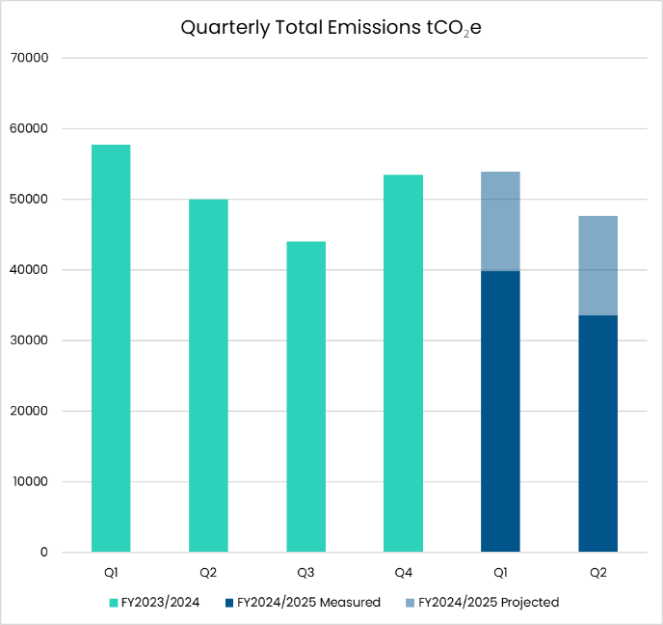

Figure 1 - Graph showing the total emissions for Health New Zealand for this quarter. Previous four quarters included for reference.



**Note on Quarterly Total Emissions**

**This graph illustrates quarterly emissions for all measured sources. Sources which are reported/measured annually are estimated in the coloured area above the current year quarterly totals.**

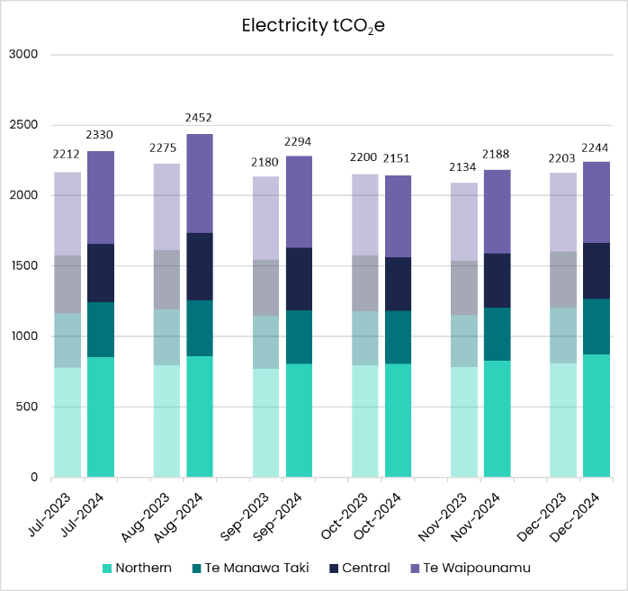

Figure 2 - Graph showing Electricity emissions for the quarter broken down by month and region.

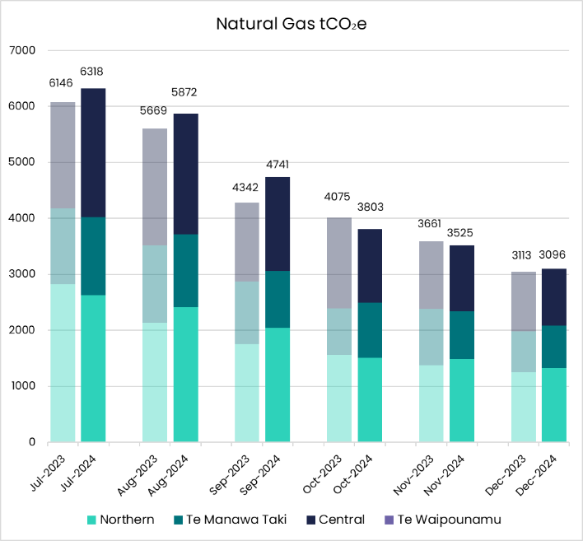

Figure 3 - Graph showing Natural Gas emissions for the quarter broken down by month and region.

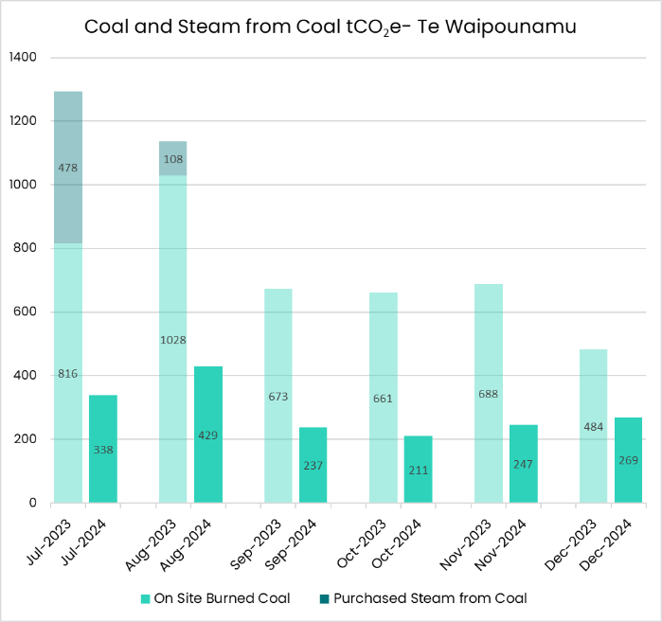

Figure 4 - Graph showing Coal and Steam from Coal emissions for the quarter broken down by month.

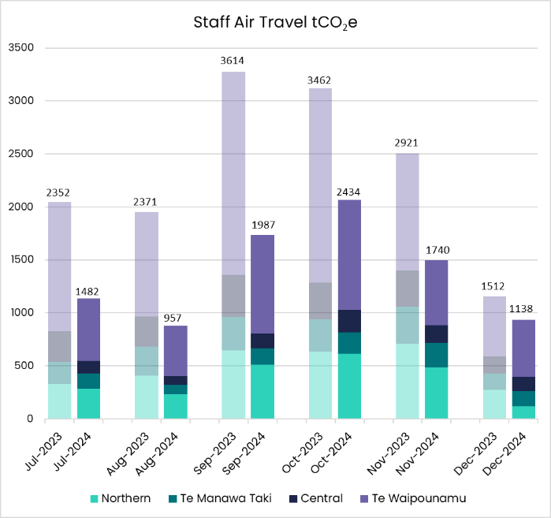

Figure 5 - Graph showing Staff Air Travel emissions for the quarter broken down by month and region.

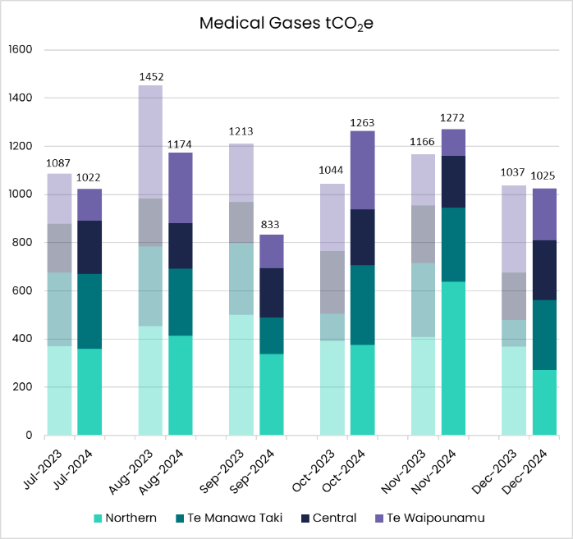

Figure 6 - Graph showing Medical Gases emissions for the quarter broken down by month and region.

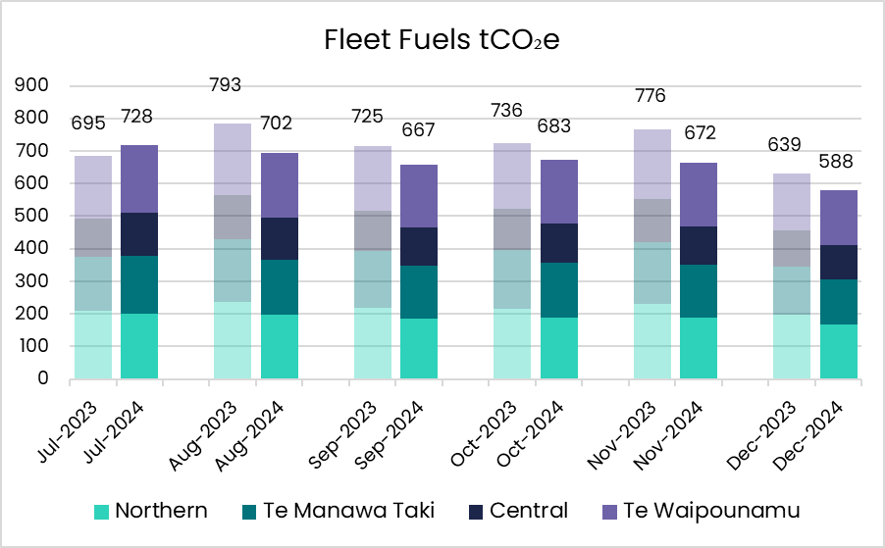

Figure 7 - Graph showing Fleet Fuel emissions for the quarter broken down by month and region.

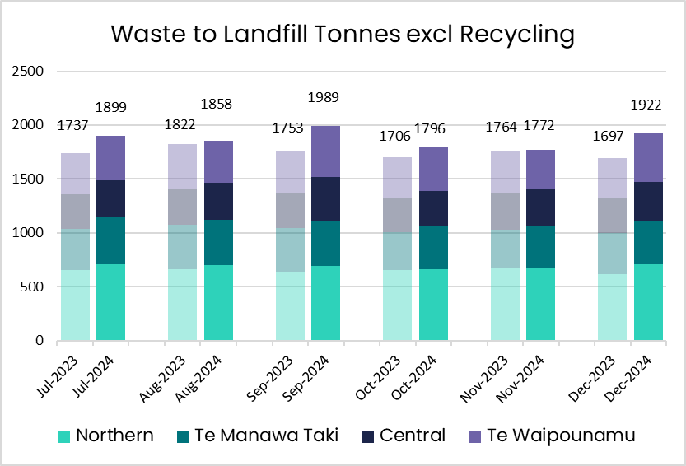

Figure 8 - Graph showing Waste tonnes sent to landfill for the quarter broken down by month and region.

# Regional Emissions

## Northern Region

### Key Objectives and Progress update

Fleet fuel and medical gas emissions reduced by 15% compared to the same quarter last year. Waste emissions increased lightly.

#### Health System Decarbonisation - Goal: To reduce health system carbon emissions in line with a 1.5-degree scenario.

**Energy Transition Programme**

1 Energy Transition project approved for the region

10 Energy Transition projects in flight for the region

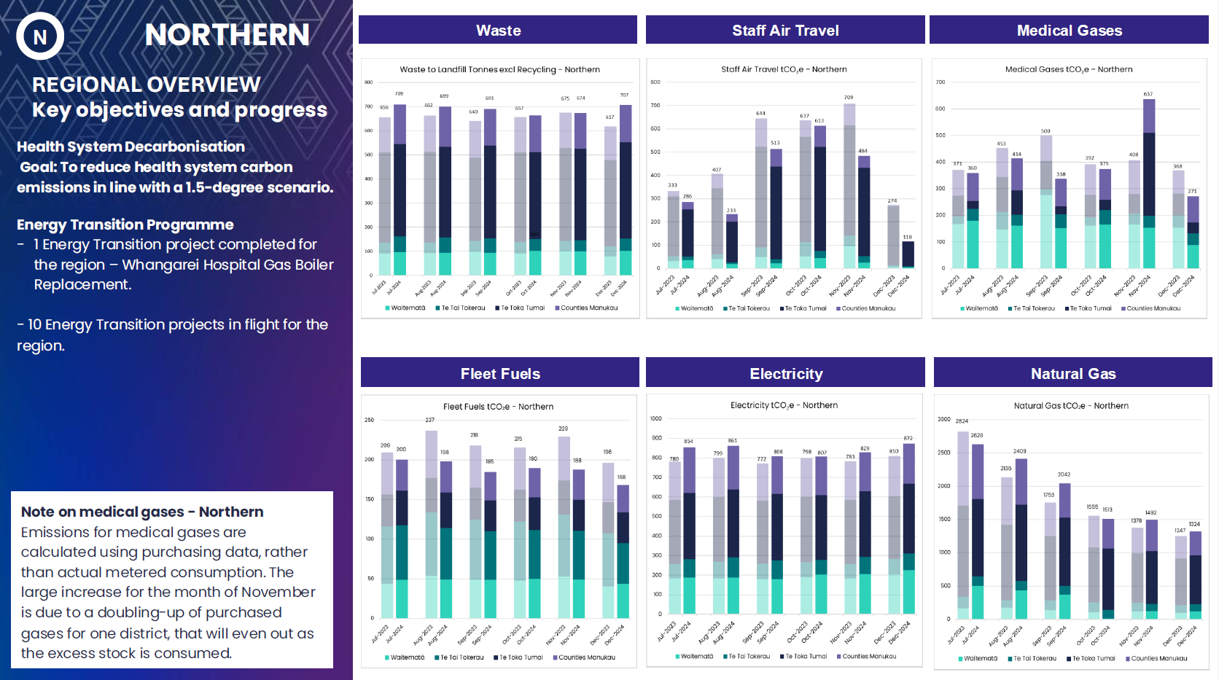

Figure 9 - Graph showing Waste, Staff Air Travel, Medical Gases, Fleet Fuels, Electricity and Natural Gas emissions for the Northern region.

Note on Medical Gas emissions – Northern  
Emissions for medical gases are calculated using purchasing data, rather than actual metered consumption. The large increase for the month of November is due to a doubling-up of purchased gases for one district, that will even out as the excess stock is consumed.

## Te Manawa Taki

### Key Objectives and Progress update

Staff air travel emissions down 50% and medical gases down 30%.

#### Health System Decarbonisation - Goal: To reduce health system carbon emissions in line with a 1.5-degree scenario

5 Energy Transition projects in flight for the region

1 Energy Transition project completed – Tauranga Hospital Gas Boiler Replacement

Coal boiler in Tokoroa replaced with heat pump.

#### Environment in all Practices - Goal: Realise co-benefits that include the environment alongside health, equity, social and economic values.

Recycling Week – Wearable Art event held by local staff at Waikato Hospital bringing awareness of the challenges and opportunities for waste minimisation in a healthcare setting.

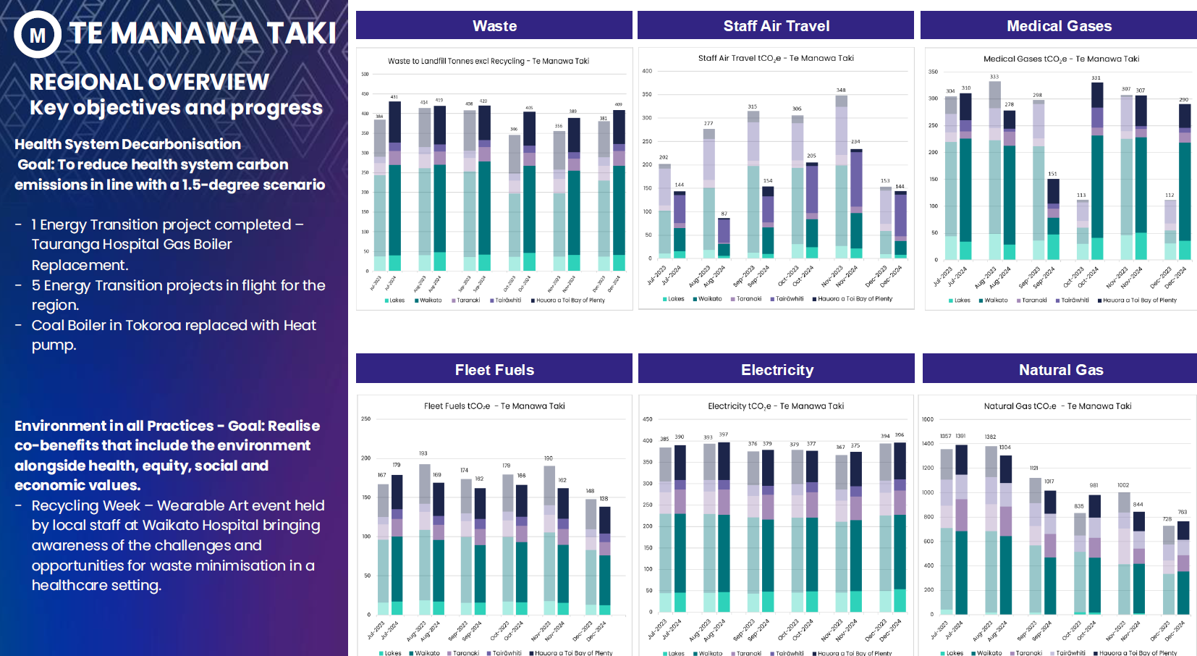

Figure 10 - Graphs showing Waste, Staff Air Travel, Medical Gases, Fleet Fuels, Electricity and Natural Gas emissions for Te Manawa Taki region.

## Central Region

### Key Objectives and Progress update

Staff air travel emissions reduced by 40% and Natural gas by 10%.

#### Health System Decarbonisation - Goal: To reduce health system carbon emissions in line with a 1.5-degree scenario

1 Energy Transition project completed – Palmerston North Hospital Chiller 4 replacement.​

15 Energy Transition projects in flight for the region.

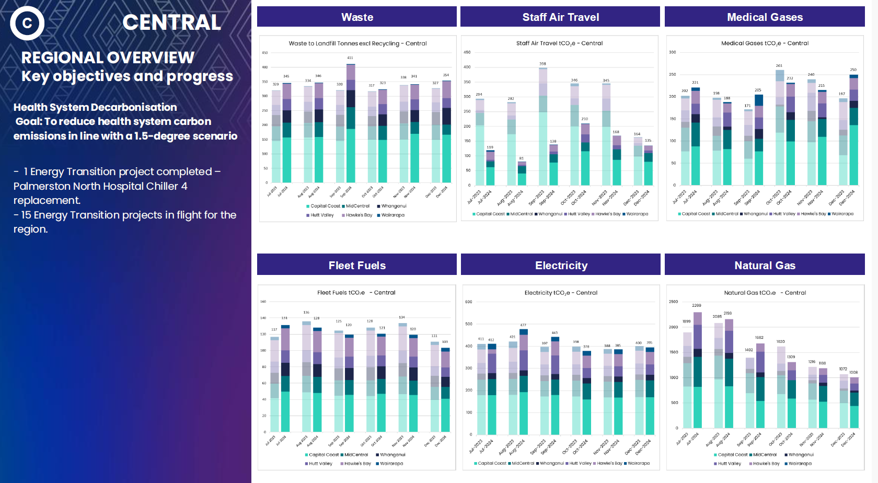

Figure 11 - Graphs showing Waste, Staff Air Travel, Medical Gases, Fleet Fuels, Electricity and Natural Gas emissions for Central region.

## Te Waipounamu

### Key Objectives and Progress update

Medical gases missions reduced by 25% and coal by 60%.

#### Health System Decarbonisation - Goal: To reduce health system carbon emissions in line with a 1.5-degree scenario.

1 Energy Transition project completed – Talbot Park Hospital LED lighting upgrade.​

23 Energy Transition projects in flight for the region.​

1 Coal Boiler Replacement project completed (Reefton).​

Buller coal boiler decommissioned.

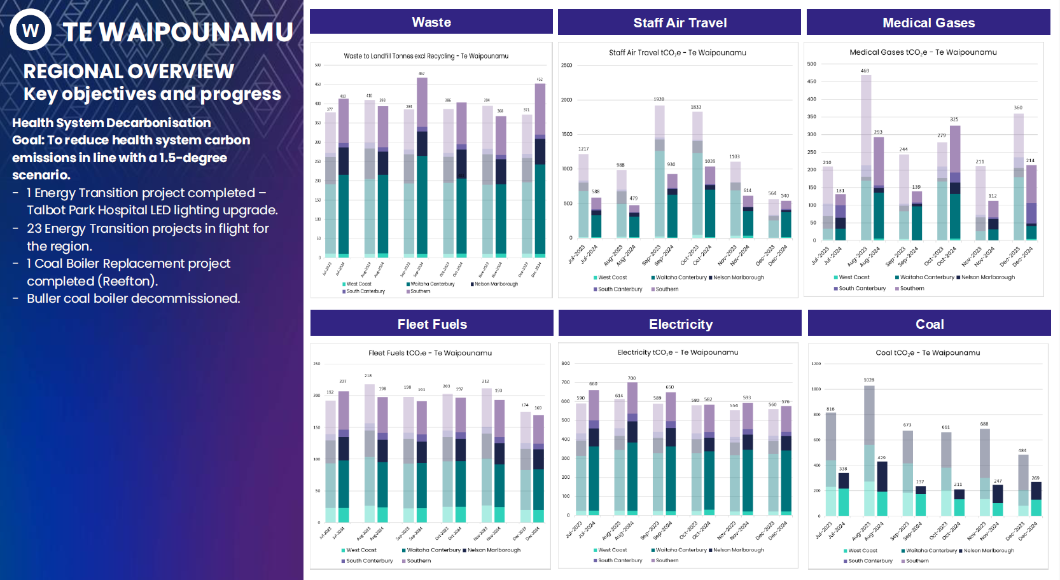

Figure 12 - Graphs showing Waste, Staff Air Travel, Medical Gases, Fleet Fuels, Electricity and Natural Gas emissions for Te Waipounamu region.

