

Sustainability Report

Quarter 3 – Financial Year 1 July 2024 – 30 June 2025

20 July 2025

Citation: Health New Zealand | Te Whatu Ora. 2025. *Sustainability Report – Quarter 3 FY 2025*   
Wellington: Health New Zealand | Te Whatu Ora.

Published in July 2025 by Health New Zealand | Te Whatu Ora  
PO Box 793, Wellington 6140, New Zealand

ISSN 3021-4106 (online)



This document is available at [tewhatuora.govt.nz](https://www.tewhatuora.govt.nz/)

|  |  |
| --- | --- |
|  | This work is licensed under the Creative Commons Attribution 4.0 International licence. In essence, you are free to: share i.e., copy and redistribute the material in any medium or format; adapt i.e., remix, transform and build upon the material. You must give appropriate credit, provide a link to the licence and indicate if changes were made. |

# Contents

Contents 3

Related reports 5

National Overview 6

Key objectives and progress 7

Health System decarbonisation 7

Emission sources report – Quarterly totals and top emission sources 8

Regional Emissions 13

Northen Region 14

Te Manawa Taki 15

Central Region 17

Te Waiponamu 18

**Sustainability Performance Summary**​

## The greenhouse gas emissions of Health New Zealand | Te Whatu Ora (Health NZ) are seeing a slow but steady reduction. Total measured emissions have decreased slighting compared to the same quarter last year.

## Staff travel emissions reductions have slowed, and there are increases for most regions in this quarter, compared to the same quarter the previous financial year. This may reflect more timely reporting or more actual travel undertaken, further details will be discussed next quarter.

## Coal-based emissions continue a substantive reduction trajectory, as more coal-replacement infrastructure projects were completed. The Energy Transition Programme and dedicated coal boiler conversion projects are key to supporting Health NZ emissions reductions.

## Fleet fuel emissions have declined by close to 10% compared to the same quarter in the previous year. 1 in 5 of Health New Zealand’s fleet are electric or hybrid electric vehicles.

# Related reports

Sustainability Report – Quarter 1 2023/24; Sustainability Report – Quarter 2 2023/24;

Sustainability Report – Quarter 3 2023/24; Sustainability Report – Quarter 4 2023/2; Sustainability Report – Quarter 1 2024/25; Sustainability Report - Quarter 2 2024/25.

# National Overview

## Key objectives and progress

### **Health System decarbonisation**

**Goal: To reduce health system carbon emissions in line with a 1.5-degree scenario.**

Emissions reduction planning and implementation for Health New Zealand | Te Whatu Ora continue a steady progress.

**Health System Resilience and Adaptation - Goal: To safeguard our health system by planning for and adapting to the impacts of climate change.**

An internal climate risk advisory group was launched.

Supporting Ministry of Health with the commencement of a Vulnerability and Adaptation Assessment.

Ongoing work to support Health National Adaptation Plan implementation.

**Environment in all Practices - Goal: Realise co-benefits that include the environment alongside health, equity, social and economic values.**

Health NZ ran a national campaign in February to bring awareness of the benefits of active travel for kaimahi. Active travel is a practical and sustainable way to increase physical activity and reduce emissions from fossil fuels.

### Emission sources report – Quarterly totals and top emission sources

Figure 1 - Graph showing the total emissions for Health New Zealand for this quarter. Previous four quarters included for reference.



**Note on Quarterly Total Emissions**

**This graph illustrates quarterly emissions for all measured sources. Sources which are reported/measured annually are estimated in the lighter coloured area above the current year quarterly totals.**

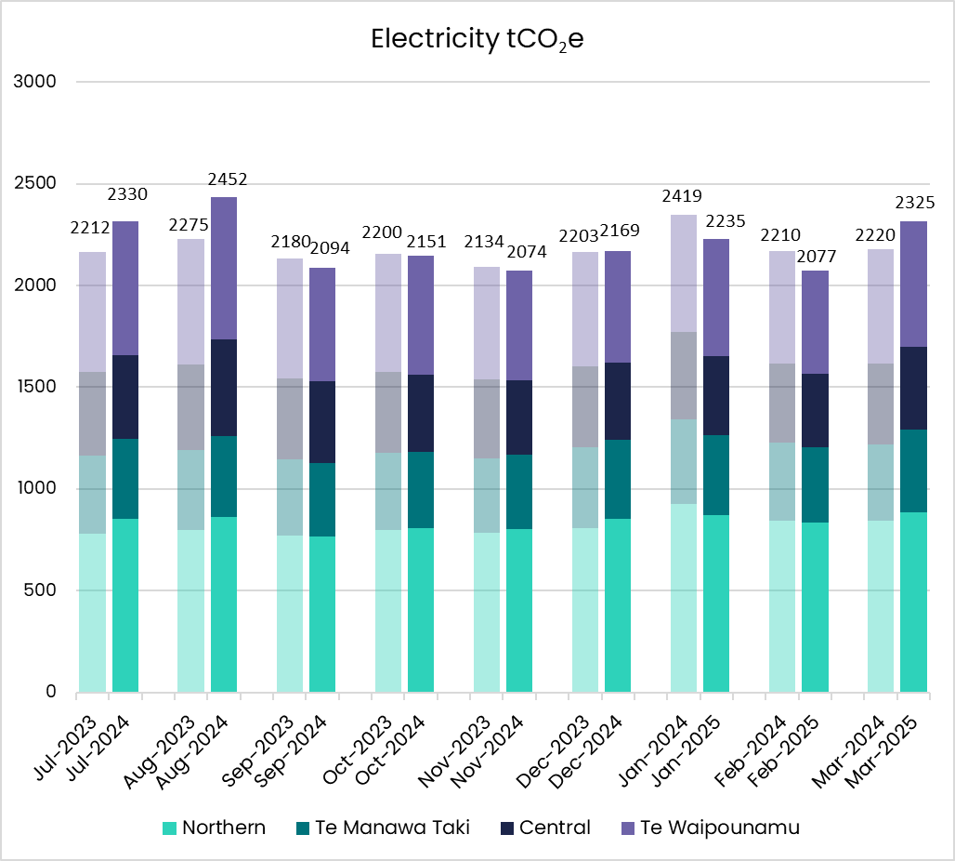

Figure 2 - Graph showing Electricity emissions for the quarter broken down by month and region.

Figure 3 - Graph showing Natural Gas emissions for the quarter broken down by month and region.

Figure 4 - Graph showing Coal and Steam from Coal emissions for the quarter broken down by month.

Figure 5 - Graph showing Staff Air Travel emissions for the quarter broken down by month and region.

Figure 6 - Graph showing Medical Gases emissions for the quarter broken down by month and region.

Figure 7 - Graph showing Fleet Fuel emissions for the quarter broken down by month and region.

Figure 8 - Graph showing Waste tonnes sent to landfill for the quarter broken down by month and region.

# Regional Emissions

## Northen Region

**Key Objectives and Progress update**

Fleet fuels emissions reduced 15% and medical gases 25% compared to the same quarter last year. Staff air travel emissions are stable.

**Health System Decarbonisation - Goal: To reduce health system carbon emissions in line with a 1.5-degree scenario.**

* 1 Energy Transition project completed for the region – Whangarei Hospital Gas Boiler (Domestic hot water and Steam heat)
* 10 Energy Transition projects in flight for the region

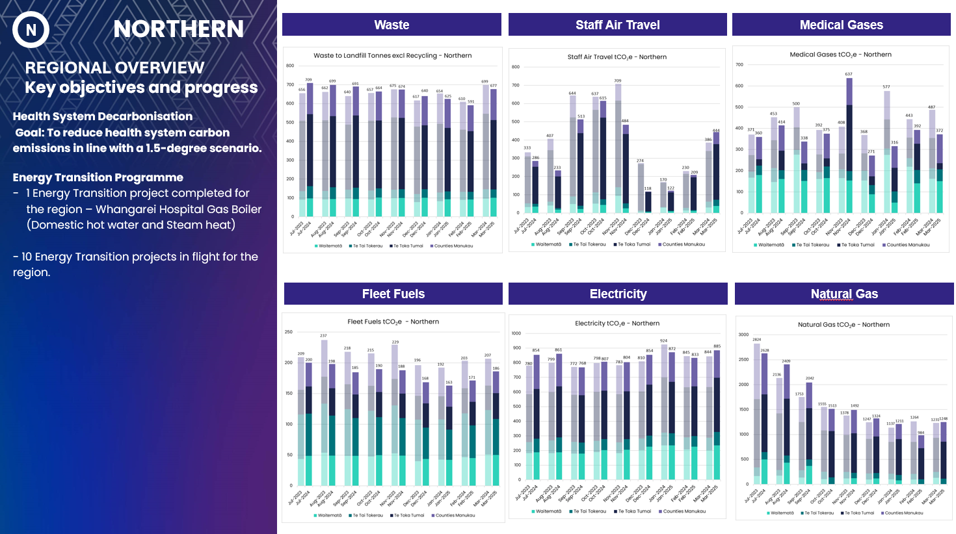

Figure 9 - Graph showing Waste, Staff Air Travel, Medical Gases, Fleet Fuels, Electricity and Natural Gas emissions for the Northern region.

## Te Manawa Taki

**Key Objectives and Progress update**

Staff air travel emissions increased 35% and fleet fuels reduced 10%.

**Health System Decarbonisation - Goal: To reduce health system carbon emissions in line with a 1.5-degree scenario**

* 2 Energy Transition projects completed – Tauranga Hospital Gas Boiler and LED lighting
* 4 Energy Transition projects in flight for the region.



**Note on Medical Gas emissions – Te Manawa Taki**

**Emissions for medical gases are calculated using purchasing data, rather than actual metered consumption. The large increase for the month of November is due to a doubling-up of purchased gases for one district, that will even out as the excess stock is consumed.**

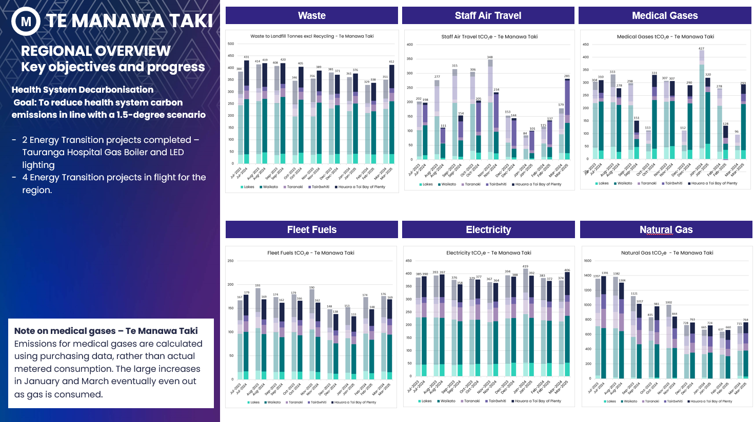

Figure 10 - Graphs showing Waste, Staff Air Travel, Medical Gases, Fleet Fuels, Electricity and Natural Gas emissions for Te Manawa Taki region

## Central Region

**Key Objectives and Progress update**

Staff air travel emissions increased 20% and medical gases by 50%. Fleet fuels emissions reduced 8%.

**Health System Decarbonisation - Goal: To reduce health system carbon emissions in line with a 1.5-degree scenario**

* 1 Energy Transition project completed – Palmerston North Hospital Chiller 4 replacement.
* 15 Energy Transition projects in flight for the region.

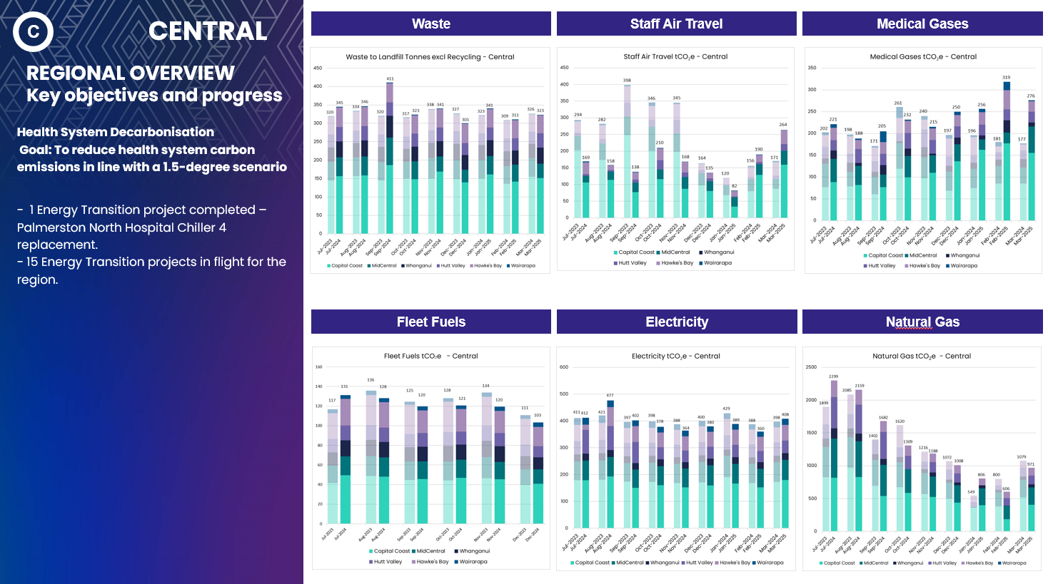

Figure 11- Graphs showing Waste, Staff Air Travel, Medical Gases, Fleet Fuels, Electricity and Natural Gas emissions for Central region.

## Te Waiponamu

**Key Objectives and Progress update**

Coal emissions decreased 70%, Fleet fuels 7%. Staff air travel increased 6%.

**Health System Decarbonisation - Goal: To reduce health system carbon emissions in line with a 1.5-degree scenario.**

* 4 Energy Transition project completed in Wakari Hospital (Heat pumps), Stewart Island (Solar PV), Talbot Park Hospital (LED Lighting), Dunstan Hospital (Mental Health building LED lighting upgrade).
* 20 Energy Transition projects in flight for the region.

Figure 12 - Graphs showing Waste, Staff Air Travel, Medical Gases, Fleet Fuels, Electricity and Natural Gas emissions for Te Waipounamu region.

