

Sustainability Report

Quarter One, 2024/25

### 1 July to 30 September, FY 2024/25

Citation: Health New Zealand | Te Whatu Ora. 2025. *Sustainability Report – Quarter One, 2024/25*.  
Wellington: Health New Zealand | Te Whatu Ora.

Published in May 2025 by Health New Zealand | Te Whatu Ora  
PO Box 793, Wellington 6140, New Zealand

ISSN 3021-4106 (online)



This document is available at [tewhatuora.govt.nz](https://www.tewhatuora.govt.nz/)

|  |  |
| --- | --- |
|  | This work is licensed under the Creative Commons Attribution 4.0 International licence. In essence, you are free to: share i.e., copy and redistribute the material in any medium or format; adapt i.e., remix, transform and build upon the material. You must give appropriate credit, provide a link to the licence and indicate if changes were made. |

**Contents**

Sustainability Performance Summary​ 4

Related reports 5

National Overview 6

Key objectives and progress 7

Regional Emissions 13

Northen Region 14

Te Manawa Taki 15

Central Region 16

Te Waipounamu 17

# Sustainability Performance Summary​

The greenhouse gas emissions of Health New Zealand | Te Whatu Ora (Health NZ) are seeing continued reduction. Total measured emissions are down compared to the same quarter last year, however, some sources, including natural gas and electricity, have seen small increases. These increases likely relate to both seasonal fluctuations and the transition of energy sources from coal to electricity or gas.​

Coal-based emissions showed a 70% reduction when compared with the same quarter in the previous year, as more coal-replacement infrastructure projects were completed. The Energy Transition Programme and dedicated coal boiler conversion projects are key to support Health NZ emissions reductions. ​

Fleet fuel emissions have declined by 6% compared to the same quarter in the previous year. The Fleet Transition Programme, supporting the reduction of transport-based emissions, continues. There has been no new battery electric vehicles added to the fleet this quarter.

Staff air travel was 33% less compared to the previous year. However, some air travel data is reported annually and therefore has a lag which may spike in the final quarter.

# Related reports

[Sustainability Report – Quarter One, 2023/24](https://www.tewhatuora.govt.nz/publications/sustainability-report-q1-fy23-24)

[Sustainability Report – Quarter Two, 2023/24](https://www.tewhatuora.govt.nz/publications/sustainability-report-quarter-2-fy-2324)

[Sustainability Report – Quarter Three, 2023/24](https://www.tewhatuora.govt.nz/publications/health-new-zealand-sustainability-report-quarter-3-23-24)

[Sustainability Report – Quarter Four, 2023/24](https://www.tewhatuora.govt.nz/publications/sustainability-report-quarter-4-2023-24)

# National Overview

## Key objectives and progress

### **Health System decarbonisation**

**Goal: To reduce health system carbon emissions in line with a 1.5-degree scenario.**

Emissions Inventory for FY23/24 completed and independently audited. ~14% emissions reduction from baseline.

Emissions reduction planning for Health New Zealand | Te Whatu Ora has progressed.

**Health System Resilience and Adaptation - Goal: To safeguard our health system by planning for and adapting to the impacts of climate change.**

Work supporting the development of the Health National Adaptation Plan, which will be completed and published in Quarter 2.

**Environment in all Practices - Goal: Realise co-benefits that include the environment alongside health, equity, social and economic values.**

Health NZ ran a national ‘Request for Information’ from potential suppliers for innovative waste services to reduce waste to landfill. 11 responses were received and have been assessed.

National Food and Drink Policy features recyclability considerations in packaging and reusable food containers.

### Emission sources report – Quarterly totals and top emission sources

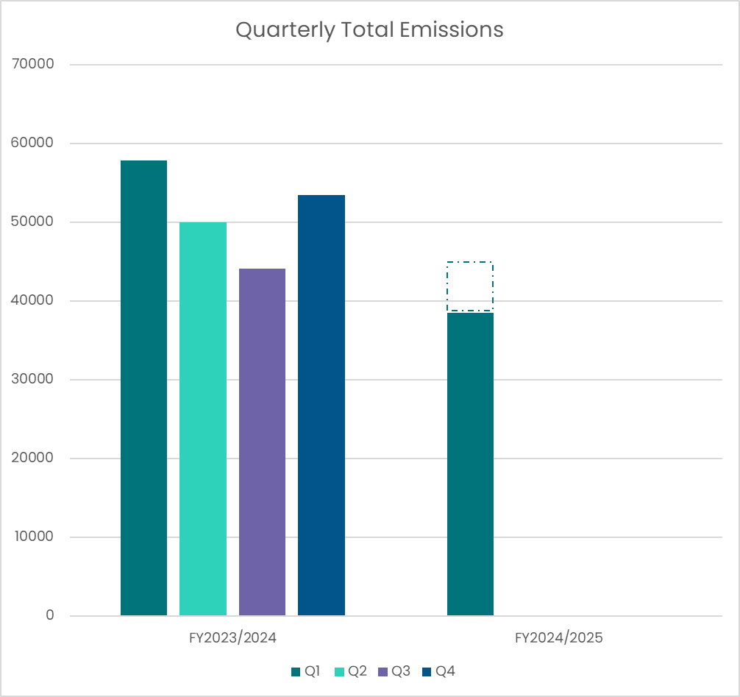

Figure 1 - Graph showing the total emissions for Health New Zealand for this quarter. Previous four quarters included for reference.

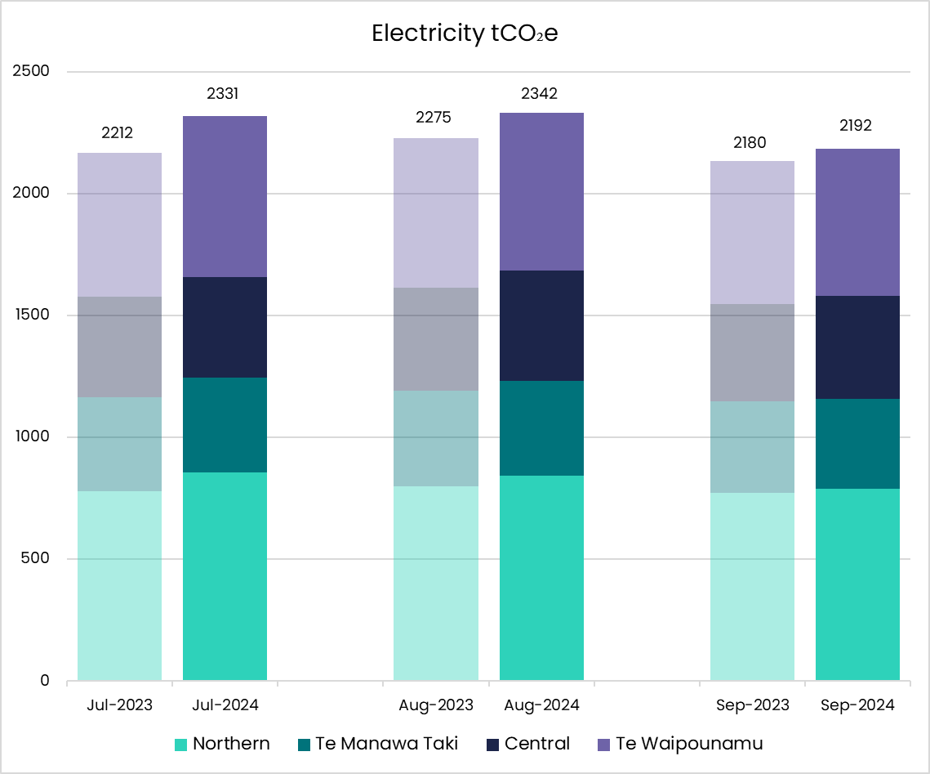

Figure 2 - Graph showing Electricity emissions for the quarter broken down by month and region.

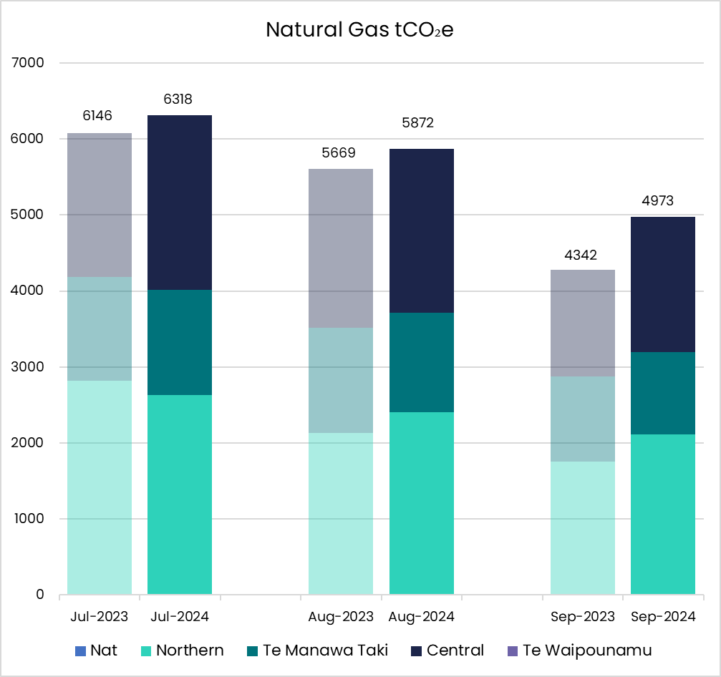

Figure 3 - Graph showing Natural Gas emissions for the quarter broken down by month and region.

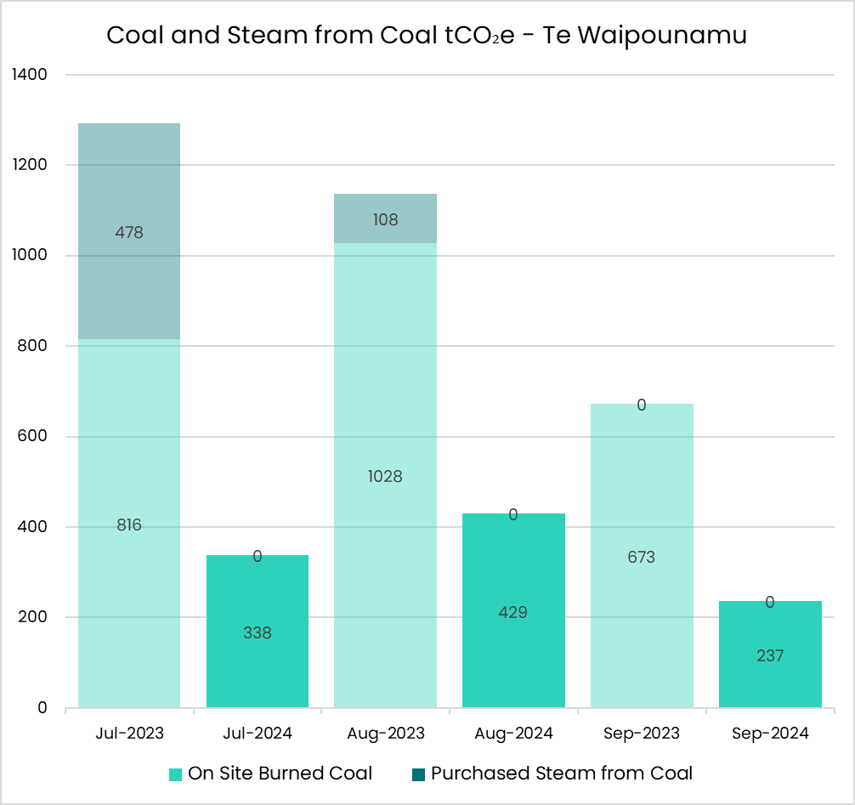

Figure 4 - Graph showing Coal and Steam from Coal emissions for the quarter broken down by month.

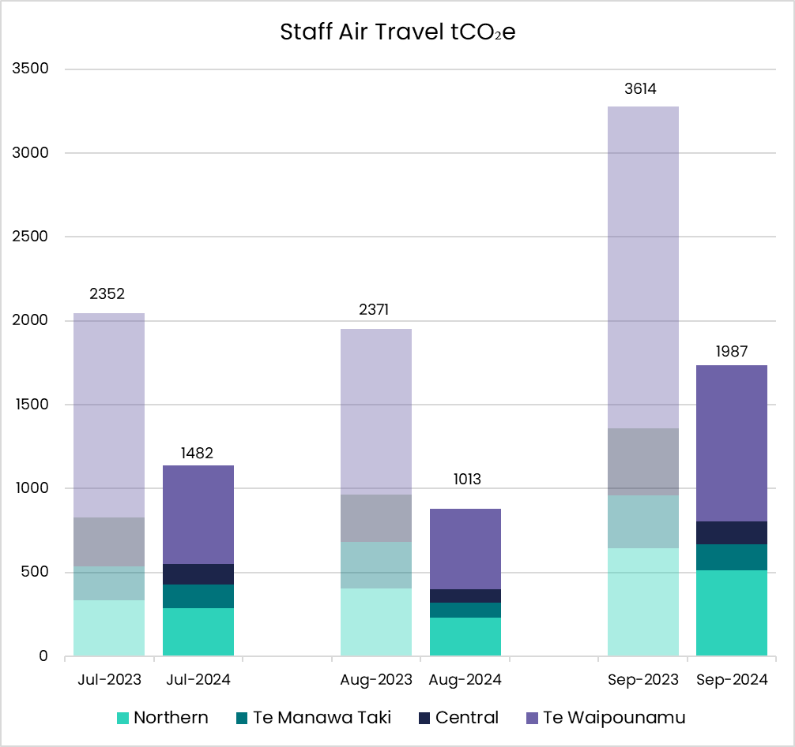

Figure 5 - Graph showing Staff Air Travel emissions for the quarter broken down by month and region.

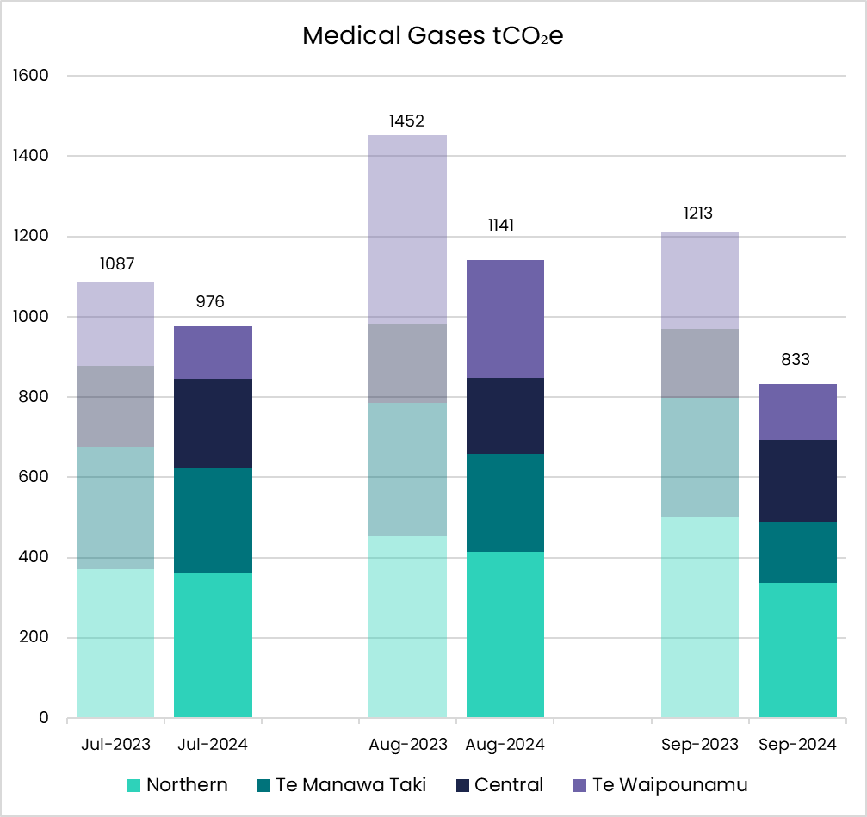

Figure 6 - Graph showing Medical Gases emissions for the quarter broken down by month and region.

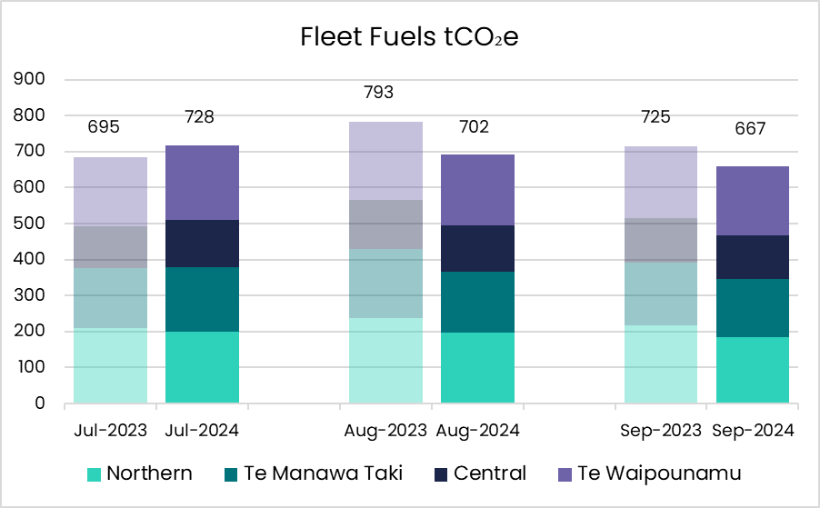

Figure 7 - Graph showing Fleet Fuel emissions for the quarter broken down by month and region.

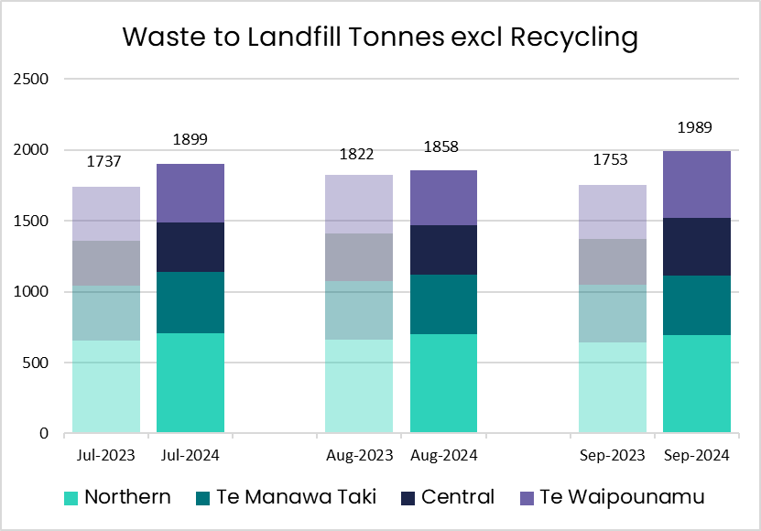

Figure 8 - Graph showing Waste tonnes sent to landfill for the quarter broken down by month and region.



**Note on Quarterly Total Emissions**

**This graph illustrates quarterly emissions for all measured sources. Sources which are reported/measured annually are estimated in the dotted area above the current year quarterly totals.**

# Regional Emissions

## Northen Region

### Key Objectives and Progress update

Fleet fuel and medical gas emissions reduced by 15% compared to the same quarter last year. Waste emissions increased.

#### Health System Decarbonisation - Goal: To reduce health system carbon emissions in line with a 1.5-degree scenario.

**Energy Transition Programme**

- 1 Energy Transition project approved for the region

- 10 Energy Transition projects in flight for the region

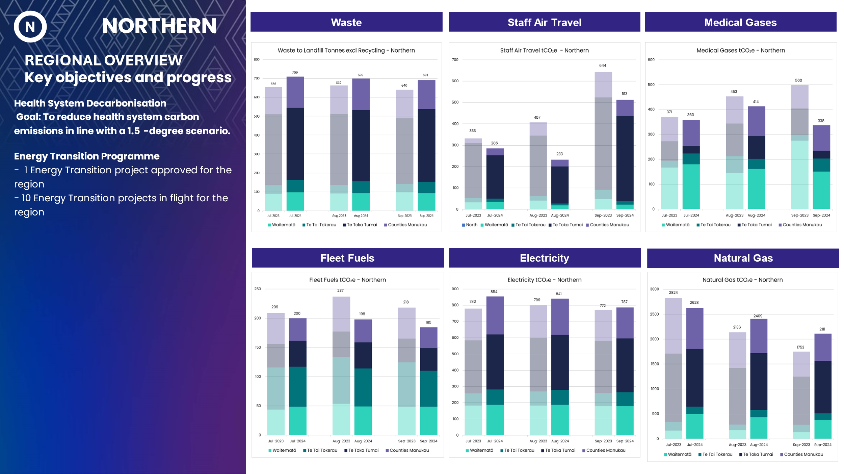

Figure 9 - Graph showing Waste, Staff Air Travel, Medical Gases, Fleet Fuels, Electricity and Natural Gas emissions for the Northern region.

## Te Manawa Taki

### Key Objectives and Progress update

Staff air travel emissions down 50% and medical gases down 30%.

#### Health System Decarbonisation - Goal: To reduce health system carbon emissions in line with a 1.5-degree scenario

- 5 Energy Transition projects in flight for the region

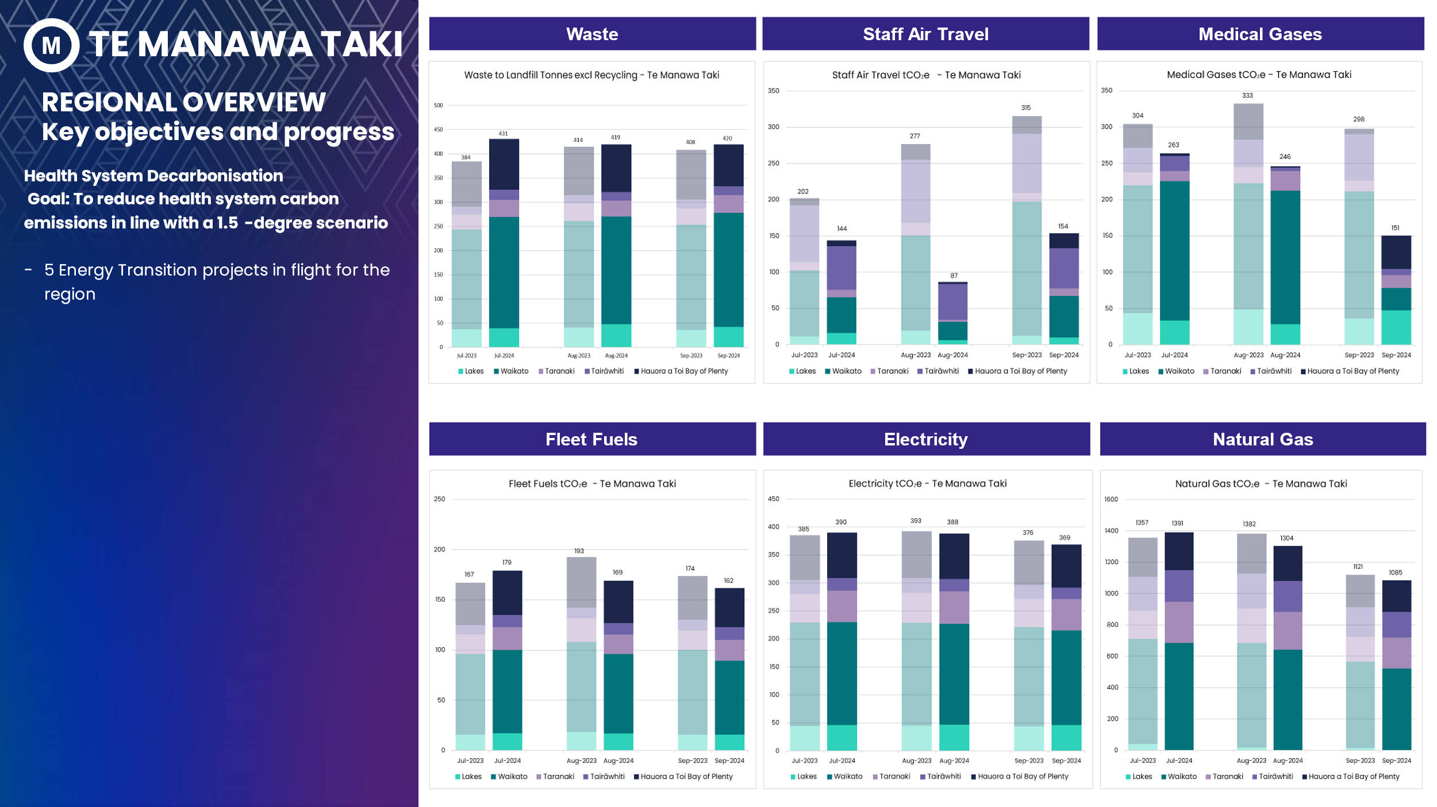

Figure 10 - Graphs showing Waste, Staff Air Travel, Medical Gases, Fleet Fuels, Electricity and Natural Gas emissions for Te Manawa Taki region.

## Central Region

### Key Objectives and Progress update

Staff air travel emissions down 65%.

#### Health System Decarbonisation - Goal: To reduce health system carbon emissions in line with a 1.5-degree scenario

- 6 Energy Transition projects approved for the region

- 15 Energy Transition projects in flight for the region

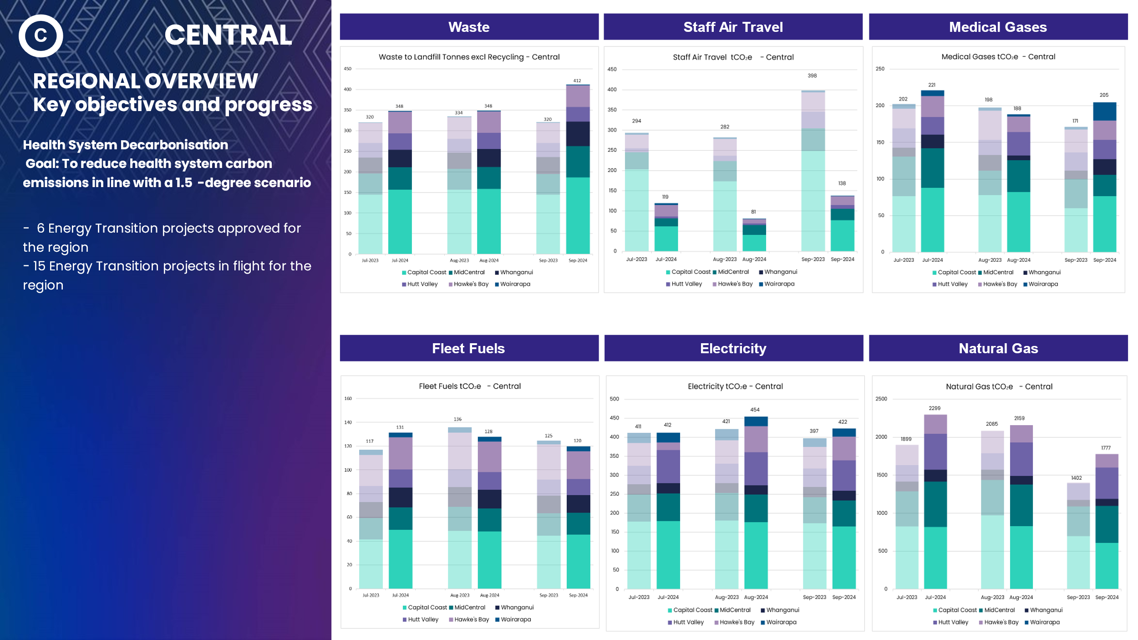

Figure 11 - Graphs showing Waste, Staff Air Travel, Medical Gases, Fleet Fuels, Electricity and Natural Gas emissions for Central region.

## Te Waipounamu

### Key Objectives and Progress update

Staff air travel emissions down 50% and medical gases down 30%.

#### Health System Decarbonisation - Goal: To reduce health system carbon emissions in line with a 1.5-degree scenario.

- 3 Energy Transition projects approved for the region

- 22 Energy Transition projects in flight for the region

- 1 Coal Boiler Replacement project completed (Dunedin Hospital Doctor’s residence)

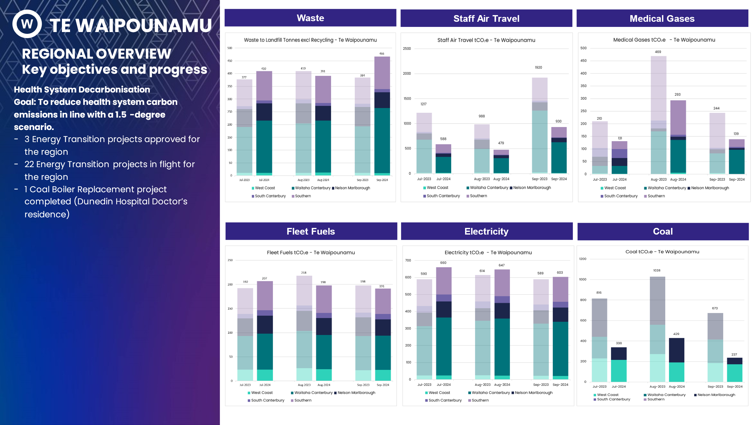

Figure 12 - Graphs showing Waste, Staff Air Travel, Medical Gases, Fleet Fuels, Electricity and Natural Gas emissions for Te Waipounamu region.

