

Sustainability Report

Quarter Four, 2024/2025

Citation: Health New Zealand | Te Whatu Ora. 2025. *Sustainability Report – Quarter Four, 2024/2025*.  
Wellington: Health New Zealand | Te Whatu Ora.

Published in September 2025 by Health New Zealand | Te Whatu Ora  
PO Box 793, Wellington 6140, New Zealand

ISSN 3021-4106 (online)



This document is available at [tewhatuora.govt.nz](https://www.tewhatuora.govt.nz/)

|  |  |
| --- | --- |
|  | This work is licensed under the Creative Commons Attribution 4.0 International licence. In essence, you are free to: share i.e., copy and redistribute the material in any medium or format; adapt i.e., remix, transform and build upon the material. You must give appropriate credit, provide a link to the licence and indicate if changes were made. |

**Contents**

Sustainability Performance year-end Summary​ 4

Related reports 5

National Overview 6

Key objectives and progress 7

Health System decarbonisation 7

Emission sources report – Quarterly totals and top emission sources 8

Regional Emissions 13

Northen Region 14

Te Manawa Taki 15

Central Region 16

Te Waipounamu 17

# Sustainability Performance year-end Summary​

The greenhouse gas emissions of Health New Zealand | Te Whatu Ora (Health NZ) continue to decrease. Overall emissions reduced by 2% year-on-year for the 2024-2025 financial year.

The overall reduction in emissions occurred even though electricity – the second largest source – experienced a 35% increase due to changes in emission factors. This increase contrasts with a modest 2% increase in electricity consumption.

Coal-based emissions reduction have been the main driver behind Health NZ’s trajectory. Most of the coal-replacement infrastructure projects are now completed and this has resulted in 65% emissions reduction compared to the previous financial year.

Staff travel emissions reductions fluctuated through the year, but they decreased by over 10% year-on-year.

Fleet fuel emissions have declined 6% and waste 7% year-on-year with 1 in 5 of Health New Zealand’s fleet being electric or hybrid electric vehicles and this trend is projected to continue upwards.

# Related reports

* Sustainability Report – Quarter 1 2023/24
* Sustainability Report – Quarter 2 2023/24
* Sustainability Report – Quarter 3 2023/24
* Sustainability Report – Quarter 4 2023/24
* Sustainability Report – Quarter 1 2024/25
* Sustainability Report - Quarter 2 2024/25
* Sustainability Report - Quarter 3 2024/25

# National Overview

## Key objectives and progress

### Health System decarbonisation

#### Goal: To reduce health system carbon emissions in line with a 1.5-degree scenario.

Health NZ published its first Emissions Reduction Plan (ERP) for the period 2025-2027. The ERP is a requirement of the Carbon Neutral Government (CNGP) Programme and it sets decarbonisation targets aligned to CNGP guidance.

#### Health System Resilience and Adaptation - Goal: To safeguard our health system by planning for and adapting to the impacts of climate change.

* Ongoing support to MoH Vulnerability and Adaptation Assessment​
* Development of Adaptation Framework for Health NZ.

#### Environment in all Practices - Goal: Realise co-benefits that include the environment alongside health, equity, social and economic values.

Health NZ ran the first Sustainability Month awareness campaign in April with weekly articles, a quiz and other engagement for kaimahi. Over 1000 interactions with sustainability content were recorded during the month.

### Emission sources report – Quarterly totals and top emission sources

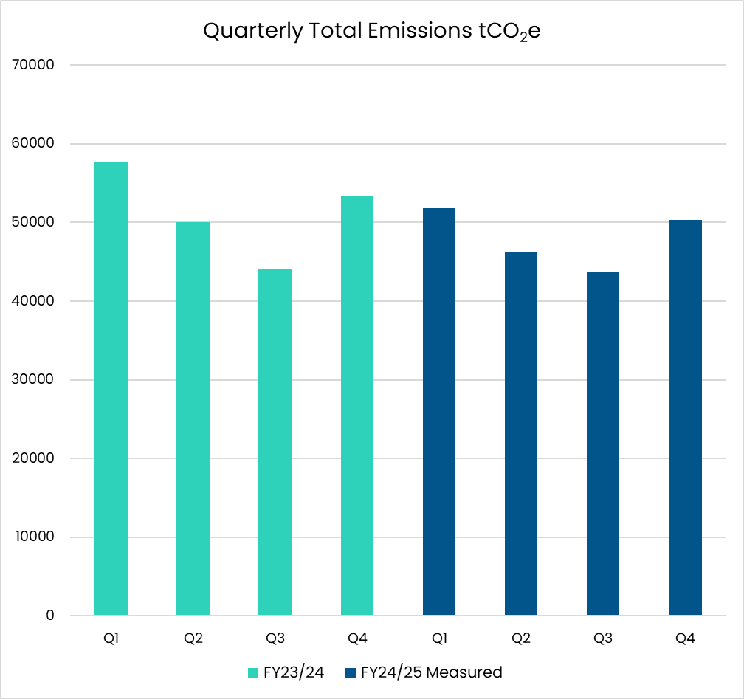

Figure 1 - Graph showing the total emissions for Health New Zealand for this quarter. Previous four quarters included for reference.



**Note on Quarterly Total Emissions**

This graph illustrates quarterly emissions for all measured sources. As this is the last quarter, sources which are reported/measured annually are actual rather than projected.

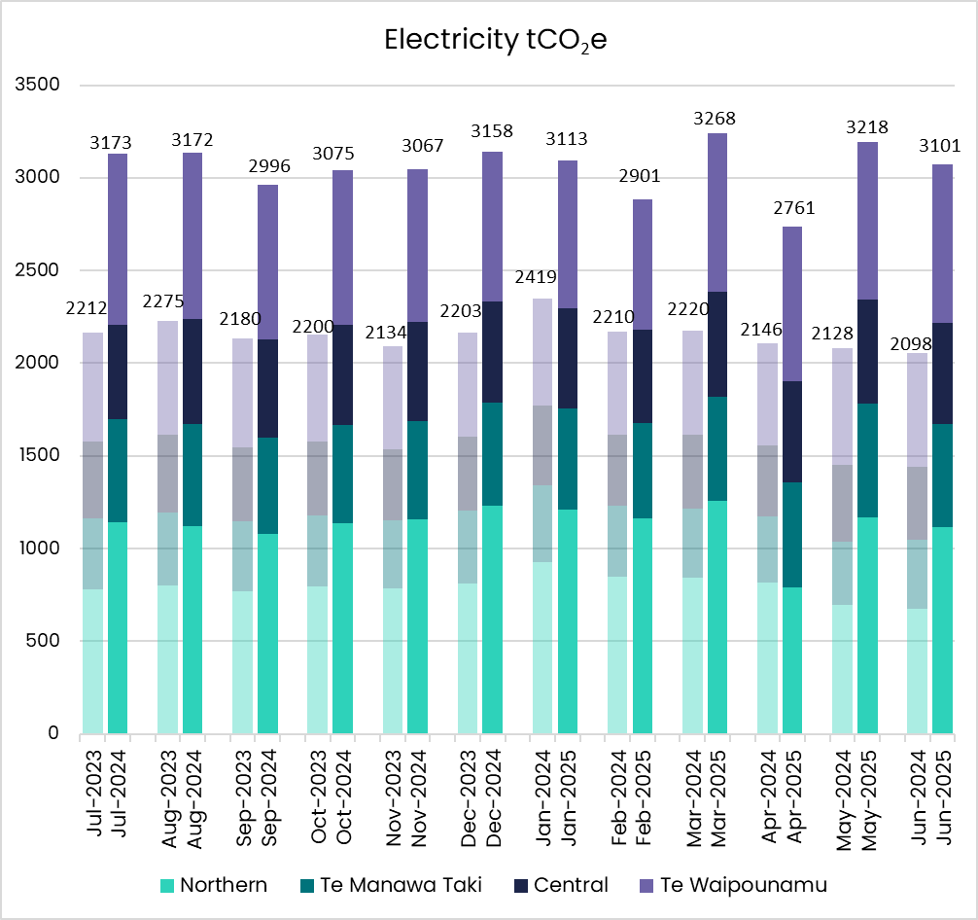

Figure 2 - Graph showing Electricity emissions for the quarter broken down by month and region.

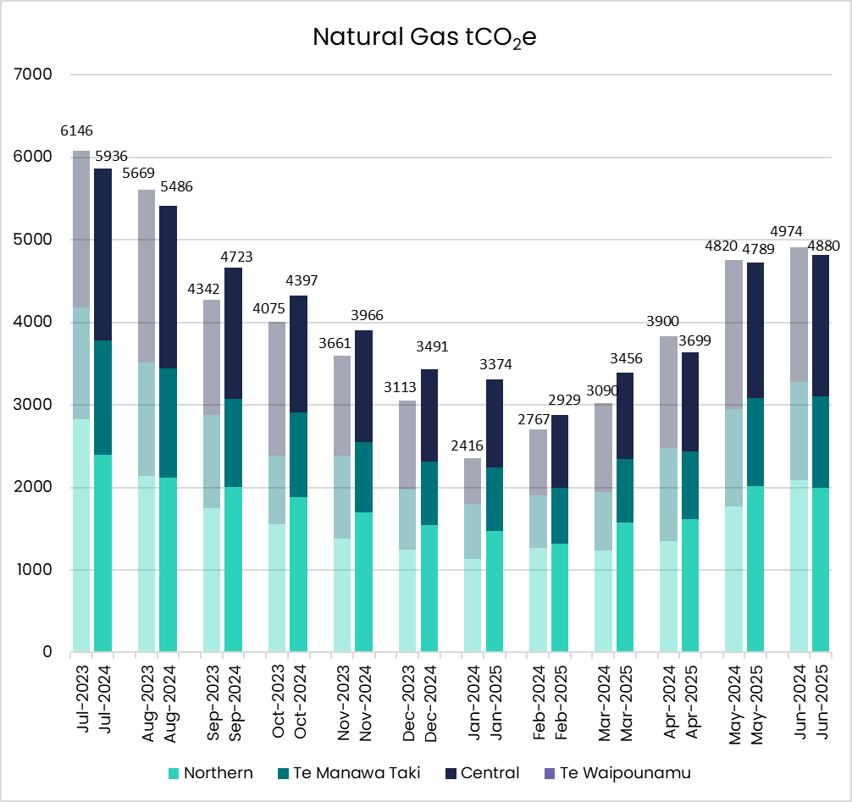

Figure 3 - Graph showing Natural Gas emissions for the quarter broken down by month and region.

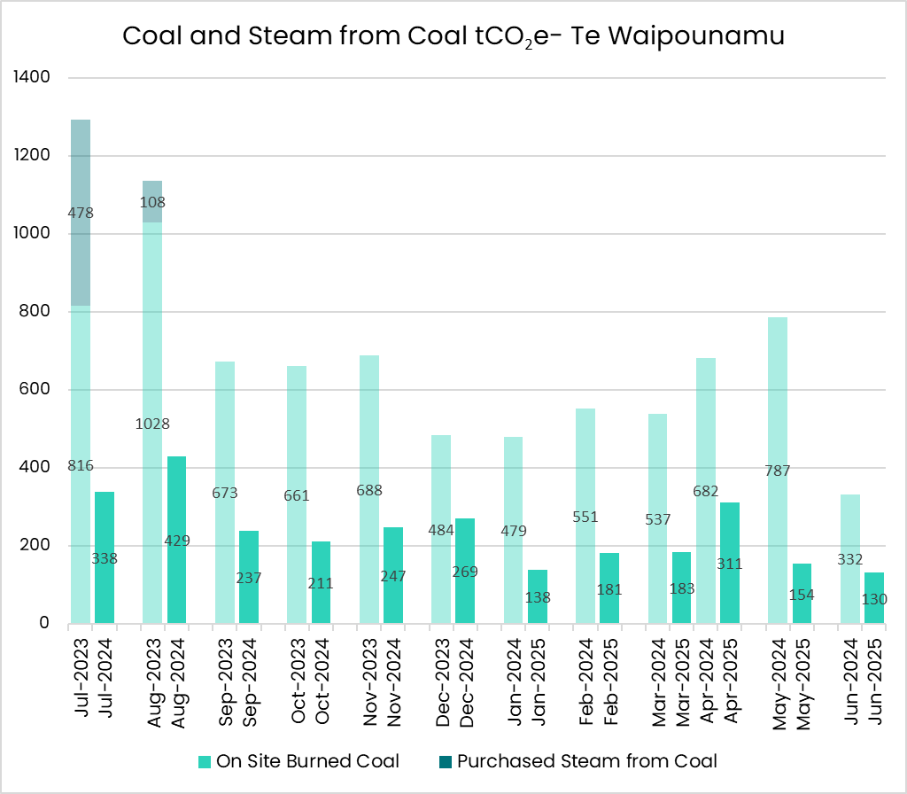

Figure 4 - Graph showing Coal and Steam from Coal emissions for the quarter broken down by month.

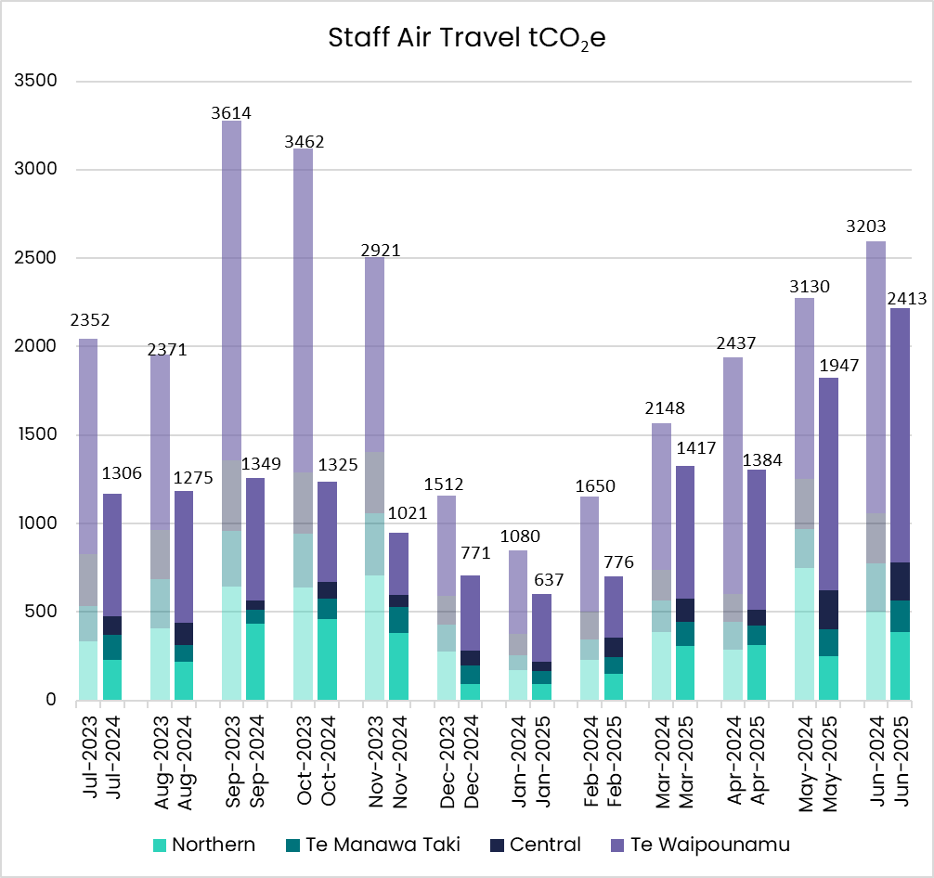

Figure 5 - Graph showing Staff Air Travel emissions for the quarter broken down by month and region.

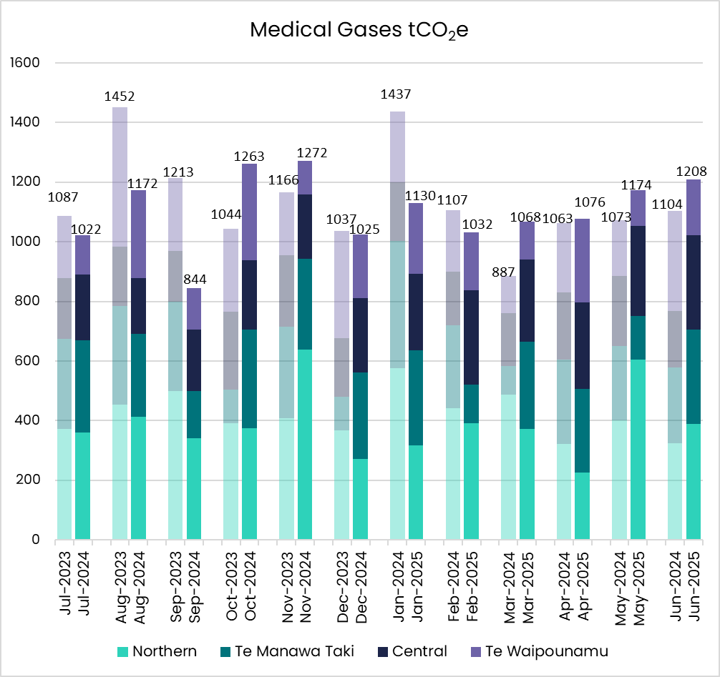

Figure 6 - Graph showing Medical Gases emissions for the quarter broken down by month and region.



Figure 7 - Graph showing Fleet Fuel emissions for the quarter broken down by month and region.

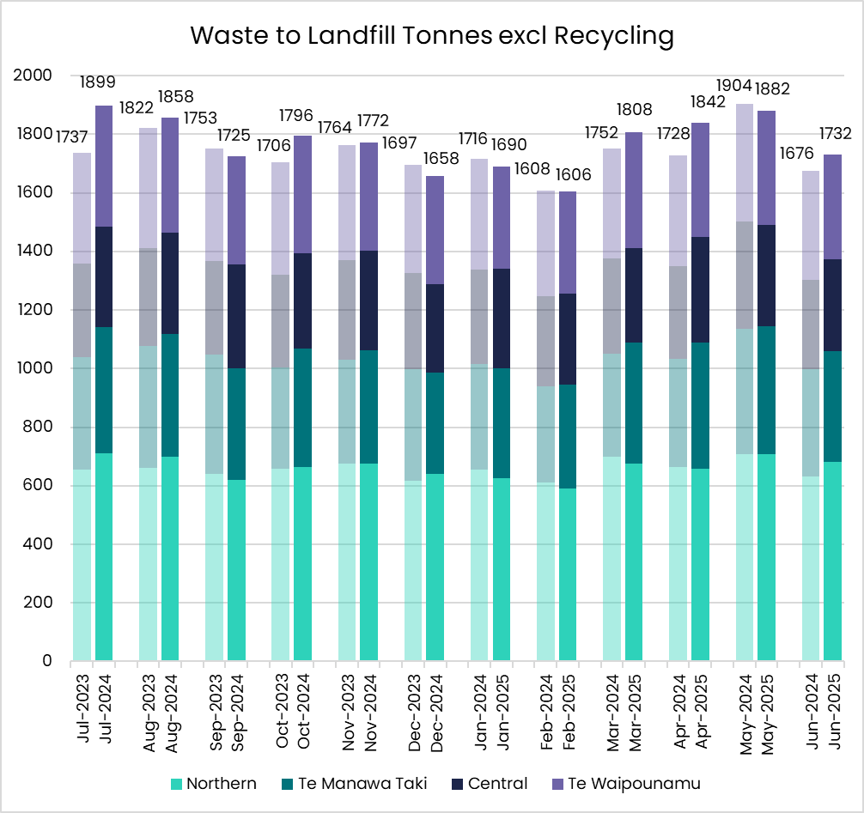

Figure 8 - Graph showing Waste tonnes sent to landfill for the quarter broken down by month and region.

# Regional Emissions

## Northen Region

#### Key Objectives and Progress update

Fleet fuels emissions reduced 15% and medical gases 25% compared to the same quarter last year. Staff air travel emissions are stable.

#### Health System Decarbonisation - Goal: To reduce health system carbon emissions in line with a 1.5-degree scenario.

* 1 Energy Transition project completed for the region – Whangārei Hospital Gas Boiler (Domestic hot water and steam heat)
* 10 Energy Transition projects in flight for the region.

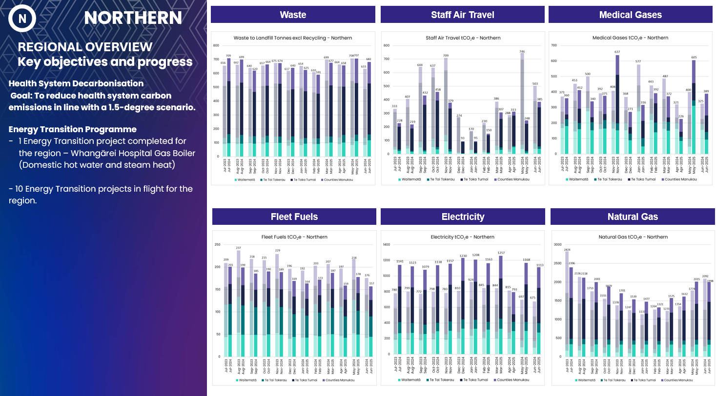

Figure 9 - Graph showing Waste, Staff Air Travel, Medical Gases, Fleet Fuels, Electricity and Natural Gas emissions for the Northern region.

## Te Manawa Taki

#### Key Objectives and Progress update

Staff air travel emissions increased 35% and fleet fuels reduced 10%.

#### Health System Decarbonisation - Goal: To reduce health system carbon emissions in line with a 1.5-degree scenario

* 2 Energy Transition projects completed – Tauranga Hospital Gas Boiler and LED lighting
* 4 Energy Transition projects in flight for the region.



**Note on Medical Gas emissions – Te Manawa Taki**

Emissions for medical gases are calculated using purchasing data, rather than actual metered consumption. The large increase for the month of November is due to a doubling-up of purchased gases for one district, that will even out as the excess stock is consumed.

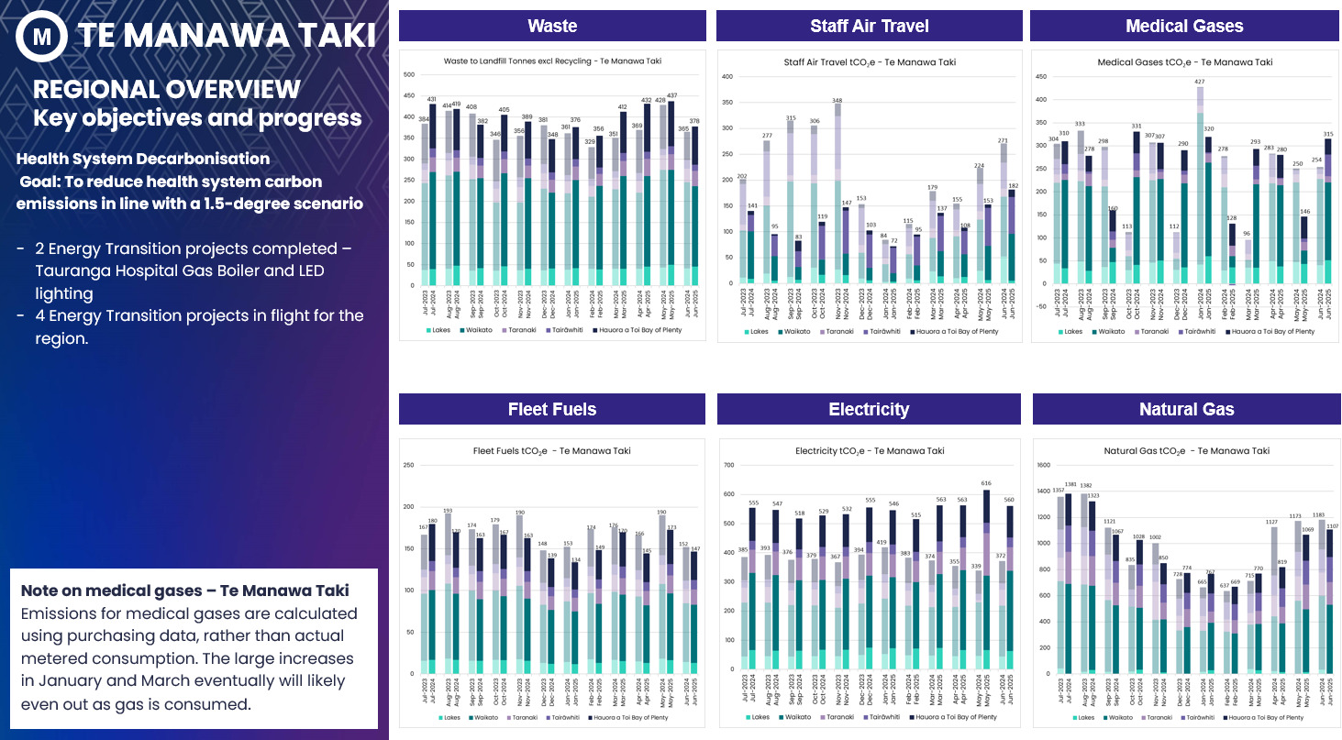

Figure 10 - Graphs showing Waste, Staff Air Travel, Medical Gases, Fleet Fuels, Electricity and Natural Gas emissions for Te Manawa Taki region

## Central Region

#### Key Objectives and Progress update

Staff air travel emissions increased 20% and medical gases by 50%. Fleet fuels emissions reduced 8%.

#### Health System Decarbonisation - Goal: To reduce health system carbon emissions in line with a 1.5-degree scenario

* 1 Energy Transition project completed – Palmerston North Hospital Chiller 4 replacement – Hawkes Bay Hospital hot water pipework insulation.
* 14 Energy Transition projects in flight for the region.

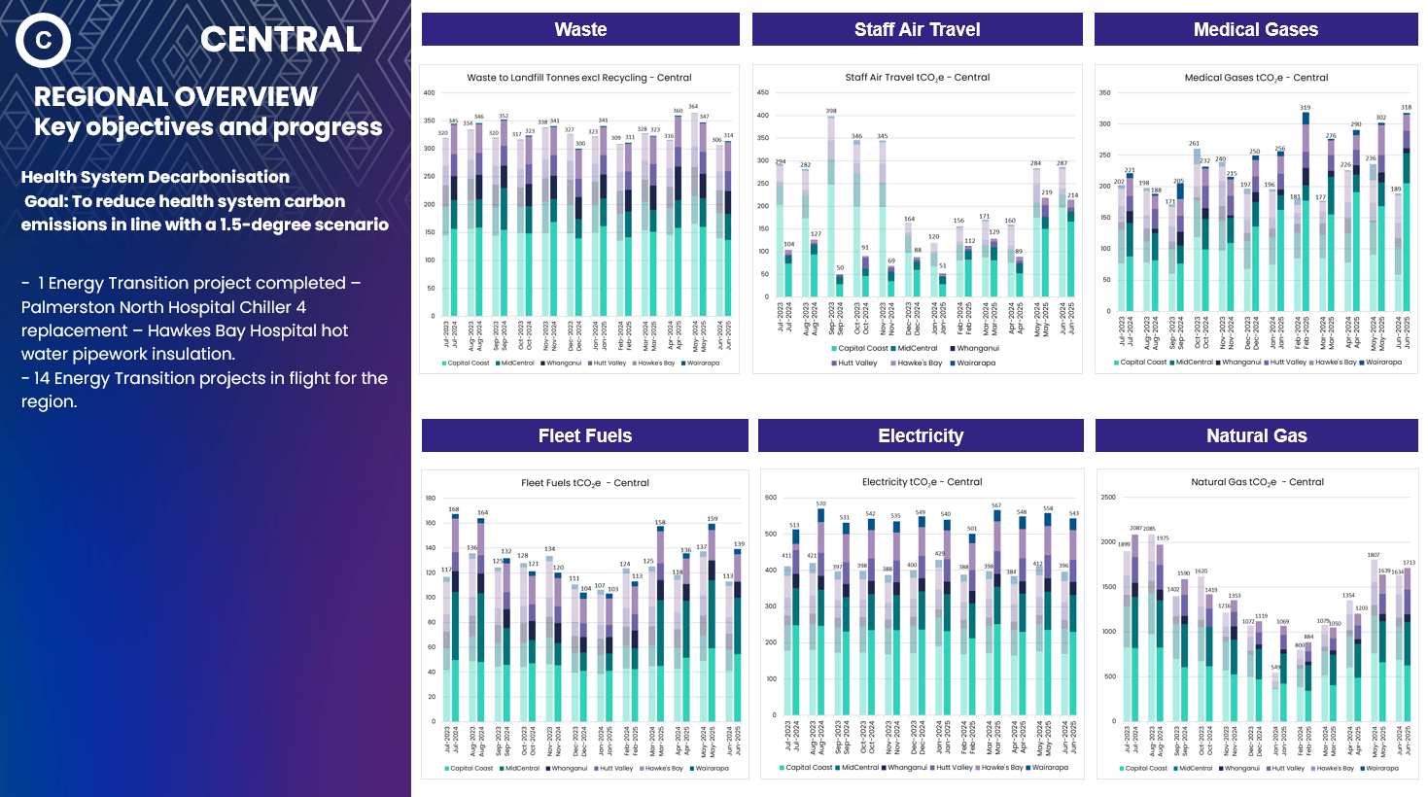

Figure 11- Graphs showing Waste, Staff Air Travel, Medical Gases, Fleet Fuels, Electricity and Natural Gas emissions for Central region.

## Te Waipounamu

#### Key Objectives and Progress update

Coal emissions decreased 70%, Fleet fuels 7%. Staff air travel increased 6%.

#### Health System Decarbonisation - Goal: To reduce health system carbon emissions in line with a 1.5-degree scenario.

* 8 Energy Transition projects completed; LED for Wairau, Nelson, Talbot Park and Dunstan Hospitals. Diesel Heating replacement at Darfield and Ellesmere Hospitals, Solar PV in Stewart Island, Heat pumps at Wakari Hospital.
* 16 Energy Transition projects in flight for the region.

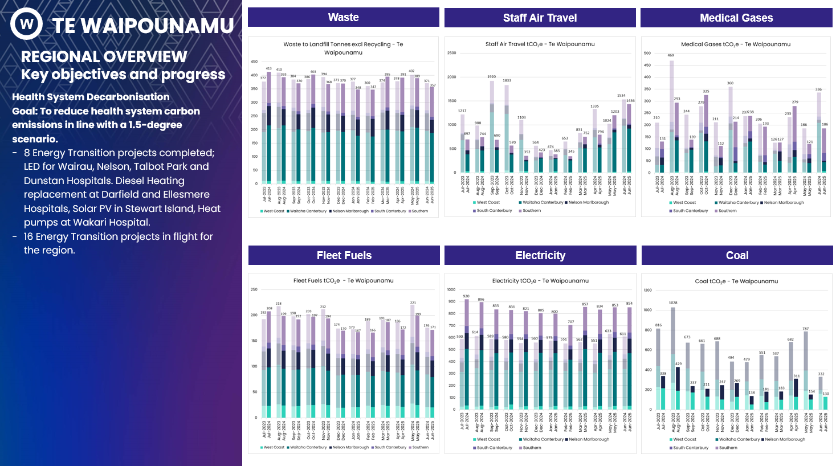

Figure 12 - Graphs showing Waste, Staff Air Travel, Medical Gases, Fleet Fuels, Electricity and Natural Gas emissions for Te Waipounamu region.

