

Rural Urgent Unplanned Care (RUUC)

Recommendations Paper

December 2024

**DRAFT ONLY (version 6) – NOT FOR SHARING**

Citation: Health New Zealand | Te Whatu Ora. 2024. *Rural Unplanned Urgent Care (RUUC) Recommendations Paper*.   
Wellington: Health New Zealand | Te Whatu Ora.

Published in December 2024 by Health New Zealand | Te Whatu Ora  
PO Box 793, Wellington 6140, New Zealand

ISBN [Insert] (print)  
ISBN [Insert] (online)



This document is available at [tewhatuora.govt.nz](https://www.tewhatuora.govt.nz/)

|  |  |
| --- | --- |
|  | This work is licensed under the Creative Commons Attribution 4.0 International licence. In essence, you are free to: share i.e., copy and redistribute the material in any medium or format; adapt i.e., remix, transform and build upon the material. You must give appropriate credit, provide a link to the licence and indicate if changes were made. |

# Contents

Contents 3

Acknowledgements 5

Executive summary 7

Background 9

Purpose 9

Scope 9

Alignment with other redesign projects 10

Context 10

Previous reviews 11

Who are we here to serve? 12

Current state 13

Accountability and service specifications 14

Current service components 15

Urgent Care Clinics 18

Emergency ambulance services 19

Road Ambulance 20

Air Ambulance 20

PRIME 21

Literature Review 24

Future system of rural urgent unplanned care 25

Principles and assumptions 25

Future state service components 26

Integrated core primary care teams 27

Enhanced access to medicines after-hours 28

Enhanced Point of Care Testing (POCT) 29

Equipment 31

Emergency road ambulance 31

Recommendations 33

Minimum service coverage standards 33

Rural proofing existing contracts 34

PHOSA 34

National Road and Air ambulance contract 34

ACC Rural General Practice (RGP) agreement 35

Access to medicines 35

Point of Care Testing (POCT) 35

Equipment 36

Patient data 36

Patient transport pathways 36

Conclusion 38

Appendix 1 - Glossary 39

# Acknowledgements

This project required subject matter knowledge and analytical expertise from a broad range of individuals and teams. On behalf of Health New Zealand | Te Whatu Ora (Health NZ), Health NZ’s National Rural Health Team would like to acknowledge and thank the many experts who contributed to our shared work to progress the Rural Unplanned Urgent Care (RUUC) redesign work.

|  |
| --- |
| ***Nāu te rourou, nāku te rourou, ka ora ai te iwi.***  ***With your food basket and my food basket the people will thrive.*** |

This whakataukī references community, collaboration, and the power of adopting strengths-based approaches. It acknowledges that everybody has something to offer and by working together we can all flourish. It encapsulates the notion that while working in isolation might result in survival, working together can take people beyond survival and onto prosperity.

Thank you to the following experts for their engagement, advice, and feedback throughout this project:

* Ruth Kibble, Senior Locality Manager, Health NZ
* Mark Bailey, Health Partner, Acute Services, ACC
* Merian Graham, Portfolio Manager, General Practice, Nursing and Dental Services, ACC
* Leigh Aston, Portfolio Advisor, ACC
* Karen Roberston, Acute Services Lead, ACC
* Stephen Graham, Clinical Support Manager, PRIME, Hato Hone St John
* Johnny Mulheron, General Manager, Ambulance Operations, Clinical Support, Hato Hone St John
* Craig Ellis, Deputy Medical Director, Hato Hone St John
* Mark Eager, National PRIME Committee Chair and Chief Executive Officer, Mobile Health Group
* Marie Daly, GM Advocacy, Hauora Taiwhenua Rural Health Network
* Fiona Moscrop, Clinical Lead, Schedule Development, Pharmac
* Carlton Irving, Chief Clinical Advisor Allied Health, Health NZ/Te Whatu Ora
* Mitch Mullooly, Senior Advisor, FENZ
* Taima Campbell, Chief Executive Officer, Hauraki PHO
* Sonya Smith, Director of Health, Ngāti Porou Oranga
* Emma Culvert, Clinical Director, Ka Ora Telecare
* Bill Eschenbach, Chief Executive Officer, Waitaha Primary Health
* Catherine Beazley, Nurse Practitioner/Clinical Director, Hauora Hokianga
* Tania Kemp, Director/PRIME provider, Aotea Health Ltd
* Andrea Judd, Clinical Director / PRIME provider, Kaikoura Health Te Ha O Te Ora
* Hilary Morish-Allen, Practice Manager, Pihanga Health
* Mike Loten, Practice Director / PRIME provider, Raglan Medical
* Rosie Whittaker, Nurse Manager / PRIME provider, Golden Bay Community Health
* Jo Stanford, General Manager, Waiau Health Trust
* Tania Downes, Consumer voice representative, Tairāwhiti
* Monique Gardiner, Consumer voice representative, Hauraki, Coromandel
* Nina Noyes, Managing Director, Twizel Medical​ Centre
* Samarina Musaad, Chemical Pathologist and Clinical Lead POCT, Northern Region, Health NZ
* Colleen Coop, Principal Service Development Manager, Rural Health, Te Waipounamu, Health NZ
* Janine Kilmartin, Principal Service Development Manager, Rural Health, Te Waipounamu, Health NZ
* Mihi Tibble, Director Primary and Community Care, Service Development, Hauora Māori Services Group, Health NZ
* Russell Cooke, System Design Manager, Referred Services, Health NZ
* Kerri Miedema, Pharmacist and Pharmacist Prescriber, Greymouth ​

# Executive summary

This report presents work undertaken over the past six months to improve urgent unplanned care for rural communities in Aotearoa New Zealand. The proposed recommendations aim to improve access to urgent and unplanned care for rural whānau, and ultimately to improve rural health outcomes.

Rural communities face significant inequities in healthcare access. National contracts and service specifications are often based on urban models of care, which do not always reflect rural contexts.

This redesign process identified a maldistribution of investment and access in primary and urgent care across the motu. For example, Urgent Care Clinics (UCCs) are unevenly distributed across Aotearoa New Zealand. Nearly all UCCs are in urban areas, particularly metropolitan Auckland. In contrast, large rural areas such as the East Cape lack accessible urgent care services. This imbalance leaves many rural residents with limited options for timely urgent care.

Urban areas also enjoy more consistent access to emergency services and essential resources like medicines and point-of-care testing. In rural settings, primary, urgent, and emergency care follow a more integrated model, often relying on a single provider for all levels of care. This 24/7 continuum of care is essential in rural areas, yet it demands resources and support that current models of care do not consistently account for.

An expert advisory group guided the redesign of Rural Unplanned Urgent Care (RUUC) services. This group, comprising a range of clinical, operational, sector and lived experience experts, supported the development of a future service model with six core components and recommendations for implementation.

The recommendations are based on the intention to not ‘other’ rural (that is to say, not to assume that all rural areas are homogenous and similar service models should apply). The recommendations are intended to enhance national coverage and performance expectations to deliver more equitable access and outcomes for rural communities. The options are intended to provide scalable solutions that regions can tailor to enhance existing primary, urgent and emergency care services. As such, there is no new, ‘greenfield’ stand-alone service proposed.

**Key recommendations:**

* **Minimum access/service coverage standards**: Establish clear minimum service coverage standards across core RUUC service components. These include integrated primary care teams, better access to medicines, increased access to point-of-care testing (POCT), improved access to key pieces of equipment, and enhanced coordination between primary care and emergency ambulance services, and access to hospital care.
* **‘Rural proofing’ national contracts**: Update national service agreements to specify rural urgent care service requirements based on the six core service components, including minimum access and coverage targets, both during normal operating hours and after-hours.
* **National road ambulance delivery model**: Ahead of the next road ambulance contract renewal (due 1 July 2026), agree clearer expectations for the rural road ambulance service delivery model. This might include more equitable and evidence-based response times between urban and rural, more equitable distribution of at least paramedic-level care at incidents and exploring integrating the PRIME (Primary Response in Medical Emergencies) schedule within the national ambulance contract.
* **ACC rural General Practice**: Subject to Commerce Act requirements, work with ACC to broaden the range of approved health professionals, including allied health, to support rural General Practice (GP) services. Health NZ should also work with ACC to align urgent care commissioning across ACC and HNZ national funding structures. ACC and Health New Zealand should consider co-commissioning approaches for rural health providers.
* **Access to medicines**: Improve access to medicines, including exploring how best to ensure funded availability of seven essential medicines currently available to ambulance services but not primary care and implementing service solutions to improve access to medicines after hours and on weekends.
* **Point-of-care testing (POCT)**: Introduce minimum POCT coverage for tests such as troponin (a protein in blood which can signal heart damage), D-dimer (to test for by-products of blood clotting), INR (a measure for blood clotting time), and Full Blood Count (FBC) into primary care and, through the national road ambulance delivery model, explore the implementation into rural ambulance services.
* **Equipment standards**: Introduce minimum coverage standards for essential equipment like ECGs, radio communication, GPS, and mobile tablets with patient data access.
* **Patient data**: Enable all service providers to access a unified patient data platform with compatible devices and systems.
* **Patient transport pathways**: Develop a national services framework for patient transport, including non-ambulance options for low-acuity cases, to optimise primary care and emergency ambulance resources in rural areas.

# Background

## Purpose

1. The Rural Urgent Unplanned Care (RUUC) redesign project, in collaboration with the Accident Compensation Corporation (ACC), aimed to design a rural unplanned, urgent care system that responds better to the needs of rural communities and improves equity of both access and outcomes.
2. Guided by the Pae Ora (Healthy Futures) legislation and the New Zealand Rural Health Strategy, this work envisions equitable access to quality care for all, recognising that rural health requires tailored solutions. This project seeks to address the systemic inequities in rural urgent and unplanned care access. The success of this initiative will have a lasting impact on rural health.
3. The RUUC project delivers on Te Pae Tata’s commitment to review Primary Response in Medical Emergencies (PRIME) services. Furthermore, designing a rural unplanned, urgent care system that provides better access to care in rural communities will reduce the need for transports to Emergency Departments. This in turn will contribute to meeting the Health Target around shorter stays in emergency departments.
4. The goals of the redesign were to:
5. Improve access to appropriate and timely unplanned, urgent care for rural populations who face barriers.
6. Align with other related redesign workstreams within Health NZ such as the Urgent Care review.
7. Capture and weave iwi Māori aspirations to develop a more responsive and whānau-centred rural unplanned, urgent care system for Māori.
8. Deliver an unplanned, urgent care system that improves equity of access for all rural communities including Pacific, high deprivation, unenrolled patients, older people, tāngata whaikaha | disabled people and people living with mental health and addiction issues.
9. Use a well-considered and collaborative redesign process that employs an innovative approach for a truly integrated rural unplanned, urgent care system.
10. Identify options to sustainably fund rural unplanned, urgent care whilst supporting workforce need and enhancing rural service viability.

## Scope

1. This redesign project seeks to review and redesign existing services within rural communities that currently offer urgent care services. This includes, rural general practice, ambulance services, PRIME, rural telehealth services and other community-based services.
2. The redesign project aims to enhance urgent care services through effectively integrating and enhancing existing services to better respond to urgent care needs in rural communities whilst better reserving primary care resources for primary care needs and emergency ambulance resources for emergency care need.
3. While completed in partnership with HNZ regions and ACC, this is a nationally-led redesign process, focussed on redesigning national Health NZ commissioning approaches to improve access to urgent and unplanned care for rural whānau. It is acknowledged that considerable further regionally-led implementation planning and delivery will be required following endorsement of this report.

## Alignment with other redesign projects

1. There are a range of other reviews and redesign projects taking place across the health system including the work within the wider primary care work programme as well as other projects specific to rural communities. The RUUC redesign approach is to ensure effective collaboration and alignment across these pieces of work.
2. These reviews include the Rural Hospital Sustainability project and the Primary Care Capitation Review, PHO-Level Review, Telehealth Services Review, Urgent Care Review for urban areas, and the Road Ambulance and Air Ambulance programmes.

## Context

1. The challenges of urgent care, after-hours primary care and emergency care cannot be readily separated from each other. There is increasing pressure on most areas of rural emergency and unplanned, urgent care.
2. Underlying trends in technology, service delivery and public expectations have a strong bearing on how primary care is and will be delivered in future.
3. Workforce challenges are felt globally and across most areas of Aotearoa. A desire for better work-life balance makes the traditional 24-hour care model used in many rural communities increasingly unattractive to many clinicians. As such, primary care workforce shortages are disproportionately felt in rural Aotearoa which is leading to increased reliance and utilisation of services such as emergency ambulance and PRIME for non-emergency, low to moderate acuity presentations.
4. Patients and communities are seeking more convenient access to care, matching what is available in other parts of their lives. The market is responding to these trends by offering new and innovative ways of delivering care, some of which can be disruptive to traditional modes of service delivery. A move towards virtual delivery of health care had already begun and this shift has been hastened by the COVID-19 pandemic.
5. Initial research and review work highlighted the following for rural communities:

* A diseconomy of scale arises in rural urgent and after-hours care where small, dispersed populations make it financially and clinically challenging to maintain 24/7 services.
* A maldistribution of investment in urgent care services across Aotearoa New Zealand means that rural communities face inequitable access to unplanned, urgent care, especially after-hours.
* Distance, roading, climate change impacts, and seasonal population fluctuations cause clinical safety concerns for unplanned, urgent care in rural areas.
* Service viability is increasingly challenged in rural areas due to workforce shortages, unsustainable funding mechanisms and pressures in primary care.
* The unplanned, urgent care system is not effectively integrated into the wider primary and emergency care system.

## Previous reviews

1. In 2016 a PRIME service review was led by the National Ambulance Sector Office (now the Ambulance Team). The PRIME funding model was considered not fit for purpose however the PRIME service review was undertaken within the context of the funding envelope at the time.
2. The PRIME service review included five workstreams, each with working groups, focused on:

* Funding arrangements (within the existing funding envelope)
* Administration
* Clinical governance
* Training and syllabus
* Equipment, kit and medicines.

1. In all, the PRIME service review identified 46 key findings. The National PRIME Committee was established to oversee the implementation of the recommendations of the PRIME Review and most of the recommendations have been implemented.
2. In April 2024, PRIME providers and rural health sector experts met to consider PRIME in the context of a wider redesign of rural urgent unplanned care. Attendees workshopped the challenges and solutions focussing on future sustainable service models and models of care. The RUUC project was scoped and established based on this engagement.

# Who are we here to serve?

1. 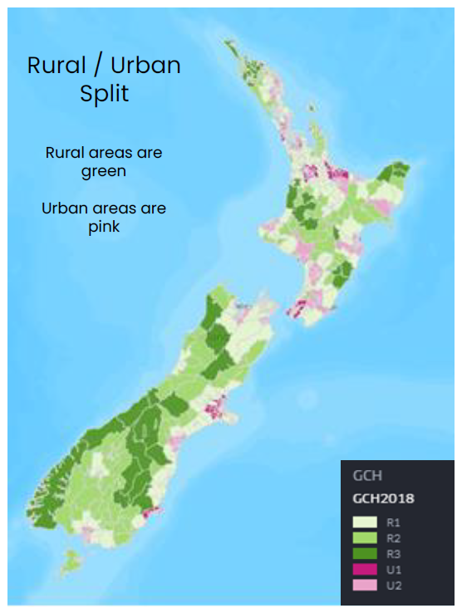Illustration One highlights the rurality across the motu based on the Geographical Classification of Health (GCH). The GCH is a rural-urban geographic classification designed to accurately monitor rural-urban variations in health outcomes. The GCH classifies all areas of NZ as rural or urban with respect to health according to their proximity to larger urban centres.
2. Around 20 percent of New Zealanders live in rural areas, with more travelling to these areas each year for work, holidays, or whānau visits.
3. The rural population is generally older and experiences greater socioeconomic challenges than urban populations. There is generally an increase in health service utilisation over 70 years of age, so the demographic makeup of rural communities has a significant impact on health services.

**Illustration One: Geographical Classification of Health**

1. Rural populations experience worse health outcomes, higher rates of chronic illness, and lower life expectancy. People living in rural Aotearoa New Zealand use health services less frequently, often presenting with more advanced illnesses, particularly rural Māori (Nixon et al, 2023).
2. In addition to using health services less frequently, rural residents may delay seeking care. Access to urgent and unplanned care decreases with greater rurality. Long travel distances, work and caregiving pressures, and mistrust in the system contribute to delayed care-seeking, widening the health gap between rural and urban populations.
3. Research shows that mortality rates are higher in rural Aotearoa New Zealand, especially among those aged under 45. Health inequalities between Māori and non-Māori are most pronounced in remote areas, where rurality exacerbates existing disparities (Crengle et al, 2022).
4. As of 2023, 7.2 percent of the Pacific population lives in rural Aotearoa New Zealand. With increasing numbers of young Pacific people moving to rural areas, unique health needs are emerging. Additionally, the Recognised Seasonal Employer (RSE) scheme has brought approximately 19,000 seasonal workers, mostly from the Pacific, into rural communities to support the horticulture and viticulture industries. This is happening in the context of a shortage of Pacific health professionals.
5. Disabled people in rural areas, representing around 19 percent of the total population according to the 2019–2022 Aotearoa New Zealand Health Survey, likely face an undercount due to limited survey coverage of some disabilities.
6. A recent analysis by Sapere[1] outlines details around primary care utilisation and need in rural areas. The rural population has a larger share of older adults, a higher proportion of the Māori population, and is overrepresented in the most deprived socio-economic quintile (Quintile 5), with fewer residents in the least deprived quintile (Quintile 1).

# Current state

1. Generally, primary, urgent and emergency care is commissioned based on urban models of care. Figure 2 outlines services that form part of urgent unplanned care responses in urban areas. In many urban communities, each service is provided by a different provider, often in different locations. Most services are not available 24/7, with most providers providing routine primary care *or* urgent care *or* emergency care.
2. By contrast, rural primary, urgent and emergency care is a more integrated model of care. It is inherently 24/7, providing a continuum of routine through to urgent care. In rural areas, a single provider will often provide many layers of the urgent care framework. For some communities this can be a single service, or even a single clinician.

**Figure One: Urgent and Unplanned Care Responses in Urban Areas**

1. Access to critical enabling services such as radiology, laboratories and medicines is more challenging in remote areas due to distance, workforce availability and the impact of fragmented historic resourcing.

## Accountability and service specifications

1. Figure Two outlines the accountability environment cascading from the Government Policy Statement (GPS) through to the contractual service specifications.

**Figure Two: Accountability Environment**

1. As outlined in Table One, service coverage and service specifications are typically based on urban models.

**Table One: Service Coverage** 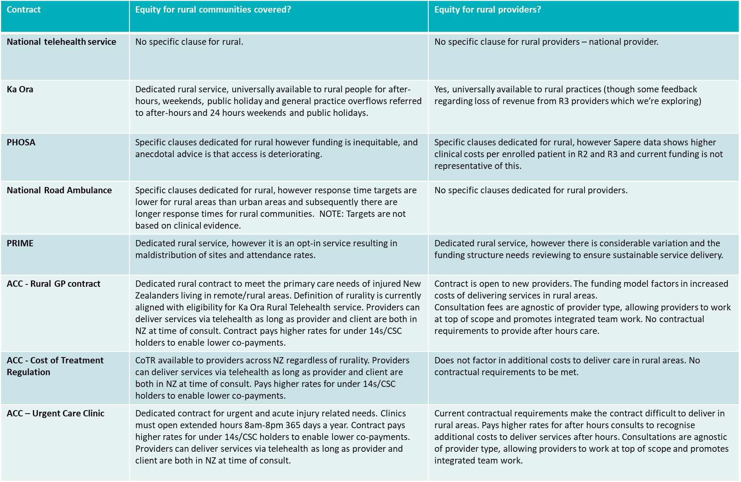

## Current service components

**Overview**

1. Rural urgent and unplanned care is commissioned via a range of service types, funding streams and coverage expectations. The major contracting mechanisms are outlined in Table Two. Each service component targets different patient needs, parts of the system and has different coverage and access attributes.
2. Generally, national contracts take an urban-centric commissioning perspective - meaning design and commissioning decisions are often led by urban teams. For rural areas, this results in ‘ruralising’ of urban models, rather than the use of a model explicitly for the rural context.

**Table Two: Summary of contract / service streams that contribute to rural urgent unplanned care response**

| **Contract / Service** | **Scope** | **Budget value** |
| --- | --- | --- |
| Ka Ora | Available to all rural residents and visitors | INFO WITHHELD |
| Primary Care Services (via the PHO Services Agreement (PHOSA)) | First contact medical urgent care  Rural funding “top-up" | $1221.6 million (2024/25)  $25 million (2024/25) |
| ACC Rural GP | Non-medical (accident) primary care services for rural communities | $32.9 million (2023/24 actual spend) |
| ACC Urgent Care Clinics | The purpose of ACC’s Urgent Care Clinic Contract is to provide urgent and after-hours acute care usually on a non-appointment basis. Seen as an intermediary service between general practice and ED. | Noting there is only one UCC considered rural.  $84.5 million (2023/24 actual spend) |
| Hato Hone St John including PRIME funding | Emergency Ambulance Communications and coordination, First response, and Paramedicine Emergency Care and transport | $349 million per annum (road ambulance) (HNZ and ACC)  $3.1 million per annum (PRIME) |
| Air ambulance | Rotary and fixed-wing air ambulance services (ACC and HNZ funded) | $128 million rotary (2023/24)  $40-50 million fixed wing (2023/24) |
| Rural Hospitals | Level 2 or 3 Emergency Departments, A&M, AAUs and other non ‘ED’  Variation in models:   * Can be collocated with primary care services under the PHOSA * Can be standalone (e.g., FACEM or FDRHMNZ led) * May or may not have walk-in access (e.g., different phone triage options) | $54 million (2023/24) |

1. In some instances, the proportion of funding provided to address rural health needs appears to be inequitable (see Figure 3 for more details). For example, the capitation review found the current funding formula does not adequately address the profile of health need in rural enrolled patient groups.
2. In another example, while rural communities are served under the national emergency road ambulance contract, the resourcing for PRIME is not sufficient/has not been used to proactively commission equitable service coverage across the motu.

**Figure Three: Commissioning Approach and Rural Communities Funding**

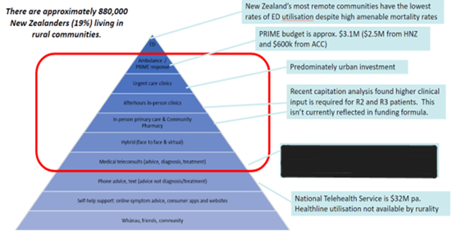

**Primary care in rural areas**

1. Rural New Zealand has 190 primary care practices as defined by the PHO Services Agreement[2]. Rural practices often face higher operating costs compared to urban ones. Analysis undertaken by Sapere as part of the capitation re-weighting project highlighted that residents in isolated rural areas (R2 and R3) incur higher healthcare costs, primarily due to increased clinical non-contact time. Despite this, the capitation funding formula does not account for rural-specific needs, leaving rural practices underfunded.
2. Rural communities face additional barriers in accessing acute and after-hours care. Rural practices often face higher operating costs compared to urban practices. As noted in the Sapere report[3], travel distances and limited-service availability make it difficult for residents to reach care, and many rural general practices operate at capacity with closed enrolments.
3. In most rural areas, after-hours care is limited to a GP on call, rather than a full-service clinic. Walk-in clinics are rare, and telehealth options are not always viable due to inadequate technology access and a shortage of staff to support remote consultations.

**Ka Ora: National rural clinical telehealth service**

1. The National Rural Clinical Telehealth Service (Ka Ora), launched in November 2023[4], aims to improve access to urgent care for rural communities. By 30 September 2024, nearly half (47 percent) of eligible[5] general practices had enrolled, with over 21,500 clinical interactions recorded.
2. Ka Ora serves a diverse population, including 17 percent Māori, 22 percent Community Services Card holders, and 33 percent children. Ongoing work seeks to expand the reach of this service and ensure public understanding of its role in delivering timely care, even without face-to-face contact.
3. Available literature stresses the need for clear public messaging on telehealth’s role. Patients need assurance that telehealth provides timely care without requiring face-to-face contact and that triage will occur when in-person care is necessary. Work is underway to expand telehealth access beyond rural areas, including for urban practices with rural patients.

**Funding streams for rural primary care**

1. The PHO Services Agreement (PHOSA)[6] specifies first level and urgent care service, 24/7 coverage, and travel time distances (within 30 minutes during regular hours and 60 minutes after-hours). Primary care services in rural locations receive funding through two streams:
2. Capitation Funding: Allocated based on the age and gender of a practice’s enrolled population. The current model does not allow for consideration of rural-specific health demands though work ongoing to redesign the capitation weighting model may address this gap.
3. Rural Funding: Provides around $25 million annually to sustain rural healthcare services, supporting first level and urgent care through various objectives like after-hours care, workforce retention, and roster support. However, rural funding for urgent care remains limited due to the broad allocation of funds across multiple needs.

**Table Three: Summary of PHOSA funding streams – 10 years from 2014/15 to 2024/25**

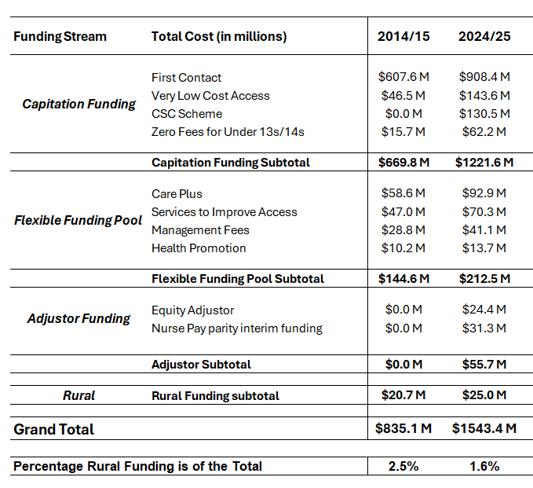

**The role of rural pharmacies in urgent care**

1. Pharmacy is another core component to comprehensive primary and urgent care. The Integrated Community Pharmacy Services Agreement (ICPSA) sets expectations for community pharmacies nationwide, including operating hours and medication access.
2. However, rural pharmacies face unique challenges. Locally commissioned services in eleven districts allocate approximately $1.3 million to support rural pharmacies, with additional funds for after-hours availability and pharmacy depots. In 2022/23, the overall rural spend was $1.67 million, recognising the essential role of pharmacies in comprehensive urgent care for rural areas.
3. While initiatives like Ka Ora and additional rural pharmacy funding provide some relief, a revised funding approach may be necessary to meet the urgent care needs of rural Aotearoa New Zealand.

**Urgent Care Clinics**

1. According to the Royal New Zealand College of Urgent Care, Urgent Care Clinics (UCCs) provide walk-in care for patients with acute injuries or illnesses. Clinics are equipped to handle urgent medical needs and accidents, offering services such as x-rays, fracture clinics, and complex wound care. Many UCCs are also co-located with pharmacies, physiotherapy, and dental services, enhancing patient access to comprehensive care.
2. However, UCCs are unevenly distributed across Aotearoa New Zealand, with only one located in a rural area designated R1, R2, or R3 under the GCH. UCCs are concentrated in urban centres, particularly in Auckland, where nearly all residents are within 20 kilometres of a clinic.
3. The proportion of rural New Zealanders within 20 kilometres of a clinic is significantly lower. For example, when looking at the Northland community within the Northern region, only 5.6 percent of their population are within 20 kilometres of a clinic. Elsewhere, 62.7 percent of Te Waipounamu’s population, 58.9 percent of Te Manawa Taki’s, and 84.6 percent of Central’s live within this range.
4. Table Four illustrates this distribution, highlighting the gaps in coverage for rural regions, especially on the East Cape, Northland and the South Island’s West Coast.

**Table Four: UCC Location Distribution**

1. In rural areas without UCCs, access to equivalent urgent care varies. Some patients face long drive times, while others may have to delay or forego care. The lack of local UCCs places a significant burden on rural residents, who often rely on general practices or emergency services for urgent care needs.
2. The ACC Rural General Practice Agreement (RGPA) partially addresses this gap by funding non-medical injury-related services. While RGPA contracts offer higher funding to account for rural cost structures, they exclude some overhead support, which UCC contracts include. This limits RGPA funding’s ability to sustain a wider range of services, further highlighting the need for more equitable UCC access in rural areas.

**Emergency ambulance services**

1. Urban patients receive faster response times than rural patients. As an example, 93 percent of immediately life-threatening (RED) calls in urban areas are responded to within 20 minutes, compared to 88 percent of RED rural calls are reached within 30 minutes.
2. Urban residents also have better access to highly qualified ambulance staff. Urban stations are typically staffed by paramedics or higher, while rural stations rely more on Emergency Medical Technicians, first responders (first response units) and volunteers. This staffing difference means that there is a delay for rural communities to higher levels of ambulance care and clinical intervention.
3. Ambulance service viability decreases as population decreases, due to lower workload (and therefore lower skill retention) and recruitment and retention. The volunteer model for rural ambulance services offers lower clinical capabilities (often only enhanced first aid, with ambulance equipment) and inconsistent availability (volunteer ambulances are available 40 percent of the time and decreasing).

**Road Ambulance**

1. The purpose of the Emergency Road Ambulance Service is to provide road-based responses for the Emergency Ambulance Service. The Hato Hone St John (HHStJ) Road Ambulance contract is between Health NZ, ACC and HHStJ for a four-year period (1 July 2022 to 30 June 2026). It is acknowledged that Wellington Free Ambulance provides road ambulance services in the Wellington region; however, due to the small rural population served, this analysis refers to HHSJ data.
2. Most service users or patients of the Emergency Road Ambulance Service are transported by road-based ambulance. Transports are mostly to hospital emergency departments, with much fewer to another destination, such as a UCC or primary care setting. Response time performance standards differ between rural and urban areas (i.e. the expectations for rural response times are less) as shown in Figure Four.

**Figure Four: National Emergency Ambulance Red Response Performance (rural vs urban)**

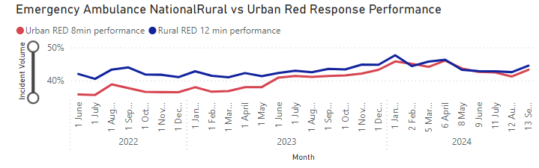

**Air Ambulance**

1. Air Ambulance connects people, especially regional, rural and remote communities, with the health care that they need. It enables access to appropriate care that people need, which may not be available locally or regionally. These services deliver critical care at scene and reduce transport times for delivery of critically ill or injured patients to definitive care.
2. There are currently three rotary wing providers and six fixed wing providers for air ambulance across the country. While it has been beyond the scope of this project to carry out a full analysis, these services are not equitably distributed across the country.
3. Air ambulances cover pre-hospital events, which are Emergency Ambulance Service incidents that require an air ambulance response and transport from the community. This includes transports from a Primary Care or integrated health facility (e.g. GP) to a healthcare facility or hospital. Figure five shows the utilisation of pre-hospital Emergency Air Ambulance by geographic location, demonstrating the importance of these services to rural communities.
4. The service also covers transfers between hospitals, including from hospitals with a Level 2 Emergency Department or higher. It involves moving patients to a higher level of care or returning them to their local hospital. This helps people access specialist care and makes better use of hospital resources by providing care in the most suitable place.
5. 2023/24 budgets (ACC and HNZ) for these services equate to $128 million for rotary wing air ambulance and $40 - 50 million on fixed wing air ambulance for 2023/24 (which is commissioned by multiple hospitals).

**Figure Five: Pre-hospital Emergency Air Ambulance (rotary) utilisation by GCH (July 2023 to July 2024)**

**PRIME**

1. PRIME was established in the early 2000s to provide a timely co-response for emergency incidents in rural and remote areas more than 30 minutes by road from an ambulance station with 24/7 cover at Paramedic or higher scope.
2. 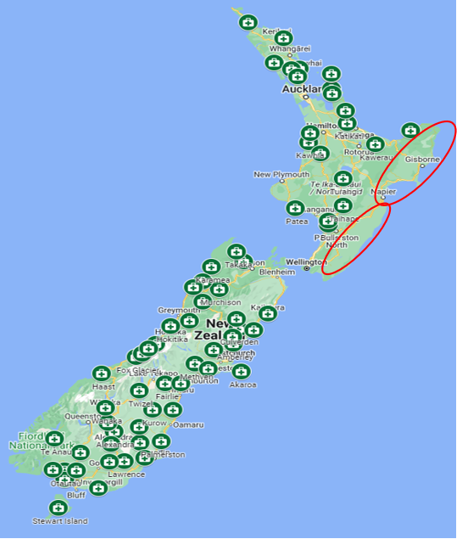PRIME supports the Emergency Road Ambulance Service (ERAS) by using doctors, nurse practitioners and registered nurses to provide a level of care in rural and remote areas exceeding that provided by ERAS alone. The PRIME service typically relies on the primary care workforce, yet emergency responses often demand resources beyond what the core service is providing for a small, enrolled population.
3. PRIME is an opt-in service. There are currently 68 sites nationally – 22 in the North Island and 46 in the South Island. Some remote and deprived areas do not have existing PRIME provision or access to emergency care. There is a range of operating hours across sites, including 44 sites that provide 24/7 coverage. Figure Six outlines the distribution of PRIME sites across the motu, while also noting certain areas are being underserviced by PRIME (circled in red)[7].

**Figure Six: PRIME Sites Distribution**

1. In the 2022/23 financial year, 46.7 percent of all PRIME calls were attended (injury and medical). Furthermore, there is considerable variation in attendance rates across regions (e.g. in 2022/23 Te Waipounamu’s attendance rate was 50 percent, compared to 17 percent in the Central region). Refer to Table Five for more information.

**Table Five: PRIME Notifications and Attendances by Region 2022/23**

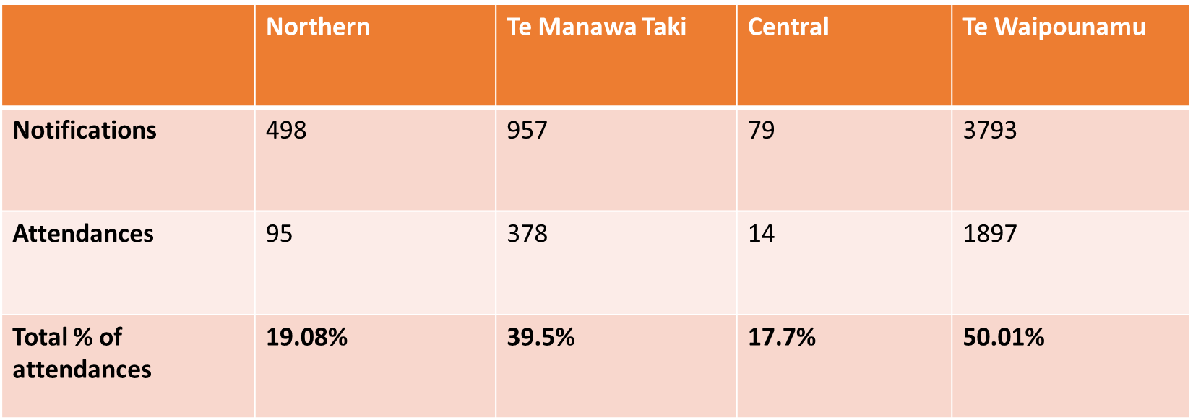

1. Figure Seven shows the outcomes of all PRIME incidents attended from 2020 to 2024 (March)[8]. Of the calls attended, 62 percent are transported to an ED and 20 percent are treated.

**Figure Seven: PRIME incidents attended 2020 to 2024 (March)**

1. Health NZ invests $2.5 million per annum into PRIME and ACC funds a further $0.6 million. Health NZ and ACC provide approximately $1 million per annum for administration of the service by HHStJ. Administration in this context includes organisation and delivery of clinical training, and equipment.
2. Health NZ’s PRIME funding contributes $1.8 million per annum in direct payments to rural practices. This provider funding is ringfenced, and any funds not disbursed to rural practices is subject to washup and may be repurposed at Health NZ’s direction. This is usually used to purchase new PRIME equipment.
3. Other than when an annual uplift has been approved, there has been no increase to the base level PRIME funding since 2016. This is contributing to sustainability pressures on PRIME providers. There is a mismatch between PRIME being a 24/7 or 12/7 model, reliant on demand-based funding. Most providers advise they run the PRIME service at a loss, and only one new PRIME site has been commissioned over the past 15 years.
4. Since 2022/23, PRIME providers have received service top-up funding additional to base funding to provide some financial support while a review of PRIME is undertaken.

**Table Six: PRIME funding for 2024/25**

| **Funding mechanism** | **What is funded (2024/25)** |
| --- | --- |
| HHStJ base funding from HNZ (3 bands - per annum/GST excl) | 1) **$14,175** for 0-20 attendances (medical)  2) **$19,627** for 21-40 attendances (medical)  3) **$25,079** for 41+ attendances (medical)  * Funding for 24/7 PRIME sites |
| ACC payments for accidents | Attendance fee - $215.03/hour  Mileage - $0.92/km  Rural GP contract or Cost of Treatment Regulations for consultation and procedure fees |
| HNZ interim top-up payments | $150 per clinical triage call  $400 per attendance (medical)  $2,000 one-off payment per site (excludes HNZ sites) |

**Emergency services in rural hospitals**

1. Hospitals, including rural hospitals, also provide urgent and unplanned care to rural communities. There are 26 rural hospitals across Aotearoa New Zealand. The level of service available across rural hospitals varies whereby:
   1. some rural hospitals have Emergency Departments, many do not;
   2. some rural hospitals charge a co-payment for lower acuity presentations;
   3. some rural hospitals do not provide a walk-in facility but operate on a referral system from primary care, emergency services or telehealth triage after hours.
2. This variation in service delivery models reflects the unique history of each community and past priorities of former District Health Boards. Local needs and resources have shaped the way rural hospitals operate, leading to a wide range of approaches across regions. These differences can impact the quality and accessibility of urgent care for rural populations.
3. Providing 24/7 medical cover and clinical support overnight is increasingly difficult due to workforce shortages. Creative solutions are emerging, such as on-call doctors who provide overnight cover, sometimes with standdown arrangements to manage workload. Telehealth models are also playing a larger role, both for patient-to-clinician and clinician-to-clinician support.
4. Future strategies and planning approaches for hospitals, including rural hospitals, are being considered in the context of nationwide clinical services and campus planning is currently being progressed.

**Methodology and approach**

1. This project took an inclusive and collaborative approach to ensure the future state service and recommendations were fit for purpose and are both patient and whānau centred whilst also ensuring we are enhancing the working environments of clinicians and providers.

### **Literature Review**

1. In August 2024, a literature review was undertaken to provide further insight into other models and considerations to inform this future state service. This included both New Zealand-based and international-based research, however it is worth noting that there were some limitations on information found for the New Zealand and Australian contexts.
2. The literature review provided insights on the following:

* Community Health Hubs model of care
* Telehealth
* Telemedicine
* Rural Emergency Trauma Care
* Hybrid models of care
* First responders
* Navigators/service development
* Enhancing Emergency Services
* Mathematical modelling to improve ambulance services
* Prevention and Social Determinants.

# Future system of rural urgent unplanned care

## Principles and assumptions

1. The recommendations for the future state of rural urgent unplanned care are underpinned by:

* **A commitment to not ‘other’ rural**: The recommendations are intended to adapt universal coverage and performance expectations to deliver more equitable access and outcomes for rural communities. As such, there is no recommended new, ‘greenfield’ stand-alone service. The options are intended to provide scalable solutions to build on and enhance current commissioned services, to improve access and outcomes for whanau.
* **Minimising the need to travel when possible**: In some instances, patients/whānau will have to leave their local area to access the definitive care they need. However, the future RUUC models aim to enhance clinical decision support to minimise the need to travel for diagnostics and care outside rural communities.
* **The provision of more options**: The proposed future state aims to provide more options for rural patients. Currently rural communities have relatively few options if they have urgent health needs, especially out of hours.
* **A shift toward generalism**[9]: Generalism enables patients to receive a broad spectrum of care locally, reducing the need for travel and supporting more sustainable healthcare delivery and is particularly valuable in rural areas.

1. This project aimed to design a national approach that enables regions to make the most of existing resources and, eventually leverage new resources, to improve access to urgent and unplanned care across Aotearoa New Zealand. As such, the proposed future state is necessarily high level. It is anticipated that the team composition, and local delivery model will vary widely across communities based on the demographics of the community, seasonality of demand and proximity to other health services.
2. The recommendations are intended to drive change away from a fragmented and siloed approach to arranging rural services, to one that is more integrated, as outlined in Figure Eight.

**Figure Eight: System shift**

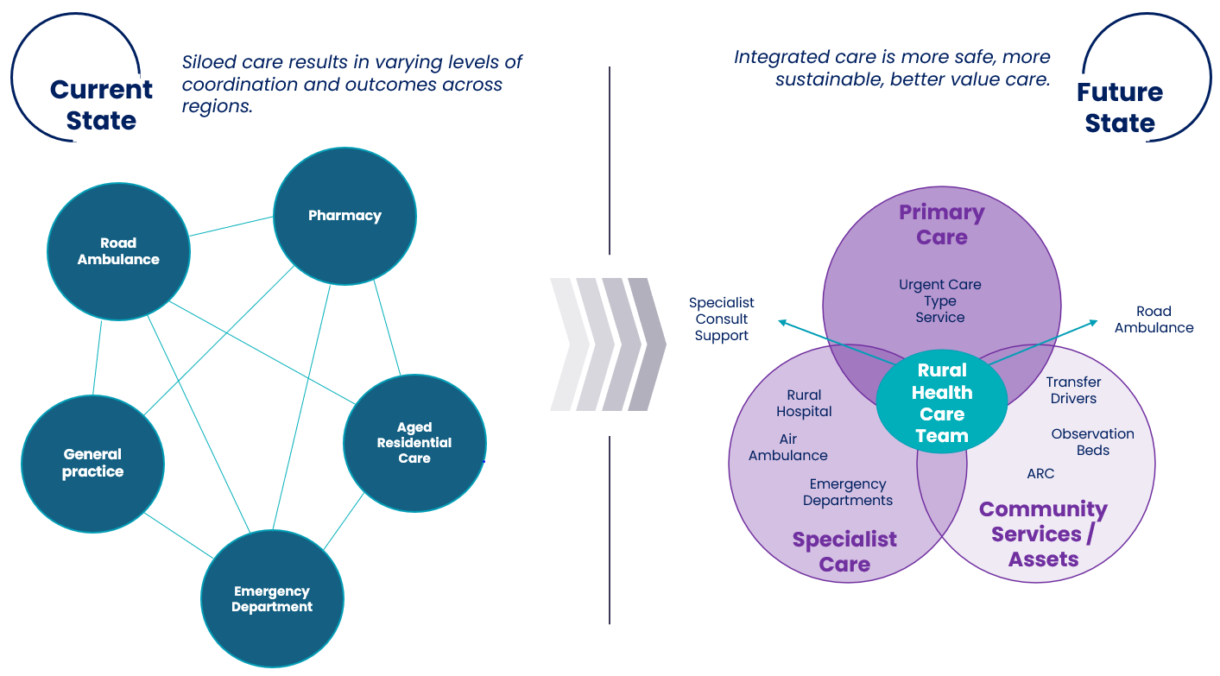

## Future state service components

1. The redesign process identified six core service components required to enhance rural access and outcomes, pertaining to urgent and unplanned care.

**Figure Nine: Future State Service Components Model**

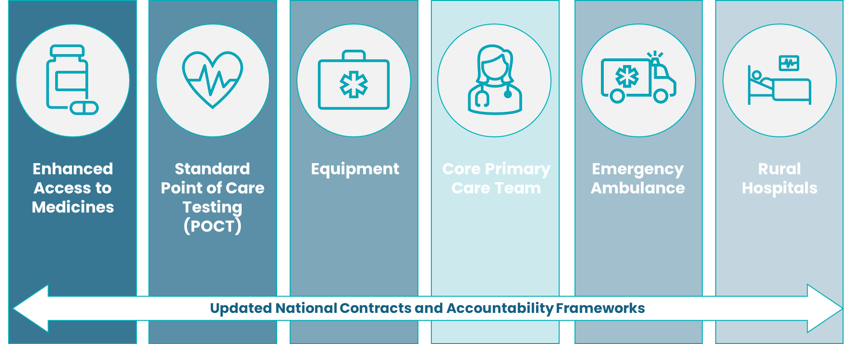

1. The service components, *Core Primary Care Team, Emergency Ambulance* and *Rural Hospitals* will require a coordinated system solution. Implementation of these service components reflect the desire to drive system change through national agreements. This will require executive sponsorship, new funding and/or re-commissioning and a multi-year implementation plan.
2. *Enhanced Access to Medicines*, *Standard Point of Care Testing* and *Equipment* on the other hand, are less complex (though nonetheless complicated) and can be commissioned, funded and implemented without necessarily changing national agreements. Implementation is recommended to be done in a staged way but could commence in 2025.

**Integrated core primary care teams**

1. A key feature of rural healthcare is generalism. Supporting integrated generalist approaches to primary care underpins these recommendations. Rural general practice teams are made up of GPs, nurses and in some cases, nurse practitioners, allied health practitioners such as paramedics, pharmacists and physiotherapists and the non-clinical workforce including kaiāwhina. In addition to rural general practice, many rural communities might also have other primary and community care providers including aged care services and ambulance services.

Aotea Great Barrier Island Health – paramedic model of care case study

*On Aotea, Great Barrier Island the paramedic works with the rural practice 3 days a week, in a Comprehensive Primary and Community Team (CPCT) funded role. The paramedic touches base at the practice for huddle at 8:30 and then going out to our isolated, patients with chronic conditions or elderly, or those without transport to do full health assessments, dressings, COPD acute care plans, or follow up visits as requested by the Clinical staff, including IV antibiotics. On other occasions the paramedic has been able to assess acute presentations in the clinic alongside the other clinicians. This role works very well on the motu and we have developed the role based on community need.*

1. Rural general practices currently have variable capacity and capability to handle urgent care needs. Urgent care needs span a range of medical and injury related concerns and in many cases a mix of the clinicians, diagnostic tests and equipment is required to deliver definitive care. Where these aren’t available, patients must be transported to a larger centre for care (often to a hospital by ambulance).
2. A more integrated primary care team with generalist skills could meet a wider range of urgent care needs. This team might include allied health professionals such as paramedics, extended care paramedics, physiotherapists, pharmacists, and counsellors. In-home care services have also been highlighted as valuable. These services could better address patient needs and help prevent the need for urgent care and hospital transport.
3. Ambulance station resources are currently based on a minimum utilisation rate for paramedics. Greater integration between rural ambulance stations and general practices could improve paramedic productivity and impact. In less busy areas, ambulance resources could operate from rural practices, supporting primary care and responding locally to emergencies.
4. Integrating primary care and ambulance teams is already occurring in some locations across Aotearoa New Zealand. In many instances, these models have been enabled by Comprehensive Primary Care Team (CPCT funding). Further expansion of these models will require both more innovative, national commissioning approaches, as well as expert, regionally-led service development and contracting. It is worth highlighting the risk to current services funded by CPCT as this is set to conclude at the end of financial year 2024/2025.
5. Ka Ora, as the recently established rural clinical telehealth service provider, was identified as an important service to support a more integrated primary care team. Ka Ora can provide after-hours service when other options are closed.
6. In addition to ‘clinician to patient’ telehealth services, ‘clinician to clinician’ services were also deemed important to support safe clinician decision making and patient care.
7. Currently, road ambulances (both paid and volunteer) handle most patient transport. In some cases, PRIME providers and other rural community members use their own vehicles. It is recommended that other transport options are explored for patients with less urgent (low acuity) needs who do not require an emergency ambulance. Alternative transport solutions would free up emergency ambulance services and shorten job cycle times. This would prevent clinical resources (i.e. PRIME providers, and primary care clinicians) from being tied up at incidents for long periods.
8. Table Seven shows the five longest job cycle times, highlighting how long PRIME providers can wait on scene for an ambulance to arrive. This includes time from dispatch of PRIME to the incident to transporting the patient to hospital.

**Table Seven: PRIME job cycle times (average minutes)**

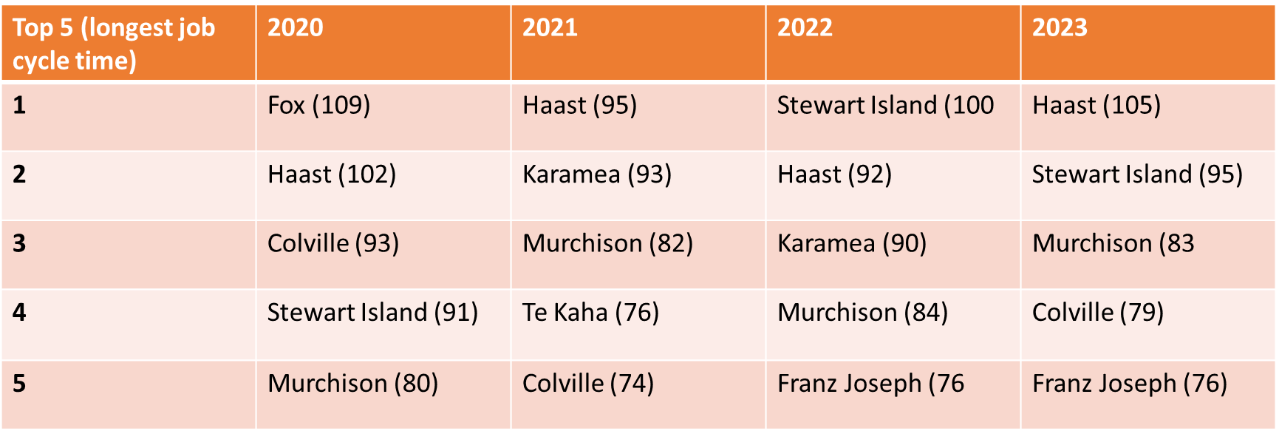

**Enhanced access to medicines after-hours**

1. 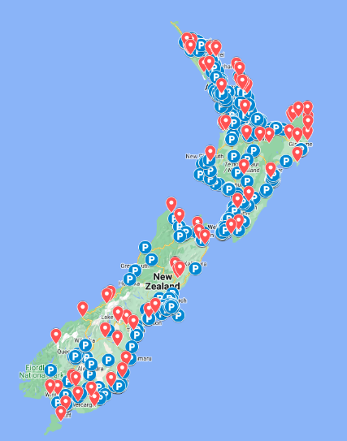Some rural communities do not have equitable access to medicines. Whilst business hours are generally well covered, there is limited access to community pharmacies, particularly after-hours.

**Figure Ten: Pharmacy and Depot Locations (Health point)** (blue = pharmacy, red = depot)

1. Pharmacy depots and collection points operate as a prescription medicine pickup location. These are also unevenly distributed across the country. Figure Ten provides a map of locations of both Community Pharmacy and Depots.
2. West Coast (79.1% of the population within a 20-minute drive-time to a Community Pharmacy), Tairawhiti 83.6%) and Northland (86%) have the lowest levels of access to community pharmacy.
3. Regardless, the existing locations of community pharmacies, depots and collection points lay a good foundation for improving after-hours access through national agreement changes.
4. Ambulance services have access to a range of medicines to provide effective urgent and emergency care. While PRIME providers form part of the ambulance response in rural areas, not all medicines commonly used by the ambulance service are available to PRIME providers.
5. Any medicine listed in the Pharmaceutical Schedule, is funded for rural practitioners. However, medicines not listed in the Pharmaceutical Schedule, or only available on the Hospital Medicines List (HML), remain accessible to rural practitioners but are unfunded. This unfunded access places an added financial burden on PRIME providers, who must often 'self-fund' these essential medicines.
6. The most frequently used medicines that are self-funded by PRIME providers are: ketamine, tranexamic acid, tenecteplase, droperidol, methoxyflurane, glucose 10 percent 500 mL (bags), glucose 5 percent 100 mL (bags). The review recommended exploring how best to ensure funded availability of these medicines to strengthen the effectiveness and sustainability of rural urgent care.
7. The redesign process found that some PRIME providers carry a ‘toolbox’ of medicines that are commonly used in primary care. Having these medicines on hand means PRIME providers can meet the needs of patients in the community, reduce the need to transport patients to hospital. See Figure Eleven as an example of the ‘toolbox’ a particular PRIME provider takes to callouts.

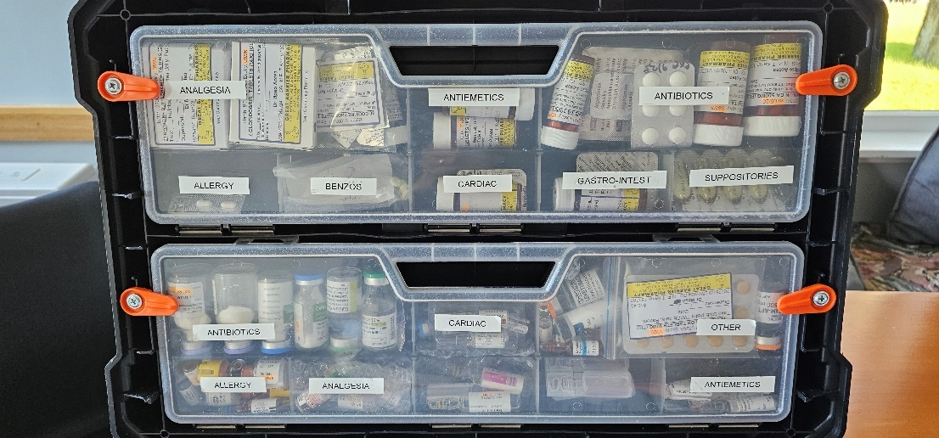**Figure Eleven: PRIME Provider Toolbox**

1. Kiosk dispensing machines placed in rural communities were also discussed and could enhance access to prescribed medicines in rural communities, especially for after-hours. It is important to note that the kiosk solution would require policy and legislation amendments and consideration for how these are operated and maintained.

**Enhanced Point of Care Testing**

1. Access to enhanced Point of Care Testing (POCT) and laboratory results can reduce the need for patient transfers and enhance clinical outcomes through more timely intervention. The availability and accessibility of laboratory services varies greatly across the country. In the absence of laboratory services, POCT can enable rapid clinical decision-making from assessment to treatment (thereby minimising unnecessary transport and hospital presentations). POCT could also enhance the sustainability of rural laboratory rosters by decreasing call-back frequency.
2. The design process found that enhancing access to POCT would improve access to definitive care and reduce the need to transport patients. It was also found that POCT could be introduced more equitably across both rural general practices and the emergency ambulance service.
3. Subject matter experts identified the following as the tests that would provide the greatest impact on the system:

* **Troponin** testing is used to determine whether cardiac damage has occurred. In patients who present with symptoms that are not clearly of cardiac origin, use of this test will tell whether admission is warranted. Having this test available therefore potentially saves unnecessary admissions of patients with chest pain. In patients with a positive result, appropriate care will be able to be fast tracked. Through the current state work earlier on in the project, it was highlighted that chest pain was one of the most common presentations for PRIME attendance. Therefore, this POCT can play a part in reducing the need for transport to an Emergency Department and also ensure patients receive definitive care, sooner.
* **D-Dimer** is used for Deep Vein Thrombosis (DVT), Venous Thromboembolism (VTE) and aortic dissection ‘rule-out’ (however, a raised value does not confirm a DVT). It can be used in a rural setting as part of an assessment for patients who present with applicable symptoms.
* **INR (International normalised ratio)** assesses the level of anticoagulation for people on warfarin. The risk of severe bleeding increases with increasing INR value. In people presenting with bleeding who are on warfarin being able to undertake an INR assists in determining the most appropriate management. Underdosing with warfarin can lead to blood clots, resulting in, for example, a stroke. INR POCT can help prevent these events with appropriate warfarin dose adjustments. This test will also be valuable for therapeutic management in the non-urgent setting, noting that the non-acute use would need a different business case.
* The main benefit of a **Full Blood Count** (FBC) in urgent General Practice is to check haemoglobin, total White Blood Cell (WBC) count, and differential cell count. Haemoglobin levels help identify significant blood loss that may require admission or a blood transfusion. The differential cell count helps determine if a clinically significant infection is present. This can reduce unnecessary antibiotic use by excluding bacterial infections. FBC can also confirm neutropenic sepsis, indicating the need for urgent admission. The differential WBC is useful in diagnosing acute abdominal pain, such as assessing the likelihood of diverticulitis or appendicitis. Further investigation is required to establish if FBC is essential for all RUUC cases, while CRP (C-reactive protein testing) may offer added utility in certain situations.
* A **basic biochemistry panel** allows testing of blood gases, creatinine, and electrolytes. This provides a metabolic screen to assess the type and extent of the patient's condition. Even if the condition itself is not typically critical, such as in long-term heart failure, severe abnormalities in gases or electrolytes indicate the need for hospitalisation.

**Equipment**

1. Currently, PRIME providers carry less equipment than emergency ambulance providers. Key pieces of equipment not available to PRIME providers include:

*Operational Equipment*

* **Radio communication** – currently PRIME providers have pagers and personal phones which limits timely access to the ambulance communications centre for rapid updates regarding PRIME call outs, especially in areas of poor mobile coverage.
* **Phone with Public Safety Network (PSN) sim/cellular service** – currently only emergency services have access to the PSN sims. These sims will take priority over other mobile users on cellular networks when the networks are congested or degraded. Note: from 2024/25 existing PRIME providers will be equipped with PSN Cellular Service.
* **GPS**– tracking PRIME providers was identified as being important from a health and safety perspective.
* **Mobile Data Terminal (MDT) with electronic patient report form (ePRF) function** – these tablet devices are currently used by ambulances and include crucial job information ranging from location and nature of incident to important clinical notes. In addition, the ePRF allow patient notes to be captured when care is delivered to ensure continuity of safe and effective care. PRIME providers currently do not have this capability.

*Clinical Equipment*

* **POCUS (Point of Care Ultrasound)** – POCUS is often used by the air ambulance service and is a device that provides advanced diagnostic ultrasonography to help better diagnose presentations seen in emergency care. This includes cardiac tamponade, left ventricle failure, pulmonary embolism, hypovolemia, free fluid in the abdomen (in trauma) and pneumothorax. All of these presentations require rapid diagnosis and definitive care to improve outcomes.
* **12 lead ECG**– this tool enables clinicians to assess patients presenting with chest pain and help rule out myocardial infarction (commonly referred to as a heart attack).

**Emergency Road Ambulance**

1. Emergency Road Ambulance Providers provide Emergency Road Ambulance and Communication Services (EAS) to the public. EAS includes timely, appropriate emergency care and where necessary, emergency transport of patients to a place of definitive care. This includes transport by either road or air ambulance. The current national service specifications for road ambulance state that the Emergency Ambulance Provider must: ​

* Respond and supply an emergency road ambulance service for people requiring assistance as a result of a medical or accident emergency when required and dispatched by the Emergency Ambulance Communication Centre (EACC). ​
* Be available 24 hours a day, 7 days a week (inclusive of statutory and public holidays), and have contingency services in place for back-up in the event of their inability to provide services for any reason.​
* Respond to requests by the EACC to transport a treatment provider(s) to the scene of an incident where it is clinically appropriate (e.g. where the patient is not able to be moved), and where it is reasonable, to return that treatment provider to town or residence, (e.g. emergency physician, anaesthetist, lead maternity carer). ​
* Crew road ambulances with appropriately skilled staff. ​
* Meet service delivery requirements described in this service specification. ​
* Send the most appropriate, resource regardless of geographical boundary.

1. Rural ambulance stations tend to have lower qualified road ambulance officers and tend to rely more on volunteers. As such, supporting better access to higher qualified paramedics is recommended in future commissioning.
2. It was identified that rostering availability should be aligned with Rural General Practice after-hours availability. Ambulance communications and clinical hub enhancements can play a vital role in reducing utilisation of rural primary care resource and emergency ambulance resource. This can enable patients to be re-directed to the right care if ambulance services are not appropriate.

# Recommendations

## Minimum service coverage standards

* **Recommendation 1**: Introduce clear minimum service coverage specifications to the core rural unplanned urgent care service components (for example *95 percent of rural New Zealanders will have access to the recommended core service components within a 60-minute drive*).

1. Minimum service coverage specifications are recommended for the following service components:

* Integrated primary care teams, including after-hours access
* Enhanced access to medicines (with a focus on after-hours)
* Enhanced access to POCT
* Enhanced access to clinical and operational equipment
* Improved integration between primary care teams and emergency ambulance in rural areas

1. Table Eight shows a high-level summary of how each service component will be approached and implemented.

**Table Eight: Service Components, contractual funding and implementation**

|  |  |  |
| --- | --- | --- |
| **Key:** | Implementation required system change through national agreements. | Implementation might be achieved outside national agreements |

|  |  |  |  |
| --- | --- | --- | --- |
| **Service Component** | **Funding required** | **Contractual pathway** | **Implementation** |
| **Integrated Primary Care Teams** | Yes, though progress could be delivered through recommissioning. | Changes to the PHOSA - *Schedule C1 (2) Urgent Care Services* | A detailed implementation plan be developed in early 2025 in partnership with regional teams and emergency ambulance. It will explore staged implementation options. |
| **Enhanced Access to medicines** | Yes. | The ICPSA *(Section 11 Opening hours).* | A detailed implementation plan to be developed in early 2025. |
| **Enhanced access to POCT and enhanced access to clinical and operational equipment** | Yes | Contractual changes are not required however, it is recommended minimum service coverage expectation be included in the PHOSA, and National Road ambulance contract | A detailed implementation plan be developed in early 2025. |
| **Emergency Ambulance** | Yes, though progress could be delivered through recommissioning. | Changes to the National Road ambulance contract: *Part 2 (Service Specifications) and Schedule 9 PRIME.* | A detailed implementation plan be developed in early 2025. Changes will likely be staged over multiple contract terms. |

## Rural proofing existing contracts

* **Recommendation 2**: Existing national service specifications and agreements should be ‘rural proofed’ to support operationalising the service coverage schedule

1. The term ‘rural proofing’ refers to a process of actively considering, designing and funding for the unique needs of rural populations.
2. Service specifications for review include the PHOSA, the national road ambulance contract including the PRIME schedule, the Integrated Community Pharmacy Services Agreement (ICPSA), and the Rural General Practice ACC contract.

## PHOSA

* **Recommendation 3**: Using the six core service components, provide clearer expectation around the urgent care service that will be available to PHOs’ enrolled population.

1. This includes improved access to medicines, improved access to POCT, improved clinical and operational equipment and better integration and rostering alignment with local ambulance availability and rostering. This could include:
   1. Refreshed specific coverage expectations for rural communities (based on the Geographical Classification of Health). For example, 95% percent of enrolled rural communities should have access to face-to-face urgent care services within a 60-minute drive.
   2. Revised funding allocation methodologies to supported changed service coverage schedules.

## National Road and Air ambulance contract

* **Recommendation 4**: Use the 2026 road ambulance contract renewal as an opportunity to progress toward a strengthened delivery model for rural emergency road ambulance.

1. The 2026 road ambulance contract renewal presents an opportunity to step toward a strengthened delivery model for rural emergency road ambulance. This will be carried out with all relevant parties, stakeholders and partners. Some of the changes that may be explored include:
2. Rural road ambulance service delivery will be better integrated with primary care teams and tailored to drive productivity and improve rural access.
3. Review of rural road ambulance response time KPIs for both PURPLE and RED incidents.
4. Rural populations will have access to a paramedic level Authority to Practice or higher on scene for a greater proportion of incidents.
5. Over time, explore the removal of the PRIME schedule and introduce the RUUC future state service, as outlined above, ensuring integration with the Emergency Road Ambulance and Communications Services (ERACS) (HHStJ). Both the PHOSA and the ERACS will complement each other and ensure the minimum service standards for rural communities are met. Other ambulance providers such as Wellington Free Ambulance will also be included.

* **Recommendation 5**: Consider how the needs of rural communities can be better met through the Aeromedical Commissioning Programme

1. Enhancements to the Air Ambulance contract to better meet the needs of rural communities will be considered as part of the Aeromedical Commissioning Programme.

## ACC Rural General Practice (RGP) agreement

* **Recommendation 6**: Look for opportunities to ensure ACC’s Rural General Practice (RGP) agreement aligns with other objectives for rural health.

1. In the first instance, it is recommended that a broader range of health professionals such as allied health could be considered as part of the approved list of health professionals able to support the provision of RGP services. While ACC’s RGP agreement is not an urgent care service, it is recommended that the description of rural urgent care services within the RGP agreement should align with that described in the PHOSA.
2. Over time, it is recommended that ACC and Health NZ explore more mature co‑commissioning approaches for rural health providers, noting the constraints of the Commerce Act.

## Access to medicines

* **Recommendation 7**: Increase ease of access to medicines commonly used by the ambulance service for urgent and emergency care.

1. Another key recommendation is exploring how best to ensure funded availability to seven currently unfunded medicines commonly used by the ambulance service for urgent and emergency care.
2. This will require locally-led service design and development work to improve access to medicines, particularly after hours and on weekends, and develop resourcing and funding options with the Living Well pharmacy commissioning team. Local activities can be supported by system change through introducing rural service coverage specifications in the Integrated Community Pharmacy Services Agreement (ICPSA).

## Point of Care Testing (POCT)

* **Recommendation 8**: Develop a minimum access/service coverage standard for point of care testing.

1. As outlined in the Future state RUUC model section, a minimum access/service coverage for point of care tests is recommended. A coordinated approach will be required to ensure we do not duplicate with existing on-site laboratory services.

## Equipment

* **Recommendation 8**: Develop a minimum access/service coverage standard for key equipment.

1. As outlined in the Future state RUUC model section, a minimum access/service coverage for the following equipment is recommended:

* *Operational Equipment*
  + Radio communication
  + Cell phone (with PSN Cellular Service)
  + GPS
  + MDT with ePRF function (tablet with patient & incident information)
* *Clinical Equipment*
  + 12 lead ECG
  + POCUS

## Patient data

* **Recommendation 9**: Ensure all service providers can access the same patient data platform.

1. It is recommended that all service providers who provide urgent care (for example ambulance and primary care) use the same patient data platform and have access to devices and systems to access these platforms. This can be achieved by approving the above recommendations regarding MDT with ePRF functionality.

## Patient transport pathways

* **Recommendation 10**: Develop a national transport pathway and services framework.

1. It is recommended that a national transport pathway and services framework be developed (including for non-ambulance, low-acuity transport service to definitive care) to preserve and better protect rural primary care general practice resource and time as well as emergency ambulance resource.

## Implementing the recommendations

1. The recommendations outlined have been prepared to offer a range of options based on decision makers’ preferred balance and priority between service coverage, financial investment and/or re-investment and clinical sustainability.
2. The recommendations could be implemented in stages, starting in early 2025, contingent on funding and/or recommissioning decisions.
   1. The recommendations related to *Integrated Core Primary Care Team, Emergency Ambulance* and *Rural Hospitals* will require a coordinated system solution. Implementation of these service components reflect the desire to drive system change through national agreements. This will require political will, executive sponsorship, new funding and/or re-commissioning and a multi-year implementation plan.
   2. The recommendations related to *Enhanced Access to Medicines*, *Point of Care Testing* and *Equipment* are less complex (though nonetheless complicated) and can be commissioned, funded and implemented without necessarily changing national agreements. Implementation is recommended to be done in a staged way but could commence in 2025.

**Figure Twelve: Implementation pathway**

1. More detailed implementation work will be required following decision makers’ consideration of this report. This detailed implementation might include a plan to introduce changes to national contracts, more detailed service design, costing and procurement planning.

# Conclusion

1. The urgent and unplanned care system in rural Aotearoa New Zealand is inequitable. Access and outcomes vary widely, funding is inconsistent and, in many areas, unsustainable.
2. This redesign project identified six core service components that could be supported through regionally-led and nationally-supported commissioning work, to improve access in the regions. The recommendations are centred on the philosophy of rural generalism, care closer to home and community-led, integrated approaches.
3. A range of options have been developed, including some high-level indicative costs, to elicit feedback and direction from decision makers regarding the desired balance between investment, service coverage and clinical stability and sustainability.

# Appendix 1 - Glossary

|  |  |
| --- | --- |
| RUUC | Rural Unplanned Urgent Care |
| HNZ | Health New Zealand |
| ACC | Accident Compensation Corporation |
| PRIME | Primary Response in Medical Emergencies |
| PCDP | Primary Care Development Programme |
| RHS | Rural Hospital Sustainability |
| PHOSA | Primary Health Organisation Services Agreement |
| ICPSA | Integrated Community Pharmacy Services Agreement |
| Ka Ora | Rural Telehealth service |
| UCC | Urgent Care Clinics |
| RNZCUC | Royal New Zealand College of Urgent Care |
| RGPA | Rural General Practice Agreement (ACC) |
| ERAS | Emergency Road Ambulance Service |
| HHStJ | Hato Hone St John |
| POCT | Point of Care Testing |
| CPCT | Comprehensive Primary Care Team (funding) |
| HML | Hospital Medicines List |
| PSO | Practitioner Supply Order |
| DVT | Deep Vein Thrombosis |
| VTE | Venous Thromboembolism |
| PSN | Public Safety Network |
| MDT | Mobile Data Terminal |
| ePRF | Electronic Patient Report Form |
| POCUS | Point of Care Ultrasound |
| EACC | Emergency Ambulance Communication Centre |
| RGP | Rural General Practice |
| PSAAP | Primary Health Organisation Services Agreement Amendment Protocol |
| Level 2 Emergency Department | As per the Tier 2 Service Specification a Level 2 Emergency Department: https://www.tewhatuora.govt.nz/assets/Our-health-system/National-Service-Framework/Service-specifications/Specialist-medical-services/T2_SM_EmergencyDepartmentService_202409.pdf |
| EACC priority triage | GREEN: Non-urgent/low acuity  ORANGE: Urgent / potentially serious but not immediately life-threatening incidents  RED: Immediately life threatening or time critical  PURPLE: Immediately life-threatening |



1. Supplementary material on rural general practice, 23 September 2024, Sapere Research Group Ltd.
2. Source: NES data as at February 2024 and the Health NZ definition for rural facility. There are **190 rural general practices** in which at least one facility counts as rural. Because some practices have multiple facilities, the number of rural general practice facilities is greater, at 233.
3. Supplementary material on rural general practice, 23 September 2024, Sapere Research Group Ltd, page 7.
4. The service is available after-hours from 5.00pm - 8.00am on weekdays, and 24 hours a day on weekends and public holidays. People visiting or temporarily in a rural location that require health assistance can also use the service if they need it.
5. The National Rural Clinical Telehealth Service defines 254 general practices as eligible, while the PHO Services Agreement (PHOSA) defines 190 practices as rural. This difference arises because eligibility includes any GP in an R1, R2, or R3 area under the Geographical Classification for Health (GCH), or in the top 20 percent based on "distance score." This score, derived from the Patient-Centred Health Services Spatial Accessibility Index, factors the driving time from each enrolee’s home to the nearest primary care and hospital facility. Primary care distance contributes 30 percent, and hospital distance 70 percent, to each enrolee’s score. With satellite clinics, rural general practice facilities total 233.
6. PHO Services Agreement, 1 July 2024, Schedule C1, Part C, page 43, Access to Urgent Care Services, Clauses 3 – 5, pp 43-43.
7. Note that since this analysis was undertaken, a new PRIME site has been established out of Te Puia (Tairāwhiti).
8. There is very limited data or qualitative understanding of the outcomes for patients who do not receive a PRIME service. However, air ambulance response is available to patients provided they meet the dispatch criteria. Potential scenarios for the approximately 2,000 patients each year who do not receive a PRIME service after calling for assistance are that they may have had an extended wait for an ambulance resource to be dispatched or opted to transport themselves.
9. Rural generalism is a broad concept in New Zealand that can refer to a medical scope of practice, a philosophy, or a model of care and ensures comprehensive care across various medical conditions. Generalism also referred to “a broad scope of medical care in the rural context that encompasses primary, emergency, and hospital-based care, as well as advanced skill sets, a population health approach and teamwork”. ASMS (2021). Rural health at a crossroads: tailoring local services for diverse communities. https://asms.org.nz/wp-content/uploads/2022/05/Rural-generalism.pdf