Quarterly Performance Report

Quarter ending
30 June 2023

Citation: Te Whatu Ora – Health New Zealand. 2023. Quarterly Performance Report. Wellington: Te Whatu Ora – Health New Zealand.
Published in June 2023 by Te Whatu Ora – Health New Zealand
PO Box 793, Wellington 6140, New Zealand
ISSN: 2816-1823 (online)
This document is available at tewhatuora.govt.nz
This work is licensed under the Creative Commons Attribution 4.0 International licence. In essence, you are free to: share ie, copy and redistribute the material in any medium or format; adapt ie, remix, transform and build upon the material. You must give appropriate credit, provide a link to the licence and indicate if changes were made.

Foreword from our CEO
On 1 July 2022 Te Whatu Ora | Health New Zealand assumed the assets, liabilities and roles of previous District Health Boards and became primarily responsible for the day to day running of Aotearoa New Zealand’s Health System.
This Quarterly Report provides a progress update on the performance of Te Whatu Ora for the period 1 April 2023 – 30 June 2023. It focuses on the six Te Pae Tata Key Priority actions. We are committed to providing comprehensive updates on our progress and aim to continuously improve our reporting.
Te Pae Tata, the interim New Zealand Health Plan, continues to focus on the system shifts either being implemented or in the planning stages. These include initiatives for a range of services at a local, regional and national level. In terms of operational service delivery, our focus on waitlists, workforce and winter pressures has continued during quarter four. Pressures in the system persist and we are addressing these issues with new and innovative approaches.
The five system shifts that act as a guide for our work include:
- The health system will uphold Te Tiriti o Waitangi
- People and whānau will be supported to stay well and connected to their communities by having more care closer to home
- High quality specialist and emergency care will be equitable and accessible to all when it is needed
- Digital and technology investments will provide more care in people's homes and communities and
- Our health workforce will be valued and well trained, ensuring we have enough skilled people to meet future needs.

During Quarter Four
- The 2023 influenza season, and the COVID-19 BA.4/5 bivalent booster were both launched on 1 April as part of the National Immunisation Programme’s Winter Preparedness campaign.
- Flu and COVID-19 campaigns run this season have included those designed by Māori, for Māori (‘We On!’) and by Pasifika, for Pasifika (‘Shoo the Flu’ and ‘Get Boosted’).
- 23 of the 28 action plans for Smokefree 2025 have been implemented.
- Te Whatu Ora and Te Aka Whai Ora have published the first, fully funded Health Workforce Plan 2023/2024 which is designed to relieve current workforce pressures and meet the challenges of the future.
- The Immunisation Administrator Fee has been increased by 29.5%. This represents an investment of $10.5 million in immunisation services provided by general practice nursing teams.

Focus on winter
Our communities, hospital staff and primary healthcare continued to see seasonal and concurrent surges of COVID-19, respiratory syncytial virus (RSV), influenza and other diseases this quarter which put additional pressure on our system.
Te Whatu Ora has a range of initiatives to address health system pressures over winter and beyond, that will be regionally tailored for implementation in local communities. These actions are focused on a combination of improving access to health services for people closer to where they live, as well as measures to help manage the demand for hospital-level care over winter.
There is a focus on more convenient and equitable access to care in the community including via clinical telehealth, remote patient monitoring, more accessible hours and urgent care plus longer-term initiatives such as ensuring more services are available - especially for Māori, Pacific, disabled and older people.
Te Whatu Ora and Te Aka Whai Ora launched the “Go well” winter campaign. The campaign features a series of six videos aimed at helping people in need of care with deciding who they should turn to, when and for which conditions. They include Middlemore Hospital’s Emergency Department, Hato Hone St John, urban and rural doctors, pharmacists, telehealth and our Māori and Pacific health provider partners.
On 12 June, the Minor Health Conditions Service commenced as part of the Winter Preparedness Plan. The Minor Health Conditions Service funds pharmacists to provide in-pharmacy treatment, and where appropriate, medication for minor health conditions, which can prevent more serious conditions from developing or prevent further costly treatment. Māori, Pacific, children under 14 years of age, or whānau members of a child with similar symptoms, and Community Service Card (CSC) holders are eligible to access the Minor Health Conditions Service.

The programme is designed to help relieve pressure on general practice and hospital services in regions with persistent and consistent hospital flow problems, as well as wider system pressure.
The scheme covers participating pharmacies in Te Tai Tokerau (Northland), Auckland, Counties Manukau, Waitematā, Bay of Plenty, MidCentral, Wellington and Hutt Valley, Canterbury, Invercargill, Gore, and Southland.

Fepulea’i Margie Apa
Chief Executive
Te Whatu Ora | Health New Zealand

Table of Contents
Foreword from our CEO 2
1. Snapshot for the Quarter 6
Workforce 6
Winter Preparedness and Vaccination Programme 6
Communications and Engagement 6
Funding 7
Technology 7
Partnering with Primary Care 7
Primary Care 7
Waitlists 8
2. Key Priorities 9
3. Our Performance 22
Delivering Te Pae Tata Interim New Zealand Health Plan 22
4. Delivering Ola Manuia Pacific Health and Wellbeing Action Plan 23
5. Priority 6 Establish Te Whatu Ora and Te Aka Whai Ora to support a financially sustainable system 26

- Snapshot for the Quarter

Workforce
Te Whatu Ora and Te Aka Whai Ora has launched the first, fully funded Health Workforce Plan designed to relieve current workforce pressures and meet workforce challenges of the future. The plan identifies six priority areas, each with a suite of supporting initiatives designed to stabilise the current workforce and ensure that we are investing in a sustainable future.
With the release of the first Health Workforce Plan and the delivery of its final recommendations, the work of the Workforce Taskforce has concluded. Delivery and monitoring of the plan will be managed by Te Whatu Ora and Te Aka Whai Ora.

Winter Preparedness and Vaccination Programme
The 2023 influenza ‘season’, and the COVID-19 BA.4/5 bivalent booster both launched
on 1 April as part of the National Immunisation Programme’s (the Programme) Winter Preparedness campaign. The programme has deployed initiatives targeting all eligible groups, including pregnant people, those aged 65 years and older, Māori and Pacific people aged 55 to 64 years, tamariki aged 6 months to 12 years, and people with serious mental health or addiction conditions. These initiatives have been elaborated below.
By 30 June 2023, influenza vaccination clinics had been held at 95 percent of Aged Residential Care facilities and 87 percent of COVID-19 vaccination clinics. As of 7 July, 1,179,064 million influenza vaccines had been administered nationwide. By 10 July 52 percent of Te Whatu Ora-employed staff had taken up a free annual influenza vaccination, and employers of non-Te Whatu Ora health workers can now claim reimbursement for the cost of providing influenza vaccinations to their staff.
As of 16 July, 2,770,367 million eligible people have received a first booster dose of COVID-19, and 964,443 a second booster dose. For people aged 65 and older, first booster uptake is at 92.8 percent for all ethnicities, with Māori uptake at 90.2 percent and Pacific people uptake is at 88.5 percent.

Communications and Engagement
A two-phased comprehensive programme of flu and COVID-19 campaigns this season has included those designed by Māori, for Māori (‘We On!’) and by Pasifika, for Pasifika (‘Shoo the Flu’ and ‘Get Boosted’). These campaigns included mainstream media advertising, digital advertising in malls, bus and train stations, and community centres.
A new television commercial and digital campaign focused on prioritising whānau who have fallen behind their scheduled vaccinations concluded on 1 June. Māori-specific activity including three new videos and supporting posters have been rolled out. Pacific-specific activity including two new videos, supporting posters, and a TikTok influencer campaign launched new collateral focusing on the ‘why’ for immunisation in a compelling and culturally appropriate way.
A new landing page and content for immunisation and pregnancy has been developed for the immunise.health.nz website. This includes a link to book pregnancy immunisations via Book My Vaccine now that Boostrix has been added. There has been development of new accessible-format information including New Zealand Sign Language (NZSL) on immunisation and pregnancy, and digital search-based advertising created to promote immunisation and pregnancy resources.

Funding
A pilot saw the start of a co-administration fee for providers to encourage concomitant administration of pertussis and influenza vaccinations for pregnant people.
An increase to the pay-per-dose rates for providers delivering childhood immunisations (including influenza) was increased, from $27.85 for the 2021/22 financial year up to $36.05 for the 2022/23 financial year. The increased rate has subsequently been adopted for all funded immunisation events in the Primary Health Organisation (PHO) Services Agreement.

Technology
The Book My Vaccine website developed for COVID-19 has been expanded to enable influenza vaccination bookings. COVID-19 and influenza vaccinations can now be booked in one appointment, allowing for the concomitant delivery of these vaccines.

Partnering with Primary Care
Te Whatu Ora is working with pharmacies to proactively ask customers if they have had their flu vaccines, especially if they are 65 years or older. Engagement with PHOs is ongoing to understand what is needed for them to connect with people who have not responded to an original invite for flu vaccines or COVID-19 boosters.

Primary Care

Annual Uplift
Te Whatu Ora has provided the general practice sector with a five percent price increase to capitation funding across all services in the Primary Health Organisation Services Agreement. This is the single largest annual increase in funding. Additionally, Te Whatu Ora is increasing the Immunisation Administration Fee by 29.5%. This represents a $10.5 million investment in immunisation services provided by general practice nursing teams.

Gender Affirming Primary Care
All three workstreams in the Gender Affirming project aimed at improving access to primary care for transgender and non-binary people are currently in active procurement, with contract negotiations underway with several providers.

Waitlists
The impacts of COVID-19, workforce shortages and staff illness have disrupted hospital systems across the world. New Zealand is not exempt from this trend. This disruption has led to reduced delivery of Planned Care. The health system is continuing to recover from these workforce shortages and the impact of COVID-19. Further funding has been allocated in 2023/24, to help reduce waiting lists, by improving patient flow, enabling planned care to be delivered in primary settings, and freeing up inpatient hospital beds, allowing for surgeries to go ahead.
To aid patients waiting more than four months for a First Specialist Assessment (FSA), regions have agreed to additional Planned Care delivery proposals, to increase the number of patients who receive a First Specialist Assessment (FSA).
All districts also have patients waiting beyond expected timeframes for treatment. Through to June 2023, regions have agreed to additional Planned Care delivery proposals which will reduce the number of patients waiting for treatment through increased surgeries, increased engagement with private providers, and optimisation of internal, outplaced and outsourced capacity.
With reference to the specific targets:
- To eliminate the waitlist of all patients waiting >365 days for treatment (excluding Orthopaedic treatment) by 31 December 2023, and
- To eliminate the waitlist of all patients waiting >365 days for Orthopaedic treatment by
30 June 2024.
Reporting to track progress towards each of these targets is being prepared and will be available from quarter one 2023/24. Regions are specifically focussing on reducing the Orthopaedic wait list. Additional planned care funding has also been provided to the regions to support the reduction of waitlists by using public and private capacity. HSS is also working with the New Zealand Orthopaedic Association (NZOA) to facilitate activities to reduce the wait list.

- Key Priorities
Six priority actions from Te Pae Tata form the backbone of our response to the interim Government Policy Statement on Health. Our progress and highlights in quarter four against each of the six priority actions are outlined below.
  - Place whānau at the heart of the system to improve equity and outcomes
Improving health outcomes, reducing health inequities and enabling people to thrive in their communities are some of the primary goals of this action. Putting whānau at the heart of everything helps drive and direct change in a way that empowers the community to take health and wellbeing into their own hands. Priority areas to improve health outcomes for all, with attention to equity, are:
- Pae ora | Better health in our communities: non-communicable disease accounts for the majority of health loss in Aotearoa. Many of the conditions could be prevented by addressing the social determinants of health. This action centres around Te Whatu Ora and Te Aka Whai Ora working with partner agencies to influence improvements in the physical, socioeconomic and commercial environments.
- Kahu Taurima | Maternity and early years: The first 2,000 days of a child’s life is extremely impactful to their future. Additionally, the majority of the inequity experienced by Māori, Pacific and Tāngata whaikaha are preventable. This action centres around commissioning services to support whānau, develop new models of care, and provide holistic and social support.
- Mate pukupuku | People with cancer: Around 30-50% of all cancers are preventable yet cancer is now a leading cause of health loss in Aotearoa. Additionally, there are also significant inequities in cancer outcomes. This action centres around improving the cancer pathway, prevention, palliative care and survivorship.
- Māuiuitanga taumaha | People living with chronic health conditions: Diabetes, cardiovascular disease, respiratory disease, stroke and gout are five chronic conditions with the greatest prevalence and inequities. This action centres around supporting people to live healthy lives, reducing the burden and prevalence of chronic conditions.
- Oranga hinengaro | People living with mental distress, illness and addictions: A large proportion of New Zealanders will experience mental distress or addiction challenges. Improving mental health and addiction outcomes will address health inequities for Māori and increase employment and productivity. This action centres around growing support services, improving care pathways and increasing the availability of services to young people.

Highlights for this quarter

Pae ora | Better health in our communities
- The implementation of 23 of the 28 Smokefree 2025 actions are completed. A number of activities also took place to promote World Smokefree May. Hāpai Te Hauora collaborated with smokefree champions to facilitate several in-person and virtual events tailored for each community. Breakfree to Smokefree, a new stop smoking campaign was launched at the end of World Smokefree May. Additionally, five providers were selected to roll out new innovative stop smoking initiatives aimed to reduce the rates of smoking in priority populations.
- Te Whatu Ora, Te Aka Whai Ora and Manatū Hauora are actively working with the Ministry of Housing and Urban Development, the Ministry of Social Development and Kāinga Ora to support the work across housing portfolios. This includes the mental health transition pilots, the Rotorua Housing Accords and the Emergency Housing Review. A cross-agency Memorandum of Understanding is also being developed with Kāinga Ora.
- Results from the Patient Experience Survey below, shows an overall increasing trend of people reporting cost as a barrier to access their General Practice from August 2020 through to 2023. This is despite the slight 0.1% decrease of national totals from November 2022 with 95% Confidence Interval (CI) [2.4, 2.7] to February 2023 with 95% CI [2.2, 2.6].
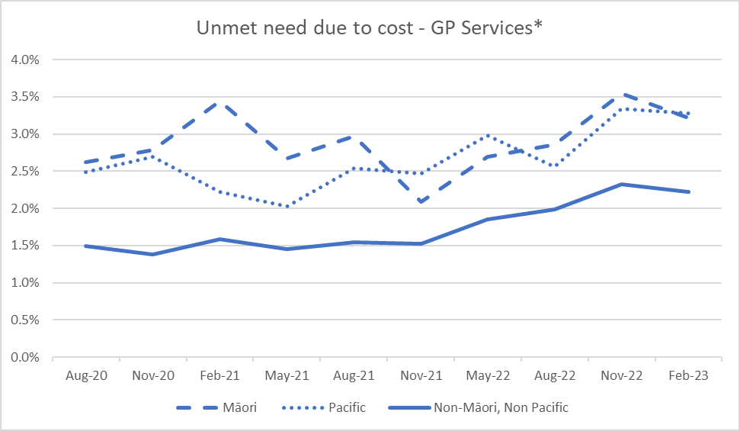
*Appointment too expensive or owed money to general practice/medical centre
- Strategic work to design the future of primary care to make it more accessible, equitable and affordable is being undertaken across Manatū Hauora, Te Whatu Ora and Te Aka Whai Ora.

Kahu Taurima | Maternity and early years
- The Well Child Tamariki Ora Enhancement Support Pilot has been extended for Lakes, Tairāwhiti and Counties Manukau. The Enhanced Support Pilots are whānau-led models of care that provide mental health support, health care, help accessing social services, housing or education, or help for whānau to learn about parenting and child development. Turuki Healthcare will commence their contract on 1 July 2023 to cover whānau living in Counties Manukau.
- Latest analysis below as at June 2023 shows Māori and Pacific three-month-old new-born enrolment with a General Practice or a Kaupapa Māori health providers is consistently under target compared to non-Māori, non-Pacific. Pacific three-month-old new-born enrolment rate shows the least improvement of only 0.6% increase in June 2023 compared to June 2022. The challenges faced with lifting new-born enrolment rates in the past year continue to be influenced by ongoing workforce challenges within primary health care such as retiring general practitioners and primary care nursing pay disparity versus hospital nurses. In response, Te Whatu Ora and Te Aka Whai Ora continue to work on embedding kaiāwhina roles, for providers serving Māori populations and lifting recruitment rates.
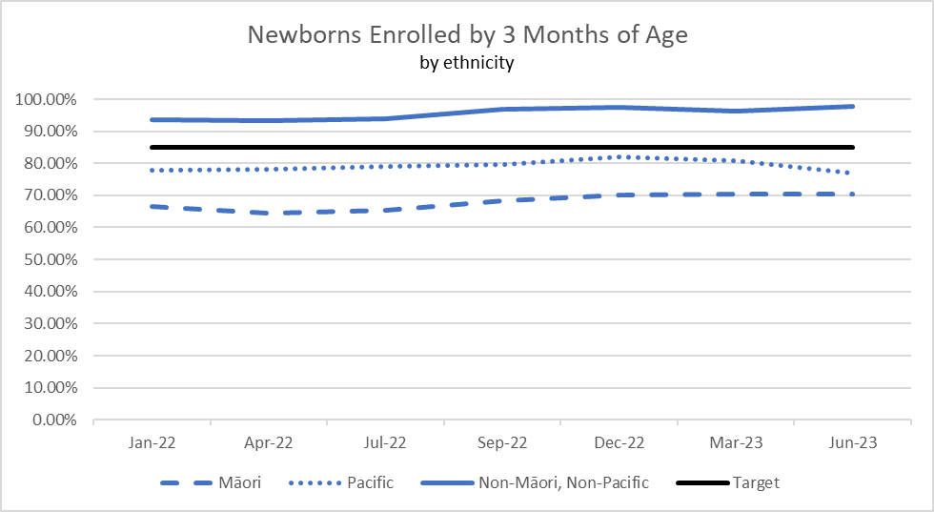
- When new-borns are enrolled with a general practice at birth, health professionals gain more opportunities to maximise their health as they grow. Kahu Taurima will drive the integration of maternity and early years services for a child’s first 2,000 days, from conception to five years old, across Aotearoa. This programme is designed to provide continuity of care throughout the pregnancy and the baby's access to healthcare services.
- Work continues on re-designing the national settings for the service components of Kahu Taurima to be delivered to all whānau including regional co-commissioning. It is expected that service delivery models of care will be developed by whānau-led co-design and continuous improvement approaches in regions will be locally tailored.
- Actions such as the development and implementation of Pacific integrated models of care for Kahu Taurima | Maternity and early childhood is in progress. Since May, four Pacific Models of Care pilots in Auckland (two providers), Wellington and Christchurch have been implemented.
- The Tāngata Whaikaha workstream team has been established. The team meets regularly and has planned engagements with key stakeholders. Efforts are being made to collect insights into the needs and issues of family members involved in Kahu Taurima journeys, and clinicians and providers will be invited to participate in the planning process so they can provide input on the resources needed to ensure they are equipped to provide care aligned with Enabling Good Lives Principles with the skills, capability, and confidence to deliver the best care.

Mate pukupuku | People with cancer
- The National Suspected Lung Cancer Pathway is in final draft using the new national framework has enabled the national pathway to highlight unwarranted variation and inequities. With all areas of Te Whatu Ora, Te Aka Whai Ora and Pacific Partners working together to commission and implement these new pathways, patients and whānau will ultimately receive equitable care across the motu.
- The human papillomavirus (HPV) pathway has been completed. However, the launch of the programme has been delayed until September 2023. A national agreement has been signed with Streamliners to provide the platform and support services for this initiative.

Māuiuitanga taumaha | People living with chronic health conditions
- Buttabean Motivation and Total Healthcare continue to work on their innovative approach to managing chronic conditions for target population groups. Early evaluation shows promising improvements across those who have participated in the service. This contract will be extended for a further 12 months in September 2023.
- A Heart Health Plan will provide wrap-around support for people who have had their cardiovascular disease risk assessed. It will help healthcare workers better support their patients to reduce the risk of cardiovascular disease. Two primary health organisations are currently trialling and refining the prototype of the Heart Health Plan. Community based Māori and Pacific providers are being approached to provide this service next year to further refine this tool.

Oranga hinengaro | People living with mental distress, illness and addictions
- The partnership with Ministry of Housing and Urban Development and Ministry of Social Development has focused on delivering two Rapua Te Āhuru Mowai services in Hamilton and Auckland. Rapua Te Āhuru Mowai is an initiative aimed at those inpatients with nowhere to go for housing in the community. The service transitions clients in mental health inpatients back into the community with both housing and wrap around support. As of June 2023, Auckland has 31 active cases, with 25 in permanent housing, out of 42 total referrals. For the Waikato pilot, 39 people have been referred to the Waikato programme, and there are currently 25 active cases.
- Te Ara Oranga is a programme aimed at addressing the complex social issues that underpin widespread impacts of methamphetamine. This programme started in Northland and has been extended to Murapara. Te Ahi Maurai will continue to scale up the initiative in Murupara. Pou Oranga Whai Ora will cover the rest of the Eastern Bay of Plenty from 1 July 2023.
  - Embed Te Tiriti o Waitangi across the health sector
This priority reflects the reform system shift of ensuring Māori have a greater role in designing health services that better meet the needs of Māori. Māori communities will play an important role in making sure our health services work for Māori, and the many New Zealanders accessing kaupapa Māori health services. A health system that does better for Māori does better for all.
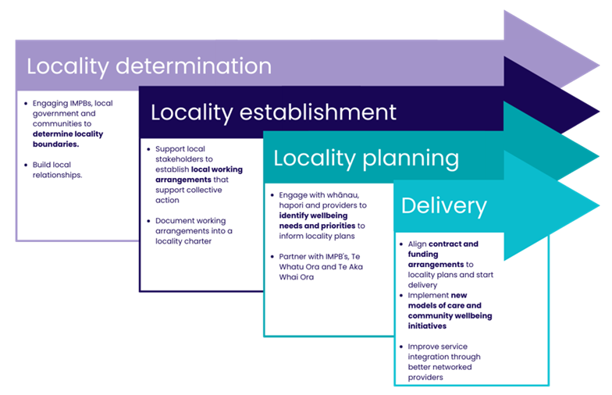
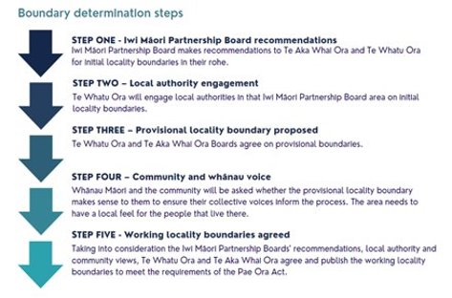

Progress with first localities (prototypes) and the national roll out
- Budget 2021 set aside $45.98m for investing in locality prototypes across four years. This funding was intended to support locality establishment, ongoing locality commissioning and network support, investment in service delivery and evaluation of prototypes. The Budget 2021 commissioning and service delivery funding will enable innovations and service development in response to the locality priorities and can demonstrate commissioning for Pae Ora through co-design with local communities. The service development funding has been allocated to each locality area using an equity-based model and will support local initiatives.
- Seven Iwi Māori Partnership Boards have provided locality boundary recommendations which cover an additional 22 provisional locality boundaries, totalling 57% of New Zealand’s population across 34 localities. Based on these recommendations and local authority engagement, Te Whatu Ora Board has agreed to an additional 22 provisional locality boundaries to commence the locality establishment process later in 2023.
- Regional and local localities kaimahi will be supported to understand and support the establishment of new localities through an in-person learning and development programme, supplemented by a digital learning platform. Change management for locality establishment is also being supported by the development of communications resources.
  - Develop an inclusive health workforce
This reflects the reform system shift of ensuring we plan for our future health workforce requirements and provide for the training and development needs of New Zealand’s health workforce.

Highlights for this quarter
- The following graph shows that in 2022 Māori accounted for 4,782 Māori nurses, 366 Māori midwives and 823 Māori doctors in the regulated workforce. In 2022, Māori make up 17.4% of the population, but the proportions of Māori nurses, midwives and doctors do not reflect this. Māori nurses account for 7.8% of the total nursing workforce (an increase from 6.9% in 2015). The proportion of Māori midwives in the total midwifery workforce increased from 9.2% in 2015 to 11.9% in 2022. Māori doctors increased as a proportion of the total doctor workforce from 3.3% in 2015 to 4.7% in 2022.
Time trend of the percentage of Māori in the nursing, Medical (doctors) and Midwifery workforce
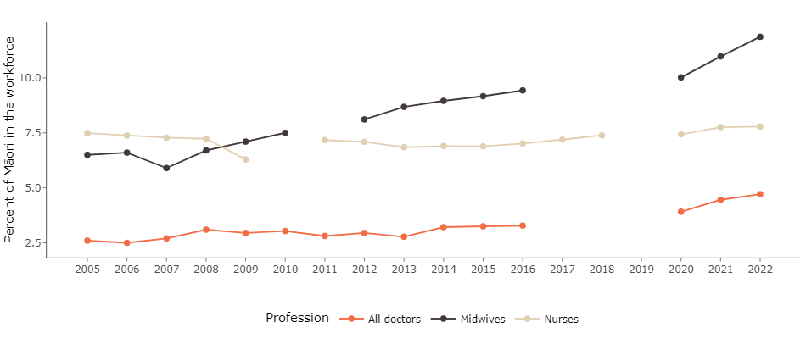
- The Health Workforce Plan 2023/24 developed by Te Aka Whai Ora and Te Whatu Ora has been completed. It has been endorsed by cabinet and released by the Minister on the 4 July 2023. The workforce plan outlines six priority areas:
- Growing pathways for Māori in health
- Growing pathways for Pacific peoples in health
- Driving local-led innovation in training
- Bolstering priority workforce groups
- Supporting and retaining our valued workforce
- Growing our future leaders
- The plan has a large focus on growing pathways for Māori and Pacific in health to address their under-representation in the workforce including:
- Streamlined pathways for tauira Māori into health careers, including investing in Māori retention, and growing programmes that already support tauira Māori into health.
- Strengthened hauora Māori workforce pathways from whānau, hapū and iwi, including scaling earn-while-you-learn pathways for Māori into health roles.
- Support for kaimahi Māori to thrive in the workplace, including expanding cultural and clinical support and coaching for our Māori workforce.
- The Health Workforce Plan provides a support-demand model for key workforces. The immediate priority is to increase the number of clinical placements to enable more students. Funding for medical school enrolments will be increased by 50 places beginning in 2024. Additionally, 130 additional nursing placements have been funded for July and August 2023, and we are working with nurse education providers to support an additional 700 nursing placements nationwide from 2024. Additional engagement with Te Pukenga, the Tertiary Education Commission and other bodies will support ongoing efforts to grow and develop a flexible workforce.
Initiatives to increase the workforce in Mental Health and Addiction Services are also underway:
- The first meeting of the four new Psychology Intern Hubs was held in Waikato to share progress and information. This new approach to building Clinical Psychology Internship capacity and experience is already showing very positive outcomes.
- An advanced training framework initiative was developed to support a new career workforce in Te Whatu Ora specialist eating disorder services. The Initiative also provides development and support for supervisors.
- A Matauranga Māori initiative was also contracted to develop support and resources for whānau and workforce in Eating Disorder/Eating Issues services.
- Five Districts began the development of Specialist Peer roles in Te Whatu Ora secondary Mental Health and Addiction services as part of their Multidisciplinary Teams (MDT). This initiative which establishes more than 26 FTE (approx. 40 peers) provides for foundational training, specialist peer and Kaupapa Māori training, as well as support for the whole MDT.
- A workforce development support initiative for specialist MDT was contracted.
- A collaborative psychiatry working group was agreed for Te Whatu Ora and the Royal Australian New Zealand College of Psychiatry to work on options for increasing the psychiatry training pipeline. It has its first meeting in early July.
- In May, Le Va, the Pacific Mental Health and Addiction Workforce Centre celebrated its 15th birthday at an awards dinner to honour the 165 ‘Futures that Work’ scholarship recipients. The Te Whatu Ora funded scholarships go to Pacific people studying toward Mental Health and Addiction careers. The event was attended by Ministers Edmonds and Davidson and Deputy Prime Minister Sepuloni.
- 341 nurses and allied health practitioners in Mental Health and Addiction services are enrolled in New Entry to Specialist Practice (NESP) training in June 2023. There is some capacity available for the mid-year intake. Te Pou is working with non-governmental organisations (NGOs) to grow NGO participation in this programme.
  - Keep people well in their communities
This priority reflects two of the reform system shifts. Firstly, people will be able to access the healthcare they need closer to home. Health services will better reflect community needs and preferences. There will be a strong emphasis on preventing illnesses and other factors that support healthy lives, such as living in a warm, dry home. Secondly, high-quality emergency or specialist care will be available when people need it. Networks of doctors and other medical professionals will work together with community services to educate and keep people well.

Highlights for this quarter
- A work programme has been established to ensure cross-agency representatives and stakeholders are involved in health needs assessments for children and young people in care and youth justice from the outset. Representation from Te Whatu Ora and Te Aka Whai Ora Kahu Taurima are part of the Oranga Tamariki Action Plan Oversight Group.
- The review of the Gateway Assessment Programme has commenced. Communication advising of the initiation of this review has been sent to Te Aka Whai Ora Regional Directors and Te Whatu Ora Regional Wayfinders for wider distribution to stakeholders.
- School Based Health Services are designed to empower young people to become more confident and reach out for help with any health (including mental health) issues when they need it. This programme is currently available to all decile 1 to 5 secondary schools, Teen Parent Units and Alternative Education sites. The expansion of the service to activity centres is progressing well with the service available in 8 of the 10 relevant districts. Agreements with Hawke’s Bay and Tairāwhiti are in progress.
- Seven providers have been selected to implement the Dementia Mate Wareware Action Plan over four years. The contracts have been signed and the announcements have been planned for mid-July 2023.
- The first phase to establishment of comprehensive primary and community care teams is currently underway. Regional Way Finders are working with localities and primary partners to progress local tailoring. Te Aka Whai Ora is supporting the process by confirming the Māori Hauora partners and the Pacific Group has completed contracting with partners who will be employing the roles as part of the Comprehensive Primary and Community Teams.
- Celebrating the launch of the National Chronic Hepatitis C Pathway across the motu. The pathway was developed collaboratively using a new national pathway development framework with national clinical and equity experts guiding the development through all phases. All regions completed a review process. Referral processes was undertaken to make the pathway fit for purpose for our primary and community teams to support patients and their whānau in their community.
- The national rollout of the Healthy Homes Initiative (HHI) is now complete. The first HHIs were established between December 2013 and March 2015 in 11 districts. Implementation in the final 9 districts was a Budget 2021 initiative. There are now providers in all districts with the final three new providers (West Coast, Whanganui and Nelson Marlborough) beginning to take referrals from 1 July 2023.
- Budget 2022 allocated $72 million over four years to extend eligibility of paid whānau or family care. Paid whānau or family care can now be provided for people assessed as having low or moderate needs. Previously, this was an option only for those assessed as having high or very high needs. Te Whatu Ora is working to strengthen the monitoring capability of uptake and impact of the policy extension, but initial reporting suggests an increase in 10% of paid whānau carers since the policy extension was implemented in December 2022. We cannot yet identify if these are newly eligible recipients.
- In addition, over this quarter Te Whatu Ora worked to make changes to the Carer Support Subsidy to make it more helpful for people, including paid whānau carers. The changes went live from 1 July and include:
- A national increase in the daily rate to at least $80.
- Full-time carers now have the flexibility to buy items that provide them with respite.
- New purchasing guidelines have been published on the webpage to support carers with making claims.
- Carer support can be used to compensate others in the household so the full-time career can have a break.
- Te Whatu Ora invested an additional $2.25 million to enable these changes to support the wellbeing of family, whānau and aiga carers.
- The BreastScreening Aotearoa (BSA) and National Cervical Screening Programme (NCSP) national kaimahi hui was planned and held in June 2023. The focus was on defining “what awesome looks like” and how partners can better support and enable increased participation in screening.
- The cervical screening monthly data shows a small but consistent increase in cervical screening coverage across all ethnicities during 2022-23. In May 2023 the National Bowel Screening Programme (NBSP) reached the milestone of 2,000 cancers being detected through the Programme. At least 30 percent of these cancers were in the early stages.
  - Develop greater use of digital services to provide more care in homes and communities
This priority reflects the reform system shift that digital technology will be used in more and better ways, to provide people with services in their homes, hapori and local communities. Technology will also help healthcare workers better understand and support their patients.

Highlights for this quarter
- Sector Digital Channels: Population Health Digital Capability platform built for COVID-19 text and email communications has been extended to support whooping cough (for over 45s) and shingle vaccination (for over 65s) notifications to 300,000 people to further protect this cohort in the winter season. This has resulted in 1,000 vaccination doses in just two weeks.
- AIR vaccinator portal continues to support Flu2023 campaign with 200,000 flu immunisations recorded through the new portal in the last month (total currently 202,000 through the AIR vaccinator portal. It is used by vaccinating pharmacies and community providers).
- Zero data cross agency collaboration launched in May to ensure people can access publicly available websites at no cost through a mobile device. Te Whatu Ora (supported by Te Aka Whai Ora and Manatū Hauora) are among the first adopters with sites such as Health Navigator, 1737- Need To Talk?, Plunket and the Te Whatu Ora and Te Aka Whai Ora websites.
- Wairarapa Go Live of a new Clinical Portal which is linked to the single instances of Capital Coast and Hutt Valley, therefore giving visibility to clinicians of patient information across all three districts. The next phase is to link this to the single portal used by Hawkes Bay, Whanganui and MidCentral therefore enabling access to patient information across the entire region.
- National Data Platform business case was approved by the Board on 23 June 2023. With a statement of work in place with the selected implementation partner, the project started a 9-week discovery stage on 17 July to document and confirm the requirements and high-level target state for the platform – including change management, operating model and technology stack. The design and build stage to follow will deliver a worked example that draws from the Medicines Data Repository and demonstrates the end-to-end operation of the platform. This will be the first of seven priority national datasets that will be added to the platform in the first 12 months, and existing National Collections datasets will all be catalogued as part of the solution.
  - Establish Te Whatu Ora and Te Aka Whai Ora to support a financially sustainable system
We are taking actions to unify and simplify the systems of decision-making through procurement, data and digital systems, long-term planning, infrastructure investment choices and workforce planning.

Highlights for this quarter

Unify to Simplify
- The change process to merge 20 district health boards and their seven shared service agencies into a single entity with a single operating model is being managed by a central change team.
- The final organisational structures along with the baseline budgets are being discussed with the relevant functional Tier 2s and the Chief Executive. Functions have been through consultation on proposed decisions. Feedback from staff has been reviewed and incorporated.
- The change team continue to monitor key milestones around final decisions / re-consultation for each business unit. Robust and consistent processes have been developed for business units, including a centrally managed Expression of Interest process. The next phase of change will involve implementing new organisational structure designs across the business units to achieve nationally planned and coordinated consistency of delivery and care.

Pae Ora Roadmap
- Work has progressed on the Pae Ora Roadmap, with initiatives largely on track and underway. The Pae Ora Roadmap highlights the significant and material short term initiatives that the organisation is prioritising to drive Pae Ora.
- Highlights include the Planned Care initiative where focused attention is directed at addressing long waiting patients, and the National Flow Programme which has been directed towards winter planning and contingency. Many of the delivery initiatives will be supported through alignment with the digital and workforce programmes. Analytics will play a vital role on focusing our delivery and improvement efforts to high impact changes.

- Our Performance
  - Delivering Te Pae Tata Interim New Zealand Health Plan
Te Pae Tata sets out the key actions that Te Whatu Ora and Te Aka Whai Ora will undertake in the first two years to build the foundations of a unified, smarter, sustainable and equity-led health system. The following table contains quarter four progress:
Sections | Number of Actions Total | Green | Amber | Red | No milestone, no response or still assessing
A new health system focused on people | 19 | 16 | 3 | - | -
Improving health outcomes and equity | 39 | 22 | 12 | 1 | 4
A unified health system | 62 | 34 | 16 | 3 | 9
Priority populations | 61 | 30 | 9 | 8 | 14
Total | 181 | 102 | 40 | 12 | 27

- Delivering Ola Manuia Pacific Health and Wellbeing Action Plan
Ola Manuia (to live in wellness) Interim Pacific Health Plan and a companion document to Te Pae Tata was launched by Hon Minister Aupito William Sio and National Pacific Health Director Markerita Poutasi on 11 November 2022. The key priorities covered by Ola Manuia span the life course of Pacific peoples from pregnant women, children and youth, through to adults and elders, and include focusing on long-term conditions (such as diabetes), mental health and tagata sa’ilimalo - people with disabilities.

Highlights for this quarter

Te Whatu Ora Pacific Health Scholarships awarded to 220 Pacific students
- 220 tertiary scholarships were awarded to Pacific students studying health and disability related courses including medicine, dentistry, nursing, midwifery and allied health. The scholarships contribute directly to students’ tuition fees.

Supporting 35 Pacific trained nurses in the new Graduate Diploma in Nursing Pacific
- The Graduate Diploma in Nursing Pacific is a new programme developed by Te Pūkenga, Whitireia, delivered in collaboration with Te Pūkenga Manukau Institute of Technology and supported by Te Whatu Ora. It offers an alternative pathway for nurses trained in the Pacific to apply for New Zealand nursing registration and a practising certificate to work as a nurse here in Aotearoa.
- Te Whatu Ora is supporting this new pathway by investing $776,440 for 2022/23 to fund 35 Pacific trained nurses enrolled in the programme, covering fees and course-related costs.

Equity adjustments to capitation
- Te Whatu Ora, in partnership with Te Aka Whai Ora, has implemented targeted investment for primary care, reaching Pacific providers who offer general practice care as well as Māori providers and other specific practices based on their enrolled Pacific and Māori populations.
This investment targets additional funding to all Pacific provider primary care practices, (10 across the country) in addition to all Hauora Māori primary care providers and 75 additional primary care providers with more than 50 percent of their enrolled population being Māori and/or Pacific peoples. This targeted approach will reach approximately 126,000 Pacific people.

Kaiāwhina funding for Pacific health roles
- Te Whatu Ora, in partnership with Te Aka Whai Ora is implementing a $44 million funding boost for primary, community and rural care in New Zealand over the next two years to build comprehensive primary care teams and grow capacity in the workforce.
- As part of this programme, almost 55 kaiāwhina FTE will be established in Pacific providers to help improve access to services for Pacific aiga/kainga/famili. Additional funding has been allocated for the training and development of the newly created kaiāwhina workforce. This will be jointly administered between Te Aka Whai Ora and Te Whatu Ora’s Pacific Commissioning team. Total investment for Pacific health is almost $8.7 million.

Pacific Provider Development Fund
- Pacific Health, in collaboration with Pacific service providers, is reviewing the Pacific Provider Development Fund. The review will identify opportunities for improvement and enhancement, including an assessment of eligibility criteria and how access by smaller providers can be supported.

Pacific Integrated Contracts programme
- Integrated contracts will make it easier for providers to work with us, removing complexity by creating one contract per provider creating administration alignment and improved health outcome reporting.
- The Pacific Integrated Contracts pilot launched in June with a three-month trial period where six Pacific providers will test the new outcomes framework and feasibility of reporting.

Kahu Taurima
- Kahu Taurima is a joint Te Aka Whai Ora and Te Whatu Ora approach to supporting whānau centred care for maternity and early years (pre-conception to five years old, or the first 2,000 Days of life).
- This programme supports Pacific providers to develop Pacific specific approaches to maternity and early years. The investment will support the delivery of culturally appropriate and innovative pilots based on Pacific models of care to improve health outcomes.
- Pacific provider pilots for Kahu Taurima have been commissioned to commence in South Auckland, Wellington, and across some areas in the South Island. These regions have been selected due to the large or growing Pacific populations.

Supporting providers to deliver integrated care through Community Hubs
- We are partnering with six Pacific Health providers across the motu to receive Pacific Community Hub funding to improve their ability to respond to their communities’ health needs.
The six providers are:
- Le Afio’aga o Aotearoa (South Seas Healthcare) – Northern Region
- K’aute Pasifika - Te Manawa Taki Region
- Pacific Health Services Hutt Valley Inc – Central Region
- Pacific Health Plus – Central Region
- Etu Pasifika Christchurch – Te Waipounamu Region
- Oamaru Pacific Island Community Group – Te Waipounamu Region
- These providers are responsible for leading the work to grow and develop services for their communities. The Pacific Health Commissioning team and Pacific Health Interim Regional Leads will work alongside providers to develop localised approaches to provide integrated care and culturally responsive services. This will involve different forms of communication and engagement such as in person, outreach, telephone and online. Providing options to collaborate will facilitate better information sharing to understand and ensure community voices are amplified. As a result, the localised plans will have explored multifaceted solutions that reflect the community's needs.

Child and Youth

Rheumatic fever roadmap
- In Aotearoa, the incidence of rheumatic fever is much higher than in other high-income countries, and almost exclusively affects Māori and Pacific children and young people aged 4-19 years old that are living in the North Island.
- In June, the Rheumatic Fever Roadmap 2023–2028 was launched by Dr Anae Neru Leavasa MP for Takanini on behalf of Hon Minister Edmonds.
- The Roadmap was developed to reset, renew, and amplify efforts to tackle rheumatic fever and rheumatic heart disease. It brings together those involved in rheumatic fever and rheumatic heart disease prevention and management and focuses activities and priorities into a coherent plan.
- Priority 6 Establish Te Whatu Ora and Te Aka Whai Ora to support a financially sustainable system
Te Whatu Ora's performance against budget is shown in the following table.
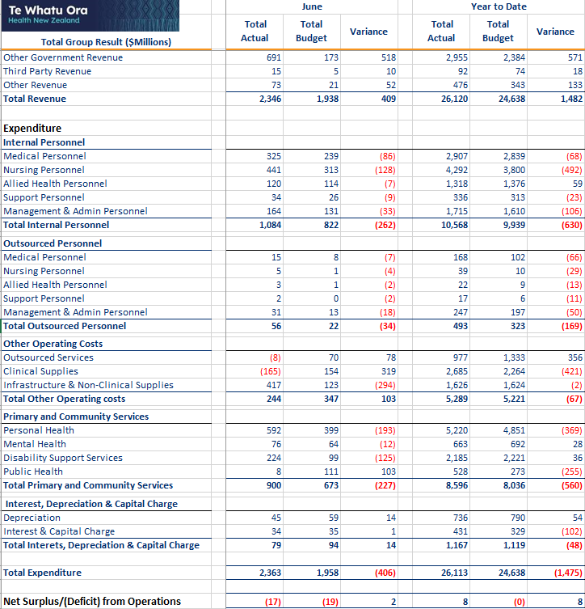
- The operating result for the month of June is favourable to budget by $2 million and $8 million favourable year-to-date.
- The result for the month has a number of year end entries including write-off of COVID stock, standardising Holidays Act provisions, correctly entering financial information from all subsidiaries and standardising account classifications. This gives variation across account categories for the month. However, the overall bottom line is within budget.
- Accruals for latest offers for unsettled collectives are also included in the result and changes required from the opening balance sheet work.
- Revenue has been reconciled and agreed for year-end with Pharmac, Manatū Hauora, Te Aka Whai Ora and Whaikaha.
- This result also reflects harmonization of actuarial accruals ensuring the consistent calculation basis is used across the organisation.
- Financial results are unaudited and subject to change.

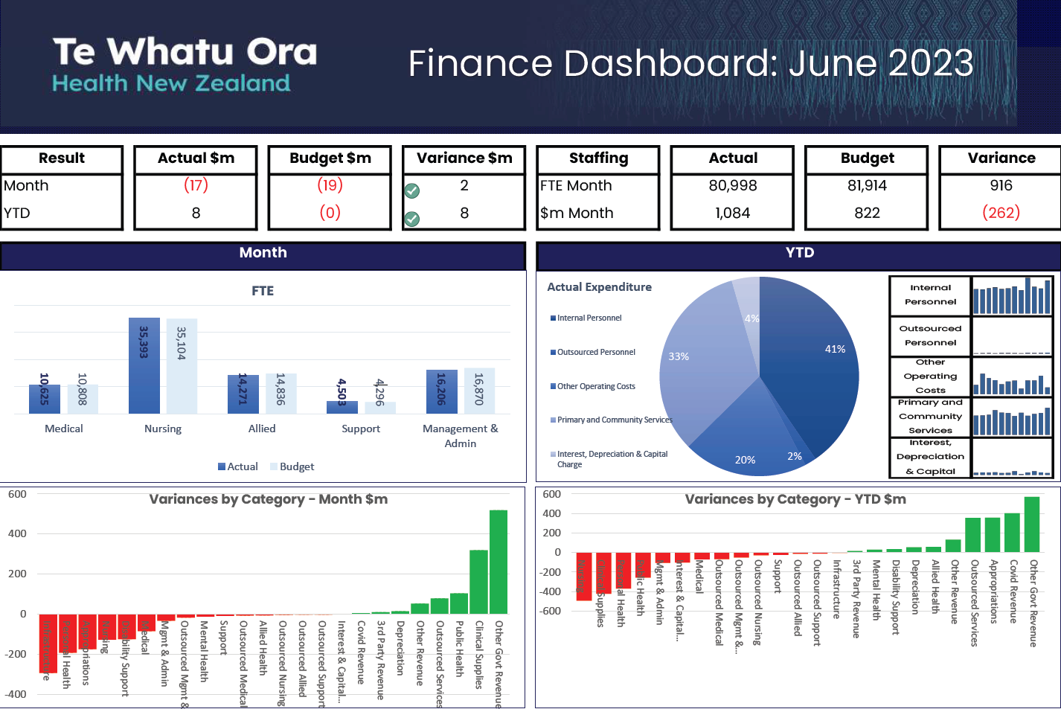

Latest data to Feb 2023 available from the HQSC Adult Primary Health Care Patient Experience Survey result https://reports.hqsc.govt.nz/APC-explorer/?_gl=1*1l9btix*_ga*MTAzNjcyNzMzOC4xNjc3NDgxOTU0*_ga_TG4RCRSBWS*MTY4MjU3NzI2MS4xNS4wLjE2ODI1NzcyNjEuMC4wLjA. Accessed on 27 July 2023.
Data sourced from Whakamaua 2020-2025: minhealthnz.shinyapps.io/WhakamauaDashboard/

