Quarterly Performance Report

Quarter ending
31 December 2022

Citation: Te Whatu Ora – Health New Zealand. 2022. Quarterly Performance Report: Quarter ending 31 December 2022. Wellington: Te Whatu Ora – Health New Zealand.
Published in May 2023 by Te Whatu Ora – Health New Zealand
PO Box 793, Wellington 6140, New Zealand
ISBN 978-1-99-106716-6 (online)
This document is available at tewhatuora.govt.nz
This work is licensed under the Creative Commons Attribution 4.0 International licence. In essence, you are free to: share i.e., copy and redistribute the material in any medium or format; adapt i.e., remix, transform and build upon the material. You must give appropriate credit, provide a link to the licence and indicate if changes were made.

Contents
Foreword 3
1 Snapshot for Quarter 2 6
2 Key Priorities 8
1. Place whānau at the heart of the system to improve equity and outcomes 8
2. Embed Te Tiriti o Waitangi across the health sector 9
3. Develop an inclusive health workforce 9
4. Keep people well in their communities 10
5. Develop greater use of digital services to provide more care in homes and communities 10
6. Establish Te Whatu Ora and Te Aka Whai Ora to support a financially sustainable system 11
3 Our Performance 12
Delivering Te Pae Tata | the Interim New Zealand Health Plan 12
Delivering Ola Manuia Pacific Health and Wellbeing Action Plan 13
Non-financial performance 15
Establish Te Whatu Ora and Te Aka Whai Ora to support a financially sustainable system 37
Te Whatu Ora Financial Performance 38
Infrastructure Investment 40
Risk Management 40
Appendix 1: Budget 22 Investments Update 43
Appendix 2: Performance by Region 63
Northern Region Summary and Highlights 63
Te Manawa Taki Region Summary and Highlights 65
Central Region Summary and Highlights 67
Te Waipounamu Region Summary and Highlights 69
Appendix 3: Glossary 71

Foreword
Our second Quarterly Report from 1 October to 31 December 2022 updates on progress with the establishment of Te Whatu Ora on 1 July 2022. We continue implementing Te Pae Tata | Interim New Zealand Health Plan 2022 (Te Pae Tata) to improve how health care is delivered to New Zealanders.
The health system shifts we are implementing aim to achieve the Government’s reform objectives for the health system to work in partnership with Māori and all communities in the design and delivery of healthcare, to tackle equity gaps across the health system, deliver person and whānau centred care and enable excellence through harnessing clinical leadership, innovation and digital technology to continuously improve how we deliver care.
We will achieve this through the following shifts:
- The health system will uphold Te Tiriti o Waitangi
- People and whānau will be supported to stay well and connected to their communities by having more care closer to home
- High quality specialist and emergency care will be equitable and accessible to all when it is needed
- Digital and technology investments will provide more care in people’s homes and communities, and
- Our health workforce will be valued and well trained, ensuring we have enough skilled people to meet future needs.
In Quarter 2 progress is being made with some highlights below:
- 11 Iwi Māori Partnership Boards have been established
- Locality prototypes have been formed and are progressing with service planning
- A rural, iwi-based, not-for-profit organisation has partnered with Te Whatu Ora to relocate a mammography unit from Waikato Hospital. In the first four weeks of the service, over 400 women had mammograms
- An expanded clinical telehealth service, providing access to 24/7 nurse triage and GP overflow services (telehealth doctor consultations if required) at no cost to patients or GPs is providing alternatives for how we choose to see a health professional
- Specialist services are giving patients more options to access care outside their previous district boundaries, eg, Timaru Hospital is providing gastroscopies and colonoscopies for populations normally served by Christchurch and Dunedin Hospital networks
- Messaging services, originally developed for COVID-19 booster reminders, are being used to encourage women to schedule a mammogram appointment. More than 640 Māori and Pacific women have had breast cancer screenings in South Auckland since November 2022. Plans are being developed to roll this out across the motu
- A programme to provide free online access for consumers to essential health information and services is up and running. While over 90% of our population have access to a smart phone, the cost of mobile data is a key barrier
- A nationwide recruitment service has been established to streamline the search, assessment and education of workers for our health system. Funding was released to establish a rural primary care locum service, increase the numbers of nurse practitioners in training for 2023, support for overseas trained doctors registering in New Zealand and subsidies for nurses (local and internationally qualified) to re-enter the workforce.
- A Pulse Survey of staff to gather feedback on workplace experiences and provide a baseline for Te Whatu Ora was completed at the end of December 2022. Over 27,900 people or 29% of staff engaged in the survey. The results will be shared with teams in quarter 3.
At a national level winter planning is well underway for 2023. We are encouraging people to get their flu vaccinations and Covid-19 vaccinations as the first line of defence this winter, with free vaccinations for those who are eligible.
We are also focusing on care closer to home, so when people do get unwell this winter there are options for care near where they live, focused on telehealth, and primary and community care, alleviating pressure on hospitals.
While winter planning is nationally led, each region will tailor these initiatives to meet local needs, with a focus on Māori, Pacific people, disabled people and older people. Hospitals will also be introducing national measures to manage patient numbers through winter and because we are now one system, we can direct resources where they are needed the most, more easily.
At the same time there will be a continuing priority to ensure tamariki are up to date with childhood immunisations, and while not a winter issue per se, these serious and preventable illnesses such as whooping cough, can be more prevalent over winter.
On the establishment of Te Whatu Ora, by the end of December, Regional Integration Teams were established to provide regional leadership and support local implementation of delivery of care. Regional Integration Teams are co-chaired by Regional Wayfinders (Commissioning) and Regional Directors from Te Aka Whai Ora.
Regional Integration Teams include regional leadership in delivery - Hospital and Specialist Services, Public Health Service, Pacific, Service Improvement and Innovation and Clinical Leadership. In Quarters 3 and 4 we will align with Regional Public Service Commissioners to focus on the social determinants of health. By December 2022, reporting lines for teams were also aligned with national leadership to unify teams and prepare for the next step of change in Quarter 3 to simplify how we work by reducing duplication.
Although we have merged 28 separate health entities we are some way from unifying how we work. At six months, the fragmentation of information and clinical systems has not changed, hampering the quality of information for national and regional decision making and challenging how quickly we can work to standardise and simplify processes.
Some improvements have been made to enable more rapid collation of operational performance information through Rapid Data Automation however, there is much more work to do to realise a joined-up system.

Fepulea’i Margie Apa
Chief Executive
Te Whatu Ora | Health New Zealand

- Snapshot for Quarter 2
Workforce: A significant tranche of investments in the health workforce is underway. This includes the successful launch of Round 3 of the Return to Nursing Support Fund and the launch of an initiative to fund Internationally Qualified Nurses for support with Competency Assessment Programmes. This latter programme had received 528 eligible registrations of interest as of 24 November, to help nurses back into practice.
Waitlists: The number of patients waiting more than four months for a first specialist assessment (FSA) fell from 38,051 in October to 37,779 in November, and for treatment, increased from 28,906 in October to 29,058 in November. Regions continue to work and collaborate to address the number of patients waiting beyond expected timeframes despite capacity and workforce constraints.
The total number of planned care interventions increased in November and continues to exceed plans as the trend has shown for the last four months. The total planned interventions were 125,245, and the actual delivery was 128,681. This is largely due to an increased volume of minor procedures, which is counteracting the lower volumes of inpatient planned surgery due to the capacity constraints. The Hospital and Specialist Services team already have several urgent actions underway to book those people who have experienced the longest wait times. Patients waiting longer than 365 days for treatment increased from 5,107 in October to 6,003 in December. However, for FSAs, this fell from 3,529 in October to 3,459 in December.
Winter Preparedness Vaccination Programme: In preparation for winter, Te Whatu Ora is running a winter preparedness campaign, which encourages uptake of the flu vaccine and the bivalent BA.4/5 COVID-19 vaccine. The campaign will commence on 1 April. To increase uptake and to further close the equity gap, Te Whatu Ora has worked with Pharmac to extend the funding of the flu vaccine to Māori and Pacific people aged 55 to 64 years and children aged 3 to 12 years. The flu vaccine will also be funded for people over 65, people with long-term conditions (like asthma and diabetes), people with specific mental health conditions or addiction issues, those who are pregnant and children aged 6 months to 3 years who meet the criteria. In addition, from 1 April, anyone aged 30 years and older will be eligible to receive the COVID-19 bivalent vaccine, at least 6 months since their last COVID-19 booster or positive COVID-19 test.
Te Whatu Ora has undertaken qualitative consumer research to inform communications and promotions for free flu and COVID-19 vaccinations. Based on the research findings, COVID-19 and flu vaccinations will be largely presented independently of each other, however, both communication campaigns will utilise a two-phased approach. Phase 1 will target priority groups, while Phase 2 sees an expansion of flu promotions to include New Zealanders who may wish to pay to get the flu vaccine. While the COVID-19 and flu vaccines will be promoted separately, both vaccinations will be offered to be administered concurrently to eligible people. To support this, give people choice, and help to improve accessibility, Book My Vaccine has been updated to enable people to make a single appointment for the administration of both their flu and COVID-19 vaccines at pharmacies and vaccination clinics (note Book My Vaccine does not include GPs).
Acute Demand: An enhanced oversight and assurance process for the Notification/Assessment/Escalation/Response approach was stood up over the Christmas holiday period. This approach is an all-of-system approach covering communicable diseases, natural disasters, weather-related events and significant disruptions to Hospital and Specialist Services, which should increase health system agility during the winter period.
Primary Care Equity and care closer to home: During this quarter there was further work undertaken to establish localities in partnership with iwi. This represents a fundamental change to the way in which healthcare services will be designed to respond to local communities. Services are being designed by local communities so that more people can access the care they need closer to home.
We have made healthcare more accessible over the summer months through an expanded clinical telehealth service. This provides access to 24/7 nurse triage and GP overflow services (telehealth doctor consultations if required) at no cost to the patient or to general practices.
Other interventions to improve access and prevention in primary care include raising awareness for cervical screening in South Auckland to ensure more Māori and Pacific women undertake their check. We are also trialling regional campaigns using tools developed in COVID-19 to encourage breast screening and vaccinations of tamariki Māori and Pacific children.
Mental Health and Addiction: Children and youth (under 25) accessing specialist mental health services within three weeks of referral is a key health system indicator. The second quarter results (December 2021-November 2022) saw a decrease in the proportion of those aged under 25 years seen by specialist mental health and addiction services within three weeks. Results for Pacific people were above the target of 80%, however Māori and non-Māori/non-Pacific were 77% and 66% respectively. By the end of October, 627,000 sessions had been delivered with an enrolled population coverage of 2.8 million people through integrated GP services under the Access and Choice initiative, where mental health and addiction clinicians are located in general practices.
Financial: Te Whatu Ora is currently on track to deliver within budget for 2022/23. Additional costs for activity for ACC were funded through extra revenue, and costs for staff overtime to cover sickness and vacancies, plus an additional public holiday, have been absorbed within budget.
- Key Priorities
There are six priority Te Pae Tata actions that form the backbone of our response to the interim Government Policy Statement on Health. Our progress and highlights in this quarter against each of the six priority actions are outlined below.

Place whānau at the heart of the system to improve equity and outcomes
Five priority areas:
- Pae ora | Better health in our communities
- Kahu Taurima | Maternity and early years
- Mate pukupuku | People with cancer
- Māuiuitanga taumaha | People living with chronic health conditions
- Oranga hinengaro | People living with mental distress, illness and addictions
Highlights:
- Additional support funding was confirmed, and new Air Ambulance Service Agreements were executed. The new contracts include updates to better recognise the workplace health and safety obligations of all parties. The contracts are with Northern Rescue Helicopter Limited, Central Air Ambulance Rescue Limited, and Helicopter Emergency Medical Services NZ Limited.
- Continuation of the Well Child Tamariki Ora Enhanced Support Pilots (ESP). The ESPs provide a wrap-around culturally responsive intensive service for high needs whānau to help improve health outcomes for tamariki. ESP services have now reached 109 mothers and 62 fathers, and a total of 72 babies have been born to women supported by ESP.
- A specialist service for victims of non-fatal strangulation was established this quarter and is available in each police district. Medical Sexual Assault Clinicians Aotearoa has formally contracted 11 approved providers, with 33 appropriately accredited clinicians available to perform services.
- A National Equity Initiative was actioned relating to increasing the number of bariatric surgery procedures delivered before June 2022. As well as the surgical procedure, this initiative includes a wrap-around service to support patients.
- Continuation of the Alcohol and Other Drug Treatment Courts. These support people whose offending is linked to alcohol and other drug (AOD) use to complete a treatment programme under judicial supervision as an alternative pathway to imprisonment. Sustainable funding for Aotearoa three AOD Treatment Clinics (located in Auckland, Waitākere and Waikato) was announced in Budget 2022.

Embed Te Tiriti o Waitangi across the health sector
This priority reflects the reform system shift that ensures Māori have a greater role in designing health services that better meet their needs. Māori communities will also play an important role in making sure our health services work for Māori, and the many New Zealanders accessing kaupapa Māori health services. A health system that does better for Māori does better for all.
Highlights:
- Eleven Iwi Māori Partnership Boards are in place and have had their operating Terms of Reference assessed and submitted to the Minister this quarter.
- A draft Māori sovereignty framework has been developed setting out protocols for the governance of data and information, privacy and security and ensuring appropriate data and protection standards are in place.

Develop an inclusive health workforce
Planning for our future health workforce and providing the training and development needs for the workforce of tomorrow so our healthcare workers will always have the skills they need.
Highlights:
- Two pilots for New Zealand Registration Examinations have been established for January 2023 intakes to get internationally trained medical practitioners practising faster, particularly in general practice and rural settings.
- Delivered two new Pacific health initiatives – a Wayfinder programme to support Pacific students entering undergraduate health courses to support the transition into tertiary study (currently centred on the University of Auckland), and a new postgraduate diploma in Pacific Health to support Pacific trained nurses to gain New Zealand registration, commencing in 2023.
- National Workforce Working Groups have been established and are developing programmes that include responses to growing the number and diversity of the health workforce, including Māori, Pacific and Tāngata Whaikaha (disabled people).

Keep people well in their communities
This priority reflects two of the reform system shifts. Firstly, people will be able to access the healthcare they need closer to home. Health services will better reflect community needs and preferences. There will be a strong emphasis on preventing illnesses and other factors that support healthy lives, such as living in a warm, dry home. Secondly, that high quality emergency or specialist care will be available when people need it. Networks of doctors and other medical professionals will work together with community services to educate and keep people well, so fewer people need healthcare in the first place.
Highlights:
- A new policy allowing Payment to Family Members for Support Services has been approved and implementation will commence in January 2023. This initiative will ensure that people receiving home and community supports because of ageing have the option to choose to pay a family member to provide those supports.
- Continuation of Mana Ake and expansion of Mental Wellbeing Support for Primary and Intermediate School-aged Students. Service delivery has commenced in West Coast and continues in Canterbury and Kaikōura. Implementation has begun in Northland and agreements in Counties Manukau, Bay of Plenty and Lakes are being finalised.

Develop greater use of digital services to provide more care in homes and communities
This priority reflects the reform system shift that digital technology will be used in more and better ways, to provide people with services in their homes, hapori and local communities. Technology will also help healthcare workers to better understand and support their patients.
Highlights:
- A team has been established and the budget confirmed to progress a nationally consistent system of data capture, analytics and intelligence. This will support the use of health intelligence and insights to ensure equity of access and outcomes from all health services across Aotearoa.

Establish Te Whatu Ora and Te Aka Whai Ora to support a financially sustainable system
In this first year, the focus will be on merging the 20 district health boards and their seven shared service agencies into a single entity with a single operating model. We will take actions to unify and simplify the systems of decision-making, nationalising enablers including procurement, data and digital systems, long-term planning, infrastructure investment choices and workforce planning. Reducing duplication and concentrating resources will achieve improvement in outcomes and equity across priority areas of health service delivery.
Highlights:
- Embedding the National Public Health Service to lead a coordinated public health approach across Aotearoa, including input into wider Te Whatu Ora work. A review of regional work programmes across the Public Health Services was undertaken this quarter and strategic briefings held with key partners Te Aka Whai Ora, Iwi Māori Partnership Boards, Data and Digital, and National Commissioning.
- Establishment of the Pae Ora Delivery Unit to support the implementation of the reform programme in a coordinated and structured way. This is being achieved by sequencing, developing, and authorising initiatives with an organisation-wide view. It includes an early, focused effort on key enablers for the reform programme, and ensuring initiatives are sufficiently robust, are aligned to Te Pae Tata and the Five System Shifts. The below figure shows our implementation progress.
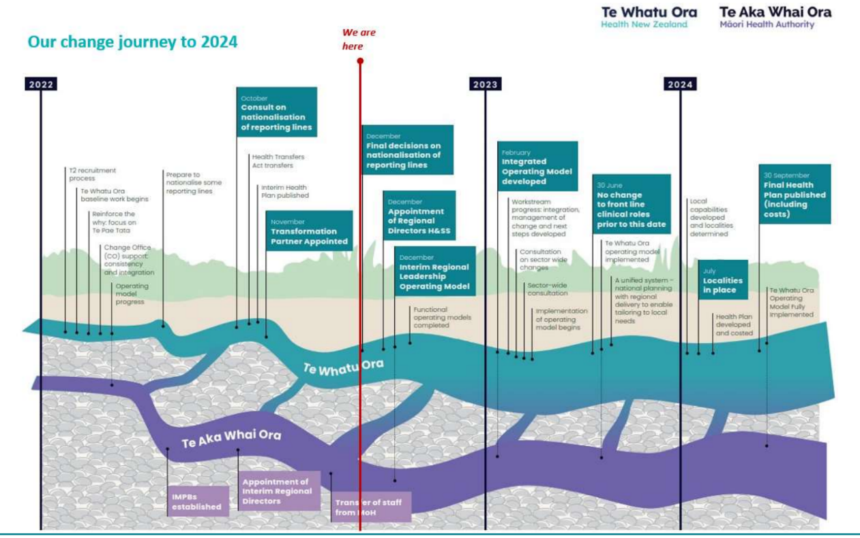
- Our Performance

Delivering Te Pae Tata | the Interim New Zealand Health Plan
Te Pae Tata sets out the key actions that Te Whatu Ora and Te Aka Whai Ora will undertake in the first two years to build the foundations of a unified, smarter, sustainable and equity-led health system. During this quarter, 52 of the reported actions were assessed as on track and one reported action was assessed as at risk. The number of actions without appropriate status milestones remains high, with 104 of all actions unable to be measured this quarter. We are working to confirm milestone measures and accountabilities as well as developing new Outcomes and Equity Measures for reporting from Quarter 3.
The following table contains Quarter 2 progress against Te Pae Tata actions.
Sections | Number of Actions Total | Green | Amber | Red | No milestone, no response or still assessing
A new health system focused on people | 20 | 5 | 11 | - | 4
Improving health outcomes and equity | 39 | 23 | 5 | 1 | 10
A unified health system | 62 | 19 | 6 | - | 37
Priority populations | 66 | 5 | 8 | - | 53
Total | 187 | 52 | 30 | 1 | 104

Delivering Ola Manuia Pacific Health and Wellbeing Action Plan
Ola Manuia (to live in wellness) Interim Pacific Health Plan and a companion document to Te Pae Tata was launched by Hon Minister Aupito William Sio and National Pacific Health Director Markerita Poutasi on 11 November 2022. The key priorities covered by Ola Manuia span the life course of Pacific peoples from pregnant women, children and youth, through to adults and elders, and include focusing on long-term conditions (such as diabetes), mental health and tagata sa’ilimalo people with disabilities.
Highlights from Quarter 2:
Addressing the burden of diabetes for Pacific communities: This initiative funds a dedicated diabetes prevention and management programme in South Auckland. The pilot includes a mix of primary, community and tertiary care interventions to help families manage and treat diabetes based on Pacific models of care.
The first phase delivered in Quarter 2 included the establishment of key enablers:
- A South Auckland Diabetes Steering Group, a group of subject matter experts in diabetes, population health, data and intelligence, bariatric and Pacific models of care that already have existing leadership roles in key steering groups within the sector.
- Ensuring outcomes are focussed on reversing diabetes in young people and increasing access to the care pathway for older people to delay the onset of renal issues and prolong life.
- A programme lead has been established to support programme deliverables and evaluation. This will identify and validate learnings to inform the wider programme for Pacific communities.
Securing Future Capability and Shifting into New Models of Care: This initiative provides a funding uplift to the Pacific Provider Development Fund (PPDF). The focus of PPDF is to grow and strengthen primary and community care capacity and capability of all Pacific providers, particularly the smaller and newer providers and those in rural settings.
- A new provider, Fale Pasifika Te Tai Tokerau has successfully accessed PPDF funding to strengthen its workforce and further develop its services to serve the Pacific communities locally and strengthen its relationship with local Iwi and providers.
- In Te Manawa Taki, PPDF funding has been awarded to K’aute Pasifika Trust for two projects.
Project 1: Improving the digital capacity and capability of K’aute Pasifika including information systems, data technology and hardware for the Fale Pasifika wellbeing hub. The hub uses a Pacific model of care which recognises the role that culture, language and community settings play in overcoming barriers to access and improving health outcomes.
Project 2: Engagement activities with Pasifika communities and stakeholders about the services. The funding will be used for FTE and effective community talanoa to engage in person with community. Commissioned a total of $11.268m worth of initiatives across 27 national Pacific providers.
Pay Relativity: A total of 23 Pacific providers have been assessed and are in scope for the first tranche. They have completed their workforce survey for Pay Relativity calculations for nursing and kaiāwhina roles. The majority are scheduled to receive their adjustments in April 2023.
National Pacific Health Senate: The National Pacific Health Senate (The Pacific Senate) was formally established following the appointment of 12 successful candidates, meeting a capability mix to meet the health gains indicated in Ola Manuia in December 2022. The purpose of The Pacific Senate will be to build foundations and infrastructure to accelerate gains in priority areas for the improved health of Pacific communities and make progress on Pacific health inequities across the system. The first Pacific Senate is scheduled to convene in February 2023.

Non-financial performance
- Interim Government Policy Statement (iGPS)
- Health System Indicators (HSI)
- Metrics set out in the Statement of Intent/Statement of Performance Expectations SOI/SPE
In our first year, we are tracking performance using the following measures from the Interim Government Policy Statement and our Statement of Performance Expectations/Statement of Intent for 2022/23.
Measures are assessed using a traffic light system, as shown in the key below. In some cases, the process of collation and validation of health system data means that the most up-to-date information available is for a different timeframe than the Quarter 2 reporting period.
Key
Criteria description | Rating | Rating Assessment
Achieved | At or above target
Not achieved, but progress made | ≤ 10% of target
Not achieved | ≥ 10% of target
Quantitative / not reporting in Q2/ To be determined (TBD)

Priority Area |  | Pae Ora | Better health in our communities
Priority 1 - Place whānau at the heart of the system to improve equity and outcomes |  | Measure | Frequency of Reporting | Baseline Value (SPE) | Expectation for July 2022 – June 2024 | Latest Result | RAG | Action in Response | Accountability Document
 |  | Percentage of children enrolled with an oral health service | Annual | Māori 80% Pacific 92% Non-Māori, non-Pacific 100% | 95% | 2022 data not yet available |  |  | SPE/SOI
 |  | Percentage of children enrolled with a general practice or a kaupapa Māori provider by age 3 months | Quarterly | Māori 67% Pacific 80% Non-Māori, non-Pacific 95% | 85% | Māori 70%  Pacific 82%  Non-Māori, non-Pacific 97% |  | We are commissioning comprehensive primary and community care models in high Māori populations that address the needs of the community. We expect this to have a big impact on the rate of Māori enrolled with a general practice or a kaupapa Māori provider. | SPE/SOI
 |  | Percentage of smokers offered help to quit in past 15 months | Quarterly | Māori 64% Pacific 74% Non-Māori, non-Pacific 68% | 90% | Māori 62%  Pacific 72%  Non-Māori, non-Pacific 65% |  | All health professionals continue to check the smoking status of their clients/patients and provide brief advice and support to quit smoking. A referral is also made to a stop smoking service or Quitline.  Please note that this measure is limited to primary care and does not represent the full scope of the Smokefree Aotearoa 2025 programme. A new measure from 2023/24 will monitor progress towards the plan, specifically smokers who enrol with a stop smoking provider, set a Target Quit Date and a validated smokefree at 4 weeks (this will include Māori, Pacific and non-Māori/non- Pacific data). | SPE/SOI
 |  | Percentage of obese children referred to a specialist service |  | Māori 94% Pacific 97% Non-Māori, non-Pacific 95% | 95% | Māori 93%  Pacific 97%  Non-Māori, Non-Pacific 94% |  | Performance reflects a health system that is experiencing a range of delivery challenges as we move through COVID-19 peaks, including longer-term issues such as workforce pressures, the increasing demand on our health system, and reduced primary care and community capacity. There has been a 64.5% drop since Q1 in the rate of referrals in Auckland district which will be addressed in ongoing provider engagement. | SPE/SOI
 |  | Percentage of people who report they were involved as much as they wanted to be, in making decisions about their treatment in general practice care |  | Māori 84% Pacific 84% Non-Māori, non-Pacific 86% | Improve from baseline (trend to increase). | Māori 88%  Pacific 86%  Non-Māori, Non-Pacific 89%  Tāngata whaikaha (disabled people) 86% |  |  | SPE/SOI / HSI
 |  | Percentage of people who report they can get primary care when they need it |  | Māori 73% Pacific 77% Non-Māori, non-Pacific 80% | Improve from baseline (trend to increase). | Māori 74%  Pacific 74%  Non-Māori, Non-Pacific 81%  Tāngata whaikaha (disabled people) 73% |  | We are working with providers and communities to address barriers to access and unmet need, for both rural and urban communities. Approaches include changes to the core funding formula for first-level services, continued investment in the growth and development of Māori and Pacific health providers, and rollout of provider networks and comprehensive primary and community care teams to provide more seamless, integrated care. | SPE/SOI / HSI
 |  | 6.2 Experience of primary health care and adult inpatient health services measured across demographic groups using patient experience surveys | Quarterly | Improvement on results from June 2021 (baseline used in Health System Indicators) | Initially, this will reflect two of the current Health System Indicators ‘People report they can get primary care when they need it’ and ‘People report being involved in the decisions about their care and treatment’ | Māori and tāngata whaikaha (disabled people) reported lower rates (73% and 74% respectively). (13.3% of respondents overall, 17% for Māori). |  | Local experience/engagement leads are supporting the development of a national picture to scope what qualitative and quantitative data is currently collected by region, including how they use the Health Quality and Safety Commission-led Patient Experience Surveys (Primary care and Inpatient surveys) to improve how people report being involved in the decisions about their care and treatment. | iGPS / HSI
 |  | 6.3 Proportion of entities that have been assessed against the Consumer Engagement Quality and Safety Marker; and of those, the proportion that have been assessed at Level 3 or 4 | July and December |  | Increasing participation of health entities & their local areas that have been assessed against the Consumer Engagement Quality and Safety Marker (CEQSM) from 30 June 2022. Establish a baseline for places that have been assessed at Level 3/4 on the CEQSM & agree to change or improvement expectations in year two from the baseline. | Engagement = 50% (10 out of 20 districts) at Level 3  Responsiveness = 40% at Level 3  Experience = 60% at Level 3. |  |  | iGPS
 | Kahu Taurima | Maternity and early years
 |  | Measure | Frequency of Reporting | Baseline Value | Expectation for July 2022 – June 2024 | Latest Result | RAG | Action in Response | Accountability Document
 |  | 3.6 Enrolment with a primary maternity care provider in the first trimester of pregnancy, reported by ethnicity and geographic area | Annual, 12 months after the end of the calendar year |  | Establish a baseline in year one and agree to change or improvement expectations in year two from the baseline. | Data at 2020:  Māori 59.7%  Pacific 45.4%  Non-Māori, non- Pacific 82.4% |  | We are currently redesigning the universal model of care, working with Lead Maternity Carers and Well Child Tamariki Ora providers to implement a more flexible and responsive model. | iGPS
 | Mate pukupuku | People with cancer
 |  | Measure | Frequency of Reporting | Baseline Value | Expectation for July 2022 – June 2024 | Latest Result | RAG | Action in Response | Accountability Document
 |  | 1.1 Variation in clinical prioritisation for cancer treatment and elective surgery, reported by ethnicity and geographic area | Monthly |  | 100% of patients were prioritised using approved nationally recognised processes or tools. | Across Aotearoa New Zealand, between 98-100% of patients are reported as being prioritised using nationally recognised processes and tools. |  | Standardisation of clinical processes will be enhanced through the implementation of some of the initiatives within the Reset and Restore Plan which was announced in October 2022. | iGPS
 |  | 1.2 Proportion of people who start first treatment for breast, cervical or bowel cancer after a screen result (presence of cancer), reported by ethnicity and geographic area | Annual (financial year) | Where the diagnosis is cancer, ≥90% of women have their initial treatment performed within 31 calendar days of the final decision to treat (treatment is defined as an MDT decision) | iGPS - This measure is still to be confirmed. | Results are reported annually and are not currently available. |  |  | iGPS
 |  |  | Annual | 95% or more of women who: have evidence of clinical suspicion of invasive carcinoma, or a laboratory report indicating ‘features suspicious for invasion’, or ‘changes consistent with squamous cell carcinoma’, or similar, must receive a date for a colposcopy appointment or a gynaecological assessment that is within 10 working days of receipt of the referral Indicator 7.4 90% or more of women with HSIL are treated within 8 weeks of histological confirmation of CIN 2/3. | iGPS - This measure is still to be confirmed. | Results are reported annually and are not currently available. |  |  | iGPS
 |  |  | Monthly and Annual | 95% of the National Bowel Screening Programme participants diagnosed with cancer are referred for pre-operative presentation at MDM within 20 working days of diagnosis | iGPS - This measure is still to be confirmed. | Results are not currently available. |  |  | iGPS
 | Māuiuitanga taumaha | People living with chronic health conditions
 |  | Measure | Frequency of Reporting | Baseline Value | Expectation for July 2022 – June 2024 | Latest Result | RAG | Action in Responses | Accountability Document
 |  | 1.5 Rate of diabetes complications, reported by ethnicity and geographic area | Annually (calendar year) |  | A decrease from the 12 months to 30 June 2021 (baseline). | The rate of complications per 100,000 people with diabetes decreased by 7.3% between 2020 and 2021. Māori rates of complications (338.1 per 100,000 people with diabetes) are 1.6 times higher than those of non- Māori or Pacific. |  |  | iGPS
 | Oranga hinengaro | People living with mental distress, illness and addictions
 |  | Measure | Frequency of Reporting | Baseline Value | Expectation for July 2022 – June 2024 | Latest Result | RAG | Action in Responses | Accountability Document
 |  | 1.3 Variation in the rates of access to key identified services by ethnicity, geographic area and other characteristics. Initial areas include access to specialist mental health (including Rangatahi) | Quarterly | Māori 79% Pacific 87% Non-Māori, non-Pacific 68% | Access to specialist mental health: An increase in the percentage of people seen within the target timeframe from the 12 months to 30 June 2022 for rangatahi (baseline) = 80% | Under 25-year-olds specialist mental health or addiction services within three weeks of referral:  Māori 77.1%  Pacific 81.7%  Non-Māori, non-Pacific 66.2% |  | New models of specialist mental health and addiction services to support people with specific needs have commenced with provider agreements and recruitment underway this quarter. This includes funding for child and adolescent mental health. | iGPS /HSI/ SPE/SOI
 |  | 3.5 Complete roll-out of the Access and Choice programme for primary mental health and addiction support services so that access is available for 325,000 people per year by the end of June 2024 | Quarterly |  | Integrated Primary Mental Health and Addiction Services: Establish baseline estimated annual access level and adjustment factor in the first quarter of 2022/23 Expectation of an estimated 248,000 annual access level based on fourth quarter access in 2023/24 | As at end of October 2022, 627,000 sessions had been delivered through the Access and Choice programme, with an enrolled population coverage of 2.8 million people through integrated GP services. Access & Choice programme is on track to deliver the intended milestones. |  |  | iGPS
 |  |  | Quarterly |  | Kaupapa Māori, Pacific and Youth Primary Mental Health and Addiction Services: Establish baseline estimated annual access level in the first quarter of 2022/23 Expectation of an estimated 77,000 annual access level based on fourth quarter access in 2023/24. | Contracted FTEs were at 1170 across the four Access and Choice workstreams (Integrated GP services, youth, Pacific and Kaupapa Māori services). |  | We are on track to deliver however, recruitment remained challenging for some providers, and we are actively working to support services to grow their staffing levels. | iGPS
 |  | Number of mental health bed nights | Annual | Māori 321,522 Pacific 68,202 Non-Māori, non-Pacific 519,569 Improve from baseline (trend to increase) | Improve from baseline (trend to increase). | Annual result reported in Quarter 4. |  |  | SPE/SOI
 |  | Total number of mental health contacts | Annual | Māori: 1,242,416 Pacific: 304,963 Non-Māori, non-Pacific: 2,538,657 | Improve from baseline (trend to increase). | Annual result reported in Quarter 4. |  |  | SPE/SOI
 |  | People served by specialist and NGO mental health services per 100,000 people |  | Māori 5,650  Pacific 2,905  Non-Māori, non-Pacific 2,988 | Improve from baseline (trend to increase). | Māori 5,436  Pacific 2,867  Non-Māori, non-Pacific 2,902 |  | New models of specialist mental health and addiction services to support people with specific needs have commenced with provider agreements and recruitment underway this quarter. This includes funding for crisis responses; maternal and infant mental health services; child and adolescent mental health and addiction services; eating disorders services; kaupapa Māori services; enablers; and workforce development. | SPE/SOI
 |  | Improve digital access to primary and mental healthcare to improve access and choice, including virtual after-hours and telehealth, with a focus on rural communities | Milestone Report |  |  | Telehealth services have been expanded, providing access to 24/7 nurse triage and Primary Care overflow services (telehealth doctor consultations if required) at no cost to patients or GPs is providing alternatives for how we see choose to see a health professional. |  |  | SPE/SOI

Priority Area | Measure | Frequency of Reporting | Base Value | Expectation for July 2022 – June 2024 | Latest Result | RAG | Action in Response | Accountability Document
Priority 2  Embed Te Tiriti o Waitangi across the health sector | Localities are established |  |  | Milestone Report | Endorsed Charters = 7 (58%)  Commenced whānau and community engagement = 9 (75%)  Locality plan first draft submitted = 7 (58%) |  |  | SPE/SOI
 | 2.1 Health entity spending on identified Māori health service providers | Available annually after the close of the financial year |  | Increase in trend in actual expenditure (compared with the average of the last five financial years). | $565.2 million  (2021/22) |  |  | iGPS
 | 2.2 Experience of health services for Māori as measured by the primary health patient care and adult inpatient experience surveys | Quarterly |  | Improvement in results from June 2021 (baseline used in Health System Indicators). | % of Māori in hospital kept informed as much as they wanted to be about their treatment and care = 73.2%  % of Māori in hospital treated with kindness and understanding by their doctor = 88%  % of Māori in hospital with their cultural needs met = 81.6% |  |  | iGPS
 | 2.3 Geographical coverage and utilisation of rongoā Māori services | Annual (financial year) |  | An increase in rongoā consultations provided in terms of both total volumes and spread across the country. | Age breakdown within the Māori ethnicity (June 2021)  0-14 = 882  15-29 = 1,050  30-44 = 1,674  45-59 = 1,985  60+ = 4,092  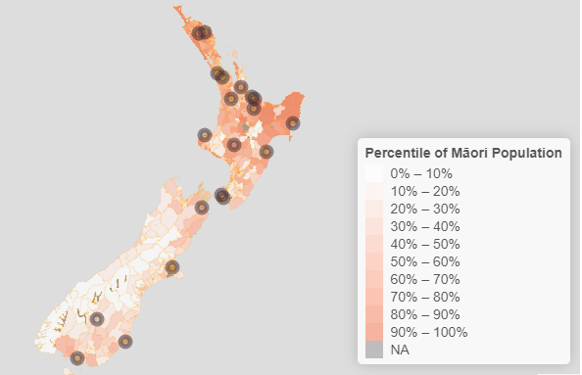 |  |  | iGPS
 | 2.4 Feedback from the iwi-Māori partnership boards on how they are fulfilling their role and whether they are receiving the support they require | Six-monthly survey as per IMPB setting |  | Establish a baseline in year one, and agree to change or improvement expectations in year two from baseline. | Data not available as iwi-Māori partnership boards are in the beginning phase of establishment. |  |  | iGPS
Priority Area | Measure | Frequency of Reporting | Baseline Value | Expectation for July 2022 – June 2024 | Latest Result | RAG | Action in Response | Accountability Document
Priority 3  Develop an inclusive health workforce | 4.1 Engagement survey on culture and shift towards a ‘one team’ ethos (measure will be in development as part of work to build data collection) | TBD - Q3 | Staff engagement survey on culture and shift towards a ‘one team’ ethos (measure will be in development as work to build data collection) |  |  |  |  | iGPS
 | 4.2 Proportion of Māori and other under-represented groups in the regulated and unregulated health workforce, compared with the proportion of the total population | Annual – starting date of 12-month period variable between professional councils | Regulated Workforce: An increase from the 12 months to 30 June 2022 (baseline) |  | October to December 2022 Total FTE Māori Pacific Asian Other  Allied and Scientific 11,213 6.90% 3.50% 18.40% 71.20%  Midwifery 844 8.80% 1.50% 6.70% 82.90%  Nursing 27,095 6.40% 3.80% 34.50% 55.40%  Resident Medical Officer (RMO) 5,304 6.40% 2.80% 26.00% 64.70%  Senior Medical Officer (SMO) 5,365 2.00% 0.90% 18.30% 78.80% |  |  | iGPS
 |  | Annual | Unregulated Workforce: An increase from the 12 months to 30 June 2022 (baseline) |  | October to December 2022 Total FTE Māori Pacific Asian Other  Care and Support 7,278 17.30% 12.90% 24.80% 45.00%  Corporate and Other 18,415 11.40% 7.20% 16.70% 64.30% |  |  | iGPS
 | 4.3 Number and proportion of graduates of health training programmes from demographic groups under-represented in the health workforce, compared with the proportion of the total population |  | TBD | TBD |  |  |  | iGPS
 | 4.4 Proportion of Māori and Pacific peoples in leadership and governance roles across the Ministry of Health and health entities |  | Quarterly | Establish a baseline and initial increases in numbers | TBD |  |  | iGPS
 | 5.2 (Measure to be developed) Develop agreed measures of quality-adjusted, system-level productivity |  | TBD | Measures of productivity will be determined and may include matters such as: hospital theatre utilisation, length of stay, FTEs per case-weighted hospital discharge, use of (clinical and non-clinical) workforces. | TBD |  |  | iGPS

Priority Area | Measure | Frequency of Reporting | Baseline Value | Expectation for July 2022 – June 2024 | Latest Result | RAG | Action in Response | Accountability Document
Priority 4  Keep people well in their communities | Winter Preparedness: Access to Primary Care, Immunisation, Planned Care (Waitlist), Acute Demand
 | 3.1 Proportion of people reporting unmet need for primary health care, reported by ethnicity and geographic area | Annually (financial year) |  | A decrease from the 12 months to 30 June 2019 (baseline) | Unmet need for GP services due to cost:  Māori 14.5%  Pacific 11.4%  Total: 10.7%  Tāngata whaikaha (disabled people): 17.3%  Unmet need for a GP due to wait time being too long in the last 12 months  Māori 14.6%  Pacific 13.5%  Total: 11.5%  Tāngata whaikaha (disabled people): 13.8% |  | The population experiencing unmet need in general practice has fallen for Māori and Pacific people over the past year however prevalence has increased for the total population. Unmet need due to long wait times for an appointment is a new measure and only reported for the first time in 2021/22. | iGPS
 | 3.2 Proportion of people waiting for planned specialist care who receive it within four months, reported by ethnicity and geographic area | Monthly |  | ESPI 2  No. of patients waiting longer than 4 months for a FSA | Data to Dec 2022:  National 27.2%  Northern 30.3%  Te Manawa Taki 29.3%  Central 19.9%  Te Waipounamu 24.7%  No ethnicity breakdown is available |  | Orthopaedic have the highest number of patients waiting. Orthopaedic conditions are generally not life-threatening therefore one of the first specialities to be cancelled when local areas have determined what type of planned care must be postponed to address acute and urgent/semi-urgent demand. We have several urgent actions focused on booking of people who have experienced long wait times and have put in place nationally consistent measures and escalation models to see where the pressures are in the system. | iGPS
 |  |  |  | ESPI 5  No. of patients given a commitment to treatment but not treated within four months | Data to Dec 2022:  National 42.5%  Northern 35%  Te Manawa Taki 44.3%  Central 47.3%  Te Waipounamu 48.4%  No ethnicity breakdown is available |  | The total number of planned care interventions increased and continued to exceed the plan, reflecting an increased volume of minor procedures that counteracted the lower volumes of inpatient planned surgery. This is due to higher occupancy of acutely unwell patients, unwell staff and vacancies. The reset and restore plan launched in October 2022 aims to progressively improve inpatient surgical performance by focusing on system-wide actions to address access, capacity and flow. | iGPS
 | 3.3 Uptake of immunisations for key age groups, reported by ethnicity and geographic area | Quarterly |  | Eight-month-olds: 95% of eligible children fully immunised at eight months of age for Māori, Pacific and Total populations. | Data to Dec 2022:  National 84.4%  Māori 70.3%  Pacific 82.5% |  | Rates of childhood immunisation have fluctuated since 2017, trending downwards since 2020 as a result of the COVID-19 pandemic. Coverage shows that an equity gap persists and there is lower coverage for tāmariki Māori at all milestone ages compared to the total coverage.  The National Immunisation Taskforce (the Taskforce) was set up in response to falling rates of childhood immunisation over the last five years. The National Immunisation Programme (the Programme) has prioritised the Taskforce’s 54 recommendations, which were presented to the Te Whatu Ora board in December 2022. The Programme has developed a workplan to enable implementation. To date 26 of the 54 recommendations have been implemented.  The Programme is working with regions and local areas to support national implementation of a childhood immunisation prioritisation matrix, which has been endorsed by the Taskforce. This tool was developed by the Northern region to focus efforts and resources towards supporting critical on-time immunisation of priority populations. The latest quarterly data indicates that the use of the prioritisation matrix may be having a positive impact on immunisation rates in the Northern region. For example, in the Auckland region 62.6% of tamariki Māori at 24 months were fully immunised in the Q1 reporting period compared to 69.3% at the end of Q2. The Programme will continue to monitor the impact of implementation of this tool as it is implemented nationally.  As part of a comprehensive programme of childhood immunisation communications, Te Whatu Ora has built a new web platform providing a one-stop shop for childhood immunisations, including COVID-19 and flu vaccinations. The platform went live on 17 March and acts as a centralised place for parents, caregivers, hāpu mama, whānau and the public to access information, resources, and tools about immunisation. | iGPS / SPE/SOI
 |  |  |  | Two-year-olds: 95% of eligible children fully immunised at two years of age for Māori, Pacific and Total populations. | Data to Dec 2022:  National 83.1%  Māori 66.4%  Pacific 81.9% |  |  | iGPS / SPE/SOI / HSI
 |  |  |  | Five-year-old: 95% of eligible children fully immunised at five years of age for Māori, Pacific and Total populations. | Data to Dec 2022:  National 80.8%  Māori 70.3%  Pacific 79% |  |  | iGPS / SPE/SOI
 |  | Annual |  | Human Papillomavirus (HPV) vaccination: 75% of eligible boys and girls fully immunised with HPV vaccine for Māori, Pacific and Total populations | Percentage fully immunised by ethnicity for the 2009 cohort only:  Māori: 46.0%  Pacific: 52.3%  Asian: 67.0%  Other: 57.9% |  | The Programme is currently commissioning an external provider to undertake an independent review of the national Schools Based Immunisation Programme (SBIP), which delivers the HPV and tetanus/diphtheria/pertussis vaccines. This review will have a focus on Māori, Pacific peoples and people with disabilities, and will focus on addressing inequities that have increased in recent years.  The Programme is expecting to receive the review findings and recommendations in June 2023, which will provide insights and actions for consideration to implement at a national, regional and local level to address inequities and increase vaccine uptake, especially for HPV. | iGPS / SPE/SOI
 |  |  |  | Influenza for 65+ years: 75% of the eligible population aged 65 years and over immunised against influenza (annual immunisation) for Māori, Pacific and Total populations | Previous winter influenza vaccination rates for people 65+:  Māori: 67.5%  Pacific: 65.6%  non-Māori, non-Pacific: 71.6% |  | The Winter Preparedness Vaccination Programme continues implementation planning of the influenza/flu season on 1 April 2023. We will be focussing on workforce, communications and technology as well as working alongside Pharmac who have already secured 1.8 million doses (including paediatric doses) for this season. To increase uptake and to further close the equity gap, we are advocating to Pharmac for an expanded eligibility criteria to include Māori and Pacific 55 – 64 years old (inclusive) and tamariki aged 6 months to 12 years. | iGPS / SPE/SOI
 |  |  |  | Covid Vaccination: | Measure being developed |  |  | iGPS
 | 3.4 Rate of hospital admissions for an illness that might have been prevented or better managed in the community, reported by ethnicity and key age groups | Quarterly |  | The rate of hospital admissions for children under five years of age for an illness that might have been prevented or better managed in the community reduces (baseline of results 12 months to December 2019 used in Health System Indicators) and/or the equity gap between Māori and Pacific people and non-Māori, non-Pacific peoples also reduces | Data to December 2022:  National 6,813  Māori 7,448  Pacific 12,427  Other 5,762 |  | Social and environmental factors such as socioeconomic status and health behaviours can have a big impact on the ASH measure.  Te Whatu Ora is developing an integrated programme of work across the organisation to address challenges in acute flow. As part of the winter 2023 approach, a core element will be focused on avoidable hospital admissions, for example, through the potential expansion of initiatives such as Primary Options for Acute Care, implementing accessible and nationally consistent clinical pathways and community care providers to create seamless pathways for whānau. | iGPS / SPE/ HSI
 |  |  |  | The rate of hospital admissions for people aged 45–64 years for an illness that might have been prevented or better managed in the community reduces (baseline of results 12 months to December 2019 used in Health System Indicators) and/or the equity gap between Māori and Pacific people and non-Māori, non-Pacific peoples also reduces. | Data to December 2022:  National 3,661  Māori 6,738  Pacific 7,282  Other 2,935 |  |  | iGPS / HSI
 | 1.4 Missed appointments for specialist care, reported by ethnicity and geographic area | Quarterly |  | A decrease from the 12 months to 30 June 2022 (baseline) and the equity gap between Māori and Pacific people and non-Māori, non-Pacific peoples also reduces. | Northern: Māori 14%, Pacific 15%, Other 5%  Te Manawa Taki: Māori 15%, Pacific 13%, Other 5%  Central: Māori 13%, Pacific 17%, Other 4%  Te Waipounamu: Māori 13%, Pacific 16%, Other 4% |  |  | iGPS
 | 3.7 Standardised rate of acute readmissions within 28 days of discharge, reported by ethnicity and geographic area | Quarterly |  | Establish a baseline in year one, and this baseline will inform the expectation for year two Note: Acute readmission 0-7 days will be a sub-component. Initially, this measure will reflect the measure included in the acute re-admission report published on the Nationwide Service Framework Library (NSFL). | The latest data available is to September 2022:  National 12.3%  Māori 12.7%,  Pacific 12.1%,  Other 12.2% |  |  | iGPS
 | Number of acute bed nights spent in hospital |  | Māori 341,366 Pacific 154,929 Non-Māori, non-Pacific 1,577,694 | Improve from baseline (trend to increase). | Māori 358,077  Pacific 168,444  Non-Māori, non-Pacific (Other) 1,627,097 |  |  | SPE/SOI
 | Acute hospital bed day rate |  | Number of days spent in hospital for unplanned care including emergencies |  | National 418  Māori 401  Pacific 471  Other 417 |  |  | HSI
 | Access to planned care |  |  | People who had surgery or care that was planned in advance, as a percentage of the agreed number of events in the delivery plan. | The total planned interventions were 125,245 and the actual delivery was 128,681 due to an increased volume of minor procedures. |  |  | HSI
 | Establish a nationally integrated public health service with consistent operating models | Milestone Report |  |  | The proposed NPHS operating model design is well established, with workshops relating to specific functions design and regular feedback to NPHS team members. |  |  | SPE/SOI
 | Continue COVID-19 response in line with policy settings, and build towards a new business as usual pandemic resilient system | Milestone Report |  | The tagged contingency has been used to fund the scaled approach to maintain a set of COVID-19 services as part of the transition towards a longer-term approach.  The expected outcomes of this are: targeting of those most vulnerable to serious illness; continued delivery of key elements of our response and giving life to the COVID-19 Strategic Framework; continued optimisation of investment and a significant reduction in overall spending; mitigation of pressure on the broader health system; and retained capacity within the health system for pandemic resilience with a sustainable funding pathway | Budget confirmed in Q2 to 30 June 2023  Further drawdown sought as part of remaining COVID-19 Public Health Response Contingency to bridge the transition of COVID-19 initiatives into a pandemic readiness state with a budget bid for FY 2023/24. |  | Reviewing scope to ensure deliverables meet Te Pae Tata delivery period (before Jul 2024).  The Pandemic Resilience model design is in place to reduce any replication or duplication of effort and maintain an active “All threats” response capability. | SPE
 | 6.1 (Measure to be developed) Health entities are clear about their own and other entities’ roles and responsibilities and are delivering to these | TBD | TBD |  |  |  |  | iGPS
 | Provider Networks are established | Milestone Report |  |  | The localities model continues to be implemented across Aotearoa. Funding is confirmed to support service integration and locality provider networks. |  |  | SPE/SOI
 | 1.3 Variation in the rates of access to key identified services by ethnicity, geographic area and other characteristics. Initial areas include first specialist assessments. | Quarterly |  | Establish a baseline for First Specialist Assessment delivery in year one. The baseline will inform an expectation for year two | Standardised Intervention rates for first specialist assessments per 10,000  Medical: 467.54  Surgical: 586.53  Total: 1,054.06 |  |  | iGPS /HSI/ SPE/SOI

Priority Area | Measure | Frequency of Reporting | Baseline Value | Expectation for July 2022 – June 2024 | Latest Result | RAG | Action in Response | Accountability Document
Priority 5  Develop greater use of digital services to provide more care in homes and communities | Data and Digital
 | Develop and implement a national plan to create consistency in data and digital capability across Te Whatu Ora | Milestone report |  |  | Workforce Capability Plan in progress  Investment Review Completed  Data and Digital Roadmap progressing through the approval process, expected to be published by March. |  | Progress is being made. Not yet fully delivered. | SPE/SOI
 | 6.4 Proportion of medical appointments completed through digital channels (initially outpatients and expanding to include general practitioner appointments when data is available) | Monthly |  | This measure will initially focus on outpatient services – first specialist assessment ( and follow-ups. Establish a baseline for the FSAs and follow-ups in year one. The baseline will inform an expectation for year two | December 2022 Attended appointments via telehealth  FSA: 5%  Follow-Ups: 16% |  |  | iGPS

Establish Te Whatu Ora and Te Aka Whai Ora to support a financially sustainable system
Te Whatu Ora is currently on track to deliver within budget for 2022/23.
Additional costs for activity for ACC were funded through extra revenue.
Costs for staff overtime to cover sickness and vacancies, plus an additional public holiday, have been absorbed within budget.
Detailed financial reporting on expenditure for specific services and initiatives is in development and will be available and reported on from Quarter 3 onwards.
The below dashboard provides an overview of Te Whatu Ora Finances for December 2022.
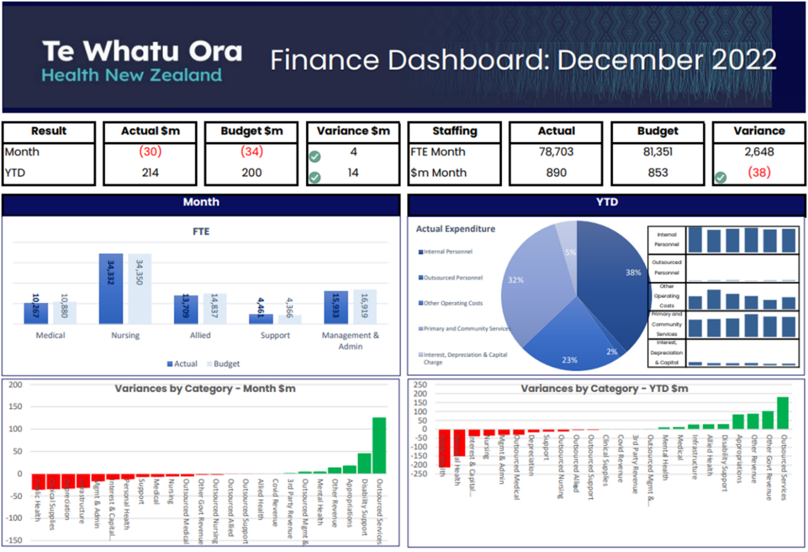

Te Whatu Ora Financial Performance

Year-to-date financial performance to 31 December 2022
- As of 31 December 2022, Te Whatu Ora financial performance is $14 million favourable to budget.
- Revenue has been above budget for the first six months for services funded via ACC. Costs have also been above budget in relation to these services.
- The public holiday observed in relation to the Queen’s passing is an unbudgeted cost that has been absorbed. It is estimated that the cost of the statutory holiday was slightly more than $30 million in total, largely in nursing staff.
- Clinical staffing categories continue to show significant vacancies. However, vacancies do not translate to financial underspends, as overtime payments and allowances earned by staff working extra hours to provide cover (and illness-related shortfalls in staffing) offset lower salary costs.
- Infrastructure and non-clinical supplies are $27 million favourable, mainly related to COVID-19 underspend against this category. The $1.4 billion COVID-19 budget was transferred to Te Whatu Ora very late in the budget process, and budgeting against spend categories could only be estimated at high-level.
- Primary and Community spend is $323 million over budget. This is mainly due to COVID-19 spend incurred within local areas that can be directly invoiced to the Ministry of Health, over and above the transferred COVID-19 budget. These costs are offset by increased revenue. Also, there is spend above budget and offsetting revenue from Whaikaha | Ministry for Disabled People (appears in other government revenue) for Disability Support Services.
- Depreciation costs are unfavourable, because of recent building revaluations. The depreciation impact is covered centrally in later months.
- Risks to the annual operating result exist, in relation to the pending finalisation of the Nursing MECA negotiations, ongoing COVID-19 and winter illness pressures, supplier cost pressures, and visibility of transferring Ministry of Health third-party contract commissioning.

The following table shows how we are tracking to budget.
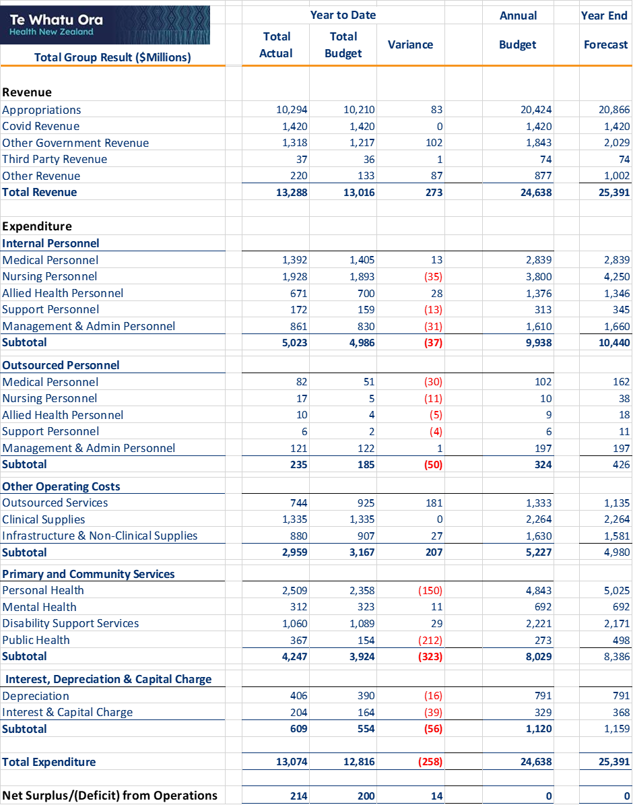

Infrastructure Investment
The Infrastructure and Investment Group (IIG) is responsible for monitoring the health sector’s capital projects that require Crown funding or exceed $10 million in capital cost. The IIG is monitoring 104 projects across the motu with combined Crown funding of $6.802 billion.
Key results for the period include:
- 23 projects have largely completed construction, with the switchboard build for Hawke’s Bay’s Main Electrical Supply Upgrade almost complete.
- Based on the December assurance reports, 61 projects are rated Green, 26 are rated Amber, and 16 are rated Red.
- As of 31 December 2022, the projects incurred $2.02 billion of actual expenditure and $1.72 billion in equity have been drawn down. This is a $61 million increase on the previous month.
- The table below shows the number of projects in each phase based on the most recent assurance reports.
 | Define | Design | Deliver | Debrief
31 December 2022 | 6 | 34 | 41 | 23
Previous Report | 6 | 36 | 40 | 22
Movement | 0 | -2 | +1 | +1

Risk Management
Understanding and managing risk is a key aspect of a high-quality health system. The table below provides an overview of key areas of risk, and management activities to address those risks.
Risk Description | Key Management Activity
Delivering Health Reforms
If Te Whatu Ora is unable to deliver the transition, associated culture and accountability change, then the benefits of the health sector reforms will not be delivered at the scale and pace expected. | Delivering the performance targets outlined in Te Pae Tata – Interim New Zealand Health Plan (October 2022) and the interim Government Policy Statement on Health 2022-2024 will start to realise the benefits of the health reforms.  Change and transformation programmes underway to support the shift from 29 entities to one organisation capable of achieving performance targets.
Workforce Capacity and Capability
If Te Whatu Ora does not have a workforce that is appropriately qualified and sufficient to meet demand, then there will not be the capacity to deliver healthcare and services to the community. | Workforce Taskforce Group.  Development of retention strategies for high-risk areas.  Delivery of Budget 22 workforce development initiatives, including short-term interventions targeting the immigration pipeline.
Clinical Practice Quality
If Te Whatu Ora is unable to deliver consistent high-quality services and care to the community, then the intent of the reforms will not be delivered. | Short-term service planning.  Short-term support within and between regions.  Renewed focus on all of system flow including enhanced primary care, focus on Emergency Department and front of house response as well as timely discharge back to the community.
Equitable Health Outcomes
If Te Whatu Ora does not have clear targeted and regularly monitored strategies, plans or programmes supported across the health sector to deliver equitable health outcomes for all New Zealanders, then Te Whatu Ora may fail to meet its obligations under Te Tiriti and not achieve the goal of improved health outcomes for all New Zealanders. | Delivery of Te Pae Tata – Interim New Zealand Health Plan (October 2022), which includes actions to improve equity for a range of population groups.  Development of a diverse and inclusive health workforce.
Financial Sustainability
If Te Whatu Ora does not meet its financial obligations in a sustainable way, then fiscal losses could occur, resulting in pressure on funding the reform change programme. | Business case approval process established for new initiatives, capital projects and other changes.  Detailed costing of all proposed policy decisions.  Advice to Ministers on the end of COVID-19 funding (provider risk, financial analysis and reprofiling, and costing beyond December 2022).  Revised budgeting and internal financial reporting processes to support the new organisational structure.
Health Safety and Wellbeing
If Te Whatu Ora is unable to manage, monitor or respond to the health, safety and wellbeing of its staff and visitors to its facilities then it will fail to meet its obligations under the Health and Safety at Work Act 2015. | Recruitment strategy to improve staffing levels.  Workplace Violence Prevention strategies including de-escalation training for staff.  Strong partnership approach with Unions.
Digital Systems and Service Enablement
If Te Whatu Ora does not have a clear strategy to maintain current systems or enable investment in technology, then it may fail to meet future demand and models of care. | Maintenance of existing technology.  Operating system and Database Remediation projects.  Investment in new enabling technologies.  Strategic partnerships with key vendors.
Infrastructure and Asset Management
If Te Whatu Ora does not understand the nature or condition of its infrastructure and assets to support future planning for maintenance and investment, then the required clinical services may not be delivered. | Align Clinical Service Planning with Capital Investment to ensure the physical structures are in place to support service delivery.  Develop high-level national/regional/local service medium and long-term masterplans.  Development of Asset Management Plan.

Appendix 1: Budget 22 Investments Update
Initiative | To 31 December 2022 | What is happening next
Addressing the Burden of Diabetes for Pacific Communities | A governance group has been stood up to oversee the commissioning and evaluation. The group includes: primary care; clinical diabetes nurse specialist; an endocrinologist; renal nurse practitioner; dietetics; psychologist; disciplines across organisations such as pharmaceuticals; Counties Te Whatu Ora leads; population health; and data and intelligence.  Discussions are underway with the Pacific consortium – Te Ranga Ora partnership programme, a pre-existing MOC redesign initiative, which is a Pacific collective approach (led by South Seas Healthcare Trust) to support a Pacific family-focused integrated care model to identify if the programme could be expanded. Work is also aligned with work underway in the Locality design for Ōtara/Papatoetoe. Engagement with specialist services in Counties; and connection to bariatric pathway work that is funded in the planned care restart, is part of the full design of the programme.  Programme Director appointed. | Procurement and contracting will begin by January 2023. Supported services delivering the new model of care will commence in February 2023.
Allowing Payment to Family Members for Support Services | New policy has been approved by Te Whatu Ora and Te Aka Whai Ora Boards.  Implementation is ready to commence from January 2023 with all local areas aware of the new policy and ready to implement it. | Communication of new policy including needs assessment service coordination agencies. People can be offered the choice of paying a family member to provide their care, in addition to other options already available. If a person chooses to have their care provided by a family member, the family member will be recruited through a formal process to a home and community support services provider and will be paid the same as any other home and community support worker.
Comprehensive Primary Care Teams | Comprehensive care team role descriptions, model of care expectations, enablers, and funding modelling tools were developed in October 2022. Initial modelling is around the introduction of comprehensive care team roles of physiotherapists, practice-based pharmacists, care coordinators and registered social workers/kaiāwhina. A flexible approach will be maintained to adapt funding to the roles required in the communities served.  Scope and prioritisation framework was agreed by Te Whatu Ora and Te Aka Whai Ora in November 2022. | The implementation plan will be approved by 28 February 2023.  Recruitment for new roles is expected to start in the April-June 2023 quarter and continue until July 2024. The initial focus is likely to be on the introduction of kaiāwhina.  People in priority areas will begin to see the outputs of this work programme from April 2023, with the introduction of new FTE. Full rollout is intended to cover 50% of NZ population over the next two years as planned.  The major rollout occurs from 1 July 2023 when the bulk of the funding becomes available.
Continuing the Alcohol and Other Drug Treatment Courts: Waikato, Auckland and Waitakere | A pilot of two Alcohol and Other Drug Treatment Courts began in Auckland in 2012: one in central Auckland and one in Waitākere. Both courts are now permanent and service delivery is continuing. Each Court can have up to 50 participants.  The Waikato Alcohol and Other Drug Treatment Court, Te Whare Whakapiki Wairua ki Kirikiriroa, opened on 12 June 2021, and service delivery is continuing to scale up. | Residential services in Waikato are in the process of increasing from four rooms to six rooms. This requires a certification process through Ministry of Health, which is currently underway.  Separately, the provider is also searching for a suitable property for four supported accommodation beds in Hamilton that will meet the required specification. We expect both of these actions to be complete by March 2023.  We expect the establishment of the Clinical Governance Group in Auckland by March 2023 to support the Courts to ensure quality and comprehensive health services. Services are otherwise up and running.
Dementia Mate Wareware Action Plan - Implementation Support Funding | The programme is informed by the Dementia Mate Wareware Action Plan which was developed in collaboration with the Mate Wareware Rōpū.  The Dementia Leadership Group (DLG) was established, with its first meeting in October 2022. The DLG is made up of sector representatives and officials that will lead the process to engage with the dementia sector. This engagement will confirm the components needed in both the four post-diagnostic pilots and the respite care pilots. Their advice will also address the establishment of Navigator roles. There is guaranteed Māori representation in the Leadership Group, and on advice from Te Aka Whai Ora, a whānau voice position has been created in the Leadership Group.  The Dementia Mate Wareware Leadership and Advisory Group, and the Dementia Mate Wareware Network (the Network) have been established and initial meetings have been held. A website to disseminate, communicate and share information has been developed. Engagement with the Dementia Mate Wareware sector has commenced. Planning is underway to commission new programmes early in the new calendar year with four pilots for post-diagnostic supports, the establishment of ‘navigator’ roles, and innovative respite care options.  Contract agreed with New Zealand Dementia Foundation (NZDF): A contract for secretariat services for the Dementia Mate Wareware Leadership and Advisory Group, and the establishment and coordination of the Network has been signed. | Detailed services will continue to be developed alongside the DLG and we expect these to be in place by June 2023.
Emergency Air Ambulance Services Additional Support Funding (14001) | Executed a four year Air Ambulance Services Agreement jointly with ACC. The new contracts include updates to better recognise workplace health and safety obligations of all parties. The contracts are with (Northern Rescue Helicopter Limited (NRHL), Central Air Ambulance Rescue Limited (CAARL), and Helicopter Emergency Medical Services NZ Limited (HEMS).  An additional H145 for HEMS (started November 2022). | Replacement of aging aircraft: one aircraft in the central region (CAARL) will be replaced with a new Airbus H145.  Two replacement backup helicopters for NRHL: 2nd hand Sikorsky76C++ anticipated July 2023 for Whangārei; new AW169 anticipated January 2025 for Ardmore.  Ongoing monitoring of four-year Agreements and service delivery against agreed KPIs. All available funding allocated for the 22/23 financial year is expected to be spent as per terms of the new contracts commencing December 22.  Providers are delivering regular updates on their timelines and work towards sourcing the new aircraft.
Emergency Road Ambulance Services Additional Support Funding (13999) | As of 31 Oct 2022, Hato Hone St John has implemented:  - Ambulance crew: 100 new FTE have been onboarded. This equates to an additional 1,680 ambulance hours per week or 30 new shifts.  - To enable this number of additional shifts, Hato Hone St John has added 20 new ambulances and two Critical Care Rapid Response units. By local area this is:  - Northland – one Critical Care Rapid Response unit and one ambulance  - Auckland – eight ambulances  - Central East – two ambulances  - Central South – one ambulance  - Tasman – one ambulance  - Canterbury – one Critical Care Rapid Response unit and seven ambulances.  Wellington Free Ambulance are actively recruiting and training to onboard additional staff throughout 2022/23. The roll-out of 40 additional manager roles is underway. | Completion of an implementation plan and resource allocation plan to be provided by St John and Wellington Free Ambulance by 3 February 2023. Recruitment of 248 additional full-time staff to be recruited over two years, including 22 staff for the Communications Centres. Additional management staff (40 FTE) to support effective span of control. Implementation over two years by 30 June 2024.  An extra 48 ambulances and 13 response cars in service. Implementation over two years by 30 June 2024.  An ICT Phasing plan is expected to be submitted and reviewed Q2 2022/23, and implementation to be completed in the 2022/23 financial year.
Extending School-Based Health Services (SBHS) | Services are currently available in decile one to five secondary schools, Teen Parent Units, and Alternative Education sites nationally. The Budget 22 initiative supports the ongoing implementation of the SBHS enhancement programme and the expansion into 13 activity centres in New Zealand. Implementation of the enhancements programme is on track with project implementation plans developed. We are currently assessing the implementation readiness for each activity centre. | Activity Centre contracts will be in place by 31 March 2023. We expect nurse FTE to be in place in activity centres during quarter one of the 23/24 financial year, depending on recruitment and staff availability.  We will continue to work with our Māori education and health partners (Ngā Kura ā Iwi o Aotearoa, Te Rūnanga Nui o Ngā Kura Kaupapa Māori o Aotearoa, the Māori Education Group at the Ministry of Education, and Te Aka Whai Ora) to identify and work with kura kaupapa. This includes how SBHS can best be implemented in these settings, considering the other health needs expressed by the kura kaupapa.
Health Workforce Development | Te Whatu Ora has delivered a significant tranche of short-term investments in health workforce. This includes the successful launch of Round 3 of the Return to Nursing Support Fund and the launch of an initiative to fund Internationally Qualified Nurses for support with Competency Assessment Programmes - the latter having received 528 eligible registrations of interest as of 24 November, to help nurses back into practice. We have launched a Health Immigration Service to accelerate immigrant recruitment for Te Whatu Ora; launched an international recruitment campaign to draw on comparable jurisdictions to grow our health workforce; and two pilots for New Zealand Registration Examinations have been established for January 2023 intakes to get medical practitioners practising faster, particularly in general practice and rural settings. We have worked with tertiary providers to deliver an initial tranche of new nurse practitioner placements for the 2023 intake, rising to a total of 100 places by 2024. These investments will continue to be maintained and built on through FY22/23.  We are also working to establish a more coherent pathway for our kaiāwhina workforce, including by working with Te Pūkenga and Toitū te Wairoa on a national approach to pathways and credentials for kaiāwhina, including opportunities for online and remote learning, so people from rural and isolated communities can more easily train as kaiāwhina. As noted in relation to the Comprehensive Primary Care Teams initiative, we are working to support kaiāwhina - including those who developed skills and capabilities through the COVID-19 response - to build capability and move into roles in primary and community settings, including Comprehensive Primary Care Teams.  We have also delivered two new Pacific health initiatives – a way finder programme to support Pacific students entering undergraduate health courses to support transition into tertiary study (currently centred on the University of Auckland), and a new postgraduate diploma in Pacific Health to support Pacific-trained nurses to gain New Zealand registration, commencing in 2023. These complement a wider range of Pacific workforce initiatives we have expanded (including Pacific Health Sciences Academies to expose Pacific students to health careers and support their development into health pathways) and continued (such as Pacific health scholarships and Aniva nursing programmes) this year.  Further activity is underway to support additional investment opportunities, including in relation to nursing stipends, and to create opportunities to expand medical student numbers in partnership with education agencies beyond 2023. | Workforce working groups - focused on each of our key professional groups - are planning and developing medium- and long-term initiatives to improve sustainability, including options to expand student support, increase training numbers and improve the ease of access to pathways into health roles, particularly for Māori and Pacific students. We anticipate seeking a drawdown of contingency funding around the end of Q1 2022/23, subject to evaluation of preferred interventions, to begin progress towards delivering these this financial year.  An enduring workforce planning and investment approach to support Budget 24 investments, alongside FY24/25 and beyond initiatives out of this investment, will be complete by 31 October 2023.
Improving Access to Primary Health Care Services for Transgender People | Procurement for the update to the national guidelines and the community-driven models of care (CDM) is underway. An advisory group is being established to oversee the evaluation of proposals received for both pieces of work as part of their mandate.  Development of an implementation and procurement plan for the first CDMs. | A request for proposals (RFP) for the first two CDMs will be opened in the new calendar year, likely around the beginning of March 2023, and then annually throughout the four-year programme as additional providers are selected and onboarded. Following an RFP process, the first two CDMs will be confirmed and in place by the end of June 2023.
Mana Ake Continuation and Expansion of Mental Wellbeing Support for Primary and Intermediate School-aged Students | Service delivery has commenced in West Coast and continues in Canterbury and Kaikōura. Implementation has begun in Northland. The agreements for Counties Manukau and Bay of Plenty/Lakes local areas have been finalised. These agreements commit all the funding for service delivery through to 2026. | Phased service delivery in Northland, Counties Manukau, Bay of Plenty and Lakes will commence during Term 1 2023 and will scale up over the four-year funding period. This will extend the well-being and mental health support to children in years 1-8 across the new and existing regions, with a focus on helping children learn skills such as coping with change or challenges, managing their emotions, building positive relationships, and overcoming grief and loss.
Neonatal Retinopathy Screening | The implementation plan has been completed and a national advisory group has been established. Implementation plans at regional and hospital levels have been agreed. | Procurement of cameras and the beginning of a staged rollout of services are on track to start by 30 June 2023.
Pacific Primary and Community Care Provider Development Securing Future Capability and Shifting into New Models of Care | 27 applications were either approved or approved in part requiring additional information. 9 providers were asked to re-submit their applications to increase their project funding for year 1. | Contracts with successful providers are expected to be in place between December and January 2022.  The Steering Committee to discuss widening the application criteria to increase new entrants into the fund in 2023/2024.
Piki Continuation of Integrated Primary Mental Health and Addiction Support for Young People in Greater Wellington | The Piki programme continues to deliver free integrated primary and mental health and addiction support for young people aged 18-25 years in the Greater Wellington area. | Service delivery will continue at existing levels, with 26.75 FTE delivering the service across ten providers in the Greater Wellington Region.  Contract variation to commit funding for ongoing service delivery through to June 2026.
Population Health and Disease Management Digital Capability | Finalised target state platform architecture for disease management ecosystem building on systems developed through the COVID-19 National Investigation and Contact tracing infrastructure.  Progress update and plan provided to Treasury, including key milestones, risks and mitigations, and an overview of the funded services going forward. | COVID-19 Consumer Campaign platform extended to other health services by 31 March 2023.  Transition of COVID-19 capital and knowledge to a mixed resourcing structure, where appropriate as the response scales down post Winter 2023.  Broader disease management model in place by 30 June 2023.  Rheumatic fever solution delivered by 30 June 2023.  COVID-19 Systems optimised and sustainable for future pandemics by 30 September 2023.  Communicable Disease Management System and future pandemic readiness complete by 31 December 2023.
Preventing Family Violence and Sexual Violence: Services for Victims of Non-fatal Strangulation | There are now Non-Fatal Strangulation Services available in each Police District; there are no indications of unmet need.  Medical Sexual Assault Clinicians Aotearoa has formally contracted 11 approved providers, with 33 appropriately accredited clinicians available to perform services covering all police districts. | To ensure improvement in the services delivered, an ongoing quality assurance programme will be in place by 31 July 2023.
Preventing the harm from serious and organised crime in New Zealand | Since 2016, Counties Manukau local area has provided 10 hours per week of clinical review and triage of deportees’ health information by a senior registered nurse. Where the nurse identifies people with an acute health need, they are referred to an appropriate service. With some exceptions, referrals relate to mental health and/or addiction needs (such as opioid substitution therapy). Occasionally the person may be met at the airport by the local mental health crisis team. | Agreement in place for this funding and to confirm a job description, which will enable recruitment to commence. This builds on an existing service and we expect implementation to happen quickly.  The deportee coordinator role would initially work alongside the existing clinical triage role that identifies acute health needs of deportees, most of which relate to mental health and addiction, to enhance responses to health needs. This includes being responsive to cultural needs.
Primary Care Funding Formula Equity Adjustments to Capitation | There has been comprehensive work completed to model options for distribution of this funding. This has included significant analysis of the enrolled population, the underserved and/or unenrolled population, and the other services funded by Districts to support equity in primary care.  Options for consideration and implementation approach complete. The implementation will include a monitoring and evaluation framework to inform the wider review of capitation and primary care funding. | Engagement with the wider sector in early 2023. Payments to providers will occur by 30 March 2023.
Service Integration for Locality Provider Networks | Locality prototypes have been established and are at various stages of development. Prototype deliverables are:  - Establish locality governance arrangements, including appropriate mechanisms for active whānau and consumer input.  - Work in partnership with Iwi-Māori Partnership Boards (IMPBs), Māori and Pacific providers and other groups representing diversity.  - Establish prototype management arrangements.  - Use population health analytics and community engagement as a basis for local planning, monitoring and delivery.  - Produce a three-year locality plan based on collective impact principles.  - Encompass the wider social determinants of health and intersectoral collaboration as core the plans.  - Establish an aligned funding plan.  - Inform new models of integration across the care continuum.  - Take a digital-first approach when considering new models of care and pathways to support locality planning and establishment.  - Contribute to the national learning environment through active engagement with the national Locality Collaborative.  - Contribute to a three-year, action-orientated evaluation of the locality approach and its impact on equity and population health outcomes.  To assist with these expected deliverables, the prototype localities will continue to receive a higher level of support from Te Whatu Ora than is likely to be able to be made available to all further localities. Support includes the production of:  - Detailed status summary of each prototype locality;  - Draft guidance on: what is a locality, what is the path to becoming a locality, and locality planning for prototypes;  - A timeline around locality boundaries determination including the process by which this will occur.  - Ongoing meetings to identify further locality boundaries.  Discussions regarding the role of future localities have been productive with current thinking being for locality leadership groups to produce whole-of-community aspirational well-being plans pertinent to the populations in their geographic region. As the locality approach matures, these plans will form the basis for locality leaders to prioritise available investment from Te Whatu Ora. Importantly, and under a collective impact approach, the power of these plans will be to collectively invest with other government (or other) agencies, including the mobilisation of community capacity (volunteers, etc.) to work toward commonly agreed community priorities. Measurement of success is proposed to be whether locally identified priorities are addressed or not, as reported by locality leadership groups. | Local government review consultation (currently underway and closing 23 February 2023. As such, further engagement on locality boundary identification likely to occur after March 2023.
Specialist Mental Health and Addiction Services Increasing Availability of Focused Supports | This investment covers multiple initiatives with an update on each below. Most initiatives will grow the capacity of existing services by funding additional staff.  - Eating Disorders - $3.95 million over four years; this funding has been allocated to the four regional eating disorder services. Agreements have been developed for signature based on funding additional clinical and non-clinical FTE for existing services. These agreements span the full four years of available funding and commit $3.86 million of the available $3.95 million.  - Maternal and infant specialist mental health and addiction services - $10.1 million over four years; agreements developed for signature. These agreements are for a two-year period to allow for additional planning regarding further expansions from July 2024.  - Community-based crisis services including peer-delivered service - $27.45 million over four years. Investment plan finalised. Agreements will be for a two-year period to allow for additional planning regarding further expansions from July 2024. The areas that receive funding will be required to work closely with policing staff to ensure there are appropriate pathways in place for people in distress who call the police.  - Child and adolescent specialist mental health and addiction services - $18.7 million over four years; work with Oranga Tamariki to assess how this funding can be used to address the needs of young people under the care of this agency and mental health services. Mapping against initiatives already underway for children and adolescents.  - Workforce - $10 million over four years; Priority areas for investment have been identified and this funding will be used to complement the large workforce development work programme underway.  - Enablers - $8.9 million over four years; some funding has been allocated and a full investment plan in place to support service provision to June 2023. Additional funding will be allocated to FTE to progress with work nationally.  - Budget 2022 funding for the final two components of this package (Expanding Te Ara Oranga to the Eastern Bay of Plenty, $3.5 million over four years, and drug checking services, $3.15 million over four years) will commence in the first quarter of the 23/24 financial year. Drug checking services contracts finalised and services providers ready for the summer season. The Expansion of Te Ara Oranga to the Eastern Bay of Plenty continues. Planning for the second phase of community-based services (funded through Budget 2019 Community and Primary Addiction Services) is underway and expected to launch in March/April 2023. | - Eating Disorders - Recruitment of new FTEs to start early in the New Year and phased service delivery to begin.  - Maternal and infant specialist mental health and addiction services - The focus is on getting agreements in place so that recruitment can start, and phased service delivery can begin. Service delivery in Waitematā and Hawke’s Bay commencing early in the New Year. We expect service delivery in the remaining areas to start by March 2023.  - Community-based crisis services including peer-delivered service - 4-5 local areas will be allocated funding in the first two years. We are working through start dates and expect some FTEs to be in place in Q3 22/23.  - Child and adolescent specialist mental health and addiction services – Finalise the investment plan in the New Year and provide specific information on start dates for service delivery.  - Workforce - Developing agreements for the $1 million available in this financial year, with spend commencing by the end of the first quarter of 2023.  - Enablers – Implement an investment approach to commit funding for this financial year.  - Drug checking service delivery will continue with contracts in place until June 2024. Before the end of the contract term, the landscape of drug checking services will be reviewed to make sure future procurement is in line with client needs.  A joined-up approach is being taken between the Expansion of Te Ara Oranga and Pou Oranga Whaiora (funded through Proceeds of Crime). Joint planning is already underway, with the second phase of community-based services (funded through Budget 2019 Community and Primary Addiction Services) and is expected to launch in March/April 2023.
Well Child Tamariki Ora Continuation of the Enhanced Support Pilots (ESPs) | The ESPs provide a wrap-around culturally responsive intensive service for high-needs whānau to help improve health outcomes for tamariki. The pilots are in Counties Manukau, Lakes and Tairawhiti. ESP services have now reached 109 mothers and 62 fathers, and a total of 72 babies have been born to women supported by ESP. Of these young parents 89% are aged 20 or younger and 99% are aged 22 or under. Overall, ESP has the potential to impact 463 total people across their households. | ESP contracts will be extended and other necessary procurements will be initiated by 1 October 2023. This includes undertaking relevant revisions, for example, the evaluation protocol is being revised to have greater cultural responsiveness.  The ESPs will be informing the implementation of Kahu Taurima.

Appendix 2: Performance by Region

Northern Region Summary and Highlights

Summary
The region continues to be challenged by high hospital occupancy and staff absence and vacancies. However, progress has been made on the regional service plan and in addressing inequities for Māori and Pacific people. Whilst there continues to be a significant equity risk with childhood immunisation rates, it is positive to report a significant improvement for the first 6-weeks and highest priority vaccine rates for tamariki Māori in this quarter.

Quarter 2 Key Highlights
A regional approach to equity prioritisation continues to be progressed, with focus on key equity gaps. Over recent months the ESPI compliance rates between Māori and non-Māori have closed for FSAs and have narrowed for treatment.
The number of patients waiting for an FSA > 365 days reduced by 17% over the quarter. The majority of patients still waiting > 12 months for assessment and treatment are in Te Tai Tokerau and the region has been supporting this area with resources and allocation of capacity from within the Auckland metro hospitals and in the private sector.
Wait times for Mental Health assessment for children and young people have improved and achievement for young Māori is now above that for non-Māori and Pacific. Achievement for young Pacific is 81%, which is slightly above target.
The new Te Tai Tokerau Mobile Diagnostic Bus - Te Pahi O Ngā Iwi (The People’s Bus) was launched, with mobile diagnostics initially focused on providing services to patients on waitlists for Vascular, Ophthalmology and ECHO (non-invasive imaging for assessing cardiac anatomy and function).
Nursing shifts below target continued to marginally improve across all areas and are down from 41% last month to an average of 38% for the month of December.
Over 60 new graduate midwives qualified in December and these new graduates are taking up employment in both the region’s hospitals and in our community LMC services.
Regional re-prioritisation of short-term investment phasing has taken place as part of an IIG process to manage cost increases and an over-subscribed Health Capital Envelope. This has resulted in the Te Whatu Ora board endorsing an additional $87.5m to address anticipated cost escalations within the Manukau Health Park programme, deferment of decisions regarding scale and timing of the Waitematā Infrastructure Services Programme and deferral of the Counties Manukau Specialised Rehabilitation project
Permanent appointments have been made for the Hospital and Specialist Services Regional Director role and Te Aka Whai Ora Regional Director. An interim Regional Director of Commissioning has also been appointed this quarter.
Below is a dashboard of the regional activity:
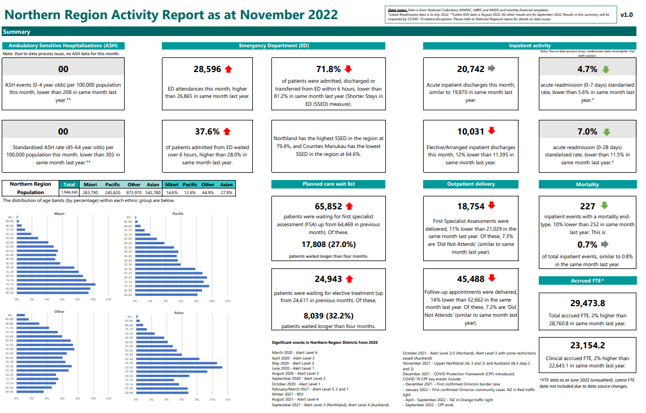

Te Manawa Taki Region Summary and Highlights

Summary
The regional system-wide initiatives started in Quarter 1 have supported Te Manawa Taki to manage the significant demand and capacity challenges impacting health services across the region during this quarter, with a greater focus on regional coordination and support. The Regional Coordination Centre supported the outgoing interim Regional Leadership Team to maintain performance oversight across Te Manawa Taki over the summer period, whilst the regional work programme moving forwards is confirmed. A regional Integration Team is being stood up in early 2023 for support functions.

Quarter 2 Key Highlights
- The Regional Integrated Operations Centre (IOC) has been actively supporting hospitals with local capacity/delivery challenges, managing 29 support requests since October 2022. This has included managing the temporary regional redeployment of staff to hospitals in need and liaising with partner agencies to manage patient diversions when needed. Consistent hospital reporting and KPIs have allowed for more informed decision making, with Regional Coordination Centre support for the ongoing development of the Regional IOC.
- As part of Te Manawa Taki winter preparedness activity, the Regional Coordination Centre is delivering a regional acute flow improvement programme. As part of the national approach, this will build on the existing local initiatives underway, and support local teams to implement operational improvements to minimise preventable delays in care. The regional acute flow diagnostic begins in February 2023 and will take a system-wide view of patient flow.
- Good progress has been made in implementing the national planned care scheduling directives. The priority for the regional planned care programme is on utilising resources across the region to maximise the delivery of planned care, with a focus on addressing patients waiting the longest and prioritising Māori and other priority populations.
- Permanent regional directors have been appointed for Hospital and Specialist Services and Commissioning/Wayfinding, alongside the interim Regional Director for Pacific health and a permanent National Public Health Service Regional Director in October 2022.

A dashboard of the regional activity follows.
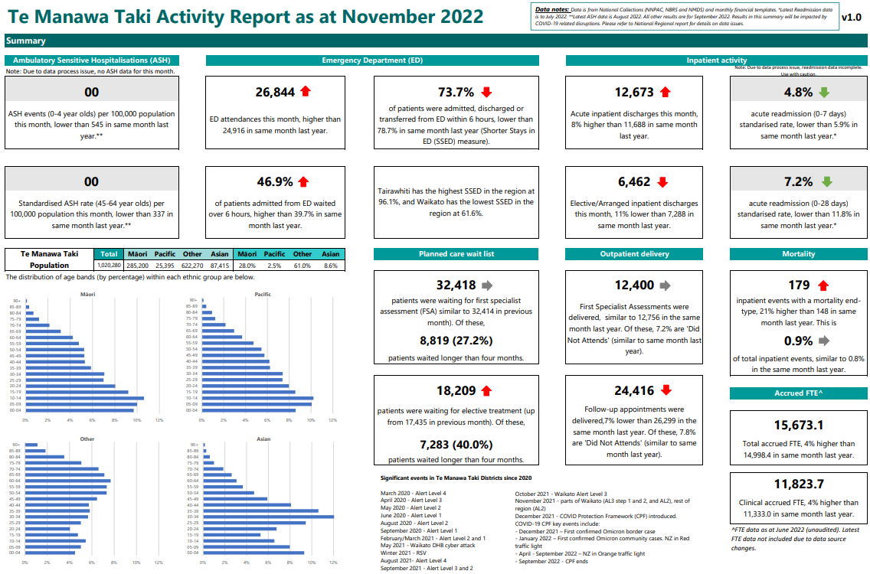

Central Region Summary and Highlights

Summary
Workforce pressures remain a key challenge across all local areas and across the system. The region continues to operate in an environment where the system is under significant pressure with hospitals regularly at capacity, significant pressure on EDs, deferral of planned care, and gaps in primary care services.
During this quarter, the region has continued to advance critical areas of work, in particular, a comprehensive programme for planned care, mental health and addiction and good progress in our child wellbeing and clinical network programmes which all have a focus on addressing inequities for Māori.

Quarter 2 Key Highlights
Newly prioritised projects for the region from Budget 2022 updates include:
- Midcentral Critical Infrastructure (electrical) and Capital, Coast and Hutt Copper Pipes business cases being prepared for submission to IIG in March 2023.
- Wellington Front of Whare/ED business case progressing well, Identified Qualified Person application complete, gateway review scheduled for the week beginning 20 February 2023. Submission to IIG in March 2023.
- A new Medical Assessment Planning Unit and Emergency Department Observation Area facility opened at MidCentral which will improve the management of the flow of people throughout the hospital.
- Planned care programme in place to address waiting lists and work has progressed to identify and agree on initiatives to be funded through the additional allocation of
$14.3 million for the Central region. The region has endorsed the establishment of a planned care clinical network to ensure the work is clinically led.
- Regional agreement on allocation of COVID-19 funding and procurement approach.
- The Royal Australasian College of Surgeons Verification Assessment for the Central Region Trauma System has been confirmed. Planning is underway for the self-assessment process to support the verification site visits in early 2024.
- The regional Mental Health and Addiction work program and project teams (representation from each local area) for each Pou established: Pou Tahi – Governance and leadership, Pou Rua – Learning and Development. Pou Toru – Enhancement of Regional Specialist Services. Pou Whā – Analytics and Insights. Pou Rima – Valuing lived Experience, Pou Ono – Innovation and Improvement. Work programme aligns closely with priorities and actions as outlined in Te Pae Tata.
- Te Whakahaere phase (implementation phase) of the Whakapakari Hūnga Tautoko Project is in progress. This phase operationalises the project solution including the employment of regional clinical support/educator positions (as designed in the Te Waihanga phase) with three appointments made who commenced in the role on
16 January, and who are providing clinical leadership to Well Child Tamariki Ora providers.
- The Synergia Report to develop a contemporary model of cardiology care for the region was accepted by the Central Region, but noted that it fell below expectations which have delayed implementation planning and have led to extensive discussions across the region regarding interventional cardiology. The work plan for 2022-23 has been agreed. Quality improvement initiatives started for heart failure management and guideline-directed prescribing post-acute coronary syndrome.
- Regional programmes of work have been reviewed to ensure that they align with Te Pae Tata.
A dashboard of the regional activity follows.
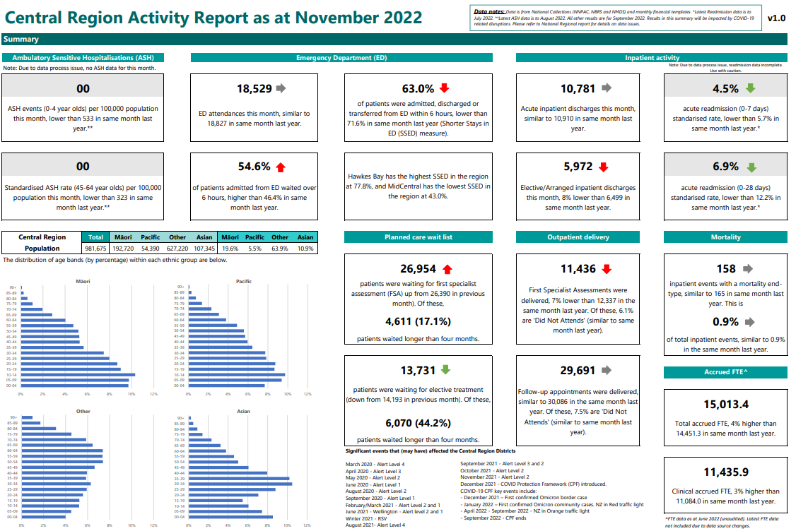

Te Waipounamu Region Summary and Highlights

Summary
As a region, we have faced continued challenges this quarter around staff vacancies. However, we continue to work together to mitigate risks and to deliver the best outcome for our patients. At risk services are engaging as a region to mitigate any impacts to service, for example, Southern Radiation Oncology is looking at regional solutions and working with the national tertiary and quaternity group on a medium to long-term plan. We are also continuing to look at recruitment and how we work with the national team around this.

Quarter 2 Key Highlights
- An initiative with WellSouth to phone Māori and Pacific patients one week prior to their outpatient appointment has resulted in a decrease in the number of ‘not able to attends’ for these groups.
- Contract is in place for new Alcohol and Other Drugs service for people with complex needs in Otago. Iwi provider Ōtākou Health Limited will deliver this through their integrated primary health service, Te Kāika. Implementation planning and recruitment are well under way. Service delivery is planned to commence in February 2023.
- Community Residential Support for Complex Clients: The Commissioning Team have been partnering with community mental health residential care providers and Specialist Mental Health Services to support tāngata whaiora with complex needs to transition from hospital to homes in the community. In the last three months, eight long-term clients have been supported into community residential care beds. This is better for clients who have a long-term home, and frees up specialist capacity to respond to urgent demand in Canterbury.
- Communications teams continue to play a key role in sharing national messaging with our local teams and various audiences. As a collective, the Te Waipounamu communications leaders continue to meet weekly to identify where resources and campaigns can be shared.
- All districts are seeing vacancy pressure across services and are working as a region to provide cover. They are also working with the national recruitment team around solutions.

Below is a dashboard of the regional activity.
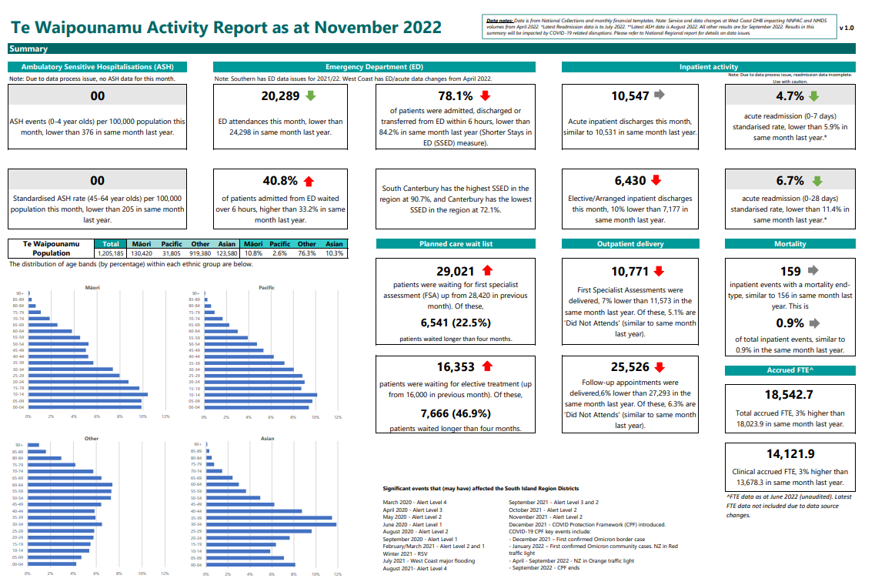

Appendix 3: Glossary
Glossary of key terms and acronyms
Term | Definition
Aiga | Family
Elective Services Patient Inflows (ESPI) | The ESPIs are a suite of indicators that monitor waiting times for elective surgery against expectations. For more information, see Patient Flow Indicators (ESPIs) | Ministry of Health NZ
Hauora | Health
Health System Indicator (HIS) | A series of measures which have been reported on as providing key insights into the performance of the hauora sector. For more information, see https://reports.hqsc.govt.nz/HS
HUD | Ministry of Housing and Urban Development
Kaimahi hauora | Health workers
Kaiāwhina | Assistant, helper
Kaimanaaki | Support worker(s) and community health worker(s)
Kaitiaki | Guardian, steward
Kaupapa Māori | The knowledge, attitudes and values that are inherently Māori as held and followed by hapū and Iwi. This is synonymously linked to mātauranga Māori and underpinned by Te Tiriti o Waitangi, self-determination, cultural validity, culturally preferred teaching, socioeconomic mediation of Māori disadvantage, whānau connections, collective aspirations, and respectful relationships underpinned by equality and reciprocity
Kaumātua | Māori elder
Mana Motuhake | Self-determination, autonomy. Mana Whenua Customary authority exercised by an Iwi or hapū in an identified area
Mātauranga Māori | Māori knowledge systems that reflect indigenous ways of thinking, relating, and discovering. It links indigenous peoples with their environments, is often inspired by environmental encounters and is conveyed within the distinctiveness of indigenous languages and cultural practices
Pakeke | Adult
Pēpi | Baby
Rangatahi | Youth
Request for Proposals (RFP) | A tender and government procurement request through our government services for contingency/contract work to fill work gap functions
Tamariki | Children
Tagata Sa’ilimalo | Collective concept inclusive of families, carers and people with disabilities. Tangata Whenua People of the land. In reference to a particular place, it means the Iwi or hapū that has mana whenua over the area
Tāngata whaikaha | People with disability
Taonga | Treasure
Taurite services | These are services that braid clinical and cultural care. They can be delivered by a Māori provider or a non-Māori provider. If delivered by a non-Māori provider, high-quality taurite services are delivered in partnerships with Māori
Te Aho o Te Kahu | Cancer Control Agency
Te Ao Māori | Māori worldview
GDP | Gross domestic product
HIRA | National digital exchange platform for health information
KPI | Key Performance Indicator
LINAC | A medical linear accelerator directs beams of radiation into tumours to treat people with cancer
UNCRPD | United Nations Convention on the Rights of Persons with Disabilities.
Whānau | Family

Children aged 0-4 years are enrolled with the Community Oral Health Service is sourced from the Well Child Tamariki Ora Quality Improvement Framework Indicators. Baseline results reflect the 2021 calendar year and are the most up-to date results available currently. Results for 2022 will be available from March 2023.
The Quarterly Enrolment Rate as at December 2022 represents the proportion of babies attaining 6 weeks of age over the period 16 September 2022 to 15 December 2022 who were enrolled with a PHO at that milestone. Enrolments are based on the National Enrolment Service (NES). Populations are based on the National Immunisation Register.
Percentage of smokers offered help to quit data is sourced from PHO reporting, latest results cover the 15-month period to December 2022 and exclude Taranaki District as no smoking data was provided at the time of reporting.
Data extracted from the Before School Check (B4SC) Information System on 8 January 2023 and covers the 6-month period 1 June 2022 to 30 November 2022.
Health Quality and Safety Commission Adult Primary Care Patient Experience Survey (unweighted), https://reports.hqsc.govt.nz/APC-explorer/_w_8bb11cf1/#!/topics.
Health Quality and Safety Commission Adult Primary Care Patient Experience Survey (unweighted), https://reports.hqsc.govt.nz/APC-explorer/_w_8bb11cf1/#!/topics.
Health Quality and Safety Commission Adult Primary Care Patient Experience Survey (unweighted), https://reports.hqsc.govt.nz/APC-explorer/_w_8bb11cf1/#!/topics.
Health Quality and Safety Commission Consumer Engagement Quality & Safety Marker, data to September 2022.
Data for this web tool was extracted from publicly funded maternity events recorded in Te Whatu Ora - Health New Zealand's National Maternity Collection. Further information about maternity (and fetal and infant deaths) can be found in the Maternity and newborn data and stats series. Lead maternity carers have a legislated period of 12-months to submit claims for services. As this data comes from the LMC claims process it can take 12-18 months before data is available for publication. Additional delays due to analytic capacity also impact the publication of results hence data is at 2020.
Elective Services Patient Flow Indicators Web Tool, ESPI 8 Data table. https://tewhatuora.shinyapps.io/ESPI_app/
Data sourced from the National Bowel Screening programme reflecting results to January 2023. This measure comes from the iGPS and remains under development. Results for the bowel screening MDM referrals may be impacted by small volumes as the rollout of the programme continues.
Latest data for under 25-year-olds accessing mental health services within 3 weeks is the period 1 December 2021 to 30 November 2022
Data sourced from the national mental health collection (PRIMHD) and reflects the year to November 2022. Mental health access data is published annually on the National Service Framework Library website. https://nsfl.health.govt.nz/accountability/performance-and-monitoring/mental-health-alcohol-and-drug-addiction-sector
Latest data to Nov 2022 available from the HQSC Adult hospital Inpatient Experience Survey result https://reports.hqsc.govt.nz/AHI-explorer/?_gl=1*1obmy1t*_ga*MTAzNjcyNzMzOC4xNjc3NDgxOTU0*_ga_TG4RCRSBWS*MTY3NzgxMDYwNS4xLjEuMTY3NzgxMTIwNS4wLjAuMA..#!/
Annual data only. Latest data is for year ending 30 June 2021.
Data sourced from the Annual NZ Health Survey reflecting the financial year 2021/22, https://minhealthnz.shinyapps.io/nz-health-survey-2021-22-annual-data-explorer/_w_c0d00ff2/#!/explore-indicators. Note: As part of the New Zealand Health Survey programme, this measure is due to be replaced in 2023 and the iGPS measure definition will be revised
Childhood immunisation coverage data is updated quarterly from the National Immunisation Register via Qlik, and is available by local area, deprivation level and ethnicity. Regional numbers are an amalgamation of areas which are based on the child’s recorded address information. The number of eligible children in each category (denominator) is based on current NIR enrolments. Numbers are subject to change as late vaccination events are entered into the systems. The data presented is by birth cohort e.g. rates are for tamariki who become eligible for vaccinations and then have completed those vaccinations in line with the schedule by 8 months, 24 months and 5 years.
Childhood immunisation coverage data is updated quarterly from the National Immunisation Register via Qlik, and is available by local area, deprivation level and ethnicity. Regional numbers are an amalgamation of areas which are based on the child’s recorded address information. The number of eligible children in each category (denominator) is based on current NIR enrolments. Numbers are subject to change as late vaccination events are entered into the systems. The data presented is by birth cohort e.g. rates are for tamariki who become eligible for vaccinations and then have completed those vaccinations.
Coverage data is reported from the National Immunisation Register Dataset (NIR) https://www.health.govt.nz/your-health/conditions-and-treatments/diseases-and-illnesses/influenza/flu-influenza-vaccines/flu-vaccine-data. HSU 20/21 FY used as denominator for uptake statistics.
Unstandardised acute bed day rate per 100,000 population. Results for the year to December 2022. https://nsfl.health.govt.nz/dhb-planning-package/system-level-measures-framework/data-support-system-level-measures/acute

