

Quarterly Performance Report

Quarter Three 2024/25

Citation: Health New Zealand | Te Whatu Ora. Quarterly Performance Report: Quarter ending 31 March 2025.   
Wellington: Health New Zealand | Te Whatu Ora.

Published in June 2025 by Health New Zealand | Te Whatu Ora  
PO Box 793, Wellington 6140, New Zealand

ISSN 2816-1823 (online)



This document is available at [tewhatuora.govt.nz](https://www.tewhatuora.govt.nz/)

|  |  |
| --- | --- |
|  | This work is licensed under the Creative Commons Attribution 4.0 International licence. In essence, you are free to: share i.e., copy and redistribute the material in any medium or format; adapt i.e., remix, transform and build upon the material. You must give appropriate credit, provide a link to the licence and indicate if changes were made. |

Contents

Organisational performance 4

Measures – high-level summary 7

Financial summary 9

Output class 1: Public health services 10

Output class 2: Primary and community care services 14

Output class 3: Hospital and specialist services 20

Output class 4: Mental health and addiction services 24

Output class 5: Hauora Māori services 29

Digital infrastructure 31

Appendix 1: How to read the charts 33

Appendix 2: Performance measure data caveats 34

# 

# Organisational performance

## Summary for the quarter

Highlights expanded on in this report include:

* Performance in 12 out of 33 measures improved, compared to quarter three last year.
* Immunisation coverage for children at 24 months has improved for the second consecutive quarter, and is the highest level obtained since quarter three 2021/22.
* Cervical HPV screening coverage has increased by 4.7 percentage points from the same quarter last year, continuing its upward trend.
* Bowel screening participation has increased, for the first time in two years.
* Performance in the emergency department (ED) health target continues to improve, with the 2024/25 milestone of 74 per cent achieved nationally. This is the highest level obtained in a quarter since quarter four 2021/22.
* Rates of hospital acquired falls and pressure injuries have declined.
* The 80 per cent target for two mental health and addiction targets (MHA faster primary access <1 wk; MHA faster specialist access <3 wks) has been achieved nationally.
* This is the first quarter we have been able to report against all Hauora Māori Services measures, with high performance across all.

Some challenges outlined in this report include:

* An increase in the rate of hospitalisations for children aged 0 – 4 years, for conditions that could potentially have been avoided by timely and effective primary care interventions (ambulatory sensitive hospitalisations (ASH) rates). Pacific children continue to have the highest ASH rates. The recent government announcements related to strengthening primary care will improve access to general practice, after-hours and other primary health provider services.
* Performance against the elective treatment health target declined over the past two quarters, but we are committed to improving performance in this target. Our focus is on increasing elective treatment delivery, improving theatre productivity, reducing the number of long-waiting patients, validating our waitlists, improving the consistency of how our waitlists are managed and how patients are booked for elective treatment.
* Our year-to-date financial result is a $883m deficit, which is $105m unfavourable to budget. Monthly deficit results are now improving, and we are on track to achieve the $1.1b deficit by the end of the financial year.

Some measures in the summary (pg 7-8) have regional and district performance (and improvement narrative) provided in this report, with supporting data caveats in Appendix 2.

## Five health targets

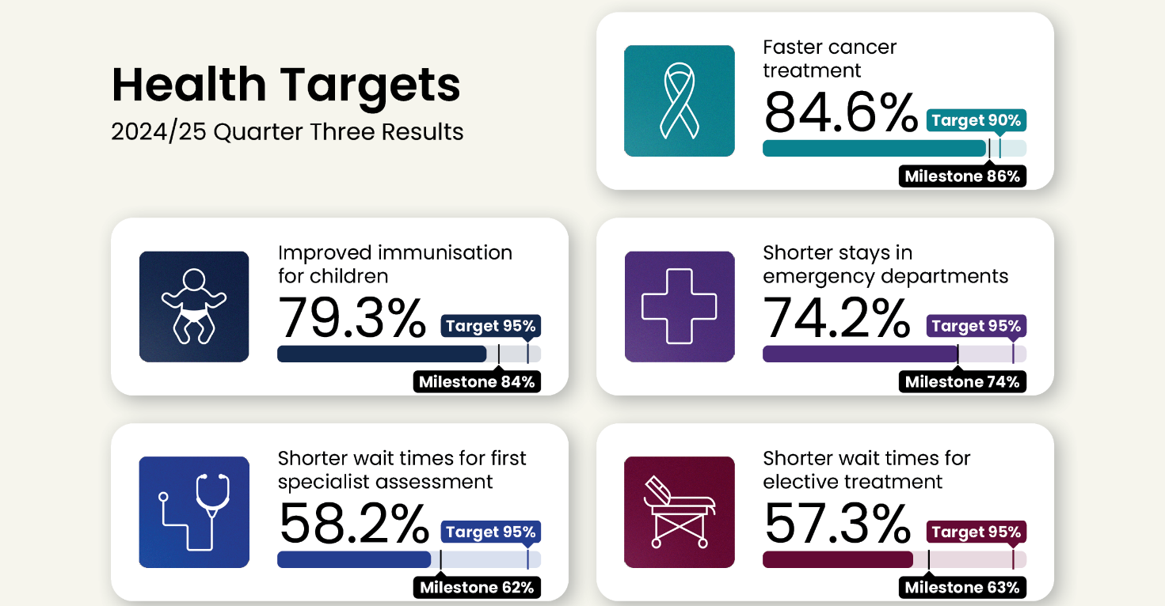

Five mental health and addiction targets

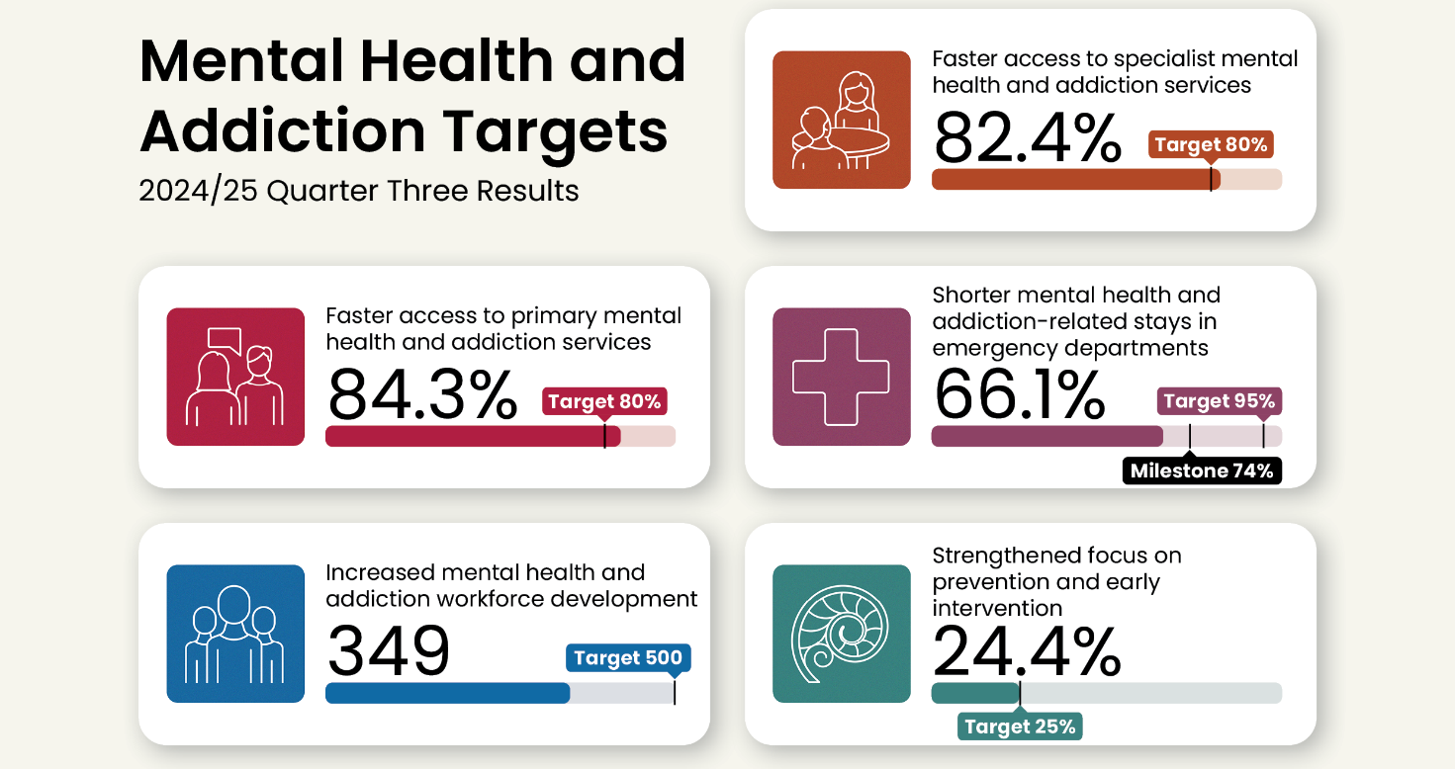

The target dashboards above provide a snapshot of national performance during quarter three against the 2024/25 milestone (as set by the [Government Policy Statement on Health](https://www.health.govt.nz/publications/government-policy-statement-on-health-2024-2027)) and the overarching target. The milestones increase year-on-year to ensure we meet the overarching targets by 2030. Detailed breakdowns of regional and district performance, improvement narrative and data caveats for the [health targets](https://www.tewhatuora.govt.nz/corporate-information/planning-and-performance/health-targets/health-targets/performance) and [mental](https://www.tewhatuora.govt.nz/corporate-information/planning-and-performance/health-targets/mental-health-and-addiction-targets/performancehttps:/www.tewhatuora.govt.nz/corporate-information/planning-and-performance/health-targets/mental-health-and-addiction-targets/performance) health and addictions targets are available on our website.

**Progress against our strategic priorities**

* Work to deliver on actions in the NZ Health Plan | Te Pae Waenga 2024-2027 were advanced through the quarter.
* Organisational structural change processes, designed to enhance Health NZ’s performance and better support local and clinical leadership at all levels, were progressed.
* The establishment of a Clinical Senate was announced. When formed, this will be a multidisciplinary group with clinicians, providing strategic advice to Health NZ governance on issues that affect Health NZ’s delivery or funding of quality, affordable and efficient patient care, informed by clinical expertise. The Senate will provide strategic oversight of Health NZ’s work to establish nationally consistent access criteria and clinical prioritisation tools for first specialist assessment (FSA) and elective treatment services (both align to health targets).
* Te Kāhui o Te Whiri Kaha supported the National Clinical Networks to develop frameworks for equitable advice and decision-making. Te Kāhui o Te Whiri Kaha is a group of Māori clinicians from diverse communities and professions, who meet monthly to address health issues that most affect Māori.
* The Northern region re-established the joint alliance leadership team of Primary Health Organisation (PHO) chief executives and clinical directors, to provide a regional oversight of primary care, and a platform to discuss challenges and improvements.
* We recruited for 23 vacant district clinical chief roles in medical, nursing and allied health (scientific and technical), to strengthen clinical leadership locally. At the end of quarter three, most roles were at offer stage. Chief midwifery roles were established in districts that did not previously have a chief midwife.

# Measures – high-level summary

The following table shows the quarter three 2024/25 (January – March) results compared to quarter three last year to account for seasonal variation. The table also compares this quarter’s results to the results published in the [Quarter two Performance Report](https://www.tewhatuora.govt.nz/publications/quarterly-performance-report-quarter-two-2024-25). Those with a two or more percentage point change (a level adopted to indicate some materiality) are marked with a green arrow **hi** improving or a red arrow **ih** slipping. A target symbol Title: Title: 🎯is used to identify the health targets. A Parliament symbol Wellington Beehive coloring page is used to identify targets that also form part of the [Government’s nine targets](https://www.dpmc.govt.nz/our-programmes/government-targets). Measures where regional and district performance are provided in this report are in bold.

| Ref | Measure short name | Q3  last year | Q3  this year | Change | Last quarter | This  quarter | Change |
| --- | --- | --- | --- | --- | --- | --- | --- |
| P2-03 | Improved immunisation for children 24mth 🎯 | 76.9% | 79.3% | **h** | 77.0% | 79.3% | **h** |
| P2-140 | Improved immunisation for children 8mth | 77.0% | 79.9% | **h** | 78.5% | 79.9% |  |
| P2-09 | Cervical HPV screening coverage | 68.9% | 73.6% | **h** | 72.7% | 73.6% |  |
| P2-07 | **Breast screening coverage** | 68.0% | 69.7% |  | 69.7% | 69.7% |  |
| P2-158 | **Bowel screening participation** | 57.6% | 57.6% |  | 57.2% | 57.6% |  |
| P2-38 | **Newborn GP enrolment** | 85.3% | 83.5% |  | 85.0% | 83.5% |  |
| P2-17 | GP enrolment | 94.4% | 94.3% |  | 94.7% | 94.3% |  |
| P2-23 | **ASH rate adults 45 – 64yrs (rate per 100,000 population)** | 3,876 | 3,795 |  | 3,847 | 3,795 |  |
| P2-22 | **ASH rate child 0 – 4yrs (rate per 100,000 population)** | 7,247 | 7,456 | **h** | 7,311 | 7,456 |  |
| P2-176 | GP accessed when wanted | 75.6% | 76.9% |  | 76.3% | 76.9% |  |
| P2-45 | Shorter stays in ED <6hrs 🎯Wellington Beehive coloring page | 70.1% | 74.2% | **h** | 72.1% | 74.2% | **h** |
| P2-51 | Faster cancer treatment <31 days 🎯 | 83.0% | 84.6% |  | 85.9% | 84.6% |  |
| P2-39 | Shorter wait times for FSA 🎯 | 59.6% | 58.2% |  | 60.6% | 58.2% | **i** |
| P2-40 | Shorter wait times for elective treatment 🎯Wellington Beehive coloring page | 59.3% | 57.3% | **i** | 59.2% | 57.3% | **i** |
| P2-58 | **Missed FSA appts** | 7.7% | 7.7% |  | 7.6% | 7.7% |  |
| P2-88 | **Medical appts via telehealth (digital)** | 6.6% | 7.2% | **h** | 7.2% | 7.2% |  |
| P2-194 | Hospital pressure injuries (rate per 10,000 hospitalisations) | 6.2 | 4.9 | **i** | 5.8 | 4.9 | **i** |
| P2-195 | Hospital falls (rate per 10,000 hospitalisations) | 3.8 | 3.4 | **i** | 3.6 | 3.4 | **i** |
| P2-44 | Involved in care decisions, hospital | 81.4% | 83.0% |  | 81.4% | 83.0% |  |
| P2-198 | MHA workforce development 🎯 | NEW* | 349^ |  | 457# | 349^ |  |
| P2-200 | MHA prevention and early intervention 🎯 | NEW* | 24.4% |  | 24.4% | 24.4% |  |
| P2-201 | Shorter MHA stays in ED <6hrs 🎯 | NEW* | 66.1% |  | 65.0% | 66.1% |  |
| P2-202 | MHA faster primary access <1 wk 🎯 | NEW* | 84.3% |  | 83.9% | 84.3% |  |
| P2-203 | MHA faster specialist access <3 wks 🎯 | NEW* | 82.4% |  | 81.9% | 82.4% |  |
| P2-69 | **MHA youth seen <3 wks** | 72.9% | 77.5% | **h** | 77.1% | 77.5% |  |
| P2-199 | **MHA access, Integrated Primary** | 48,872 | 57,658 | **h** | 56,622 | 57,658 |  |
| P2-187 | **MHA services access (rate per 100,000 population)** | 2,704 | 2,773 | **h** | 2,843 | 2,773 | **i** |
| P2-206 | Hauora Māori contracts | NEW* | 44.0% |  | 44.0% | 44.0% |  |
| P2-208 | **IMPB strategic involvement** | NEW* | 80% |  | NEW* | 80% |  |
| P2-205 | **Hauora Māori outcomes** | NEW* | 89% |  | NEW* | 89% |  |
| P2-152 | Health NZ workforce turnover | 2.8% | 2.1% | **i** | 2.0% | 2.1% | **h** |
| P2-153 | Health NZ Māori and Pacific Peoples workforce | 12.5% | 15.0% | **h** | 13.6% | 15.0% | **h** |
| P2-169 | **My Health Record access** | 51,700 | 48,858 | **i** | 51,452 | 48,858 | **i** |

NEW* = data was not collected in 2023/24 (see relevant data caveats throughout the report).

# = Result is for the 2024 calendar year. ^ = Represents a partial result (only semester one) for the 2025 academic/calendar year

# Financial summary

This table summarises financial performance for the year-to-date. Column totals may not reconcile due to rounding of numbers within the tables.

|  |  |  |  |  |
| --- | --- | --- | --- | --- |
|  | Year to Date (31 March-25)  Actual $m | Year to Date (31 March-25) Budget $m | Year to Date (31 March-25) Variance $m | 2024/25 SPE  Budget $m |
| Revenue |  |  |  |  |
| Appropriation funding | 18,436 | 18,606 | (170) | 24,810 |
| Other Government funding | 2,303 | 2,262 | 41 | 3,016 |
| Other revenue | 417 | 352 | 65 | 471 |
| Total revenue | **21,157** | **21,220** | **(64)** | **28,297** |
| Expenditure – operating costs |  |  |  |  |
| Personnel costs | 9,286 | 9,329 | 43 | 12,466 |
| Outsourced staff costs | 333 | 203 | (130) | 270 |
| Other operating costs | 3,746 | 3,761 | 15 | 5,002 |
| External service providers | 7,637 | 7,648 | 11 | 10,235 |
| Interest, depreciation and capital charge | 1,039 | 1,058 | 19 | 1,424 |
| Total expenditure | **22,039** | **21,998** | **(42)** | **29,397** |
| Surplus/ (Deficit) | **(883)** | **(778)** | **(105)** | **(1,100)** |

The quarter three year-to-date result was a deficit of $883m, which was $105m unfavourable to budget. Revenue was $64m unfavourable to budget, mostly due to appropriation funding. $157m of appropriation revenue was deferred, to match spending with revenue, primarily $46m for Hauora Māori services and $39m for budget initiatives.

Total expenditure was $42m more than budget year-to-date, inclusive of contingencies accrued for initiatives, including the electives boost, and possible cost pressures for the balance of the year. Personnel costs were lower than budget year-to-date, partly due to one-off benefits from leave liability revaluations and release of 2023/24 accruals for pay equity. Outsourced personnel costs year-to-date were higher than budget ($130m), reflecting continued use of contingent workforce to cover staff gaps (due to vacancies, leave, etc) and resourcing for projects and initiatives.

Health NZ is on track to achieve the $1.1b budget deficit.

Output class 1: Public health services

P2-07 Breast screening coverage

This measure shows the number of individuals aged 45 – 69 who have had breast cancer screening in the past two years.

**National result:**

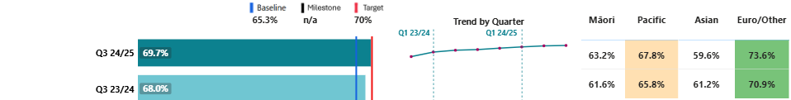

**Results by region and district:**

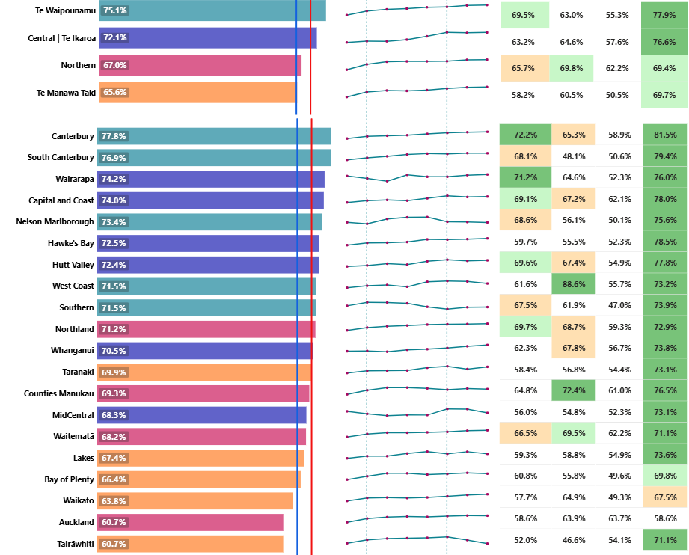

|  |  |  |  |  |  |  |  |
| --- | --- | --- | --- | --- | --- | --- | --- |
|  | **Target achieved** |  | **Within 1% of Target** |  | **Within 5% of Target** | **x%** | **White – Target not achieved** |

Breast screening coverage has remained stable compared to quarter two, but has improved compared with the same time last year.

Breast screening rates for Asian women are lower than for any other ethnicity. Focused efforts are underway, such as plans to extend the successful model used at Waitematā district to improve Asian breast screening coverage.

The National Breast Screening System (Te Puna) launched in February 2025 with BreastScreen Midland (Te Manawa Taki), followed by BreastScreen South and BreastScreen Otago Southland in March. Te Puna introduces a population-based register to the breast screening programme that will enable providers to systematically identify and invite eligible participants in their districts. Over time, this will enable BreastScreen Aotearoa to reach more people, resulting in improved performance in this measure.

The BreastScreen Aotearoa age extension for women aged 70 – 74 launched in Nelson Marlborough on 31 October 2024. A total of 158 women in that extended age-group have been screened in the district since the launch, while coverage rates for women aged 45 – 69 remain stable. A phased approach is being taken to ensure breast screening service delivery and cancer treatment services can meet the additional demand of the age extension. The national rollout of the age extension is planned to start in October 2025 and will be completed by September 2030.

As of 31 March 2025, over 4,000 wāhine were screened as a direct result of the recommendations from the [2023 BreastScreen Aotearoa Quality Review](https://www.tewhatuora.govt.nz/publications/bsa-quality-and-safety-review-report)(through funded initiatives – increasing access, removing barriers). Of these, more than 2,500 were women from high-needs populations (estimated more than 1,400 were Māori and 740 Pacific). Specific activities to increase rates in regions with low coverage include:

* A targeted initiative in Te Manawa Taki, in partnership with Hauraki PHO, to connect with unscreened and under-screened women in the Thames area to support them to enrol and book a screen. Between July 2024 and 31 March 2025, there have been 218 engagements, with 70 women completing their breast screen.
* BreastScreen Waitematā Northland and BreastScreen Auckland Central received funding to implement additional initiatives. These include alternative hours of screening and contacting, as well as new locations for the mobile unit to visit. These will be implemented in quarter four.

P2-158 Bowel screening participation

This measure presents the number of eligible individuals (aged 60 – 74) who returned a testing kit with a definitive result over a rolling 24-month period (as at 30 June 2024). It is presented as a proportion of the total number of eligible individuals invited to participate in screening during the timeframe.

**National result:**

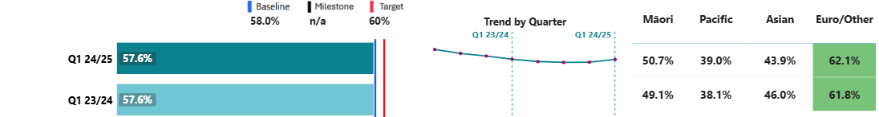

**Results by region and district:**

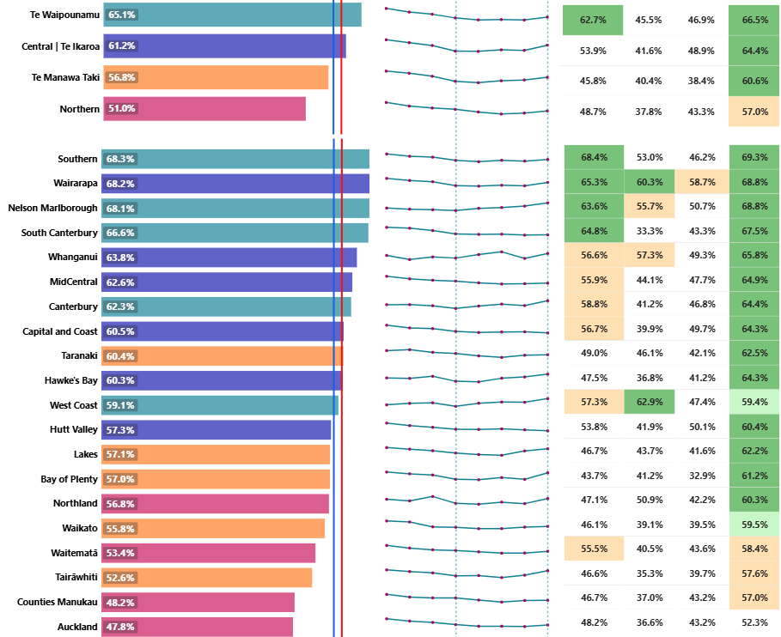

|  |  |  |  |  |  |  |  |
| --- | --- | --- | --- | --- | --- | --- | --- |
|  | **Target achieved** |  | **Within 1% of Target** |  | **Within 5% of Target** | **x%** | **White – Target not achieved** |

Although bowel screening rates have been declining, recent efforts have seen the decline stabilise, with a slight improvement seen in quarter three results.

The Northern region has the lowest bowel screening participation rates. A pilot in Waitematā, Auckland and Counties Manukau districts for returning bowel screening kits to a community laboratory is ongoing. This method offers an additional way for participants to return their kits, besides the current postal option – an option that may be more appropriate, particularly for Pacific people who have lower participation rates.

From July to December 2024, approximately 33 per cent of kits were returned to the lab rather than by post, increasing to 38 per cent of kits in January 2025 (data for February and March is not yet available). In March 2025, this alternative return approach was successfully implemented in Northland, with further plans for implementation in other regions during 2025.

In quarter three, there were several announcements relating to bowel screening age extension (including lowering the age at which people can start taking part in free screening from 60 to 58 years old) and investing in activities to ensure participation by high-needs groups. Lowering the age to 58 means that at least 122,000 more people will be eligible for a free test over the first year of implementation. The age extension will be implemented nationwide in two tranches, with the first tranche (two regions) commencing in October 2025, followed by the second tranche (remaining two regions) in March 2026.

In March 2025, Wairarapa became the thirteenthdistrict to go live with new Community Invitation Campaign Strategy functionality in the Bowel Screening Register. This functionality gives districts and their community providers the option to engage with and invite their high-needs populations to participate in screening. It enables targeted invitations to participants and bowel screening kits to be hand delivered at a range of face-to-face events, with the aim of optimising participation rates for Māori and Pacific Peoples.

Financial performance

|  |  |  |  |  |
| --- | --- | --- | --- | --- |
| Revenue and expenditure | Year to Date  (31 March-25)  Actual  $m | Year to Date Budget  $m | Year to Date  Variance  $m | Full Year 2024/25  Budget  $m |
| Total operating revenue | 406 | 400 | 6 | 533 |
| Total operating expense | 387 | 406 | 19 | 533 |
| Surplus/(deficit) | 19 | (6) | 26 | 0 |

The year-to-date result for this output class was a $19m surplus, which is $26m favourable to budget.

# Output class 2: Primary and community care services

### P2-38 Newborn GP enrolment

This measure shows the percentage of newborns enrolled with a general practice (or a kaupapa Māori provider delivering general practice care) by three months of age.

**National result:**

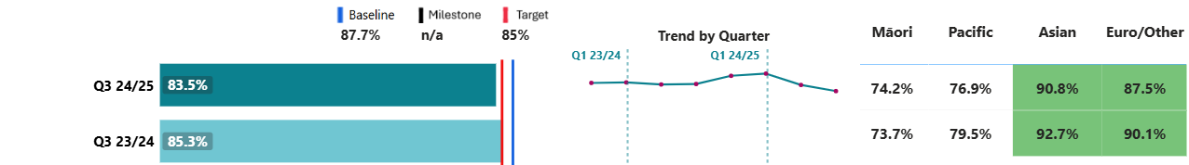

**Results by region and district:**

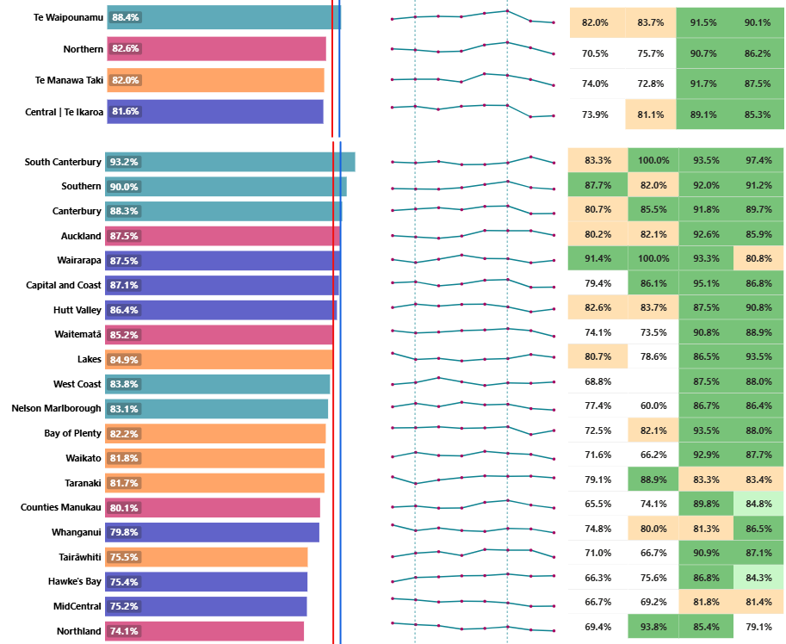

|  |  |  |  |  |  |  |  |
| --- | --- | --- | --- | --- | --- | --- | --- |
|  | **Target achieved** |  | **Within 1% of Target** |  | **Within 5% of Target** | **x%** | **White – Target not achieved** |

Newborn enrolment rates have been declining over the past two quarters. Newborn enrolment systems are not consistent across the country and provide barriers for some whānau. New processes have been put in place this year, with the extension of provisional enrolment from three months to 12 months and, for some families, removing the requirement for presentation of birth certificates.

Central and Te Manawa Taki, are the regions with the lowest newborn enrolment rates, and have activity underway to improve performance.

Central region is working to develop a newborn enrolment resource toolkit. An initial hui was held in March with PHOs that had either developed newborn enrolment resources or recently conducted stakeholder engagement. The region is also working with partners in PHOs and general practice to understand the reasons for the decline in Māori and Pacific enrolments. It will have insights available next quarter to make improvements going forward.

Te Manawa Taki is initiating a new six-week mama and pēpē check within general practice. The aim is to provide a comprehensive check and advice, including mama postnatal check, newborn check, six-week immunisation and newborn enrolment in the same visit. Te Manawa Taki will continue to focus on newborn enrolment through 2025/26 in partnership with regional PHOs, prioritising timely enrolment as a contributory measure towards improved immunisation coverage.

### P2-23 ASH rate adults 45 – 64yrs per 100,000

This measure shows ambulatory sensitive hospitalisations (ASH) for people aged 45 – 64 years old for an illness that might have been prevented or better managed in a primary care setting, as a rate per 100,000 population. A smaller rate correlates to lower ASH rates (favourable), and a larger rate to higher ASH rates (unfavourable).

**National result:**

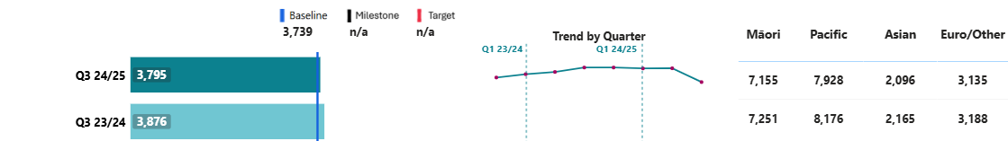

**Results by region and district:**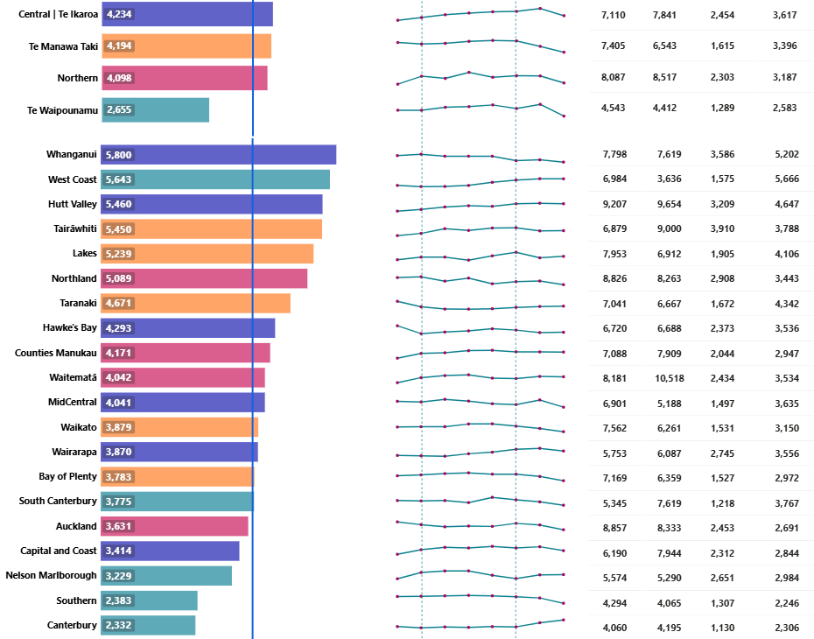

### P2-22 ASH rate child 0 – 4yrs per 100,000

This measure shows ASH rates for children aged 0 – 4 years old for an illness that could have been prevented or better managed in a primary care setting, as a rate per 100,000 population. A smaller rate correlates to lower ASH rates (favourable), and a larger rate to higher ASH rates (unfavourable).

**National result:**

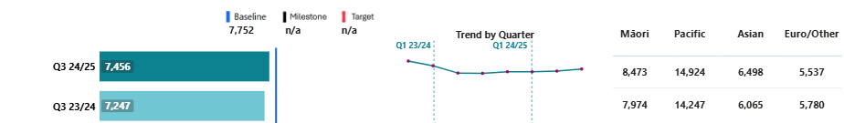

**Results by region and district:**

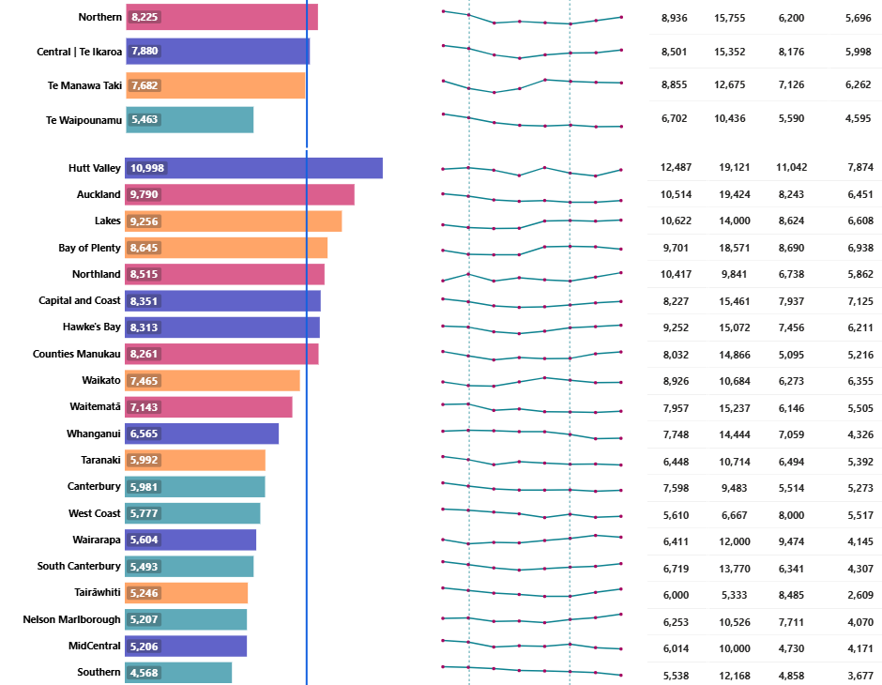

ASH rates have increased slightly for children and decreased slightly for adults. Pacific children have double the ASH rate of the total population, and almost three times that of European/Other.

The recent government announcements related to strengthening primary care will improve access to general practice, after-hours and other primary health provider services. We anticipate we will be able to support more people in primary care, which should contribute to improvements in ASH rates.

Reducing ASH rates is a focus for regions, with Northern, Te Manawa Taki and Central above baseline for adult rates, and Northern and Central above baseline for child rates.

The Northern region’s system level measures and associated actions are expected to contribute to the reduction in ASH rates through a focus on oral health prevention and early intervention. Specific initiatives include:

* Working with Well Child Tamariki Ora and Before School Check providers to increase early screening and referrals to Community Oral Health Service.
* Using outreach oral health services to increase prevention and early intervention for tamariki attending early childhood centres, kohanga reo and language nests.
* Rollout of a Pacific mobile dental service to increase access and early intervention for tamariki living in high-needs areas.

In Te Manawa Taki we have been working with PHO partners to plan and deliver proactive respiratory advice for patients, usually timed alongside delivery of influenza vaccines. Both elements are aimed at reducing the health burden on patients and hospitals over the autumn and winter period.

In Te Manawa Taki, a new urgent after-hours care service in Tairāwhiti will be launched in quarter four. The service will include:

* A walk in or phone first service to a see a nurse, nurse practitioner or doctor;
* Kaiāwhina-assisted health navigation;
* A local nurse-led phone line operating the same hours as the service.

It will operate on weekends and public holidays, and as capacity allows, may extend to weekday evenings. This will increase the community’s access to an after-hours primary care service.

In the Central region, Hutt Valley is the only urban centre in New Zealand without a daytime urgent care service. This may be contributing to the high rates of ASH in the district. We are working with our providers on enhancing services to cover this gap in both the short and longer term.

## Financial performance

|  |  |  |  |  |
| --- | --- | --- | --- | --- |
| Revenue and expenditure | Year to Date (31 March-25)  Actual  $m | Year to Date (31 March-25)  Budget  $m | Year to Date (31 March-25)  Variance  $m | Full Year 2024/25  Budget  $m |
| Total operating revenue | 7,309 | 7,017 | 292 | 9,387 |
| Total operating expense | 7,281 | 7,242 | (39) | 9,637 |
| Surplus/(deficit) | 28 | (225) | 253 | (250) |

The year-to-date result for this output class was a $28m surplus, which is $253m favourable to budget.

Output class 3: Hospital and specialist services

P2-58 Missed FSA appts

This measure shows the patients who did not attend or did not wait for their FSA as a proportion of total appointments.

**National result:**

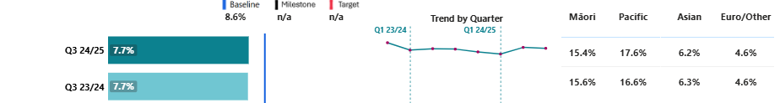

**Results by region and district:**

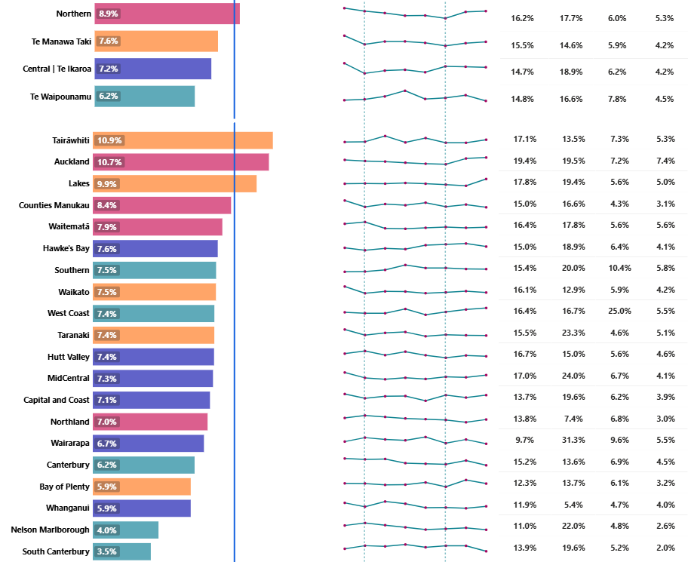

Initiatives in the Northern region to reduce missed appointments include provision of cultural support and health navigators, and increased use of twilight clinics and telehealth services, offering more flexible and accessible appointment options. Districts have initiatives to support appointment attendance for Māori and Pacific Peoples. Hawke’s Bay and Capital Coast/Hutt Valley navigators support Pacific Peoples to attend appointments, and Wairarapa has two Kaitātaki Whānau Ora Navigators.

P2-88 Medical appts via telehealth (digital)

This measure reports outpatient attendances that were completed via telephone or video as a proportion of all outpatient attendances.

**National result:**

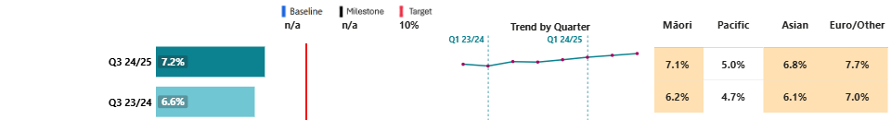

**Results by region and district:**

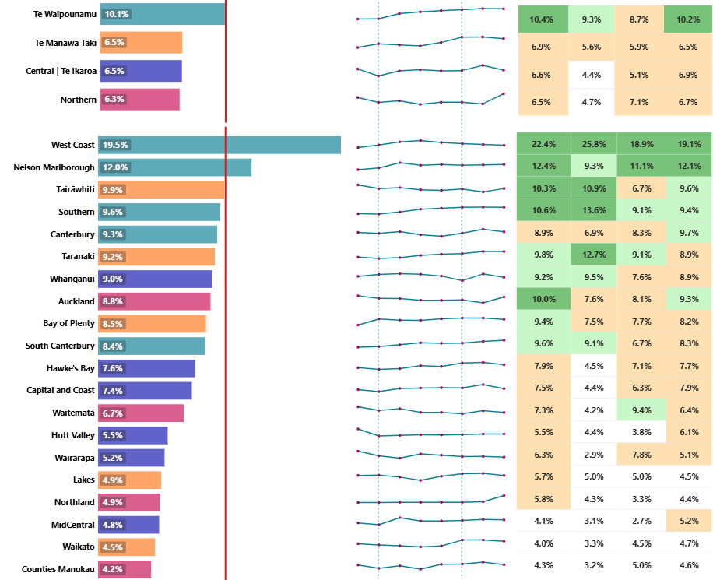

|  |  |  |  |  |  |  |  |
| --- | --- | --- | --- | --- | --- | --- | --- |
|  | **Target achieved** |  | **Within 1% of Target** |  | **Within 5% of Target** | **x%** | **White – Target not achieved** |

Te Waipounamu has the highest proportion of follow-ups delivered by telehealth, with the West Coast being the highest-performing district by a significant margin. Given the rural and remote location of patients living on the West Coast, the district routinely uses telehealth to reduce travel time for patients and to increase efficiency for specialists. Patients have the option of taking phone consults from home on their own phone. If a video consult with a specialist is required, these are supported in rural clinics (e.g. Karamea or Fox Glacier) by a rural nurse specialist, who stays with the patient throughout the video call. If it is not advisable for the patient to travel, rural nurse specialists travel to the patient’s home to facilitate the video connection.

Although the Northern region is the lowest-performing in this measure, performance has improved by 0.8 per cent from the previous quarter with an increase in clinically appropriate use of telehealth. Performance for the Northern, Central and Te Manawa Taki regions are now relatively similar.

In the Central region:

* The regional cancer and treatment service provided by the MidCentral district uses telehealth to support people accessing appointments. In addition, several planned care specialties perform non-contact clinic appointments by telephone with patients.
* The Hutt Valley district provides vascular video clinics and chart reviews.
* In the Hawke’s Bay, the new Heart Hub has a dedicated telehealth room to support multidisciplinary team meetings, remote patient management and virtual pre-assessments.

In Te Manawa Taki:

* Two surgeons in Taranaki regularly use telehealth clinics in ENT and general surgery.
* Tairāwhiti uses virtual appointments for haematology and dermatology. Remote clinics are being offered to improve access to cardiology care for patients living in Tairāwhiti.

Financial performance

|  |  |  |  |  |
| --- | --- | --- | --- | --- |
| Revenue and expenditure | Year to Date  (31 March-25)  Actual  $m | Year to Date (31 March-25)  Budget  $m | Year to Date (31 March-25)  Variance  $m | Full Year 2024/25  Budget  $m |
| Total operating revenue | 11,030 | 11,334 | (304) | 15,116 |
| Total operating expense | 12,058 | 11,892 | (166) | 15,966 |
| Surplus/(deficit) | (1,028) | (558) | (470) | (850) |

The year-to-date result for this output class was a $1,028m deficit, which is $470m unfavourable to budget. The result includes contingencies accrued for initiatives such as the electives boost and possible cost pressures for the balance of the year.

Output class 4: Mental health and addiction services

P2-69 MHA youth seen <3 wks

This measure shows the percentage of youth (under 25) seen within three weeks from a MH&A referral.

**National result:**

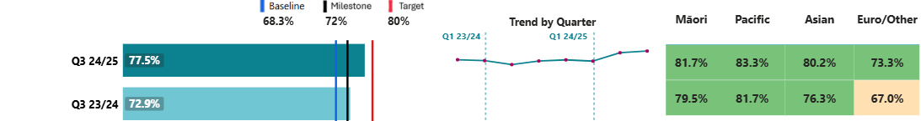

**Results by region and district:**

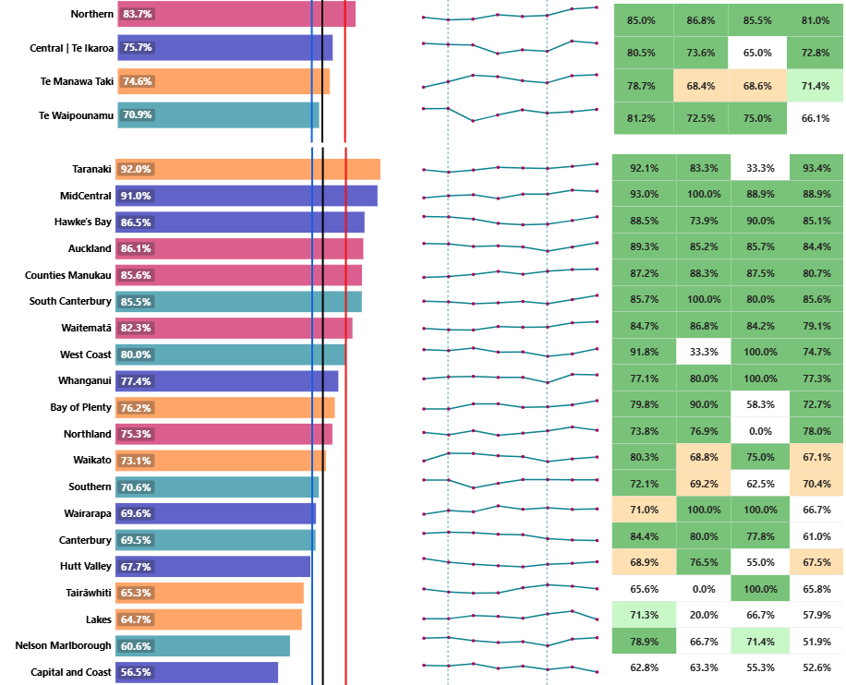

|  |  |  |  |  |  |  |  |  |  |
| --- | --- | --- | --- | --- | --- | --- | --- | --- | --- |
|  | **Milestone achieved** |  | **Within 1% of Milestone** |  | **Within 5% of Milestone** | **x%** | **White – Milestone not achieved** |  | **White with no result – no results for this ethnicity** |

Te Manawa Taki, Central and Northern regions have achieved the 2024/25 milestone, and Northern has also achieved the 80 per cent target. Te Waipounamu is the lowest-performing region, 1.1 per cent away from the milestone.

In Te Waipounamu, performance is most challenging on the West Coast and in Nelson Marlborough. In response to this, the districts are trialling more effective triage approaches. We have seen a notable improvement in performance in the West Coast since last quarter (from 68.0 per cent to 80.0 per cent, a 12 per cent increase); work will assess whether this improvement has resulted from its improved process and whether it is likely to be sustained.

MidCentral is the second-best performing district, despite having some of the highest referral rates per capita. The MidCentral Child and Adolescent Mental Health Service is a highly-responsive interdisciplinary team. Its success stems from quick access for urgent referrals, working collaboratively with schools, primary care, and community services to ensure timely support that is easy to access and tailored to each young person’s needs.

P2-199 MHA access, Integrated primary

This measure shows the number of people accessing primary MH&A services through the integrated primary MH&A services (a subset of the Access and Choice programme).

**National result:**

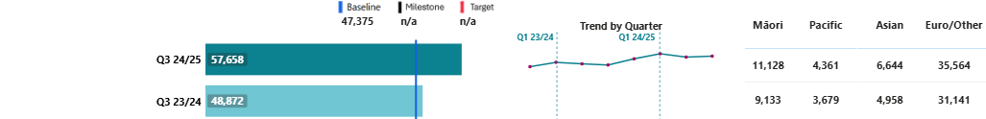

**Results by region and district:**

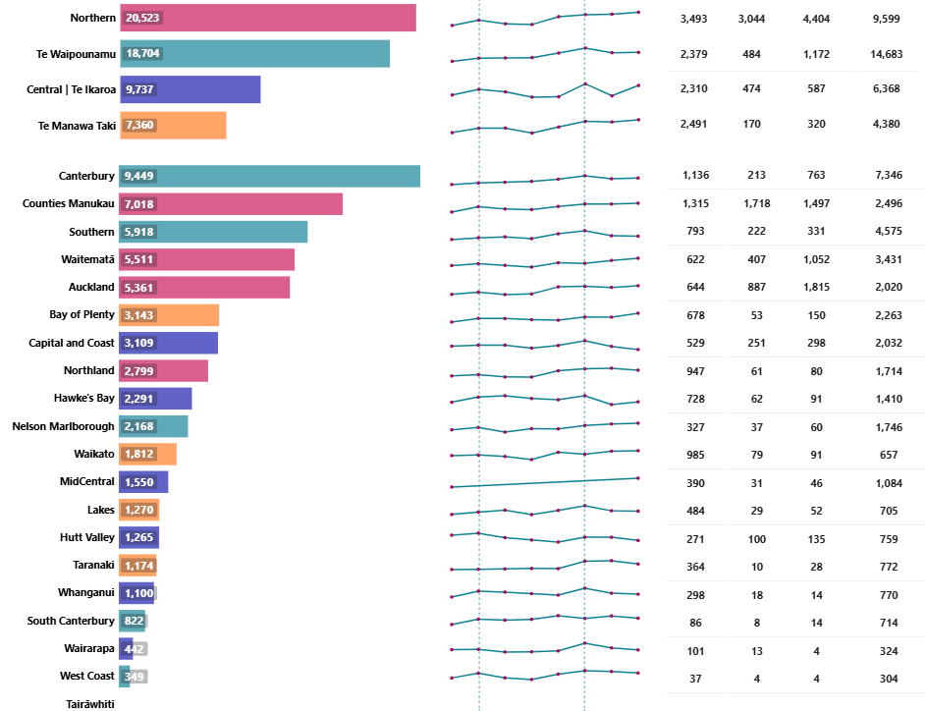 Covering space

Increasing access to integrated primary MH&A services reflects ongoing service expansion over two years with the roll-out of new services completed in 2023/24. All regions experienced an increase in access over the last quarter, with the Northern region having the highest volumes accessing primary MH&A services out of the four regions, reflective of its population size.

P2-187 MHA services access per 100,000

This measure shows the rate of new people accessing either primary (through the Access and Choice programme) and/or specialist MH&A services per 100,000 people.

**National result:**

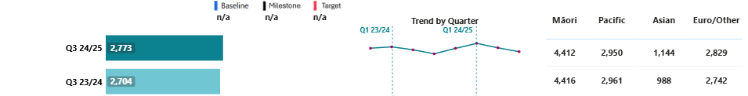

**Results by region and district:**

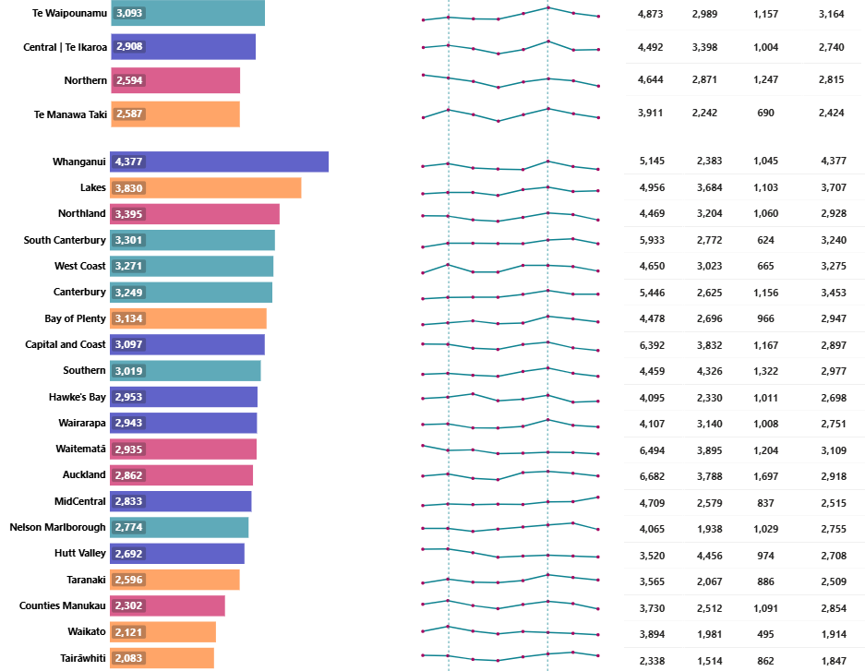

Use of mental health services has been declining for the past two quarters. Te Waipounamu is the region with the most users per 100,000 population. Māori remain the highest users of services and Asian peoples remain the lowest. As this is a new measure, we will continue to track trends over time. Activities to improve access to services are reflected in the previous measures (above).

Financial performance

|  |  |  |  |  |
| --- | --- | --- | --- | --- |
| Revenue and expenditure | Year to Date (31 March-25)  Actual  $m | Year to Date (31 March-25)  Budget  $m | Year to Date (31 March-25)  Variance  $m | Full Year 2024/25  Budget  $m |
| Total operating revenue | 2,010 | 2,035 | (25) | 2,683 |
| Total operating expense | 1,991 | 2,035 | 44 | 2,683 |
| Surplus/(deficit) | 19 | 0 | 19 | 0 |

The year-to-date result for this output class was a $19m surplus, which was $19m favourable to budget. As the MH&A ringfence is a minimum expected spend, there is a slight underspend against the ringfence budget for the year to date to 31 March 2025.

Output class 5: Hauora Māori services

**Performance measures**

P2-208 IMPB strategic involvement

Percentage of Iwi Māori Partnership Boards (IMPBs) that participate in setting strategic priorities for commissioning in Health NZ.

|  |  |  |
| --- | --- | --- |
| Baseline and target | Q1 & Q2 2024/25 | Q3 2024/25 |
| Baseline: NEW; 2024/25 target: 80% | Under development* | 80% |

* IMPBs began influencing Health NZ commissioning in quarter three.

12 out of 15 IMPBs have submitted final versions of their community health plans to inform priorities for commissioning, meeting the 2024/25 target for this measure. These plans have been approved by IMPB governance and are ready to implement from 1 July 2025.

The integration of IMPBs into Health NZ planning and funding processes has been framed around legislated and Cabinet-mandated IMPB functions: whānau voice, strategic commissioning, and monitoring. In quarter three, actions completed to support the integration of IMPBs into Health NZ planning and funding processes include:

* Assessed hauora Māori commissioning against community health plan priorities.
* Developed the action plan for IMPB integration, including relevant functions as set out in the Pae Ora (Healthy Futures) Act, incorporating the respective strategic roles and responsibilities of both Health NZ and IMPBs, in alignment with the health delivery plan and governance code.
* Confirmed agreement in principle from key regional stakeholders to the proposed integration action plan.

Health NZ is supporting all 15 IMPBs to influence the planning, design and monitoring of health services in line with their community health plan priorities from 1 July 2025.

P2-205 Hauora Māori outcomes

Percentage of hauora Māori partners that are meeting their contracted outcome targets as defined in the new outcomes-based contracts.

|  |  |  |
| --- | --- | --- |
| Baseline and target | Q1 & Q2 2024/25 | Q3 2024/25* |
| Baseline: NEW; 2024/25 target: 50% | Under development | 89% |

* Reports are received at the end of the quarter, followed by analysis and assessment, enabling reporting in the following quarterly report (a quarter in arrears).

Quarter three assessment showed 89 per cent achievement of outcome domains. We will continue to track this to identify opportunities for improvement. As this is the second quarter of embedding this new model, reporting is still being refined.

|  |  |  |
| --- | --- | --- |
| Domain | Q3* | Examples of outcomes |
| Health enablers | 71% | Improved: access to services, education, employment; financial literacy and capability; living conditions. |
| Whānau health | 90% | Improved: health and wellbeing of māmā and pēpi; long-term conditions; medication management. |
| Te ao Māori | 87% | Greater quality of life, strengthened cultural identity. |
| Whānau leadership and empowerment | 85% | Improved: navigation of the health system; health literacy. |
| Whānau relationships | 84% | Improved quality of care and treatment of whānau, reduction in experiences of racism, stigma, discrimination. |

Financial performance

|  |  |  |  |  |
| --- | --- | --- | --- | --- |
| Revenue and expenditure | Year to Date (31 March-25)  Actual  $m | Year to Date (31 March-25)  Budget  $m | Year to Date (31 March-25)  Variance  $m | Full Year 2024/25  Budget  $m |
| Total operating revenue | 401 | 433 | (32) | 578 |
| Total operating expense | 322 | 423 | 101 | 578 |
| Surplus/(deficit) | 79 | 10 | 69 | 0 |

The year-to-date result for this output class is a $79m surplus, which is $69m favourable to budget and will be subject to a transfer process into 2025/26.

# Digital infrastructure

As at 31 March 2025, we have 16 major digital programmes/projects, valued at around $5m, that are monitored centrally. In addition to these major programmes/projects, there are 56 projects with a budget from $1m - $5m, 86 projects with a budget $250,000 - $1m, along with a number of smaller projects (e.g., minor updates and enhancements, lifecycle maintenance) being delivered across the digital portfolio. There were 87 go-lives across the portfolio this quarter. Through the digital work programme, Health NZ continues to remediate technical debt (end-of life, out of support applications and infrastructure) by replacing aging systems with fit-for-purpose modern technology. Several key infrastructure projects went live in Te Waipounamu to upgrade and replace old systems with modern platforms. Health NZ is operating a complex, fragile and fragmented IT ecosystem, and sustaining critical systems is challenging. During the quarter our teams responded to 193 major incidents and activated for 19 cyber security events. Significant progress has been made on the development of the digital investment plan, which outlines the investments needed over the next 10 years.

Key highlights this quarter include:

* Replacement of the mental health system in Northland. Regional Collaborative Community Care is an application to support Addiction and Community Health Services, introducing digital tools and processes that will create efficiencies for clinicians. This programme has been designed as a scalable platform that can be configured and used across other regions (subject to regional prioritisation and funding).
* Radiology upgrade in Te Manawa Taki delivered a new Radiology Information System and Picture Archiving and Communication System. This replaced legacy technology with a modern supported platform, aligning radiology services across districts in the region. The improved technology fosters a collaborative and inclusive way of working, enhancing our ability to provide high-quality care. This project is part of a larger national radiology stabilisation programme.
* Integrating MedChart at MidCentral – implemented an electronic medication management system to streamline workflows, improve patient safety and enhance efficiency. MedChart optimises prescription and pharmacy processes, reducing administrative workload. This product is a national configuration which has been implemented with future opportunities in mind, however these are dependent on future planning and funding decisions. In most regions an upgrade of the underlying pharmacy inventory application is also required (with work underway in some locations, and plans being developed for others).

P2-169 My Health Record access

This measure shows the number of registered users who logged on to My Health Record to access their health information. See Appendix 2 for data caveats.

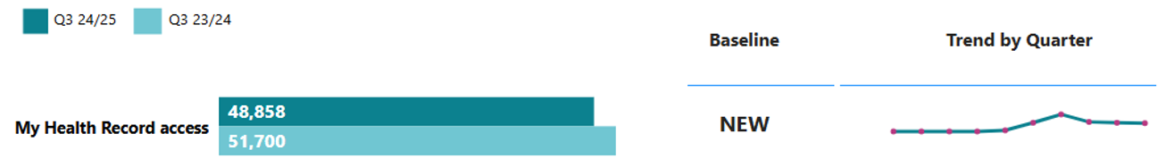

NEW: Baseline will be set in 2024/25.

The main activities in quarter three include consumers logging in to view their immunisation records (32,967), along with exporting their immunisation history (7,106 downloads). My Health Record has had a decline in usage over the past quarter due to no public promotion and release of new features.

# Appendix 1: How to read the charts

Performance measure results are presented in comparison to results for the same quarter in the previous year, and against the baseline, milestone and target (if they were set). This accounts for and acknowledges the impact of seasonal changes in some health measures. Where data is available, trend lines present results over the past eight quarters (including current), to provide an indication of performance over time.

Performance is also presented by region, district and ethnicity, where data is available. A key to the charts is below.

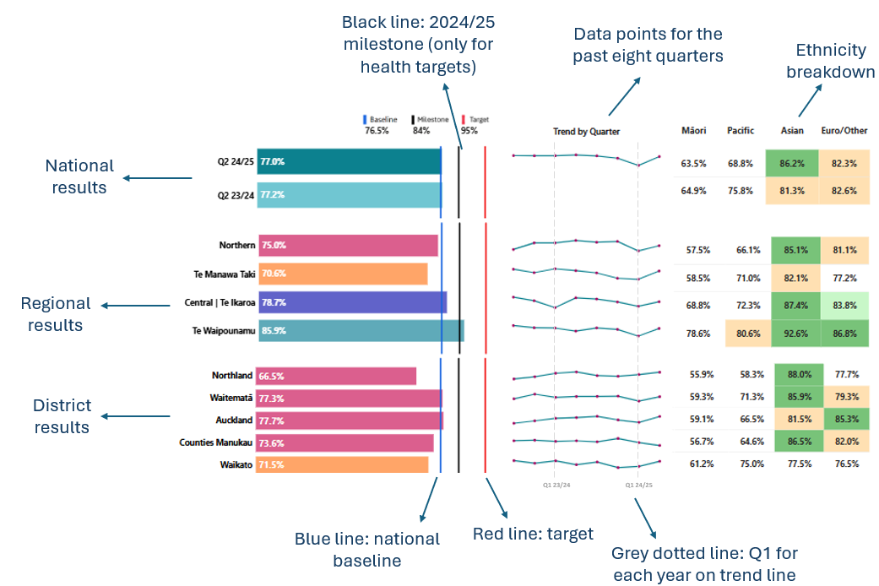

A key for the colour coding is provided below. Although a percentage symbol is used in the legend, the colour coding reflects percentage points away from the milestone/target.

|  |  |  |  |  |  |  |  |  |  |
| --- | --- | --- | --- | --- | --- | --- | --- | --- | --- |
|  | **Milestone achieved** |  | **Within 1% of Milestone** |  | **Within 5% of Milestone** | **x%** | **White – Milestone not achieved** |  | **White with no result – no results for this ethnicity** |

# 

# Appendix 2: Performance measure data caveats

Performance measures are selected from our [Statement of Intent 2024-2028](https://www.tewhatuora.govt.nz/publications/statement-of-intent-2024-2028) and [Statement of Performance Expectations 2024/25](https://www.tewhatuora.govt.nz/publications/statement-of-performance-expectations-2024-25). The complete set of performance measures, from across all accountability documents, is reported annually.

Long and short names for measures, reference numbers, definitions, data sources and methods are published as a standalone document on our [website](https://www.tewhatuora.govt.nz/corporate-information/planning-and-performance/quarterly-performance-reporting). Breakdowns for each measure by region, district and ethnicity are provided where possible. The term ‘district’ refers to the geographic boundaries covered by former DHBs.

All performance data provides a snapshot in time. On any given day, there may be variances depending on when data is uploaded and subsequently extracted. While we have taken all reasonable steps to ensure the accuracy and completeness of the information, we accept no liability or responsibility for how the information is used or subsequently relied on.

When comparing the data from previous quarterly reports to the current one, there may be slight variations due to the latter data being more complete. Data validation is done at both national and (where relevant) local levels, by clinical and data teams, subject matter experts and those involved in the creation of the report.

Some districts have small population sizes, which may mean they have very small numbers for some measures when broken down by ethnicity. This may, at times, create an inflated result due to the underlying volumes being relatively low.

The financial year spans 1 July – 30 June, and quarters refer to the following periods:

* Quarter 1: 1 July – 30 September
* Quarter 2: 1 October – 31 December
* Quarter 3: 1 January – 31 March
* Quarter 4: 1 April – 30 June.

Output class 1: Public health services

**Breast screening coverage:** Data extraction occurred on 16 April 2025. Population estimates (denominator) have been updated to apply the Stats NZ 2024 population update. This adjustment occurs annually following provision of updated population projections from Stats NZ and is applied retrospectively across the time-series. Ethnicity and residential locations (numerator) are now based on demographics sourced using the NHI database. Previously this was sourced from the operational register. This change aligns with other screening programmes and will improve consistency and accuracy of screening programme reporting. As eligible people are invited to be screened every two years, the coverage rate is calculated over a two-year period.

**Bowel screening participation:** Data extraction occurred on 1 May 2025. Latest data available is quarter one 2024/25. This is the result displayed and compared with quarter one 2023/24. Once kits are sent out, participants have six months to complete and return them. Therefore, reporting on this indicator requires a six-month lag. As the programme invites participants back every two years, participation rates are calculated over a two-year period.

#### Output class 2: Primary and community care services

**ASH rate adults 45** – **64yrs per 100,000** and **ASH rate child 0** – **4yrs per 100,000:** Last quarter,Auckland district implemented TrakCare, a new patient administration system, which has impacted data completeness of these measures. It will take time for data completeness to improve, so future results published for Auckland may show slight variations compared to results in this report, due to subsequent data being more complete.

#### Output class 3: Hospital and specialist services

Last quarter, Auckland district implemented TrakCare, a new patient administration system, which has impacted data completeness for all measures in this output class aside from ‘Involved in care decisions, hospital’. It will take some time for data completeness to improve, so results published for Auckland may show slight variations in future reports, due to subsequent data being more complete.

**Output class 4: Mental health and addiction services**

**MHA youth seen <3 wks:**Measurement changed in 2024/25 to support more current and inclusive monitoring. We have moved from a 12-month rolling average to measuring ‘seen dates’ each quarter and including all ages and addiction services. All referrals (including inpatient admissions) are included. Our focus is on waiting time to individual teams rather than new episodes / access to services. Urgent and non-urgent referrals are included and grouped together. Whānau-only face-to-face contacts are now included as in-scope activities. Referrals that have not yet had contact will not show.

**MHA access, integrated primary:**   
The Access and Choice data collection involves providers from Integrated Primary Mental Health and Addictions Services, youth, Pacific and kaupapa Māori services.  
IPMHA providers account for approximately 70 per cent of the activity and this is provided at event level. Inclusion of referral date was mandated in October 2024 and makes the ability to measure waiting times more accurate. This measure is limited to IPMHA providers in quarter one to quarter three. There is a staged plan to include the other providers data at event level from quarter four 2024/25 through to 2026/27 in the Access and Choice programme.

Tairāwhiti data is captured differently and does not align with the graphs presented in this report for this measure, so it has not been included. Tairāwhiti is geographically diverse and isolated. Services are delivered in a more collaborative and integrated model, which enables greater flexibility to deliver services in a range of settings and to engage as many whānau as possible. The data collected from all Tairāwhiti Access and Choice services is slightly different to what is collected in other districts, especially in regard to the Integrated Primary Mental Health and Addiction Service. Because of this, Tairāwhiti data cannot currently be integrated with the wider data set as it is not an exact match.

#### Digital Infrastructure

**My Health Record access:** My COVID Record was decommissioned in February 2024, and all traffic redirected to My Health Record. As such, access increased from this point on.

