

Quarterly Performance Report

Quarter Four 2024/25

Citation: Health New Zealand | Te Whatu Ora. Quarterly Performance Report: Quarter ending 30 June 2025.   
Wellington: Health New Zealand | Te Whatu Ora

Published in September 2025 by Health New Zealand | Te Whatu Ora  
PO Box 793, Wellington 6140, New Zealand

ISSN 2816-1823 (online)



This document is available at [tewhatuora.govt.nz](https://www.tewhatuora.govt.nz/)

|  |  |
| --- | --- |
|  | This work is licensed under the Creative Commons Attribution 4.0 International licence. In essence, you are free to: share i.e., copy and redistribute the material in any medium or format; adapt i.e., remix, transform and build upon the material. You must give appropriate credit, provide a link to the licence and indicate if changes were made. |

Contents

Organisational performance 4

Measures – high-level summary 7

Output class 1: Public health services 9

Output class 2: Primary and community care services 13

Output class 3: Hospital and specialist services 18

Output class 4: Mental health and addiction services 21

Output class 5: Hauora Māori services 25

Digital infrastructure 26

Appendix 1: How to read the charts 28

Appendix 2: Performance measure data caveats 29

# 

# Organisational performance

Highlights for the quarter, through this report include:

* Performance has significantly improved in 11 of the 33 measures when compared to the same time last year.
* The 2024/25 milestone has been achieved this quarter for three health targets: Faster cancer treatment <31 days, shorter wait times for first specialist assessments, and shorter wait times for elective treatment. We were just 0.1 per cent away from achieving the shorter stays in ED <6 hours target milestone.
* Health NZ wrote to the 38 Primary Health Organisations to strengthen the partnership and clarify expectations for achieving the childhood immunisation Health Target.
* Childhood immunisation rates continue to improve for the third consecutive quarter, although we did not reach the target milestone.
* We continue to meet the 80 per cent target for two mental health and addiction (MHA) targets (MHA faster primary access <1 week and MHA faster specialist access <3 weeks).

Some challenges outlined in this report include:

* Newborn enrolment rates with general practice have been declining over the past year. The Central region has developed a newborn enrolment resource toolkit to support a regional approach to solving this issue. The Northern region is improving the escalation process for declined enrolments and prioritising open-book access for children, especially in rural areas.
* The rate of hospital-acquired pressure injuries and falls per 10,000 hospitalisations increased in the last quarter, from 4.9 to 6.1 and from 3.4 to 4.8 per 10,000 respectively. All hospitals have processes in place to monitor and prevent the risk of pressure injuries and falls. Districts with higher rates have implemented specific initiatives to address this. In areas where the number of inpatient admissions is relatively low, a few events can lead to a high rate per 10,000.

Financial performance information is not included in this Quarter Four report. The Health NZ 2024/25 annual report, including year-end financial statements, is currently being finalised and is subject to completion of audit assurance work by the Office of the Auditor-General. Health NZ is required to prepare and publish the annual report in accordance with the timelines and requirements set out in the Crown Entities Act 2004.

## Five health targets

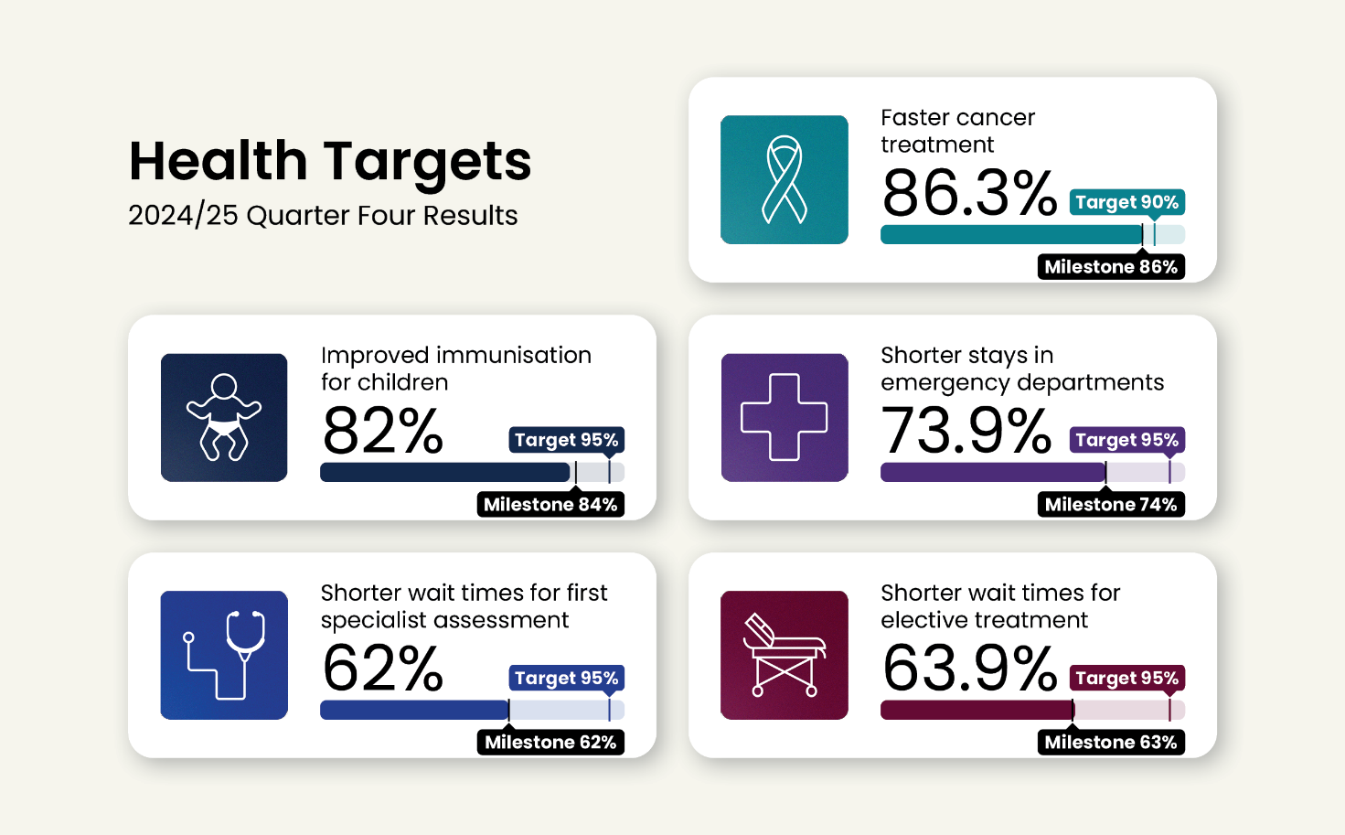

Five mental health and addiction targets

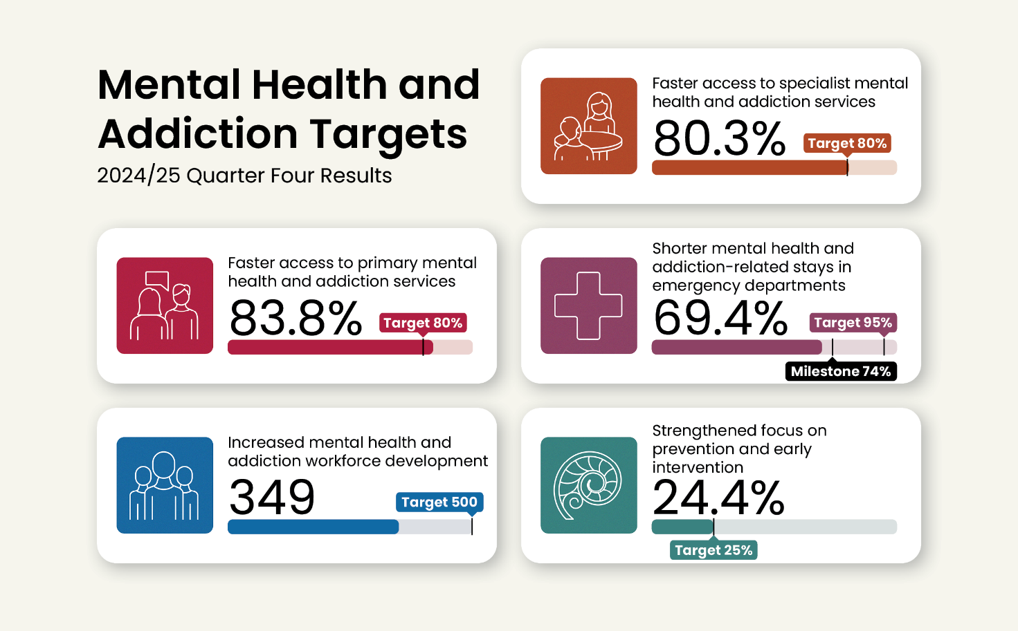

The target dashboards above provide a snapshot of national performance during quarter four against the 2024/25 milestone (as set by the [Government Policy Statement on Health](https://www.health.govt.nz/publications/government-policy-statement-on-health-2024-2027)) and the overarching target. Milestones increase year-on-year to ensure we meet the overarching targets by 2030. Detailed breakdowns of regional and district performance, improvement narrative and data caveats for the [health targets](https://www.tewhatuora.govt.nz/corporate-information/planning-and-performance/health-targets/health-targets/performance) and [mental](https://www.tewhatuora.govt.nz/corporate-information/planning-and-performance/health-targets/mental-health-and-addiction-targets/performancehttps:/www.tewhatuora.govt.nz/corporate-information/planning-and-performance/health-targets/mental-health-and-addiction-targets/performance) health and addictions targets are available on our website.

**Progress against our strategic priorities**

* Progress was made towards delivering actions in the NZ Health Plan | Te Pae Waenga 2024-2027 during the quarter. The plan was provided to the Auditor-General late December 2024 for audit assurance in accordance with the Pae Ora (Healthy Futures) Act 2022. His report was received 23 May 2025 and, following consultation with the Ministry of Health, the final plan was submitted to the Minister of Health for approval   
  16 July 2025. The Minister approved the plan on 31 July, it was presented to Parliament in accordance with the Act and published on Health NZ’s website on 1 August 2025.
* 13 [National Clinical Networks](https://www.tewhatuora.govt.nz/corporate-information/our-health-system/strategic-initiatives-in-health-research-and-innovation/national-clinical-networks/about) have been established (cancer, cardiac, diabetes, renal, maternity, eye health, infection services, mental health and addiction, stroke and trauma, oral health, radiology, rural health), members appointed and work programmes underway.
* The [New Zealand Clinical Senate](https://www.tewhatuora.govt.nz/corporate-information/about-us/expert-groups/new-zealand-clinical-senate) has been established to provide advice to the board. It received 208 expressions of membership interest (141 district and 67 regional) with 90 people selected. Its first meeting is scheduled for October 2025.
* Organisational structure change processes that are designed to enhance Health NZ’s performance, improve delivery of core functions and support local and clinical leadership, were finalised across most business units. A chief public health clinical officer leadership role was established in the National Public Health Service to better support public health clinical leadership at all levels.
* Regions have governance arrangements in place to ensure oversight of financial, clinical and operational management across the region and in districts.
* The Resident Doctors Support Service was established. It partners with key stakeholders, including unions, the Medical Council of New Zealand and medical colleges, to help develop a well-trained and supported medical workforce.
* Clinical input continues to be embedded into digital initiatives via national and regional digital governance forums, and development of the Digital Investment Plan and roadmaps. Quarterly planning and prioritisation with clinical leaders is now in place to ensure investment is directed to high priority areas.
* Te Kāhui o Te Whiri Kaha (network of 15 Māori clinicians) supported development of the perinatal bereavement care pathway and primary care system level measures, ensuring Māori clinical contributions to shape these products. In addition, working arrangements were formalised with the Māori co-chairs of the National Clinical Networks, to guide and influence future work.
* A director of digital innovation and AI was appointed, to lead Health NZ’s commitment to leveraging AI in improving health outcomes. Health NZ supports the safe, effective, and equitable use of AI to support frontline staff to improve patient experience.

# Measures – high-level summary

The following table shows quarter four 2024/25 (April-June) results compared to quarter four last year (to account for seasonal variation). The table also compares this quarter’s results to those published in the [Quarter 3 Performance Report](https://www.tewhatuora.govt.nz/publications/quarterly-performance-report-quarter-three-2024-25). Measures with a two or more percentage point change (a level adopted to indicate materiality) are marked with a green arrow **hi** (improving) or red arrow **ih** (slipping). A target symbol Title: Title: 🎯identifies health targets. A Parliament symbol Wellington Beehive coloring page identifies targets that form part of the [Government’s nine targets](https://www.dpmc.govt.nz/our-programmes/government-targets).

| Ref | Measure short name | Q4  last year | Q4  this year | Change | Last quarter | This  quarter | Change |
| --- | --- | --- | --- | --- | --- | --- | --- |
| P2-03 | Improved immunisation for children 24mth 🎯 | 76.5% | 82.0% | **h** | 79.3% | 82.0% | **h** |
| P2-140 | Improved immunisation for children 8mth | 77.7% | 80.4% | **h** | 79.9% | 80.4% |  |
| P2-09 | Cervical HPV screening coverage | 69.2% | 74.1% | **h** | 73.6% | 74.1% |  |
| P2-07 | Breast screening coverage | 68.6% | 68.9% |  | 69.7% | 68.9% |  |
| P2-158 | Bowel screening participation | 57.3% | 57.8% |  | 57.6% | 57.8% |  |
| P2-38 | Newborn GP enrolment | 87.4% | 82.9% | **i** | 83.5% | 82.9% |  |
| P2-17 | GP enrolment | 94.4% | 94.2% |  | 94.3% | 94.2% |  |
| P2-23 | ASH rate adults 45 – 64yrs (rate per 100,000 population) | 3,821 | 3,782 |  | 3,795 | 3,782 |  |
| P2-22 | ASH rate child 0 – 4yrs (rate per 100,000 population) | 7,325 | 7,471 |  | 7,456 | 7,471 |  |
| P2-176 | GP accessed when wanted | 77.2% | 77.9% |  | 76.9% | 77.9% |  |
| P2-45 | Shorter stays in ED <6hrs 🎯Wellington Beehive coloring page | 71.2% | 73.9% | **h** | 74.2% | 73.9% |  |
| P2-51 | Faster cancer treatment <31 days 🎯 | 83.5%* | 86.3% | **h** | 84.6% | 86.3% |  |
| P2-39 | Shorter wait times for FSA 🎯 | 61.5% | 62.0% |  | 58.2% | 62.0% | **h** |
| P2-40 | Shorter wait times for elective treatment 🎯Wellington Beehive coloring page | 61.4%* | 63.9% |  | 57.3% | 63.9% | **h** |
| P2-58 | Missed FSA appts | 7.5% | 7.8% | **h** | 7.7% | 7.8% |  |
| P2-88 | Medical appts via telehealth (digital) | 6.7% | 7.4% | **h** | 7.2% | 7.4% | **h** |
| P2-194 | Hospital pressure injuries (rate per 10,000 hospitalisations) | 6.5 | 6.1 | **i** | 4.9 | 6.1 | **h** |
| P2-195 | Hospital falls (rate per 10,000 hospitalisations) | 3.6 | 4.8 | **h** | 3.4 | 4.8 | **h** |
| P2-44 | Involved in care decisions, hospital | 80.2% | 81.9% |  | 83.0% | 81.9% |  |
| P2-198 | MHA workforce development 🎯 | NEW* | 349^ |  | 349^ | 349^ |  |
| P2-200 | MHA prevention and early intervention 🎯 | NEW* | 24.4% |  | 24.4% | 24.4% |  |
| P2-201 | Shorter MHA stays in ED <6hrs 🎯 | NEW* | 69.4% |  | 66.1% | 69.4% | **h** |
| P2-202 | MHA faster primary access <1 wk 🎯 | NEW* | 83.8% |  | 84.3% | 83.8% |  |
| P2-203 | MHA faster specialist access <3 wks 🎯 | NEW* | 80.3% |  | 82.4% | 80.3% | **i** |
| P2-69 | MHA youth seen <3 wks | 73.4% | 75.4% | **h** | 77.5% | 75.4% | **i** |
| P2-199 | MHA access, Integrated Primary | 54,971 | 62,305 | **h** | 57,658 | 62,305 | **h** |
| P2-187 | MHA services access (rate per 100,000 population) | 2,887 | 3,044 | **h** | 2,773 | 3,044 | **h** |
| P2-206 | Hauora Māori contracts | NEW* | 44.0% |  | 44.0% | 44.0% |  |
| P2-208 | IMPB strategic involvement | NEW* | 80.0% |  | 80.0% | 80.0% |  |
| P2-205 | Hauora Māori outcomes | NEW* | 88.0% |  | 89.0% | 88.0% |  |
| P2-152 | Health NZ workforce turnover | 2.8% | 2.6% | **i** | 2.1% | 2.6% | **h** |
| P2-153 | Health NZ Māori and Pacific Peoples workforce | 14.4% | 14.6% |  | 15.0% | 14.6% | **i** |
| P2-169 | My Health Record access | 101,000 | 57,198 | **i** | 48,858 | 57,198 | **h** |

* = Baseline as at quarter 4 2023/24

NEW = data was not collected in 2023/24 (see relevant data caveats throughout the report).

^ = Represents a partial result (only semester one) for the 2025 academic/calendar year. The 2024 full year result was 457.

Output class 1: Public health services

P2-07 Breast screening coverage

This measure shows the number of individuals aged 45 – 69 who have had breast cancer screening in the past two years.

**National result:**

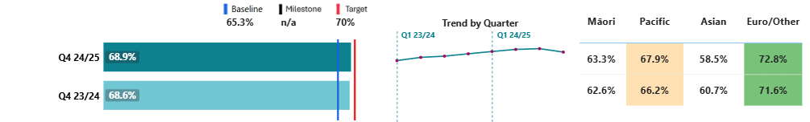

**Results by region and district:**

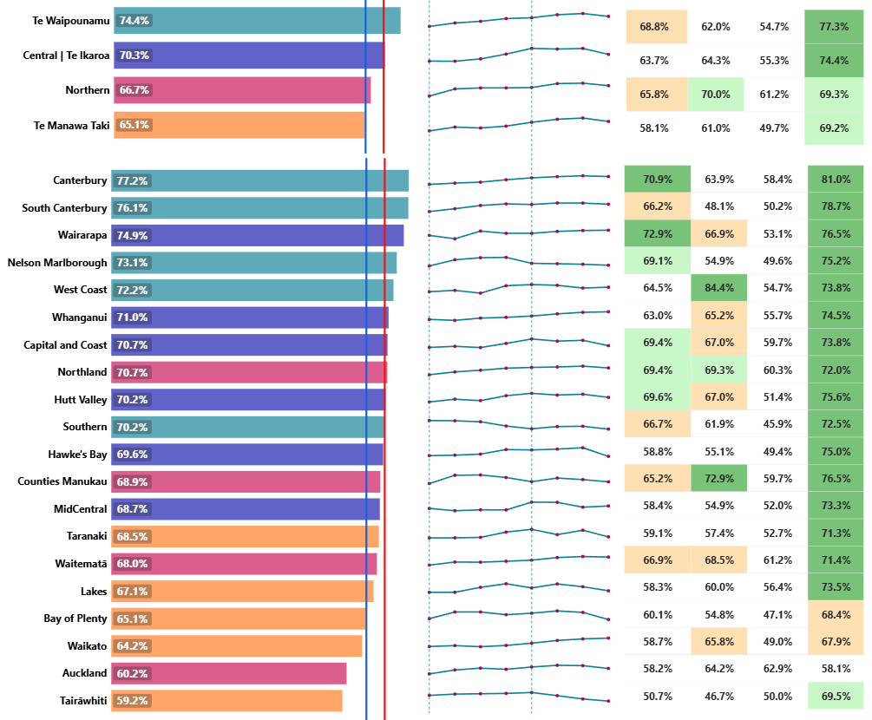

|  |  |  |  |  |  |  |  |
| --- | --- | --- | --- | --- | --- | --- | --- |
|  | **Target achieved** |  | **Within 1% of Target** |  | **Within 5% of Target** | **x%** | **White – Target not achieved** |

Breast screening coverage has dropped slightly compared to quarter three, although it has improved compared with the same time last year.

Breast screening rates among Asian women remain the lowest when comparing across ethnicities. BreastScreen Aotearoa continues its partnership with Health NZ’s Asian and Ethnic Health Services team to support screening uptake among Asian women in the Auckland and Waitematā regions. The Asian and Ethnic Health Services team has also received training in Te Puna, the national breast screening system, with a long-term goal of supporting women across the country through the Asian Health Line.

National implementation of Te Puna was completed in June 2025 (see Digital section, page 28). This is a significant milestone and enables leveraging of digital tools to deliver the breast screening programme.

Alongside the rollout of Te Puna, efforts have been made to raise awareness of the breast screening programme and encourage uptake of screening now that participants can book and manage their appointments online. This has included the launch of two national campaigns aimed at engaging women from high health needs groups to participate in screening. To date, the campaigns have generated more than 7.5 million impressions nationally, indicating strong reach and engagement.

Breast screening rates remain the lowest in the Te Manawa Taki and Northern regions. BreastScreen Aotearoa continues to work closely with providers and community partners to increase access and screening in these regions with the support of funded initiatives from the [2023 BreastScreen Aotearoa Quality Review](https://www.tewhatuora.govt.nz/publications/bsa-quality-and-safety-review-report).

BreastScreen Midland partnered with the Māori Women’s Welfare League peka in Te Kuiti to encourage members to screen during the mobile unit’s visit to Piopio and Te Kuiti. Activities included: organised hikoi; presence at local events; and direct engagement with wāhine in public places, for example in the street and at the supermarket. The visit was highly successful, with the mobile unit fully booked and very few missed appointments.

BreastScreen Auckland Central expanded screening hours to weekends and outside of traditional working hours to improve access.

P2-158 Bowel screening participation

This measure presents the number of eligible individuals (aged 60 – 74) who returned a testing kit with a definitive result over a rolling 24-month period (ending 31 December 2024). It is presented as a proportion of the total number of eligible individuals invited to participate in screening during the timeframe.

**National result:**

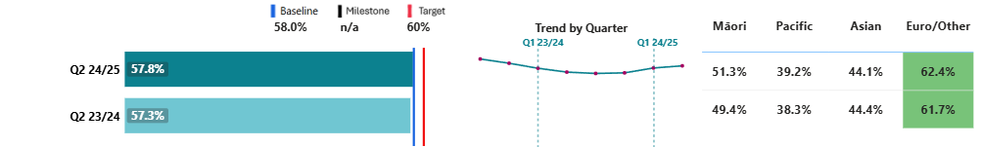

**Results by region and district:**

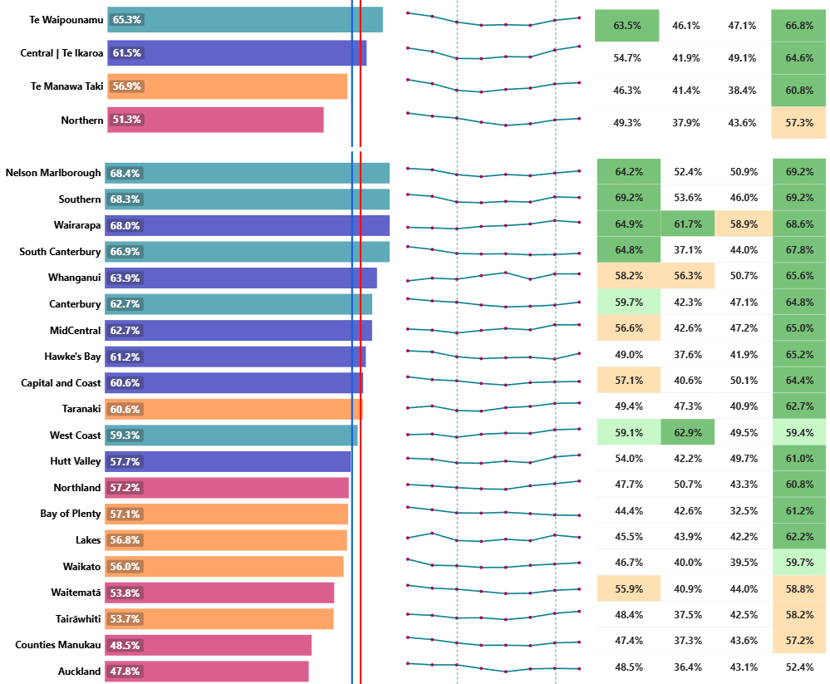

|  |  |  |  |  |  |  |  |
| --- | --- | --- | --- | --- | --- | --- | --- |
|  | **Target achieved** |  | **Within 1% of Target** |  | **Within 5% of Target** | **x%** | **White – Target not achieved** |

From December 2024, a trial took place in the Northern region of sending texts to those due to receive an invitation for their next screening, letting them know a new test kit was on its way. The notification also provided an opportunity for people to update their demographic details with the National Coordination Centre if needed. Analysis of data from February to March 2025 shows that the return rate for those who received a text was 42%, compared to 34% for a similar group who did not receive a text during the same period. This represents an 8-percentage point increase in return rates. Given this positive result, the initiative will now continue and planning is underway for a national rollout.

The initiative for returning bowel screening kits to community laboratories – rather than solely by post – is ongoing in all districts in the Northern region. Between July and December 2024, approximately 33 per cent of kits across the three metro Auckland districts were returned via community labs, increasing to 38 per cent in January 2025. Northland began this initiative in March 2025 and, as at the end of June, 36 per cent of kits across the full region were returned to community laboratories. The approach is expected to result in an up to 3 per cent increase in overall participation. In June 2025, this alternative return approach was successfully implemented in the West Coast, with further plans for implementation in other districts during 2025.

New engagement methods for bowel screening to better reach Pacific communities will be developed in 2025/26 and incorporated into regional action plans, following a gap analysis process.

Quarter four saw work progressed for the age extension of screening eligibility to 58-year-olds (meaning an extra 120,000 – 130,000 people will be invited to take part every two years), along with initiatives to support participation among high-needs groups. This included finalising a provider for the update of the bowel screening multimedia campaign and continuing the development of an education module for non-clinical staff. The age extension will be implemented in two tranches, with the first (two regions) commencing in quarter one 2025/26, and the second (remaining two regions) in quarter three.

# Output class 2: Primary and community care services

### P2-38 Newborn GP enrolment

This measure shows the percentage of newborns enrolled with a general practice (or a kaupapa Māori provider delivering general practice care) by three months of age.

**National result:**

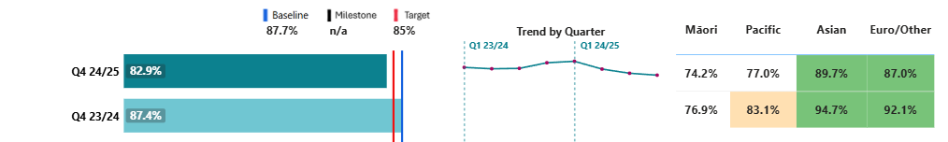

**Results by region and district:**

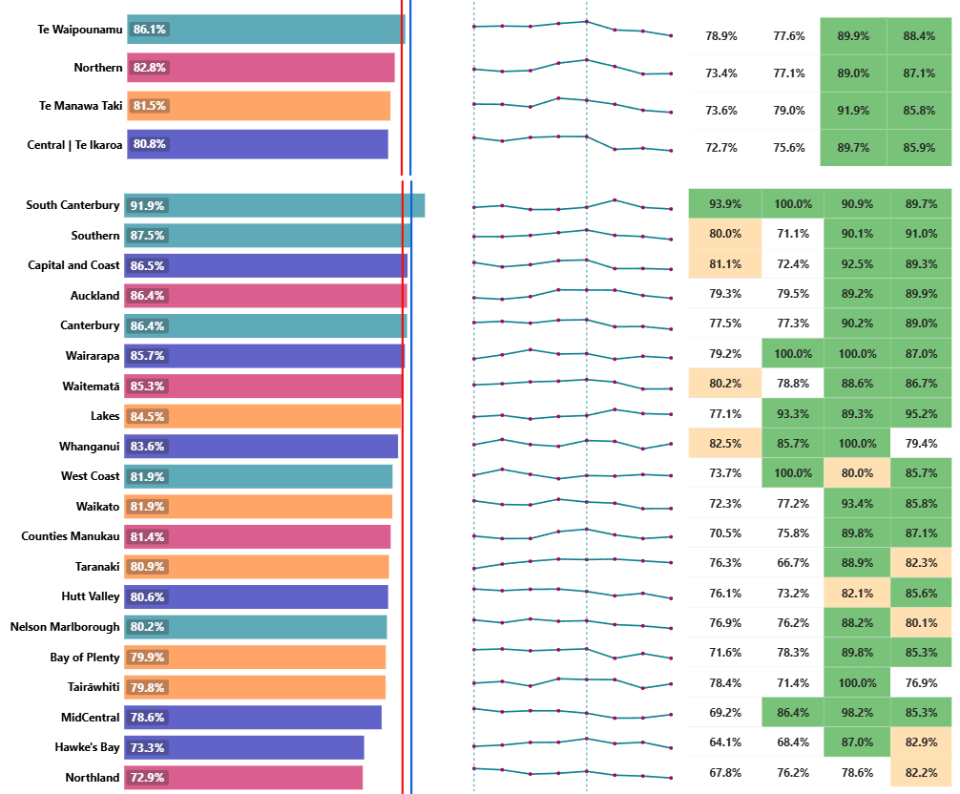

|  |  |  |  |  |  |  |  |
| --- | --- | --- | --- | --- | --- | --- | --- |
|  | **Target achieved** |  | **Within 1% of Target** |  | **Within 5% of Target** | **x%** | **White – Target not achieved** |

Newborn enrolment rates have been declining over the past year. Newborn enrolment systems are not consistent across the country and create barriers for some whānau, with significant variation of rates being seen at a district and regional level.

Te Waipounamu is the only region to have achieved the target, with the remaining three regions within 2 per cent of each other.

Central, the lowest-performing region, completed development of a newborn enrolment resource toolkit in quarter four, and distribution of it to primary care has commenced. The toolkit is intended to support a regional approach, while also incorporating primary health organisation (PHO) specific information, particularly in relation to specific practice management systems.

Northland, the lowest-performing district within the Northern region, has developed a Te Tai Tokerau Childhood Immunisation Action Plan to lift immunisation rates. To support this, the Northern region is prioritising open-book access for children by collaborating with GP practices, especially in areas such as the Far North.

### P2-23 ASH rate adults 45 – 64yrs per 100,000

This measure shows ambulatory sensitive hospitalisations (ASH) for people aged 45 – 64 years old for an illness that might have been prevented or better managed in a primary care setting, as a rate per 100,000 population. A smaller rate correlates to lower ASH rates (favourable), and a larger rate to higher ASH rates (unfavourable).

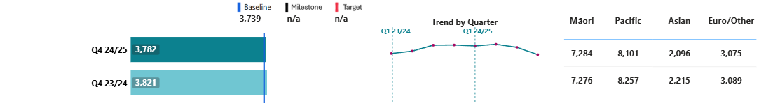**National result:**

**Results by region and district[1]:**

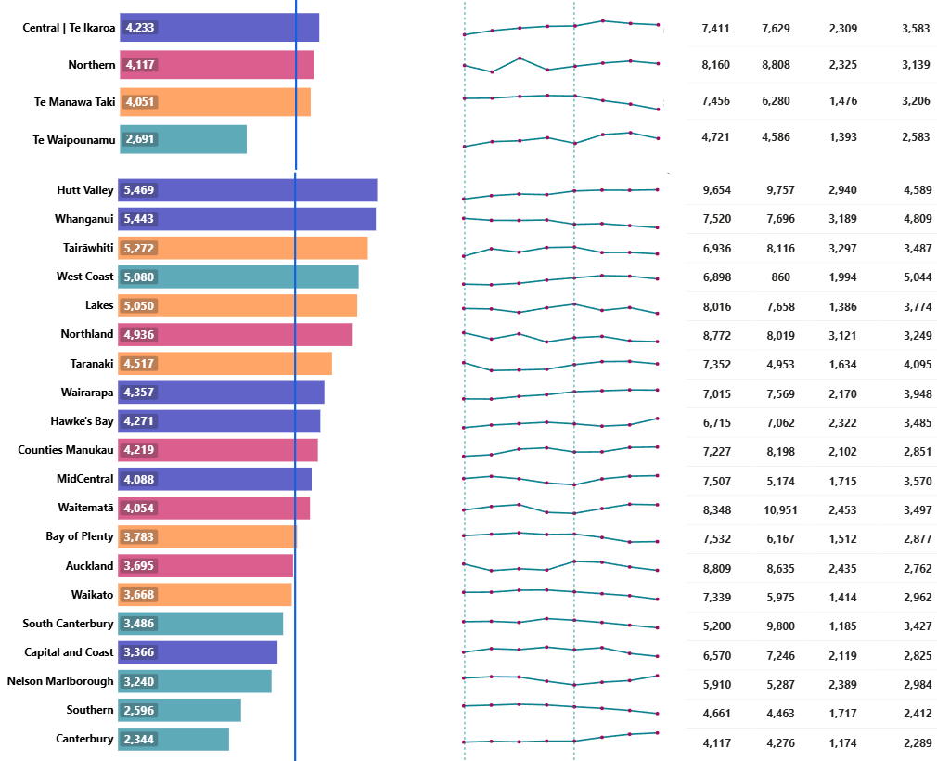

### P2-22 ASH rate child 0 – 4yrs per 100,000

This measure shows ASH rates for children aged 0 – 4 years old for an illness that could have been prevented or better managed in a primary care setting, as a rate per 100,000 population. A smaller rate correlates to lower ASH rates (favourable), and a larger rate to higher ASH rates (unfavourable).

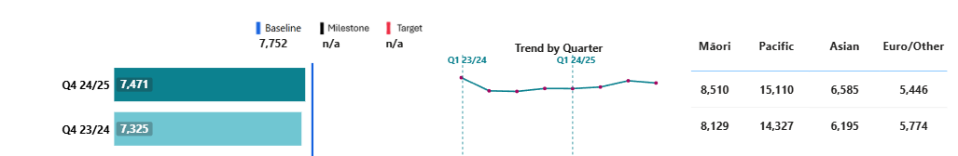**National result:**

**Results by region and district[2]:**

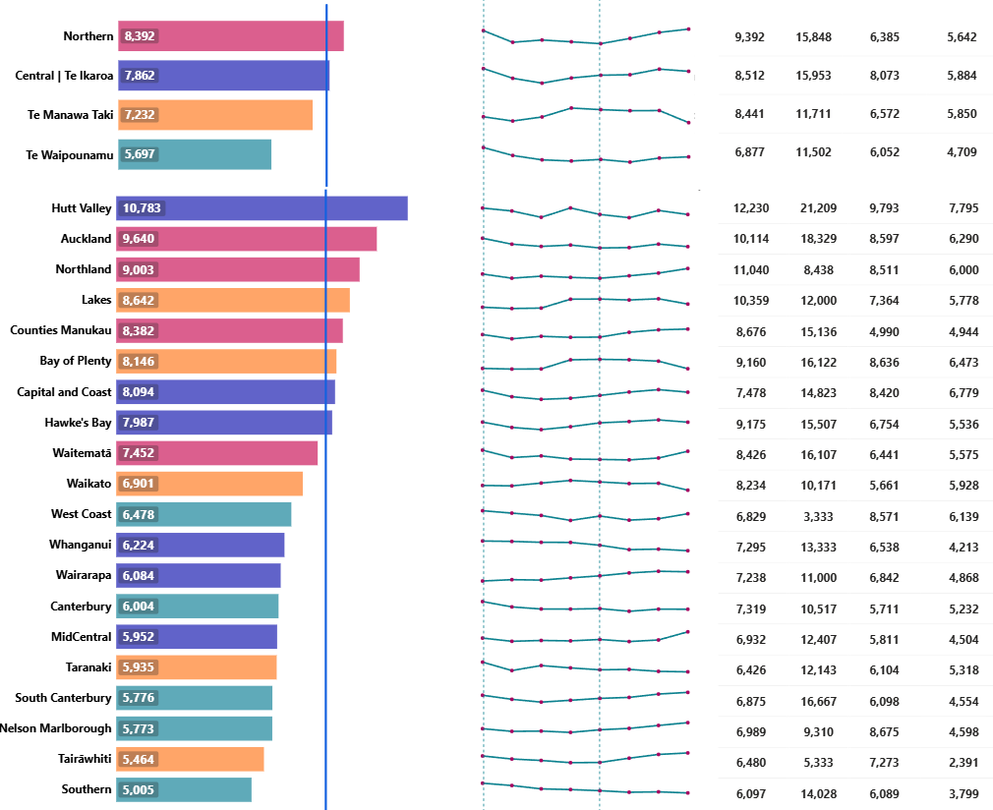

ASH rates for adults are improving and are relatively consistent across quarters for children. Pacific Peoples (both adults and children) have significantly higher ASH rates compared to the total population. The recently announced GP online service provides 24/7 access to GPs (at low or no cost for children) and is expected to help reduce ASH rates over time. The Comprehensive Primary and Community Teams Programme enables more co-ordinated care and improved outcomes for patients, especially those with complex needs, and has been extended to 30 June 2026.

Reducing ASH rates is a focus for regions, with Northern, Te Manawa Taki and Central above baseline for adult rates, and Northern and Central above baseline for child rates.

The Northern region has the following activity underway to improve ASH rates:

* Support is provided for housing repairs through the Healthy Homes Initiative in Northland to help reduce rheumatic fever risk.
* Implementation is underway for a phased extension of the rheumatic fever pharmacy testing programme, with nine pharmacies in West and South Auckland currently participating, and a further three preparing to join.
* Dental surgical procedures for under five-year-olds are being outsourced to reduce the wait list. ASH rates may potentially increase in the short term while this backlog of unmet demand is addressed, with a reduction over the medium to long term.

The Tairāwhiti urgent after-hours clinic (Te Manawa Taki region) opened this quarter and is integrating with services in the community, including the Emergency Department. Early indications show the service is meeting the need for primary care services in the community.

Hutt Valley (Central region) has been experiencing challenges with access to GPs, with some general practices struggling to recruit clinical workforce. While this is addressed, the district has put in place other options such as increasing nurses in pharmacy to treat conditions such as dehydration and skin infections. The urgent care framework includes provision of an accident and urgent care daytime service in the Hutt Valley in 2025/26, which will improve access to primary care and contribute to reducing ASH rates.

Initiatives have been implemented across Te Waipounamu to address the disproportionately high ASH rates among Māori and Pacific children, which include:

* A review of children waiting over nine months for paediatric dental treatment, with treatment now completed or planned.
* Development of oral health and hygiene programmes with four Hāuora Māori Partners, which reached 200 children and their whānau by June 2025.
* Revision of pregnancy and parenting education in Canterbury and South Canterbury districts, prioritising intensive support for those with the greatest need. Early results show increased participation by Māori young parents (23 per cent) and stronger engagement in breastfeeding peer support and sudden unexpected death in infancy prevention education.

Output class 3: Hospital and specialist services

P2-58 Missed FSA appts

This measure shows the patients who did not attend or did not wait for their FSA as a proportion of total appointments.

**National result:**

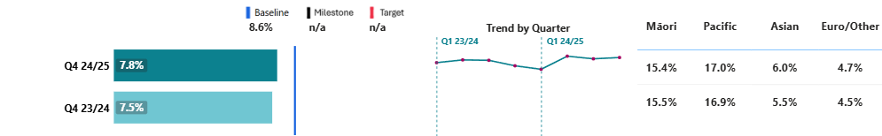

**Results by region and district[3]:**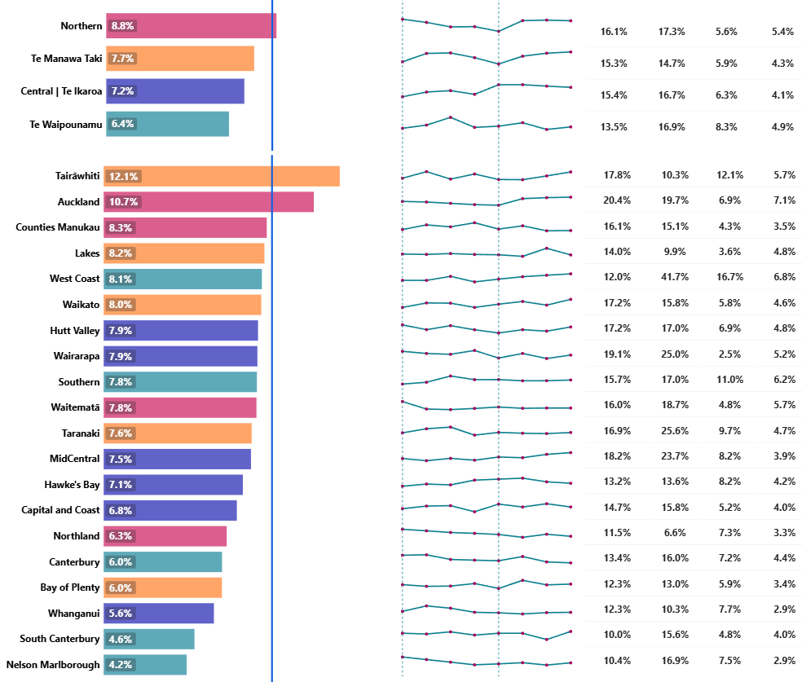

The rate of missed FSA appointments has remained relatively stable over the past three quarters. Variation persists, particularly among Māori and Pacific Peoples, whose rates – although gradually reducing over time – remain higher than those of other ethnicities.

Tairāwhiti district has the highest rate of missed appointments in the country. The district is using the support of the hospital social work team as well as community providers to contact hard-to-reach patients. A review of standard operating procedures and data is underway to ensure patients cancelling appointments due to illness or other reasons are not being recorded as ‘did not attend’. This validation process will ensure Tairāwhiti’s results for this measure are an accurate reflection of performance.

Although Capital and Coast district’s rate of missed appointments is lower than the national average, a trial is underway to support Kapiti Coast residents to travel via shuttle to appointments at Wellington Regional Hospital. This trial acknowledges parking can be a barrier for some patients who need to attend appointments at the hospital. An evaluation of the trial will be carried out towards the end of quarter two 2025/26.

Te Waipounamu has the lowest missed appointment rate, with all districts in the region having results better than the baseline. The region monitors missed appointment rates by ethnicity across all districts. A new reporting tool is in development to identify patients scheduled for upcoming appointments who are considered at higher risk of not attending.

P2-88 Medical appts via telehealth (digital)

This measure reports outpatient attendances that were completed via telephone or video as a proportion of all outpatient attendances.

**National result:**

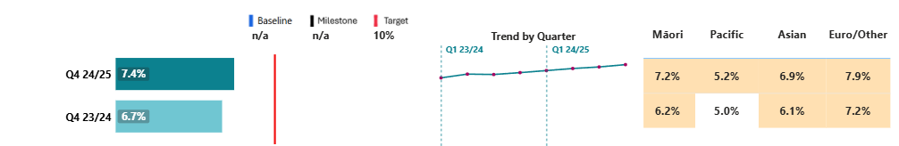

**Results by region and district:**

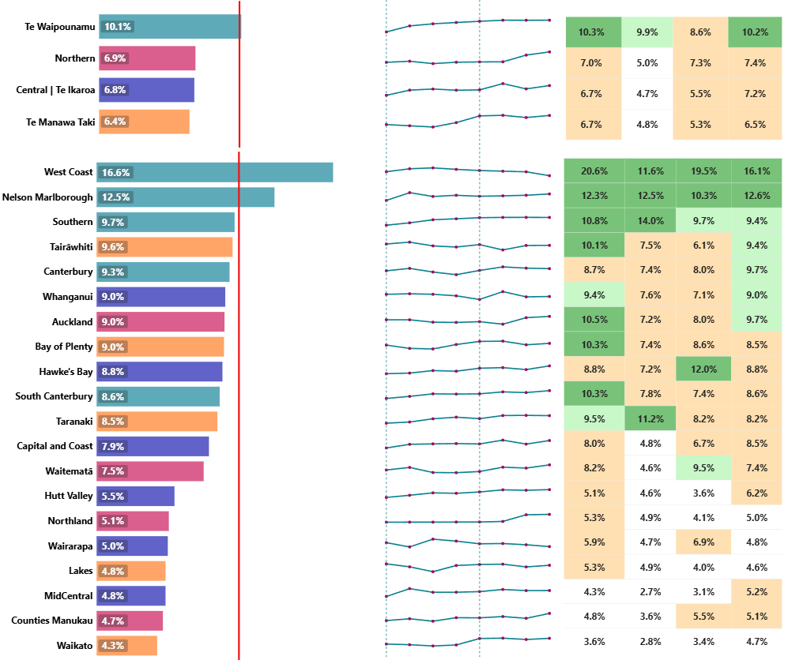

|  |  |  |  |  |  |  |  |
| --- | --- | --- | --- | --- | --- | --- | --- |
|  | **Target achieved** |  | **Within 1% of Target** |  | **Within 5% of Target** | **x%** | **White – Target not achieved** |

There is continued improvement in results for this measure, with around 8 per cent of follow-ups and 4 per cent of FSAs delivered by telehealth. The use of telehealth, where clinically appropriate, is an integral part of FSA wait time improvement plans.

Output class 4: Mental health and addiction services

P2-69 MHA youth seen <3 wks

This measure shows the percentage of youth (under 25) seen within three weeks from a MH&A referral.

**National result:**

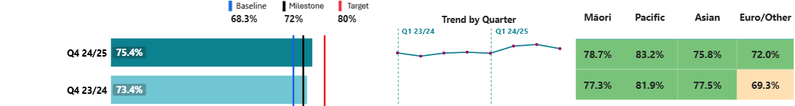

**Results by region and district:**

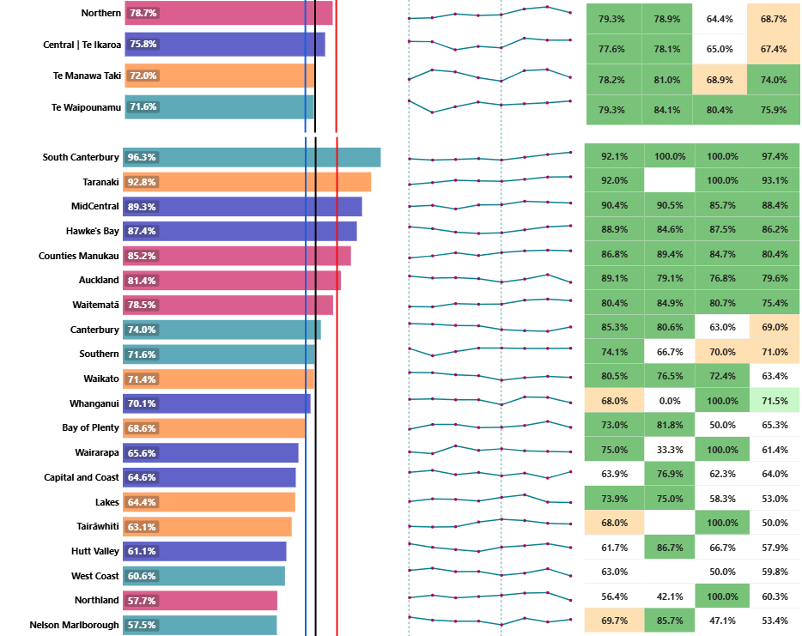

|  |  |  |  |  |  |  |  |  |  |
| --- | --- | --- | --- | --- | --- | --- | --- | --- | --- |
|  | **Milestone achieved** |  | **Within 1% of Milestone** |  | **Within 5% of Milestone** | **x%** | **White – Milestone not achieved** |  | **White with no result – no results for this ethnicity** |

While there has been a slight decline in overall performance since last quarter, the 2024/25 milestone was achieved nationally this quarter. Te Manawa Taki, Central and Northern regions all achieved the milestone.

Activity underway across the wider Central region during quarter four has resulted in an 8.1 per cent improvement in performance in the Capital and Coast district result (which was the lowest-performing district last quarter).

* In response to feedback from families, Wairarapa Child and Adolescent Mental Health Services (CAMHS) has introduced extended appointment hours, offering appointments on Saturday mornings, one evening per week, and one early morning per week. This initiative has been welcomed by the community who can face challenges attending appointments during standard office hours due to work or other commitments.
* Across the region, CAMHS continue to work on improving collaboration and maintaining relationships with primary care and NGO partners. This includes meeting with the local Kapiti Youth Service and building a connection with Hora Te Pai medical centre to support early access.

This quarter, Nelson Marlborough was the lowest-performing district in the country. In late 2024, Nelson Marlborough revised its Infant CAMHS referral process to involve a clinical co-ordinator actively managing caseloads, which has helped reduce wait lists and improved service responsiveness. Both Nelson Marlborough and South Canterbury districts conducted reviews of their triage and intake processes, which have seen a reduction in wait times for Infant CAMHS, demonstrating the impact of streamlined processes.

Across the broader Te Waipounamu region, Infant CAMHS wait times improved by 6 per cent in this quarter, indicating that targeted, locally-driven changes are contributing to better service access and reduced delays. A review of Infant CAMHS triage processes across the region is planned for quarter one 2025/26.

P2-199 MHA access, Integrated primary

This measure shows the number of people accessing primary MH&A services through the integrated primary MH&A services (a subset of the Access and Choice programme).

**National result:**

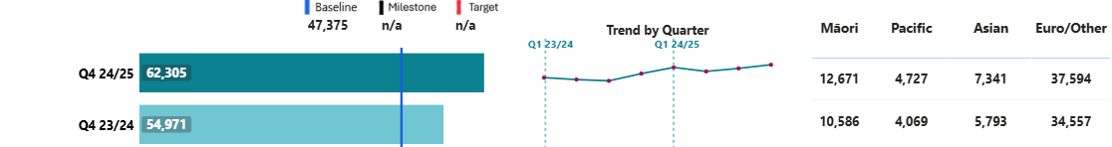

**Results by region and district:**

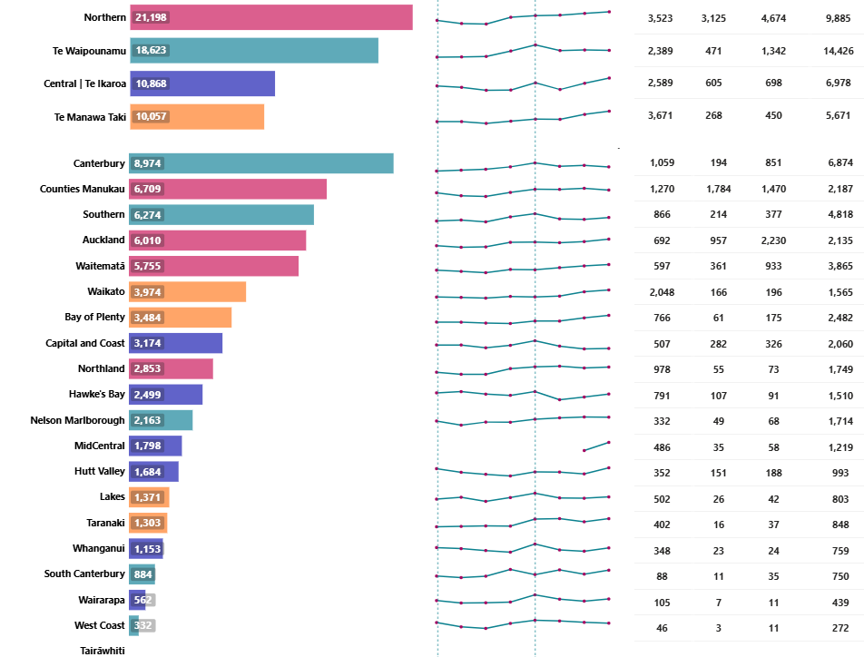Covering space

**UNAVAILABLE (see caveats)**

Most regions saw increased volumes of people using primary MH&A services in the last quarter, with the Northern region continuing to have the highest volumes out of the four regions, reflective of its population size. Canterbury district saw the highest number of people, reflecting its population and significant coverage with the IPMHA programme.

P2-187 MHA services access per 100,000

This measure shows the rate of new people accessing either primary (through the Access and Choice programme) and/or specialist MH&A services per 100,000 people.

**National result:**

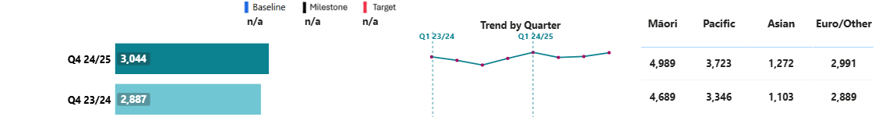

**Results by region and district:**

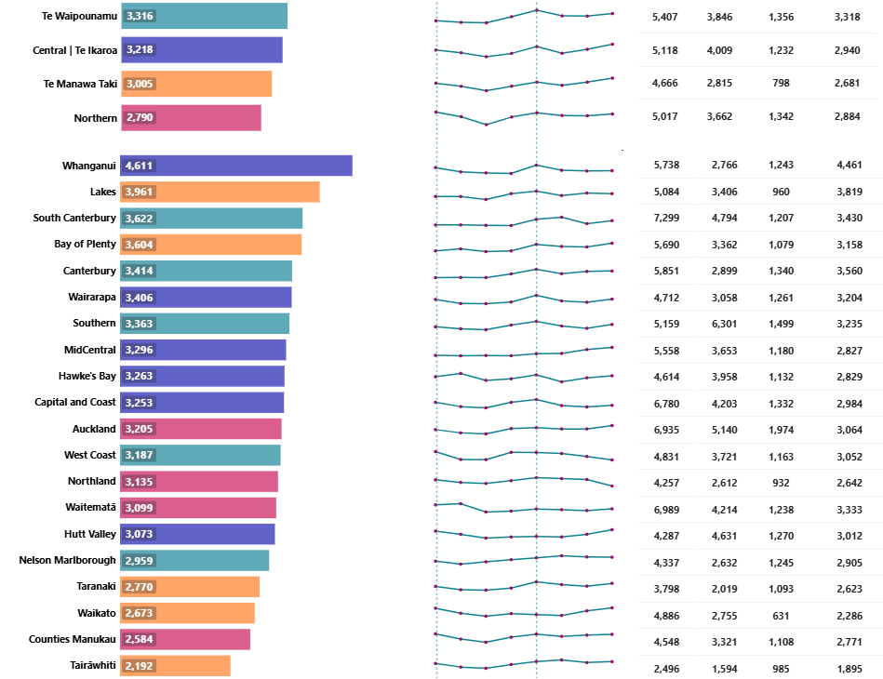

Use of all MH&A services has increased this quarter, following decreases in prior quarters. Te Waipounamu continues to have the most users per 100,000 population. Māori remain the highest users and Asian peoples the lowest. Activities to improve access to services are discussed in the previous measures (above).

Output class 5: Hauora Māori services

P2-208 IMPB strategic involvement

Percentage of Iwi Māori Partnership Boards (IMPBs) that participate in setting strategic priorities for commissioning in Health NZ.

|  |  |  |  |
| --- | --- | --- | --- |
| Baseline and target | Q1 & Q2 | Q3 | Q4 |
| Baseline: NEW; 2024/25 target: 80% | Under development* | 80% | 80% |

* IMPBs began influencing Health NZ commissioning in quarter three.

12 out of 15 IMPBs submitted final versions of their community health plans that met all expected criteria to inform priorities for commissioning, meeting the 2024/25 target for this measure. Following extensive engagement within Health NZ and with IMPBs, national and regional processes for integrating IMPBs into Health NZ business planning were established in quarter four.

P2-205 Hauora Māori outcomes

Percentage of hauora Māori partners that are meeting their contracted outcome targets as defined in the new outcomes-based contracts.

|  |  |  |  |
| --- | --- | --- | --- |
| Baseline and target | Q1 & Q2 | Q3 | Q4 |
| Baseline: NEW; 2024/25 target: 50% | Under development | 89% | 88% |

Assessment of quarter four reporting from hauora Māori partners showed 88 per cent achievement of client outcomes across all partners and domains, detailed below:

|  |  |  |
| --- | --- | --- |
| Domain | Q4 | Examples of outcomes |
| Health enablers | 78% | Improved: access to services, education, employment; financial literacy and capability; living conditions. |
| Whānau health | 89% | Improved: health and wellbeing of māmā and pēpi; long-term conditions; medication management. |
| Te ao Māori | 89% | Greater quality of life, strengthened cultural identity. |
| Whānau leadership and empowerment | 83% | Improved: navigation of the health system; health literacy. |
| Whānau relationships | 80% | Improved quality of care and treatment of whānau, reduction in experiences of racism, stigma, discrimination. |

# Digital infrastructure

We are focused on sustaining and maintaining our most critical digital services, especially those supporting clinical service delivery. During quarter four, teams responded to 64 major incidents and activated for 25 cyber security events.

We continue to deliver the digital work programme. This includes remediation of critical infrastructure and addressing technical debt (end-of life, out of support applications and infrastructure in our clinical systems) by replacing aging systems with fit-for-purpose technology. As at 30 June 2025, we have 19 major digital programmes/projects (budget of $5m or greater that are monitored centrally). In addition to these major programmes/projects, there are 54 projects with a budget ranging from $1m – $5m, 68 projects with a budget of $250,000 – $1m, along with a number of smaller projects (e.g. minor updates and enhancements, lifecycle maintenance) being delivered across the digital portfolio. There were 126 go-lives across the portfolio this quarter.

Key delivery highlights this quarter include:

* Te Puna, the online breast screening system that enables enrolment and appointment bookings online, is now live nationwide following rollouts in parts of the Central and Northern regions. Te Puna sends a secure personalised link or QR code via email, text or letter to women when they become eligible or are due for a screen. This has significantly improved access to breast screening services – particularly for wāhine Māori, Pacific women, and women who are under-screened or unscreened.
* Replacing old technology in hospitals and community health services with modern, cloud-based systems to give clinicians a unified view of the patient journey. Following a successful go-live, the West Coast has now joined the South Island Patient Information Care System. This was the final step in a complex, multi-year regional work programme. Capital Coast joins Hutt Valley and Wairarapa for a single patient view across the Central region.
* My Health Account Authentication for ACC ProviderHub registration went live in April and we now have 1,593 accounts for providers onboarded. This means users can sign in securely to access ACC’s modern self-service provider claims hub.
* A new Data Protection Tool has been introduced to reduce accidental sharing of large volumes of personal information by identifying external emails that contain a high volume of NHI numbers and asking senders to check data and recipients.

Digital infrastructure and services are essential to improving health outcomes, building system sustainability, and enabling new models of care. A Digital Investment Plan, which sets out a 10-year strategy for future investments, has been developed and is going through final approval processes, including Ministerial approval. Financial modelling is underway.

P2-169 My Health Record access

This measure shows the number of registered users who logged on to My Health Record to access their health information. See Appendix 2 for data caveats.

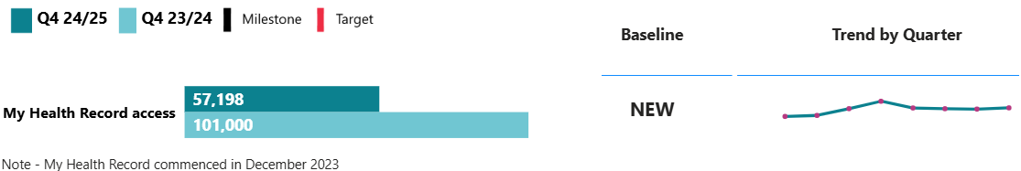

NEW: Baseline will be set in 2024/25.

The main activities in quarter four include consumers logging in to view their immunisation records (36,819) and exporting their immunisation history (7,136 downloads). My Health Record usage remains stagnant due to no public promotion and release of new features. The focus remains on retaining the operational running of this service.

# 

# Appendix 1: How to read the charts

The charts show performance in three ways: in comparison with the same quarter last year, the baseline, and (where set) against the expected milestone for this quarter and against the target. This approach is useful to show seasonal impacts where these occur. Where data is available, trend lines present results over the past eight quarters (including current), to provide an indication of performance over time. A key to the charts is below.

## Summary charts:

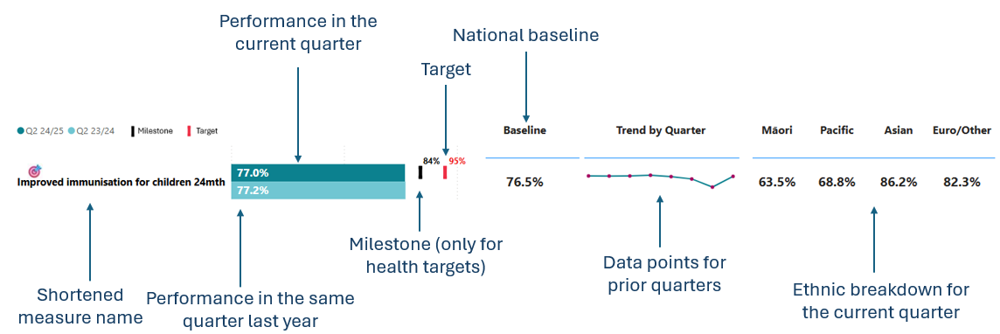

Performance is also presented by region, district and ethnicity, where data is available.

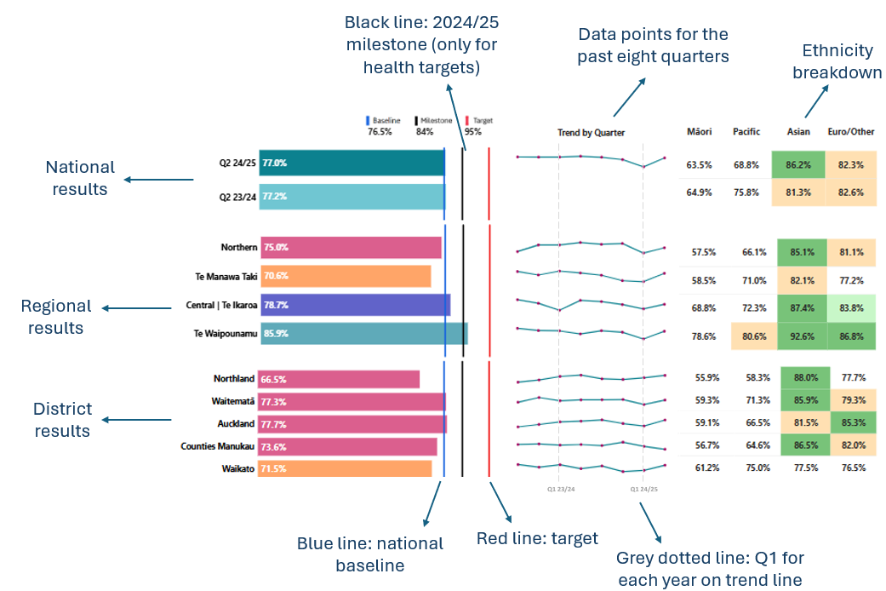

A key for the colour coding is provided below. Although a percentage symbol is used in the legend, the colour coding reflects percentage points away from the milestone/target.

|  |  |  |  |  |  |  |  |  |  |
| --- | --- | --- | --- | --- | --- | --- | --- | --- | --- |
|  | **Milestone achieved** |  | **Within 1% of Milestone** |  | **Within 5% of Milestone** | **x%** | **White – Milestone not achieved** |  | **White with no result – no results for this ethnicity** |

# Appendix 2: Performance measure data caveats

Performance measures are selected from our [Statement of Intent 2024-2028](https://www.tewhatuora.govt.nz/publications/statement-of-intent-2024-2028) and [Statement of Performance Expectations 2024/25](https://www.tewhatuora.govt.nz/publications/statement-of-performance-expectations-2024-25). The complete set of performance measures, from across all accountability documents, is reported annually.

Long and short names for measures, reference numbers, definitions, data sources and methods are published as a standalone document on our [website](https://www.tewhatuora.govt.nz/corporate-information/planning-and-performance/quarterly-performance-reporting). Breakdowns for each measure by region, district and ethnicity are provided where possible. The term ‘district’ refers to the geographic boundaries covered by former DHBs.

All performance data provides a snapshot in time. On any given day, there may be variances depending on when data is uploaded and subsequently extracted. While we have taken all reasonable steps to ensure the accuracy and completeness of the information, we accept no liability or responsibility for how the information is used or subsequently relied on.

When comparing the data from previous quarterly reports to the current one, there may be slight variations due to the latter data being more complete. Data validation is done at both national and (where relevant) local levels, by clinical and data teams, subject matter experts and those involved in the creation of the report.

Some districts have small population sizes, which may mean they have very small numbers for some measures when broken down by ethnicity. This may, at times, create an inflated result due to the underlying volumes being relatively low.

The financial year spans 1 July – 30 June, and quarters refer to the following periods:

* Quarter 1: 1 July – 30 September
* Quarter 2: 1 October – 31 December
* Quarter 3: 1 January – 31 March
* Quarter 4: 1 April – 30 June.

Output class 1: Public health services

**Breast screening coverage:** Data extraction occurred on 15 July 2025. As eligible people are invited to be screened every two years, the coverage rate is calculated over a two-year period.

**Bowel screening participation:** Data extraction occurred on 4 August 2025. Latest data available is quarter two 2024/25. This is the result displayed and compared with quarter two 2023/24. Once kits are sent out, participants have six months to complete and return them, therefore reporting on this indicator requires a six-month lag. As the programme invites participants back two yearly, participation rates are calculated over a two-year period.

#### Output class 2: Primary and community care services

**Ambulatory sensitive hospitalisations**: At year end Waikato discharges were not fully complete which may have had an impact on the published result.

**Output class 4: Mental health and addiction services**

**MHA faster specialist access <3 wks** and **MHA youth seen <3 wks:**Measurement changed in 2024/25 to support more current and inclusive monitoring. We have moved from a 12-month rolling average to measuring ‘seen dates’ each quarter and including all ages and addiction services. All referrals (including inpatient admissions) are included. Our focus is on waiting time to individual teams rather than new episodes / access to services. Urgent and non-urgent referrals are included and grouped together. Whānau-only face-to-face contacts are now included as in-scope activities. Referrals that have not yet had contact will not show.

**MHA access, integrated primary:** The Access and Choice data collection includes four workstreams: Integrated Primary Mental Health and Addictions Services; Youth; Pacific; and Kaupapa Māori services. IPMHA providers account for approximately 70 per cent of the activity, and reporting on this is provided at event level.

Tairāwhiti Access and Choice services are delivered in an integrated way across workstreams to meet the needs of geographically diverse and isolated communities. Services are delivered in a more collaborative and integrated model, which enables greater flexibility to deliver services in a range of settings and to engage as many whānau as possible. Summary level data is captured and reported but does not align exactly with other Access and Choice data so is not currently included in reporting.

Data for MidCentral district for the MHA access, Integrated primary measure was unavailable until quarter three 2024/25. As such, a trend line does not exist prior to this.

#### Digital Infrastructure

**My Health Record access:** My COVID Record was decommissioned in February 2024, and all traffic redirected to My Health Record. As such, access increased from this point.



1. Graph is sorted from highest rates per 100,000 (at the top) to lowest. Lower rates are favourable.
2. Graph is sorted from highest rates per 100,00 (at the top) to lowest. Lower rates are favourable.
3. Graph is sorted from highest proportion of missed FSAs (at the top) to lowest. Lower rates are favourable.