Quarterly Performance Report

Quarter ending
31 March 2023

Citation: Te Whatu Ora – Health New Zealand. 2023. Quarterly Performance Report: Quarter ending 31 March 2023. Wellington: Te Whatu Ora – Health New Zealand.
Published in March 2023 by Te Whatu Ora – Health New Zealand
PO Box 793, Wellington 6140, New Zealand
ISSN: 2816-1823 (online)
This document is available at tewhatuora.govt.nz
This work is licensed under the Creative Commons Attribution 4.0 International licence. In essence, you are free to: share i.e., copy and redistribute the material in any medium or format; adapt i.e., remix, transform and build upon the material. You must give appropriate credit, provide a link to the licence and indicate if changes were made.

Foreword from our CEO
This Quarterly Report provides a progress update to the end of March 2023, nine months since the Te Whatu Ora establishment. On 1 July 2022 Te Whatu Ora | Health New Zealand assumed the assets, liabilities, and roles of previous District Health Boards (DHB) and became primarily responsible for the day to day running of Aotearoa New Zealand’s Health System.
Te Pae Tata, the interim New Zealand Health plan, continues to be implemented with system shifts either starting to be realised or in the planning stages. These include initiatives for a range of services at a local, regional, and motu-wide level. Our focus on waitlists, workforce, and winter pressures continues. Pressures in the system stubbornly persist and we are addressing these issues with new and innovative approaches.
The system shifts that act as a guide for our work include:
- The health system will uphold Te Tiriti o Waitangi;
- People & whanau will be supported to stay well and connected to their communities by having more care closer to home;
- High-quality specialist and emergency care will be equitable and accessible to all when it is needed;
- Digital and technology investments will provide more care in people's homes and communities; and
- Our health workforce will be valued and well trained, ensuring we have enough skilled people to meet future needs.
During Quarter 3:
- Cyclone Gabrielle caused mass disruption to communities in Northland, West Auckland, Eastern Bay of Plenty, and Hawkes Bay. Te Whatu Ora led the health response providing necessary support to affected communities across the motu;
- Nurses pay equity arrangements of more than half a billion dollars were announced by Minister of Health, Dr Ayesha Verrall;
- People aged 65 and over, Māori and Pacific people aged 55 and over, pregnant people, and those most likely to get very sick with the flu, were informed that they can now get a vaccine free of charge; and
- An additional COVID-19 bivalent booster is available for free for people at higher risk of severe illness from COVID-19, regardless of how many doses they have previously had.
On the internal front, a Pulse Survey of staff to gather feedback on workplace experiences and provide a baseline for Te Whatu Ora was completed and shared with staff. The results provide a clear pathway for the work ahead to build a workplace where everyone can thrive.
We are some way from ‘unifying’ how we work internally, and at nine months simplifying and standardising our processes remains challenging, including for data. However, we are putting in place new national structures to support this work to happen.
Focus on winter
Our communities, hospital staff and primary healthcare will continue to see seasonal and concurrent surges of COVID-19, respiratory syncytial virus (RSV), influenza, and other diseases that will put additional pressure on our system.
Te Whatu Ora has a range of initiatives to address health system pressures for winter and beyond, that will be regionally tailored for implementation in local communities. These actions will be focused on a combination of improving access to health services for people closer to where they live, as well as measures to help manage the demand for hospital-level care over winter.
There is a focus on more convenient and equitable access to care in the community including via clinical telehealth, pharmacy advice and care, and longer-term initiatives such as ensuring more services are available - especially for Māori, Pacific, disabled people, and older people.
The first line of defence against serious illness this winter is to ensure high rates of immunisation across the country. We are encouraging people to get the flu vaccine and the COVID-19 booster to ensure they have the best protection available. These winter preparedness initiatives span the health system with a focus on enhancing primary and community services, reducing pressure on emergency departments (EDs) and acute care by improving hospital flow and discharge, maintaining planned care, strengthening immunisation, using short-term workforce actions, and maintaining the COVID-19 response.

Fepulea’i Margie Apa
Chief Executive
Te Whatu Ora | Health New Zealand

Contents
Foreword from our CEO 2
1 Snapshot for the Quarter 5
2 Key Priorities 9
2.1 Place whānau at the heart of the system to improve equity and outcomes 9
2.2 Embed Te Tiriti o Waitangi across the health sector 11
2.3 Develop an inclusive health workforce 12
2.4 Keep people well in their communities 13
2.5 Develop greater use of digital services to provide more care in homes and communities 13
2.6 Establish Te Whatu Ora and Te Aka Whai Ora to support a financially sustainable system 14
3 Our Performance 15
Delivering Te Pae Tata Interim New Zealand Health Plan 15
Delivering Ola Manuia Pacific Health and Wellbeing Action Plan 15
Non-financial performance 17
Priority 6 Establish Te Whatu Ora and Te Aka Whai Ora to support a financially sustainable system 39
Te Whatu Ora Financial Performance 40
Infrastructure Investment 43
Risk Management 45
Appendix 1: Budget 22 Investments Update 52
Appendix 2: Performance by Region 60
Te Waipounamu Region Summary and Highlights 60
Northern Region Summary and Highlights 66
Te Manawa Taki Region Summary and Highlights 70
Central Region Summary and Highlights 74
Appendix 3: Glossary 78

- Snapshot for the Quarter

Cyclone Gabrielle Response
A key focus this quarter has been the response to Cyclone Gabrielle. This was about working with the interests of whānau at the centre, bringing together the efforts of Te Aka Whai Ora, the National Public Health Service (NPHS), Hospital and Specialists Services, and our regional Wayfinders for the first time in a national emergency to support the response. This ensured there was access to Whakatane and Tauranga Hospitals and emergency pharmacy from Opotiki for those people needing support in the northern regions of Te Tairawhiti.
The NPHS immediately released medical teams and logistics from across the country to boost the NPHS Tairawhiti and Hawkes Bay teams. This support continues with the NPHS actively engaged in Public Health recovery planning at local and national levels. Debriefs have been held with local and deployed team members to identify lessons and strengthen readiness for future events.
We still face a significant period of recovery, particularly those who have been impacted in western rural (Te Karaka) and our eastern coastal communities.

Workforce
The Workforce Taskforce is focussed on delivering the immediate initiatives announced in August 2022 to mitigate workforce pressures. These initiatives include international recruitment campaigns, more favourable immigration settings for health professionals, support for overseas trained doctors and nurses to register in Aotearoa, and supporting nurses to return to practice. Te Whatu Ora has engaged with staff on their experience through the Pulse Survey and recognised nurses pay equity.

Waitlists
All regions have patients waiting beyond expected timeframes for treatment. This has increased from 34,257 in February to 34,557 in March across a range of specialities. Orthopaedics (8,717), General Surgery (5,962), Ear, Nose and Throat (4,284), and Ophthalmology (3,808) have the largest number of patients waiting.​ Confirmed March 2023 data shows that the number of patients waiting beyond expected timeframes (four months) for a First Specialist Assessment (FSA) increased from 53,604 in February to 54,760 in March. The increase occurred across a range of specialities with Orthopaedics (10,417), Ear, Nose and Throat (8,441), Gynaecology (6,066), and General Surgery (5,621) having the largest number of patients waiting.
Regions have specific reduction priorities through to 30 June 2023. These will contribute to reducing the number of patients waiting beyond four months for an FSA.

Winter Preparedness:

Influenza and COVID-19 vaccination programmes
The severity of the 2023 influenza season in Aotearoa is difficult to predict as seasonal viruses may not follow typical patterns. COVID-19 infections and the risk of COVID-19 co-infection (simultaneous infection of influenza and COVID-19) may contribute to an increasing strain on the healthcare system in Aotearoa. Preparation is therefore a priority. Immunisation is the best way to protect our communities from infection and serious illness. A number of initiatives are underway to ensure uptake of both the COVID-19 vaccine and influenza vaccine is as high as possible.
The 2023 influenza season launches on 1 April. Pharmac has secured 1.8 million influenza vaccines (including paediatric doses) for distribution. This season, funded influenza vaccinations are available for the following groups who meet Pharmac’s eligibility criteria:
- Pregnant people
- People aged 65 years and older
- Māori and Pacific people aged 55 to 64 years
- Tamariki aged 6 months to 12 years (inclusive)
- People aged 6 months to 65 years with serious mental health or addiction conditions
- People aged 6 months to 65 years with eligible conditions.
The goals for the 2023 influenza season are to:
- achieve 75 percent influenza immunisation coverage for all people aged 65 years and over
- achieve 75 percent influenza immunisation coverage for Māori and Pacific people aged 55 and over
- eliminate the equity gap for all eligible Māori and Pacific people
- achieve 80 percent influenza immunisation coverage for Te Whatu Ora frontline health and disability workers
- increase the total number of non-Te Whatu Ora frontline health and disability workers vaccinated against influenza.
A campaign activity promoting influenza and COVID-19 vaccines is underway, focusing initially on high-priority groups including Māori and Pacific peoples aged 55 and over.
The National Immunisation Programme is working with Te Aka Whai Ora and Pacific Health to create bespoke By Māori for Māori and By Pacific for Pacific campaign collateral. Funding has also been provided to Te Aka Whai Ora ($1 million) and Pacific Health ($500,000) to support equity initiatives.
The National Immunisation Programme has contacted over 1 million people in Aotearoa to make them aware they are eligible for the new COVID-19 booster (subject to the 6-month stand down period). A range of community immunisation initiatives has been planned by district immunisation teams and Māori and Pacific providers to support both the influenza and COVID-19 vaccine rollouts.

Primary Care
The latest results for the percentage of people who report they can get primary care when they need it are below baseline. Budget 2022 allocated $86m over four years to more equitably allocate primary care funding to general practices on the basis of their enrolled high priority populations, including Māori, Pacific and people experiencing high deprivation, with the aim of providing more accessible and responsive care. Implementation of the funding is expected to occur in the final quarter of 22/23.
Throughout 2022, the percentage of the population enrolled with a Primary Health Organisation (PHO) remained fairly stable. PHO enrolment rates remain below target (around 12%) for Māori compared to Non-Māori and Non-Pacific. The clinical telehealth service is providing 24/7 GP consult and nurse triage for enrolled or casual patients of Māori, Pacific and rural general practices, and general practices impacted by the recent Cyclone events, to support capacity constraints. The service is free for patients.

The following graph shows that during the financial year 2022/23, was an increasing trend of people reportedly not accessing their GP due to cost. The equity gap between Māori, Pacific, and the Non-Māori-Non-Pacific population has also not improved.
Several initiatives already exist to assist with the cost of a daytime appointment with a nurse or general practitioner such as the Community Services Card (CSC), Very Low Cost Access (VLCA) scheme, and Zero Fees for Under 14 year-olds.
Strategic work to design the future of primary care to make it more accessible, equitable, and affordable is being undertaken across Manatū Hauora, Te Whatu Ora, and Te Aka Whai Ora.
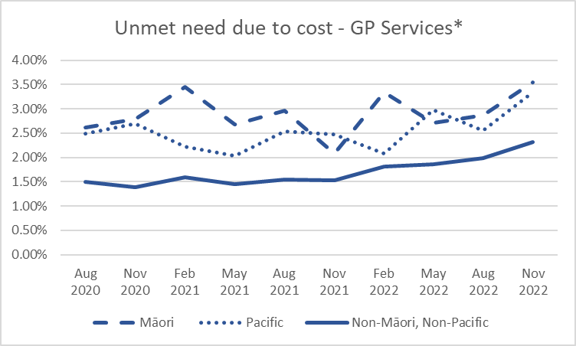
*Appointment too expensive or owed money to general practice/medical centre.

- Key Priorities
Six priority Te Pae Tata actions form the backbone of our response to the interim Government Policy Statement on Health. Our progress and highlights in quarter three against each of the six priority actions are outlined below.
  - Place whānau at the heart of the system to improve equity and outcomes
Five priority areas:
- Pae ora | Better health in our communities
- Kahu Taurima | Maternity and early years
- Mate pukupuku | People with cancer
- Māuiuitanga taumaha | People living with chronic health conditions
- Oranga hinengaro | People living with mental distress, illness and addictions
Highlights:
Pae ora | Better health in our communities: Funding has been provided for two remote-rural general practices, in Fiordland and Wanaka, to support the delivery of Point-of-Care laboratory testing in their communities. This ensures patients can be assessed and receive the right treatment in a timely manner. This approach will support a reduction in unnecessary travel around the district and more equitable service access for these rural areas.

Kahu Taurima | Maternity and early years:

Below is a trend graph up to March 2023. Over the financial year 2022/2023 there has been a slight increase in newborn enrolment for Māori, although rates are still consistently below target and below the total population enrolment rate.

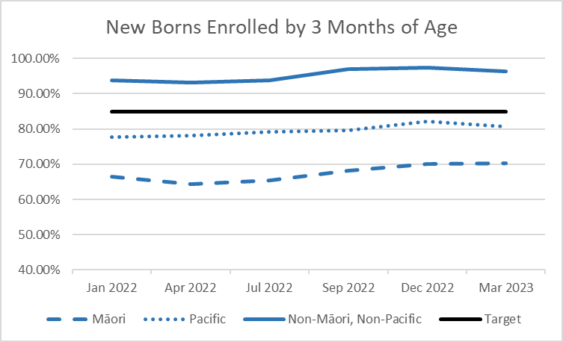

The redesign of universal model of care (now called ‘Services for all whānau’) is underway with a system design group co-led by Te Whatu Ora and Te Aka Whai Ora. The maternity and early years ‘services for all whānau’ model incorporates Kahu Taurima Tohu elements, whānau insights, the Te Ao Māori model of care - Pēpi initiatives, Pacific and whaikaha models, and the maternity and early years clinical and service transformation work.
Mate pukupuku | People with cancer: Radiation Oncology continues to be a vulnerable service area for the South Island, particularly in Southern. A national working group has been established to support immediate pressures and to form a clinical network to ensure the future viability of Radiation Oncology services. Interim regional pathways to assist acute and on call cover have been embedded, with national assistance. Recruitment continues to be a focus across the region.
Māuiuitanga taumaha | People living with chronic health conditions: $3 million has been invested to support implementing ‘Addressing the Burden of Diabetes in Pacific Communities’. This will connect with the South Auckland Diabetes pilot. An advisory group has been established to develop innovative workforce solutions to support diabetes care and management.
Oranga hinengaro | People living with mental distress, illness and addictions: A new online resource aimed at making it easier for secondary school staff to recognise and respond to the wellbeing concerns of rangatahi (Years 9 to 13) has had an excellent response since it went live in June 2022. Developed by Manu Ka Rere, a collective of Canterbury-based youth mental health and addiction NGOs, Rangatahi Well recognises the important role secondary school kaimahi have in offering early support to rangatahi with wellbeing needs. Rangatahi Well offers local advice, recommended resources and support options for rangatahi along with ongoing learning and development opportunities for kaimahi and others working in this space. Since going live there have been more than 2,300 unique visitors to the web platform.
  - Embed Te Tiriti o Waitangi across the health sector
This priority reflects the reform system shift of ensuring that Māori have a greater role in designing health services that better meet Māori their needs. Māori communities will play an important role in making sure our health services work for Māori, and the many New Zealanders accessing kaupapa Māori health services. A health system that does better for Māori does better for all.
Progress with first localities (prototypes) and the national roll out of localities: All the first twelve localities (prototypes) have confirmed their locality partnership working arrangements and engaged with whānau Māori and communities to determine their hauora (health and wellbeing) priorities.
- The first localities have focussed their engagement on uplifting the voices that have been identified as priority populations in Te Pae Tata, maintaining the integrity of the whānau voice they are collecting, and demonstrating to their communities the meaningful change that localities will support for the people who live there. The first locality partnerships will be reflecting these priorities in their draft locality plans which Te Whatu Ora will receive in April.
- Activities include receiving locality boundary recommendations from Iwi Māori Partnership Boards (IMPBs) and consultation with local authorities on the recommended locality boundaries. It is estimated that 50% of the total population will be covered by a provisional boundary by July 2023 and 100% by July 2024.
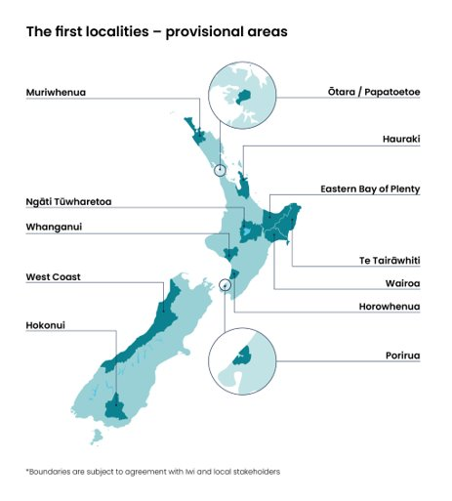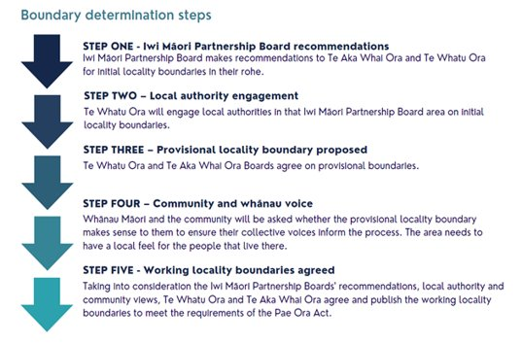
  - Develop an inclusive health workforce
This reflects the reform system shift of ensuring we plan for our future health workforce requirements and provide for the training and development needs of New Zealand’s health workforce of tomorrow.
A targeted recruitment campaign was run in the Waikato aimed at local nurses and midwives. The campaign had a focus on a flexible work style, promoting flexible hours and working conditions. This resulted in the recruitment of 33 nurses to date and identified several non-regulated workers who are in fact international nurses but unable to achieve competency from Nursing Council New Zealand due to failing International English Language Tests. Assistance is now being provided, and if they pass, these workers will be supported into a Competency Assessment Programme run by the local polytechnic. This will now be shared across the region.
  - Keep people well in their communities
This priority reflects two of the reform system shifts. Firstly, people will be able to access the healthcare they need closer to home. Health services will better reflect community needs and preferences. There will be a strong emphasis on preventing illnesses and other factors that support healthy lives, such as living in a warm, dry home. Secondly, high-quality emergency or specialist care will be available when people need it. Networks of doctors and other medical professionals will work together with community services to educate and keep people well.
The Te Kāika Wellbeing Hub, a community health hub being built in South Dunedin, is a partnership between Ōtākou Health Limited, Te Whatu Ora Southern and the Ministry of Social Development. The Hub will enable a shift of community services, currently delivered in the hospital, to a more accessible community base. Partners are currently developing an integrated model of care that puts patients and whānau at the centre and working to identify which services will be part of the Hub. Construction is set to be completed in May 2024.
  - Develop greater use of digital services to provide more care in homes and communities
This priority reflects the reform system shift that digital technology will be used in more and better ways, to provide people with services in their homes, hapori, and local communities. Technology will also help healthcare workers better understand and support their patients.
We have launched a website that gives people and their whānau an easier pathway to find free support for mild and moderate mental health and addiction issues. The website www.wellbeingsupport.health.nz brings together all Access and Choice primary mental health and addiction services all in one place. It gives those interested in accessing support a search tool to find their nearest providers. The website also promotes digital mental wellbeing tools and has a specific page summarising rural mental wellbeing supports.

  - Establish Te Whatu Ora and Te Aka Whai Ora to support a financially sustainable system
In this first year, the focus is on merging the 20 district health boards and their seven shared service agencies into a single entity with a single operating model. We are taking actions to: unify and simplify the systems of decision-making; nationalise enablers including procurement, data and digital systems, long-term planning, infrastructure investment choices, and workforce planning. It will also reduce duplication and concentrate resources to achieve improvement in outcomes and equity across priority areas of health service delivery.
Te Whatu Ora and Te Aka Whai Ora have continued to implement Workforce Taskforce actions to strengthen the health workforce, carry out an employee Pulse Survey to help inform activity to improve the workplace experience, and new system leadership structures are changing how the system is led to provide collective leadership and decision-making.
Most Te Whatu Ora functions now report through to a national leader following the Simplify to Unify changes, either directly or through regional structures. The next phase of change involves implementing detailed organisational structure designs for all business units. These are currently underway. Regional integration teams, co-chaired by Te Aka Whai Ora, are also in place, and 12 locality prototypes have been established which will provide insights to feed into the development of further localities.
A roadmap of key strategic initiatives has been agreed. The Te Whatu Ora Strategic Roadmap highlights the significant and material short term initiatives that the organisation is prioritising to drive Pae Ora. These initiatives cover all aspects of Te Whatu Ora, including initiatives that directly link to Te Pae Tata actions. These initiatives build on the work we have already done in bringing our people into one structure. In addition, it will create a health system that is more equitable, accessible, cohesive, and people-centred, and that will benefit the health and wellbeing of every New Zealander. Strategic Initiatives include programmes of work such as planned care, developing a national desktop, and shifting resources to the frontline.

- Our Performance

Delivering Te Pae Tata Interim New Zealand Health Plan
Te Pae Tata sets out 187 key actions that Te Whatu Ora and Te Aka Whai Ora will undertake in the first two years. These actions will build the foundations of a unified, smarter, sustainable and equity-led health system. The actions are spread over four sections that highlight the different priority areas. During quarter three, progress has been made on 109 actions (58%). When assessed against the implementation plan, 63 actions (34%) are on track, 45 (24%) require monitoring and one action was assessed as at risk.
Progress has been made on 27 actions compared to last quarter, with 11 more actions on track. Organisational restructuring has been a significant challenge for progress in this quarter and business units are working to address Te Pae Tata actions.
The table below contains the Quarter 3 progress of actions in Te Pae Tata:
Sections | Number of Actions Total | Green | Amber | Red | No milestone, no response or still assessing | No Response
A new health system focused on people | 20 | 7 | 8 | - | 4 | 1
Improving health outcomes and equity | 39 | 18 | 11 | - | 4 | 6
A unified health system | 62 | 29 | 12 | 1 | 7 | 13
Priority populations | 66 | 9 | 14 | - | 38 | 5
Total | 187 | 63 | 45 | 1 | 53 | 25

Delivering Ola Manuia Pacific Health and Wellbeing Action Plan
Ola Manuia (to live in wellness) Interim Pacific Health Plan and a companion document to Te Pae Tata was launched by Hon Minister Aupito William Sio and National Pacific Health Director Markerita Poutasi on 11 November 2022. The key priorities covered by Ola Manuia span the life course of Pacific peoples from pregnant women, children and youth, through to adults and elders, and include focusing on long-term conditions (such as diabetes), mental health, and tagata sa’ilimalo people with disabilities.
Highlights from Quarter 3:
National Pacific Health Provider Fono: The National Director Pacific Health hosted the first in person Te Whatu Ora National Pacific Health Provider Fono at Ko Awatea, Middlemore Hospital. The Fono was attended by Executive representatives from 42 pacific health providers engaging in provider-led talanoa contributing insight and feedback on key programmes of work across Pacific health priorities in development and the delivery of health and wellbeing services for Pacific communities. Hon Minister Barbara Edmonds, Minister for Pacific Peoples and Associate Minister of Health (Pacific Peoples) along with Hon Aupito William Sio joined at the fono dinner to acknowledge and celebrate the critical role Pacific Providers play in communities and their commitment over the course of the pandemic and more recently, severe weather events.
National Pacific Health Senate: Pacific Senate meetings have commenced and will continue meeting monthly. Moving forward, a Pacific Senate member will sit on the Clinical Governance Forum.
Pacific Health Workforce Update:
- The development of an Interim Pacific Health Workforce Strategy is an action within Ola Manuia for the period ending June 2024. The interim strategy will align to the current interim health plans and work programmes as Te Whatu Ora progresses its first phase of transition. It will include enabling actions that build the foundations for future Pacific workforce development and initiatives. The development of the Pacific Health and the New Zealand Health Workforce Strategies will be completed during 2023.
- The WayFinder Programme was launched at Wintec Te Pūkenga, a for-Pacific, by-Pacific support programme for Pacific students who want to pursue a career in health. The programme is co-funded by Wintec Te Pūkenga, Ministry of Social Development, and Te Whatu Ora. There are 15 Pacific students in the first cohort who are set to study health at Wintec (enrolled nursing, nursing, midwifery, physiotherapy).
- Te Whatu Ora Pacific Health Scholarships have progressed to the final phase of the application process. The final cohort of successful applicants will be confirmed at the end of April. This includes the applicant’s acceptance process.

Regional Update: Te Whatu Ora sponsored the Oceania Cultural Festival, led by Pacific Island Trust Bay of Plenty (PICT). The key theme of the event was Pacific dance, arts, sports, and food for Pacific and wider communities with a focus on Pacific migrant workers. At the event, the PICT nursing team provided free general health checks such as blood pressure, Body Mass Index, and health information and reached 156 people and their families.

Non-financial performance
- Interim Government Policy Statement (iGPS)
- Health System Indicators (HSI)
- Metrics set out in the Statement of Intent/Statement of Performance Expectations SOI/SPE
In our first year, we are tracking performance using the following measures from the Interim Government Policy Statement and our Statement of Performance Expectations/Statement of Intent for 2022/23. Some measures are also included in the Whakamaua: Māori Health Action Plan 2020-2025.
Measures are assessed using a traffic light system, as shown in the key below. In some cases, the process of collation and validation of health system data means that the most up-to-date information available is for a different timeframe than the Quarter 3 reporting period.
Key
Criteria description | Rating | Rating Assessment
Achieved | At or above target
Not achieved, but progress made | ≤ 10% of target
Not achieved | ≥ 10% of target
Qualitative / not reporting in Q2/ To be determined (TBD)

Priority Area | Pae Ora | Better health in our communities
 | Priority 1 - Place whānau at the heart of the system to improve equity and outcomes
 | Measure | Frequency of Reporting | Baseline Value (SPE) | Expectation for July 2022 – June 2024 | Latest Result | RAG | Action in Response |  | Accountability Document
 | Percentage of children enrolled with an oral health service | Annual | Māori 80% Pacific 92% Non-Māori, non-Pacific 100% | 95% | Māori 82%  Pacific 100%  Non-Māori, non-Pacific 100% |  | Due to most districts having quadruple enrolment systems at birth, overall preschool enrolment rates into COHS remain high. However, work with whānau, maternity and Well Child providers is required to understand and address the lower enrolment rate for Māori. Te Whatu Ora and Te Aka Whai Ora are establishing a National Oral Health Equity Programme that aims to address inequities in oral health for Māori and Pacific and will include actions to address enrolment and service access. |  | SPE/SOI
 | Percentage of children enrolled with a general practice or a kaupapa Māori provider by age 3 months | Quarterly | Māori 67% Pacific 80% Non-Māori, non-Pacific 95% | 85% | Māori 70.3%  Pacific 80.7%  Non-Māori, non-Pacific 96.3% |  | Te Whatu Ora and Te Aka Whai Ora are commissioning comprehensive primary and community care models, including kaiāwhina roles, for providers serving high Māori populations. We expect this to contribute to an improvement in the rate of Māori enrolled with a general practice or a kaupapa Māori provider in the coming year.  Budget 2022 allocated $86 million over four years to more equitably allocate primary care funding to general practices on the basis of their enrolled high needs populations, including Māori, Pacific and people experiencing high deprivation, with the aim of providing more accessible and responsive care in general practice. This funding will be rolled out in the last quarter of the current financial year. |  | SPE/SOI/Whakamaua
 | Percentage of smokers offered help to quit in past 15 months | Quarterly | Māori 64% Pacific 74% Non-Māori, non-Pacific 68% | 90% | Māori 63%  Pacific 72%  Non-Māori, non-Pacific 65% |  | All health professionals continue to check the smoking status of their clients/patients and provide brief advice and support to quit smoking. A referral is also made to a stop smoking service or Quitline. Please note that this measure is limited to primary care and does not represent the full scope of the Smokefree Aotearoa 2025 programme. A new measure from 2023/24 will monitor progress towards the plan, specifically smokers who enrol with a stop smoking provider, set a Target Quit Date and a validated smokefree at four weeks (this will include Māori, Pacific and non-Māori/non- Pacific data). |  | SPE/SOI
 | Percentage of obese children referred to a specialist service | Sourced from monthly performance report. Covers six-month period between 8 August 2022 to 7 February 2023 | Māori 94% Pacific 97% Non-Māori, non-Pacific 95% | 95% | Māori 94%  Pacific 95%  Non-Māori, Non-Pacific 94% |  | This measure is being deleted from July 2023 and with consistent achievement or near achievement of the target for all population groups, no performance improvement activities are being undertaken. |  | SPE/SOI
 | Percentage of people who report they were involved as much as they wanted to be, in making decisions about their treatment in general practice care | Quarterly | Māori 84% Pacific 84% Non-Māori, non-Pacific 86% | Improve from baseline (trend to increase). | Nov 2022  Total: 86%. No significant change from baseline.  Māori 84%  Pacific 85%  Non-Maori, non-Pacific87%  Tāngata whaikaha (disabled people, unweighted data) 85% |  | We are streamlining and improving feedback and complaints processes to make it easier for all consumers and whānau to provide feedback on their experience of care. This includes developing complaints and feedback approaches that work better for Māori, Pasifika, people with disabilities and other priority groups who have not been served well in the past.  Through the ‘localities model’, people will be able toparticipate in the planning and commissioning of community-based care to ensure that services reflect the particular needs of their community.  The Consumer Health Forum Aotearoa provides consumers and whānau with meaningful opportunities to have a say in the design and delivery of health services. |  | SPE/SOI / HSI
 | Percentage of people who report they can get primary care when they need it | Quarterly | Māori 73% Pacific 77% Non-Māori, non-Pacific 80% | Improve from baseline (trend to increase). | Māori 70%  Pacific 71%  Non-Maori, Non-Pacific77%  Tāngata whaikaha (disabled people, unweighted data) 71% |  | Budget 2022 allocated $86m over four years to more equitably allocate primary care funding to general practices on the basis of their enrolled high needs populations, including Māori, Pacific and people experiencing high deprivation. This is aimed at providing more accessible and responsive care. Implementation of the funding is expected to occur in the last quarter of 22/23.  The clinical telehealth service providing 24/7 GP consult and nurse triage for enrolled or casual patients of Māori, Pacific and rural general practices is in place to support capacity constraints in general practice. This service is also available to people in Cyclone impacted regions. |  | SPE/SOI / HSI/iGPS/Whakamaua
 | 6.3 Proportion of entities that have been assessed against the Consumer Engagement Quality and Safety Marker; and of those, the proportion that have been assessed at Level 3 or 4 | July and December | Baseline data June 2022  Responsiveness 55%  Engagement 45%  Experience 65% | Increasing participation of health entities & their local areas that have been assessed against the Consumer Engagement Quality and Safety Marker (CEQSM) from 30 June 2022. Establish a baseline for places that have been assessed at Level 3/4 on the CEQSM & agree to change or improvement expectations in year two from the baseline. | This result is based on most recent data from HQSC.  Data for the next reporting period (Oct-March 2023) will be available in July. |  | The latest Consumer Engagement Qualtiy and Safety Marker data submitted by districts in March 2023 will be published by HQSC in July.  The latest results are being assessed and moderated where necessary and will be available in July 2023 and included in the fourth quarterly report.  The consumer and whanau engagement Qualtiy and Safety Marker is currently being revised to incorporate the code of expectations and will be utilised in the September 2023 reporting by distircts. |  | iGPS
 | Kahu Taurima | Maternity and early years
 | Measure | Frequency of Reporting | Baseline Value (SPE) | Expectation for July 2022 – June 2024 | Latest Result | RAG | Action in Response |  | Accountability Document
 | 3.6 Enrolment with a primary maternity care provider in the first trimester of pregnancy, reported by ethnicity and geographic area | Annual, 12 months after the end of the calendar year |  | Establish a baseline in year one and agree to change or improvement expectations in year two from the baseline. | Data at 2020:  Māori 59.7%  Pacific 45.4%  Non-Māori, non- Pacific 82.4% |  | The redesign of universal model of care (now called ‘Services for all whānau’) is underway with a system design group co-led by Te Whatu Ora and Te Aka Whai Ora. The maternity and early years services for all whānau model incorporates Kahu Taurima Tohu elements, whānau insights, the Te Ao Māori model of care – Pēpi initiatives, Pacific and whaikaha models and the maternity and early years clinical and service transformation work. |  | iGPS
 | Mate pukupuku | People with cancer
 | Measure | Frequency of Reporting | Baseline Value | Expectation for July 2022 – June 2024 | Latest Result | RAG | Action in Response |  | Accountability Document
 | 1.1 Variation in clinical prioritisation for cancer treatment and elective surgery, reported by ethnicity and geographic area | Monthly |  | 100% of patients were prioritised using approved nationally recognised processes or tools. | In February 2023, 99% of people were recorded as being treated who were prioritised using nationally recognised processes or tools. |  |  |  | iGPS
 | 1.2 Proportion of people who start first treatment for breast, cervical or bowel cancer after a screen result (presence of cancer), reported by ethnicity and geographic area | Annual (financial year) | Where the diagnosis is cancer, ≥90% of women have their initial treatment performed within 31 calendar days of the final decision to treat (treatment is defined as an MDT decision) | iGPS - This measure is still to be confirmed. |  |  |  |  | iGPS
 |  | Annual | 95% or more of women who: have evidence of clinical suspicion of invasive carcinoma, or a laboratory report indicating ‘features suspicious for invasion’, or ‘changes consistent with squamous cell carcinoma’, or similar, must receive a date for a colposcopy appointment or a gynaecological assessment that is within 10 working days of receipt of the referral Indicator 7.4 90% or more of women with HSIL are treated within 8 weeks of histological confirmation of CIN 2/3. | iGPS - This measure is still to be confirmed. |  |  |  |  | iGPS
 |  | Monthly and Annual | 95% of the National Bowel Screening Programme participants diagnosed with cancer are referred for pre-operative presentation at MDM within 20 working days of diagnosis | iGPS - This measure is still to be confirmed. |  |  |  |  | iGPS
 | Māuiuitanga taumaha | People living with chronic health conditions
 | Measure | Frequency of Reporting | Baseline Value | Expectation for July 2022 – June 2024 | Latest Result | RAG | Action in Responses |  | Accountability Document
 | Annually (calendar year)1.5 Rate of diabetes complications, reported by ethnicity and geographic area | Quarterly |  | A decrease from the 12 months to 30 June 2021 (baseline). | The rate of complications per 100,000 people with diabetes decreased by 7.3% between 2020 and 2021. Māori rates of complications (338.1 per 100,000 people with diabetes) are 1.6 times higher than those of non- Māori or Pacific. |  |  |  | iGPS/Whakamaua
 | Oranga hinengaro | People living with mental distress, illness and addictions
 | Measure | Frequency of Reporting | Baseline Value (SPE) | Expectation for July 2022 – June 2024 | Latest Result | RAG | Action in Responses | Accountability Document
 | 1.3 Variation in the rates of access to key identified services by ethnicity, geographic area and other characteristics. Initial areas include access to specialist mental health (including for rangatahi) | Quarterly | Māori 79% Pacific 87% Non-Māori, non-Pacific 68% | Access to specialist mental health: An increase in the percentage of people seen within the target timeframe from the 12 months to 30 June 2022 for rangatahi (baseline) = 80% | Under 25-year-olds specialist mental health or addiction services within three weeks of referral:  For the 12 months ending 31 December 2022  Māori 77.4%  Pacific 81.7%  Non-Māori, non-Pacific 66.6% |  | Through Budget 2022 targeted specialist mental health services are being expanded in the areas with the most need. This includes funding for crisis responses; maternal and infant mental health services; child and adolescent mental health and addiction services; eating disorders services; and kaupapa Māori services. | iGPS /HSI/ SPE/SOI/Whakamaua
 | 3.5 Complete roll-out of the Access and Choice programme for primary mental health and addiction support services so that access is available for 325,000 people per year by the end of June 2024 | Quarterly |  | Integrated Primary Mental Health and Addiction Services: Establish baseline estimated annual access level and adjustment factor in the first quarter of 2022/23 Expectation of an estimated 248,000 annual access level based on fourth quarter access in 2023/24 | The estimated annual access for Access and Choice at the end of Quarter 2 2022/23 was 162,600, just short of the target of 175,000. |  | The growth of the programme is on track to reach its intended capacity of seeing 325,000 people per annum by the end of the rollout, as further service expansion and recruitment is under way.  We expect to reach the 30 June 2023 estimated annual access target of 200,000. | iGPS
 |  | Quarterly |  | Kaupapa Māori, Pacific and Youth Primary Mental Health and Addiction Services: Establish baseline estimated annual access level in the first quarter of 2022/23 Expectation of an estimated 77,000 annual access level based on fourth quarter access in 2023/24. | We are on track to deliver however, recruitment remains challenging for some providers, and we are actively working to support services to grow their staffing levels.
 | Number of mental health bed nights | Annual | Māori 321,522 Pacific 68,202 Non-Māori, non-Pacific 519,569 Improve from baseline (trend to increase) | Improve from baseline (trend to increase). | Annual result reported. |  |  | SPE/SOI
 | Total number of mental health contacts | Annual | Māori: 1,242,416 Pacific: 304,963 Non-Māori, non-Pacific: 2,538,657 | Improve from baseline (trend to increase). | Annual result reported. |  |  | SPE/SOI
 | People served by specialist and NGO mental health services per 100,000 people |  | Māori 5,650  Pacific 2,905  Non-Māori, non-Pacific 2,988 | Improve from baseline (trend to increase). | For the 12 months ending 31 December 2022  Māori: 5,505  Pacific: 2,758  Other: 2,915 |  | Through Budget 2022 targeted specialist mental health services are being expanded in the areas with the most need. This includes funding for crisis responses; maternal and infant mental health services; child and adolescent mental health and addiction services; eating disorders services; and kaupapa Māori services. | SPE/SOI
 | Improve digital access to primary and mental healthcare to improve access and choice, including virtual after-hours and telehealth, with a focus on rural communities |  |  |  | We have launched a website that gives people and their whānau an easier pathway to find free support for mild and moderate mental health and addictions issues. www.wellbeingsupport.health.nz provides a home for the Access and Choice primary mental health and addiction services all in one place. It gives those interested in accessing support a search tool to find their nearest providers. The website also promotes digital mental wellbeing tools and has a specific page summarising rural mental wellbeing supports. |  |  | SPE/SOI

Priority Area | Measure | Frequency of Reporting | Baseline Value (SPE) | Expectation for July 2022 – June 2024 | Latest Result | RAG | Action in Response | Accountability Document
Priority 2 Embed Te Tiriti o Waitangi across the health sector
 | Localities are established |  |  | Milestone Report | Proposed provisional locality boundaries (covering 50% of the population) will be ready for endorsement in June 2023. We are on track to have 100% of the population within a proposed locality boundary by October 2023. |  |  | SPE/SOI
 | 2.1 Health entity spending on identified Māori health service providers | Available annually after the close of the financial year |  | Increase in trend in actual expenditure (compared with the average of the last five financial years). | $565.2 million spent in funding to Māori Health providers in 2020/21. Payments have been made to many Māori Health providers in line with the objectives of the health reforms. A substantial amount of contracts have been identified and transferred to Te Aka Whai Ora, and further work is under way. At year end the combined spending of Te Aka Whai Ora and Te Whatu Ora on Māori Health Providers will be reported. |  |  | iGPS/Whakamaua
 | 2.2 Experience of health services for Māori as measured by the primary health patient care and adult inpatient experience surveys | Quarterly |  | Improvement in results from June 2021 (baseline used in Health System Indicators). | % of Māori in hospital kept informed as much as they wanted to be about their treatment and care = 73.2%  % of Māori in hospital treated with kindness and understanding by their doctor = 88%  % of Māori in hospital with their cultural needs met = 81.6% |  |  | iGPS/Whakamaua
 | 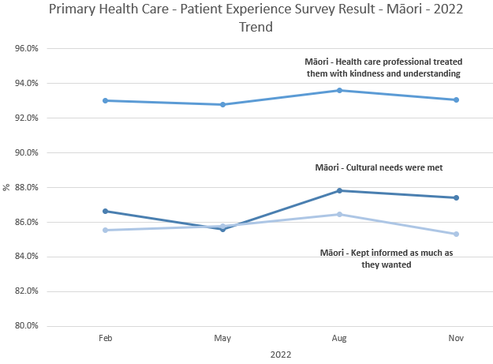
 | 2.3 Geographical coverage and utilisation of rongoā Māori services | Annual (financial year) |  | An increase in rongoā consultations provided in terms of both total volumes and spread across the country. | Age breakdown within the Māori ethnicity (June 2021)  0-14 = 882  15-29 = 1,050  30-44 = 1,674  45-59 = 1,985  60+ = 4,092  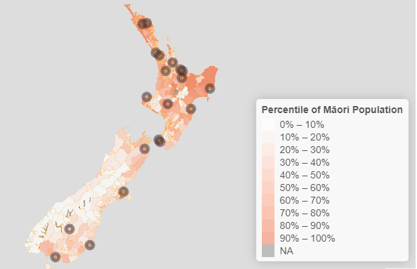 |  |  | iGPS/Whakamaua
 | 2.4 Feedback from the iwi-Māori partnership boards on how they are fulfilling their role and whether they are receiving the support they require | Six-monthly survey as per IMPB setting |  | Establish a baseline in year one, and agree to change or improvement expectations in year two from baseline. |  |  |  | iGPS
Priority Area | Measure | Frequency of Reporting | Baseline Value (SPE) | Expectation for July 2022 – June 2024 | Latest Result | RAG | Action in Response | Accountability Document
Priority 3 Develop an inclusive health workforce
 | 4.1 Engagement survey on culture and shift towards a ‘one team’ ethos (measure will be in development as part of work to build data collection) | TBD | Staff engagement survey on culture and shift towards a ‘one team’ ethos (measure will be in development as work to build data collection) |  | Average score across relevant Pulse results: 58% (Likert scale)  Question Score  There is a sense of connection and belonging within our team 66%  I understand the reasons for changes taking place in our healthcare system 62%  We have a shared vision, long term focus, and clear sense of purpose 57%  I am able to reach out to anyone in our organisation when I need to 57%  The changes we are making will enable us to better meet the needs of our communities 56%  Our team is starting to build relationships with teams across Aotearoa 50% |  | A programme of national and local actions in response to matters raised through the Pulse Survey has been commenced, with weekly tracking of progress against local actions, to make a swift impact for our teams. | iGPS
 | 4.2 Proportion of Māori and other under-represented groups in the regulated and unregulated health workforce, compared with the proportion of the total population | Annual – starting date of 12-month period variable between professional councils | Regulated Workforce: An increase from the 12 months to 30 June 2022 (baseline) |  | Results Total FTE Māori Pacific Asian Other  Allied and Scientific 11,377 6.9% 3.6% 18.7% 70.8%  Midwifery 906 8.1% 1.7% 7.3% 83.0%  Nursing 27,653 6.3% 3.9% 35.0% 54.8%  Resident Medical Officer (RMO) 5,094 7.3% 3.2% 24.6% 64.9%  Senior Medical Officer (SMO) 5,450 2.1% 0.9% 18.9% 78.1% |  | Data shows a material, positive increase in the representation of Māori and Pacific peoples across professional groups against December 2021 data, with select outliers. As part of workforce planning under development, we will target areas of underrepresentation and poor growth in workforce representation to shift results; noting that there is a significant lag-time between interventions and movement in this measure. | iGPS/Whakamaua
 |  | Annual | Unregulated Workforce: An increase from the 12 months to 30 June 2022 (baseline) |  | Results Total FTE Māori Pacific Asian Other  Care and Support 7,357 17.2% 12.8% 25.8% 44.2%  Corporate and Other 19,008 11.0% 7.0% 17.3% 64.4% |  | Results show no material movement in corporate and other representation against December 2021 data; and a decrease in Māori and an increase in Pacific peoples care and support representation over the same time period. As part of workforce planning under development, we will target areas of underrepresentation and poor growth in workforce representation to shift results. | iGPS/Whakamaua
 | 4.3 Number and proportion of graduates of health training programmes from demographic groups under-represented in the health workforce, compared with the proportion of the total population |  | TBD | TBD | TBD |  |  | iGPS
 | 4.4 Proportion of Māori and Pacific peoples in leadership and governance roles across the Ministry of Health and health entities |  | Quarterly | Establish a baseline and initial increases in numbers | TBD |  |  | iGPS/Whakamaua
 | 5.2 (Measure to be developed) Develop agreed measures of quality-adjusted, system-level productivity |  | TBD | Measures of productivity will be determined and may include matters such as: hospital theatre utilisation, length of stay, FTEs per case-weighted hospital discharge, use of (clinical and non-clinical) workforces. | TBD |  |  | iGPS

Priority Area | Measure | Frequency of Reporting | Baseline Value | Expectation for July 2022 – June 2024 | Latest Result | RAG | Action in Response | Accountability Document
Priority 4 Keep people well in their communities
 | Winter Preparedness: Access to Primary Care, Immunisation, Planned Care (Waitlist), Acute Demand
 | 3.1 Proportion of people reporting unmet need for primary health care, reported by ethnicity and geographic area | Annually (financial year) |  | A decrease from the 12 months to 30 June 2019 (baseline) | Results for 2021/22 financial year  Unmet need for GP services due to cost:  Māori 14.5%  Pacific 11.4%  Total 10.7%  Tāngata whaikaha (disabled people): 17.3%  Unmet need for a GP due to wait time being too long in the last 12 months:  Māori 14.6%  Pacific 13.5%  Total 11.5%  Tāngata whaikaha (disabled people) 13.8% |  | To support clinical capacity, and general practices with patient demand, a clinical telehealth service providing 24/7 GP and nurse consult is available to both enrolled and casual patients at rural, Maori and Pacific general practices free of charge to patients and the general practice. The service is also available to general practices who have experienced recent adverse weather events.  To support workforce capacity, Te Whatu Ora has funded locum placements for GPs and Nurse Practitioners to help general practices that are under pressure from staffing issues.  There are a number of local Te Whatu Ora and PHO funded clinical telehealth/virtual care to support patients that are unable to get general practice appointments. These initiatives are often partially subsidised to make it affordable to patients. | iGPS/Whakamaua
 | 3.2 Proportion of people waiting for planned specialist care who receive it within four months, reported by ethnicity and geographic area | Monthly |  | ESPI 2 No patients waiting for an FSA wait longer than four months | Data to Feb 2023:  National 31.9%  Northern 34.8%  Te Manawa Taki 33.8%  Central 25.5%  Te Waipounamu 29.6% |  | Districts have committed to priorities to address certain aspects of the waiting lists through to 30 June 2023. This will reduce the number waiting beyond 4 months for assessment and treatment. | iGPS
 |  |  |  | ESPI 5 No patients are committed to treatment and are not treated within four months | Data to Feb 2023  National 45.8%  Northern 40.8%  Te Manawa Taki 46.5%  Central 48.1%  Te Waipounamu 50.8% |  |  | iGPS
 | 3.3 Uptake of immunisations for key age groups, reported by ethnicity and geographic area | Quarterly |  | Eight-month-olds: 95% of eligible children fully immunised at eight months of age for Māori, Pacific and Total populations. | Total 83.6%  Māori 69.7%  Pacific 83.5% |  | This quarter has seen significant increases in coverage for tamariki Māori at the 2-year milestone (a 2.5 percentage point increase) and Pacific children at the 5-year milestone (a 3.3 percentage point increase). Coverage for NZ European has decreased at all milestone ages compared to the previous quarter.  To support progress towards 95 percent coverage across all ethnicities the National Immunisation Programme is working with Te Aka Whai Ora on a number of activities:  - The National Immunisation Taskforce’s report Initial Priorities for the National Immunisation Programme in Aotearoa was recently published which outlines 54 recommendations. Currently 26 of the recommendations are underway.  - A comprehensive communications and engagement campaign to lift childhood vaccination rates launched on 19 April. Bespoke by Māori for Māori and by Pasifika for Pasifka campaign collateral (videos and posters) are also being developed to support this campaign.  - A new website, immunise.health.nz, provides easy-to-access information on immunisation and a new tool to create a personalised childhood schedule.  The Programme is supporting regions to implement the Childhood Immunisation Prioritisation Matrix, which indicates the highest priority vaccination activity to receive the sector’s priority efforts and vaccination resource. The Programme has also developed a data dashboard that provides insights at a local level, including the number of immunisations required to reach 95%. | iGPS / SPE/SOI
 |  |  |  | Two-year-olds: 95% of eligible children fully immunised at two years of age for Māori, Pacific and Total populations. | Total 83.2%  Māori 68.9%  Pacific 81.2% |  |  | iGPS / SPE/SOI / HSI
 |  |  |  | Five-year-olds: 95% of eligible children fully immunised at five years of age for Māori, Pacific and Total populations. | Total 81.0%  Māori 69.7%  Pacific 82.3% |  |  | iGPS / SPE/SOI
 |  | Annual |  | Human Papillomavirus (HPV) vaccination: 75% of eligible boys and girls fully immunised with HPV vaccine for Māori, Pacific and Total populations | Total 55.8%  Māori 46.2%  Pacific 50.0% |  | Coverage indicated here is an interim quarterly progress update only.  Coverage rates will fluctuate quarter to quarter as HPV immunisation is primarily delivered through school-based programmes.  The Programme is working with an external provider to review the school-based imunisation programme, including HPV immunisation delivery, to identify strategies to support uptake of the vaccine, particularly for Māori and Pacific. | iGPS / SPE/SOI
 |  |  |  | Influenza for 65+ years: 75% of the eligible population aged 65 years and over immunised against influenza (annual immunisation) for Māori, Pacific and Total populations |  |  |  | iGPS / SPE/SOI
 |  | Annual |  | 75% of the eligible/recommended population aged 18 years and over immunised against COVID-19 (annual immunisation) for Māori, Pacific, and Total populations |  |  |  | iGPS
 | 3.4 Rate of hospital admissions for an illness that might have been prevented or better managed in the community, reported by ethnicity and key age groups | Quarterly |  | The rate of hospital admissions for children under five years of age for an illness that might have been prevented or better managed in the community reduces (baseline of results 12 months to December 2019 used in Health System Indicators) and/or the equity gap between Māori and Pacific people and non-Māori, non-Pacific peoples also reduces | Results are reported as a rate per 100,000. Latest results reflect the 12 months to December 2022  National 6,813  Māori 7,448  Pacific 12,427  Other 5,762 |  | Te Whau Ora has initiated a programme of work to drive actions that will support local systems to reduce demand for acute services, including ambulances. This is in mobilisation currently ahead of winter, and includes:  - Increasing access to services at pharmacies and GPs  - Reducing system pressures by preventing hospital admission through initiatives such as Hospital in the Home to reduce need for hospitalisations  - Increasing immunisation to protect from severe illness and hospitalisation | iGPS / SPE/ HSI/Whakamaua
 |  |  |  | The rate of hospital admissions for people aged 45–64 years for an illness that might have been prevented or better managed in the community reduces (baseline of results 12 months to December 2019 used in Health System Indicators) and/or the equity gap between Māori and Pacific people and non-Māori, non-Pacific peoples also reduces. | Results are reported as a rate per 100,000 (standardised). Latest results reflect the 12 months to December 2022  National 3,618  Māori 6,771  Pacific 7,386  Other 2,883 |  |  | iGPS / HSI
 | 1.4 Missed appointments for specialist care, reported by ethnicity and geographic area | Quarterly |  | A decrease from the 12 months to 30 June 2022 (baseline) and the equity gap between Māori and Pacific people and non-Māori, non-Pacific peoples also reduces. | Data for the period Jan-March 2023 was not available at the time of reporting. |  | There is a programme of work underway that will validate and review the datasets relating to the monitoring of missed appointments. The review intends to ensure consistency of collection and reporting across the country including determining patient versus service reasons. We hope to provide updated data in the next report. | iGPS/Whakamaua
 | 3.7 Standardised rate of acute readmissions within 28 days of discharge, reported by ethnicity and geographic area | Quarterly |  | Establish a baseline in year one, and this baseline will inform the expectation for year two Note: Acute readmission 0-7 days will be a sub-component. Initially, this measure will reflect the measure included in the acute re-admission report published on the Nationwide Service Framework Library (NSFL). | National 12.5%  Māori 12.8%  Pacific 12.3%  Other 12.4% |  | As part of winter preparedness and ongoing flow programmes of work, Te Whatu Ora is focusing on the step-down of patients from a hospital setting. Regions are expanding existing Hospital in the Home models of care, and working towards the implementation of these models where there are none currently. Additional interim care beds are being established in conjunction with commissioning to facilitate patients return home. Pathways are being developed and implemented to reduce avoidable admissions from aged residential care. | iGPS
 | Number of acute bed nights spent in hospital |  | Māori 341,366 Pacific 154,929 Non-Māori, non-Pacific 1,577,694 | Improve from baseline (trend to increase). | Latest results reflect the 12 months to December 2022  National 2,153,617  Māori 358,077  Pacific 168,444  Other 1,627,097 |  | Te Whatu Ora initiated a programme of work to drive actions that will support local systems to mitigate acute demand pressures (referenced above). In addition to a range of other initiatives, this includes actions focused on supporting timely discharge, increasing step down capacity outside of the acute setting, and reducing length of stay/volumes of long stay (7 day plus) patients. | SPE/SOI
 | Acute hospital bed day rate |  | Number of days spent in hospital for unplanned care including emergencies |  | Results are reported as a rate per 1,000 (standardised). Latest results reflect the 12 months to December 2022  National 399  Māori 571  Pacific 684  Other 355 |  |  | HSI
 | Access to planned care |  |  | People who had surgery or care that was planned in advance, as a percentage of the agreed number of events in the delivery plan. | As of end of February 2023 the total planned interventions were 189,570 and the actual delivery was 199,504 due to an increased volume of minor procedures. |  | Initiatives to reduce wait lists for assessment and treatment are being led nationally and include outsourcing to private hospitals, improving utilisation of available theatre capacity, and measures to improve equity. All regions are developing and reviewing plans to ensure planned care is maintained through periods of high acute demand. Hospitals are focused on maintaining acute patient flow to minimise acute care incursion into planned care capacity. Local response plans are in place for escalation actions to maintain planned care. | HSI
 | Establish a nationally integrated public health service with consistent operating models | Milestone Report |  |  | The National Public Health Service operating model complete with detailed design on the remaining purchasing/performance function commencing April 2023. Consultation on proposed tier 4-5 structure in progress. |  |  | SPE/SOI
 | Continue COVID-19 response in line with policy settings, and build towards a new business as usual pandemic resilient system | Milestone Report |  |  | The tagged contingency has been used to fund the scaled approach to maintain a set of COVID-19 services as part of the transition towards a longer-term approach.  The expected outcomes of this are: targeting of those most vulnerable to serious illness; continued delivery of key elements of our response and giving life to the COVID-19 Strategic Framework; continued optimisation of investment and a significant reduction in overall spending; mitigation of pressure on the broader health system; and retained capacity within the health system for pandemic resilience with a sustainable funding pathway |  |  | SPE
 | 6.1 (Measure to be developed) Health entities are clear about their own and other entities’ roles and responsibilities and are delivering to these | TBD | TBD |  |  |  |  | iGPS
 | Provider Networks are established | Milestone Report | TBD | TBD |  |  |  | SPE/SOI

Priority Area | Measure | Frequency of Reporting | Baseline Value | Expectation for July 2022 – June 2024 | Latest Result | RAG | Action in Response | Accountability Document
Priority 5 Develop greater use of digital services to provide more care in homes and communities
 | Data and Digital
 | Develop and implement a national plan to create consistency in data and digital capability across Te Whatu Ora |  | Milestone report | Functional Data and Digital business unit established and operational by July 2023. | Proposed structure is currently out for consultation. |  |  | SPE/SOI
 | 6.4 Proportion of medical appointments completed through digital channels (initially outpatients and expanding to include general practitioner appointments when data is available) | Monthly |  | This measure will initially focus on outpatient services – first specialist assessment (FSA) and follow-ups. Establish a baseline for the FSAs and follow-ups in year one. The baseline will inform an expectation for year two | Total FSAs and Follow-ups 2023 (Jan-Mar) telephone/video: 45,610  Total FSA + Follow ups: 443,117  10%  *please note, this data collection is dynamic and rates change as data becomes more complete. Information for December 2022 has subsequently updated to the following:  Total FSAs and Follow-ups 2023 (Oct - Dec) telephone/video: 50,473  Total FSA + Follow ups: 467,754  11% |  |  | iGPS

Priority 6 Establish Te Whatu Ora and Te Aka Whai Ora to support a financially sustainable system
Key Points
- The operating result for March was unfavourable to budget by $2m, and $11m favourable year to date.
- The operating result for February was favourable to budget by $2m, and $13m favourable year to date.​
- The operating result for January was unfavourable to budget by $3m, and $11m favourable year to date.The result for March includes $4.9m of disaster recovery costs.
- The year-end forecast remains within budget and at breakeven. Forecasting COVID-19 costs is challenging. It remains dependent on policy settings and levels of outbreak.
- The year-to-date results reflect upsides due to reform savings, vacancies and lower than budget volumes in some demand-driven services. Results are offset by Queens Memorial Day, expected restructuring costs, winter pressures, high sick leave due to COVID-19 and workforce investment.
- Key trends over the nine months are continuing vacancies overall in the employed workforce leading to higher per FTE costs. Sick leave and overtime costs remain high.
- Nursing Pay Equity uplifts have now been processed and are reflected in the year-to-date result.
- Roll out of the FPIM system continues. This is a critical enabler for finance transformation.
- Capital and Coast successfully went live on FPIM on 1st April. Auckland successfully went live on FPIM on 1st March.
- Audits of the Annual reports for 18 outgoing DHBs have been completed. The final two DHB audits are due to be completed imminently.

Te Whatu Ora Financial Performance

Year-to-date operational financial performance to 31 March 2023
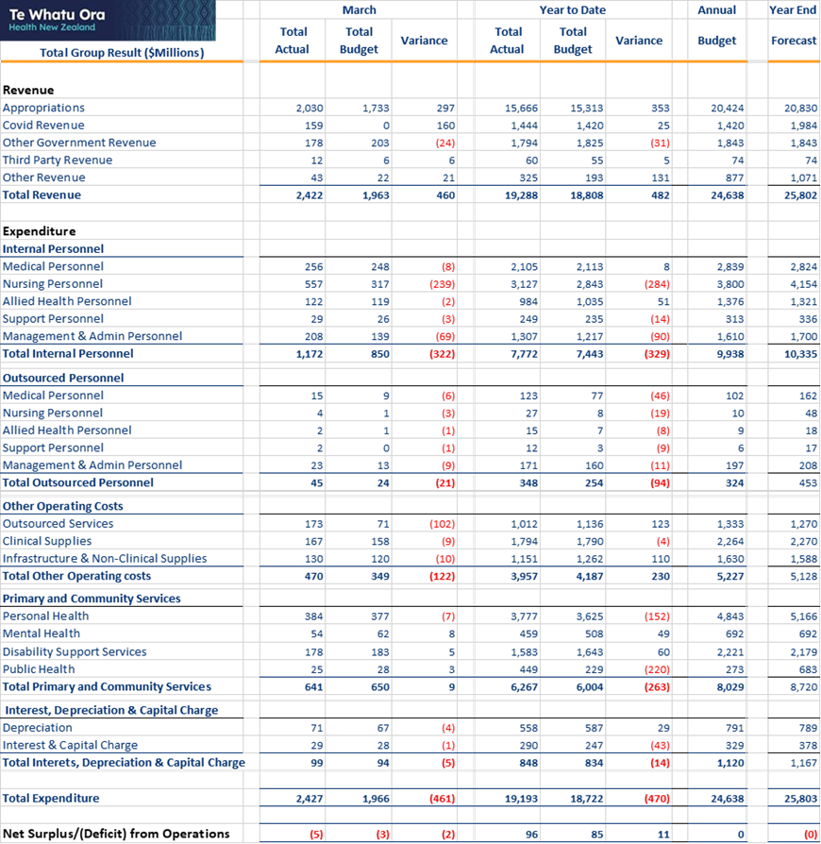
March Year to Date (YTD)
The YTD net operating result is $11m favourable to budget. Within this result there are under and overspends that net off. The key year to date upsides are:
- Holding vacancies for back-office staff
- Savings driven by Health reforms
- Volumes below budget for demand driven expenditure in Aged Residential Care, Primary care, community contract efficiencies and reconfigurations
These are offset by costs above budget due to:
- Winter pressures
- Queens Holiday Memorial Day
- Investment in Workforce initiatives
- High sick leave and other costs driven by COVID-19 in Hospital and Specialist Services
- Provision for restructuring costs
Nursing Pay Equity
February and March have seen the payment of all backpays and other commitments under the Nursing Pay Equity agreement. Additional Appropriations revenue has now been received to cover the unbudgeted settlement impact. As a result, both Nursing costs and Appropriations income now show large variances within the consolidated financials to March.
Note that the settlement has ongoing costs, and these are fully funded. The remaining months of this financial year will see increased revenue and expenditure as a result. This is before increased costs and funding become part of our baseline for 2023/24.
Cyclone Response
Costs related to the cyclone response had not filtered through to our February result – however, the March financial result was adversely impacted by approximately $5m, incurred through a mix of Tairawhiti and Hawkes Bay costs, as well some within Corporate.

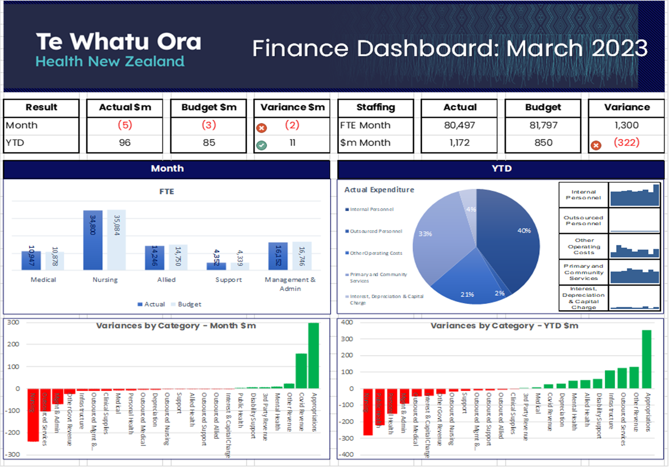

Infrastructure Investment
The Infrastructure and Investment Group (IIG) is responsible for monitoring the health sector’s capital projects that require Crown funding or exceed $10 million in capital cost. These are currently 110 projects across the motu with combined total value of $7.787 billion.
Performance reporting indicates that most projects are on track with 40 projects in delivery and 23 projects in the completed/debrief phase. The table below shows the number of projects in each project phase:
Time Frame | Define | Design | Deliver | Debrief
28 February 2023 | 11 | 36 | 40 | 23
31 January 2023 | 12 | 35 | 40 | 23
Movement | -1 | +1 | 0 | 0
The IIG is also responsible for the 36 projects in the Rapid Hospital Improvement Programme (RHIP), 17 of which are now complete.
Highlights on progress made on Te Pae Tata actions:
Action Description | Q3 Update | RAG
Deliver a National Asset Management Strategy and Capital Investment Plan by December 2023 including the information solution strategy, requirements and road map for asset management and investment analysis. | The National Asset Management Strategy (NAMS) is progressing well, and we are now in the development phase.  The Capital Investment Plan is progressing well. Work has focussed on integrating the Investment Plan into overall Te Whatu Ora planning systems.  The information solution strategy, requirements and Road Map for asset management and investment analysis is progressing well. We have captured the current state of asset information systems and high-level requirements and have started planning for the next stage of the project.  Although the projects are progressing well, the tight timeframe for the delivery of the projects (going to Cabinet December 2023) is why the action has an amber RAG status.
Develop design standards for Aotearoa health facilities, contributing to and building on the Australasian Health Facility Guidelines. | The Design Guidance and Assurance Framework has been approved. This outlines how Aotearoa will develop and contribute to the Australasian Health Facility Guidelines and ensure that there are specific design guidance and assurance.
Develop partnerships with other government sectors to align with and leverage off large capital delivery programmes in other sectors. | Engagement with other government agencies primarily through the Construction Sector Accord forums is well underway.

Risk Management
Understanding and managing risk is a key aspect of a high-quality health system. The table below provides an overview of key areas of risk, and management activities to address those risks.
Risk Description | Key Management Activity
If Te Whatu Ora is unable to deliver the transition, associated culture and accountability change, then the benefits of the health sector reforms will not be delivered at the scale and pace expected. | Te Whatu Ora is working on the implementation of a national, regional, and local organisation structure that unifies and simplifies the system using a consistent standardised operating model for corporate functions, including people and culture, finance, commissioning, hospital and specialist, data, and digital and infrastructure.  This simplification is under way with two waves of consultation commenced, to unify service delivery in non-front line business functions. The intended outcome is to enable savings for the 2023/24 financial year, that can be consolidated to redirect resources to the delivery of healthcare.
If Te Whatu Ora does not have a workforce that is appropriately qualified and sufficient to meet demand, then there will not be the capacity to deliver healthcare and services to the community. | Te Whatu Ora is focussed on delivering the immediate initiatives announced in August to mitigate immediate workforce pressures – international recruitment campaigns, immigration service, supporting overseas trained doctors and nurses to register in NZ, supporting nurses to return to practice.  Te Whatu Ora has engaged with staff on their experience through the Pulse Survey and delivered significant investments in pay by getting the agreement from the ERA to pay Agreement in Principle interim pay equity rates to our nurses. We are working to develop further priorities to strengthen the workforce from 2023 forward into the future, to ensure our workforce is sustainable and well supported.
If Te Whatu Ora is unable to deliver consistent high-quality services and care to the community, then the intent of the reforms will not be delivered. | Te Whatu Ora prioritised work on Planned Care, Acute & Seasonal Pressure, the Immunisation and Workforce Taskforces, at national and region levels to support and enhance equitable provision of care.  The development of a national clinical governance framework that supports whole of system quality and patient safety.  Initial work on the development of national clinical networks to deliver greater nationally consistent models of care that address equitable access and outcomes for communities.
If Te Whatu Ora does not have clear targeted and regularly monitored strategies, plans or programmes supported across the health sector to deliver equitable health outcomes for all New Zealanders, then Te Whatu Ora may fail to meet its obligations under Te Tiriti and not achieve the goal of improved health outcomes for all New Zealanders. | Delivering Te Pae Tata, building Māori/Pacific leadership/partnership and advisory workforce capacity, identifying equity gaps in services and quality of care, and ongoing communication and collaboration with community groups and NGOs.  Communication and stakeholder engagement strategies for messaging and information to manage impact during consultation for change period such as low productivity and higher absenteeism from work.  Programmes of work are appropriately resourced and milestone deliverables monitored with early treatment strategies implemented when required.  Continue to engage with Te Aka Whai Ora on these priority areas to ensure alignment of targets and strategies to ensure we are actively pursuing collaboration and alignment.
If Te Whatu Ora does not meet its financial obligations in a sustainable way, then fiscal losses could occur, resulting in pressure on funding the reform change programme. | New operational planning and budgeting processes for Budget 2023/24 underway and aligned to Te Pae Tata goals, and realising operational savings from implementing operating models at a lower cost base.
If Te Whatu Ora is unable to manage, monitor or respond to the health, safety and wellbeing of its staff and visitors to its facilities then it will fail to meet its obligations under the Health and Safety at Work Act 2015. | Strengthening the consistency of the statutory notifications process and reporting of incidents, accident, critical risk reporting (including a deep dive into violence and aggression), preparing strategies and framework, and building specialist risk capacity. Union engagement has occurred on piloting a campaign to reduce violence and aggression towards staff in May.
If Te Whatu Ora does not have a clear strategy to maintain current systems or enable investment in technology, then it may fail to meet future demand and models of care. | The future strategies are in development:  - The Data and Digital Strategy and Horizon 1 2-year road map (aligned to Te Pae Tata) was approved by the Board in March 2023. Metrics to measure and monitor progress in the delivery of the strategy against defined targets are in development.  - Development of the Data & Digital operating model. Consultation will commence in April with final decisions due in June. The operating model will guide delivery and ensure FTE and budget allocations are correctly attributed. The first iteration of the FY23/24 budget, inclusive of consideration to requests for additional contingency drawdown for Cabinet appropriations, are in development.  - The national review of all Data and Digital investments is an iterative process to identify opportunities for consolidation, efficiency and the ability to redirect resourcing to those areas of the Horizon 1 roadmap (aligned to Te Pae Tata) that are currently unfunded. A review of the remaining pending and paused initiatives was undertaken in March 2023, with a focus on aligning value streams to national direction, and rationalising investments where possible balanced with investment required to address immediate operational business risk (including technical debt). The next steps (April and May period) include working with clinical groups to validate recommendations and value stream roadmaps, and to work with finance and ELT on the financial implications for FY24 and beyond.  The risk for current systems include:  - Breach of Systems / Cybersecurity incident – resulting in interruption, manipulation or destruction of critical clinical and corporate system(s) that threatens healthcare delivery and outcomes and / or the disclosure, destruction or alteration of patient information which pose threats to privacy, and information as taonga as well as the sider impacts to primary and allied care that would follow.  - A delivery focus cyber reset is underway as part of the wider review of the national cyber strategy and investments. This will be informed by the Data and Digital operating model with a timing of the beginning of FY24, influenced by the completion of staff consultation. Quick win plans have focused on:  - Cyber security incident responses – the rollout of national training with exercises for each region delivered on a quarterly schedule and implementation of an Emergency Operations Centre in-a-box solution whilst participating in the Cyclone Gabrielle response.  - Anti–phishing awareness platform, ready for 6 new locations which do not currently have this capability.  - Further development and real-world testing of a new third-party security risk automation platform.  - Technical Debt – Te Whatu Ora operates a large and complex technology environment across 29 entities. Over time, an increasing number of applications, operating systems, networks, and infrastructure components have exceeded their recommended industry standards or lifetimes and become out-of-date and unsupported by vendors. This is commonly referred to as technical debt, acknowledging that this holistic term also encompasses operational debt which is an added consequence of not staying at pace with release cycles and through the lack of modern tooling required to manage large and complex environments.  - Work is underway to understand the extent of the problem from a national perspective and to manage rectification in a consistent and coordinated manner. Each region is at varying levels of advancement to manage technical debt including scoping the extent of technical debt and undertaking tactical initiatives.  - An architecture blueprint is being prepared to provide national direction around Te Whatu Ora technology choices in alignment with the new operating model. It will provide clear direction of the future state architecture intent and inform future investments. This blueprint which is based around a framework which takes a domains-based approach will help provide direction and structure to the management of technical debt.
If Te Whatu Ora does not have a clear programme to ensure the accuracy and consistency of its data and protect against unauthorised access to information, then it may fail to meet future demand and its statutory obligations. | - The health system reforms present a unique opportunity, and need, to restructure our data and digital capabilities, functions, tools, and ways of working across the health system. To achieve the data benefits intended by the reform, data governance is being strengthened by remobilisation in April 2023 of the Joint Oversight Group (JOG) between Te Whatu Ora, Te Aka Whai Ora and Manatū Hauora working pursuant to the Māori Sovereignty Framework, Data & Information Strategy for Health & Disability (DISH), and Data Tripartite Agreement to facilitate system-wide strategic data and digital co-ordination.  - The National Data Platform (NDP) development work is progressing to plan. The procurement process has reached the final stages of selection for a design and delivery partner and is due for completion in early May (with respondents advised in good faith that funding is subject to approval of the business case). The Single Stage Business Case (SSBC) is being developed in parallel with the RFP and will be delivered in June. While NDP work progresses, the Rapid National Data Automation (RNDA) project continues to deliver value as an interim solution, with the addition of new data sets.  - Under the direction of the National Service Improvement and Innovation Group, a separate piece of work is underway to ensure appropriate quality assurance processes are in place for externally reported data.
If Te Whatu Ora is unable to effectively respond to incidents or events that have the potential to significantly disrupt health services and care, then there may not be the capacity to deliver healthcare and services to the community. | Ongoing strengthening and coordination of incident and business continuity management structures and capability, ensuring service continuity during summer holiday period and responding to recent weather events.
If Te Whatu Ora does not understand the nature or condition of its infrastructure and assets to support future planning for maintenance and investment, then the required clinical services may not be able to be delivered. | The recently approved release of tagged contingency (as well as an impending B23 operating budget bid) allows the IIG to materially advance condition assessments (including seismic assessments), on a prioritised basis. The condition assessments will reduce this risk. The procurement and use of an Asset Information Management System and the National Asset Management Strategy, once published, will further reduce the risk by establishing and maintaining a contemporary, national view of the asset portfolio and identifying the strategy to manage it.
If Te Whatu Ora does not understand its legislative and regulatory obligations, then it may fail to meet these statutory obligations. | Regular reporting to management and the Board on legal and compliance issues and ongoing review, refresh and update of corporate policies, frameworks and MoUs.
If Te Whatu Ora does not meet its obligations to establish localities to operate effectively and efficiently within the required timeframe, then it may fail to meet future demand and not provide the capacity to deliver healthcare and services to the community. | Current forecast is to have 50% of population covered by July 2023 and 100% by October 2023. Other programmes include: activity around organisational changes, communications and engagement plan, operating model and funding of future localities, workforce culture and capability, and learning and insights from prototypes.
If Te Whatu Ora does not have shared strategies or plans or deliver programmes of work and approaches that explicitly give effect to the principles of te Tiriti o Waitangi, it may fail to comply with its obligations under te Tiriti of Waitangi. | Continuing to strengthen management and Board level partnership with Te Aka Whai Ora, delivering Te Pae Tata, embedding regional and local iwi/Māori partnerships through locality planning, and other related initiatives.  Prioritising work programme and monitoring process to meet milestones and KPIs and identify anticipated delays early to initiate strategies to manage.  Roles created within System Innovation and Improvement with joint accountabilities or key interests to Te Aka Whai Ora to help align Te Whatu Ora and Te Aka Whai Ora strategies, plans and priority programmes, and ensure collaboration at all levels.
If Te Whatu Ora is unable to build and maintain trust and confidence in its ongoing service performance and in the effectiveness of the transition and change in approach to health service commissioning and delivery, then the intent of the reforms will not be delivered | Continuing to build structured capacity to support engagement across agencies and with the Ministers Office, ongoing operating model transformation prioritised and related activities underway.
If Te Whatu Ora is unable to build and maintain trusted relationships and partnerships with Māori and key stakeholders at national, regional, and local levels, then the intent of the reforms will not be delivered | Continuing to mature localities and the key stakeholder relationships and partnerships underpinning them, ongoing engagement with other agencies and engagement with whanau and communities underway.

Appendix 1: Budget 22 Investments Update
Initiative | To 31 March 2023 | What is happening next
Addressing the Burden of Diabetes for Pacific Communities | - South Auckland Diabetes Advisory Group established in January 2023.  - Programme Manager in position from January 2023, and draft programme plan created.  - Service specifications finalised in February 2023.  - Contract with provider in place in March 2023.  - Engagement with the Pacific Consortium.  - Presentation to National Pacific Senate. | Comprehensive review of current state of diabetes services for Counties Manukau, including face to face engagements with service funders and providers.  Engagement with Otara/Papatoetoe locality.  Ongoing discussions with current programmes of interest to inform the Model of Care.
Allowing Payment to Family Members for Support Services | - New payment policy approved by Te Whatu Ora and Te Aka Whai Ora Boards.  - Implementation began in January 2023.  - Widespread communications plan has been developed, with a specific focus on Māori and Pacific communities. | Needs Assessment Service Coordination (NASC) agencies are offering people the choice of paying a family member to provide care for people with low and moderate needs. Monitoring of uptake is ongoing, focused on the increase in uptake of services, and a comprehensive evaluation framework will be developed by 2024.
Comprehensive Primary Care Teams | - Draft scope and prioritisation approach developed in September 2022; agreed in November 2022.  - Care team role descriptions, models of care, enablers and funding modelling tools developed in October 2022.  - The implementation plan for the first phase of comprehensive primary care and community teams developed for approval in the first week of April 2023.  - Regional engagement and implementation planning is under way. | Recruitment, focused on kaiāwhina in seasonal pressure areas and wider comprehensive care teams in early localities, is scheduled to run from May– July 2023.  Providers will get funding in hand, and FTEs on the ground, starting in May 2023.  Approval for the next phase of implementation is being sought and the full roll-out begins in July 2023.
Continuing the Alcohol and Other Drug Treatment Courts: Waikato, Auckland and Waitakere | Existing Courts in Auckland and Waitakere (established 2012) and Waikato (established 2021) continue to operate.  The Budget 2022 funding to make these Courts sustainable and permanent has been allocated through June 2026. | Certification of Waikato’s expansion (from four to six rooms) has not been processed yet but is expected to be complete by June 2023.  Waikato is finalising the purchase of a supported accommodation residence in Hamilton, expected in April.  Clinical Governance Group to support the Courts will be established in June 2023.
Dementia Mate Wareware Action Plan - Implementation Support Funding | - Dementia Mate Wareware Leadership Group established in October 2021.  - Three-year contract for Secretariat services for the Leadership Group signed.  - Stage 1 of registration of interest (ROI) in is progress; 72 ROIs were received, and evaluation and shortlisting are under way. | Stage 2 Request for proposal, will commence on 21 April 2023 and close on 4 May 2023.  Contracts will be agreed by 30 June 2023.
Emergency Air Ambulance Services Additional Support Funding (14001) | New four-year contracts signed in November 2022. New aircraft for Helicopter Emergency Medical Services NZ delivered in November 2022. Aircraft in Central Region replaced with near new Airbus H145 in Quarter 3.  A fixed wing, and a road patient transport service, have been contracted to support inter-hospital transport between the Far North and Auckland.  In November 2022, helicopter, pilots, and clinical crew were added to operate an additional 12-hour shift in Queenstown | Working with Northern region provider to lease two 7-year-old AW169 aircraft for delivery within 12 months, while working on finalising a production slot for the new AW169 or further lease a third AW169 aircraft.  Airbus has indicated production of essential replacement helicopter blades for the 30+ years old aircraft (BK117) currently used in Central and Southern has ceased.  Te Whatu Ora is working with the Central region provider to explore leasing up to two H145 aircraft to replace their old aircraft.  Te Whatu Ora is working with providers to increase resilience against disaster and supply chain constraints, and to prepare for Winter 2023 to reduce rotary air ambulance demand.
Emergency Road Ambulance Services Additional Support Funding (13999) | Budget 2022 provided for additional ambulance shifts to maintain response time performance, approximately equating to:  - 248 new FTEs (including 22 new Communication Centre FTEs) by June 2024.  - 40 new management FTEs by June 2023.  - 48 new ambulances by June 2024.  - 13 new response cars by June 2024.  Hato Hone St John (HHSJ) and Wellington Free Ambulance (WFA) advise they have achieved to date:  - 98 new FTE (10 WFA & 88 HHSJ), plus 21 graduate paramedics (WFA) and 30 Australian undergraduates (as HHSJ emergency medical technicians).  - 36 new management FTEs. | HHSJ and WFA are both experiencing recruitment and retention issues and carrying large frontline vacancies. They are actively recruiting to fill vacancies, but this is adversely impacting their ability to add the new ambulance shifts funded from Budget 22. Mitigations currently in place include an international paramedic recruitment campaign.  The Te Whatu Ora national ambulance team is working with providers on winter preparedness.
Extending School-Based Health Services (SBHS) | Progressing expansion agreements for Activity Centres with relevant Te Whatu Ora Districts continues. Service level agreements have been prepared for the following areas and are in the process of being signed: Southern, Hawke's Bay, Tairawhiti, Capital and Coast, Hutt Valley, Taranaki, MidCentral, Lakes, Auckland, Counties Manukau, Bay of Plenty.  Stakeholder engagement and relationship building internally and across government is ongoing to prepare for expansion into kura kaupapa Māori.  Procurement for the Te Ūkaipō Wānanga Programme is under way. Te Ūkaipō Wānanga will progress embedding of Te Ūkaipō in SBHS, which will contribute to capacity for increased service delivery in kura kaupapa. Branding guidelines for Te Ūkaipō are being developed.  Current state reports for workforce and model of care projects were submitted to Te Whatu Ora in March 2023. | Nurse FTE is expected to be in place in activity centres during Q1 of the 23/24 financial year, depending on recruitment and staff availability.  Stakeholder engagement and relationship building will continue.  Development of Te Ūkaipō Wānanga programme is anticipated from April 2023 through August 2023, depending on procurement progress.
Health Workforce Development | The $39 million allocation for Māori workforce development is targeting initiatives to expand the Hauora Māori scholarships, Mātauranga / Mataora Māori training, training more Rongoā Māori practitioners, and expanding the Pūhoro STEM programme. Te Aka Whai Ora Board added $10 million to this appropriation for Hauora Māori Commissioning.  Applications opened for the Te Pitomata Grant (previously Hauora Māori Scholarships). The focus areas for these grants are Medical, Nursing, Midwifery, Allied Health Scientific and Technical, and Corporate. These areas were identified where critical growth is required due to Māori workforce underrepresentation.  $3 million to support implementing ‘Addressing the Burden of Diabetes in Pacific Communities’ will connect with the South Auckland Diabetes pilot. The advisory group has now been established and will develop workforce innovations to support diabetes care and management. | In the first week of April, $4.9 million of the workforce growth and training funding (FY 2022/23) was agreed for kaiāwhina as part of Comprehensive Primary and Community Care teams through Māori Haoura Partners and Pacific Partners.  Workforce working groups are planning medium- and long-term initiatives to improve workforce sustainability.  Workforce planning and investment approach to support Budget 24 investments will be complete by 31 October 2023.  Approvals for the implementation of the future years workforce growth and training funding are being sought. The proposal will focus on additional roles as part of the Comprehensive Primary and Community Care Teams
Improving Access to Primary Health Care Services for Transgender People | Advisory group established in March 2023 and now meeting monthly.  Request for proposal (RFP), for update to Gender-Affirming Guidelines closed 31 March 2023. Provider will be contracted by the end of June 2023. | RFP for Community Driven Models of Care has closed and we are confirming the preferred providers Two providers will be selected and contracted by the end of June 2023.  RFP for Workforce Development has closed. Provider will be contracted by the end of June 2023.
Mana Ake Continuation and Expansion of Mental Wellbeing Support for Primary and Intermediate School-aged Students | - Agreement with all local areas regarding funding levels, models of service delivery, FTE numbers and phasing of the service roll out.  - Agreements in place in December 2022.  - Service delivery is ongoing in schools in Canterbury and Kaikōura.  - Service delivery has started in West Coast and roll out to all schools is ongoing. | Phased service delivery is expected to commence in in Te Tai Tokerau Northland, Counties Manukau, and Lakes in May 2023. Services will continue to grow and expand throughout the year as additional FTE are recruited and onboarded.  Contract with provider for web platform will be finalised and in place in April 2023.
Neonatal Retinopathy Screening | National Advisory Group established. Funding commences in 23/23 financial year. | Regional and hospital-level implementation plans will be agreed. Roll out will begin in 2023/24.
Pacific Primary and Community Care Provider Development Securing Future Capability and Shifting into New Models of Care | - 27 applications have been approved, including to three new Pacific providers (representing $22.8 million over three-years). All funds are committed and with the sector.  - National Pacific Provider Fono occurred in March. | The Steering Committee will meet before June 2023 to discuss the upcoming funding round and the findings of a Summary Report, which captures the talanoa held at the Pacific Provider Fono in March 2023.
Piki Continuation of Integrated Primary Mental Health and Addiction Support for Young People in Greater Wellington | - Provider negotiations held in late 2022.  - Contract variation signed in December 2022.  - Ongoing service delivery. | Service delivery will continue at existing levels, with 26.75 FTE across 10 providers in the Greater Wellington Region.
Population Health and Disease Management Digital Capability | - Enhanced Border Surveillance measure implemented in January 2023.  - Measles module of National Contract Tracing Solution used in February 2023.  - Joint Steering Group in place.  - Reorganisation of National Digital Services continues, with recruitment under way and Tier 4 and 5 roles appointed. Some delay in further hiring of roles due to organisation-wide change. | - Further development of measles module capability.  - Development of a new mobile friendly website that builds on My COVID record functionality that is scalable across multiple health services.  - Recruitment is subject to organisation-wide reorganisation and has been delayed, with area consultation scheduled for April 2023.
Preventing Family Violence and Sexual Violence: Services for Victims of Non-fatal Strangulation | The service is established and in place. Work to date has used Budget 2020 funding for design development, and implementation of a training and accreditation programme for health professionals on Non-Fatal Strangulation (NFS) offences, as well as funding provided for NFS services. | To ensure improvement in the services delivered, an ongoing quality assurance programme is being developed and is expected to be finished by 30 August 2023.
Preventing the harm from serious and organised crime in New Zealand | Since 2016, a contract with Counties Manukau provides 10 hours per week of clinical review and triage of deportees’ health information by a senior registered nurse. Work is under way to develop the agreement and job description for the dedicated FTE. | An agreement, and confirmed job description, for nurse FTE will be agreed in Q4.
Primary Care Funding Formula Equity Adjustments to Capitation | Modelling and analysis of funding options is complete.  The options for consideration have been agreed, and the funding option approved in the first week of April 2023.  Sector engagement is under way. | Payments to providers will be initiated April - June 2023.
Service Integration for Locality Provider Networks | - Twelve locality prototypes have been established and are at various stages of development, supported by Te Whatu Ora.  - Iwi Māori Partnership Boards have been established, to support the locality boundary work.  - Met with Local Government New Zealand to discuss boundary identification. | Funding sign-off pending and distribution expected to flow to those on the ground from May to June 2023.  Engagement process with Iwi Māori Partnership Boards and Local Authorities to identify boundaries continues, with 50 percent coverage expected by July 2023.
Specialist Mental Health and Addiction Services Increasing Availability of Focused Supports | - Agreements for eating disorder services have been signed by all four regions and recruitment has commenced.  - The investment strategy for maternal and infant mental health services has been agreed. Agreements have been completed with Nelson Marlborough, which has started recruitment. Agreements are underway with the following areas : Waitematā, MidCentral, Bay of Plenty, Taranaki, Southern, Hawke’s Bay and Whanganui  - The investment strategy for community crisis centres has been agreed. Agreements have been drafted for Bay of Plenty, Lakes and MidCentral.  - An investment strategy for Child and Adolescent Mental Health Services has been agreed, and Agreements are in the final stages of development.  - A workforce development plan has been completed.  - A portion of the Kaupapa Māori funding has been allocated to support mental wellbeing of whānau impacted by Cyclone Gabrielle, the remainder will fund packages of care.  - Te Ara Oranga has been expanded to Murapara and continues in Northland.  - Four licensed drug checking providers (three frontline, and ESR) have been contracted to deliver drug checking services through to 30 June 2024. The summer season went well with significantly increased capacity due to public funding and ESR purchasing four new FT-IR spectrometers.  - $500,000 of kaupapa Māori specialist services funding has been reprioritised for the Cyclone Gabrielle psychosocial response. | - Recruitment for eating disorders services is expected to be complete, with phased service provision beginning, by 30 June 2023.  - Agreements for maternal and infant mental health services will be in place for all identified areas by 30 April, except Tairāwhiti, which is on hold for six months following Cyclone Gabrielle.  - Agreements will be in place, and phased service delivery will begin, for all crisis services by 30 June 2023.  - Child and Adolescent Mental Health Services service delivery is expected to begin roll out in May 2023.  - Workforce development investment strategies will be completed and approved by 30 April 2023, and initiatives in place by 30 June 2023.  - Te Ara Oranga will expand in Eastern Bay of Plenty.  - Drug checking services will continue, albeit expected scaled down, over the next few months now that the peak summer season has concluded.  - Work to commission kaupapa Māori psychosocial response services is under way led by Te Aka Whai Ora.  - Five kaupapa Māori partners have been identified and will be contracted for He Kete Whai Ora (cultural packages of care) by 30 April 2023.  - The first-year development of the Māori Oranga Hinengaro pathway is currently under way with a scope being finalised for the project. It is expected that an external partner will be commissioned to deliver this mahi.
Well Child Tamariki Ora Continuation of the Enhanced Support Pilots (ESPs) | Pilots continue in Lakes and Tairawhiti districts.  A new provider is being commissioned in Counties Manukau. Pilot evaluation is ongoing and further performance information is expected later in 2023. | Contracts will be extended, and other necessary procurements will be initiated by 1 October 2023.

Appendix 2: Performance by Region

Te Waipounamu Region Summary and Highlights

Summary
Accelerating a Regional Approach: We continue to realign regionally to support delivery of Te Pae Tata and make the most of the opportunities unlocked by our new structure. Our Public Health team now has an interim Regional Clinical Director and Regional Business Development Manager in place. Supported by the Public Health and Immunisation Leadership Groups, these two roles are working with public health teams across Te Waipounamu (the South Island) and equivalents around the motu to identify how we can prioritise and transform our public health service. Our Hospital & Specialist Services have identified regional leads to implement key national programmes. This includes regional leads for System Pressures, Planned Care, Critical Care, Infrastructure, and Data & Digital. Each focus area has a regional workgroup in place and a work programme in progress. A regional Clinical Leadership Group has also been established this quarter.

Quarter 3 Key Highlights
Expanding the Reach of Specialist Withdrawal Services: First conceptualised in 2020, there is now an established hub & spoke network of withdrawal management (detox) nurses in place in Te Waipounamu. The network is supported by a 0.5 FTE clinical coordinator in Canterbury and detox nurses spread across the South Island, including 6 FTE new roles. The hub & spoke service model increases options for people wanting to access withdrawal services in their own communities and reduces the need for people to travel away from their whānau and support networks for treatment.
National Programme Progress Update
Prioritising Immunisation: Childhood immunisation coverage continues to be strong across Te Waipounamu relative to the national picture. While uptake levels are positive, a high proportion of Māori children are unprotected, so this remains a regional focus. We have formed a regional Immunisation Leadership Group to provide oversight and leadership to local operations and to take advantage of regional opportunities. We are also supporting Pharmacy in their increasing vaccination role as we prepare for the influenza vaccination campaign starting 1 April. Pharmacies are offering an increasing range of vaccination services, with Influenza, COVID-19, Tdap and MMR vaccinations now able to be administered by Pharmacist Vaccinators. In the first week of April 84.6% of all COVID vaccinations delivered in primary care in Canterbury were given by pharmacy.
Reducing Wait-times: Our regional Planned Care Working Group continues to support and drive initiatives to address long-waits across the South Island. Additional funding, allocated earlier in the year, is reducing waits and enabling increased access for rural populations. The West Coast is on track to deliver an additional 34 major joint (hip and knee surgery) procedures by 30 June through outsourcing to the private sector in Christchurch. An additional 16 dental surgery procedures for children will be undertaken at Te Nikau Grey Hospital in late May. Two Maxillofacial procedures were undertaken for the first time in Timaru this quarter. A range of initiatives are also being introduced to address the impact ongoing staffing shortages in anaesthetics, physiotherapy and nursing are having on our ability to consistently provide planned elective surgical services. This includes: nursing roster and recruitment support, staff orientation and professional development, system-wide approaches to resource allocation, and increased access to real-time data to support decision making.
Localities Community Engagement and Planning: Our two locality prototypes in Hokonui and Takiwā Poutini (West Coast) have implemented the first phase of community engagement. Hundreds of whānau across both localities provided their input and voice to help the Locality Networks understand what is important to our communities. The community voice will feed into the Localities Plans due to in April and May and help to identify priority areas for focus and investment.
System Pressures Progress Update
Addressing Winter Pressures: Te Waipounamu teams are engaged in the national Seasonal Pressures Programme and working with our provider partners to prepare our system for winter. While Christchurch and Invercargill have been identified as focus areas due to higher Emergency Department (ED) pressures, preparations are being made across the wider South Island. This includes extending and enhancing existing workforce and service options across primary care, urgent and after-hours general practice, home and community services and hospital and specialist services. Specific initiatives include:
- Developing and agreeing on system-wide escalation pathways.
- Working directly with urgent care centres to address individual sustainability issues.
- Supporting enhanced navigation services across existing Acute Demand and COVID-19 Hub Services.
- Supporting Pharmacy to identify options to address demand pressures and funded treatments for some minor ailments (triage, treat or referral service).
- Engaging locally with Hato Hone St John to identify local opportunities for Advanced Care Paramedics to provide clinical interventions onsite rather than transporting to Urgent Care Clinics (UCC) or ED.
- Expanding and promoting the use of Healthline, virtual General Practice (GP) consultations such as Practice Plus and telehealth across general practice and urgent care clinics.
- Expanding a new system resilience tool to incorporate Aged Residential Care (ARC), supported discharge and community support services to help the system respond to pressures points.
- Working directly with ARC and Home & Community Support Services (HCSS) to increase capacity for supported discharge and for delivering needs assessments in the community.

Equity Focus
Alternative Mental Health Support for Māori: An alternative pathway for Māori who are experiencing mental health distress has been developed collaboratively by Specialist Mental Health Services, two local Kaupapa Māori agencies, and the Commissioning team in Canterbury. This service provides an alternative whānau ora response for people who may otherwise present to crisis services or who have presented in crisis but do not require admission to an acute inpatient unit. Commencing in October 2022, the service has provided 76 people with support in the first 6 months of operation. We are working with Te Aka Whai Ora colleagues to identify ongoing support for the service into 2023/24.
Compass Mental Health Peer Support are also receiving accolades for their work supporting tāngata whaiora experiencing mental health crises in the Nelson Emergency Department. The work is enabling the voice of tangata whaiora to be heard and to drive a targeted response in the area.
Improving Pacific Dental Outcomes: Pacific adolescents in Nelson/Marlborough who haven’t attended the yearly dental appointment they are eligible for have been identified by comparing dental claim data with enrolment data. This work has allowed the Nelson Tasman Pasifika Trust to contact whānau and support Pacific adolescents to access dentistry services. We hope to see a closing of the equity gap in terms of access for this population group over the coming year.
Point of Care Testing in Remote Rural: Funding has been provided for two remote-rural general practices, in Fiordland and Wanaka, to support delivery of Point-of-Care laboratory testing for their communities. This ensures patients can be assessed and receive the right treatment in a timely manner. This approach will support a reduction in unnecessary travel around the district and more equitable service access for these rural areas.
Workforce Update
Successful Recruitments: Several positive steps have been made in terms of recruitment into services with long-standing vacancies across the South Island. The Southern team have recruited three locums into the Dunedin Oncology team and identified two further candidates for permanent roles. A Clinical Nurse Specialist (CNS) Rehab/Stroke care has been appointed in Wairau which will contribute to flow into the wider community and support better outcomes in length of stay. Rheumatologist and Dermatologist positions in South Canterbury are also close to commencement.
Other areas continue to identify shortages and recruiting challenges, including our community partners:
Community Registered Nursing (RN) Shortages: We continue to see ongoing RN shortages across ARC and HCSS, with shortages of beds and difficulty providing home-based support packages over the weekends and in rural areas. We are working with providers to secure capacity and prioritise services. Support being provided to the sector includes: ARC escalation pathway, virtual RN cover, pay disparity payments, Flu and COVID vaccination support, and a repatriation for residents having to access ARC out of region due to bed shortages. Hospital and Psychogeriatric ARC level-beds are particularly impacted, and we are working with providers and colleagues across the South Island to identify shared capacity and to support people with the right level of care. We are also supporting ARC facilities with IPC support for COVID outbreaks to reduce the impact within their facilities and grow their capability to self-manage outbreaks.
Midwifery Workforce Shortages: LMC and core midwifery shortages continue to be a pressure point. Mitigations include a combination of workforce and model of care solutions including the use of locum midwives, recruiting RNs and Health Care Assistants to support services, and LMC shift-cover and case loading initiatives to alleviate workforce pressures. Rural LMC sustainability packages have been successful in Canterbury, West Coast and Chatham Islands and a similar model is being investigated in Southern.
Emerging Concerns
Increased Demand for Travel Assistance: Provision of planned care outside of people’s area of domicile means shorter wait times for treatment but an increase in requests for accommodation and transport support that don’t always meet the current National Travel Assistance Policy criteria. These requests are being addressed as exceptions to support treatment to occur and funded through the Planned Care programme. However, we are also seeing increasing demand outside the Policy criteria where people don’t have the means to travel or accommodation or travel costs exceed those covered under the Policy.
Primary Care Capacity: People continue to report long waits for appointments with their general practiceAccess to general practice is a factor in the increasing number of people with lower acuity needs presenting to Urgent Care Clinics and EDs. Pharmacy are also reporting that they are stretched in some areas, particularly after-hours and on public holidays. Our Commissioning teams are working with our primary care partners and ACC to support increased capacity and identify sustainable after-hours models. This work intersects with the winter planning preparations highlighted above and with the work of the national Early Actions Programme.
Faster Cancer Treatment: Radiation Oncology continues to be a vulnerable service area for the South Island, particularly in Southern. A national working group has been established to support immediate pressures and to form a clinical network to support the future viability of Radiation Oncology services. Interim regional pathways to assist acute and on call cover have been embedded, with national assistance, and recruitment continues to be a focus across the region.
Items of Interest
Public Health Support for Communities: Local public health services continue to support our local communities: helping to contain a meningococcal outbreak at Canterbury University, investigating a possible case of Pertussis in Nelson/Marlborough, and working with Taumata Arowai and Manatū Hauora to address process for a potential water contamination issue in Southern.
Enhancing Mental Health Support for Rangatahi: A new online resource aimed at making it easier for secondary school staff to recognise and respond to the wellbeing concerns of rangatahi (Years 9 to 13) has had an excellent response since it went live in June 2022. Developed by Manu Ka Rere, a collective of Canterbury-based youth mental health and addiction NGOs, Rangatahi Well recognises the important role secondary school kaimahi have in offering early support to rangatahi with wellbeing needs. Rangatahi Well offers local advice, recommended resources, and support options for rangatahi and ongoing learning and development opportunities for kaimahi and others working in this space. Since going live there have been more than 2,300 unique visitors to the web platform.
Community Wellbeing Hub under Development: The Te Kāika Wellbeing Hub, a community health hub being built in South Dunedin, is a partnership between Ōtākou Health Limited, Te Whatu Ora Southern and the Ministry of Social Development. The Hub will enable a shift in community services, currently delivered in the hospital, to a more accessible community base. Partners are currently developing an integrated model of care that puts patients and whānau at the centre and working to identify which services will be part of the Hub. Construction is set to be completed in May 2024.
Future Focused Facilities: Construction has begun on the ICAMHS building in Nelson, which is being modified to accommodate paediatric outpatients within one building. This is an exciting investment and will bring opportunities for further collaboration across services. The new Te Rau Kawakawa facility in Westport will have an open day in April, with the Minister of Health attending and an opportunity for the public to walk through the facility. Services will be moving across to the new facility in early May.
Below is a dashboard showing regional activity:

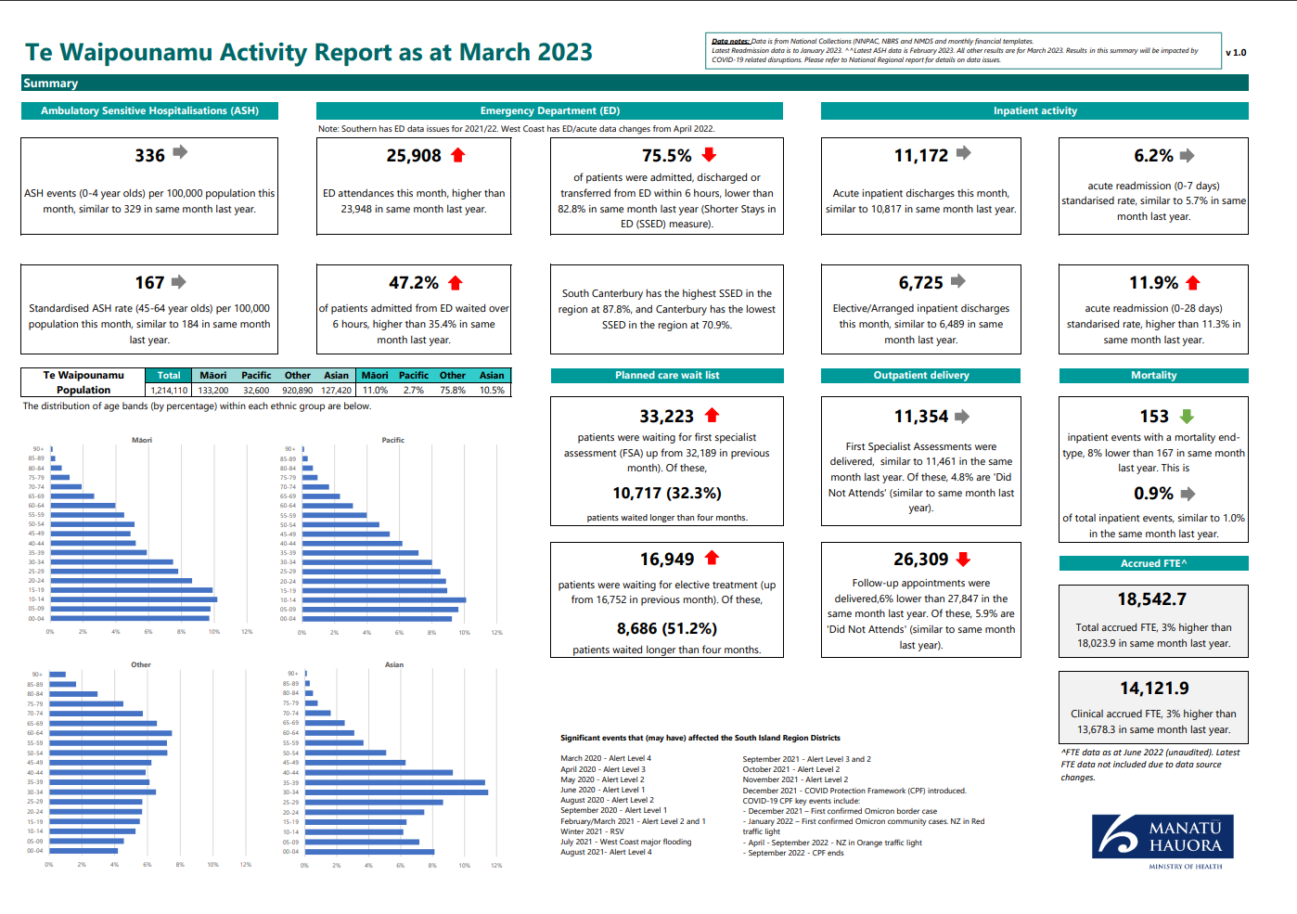

Northern Region Summary and Highlights

Summary
The region continues to be challenged by high hospital occupancy and staff absence and vacancies. However, good progress has been made on the regional service plan and in addressing inequities for Māori and Pacific. However, there are some key equity risks that require focus.

Quarter 3 Key Highlights
The region continues to focus on equity prioritisation for planned care. This includes implementation of the planned care equity tool across all surgical services. This has resulted in the rates for ESPI compliance between Māori and Pacific and other ethnicities closing for ESPI 2 and continuing to narrow for ESPI 5.
The region has robust plans for meeting the planned care directive for patients waiting > 12 months on outpatient and treatment waitlists. The number of patients waiting > 12 months for outpatient appointments or treatment without a confirmed booking has decreased substantially this quarter. The region is working collaboratively to ensure these numbers reduce to zero by 30 June for all but a small number of specialties within specific districts.
A regional acute flow collaboration programme is progressing. The diagnostic process undertaken at North Shore and Waitakere hospitals has now been completed at Middlemore and Auckland City Hospitals. The final reports are being developed for these two hospitals to inform improvement programmes. Implementation of improvements at North Shore hospital are underway and data shows improvement in the ED 6-hr target.
Local initiatives are in place to identify barriers to care and triage ultrasound requests. This is to ensure that Māori and low-income families have access to scanning, as significant risk has been identified to equitable access.
Immunisation:
- The Northern Region designed Childhood Immunisation Prioritisation Matrix for primary care and outreach has been implemented to ensure the stretched workforce prioritises those most at risk of pertussis and measles disease: antenatal women, Māori and Pacific newborns – 12month old, and their whānau. This tool has now been adopted as National policy.
- Funding in metro-Auckland for a rapid response out-reach workforce nearly doubled Metro Auckland capacity. Over 90% of those vaccinated are Māori and/or Pacific infants.
- Accelerated delivery of the annual SMILE healthy pregnancy campaign (which includes antenatal immunisation promotions) to urgently raise awareness about pertussis protection.
- All three metro-Auckland districts now have antenatal clinic immunisation services. The Counties Manukau Maternal Immunisation Service project has introduced dedicated authorised vaccinators across three Primary Birthing Units (Papakura, Botany, Pukekohe) and Niu Life Midwives, a midwifery clinic catering predominantly to Pacific maamaa and whanau. March was a record month with the addition of Botany PBU and maternal immunisation awareness campaign.
Mental Health Mana Ake: In this region, Counties and Te Tai Tokerau are two of the six districts funded nationally to roll out Mana Ake. This is a whole of school approach; classroom / group / individual and family support; professional development and support for educators; bespoke programmes for non-school settings; and to clarify and improve pathways and connections for tamariki and whanau across health / mental health.
Refugees As Survivors NZ – Incorporating Refugee Voices into Reporting Processes:
A review of the reporting process across Refugee Mental Health services based in TAMA (the Mangere Refugee Re-settlement Centre) has been completed in partnership with Refugees As Survivors New Zealand Trust. This was undertaken to support effective outcomes monitoring, while identifying opportunities to highlight the feedback and experiences of service users and refugee communities. Gathering lived experience feedback within the environment of TAMA was very challenging. Language barriers (with many refugees not speaking English), differing cultural understandings of mental health and emotions, perceived power dynamics between service users and the provider, and the ongoing impact of trauma on refugee communities meant the majority of consumers are unlikely to engage with many of the processes used to highlight the lived experience voice. A reporting framework has been developed using staff experiences, and unsolicited feedback to compile a narrative about service strengths, opportunities for improvement, and refugee experiences of services. This includes case studies (including a celebration, a learning opportunity, and an account of tangata whaiora or whaanau change), an anonymised report of any spontaneous feedback shared by consumers, whaanau or translators (who also play a cultural advisory role for clinical services), and resulting clinician reflections. Alongside this, a selected range of quantitative outcome measures were gathered, focused on data relevant to the unique environment in TAMA and readily accessible to the provider. The process has demonstrated the value of lived experience and the opportunities to highlight this in order to achieve health equity.
System Pressures: Primary care capacity is constrained across the region. GP shortage is continuing to grow in Northland, in particular in the Far North area with three out of four GP provider services with closed books.
To support the system pressures work, a number of activities are being planned across the region:
- High-priority roll out of the Primary Care Resilience Tool (expanding nationally, in addition to pharmacy and Home and Community Support Services)
- Supporting primary care with revision of business continuity plans (Winter Playbook) coming into winter and communications to support the same
- Review primary care streaming requirements (where ‘green streaming’ is emphasised) which have been in place since COVID-19
- Identifying additional telehealth opportunities for the region (alongside existing national agreements)
National Public Health Service (NPHS): Two public health services make up the NPHS for the Northern Region – Ngā Tai Ora (Northland Service) and Auckland Regional Public Health Service (ARPHS). Key highlights for quarter three are:
- Response to weather events. Ngā Tai Ora (Northland Service) supported their communities in the response. ARPHS provided support for Tairāwhiti and Hawke’s Bay with the deployment of Medical Officers of Health, Health Protection Officers and Advisors, and Emergency Management to support recovery efforts. Ngā Tai Ora continues to support the Northland post-cyclone recovery by engaging with the affected communities, undertaking public health risk assessments, supporting impacted communities to access appropriate funding channels by facilitating funding application workshops, and providing public health advice to Mangawhai community.
- Successful management of measles outbreak across three regions and continued maintenance of outbreak readiness and response.
- Public health engagement and participation in the Taikorihi locality development.
- Public health planning continues to deliver core public health functions and priorities set out in Te Pae Tata.
- Active participation in national priorities that aim to reduce non-communicable disease (e.g. Smokefree Environments and Regulated Products Amendment Act, which passed in December 2022) as well as supporting regional and local public health advocacy.
Below is a dashboard showing regional activity:

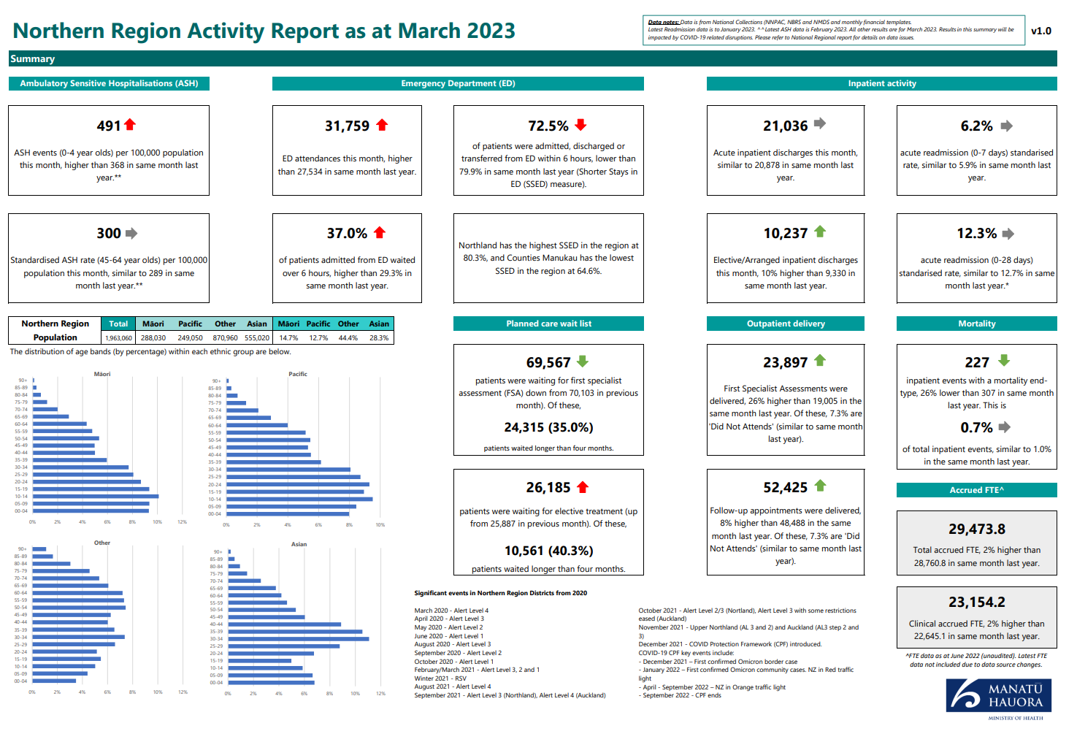

Te Manawa Taki Region Summary and Highlights

Summary
As we begin to see the effects of the shift to regionalisation, Te Manawa Taki was tested early in our establishment because of Cyclone Gabrielle, we learnt quickly and responded to the new environment in ways that saw value in adapting resources nationally, regionally and locally. Te Manawa Taki Q3 report highlights on achievements against Te Pae Tata, and the immediate pressures of the system. Emerging within this is the priority of immunisation across all parts of the system. We are progressing with the partnership between Te Aka Whai Ora and Te Whatu Ora at all levels of the new / emerging system.
Cyclone Gabrielle Response:
- In a true testament to working with the interests of whānau at our centre, Cyclone Gabrielle brought the efforts of Te Aka Whai Ora, the National Public Health Service, the Hospital and Specialists Services and Commissioning together to manage both the initial and immediate response to the loss of connectivity, electricity and water to the locality, bringing diplomacy, negotiation, and our best facilitation skills to the fore.
- Access was enabled to Whakatane and Tauranga Hospitals and emergency pharmacy from Opotiki for those people needing support in the northern regions of Te Tairawhiti.
- The National Public Health Service (NPHS) immediately released Health Protection Officers, Medical Officers of Health, other team members and vehicles from across Te Manawa Taki and country-wide to boost the NPHS Tairawhiti team. This support continues with the active engagement of the NPHS in Public Health recovery planning at local and national levels. Debriefs have been held with local and deployed team members to identify lessons and strengthen readiness for future events.
- Commissioning teams from the Bay of Plenty and Taranaki were also released to assist. This support continues today as we enter the recovery phase. This support was released quickly and on the heels of the recent flooding events experienced in Coromandel.
- The region acknowledges the support of national teams who worked to negotiate locums, travel, Starlink phones, Pharmacy Supply Chain, and the raft of other support over this period.
- We still face a significant period of recovery, particularly those impacted in Western Rural (Te Karaka) and our Eastern coastal communities.

Quarter 3 Key Highlights
- Immunisation rates overall remain a challenge with our focus on an increased collaborative effort starting late in Q3. Improving Māori and Pacific immunisation rates is the key priority across Te Manawa Taki, with different approaches and lessons being shared across the region. Māori Health provider networks across the region are pivoting their services with expertise developed through the COVID-19 response and partnering with each other and Te Whatu Ora teams to capitalise gains to up our rates.
- With both the Iwi Māori Partnership Boards and the four locality prototypes now established we are beginning to see the shape of the future emerging with the initial priority areas emerging.
- Kahu Taurima. Two of the original pilots for the enhanced Well Child/Tamariki Ora programmes run in this region, these teams are now working closely with the national teams to expand these further with both new and more linked programmes of Kahui Taurima.
- Mental Health and Addictions work is progressing across the region of the implementation of both the proceeds of crime and final Budget 19 investments. As expected, there will be a set of recovery programmes being established in the next quarter.
- Long-Term Conditions Māuiuitanga Taumaha. There are a number of Kaupapa Māori led programmes in response to diabetes underway in the region: Taumata Rei, a programme starting with Whānau strengths and capability working across four Māori health providers (Tūranga health, Ngāti Porou Oranga, Hauiti Hauora, and Te Kupenga Net Trust), another in Waikato with Raukawa Charitable trust, South Waikato Pacific Island Community services and district specialists working together for whānau.
- Mate Pukupuku. Bowel Screening: our final area of Waikato joined this service. We look forward to outcomes from the agreed piloting of the lowered age of 55 years of age for Māori.
- Wait Lists. The Hospital and Specialist Services across Te Manawa Taki are focused on reducing the number of patients waiting >365 days in line with the national priority. The work programme has been developed to support the implementation of the Reset and Restore recommendations and reduce the number of people waiting, with a focus on Māori as a key priority. The number of patients waiting greater than 365 days to be treated has been reducing. However, the net reduction in numbers waiting has only had a slight decrease when the patients moving into this wait time bracket are taken into account.
The current focus is on ensuring patients waiting > 18 months all have a plan for treatment and are being treated. Over the next month, a regional review of those patients with no plan will be undertaken with a view to developing a regional solution for these patients to ensure they are able to receive treatment.
- Winter Preparedness /Acute Flow: Planning for the winter period has progressed, building on previous years initiatives, and planning with key partners occurring across each district. Ensuring capacity to meet demand, including the potential for the increased number of COVID-19 positive patients plus increased staff illness over this time whilst maintaining access to planned care, are key outcomes underpinning the planning.
- Acute flow: Many activities are underway across the region focusing on improving acute flow. A diagnostic is currently being undertaken in each hospital to identify current activities and confirm existing barriers to flow. This will then be reviewed from a regional perspective, inform the work programme regionally and confirm the local priorities for improvement. Key measures are also being reviewed from both a local and regional perspective to assist with monitoring progress overall.
- Workforce: This remains a key area of focus across the region. There has been some reduction in vacancies overall in the last quarter, but some key parts of the workforce continue to experience workforce shortages, including Pharmacy, Anaesthetic Technicians, Theatre staffing, critical care, and both junior and senior medical staff. Specific activities within each local area are currently under review. The leads for each professional workforce group across the region are also meeting over the next month to identify other initiatives and strategies that can be actioned to improve recruitment and retention, regional opportunities, and alternative models that will support the remaining workforce and maintain service delivery across all services. There has been some success over the last quarter with nursing recruitment in Waikato. A targeted recruitment campaign was run aimed at local nurses and midwives promoting flexible hours and working conditions. This resulted in the recruitment of 33 nurses to date and identified several non-regulated workers who are in fact international nurses but unable to achieve competency from Nursing Council New Zealand due to failing International English Language Tests. In this regard, the district is currently providing some assistance, and if they succeed, will support them into a Competency Assessment Programme offered by the local polytechnic. This approach will now be shared across the region.
Below is a dashboard showing regional activity:

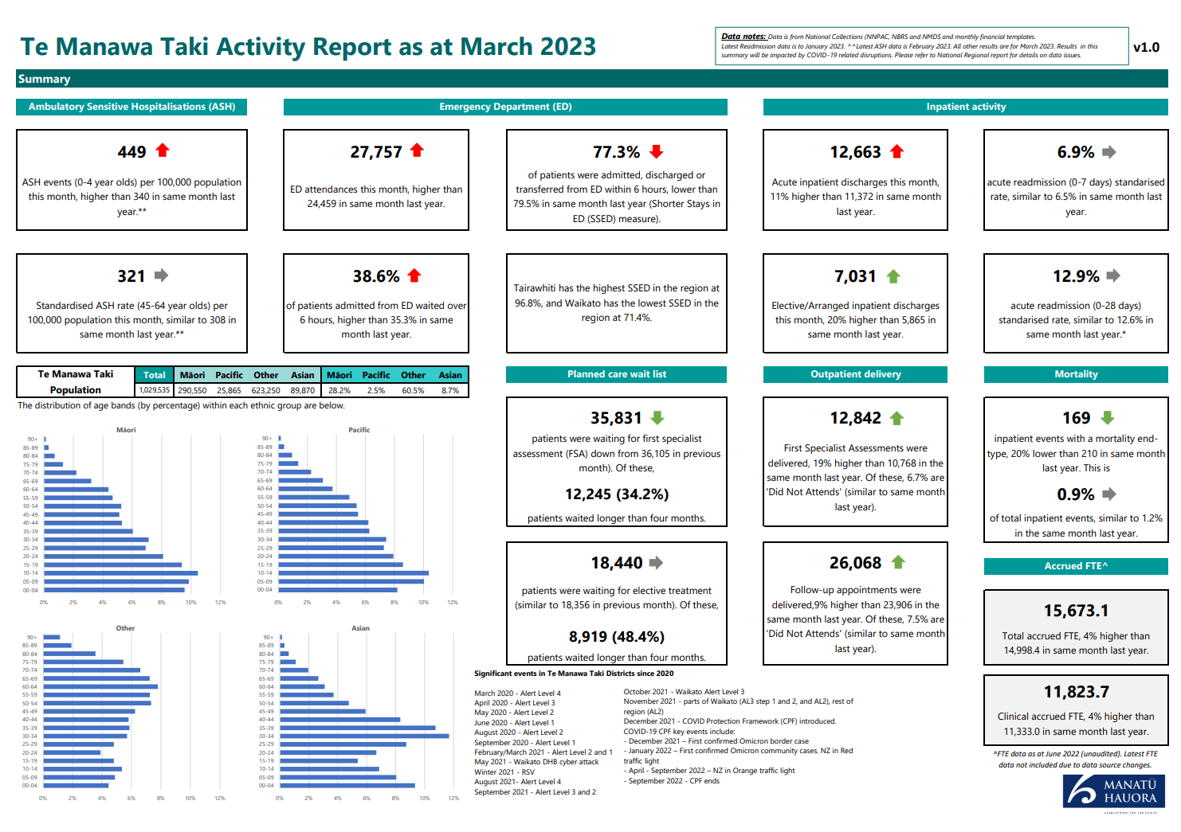

Central Region Summary and Highlights

Summary
Cyclone Gabrielle
A key focus for the region during this quarter has been on response and recovery following the impact of Cyclone Gabrielle, which was significant for the Hawke’s Bay district. The initial response was focussed on making sure that local people affected, including our own staff, were supported with housing, drinking water, food, health care, and psychosocial support.
Work focused on making sure that local general practices and pharmacies could continue to operate, including access to generators. The provision of mental health and psychosocial services was also prioritised following the cyclone. Clinical staff from across the region were seconded into affected areas to assist. Community health providers from the region coordinated the delivery of COVID-19 tests and personal hygiene products to the communities affected. Other support included to aged residential care and home and community support services, as well as funding initiatives across pharmacy and general practice. This support included free primary care visits, clinical telehealth, and medicine dispensing. A recovery lead has now been appointed to manage the health recovery response in collaboration with social sector agencies.
Regional Planning
The focus for the region includes developing our regional immunisation programme in response to the Immunisation Taskforce report and governance of the Central Regional Health & Wellbeing Services Plan 2024-2026/27 development.
The overarching focus of this plan is on achieving equity for Māori, Pacific, Tāngata whaikaha Māori, and people with a disability. The plan will embed Te Tiriti through Tiriti principles, and explicitly work towards the four goals of mana whakahaere, mana motuhake, mana tangata, mana Māori. We will work with our Iwi Māori Partnership Boards and Locality leads on the development of the regional plan to ensure the voices of Māori, Iwi, and our communities are prioritised.
Regional programmes
During this quarter the region has continued to advance critical areas of work, including comprehensive programmes for planned care, mental health and addictions, child wellbeing, outbreak, and emergency management (including COVID-19 and Cyclone Gabrielle Response). Also progressed in the quarter are our clinical networks and associated programmes (cardiology, stroke, trauma and radiology), which all have a focus on addressing inequities for Māori.

Iwi Māori Partnership Boards
We have five Iwi Māori Partnership Boards within the Central Region: Tihei Tākitimu (Takitimu Hawkes Bay), Te Mātuku (Whanganui), Te Pae Oranga o Ruahine o Tararua (Manawatū), Te Karu o te Ika Poari Hauora (Wairarapa), and Āti Awa Toa (Wellington/Hutt). Discussions have been initiated with the IMPBs about the regional plan.
Localities
The Central Region is supporting the development of four Locality prototypes: Wairoa, Whanganui, Horowhenua and Porirua. Our teams have been supporting the planned development through communication and stakeholder engagement, data collection and aggregation, providing information and insights, and project management support. The Commissioning team are working closely with provider networks and communities to build relationships and support the development of potential new localities.
System Pressures
Capital Coast and Hutt Valley and MidCentral districts are working collaboratively as a region to deliver on the National System Pressures programme. This sits alongside wider local responses to reduce acute demand and improve system integration. Actions include increasing general practice access to specialist advice via phone and supporting integrated models of care, supporting targeted populations with immunisations, providing flu vaccinations, and expanding Primary Options for Acute/Ambulatory Care work.
The minor skin ailments programme is being delivered in community pharmacies to offer additional capacity and reduce urgent care presentations. Training is underway across all GP practices to expand tele-triage. Plans are being developed to increase the volume of flexible and acute packages of care to reduce ED presentations. Workforce capacity issues across the system, especially in our more rural and remote areas, will likely present the biggest challenge as we plan for the system pressures work.
Comprehensive Primary Care Teams
This programme will combine traditional primary care services (most commonly GPs and registered nurses) with physiotherapists, practice-based pharmacists, care coordinators, and registered social workers/kaiāwhina. The development of local tailoring to enable the implementation of this phase of Comprehensive Primary Care Teams is underway. We are meeting with PHOs to discuss how we could tailor the programme to best meet local needs.
Pae Ora
Improving our immunisation coverage and achieving equity remain a focus of the Central Region. We are developing a package of initiatives to improve childhood immunisation based on the Immunisation Taskforce equity goals.
Hospital and Specialist Services
The timely discharge of patients in some parts of the region is impacted by challenges accessing support outside of the hospital, including assessment, aged care, and palliative care services. Hospital occupancy is high in some parts of the region, which impacts on the ability to admit patients from ED. ED presentations continue to be impacted by issues of access to primary care, particularly by unenrolled populations. The region continues to operate in an environment where the system is under significant pressure with high hospital occupancy, significant pressure on EDs, deferral of planned care and gaps in primary care services.
Highlights
- Hawkes’ Bay: First 2000 days Tuai Kōpu programme actively supports hapu wāhine to engage with midwives as soon as a pregnancy is identified, as well as reducing other access barriers to Well Child Tamariki Ora services and general practice. Te Matua Maui funding will provide two years of free general practice and nurse practitioner services for Rangatahi 14-24, including removal of co-payment for prescriptions. A review of podiatry services has been completed across Hawke’s Bay’s community and secondary podiatry services, and an action plan is being developed based on the recommendations of the review. A Long Terms Conditions (LTC) Nurse Practitioner team has been stood up with work progressing on model of care, with first target area being Central Hawke’s Bay. Community respiratory –a community COPD pathway has been developed.
- MidCentral: A five bed Kaupapa Māori Extended Care & Rehabilitation Service based in Horowhenua has been established with final contractual requirements underway. RFP processes have resulted in confirmation of a preferred provider for Mental Health & Addictions Intentional Peer Support/Recovery Support Services across Horowhenua, Manawatu, and Tararua. This initiative is supported by additional Peer Support training to embed peer support into clinical services.
- Wairarapa: Whakapakari Huna Tautoko - introducing a service that provides clinical supervision and regional support for Well Child Tamariki Ora services. Following a review, enrolled babies are now booked for immunisations on notification of birth. Wairarapa is also working with Family Start and making referrals to a range of services (healthy homes, smoking cessation, Safe Kids, Immunisation), which is increasing engagement with the community. Wairarapa is also working in partnership with PHO’s in the region to develop an Unenrolled patient clinic based in Masterton.
Below is a dashboard showing regional activity:

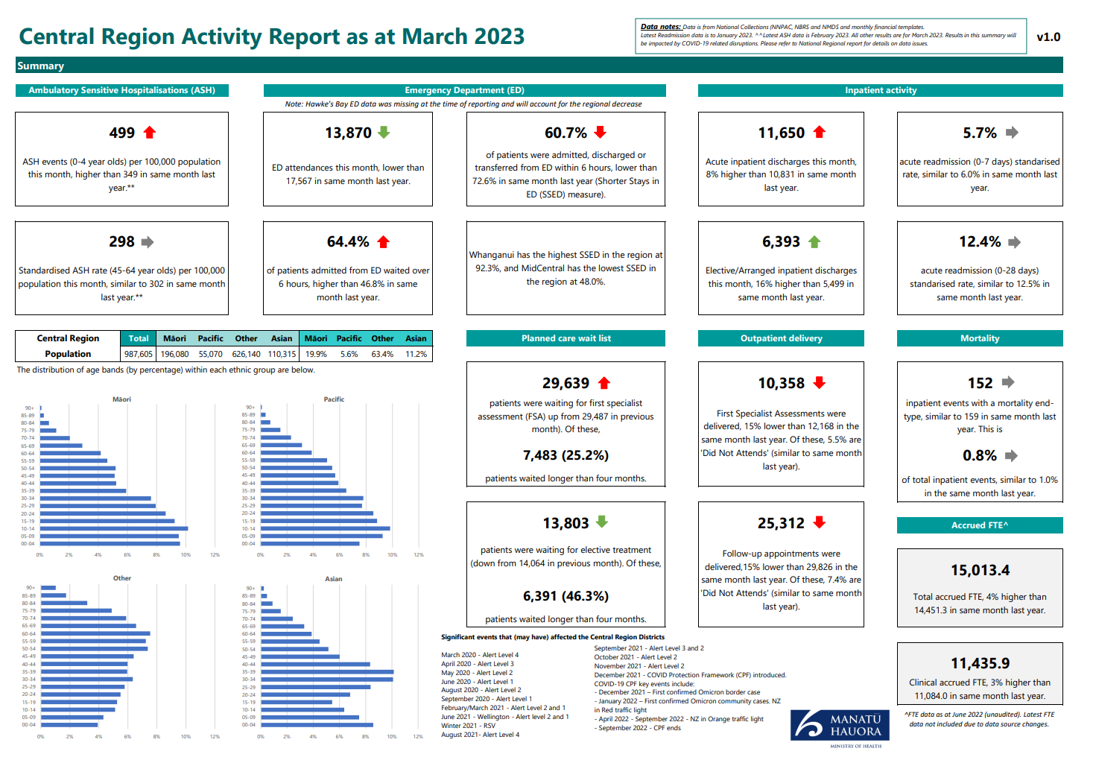

Appendix 3: Glossary
Glossary of key terms and acronyms
Term | Definition
Aiga | Family
Elective Services Patient Inflows (ESPI) | The ESPIs are a suite of indicators that monitor waiting times for elective surgery against expectations. For more information, see Patient Flow Indicators (ESPIs) | Ministry of Health NZ
Hauora | Health
Health System Indicator (HIS) | A series of measures which have been reported on as providing key insights into the performance of the hauora sector. For more information, see https://reports.hqsc.govt.nz/HSI
HUD | Ministry of Housing and Urban Development
Kaimahi hauora | Health workers
Kaiāwhina | Assistant, helper
Kaimanaaki | Support worker(s) and community health worker(s)
Kaitiaki | Guardian, steward
Kaupapa Māori | The knowledge, attitudes and values that are inherently Māori as held and followed by hapū and Iwi. This is synonymously linked to mātauranga Māori and underpinned by Te Tiriti o Waitangi, self-determination, cultural validity, culturally preferred teaching, socioeconomic mediation of Māori disadvantage, whānau connections, collective aspirations, and respectful relationships underpinned by equality and reciprocity
Kaumātua | Māori elder
Mana Motuhake | Self-determination, autonomy. Mana Whenua Customary authority exercised by an Iwi or hapū in an identified area
Mātauranga Māori | Māori knowledge systems that reflect indigenous ways of thinking, relating, and discovering. It links indigenous peoples with their environments, is often inspired by environmental encounters and is conveyed within the distinctiveness of indigenous languages and cultural practices
Pakeke | Adult
Pēpi | Baby
Rangatahi | Youth
Request for Proposals (RFP) | A tender and government procurement request through our government services for contingency/contract work to fill work gap functions
Tamariki | Children
Tagata Sa’ilimalo | Collective concept inclusive of families, carers and people with disabilities. Tangata Whenua People of the land. In reference to a particular place, it means the Iwi or hapū that has mana whenua over the area
Tāngata whaikaha | People with disability
Taonga | Treasure
Taurite services | These are services that braid clinical and cultural care. They can be delivered by a Māori provider or a non-Māori provider. If delivered by a non-Māori provider, high-quality taurite services are delivered in partnerships with Māori
Te Aho o Te Kahu | Cancer Control Agency
Te Ao Māori | Māori worldview
GDP | Gross domestic product
HIRA | National digital exchange platform for health information
KPI | Key Performance Indicator
LINAC | A medical linear accelerator directs beams of radiation into tumours to treat people with cancer
UNCRPD | United Nations Convention on the Rights of Persons with Disabilities
Whānau | Family

Data source: https://www.tewhatuora.govt.nz/our-health-system/primary-care-sector/primary-health-organisations/enrolment-with-a-general-practice-and-primary-health-organisation
Latest data to Nov 2022 available from the HQSC Adult Primary Health Care Patient Experience Survey result https://reports.hqsc.govt.nz/APC-explorer/?_gl=1*1l9btix*_ga*MTAzNjcyNzMzOC4xNjc3NDgxOTU0*_ga_TG4RCRSBWS*MTY4MjU3NzI2MS4xNS4wLjE2ODI1NzcyNjEuMC4wLjA.
Children aged 0-4 years are enrolled with the Community Oral Health Service is sourced from the Well Child Tamariki Ora Quality Improvement Framework Indicators. Baseline results reflect the 2021 calendar year and are the most up-to date results available currently. Results for 2022 will be available from March 2023.
The Quarterly Enrolment Rate as at March 2023 represents the proportion of babies attaining 3 months of age over the period 16 December 2022 to 15 March 2023 who were enrolled with a PHO at that milestone. Enrolments are based on the National Enrolment Service (NES). Populations are based on the National Immunisation Register.
Percentage of smokers offered help to quit data is sourced from PHO reporting, latest results cover the 15-month period to December 2022 and exclude Taranaki District as no smoking data was provided at the time of reporting.
Data extracted from the Before School Check (B4SC) Information System on 8 April 2023 and covers the 6-month period 1 September 2022 to 28 February 2023. Due to small numbers, the data for children of Pacific ethnicity are included among other ethnicity, except for the following 8 districts (Auckland, Waitemata, Counties Manukau, Waikato, Capital & Coast, Hawke’s Bay, Hutt Valley and Canterbury).
Health Quality and Safety Commission Adult Primary Care Patient Experience Survey (Disabled people use unweighted data), https://reports.hqsc.govt.nz/APC-explorer/_w_8bb11cf1/#!/topics.
Health Quality and Safety Commission Adult Primary Care Patient Experience Survey (Disabled people uses unweighted data), https://reports.hqsc.govt.nz/APC-explorer/_w_8bb11cf1/#!/topics.
Health Quality and Safety Commission Consumer Engagement Quality & Safety Marker, data to September 2022.
Data for this web tool was extracted from publicly funded maternity events recorded in Te Whatu Ora - Health New Zealand's National Maternity Collection. Further information about maternity (and fetal and infant deaths) can be found in the Maternity and newborn data and stats series. Lead maternity carers have a legislated period of 12-months to submit claims for services. As this data comes from the LMC claims process it can take 12-18 months before data is available for publication. Additional delays due to analytic capacity also impact the publication of results hence data is at 2020.
Elective Services Patient Flow Indicators Web Tool, ESPI 8 Data table. https://tewhatuora.shinyapps.io/ESPI_app/
Data sourced from the National Bowel Screening programme reflecting results to January 2023. This measure comes from the iGPS and remains under development. Results for the bowel screening MDM referrals may be impacted by small volumes as the rollout of the programme continues.
Latest data for under 25-year-olds accessing Te Whatu Ora mental health services within 3 weeks is the period 1 January 2022 to 31 December 2022. This data excludes NGO mental health services.
The original intent and commitment related to Budget 19 funding for the Access and Choice was to reach 325,000 people per year (by the end of the roll-out) across the whole programme. There are no sub-targets for the different streams within Access and Choice. Therefore, we report against the original target for the whole programme, rather than sub-targets.
Data sourced from the national mental health collection (PRIMHD) and reflects the year to November 2022. Mental health access data is published annually on the National Service Framework Library (NSFL) website. Please note this website has been descomissioned as of 1st July 2023. At the time of data production, the data was sourced correctly from NSFL website. The new location of the mental health data can be accessed at: https://www.health.govt.nz/new-zealand-health-system/accountability-and-funding/planning-and-performance-data
Data sourced from the national mental health collection (PRIMHD) and reflects the year to 31 December 2022. Mental health access data is published annually on the National Service Framework Library (NSFL) website. Please note that this website has been descomissioned as of 1st July 2023. At the time of data production, the data was sourced correctly from the link above. The new location of the mental health data can be accessed at: : https://www.health.govt.nz/new-zealand-health-system/accountability-and-funding/planning-and-performance-data
Latest data to Nov 2022 available from the HQSC Adult hospital Inpatient Experience Survey result https://reports.hqsc.govt.nz/AHI-explorer/?_gl=1*1obmy1t*_ga*MTAzNjcyNzMzOC4xNjc3NDgxOTU0*_ga_TG4RCRSBWS*MTY3NzgxMDYwNS4xLjEuMTY3NzgxMTIwNS4wLjAuMA..#!/
Latest data to Nov 2022 available from the HQSC Adult Primary Health Care Patient Experience Survey result https://reports.hqsc.govt.nz/APC-explorer/?_gl=1*1l9btix*_ga*MTAzNjcyNzMzOC4xNjc3NDgxOTU0*_ga_TG4RCRSBWS*MTY4MjU3NzI2MS4xNS4wLjE2ODI1NzcyNjEuMC4wLjA.
Annual data only. Latest data is for year ending 30 June 2021.
Data sourced from the Annual NZ Health Survey reflecting the financial year 2021/22, https://minhealthnz.shinyapps.io/nz-health-survey-2021-22-annual-data-explorer/_w_c0d00ff2/#!/explore-indicators. Note: As part of the New Zealand Health Survey programme, this measure is due to be replaced in 2023 and the iGPS measure definition will be revised
No ethnicity breakdown is available
No ethnicity breakdown is available
Childhood immunisation coverage data is updated quarterly from the National Immunisation Register (NIR) and reported via Qlik as at 11 April 2023. The number of eligible children in each category (denominator) is based on children currently enrolled on the NIR. with a status of Active, Provisional Opt-off or Opt-off, who turned the milestone age during the reporting period,. The numerator is eligible children who had received all of their scheduled vaccinations for their age (according to the National Immunisation Schedule) when they turned the milestone age. Total includes all districts as well as those currently unassigned to a district. Data subject to change as vaccination events are entered late or a child moves between districts.
HPV immunisation coverage data is updated quarterly from the NIR and reported as at 11 April 2023. Volumes vary by quarter due to the partially school-based delivery and the measure is annual only. The number of eligible children in each category (denominator) is based on children currently enrolled on the NIR who were born in 2009 with a status of Active, Provisional Opt-Off or Opt-Off. The numerator is eligible children who have received their final dose (dose 2 or 3, as clinicially indicated to be considered fully vaccinated) by the end of the reporting period. Second doses administered within 22 weeks of first doses excluded. Total includes all regions, plus individuals where the address is not currently assigned. Location and prioritised ethnicity from NHI; ‘Other’ ethnicity refers to all except Māori, Pacific or Asian. Data subject to change as vaccination events are entered late or a child moves between districts.
Coverage data is reported from the NIR and CIR - see https://www.health.govt.nz/your-health/conditions-and-treatments/diseases-and-illnesses/influenza/flu-influenza-vaccines/flu-vaccine-data HSU 20/21 FY used as denominator for uptake statistics.
Data Definition for COVID-19 Vaccination was approved during the development of the quarterly 3 report, and no changes have been made to it. COVID-19 vaccination measures will be included in Quarter 4.
Unstandardised acute bed day rate per 100,000 population. Results for the year to December 2022 were accessed from the National Service Framework Library (NSFL) website. Please note that this website has been decommissioned as of 1st July 2023. The data was sourced correctly from the NSFL website at the time of production.The new location of acute hospital bed day rate can be accessed at: https://www.health.govt.nz/new-zealand-health-system/accountability-and-funding/planning-and-performance-data
Define = Development and approval of project business cases, including indicatively prioritised projects.
Design = Includes projects in detailed design and procurement.
Deliver = Includes projects doing demolition works, construction and installation.
Debrief = Completed projects and projects waiting for post implementation and/or post occupancy evaluations of the projects.

