Quarterly Performance Report

Quarter ending 31 December 2023

Citation: Health New Zealand | Te Whatu Ora. *Quarterly Performance Report: Quarter ending 31 December 2023*. Wellington: Health New Zealand | Te Whatu Ora.

Published in March 2024 by Health New Zealand | Te Whatu Ora  
PO Box 793, Wellington 6140, New Zealand

ISSN 2816-1823 (online)



This document is available at [tewhatuora.govt.nz](https://www.tewhatuora.govt.nz/)

|  |  |
| --- | --- |
| **CCBY** | This work is licensed under the Creative Commons Attribution 4.0 International licence. In essence, you are free to: share ie, copy and redistribute the material in any medium or format; adapt ie, remix, transform and build upon the material. You must give appropriate credit, provide a link to the licence and indicate if changes were made. |

# Foreword from our CE

This report summarises our work during quarter two (1 October – 31 December 2023) and presents our progress against expectations set out in Te Pae Tata | the interim New Zealand Health Plan and the Statement of Performance Expectations. Highlights you will see expanded in this quarterly report include:

* As part of the Government’s 100-Day Plan and ongoing work to keep emergency departments safe, we placed an additional 200 (93 FTE) security staff in 32 emergency departments (EDs) across the country.
* Ka Ora Telecare, a rural clinical telehealth service, was launched. Within four weeks of launch 35% of eligible rural practices had enrolled in the service. Since its launch, there have been 2,518 nurse appointments and 1,913 GP appointments. 14% of calls have been from Māori.
* We are expanding the Extended Primary and Community Care (EPCC), previously known as POAC, to extend access to funding for women experiencing Abnormal Uterine Bleeding. This investment was done in two phases. Phase 1 provided $5.32 million in funding for system pressure relief in eight priority local areas. Phase 2 provided $15.9 million across the four regions to expand the programme. This enables women to access free primary care visits and reduces pressure on secondary gynaecology specialist services.
* The number of young people who had access to specialist mental health services within three weeks of referral increased by 1.5% compared to the first quarter. Current results are similar to the baseline results for the year ending September 2022 (68.5%).
* In this quarter, 97% of New Zealand’s estimated population (5,151,948) were enrolled with a general practice, compared to 96% (5,134,170) in quarter one, representing a 1% increase or an additional 17,778 New Zealanders.
* Ambulance providers have increased frontline staff by over 180 FTE from the beginning of the previous financial year, this includes communications centre personnel. Additional funding and a focus on effective recruitment and training policies across clinical roles have reduced long-standing staff vacancies.

During this quarter, we responded to a significant cyber breach by a former employee who inappropriately shared data. The response to address this has had a long tail of actions with notifications made to affected patients and staff in quarter three. We apologise for the impact this has had.

We have also incorporated reporting on the 12 Clinical Performance Metrics (CPMs), which were previously published separately, into this quarterly report.

**Fepulea’i Margie Apa   
Chief Executive   
Health New Zealand | Te Whatu Ora**

Contents

Foreword from our CE 3

1 Snapshot for the Quarter 6

2 Health System Reform 9

2.1 The health system will reinforce Te Tiriti principles and obligations 9

2.2 Access to a comprehensive range of support in their local communities 9

2.3 Access to high-quality emergency and specialist care 10

2.4 Digital services in homes 11

2.5 Valuing the health workforce 11

3 Delivering the Interim New Zealand Health Plan | Te Pae Tata 12

4 Achieving Equity 15

5 Delivering Ola Manuia Pacific Health and Wellbeing Action Plan 18

6 Non-Financial Performance 19

1 Immunisation coverage at 24 months 21

2 Newborn enrolments 22

3 Primary care enrolment 23

4 Involvement in care decisions – primary care 24

5 Ambulatory sensitive hospitalisations 0-4 years 25

6 Ambulatory sensitive hospitalisations 45-64 years 26

7 Access to primary mental health and addiction services 27

8 Access rates for specialist mental health services 28

9 Mental health wait times for under 25-year-olds 29

10 Shorter stays in Emergency Departments 30

11 Emergency Department presentations 31

12 Admissions from Emergency Departments 32

13 Acute bed days per capita 33

14 Inpatient length of stay >7 days 34

15 Involvement in care decisions – in hospital 35

16 People waiting more than four months for first specialist assessment (FSA) 36

17 People waiting more than four months for a procedure 37

18 People waiting more than 365 days for a procedure 38

19 Medical appointments through digital channels 39

20 Missed appointments 40

21 Delivery of planned care interventions 41

22 Cancer patients waiting less than 31 days for first treatment 42

Our milestones 43

7 Financial Performance 45

Budget Spending Summary as at 31 December 2023 53

Appendices 56

Appendix 1: Measure Definitions 56

Appendix 2: Local trends 61

1. Snapshot for the Quarter

### Immunisation

* This quarter marked the beginning of the seasonal preparation for the 2024 Influenza Programme, which will run from 1 April to 30 September 2024. Our objectives are to:

1. Achieve 70% coverage for people aged 65 years and over.
2. Improve coverage rates for people at highest risk of hospitalisation or death and for people working in high-risk settings.
3. Offer the influenza vaccine to all children aged between six months and four years upon hospital discharge following respiratory illness.
4. Offer influenza vaccine to all pregnant people.
5. Offer influenza vaccine to all eligible people on discharge from hospital.
6. Achieve 70% coverage for employed staff.

* We started working with Pharmac to enable pharmacists to administer childhood vaccinations in community pharmacies. We are aiming for a proposed go-live date during quarter four (1 April 2024). Our aim is to expand the access points for children to receive vaccinations as part of achieving the national health target for immunisation.
* During quarter two, all contracted Māori and Pacific immunisation service providers were contacted regarding data sharing agreements with Health NZ. As of November 2023, agreements with 18 Pacific providers and 17 Hauora Māori partners had been finalised.
* In December 2023, the National Immunisation Register was retired, and the new Aotearoa Immunisation Register (AIR) went live. The AIR provides information about immunisation coverage across the population and records the vaccinations New Zealanders have received or chosen not to receive. At the same time, Whaihua (a new customer relationship management tool) went live to manage newborn enrolment in primary care alongside the newborn Enrolment Service (NBES) – this aims to support on-time immunisation from six weeks (by any available provider) and enrolment with general practice when this is delayed due to declined nominations (e.g., because of closed books).
* The Immunisation Taskforce programme is multi-horizon, with the first horizon ending December 2024. During quarter two,14 of the 54 taskforce recommendations were completed. These recommendations primarily relate to system governance and initiatives that will help increase and diversify the vaccinating workforce to improve its effectiveness at reaching all communities. A further 31 recommendations have work underway focusing on: expanding service options such as Plunket and Well Child Tamariki Ora providers; making it easier to become an authorised vaccinator; increasing antenatal immunisation rates; and enhancing pre-call, recall and catch-up systems. For the nine recommendations not yet started, key areas include enhancing provider performance reporting; investigating contractual arrangements to increase vaccination rates; and reviewing newborn enrolment policies. All 54 recommendations are expected to be underway by the end of 2024.
* A campaign to address misinformation and complacency by making factual information accessible on childhood immunisations is underway and will run until June 2024. The campaign activity uses social marketing linked with community action and places particular emphasis on Māori and Pacific social marketing campaigns. Social marketing activity first ran in November and December 2023 and will restart in March 2024. The first tranche of Māori social marketing campaigns generated 585,000 views, and the Pacific social marketing campaigns generated one million views. These communications will continue to evolve throughout 2024.

### Primary Care

* In quarter two, an enhanced newborn enrolment (NBE) process was initiated in conjunction with the Aotearoa Immunisation Register (AIR) rollout. Over the next six months, we will automate newborn enrolments by linking directly with maternity systems and Well-Child providers. Automated enrolment of newborns enables more effective monitoring and tracking of immunisation rates and improves the effectiveness of immunisation outreach services. Operation of these systems is expected in the first two quarters of 2024-25.

### Wait Times for Planned Care

* Our goal was to have no one waiting for planned care treatment (excluding orthopaedics) for more than 12 months by 31 December 2023. We did not meet this goal and patients waiting more than 365 days for treatment, remained untreated at the end of December. Not achieving the goal is due to a combination of factors, including complexity (e.g. where multiple surgeons need to be coordinated), cancelled surgery (which needs to be rescheduled), patients unable to travel, and patients who are now deemed fit for surgery coming onto the waitlist who have yet to be given a confirmed date. As the waitlist is dynamic, with new patients added to the >365 overdue list, numbers and projected month-end positions will change based on delivery within each region. Regions have committed to treating all of these patients by 31 March 2024. Progress will be reported weekly from January 2024.
* As part of the Planned Care Reset and Restore programme, we aim to have no Orthopaedic patients waiting beyond 365 days for treatment by 30 June 2024. Regions have been making progress in treating all >365-day patients waiting for orthopaedic surgery. Achievement of the goal by 30 June 2024 is on track. Over the previous 12 months, the average ‘turn rate’ for orthopaedics (i.e., the number of patients removed from the waitlist vs the number added) has been >1. A turn rate >1 indicates that more patients are being removed from the waitlist versus the number added. As at 7 January (the closest reporting period to 31 December) the remaining number of patients to be treated was 1,307 or 50 per week - a reduction of 3,664 since 1 July 2023. Weekly monitoring and meetings with Room Data Sheets, outsourcing and sector partnerships and alternative pathways, improved data visibility and production planning are all enabling factors.

### Workforce

* As part of the Government’s 100-Day Plan and ongoing work to keep emergency departments safe, an additional 200 (93 FTE) security staff were employed to provide around-the-clock security in 32 emergency departments (EDs). Eight higher-risk EDs in the four Auckland hospitals, along with Waikato, Wellington, Christchurch and Dunedin hospitals each received an additional five security staff. A further 24 EDs near summer hotspots also received additional security of between two and five security staff. The additional staff were made available from December through to mid-January or late February, depending on local needs. Approximately $5.7 million was allocated for this initiative to keep ED staff and patients safe over the holiday period when traditionally there has been increased demand. Feedback from frontline staff was positive, with staff and patients saying they feel safer.
* This quarter, a pay equity settlement was reached for our directly employed librarian and interpreter workforces. This is the final of several recent settlements (in October 2023, pay equity settlements were achieved for employed midwives and the allied, scientific and technical workforces) addressing sex-based pay inequity across our health professionals.

1. Health System Reform

The health reform has enabled nationally led work programmes to drive changes that will meet legislative requirements of the Pae Ora (Healthy Futures) Act 2022 and ensure consistent, high-quality healthcare for all New Zealanders.

* 1. The health system will reinforce Te Tiriti principles and obligations
* Tools and processes are being developed to improve the integration of Te Tiriti principles into work programmes. The National Public Health Service (NPHS) endorsed a Te Tiriti o Waitangi implementation tool and score card in November 2023 to ensure all projects and programmes of work can demonstrate consideration of Te Tiriti principles.
* Te Tiriti and cultural awareness training is being designed and developed as a learning pathway to improve NPHS staff capability to address systemic bias within current systems.
* A range of Memoranda of Understanding (MoU) with iwi to improve engagement with the health system were advanced in this quarter, including with Maniapoto. These MoU are part of a broader treaty settlement claim with the Crown.
* In this quarter, a key forum with iwi Māori Partnership Boards (IMPBs) was held in Tairāwhiti in December to advance a more formal relationship with Health NZ in anticipation of legislation changes. This forum was to consider options for how IMPBs can interface directly in service planning at a regional level.
  1. Access to a comprehensive range of support in their local communities
* Ka Ora Telecare, a rural clinical telehealth service, went live on 8 November 2023, providing rural communities with primary care (GP consults and nurse triage) after hours. The service aims to improve access to primary health care for almost 900,000 New Zealanders. Within four weeks of launch (by 15 December 2023) 35% of all eligible rural practices had enrolled in the service. Since the service launched, there have been 2,518 nurse appointments and 1,913 GP appointments. 14% of calls have been from Māori.
* In quarter two, the regional implementation of Comprehensive Primary and Community Teams (CPCT) focused on finalising their make-up and determining target locality prototypes based on Māori, Pacific and rural populations. 40 FTE CPCT additional clinical team members have been employed or contracted across the motu to date, with several more imminent. The following clinical roles are being recruited: physiotherapists, care coordinators, pharmacists, extended care paramedics, podiatrists and dentists. Integration leads have been recruited to support the implementation of the CPCT approach across the motu, alongside clinical roles. Primary Health Organisations, general practices and/or Hauora Māori providers are deploying these roles across different regions, including Waikato, Bay of Plenty, Lakes, Tairāwhiti and Taranaki, Wellington and across the South Island. Additional roles are being contracted for Northland and Auckland regions, Hawke’s Bay, Whanganui, MidCentral and Wairarapa. These actions mean patients and whānau will have better support to change social and lifestyle factors, addressing the impacts of long-term conditions, particularly for Māori, Pacific and rural whānau. These roles release time to focus on those needs that can only be addressed by GPs.
* We are implementing the Extended Primary and Community Care (EPCC), previously known as POAC and the disbursement of Hospital Planned Care funding for women experiencing abnormal uterine bleeding. This investment was done in two phases. Phase 1 provided $5.32 million for system pressure relief in eight priority local areas. Phase 2 provided $15.9 million across the four regions to expand the programme. We prioritised supporting three healthcare pathways and plan to assess gaps in the programmes across each region.
  1. Access to high-quality emergency and specialist care
* Ambulance providers have increased frontline staff by over 180 FTE from the beginning of the previous financial year, including communications centre personnel. Additional funding and a focus on effective recruitment and training policies across clinical roles have reduced long-standing staff vacancies across ambulance services. In 2022/23 purchasers (joint funding from ACC and Health NZ) provided $26 million towards additional FTEs and ambulances with an additional $6 million allocation from repurposed funding towards training.
* During severe weather events in the east of the North Island, rotary air ambulances were increasingly employed to minimise the impacts of the current state of the road network on ambulance despatches. The use of rotary air ambulance on the East Cape was in addition to road ambulances deployed in Whitianga and Whangamatā while State Highway 25A was under reconstruction. Additional air ambulance services were funded through a combination of the existing budget, offset by staff vacancies in Auckland and an additional $400,000 from the Budget 2023/24 Cyclone Gabrielle appropriation.
  1. Digital services in homes
* A two year Remote Patient Monitoring Pilot began on 1 July, 2023, and will initially target 60 whānau from rural Māori communities with an investment of up to $900,000. The pilot is currently focused on heart failure and chronic obstructive pulmonary disease (COPD) care plans and uses a mobile application, Piki Te Ora, to collect data on a participant’s current physiological parameters, such as heart and respiratory rate, blood pressure, heart rate variability and oxygen saturation. Piki Te Ora is a critical component of this project as the data collected is made available to patients and healthcare providers to help inform clinical decision-making. This pilot will reduce the pressure on hospital and specialist services, reduce whānau travel costs and other out-of-pocket expenses, improve efficiency of primary care delivery and provide halo effects within the community.
* This quarter, we introduced 15 new participants, from Ngāti Porou Oranga, on the East Coast (particularly rural areas from Tologa Bay to Ruatoria), bringing our total to 30 participants. Through better monitoring of heart failure, the approach is to identify and intervene when participants are decompensating and whānau can assist, thereby reducing the risk of admission but also proactively managing heart failure in a low-touch way. Daily monitoring and intervention provide access to services for communities that find this difficult and are expected to reduce the use of primary care, emergency departments, admissions, and the need for outpatient clinic follow-ups.
  1. Valuing the health workforce
* The Health Workforce Plan 2023/24 (the Plan) identifies six areas, aligned with Te Pae Tata, supporting progress towards the goal of a sustainable, supported, and equitable health workforce. Key completed initiatives for this quarter include:

1. Investing in the Rural Medical Immersion Programme and developing a rural hub for continued and expanded education in rural settings over time.
2. Additional 50 medical school placements to increase domestic training pipelines - additional placements available from the beginning of 2024.
3. Additional 50 pharmacy prescriber placements shared across the University of Auckland and Otago University for the 2024 academic year.
4. Expanding the Voluntary Bonding Scheme to include pharmacists and all midwives (among others).
5. Funding 123 places in the national Nurse Practitioner Training Programme (2024 academic year), in addition to the 43 places already funded in 2023.
6. Delivering the Interim New Zealand Health Plan | Te Pae Tata

The Interim New Zealand Health Plan | Te Pae Tata consists of 187 actions, each with milestones. There are 162 milestones aligned with quarter two, summarised below.

|  |  |  |  |  |  |  |
| --- | --- | --- | --- | --- | --- | --- |
| Sections | Total Actions | Green | Amber | Red | No Milestone | Still Assessing[1] |
| People and Whānau at the heart of health | 24 | 17 | 5 |  | 2 |  |
| Improving health outcomes and equity | 39 | 18 | 4 |  | 15 | 2 |
| A unified health system | 63 | 30 | 6 | 3 | 14 | 10 |
| Priority populations | 61 | 35 | 6 | 3 | 10 | 7 |
| Total | 187 | 100 | 21 | 6 | 41 | 19 |
| Last quarter (quarter one) |  | 77 | 39 | 2 | 18 | 51 |

#### People and whānau at the heart of health

* Progress with the rainbow community has been made to include their voice in design, delivery, and performance of the health system. The next steps involve budget approval, finalising the work plan, and incorporating rainbow community voice in the co-design and improvement of health services.
* Nationalising hospital consumer feedback, to measure experience, and improve service and delivery has begun. The aim is to develop one consistent nationally used taxonomy, enabling standardised reporting.

#### Improving health outcomes and equity

* Improving mental health and wellbeing through whānau, communities and localities are priority actions. Engagement with rangatahi identified: access to safe, culturally-responsive services; a confident and equipped workforce; collaboration between organisations to meet holistic needs. Mental health service models currently being delivered are: Mana Ake, Youth Access and Choice Primary Mental Health services, the Youth One Stop Shop (YOSS), and SPARX - building resilience through gameplay via an online tool and Health School Lunch Programme | Ka Ora Ka Ako.

#### A unified health system

* A national palliative care steering group was established to oversee working groups delivering equitable access and outcomes from palliative care services; a national paediatric and adult palliative care model; and a national outcome and reporting framework. Ensuring equity remains at the forefront of the national palliative care work programme is priority.
* Phase one of the aged care funding and service model review was completed and identified the following challenges: an ageing population; financial pressures; workforce shortages; variable access to services; and more people choosing to continue living at home as they age. Phase two will develop recommendations for redesign of funding and service models and will provide a baseline (to be completed mid-2024).

#### Priority populations

* A Tāngata whaikaha | Disabled people strategic leadership team is now in place with the Office of the Chief Executive. Workshops have identified national resources, workforce, processes and initiatives. Priority is to understand our ability to deliver equitable, inclusive and accessible health services, along with raising disability awareness within Health NZ.

### Māori Health Improvement

Te Pae Tata priority actions include growing and increasing Māori in leadership positions and strengthening Māori providers and improving access to Kaupapa Māori services. Progress against these actions includes:[2]

#### Māori health gain areas

* Faster Cancer Treatment data shows progress towards the 85% target of people with cancer receiving treatment within 31 days of a decision to treat. We are working with Te Aho o Te Kahu to understand the data and our joint responsibilities against actions.
* We are testing the redesigned Well Child Tamariki Ora schedule. Updates will be available in the next quarterly report.

### The next New Zealand Health Plan

* Development of the 2024-27 Health Plan, in partnership with Te Aka Whai Ora, continues. We have been working since early 2023 to develop the first full plan covering the three-year period 2024-2027. The plan will come into effect on 1 July 2024.

### Aotearoa New Zealand Health Status Report 2023

The Health Status Report is being finalised ahead of publishing in early 2024. The report will tell the story of who we are (population-wise), how we live, and lifestyle factors influencing our health outcomes as a nation. The report will provide data and context to prioritise resources to best support future health needs.

1. Achieving Equity

### Better health in our communities

#### Rheumatic fever

* The Rheumatic Fever National Care Coordination System saw significant progress this quarter. The system ensures rheumatic fever patients receive secondary antibiotic prophylaxis on time, regardless of where they live or move to, within New Zealand. Currently, approximately 1,800 people receive this antibiotic.
* Additional phases are being piloted in Northland and Waikato, with roll-out across the North Island in 2024. Expansion to the South Island will be deployed in later phases.
* To date, $2.466 million has been spent on the design, development, and pilot implementation. Baseline funding of $2 million per year is required to maintain the system.

#### HIV Action Plan

Budget 22 allocated $18 million to support implementation of the HIV Action Plan over four years. Since March 2023, $4.1 million has been used, with progress in the following areas:

* Clinical guidance for combination prevention.
* Training providers to conduct innovative HIV testing.
* HIV providers delivery peer and community led programmes to support migrants from HIV prevalent countries.
* Development of a social marketing campaign to challenge the stigma and discrimination experienced by people living with HIV (NPHS led).
* HIV behavioural surveillance research is being commissioned.
* Hospital Specialist Services plan to recruit HIV clinical leads and contact tracers across all regions.

### Mate Pukupuku | People living with cancer

* Whanganui Hospital Chemotherapy and Infusion Centre, named Kimiora, was opened on 14 December. The centre is intended to provide infusions of up to 10 patients a day, most of whom previously travelled to Palmerston North for treatment. This new facility will help patients save hundreds of trips between the cities each year, easing the burden on already sick patients and their whānau.
* This quarter, an implementation and reporting delivery of two newly funded immunotherapy drugs for the treatment of people with advanced Non-Small Cell Lung Cancer (NSCL) for first and second-line treatment was approved. Implementation will require an investment of $2.7 - $3.0 million in the first 12 months, increasing to between $3.1 - $3.5 million in the subsequent 12 months. Based on trials, these drugs will extend survival for those who undergo treatment. Implementation will provide equitable access to the two funded immunotherapy drugs across the motu. Work is underway to refine and streamline reporting on waiting times and service capacity.
* Pathways are being developed to support access to diagnostics for cancer detection and timely referral to specialist services. The lung cancer pathway aims to provide easier access to Computed Tomography (CT) scanning for people where there is a high clinical suspicion and multiple risk factors for lung cancer, without the requirement for a preceding chest x-ray or specialist appointment. This will speed up diagnosis and reduce unnecessary steps, especially benefiting rural patients and those with difficulty accessing the health system.
* On 22 and 30 November, Auckland and Capital & Coast/Hutt Valley became the fourth and fifth areas to go live with the new Community Invitation Campaign Strategy functionality in the National Bowel Screening Programme IT system. This new functionality will enable participants to be invited and bowel screening kits to be hand delivered at a range of face-to-face events, with the aim of optimising participation rates for Māori and Pacific peoples, and local community needs. Results have been promising with one campaign at a rugby league club achieving a 64.5% participation rate. The target is to have the campaign function live in all regions by June 2024.

### Kahu Taurima | Maternity and Early Years

* This quarter, we focused on redesigning the care model for maternity and early years. Our goal is to achieve equitable, accessible care for whānau, based on sound clinical guidelines and delivered by a workforce that is supported by a funding model that is fit-for-purpose.
* Increasing and supporting our midwifery workforce is critically important. A range of initiatives are underway, including sourcing a provider to redesign the Midwifery Graduate Support Programme by August 2024. The programme will ensure that Māori, Pacific and Tāngata Whaikaha midwives receive support in ways that are appropriate for them and will improve retention by supporting midwives in the early years of their careers.
* Procurement commenced this quarter to source six providers/partners to test the redesign and proposed changes to the Child Growth and Development Schedule. These changes have been designed to provide a proactive assessment of children to identify and respond to issues early, well before the child starts school.
* We have also commenced procurement for services to support the development of a national Bereavement Care Pathway. The objective of this pathway is to ensure all bereaved whānau consistently have access to equitable, high-quality, individualised, safe and culturally responsive bereavement care across Aotearoa.

### Māuiuitanga Taumaha | People living with chronic health conditions

* Health Literacy NZ and Health Navigator Charitable Trust launched the goutguide.nz in October 2023. This is New Zealand’s first online gout management website for primary care, funded by Health NZ, in collaboration with five ProCare practices in Auckland. The guide seeks to improve gout care in primary care, particularly for Māori and Pacific peoples.
* Three consumer focus group meetings were held to test and refine the messages in the Heart Health Plan (HHP). The HHP was well received overall, with some suggestions for improvement. These will be incorporated into the next iteration of the plan which will be developed once the current prototype testing with Primary Health Organisation providers is completed in 2024.

### Oranga Hinegaro | People living with mental distress, illness and addictions

* Budget 2022 provided $90 million over four years for the Mana Ake programme to enable ongoing service delivery in Canterbury and Kaikōura, and start new services in Northland, Counties Manukau, Bay of Plenty, Lakes and West Coast. The programme is set to benefit around 195,000 primary and intermediate aged children, offering support to promote their wellbeing and positive mental health. The programme is well established in Canterbury/Kaikōura, operating in 219 schools and has been expanded and introduced in most schools on the West Coast, delivering services to 14 additional schools. In Lakes/Bay of Plenty, 35 schools are already benefitting from its service as it continues to scale up. In Northland, 78 schools have received services with more to participate as providers recruit and onboard additional staff. In December, Counties Manukau was nearing the end of procurement processes with the first provider contracts starting from 1 February 2024.

1. Delivering Ola Manuia Pacific Health and Wellbeing Action Plan

The plan sets out the priority outcomes and accompanying actions for the health and disability system for Pacific peoples.

#### Pacific Provider Development Fund

* The panel review of the 2023 funding round is completed. $5.702 million has been committed to improving the capacity and capability of Pacific health and disability providers to deliver innovative models of care. This total excludes multi-year funding endorsed in the 2022 funding round. There were 33 applications received for the 2023 round with 24 applications succeeding, including six from new providers.

#### Pacific Health scholarships

* Applications for the 2024 scholarships opened on 5 December 2023. The 2024 scholarships will provide $2 million (an increase from $1.5 million in 2023 where 220 scholarships were awarded) to support Pacific students to complete their health studies. Applications closed on 5 February 2024. We have increased the number of scholarships available, widened the eligibility criteria and developed a new and simpler online application portal for applicants. The new portal enables us to analyse trends in greater detail.

#### Pacific Health Science Academies

* Pacific Health Science Academies (HSA) aims to increase students’ awareness of, and interest in, health education pathways and support students to meet the academic requirements for tertiary level health education programmes. Thirteen schools (including five schools with their first Year 13 cohorts) in the Northern region ran HSA in the 2023 academic year. Eligible students studying at least two science subjects receive educational and pastoral support. In 2023, 96 students were awarded HSA scholarships totalling $100,000 to help with costs for Year 12 and 13 schooling or their first year of university studies.

1. Non-Financial Performance

We track performance using measures and milestones from our Statement of Performance Expectations (SPE) for 2023/24, the interim New Zealand Health Plan | Te Pae Tata 2022-2024 and some additional transparency measures that our Board decided to publish in December 2022.

This report includes results for 22 measures which are reported quarterly, six-monthly and annually. The measures aim to assess our performance across the country, track performance consistently over time and enable us to develop solutions that address local issues.

We have combined the clinical performance metrics, which were previously published separately, into this report. The clinical performance metrics included in this section are identified with a + symbol for ease of navigation. The clinical performance metric, ‘Admissions from Emergency Departments’ has not been published for some time due to ongoing challenges with validating the data. We have now gained a consensus on a meaningful definition for this metric to enable consistent reporting.

We have provided, where possible, breakdowns of our measures by region, ethnicity and areas (using former district boundaries). The ethnicity data was sourced from prioritised ethnicity in the National Health Index system, and for Ambulatory Sensitive Hospitalisations and Acute Bed Day rates, matched to prioritised ethnicity in Statistics New Zealand Usual Resident Population projections.

All performance data provides a snapshot in time. However, on any given day, there may be variances depending on when data is uploaded and subsequently extracted. Although we have taken all reasonable steps to ensure the accuracy and completeness of the information in this report, we accept no liability or responsibility for how the information is used or subsequently relied on.

Data validation is done at both national and (where relevant) local level, by clinical and data teams, subject matter experts, and those involved in the creation of the report. Where the term “district” is used throughout this report, it refers to the geographic boundaries covered by former District Health Boards (DHBs).

Definition, target, baseline and source document details are included in Appendix 1.

Results for local areas is available for clinical performance metrics in Appendix 2.

### Performance measures – high-level summary

The table below shows this quarter’s results for 22 measures, compared to the prior quarter (quarter one 2023-24), those with more than 2% change are marked **Þ** improving (4), or **Ý** deteriorating (2). One measure was unable to be reported. All measures are discussed on the following pages.

|  |  |  |  |
| --- | --- | --- | --- |
| # | Measure | Q1 23/24 | Q2 23/24 |
| 1 | Immunisation coverage at 24 months 🎯 + | 83.0% | 81.0% |
| 2 | Newborn enrolments (no update for quarter two) | 88.2% | N/A |
| 3 | Primary care enrolment | 96% | 97% |
| 4 | Involvement in care decisions – primary care | 87% | 89% |
| 5 | Ambulatory sensitive hospitalisations 0-4 years + | 7,649 | 7,345 Þ |
| 6 | Ambulatory sensitive hospitalisations 45-64 years + | 3,781 | 3,812 |
| 7 | Access to primary mental health and addiction services | 1,199 | 1,165 Þ |
| 8 | Access rates for specialist mental health services | 1,485 | 1,495 |
| 9 | Mental health wait times for under 25-year-olds + | 66.6% | 68.3% |
| 10 | Shorter stays in Emergency Departments 🎯 + | 67.8% | 69.8% |
| 11 | Emergency Department presentations + | 338,294 | 317,831 Þ |
| 12 | Admissions from Emergency Departments + | 30% | 29% |
| 13 | Acute bed days per capita + | 419 | 421 |
| 14 | Inpatient length of stay >7 days | 9.1% | 8.6% |
| 15 | Involvement in care decisions – in hospital | 83% | 81% |
| 16 | People waiting more than 4 months for first specialist assessment 🎯 + | 59,818 34% | 68,179 ⮉ 37% |
| 17 | People waiting more than 4 months for a procedure 🎯 + | 28,826 38% | 30,757 ⮉ 40% |
| 18 | People waiting more than 365 days for a procedure + | 4,606 | 3,645 Þ |
| 19 | Medical appointments through digital channels | 9.9% | 9.9% |
| 20 | Missed appointments | 7.4% | 7.3% |
| 21 | Delivery of planned care interventions | 79,001 | 78,943 |
| 22 | Cancer patients waiting less than 31 days for first treatment 🎯 + | 84.6% | 85.2% |

Government Health Targets commencing 1 July 2024 (note the Government’s targets are different to the targets established by Te Whatu Ora for 2023/24).



## 1 Immunisation coverage at 24 months

This measure shows the percentage of children who have all their scheduled vaccinations by the time they are two years old.

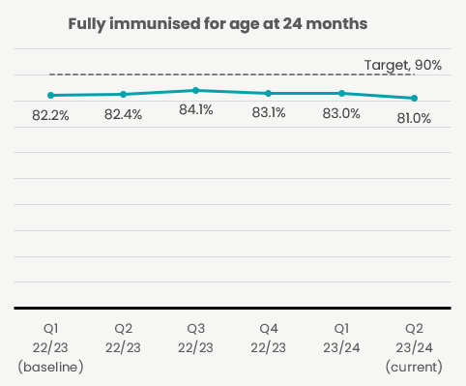Performance fell across all ethnicities in quarter two with immunisation rates for Māori falling to 65% (5% fall) to their lowest level since quarter one 2022/23. Rates for Pacific peoples and European/Other remain below target at 80% and 86% respectively. The only group currently meeting the 90% target is Asian peoples at 91%. Regional rates all fell, except Central, with Te Waipounamu falling below target for the first time in 12-months. Regional teams are being supported to implement their regional action plans to increase childhood immunisation coverage. To support equitable uptake, we have implemented the immunisation prioritisation matrix at a regional and local level. This supports providers to determine which population groups and vaccines to prioritise when faced with limited time and resources. During quarter two, Whaihua (a new customer relationship management tool) was implemented to manage newborn enrolment in primary care. This enables users to create and follow up newborn information and support the provision of immunisation services. There is a decrease in coverage for the 24 months milestone from quarter one to quarter two, which cannot be attributed to technology or denominator changes and is in line with reductions in the volumes of vaccinations delivered to children seen over the last year. There are multiple contributors to the reduction in immunisation, such as were identified in the Immunisation Taskforce report. We are implementing all of the Taskforce recommendations. We will continue to monitor this trend.

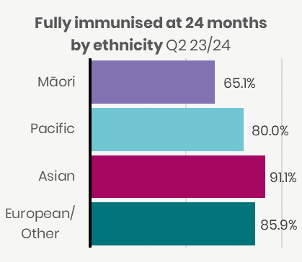 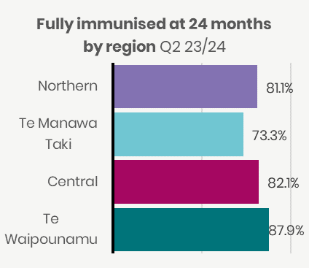

Source of data is National Immunisation Register (NIR) / Aotearoa Immunisation Register (AIR). Due to the transition from NIR to AIR, a hybrid methodology was needed for quarter 2 2023/24.

## 2 Newborn enrolments

This measure shows the percentage of newborns (up to three months) who are enrolled with a GP or a Kaupapa Māori provider.

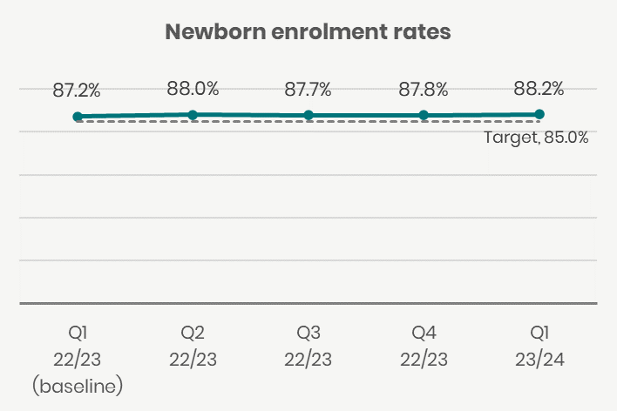Newborn enrolment rates (NBEs) have remained stable over the past year. We have seen slight increases for Pacific peoples, European/Other and Asian enrolments in the last quarter. Māori enrolment rates remain well below both the target and the other reported ethnicities. Regionally performance has remained consistent with all regions at or above target. Working in partnership with Primary Health Organisations, improving the NBE process to function more effectively is a focus. This work will be done alongside general practice teams. Particular focus needs to be placed on those patients who may not have a stable relationship with general practice. We intend to automate newborn enrolments by directly linking with maternity systems and well child providers in the next six months. We expect to see improvements in the first six months of 2024/25.

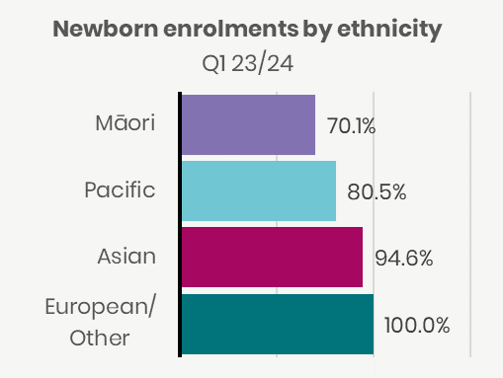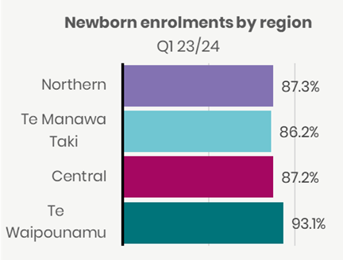

Source of data is National Immunisation Register (NIR) / Aotearoa Immunisation Register (AIR). Due to the transition from NIR to AIR, a hybrid methodology was needed for Quarter 2 2023/24.

## 3 Primary care enrolment

This measure shows people enrolled with a GP (or a Kaupapa Māori provider delivering general practice care) as a percentage of estimated resident population, Stats NZ.

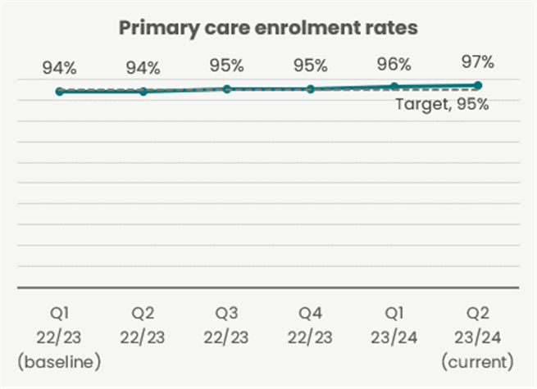Overall, the proportion of people enrolled with a general practice increased slightly in quarter two. Rates for Māori, Pacific peoples and Asian also increased. We have seen fluctuations in enrolment rates over the past 12-months across all ethnic groups, however regional rates of enrolments appear to be slightly up over time. The national baseline has increased by 3% to 97% since 2022/23, however access rates for Māori remain much lower than other groups. The health system continues to experience high rates of patient enrolment in general practice, although many general practices report ongoing workforce pressures. Primary Health Organisations are working closely with general practice teams to encourage patient enrolment.

**Patients reporting they felt involved in primary care decisions by ethnicity & region** quarter two 23/24

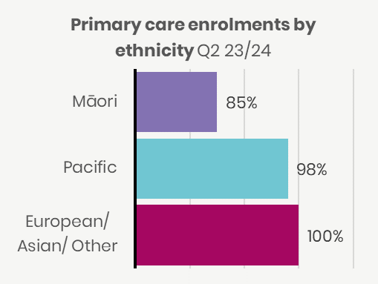

Source of data is National Enrolment Service (NES) / National Immunisation Register (NIR) / Aotearoa Immunisation Register (AIR). This metric is not yet available with an ethnicity breakdown for Asian peoples.

## 4 Involvement in care decisions – primary care

This measure reports the proportion of people who responded “yes” to the question “Did the health care professional involve you as much as you wanted to be in making decisions about your treatment and care?” in the Health Quality and Safety Commission (HQSC) quarterly survey.

Reported results for European/Other, Asian, and Total increased this quarter while results for Māori and Pacific peoples remained relatively stable. Results are sourced from the primary care patient experience survey and are not available by region. This measure is reported through the national primary care experience survey. Results show that most people feel involved in the care delivered by their general practice team.

**Patients reporting they felt involved in primary care** **decisions** **by ethnicity & region** quarter 2 23/24

|  |  |
| --- | --- |
|  |  |

Source of data is the Adult primary care patient experience survey from HQSC. Results are based on weighted data.

## 5 Ambulatory sensitive hospitalisations 0-4 years

This measure shows hospitalisations for children aged 0-4 years for an illness that might have been prevented or better managed in a primary care setting, as a rate per 100,000 population.

Admissions have remained relatively stable for children who may have been managed in primary care. Differences in rates for Pacific children, compared to other children, remain higher than the differences for other groups. Work continues in primary care to provide better support for these children at a PHO and regional level. There is work being scoped around how primary care and general practice teams can be supported to provide enhanced care for children and the enrolled population.

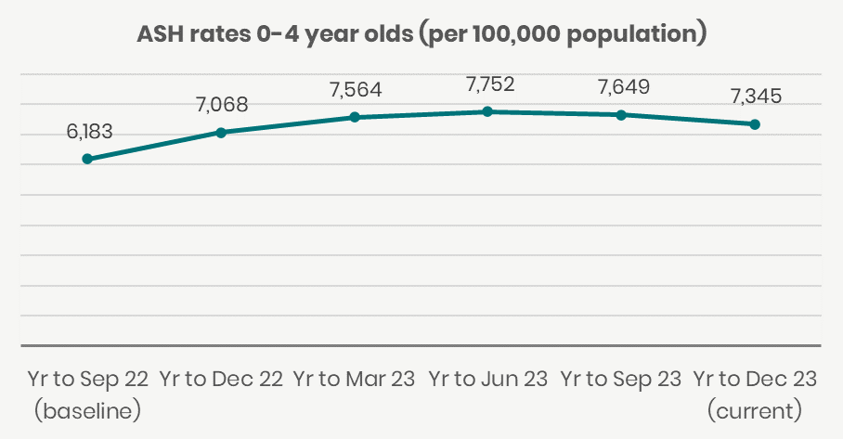

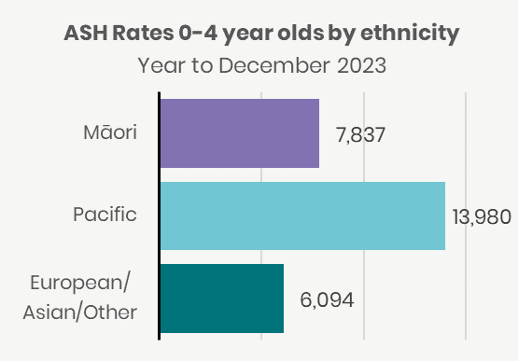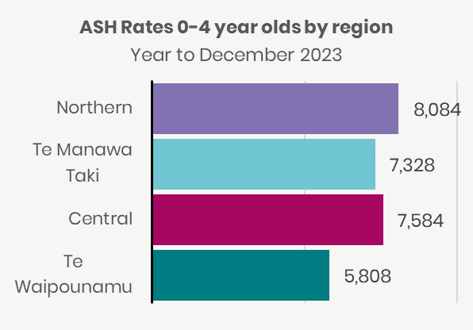

Note that results in quarter two 2023/24 for Whanganui and Wairarapa could not be produced because of clinical coding delays. Values were imputed for those two local areas to derive a national rate. This data is provisional and subject to change.

Source of data is the National Minimum Data Set (NMDS).

## 6 Ambulatory sensitive hospitalisations 45-64 years

This measure shows hospitalisations for people aged 45-64 years for an illness that might have been prevented or better managed in a primary care setting, presented as a rate per 100,000 population.

Admissions have remained relatively stable for adults who may have been managed in primary care. The rates for Pacific peoples and Māori remain higher compared to other populations. Work continues in primary care to provide better support the acute and proactive care in the community at a PHO and regional level. Areas of focus include the better management of long-term conditions which contribute to these admissions. Work is being scoped around how primary care and general practice teams can be supported to provide enhanced care for the enrolled population.

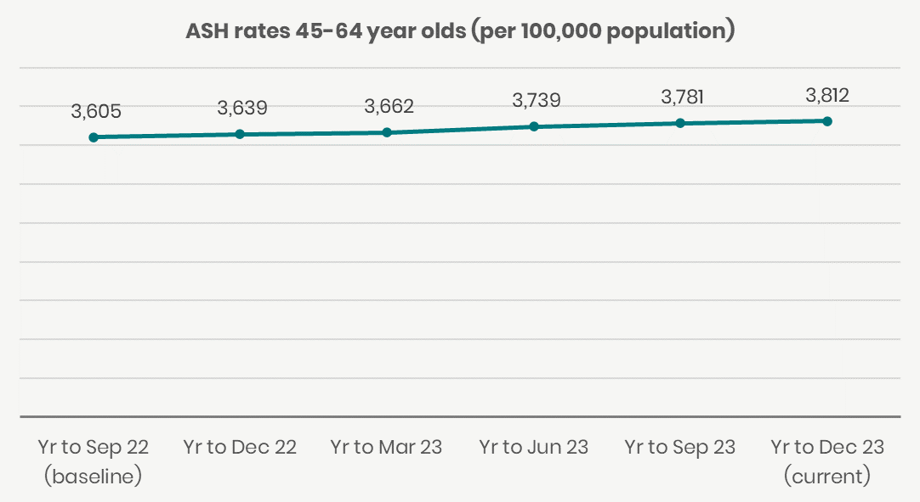

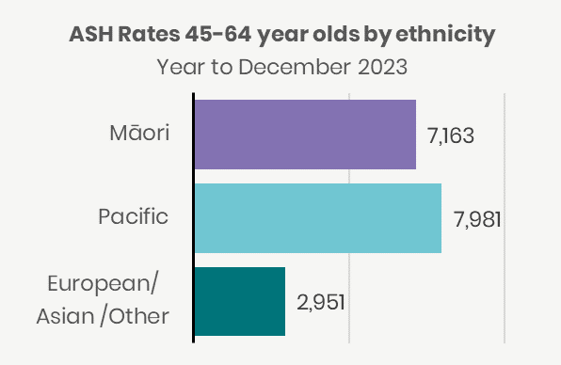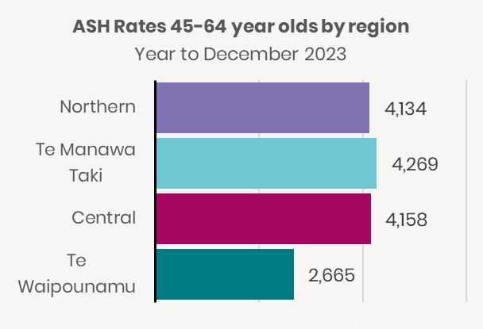

Note that results in quarter two 2023/24 for Whanganui and Wairarapa could not be produced because of clinical coding delays. Values were imputed for those two local areas to derive a national rate. This data is provisional and subject to change.

Source of data is the National Minimum Data Set (NMDS).

## **7 Access to primary** mental health and addiction services

This measure reports the rate of people accessing primary mental health and addiction services (Health NZ and NGO combined) per capita.

This measure reflects access to primary mental health and addiction services funded since 2019 only and excludes previously existing primary mental health and addiction services because of lack of reliable data from those services. There has been steady growth in overall access to these services reflecting progressive expansion over time. These new services prioritise access for Māori and Pacific peoples and, accordingly, rates of access for these population groups are higher than for other population groups, as intended. Access is low among Asian populations relative to all other population groups, and Asian access to services will be a focus for future planning and improvement.

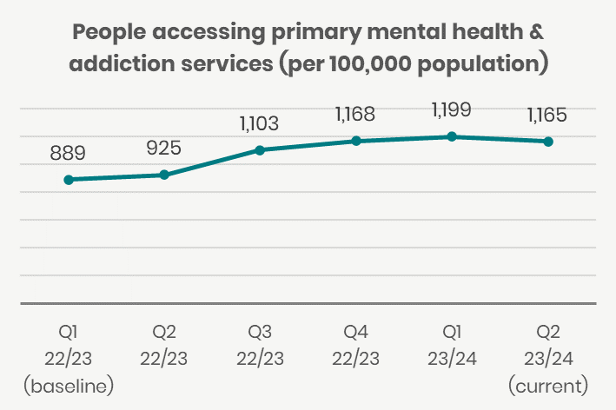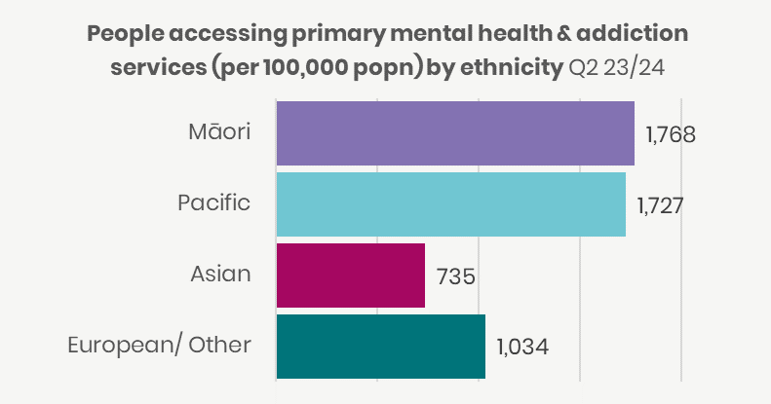

Source of data is Access and Choice System and Population Statistics from Stats NZ. Results are presented as the proportion of people per 100,000 population accessing primary mental health and addiction services.

## 8 Access rates for specialist mental health services

This measure reports the rate of people per capita served by specialist mental health services (Health NZ and NGO combined).

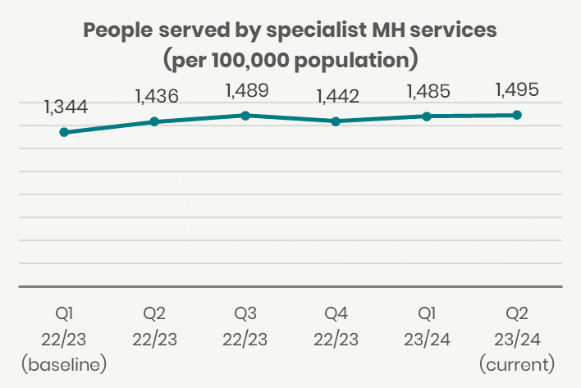Access rates per 100,000 have remained relatively stable over the past 12-months with a slight upward trend across all ethnic groups from baseline in 2022/23. Access rates for Māori are significantly higher than the national total, while rates for Asian populations are significantly lower. Reporting by region is expected to be available from Q3. There continues to be evidence of increased demand, particularly in the younger age groups, with workforce constraints impacting on the system’s ability to meet that demand. Workforce development initiatives to increasing training opportunities and international recruitment to key clinical professions are having some impact, but overall vacancies remain around 20%.

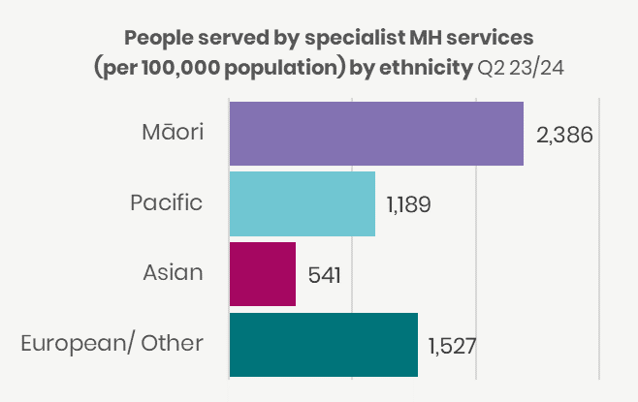

Source of data is Programme for the Integration of Mental Health Data (PRIMHD) and Population Statistics from Stats NZ. With effect from July 2023, the data presented for this measure will include updated PRIMHD data for the two latest 12-month periods, ending with the relevant quarter. Previously published data has been removed and replaced with the latest information. Results are presented as the proportion of people per 100,000 population, served by specialist mental health services (Te Whatu Ora and NGO combined).

## 9 Mental health wait times for under 25-year-olds

This measure reports under 25-year-olds being seen by specialist mental health services within three weeks of referral as a proportion of referrals received.

The proportion of young people accessing specialist mental health services within three weeks of referral in the year to December 2023 is similar to the baseline result for year to September 2022. Rates for Māori and Pacific peoples are above the European/Other rate, while the Central region rate is substantially higher than other regions. There continues to be evidence of increased demand with workforce constraints impacting on the system’s ability to meet that demand. Workforce development initiatives around increasing training opportunities and international recruitment to key clinical professions are having some impact, but overall vacancies remain around 20%.

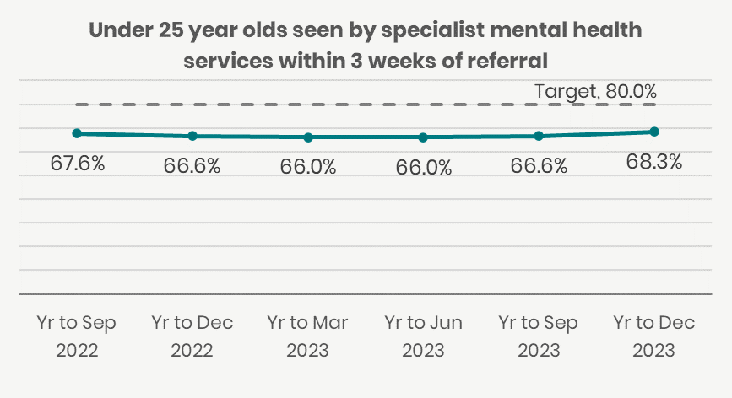

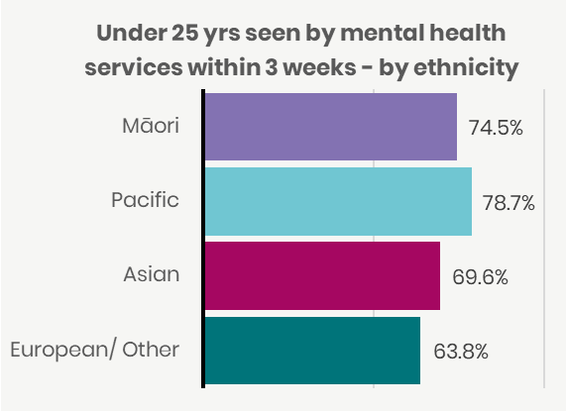

Source of data is the Programme for the Integration of Mental Health Data (PRIMHD). Data is incomplete for quarter two. Measure is presented as a rolling 12 months to the quarter.

## 10 Shorter stays in Emergency Departments

This measure reports patients admitted, discharged or transferred from an Emergency Department (ED) within six hours (Shorter Stays in ED – SSED) as a percentage of all patients who left ED in the period.

ED wait times improved between quarter one and two for all ethnic groups, however total performance remains below the baseline for quarter one 2022/23 of 72% and well below the national target of 95%. The regional rates also improved in all regions except Te Waipounamu. Wait times in Central remain the lowest in the country and have been trending downward for several quarters. Access to inpatient hospital beds is a key driver of patient flow through ED. The national Hospital and Specialist Services Acute Care plan is in the early stages of implementation. It aims to address this issue. All regions prepared and implemented plans to support and manage the delivery of hospital acute services over the holiday period.

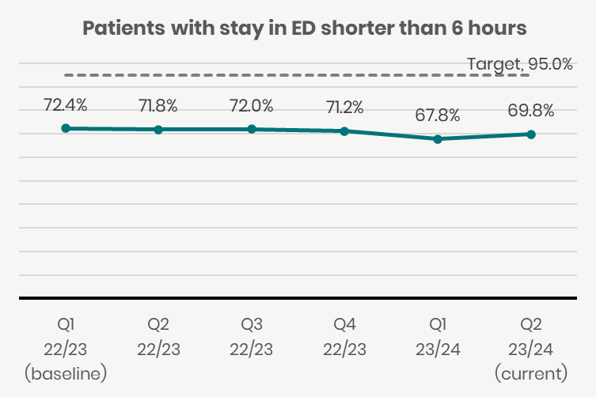

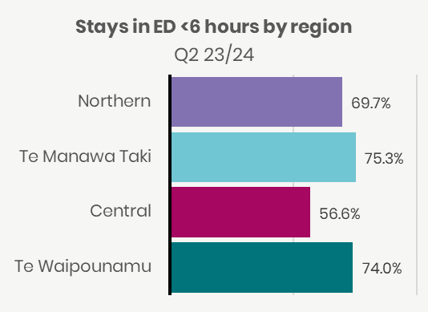

Source of data is the National Non-Admitted Patient Collection (NNPAC). Results are incomplete for Southern due to system upgrades underway. Southern is removed from local area specific charts. This could have a small effect on SSED rates for national trend, and SSED by region and ethnicity.

## 11 Emergency Department presentations

This measure reports the number of people who present to an emergency department including those that did not wait to be seen. Numbers of presentations have remained flat for the past six quarters.

|  |  |
| --- | --- |
|  |  |

Source of data is National Non-Admitted Patient Collection (NNPAC). Results are incomplete for Southern due to system upgrades underway. Southern is omitted from local area specific charts. This will cause total presentation numbers and   
Te Waipounamu presentation numbers to be slightly understated for quarter two.

## 12 Admissions from Emergency Departments

This measure reports patients admitted to a hospital ward following attendance at an Emergency Department (ED) as a proportion of all patients who attended an ED.

While the percentage of admissions from ED has remained stable for many years, the volume of patients presenting to ED and requiring subsequent admission is rising. The rise in ED presentations is largely in line with population growth. In the 2018-2023 period, there was a 6.7% growth in population, a 7% increase in acute adult admission events, and a 12% increase in acute case weights. As the total number of attendances and admissions rises, we focus on ensuring supportive and accessible primary, urgent and after-hours care. A national acute care programme of work is focusing on patient flow through hospitals.

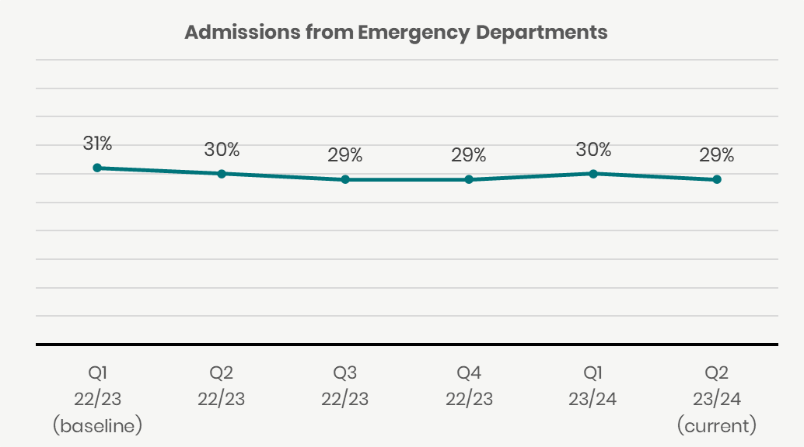

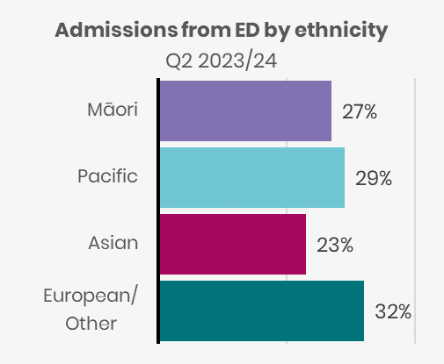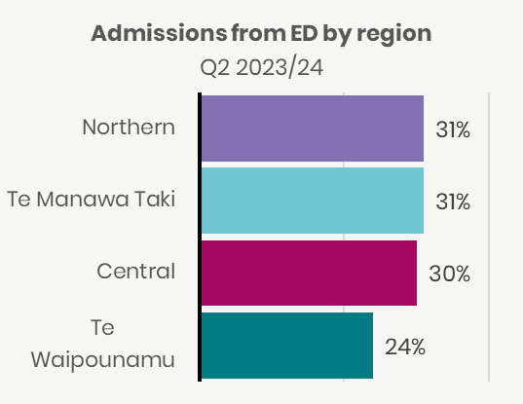

Source of data is the National Non-Admitted Patient Collection (NNPAC). Results are incomplete for Southern due to system upgrades underway. Southern is omitted from local area specific charts. This could have an effect on admission to ED rates for quarter two.

## 13 Acute bed days per capita

This measure reports bed days spent in hospital following an acute admission per 1,000 population, age standardised.

Demand for acute care is driven by an aging and growing population. During 2008 – 2022, ED presentations at triage levels 2 and 3 (more acute) increased, in contrast to a fall in triage level 4 and 5 presentations. This complexity is driving higher acute bed days. Māori and Pacific populations were the highest users of ED over the last decade, consistent with health status measures. Higher Māori and Pacific bed days in quarter one (winter) over the past two years is likely reflective of underlying chronic conditions, paediatric admissions and inequity. The national acute care programme of work is focusing on models of care, including establishment of hospital in the home and early supported discharge nationally.

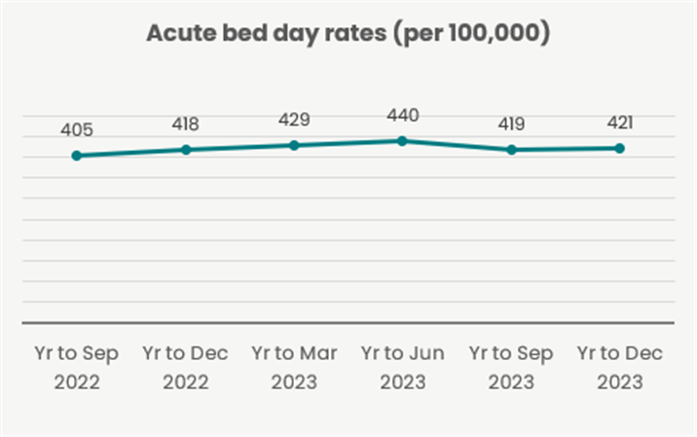

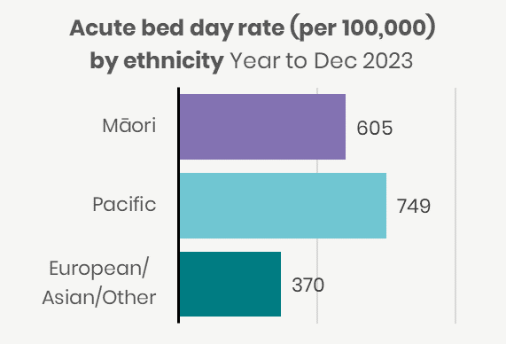

Source of data is the National Minimum Data Set (NMDS) and Population Statistics from Stats NZ. Dec 2023 results for Whanganui and Wairarapa are delayed for submissions to National Collections due to staff shortages. The year-to-December 23 figure will be slightly understated. Results are presented as the number of bed days for acute hospital stays per 100,000 population, age standardised.

## 14 Inpatient length of stay >7 days

This measure reports hospital discharges with an inpatient length of stay of greater than seven days as a proportion of all discharges in period.

The proportion of inpatient stays with a length of stay greater than seven days remains consistent at 8-9% for the total population. Rates for Māori and Asian populations are lower than the total at 6-7% nationally. Long inpatient stays are an indicator of system performance in relation to hospital flow. This is a core measure and area of focus to be addressed through the Acute Care Plan.

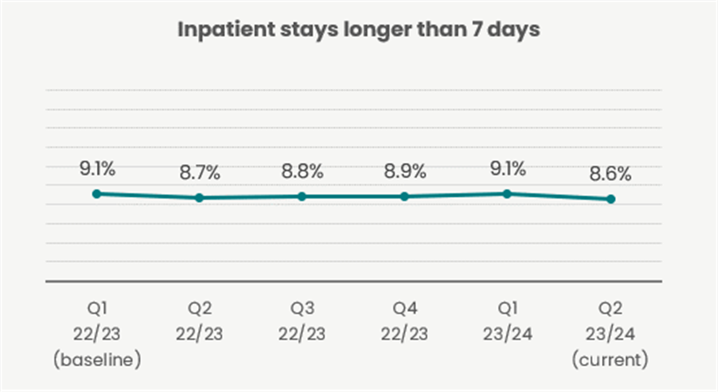

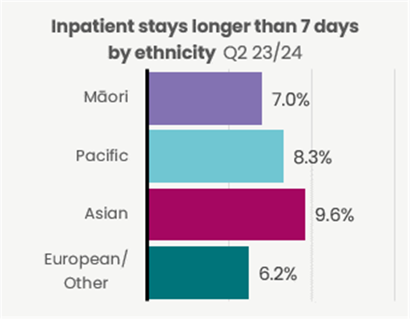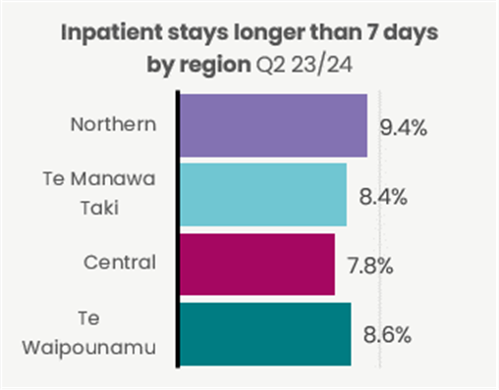

Source of data is the National Minimum Data Set (NMDS). Results are presented as a percentage of acute discharges over seven nights in medical or surgical specialties, divided by all acute discharges in medical or surgical specialties.

## 15 Involvement in care decisions – in hospital

This measure shows the people who report they were involved as much as they wanted to be in decisions about their treatment as a proportion of all adult inpatients who responded to the Health Quality and Safety Commission quarterly survey.

The proportion of patients who report they were involved in their treatment has fluctuated over the past 12 months however there has been an increase from baseline across all groups, which is positive. Total performance against baseline since 2022/23 has increased by 5% to 81%. Responses for Pacific and Asian groups tend to show more positive engagement with the system compared with Māori and New Zealand European/Other over the past 12-months. The trend that most people feel involved as much as they wanted to be in making decisions about their own treatment is encouraging and demonstrates that Health NZ staff are working hard to meet the needs of consumers and whānau. With the trend of improvement, we will continue to work towards incremental improvements through continuous quality improvement practices.

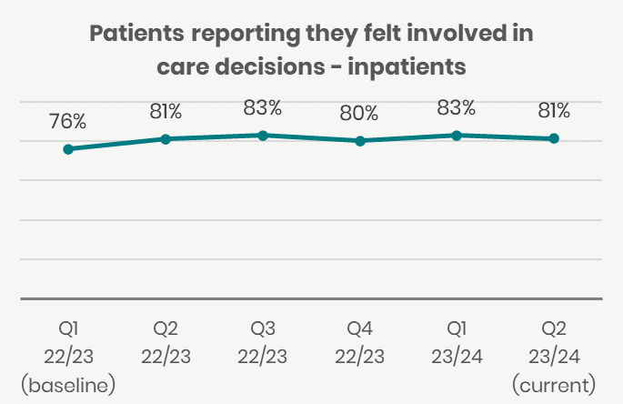

**Patients reporting they felt involved in care decisions - inpatient by ethnicity & region** quarter two 23/24

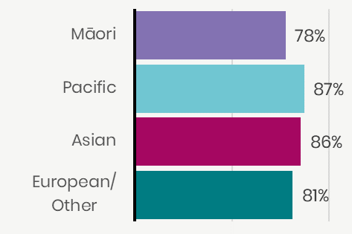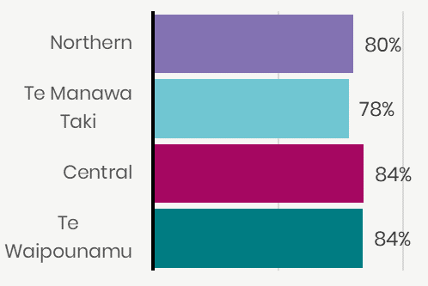

Source of data is the HQSC Adult Hospital Inpatient Experience Survey. Results are based on weighted data.

## 16 People waiting more than four months for first specialist assessment (FSA)

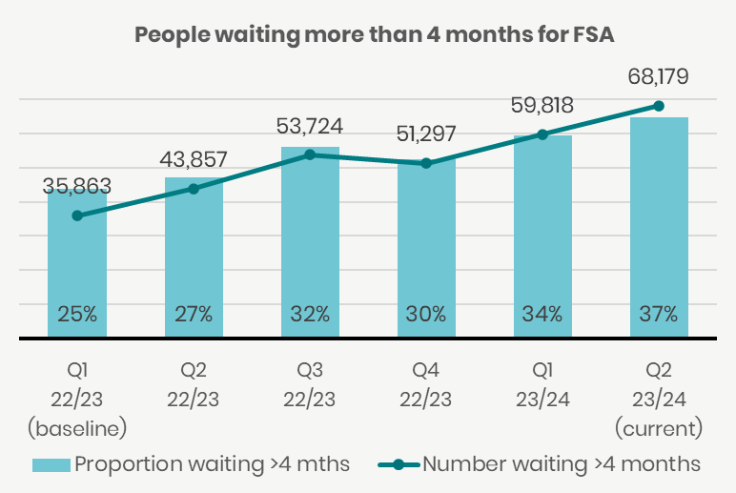This measure reports people waiting longer than four months for first specialist assessment (FSA). This measure is Elective Services Performance Indicator 2 (ESPI2).

There has been a long-term increase in the number and proportion of people waiting longer than four months for a FSA. At end quarter two over 68,000 patients were on the ESPI2 waitlist waiting more than 120 days, which represents 37% of all waiting for a FSA. Reducing the number of people waiting longer than four months for a FSA is a key element of the work plan developed in late quarter two for implementation in 2024. Work to validate the ESPI2 waitlist was initiated in quarter two as well as communication with patients on the FSA waitlist, mirroring the approach taken with the long-waiting treatment waitlist established in quarter one. The Planned Care team met in December 2023 to develop the forward workplan over the next 18 months. The workplan, for initiation in Q3, includes:

* A sustained focus on reducing ESPI2 wait times through weekly performance reporting and monitoring with regional directors.
* Launch of the phased patient communications for long-waiting ESPI2 patients.
* Working with clinical networks to access criteria and clinical prioritisation standardisation.
* Developing nationally-standardised access, booking and waitlist management practice.

Deploying new Outpatient Models of Care to reduce unnecessary follow-ups to release capacity for FSAs.

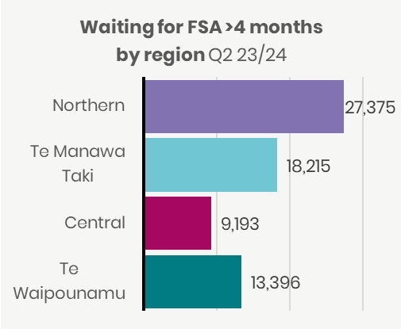

Source of data is National Booking Reporting System KPI (NBRS KPI). Results are incomplete for Southern due to system upgrades underway. Southern is omitted from local area specific charts but is included in summary graphs, otherwise results would be understated rather than likely overstated.

## 17 People waiting more than four months for a procedure

This measure reports people given a commitment to treatment but not treated within four months as a proportion of all people waiting for a procedure. This measure is Elective Services Performance Indicator 5 (ESPI5).

ESPI5 waitlists increased in quarter two across all regions and ethnicities. Regions have maintained a concerted focus throughout this period on treating the longest-waiting patients, and the numbers of patients waiting >365 days is reducing. However, notwithstanding this positive outcome, the demand for treatment continues with patients joining the waitlist for treatment. We continue to work with regions to review performance weekly, ensuring that long-waiting patients have treatment plans and confirmed dates for treatment. This includes providing targeted support in quarter two where specific local areas are outliers, in the size of the long-waiting treatment waitlist.

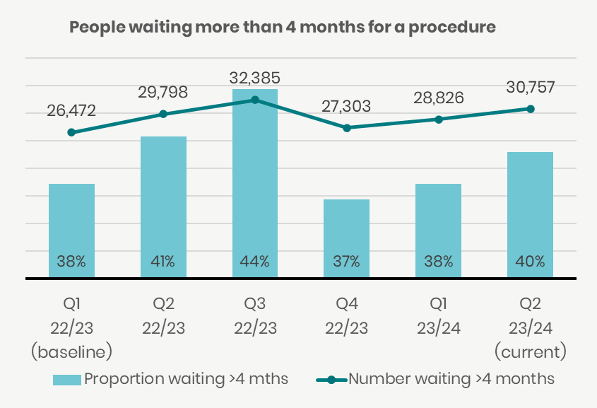

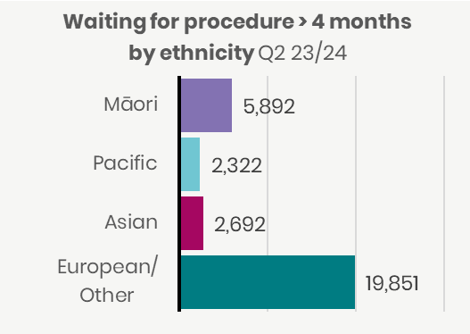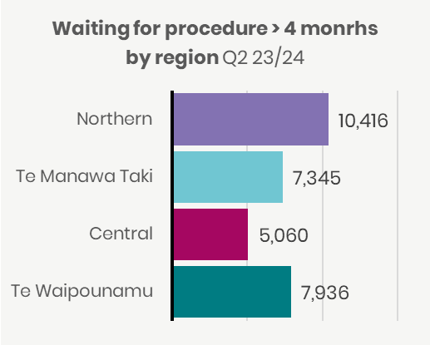

Source of data is the National Booking Reporting System (NBRS). Results are incomplete for Southern due to system upgrades underway. Southern is omitted from local area specific charts. This will have a small effect on quarter two results which will differ from validated numbers for quarter two results when quarter three report is published.

## 18 People waiting more than 365 days for a procedure

This measure reports the number of people who have been waiting for a procedure for more than 365 days from when they were ready for treatment.

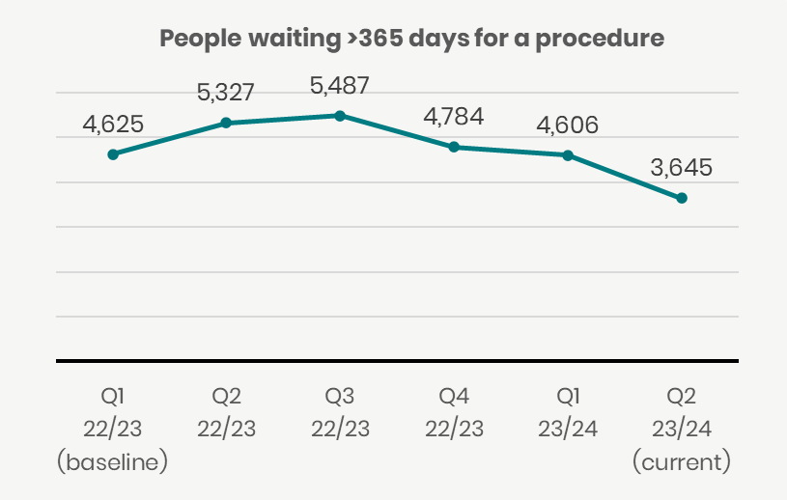Regions have maintained a focus and weekly performance monitoring on treating the longest-waiting patients and the numbers of patients waiting >365 days. While significantly reducing the total number of patients, the target to have all patients waiting >365 days for treatment by 31 December was not met. As at December there were a number of patients on the waitlist for treatment, excluding orthopaedics. Regions have agreed that all patients waiting >365 days will receive treatment by 31 March 2024. Regions will report to weekly and end-month positions from January 2024 to ensure there is a forward view of patients tipping into the waitlist and the delivery required to meet this commitment. We will reduce the threshold for monitoring long-waiters to 300 days at the end of Q3 to continue the focus on reducing the tail of the waitlist.

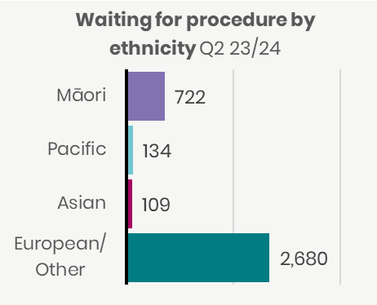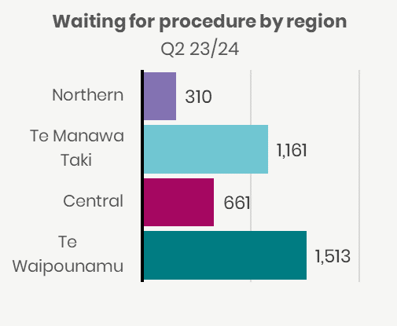

Source of data is the National Booking Reporting System (NBRS). Results for Southern and Nelson Marlborough are not validated for quarter two. Southern and Nelson Marlborough are omitted from local area specific charts. Canterbury observed a slight variance of their result due to data delays affected by Southern’s system upgrades. Canterbury agreed to publish current results as is. Southern and Nelson Marlborough are included in Ethnicity and Region charts, otherwise results would be understated rather than likely slightly overstated.

## 19 Medical appointments through digital channels

This measure reports outpatient attendances that were completed via telephone or video as a proportion of all outpatient attendances.

Delivery of digital telehealth has remained relatively stable over the past year. There has been a slight decrease in telehealth delivery from baseline. The delivery of targeted initiatives continues to be the main focus for improving digital access to health services. Specifically, the use and promotion of telehealth services, remote patient monitoring (RPM) and patient portals support individuals to access healthcare through digital channels.

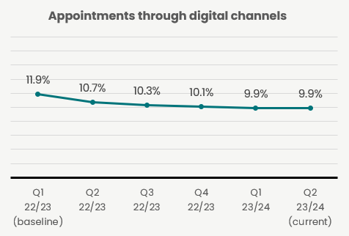

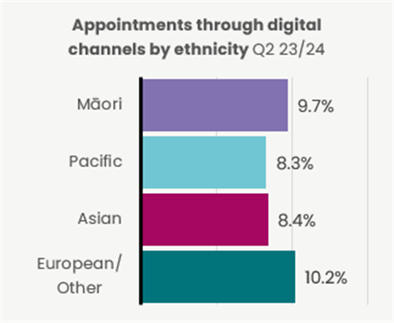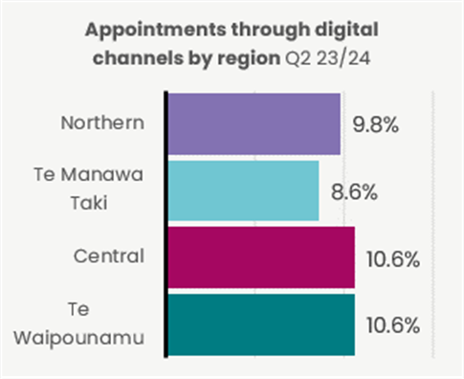

Source of data is the National Non-Admitted Patient Collection (NNPAC).

## 20 Missed appointments

This measure reports the proportion of people who did not attend or did not wait for a specialist first specialist assessment or follow-ups.

Missed appointments continue to be an issue across all regions. While progress has been made, there is still inequity demonstrated by higher rates of missed appointments for Māori and Pacific peoples. Initiatives to improve access include the national travel assistance programme, as well as the development of specific health pathways to standardise healthcare access and referral processes. Planning for improved Outpatient communications and identification of barriers to access for patients using the CIPR platform was undertaken in quarter two, and establishment work will be undertaken in Q3 with deployment in Q4.

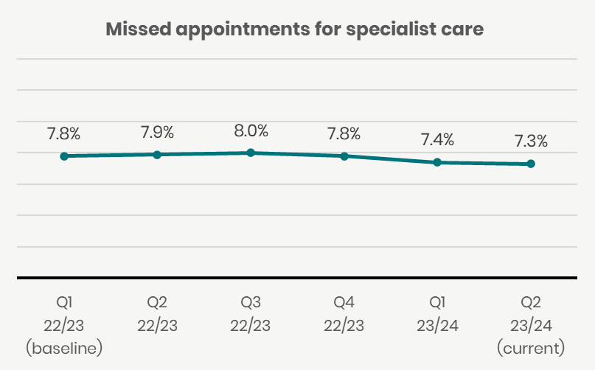

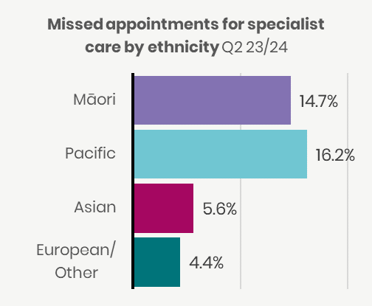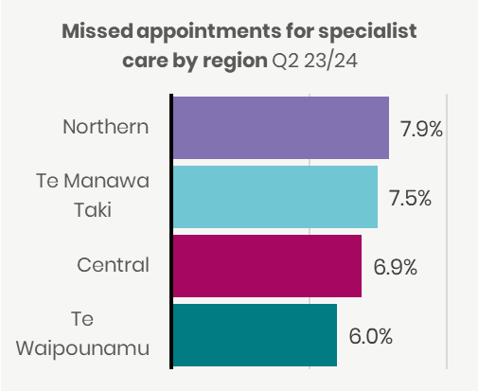

Source of data is the National Non-Admitted Patient Collection (NNPAC).

## 21 Delivery of planned care interventions

This measure reports the number of planned care interventions including inpatient surgical discharges; minor procedures delivered in inpatient, outpatient and community settings, and non-surgical interventions.

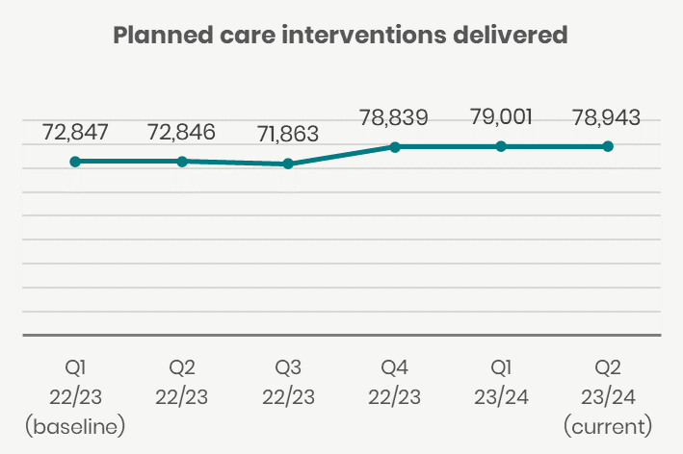There was slight decline in the delivery of planned care interventions in quarter two compared with quarter one although delivery is still up on the quarter one 2022/23 baseline period. The reduction in delivery aligns with the holiday period and follows the same trend as 2022/23. Regionally, Te Manawa Taki and Te Waipounamu saw increased delivery of around 500 procedures compared with quarter one, while Northern and Central saw similar volumes of decline. Weekly reporting of planned care delivery was rolled out at a local area and regional level to support monitoring and targeted waitlist support. Theatre utilisation and productivity metrics have been developed to support monitoring and process improvement for planned care delivery. Reporting of theatre utilisation metrics will commence from Q3. A Theatre Expert Advisory Group (TEAG) was convened in quarter two to support this work, with the goal of ensuring national consistency in approach and identifying actions based on utilisation reporting.

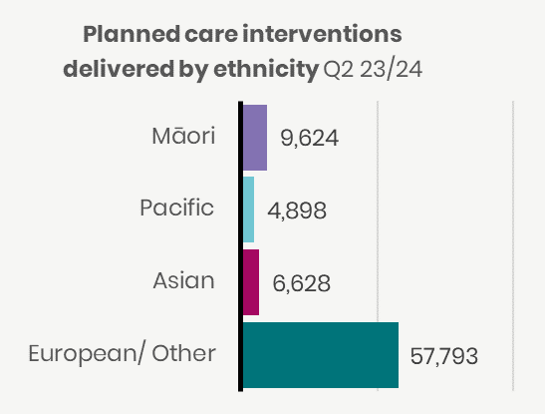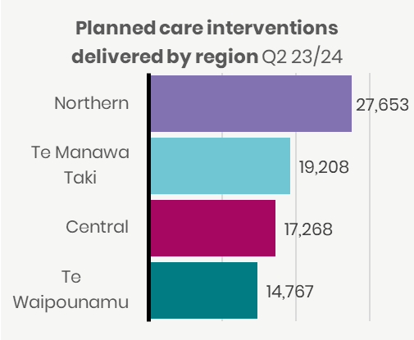

Source of data is the National Minimum Data Set (NMDS) and National Non-Admitted Patient Collection (NNPAC). Results are incomplete for Southern due to system upgrades underway. Ethnicity totals do not reconcile to regions as not all patients have a local area assigned.

## 22 Cancer patients waiting less than 31 days for first treatment

This measure shows the proportion of eligible cancer patients who receive their first treatment within 31 days of a health professional’s decision to treat.

Performance has remained relatively stable over the past 12-months. There is little variation between groups, which is positive, however treatment times for Pacific have dropped slightly from baseline to 81.9%. All regions are achieving target with little variation, although performance has fallen from early 2022/23. Addressing constraints across the cancer pathway is a focus in all regions. A data linking project will be completed in early 2024 which will show where there are systematic challenges in the system for Pacific and Māori women with endometrial cancer. Workforce, diagnostics and equipment are currently key areas of focus to improving our timely cancer service delivery. Initiatives to improve performance include: international recruitment for radiation therapists and oncologists to improve access; developing national clinical pathways to facilitate rapid diagnosis of suspected cancer and eliminate variation in the system; and identification of additional Linear Accelerator (LINAC) machine sites to increase demand, which is expected to be delivered from 2026.

Source of data is the Faster Cancer Treatment Data (FCT). Results are unavailable for South Canterbury due to submission issues. South Canterbury is omitted from local area specific charts. This could have a small effect on quarter two results.

Corrected graphs. In the original published version of this report, this was recorded as waiting > 31 days for cancer treatment by region. This was a typo, as “waiting >31 days for cancer treatment” was incorrectly entered. The correct title is waiting < 31 days for cancer treatment.

## Our milestones

The below sets out milestones in our Statement of Performance Expectations

|  |  |  |
| --- | --- | --- |
| Te Pae Tata Priority 2 - Embed Te Tiriti o Waitangi across the health sector | Milestones | Progress made – Quarter Two 2024 |
| Localities are established. | Health NZ received the boundary recommendations from Iwi Māori Partnership Boards, covering 74% of the population with 40 proposed localities (including prototypes). Based on experience to date with prototypes, we are considering the next steps (alongside the Minister of Health and Ministry). |
| Provider networks are established. | Working with primary care partners on future arrangements. A discussion document will be developed by 30 April. |
| Te Pae Tata Priority 4 - Keep people well in their communities | Establish a nationally integrated public health service with consistent operating models. | The National Public Health Service (NPHS) completed its organisational design with the final decision document published on 25 October 2023). Transition to the new structure is well underway, with the recruitment process complete, and transition of people into their changed roles in the system. |
| Continue COVID-19 response in line with policy settings and build towards a new business-as-usual pandemic resilient system. | The National Public Health Service (NPHS) has continued to refine the COVID-19 response via a scaled approach, as agreed by joint-Ministers, with services and community-led programmes focused on communities at greatest risk of serious illness from COVID-19. Change management for scaling down and transitioning COVID-19 services and programmes moved into Phase 2 on 1 October 2023, with Phase 3 commencing on 31 December 2023. |
| Te Pae Tata Priority 5 - Develop greater use of digital services to provide more care in homes and communities | Improve digital access to primary and mental healthcare to improve access and choice, including virtual after-hours and telehealth with a focus on rural communities rural | The National Rural Clinical Telehealth was launched on 8 November. As at 15 December, 35% of eligible general Practices had enrolled to use the service. Ongoing outreach will continue in January. |
| Te Pae Tata Priority 6 - Establish Health NZ and Te Aka Whai Ora to support a financially sustainable system | Progress the approved capital infrastructure projects that are underway, taking all practicable measures to ensure that project milestones are met, and anticipated benefits realised, within budget. | As at 31 December 2023, there were 73 approved capital infrastructure projects were underway, of which 16 were identified as having significant budget and milestone risk. The increase in “at-risk” projects is based on funding or schedule change requests, requiring Board or Ministerial approval. Change requests are raised for cost impacts, asbestos contamination and cost implications of project schedule changes.  Two projects previously reported as complete returned to ‘Deliver’ to complete final site clean-up works. One project moved back to ‘Design’ from ‘Deliver’ because the project was halted in June 2022 due to seismic concerns and is now ready to be re-established with a new design.  One project moved from ‘Design’ to ‘Deliver’ and three projects were completed in the period. |
| Deliver the approved digital capital projects in line with Business Cases. | Overall delivery of capital projects in line with their respective business cases is progressing as planned for the most part. For the 10 most significant projects or programmes currently underway, (based on overall implementation value) there are now none with a red status, and the balance are currently indicating an overall RAG status of green or amber. Common challenges have been highlighted across projects in relation to resource constraints, particularly through the current period of change. While the market appears to be beginning to shift, specialist skills remain scarce and attract a premium. |

1. Financial Performance

#### High-level summary, key issues, risks and work plan

* The operating result for the month of December is a $13 million deficit, which is $5 million favourable to the $18 million budgeted deficit. The year-to-date result is a surplus of $19 million, which is $26 million favourable to the $7 million budgeted deficit. Closing cash at the end of December was $1.866 billion, excluding trusts.
* The Year-End forecast is for a $507 million surplus against a breakeven budget. Due to timing differences on pay equity settlement costs and funding, where costs were accrued in the 22/23-year offsetting funding is being received this financial year. The full upside anticipated from this has been reduced due to the write down of COVID-19 stock and impacts of wage settlements.
* Planned savings are largely on track after six months, and year-to-date savings against planned initiatives of $141 million have been achieved, a further $102 million of other savings have also been achieved giving a total of $243 million achieved after six months against the $540 million full-year target. Savings are phased, reflecting the months when they are expected to be achieved, the full annual savings target is $540 million.
* Key trends over the 18 months of operation since our establishment are continuing vacancies overall in the employed workforce. These are offset by use of overtime, locum and external agency staff.
* The two most significant financial risks in the current year remain the risk around collective employment settlement agreements above budgeted and funded levels and inflationary pressures.
* Budget 2024 preparations continue. Five-year financial forecast and scenario model has been developed and was updated to reflect budget guidance from Treasury in December.
* Capital Expenditure (Capex) for the year-to-date November 2023 is $667 million below the budgeted level, with actual spend at $588 millon versus a phased budget of $1.255 billion. A review will be completed post December Capex reporting to reconfirm the Capex cashflow forecasts, covering the status of business case development, approvals, procurement and implementation stages of projects. A Capex planning approach is also being developed to implement a longer-term baseline Capex plan from 2024/25 onwards.
* Roll out of the FPIM system continues with 25 components now migrated. Two local areas (Lakes and Tairawhiti) and two shared service agencies (Healthshare and Central TAS) are yet to be migrated onto FPIM, and these will be completed by June 2024.

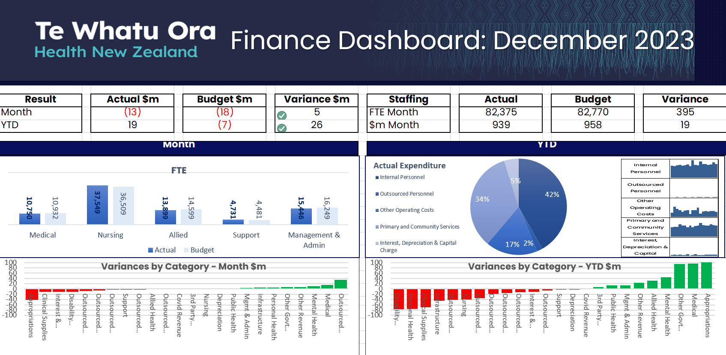

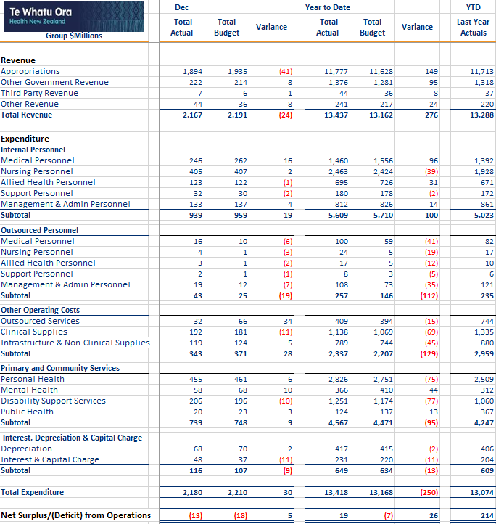

#### Savings Commentary

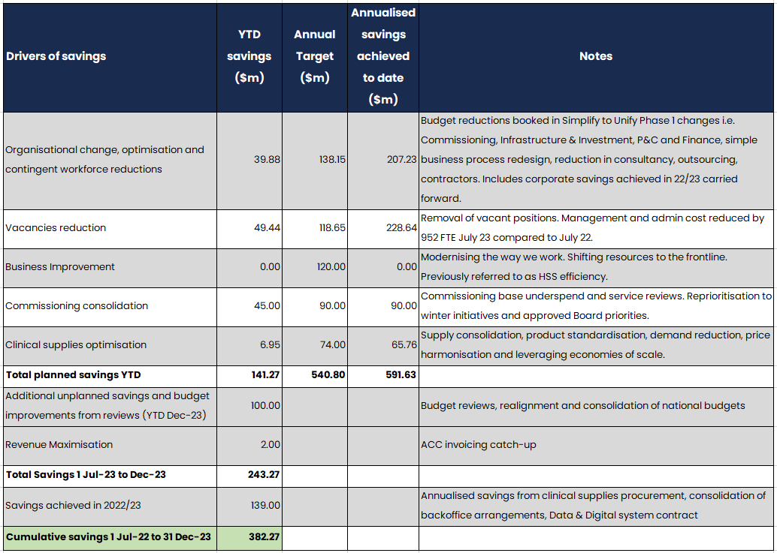

#### Savings Target Realisation

* Planned savings of $141.27 million were achieved for the year to date to 31 December 2023, against a higher phased budget.
* The above table reflects savings built into the 2023/24 operational budget. To recap, the initial annual savings of $500 million was upgraded to $540 million to cover increased provision to settle collective employment agreements. The breakdown above reflects targets built into operational budgets on a bottom-up basis to ensure accountability and accurate reporting. Savings are phased throughout the year with more savings expected to be realised in the later months. It is forecast that the overall savings envelope of $540 million planned for the year will be achieved, including new savings that offset those not achieved.
* In addition, the table now includes additional unplanned savings and budget improvements realised from ongoing budget and run rate reviews. The savings achieved in 2022/23 have also been included to show the full savings achieved by Health NZ since establishment.

#### HSS/Efficiency reporting

* We are still working to rebase budgets to satisfy reporting to Regional Directors. In addition, we are undertaking analysis which was driven out of major cost categories, the budget risks identified in B23/24, reformation of the planning and purchasing approaches, and some technology enablers.

Actions and analysis underway:

* Ongoing cost reviews at a regional level ($500 million savings target)
* Care Capacity Demand Management (CCDM) is used for safe staffing levels for nursing and will be used for Allied Health shortly. A review of the CCDM methodology and wider nursing investment and productivity is underway. This is a $5 billion per year investment category. A longer-term review of inter-professional models of care is planned. This will result in more affordable workforce models for nursing, Allied Health, RMOs and SMOs)
* Clinical supply costs will be informed by engagement with National Clinical Networks to recruit clinicians to champion reduction in variation of practice (collapsing 250,000 supply lines to closer to 60,000 which is best practice). This is a long-burn initiative which will shift the cost curve over the next five years.
* Productivity measures are limited to those which can be reliably collected by SI&I, and we have a one-year roadmap in play (SI&I, Finance, H&SS and EY). Our focus is on operating theatres and bed flow management. The first report has been delivered to central agencies covering:
* Case-weighted hospital discharges per FTE
* Average Length of Stay (ALOS) – medical and surgical episodes of care
* Percentage Long Stay (>7 Days) – medical and surgical episodes of care
* Work is underway to refine existing productivity measures and develop suites of productivity measures, supported by performance and quality measures to enable an understanding of not just productivity trends but also drivers and influencers of productivity within service delivery settings. This is expected to be a 12-month work programme :
* Development of productivity measures and the efficiency and performance measures that help understand drivers of productivity
* Consolidation and automation of data sources including data quality assessment and control
* Productivity insight generation to increase the use of productivity reporting to support business decision making.
* National laboratory commissioning (2 years)
* National radiology commissioning (2 years)
* National outsource surgical services commissioning (2 years)
* National payroll and rostering to drive workforce analytics and overtime/leave management (5 years)
* National and Regional hospital operating models and control centres (1 year)
* National Booking system, referral management and waitlist management (unknown timeline D&D enabler)
* Laboratory and Radiology results access (unknown timeline D&D enabler)
* Regional Clinical Delivery Networks implemented across a range of specialties (roadmap to be announced)

#### Mental Health Output Class

* The second quarter 2023/24 mental health output class as shown in the table below indicates mental health expenditure exceeds the draft budget by $18.014 million.

Table showing the budget for Mental Health Output

* Salary increases from collective employment agreements settlement contribute to the high personnel expenditure. This is expected to continue for the remainder of the year and may further increase with further wage increases, e.g. a nursing agreement has a further 3% increase from 1 April 2024.

Finance Reporting Roadmap

|  |  |
| --- | --- |
| FPIM Deliverables Summary | Status |
| All deliverables are on track year to date. Whanganui, Mid Central, Hawke’s Bay and Nelson/Marlborough have all successfully gone live, and over 97% of Health NZ financial system transactions are live on FPIM. | ◉ |
| Whole of Health NZ Delegations Policy updated and delegations to match loaded into FPIM system. | ◉ |

|  |  |
| --- | --- |
| Financial Reporting Deliverables Summary | Status |
| All costs across the business were mapped in 2022/23 to the new functional structure | ◉ |
| The Mental Health ringfence for 2022/23 was confirmed with MOH in June 2023 | ◉ |
| Opening Balance Sheet was finalised in July and audit clearance provided | ◉ |
| Year-end Financial Statements were consolidated, audited and signed off by the Board, then Audit Clearance was provided by the 31 October 2023 deadline | ◉ |
| Quarterly CFIS reporting was delivered | ◉ |

Appropriation and Output Class Reporting

Summary: Output Class Expenditure YTD to 31 December 2023

|  |  |  |  |
| --- | --- | --- | --- |
| Output Class | 2023/24 Actual | 2023/24 Budget | 2023/24 Variance |
| Hospital & Specialist Services | 7,576 | 7,212 | -364 |
| Mental Health & Addictions | 1,117 | 1,099 | -18 |
| Primary & Community Services | 4,320 | 4,529 | 209 |
| Public Health | 292 | 181 | -111 |
| COVID-19 | 113 | 148 | 35 |
| **Total** | **13,418** | **13,169** | **-249** |

Summary: Output Class Income and Expenditure YTD to 31 December 2023

|  |  |  |  |  |
| --- | --- | --- | --- | --- |
| Appropriation | Hospital & Specialist Services | Primary, Public & Community | COVID-19 | Total |
| Income | 8,279,665 | 4,999,264 | 158,124 | 13,437,053 |
| Expenditure | 8,722,250 | 4,583,227 | 112,874 | 13,418,351 |
| **Variance** | **(442,585)** | **416,037** | **45,250** | **18,702** |

#### Commentary on financial performance by Output Class:

* Hospital and Specialist Services’ expenditure is tracking unfavourable to budget by $364 million, reflecting cost pressures above funded levels mainly from MECA settlements above budget and contractual obligation impacts including CCDM, pay equity impacts on leave revaluations, depreciation from revaluations, maintenance costs above budget. The expenditure variance also includes $160 million relating to budget treatment for Enable - this is fully offset by revenue.
* Primary and Community expenditure is overall favourable to budget mainly Maternity services, Primary Care, Mental Health and staffing costs.
* Overall, across all appropriations the net result for the YTD period to 31 December is a $18.7 million surplus, which is favourable to the YTD $7 million budget deficit.

### Infrastructure Investment

There are 73 in-flight projects with combined total value of $6.56 billion. Performance reporting shows that most projects are on track. The table below shows the number of projects in each project phase compared with the previous quarter:

|  |  |  |  |  |
| --- | --- | --- | --- | --- |
|  | Define | Design | Deliver | Total |
| Portfolio as at 30 September 2023 | 5 $0.09 billion | 21 $1.58 billion | 48 $4.86 billion | 74 $6.53 billion |
| Portfolio as at 31 December 2023 | 4 $0.09 billion | 22 $1.56 billion | 47 $4.91 billion | 73 $6.56 billion |
| **Movement In** |  | 2 | 3* |  |
| **Movement Out** | 1 | 1 | 4** | 1 |

## Budget Spending Summary as at 31 December 2023

|  |  |  |  |
| --- | --- | --- | --- |
| Te Pae Tata Priority Actions | Initiative | 2023/24 Funding  ($m) | Spend to 31 December  ($m) |
| 1. Place whānau at the heart of the system to improve equity and outcomes | Addressing the Burden of Diabetes for Pacific Communities | 5.00 | 0.250 |
| Improving Access to Primary Health Care Services for Transgender People | 0.58 | 0.292 |
| Introducing a Rights-based Approach to Health Care for Intersex Children and Young People | 0.70 | 0.117 |
| Mana Ake – Continuation and Expansion of Mental Wellbeing Support for Primary and Intermediate School-aged Students | 21.82 | 10.782 |
| Neonatal Retinopathy Screening | 2.33 | 0.000 |
| Pacific Primary and Community Care Provider Development –Securing Future Capability and Shifting into New Models of Care | 14.04 | 3.884 |
| Piki – Continuation of Integrated Primary Mental Health and Addiction Support for Young People in Greater Wellington | 3.50 | 1.838 |
| Population Health and Disease Management Capability | 29.28 | 14.216 |
| Preventing Family Violence and Sexual Violence: Services for Victims of Non-fatal Strangulation | 2.03 | 0.000 |
| Specialist Mental Health and Addiction Services – Increasing Availability of Focused Supports | 14.70 | 4.817 |
| Well Child Tamariki Ora – Continuation of the Enhanced Support Pilots | 1.25 | 0.625 |
| HIV Action Plan Implementation | 5.375 | 0.670 |
| Smokefree Aotearoa 2025 Action Plan | 1.64 | 0.287 |
| 3. Develop an inclusive health workforce | Health Workforce Development | 13.00 | 3.350 |
| Support Workers (Pay Equity) Settlements Act 2017 | 38.63 | 19.315 |
| 4. Keep people well in their communities | Comprehensive Primary Care Teams | 61.15 | 23.192 |
| Continuing the Alcohol and Other Drug Treatment Courts: Waikato, Auckland and Waitakere | 8.12 | 3.813 |
| Extending School-based Health Services | 3.14 | 0.612 |
| Preventing the harm from serious and organised crime in New Zealand | 0.19 | 0.062 |
| Service Integration for Locality Provider Networks | 27.62 | 3.571 |
| New Public Health Agency and National Public Health Service Establishment | 11.853 | 4.090 |
| 5. Develop greater use of digital services to provide more care in homes and communities | Establishing the National Public Health Service – Digital and Data Infrastructure | 6.16 | 0.127 |
| Southern Health System Digital Transformation Programme | 4.23 | 0.000 |
| Health Data and Digital – Foundations and Innovation | 58.49 | 4.058 |
| 6. Establish Health NZ and Te Aka Whai Ora to support a financially sustainable system | Allowing Payment to Family Members for Support Services | 17.00 | 8.500 |
| Dementia Mate Wareware Action Plan - Implementation Support Funding | 2.86 | 1.430 |
| Emergency Air Ambulance Services – Additional Support Funding | 22.51 | 11.256 |
| Emergency Road Ambulance Services – Additional Support Funding | 44.78 | 22.388 |
| Primary Care Funding Formula – Equity Adjustments to Capitation | 24.41 | 12.207 |
|  | Total operating | 469.73 | 155.746 |

#### North Island Weather Event Initiatives

|  |  |  |
| --- | --- | --- |
| Initiative | 2023/24 Funding ($m) | Spend to 31 December ($m) |
| Hospital and Specialist Services | 1.770 | 1.188 |
| Mental Health and Wellbeing Response | 9.890 | 2.932 |
| Primary, Community and Residential Care Recovery | 13.304 | 10.830 |
| Transport and Power | 5.730 | 1.934 |
| **Total operating** | **30.694** | **16.884** |

# Appendices

## Appendix 1: Measure Definitions

The table below provides additional information for each of the performance measures listed in section 6 (non-financial performance) above. A definition of each measure has been provided, along with information on the target (where possible) and baseline performance for the period quarter one 2022/23. The accountability documents (Doc*) aligned to each measure are indicated as well with the below key:

* Statement of Performance Expectations 2023-24 (SPE)
* Te Pae Tata | Interim New Zealand Health Plan (TPT)
* Board identified Clinical Performance Metric for transparency reporting

Performance measures with a **+** symbol have additional data at a local level which can be found in Appendix 2.

🎯 Government Health Target specific reporting commencing 1 July 2024.

|  |  |  |  |  |  |
| --- | --- | --- | --- | --- | --- |
| # | Measure name | Definition | 23/24 Target | National Baseline[3] | Doc* |
| 1 | Immunisation coverage at 24 months 🎯+ | Percentage of children who have all of their scheduled vaccinations by the time they are two years old. Coverage is calculated as the percentage of children who turned two during the period who are recorded as fully immunised for their age on the National Immunisation Register (NIR) / Aotearoa Immunisation Register (AIR). | 90% | National baseline 82% (Q1 2022/23) | SPE  TPT  Board |
| 2 | Newborn enrolments | Percentage of children enrolled with a general practice or a Kaupapa Māori provider by age three months. Results are presented as a proportion of the total number of newborns enrolled at three months over the total number of newborns in the population. | 85% overall and maintain performance for populations | National baseline 87% (Q1 2022/23) | SPE |
| 3 | Primary care enrolment | People enrolled with a general practice (or a Kaupapa Māori provider delivering general practice care) as percentage of estimated resident population, Stats NZ | 95% overall and maintain performance for populations | National baseline 94% (Q1 2022/23) | SPE |
| 4 | Involvement in care decisions – primary care | Percentage of people who say they felt involved in decisions about treatment and care with their GP or nurse. Results presented as a proportion of people who responded “yes” to the question “Did the health care professional involve you as much as you wanted to be in making decisions about your treatment and care?” in HQSC quarterly survey. | N/A | National baseline 87% (Q1 2022/23) | SPE |
| 5 | Ambulatory sensitive hospitalisations 0-4 years + | Hospitalisations for children under five years of age for an illness that might have been prevented or better managed in a primary care setting. Results are presented as a rate per 100,000 population. This measure is calculated for a full year to the end of the reported quarter. | Improve from baseline (trend to decrease) | National baseline 25% (Q1 2022/23) | SPE  TPT  Board |
| 6 | Ambulatory sensitive hospitalisations 45-64 years + | Hospitalisations for people aged 45–64 for an illness that might have been prevented or better managed in a primary care setting. Results are presented as a rate per 100,000 population. This measure is calculated for a full year to the end of the reported quarter. | Improve from baseline (trend to decrease) | National baseline 3,605 per 100,000 (Q1 2022/23) | SPE  TPT  Board |
| 7 | Access to primary mental health and addiction services | Number of people accessing Access and Choice services. This measure is presented as a rate per 100,000 people. | Improve from baseline (trend to increase) | National baseline 916 (Q1 2022/23) | SPE  TPT |
| 8 | Access rates for specialist mental health services | People served by specialist mental health services (Health NZ and NGO combined). This measure is presented as a rate per 100,000 people. | Improve from baseline (trend to increase) | National baseline 1,344 (Q1 2022/23) | SPE |
| 9 | Mental health wait times for under 25 year olds + | The proportion of under 25-year-olds who have been referred to and seen by a specialist mental health service within three weeks of referral. This measure is calculated for a full-year to the end of the reported quarter. | 80% and maintain performance for populations exceeding this target | National baseline 68.5% (Year to Sep 2022) | SPE  TPT  Board |
| 10 | Shorter stays in Emergency Departments 🎯 + | This measure reports patients admitted, discharged, or transferred from an ED within six hours (Shorter Stays in ED) as percentage of all patients who left ED in the period. | 95% | National baseline 72% (Q1 2022/23) | SPE  Board |
| 11 | Emergency Department presentations + | Number of people who present to an emergency department including those who did not wait to be seen. | N/A | 318,151 (Q1 2022/23) | Board |
| 12 | Admissions from Emergency Departments + | Patients admitted to a hospital ward following attendance at an Emergency Department (ED) as a proportion of all patients who attended an ED. | N/A | 31% (Q1 2022/23) | Board |
| 13 | Acute bed days per capita + | Acute bed days are the number of days a person spends in hospital, following an acute admission. The acute bed days rate is presented as the number of bed days for acute hospital stays per 1,000 population, age-standardised. This measure is calculated for a full-year to the end of the reported quarter. |  |  | SPE  TPT  Board |
| 14 | Inpatient length of stay >7 days | Number of hospital discharges with an inpatient length of stay of greater than seven days as proportion of all discharges in period. | Improve from baseline (trend to decrease) | National baseline 9% (Q1 2022/23) | SPE |
| 15 | Involvement in care decisions – in hospital | People who reported they were involved as much as they wanted to be in decisions about their treatment as a proportion of all adult inpatients who responded to the HQSC quarterly survey | Improve from baseline (trend to increase) | National baseline 76% (quarter two 2022/23) | SPE |
| 16 | People waiting more than four months for first specialist assessment 🎯 + | Proportion of people waiting longer than four months for their first specialist assessment. The target wait time for people to receive a first specialist assessment is four months from the date of referral. This measure is Elective Services Performance Indicator 2 (ESPI2) | 0% | National baseline 25% (Q1 2022/23) | SPE  TPT  Board |
| 17 | People waiting more than four months for a procedure 🎯 + | People given a commitment to treatment but not treated within four months as a proportion of all people waiting for a procedure. This measure is Elective Services Performance Indicator 5 (ESPI5). | 0% | National baseline 38% (Q1 2022/23) | SPE  Board |
| 18 | People waiting more than 365 days for a procedure + | The number of people who have been waiting for a procedure for more than 365 days from the time they were ready for treatment. | N/A | National baseline 4,625 (Q1 2022/23) | Board |
| 19 | Medical appointments through digital channels | This measure reports outpatient attendances that were completed via telephone or video as a proportion of all outpatient attendances. | Improve from baseline (trend to increase) | National baseline 12% (Q1 2022/23) | SPE |
| 20 | Missed appointments | Patients who did not attend or did not wait for first specialist assessment or follow-ups as proportion of total appointments. | Improve from baseline (trend to decrease) | National baseline 8% (Q1 2022/23) | SPE |
| 21 | Delivery of planned care interventions | Number of planned care interventions delivered against target, including: inpatient surgical discharges; minor procedures delivered in inpatient, outpatient and community settings; and non-surgical interventions. | Maintain delivery of planned care intervention volumes | 79,680 | SPE |
| 22 | Cancer patients waiting less than 31 days for first treatment 🎯 + | This measure shows the proportion of eligible cancer patients who receive their first treatment within 31 days of a health professional’s decision to treat. | 85% and maintain performance for populations exceeding this target | National baseline 86% (Q1 2022/23) | Board |

## Appendix 2: Local trends

### Immunisation coverage at 24 months

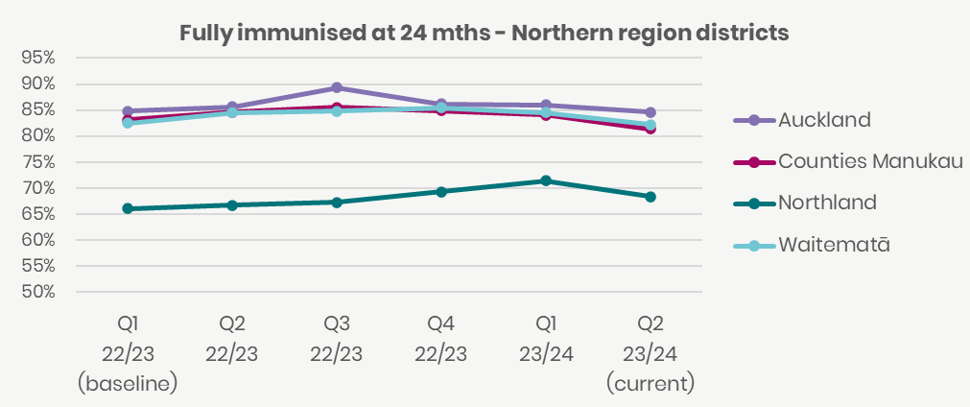

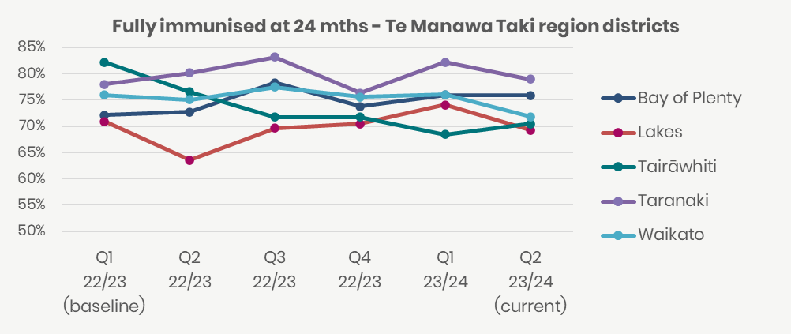

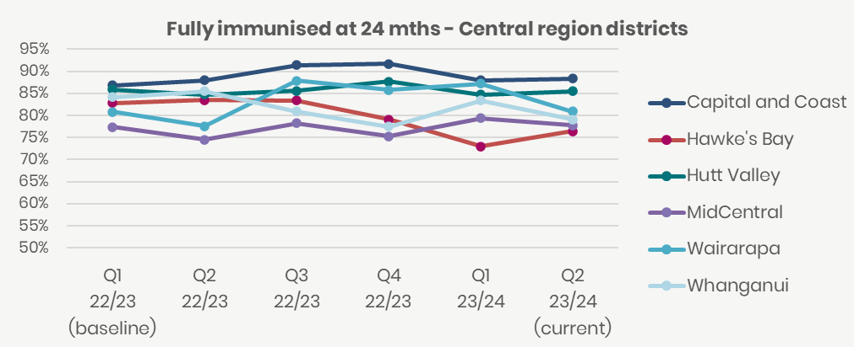

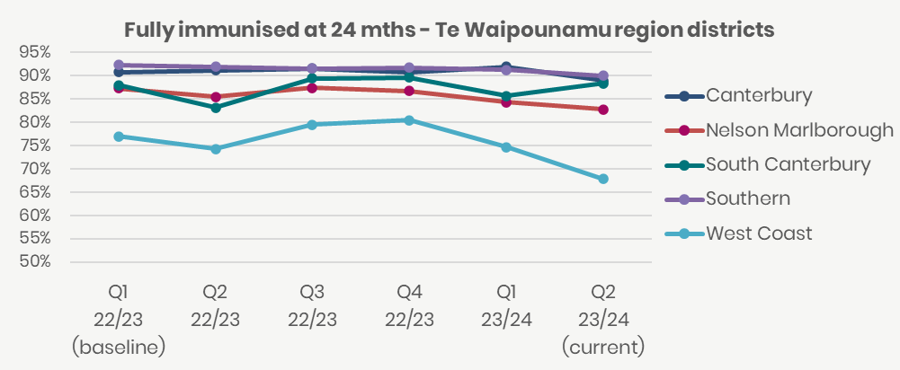

### Ambulatory sensitive hospitalisations 0-4 years

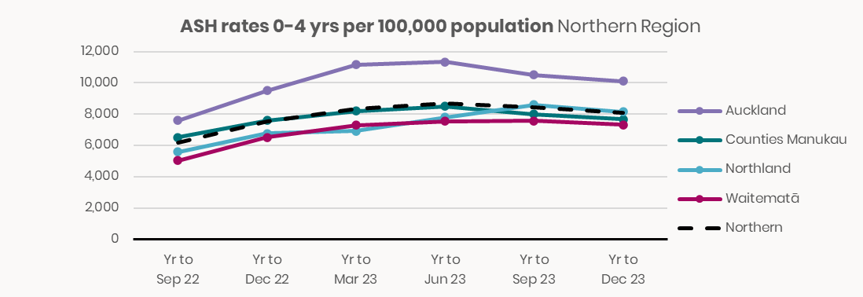

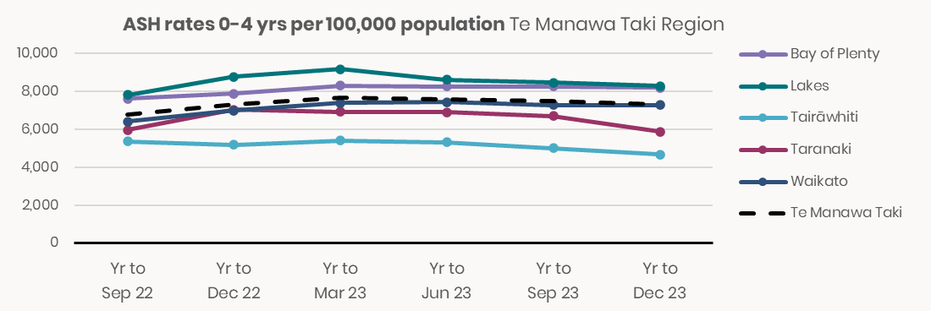

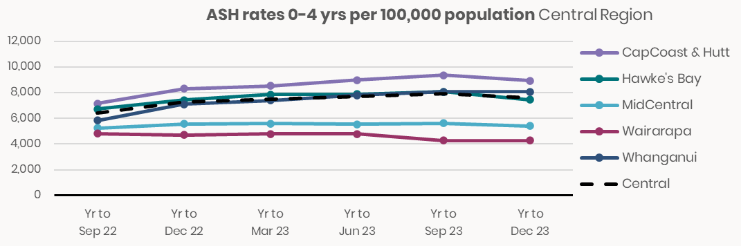

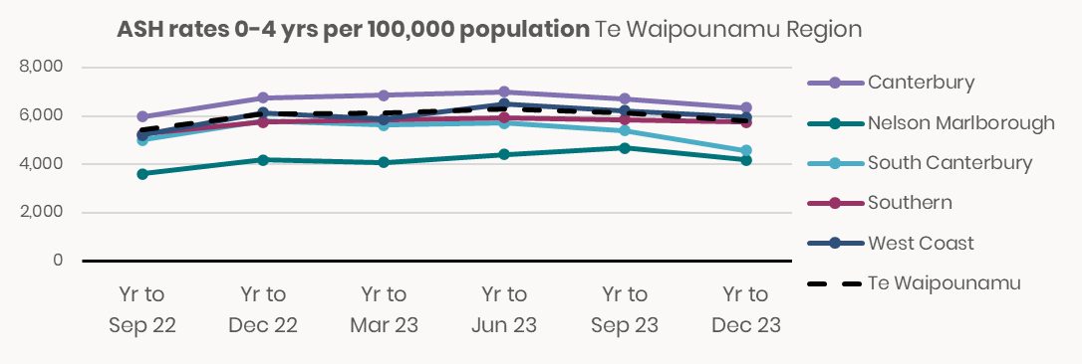

### Ambulatory sensitive hospitalisations 45-64 years

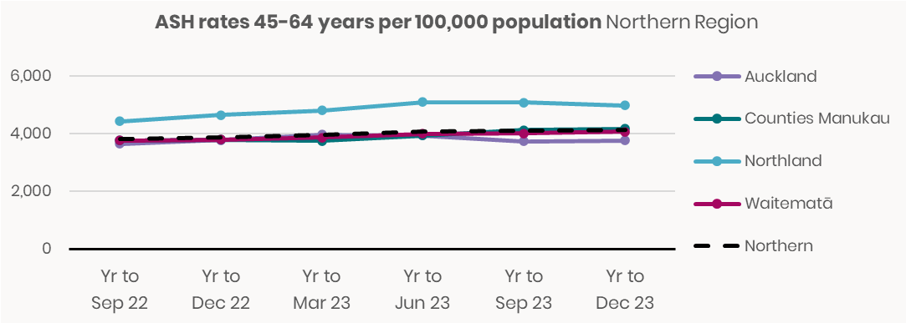

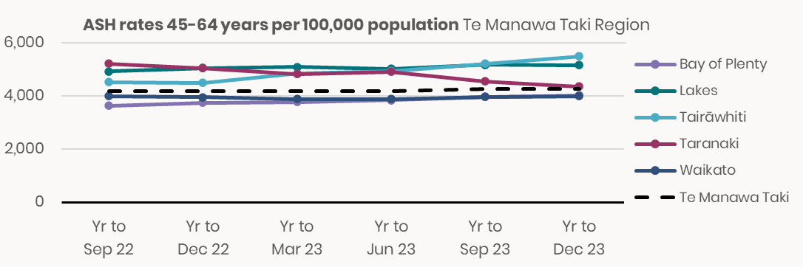

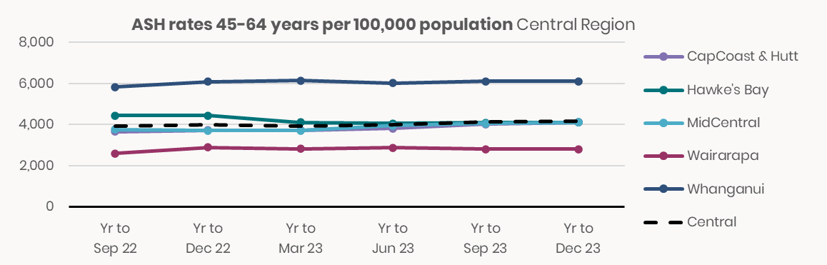

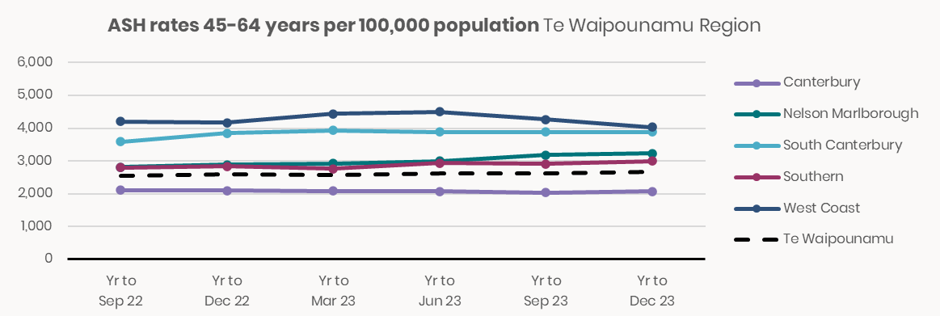

### Mental health wait times for under 25 year olds

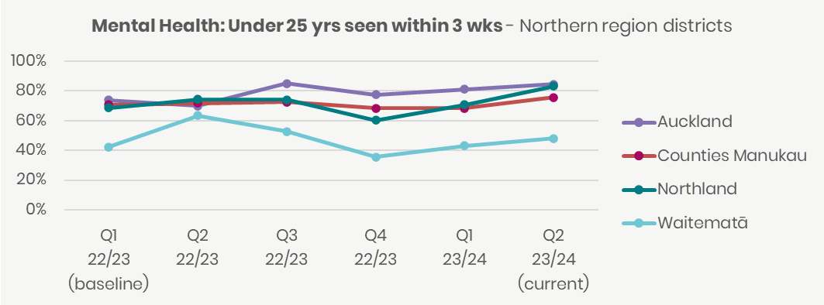

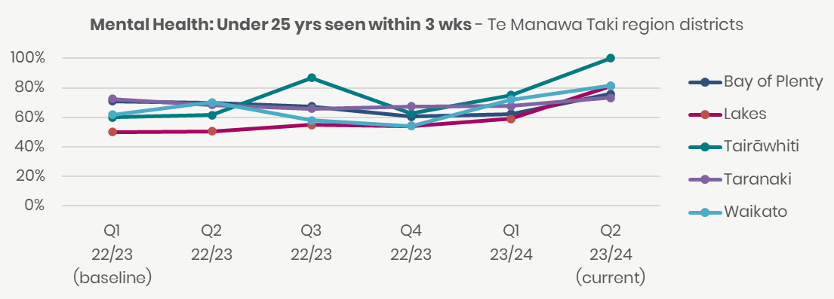

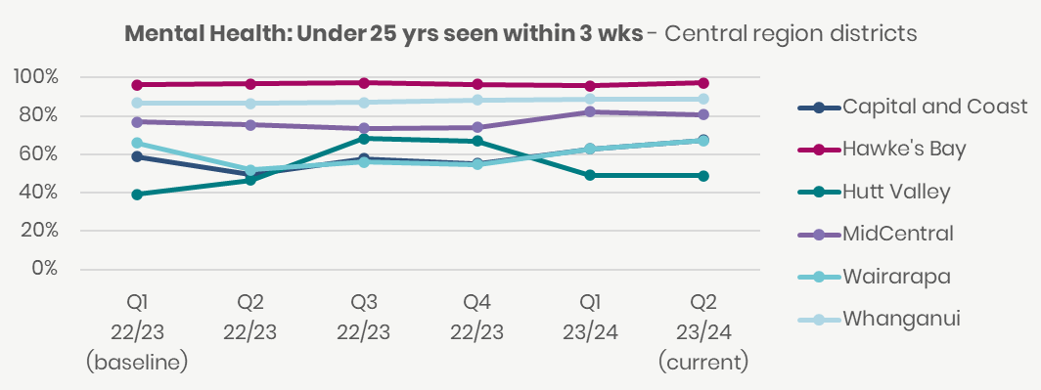

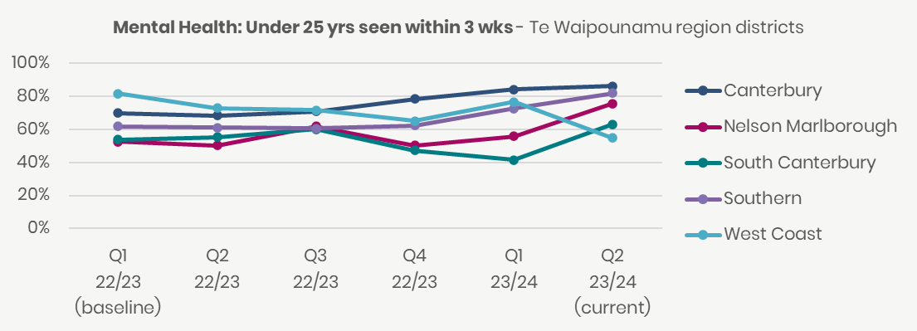

### Shorter stays in Emergency Departments

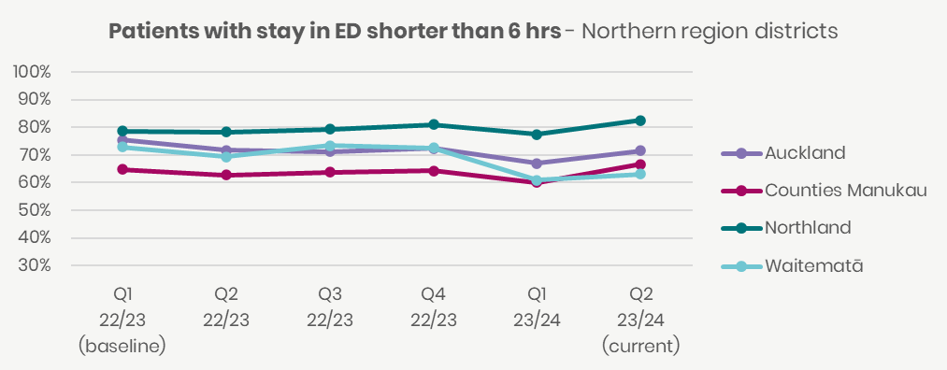

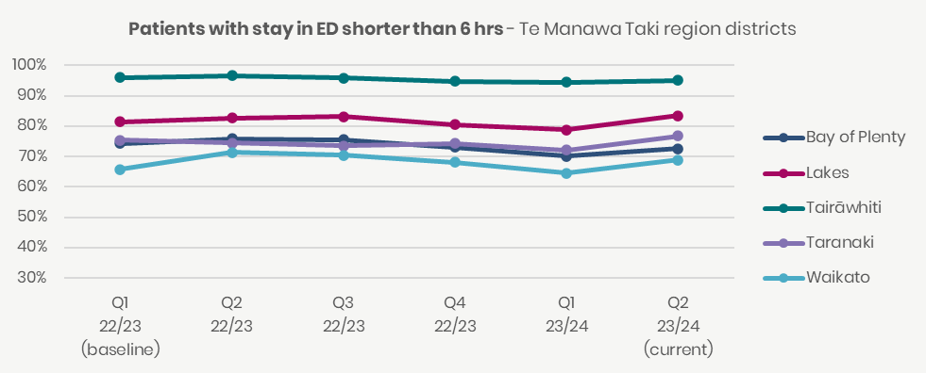

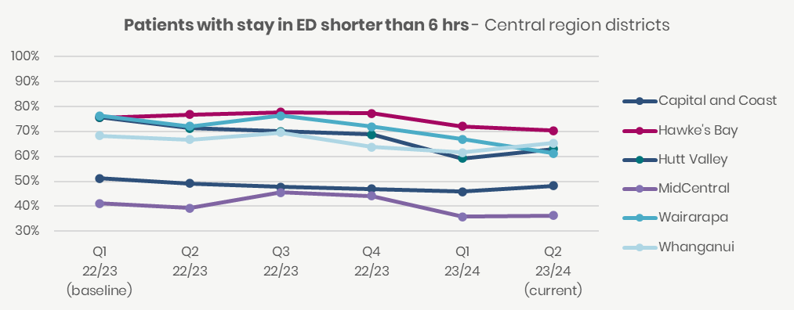

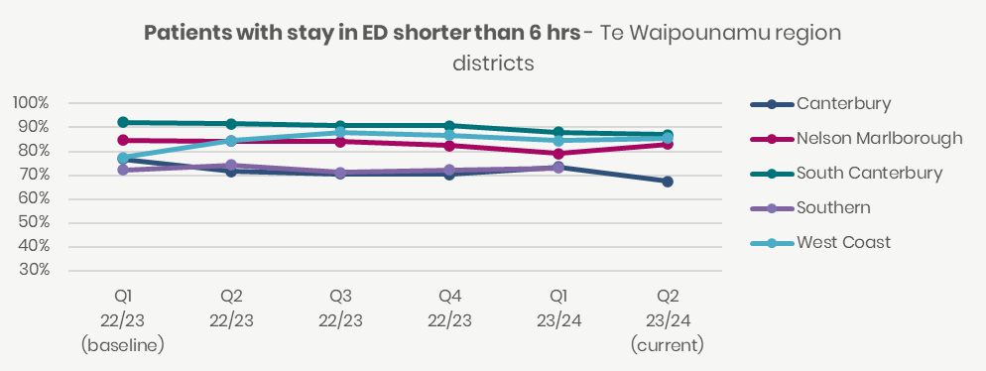

Note: Southern result for last quarter withheld due to system issues.

### Emergency Department presentations

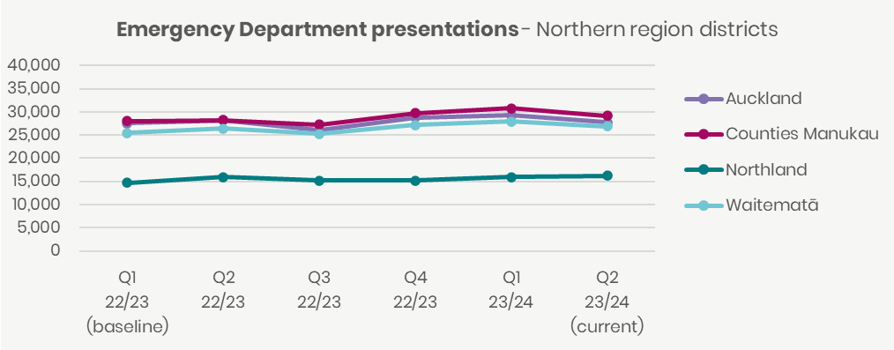

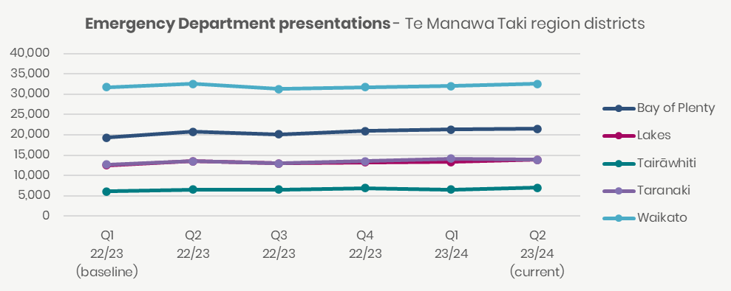

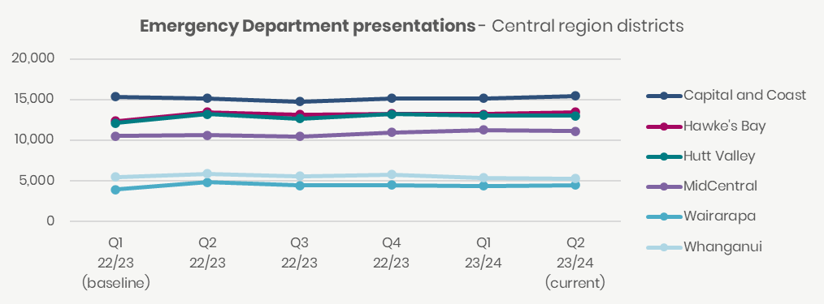

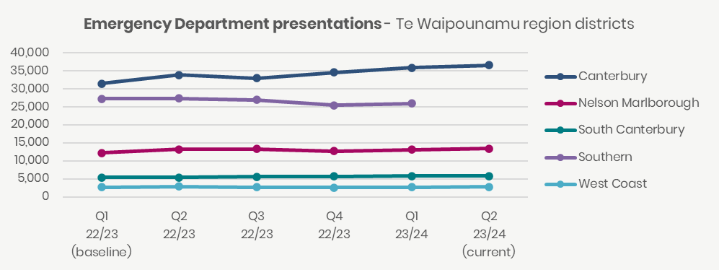

Note: Southern result for last quarter withheld due to system issues.

### Admissions from Emergency Departments

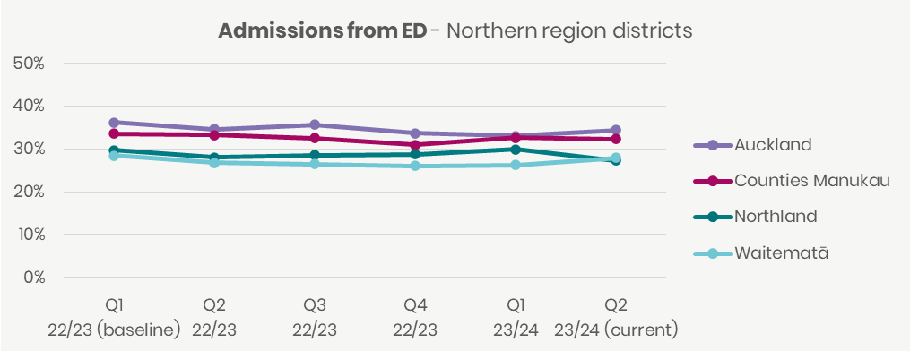

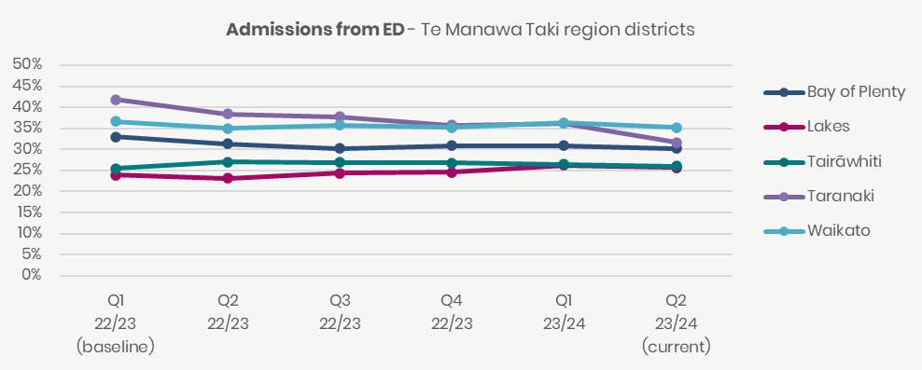

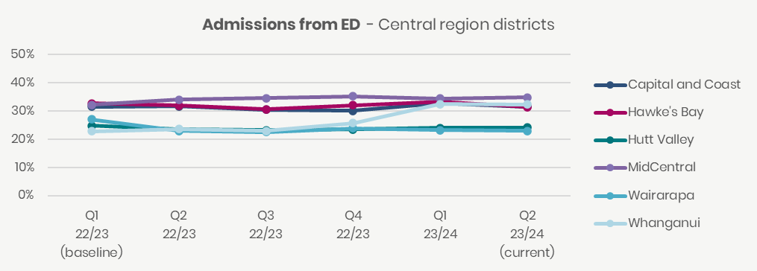

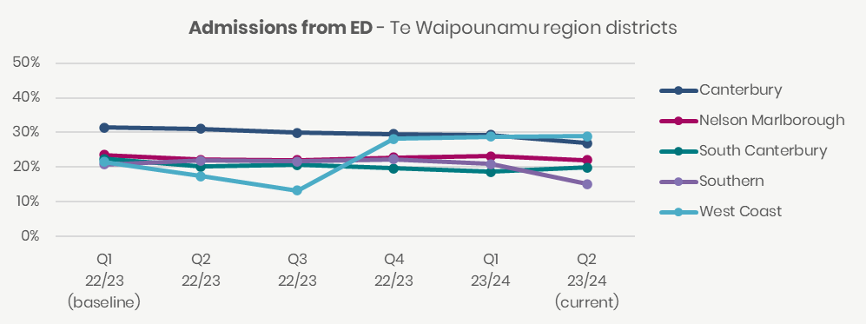

### Acute bed days per capita

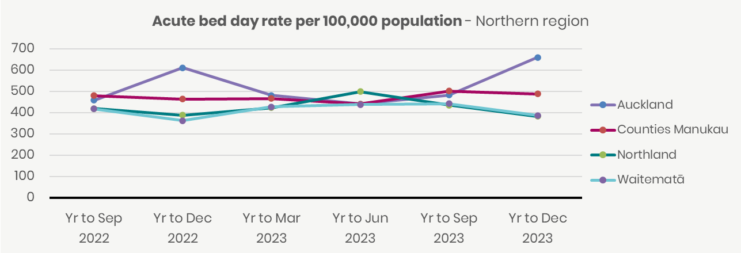

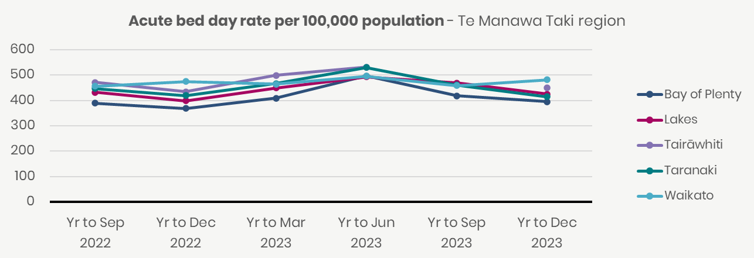

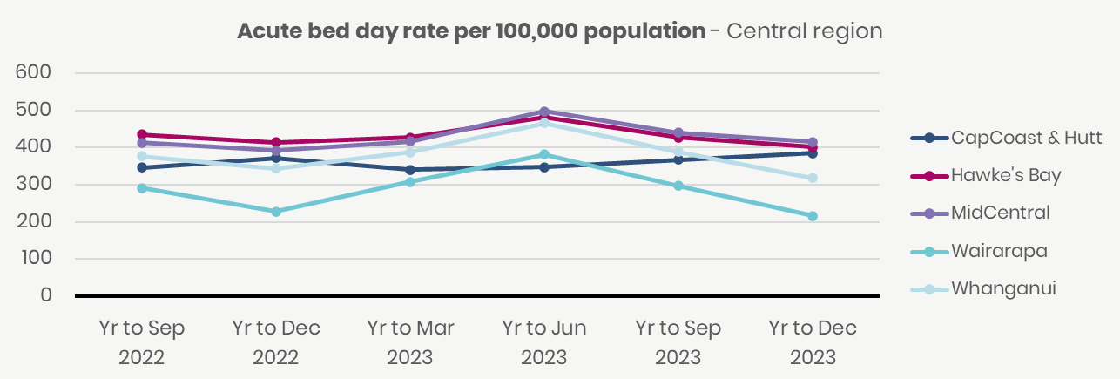

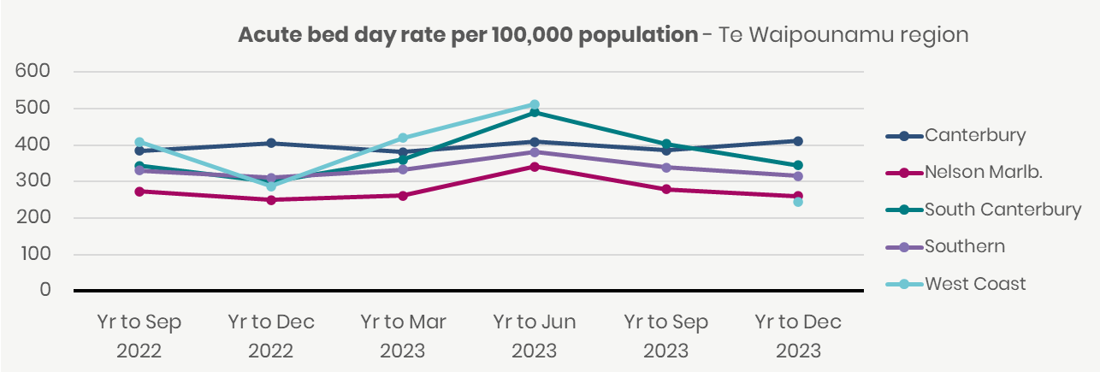

### People waiting more than four months for first specialist assessment

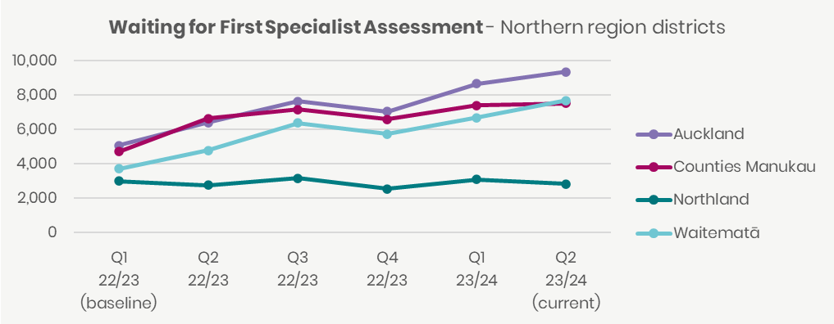

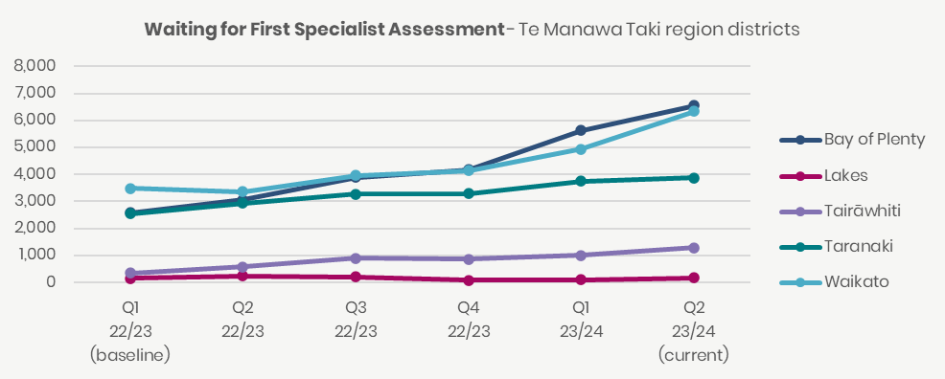

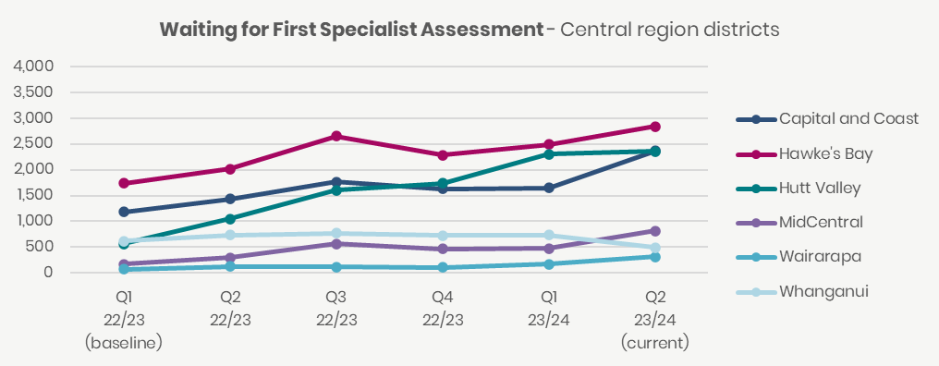

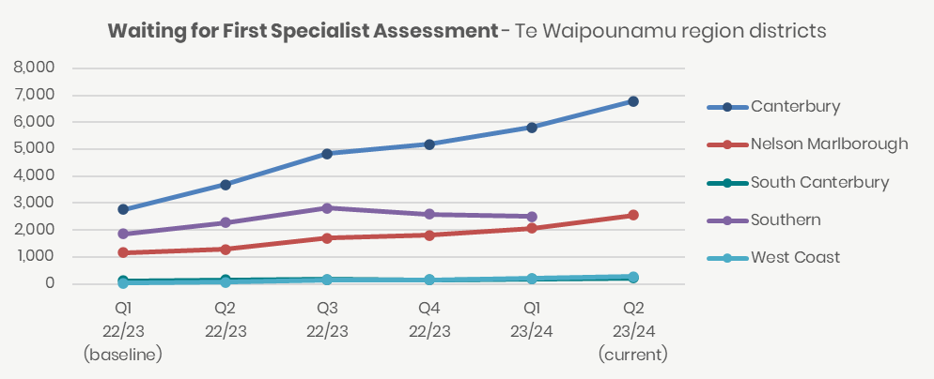

Note: Tairawhiti and Southern could not validate their numbers in the National Collections and therefore their results could not be published for quarter two 2023/24.

### People waiting more than four months for a procedure

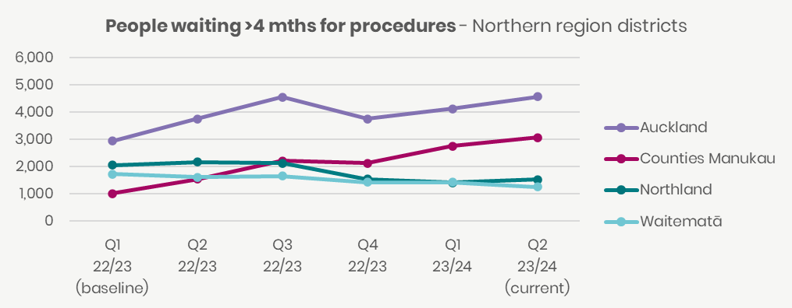

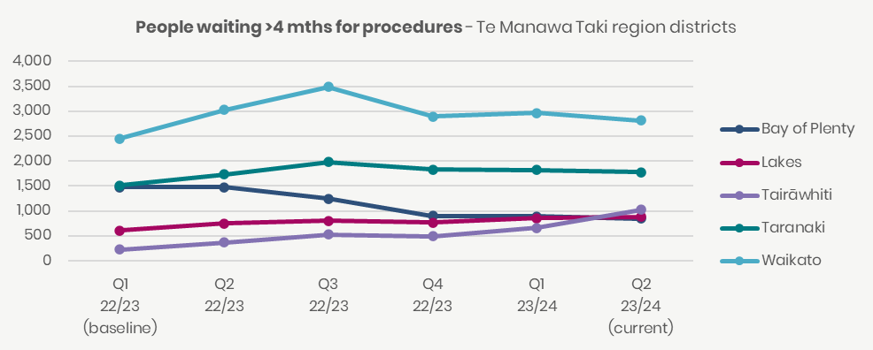

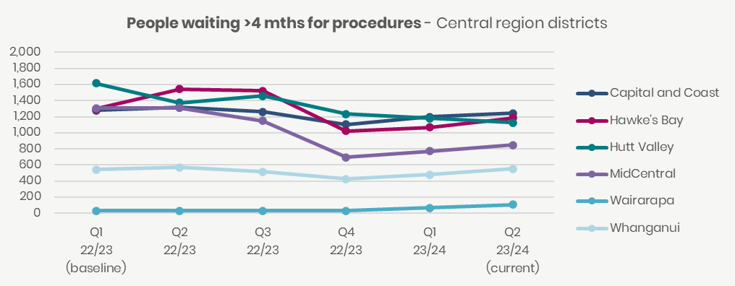

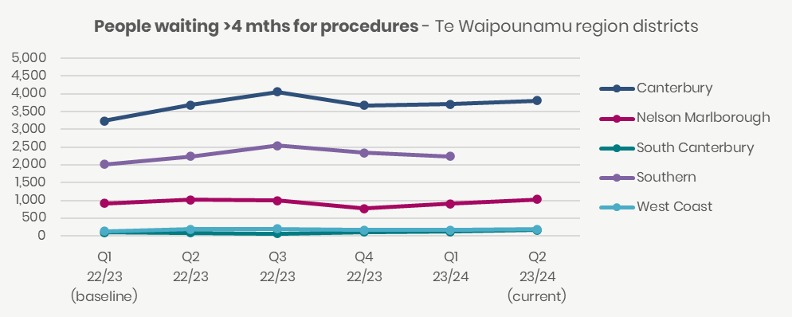

Note: Tairawhiti and Southern could not validate their numbers in the National Collections and therefore their results could not be published for quarter two 2023/24.

### People waiting more than 365 days for a procedure

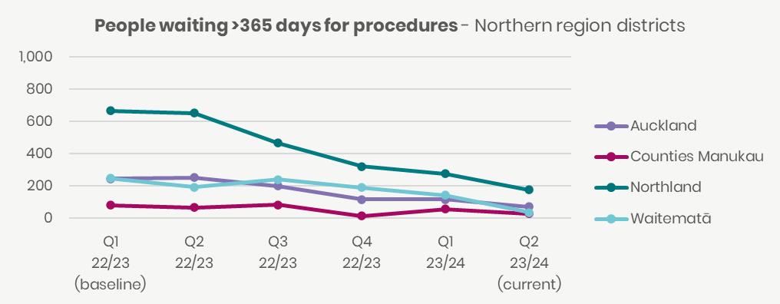

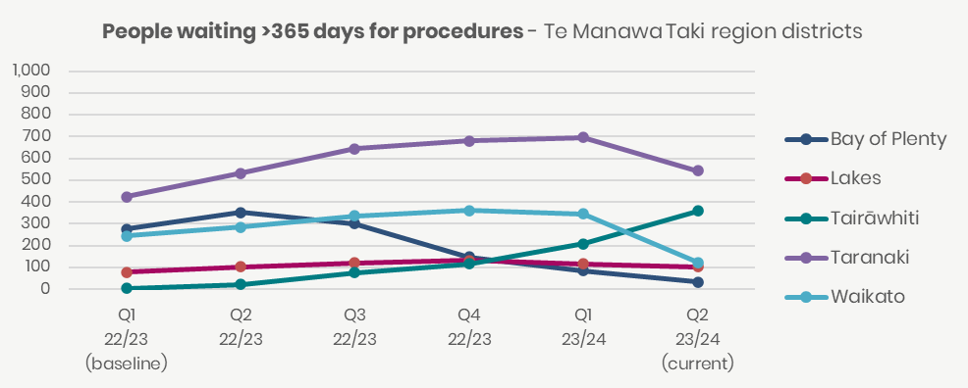

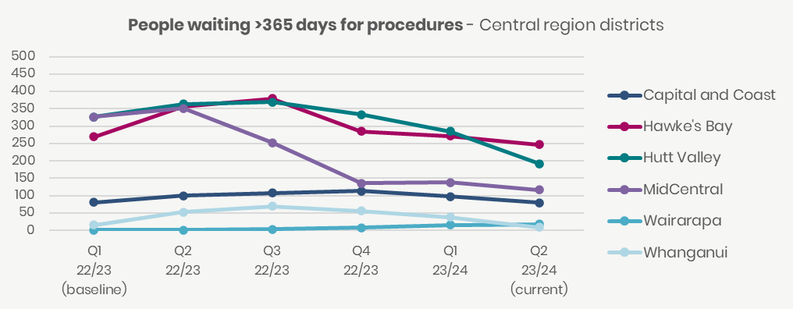

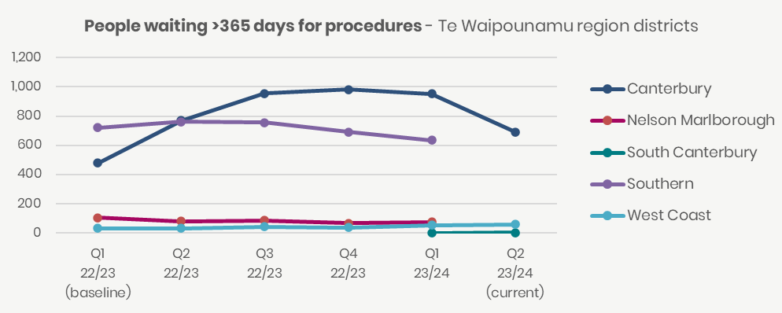

Note: Southern and Nelson Marlborough could not validate numbers in the National Collections and therefore their results could not be published for quarter two 2023/24.

### Cancer patients waiting less than 31 days for first treatment

Note: South Canterbury could not validate numbers in the National Collections and therefore their results could not be published for quarter two 2023/24 for this measure.

Corrected graphs. In the original published version of this report, this was recorded as waiting > 31 days for cancer treatment by region. This was a typo, as “waiting >31 days for cancer treatment” was incorrectly entered. The correct title is waiting < 31 days for cancer treatment.

1. No update was received for these actions prior to publication. Actions will be reassessed and updated in next quarter’s report.
2. The Equity section of this report outlines specific actions within the Māori Health Improvement. The section highlights progress on better health in our communities, maternity and early years, people with cancer, people living with chronic health conditions and People living with mental distress, illness and addictions.
3. Baseline for all measures is based on the National achievement as at quarter one 2022-23.