Clinical Performance Metrics

Citation: Te Whatu Ora – Health New Zealand. 2023. Clinical Performance Metrics: Wellington: Te Whatu Ora – Health New Zealand.
Published in July 2023 by Te Whatu Ora – Health New Zealand
PO Box 793, Wellington 6140, New Zealand
ISBN: 978-1-99-106729-6 (online)
This document is available at tewhatuora.govt.nz
This work is licensed under the Creative Commons Attribution 4.0 International licence. In essence, you are free to: share i.e., copy and redistribute the material in any medium or format; adapt i.e., remix, transform and build upon the material. You must give appropriate credit, provide a link to the licence and indicate if changes were made.

Introduction
In July 2022 Te Whatu Ora | Health New Zealand was formally established and became responsible for reporting on the performance of Aotearoa New Zealand’s health system. Prior to the establishment of Te Whatu Ora, Manatū Hauora | Ministry of Health was responsible for health system performance reporting and published quarterly performance reports to the public.

Quarterly public reporting by Manatū Hauora was a well-established practice involving non-financial reporting of (then) District Health Boards (DHBs). Data used for the public quarterly performance reporting by Manatū Hauora was, to a large extent, captured through national collections databases (national collections of health and disability information). A Manatū Hauora team (the National Collections and Reporting Group) was responsible for maintaining the collections’ databases and monitoring the quality of the information in the collections, and there was a wider Manatū Hauora team of analysts with subject matter expertise in each of the collections and years of experience in the quarterly reporting.

There were a number of steps in place to check and validate the data, with a three-month lag in data that was reported each quarter. This allowed for completion of data uploading, preparation of the data for reporting, and data validation and sign-off. The checking and validation process included local staff (data managers, clinicians and service managers) checking and verifying data.

With the establishment of Te Whatu Ora, Manatū Hauora ceased its non-financial performance reporting processes on 30 June 2022. The National Collections and Reporting Group transferred from Manatū Hauora to the Data and Digital Directorate of Te Whatu Ora. However, many of the national collections’ subject matter expert analysts did not transfer to Te Whatu Ora. In addition, some of the roles transferred were vacated due to staff leaving on transfer, leading to a loss of knowledge and expertise in the national collections and performance reporting.

In July 2022, Te Whatu Ora commenced monthly financial and non-financial performance reporting to its Board (the Board); this information was not released to the public.
The public release of performance information was discussed by the Board at its meeting in September. A paper presented to the Board noted that there was a project underway to publish key operational data on the website. The Board requested the Chief Executive (CE) draft an approach to the public release of performance data for the Board’s endorsement.

A Te Whatu Ora project team consulted and engaged with a broad group of people to develop a set of indicators for monthly public reporting and agree a process for validating and publishing the data. The purpose of public reporting was to provide visibility of key operational information to the public in a way that builds trust and confidence in Te Whatu Ora, and the aim was to publish the first monthly report by Christmas 2022. A set of 12 clincial performance metrics were identified and endorsed by the Board.

The first publication of the 12 clinical performance metrics occurred on 19 December 2022, covering data for a variety of time periods during the financial year 2022-2023.In early March 2023 the metrics were updated to show data for the period January 2022 – December 2022. On 8 March a media organisation notified Te Whatu Ora that there were errors in the Shorter Stays in Emergency Departments (SSED) measure that had been published in March. The data that had been published was temporarily taken down while it was checked and validated, and it was re-published on 3 April 2023.

Following the publication error, a review was initiated by Te Whatu Ora’s Chief Executive to identify how inaccurate data was published and to identify improvements to systems and processes to prevent a recurrence.

The full report on the review can be found here: https://www.tewhatuora.govt.nz/publications/quarterly-performance-report-1-january-31-march-2023/

As a reformed health care system, we understand that accurate data reporting to the public is fundamental to the development of public trust and confidence. Te Whatu Ora is on a journey to improve the quality of our operational and our national datasets with the aim of improving the system of internal performance reporting and partnering with Te Aka Whai Ora to develop and publish publicly meaningful measures.

Clinical Performance Metrics
Data presented in this document shows information on 11 out of 12 clinical metrics for Te Whatu Ora for the period January to March 2023 compared with January to March 2022. It is presented in visual bar-graph form to enable ease of comparison between years. If you would like access to the month-to-month data that underpins the graphs presented in this document, please contact us and we will make it available to you.

Seven of the 12 clinical metrics are performance measures included in our accountability documents (Statement of Intent/Statement of Performance Expectations), so these measures are also presented in Te Whatu Ora’s substantive quarterly performance reports (also published on our website), specifically:
            - Immunisation Coverage at 24 Months
            - Ambulatory Sensitive Hospitalisations (ASH) 0-4 Years
            - Ambulatory Sensitive Hospitalisations (ASH) 45-64 Years
            - Mental Health Wait Times
            - Acute Bed Days
            - ESPI 2 – Patients Waiting Longer than 4 Months for their First Specialist Assessment
            - ESPI 5 – Patients Given a Commitment to Treatment but not Treated within 4 Months
The remaining five clinical performance metrics are:
            - Emergency Department Presentations
            - Emergency Department Attendances <6hrs (SSED)
            - Faster Cancer Treatment 31 day indicator
            - Planned Care Waiting >365 days
            - Emergency Department Admissions
Clinical metric 12 is not published in this report due to ongoing challenges with validating the data used to produce this metric which is partly due to differing interpretations in districts as to what counts as an ‘admission’. We are working to gain consensus on a meaningful definition for this metric, to ensure it is applied consistently across the districts.
The 12 clinical performance metrics aim to measure how well the health care system across the country is performing, providing the opportunity to develop local health solutions to address local health issues. They also include metrics for cancer, acute and planned care.
The metrics allow us to measure performance over time with consistency. Where possible the data is published across all regions and districts.

All performance data provides a snapshot in time and there will be variances depending on when data is uploaded on any given day. An explanation of each data set is contained within the below graphs.

1 Immunisation Coverage at 24 Months
Coverage is calculated as the percentage of children who turned two years of age during the period who are recorded as fully immunised for age on the National Immunisation Register (NIR), including all scheduled vaccines due between birth and age two years. This measure excludes children for whom vaccination has been declined by parents of guardians or those that have opted off the national immunisation register.
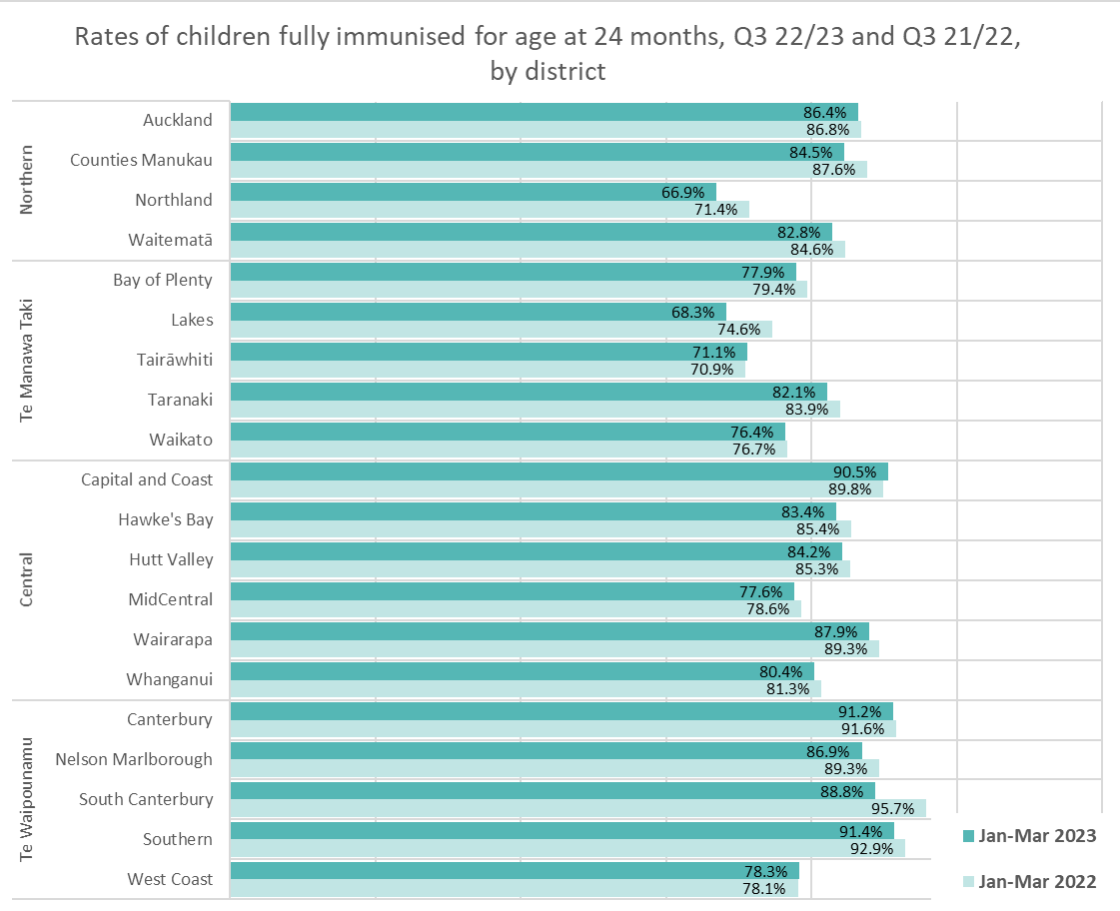
Childhood immunisation rates in Aotearoa New Zealand have fallen to critical levels, in part due to the COVID-19 pandemic. In 2022, Te Whatu Ora established the National Immunisation Taskforce to provide advice on steps to rapidly improve childhood immunisation rates and achieve equity in coverage. In April 2023, the Taskforce released a report, Initial Priorities for the National Immunisation Programme in Aotearoa, identifying systemic issues across various parts of the immunisation system which could work better to deliver immunisations to children. The key goal of the Taskforce is to build a system that delivers immunisations on-time and works for Māori, who are more at risk of vaccine-preventable disease. Several significant pieces of work are currently underway.

2 Ambulatory Sensitive Hospitalisations, 0-4 yrs
Ambulatory sensitive hospitalisations (ASH) are acute admissions that are considered potentially reducible through interventions deliverable in a primary care setting. Results are presented as a rate per 100,000 population, i.e. the number of ASH admissions to hospital for children aged between 0 and 4 years divided by the number of children in the population x 100,000.
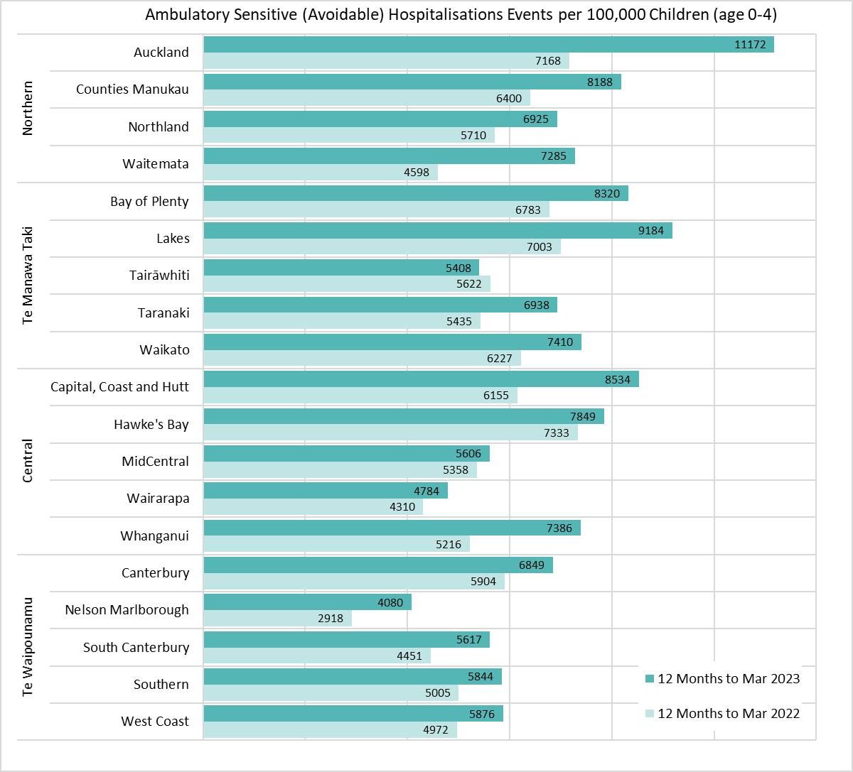
The rate of avoidable hospitalisations for 0-4 year olds has increased for all districts apart from Tairawhiti between the year to March 2022 and the year to March 2023.

3 Ambulatory Sensitive Hospitalisations, 45-64 yrs
Ambulatory sensitive hospitalisations (ASH) are acute admissions that are considered potentially reducible through interventions deliverable in a primary care setting. Results are presented as a rate per 100,000 population, i.e. the number of ASH admissions to hospital for adults aged between 45 and 64 years divided by the number of adults aged 45-65 years in the population x 100,000.
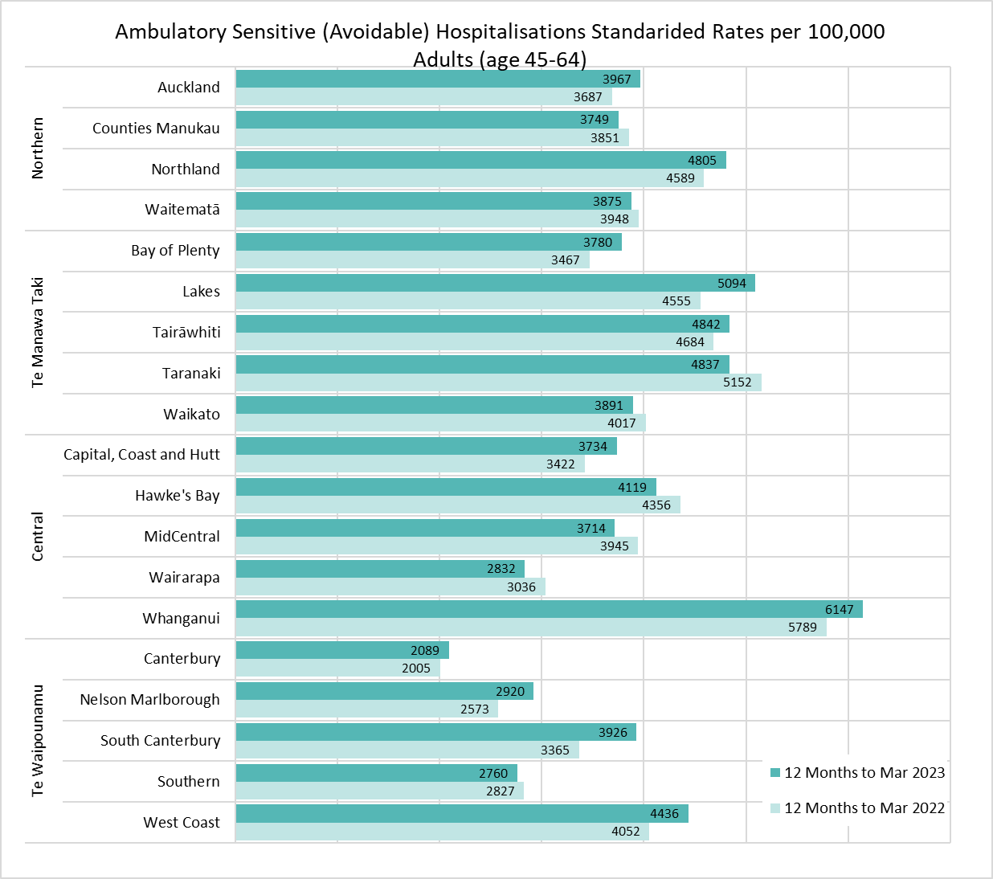
The ASH rate for 45-65 year olds increased by more than 10% in three districts (Lakes, Nelson Marlborough and South Canterbury) between the year to March 2022 and the year to March 2023.

4 Mental Health Wait Times
This measure reports the proportion of young people (aged under 25) who have been referred to and seen by a specialist mental health service who were seen within three weeks of referral. Waiting times are counted from the time referral is received to first face-to-face contact with a mental health professional.
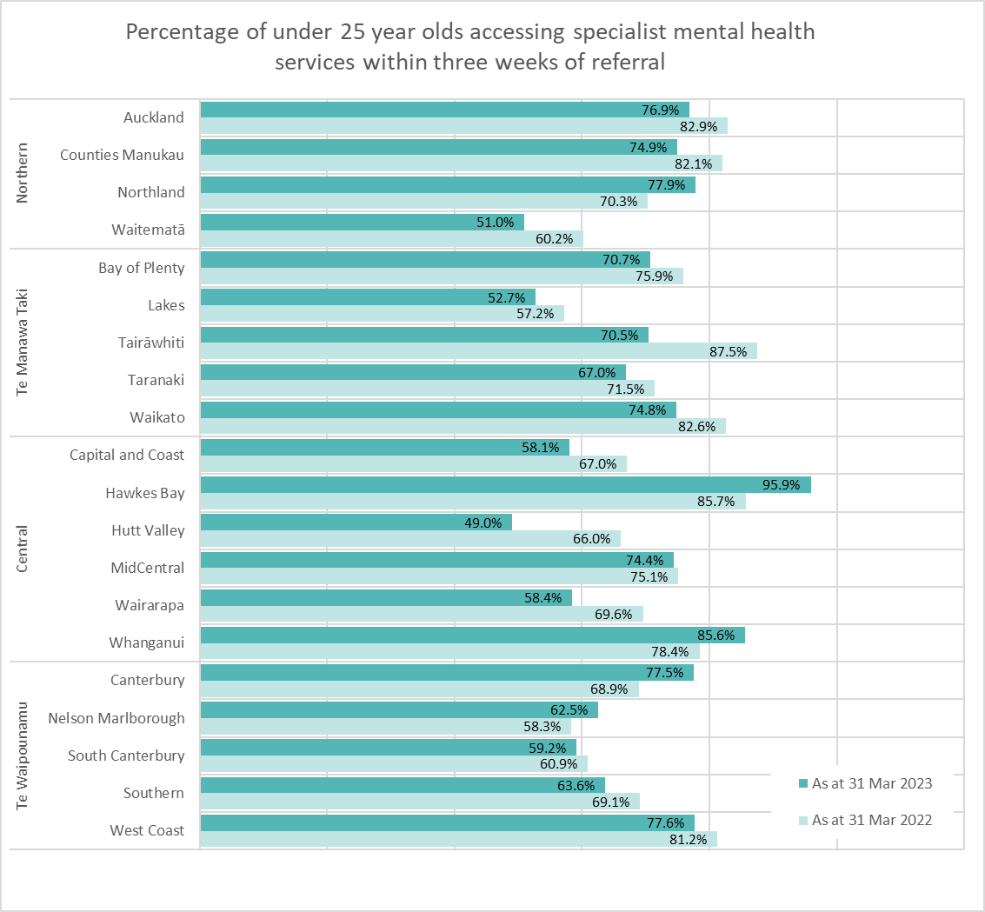
While five districts (Northland, Hawke’s Bay, Whanganui, Canterbury, Nelson Marlborough) showed improvement in the time to first assessment in the year to March 2023 compared to the previous year, the majority showed an increase in the proportion of young people not accessing services within three weeks.

Note: Data for March 2023 in Canterbury is incomplete at time of reporting, and therefore the Apr 2022-Mar 2023 result may change in subsequent reports when data is complete. The source of data is the Programme for the Integration of Mental Health Data (PRIMHD) National Collection.

5 Acute Bed Days
Acute bed days are the number of days a person spends in hospital, following an acute admission. The acute bed days rate is presented as the number of bed days for acute hospital stays per 1000 population, age standardised. This measure is intended to reflect the demand for acute inpatient services on the health system.
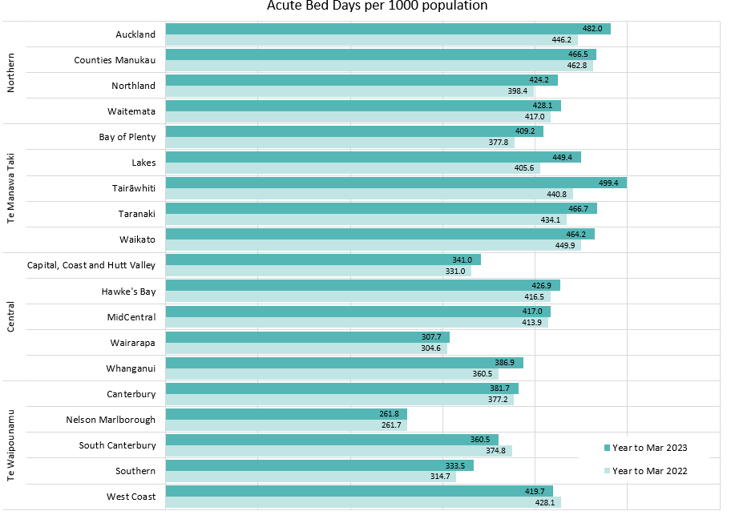
The number of acute bed days per 1000 population has increased in all districts apart from two (South Canterbury and Nelson Marlborough) in the year to March 2023, compared to the year to March 2022.

6 Faster Cancer Treatment
This measure shows the proportion of eligible cancer patients who receive their first treatment within 31 days of a decision to treat by a health professional. The days are counted from the decision to treat date to the delivery of their first treatment.
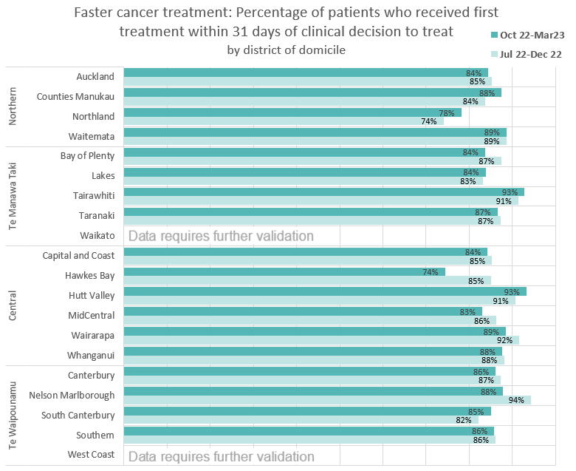
Six districts (Counties Manukau, Waitematā, Lakes, Tairawhiti, Hutt Valley and South Canterbury) showed a small decrease in time to first treatment for cancer (from decision to treat) in the six months to March 2023 compared to the six months to December 2022. The other districts showed an increase, with one district (Hawke’s Bay) showing a >10% increase in the six months to March 2023 compared to the six months to December 2022.
Note: For 14 districts source of data is Faster Cancer Treatment (FCT) national collection. For 4 districts, the source of data is district supplied and for two districts, data requires further validation before publication.

7 Planned Care ESPI 2 - Patients Waiting Longer Than 4 Months for First Specialist Assessment (FSA)
Elective Services Patient Flow Indicators (ESPI) measure whether districts are meeting the required performance standard at a number of key decision or indicator points on the person’s journey through the Planned Care system. ESPI 2 refers to patients waiting longer than 4 months for their first specialist assessment (FSA).
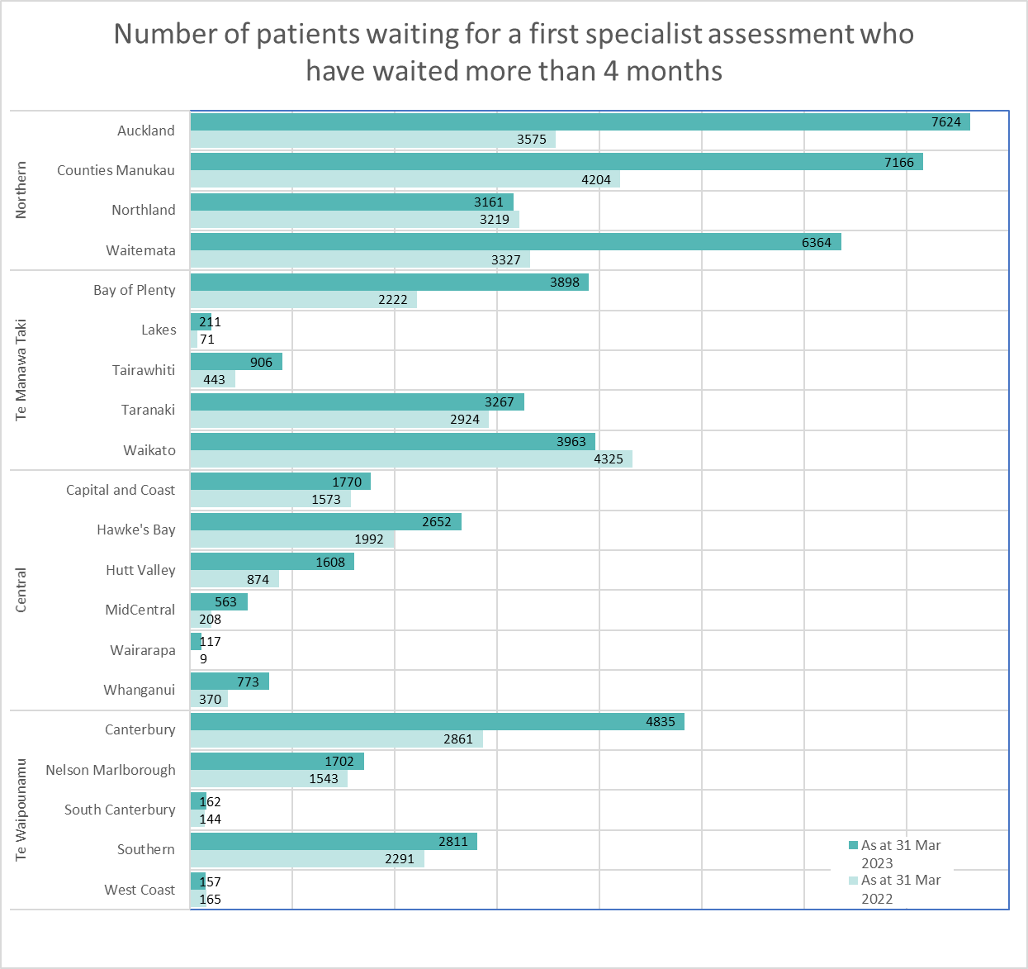
For four districts (Northland, Waikato, South Canterbury, West Coast) the number of patients waiting more than four months for first specialist assessment between March 2022 and March 2023 decreased or remained the same. For other districts, the number waiting increased between those periods.
Note: Source of data is the ESPI2 National Collection.

8 Planned Care ESPI 5 - Patients given a commitment to treatment but not treated within 4 months
Elective Services Patient Flow Indicators (ESPI) measure whether districts are meeting the required performance standard at a number of key decision or indicator points on the person’s journey through the Planned Care system. ESPI 5 refers to patients given a commitment to treatment but not treated within 4 months. The goal is to ensure no patients with this status remain untreated after 4 months.
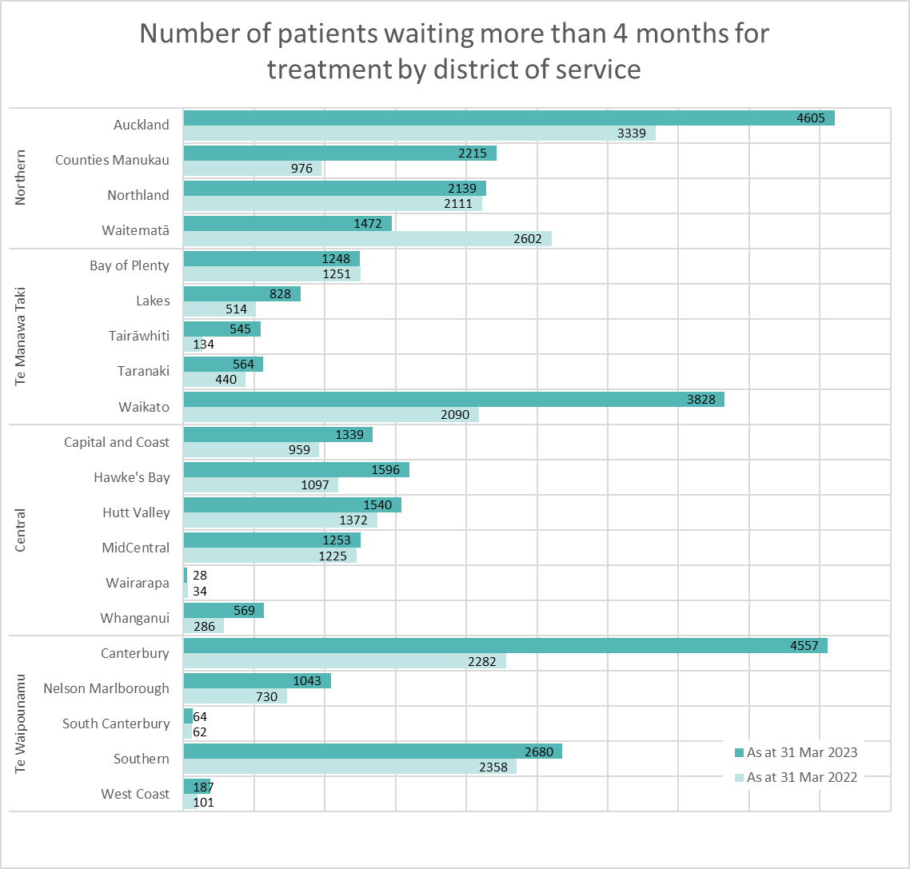
For three districts (Waitematā, Wairarapa and South Canterbury) the number of patients waiting more than four months for treatment between March 2022 and March 2023 decreased or remained the same.
Note: Source of data is National Booking Reporting System (NBRS) for 19 districts and district supplied for one district.

9 Planned Care: Long wait times for treatment
This measure reports the total number of people in each district who have been waiting on a planned care waitlist for a procedure for more than 365 days from the time they were ready for treatment.
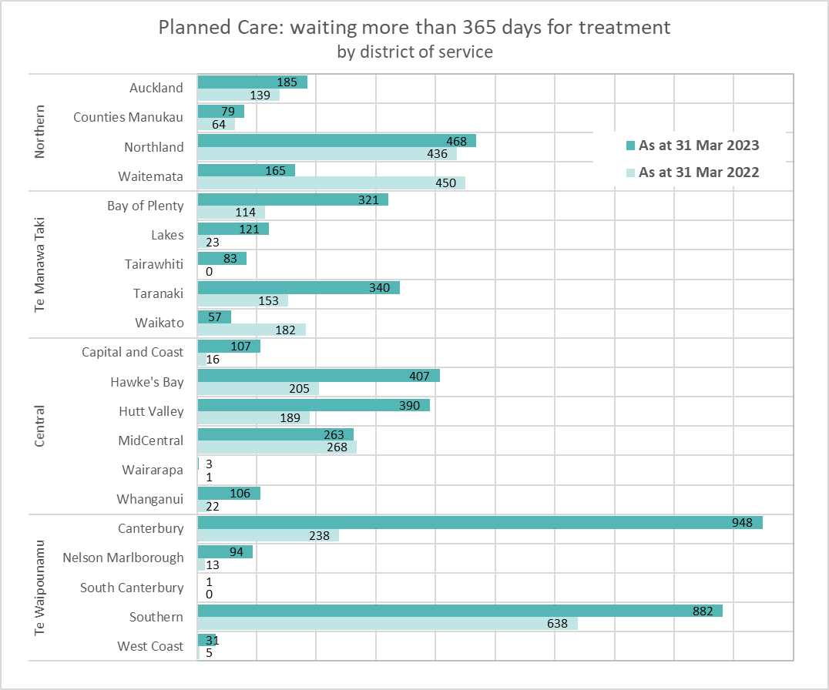
For 14 districts, the number of patients waiting for more than a year for treatment increased between end of March 2022 and end of March 2023. Two districts (Canterbury and Southern) had more than 700 people who had waited more than a year for treatment as at end of March 2023.
Note: For 13 districts source of data is the National Booking Reporting System. For 7 districts, source of data is NBRS for period ending Mar 2022 and district supplied for period ending Mar 2023 (and validated as close match to Rapid National Data Automation (RNDA) Dataset for Waitlists).

10 Emergency Department Presentations
Emergency department (ED) presentations reflects the number of people who present to an emergency department.
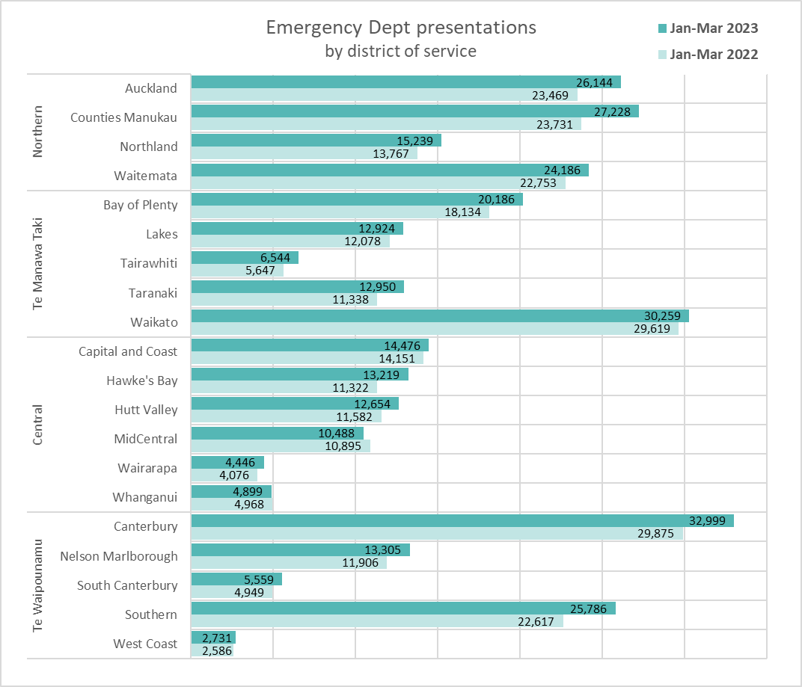
All districts apart from two (Midcentral and Whanganui) experienced an increase in ED presentations between the two periods. Ten districts (Auckland (Te Toka Tumai), Counties Manukau, Northland, Bay of Plenty, Tairawhiti, Taranaki, Hawkes Bay, Nelson Marlborough, South Canterbury and Southern) experienced an increase in ED presentations of greater than 10% in Jan-Mar 2023 compared to the same period 2022.
Note: This measure excludes patients presenting directly to an Acute Assessment Unit (AAU) or via ED where the only input in ED was triage. For 17 districts source of data is National Non-admitted Patient Collection (NNPAC) and for 3 districts source of data is district supplied.

11 Shorter Stays in Emergency Departments (EDs)
This measure reports the proportion of ED patients who were admitted, discharged, or transferred from an emergency department within six hours. This measure excludes those people who presented to ED in error as well as those who did not wait to be seen.
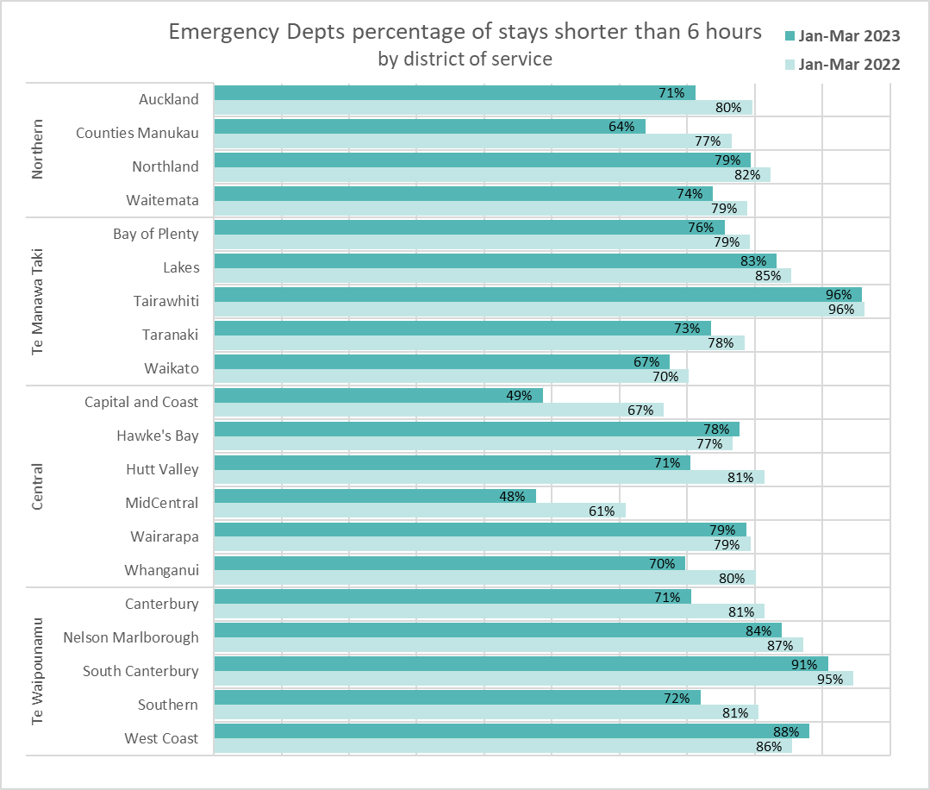
For 11 districts there was an increase of greater than 10% in their ED length of stay in Jan-Mar 2023 compared to the same period 2022. Overall, the proportion of ED stays under 6 hours decreased by 9% (Jan-Mar 2022,79% to Jan-Mar 2023, 72%) while ED presentations increased by 9%.
Note: This measure excludes patients presenting directly to an Acute Assessment Unit (AAU) or via ED where the only input in ED was triage and patients who did not wait to be seen. For 17 districts source of data is National Non-admitted Patient Collection (NNPAC) and for 3 districts source of data is district supplied.

The information contained in this report has been derived from the National Immunisation Register database. While the Ministry of Health has taken all reasonable steps to ensure that the information contained in this report is accurate and complete, it accepts no liability or responsibility for the manner in which the information is used or subsequently relied on.

