 

Primary Health Dataset Programme (PHDP)

Current State Analysis

October 2022

Citation: Te Whatu Ora – Health New Zealand. 2022. *Primary Health Dataset Programme (PHDP) Current State Analysis Report*. Wellington: Te Whatu Ora – Health New Zealand.

Published in October 2022 by Te Whatu Ora – Health New Zealand  
PO Box 793, Wellington 6140, New Zealand

ISBN 978-1-99-117127-6



This document is available at [tewhatuora.govt.nz](https://www.tewhatuora.govt.nz/)

|  |  |
| --- | --- |
| **CCBY** | This work is licensed under the Creative Commons Attribution 4.0 International licence. In essence, you are free to: share ie, copy and redistribute the material in any medium or format; adapt ie, remix, transform and build upon the material. You must give appropriate credit, provide a link to the licence and indicate if changes were made. |

# Foreword

The Primary Care Dataset Programme (PHDP) seeks to create a more comprehensive dataset that includes data already held nationally and data that is not available nationally to improve health service planning and delivery. It is a collaborative programme of work between Te Whatu Ora, Te Aka Whai Ora and the primary health care sector.

The approaches taken by Primary Health Organisations (PHOs) in the access, curation and use of data sourced from general practice and in some cases other source is explored in this report. As well access preferences from PHOs to data held nationally, that may support their work is also explored.

Thanks to the PHOs who have dedicated time and resources in participating in this work.

Contents

Foreword 3

Acknowledgements 7

Executive summary 8

1. Objective 10

2. Background 10

2.1 Primary Health Dataset 11

2.2 Primary health dataset programme approach 12

2.2.1 Current state survey 15

2.2.2 Data availability survey 16

3. Current state capability across the data management lifecycle 17

3.1 Structure and composition of PHOs 17

3.2 Stakeholder personas 18

3.2.1 Consumer 18

3.2.2 General Practice 19

3.2.3 PHOs 19

3.2.4 Central Agency Te Whatu Ora, Te Aka Whai Ora, Manatū Hauora 20

3.3 Data management tooling across PHOs 20

3.4 Self-assessment of data management lifecycle capabilities 21

3.4.1 Summary 21

3.4.2 Collaboration with practices for data collection 25

3.4.3 Data transformation, consolidation, and curation 26

3.4.4 Data storage 28

3.4.5 Data analysis and reuse for decision making and action 30

3.4.6 Data governance 32

3.5 Assessment of relevant documents supplied 33

3.6 Summary of gap(s) in current approaches and barriers to success 34

3.6.1 Governance 34

3.6.2 Insufficient funding 34

3.6.3 Capability 37

3.6.4 Technology 37

3.6.5 Process 39

3.6.6 Data quality 39

3.6.7 Data culture 40

3.6.8 General Practice 41

3.6.9 Vendors 41

3.7 Resources needed for success 42

4. View of use(s) for PMDS for population health analysis 43

4.1 Current state population health analysis based on reports already produced 43

4.2 On National Collections 44

4.2.1 Current usage 44

4.2.2 Desired use and desired population health questions to be answered 46

4.2.3 Barriers to its use 47

4.2.4 Other feedback to PHDP, including datasets that may be missing 48

4.2.5 Top National Collections desired 49

4.2.6 Unavailable National Collections 49

5. Data availability 50

5.1 Data elements / fields 50

5.1.1 Overall availability 52

5.1.2 Direct match 54

5.1.3 Transformation required from data held 55

5.2 Summary 60

5.2.1 Limitations of survey results 60

5.2.2 Summary of degree of support required 61

6. Next steps 64

6.1 Updated proposed PMDS 64

6.2 Programme steps 66

7. Appendices 67

A. PHDP presentation to stakeholder(s) sample 67

B. Engagement register 67

C. Engagement briefing notes 67

D. Engagements Word Cloud 67

E. Current State and Data Availability Survey 67

F. Approval memo – Primary Health Dataset Proposal 67

G. Health and Disability System Review Report 2020 67

H. Current State and Data Availability Survey PowerBI report 68

I. Stakeholder activities across the Consumer / Patient Journey Stages 68

J. Data and Information Strategy for Health and Disability 2021-2024 68

K. Interim Government Policy Statement on Health 2022-2024 68

L. PHDP Governance Terms of Reference 68

# Acknowledgements

**Author(s)**

Author:

Gayatri Sevilla Fernando, Lead / Senior Business Analyst, Primary Health Care System Improvement, Innovation and Commissioning

Editors:

Stephen Lavery, Programme Manager Primary Health Care System Improvement, Innovation and Commissioning

Tony Cooke, Co-lead, Primary Health Dataset Programme

**Acknowledgements**

To Primary Health Organisations and contracted provider CEOs and technical representatives, Royal New Zealand College of General Practitioners (RNZCGP) and New Zealand Rural General Practice Network (NZRGPN), Managed Services Organisations (MSO). GenPro, Māori health providers, Federation of Primary Care, Practice Managers and Administrators Association of New Zealand (PMAANZ), Primary Care Clinical Leads, Health Quality and Safety Commission (HQSC), National Collections and Reporting Team, Health and Disability Intelligence, Te Whatu Ora, Christine Scott, National Manager, Clinical Pathways, Te Whatu Ora and the Primary Health Dataset Programme Governance Board.

**Disclaimer**

The insights and recommendations in this case study are the result of the analysis and interpretation of the Authors, based on the engagements held with the Primary Health Organisations and contracted providers in June and July 2022.

# Executive summary

Implementing the Health and Disability System Review (The Review) recommendations to support good health outcomes for all New Zealanders require a connected, equitable and sustainable health system reliant on significant improvements to the way data and information will be collected, managed, used, and shared.

The Primary Health Dataset Programme (PHDP) serves to support the Review’s outcomes, specifically in helping enable population health approaches.  Primary Health Organisations (PHOs) were engaged and surveyed with respect to their role and expertise in data management, as well as a broad engagement with other primary health groups to understand current state data capability and data availability accordingly, the results of which are presented in this report.

The current state analysis focusing on data capability reveal an average self-reported rating of 83% in effectiveness as far as PHOs’ data capabilities are concerned. The highest confidence is found in PHOs’ ability to collaborate with general practices (GPs), rated at an average of 91%, in contrast to data governance capabilities rated at an average 76%.  Ratings varied considerably across PHOs. For data governance, for example, some say their data governance is very good, while others say there is room for improvement.  This variability also exists between PHOs relative to their size. Small (enrolment population less than 100,000) and large (greater than 250,000) PHOs tend to describe better relationships with their affiliated general practices and consequently they have a higher degree of trust when sharing information, while some medium sized PHOs (enrolment population between 100,000 and 250,000) describe struggles with general practices who opt-out of providing data for wider analytical purposes in around 5% of cases.

Many of the technology platforms and tools used by PHOs are typical mainstream technologies e.g., PowerBI, Office 365, Azure, etc., for the most part, and a reasonably high level of confidence was expressed in their use. Larger PHOs and Management Service Organisations (MSO) are naturally more sophisticated in their range of data collected and the use of programme or population level dashboards compared with medium sized PHOs who experience more difficulty.

While larger PHOs have the economy of scale to conduct population health analysis, other PHOs expressed a shortage of resources and knowledge to perform more detailed population health analysis and other forms of analysis, for example, for surveillance. There is a desire for greater sharing of knowledge and to have repeatable and recognised methodologies in this area.

As far as data availability to potentially produce the Primary Health Dataset is concerned, 73% of the proposed data elements appear to be held by PHOs already, 53% of which will require transformation. This increases to 84%, however, upon removing 9 data elements, also reducing the extent to which transformation will be required at 41% of data elements only.

Survey results also show that PHOs are collecting data from all the key data classes identified in recommendations circulated to the PHDP governance group in May 2022. Predictably, where data coincides with reportable measures or claims for various programmes there is a high degree of alignment e.g., smoking status, immunisation. PHOs already use this data for a wide variety of purposes, and all have said they use the data for better decision making for health service design and a population health focus.

Furthermore, considerable investment and effort has already been made by PHO data management teams in customising code to manage the extraction of data from practice management systems. However, because there have been few incentives for classifying and moderating data at the point of care, data tends to be collected in a variety of different ways and in different formats or as plain text – even within same versions of the system. PHO data management staff have to unravel all manner of variety in order to standardise the data to allow it to be consumed for analytical purposes.

All PHOs have also expressed a desire for better and easier access to existing datasets held nationally to support their population health analysis practices. In some cases, survey results reveal a lack of awareness that National Collections data is available for their use. Also, rather than try and source data from National Collections, some PHOs have instead worked with their Te Whatu Ora districts to combine secondary care data into a population health dataset, which ends up being more up to date because of the six-week time lag in reporting hospital discharges to the National Minimum Dataset.

The PHDP programme has conveyed in its engagements that this report will be used to inform recommendations to further develop the programme. A thematic analysis of PHOs’ feedback shows that their belief in this programme’s success will depend on barriers to be addressed around data governance, leadership, sufficient funding, capability support, technology, process, data quality, data culture, general practice and vendor support.

# Objective

1. To analyse and document the current data management approaches of Primary Health Organisations (PHOs) to support the Primary Health Dataset Programme.

2. To assess the barriers and risks associated with the development of the Primary Health Dataset.

3. To confirm the scope and direction of any further analysis required to shape the next steps in the programme, which will inform options for the establishment of a primary health dataset, timeframes and resource requirements.

# Background

Significant change has been signalled through the government’s decisions to implement the Health and Disability Review 2020[1]. Critical to these proposed changes is the intention to significantly shift the focus of the health system to improving equity for people who have access barriers or do not participate in the health system, as well as in ensuring the system is integrated and deliberately planned with a longer-term focus.

Similarly, the Waitangi Tribunal findings from the Wai 2575 - the Health Services and Outcomes Inquiry (Wai 2575)[2] further consolidates policy, strategy, and operational direction for the system in terms of improved outcomes for Māori.

Manatū Hauora (Ministry of Health), Te Whatu Ora (Health New Zealand) and Te Aka Whai Ora (Māori Health Authority) are the structures to advance these aims.

Data and digital enabled approaches are key enablers. As the health and disability system increasingly relies on technology, the development, creation and use of nationally standardised datasets as well as the joining up of all data including data managed in a primary and community care setting will be essential to targeting of priority populations whose specific needs will need to be supported and advanced as well as for population health, policy development and service planning to be enhanced.

## Primary Health Dataset

The concept of a primary health dataset or service has evolved for over five years with a high degree of interest from across the health sector. Data is the bedrock of an evidence-based health and disability system[3]. A connected, equitable and sustainable health system that actively supports good health outcomes for all New Zealanders is reliant on improvements to the way data and information is collected, managed, used, and shared.

Without the ability to analyse primary and community care health data together with data already held nationally, a population level health approach will remain constrained. The association of all datasets held within the health sector is crucial to population level planning. These core datasets also help to bridge “the gaps in knowledge, particularly in understanding contributions of primary care and Non-Government Organisations (NGOs) to health outcomes along with understanding and measuring people’s unmet needs”[4] which is also supported by the Data and Information Strategy Roadmap[5]. The Primary Health Dataset Programme (PHDP) will effectively help supplement and combine data already held nationally as well as offering crucial health status data not held nationally.

A combined national view of health data is critical for:

1. Population health planning, policy development, commissioning, investment, implementation and monitoring of national programmes, improved models of care, and clinical pathways across the health system.
2. Public health knowledge and surveillance.
3. Evidence-based planning and development of localities.
4. Insights and monitoring of progress of the Te Aka Whai Ora, Te Whatu Ora, and Manatū Hauora delivering to the Interim Government Policy Statement on Health 2022-2024[6]

## Primary health dataset programme approach

New Zealand’s health and disability system is large and complex, with the Review[7] stating that it is unrealistic to think that “*one system, either nationally or across all aspects of service delivery in a locality, would be possible given the current data and digital technology environment. Neither would the answer be the continued use of thousands of standalone applications that are often heavily customised*.” Developing a deliberate, staged plan that is required to transform the system will require a methodical approach with a sufficient depth of understanding of this complexity.

PHDP applies a broad engagement approach to help create a genuine partnership with the primary care sector. This realises the opportunity to combine sector capability with Ministry, Te Whatu Ora and Te Aka Whai Ora scale and resources to connect siloed data platforms, leverage analytical expertise, and better serve communities of interest.

To support these aims a current state analysis view of PHOs was initiated and alongside this an account of the thoughts, feedback and concerns from the primary and community sector have been synthesised into this report.  
  
A governance group (refer to Appendix L for Terms of Reference) has also been established, consisting of acknowledged leaders within the sector to align with the partnership approach taken with the sector (Refer to Table 1).

**Table 1 - PHDP Governance Group members**

| Name | Role | Sector Group | Knowledge domain |
| --- | --- | --- | --- |
| Martin Hefford | Interim Workstream Lead and chair | Te Whatu Ora, Commissioning and Localities | Primary and Community Care, Secondary Care Planning & Funding |
| Justin Butcher | Chief Executive, Pinnacle | PHO | Primary and Community Care |
| Richard Medlicott | General Practitioner | Royal New Zealand College of General Practitioners (RNZCGP) | General Practice |
| Bryan Betty | Medical Director | RNZCGP | General Practice |
| Jade Chase | Chief Advisor Pae Ora | Māori Health, Ministry of Health | Māori Health |
| Geoffrey Thompson | Manager | Māori Health Insights, Ministry of Health | Māori Health |
| Simon Royal | Independent Advisor | PHO / Primary and Community Care | Māori Data Sovereignty  Primary Health Organisation |
| Allan Moffitt | Primary Care Clinical Director, ProCare | PHO | Primary and Community Care |
| Darren Douglass | Group Manager | Te Whatu Ora, Digital Strategy and Investment, Data and Digital | Data and Digital |
| Kadin Latham | Principal Advisor | Māori Health Authority, Te Aka Whai Ora | Māori Health |
| Stephen Lavery | Programme Co-lead, Programme Manager, Primary Care | Te Whatu Ora, Primary Health Care System Improvement and Innovation/Commissioning | Primary and Community Care |
| Tony Cooke | Programme Co-lead, Business Partner for Primary Care, Data and Digital. | Te Whatu Ora, Data and Digital | Public Health, Primary Health, Hospital Services, Data & Digital leadership |

Engagement with the primary care sector has been extensive, with a particular focus on general practice and PHOs for the current state. It is recognised that other primary and community care provider networks also access, curate and use data and that further work will need to occur to more clearly understand that.

It is also recognised that general practice has a unique role in terms of the PHO Services Agreement (PHOSA) obligations and approach that leads to over 4.7 million people being enrolled with general practice and PHOs. A total of 13 briefings across various health related organisations have been held (refer to Table 2 below or Appendix B for the PHDP engagement register), with PHOs being surveyed in their role in carrying out data management functions (refer to Appendix E for Current State and Data Availability Surveys).

**Table 2 - Primary and community care engagements**

| # | Event title and description | Date |
| --- | --- | --- |
| 1 | Initial engagement email and early thoughts survey (for selected groups) | 21 Jun 22 |
| 2 | PHO CEO briefing | 28 Jun 22 |
| 3 | PHO Technical representatives Q&A session | 6 Jul 22 |
| 4 | Royal New Zealand College of General Practitioners (RNZCGP) and New Zealand Rural General Practice Network (NZRGPN) briefing | 8 Jul 22 |
| 5 | Vendor briefing | 18 Jul 22 |
| 6 | Managed Services Organisation (MSO) briefing | 19 Jul 22 |
| 7 | GenPro briefing | 19 Jul 22 |
| 8 | Māori stakeholders briefing | 19 Jul 22 |
| 9 | PHO Technical briefing follow-up | 21 Jul 22 |
| 10 | Federation of Primary Care briefing | 22 Jul 22 |
| 11 | PHDP Current State (Part 1) and Data Availability Survey release (Part 2) | 26 Jul 22 |
| 12 | Practice Managers and Administrators Association of New Zealand (PMAANZ) briefing | 28 Jul 22 |
| 13 | Primary Care Clinical Leads update | 28 Jul 22 |
| 14 | Health Quality and Safety Commission (HQSC) briefing | 9 Aug 22 |

## Current state survey

There are a total of 31 Primary Health Organisations (PHO) and Managed Service Organisations (MSO) providing data management services for general practices. Some PHOs manage multiple PHO contracts across Te Whatu Ora district boundaries, resulting in 38 PHO contracts[8]. For the purposes of this report, note that the 38 PHO contracts serve as the denominator for any reference to ‘PHOs’.

All 38 PHOs were given 10 working days from 26 July 2022, to complete the current state survey and the data availability survey (refer to Appendix E). 28 responses covering 34 PHO contracts were received for the current state survey, while 19 responses covering 25 PHO contracts were received for the data availability survey as at 30-Aug-22 covering 92% and 79% of the enrolled population of New Zealand accordingly. The surveys aimed to collect structured data where possible, to gain a high-level understanding of the following domains:

1. PHOs overall profile (e.g., Contact information, General Practice affiliates and data management and digital service provisioning)
2. Desired use of the National Collections datasets
3. Data infrastructure that exists to support data management services, tool(s), the data management service(s) and organisational capacity to manage and curate data
4. Views and definitions of what good looks like in data management, how data is used and managed across its lifecycle; and
5. Barriers and resource requirements to the success of the PHDP programme.

Where relevant, this report classifies findings across the size of the PHO’s enrolled population, namely small (<100,000), medium (100,000–250,000­) and large (>250,000) segments. These segments are used to anonymise survey results received.

## Data availability survey

The data availability survey, on the other hand, aimed to understand the PHOs’ ability to provide for what could potentially make up a primary health dataset (PHDS). For the purposes of this analysis this has been referred to as the Primary Minimum Dataset (PMDS). The programme team also intended to explore the variation of approaches between PHOs.

39 data elements across eight data classes were selected as potentially relevant or important by senior analysts within the Health and Disability Intelligence (HDI) unit and National Collections and Reporting (NCR)[9] teams. This was to propose a starting point for exploration recognising that the primary and community care sector may have different needs and views on what is important.

These proposed data classes and data elements align to the following questions:

a) what health conditions people have (condition, diagnosis)

b) what general practice does to treat those conditions (medications, procedures)

c) what services is the person is being referred to; and

d) what other services are being provided that may relate to prevention e.g., immunisation, screening and other programmes.

The relationship between data elements can be complex. From an analytical perspective it can be difficult to prioritise one data item over another due to the large number of use cases that can apply to each data item, and often for analytical purposes one data source acts as a cross-check to another.

# Current state capability across the data management lifecycle

## Structure and composition of PHOs

Summary / Key highlights

Refer to Figure 1 or the overview page of the Microsoft Power Business Intelligence (PowerBI) report in Appendix H for more information.

* Survey coverage in terms of enrolled population is 4.5 million or 92% for the Current State Survey and 3.8 million or 79% for the Data Availability Survey.
* 50% of the PHO respondents were small (up to 100,000 enrolments), 33% medium (100,000–250,000 enrolments), and 17% large (more than250,000 enrolments). Large PHOs cover 42% of total GP Affiliations, 30% for medium and 28% for small PHOs.
* The number of GP organisations affiliated to a PHO averages 21 for small, 34 for medium and 96 for large.
* The number of affiliations range from a minimum of two practice locations to a maximum of 172 locations while their PHO enrolment sizes range from 9,551 to a maximum of 805,582.
* 92% of PHOs have full cooperation from their affiliated General Practice locations to access their data.
* Data and digital services provided by PHOs (based on the evaluation of a descriptive response) are 45% In-house, 27% Outsourced and 27% Mixed between in-house and outsourced.

**Figure 1 - Overview dashboard of PHO respondents' profile**

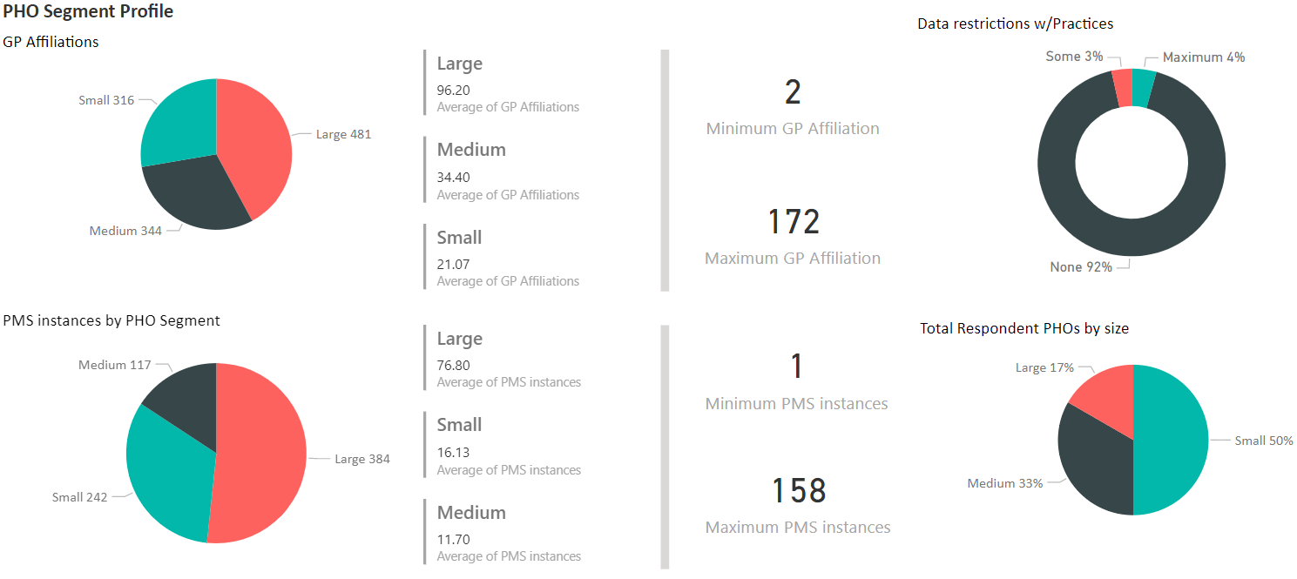

## Stakeholder personas

The following stakeholder personas have been developed based on the programme teams’ experience, knowledge or programme engagements conducted with the sector. It aims to capture and confirm key goals, frustrations, motivations, asks from PHDP, PMDS priorities as well as change engagement outlook(s) from each of the stakeholder groups.

## Consumer

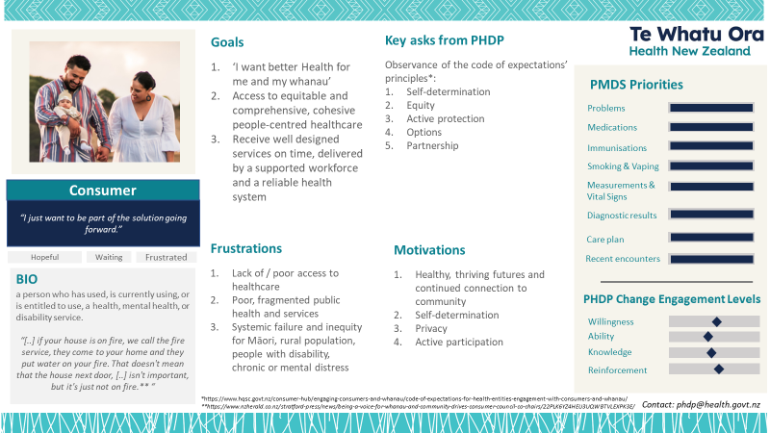

## General Practice

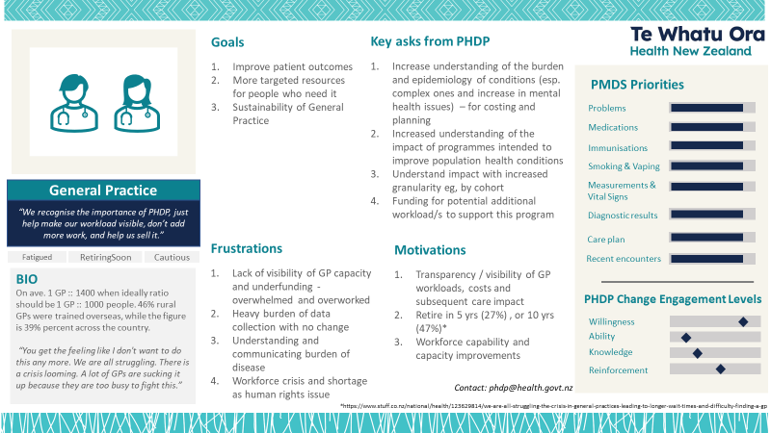

## PHOs

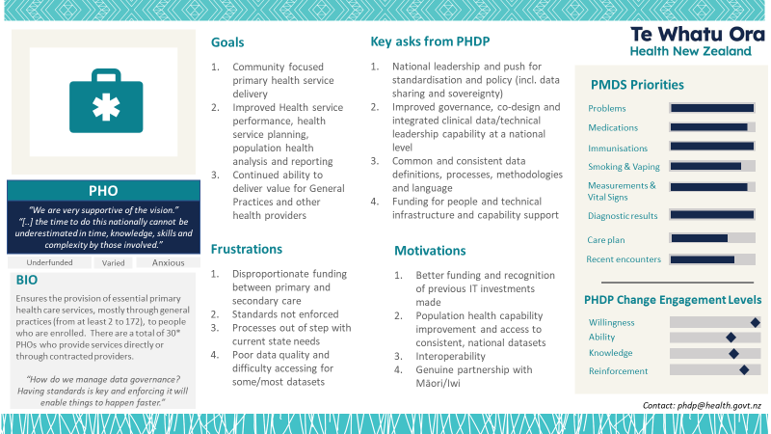

## Central Agency: Te Whatu Ora, Te Aka Whai Ora, Manatū Hauora

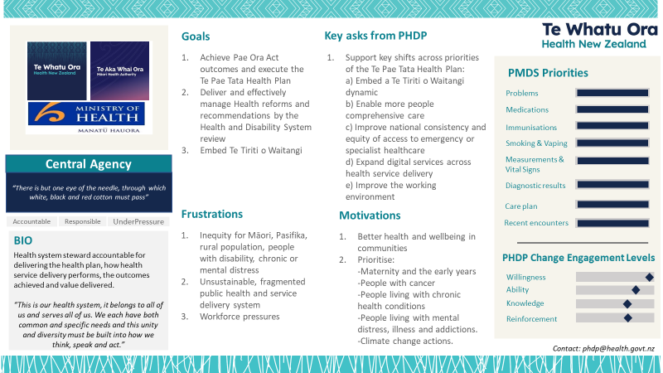

## Data management tooling across PHOs

Survey questions relating to understanding PHO data management tools were deliberately framed to be open-ended text to give respondents the flexibility to describe their services in the way that suited them. It also subsequently reflects the degree of clarity or understanding of the respondents behind classification of tool(s) across the data management lifecycle.

The tool(s) mentioned the most or consistently across data management lifecycle areas are as follows:

* Data Infrastructure – outsourced across provider(s), local and server database management, data warehouse, database as a service.
* Data commissioning – outsourced across various providers (e.g., Mōhio, Datacraft, Karo, PC Media, Benton, DOT loves data), Medtech or Dr. Info.
* Data transformation, consolidation and curation – outsourced across providers, Microsoft 365 tools, Azure and Microsoft SQL, EightWire, Azure Data Factory, Azure Logic Apps, Wherescape RED, Microsoft PowerBI.
* Data storage - Outsourced (Mōhio, Primary IT, Karo, HealthSafe), local and hosted offsite storage in NZ, Azure DW, MS Office / 365 (incl. Sharepoint, OneDrive), hosted data warehouse and SQL, WAN server / onsite storage or via 3rd party (Google, Azure cloud storage).
* Data sharing and consumption - Outsourced (Mōhio, Karo, Datacraft, Think IT, HealthSafe, Procon, Conporto, BPAC), MS Office / 365 (incl. Sharepoint), PowerBI, Qlik, FTP/SFTP, Direct export, Dr. Info, Noted.
* Data governance – Active Directory, change management and data verification gated process with operational frameworks, incl. access review processes, defined Data Governance Policy/ies, Board reviews, Secure File Transfer Protocol (SFTP), Secure mail, Microsoft Office / 365 (incl. Sharepoint).

## Self-assessment of data management lifecycle capabilities

This section of the report summarises the responses received across question number 25 to 34 of the current state survey that focused on rating and description behind the PHOs’ view of their own practices and abilities across the data management lifecycle. After a summary of findings surrounding self-ratings, a summary of the received rationale behind them follows.

## Summary

Figure 3 provides an overview of the themes that rationalise confidence levels of PHOs across each of the data management lifecycle areas assessed, while key observations follow below:

* 83% (or 4.17 where 5 is rated highest) is the average overall self-reported capability rating of PHOs across data management lifecycle areas. Informally comparing this result to the Capability Maturity Model (CMM) Data Maturity Model (DMM) measurements in other government agencies or related studies, these results seem to be higher than the typical average of 40% to 60% (i.e., Level 2 - “Managed”, or Level 3 – “Defined”), relative to industry standards[10].
* The highest confidence of PHO capability lies in its ability to collaborate with practices for data collection purposes at 91% (4.54), with the large PHOs being the most confident at an average self-rating of 96% (4.8).
* The area with the least relative confidence across data management lifecycle areas is in data governance at a rating of 76% (3.79). Between the PHO segments, medium sized PHOs rated themselves the lowest at an average of 73% (3.63). See Figure 2.
* Data transformation, consolidation and curation is an area with more negative themes provided in the comments (i.e., three as compared with one only for others) to rationalise the capability relative to all other areas. It is also the second lowest-rated capability after data governance at 81% (4.07).
* Analysis of the rationales provided by PHOs across the self-ratings reconciled with the tools and applications being used across the data management lifecycle areas reveal three to four mostly positive themes that indicates an equivalent Level 2 or Level 3 maturity based on the CMM DMM definitions.

**Figure 2 - Average self-ratings across the data management lifecycle by PHO segment**

**Figure 3 - Summary of ratings and themes to rationalise self-assessed ratings across data management lifecycle areas**

## Collaboration with practices for data collection

Success in this area has revolved around the following themes for an average rating of 91% (4.54) across PHOs. Across most PHOs, this area has received the highest ratings across small, medium and large PHOs, with the larger PHOs having the highest rating at 96% (4.8). This space also shows the largest differences in self-ratings, specifically between medium sized PHOs and larger ones at 16% (0.8 points) versus an average of less than 10% (0.5).

**Figure 4 - Word cloud for rationale behind self-rating for collaborating with practices for data collection purposes**

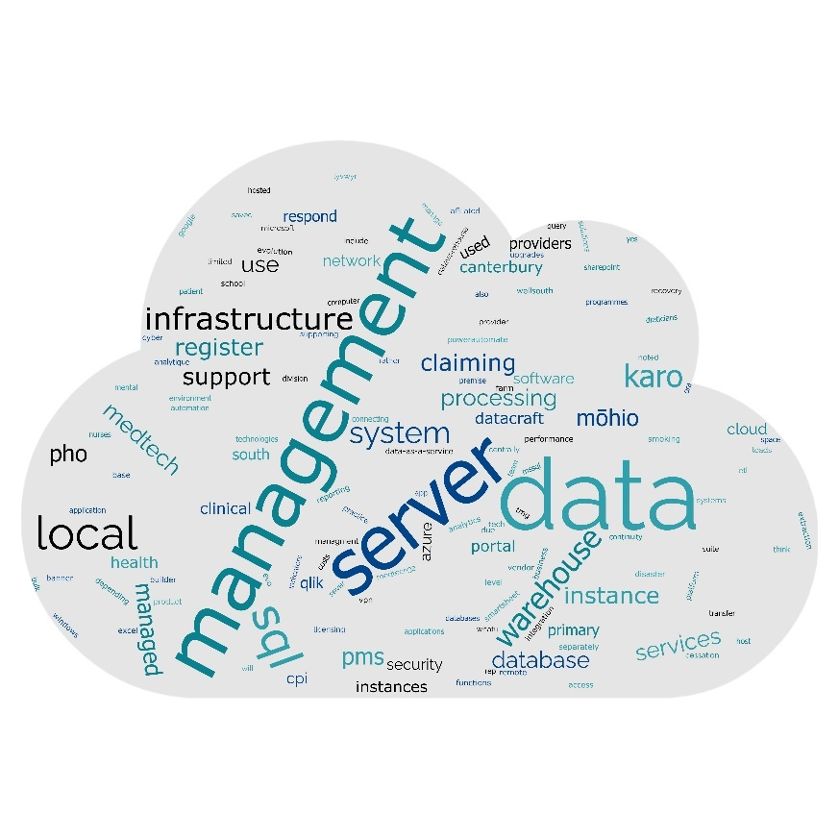

Theme 1. Trusted relationship based on mutual value, early engagement and legal / commercial foundations.  
Relationships with practices and contracted providers are perceived as good, trusted working relationships for the following reasons:

* a PHO’s small size and the ability to establish close relationships because of this
* the mutual value gained by each party, especially to support queries about patients and outcomes, constrained only by staffing issues and time constraints
* having the management authorisation and/or permission to collaborate and collect data, and maintaining transparency surrounding these activities between the parties
* early engagement and relationships having built at the onset, such as through the process of building data warehouse(s); and
* Contracted Provider agreement clauses that exist, formalising the permission to extract data to support clinical governance.

Theme 2. Satisfactory service delivery  
Satisfactory service delivery has been described by PHOs as the delivery of accurate and timely reporting, having full unrestricted access with general practices, the availability and use of data extractor tools from contracted provider(s), and the quick resolution of issues with raw data coming from the Patient Management Systems (PMSs).  
  
Conversely, findings also report an inconsistency of support from PMS vendors, something that had also been shared with the programme team through the engagement briefings.  
  
Theme 3. Structurally supported and empowered  
Success in collaboration has also been attributed to clear ownership and efficient management and consolidated PMS platforms, having a dedicated team with clinical and data analysts within PHOs, or in-house capability liaising with practices which maintained great working relationships with them.

Data governance structures have also been established to allow for the addition of new data extracts from all participating practices, through a peer group of general practice leaders rather than individual approval. PHOs describe their data sharing as efficient and secure due to the governance structures in place as well as the recognition that when additional permissions are required, the process to obtain appropriate permissions are followed.

## Data transformation, consolidation, and curation

Success in this area has revolved around the following themes for an average rating of 81% (4.07 out of 5) across PHOs. This area maintains the second to the lowest confidence levels relative to other data management activities, with the larger PHOs being the most confident with an average self-rating of 84% (4.2/5).

**Figure 5 - Word cloud for rationale behind self-rating for data transformation, consolidation and curation abilities**

Theme 1. Integrated expertise and a significant time spent on requirements identification and analysis   
Key to above average ratings in this area has been attributed to a:

“*..deep understanding of the data and clinical knowledge, with proven examples.*”

and activities and tool(s) such as--

“*Population health analysis, provider dashboards and lists, and shared clinical information with the local hospital*”

that exist. A significant amount of time had also been reported to have been spent identifying data to be collected from practices, supported by a data warehouse with the ability to automate their extraction, transformation, and loading (ETL)[11] of data.   
  
Theme 2. Use of modern tools and the reliability of providers with extensive experience  
Essential to success in transformation, consolidation and curation of data is the use of modern tools described in section on data management tooling across PHOs. PHOs can visualise and readily transform data and refine this process over several years, reinforced by the integrated expertise that have been established. Specifically, success has also been described due to the structured, daily, and automated ETL processes that *“normalise data to a PMS-agnostic, standards-based patient-centric data model that provides a single version of the true for reporting to many stakeholders.”*  Barriers, if any, were noted to potentially come from data services that could limit the speed of data extraction, however once data is stored, internal capability would be required and critical to be successful in this area.   
  
Theme 3. Poor, outdated or limited technology and tools, especially for extracting data from free text  
Alternatively, for those whose self-ratings were lower, these have been attributed to having poor, outdated or limited technology and tools.

*“Some PMS systems have lacklustre architecture and standards enforcement, No enforcement of standards in fields for some clinical outcomes”*

For these PHOs, tools are limited to Microsoft Office only and they have limited options for sophisticated calculations and visualisation display. Finally, responses have also noted that their success in transformation, consolidation and curation also depends on the data quality, and that the highest difficulty lies in the consolidation of free text fields which make up a lot of the data.  
  
Theme 4. Limited access, lack of capability, resources or expertise  
In addition to the above, restricted access to data and the lack of capability, resources (including the time to perform data transformation and management activities), or expertise to do such activities appear to be caveats to the self-rating rationales provided.

## Data storage

Success in this area has revolved around the following themes for an average rating of 84% (4.21 out of 5) across PHOs. Medium sized PHOs have the most confidence in this area with an average self-rating of 90% (4.5). This area reveals the second largest difference in self-ratings between small and medium sized PHOs as well at 10% (0.5 points) versus an average of less than that.

**Figure 6 - Word cloud for the rationale behind self-rating for data storage abilities**

Theme 1. Secure and reliable infrastructure  
Confidence in this area is illustrated by the precision in the provided descriptions for how/why there were “*good systems in place*”. Data storage appears to be an area where there has been a *“recognisable significant leap over the years”* with data increasingly being stored in the cloud (private/public). Relevant keywords that have been used to rationalise self-ratings here were:

* data mart(s) that exist or are being developed
* a data warehouse or data platform that allows secure access/collaboration, or are in the middle of getting established, if not upgraded
* the availability of and reliance on reporting portal(s) with embedded PowerBI or Qlik reporting with a suite of reports for population health,
* role based reporting access to practices through a single, provider-managed system
* democratised access to data
* daily updates to data
* row level security in databases
* data disseminated via Secure File Transfer Protocol (FTP).

Theme 2. In-house capability and continuous improvement  
Having in-house capability in place and a continuous quality improvement discipline has been attributed as a big factor for success in this area. Investments in technology over the years played a major role as well, as exemplified by some data intelligence project(s) that are either in flight or planned to be implemented.

Other activities include the development of dashboards with practice working groups and how lessons have been learned in the past where the design process was not as collaborative, hence resulting in its low uptake at the time.

## Data analysis and reuse for decision making and action

Success in this area has revolved around the following themes for an average rating of 85% (4.25 out of 5) across PHOs. This space is one where all PHOs have similar levels of self-ratings with a difference of up to 3.6% (0.18 points) only between segments.

**Figure 7 - Word cloud for the rationale behind self-rating for data analysis and reuse for decision making and action**

Theme 1. Established structures and processes enabling data to be integrated into decision making  
Key to the confidence in this area were the established processes as well as the recognition and commitment to data being essential to PHO operational capabilities. It was also reported that for some PHOs, the collaboration of a population health team and a medical director to guide data analysis allowed them to have robust and appropriate decisions made at a PHO and practice level. In addition, established governance structures such as PHO Clinical Governance complemented by quality improvement processes were also seen to be effective in supporting the use of data for decision making.  
  
Theme 2. Good relationships and previous experience  
Established organisational structures and processes are also supported by good relationships demonstrated by the ability to have full access to practice data under best efforts from each party. Besides, for PHOs, data analysis practices have been on-going over many years, including more recent analysis such as *“[..] using data from CIR to highlight gaps in COVID-19 vaccination uptake for local areas for each clinic.”* along withrelevant previous experience from some of the PHOs’ staff and leaders. For those without in-house capability, the reliability of the data service provider for enabling *“individual level to aggregated performance reports and incorporation of items like self-service BI, online dashboards, machine learning and data science.”* served as a causefor confidence in this area.  
  
Theme 3. Modern tool(s) and in-house capability  
For PHOs with the in-house capability, capacity and technologies to support their data analysis and decision making, having a data ware warehouse allowed PHOs to have the ability to rapidly analyse, interrogate, and visualise data to answer questions quickly efficiently and be able to feed these back to end-users/stakeholders. Data is also processed once to provide common standards-based data, providing a common measure for reporting across a range of stakeholders.

*“Very close working relationship with population health experts and practice forums has meant a clear roadmap and use for data for practice decision making and quality improvement.”*

*“Data defines our priority areas and is essential to everything we do”*

*“[..]common PMS, standards-based patient level data stored in primary level facts and dimensions. Data is further processed to create secondary or tertiary facts and dimension.”*

Theme 4. Lack of capability, resources or expertise and data not timely enough  
For PHOs who were less confident in this area, this is attributed to not having in-house capability, expertise, or time to perform necessary data transformation required for further data analysis. Note that some small and medium sized PHOs outsource their curation and analytical services to Datacraft who can provide extraction, curation, warehousing, analysis, and dashboard services.

*“Majority of the data that is required / needed is often requested to be current / latest but this generated at the end of monthly and distributed to our network such as practice registry.”*

## Data governance

Success in this area has revolved around the following themes for an average rating of 76% (3.79) across PHOs. Large PHOs have the highest relative self-rating at 80% (4.0) with a difference of 7% (0.37 points) between medium sized PHOs.

**Figure 8 - Word cloud for the rationale behind self-rating for data governance**

Theme 1. Perceived “Good practices”, relevant expertise / previous experience   
The following phrases or statements rationalise the confidence PHOs maintain in this area:

* *“robust data governance policy”*
* *“existing Clinical Governance, setting up Data Governance Group (covers Māori Data Sovereignty)” , “[..] Clear guidelines from Māori representatives, clinical directorate and leading governance providers are followed and continuously reviewed”*
* *“well-documented data governance framework that is used for all data requests”, “good approvals in place, still work to formalize some informal processes”*
* *“..strong controls around data collection and storage”* while enabling users the ability to request and access data, having *“checks and balances in place”* and having a *“quality compliance system”* where *“access is granted only as appropriate for the user's role”*
* there is an established feedback loop with practices, consisting of a *“close knit data group internally consisting of 1 data analyst (who sits on custodian) and one clinical director (who sits on the stewardship)”*
* *“end-to-end understanding of data mapping and flow”*
* *“experience integrating with a cloud environment and external data sources”, or “expertise in this area from our Chief Information Officer”*
* confidence in data governance was also described in terms of security practices, including *“data controlled by one key person.”*

Theme 2. Lack of resources, expertise, or best practice knowledge  
Where PHOs do not have in-house capability or a dedicated analytics team, the following phrases summarise the rationale for having reduced confidence in this area:

* *“[PHO] does not have all the sophisticated tools in house, but the Ministry could support the acquisition and access to these tools as well as providing ongoing training on the best practice.”*
* *“We believe we have reasonable processes in place, but we do not believe we have adopted best practice data governance.”*
* *“We battle to get local governance across the line.”*

## Assessment of relevant documents supplied

The current state survey also requested for the below documents from PHOs where available to help the programme team understand background context and work already undertaken in this area. Documents across 14 PHOs have been received and results from further analysis based on these documents will be shared when completed.

* enrolment, consent, Privacy Impact Assessments (PIA), security and governance
* data collection purpose(s) and data sharing agreements
* data schemas
* best examples of population health analysis/reports
* any other relevant documentation.

## Summary of gap(s) in current approaches and barriers to success

Figure 9 summarises the various themes that PHOs have identified across survey results or engagements held as the barriers to the success of this program. Themes are overlaid across process sub-domains within the larger governance and management domains based on the COBIT 5 Processes for Governance of Enterprise IT reference model[12].

## Governance

The relative reduced confidence in self-ratings in this area reported in the ‘Self-assessment of data management capabilities’ section are reflected in some comments that reported a lack of data governance framework or controls especially with respect to data sharing as one of the primary barriers to the success of the primary health dataset program. It was also suggested for programmes to *“Integrate [..] where possible to avoid said rework and pool the talent. Should be primary care lead”.*

## Insufficient funding

Funding issues as a barrier to the success of this programme were certainly pronounced and reported through not just the survey results but also through the engagements held. Like the findings stated in the Review[13], PHOs report that *“Funding for secondary care IT systems vs primary care IT systems is grossly disproportionate.”*. *“Infrastructure investment to support data collection, curation and usage is not specifically funded for primary care, and at a PHO level relies on a critical mass of clinical service and other contracts to sustain.”*. *“At the same times we are routinely audited against risk criteria that include investigation to ensure that we are not spending clinical service money on IT. All of this feels very precarious at the current time, due to health reform and proposed replacement of PHO Service Agreement.”*

Suggestions for a review of funding levels to surface budget constraints were provided, given *“expectations [have been] increasing without adequate funding increases”* which often leads to the inability to use or apply best practice approaches.

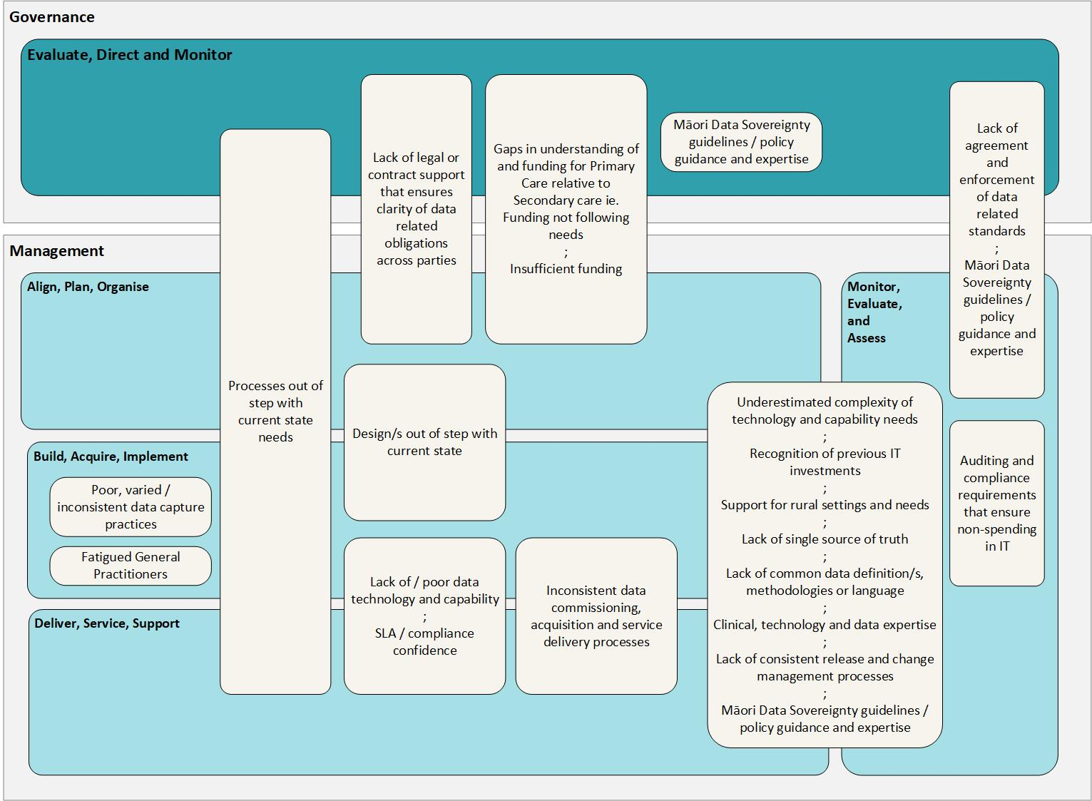**Figure 9 - Summary of themes of barriers to the success of PHDP across governance and management domains of the** COBIT 5 Processes for Governance of Enterprise IT reference model

## Capability

Small and medium sized PHOs particularly report the underestimation in the level of complexity in managing data, hence requiring support in terms of ongoing staff, best practice knowledge, skills, and training to establish enduring capability to successfully manage data across planning, building, delivering, supporting, and maintaining data and its relevant systems. It is noted that special attention be given to *“fully utilise data, esp. for/with experience in rural settings.”* The need to be explicit about data obligations is also advised: *“PHO SLA is not concise on General Practice Teams data obligations and adherence to data.”*

## Technology

While various standards exist, PHOs affirm many of the same findings stated in the Review[14] as far as data quality challenges were concerned (Refer to Figure 10). PHOs specifically state the lack of standardisation in extraction criteria to encourage common applications and interoperability (including among coding systems).

*“None of this work without standards and clear interoperability. Otherwise, every PHO will be spending thousands of hours on massaging data to the schema.”*

While SNOMED CT[15] is the proposed health sector standard for clinical coding, only one PMS system uses this. General practitioners are very used to using Read codes which is the underlying code system for Medtech used in more than 70% of practices. General practitioners may also describe key measurements, such as blood pressure, and symptoms in unstructured, free form notes rather than capture this information in available structured fields.

Given the originating data source for primary care data resides in practice management systems, it is important to understand that these were initially designed for clinical management and administrative purposes versus the capture of population health data which needs to be standardised. This results in the difficulty in data extractions. Also, *“Much of the clinical encounter record is captured as free text, as a professional record for the clinician to reference rather than captured with the intent to be shared and analysed by others.”* Consistency of data mapping and application of codes across different PMS systems is also called for, so are efforts to ensure selection, consolidation and transformation to be easier for all.

Other technology related barriers stated are clunky data extraction, transformation and loading capability for some datasets, the lack of a single source of truth, the lack of/poor data warehouse management and how national guidelines to support Māori Data Sovereignty across the sector would be welcomed.

**Figure 10 - Health and disability system review 2020 - data quality challenges**

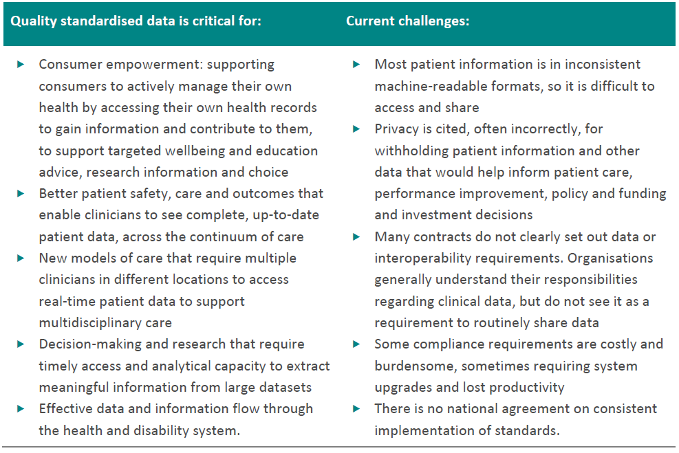

## Process

*“Data use culture and expertise in managing privacy and security of data and access rights is variable across the sector and creates challenges to sharing information when rights and obligations are not clearly understood.”* There isa limited shared understanding of the complexity in data collection and what this entails. This is potentially exemplified bythe difference in the assessment and reporting of data availability of the proposed data elements for the PMDS between the large and small PHOs (if excluding small PHOs with a large PHO ‘parent’ affiliation). Despite their size and reported lack of in-house capability and expertise, (orphaned) small and medium sized PHOs report higher levels of overall data availability of the proposed data elements for the PMDS compared to the larger PHOs.This may reflect the fact that many smaller PHOs outsource their enrolment and population health analytics to a third party who then provide a rich level of analysis and reporting. More work in analysing the different capabilities between PHOs are required. Privacy statements also lack standardisation across the sector, and privacy or data security approaches end up as barriers in themselves due to incorrect understanding or poor implementation.

*“[..] limited shared understanding of the complexity of data collection and the relationships required to be maintained with local providers (that are private businesses)”*

In smaller PHOs, there is a need for analytical capability to fully utilise the data and information, adding *“It is extremely difficult to employ a full-time analyst with adequate experience in a rural setting”*. The difficulty in PHOs’ ability to influence improvement in the use of and processes surrounding data source systems were also seen as barriers.

## Data quality

Key summarised statements surrounding data quality as barriers include:

* Reports of poor data quality at the source itself, given variances in day-to-day practice usage. [It is not unrealistic to think that there may be as many variations in the data as there are in the number of general practices][16], especially surrounding particular data element(s).

*“National reference documents for data collection for PHO data sets (eg SUR [Service Utilisation Report], CPI [Clinical Performance Index] have not moved to well reflect changes in models of care, modality of care, changes in workforce composition and clinical tasks performed, or comprehensive care team providing wrap around clinical care through PHO clinical network. Most of what we do currently is invisible to the system and/or misinterpreted due to out of data reference criteria, and we do want to change that view”*

* A reported mismatch across layers of the technologies or processes i.e., between PMSs in themselves, PMS and source data, and the same systems/layers with regional and national data.
* Lack of common data dictionaries, data definitions and methodologies to support consistent reporting. Standards, usage, coding methodologies and definitions are recommended to be implemented across platforms, not just for SNOMED CT but including practice and patient management workflows (i.e., through the health consumer journey).
* Clinical and delivery practices and documentation are sometimes out of step with current state/new models of care e.g., Healthcare home model and the role(s) of stakeholders across the sector. Data structures, design and management processes need to reflect the various use cases PHOs use data for: extensive end-to-end clinical workflow, financial and assurance purposes in addition to population health planning.

## Data culture

Data culture is the collective behaviour and belief of people who value, practice, and encourage the use of data to improve decision-making. As a result, data is woven into the operations, mindset, and identity of an organization[17]. Data culture was conveyed as something that can also serve as a barrier unless there are demonstrative efforts to ensure inclusion, collaboration, access and data sharing to and between:

* PMS / vendor data
* secondary health data
* National Collections.

Processes that can enable a more seamless way of getting new data outside of existing clinical performance indicators were also recommended.

## General Practice

PHOs report that *“Enrolling general practices are just one part of the primary care service landscape coordinated by PHOs and the full population health view is not supported by data collection from general practice only.”* Given practices are the stewards, if not owners of primary care with the health consumers, collaboration across all stakeholders in the ecosystem to enable a full population health view will be crucial.

## Vendors

Key summarised statements surrounding barriers with vendors include:

* the quality of vendor support, willingness, consistency, responsiveness or the reported lack collegial environment that is fostered

*"An electronic PMS Manual to streamline processes that is updated monthly...including Read Codes processes i.e diagnosis (multiple codes in use), classification for smoking brief advise (multiple codes in use)”*

* improved technology capability e.g., Application Programming Interface (APIs)
* lack of standardised or enforced release and change management: *“upgrades’ beta and validation testing often is prolonged and can impact the quality of data extracts (errors, data type changes, etc)”*
* vendor non-compliance to Ministry of Health requirements
* there is also an absence of mechanisms, assurances, or policy support from the Ministry to prevent vendors from potentially restricting access to data held by them and forcing this only through channels under their control and at a cost, especially where some PHOs often prefer direct database access.

## Resources needed for success

Summarised as well as verbatim statements surrounding the resources required for the success of this PHDP programme across five categories follow below.

**Table 3 - Table of resources needed by PHOs for the success of PHDP**

|  |  |  |  |
| --- | --- | --- | --- |
| National leadership and standardisation | Time resources and monetary support | Technology | Other |
| * *“National leadership and push for standardisation. “* * *“Clear and cohesive Schema/Endpoint documentation. Well defined use case for the data that we can communicate.”* * *"None of this works without standards and clear interoperability. Otherwise, every PHO will be spending thousands of hours on massaging data to the schema.”* | * Funding and coverage for additional workload and innovation * Resource needs and complexity thereof cannot be underestimated given this has been a long term and continually evolving undertaking at a PHO level | * Easy access to and user-friendly tools including managing secure data transfer * User friendly platform with easy data access – *“MOH Qlik Hub has some great datasets but practices can't access easily, and information is not always relevant at the local level.”* * Technology guidelines in line with Māori Data Governance and Sovereignty * Centralised data capture and analysis services with information returned for action planning * Expertise | **Data quality**   * Transform primary health data into a selection of calculated indicators that are standardised for comparison with locality and NZ total   **Contractual**   * An agreement with practices, including standards to comply to   **Vendor**   * PMS vendor engagement and alignment   **Culture**   * Right mindset, willingness to collaborate, share; ensure relevance * Inclusion of primary care clinicians to understand the nuance of some datasets |
| Data access and data service delivery | | | |
| * To 3rd party data. * *“Assistance to small rural PHOs to access the necessary tools with ongoing training to increase the in-house capacity for data governance and utilisation".* * *“Having a ‘go-to’ person to clarify and unpack any curly technical jargons and data issues”.* * Māori Data Governance and Sovereignty guidelines. * Quality data / insights from centralised data capture and analysis services for action planning. * Visibility of nationally available/held data *“to ensure it aligns with what data we already collect from practices and the quality of the data itself.”* * *“Data that's beneficial for patient care and programs".* * Process for data access and the ability to contribute data as well. | | | |

# View of use(s) for PMDS for population health analysis

## Current state population health analysis based on reports already produced

Survey results show that all PHOs already use data for population health analysis (Figure 11). While some PHOs were able to share some best examples of these reports, further work and analysis is needed to discover common features and requirements that could inform the content of Version 1 of the PMDS. Later versions will need to ensure alignment with the upcoming Te Pae Tata 2022 Interim Health Plan.

**Figure 11 - Where PHOs use data for**

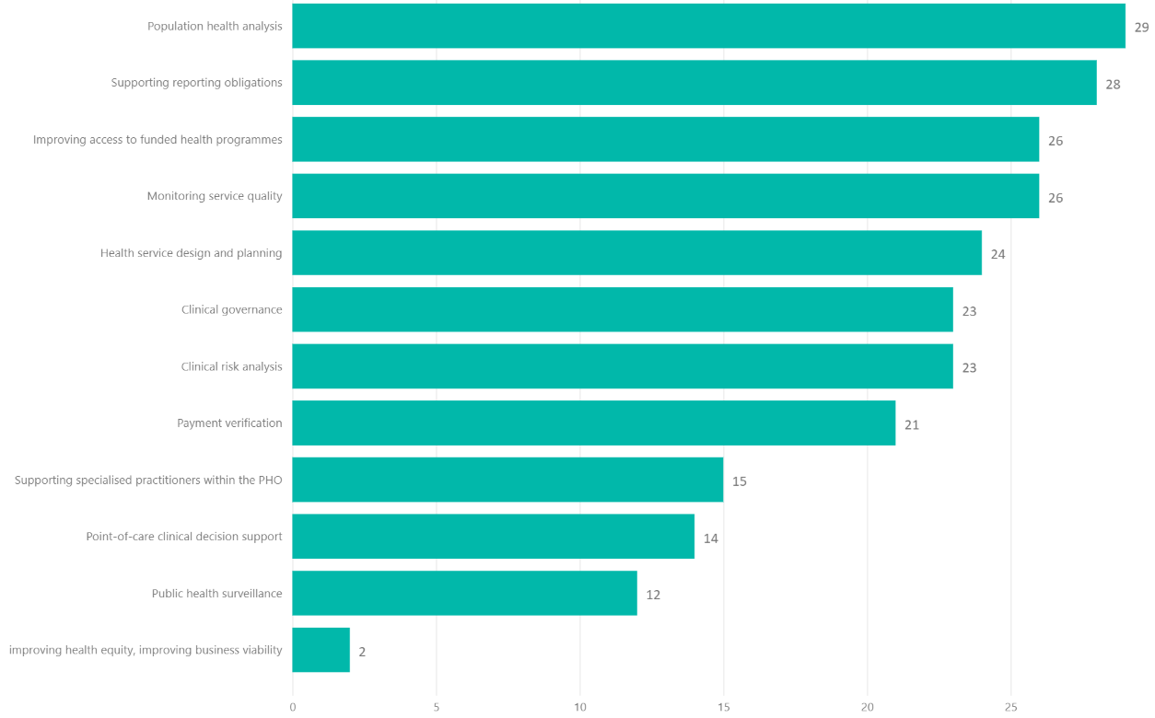

## On National Collections

## Current usage

The goal of National Collections and Reporting (NCR) is to provide trusted health data and turn it into information and actionable insights to inform policy, research and monitoring at a population level. It supports population health by providing comprehensive sets of data and information to identify segments of the population with unmet need and provide better targeting of health services. Access to National Collections by the non-government health sector for population health planning is variable.

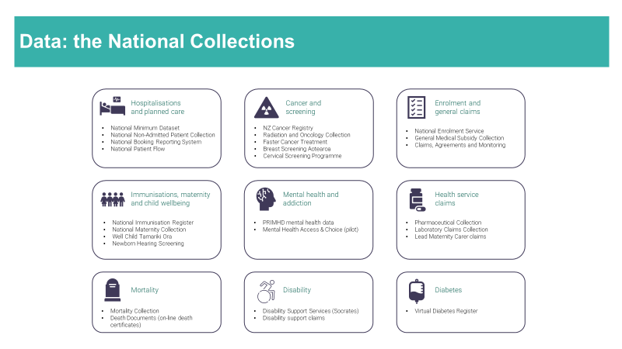The principal usage of the National Collections is illustrated below.

**Figure 12 - National Collections data marts**

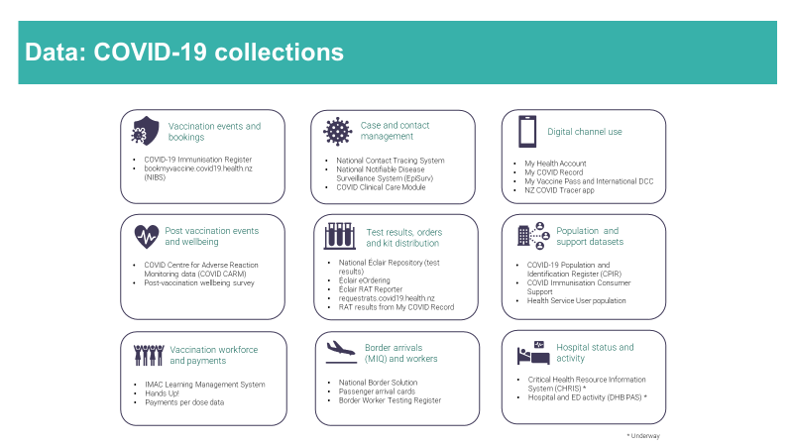

In 2019/20, the NCR team responded to over 5,000 requests from researchers, health providers, health agencies, public queries, media and ministers and wider government for data and information relating to National Collections and coding. 18 datasets are provided to the Integrated Data Infrastructure database held by Statistics New Zealand.

The NCR team are currently working to improve access and self-service. Role-based access controls, standard reporting tools and training modules to support National Collections usage are available but are not consistently known about. Improved presence in the sector and more transparent data governance is needed.

## Desired use and desired population health questions to be answered

Survey results reveal the following responses to the survey question *“What kind of other population health questions do you wish to answer but are currently unable to, for various reason(s)? List your top five (5) questions”*:

* Outcomes / intervention analysis data and the use of data for such purposes.
* Barriers to healthcare access and quantitative measures for the same.
* Equity criteria to formulate the equity rate.
* Complexity, epidemiology and burden of care, especially for patients having more than one illness/condition (including long-term).
* *“Outbreaks and epidemic clusters”.*
* *“It’s not that we can’t answer but it takes times and resource to get answers. The main issue I'd like to understand is patient flow - not [viewing] a patient as secondary vs primary vs specialist appointments but combining all of them to understand all patient appointments”.*
* *"Geo Classifications (quintiles i.e., justify classification codes)”.*

## Barriers to its use

Survey results around barriers to the use of National Collections revolve around three themes.

*“What we need is a set of calculated indicators by PHO, benchmarking to local regional and NZ results; with the ability to filter by ethnicity, broad age group, gender, and reporting period for monitoring trends. “*

1. availability and access
2. data service delivery
3. technology and capability.

Theme 1. Availability and access

Most comments report difficulty in access or no direct access to the National Collections. Many do not know what data collections are available or the data elements in them. Expectations surrounding access, however, includes the ability to match the National Collections with identifiable data they hold to enable and drive health interventions at individual/collective levels and for the data not to be raw, but calculated information or indicators based on nationally consistent business rules. It was also reported that it was easier sometimes to get data from the local Te Whatu Ora district (formerly DHB) compared to the Ministry, adding that “*Snowflake accounts are impossible to come by*.”

Theme 2. Data Service Delivery

There was also either inconsistencies in the process, or difficulty for PHOs to know who to contact, where to go, how to get the data, or how to approach this process and ensure the right permissions are obtained.

Some PHOs who have direct access to some data collections obtained their permission some time ago and are since seen as having a ‘historical’ right, while others have not been able to get permission. Yet for other PHOs, access to their COVID managed patient data through their local Te Whatu Ora district team has remained a request that has not been resolved for the last six months.

Alternatively, where permissions existed, and access is at hand, technologies can be slow, user interfaces clunky (portal), data frequency inconsistent and overall timeliness, poor.

As a result, monitoring interventions and monitoring activities in general for analytical purposes is mostly done retrospectively. *“Significant time lags between activity occurring and its availability in national systems”* are reported and *“Access to data from the Te Whatu Ora district secondary care provider give nearer real time data.”*

Finally, practices and documentation, including for some National Collections are simply reported to be out of step with current state/new models of care and the role(s) of stakeholders across the sector (as noted in section 4.2). The data structures, design and management processes do not reflect the various use cases PHOs currently use data for i.e., extensive end-to-end clinical workflow, financial and assurance purposes in addition to population health planning.

Theme 3. Technology and capability

More relevant to small and medium sized PHOs, the third and final theme reports the lack of tools for analysis apart from Microsoft Office tools (i.e., Excel) as a barrier to the use of the collections. Work will also be expected to prevent inconsistency in the channels, methods and processes of use to be supported with having the training, full-time capability (especially for rural settings) and tools to access or ingest directly into databases as preferred and managing the data across its lifecycle.

## Other feedback to PHDP, including datasets that may be missing

For the PMDS, the following datasets were suggested as missing were the following:

1. Allergies and reactions.
2. Screening data, unless subsumed under ‘Diagnoses’.
3. Pharmacy - Dispensing data; and
4. Mental and Sexual Health data (assuming appropriate collection based on data sensitivity).

Other feedback provided included:

* *“Those that have been selected as 'not held' may actually be [in] the landed data. Work would need to be carried out to confirm”.*
* Data needs to be timely. *“Any data provided needs to be timely and meaningful to clinicians and a degree of comfort that it is being collected consistently across the sector by clinicians who are trained to utilize IT platforms and detailed coding”*.
* *“[..] a stepwise approach would be most achievable given the detail and complexity of the PMDS supported by nationally consistent data mapping and application of codes”.*

It should be noted this suggested missing data may not be relevant for analytical purposes e.g., allergies and reactions but may be relevant for clinical governance purposes.

## Top National Collections desired

Survey response results reveal the types of National Collections datasets PHOs deemed most relevant for their work*.

*Note: “*Choices made on assumption that current access to some of the data such as NIR through QLIK, COVID-19 through the Ministry routine reports and SLM reports would still continue.*”

## Unavailable National Collections

Most of the National collections were considered important and relevant, while the following data sets were deemed as missing or desired to assist PHOs with improved population health planning (listed according to roughly the number of times the datasets were mentioned):

1. unenrolled population *(“unenrolled at [..] but enrolled out of region when presenting for Covid”*) and health needs, demographic breakdown
2. iwi affiliation – health equity, benchmarking data
3. secondary care – use of hospital services, interaction across other area(s) relative to home location
4. socio-economic variables or measures – socio-economic impact outside of deprivation and quintile; link between social determinants and ill health; socio-economic variables outside of age/gender/deprivation
5. pharmacy dispensing data
6. breast screening, cervical screening and bowel screening data
7. cancer prevalence, cancer testing i.e., stomach where screening is not available
8. diabetes
9. death – causes of, etc.,
10. maternity
11. cardiovascular disease (CVD)
12. oral health dataset
13. surgery data.
14. aged residential care and NASC usage
15. Plunket's B4 School data.

# Data availability

This section explores the findings surrounding the availability of the proposed data elements across PHOs.

## Data elements / fields

Table 4 below shows the list of data elements devised based on the process described in section 2.2.2. While there were no major concerns received to the list of proposed data classes or fields, further engagement and analysis have yet to be conducted in order to agree and finalise an initial version of the PMDS.

**Table 4 - Table of proposed data elements for the PMDS**



## Overall availability

While further analysis will be required to verify responses received and the associated assumptions along with them, survey results show that 73% of the proposed data elements are collected or held by PHOs in some form or another i.e., as a direct match or requiring some or complex transformation to match the proposed data element (Figure 15). Large PHOs hold the greatest number of PMDS elements available while medium and small PHOs have minimal differences in those they hold. Figure 14 further illustrates data availability for each proposed data element across all PHOs.

Finally, ‘Smoking’ and the ‘Measurements and vital signs’ data class is most held across PHOs in contrast to ‘Care plan’ that is least available.

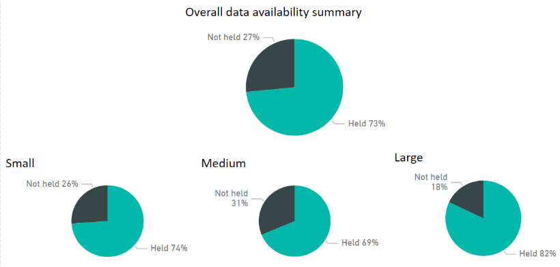**Figure 13 - Overall data availability for proposed PMDS elements - overall and by PHO segment**

-

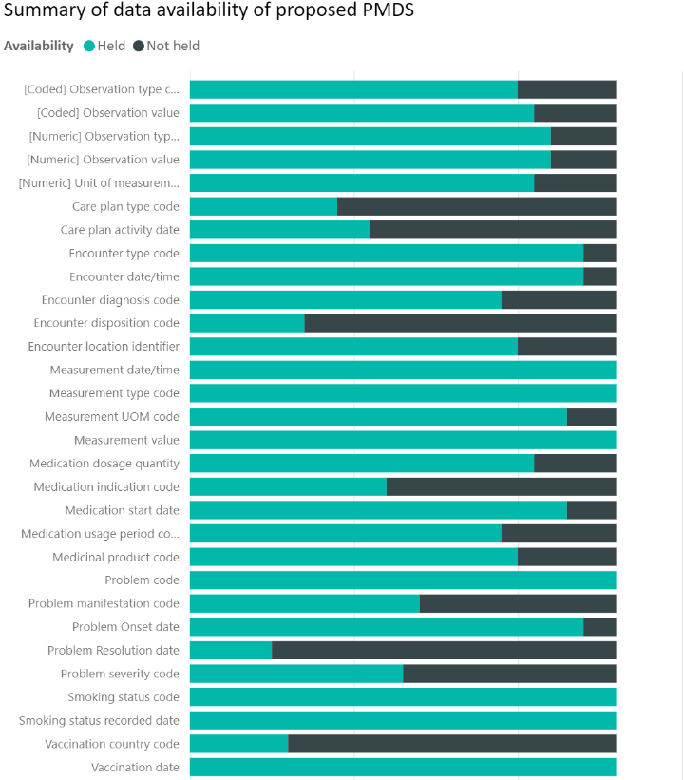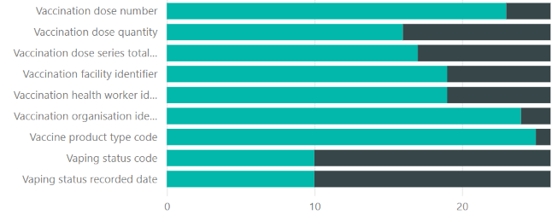

**Figure 14 - Summary of data availability of proposed PMDS elements**

Note that a sensitivity analysis on this proposed dataset was done by removing nine of the lesser available and less essential data items[18] (See section 6.1 for the updated proposed PMDS). This yielded an overall availability rate of 84%.

## Direct match

Table 5 shows proposed PMDS elements are indicated by PHOs to be a direct match[19] to those they already hold.

**Table 5 - Table of data elements directly matching proposed PMDS**

|  |  |  |
| --- | --- | --- |
| Small  (34 data elements) | Medium  (36 data elements) | Large  (29 data elements) |
|  |  |  |

## Transformation required from data held

Figure 15 displays each proposed PMDS element and the transformation that will be required, while some key observations follow:

* 53% of PMDS elements will require transformation to form the initial PMDS based on the proposed data elements, assuming elements that are a direct match are verified after further analysis to be consistent across PHOs.
* Large PHOs appear to have the most PMDS elements available at 82% coverage, however they also require the most amount of transformation of the data elements.
* Medium sized PHOs have the greatest number of PMDS elements that are a direct match, at 92% of total. The top three data classes voted most important for the PMDS – ‘Immunisations’, ‘Problems / Conditions / Diagnosis’, and ‘Measurements and vital signs’ require an average of 15%, 21%, and 34% in complex transformations accordingly (Figure 17).

**Figure 15 – Summary of data availability and of transformation required across data elements held**

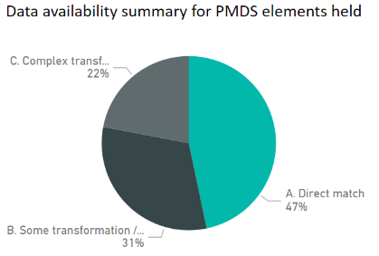 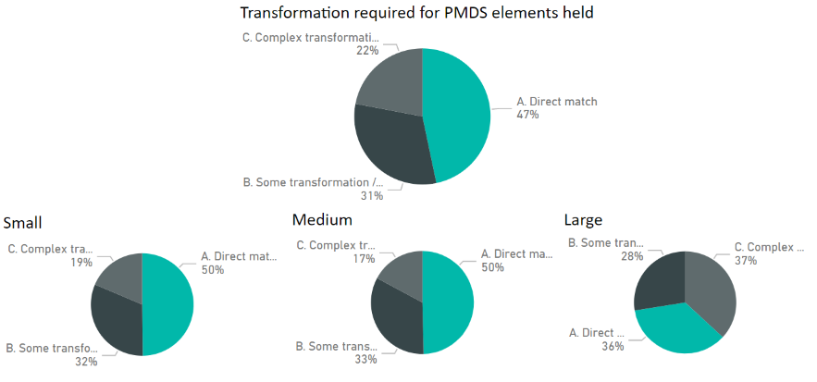

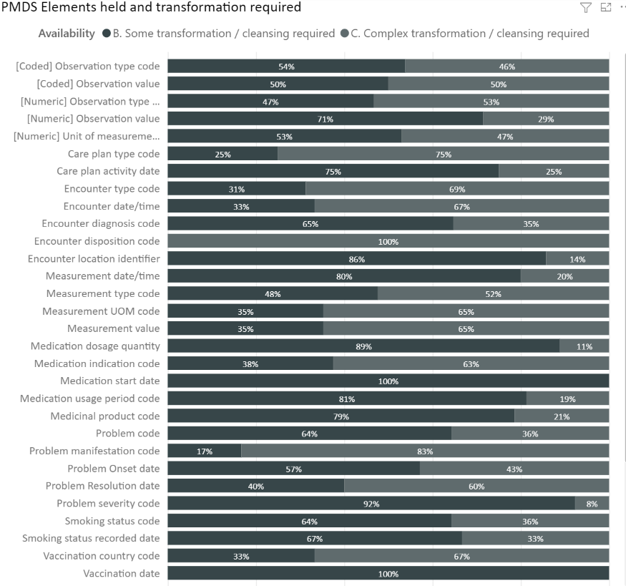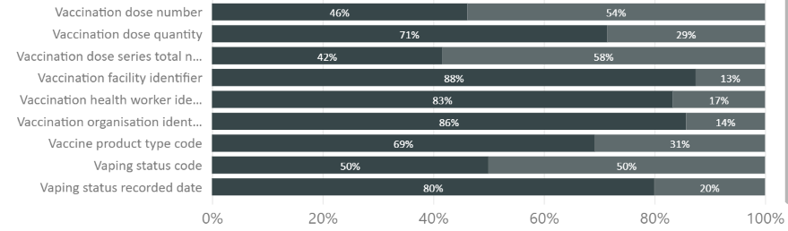

**Figure 16 - Overall PMDS elements held, and transformation required**

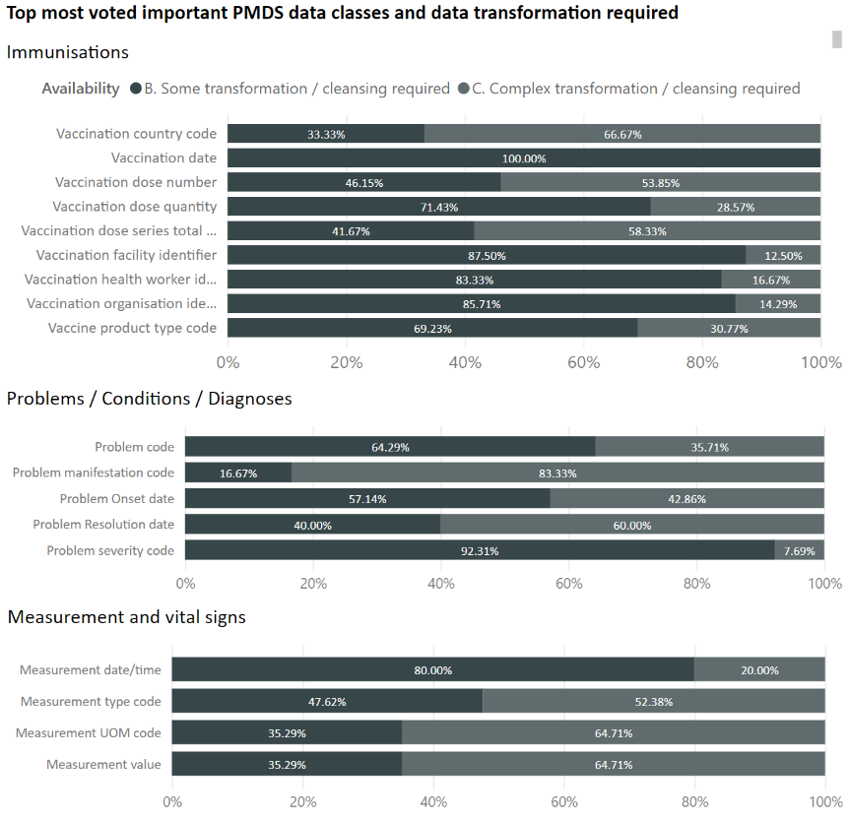

**Figure 17 – Top most voted important PMDS data classes and transformation required**

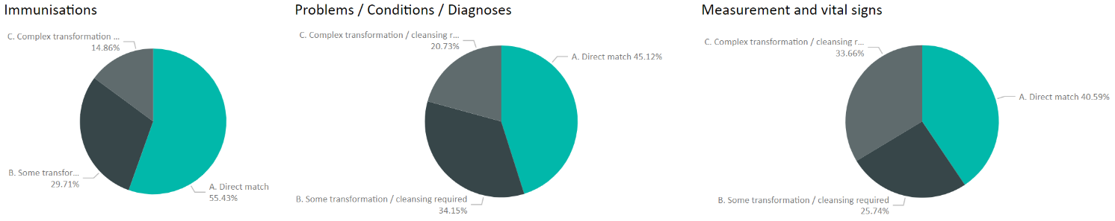

## Summary

## Limitations of survey results

As noted in section 2.2 Primary health dataset programme approach, the surveys were released consistent with a broad engagement approach. This report focuses on providing a factual account of comments and feedback received, without applying or expressing judgment over any particular practice, activity or technology. General subjectivity in exercises such as this is recognised, nevertheless, further analysis will be conducted relative to the quality of results, programme team recommendations, and governance group direction(s) as well.

These survey results are preliminary and have not been validated fully. Individual anomalies or outliers in responses have not been resolved (these may be administrative errors, misunderstandings, or a genuine outlier). Also, the capability reported by small and medium PHOs needs further analysis as some use third party providers and others do not. Where a third-party provider is used, their potential capability will be higher, but they have not necessarily been consistently reported as such.

Examples of areas requiring further study include:

1. the degree of transformation required to form the potential PMDS as well as the associated assumptions along with them that have yet to be verified e.g., for the ‘Medications’ data class, how much retrospective data in years is available? To what level of detail / depth? Is there a focus on specific illnesses/conditions only or something broader? Based on what type of logic/constraints? How do PHOs define complexity in data transformation?
2. sensitivity analysis on the data elements held and National Collections datasets;
3. managed service organisations and the variances in their relationship with PHOs, etc.,;
4. follow-ups to the extent of and use of declared software, applications and tooling used for data management, actual Practice Management System instances and the associated practices for its use as far as environment management is concerned;
5. current state analysis of National Collections;
6. any other detail and context enriching insight that PHOs and stakeholders may share.

## Summary of degree of support required

PHOs were presented with a strawman model of data elements within eight different data domains. They were asked to match their existing curated data to the strawman model. Some domains which are clearly used for required reporting and analysis, for example, immunisations, have a high degree of matching, while other newer features such as care plans were less so.

Standardisation appears to be an area that will require extensive support. There does not seem to be a clear standard for the way information is held within PHO data warehouses. A pragmatic approach is taken, and if reports are required in a certain format then data is typically transposed in the data warehouse rather than at source. The lack of implemented standards and prevalence of old versions of PMS installations with loose clinical coding constructs mean that there is a wide variety of data collection mechanisms. Much of the effort and time in managing and curating the data is spent in dealing with this complexity.

Whilst not yet included in the proposed strawman PMDS, referrals and primary care procedures have been identified as areas of interest in terms of health service planning by the Health and Disability Intelligence / National Collections Reporting team, and yet these domains have not yet been well developed for analytical purposes. Care plans can tell us about the management of complex and multi-morbidity cases, for example, but findings show that this capability is currently only sparsely utilised by general practice.

**Figure 18 - 9 Most voted important data classes for the PMDS**

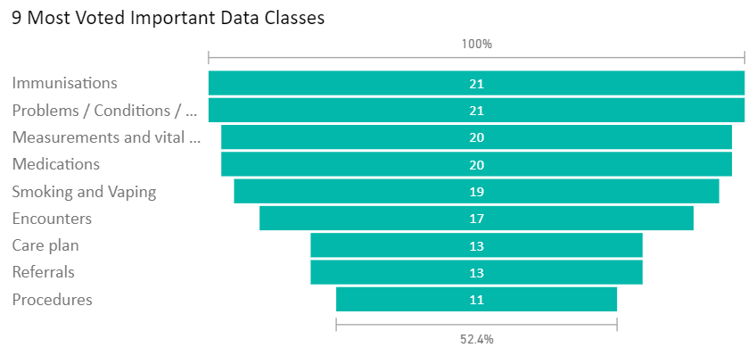

* + 1. **View of proposed data elements across the health consumer journey**

Across the various engagements held, feedback surrounding ensuring clarity of the impact of this programme to the people on the ground, or those in the ‘coalface’ have been emphasised numerous times. In collaboration with Christine Scott, National Manager, Clinical Pathways, Te Whatu Ora, the below diagram has been developed with the author as a starting point to:

1. provide a common, health system stakeholder-agnostic view of the health consumer / patient journey across primary and secondary care,
2. provide a common view of the usefulness of the proposed PMDS data elements within the health consumer / patient journey, and how data elements may contribute across the various activities held across the health consumer / patient journey for both primary and secondary care,
3. illustrate the various high-level activities and roles that each stakeholder performs in line with the consumer / patient journey, and to
4. provide a consumer/patient-centric rich and common contextual background across stakeholders, useful for testing national or population health related use cases.

Further work in collaboration with various stakeholders have yet to be conducted to verify and refine the terminologies used as well as around the various activities denoted across the health consumer / patient journey.

**Figure 19 - DRAFT v0.02 Stakeholder activities across the health consumer / patient journey stages**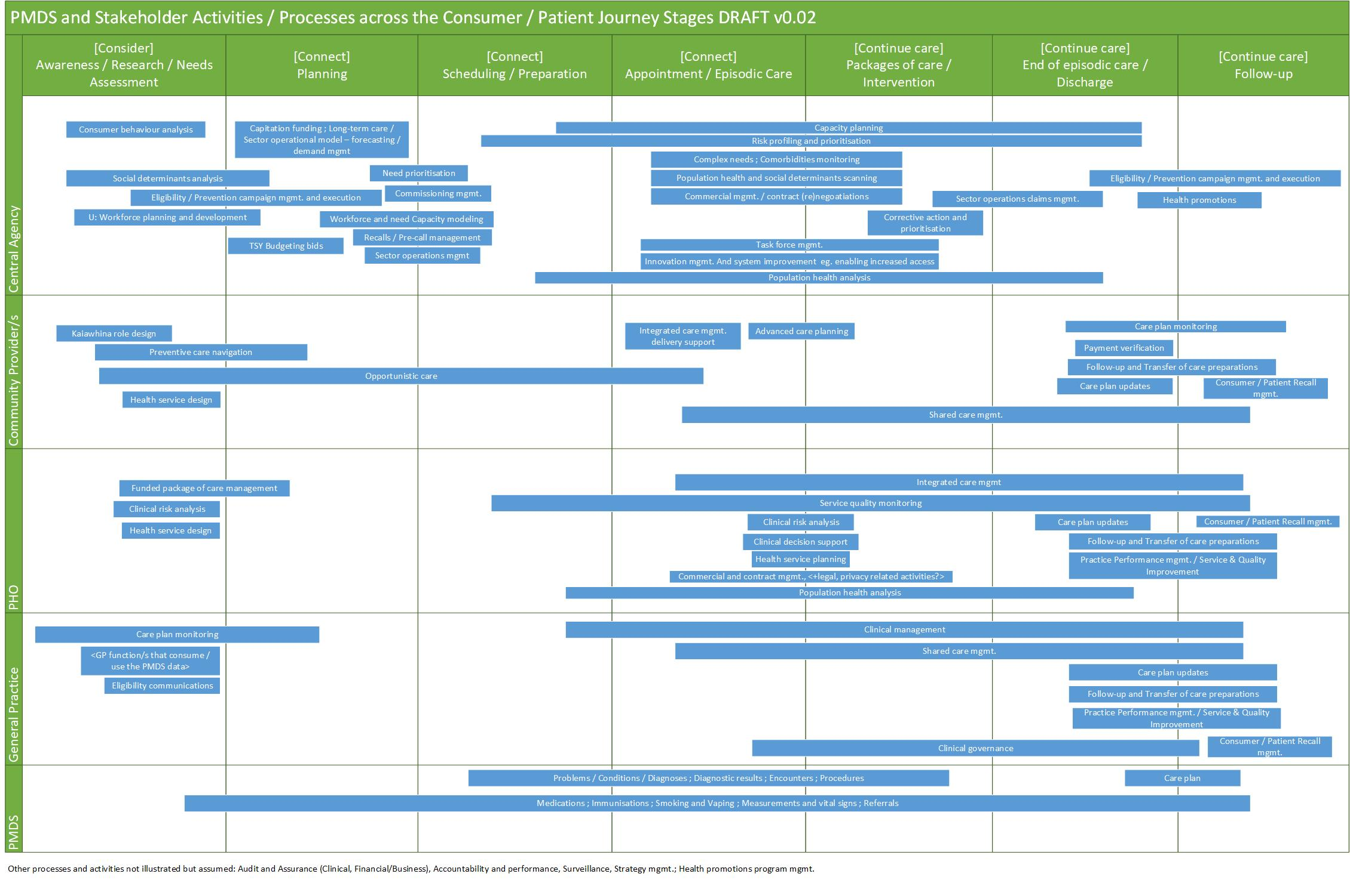

# Next steps

## Updated proposed PMDS

Based on the data availability findings, it is proposed that up to nine data elements (out of the original 39) be dropped from the PMDS framework (depicted in Table 6 below). If the following fields that are less available are removed, it will yield an overall availability of 84%:

1. care plan type code
2. care plan activity date
3. problem resolution date
4. problem severity code
5. vaccination country code
6. vaccination dose series total number
7. encounter disposition code
8. vaping status code
9. vaping status recorded date.

The pros and cons as well as difficulties of collecting these data elements for any PMDS needs to be developed in partnership with the sector.

**Table 6 - Updated proposed PMDS**



**Figure 20 - Overall data availability based on updated proposed PMDS**

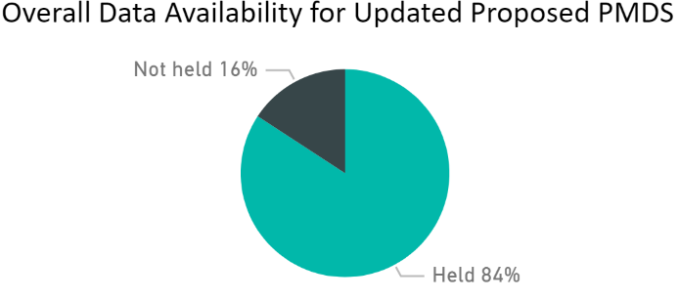

## Programme steps

The PHDP programme team has conveyed in its engagements that this report will be used to inform recommendations to further develop the programme. As described in section 3.6, the PHOs’ belief in this programme’s success will depend on barriers to be addressed around data governance, leadership, sufficient funding, capability support, technology, process, data quality, data culture, general practice and vendor support. Next steps and workplans based on the PHDP programme’s governance group directions will be shared with the sector by the PHDP programme team once they are approved.

# Appendices

## PHDP presentation to stakeholder(s) sample

## Engagement register

## Engagement briefing notes

## Engagements Word Cloud

## Current State and Data Availability Survey

## Approval memo – Primary Health Dataset Proposal

## Health and Disability System Review Report 2020

[https://systemreview.health.govt.nz/final-report/download-the-final-report/](https://systemreview.health.govt.nz/final-report/download-the-final-report/%20)

## Current State and Data Availability Survey PowerBI report

## Stakeholder activities across the Consumer / Patient Journey Stages

## Data and Information Strategy for Health and Disability 2021-2024

Strategy: <https://www.health.govt.nz/system/files/documents/publications/13308_data_strategy_document_final_9_dec.pdf>  
  
Roadmap:  
<https://www.health.govt.nz/publication/data-and-information-strategy-health-and-disability-roadmap-2021-2024>

## Interim Government Policy Statement on Health 2022-2024

<https://www.health.govt.nz/publication/interim-government-policy-statement-health-2022-2024>

## PHDP Governance Terms of Reference

1. <https://systemreview.health.govt.nz/final-report/download-the-final-report/>
2. <https://www.health.govt.nz/our-work/populations/maori-health/wai-2575-health-services-and-outcomes-kaupapa-inquiry>
3. <https://www.health.govt.nz/system/files/documents/publications/13308_data_strategy_roadmap.pdf>
4. Strengthening the use of health insights and intelligence, p. 31 of the upcoming Te Pae Tata (New Zealand Health Plan 2022)
5. <https://www.health.govt.nz/system/files/documents/publications/13308_data_strategy_roadmap.pdf>
6. <https://www.health.govt.nz/publication/interim-government-policy-statement-health-2022-2024>
7. Ibid,
8. Based on the July release from <https://www.health.govt.nz/our-work/primary-health-care/about-primary-health-organisations/enrolment-general-practice-and-primary-health-organisation>
9. HDI are required to respond to questions and provide strategic information and analysis for all levels of the (now) three health agencies for the purposes of policy, planning and population health. NCR provide responses from National Collections for up to 5,000 queries per annum from all parts of the sector including universities and other researchers. This is their indicative list and selection based on the NZIPS standard which is proposed as the future standard for the electronic transfer of primary care data.
10. CMMI Institute, (2019), “Data Maturity Model at a glance”, accessed 15th of August 2022, [[*https://stage.cmmiinstitute.com/getattachment/cb35800b-720f-4afe-93bf-86ccefb1fb17/attachment.aspx*](https://stage.cmmiinstitute.com/getattachment/cb35800b-720f-4afe-93bf-86ccefb1fb17/attachment.aspx)]   
    Elias Baltassis, Anne-Douce Coulin, Antoine Gourévitch, Yassine Khendek, and Lucas Quarta, (2019), *“A Rough Road to Data Maturity”, accessed 15th of August 2022, [https://www.bcg.com/publications/2019/rough-road-to-data-maturity]*
11. ETL is a process where data is extracted and collated from one or more sources and transformed (cleaned, sanitized, scrubbed) and loaded into one or more destinations.
12. Oluwaseyi Ojo, Ph.D., CEng, COBIT 5 Certified Assessor, ITBMC , (2017), “Delivering Disruptive Innovation Using the COBIT 5 Framework“, accessed 15 Aug 22 , [*https://www.isaca.org/resources/news-and-trends/industry-news/2017/delivering-disruptive-innovation-using-the-cobit-5-framework*]
13. https://systemreview.health.govt.nz/final-report/download-the-final-report/.
14. https://systemreview.health.govt.nz/final-report/download-the-final-report/
15. SNOMED CT is an abbreviation for Systematized Nomenclature of Medicine -- Clinical Terms
16. https://systemreview.health.govt.nz/final-report/download-the-final-report/
17. Tableau, accessed 18th of August 2022 [*https://www.tableau.com/why-tableau/data-culture*]
18. This was done by removing a number of data elements specified under section 6.1
19. Pending further analysis and verification in collaboration with PHOs