Review of Adult Palliative Care Services in New Zealand

Citation: Ministry of Health. 2017. Review of Adult Palliative Care Services in New Zealand. Wellington: Ministry of Health.
Published in March 2017
by the Ministry of Health
PO Box 5013, Wellington 6140, New Zealand
ISBN 978-1-98-850236-6 (print)
ISBN 978-0-947515-82-9 (online)
HP 6516
This document is available health.govt.nz
This work is licensed under the Creative Commons Attribution 4.0 International licence. In essence, you are free to: share ie, copy and redistribute the material in any medium or format; adapt ie, remix, transform and build upon the material. You must give appropriate credit, provide a link to the licence and indicate if changes were made.

Contents
1 Background 1
Purpose of the Review 1
Strategic connections 1
A refreshed strategic direction for palliative care 2
What is palliative care? 3
2 Key aspects of current palliative care services 5
Settings of services 5
Assessing service integration 5
Funding 6
What matters to people – what we know 7
3 Changing demands on palliative care services 8
Forecast need for palliative care 8
Implications of the forecast need 9
Future workforce capacity 10
Stakeholders’ views on future demands on funding 11
What matters to people – what we need to know 11
4 Themes from stakeholders 12
5 Priority areas and actions 13
Priority area: Increase emphasis on primary palliative care 13
Priority area: Improve quality in all settings 14
Priority area: Grow the capability of informal carers in communities 15
Priority area: Respond to the voices of people with palliative care needs and their families and whānau 15
Priority area: Ensure strong strategic connections 16
References 17
Appendix 1: Respondents to targeted consultation on draft Review findings, July 2016 18

List of figures
Figure 1: Five strategic themes of the New Zealand Health Strategy 1
Figure 2: The relationship between primary palliative care and specialist palliative care 4
Figure 3: Projected need for palliative care in New Zealand, 2016–2068 9

1 Background

Purpose of the Review
The purpose of the Review of Adult Palliative Care Services in New Zealand (the Review) is to recommend actions to ensure that all New Zealand adults who would benefit from palliative care at the end of their life continue to receive high-quality care and a seamless experience of care regardless of whether they are at home, in hospital, in a hospice or in an aged residential care facility.

The Review was conducted from October 2015 to September 2016. Its terms of reference (available on the Ministry of Health website) limited the Review to adult services, as paediatric palliative care services are provided on a significantly smaller scale and through a different set of services. Its findings are drawn from projections the Ministry of Health commissioned, information from stakeholders, and evidence gathered during the Review. The Palliative Care Advisory Panel has been consulted.

Strategic connections
Figure 1: Five strategic themes of the New Zealand Health Strategy  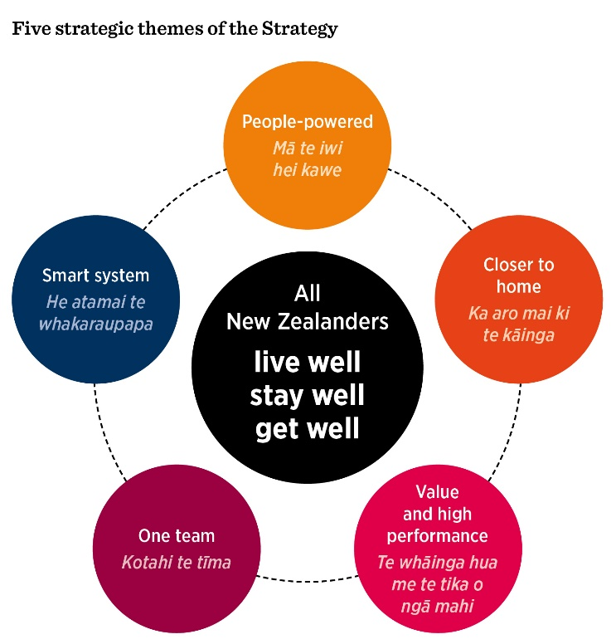 | The Roadmap of actions 2016 in the New Zealand Health Strategy identifies the Review as one of its actions.  The refreshed strategic direction for adult palliative care outlined in the Review aligns with the direction for the health system established by the New Zealand Health Strategy under five strategic themes (Figure 1), and with the Healthy Ageing Strategy.  The Healthy Ageing Strategy also has a focus area on support for a respectful end of life. The Healthy Ageing Strategy is about supporting older people to age well, make informed choices about their health and wellbeing and ensure a person-centred, responsive system. In particular, it is about enabling people to feel safe and supported to openly discuss and plan for their end of life.

The Healthy Ageing Strategy is the result of a highly collaborative process, involving many individuals and organisations, and public consultation. It will be a key platform for improving outcomes for older people and their families and whānau.

A key strand connecting the New Zealand Health Strategy, the Healthy Ageing Strategy and the Review is the aim to support people in the final stages of life, whatever their age group. Actions to improve the general public’s awareness and understanding of this phase of life (Closer to home) as well as to develop the capability of the primary palliative care workforce and informal carers (One team) are a priority. Improving service quality, through increased national consistency (Value and high performance), and incorporating the views of patients, families and whānau (People-powered) are other common themes.

A refreshed strategic direction for palliative care
This report summarises key aspects of current service delivery of adult palliative care in New Zealand, and gives an overview of factors influencing the changing demand for these services. It outlines the implications of the forecast changes and opportunities to help manage them with a continued focus on high-quality care.

The overarching goal for adult palliative care service delivery in New Zealand is to provide high-quality care, in all settings and geographical locations, enabling someone to die in an environment that feels, and is, safe and comfortable.

High-quality palliative care is, at its heart, people-centred and responsive, offering clinical, physical, psychosocial, spiritual and cultural aspects of care and support. Transitions between goals of care, and sometimes place of care, can represent milestones in the journey of the person who is dying. Open communication and a clear patient pathway for this journey as it progresses are other characteristics of a high-quality experience. Support for family, whānau and friends, both before and after a death, is a further core aspect.

This report outlines a suite of actions under five priority areas, which reflect the key themes arising from the Review. The five priority areas are to:
- increase the emphasis on primary palliative care
- improve quality in all settings
- grow the capability of informal carers in communities
- respond to the voices of people with palliative care needs and their families and whānau
- ensure strong strategic connections.

These priority areas and their actions are aimed at managing future demand and achieving the overarching goal. They underpin a refreshed strategic direction for the delivery of adult palliative care services.

This report represents a high-level summary of a comprehensive reference document that the Ministry of Health compiled for the purposes of the Review, with input from the sector.

What is palliative care?
This section defines the term ‘palliative care’ and the two main ways of delivering it. For explanations of other relevant terms used in this report, see the New Zealand Palliative Care Glossary (Ministry of Health 2015a).

Palliative care is care for people of all ages with a life-limiting or life-threatening condition, which aims to:
- optimise an individual’s quality of life until death by addressing the person’s physical, psychosocial, spiritual and cultural needs
- support the individual’s family, whānau and other caregivers where needed, through the illness and after death.

Palliative care is provided according to an individual’s need, and may be suitable whether death is days, weeks, months or occasionally even years away. It may be suitable sometimes when treatments are being given aimed at improving quantity of life. The preferred approach is that it is available wherever the person may be located and is provided by all health care professionals, supported where necessary, by specialist palliative care services.

‘Primary palliative care is provided for those affected by a life-limiting or life-threatening condition as an integral part of standard clinical practice by any health care professional. It refers to palliative care provided as a routine component of usual care by all individuals and organisations who are not part of a specialist palliative care team. Primary palliative care providers assess and refer people to specialist palliative care services when the needs of the person extend beyond the scope of the service.

Specialist palliative care is palliative care provided by those who have undergone specific training and/or accreditation in palliative care or palliative medicine, working in the context of an expert interdisciplinary team of palliative care health professionals.

Specialist palliative care is delivered both:
- directly – to provide direct management and support of the person, family and whānau where more complex palliative care need exceeds the resources or scope of the primary palliative care provider. The delivery may be continuous or episodic depending on the changing needs of the person receiving care and their family and whānau
- indirectly – to provide advice, support, education and training for other health professionals and volunteers to support the primary provision of palliative care.

Figure 2: The relationship between primary palliative care and specialist palliative care
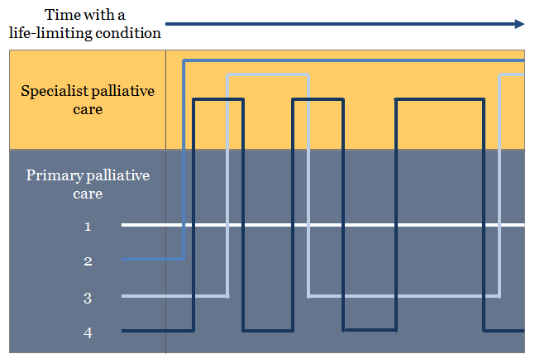

Figure 2 above illustrates examples of the provision of primary palliative care and specialist palliative care and how delivery may be continuous or episodic depending on the changing needs of the person receiving care. The following four examples are illustrated.
1) All care is provided by the primary palliative care providers with no input required from specialist palliative care services.
2) Care is provided by specialist palliative care for the duration of the illness with little or no input from primary palliative care providers.
3) Initial involvement from specialist palliative care to guide a plan of care with re-referral during the deteriorating phase or during the last days of life.
4) Multiple episodes of specialist palliative care involvement during times of increased need/complexity, not necessarily during the last days of life.

3) and 4) are examples of the ways in which care may be provided intermittently by specialist palliative care in combination with primary palliative care. Continuity of care is provided by the primary palliative care provider(s).

2 Key aspects of current palliative care services

Settings of services
In New Zealand, primary and specialist palliative care services are delivered in hospitals, aged residential care, private homes and hospices. In 2013 almost one-third of deaths across New Zealand occurred in public hospitals, one-third in aged residential care facilities, 23 percent in private homes and just under 7 percent in hospice inpatient units. These proportions varied across regions, genders, ethnicities and age at death.

The hospice service extends well beyond inpatient beds. In the year to June 2015, 74 percent of people using hospice services had no admissions to an inpatient facility and 69 percent of people who died supported by hospice, did so in the community, either at home or in aged residential care (Hospice New Zealand Annual Review 2015).

Importantly, place of death data may not reflect a person’s main place of care, or their main provider of care, as people may transition to other settings or services at critical points on their journey.

Post-death and bereavement support for family, whānau and friends is an important aspect of palliative care services. A range of providers may deliver that support across a range of settings and geographical locations, wherever the bereaved are based.

Assessing service integration
As part of the Review, district health boards self-assessed their current services against the Resource and Capability Framework for Integrated Adult Palliative Care Services in New Zealand (Ministry of Health 2013).

The Resource and Capability Framework provides guidance to funders and policy makers to inform the strategic planning and purchasing of accessible and equitable palliative care services for New Zealanders.

The Resource and Capability Framework describes the levels of care and staffing resources appropriate for the New Zealand context, and the formal links between all providers of palliative care so that the needs of the patient and their family and whānau.

The Framework promotes a collaborative and integrated approach to palliative care service delivery. It is based on the concept that, for many people, their primary care provider – for example, their general practice team – can meet their need for palliative care, with specialist palliative care services provided as required.

Both the New Zealand Health Strategy and the Healthy Ageing Strategy recognise improving integration is a fundamental building block to improving communication, service planning and delivery (One team; Value and high performance).

In summary, the findings from district health boards’ self-assessments in relation to integration were as follows.
- Overall, district health boards report good levels of collaboration and integration of specialist palliative care services between hospitals and hospices across districts. Some gave examples of larger hospices acting as hubs for specialist services within a district.
- District health boards report strong, functional relationships between specialist palliative care services, hospices, aged residential care and primary care at a local level, while recognising challenges with these relationships in some communities. In their view, partnering is more successful when individual general practice teams and the aged residential care facility are willing and have the capacity to do so and specialist palliative care is available.
- Many regions have established palliative care networks or working groups, some of which are linked to cancer networks or health of older people networks. Some regions have more mature collaborative models, for example in Canterbury under the South Island Alliance (a collaboration of the South Island’s five district health boards).
- Reports indicate pockets of primary palliative care services are operating independently and with limited access to specialist palliative care services, for example, in more isolated communities. District health boards report that the consistency of services across these pockets is difficult to determine.

Some examples of barriers to integration that district health boards and network leads gave are:
- the uneven distribution of palliative medicine specialists and palliative care nursing specialists, meaning there are shortages in some areas, particularly rural areas
- the need to build capability and support in primary palliative care across general practice teams, aged residential care staff, nurses, hospital staff and ambulance staff
- inconsistent criteria for referral from primary care to specialist palliative care, which can lead to variability of access
- information technology barriers to sharing patient information (although some regions have resolved this issue)
- differences in funding and reporting arrangements between providers
- unclear service specifications for specialist palliative care
- variable levels of confidence about the cultural appropriateness of the current models of care.

Funding
Under the Service Coverage Schedule, palliative care services funded by district health boards include assessment, care coordination, clinical care and some support services. Palliative care service provision is often integrated with other service delivery and coding, as many elements of palliative care are not distinctly different from non-palliative care. For example, it overlaps with service provision for long-term conditions. Most district health boards choose not to fund hospital specialist palliative care as a separate service.

Budget 2015 provided funding of $76.1 million for hospice service delivery. That included $24.1 million over four years to support the delivery of new palliative care services and innovation in aged residential care, primary care and community settings. To date, 40 new palliative care positions have been established across 15 district health boards, along with proposals for greater collaboration and integration across settings.

In regard to funding arrangements, stakeholders have initiated discussions on the optimal way of allocating funding across the palliative care sector in the future to meet changing demands, determine cost-effectiveness and continue to achieve high-quality outcomes.

What matters to people – what we know
Evidence in New Zealand shows that what matters to people at the end of life is being accompanied by significant others, friends and family, control of symptoms especially pain, and not being a strain on family and whānau members. They describe self-management, to the extent it is possible, as empowering. To Māori, engagement with spiritual aspects of care is particularly important.

Research by the Palliative Care Council of New Zealand (2015) reveals consistent themes in people’s perceptions of high-quality palliative care. Notably, it found that good communication is crucial, alongside respect for patients and their families and whānau, particularly in terms of listening to their desires and choices. Underpinning the experience of high-quality care is workforce capability, competence, ability to access care when it is needed and care continuity.

Respondents in that study reported that their experience of care in the hospice environment was of an overall high standard, although they raised some concerns over patients being transferred to hospice care later than they desired. In aged residential care facilities, respondents consistently identified communication and the administration of pain relief and medication as important in determining the quality of their care. Patients in the hospital environment again tended to mention the importance of communication, including receiving information on diagnosis, and to perceive the hospital environment as impersonal.

Māori respondents thought a whānau-oriented approach was important to high-quality palliative care. They also supported having a culturally competent workforce and good-quality written information, and addressing barriers to accessing specialist palliative care services.

Limited stakeholder consultation highlighted several matters about access to palliative care by Pacific peoples. First, demand is ongoing for Pacific navigators, interpreters and advocates to help clients and the wider extended family understand and navigate the system and to access palliative care along with psychosocial and spiritual support in all settings. Second, communication is key – it is important for Pacific families to understand what is happening, to know who is involved and to be involved. Finally, where hospices and aged residential care facilities have trained Pacific staff, staff who speak Pacific languages, or Pacific liaison roles, this has helped the person and their family feel safe and comfortable.

Consultation for the Healthy Ageing Strategy confirms people want to be confident that they receive care and support that focuses on what is important to them, whichever setting or location they are in.

3 Changing demands on palliative care services

Forecast need for palliative care
The evidence is clear: more people will be dying each year, and people will be dying at older ages and increasingly with the presence of frailty and comorbidities including dementia. Specifically, the updated projections indicate the following trends.
- In the next 20 years the number of deaths in New Zealand is projected to increase by almost 50 percent, from the current rate of around 30,000 per year to 45,000 per year in 2038.
- By 2068 the number of deaths per year is projected to reach 55,500. This increase will happen because people will be living longer than in earlier periods, and the absolute number of older people will be higher as the ‘baby boom’ generation (born between 1946 and 1965) enter their older years.
- The age at death will increase rapidly. In 20 years, over half of deaths will be in the age group of 85 years and over. Most of the deaths at the oldest ages will be women.
- A substantial increase in the proportion of Māori deaths or Pacific deaths is unlikely, but the proportion of Asian deaths is likely to increase from 3.3 percent in 2016 to 8.2 percent (of the total number of deaths) by 2038.
- The rising prevalence of comorbidities suggests that people’s course of illness at the end of life could be very hard to predict and to plan and coordinate care for.
- The number of people needing palliative care is projected to increase by 51 percent from 24,680 in 2016 to 37,286 by 2038. In terms of the proportion of all deaths, people needing palliative care would increase from 80.9 percent in 2016 to 82.8 percent in 2038. These projected figures do not distinguish between the need for specialist palliative care and the need for primary palliative care.
- Based on historic patterns of place of death, the need for palliative care is projected to increase between 2016 and 2038 by 37.5 percent in public hospitals, 84.2 percent in aged residential care and 51.8 percent under hospice care (including those under hospice services in aged residential care and in the community).

Figure 3 illustrates the forecast trend of the need for palliative care from 2016–2068. The forecast maximum need in the figure shows essentially all deaths, excluding maternity deaths and excluding sudden deaths from external causes unless these occur in aged residential care or a hospice inpatient unit.

Figure 3: Projected need for palliative care in New Zealand, 2016–2068
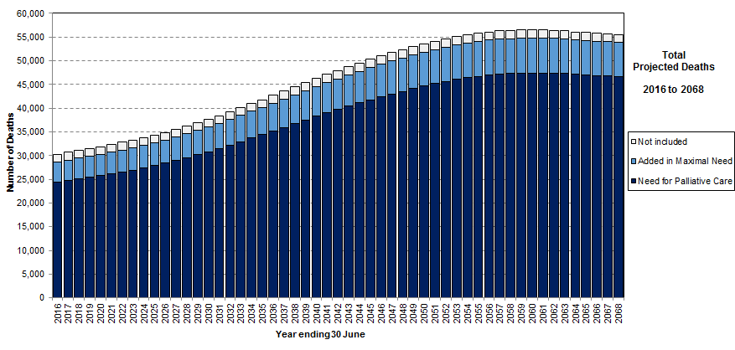

Implications of the forecast need
Because of advances in chronic disease management coupled with an increasing number of older people, comorbidities will be increasingly common. Correspondingly, approaches for planning end of life care that focus on a single disease only will increasingly make less sense as people’s functional decline towards the end of life may become very difficult to predict. These trends will have implications for the coordination of person-centred care, health and social services, prognostication, referrals, patient experience and choice, the experience and choice of family and whānau, and other aspects of the wider health and social sectors.

It is difficult to estimate with any certainty what the changing trends will mean for the demand on the different levels of palliative care and the proportion of those with complex needs likely to require either episodic or ongoing specialist care. Compounding this uncertainty are evident gaps in our knowledge of the palliative care needs of those with dementia and frailty and how those needs will affect demand on specialist palliative care services.

The care that most people receive at the end of their lives will increasingly be provided not by specialist palliative care practitioners but by a primary palliative care team. That team will include general practitioners, practice nurses, district nurses, aged residential care workers, allied health practitioners, spiritual workers, home and community carers and the wider community.

There is some consensus that most people’s palliative care needs can, and should, be met through good primary palliative care in primary care settings (home, hospice, aged residential care) and hospital settings. This creates a need to strengthen the emphasis on primary palliative care, and to acknowledge and build understanding that providing primary palliative care is the role of all health practitioners and allied health practitioners. Some core elements of palliative care, such as aligning treatment with a patient’s goals, basic symptom management and psychosocial support, should increasingly become routine aspects of care delivered by any health practitioner, supported by minimum palliative care competencies.
Supporting people to live and die in the community (at home or in aged residential care) is a strong theme in the Healthy Ageing Strategy. Consumers consistently called for community-based care delivered by a competent primary-level workforce, working with kaiāwhina and whānau, and supported by specialists as appropriate.

Future workforce capacity
There is a shortage of palliative medicine specialists in some parts of the country. While the ratio of palliative medicine specialists per head of population may meet the recommendations of the Australian and New Zealand Society of Palliative Medicine overall, in some locations limited access to specialist care is creating inequities. District health boards report difficulty in recruiting and retaining palliative medicine specialists in some locations, particularly in rural areas. Such difficulties limit access both for people needing specialist care and for primary palliative care teams seeking support and advice. To compound this situation, the number of palliative medicine specialists per person in the population is forecast to decline by 2026.

Alongside this is a forecast shortage of palliative care nurses, general practitioners with a special interest in palliative care, and Māori health workers.

The nursing and palliative medicine specialist workforce is also ageing, meaning its sustainability is a concern. While this is an issue across much of the health workforce, it is particularly relevant to palliative medicine specialists. By 2020, 56 percent of the current palliative medicine specialist workforce will be over the age of 65 years. This issue is compounded by the ageing population, which increases demand for palliative care services.

The Workforce Forecasting Model projects that, over the next 10 years, the ratio of nurses and palliative medicine specialists to the population group aged 60 years and over will decline. This is because a large proportion of the current health workforce is aged 55 years and over and the number of New Zealanders aged 60 years and over is expected to increase.

The ageing population and the emphasis on integrated care mean that home and personal caregiver roles are becoming an increasingly important part of the palliative care multidisciplinary team. Stakeholders note that they are also seeing clients with increasingly complex conditions. Developing the care and support workforce will need to be considered to deal with these trends. As part of this work, Careerforce is developing training packages in palliative care. Like the other groups of health professionals noted above, the care and support workforce is ageing.

Volunteers, family, whānau, friends and the wider community contribute significantly to the delivery of primary palliative care as informal carers in all settings. Based on the projections of future demand for palliative care, the system’s reliance on this workforce is likely to increase. The cost of replacing informal care with formal care would be substantial. There will be an increased need to train and support informal carers, volunteers and community groups to take on potentially more frequent, longer and more complex roles in supporting people with palliative care needs. The aged residential care sector is well placed to contribute to this work, if it has appropriate resourcing.

The need is growing for a workforce that is competent to accommodate increasingly diverse personal, cultural and spiritual values and customs.

Stakeholders’ views on future demands on funding
Many stakeholders have noted that, to meet changing demand, funding settings will need to provide stronger incentives for providers to collaborate, and drive efficiencies in service provision.

Aged residential care providers say they face increasing cost pressures. One particular issue for them is uncertainty over whether the aged residential care sector in the future will have sufficient capacity and choice of facility type in some locations to meet the growing demand from the ageing population. Other uncertainties concern funding sustainability and the future availability of specialist palliative care services.

The main funding issues individual primary care practitioners raised during the Review relate to access and equity. Some general practitioners reported that they face challenges funding home visits and after-hours care of palliative patients, and that financial barriers make it difficult for patients to access general practitioners regularly or after hours. The Review found that some primary health organisations are strongly committed to building models of care and clinical care pathways for palliative care in their communities.

What matters to people – what we need to know
There are notable gaps in information and knowledge on the perspectives and experiences of people with palliative care needs and of their bereaved family and whānau. A national picture on preferences for both place of care and place of death is emerging but not yet clear. We know little about what influences preferences and how these change in response to rapidly changing care needs and as death approaches. This information is particularly lacking for Pacific, Indian and other Asian populations.

4 Themes from stakeholders
During the Review, stakeholder engagement was undertaken on the status of palliative care in New Zealand and the priorities for palliative care in the future. Targeted consultation on draft Review findings was undertaken in July 2016. For a list of respondents, see Appendix 1.

Stakeholders consistently raised the following themes, which have informed the refreshed strategic direction for palliative care.
- Address the invisibility of death, dying and palliative care. Lift the stigma around dying so that New Zealanders can die well. Achieving this change requires information, education and awareness raising.
- Build the capability of all health workers. Death and dying are part of life and living – this concept does not comprehensively feature in training across all of the health care workforce.
- Continue to build a strong and well-supported specialist workforce. This needs attention now to cope with future demands.
- Ensure equitable, patient-centred care for all who need it. Access to both primary and specialist palliative care is variable and can be unavailable, depending on local service delivery arrangements. Particular inequities are evident in access to 24-hour advice and support.
- Better recognise and value the role and needs of informal, family and whānau carers.
- Consider the voices of patients and their families and whānau in improving services. Patient outcomes, views and perspectives are not consistently captured and responded to.
- Improve cooperation and coordination between providers. High-quality care at the end of life happens when strong networks exist between specialist palliative care providers and primary palliative care teams – including general practitioners, practice nurses, district nurses, support care providers and allied health practitioners – alongside the person being cared for, their family and friends, their whānau and their community.
- Continue to build integrated models of care and accountability arrangements that help providers to collaborate.
- Focus on outcomes and make better use of data. A core set of outcome measures needs to be established and applied across all settings.
- Funding arrangements need to be fair and transparent, and support equity. It is difficult to navigate the various funding mechanisms and incentives. The ability to determine whether service delivery gives value for money is limited at present.
- Any additional compliance requirements by providers will need to be funded appropriately. In particular, implementing a national quality framework may need funding.
- Actions coming from the Review need to be adequately resourced.

5 Priority areas and actions
As a result of the Review findings and the evident need to address the projected demand on the palliative care services, this Review has identified five priority areas, with associated actions. The actions are aimed at achieving the overarching goal for adult palliative care service delivery in New Zealand. That is, services will provide high-quality care, in all settings and geographical locations, enabling someone to die in an environment that feels, and is, safe and comfortable. High-quality palliative care is, at its heart, people-centred and responsive.

The actions align with those in the New Zealand Health Strategy and the Healthy Ageing Strategy and can be progressed as a coordinated and coherent package. Driven by the actions described below, the following priority areas underpin a refreshed strategic direction for the future of adult palliative care services.

Priority area: Increase emphasis on primary palliative care
There is opportunity to strengthen the emphasis on primary palliative care and on the knowledge and skills of the primary palliative care workforce. To achieve this increased emphasis, a sufficient and sustainable specialist workforce is needed to support, advise and educate those providing primary palliative care. Alongside this, the interface between specialist and primary palliative care should be clear and widely understood.

General practice and multidisciplinary teams in primary care settings, and their relationships with specialist palliative care providers, will be key to responding effectively to the projected increase in palliative care need (Keane et al 2015).

The potential exists to better use the skills and expertise of the wide range of allied health professionals in the care of palliative patients and to involve them earlier. These professionals include physiotherapists, occupational therapists, speech and language therapists, dieticians, social workers and psychologists. Alongside this is the opportunity to more fully use the skill set of the pharmacist workforce in medicines management, particularly in the community setting. In addition, the unique skill set of specialist palliative care nurses could be used further in mentoring, training and education, care coordination and relationship management roles between specialist services and other health care providers.

Actions: Increase emphasis on primary palliative care
a. Revise national referral guidance for specialist palliative care and clarify the role of specialist palliative care to better support the sector to understand the interface between specialist and primary palliative care.
b. Support modification of undergraduate curricula to improve understanding of palliative care across all workforce groups.
c. Facilitate conversations with the sector about minimum palliative care competencies, knowledge and skills across all workforce groups.
d. Make better use of pharmacists (including clinical pharmacists and pharmacist prescribers), allied health, and advanced nursing roles and specialist palliative care nurses.

Priority area: Improve quality in all settings
While all of the actions coming from the Review will help to improve various aspects of quality, understanding and measuring outcomes is a key element in achieving this improvement.

To progress this priority area the Review proposes establishing a national agreement on service expectations, including quality standards, and increasing the visibility of palliative care quality indicators in accountability arrangements. These goals could be advanced by developing the following three building blocks.
- National service expectations for palliative care will centralise current expectations for publicly funded services, and support a range of commissioning and contracting models. They will also provide clear accountability and links to current guidelines and service standards where national consistency or guidance is needed; for example, Te Ara Whakapiri: Principles and guidance for the last days of life (Ministry of Health 2015b).
- An outcomes framework to support, and be supported by, the National Service Expectations. The outcomes framework would take a results-based accountability approach and build on the existing outcomes framework, ‘Measuring What Matters’, developed by the Palliative Care Council of New Zealand (Palliative Care Council of New Zealand 2012). It will inform what is important to measure and the purpose of the measurement.
- A core, national set of outcomes, quality and activity data for palliative care is a necessary building block to underpin those described above.

While the first two building blocks above are achievable in the short term, moving to a core, national set of data for palliative care would take some time.

The Ministry of Health’s existing National Service Specifications for Specialist Palliative Care Service describe the minimum national service requirements for specialist palliative care. It is noted that district health boards vary in the extent to which they apply these specifications; some report difficulties with implementation. Under the proposed quality framework, the specifications can sit alongside the three building blocks and continue to be voluntary, as they are currently.

All full member hospices have adopted the existing Hospice New Zealand Standards for Palliative Care (Hospice New Zealand 2012). Hospice New Zealand notes that the long-term vision for its standards is that any health care provider caring for people with palliative care needs can use these standards as a self-monitoring performance tool. The proposed building blocks present an opportunity to develop these standards further.

The Resource and Capability Framework for Integrated Adult Palliative Care Services in New Zealand (Ministry of Health 2013) is another example of national guidelines that could inform national service expectations.

Actions: Improve quality in all settings
a. Agree national service expectations for palliative and end-of-life care for use in all settings (for example, aged residential care, primary care, hospitals and hospices).
b. Establish an outcomes framework to support a range of commissioning models using a results-based accountability approach.
c. Agree a core, national set of outcome, quality and activity data for palliative care (across all providers).
d. Include palliative care quality indicators in the system outcomes monitoring framework.

Priority area: Grow the capability of informal carers in communities
The system has the scope to better support and recognise the importance of informal carers. Changes to wider social policies directly affect the availability of this group. For example, people aged in their 60s are potential caregivers for parents in their 80s and 90s, and superannuation policies affect their ability to take on this role. Supporting employed carers could be strengthened through flexible working hours, leave provisions or job security provisions that apply while they are caring for a family member.

Actions: Grow the capability of informal carers in communities
a. Improve support for informal carers, including the provision of respite, guidance and information, and training, in line with the Government’s Carers Strategy.
b. Advance the potential of new technologies to both support people in their homes and enable easy access to specialised support and advice; for example, telecare, e-monitoring, and assistive home technology.
c. Work across government to consider financial and work-related barriers to informal care; for example, helping people to remain employed while caregiving.

Priority area: Respond to the voices of people with palliative care needs and their families and whānau
Information on the patient experience is an invaluable tool for identifying where care improvement is necessary, and for ensuring palliative care is person-centred. Research suggests it could be helpful to adapt the United Kingdom Views of Informal Carers – Evaluation of Services (VOICES) survey to the New Zealand context (Frey et al 2016). This survey collects bereaved people’s views on the quality of care provided in the last three months of life. Auckland District Health Board and the South Island Alliance are piloting an adapted VOICES survey. This presents an opportunity to further explore the value and feasibility of having a national survey of bereaved people’s experiences of care and services.

Actions: Respond to the voices of people with palliative care needs and their families and whānau
a. Progress options for a national survey of patient or family and whānau experiences of end-of-life care.
b. Evaluate the hospice innovation funding proposals to improve the quality of palliative care in aged residential care, primary care and community settings.

Priority area: Ensure strong strategic connections
The priority areas identified for palliative care in this Review have considerable synergy with the following actions identified in the Roadmap of actions 2016.

Actions: Ensure strong strategic connections
(actions under the New Zealand Health Strategy: Roadmap of actions 2016)
a. Workforce development for carer, kaiāwhina and support workforce.
b. Shared electronic patient health record as well as patient portals.
c. Better use of the skills and expertise of the allied health workforce.
d. Increasing workforce diversity.
e. Review, together with services users, quality dimensions for aged residential care and home support.
f. Support clinicians and people in developing advance care plans and advance directives.

References
Frey R, Williams L, Trussardi G, et al. 2016. The views of informal carers’ experiences of services (VOICES): towards an adaptation for the New Zealand bicultural context. BMJ Supportive and Palliative Care.
Hospice New Zealand. 2012. Hospice New Zealand Standards for Palliative Care. Wellington: Hospice New Zealand.
Hospice New Zealand. 2015. Hospice New Zealand 2015 Annual Review. Wellington: Hospice New Zealand.
Keane B, Bellamy G, Gott M. 2015. General practice and specialist palliative care teams: an exploration of their working relationship from the perspective of clinical staff working in New Zealand. Health Soc Care Community doi:10.1111/hsc.12296.
Ministry of Health. 2013. Resource and Capability Framework for Integrated Adult Palliative Care Services in New Zealand. Wellington: Ministry of Health.
Ministry of Health. 2015a. New Zealand Palliative Care Glossary. Wellington: Ministry of Health.
Ministry of Health. 2015b. Te Ara Whakapiri: Principles and guidance for the last days of life. Wellington: Ministry of Health.
Palliative Care Council of New Zealand. 2011. National Health Needs Assessment for Palliative Care Phase 1 Report: Assessment of palliative care need. Wellington: Cancer Control New Zealand.
Palliative Care Council of New Zealand. 2012. Measuring What Matters: Palliative care. Wellington: Cancer Control New Zealand.
Palliative Care Council of New Zealand. 2015. Draft Results of a Survey of Family/Whānau Caring for People in Their Last Days of Life: Working Paper No.9. Wellington: Cancer Control New Zealand.
Quill T, Abernethy A. 2013. Generalist plus specialist palliative care – creating a more sustainable model. N Engl J Med 368: 1173–5.

Appendix 1: Respondents to targeted consultation on draft Review findings, July 2016
Lakes District Health Board
Waikato District Health Board
Northland District Health Board
Taranaki District Health Board
Counties Manukau District Health Board
Waikato Hospital Palliative Care Service
Christchurch Hospital, Canterbury Integrated Palliative Care Services
Hospital Palliative Care New Zealand
Midland Palliative Care Work Group, Midland, Waikato and Lakes
Home and Community Health Association
Care Association New Zealand
University of Auckland
New Zealand Aged Care Association
Hospice New Zealand
Totara Hospice
Mercy Hospice Auckland
Te Awakairangi Health Network
TAS
Compass Health Primary Health Organisation
General Practice New Zealand

The Palliative Care Advisory Panel was established in November 2015 to continue the work programme of the Palliative Care Council of New Zealand and advise the Ministry of Health on issues such as equity of access and quality of care. The 11-member panel, chaired by Professor Merryn Gott, has expertise from a wide range of sectors, including the aged care, consumer, primary care, district health board, hospice and research sectors.
The Service Coverage Schedule allows the Minister of Health to explicitly agree to the level of service coverage for which the Ministry of Health and district health boards are held accountable.
The first estimates of need for palliative care in New Zealand were published in 2011 with projections to 2016 and 2026 (Palliative Care Council of New Zealand 2011). Revised and updated projections of future need for palliative care services were commissioned from Professor Heather McLeod in 2016 and are summarised here.
Although future levels of patient need for palliative care are hard to predict, there is some consensus that most people’s palliative care needs can be met in primary care and hospital settings, without the need for specialist palliative care (Quill and Abernethy 2013).
Health Workforce New Zealand’s Workforce Forecasting Model of the medical and nursing workforce uses historic annual practising certificate data from the Medical Council of New Zealand and Nursing Council of New Zealand to estimate how the age, head count and full-time equivalents (FTEs) of the medical and nursing workforce will change over the next 10 years.
Stakeholder engagement on the Review included site visits in four regions and input from district health boards, regional/district palliative network leads, Hospital Palliative Care New Zealand, General Practice New Zealand, primary care providers, primary health organisations, Hospice New Zealand, hospice chief executives and board chairs, the Aged Residential Care Steering Group, New Zealand Aged Care Association, home care workers, the Home and Community Health Association, the Care Association of New Zealand, palliative care nurses, directors of Allied Health, Grey Power, and consumer representative groups. The Palliative Care Advisory Panel was consulted.
Te Ara Whakapiri: Principles and guidance for the last days of life (Ministry of Health 2015b) replaces the Liverpool Care Pathway as guidance for care in the last days of life across all service settings, including the home, residential care facilities, hospitals and hospices. The Palliative Care Advisory Panel oversaw the implementation of Te Ara Whakapiri during 2016.

