Te Ara Whakapiri Toolkit

Care in the last days of life

Citation: Ministry of Health. 2017. *Te Ara Whakapiri Toolkit: Care in the last days of life*.  
Wellington: Ministry of Health.

Published in April 2017  
by the Ministry of Health  
PO Box 5013, Wellington 6140, New Zealand

ISBN 978-1-98-850220-5 (online)  
HP 6561

This document is available at health.govt.nz



 This work is licensed under the Creative Commons Attribution 4.0 International licence. In essence, you are free to: share ie, copy and redistribute the material in any medium or format; adapt ie, remix, transform and build upon the material. You must give appropriate credit, provide a link to the licence and indicate if changes were made.

Contents

Introducing the Te Ara Whakapiri toolkit 1

How to use the Te Ara Whakapiri toolkit 2

Staff signature sheet 3

Care in the last days of life 5

Ongoing care of the dying person 9

Home care in the last days of life 11

Recognising the dying person flow chart 13

Medical management planning – general principles 15

Bereavement risk assessment tool 17

Discharge checklist 19

Symptom management guidelines 21

Contents 21

Management of pain 22

Management of agitation, delirium, restlessness 26

Management of nausea/vomiting 29

Management of excessive respiratory tract secretions 32

Management for dyspnoea/breathlessness 35

When death approaches 39

Dying at home 41

# Introducing the Te Ara Whakapiri toolkit

*Te Ara Whakapiri: Principles and guidance for the last days of life* defines what adult New Zealanders can expect as they approach the end of their life. It is a statement of guiding principles and components for the care of adults in their last days of life across all settings, including the home, residential care, hospitals and hospices.

The term ‘last days of life’ defines the period of time in which a person is dying. It is the period in which death is imminent and may be measured in hours or days.

TeAra Whakapiri is based on an extensive evaluation of the available literature and is informed by local research, ensuring it is applicable to the unique context that is Aotearoa New Zealand. It has been endorsed by key professional health organisations in New Zealand and marks a major step towards ensuring that all health care services across the country are focused on delivering the very best care for people who are dying and for their family/whānau whatever the setting.

Investigations of New Zealanders’ experience of palliative and end-of-life care highlighted the following two key requirements.

* A responsive, fully trained workforce, available any time of the day or night to provide care, advice and compassionate support within appropriate cultural and spiritual conventions
* Clear and simple communication, including advice about recognising when a person is dying, approaches to treatment and care, the use of an individualised plan of care and opportunities for the family/whānau to contribute to care if they wish.

Seven overarching principles are underpinned by Te Whare Tapa Whā, a model of care that is concerned with the total wellbeing of the person and their family/whānau.

1 Care is patient-centred and holistic.

2 The health care workforce is appropriately educated and is supported by clinical champions.

3 Communication is clear and respectful.

4 Services are integrated.

5 Services are sustainable.

6 Services are nationally driven and supported to reduce variation and enhance flexibility.

7 Resources and equipment are consistently accessible.

Te Ara Whakapiri simply seeks to focus on delivering the very best care for people who are dying and for their family/whānau whatever the setting. This toolkit has been developed to enrich and support delivery of end-of-life care throughout the country.

## How to use the Te Ara Whakapiri toolkit

The support and care of families/whānau as well as the dying person is a crucial part of last days of life care. It is best delivered by a multidisciplinary team, supporting everyone involved to identify realistic goals of care and contribute to decision-making, whilst also helping them deal with their own distress.

Teams of health care professionals can use elements of the Te Ara Whakapiri Toolkit in any care setting to help them make regular assessments that includes reflection, review and critical decision-making in the best interest of the person they are caring for.

The recognition and diagnosis of dying is always complex, irrespective of previous diagnosis or history. Uncertainty is an integral factor in the dying process, and there are occasions when a person who is thought to be dying lives longer, or dies sooner, than expected. **Seek a second opinion or specialist palliative care support as needed**.

Good, comprehensive, clear communication and access to appropriate supports are required to identify and address differences in cultural perspectives in last days of life care respectfully.

All decisions leading to a change in care goals should be communicated to the person where appropriate and to the family/whānau. The views of all concerned must be listened to and documented.

To assist with delivering care in the last days of life, this toolkit includes:

* a baseline assessment and care-after-death checklist (*Care in the Last Days of Life*)
* ongoing plans of care (*Ongoing Care of the Dying Person* to be used in health care settings and *Home Care in the Last Days of Life* to be used in the person’s home)
* the *Recognising the Dying Person Flow Chart*
* a list of principles for general medical management planning (*Medical Management Planning – General Principles*)
* the *Bereavement Risk Assessment Tool*
* a *Discharge Checklist* (for people going home to die)
* symptom-management flow charts (covering pain, agitation, delirium and restlessness, nausea and vomiting, excessive respiratory tract secretions and dyspnoea/breathlessness).

The toolkit also includes information for patient/family/whānau as needed:

* *When Death Approaches*
* *Dying at Home*.

Clinical notes should be used to document significant information from the assessments and care after death to ensure clear communication for all those involved in the delivery of care.

There is also a staff signature sheet that helps identify all staff who are using the checklists and plans of care in relation to caring for a particular person.

|  |  |  |  |  |
| --- | --- | --- | --- | --- |
|  | Local logo |  | Patient name: |  |
| NHI: |  |
| DoB: |  |

# Staff signature sheet

Please sign below if completing any Te Ara Whakapiri documentation.

| **Name** | **Designation** | **Signature** | **Initials** |
| --- | --- | --- | --- |
|  |  |  |  |
|  |  |  |  |
|  |  |  |  |
|  |  |  |  |
|  |  |  |  |
|  |  |  |  |
|  |  |  |  |
|  |  |  |  |
|  |  |  |  |
|  |  |  |  |
|  |  |  |  |
|  |  |  |  |
|  |  |  |  |
|  |  |  |  |
|  |  |  |  |

## Multidisciplinary team (MDT) review

A multidisciplinary team (MDT) review should take place every three days, if the person’s condition improves or if they or their family/whānau express concern about the plan of care.

|  |  |  |  |  |  |
| --- | --- | --- | --- | --- | --- |
| Reassessment date: |  | Reassessment time: |  | Initials: |  |
|  |  |  |  |  |  |
| Reassessment date: |  | Reassessment time: |  | Initials: |  |
|  |  |  |  |  |  |
| Reassessment date: |  | Reassessment time: |  | Initials: |  |

|  |  |  |  |  |
| --- | --- | --- | --- | --- |
|  | Local logo |  | Patient name: |  |
| NHI: |  |
| DoB: |  |

# Care in the last days of life

|  |  |  |  |  |  |  |  |  |  |  |  |  |  |  |  |  |  |  |  |  |  |  |  |  |  |  |  |  |  |
| --- | --- | --- | --- | --- | --- | --- | --- | --- | --- | --- | --- | --- | --- | --- | --- | --- | --- | --- | --- | --- | --- | --- | --- | --- | --- | --- | --- | --- | --- |
| **Baseline assessment** | | | | | | | | | | | | | | | | | | | | | | | | | | | | | |
| **Recognition that the person is dying or is approaching the last days of life** | | | | | | | | | | | | | | | | | | | | | | | | | | | | | |
| Is the *Recognising the Dying Person* *Flow Chart* available to support decision‑making? | | | | | | | | | | | | | | | | | | | | | | | | | Yes ⬜ | | | | |
| Diagnosis: | |  | | | | | | | | | | | Ethnicity: | | | | | | | |  | | | | | | | |  |
| Lead practitioner name: | | | | | |  | | | | | | | Designation: | | | | | | | | |  | | | | | | |  |
| Lead practitioner’s contact no: | | | | | | | |  | | | | | After-hours contact no: | | | | | | | | | | | | |  | | |  |
| *Note: The lead practitioner is the person’s GP, hospital specialist or nurse practitioner.* | | | | | | | | | | | | | | | | | | | | | | | | | | | | | |
| **The person’s awareness of their changing condition** | | | | | | | | | | | | | | | | | | | | | | | | | | | | | |
| Is the person aware they may be entering the last few days of life? | | | | | | | | | | | | | | | | | | | | | | | | | Yes ⬜ | | | No ⬜ | |
| **The family/whānau’s awareness of the person’s changing condition** | | | | | | | | | | | | | | | | | | | | | | | | | | | | | |
| Is the family/whānau aware that the person may be entering the last few days of life? | | | | | | | | | | | | | | | | | | | | | | | | | Yes ⬜ | | | No ⬜ | |
| **Family/whānau contact** | | | | | | | | | | | | | | | | | | | | | | | | | | | | | |
| If the person’s condition changes, who should be contacted first? | | | | | | | | | | | | | | | Name: | | | | |  | | | | | | | | |  |
| Relationship to person: | | | | | |  | | | Phone (H): | | | | |  | | | (Mob): | | | | | |  | | | | | |  |
| When to contact: | | | | At any time ⬜ | | | | | | Not at night-time ⬜ | | | | | | | | | Staying overnight ⬜ | | | | | | | | | | |
| Is an enduring power of attorney in place? | | | | | | | | | | | | | | | | | | Yes ⬜ | | | | | | No ⬜ | | |  | | |
| Has it been activated? | | | | | | | | | | | | | | | | | | Yes ⬜ | | | | | | No ⬜ | | | N/A ⬜ | | |
| **Advice to relevant agencies of the person’s deterioration** | | | | | | | | | | | | | | | | | | | | | | | | | | | | | |
| Has the GP practice been contacted if they are unaware the person is dying? (If out of hours, contact next working day.) | | | | | | | | | | | | | | | | | | Yes ⬜ | | | | | | No ⬜ | | | N/A ⬜ | | |
| *Note: Consider notifying the person’s specialist teams, district nursing services, residential care and other agencies involved in their care.* | | | | | | | | | | | | | | | | | | | | | | | | | | | | | |
| Has this assessment been discussed with the person and family/whānau and priorities of care been identified? | | | | | | | | | | | | | | | | | | Yes ⬜ | | | | | | No ⬜ | | |  | | |
| If not, discuss reasons: | | | | |  | | | | | | | | | | | | | | | | | | | | | | | |  |
|  | | | | | | | | | | | | | | | | | | | | | | | | | | | | | |
| **Taha tinana – *Physical health*** | | | | | | | | | | | | | | | | | | | | | | | | | | | | | |
| **Assessment of physical needs** | | | | | | | | | | | | | | | | | | | | | | | | | | | | | |
| Is the person: | | | | Conscious ⬜ | | | | | | Semi-conscious ⬜ | | | | | | | | | Unconscious ⬜ | | | | | | | | | | |
| In pain | Yes ⬜ | | No ⬜ | | | | Able to swallow | | | | Yes ⬜ | No ⬜ | | | | Confused | | | | | | | | | | Yes ⬜ | | No ⬜ | |
| Agitated | Yes ⬜ | | No ⬜ | | | | Continent (bladder) | | | | Yes ⬜ | No ⬜ | | | | Experiencing respiratory tract secretions | | | | | | | | | | Yes ⬜ | | No ⬜ | |
| Nauseated | Yes ⬜ | | No ⬜ | | | | Catheterised | | | | Yes ⬜ | No ⬜ | | | |
| Vomiting | Yes ⬜ | | No ⬜ | | | | Continent (bowels) | | | | Yes ⬜ | No ⬜ | | | | Skin integrity at risk | | | | | | | | | | Yes ⬜ | | No ⬜ | |
| Dyspnoeic | Yes ⬜ | | No ⬜ | | | | Constipated | | | | Yes ⬜ | No ⬜ | | | | At risk of falling | | | | | | | | | | Yes ⬜ | | No ⬜ | |
| Is the person experiencing other symptoms (eg, oedema, myoclonic jerks, itching)? | | | | | | | | | | | | | | | | | | | | | | | | | | Yes ⬜ | | No ⬜ | |
| Describe: |  | | | | | | | | | | | | | | | | | | | | | | | | | | | |  |
|  | | | | | | | | | | | | | | | | | | | | | | | | | | | | | |

|  | | | | | | | | |  | | | |  | | | | | | | | | |  | | | | | | | | | | | Patient name: | | | | | | | | | | | | | | |  | | | | | | | | | | | | | | | | | | | | | | | | | | | | |
| --- | --- | --- | --- | --- | --- | --- | --- | --- | --- | --- | --- | --- | --- | --- | --- | --- | --- | --- | --- | --- | --- | --- | --- | --- | --- | --- | --- | --- | --- | --- | --- | --- | --- | --- | --- | --- | --- | --- | --- | --- | --- | --- | --- | --- | --- | --- | --- | --- | --- | --- | --- | --- | --- | --- | --- | --- | --- | --- | --- | --- | --- | --- | --- | --- | --- | --- | --- | --- | --- | --- | --- | --- | --- | --- | --- | --- | --- |
|  | | | | | | | | |  | | | |  | | | | | | | | | |  | | | | | | | | | | | DoB: | | | | | | | | | | | | | | |  | | | | | | | | | | | | | | | | | | | | | | | | | | | | |
|  | | | | | | | | | | | | | | | | | | | | | | | | | | | | | | | | | | | | | | | | | | | | | | | | | | | | | | | | | | | | | | | | | | | | | | | | | | | | | |
| **Availability of equipment** | | | | | | | | | | | | | | | | | | | | | | | | | | | | | | | | | | | | | | | | | | | | | | | | | | | | | | | | | | | | | | | | | | | | | | | | | | | | | |
| Is the necessary equipment available to support the person’s care needs (eg, air mattress, hospital bed, syringe driver, pressure-relieving equipment)? | | | | | | | | | | | | | | | | | | | | | | | | | | | | | | | | | | | | | | | | | | | | | | | | | | | | | | | | | | | | | Yes ⬜ | | | | | | | | | | | | No ⬜ | | | | |
| **Provision of food and fluids** | | | | | | | | | | | | | | | | | | | | | | | | | | | | | | | | | | | | | | | | | | | | | | | | | | | | | | | | | | | | | | | | | | | | | | | | | | | | | |
| Is clinically assisted (artificial) nutrition in place? | | | | | | | | | | | | | | | | | | | | | | | | | | | | | | | | | | | | | | | | | | | | | | | | | | | | | | | | | | | | | Yes ⬜ | | | | | | | | | | | | No ⬜ | | | | |
|  | | | | | | | | If yes, record route: | | | | | | | | | | | | | NG ⬜ | | | | | | | | | | | | | | | PEG/PEJ ⬜ | | | | | | | | | | | | | | | NJ ⬜ | | | | | | | | | | | | | | | | | | | | | TPN ⬜ | | | | | |
| Ongoing clinically assisted (artificial) nutrition is: | | | | | | | | | | | | | | | | | | | | | | | | | | | | | | | | | | | | | | | | | | | | | | | | | | | | | | | | | | | | | | | | | | | | | | | | | | | | | |
|  | | | | | | | | Not required ⬜ | | | | | | | | | | | | | Discontinued ⬜ | | | | | | | | | | | | | | | | | Continued ⬜ | | | | | | | | | | | | | | | | | | | | | Commenced ⬜ | | | | | | | | | | | | | | | | | | |
| Is clinically assisted (artificial) hydration in place? | | | | | | | | | | | | | | | | | | | | | | | | | | | | | | | | | | | | | | | | | | | | | | | | | | | | | | | | | | | | | Yes ⬜ | | | | | | | | | | | | No ⬜ | | | | |
|  | | | | | | | | If yes, record route: | | | | | | | | | | | | | IV ⬜ | | | | | | | | | | | | | | | Subcut ⬜ | | | | | | | | | | | | | | | PEG/PEJ ⬜ | | | | | | | | | | | | | | | | | | | | | | NG ⬜ | | | | |
| Ongoing clinically assisted (artificial) hydration is: | | | | | | | | | | | | | | | | | | | | | | | | | | | | | | | | | | | | | | | | | | | | | | | | | | | | | | | | | | | | | | | | | | | | | | | | | | | | | |
|  | | | | | | | | Not required ⬜ | | | | | | | | | | | | | Discontinued ⬜ | | | | | | | | | | | | | | | | | Continued ⬜ | | | | | | | | | | | | | | | | | | | | | Commenced ⬜ | | | | | | | | | | | | | | | | | | |
| **Doctor or nurse practitioner to complete** | | | | | | | | | | | | | | | | | | | | | | | | | | | | | | | | | | | | | | | | | | | | | | | | | | | | | | | | | | | | | | | | | | | | | | | | | | | | | |
| **Review of current management and prescribing of anticipatory medication** | | | | | | | | | | | | | | | | | | | | | | | | | | | | | | | | | | | | | | | | | | | | | | | | | | | | | | | | | | | | | | | | | | | | | | | | | | | | | |
| Has current medication been assessed and non-essentials discontinued? | | | | | | | | | | | | | | | | | | | | | | | | | | | | | | | | | | | | | | | | | | | | | | | | | | | | | | | | | | | | | | Yes ⬜ | | | | | | | | | | |  | | | | |
| Has the person’s need for current interventions been reviewed? | | | | | | | | | | | | | | | | | | | | | | | | | | | | | | | | | | | | | | | | | | | | | | | | | | | | | | | | | | | | | | Yes ⬜ | | | | | | | | | | |  | | | | |
| **Anticipatory prescribing of medication completed (refer to relevant symptom management flow charts (links):** | | | | | | | | | | | | | | | | | | | | | | | | | | | | | | | | | | | | | | | | | | | | | | | | | | | | | | | | | | | | | | | | | | | | | | | | | | | | | |
| Pain | | | | | | | | | | | | | | | | | Yes ⬜ | | | | | | | | | | | | Nausea/vomiting | | | | | | | | | | | | | | | | | | | | | | | | | | | | | | | | | Yes ⬜ | | | | | | | | | | | | | | | |
| Agitation | | | | | | | | | | | | | | | | | Yes ⬜ | | | | | | | | | | | | Dyspnoea/breathlessness | | | | | | | | | | | | | | | | | | | | | | | | | | | | | | | | | Yes ⬜ | | | | | | | | | | | | | | | |
| Respiratory tract secretions | | | | | | | | | | | | | | | | | Yes ⬜ | | | | | | | | | | | |  | | | | | | | | | | | | | | | | | | | | | | | | | | | | | | | | |  | | | | | | | | | | | | | | | |
| Have additional treatment and/or care-related issues been discussed with the family/whānau if needed (eg, food, fluids, place of care, ceiling of care, cardiopulmonary resuscitation)? | | | | | | | | | | | | | | | | | | | | | | | | | | | | | | | | | | | | | | | | | | | | | | | | | | | | | | | | | | | | | | Yes ⬜ | | | | | | | | | | | |  | | | |
| **Consideration of cardiac devices:** If a person has a cardiac device (eg, cardioverter defibrillator (ICD) or ventricular assist device), a conversation should take place with the person and/or the family/ whānau to discuss what can occur in the last days of life, whether the cardiac device should be deactivated and, if so, how and when this would take place. | | | | | | | | | | | | | | | | | | | | | | | | | | | | | | | | | | | | | | | | | | | | | | | | | | | | | | | | | | | | | | | | | | | | | | | | | | | | | |
| Has the cardiac device been deactivated? | | | | | | | | | | | | | | | | | | | | | | | | | | | | | | Yes ⬜ | | | | | | | | | | No ⬜ | | | | | | | | | | No ICD in place ⬜ | | | | | | | | | | | | | | | | | | | | | | | | | | | |
| **Full documentation in the clinical record is required for any issues identified.** | | | | | | | | | | | | | | | | | | | | | | | | | | | | | | | | | | | | | | | | | | | | | | | | | | | | | | | | | | | | | | | | | | | | | | | | | | | | | |
| Doctor’s / nurse practitioner’s name (print): | | | | | | | | | | | | | | | | | | | | | | | |  | | | | | | | | | | | | | | | | | | | | | | | | | | | | | | | | | | | | | | | | | | | | | | | | | | |  | | |
| Signature: | | | |  | | | | | | | | | | | | | | | | | | | | | | | | | | | | | Date: | | | | | |  | | | | | | | | | | | | | Time: | | | | | | | | | | | | |  | | | | | | | | | |  | | |
|  | | | | | | | | | | | | | | | | | | | | | | | | | | | | | | | | | | | | | | | | | | | | | | | | | | | | | | | | | | | | | | | | | | | | | | | | | | | | | |
| **Taha hinengaro – *Psychological and mental health*** | | | | | | | | | | | | | | | | | | | | | | | | | | | | | | | | | | | | | | | | | | | | | | | | | | | | | | | | | | | | | | | | | | | | | | | | | | | | | |
| **Assessment of the person’s preferences and wishes for care** | | | | | | | | | | | | | | | | | | | | | | | | | | | | | | | | | | | | | | | | | | | | | | | | | | | | | | | | | | | | | | | | | | | | | | | | | | | | | |
| Does the person have an advance care plan (ACP) / or other directive? | | | | | | | | | | | | | | | | | | | | | | | | | | | | | | | | | | | | | | | | | | | | | | | | | | | | | | | | | | | | | | Yes ⬜ | | | | | | | | | | | No ⬜ | | | | |
| Has the person expressed the wish for organ/tissue donation? | | | | | | | | | | | | | | | | | | | | | | | | | | | | | | | | | | | | | | | | | | | | | | | | | | | | | | | | | | | | | | Yes ⬜ | | | | | | | | | | | No ⬜ | | | | |
| Has the person expressed a preferred place of care? | | | | | | | | | | | | | | | | | | | | | | | | | | | | | | | | | | | | | | | | | | | | | | | | | | | | | | | | | | | | | | | | | | | | | | | | | | | | | |
|  | | | | | | | | No preference ⬜ | | | | | | | | | | | | Home ⬜ | | | | | | | | | | | | | | | ARC ⬜ | | | | | | | | | | | | Hospital ⬜ | | | | | | | | | | | | | | | | | | | Hospice ⬜ | | | | | | | | | | | |
| Does the person have a Do Not Attempt Cardiopulmonary Resuscitation (DNACPR) order in place? | | | | | | | | | | | | | | | | | | | | | | | | | | | | | | | | | | | | | | | | | | | | | | | | | | | | | | | | | | | | | | | Yes ⬜ | | | | | | | | | |  | | | | |
| Does the person have any cultural preferences? | | | | | | | | | | | | | | | | | | | | | | | | | | | | | | | | | | | | | | | | | | | | | | | | | | | | | | | | | | | | | | | Yes ⬜ | | | | | | | | | | No ⬜ | | | | |
| If yes, describe: | | | | | | |  | | | | | | | | | | | | | | | | | | | | | | | | | | | | | | | | | | | | | | | | | | | | | | | | | | | | | | | | | | | | | | | | | | | | |  | |
| Does the person have any emotional or psychological symptoms or concerns? | | | | | | | | | | | | | | | | | | | | | | | | | | | | | | | | | | | | | | | | | | | | | | | | | | | | | | | | | | | | | | | | Yes ⬜ | | | | | | | | | No ⬜ | | | | |
| If yes, describe: | | | | | | |  | | | | | | | | | | | | | | | | | | | | | | | | | | | | | | | | | | | | | | | | | | | | | | | | | | | | | | | | | | | | | | | | | | | | |  | |
|  | | | | | | | | | | | | | | | | | | | | | | | | | | | | | | | | | | | | | | | | | | | | | | | | | | | | | | | | | | | | | | | | | | | | | | | | | | | | | |
| **Te wairua – *Spiritual health*** | | | | | | | | | | | | | | | | | | | | | | | | | | | | | | | | | | | | | | | | | | | | | | | | | | | | | | | | | | | | | | | | | | | | | | | | | | | | | |
| **Provision of opportunity for the person and their family/whānau to identify what is important to them** | | | | | | | | | | | | | | | | | | | | | | | | | | | | | | | | | | | | | | | | | | | | | | | | | | | | | | | | | | | | | | | | | | | | | | | | | | | | | |
| If able, has the person been given the opportunity to express what is important to them at this time (eg, wishes, feelings, spiritual beliefs, religious traditions, values)? *(Refer to the person’s ACP for personal wishes if completed)* | | | | | | | | | | | | | | | | | | | | | | | | | | | | | | | | | | | | | | | | | | | | | | | | | | | | | | | | | Yes ⬜ | | | | | | | | | | Not able ⬜ | | | | | | | | | | |
| Specify if applicable: | | | | | | | | | |  | | | | | | | | | | | | | | | | | | | | | | | | | | | | | | | | | | | | | | | | | | | | | | | | | | | | | | | | | | | | | | | | | |  | |
| Has the family/whānau been given the opportunity to express what is important to them at this time? | | | | | | | | | | | | | | | | | | | | | | | | | | | | | | | | | | | | | | | | | | | | | | | | | | | | | | | | | Yes ⬜ | | | | | | | | | |  | | | | | | | | | | |
| Specify if applicable: | | | | | | | | | |  | | | | | | | | | | | | | | | | | | | | | | | | | | | | | | | | | | | | | | | | | | | | | | | | | | | | | | | | | | | | | | | | | |  | |
| Has the person’s own spiritual advisor/minister/priest been contacted? | | | | | | | | | | | | | | | | | | | | | | | | | | | | | | | | | | | | | | | | | | | | | | | | | | | | | | | | | Yes ⬜ | | | | | | | | | | | N/A ⬜ | | | | | | | | | |
| Name: | | |  | | | | | | | | | | | | | | | | Contact no: | | | | | | | | |  | | | | | | | | | | | | | | | | | | Date/time: | | | | | | | | | | | |  | | | | | | | | | | | | | | | | | |  | |
| Are there other needs to address (such as access to outdoors, pets, touch therapy, music, prayer, literature, etc)? | | | | | | | | | | | | | | | | | | | | | | | | | | | | | | | | | | | | | | | | | | | | | | | | | | | | | | | | | Yes ⬜ | | | | | | | | | | | No ⬜ | | | | | | | | | |
|  |  | | | | | | | | | | | | | | | | | | | | | | | | | | | | | | | | | | | | | | | | | | | | | | | | | | | | | | | | | | | | | | | | | | | | | | | | | | |  | |
|  | | | | | | | | | | | | | | | | | | | | | | | | | | | | | | | | | | | | | | | | | | | | | | | | | | | | | | | | | | | | | | | | | | | | | | | | | | | | | |
| **Te whānau – *Extended family health*** | | | | | | | | | | | | | | | | | | | | | | | | | | | | | | | | | | | | | | | | | | | | | | | | | | | | | | | | | | | | | | | | | | | | | | | | | | | | | |
| **Identification of communication barriers and discussion of needs** | | | | | | | | | | | | | | | | | | | | | | | | | | | | | | | | | | | | | | | | | | | | | | | | | | | | | | | | | | | | | | | | | | | | | | | | | | | | | |
| Is the person able to take a full and active part in communication? | | | | | | | | | | | | | | | | | | | | | | | | | | | | | | | | | | | | | | | | | | | | | | | | | | | | | | | | | Yes ⬜ | | | | | | | | | | | No ⬜ | | | | | | | | | |
| Have the cultural needs of the family/whānau been identified and documented? | | | | | | | | | | | | | | | | | | | | | | | | | | | | | | | | | | | | | | | | | | | | | | | | | | | | | | | | | Yes ⬜ | | | | | | | | | | | |  | | | | | | | | |
| Has the person and/or the family/whānau expressed concern about previous experiences of death and dying? | | | | | | | | | | | | | | | | | | | | | | | | | | | | | | | | | | | | | | | | | | | | | | | | | | | | | | | | | Yes ⬜ | | | | | | | | | | | No ⬜ | | | | | | | | | |
| **Provision of information to the family/whānau about support and facilities** | | | | | | | | | | | | | | | | | | | | | | | | | | | | | | | | | | | | | | | | | | | | | | | | | | | | | | | | | | | | | | | | | | | | | | | | | | | | | |
| Has the family/whānau received information about support and facilities available to them? | | | | | | | | | | | | | | | | | | | | | | | | | | | | | | | | | | | | | | | | | | | | | | | | | | | | | | | | | Yes ⬜ | | | | | | | | | | | |  | | | | | | | | |
| Has the *When Death Approaches* information sheet been offered to the family/whānau? | | | | | | | | | | | | | | | | | | | | | | | | | | | | | | | | | | | | | | | | | | | | | | | | | | | | | | | | | Yes ⬜ | | | | | | | | | | | |  | | | | | | | | |
| If the person is being cared for at home, has the family/whānau received information about who to contact after hours or if the person’s condition changes? | | | | | | | | | | | | | | | | | | | | | | | | | | | | | | | | | | | | | | | | | | | | | | | | | | | | | | | | | Yes ⬜ | | | | | | | | | | | |  | | | | | | | | |
| Has the *Dying at Home* information sheet been offered to the family/whānau? | | | | | | | | | | | | | | | | | | | | | | | | | | | | | | | | | | | | | | | | | | | | | | | | | | | | | | | | | Yes ⬜ | | | | | | | | | | | |  | | | | | | | | |
| Has advice been given to the family/whānau on what to do in an emergency? | | | | | | | | | | | | | | | | | | | | | | | | | | | | | | | | | | | | | | | | | | | | | | | | | | | | | | | | | Yes ⬜ | | | | | | | | | | | |  | | | | | | | | |
| **Full documentation in the clinical record is required for any issues identified in this assessment.** | | | | | | | | | | | | | | | | | | | | | | | | | | | | | | | | | | | | | | | | | | | | | | | | | | | | | | | | | | | | | | | | | | | | | | | | | | | | | |
| Nurse’s name (print): | | | | | | | | | | |  | | | | | | | | | | | | | | | | | | | | | | | | | | | | | | | | | | Date: | | | | | | | | | | | |  | | | | | | | | | | | | | | | | | | |  | |
| Signature and designation: | | | | | | | | | | | | | | |  | | | | | | | | | | | | | | | | | | | | | | | | | | | | | | Time: | | | | | | | | | | | |  | | | | | | | | | | | | | | | | | | |  | |
|  | | | | | | | | | | | | | | | | | | | | | | | | | | | | | | | | | | | | | | | | | | | | | | | | | | | | | | | | | | | | | | | | | | | | | | | | | | | | | |
| **Care after death** | | | | | | | | | | | | | | | | | | | | | | | | | | | | | | | | | | | | | | | | | | | | | | | | | | | | | | | | | | | | | | | | | | | | | | | | | | | | | |
| It may be appropriate to complete some of this section before the person’s death. | | | | | | | | | | | | | | | | | | | | | | | | | | | | | | | | | | | | | | | | | | | | | | | | | | | | | | | | | | | | | | | | | | | | | | | | | | | | | |
| **Taha tinana – *Physical health*** | | | | | | | | | | | | | | | | | | | | | | | | | | | | | | | | | | | | | | | | | | | | | | | | | | | | | | | | | | | | | | | | | | | | | | | | | | | | | |
| **Verification of death** | | | | | | | | | | | | | | | | | | | | | | | | | | | | | | | | | | | | | | | | | | | | | | | | | | | | | | | | | | | | | | | | | | | | | | | | | | | | | |
| Time of death: | | | | |  | | | | | | | | | | | | | | | | | | | | | | Date of death: | | | | | | | | | | | | | | |  | | | | | | | | | | | | | | | | | | | | | | | | | | | | | | | | | |  | |
| Is the person to be buried or cremated? | | | | | | | | | | | | | | | | | | | | | | | | | | | | | | | | | | | | | | | | | | | | Burial ⬜ | | | | | | | | | | | or | | | | | Cremation ⬜ | | | | | | | | | | | | | | | | | |
| Name of doctor informed of person’s death: | | | | | | | | | | | | | | | | | | | | | | | | |  | | | | | | | | | | | | | | | | | | | | | | | | | | | | | | | | | | | | | | | | | | | | | | | | | | |  | |
| Name of funeral director: | | | | | | | | | | | | | |  | | | | | | | | | | | | | | | | | | | | | | | | | | | Tel no: | | | | | | | | | | | | | |  | | | | | | | | | | | | | | | | | | | | |  | |
| Date and time death verified: | | | | | | | | | | | | | | | | | |  | | | | | | | | | | | | | Who verified the death? | | | | | | | | | | | | | | | | | | | | | | | |  | | | | | | | | | | | | | | | | | | | | |  | |
|  | | | | | | | | | | | | | | | | | | | | | |  | | | | | | | | | | | | | | | | | | | | | | | | | | | | | | | | | | | | | | | | | | | | | | | | | | | | | |  | |
| **Taha tinana – *Physical health*** (continued) | | | | | | | | | | | | | | | | | | | | | | | | | | | | | | | | | | | | | | | | | | | | | | | | | | | | | | | | | | | | | | | | | | | | | | | | | | | | | |
| Is the coroner likely to be involved? | | | | | | | | | | | | | | | | | | | | | | | | | | | | | | | | | | | | | | | | | | | | | | | | | | | | | Yes ⬜ | | | | | | | | | | | | | | | | | No ⬜ | | | | | | | |
| Has a medical certificate been completed? | | | | | | | | | | | | | | | | | | | | | | | | | | Yes ⬜ | | | | | | Doctor’s name: | | | | | | | | | | | | | | | |  | | | | | | | | | | | | | | | | | | | | | | | | | | | | |  |
| *Note: Relevant members of the multidisciplinary team (MDT) should be advised of the person’s death in a timely fashion (eg, district nurses, hospice, GP/specialist).* | | | | | | | | | | | | | | | | | | | | | | | | | | | | | | | | | | | | | | | | | | | | | | | | | | | | | | | | | | | | | | | | | | | | | | | | | | | | | |
| **The person/tūpāpaku is treated with dignity and respect.** | | | | | | | | | | | | | | | | | | | | | | | | | | | | | | | | | | | | | | | | | | | | | | | | | | | | | | | | | | | | | | | | | | | | | | | | | | | | | |
| **Ensure the wishes and cultural requirements of the deceased person and their family/whānau are met in terms of after-death care.** | | | | | | | | | | | | | | | | | | | | | | | | | | | | | | | | | | | | | | | | | | | | | | | | | | | | | | | | | | | | | | | | | | | | | | | | | | | | | |
| Are valuables to be left on the person/tūpāpaku? | | | | | | | | | | | | | | | | | | | | | | | | | | | | | | | | | | | | | | | | | | | | | | | | | | | | | | Yes ⬜ | | | | | | | | | | | | | | | | | No ⬜ | | | | | | |
|  | |  | | | | | | | | | | | | | | | | | | | | | | | | | | | | | | | | | | | | | | | | | | | | | | | | | | | | | | | | | | | | | | | | | | | | | | | | | | |  |
| *Note: Support the family/whānau to participate in after-death care if they wish to be involved, undertake after-death care according to local policies and procedures and return personal belonging to the family/whānau in a respectful way.* | | | | | | | | | | | | | | | | | | | | | | | | | | | | | | | | | | | | | | | | | | | | | | | | | | | | | | | | | | | | | | | | | | | | | | | | | | | | | |
| **Te whānau – *Extended family health*** | | | | | | | | | | | | | | | | | | | | | | | | | | | | | | | | | | | | | | | | | | | | | | | | | | | | | | | | | | | | | | | | | | | | | | | | | | | | | |
| Has the family/whānau been given the opportunity to express spiritual, religious and cultural needs? | | | | | | | | | | | | | | | | | | | | | | | | | | | | | | | | | | | | | | | | | | | | | | | | | | | | | | Yes ⬜ | | | | | | | | | | | | | | | | |  | | | | | | |
| *Note: Provide an opportunity to talk with the family/whānau about their spiritual, religious or cultural needs.* | | | | | | | | | | | | | | | | | | | | | | | | | | | | | | | | | | | | | | | | | | | | | | | | | | | | | | | | | | | | | | | | | | | | | | | | | | | | | |
| Has a private space been made available for the family/whānau? | | | | | | | | | | | | | | | | | | | | | | | | | | | | | | | | | | | | | | | | | | | | | | | | | | | | | | Yes ⬜ | | | | | | | | | | | | | | | | |  | | | | | | |
| *Note: Respect the family/whānau need for privacy, ensure a private space is available for prayer, karakia or other cultural or spiritual needs and arrange for blessing of the room/bedspace as appropriate.* | | | | | | | | | | | | | | | | | | | | | | | | | | | | | | | | | | | | | | | | | | | | | | | | | | | | | | | | | | | | | | | | | | | | | | | | | | | | | |
| **The family/whānau is provided with information about what to do next.** | | | | | | | | | | | | | | | | | | | | | | | | | | | | | | | | | | | | | | | | | | | | | | | | | | | | | | | | | | | | | | | | | | | | | | | | | | | | | |
| Has a conversation been held with the family/whānau to ensure they have adequate information about what to do next? | | | | | | | | | | | | | | | | | | | | | | | | | | | | | | | | | | | | | | | | | | | | | | | | | | | | | | Yes ⬜ | | | | | | | | | | | | | | | | |  | | | | | | |
| Has written material been offered (this may include information regarding local funeral directors, funeral planning, etc)? | | | | | | | | | | | | | | | | | | | | | | | | | | | | | | | | | | | | | | | | | | | | | | | | | | | | | | Yes ⬜ | | | | | | | | | | | | | | | | |  | | | | | | |
| *Note: Additional support should be offered at the time of death if needed. This may include a social worker, cultural support and/or chaplain support.* | | | | | | | | | | | | | | | | | | | | | | | | | | | | | | | | | | | | | | | | | | | | | | | | | | | | | | | | | | | | | | | | | | | | | | | | | | | | | |
| **Taha hinengaro – *Mental health*** | | | | | | | | | | | | | | | | | | | | | | | | | | | | | | | | | | | | | | | | | | | | | | | | | | | | | | | | | | | | | | | | | | | | | | | | | | | | | |
| **The family/whānau is able to access information about bereavement support and counselling if needed.** | | | | | | | | | | | | | | | | | | | | | | | | | | | | | | | | | | | | | | | | | | | | | | | | | | | | | | | | | | | | | | | | | | | | | | | | | | | | | |
| Was the family/whānau present at the time of death? | | | | | | | | | | | | | | | | | | | | | | | | | | | | | | | | | | | | | | | | | | | | | | | | | | | | | | Yes ⬜ | | | | | | | | | | | | | | | | | No ⬜ | | | | | | |
| If not, has the family/whānau been notified? | | | | | | | | | | | | | | | | | | | | | | | | | | | | | | | | | | | | | | | | | | | | | | | | | | | | | | Yes ⬜ | | | | | | | | | | | | | | | | | No ⬜ | | | | | | |
| Name of person notified: | | | | | |  | | | | | | | | | | | | | | | | | | | | | | | | | | | | | | | Relationship to the deceased person: | | | | | | | | | | | | | | | | | | |  | | | | | | | | | | | | | | | | | | | | |  |
| If no one was notified, explain why not. | | | | | | | | | | | | | | | | | | | | | | | | | | | | | | | | | | | | | | | | | | | | | | | | | | | | | | | | | | | | | | | | | | | | | | | | | | | | |  |
|  | |  | | | | | | | | | | | | | | | | | | | | | | | | | | | | | | | | | | | | | | | | | | | | | | | | | | | | | | | | | | | | | | | | | | | | | | | | | | |  |
| Did the family/whānau appear to be significantly distressed by the death? | | | | | | | | | | | | | | | | | | | | | | | | | | | | | | | | | | | | | | | | | | | | | | | | | | | | | | Yes ⬜ | | | | | | | | | | | | | | | | | No ⬜ | | | | | | |
| Was there evidence of conflict that remained unresolved within the family/whānau? | | | | | | | | | | | | | | | | | | | | | | | | | | | | | | | | | | | | | | | | | | | | | | | | | | | | | | Yes ⬜ | | | | | | | | | | | | | | | | | No ⬜ | | | | | | |
| *Note: Written bereavement information should be offered as available.* | | | | | | | | | | | | | | | | | | | | | | | | | | | | | | | | | | | | | | | | | | | | | | | | | | | | | | | | | | | | | | | | | | | | | | | | | | | | | |
| ***If Yes was ticked to either of the last two questions AND/OR the family/whānau expressed distress at being unable to say goodbye, complete the Te Ara Whakapiri Bereavement Risk Assessment Tool.*** | | | | | | | | | | | | | | | | | | | | | | | | | | | | | | | | | | | | | | | | | | | | | | | | | | | | | | | | | | | | | | | | | | | | | | | | | | | | | |
| Nurse’s name (print): | | | | | | | | | | | |  | | | | | | | | | | | | | | | | | | | | | | | | | | | | | | | Date: | | | | | | | | | | | | |  | | | | | | | | | | | | | | | | | | | | |  |
| Signature and designation: | | | | | | | | | | | | | | | |  | | | | | | | | | | | | | | | | | | | | | | | | | | | Time: | | | | | | | | | | | | |  | | | | | | | | | | | | | | | | | | | | |  |
|  | | | | | | | | | | | | | | | | | | | | | | | | | | | | | | | | | | | | | | | | | | | | | | | | | | | | | | | | | | | | | | | | | | | | | | | | | | | | | |

|  |  |  |  |  |
| --- | --- | --- | --- | --- |
|  | Local logo |  | Patient name: |  |
| NHI: |  |
| DoB: |  |

# Ongoing care of the dying person

Use the ACE coding below, initial each entry and record details in the progress notes. Seek a second opinion or specialist palliative care support as needed.

|  |  |  |  |
| --- | --- | --- | --- |
| **A C E codes:** | **A = Achieved** No additional intervention required | **C = Change** Intervention required and documented | **E = Escalate** Medical or senior nurse review required and documented |

|  |  |  |  |  |  |  |  |  |  |  |  |  |  |  |
| --- | --- | --- | --- | --- | --- | --- | --- | --- | --- | --- | --- | --- | --- | --- |
| **Domains and goals** | **Date** | / / | | | | | | | / / | | | | | |
| **Time** |  | |  |  |  |  |  |  |  |  |  |  |  |
| **Te taha tinana – *Physical health*** | | | | | | | | | | | | | | |
| **Pain**  The person is pain free at rest and during any movement. | |  | |  |  |  |  |  |  |  |  |  |  |  |
| **Agitation/delirium/restlessness**  The person is not agitated or restless and does not display signs of agitated delirium or terminal anguish. | |  | |  |  |  |  |  |  |  |  |  |  |  |
| **Respiratory tract secretions**  The person is not troubled by excessive secretions. | |  | |  |  |  |  |  |  |  |  |  |  |  |
| **Nausea and vomiting**  The person is not nauseous or vomiting. | |  | |  |  |  |  |  |  |  |  |  |  |  |
| **Breathlessness/dyspnoea**  The person is not distressed by their breathing. | |  | |  |  |  |  |  |  |  |  |  |  |  |
| **Other symptoms** (document fully in clinical notes)  The person is free of other distressing symptoms, eg, myoclonic jerks, itching. | |  | |  |  |  |  |  |  |  |  |  |  |  |
| **Mouth care**  The person’s mouth is moist and clean. | |  | |  |  |  |  |  |  |  |  |  |  |  |
| **Nurse initials each set of entries** | |  | |  |  |  |  |  |  |  |  |  |  |  |
|  | | AM | | | PM | | N | | AM | | PM | | N | |
| **Elimination** (bowels and urination)  Outputs are managed with pads, catheters, stoma care, rectal interventions, etc.  *Note: Observe for distress due to any of the following: constipation, faecal impaction, diarrhoea, urinary retention.* | |  | | |  | |  | |  | |  | |  | |
| **Mobility/pressure injury prevention**  The person is in a safe and comfortable environment.  Repositioning and use of pressure relieving equipment is effective. | |  | | |  | |  | |  | |  | |  | |
| **Ongoing care of the dying person** | | | Person’s name: | | | | |  | | | | | | |
| DoB: | | | | |  | | | | | | |

|  |  |  |  |
| --- | --- | --- | --- |
| **A C E codes:** | **A = Achieved** No additional intervention required | **C = Change** Intervention required and documented | **E = Escalate** Medical or senior nurse review required and documented |

|  |  |  |  |  |  |  |  |  |  |  |  |  |
| --- | --- | --- | --- | --- | --- | --- | --- | --- | --- | --- | --- | --- |
| **Domains and goals** | **Date** | / / | | | | | | / / | | | | |
| **Time** | AM | | PM | | N | | AM | | PM | | N |
| **Te taha tinana – *Physical health*** | | | | | | | | | | | | |
| **Hygiene/skin care**  The person’s personal hygiene needs are met.  The person’s family/whānau has been given the opportunity to assist with the person’s personal care. | |  | |  | |  | |  | |  | |  |
| **Food/fluids**  Oral intake is maintained for as long as the person wishes.  If in place, artificial hydration and feeding is meeting the person’s needs. | |  | |  | |  | |  | |  | |  |
| **Te taha hinengaro – *Psychological / mental health*** | | | | | | | | | | | | |
| **Emotional support**  Any emotional distress such as anxiety is acknowledged and support is provided. | | |  | |  | |  | |  | |  |  |
| **Cultural**  The person’s cultural needs are acknowledged and respected. | | |  | |  | |  | |  | |  |  |
| **Te taha wairua – *Spiritual health*** | | | | | | | | | | | | |
| **Addressing spiritual needs**  Religious and spiritual support is offered to the person and to their family/whānau as per the person’s wishes. | | |  | |  | |  | |  | |  |  |
| **Te taha whānau – *Extended family health*** (these items refer to the health of the carers, not the person) | | | | | | | | | | | | |
| **Emotional support**  Any distress relating to issues such as grief and anxiety is acknowledged and addressed. The need for privacy is respected. | | |  | |  | |  | |  | |  |  |
| **Practical support**  Advice and guidance are offered according to the needs of the person’s family/whānau. | | |  | |  | |  | |  | |  |  |
| **Cultural support**  The cultural needs of the family/whānau are reviewed and care is mindful of these needs. | | |  | |  | |  | |  | |  |  |
| **Communication**  Communication is open to address any fears or concerns about the dying process. | | |  | |  | |  | |  | |  |  |
| **Nurse initials each set of entries** | | |  | |  | |  | |  | |  |  |

|  |  |  |  |  |
| --- | --- | --- | --- | --- |
|  | Local logo |  | Patient name: |  |
| NHI: |  |
| DoB: |  |

# Home care in the last days of life

Complete at least once a day with the help of your nurse or doctor if needed.  
Use the ACE codes in the boxes. Health professionals initial entries at the end of this care plan.

|  |  |  |  |
| --- | --- | --- | --- |
| **A C E codes:** | **A = All good** Issue is being managed well or is not a problem | **C = Change of care made** Have needed to make a change to care but everything is under control | **E = Extra help requested** Treatment is not working and is causing concern |

|  |  |  |  |  |  |
| --- | --- | --- | --- | --- | --- |
| **Domains and goals** | **Date** | / / | / / | / / | / / |
| **Time** |  |  |  |  |
| **Te taha tinana – *Physical health*** | | | | | |
| **Pain**  The person is comfortable when resting and during any movement. They have told you if they can that they are not sore, achy or in pain. | |  |  |  |  |
| **Restless, muddled or agitated**  You think the person is settled and not confused or distressed. | |  |  |  |  |
| **Noisy breathing**  The person is breathing comfortably and is not making noises that they or you find upsetting. | |  |  |  |  |
| **Nausea and vomiting**  The person tells you that they are not feeling queasy or want to be sick.  They have not vomited. | |  |  |  |  |
| **Breathlessness**  The person tells you (and it appears) that their breathing is comfortable.  *Note: It is normal for breathing to change a little at this time.* | |  |  |  |  |
| **Other symptoms**  There any no other symptoms causing distress or concern. | |  |  |  |  |
| **Mouth care**  The person tells you that their mouth is comfortable and it looks moist and clean. | |  |  |  |  |
| **Going to the toilet**  Opening bowels and passing urine are not difficult or painful.  Constipation, faecal impaction, diarrhoea, urinary retention, etc, may be managed with pads, catheters, stoma bags, bottles or bed pans. | |  |  |  |  |

| **Home care in the last days of life** | Person’s name: |  |
| --- | --- | --- |
| DoB: |  |

|  |  |  |  |
| --- | --- | --- | --- |
| **A C E codes:** | **A = All good** Issue is being managed well or is not a problem | **C = Change of care made** Have needed to make a change to care but everything is under control | **E = Extra help requested** Treatment is not working and is causing concern |

|  |  |  |  |  |  |
| --- | --- | --- | --- | --- | --- |
| **Domains and goals** | **Date** | / / | / / | / / | / / |
| **Time** |  |  |  |  |
| **Te taha tinana – *Physical health*** | | | | | |
| **Mobility/pressure injury prevention**  Turning in bed is being managed without distress.  The person’s skin is not broken or red and any dressings are in place. | |  |  |  |  |
| **Hygiene/skin care**  The person is kept clean and comfortable, with the help of carers if needed. | |  |  |  |  |
| **Food/fluids**  You and the person are happy with the plan for managing their food or fluid intake.  *Note: This may be the occasional sip of drink or teaspoon of food, or for many people, this may mean no intake at all.* | |  |  |  |  |
| **Te taha hinengaro – *Psychological / mental health*** | | | | | |
| **Emotional support**  Any emotional concerns, such as anxiety, are being attended to. | |  |  |  |  |
| **Cultural**  Any cultural preferences are being respected. | |  |  |  |  |
| **Te taha wairua – *Spiritual health*** | | | | | |
| **Addressing spiritual needs**  The person feels confident that their spiritual or religious needs are being met adequately and they have contact with any spiritual advisors as required. | |  |  |  |  |
| **Te taha whānau – *Extended family health*** | | | | | |
| **Emotional support**  The person’s family/whānau is receiving enough support and guidance to continue caring. | |  |  |  |  |
| **Practical support**  The family/whānau is receiving enough help and has contact numbers to refer to if needed. | |  |  |  |  |
| **Cultural support**  This is available if needed and visitors are respectful of the cultural preferences of the family/whānau. | |  |  |  |  |
| **Communication**  Conversations about to what to expect occur whenever the family/whānau require them. | |  |  |  |  |
| **Nurse initials (covers all entries)** | |  |  |  |  |

# Recognising the dying person flow chart

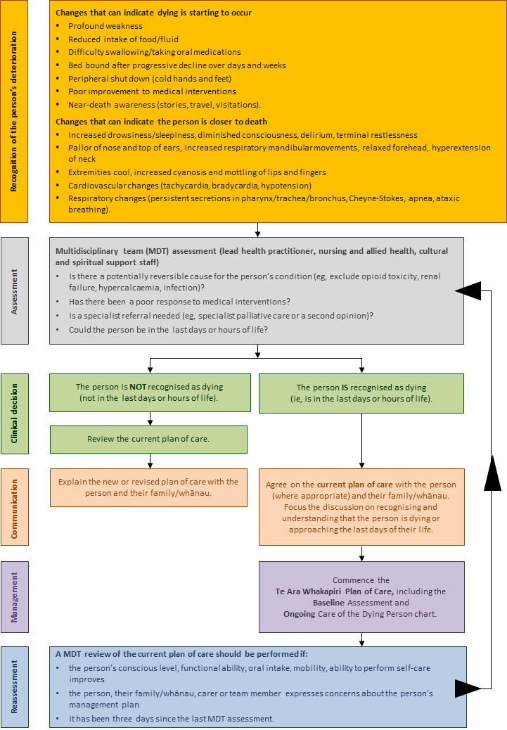

# Medical management planning – general principles

|  |  |  |
| --- | --- | --- |
| **Purpose** |  | **It is essential that:**   * **dying** is identified and **recognised** as early as possible, although this can be difficult as signs and symptoms suggesting dying can be subtle (see *Recognising the Dying Person Flow Chart*) * all members of the multidisciplinary team (MDT) understand the **priorities of care** * the person is assessed and **communication** is unhurried, compassionate and valued for all people involved (the person (if able), family/whānau and staff) * the person has an **individualised plan of care** that aligns with their stated preferences and needs (if able) and those of their family/whānau * **dignity, respect and privacy** are provided and maintained * every effort is made to **optimise symptom management** * staff are enabled and supported to deliver the **highest standard** of last days of life care. |
|  |  |  |
| **Principles** |  | **The principles of good care at the end of life include:**   * **attending** to culture, with clear communications and explanations * **continuing** any regular medications if withdrawal could cause adverse effects (this may include anti‑anginals, heart failure medications, steroids and benzodiazepines, if dependent) * **stopping** all non-essential medications (this may include anti-hypertensives, oral hypoglycaemics, diuretics, antibiotics, etc) * **starting** appropriate medications for existing symptoms as needed (PRN), subcutaneous and oral (if still able to swallow) and, if necessary, via continuous subcutaneous infusion (CSCI) * **anticipating** symptoms that may occur and prescribing PRN medications (see Anticipatory and Symptomatic Prescribing below) (chart orally if still able to swallow AND as subcutaneous boluses) * **reviewing** medications at least daily * **considering** the risks and benefits of administering hydration by parenteral route before commencing or stopping intravenous or subcutaneous fluids. |
|  |  |  |
| **Anticipatory and symptomatic prescribing** |  | **Reviewing prescribed medications**  There are five main symptoms that must be anticipated so that care is optimised. Not every dying person experiences these, but some may experience all five. The symptoms are:   * pain * nausea and vomiting * respiratory tract secretions * delirium, restlessness, agitation * breathlessness/dyspnea.   It is important to anticipate potential symptoms and prescribe accordingly.  Anticipatory prescribing enables health professionals to respond quickly should a symptom arise or when swallowing becomes difficult.  Explain to the person (if able) and their family/whānau the rationale for anticipatory prescribing.  If more than three doses of any prescribed drug are required within the minimum administration period (eg, if prescribed Q1H PRN and three doses are required in three hours), review and consider whether a continuous subcutaneous infusion (CSCI) would be preferable.  **Refer to symptom management flow charts.** |

|  |  |  |  |  |
| --- | --- | --- | --- | --- |
|  | Local logo |  | Patient name: |  |
| NHI: |  |
| DoB: |  |

# Bereavement risk assessment tool

|  |  |  |  |  |  |  |  |  |  |  |  |
| --- | --- | --- | --- | --- | --- | --- | --- | --- | --- | --- | --- |
| Name of the deceased person | |  | | | NHI |  | | | Date of death | |  |
| Name of the key family/whānau contact | | | |  | | | | Relationship to the deceased |  | | |
| Address |  | | | | | | | | | | |
| Phone numbers (H) | | |  | | (W) | |  | | (Mob) |  | |

|  |  |  |  |  |
| --- | --- | --- | --- | --- |
|  | **Risk factor** | **Indications** | | **Score** |
| 1 | Anger | None  Mild irritation  Moderate (occasional outbursts)  Severe (spoiling relationships)  Extreme (always bitter) | | 1  2  3  4  5 |
| 2 | Blame/guilt, feeling bad and or responsible for something | None  Mild (vague and general)  Moderate (some clear thoughts of blame, etc)  Severe (preoccupied with self blame)  Extreme (major problem) | | 1  2  3  4  5 |
| 3 | Current relationships | Close, intimate relationship with another  Warm, supportive family  Family supportive but lives at a distance  Doubtful (person uncertain whether others will be supportive)  Unsupportive | | 1  2  3  4  5 |
| 4 | How will the key person cope? | Well (normal grief and recovery without help)  Fair (probably get by without specialist help)  Doubtful (may need specialist help)  Badly (requires specialist help)  Very badly (requires urgent help) | | 1  2  3  4  5 |
| **Complete a separate form for each person at risk** | | | **Total:** |  |
| **A = ABSENT Low risk (score less then 7)** | | **Provide local brochure/information as available** | | |
| **C = CAUTION Moderate risk (score 7–9)** | | **Give a copy of your bereavement brochure and suggest contacting one of the local support agencies (see over)** | | |
| **E = EXTRA HELP FROM SPECIALIST SUPPORT RECOMMENDED High risk (score 10 or more)** | | **Encourage the person to contact a specialist health care professional eg, GP, counsellor or hospice bereavement service**  **Give a copy of your bereavement brochure** | | |

|  |  |  |
| --- | --- | --- |
| **Local support agencies** | **Information** | **Contact details** |
| Each organisation to personalise to its local area |  |  |
|  |  |  |
|  |  |  |
|  |  |  |
|  |  |  |
| **Specialist bereavement support** | **Information** | **Contact details** |
|  |  |  |
|  |  |  |
|  |  |  |
|  |  |  |

|  |  |  |  |  |
| --- | --- | --- | --- | --- |
|  | Local logo |  | Patient name: |  |
| NHI: |  |
| DoB: |  |

# Discharge checklist

This checklist will help facilitate a safe, smooth and seamless transition from hospital/hospice care for the dying person who chooses to be cared for at home.

* Hospital/hospice staff must prioritise the discharge as URGENT to minimise any potential delays.
* Involve the person and their family/whānau and/or carer in the discharge details and the plan of care.
* Contact the person’s general practitioner (GP) and ensure the GP is supportive of the discharge. Advise the person and their family of the importance of a GP visit soon after discharge if death is imminent.
* Refer to the relevant community nursing service(s) in good time and consider arranging for referral to specialist palliative care / hospice.
* Where appropriate, ensure sufficient subcutaneous medications are prescribed and available in the home, with the relevant authorities.

| **Checklist** | **Yes** | **No** | **N/A** | **Comment** |
| --- | --- | --- | --- | --- |
| The person has a preferred place of care. |  |  |  |  |
| The person and their family/whānau and/or carer are aware of the prognosis and expectation that death might be imminent. |  |  |  |  |
| The family/whānau and/or carer support the decision for the person’s discharge and are aware of the plan of care and any arrangements for services/visits/equipment. |  |  |  |  |
| Other multidisciplinary team (MDT) members have contributed to the person’s discharge plan and support the discharge. |  |  |  |  |
| Do Not Attempt Cardiopulmonary Resuscitation (DNACPR) decision documentation has been completed or photocopied. |  |  |  |  |
| An ambulance has been booked and is aware of any DNACPR decision. |  |  |  |  |
| The district nurse has been informed and is aware of the person’s care needs and discharge date and time. |  |  |  |  |
| The person’s GP has been informed and has made arrangements to visit the person. |  |  |  |  |
| Hospice/community palliative care are aware of the discharge and will review the person’s needs as soon as possible. |  |  |  |  |
| The Needs Assessment Service Coordination (NASC) organisation / the person’s social worker have reviewed the person’s needs, and an individual care package is in place. |  |  |  |  |
| Occupational therapy (OT) has reviewed the person’s needs, and equipment has been delivered / is planned, eg, electric bed, mattress, etc. |  |  |  |  |
| Discharge medications have been prescribed, including subcutaneous AND anticipatory medications. |  |  |  |  |
| Non-essential medications have been discontinued. |  |  |  |  |
| The NIKI T34 discharge checklist has been completed (if used). |  |  |  |  |
| The person and their family/whānau and/or carer have been asked if they would like a copy of the medical discharge letter. |  |  |  |  |
| The person and their family/whānau and/or carer understand the discharge medications that the person requires. |  |  |  |  |
| Domiciliary oxygen has been arranged. |  |  |  |  |
| The family/whānau and/or carer have been advised to contact their community nurse after the death for help, as needed, and to relieve them of any equipment. |  |  |  |  |

# Symptom management guidelines

## Contents

### Management of pain

* Definition
* Assessment tools
* Holistic considerations
* Flow chart
* Flow chart (severe renal impairment)

### Management of agitation, delirium and restlessness

* Definition
* Holistic considerations
* Flow chart

### Management of nausea/vomiting

* Definition
* Assessment
* Holistic considerations
* Flow chart

### Management of excessive respiratory tract secretions

* Definition
* Assessment
* Holistic considerations
* Flow chart

### Management of dyspnoea/breathlessness

* Definition
* Assessment
* Holistic considerations
* Flow chart

## Management of pain

### Definition

Pain is; “an unpleasant sensory or emotional experience associated with actual or potential tissue damage, or described in terms of such damage” (International Association for the Study of Pain, 2008).

### Assessment tools

#### Person able to communicate

|  |  |  |  |  |  |  |
| --- | --- | --- | --- | --- | --- | --- |
| 1. | **Use preferred tool for your organisation** eg, Wong-Baker FACES™ Pain Rating Scale. | | | |  | |
| 2. | **Describe type of pain** | | **Type of pain** | | | **Descriptor** |
|  |  | | Somatic | | | Aching, throbbing, gnawing, localised |
|  |  | | Visceral | | | Deep aching, cramping, dull pressure |
|  |  | | Neuropathic | | | Burning, shooting, pins and needs, tingling |
|  |  | | Bone | | | Constant, deep |
| 3. | **Document clearly:** Consider the following, assessing their pain using the PQRST format: | | | | | |
|  | **P** | Palliating factors Provoking factors | | “What makes it better?” “What makes it worse?” | | |
|  | **Q** | Quality | | “What is your pain like? Give some words that tell me about it.” | | |
|  | **R** | Radiation | | “Does that pain go anywhere else?” | | |
|  | **S** | Severity | | “How severe is it?” Measured on numbered scale | | |
|  | **T** | Time | | “Do you feel it all the time?” “Does it come and go?” | | |
|  | **U** | Understanding | | “What does this symptom mean to/for you?” “How does this symptom affect your daily life?” “What do you believe is causing this pain?” | | |

#### Person unable to communicate

Use the preferred tool for your organisation if available. If no tool is available, the **Abbey Pain Scale** can be used to assess pain in those unable to communicate. This can be found at [www.apsoc.org.au/PDF/Publications/4_Abbey_Pain_Scale.pdf](http://www.apsoc.org.au/PDF/Publications/4_Abbey_Pain_Scale.pdf)

### Holistic considerations

#### Reflect on: Te Whare Tapa Wha principles (Durie 1994)

|  |  |
| --- | --- |
| **Emotional considerations:** | Fear and anxiety can be both cause and consequence. |
| **Spiritual considerations:** | What impact does pain have on the person’s sense of self and their mana/wellbeing?  Are there any cultural considerations, eg, Māori/Asian/Pacific peoples? |
| **Social considerations:** | How does the pain affect the person’s family/whānau life?  And how is this, in turn, affecting the family/whānau’s relationship with their partner/friends? |
| **Physical considerations:** | Are there activities or positions that are particularly painful for the person? |

1 Involve the person’s family/whānau if the person is happy for them to be involved.

2 Being with the person and believing that their pain exists can help reduce their pain.

3 Helping to position the person to make them as comfortable as possible and helping to reposition them regularly can help reduce stiffness and muscular aches and provide pressure relief. Provide pressure relieving aids.

4 Guided imagery and distraction is a technique that teaches the person to mentally remove themselves from the present and imagine that they are in another place, eg, a favourite vacation spot. It can help reduce some types of pain by helping the person to relax or distract them from unpleasant thoughts. Distraction therapy comes in many forms, eg, guided audio, TV, music, reminiscing, etc.

5 Heat and/or coolness can often help ease pain, eg, by applying heated or chilled wheat packs. Care should be taken to ensure the temperature is suitable and the person will not be burned.

6 Massage or touch can be beneficial. Those giving massage should have an understanding of what is beneficial and what may cause harm. It is important to be aware that some people may not be comfortable with massage or touch.

7 Prayer and mindfulness meditation can be beneficial in reducing pain or existential suffering, depending on the person’s spiritual or cultural perspectives.

### Pain management flow chart

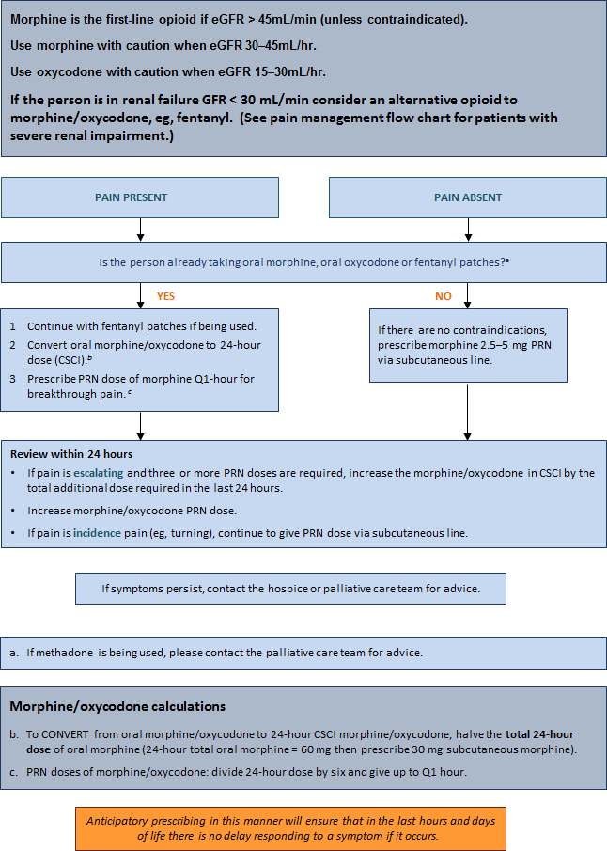

### Pain management flow chart for patients with severe renal impairment (eGFR < 30mL/min)

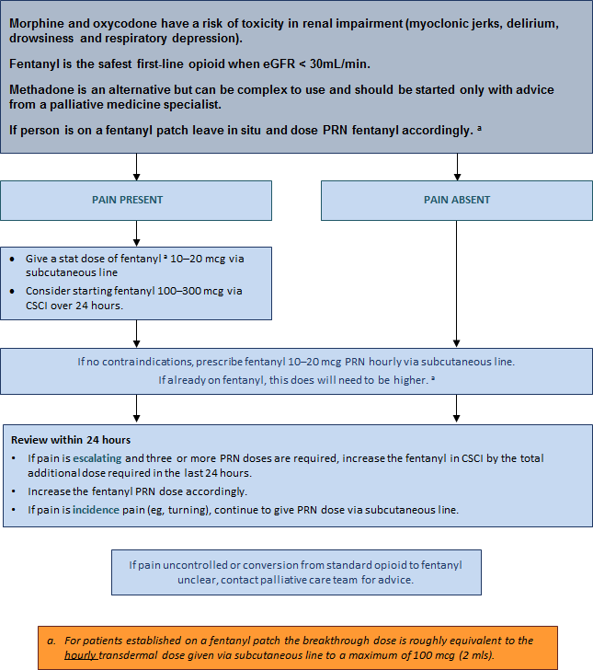

## Management of agitation, delirium, restlessness

Agitation, delirium or restlessness is extremely common in dying people. The cause is often multifactorial and not reversible. It can be a distressing problem and difficult to manage. The burden of investigations in a dying person is often best avoided, but some causes can be treated (eg, pain, urinary retention, dehydration). Terminal restlessness is often a ‘pre-death event’.

Also known as: **terminal agitation, terminal delirium, terminal anguish, terminal distress**.

### Definition

Delirium occurring in the last days of life is often referred to as terminal restlessness or agitation. In the last 24–48 hours of life, it is most likely caused by the irreversible processes of multiple organ failure.

### Holistic considerations

#### Reflect on: Te Whare Tapa Wha principles (Durie 1994)

|  |  |
| --- | --- |
| **Emotional considerations:** | How can emotional issues be identified and addressed at this time? Is there time to address these before the person dies? |
| **Spiritual considerations:** | How can feelings of hopelessness and helplessness (by the person and/or their family/whānau) be addressed?  Would the person like to see / benefit from a chaplain visiting? How would such a visit affect the person, their perception of self and their lifestyle? |
| **Social considerations:** | Is the person safe where they are at the moment? Can they remain there until they die? What other support does the family/whānau need at this time? |
| **Physical considerations:** | How can we make this person safe? How is this symptom affecting the person’s physical needs? |

#### Management

Treat and/or remove possible causes of pain, for example, by:

1 regularly changing the person’s position

2 checking their bladder/bowels to eliminate retention/impaction

3 ensuring their safety

4 involving the person and their family/whānau and providing them with explanations as required

5 using sitters

6 providing a low-stimulus environment, ie, low-level noise and lighting

7 surrounding the person with familiar voices, pictures, belongings

8 providing gentle massage, aromatherapy, familiar music (volume low)

9 offering spiritual/religious guidance or support (if the person and/or their family/whānau have requested it)

10 lowering the person’s bed

11 providing sensor mats

12 helping keep the person’sbody or room at a comfortable, soothing temperature

13 helping apply smoking or nicotine patch.

### Agitation, delirium, restlessness management flow chart

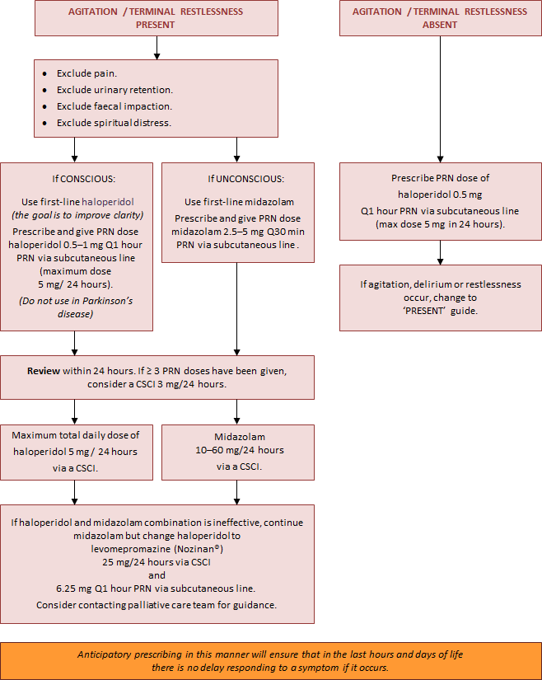

## Management of nausea/vomiting

People at the end of their lives can experience nausea and vomiting, which has an adverse effect on the person’s physical, psychological and social wellbeing and significantly impairs their quality of life.

### Definition

**Nausea:** A feeling of sickness in the stomach characterised by an urge to, but not always leading to, vomit.

**Vomiting:** The forcible voluntary or involuntary emptying of the stomach contents through the mouth.

### Assessment

1 Knowledge of the physiology of nausea and vomiting will promote a rational choice of treatment.

2 History of symptoms and previous management (pharmacological and other) should be continued.

3 Treat reversible causes if possible and appropriate (such as constipation).

### Holistic considerations

#### Reflect on: Te Whare Tapa Wha principles (Durie 1994)

|  |  |
| --- | --- |
| **Emotional considerations:** | Fear and anxiety can be both cause and consequence. |
| **Spiritual considerations:** | What impact does the nausea have on the person’s mana and sense of self?  Are there any cultural considerations, eg, Māori/Asian/Pacific peoples? |
| **Social considerations:** | How is not eating affecting the person’s family/whānau life? And how is this, in turn, affecting the family/whānau’s relationship with their partner/friends? |
| **Physical considerations:** | Is there pressure from other people to eat? Does the smell of cooking/food cause the person to feel sick? |

#### Management

Consider exploring the following options for managing nausea and vomiting.

1 Eliminate sights and smells that cause nausea and vomiting, eg, foods, deodorants, air fresheners, body odour and bowel motions.

2 Provide a well-ventilated room, circulating fresh air from a fan or open window.

3 Help the person dress in comfortable, loose-fitting, cool clothing.

4 Optimise the person’s oral hygiene. Consider using ½ tsp baking soda, ½ tsp salt in 250 mL water as a mouthwash. Alternatively, there are many different types of mouthwash available.

5 Offer sour candy ice chips made from a lemon/pineapple based juice, ginger ale or fruit as per the person’s individual preference and if they are still able to tolerate the taste.

6 Some people may prefer peppermints or peppermint tea.

7 If the person is still eating, offer small amounts of bland foods, fluids and snacks at room temperature.

8 Help elevate the person’s upper body when they are eating or drinking.

9 The person may already have a nasogastric (NG) tube on free drainage.

10 Use guided imagery/visualisation, teaching the person to mentally remove themselves from the present and imagine that they are in another place, eg, a favourite vacation spot. This can mentally block the nausea and vomiting.

11 Use music therapy to relieve stress and give a sense of wellbeing.

12 Use distraction techniques, such as, discussing family routines or providing suitable music or DVDs (eg, documentaries).

13 Apply acupressure. This can be done by the person or a family member/friend. Acupressure wrist bands are also available.

Some therapies that were used to provide more comfort for the person in the past may no longer be appropriate at the person’s end-of-life stage.

### Nausea/vomiting management flow chart

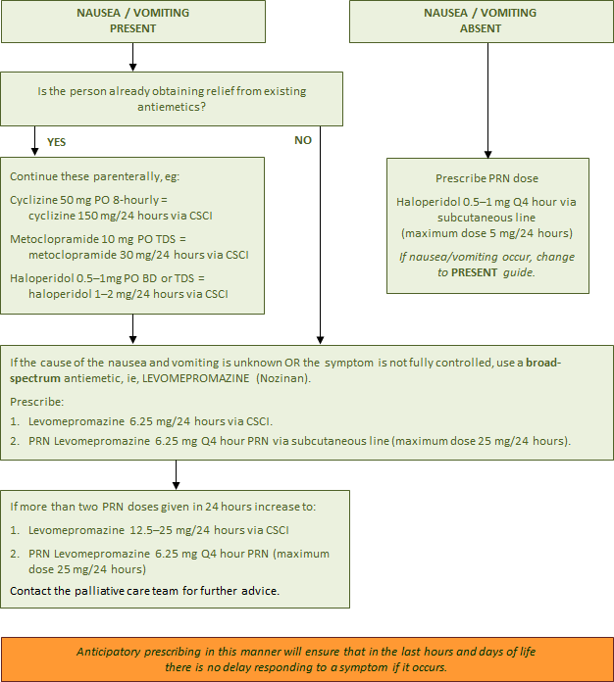

## Management of excessive respiratory tract secretions

Respiratory tract secretions are generally seen only in dying people who are too weak to expectorate and are no longer able to clear their oral and upper airway secretions. The pooled secretions in the oropharynx and bronchi vibrate as air moves over them. It is audible and is described as noisy, rattling, gurgling and unpleasant. It is often called the ‘death rattle’. Excessive respiratory tract secretions have been observed in 23–92 percent of cases and are an indicator of impending death.

### Definition

#### Classifications

* **Type I** due to salivary secretions.
* **Type II** due to accumulated bronchial secretions in the presence of pulmonary disease and infections, tumour, fluid retention or aspiration.

Studies suggest that people who develop noisy respirations have the following risk factors:

* Lung cancer
* Chest infections, ie, pneumonia
* Brain tumours
* Head and neck cancers
* Pulmonary diseases, ie, asthma, bronchitis, bronchiectasis
* Neuromuscular disorders, ie, myasthenia gravis, Guillain-Barre syndrome
* Cystic fibrosis
* Cardiac arrest
* Heart failure
* Cessation of steroids in cerebral involvement.

These situations are associated with an increase in oral, bronchial mucous and exudative secretions.

### Assessment

1 Consider the person’s diagnosis – does the person have the risk factors? Is the breathing noisy and rattily. There are no standardised assessment tools to classify or measure the intensity of secretions, but some research has used subjective noise scores.

2 Consider the distress of the person – are they restless or frowning?

3 Consider the distress of the person’s family/whānau and carers – they may be anxious and fear the person is choking to death or drowning. Approximately half of those relatives and friends who witness it, as well as hospital staff, find the noise of respiratory tract secretions distressing.

### Holistic considerations

#### Reflect on: Te Whare Tapa Wha principles (Durie 1994)

|  |  |
| --- | --- |
| **Emotional considerations:** | What does this symptom mean for the family/whānau? |
| **Spiritual considerations:** | Are there any considerations that need to be taken into account around this time? |
| **Social considerations:** | How does this symptom affect family/whānau? |
| **Physical considerations:** |  |

1 Anticipate problems if the person has the risk factors that increase airway secretions.

2 Reposition the person, often on their side in a semi-recumbent position, to facilitate postural drainage. Or raise the head of the bed and prop up the person with pillows.

3 Carefully assess hydration and reduce or cease parenteral fluids if required.

4 Explain the changes being observed in the dying person to the family and whānau. Communicate with compassion and sensitivity. Reassure the family the reason their loved one is not able to cough or clear their throat is due to their unconscious state – the person is not usually distressed.

5 Use distraction therapy, eg, music, TV, family talking and reminiscing.

6 Use aromatherapy therapy, eg, any of the following essential oils in an aroma burner or vaporiser: eucalyptus, cypress, ylang ylang, lavender, lemon, lime, cypress, marjoram, cedarwood.

7 Regularly provide mouth and lip care. Wipe away any dribbling with tissues. Use appropriate mouth swabs, eg, Den Tips® Disposable Oral Swabs, to gently wipe any loose secretions out of the person’s mouth if they allow it.

8 If the person has been receiving supplementary oxygen, it may no longer be necessary and can be discontinued. If the person remains on oxygen and thick secretions are a problem, add humidity if the device allows it.

9 Suctioning is not normally used in palliative care. In some hospitals, tracheal aspiration may be performed by skilled personnel, clearing secretions before anticholinergic drugs are started – this remains a complex and difficult procedure.

10 Many studies indicate a need for further research in order to develop ‘best practice’ standards.

### Excessive respiratory tract secretions management flow chart

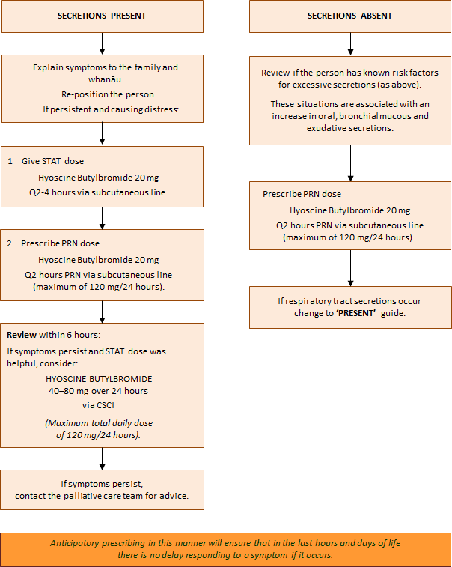

## Management for dyspnoea/breathlessness

Dyspnoea is a very subjective symptom and does not always fit with the physical signs. Studies show that what onlookers see as distressing may not be distressing for the person. When the sensation of breathlessness is frightening, it may be described as suffocating, smothering, laboured breathing or air hunger.

### Definition

#### The mechanism of dyspnoea/breathlessness

There are reported to be three paradigms of dyspnoea.

1 A perceived increase in respiratory effort or work of breathing (in people with **airflow obstruction**, eg, **COPD** or **bronchiectasis** or a **large pleural effusion**).

2 An increase in the proportion of chest wall strength and respiratory muscles required to maintain homeostasis (in people with neuromuscular disease (**MND**) and **cancer cachexia**).

3 An increase in ventilatory requirements, due to **sepsis, anaemia, acidosis** or **hypoxemia**.

### Assessment

1 Because this is a very subjective experience, the assessment is best based on the person’s own report.

2 In severe breathlessness, clinical signs will be visible, such as; increased respiratory rate, excessive use of accessory muscles, gasping/air hunger, pursed lip breathing or arms held fixed down onto mattresses.

3 **For unconscious people at the end of life,** the health care professional will have to rely on relevant physical clues and support from the family/whānau. For example, tachypnoea (fast breathing), tachycardia (fast heart rate/pulse) and Cheyne-Stokes respiration may not necessarily be an indication of distress, unless accompanied by sweating, grimacing, agitation or use of accessory muscles.

### Holistic considerations

#### Reflect on: Te Whare Tapa Wha principles (Durie 1994)

|  |  |
| --- | --- |
| **Emotional considerations:** | How might it feel for the person to be out of breath all the time? How might the person’s distress be perceived by those around them? |
| **Spiritual considerations:** | What does being breathless mean to the person? How does this affect the person and their perception of self? |
| **Social considerations:** | How does being breathless affect the person’s lifestyle and the lifestyle of those around them? |
| **Physical considerations:** | Are there activities that particularly cause breathlessness but that are meaningful to the person? |

### Management

1 **Positioning:** Straight and upright – however, it may not be possible for a person to be positioned straight and upright at the end of their life due to weakness. Provide some support with pillows, avoiding horse shoe pillows as people who are small and frail may slip into the hollow space and compress their lungs. Support the person’s arms on pillows to help keep their shoulders relaxed and decrease their tension. It is equally important to support the person’s head in a good position.

2 **Environment:** A light, airy side room or single room with opening windows. Avoid showering or bathing in very hot water and a humid environment. Offer a gentle flow of air across the person’s face from an intermittent fan – the person could hold a fan if they still have the capacity. Dress them in non-restrictive cotton clothing when they are in bed.

3 **Relaxation, anxiety reduction:** Touch may or may not be appropriate. Massage the person’s feet and hands if they can tolerate it. Offer the person’s choice of relaxing music. Encourage visits from family and friends. Read out loud to the person. Health care professionals should have a calm approach. Avoid using phrases such as ‘just keep calm’.

4 **Planning and practice:** Plan what needs to be done andlook for efficient ways of doing this. Practice abdominal breathing techniques.

### Dyspnoea/breathlessness management flow chart

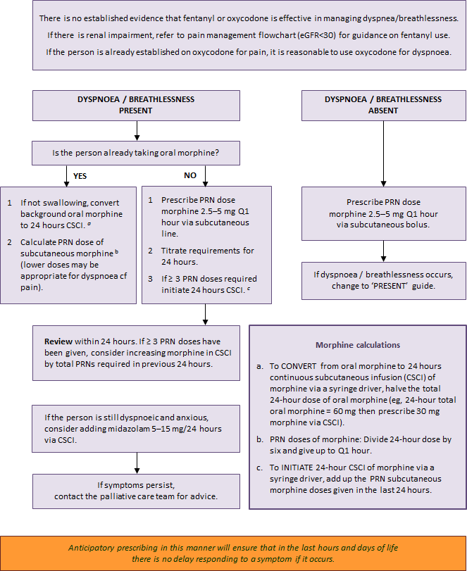

# When death approaches

Knowing what to expect as death approaches can help make this time less worrying. This information sheet describes the symptoms that commonly occur when someone is near the end of their life, provides practical advice for when a person is dying at home and explains what might happen afterwards. Each person is unique, and these symptoms may not occur in every instance, nor will they necessarily happen in any particular order.

### Sleep

In the final stages of illness, most people feel content to stay in bed and may spend more time sleeping. At times, they may not respond to you or it may be hard to wake them.

###### What to do

* Communicate at times when the person seems most alert.
* Never assume that they cannot hear; so continue talking to them.

### Food and fluids

It is common for a person to have little interest in eating or drinking in the final stages of their life. Dehydration is not usually a problem as the body adapts to the reduced intake of fluids.

###### What to do

* Do not offer food or fluid if a person is unable to swallow as this may cause distress.
* Ice chips or a straw or sipper cup can help a person swallow small amounts of fluids.
* Provide mouth swabs soaked in iced water or fruit juice to help keep their mouth moist.
* Some form of lip balm or moisturiser is also useful to prevent dry, chapped lips.

### Skin

The person’s nose, ears, hands and feet may feel cooler. Sometimes the skin may look flushed and the hands, feet and on the underside of the body may become discoloured or blotchy.

###### What to do

* Apply a cool, moist cloth to the forehead.
* Have blankets to hand to provide extra warmth.

### Breathing patterns

The person’s breathing may become more and more irregular as the respiratory system slows.

###### What to do

Changes in breathing can be a sign that the person is approaching death.

* Contact family/whānau members who might wish to be present at the time of death.

### Noisy breathing

Saliva and mucus may increase as the person becomes too weak to cough or swallow.

###### What to do

* Help the person sit up a little or turn them to one side.
* Mouth care may help.
* The person’s doctor or nurse may suggest a medication that may help.

### Confusion

The person may become confused about time, place and the identity of familiar people.

###### What to do

* Talk to them calmly to reassure them.
* Identify yourself by name each new time you address them.
* Use a night light and keep familiar objects in the room.

### Restlessness and agitation

These symptoms usually occur when a person has become semi-conscious. Signs include twitching, plucking at the air or at bedclothes, trying to get out of bed even if the person is unable to stand alone and moaning or calling out constantly. Many families/whānau find this time difficult because they feel unsure how to help. Restlessness may be due to treatable causes, such as, constipation or a full bladder, or the irreversible effects of the person’s disease.

###### What to do

* Keep the person calm by sitting with them and speaking to them reassuringly.
* Quiet music, radio or aromatherapy can be soothing.
* Always assume that the person can hear you and that they will find your voice comforting.
* Help the person change their position, provide mouth care or help them with toileting. Their doctor may prescribe a muscle relaxant.

### Loss of bowel and bladder control

This may occur when a person is close to death.

###### What to do

* Use continence pads and sheets to maintain the person’s comfort.
* A catheter to drain fluid may be required.

### When death occurs

The person will be unresponsive and not breathing, there will be no visible pulse or heartbeat and the facial muscles will relax, with the mouth and eyes falling open slightly.

###### What to do

* There is no rush to do anything immediately. You may wish to spend time with the person.
* It is helpful to note the time of death.
* Contact your nurse. If death occurs during the night, then it is OK to wait until the morning.
* The person’s GP must visit to confirm a death at home and write a death certificate.
* Most people contact a funeral director (through the Yellow Pages or an internet).
* There may be many people to notify. Consider delegating this task to family/whānau or friends.

# Dying at home

Dying is different for every person and for every family/whānau. It is important to do whatever feels right during this time. In our multicultural society, it is important we accept the traditions surrounding death that exist in our different cultures. This information sheet gives practical advice relating to the point of death and what follows.

### How will I know that death has occurred?

At the time of death:

* the person will not respond when you speak to them
* they will not breathe or move
* their eyes may be open or closed, and their jaw will relax
* the colour of their skin will become paler and cooler.

No matter how much you prepare for it, death arrives in its own time and in its own way.

### What do I do now?

It is important that you do everything in your own time and carry out any other plans or arrangements you have made. Take as much time as you need to say your goodbyes.

* If you don’t want to be alone, contact a relative or friend to join you.
* You do **not** have to call an ambulance or the police. It is helpful to note the time of death.
* There may be family/whānau and friends to inform; you may want to delegate this task.
* Contact your GP and/or your community nurse; this can wait until morning if the person died overnight. Your GP must see them in person before they can sign a death certificate – you will be able to get a copy of the death certificate from the funeral director later.
* It is often possible for the deceased person to stay at home for a length of time to allow friends and relatives to come and say their goodbyes.
* Turn off room heaters and electric blankets and keep the room as cool as possible. This is particularly important if you do not wish the person to be embalmed.
* It is not necessary to wash them but, if you wish, you can sponge their skin and face and replace any dentures they might usually wear. If this is not possible, place the dentures in a container and ensure the funeral director receives them. (Note: the deceased person’s body will become stiff over time, so it is important to do this sooner rather than later.)

### Funeral arrangements

* Contact a funeral director of your choice to notify them of the death.
* You will need to advise them as to your choice of cremation or burial.
* The funeral director will arrange with you to collect the deceased person. They will arrange to meet you at the place where the person is lying or at the funeral home as per your wishes.

**Other people you may also need to contact over the next few days include:**

* the deceased person’s solicitor or executor of the will
* a priest, vicar, minister (if applicable)
* Work and Income (WINZ) (if the person was receiving a benefit)
* social services, eg, home help, personal carers
* any insurance companies the person may have been using, eg, home and contents insurance or health insurance
* Inland Revenue (IRD)
* New Zealand Post (NZ Post) to arrange a redirection on the person’s mail
* the person’s power/phone/gas companies.

### Grieving

When someone close to you dies, you may experience many emotions including:

* sadness, for the loss in your life
* shock/disbelief, at what has happened, a sense of unreality
* anger, at what has happened and possibly towards whatever caused it
* relief, that your loved one’s suffering is now over and that you are also now free from the worry and exhaustion of providing care
* guilt, that there are things you did or didn’t do well enough
* loneliness, as you miss your loved one’s company and support.

Sometimes these feelings are accompanied by physical symptoms, eg, lack of energy, upset stomach, loss of appetite, headaches, difficulty sleeping. These feelings and physical effects are part of the normal response to the death of someone close and are part of the grieving process.

###### Things you can do to help with your grief

* Express your emotions and let your family share in your grief.
* Remember that you need time to rest, think, exercise, sleep and eat.
* The bad days will come and go; be gentle with yourself when they occur.
* Remember that children experience similar feelings and need to share their grief. Encourage children to continue with their usual activities and routines, but be guided by your child’s individual needs and circumstances.
* People grieve differently – some people want to keep busy, some want to talk, others do not.

###### When to seek professional help with your grief

Many feelings and physical effects are a normal part of grieving. However, you may wish to seek professional help if:

* your emotions or physical symptoms are making it difficult to manage day-to-day tasks
* you are feeling exhausted, anxious, suicidal, depressed, continually stressed, helpless or are experiencing uncontrollable anger or sleeplessness
* you are becoming dependent on drugs or alcohol
* you are becoming withdrawn and finding it difficult to speak to or spend time with others
* you are finding it difficult to cope at work
* you notice major ongoing behavioural changes in your children/teenagers
* you have little desire to get involved in activities that you once enjoyed.

**Talk with your GP or community nurse about the options available to you. They will refer you or your child to a specialist if necessary.**