A clinical practice guideline: Summary of recommendations
  - Small for Gestational Age and Fetal Growth Restriction in Aotearoa New Zealand
  - He Aratohu Ritenga Haumanu mō te Tōhuatanga Kōpiri me te Pakupaku Rawa
Citation: Te Whatu Ora – Health New Zealand. 2023. Small for gestational age and fetal growth restriction in Aotearoa New Zealand He Aratohu Ritenga Haumanu mō te Tōhuatanga Kōpiri me te Pakupaku Rawa. A clinical practice guideline: Summary of recommendations. Wellington: Te Whatu Ora – Health New Zealand.
Published in July 2023 by Te Whatu Ora – Health New Zealand
PO Box 793, Wellington 6140, New Zealand
ISBN 978-1-99-106734-0 (online)
This document is available at tewhatuora.govt.nz
This work is licensed under the Creative Commons Attribution 4.0 International licence. In essence, you are free to: share ie, copy and redistribute the material in any medium or format; adapt ie, remix, transform and build upon the material. You must give appropriate credit, provide a link to the licence and indicate if changes were made.

Contents
Introduction 4
Review date 5
Intended users of this clinical practice guideline 5
Summary of changes 6
Clinical practice recommendations 7
Definition and classification 9
Risk assessment for the development of FGR and interventions to reduce risk 13
Antenatal screening for FGR 17
Antenatal management of FGR 21
Maternal postnatal management 30
Diagnosis and management of neonates with FGR 31
Recommended antenatal screening 40
Management of FGR < 32+0 weeks 41
Management of FGR ≥ 32+0 weeks 42
Management of the neonate with FGR 43
Appendix 1: Abbreviations 44
Appendix 2: Te reo Māori kupu 45
References 46

Introduction
This clinical practice guideline aims to reduce rates of stillbirth and neonatal mortality and morbidity associated with fetal growth restriction (FGR) by standardising care across Aotearoa New Zealand. This guideline:
- provides evidence-based best practice recommendations for screening, diagnosing and managing small for gestational age (SGA) and FGR in singleton pregnancies
- focuses on placental insufficiency, which is the most common cause of FGR
- is not a comprehensive guide for managing chromosomal and anatomical abnormalities, but contains aspects relevant to those pregnancies
- was developed with consideration of equity, hauora Māori and te ao Māori
- supersedes previous guidelines on SGA and FGR used in Aotearoa New Zealand, including the New Zealand Maternal Fetal Medicine Network’s 2014 guideline
- recognises that even with optimal screening practices, up to approximately 60% of SGA babies are detected and 40% or more are not detected.^{1,2}
This clinical practice guideline reflects international best practice. The FGR Guideline Development Panel interpreted literature and developed recommendations specifically for Aotearoa New Zealand and its model of maternity care.
This clinical practice guideline should be read in conjunction with Ngā Paerewa Health and disability services standard 8134:2021 and the corresponding sector guidance for birthing units and in-patient or private hospital services.³ Ngā Paerewa, alongside the sector guidance, contains information about best practice maternity and neonatal service provision.
The term SGA refers to an estimated fetal weight (EFW) or birthweight < 10th customised centile.
The term FGR refers to fetal growth that is abnormally reduced (that is, less than expected due to pathology).
Most, but not all, fetuses and neonates with FGR are SGA, while some SGA fetuses and neonates are not growth restricted.

Review date
This clinical practice guideline should be reviewed in 2027.

Intended users of this clinical practice guideline
The intended users of this clinical practice guideline are health practitioners involved in pregnancy, birth, and postnatal care in Aotearoa New Zealand. This group includes midwives, nurses, obstetricians, maternal fetal medicine specialists, neonatologists, paediatricians, general practitioners, sonographers and radiologists. Health practitioners should use this clinical practice guideline to support their clinical judgement, knowledge and expertise and provide for a timely, consistent and effective approach to diagnosing and managing SGA and FGR pregnancies and neonates with FGR.
Whānau can use this clinical practice guideline to understand how pregnancies with small babies or babies with FGR are diagnosed and managed.

Summary of changes
 | NZMFMN 2014 guideline¹ | This guideline
Definition of early-onset SGA or FGR | < 34 weeks’ gestation | < 32+0 weeks’ gestation
Suspicion of SGA | AC < 5th centile | AC < 10th centile based on the Australasian Society of Ultrasound Medicine fetal biometry chart, with centile documented in report
 | Discrepancy between HC and AC | Removed from diagnosis of FGR
Slowing of fetal growth | Reduction in EFW percentile ≥ one third  or  reduction in AC of > 30 centiles  or  a change in AC of < 5 millimetres over 14 days | Decline in EFW > 30 centiles ≥ 28 weeks’ gestation or decline in AC > 30 centiles ≥ 28 weeks’ gestation
Risk factors for SGA and FGR | PAPP-A < 0.4 MoM (if performed) | Removed
 | Maternal age > 40 years | Major risk factor: Maternal age ≥ 40 years (nulliparous)  Minor risk factor: Maternal age ≥ 40 years (multiparous)
 | Not defined | Addition of minor risk factors
Schedule of growth scans for those with SGA or FGR risk factors |  | Addition of screening schedule for those with three of more minor risk factors
MCA Doppler and CPR in late-onset FGR | MCA and CPR used for monitoring of late-onset FGR | Only CPR used for monitoring late-onset FGR
Definition of neonatal FGR | Not defined | See Table 5
AC = abdominal circumference; CPR = cerebroplacental ratio; EFW = estimated fetal weight; FGR = fetal growth restriction; HC = head circumference; MCA = middle cerebral artery; MoM = multiple of medians; NZMFMN = New Zealand Maternal Fetal Medicine Network ; PAPP-A = pregnancy-associated plasma protein-A; SGA = small for gestational age.

Clinical practice recommendations
The clinical practice recommendations follow the course of pregnancy and birth, with six groups of recommendations:
- definition and classification
- risk assessment for the development of FGR and interventions to reduce risk
- antenatal screening for FGR
- antenatal management of FGR
- maternal postnatal management
- diagnosis and management of neonates with FGR.
Alongside each recommendation is a grade for the certainty of the evidence (that is, the evidence level) that has informed the recommendation and the strength of the recommendation (that is, the grade of recommendation).
Principles underpinning the clinical practice recommendations
Five principles underpin the clinical practice recommendations:
- The pregnant woman/person is at the centre of all care decisions and shares decision-making with health practitioners within Aotearoa New Zealand’s model of continuity of midwifery care.
- The optimal pregnancy outcome is the birth of a healthy, well-grown baby and a well woman/person following spontaneous onset of labour at term.
- Where a pregnancy is identified as SGA or FGR, additional monitoring and judicious use of intervention is planned with informed decision-making between the pregnant woman/person and care provider with the aim of optimising outcomes for the pregnant woman/person and baby.
- Where possible, expectant management should be planned, supporting the safe prolonging of pregnancy and physiological birth.
- Potential resource limitations and access to care and equity are considered at each step, but these considerations do not change the best practice recommendations.
The certainty of evidence for each recommendation is rated using a modification of the Royal College of Obstetricians and Gynaecologists’ four-level classification system (A to D). All recommendations were agreed by consensus among panel members. The evidence grading approach is summarised below.
Classification of evidence levels |  | Grades of recommendations
1++ | High-quality meta-analyses, systematic reviews of RCTs or RCTs with a very low risk of bias | A  B  C  D | At least one meta-analysis, systematic review or RCT rated as 1++ and directly applicable to the target population; or  A systematic review of RCTS or a body of evidence consisting principally of studies rated as 1+ directly applicable to the target population and demonstrating overall consistency of results.  A body of evidence, including studies rated as 2++ directly applicable to the target population and demonstrating overall consistency of results; or  Extrapolated evidence from studies rated as 1++ or 1+  A body of evidence, including studies rated as 2+ directly applicable to the target population and demonstrating overall consistency of results; or  Extrapolated evidence from studies rated as 2++  Evidence level 3 or 4; or  Extrapolated evidence from studies rated as 2+
1+ | Well-conducted meta-analyses, systematic reviews of RCTs or RCTs with a low risk of bias
1- | Meta-analyses, systematic reviews of RCTs or RCTs with a high risk of bias
2++ | High-quality systematic reviews of case–control or cohort studies or high-quality case–control or cohort studies with a very low risk of confounding, bias or chance and a high probability that the relationship is causal
2+ | Well-conducted case–control or cohort studies with a low risk of confounding, bias or chance and a moderate probability that the relationship is causal
2- | Case–control or cohort studies with a high risk of confounding, bias or chance and a significant risk that the relationship is not causal
3 | Non-analytical studies (e.g., case reports, case series)
4 | Expert opinion | GPP | Recommended best practice based on the clinical experience of the panel
GPP = good practice point; RCT = randomised control trial.

Definition and classification
Definition and classification recommendations |  | Evidence level | Grade of recommendation | Rationale
1 | Assess EFW and birthweight using customised centile standards.* | 2+ | C | Customised SGA better identifies at-risk fetuses and neonates than population-based SGA definitions, particularly among Aotearoa New Zealand’s diverse ethnicities. Use of a single customised reference supports consistent national practice and audit.²
2 | Define SGA as EFW or birthweight < 10th centile. | 1++ | A | This reflects the internationally accepted definition of SGA.
3 | Define FGR using a combination of fetal size, fetal growth, and fetal and maternal Doppler assessment:  - Early-onset FGR is diagnosed < 32⁺0 weeks’ gestation  - Late-onset FGR is diagnosed ≥ 32+0 weeks’ gestation. | 2+ | C | For further definition of early-onset and late-onset FGR, see Table 1.
4 | Define slowing of fetal growth as a decline in EFW or AC of > 30 centiles at ≥ 28+0 weeks’ gestation.  If there is a decline in growth < 28 weeks’ gestation, consider a further growth scan in two to three weeks’ time.  Where possible, electronic plotting is recommended to improve accuracy and reduce transcription errors. | 3 | D | The threshold to define FGR based on a decrease in EFW or AC remains unclear.^{†,4,5} Slowing of fetal growth is not a standalone criterion to define FGR.  Growth scans performed at least three weeks apart minimise false positive diagnoses associated with the inherent error within fetal biometry measurements.  Timing of scans should be tailored to the individual clinical scenario.
5 | When FGR is suspected (EFW or AC < 10th centile, or slowing of fetal growth), perform these Doppler parameters:  - Umbilical artery (UA) Doppler⁶  - Uterine artery (UtA) Doppler mean pulsatility index (PI) and assessment of notching – assess only once⁶  See Recommendation 11 for UtA Doppler in FGR risk assessment  - MCA Doppler PI ≥ 32+0 weeks’ gestation.⁶  Report only CPR.  If Doppler studies are normal, perform a repeat growth scan to assess fetal growth trajectory. | 2-  1+  2+  2+ | C  A  C  C | The customised EFW centile should be plotted at the earliest possible opportunity to minimise delays in diagnosis and subsequent care. This is usually performed by the LMC or referrer.‡  If possible, assessment of customised EFW at the time of ultrasound allows additional Doppler studies to be performed concurrently if required. This minimises delays and return scanning for Doppler assessment.  Doppler studies provide an indirect assessment of placental function and fetal wellbeing.  UtA Doppler (abnormal if mean PI > 95th centile and/or bilateral notching) does not show progression in the third trimester. A single measurement can be performed at the time of diagnosis.  International consensus on the use of MCA Doppler in late-onset FGR is lacking. SGA fetuses with abnormal MCA and/or CPR have higher rates of adverse perinatal outcome.^{8,9} CPR has a stronger association with adverse outcome than MCA has.  Growth scans performed at least three weeks apart minimise false positive diagnoses associated with the inherent error within fetal biometry measurements.
AC = abdominal circumference; CPR = cerebroplacental ratio; EFW = estimated fetal weight; FGR = fetal growth restriction; GROW = gestation-related optimal weight; MCA = middle cerebral artery; PI = pulsatility index; SGA = small for gestational age; UA = umbilical artery; UtA = uterine artery.
* Customised centiles for Aotearoa New Zealand are available online at GROW-App NZ (https://nzaws.growservice.org/App/Account/Login) and are incorporated into the BadgerNet platform.
† The promising Hugh and Gardosi model of fetal growth assesses customised EFW gain as percentage deviation from expected.⁷ It can be used to assess growth trajectory over a shorter time frame. This model should be investigated further in the Aotearoa New Zealand context, including implications for implementation.
‡ Radiology providers do not have the required clinical information to create a customised antenatal chart, which is recommended at booking.

Table 1: Definition for early and late-onset FGR in the absence of congenital anomalies⁴
Early-onset FGR  Diagnosed < 32+0 weeks’ gestation | Late-onset FGR  Diagnosed ≥ 32+0 weeks’ gestation
EFW customised or AC < 3rd centile  or  UA with absent or reversed end-diastolic flow  or  EFW customised or AC < 10th centile plus one or more of:  - UA Doppler PI > 95th centile  - UtA Doppler mean PI > 95th centile or bilateral notching (perform only once at the time of diagnosis). | EFW customised or AC < 3rd centile  or  Two or more of:  - EFW customised or AC < 10th centile  - slowing of fetal growth: decline in EFW or AC of > 30 centiles from 28+0 weeks’ gestation onwards*  - any of:  - UA Doppler PI > 95th centile or  - CPR < 5th centile or  - UtA mean PI > 95th centile or bilateral notching (perform only once at the time of diagnosis).
AC = abdominal circumference; CPR = cerebroplacental ratio; EFW = estimated fetal weight; FGR = fetal growth restriction; PI = pulsatility index; UA = umbilical artery; UtA = uterine artery.
* If there is decline in EFW or AC of > 30 centiles before 28 weeks’ gestation in the absence of early-onset FGR, consider another growth scan in two to three weeks. If the fetal growth trajectory between the last two scans is normal, the AC and EFW is > 10th centile, the fetus is not suspected to be growth restricted and further growth scans should follow risk-factor screening recommendations (see Table 4).

Risk assessment for the development of FGR and interventions to reduce risk
Risk assessment and intervention recommendations |  | Evidence level | Grade of recommendation | Rationale
6 | Inform women/people considering pregnancy of periconception lifestyle advice, including a healthy diet, regular moderate exercise, and entering pregnancy at as healthy a weight as possible. | 4 | GPP | Those entering pregnancy with a BMI 18.5 kg/m² to 25 kg/m² have the lowest chance of having an SGA pregnancy. Rates of SGA increase as BMI moves further from the healthy weight range (u-shaped curve). Higher rates of pre-existing hypertension and diabetes are experienced by people with obesity.
7 | Advise women/people considering pregnancy to supplement diet with daily folic acid. | 2++ | B | Pre-conceptual folic acid supplementation may reduce the risk of FGR as well as neural tube defects.
8 | Advise women/people to stop cigarette smoking and other recreational drug use (including cannabis) before pregnancy.  Follow advice about supporting smoking cessation as set out in the New Zealand Guidelines for Helping People Stop Smoking.¹⁰ | 1+  4 | A  GPP | Stopping tobacco use < 15+0 weeks’ gestation decreases the chance of FGR.
9 | Perform a clinical risk assessment for FGR for pregnant women/people in early pregnancy.  Continue to screen for the development of new clinical risk factors throughout pregnancy. | 2+  4 | B  GPP | Risk factors for FGR pregnancies may be present at booking or may develop as pregnancy progresses. Timely identification enables appropriate ultrasound growth assessment and management.
10 | Do not use biomarkers or integrated risk assessments as screening tools for FGR (combinations of clinical risk factors, biomarkers and early pregnancy ultrasound parameters). | 2+ | C | There is limited evidence that biomarkers or early pregnancy Dopplers have sufficient sensitivity or specificity to accurately predict FGR.
11 | In pregnancies with risk factors for early-onset FGR, perform mean UtA Doppler PI with assessment of notching at 20 to 24 weeks’ gestation. | 2+ | C | An abnormal UtA Doppler PI at mid-pregnancy, combined with maternal characteristics is better at predicting early-onset FGR (and pre-eclampsia) compared with late-onset FGR.
12 | Offer low-dose aspirin to pregnant women/people who have had a previous FGR pregnancy or who have a major risk factor for pre-eclampsia.  Low-dose aspirin 100 milligrams per day taken at night, starting between 12+0 to 16+6 weeks’ gestation until 36 weeks’ gestation. | 1+ | B | Pregnant women/people with major risk factors for pre-eclampsia have a reduced risk of FGR (and pre-eclampsia) when taking low-dose aspirin.  They also benefit from calcium supplementation to reduce the risk of hypertensive disorders of pregnancy. For further advice about risk factors for hypertension and pre-eclampsia in pregnancy and the use of low-dose aspirin and calcium, see the Diagnosis and Treatment of Hypertensions and Pre-eclampsia in Pregnancy in Aotearoa New Zealand guideline.¹¹
13 | Do not use low molecular weight heparin for the prevention of FGR. | 2++ | A | High-quality trials show that heparin provides no beneficial moderating effect on the risk of developing pre-eclampsia or SGA and FGR outcomes.
BMI = body mass index; FGR = fetal growth restriction; GPP = good practice point; SGA = small for gestational age; UtA = uterine artery.

Table 2: Major risk factors for SGA and FGR (OR or RR > 2.0)^{12,13}
Maternal demographics | Maternal medical history
Maternal age ≥ 40 years (nulliparous)  Continued smoking ≥ 16 weeks’ gestation (> 10 per day)  Recreational drug use | Chronic hypertension*†  Diabetes with vascular disease*†  Renal impairment*†  Antiphospholipid syndrome*†
Previous pregnancy history | Current pregnancy risk
Previous SGA or FGR pregnancy*†  Previous hypertensive disorder of pregnancy*†  Previous stillbirth† | Heavy bleeding < 20 weeks  Pre-eclampsia or gestational hypertension  Antepartum haemorrhage or placental abruption
FGR = fetal growth restriction; OR = odds ratio; RR = relative risk; SGA = small for gestational age.
* Low-dose aspirin is recommended, starting 12+0 to 16+6 weeks’ gestation, taken at night. For further advice about the use of low-dose aspirin and calcium, see the Diagnosis and Treatment of Hypertension and Pre-eclampsia in Pregnancy in Aotearoa New Zealand guideline.11
† Risk factors for early-onset FGR include previous FGR birth < 32 weeks’ gestation, previous hypertensive disease with birth < 34 weeks’ gestation, significant maternal medical disease and previous stillbirth (particularly early gestation or associated with FGR).
Table 3: Minor risk factors for SGA and FGR (OR or RR <2.0)¹²⁻¹⁶
Maternal demographics | Maternal medical history
Nulliparity  Maternal age ≥ 40 years (multiparous)  Smoking one to 10 cigarettes per day | Conception via assisted reproductive technology  BMI ≥ 30 kg/m² or < 18.5 kg/m²
Previous pregnancy history | Current pregnancy risk
Short (< 6 months) or long (> 60 months) interpregnancy interval | Placenta praevia  Low gestational weight gain‡
BMI = body mass index; FGR = fetal growth restriction; OR = odds ratio; RR = relative risk; SGA = small for gestational age.
‡ Low gestational weight gain (GWG) can be considered when a woman/person’s weight gain (compared to pre-pregnancy or early pregnancy) at any given gestation is not on track to reach minimum recommended GWG for her/their BMI category by end of pregnancy. For further information about total weight gain recommendations for each BMI category, see Table 4 in the Evidence Statements.

Antenatal screening for FGR
Antenatal screening for FGR recommendations |  | Evidence level | Grade of recommendation | Rationale
14 | Do not offer routine ultrasound for fetal growth assessment to pregnant women/people without ≥ 1 major or > 3 minor risk factors for FGR. | 1+ | A | Routine ultrasound can result in increased false positive diagnoses and unnecessary intervention without evidence of improved outcomes.  See Recommendation 16 for screening where fundal height measurements are unreliable.
15 | Recommended screening for pregnant women/people at low risk of FGR (that is, no major and two or fewer minor risk factors) is serial fundal height assessment at each antenatal visit, plotted on a customised fundal height chart, starting at 26 to 28 weeks’ gestation. Measurements should be at least two weeks apart.  If the plotted fundal height is < 10th centile or if fundal height declines > 30 centiles, refer for ultrasound assessment of fetal growth. | 2+  3 | B  GPP | There are no published data on the degree of decline in fundal height centile that is associated with an increased risk of FGR.
16 | Recommended screening for pregnant women/people where fundal height measurements are unreliable (BMI > 35 kg/m², large or multiple fibroids, polyhydramnios) is ultrasound assessment of fetal size between 30 and 32 weeks’ gestation and again between 36 and 38 weeks’ gestation.* | 4 | GPP | If only one scan is possible, a scan between 36 and 38 weeks’ gestation is more likely to identify late-onset FGR. A single scan cannot assess fetal growth trajectory.
17 | Consider screening pregnant women/people with three or more minor risk factors with ultrasound assessment of fetal size between 30 to 32 weeks’ gestation and again between 36 to 38 weeks’ gestation.* | 4 | GPP | When combined, multiple minor risk factors are likely to increase the risk of late-onset FGR.  If only one scan is possible, a scan between 36 to 38 weeks’ gestation is more likely to identify late-onset FGR. A single scan cannot assess fetal growth trajectory.
18 | Recommended screening for pregnant women/people with one or more major risk factors for FGR is monthly ultrasound growth assessments starting between 28 and 30 weeks’ gestation until birth.* | 3 | B | Serial ultrasound monitoring enables early identification of suspected FGR with appropriate assessment and ongoing monitoring.
19 | Recommended screening for pregnant women/people with risk factors for early-onset FGR is monthly ultrasound growth assessments starting at 24 to 26 weeks’ gestation until birth.* | 3 | C | Consider more frequent maternal and fetal assessment with abnormal screening UtA Doppler (see Recommendation 11).
20 | Ultrasound assessment:  - Plot fetal biometry on an Australasian Society of Ultrasound Medicine chart (electronically if possible) and routinely report AC centile.  - Use the Hadlock three or four parameter formulae to calculate EFW in grams and report a customised centile where possible.²⁰ | 4  2+ | GPP  B | The use of locally developed fetal biometry charts is recommended.^{17,18,19} The Australasian Society of Ultrasound Medicine fetal biometry charts are the most commonly used standard and using these will support national consistency.
AC = abdominal circumference; BMI = body mass index; EFW = estimated fetal weight; FGR = fetal growth restriction; GPP = good practice point; UtA = uterine artery.
* More frequent and/or earlier initiation of growth scans may be indicated based on individualised risk assessment (such as the development of an additional risk factor like pre-eclampsia).

Table 4: Recommended screening schedule of growth scans for pregnant women/people with FGR risk factors or unreliable fundal height measurement but with a normally growing fetus
Three or more minor risk factors or unreliable fundal height | Major risk factor for SGA or FGR | One or more risk factors for early-onset FGR
Consider two growth scans:  - at 30 to 32 weeks’ gestation  and  - at 36 to 38 weeks’ gestation†  (For example, one scan at 32 weeks’ gestation and one scan at 37 weeks’ gestation) | Monthly growth scans starting from between 28 and 30 weeks’ gestation until birth  (For example, one scan at each of 30, 34 and 38 weeks’ gestation) | Monthly growth scans starting from between 24 and 26 weeks’ gestation until birth  plus  Consider UtA Doppler study between 20 and 24 weeks’ gestation‡  (For example, one scan at each of 24, 28, 32, 36 and 40 weeks’ gestation)
AC = abdominal circumference; BMI = body mass index; EFW = estimated fetal weight; FGR = fetal growth restriction; GPP = good practice point; UtA = uterine artery.
† If only one scan is possible, a scan between 36 and 38 weeks’ gestation is more likely to identify late-onset SGA or FGR. A single scan cannot assess fetal growth trajectory.
‡ UtA Doppler modifies the risk assessment for early-onset FGR (and pre-eclampsia). Closer maternal and fetal monitoring is recommended in the presence of an abnormal UtA Doppler. A normal UtA Doppler indicates that the development of early-onset FGR (and pre-eclampsia) is unlikely. Individualised clinical assessment of FGR risk may mean more frequent assessment of fetal size is appropriate. If FGR is confirmed, increased growth monitoring is required.

Antenatal management of FGR
Antenatal management recommendations |  | Evidence level | Grade of recommendation | Rationale
Actions to be completed by primary maternity services provider
21 | If FGR is suspected, complete an initial assessment:  - confirm gestational age  - consider risk factors for placental-mediated FGR, including risk factors that may have developed during pregnancy  - review antenatal screening for aneuploidy and other conditions (such as MSS1, MSS2 and NIPT), if performed  - review ultrasound for fetal biometry and Doppler studies (UA, UtA and CPR if ≥ 32+0 weeks’ gestation)  - review ultrasound for fetal anatomy and placental location or morphology. | 2++ | B | These parameters enable the accurate diagnosis and management of FGR, including identification of non-placental causes of FGR.
22 | Recommend referral for obstetric specialist review for all pregnant women/people with SGA or FGR.  Refer or discuss with fetal medicine:  - early-onset FGR (particularly < 28+0 weeks’ gestation)  - FGR with associated polyhydramnios or fetal malformation, regardless of gestational age. | 4 | GPP | Fetal medicine review includes a detailed anatomy survey and discussion of options of genetic testing, including amniocentesis with testing for FISH or qfPCR and, if abnormal, Giemsa-band karyotype. If normal, proceed with microarray. Also consider PCR for infectious agents at the time of invasive testing.
Actions to be completed by specialist maternity services providers
23 | In early-onset or severe FGR (EFW < 3rd centile), consider screening for congenital infection with maternal serology for:  - CMV (IgG and IgM)  - rubella if not clearly immune (IgG and IgM)  - syphilis (if higher risk; EIA screen initially)  - toxoplasmosis (IgG and IgM). | 2++ | B | Services may request LMCs to order these tests as part of their agreed referral pathways. A full TORCH screen is not required in all cases.
24 | Clinical management of pregnant women/people with suspected or confirmed FGR includes consideration of gestational age, severity of FGR and multimodality assessment, including cardiotocograph (CTG), ultrasound for fetal biometry and fetal Doppler (UA, CPR, UtA, ± ductus venosus, DV, if indicated).  Do not use CTG assessment in isolation | 2+  1+ | C  A | These parameters enable accurate understanding of fetal wellbeing and inform management.  CTG provides an assessment of current fetal wellbeing but has limited ability to predict fetal deterioration.
25 | For an isolated finding of abnormal CPR in a term SGA fetus without evidence of FGR consider repeating the ultrasound assessment within 24 to 48 hours (if resources allow) to mitigate the possibility of a false positive result, particularly if the result informs a planned birth < 38+0 weeks’ gestation. | 3 | D | SGA without FGR is defined as EFW from 3rd to < 10th centile, normal fetal and maternal Dopplers, and normal fetal growth.  MCA PI measurements have poor inter-observer reliability.  To support sonography resources, repeat Doppler studies within a short timeframe should be targeted to Doppler studies (± amniotic fluid assessment). Further ‘routine’ examination of the fetus is not required.
26 | Ensure all Doppler studies are performed by operators with appropriate training and expertise in each study to minimise measurement errors. | 4 | GPP | Technical information on Doppler measurements is detailed in the New Zealand Obstetric Ultrasound Guidelines.⁶
27 | Use computerised cardiotocograph (cCTG) where possible rather than CTG in the assessment of early-onset FGR.  If cCTG is not available or not used, assess fetal wellbeing using a combination of conventional CTG and fetal Doppler studies. | 2+ | C | Fetal heart rate (FHR) assessments with cCTG improve interobserver reliability and allow for detailed assessment of STV. cCTG has an inbuilt algorithm for assessing short-term variability (STV). This is different to electronic CTG, which is a digital version of a conventional CTG.
28 | Where there is isolated SGA without evidence of FGR, up to 36+6 weeks’ gestation, perform:  - ultrasound for fetal growth, UA Doppler and amniotic fluid volume (± CPR if ≥ 32+0 weeks’ gestation) every two weeks  - clinical review every two weeks.  In addition, from 37+0 weeks’ gestation:  - perform weekly clinical review  - consider weekly ultrasound for UA Doppler, amniotic fluid volume and CPR  - recommend birth at 40+0 weeks’ gestation (and not earlier than 39+0 weeks’ gestation) if spontaneous labour has not occurred. | 2+ | B | SGA without FGR is EFW 3rd to < 10th centile, normal fetal and maternal Dopplers and normal fetal growth.  Increase surveillance and/or consider inpatient monitoring if there is oligohydramnios, static or very poor interval growth or suspected pre-eclampsia.  Individualise timing of birth recommendations and discuss and agree with the pregnant woman/person, their whānau (if appropriate) and the LMC.
29 | Where early-onset FGR occurs with forward flow in the UA, perform:  - at least weekly ultrasound for UA Doppler and amniotic fluid volume  - at least weekly clinical review and cCTG (or CTG if cCTG is not available)  - ultrasound for fetal growth every two weeks. | 3 | C | Increase surveillance and/or consider inpatient monitoring if there is oligohydramnios, static or very poor interval growth or suspected pre-eclampsia.
30 | Where early-onset FGR occurs with absent end-diastolic flow (AEDF) or reversed end-diastolic flow (REDF) in the UA:  - admit to a unit with appropriate neonatal services for inpatient monitoring and birth planning  - perform at least twice daily cCTG (or CTG if cCTG is not available) and clinical review  - perform ultrasound for UA, DV Doppler and amniotic fluid volume two to three times every week  For AEDF: recommend birth by pre-labour caesarean by 32+0 to 33+6 weeks’ gestation.  For REDF: recommend birth by pre-labour caesarean by 30+0 to 31+6 weeks’ gestation. | 2++ | A | Do not perform DV Doppler after 34+0 weeks’ gestation as fetuses with AEDF or REDF in the UA have met the gestation criteria for birth.  Individualise timing of birth recommendations and discuss and include fetal medicine and neonatology input. Discuss and agree recommendations with the pregnant woman/person, their whānau (where appropriate) and the LMC.
31 | Where late-onset FGR occurs:  - perform ultrasound for UA, CPR Doppler and amniotic fluid volume two times per week  - perform clinical review and CTG two times per week  - perform ultrasound for fetal growth every two weeks  - recommend birth by 38+0 weeks’ gestation (usually not before 37+0 weeks’ gestation). | 2+ | B | Increase surveillance and/or consider inpatient monitoring or earlier birth if clinical concern exists (oligohydramnios, static or very poor interval growth or suspected pre-eclampsia).  Individualise timing of birth recommendations and discuss and agree with the pregnant woman/person, their whānau (if appropriate) and the LMC.
32 | Absolute indications for birth are:  - grossly abnormal CTG or cCTG (eg, unprovoked decelerations, or reduced STV in babies intended for neonatal intensive care admission)  - severe maternal concerns (eg, pre-eclampsia with uncontrolled hypertension, HELLP syndrome or other end-organ damage). | 4 | GPP | Reduced STV are:  - 26+0 to 28+6 weeks’ gestation: STV < 2.6 ms  - 29+0 to 31+6 weeks’ gestation: STV < 3.0 ms.  The definition of grossly abnormal cCTG or CTG aligns with the findings of the TRUFFLE study.²¹  Individualise timing of birth recommendations and discuss and agree with the pregnant woman/person, their whānau (if appropriate) and the LMC.
33 | Follow the same administration protocols for antenatal corticosteroids (including repeated doses) and magnesium sulphate in FGR pregnancies at risk of preterm birth as for non-FGR pregnancies.  Do not delay birth to complete corticosteroids or magnesium sulphate if concern exists about imminent fetal or maternal deterioration. | 1+ | A | Antenatal corticosteroids and magnesium sulphate improve outcomes for FGR neonates.
34 | Following antenatal corticosteroid administration, decisions on birth for presumed fetal compromise should be consultant-led and made with appropriate caution due to corticosteroid effects on FHR. | 4 | D | Antenatal corticosteroids can cause transient changes in fetal Doppler, FHR and fetal movements that make interpretation of true fetal compromise more difficult.
35 | Transfer pregnant women/people with FGR to a hospital with a tertiary neonatal unit if:  - at risk of birth < 28+0 weeks’ gestation  - EFW < 1,000 g.  Discuss transfer of pregnant women/people to a tertiary service if:  - at risk of birth at 28 to 32 weeks’ gestation  - EFW 1,000 grams to 1,500 grams, depending on the local level of neonatal care available and consideration of overall risk. | 4 | D | Antenatal transfer of pregnant women/people with FGR pregnancies at risk of preterm birth improves neonatal outcomes and prevents postnatal tertiary transfer.
36 | Recommend birth by pre-labour caesarean if there is late UA (AEDF or REDF) or DV Doppler changes, abnormal CTG or contraindications for vaginal birth.  Consider induction of labour for most other pregnant women/people with FGR.  Consider birth by pre-labour caesarean for maternal indications such as severe pre-eclampsia or HELLP. | 4 | GPP | FGR alone is not an indication for caesarean.
37 | Consider using mechanical methods to induce labour (such as a Foley or balloon catheter). | 4 | GPP | Mechanical methods may be associated with lower rates of uterine hyperstimulation than vaginal dinoprostone. Low dose oral misoprostol probably has a similar risk of uterine hyperstimulation and may reduce the risk of caesarean compared with mechanical methods, however the certainty of evidence is low. Robust data on the optimum method of IOL in FGR pregnancies are lacking.
38 | Recommend continuous CTG monitoring in active labour for all SGA and FGR pregnancies (that is, from the onset of regular contractions), including a full discussion of the risks and benefits. | 4 | GPP | While isolated SGA without evidence of FGR carries a lower risk of intrapartum compromise than FGR, SGA pregnancies still have higher rates of placental under-perfusion and a greater chance of fetal compromise requiring caesarean birth compared with appropriate for gestational age pregnancies.*
AEDF = absent end-diastolic flow; cCTG = computerised cardiotocography; CMV = cytomegalovirus; CPR = cerebroplacental ratio; CTG = cardiotocography; DV = ductus venosus; EFW = estimated fetal weight; EIA = enzyme immunoassay; FGR = fetal growth restriction; FHR = fetal heart rate; HELLP = haemolysis, elevated liver enzymes and low platelets; IgG = immunoglobulin G; IgM = immunoglobulin M; IOL = induction of labour; LMC = Lead Maternity Carer; MCA = middle cerebral artery; NIPT = non-invasive prenatal testing; PCR = polymerase chain reaction; PI = pulsatility index; REDF = reversed end-diastolic flow; SGA = small for gestational age; STV = short-term variability; UA = umbilical artery; UtA = uterine artery.
* Respect the pregnant women/person’s decision if they decline continuous CTG.

Maternal postnatal management
Maternal postnatal recommendations |  | Evidence level | Grade of recommendation | Rationale
Provided by maternity services in the postnatal period
39 | Send placenta of all FGR babies and (if possible) SGA babies for histopathology.  Report histopathology using the Amsterdam workshop consensus criteria²² to identify placental pathologies that have high recurrence rates, particularly for:  - babies with FGR who do not have an obvious identifiable cause  or  - severe FGR (< 3rd centile), early-onset FGR and/or preterm birth < 37+0 weeks’ gestation. | 3 | GPP | A lack of rurally available perinatal pathologists means the placenta may need to be transported to a main centre. This raises concerns about cultural acceptability for some parents and whānau. Providing placental histopathology to those without obvious risk factors for FGR (including those with early-onset, severe growth restriction or preterm birth) may be acceptable given the recurrence risk. Whānau must be offered return of the placenta, given the option of not having it treated with chemicals for preservation, and informed if any portion of the placenta will not be returned to them (for example, if a sample is taken from the placenta for analysis).
40 | Tailor counselling about the risk of recurrence of FGR to the woman/person, taking into consideration individual risk factors, severity of the FGR, any co-existing pre-eclampsia and any placental histopathology results. | 4 | GPP | This information will help parents and whānau to prepare for any future pregnancies.
Provided by general practice-led primary care services
41 | Advise those who have given birth to a baby with FGR of their increased long-term chance of developing cardiovascular disease.  Offer cardiovascular health and wellbeing advice, and recommend regular lifelong screening for cardiovascular complications such as hypertension and hypercholesterolaemia to those who have given birth to a baby with FGR. | 4  4 | GPP  GPP | Those who give birth to a baby with FGR or who experience another placental-mediated complication (such as pre-eclampsia) have a well-established increase in long-term cardiovascular risk.
CVD = cardiovascular disease; FGR = fetal growth restriction; GPP = good practice point; SGA = small for gestational age.

Diagnosis and management of neonates with FGR
Neonatal recommendations |  | Evidence level | Grade of recommendation | Rationale
42 | Calculate a customised birthweight centile for all babies using the GROW app.* | 3 | D | Customised SGA better identifies at-risk fetuses and neonates than population-based SGA definitions, particularly among Aotearoa New Zealand’s diverse ethnicities. Use of a single customised reference supports consistent national practice and audit.²
43 | Assess neonates suspected of FGR (that is, customised birth centile ≥ 3 to < 10) by reviewing maternal risk factors for FGR and calculating population cross-sectional z-scores for length, HC and BMI.† | 3 | D | Customised references are available for only birthweight. Cross-sectional population references are needed to assess other anthropometric parameters.  Electronic online calculators are available for all neonatal biometry z-scores.  LMC and/or secondary services may agree to be responsible for gathering these measurements, depending on local referral pathways.
44 | Diagnose FGR in the neonate if one or more of:  - customised birthweight < 3rd centile  - customised birthweight centile from ≥ 3 to < 10 with two or more additional features:  - BMI z-score < -1.3‡  - length z-score < -1.3‡  - skin or body fat z-score < -1.3 (where equipment and expertise allow)‡  - antenatal diagnosis of FGR  - one or more major maternal risk factors for FGR  - evidence of placental insufficiency on histology  - antenatal diagnosis of FGR and evidence of placental insufficiency (eg, abnormal Doppler studies), even if the customised birthweight is ≥ 10 centile. | 4 | D | This definition is a modification of the Delphi expert consensus to ensure consistency with the Growth Assessment Protocol. It recognises low body fat as a key feature of FGR and placental insufficiency as the predominant cause.  The inclusion of an antenatal diagnosis of FGR with evidence of placental insufficiency recognises that FGR may occur within the normal birthweight range. Although placental histology will not generally be available until the second week after birth, this criterion ensures discharge and clinic diagnoses are as accurate as possible and informs care in a subsequent pregnancy.
45 | Arrange paediatric or neonatal review for neonates with FGR and any of:  - customised birthweight centile < 3  - abnormal first or second trimester maternal screening tests  - confirmed or suspected genetic abnormality (eg, dysmorphism, malformation, body asymmetry or disproportionate microcephaly or macrocephaly)  - confirmed or suspected congenital infection (eg, thrombocytopaenia, hepatosplenomegaly, skin rash or disproportionate microcephaly)  - disproportionate microcephaly or macrocephaly (eg, difference between length and HC z-score > 1)  - poor postnatal growth. | 4 | GPP | Neonates with customised birthweight centile < 3 are at greatest risk of transitional problems. They may need ongoing inpatient medical review as well as paediatric or neonatal outpatient follow-up. Neonates with FGR without placental insufficiency are more likely to have a maternal and/or fetal cause. A baby with customised birthweight ≥ 3 centile, with evidence of placental insufficiency and no other issues, does not routinely require a paediatric review.
46 | If the baby’s length is measured, use a neonatometer, large calliper or measuring mat. | 3 | D | Accurate measurement of length requires a neonatometer or calliper. A measuring mat will give measurement within 0.5 centimetres if used on a flat surface with two people. Tape measures are not accurate.
Specialist services
47 | Assess neonates suspected of FGR (customised birthweight centile ≥ 3 to < 10th) by measuring skin fat, where equipment and expertise allow. | 3 | D | Neonates with SGA who have low adiposity are at increased risk of transitional problems after birth.^{28,29} Direct measurement of neonatal adiposity (skinfold or air displacement plethysmography) is increasingly used as a routine clinical tool, with air displacement plethysmography available at several large maternity centres.
48 | Complete the following first-line investigations of neonates with FGR and no clinical evidence of placental insufficiency (ie, abnormal Doppler studies):  - review routine maternal antenatal serology, including for rubella, HIV and syphilis  - consider placental histology (see Recommendation 39)  - neonatal  - FBC  - urine CMV PCR  Ensure newborn hearing screen is completed. | 2- | D | If placental insufficiency is established, alternative diagnoses are rare. In the absence of placental insufficiency, a stepwise approach is recommended, starting with first-line investigations followed by investigation for congenital infections and genetic disorders (as indicated by the clinical features). Positive rubella IgG with negative IgM in later pregnancy does not necessarily exclude primary infection as IgM may clear within a couple of months. A negative syphilis serology screen in early pregnancy does not preclude later primary infection.
49 | Complete the following investigations if congenital infection is suspected (such as purpura, hepatosplenomegaly, microcephaly, thrombocytopenia, early jaundice, hearing impairment),:  - maternal  - CMV serology (IgG and IgM)  - syphilis serology (EIA screen initially) if not tested in third trimester  - rubella serology (IgG and IgM) if not clearly immune  - toxoplasmosis serology (IgG and IgM).  - neonatal  - FBC, LFT, total and conjugated bilirubin  - urine CMV PCR  - ensure newborn hearing screen is completed  - rubella serology (IgG and IgM) if the mother is not clearly immune or negative  - syphilis (PCR) if the mother is not clearly negative  - toxoplasmosis serology (IgG and IgM) if the mother is not clearly immune or negative  - ophthalmology review: cataracts and chorioretinitis  - cranial ultrasound: calcifications, ventriculomegaly, cysts  - consider abdominal ultrasound (hepatosplenomegaly, calcification, ascites) and long bone X-rays.  - if congenital rubella is confirmed, request blood PCR (EDTA), cerebrospinal fluid PCR and echocardiography  - if congenital syphilis is confirmed, request placental PCR, cerebrospinal fluid testing (VDRL) and long bone X-rays  - if congenital toxoplasmosis is confirmed, request placental and cerebrospinal fluid PCR. | 4 | D | Blood CMV PCR is not routinely required but may be considered if the CMV urine is positive, after discussion with an infectious diseases specialist to assess response to anti-viral treatment.  Positive maternal CMV or rubella IgG with negative IgM in later pregnancy does not necessarily exclude primary infection as IgM may clear within a couple of months.  A negative syphilis serology screen in early pregnancy does not preclude later primary infection.
50 | If a genetic disorder is suspected, complete the following investigations:  - molecular karyotype (EDTA) or  - if aneuploidy is suspected, FISH and standard karyotype (heparin).  Consider consultation with a clinical geneticist. | 4 | D | If placental insufficiency is well established, alternative diagnoses are rare. In the absence of placental insufficiency, a stepwise approach is recommended, starting with first-line investigations followed by further investigation for congenital infections and genetic disorders as indicated by the clinical features.
51 | Monitor neonates with FGR with the New Zealand Newborn Observation Chart and the Newborn Early Warning Score (NOC and NEWS) for ≥ 24 hours. | 2+ | C | NOC and NEWS have been adopted in most hospitals and are available on the BadgerNet platform.
52 | Screen neonates with FGR for hypoglycaemia for 12 to 24 hours.§ | 4 | D | FGR is an important risk factor for transitional neonatal hypoglycaemia.
BMI = body mass index; CMV = cytomegalovirus; EDTA = ethylenediaminetetraacetic acid; EIA = enzyme immunoassay; FBC = full blood count; FGR = fetal growth restriction; GAP = Growth Assessment Protocol; GROW = gestation-related optimal weight; HC = head circumference; HIV = human immunodeficiency virus; IgG = immunoglobulin G; IgM = immunoglobulin M; LFT = liver function test; LMC = Lead Maternity Carer; NOC = Newborn Observation Chart; NEWS = Newborn Early Warning Score; PCR = polymerase chain reaction; SGA = small for gestational age.
* Customised centiles for Aotearoa New Zealand are available online at GROW-App NZ (https://nzaws.growservice.org/App/Account/Login) and are incorporated into the BadgerNet platform.
† BMI as an indicator of proportionality provides consistency through childhood and beyond. Measures of body composition like fat mass should be referenced to length.^{23,24} Use of BMI allows for partitioning into fat mass index and lean mass index, aiding interpretation.²⁵ The Fenton reference or length and HC is the largest cross-sectional reference of neonates from 23+0 to 40 weeks’ gestation. It is widely used in Aotearoa New Zealand for monitoring the growth of preterm infants. The Fenton reference is intended to be used with the WHO Child Growth Standard after 50 weeks. Thus, curves from term postmenstrual age have been smoothed to join the WHO Standard.²⁶ The Olsen BMI reference is very large.²⁷ Electronic calculators are available for both references (for example, www.nepios.net) and will be incorporated into the BadgerNet platform.
‡ For assessment of fetal or neonatal growth abnormalities, z-scores are preferred as these reflect the degree of deviation from normal more clearly than centiles. For example, a 40-point drop from the 70th centile is a z-score change of 1, but a 4-point drop from the 5th centile is also z-score change of 1. Z-scores are determined from LMS (Lambda for the skew, Mu for the median, and Sigma for the generalized coefficient of variation) data at each postmenstrual week, which avoids the need to smooth variance and skew that may vary across data sets). A z-score of -1.3 approximates the 10th centile, and a z-score of -1.9 approximates the 3rd centile. Virtually all neonates with a customised centile < 3 also have a population birthweight z-score < -2. If the population birthweight z-score is -2 to -1.3 and customised birthweight centile is ≥ 10, the neonate is considered to have excessively constrained in utero growth (that is, low uteroplacental capacity due to physiological factors).
§ Among at-risk neonates who develop transitional hypoglycaemia, 90% present within the first 12 hours after birth. It is unclear whether neonates who are born SGA without FGR have a similar risk of transitional hypoglycaemia. Aotearoa New Zealand clinical practice guidelines for neonatal hypoglycaemia are being developed and will provide evidence-based recommendations for screening neonates who are FGR and/or SGA.
Table 5: Definition for FGR in the neonate
Diagnosis of FGR in the neonate
- Customised birthweight < 3rd centile
- Customised birthweight centile from ≥ 3 to < 10 with two or more additional features:
- BMI z-score < -1.3
- length z-score < -1.3
- skin or body fat z-score < -1.3 (where equipment and expertise allow)
- antenatal diagnosis of FGR
- one or more major maternal risk factors for FGR
- Evidence of placental insufficiency on histology
- Antenatal diagnosis of FGR and evidence of placental insufficiency (eg, abnormal Doppler studies), even if the customised birthweight is ≥ 10th centile.
BMI = body mass index; FGR = fetal growth restriction.

Recommended antenatal screening
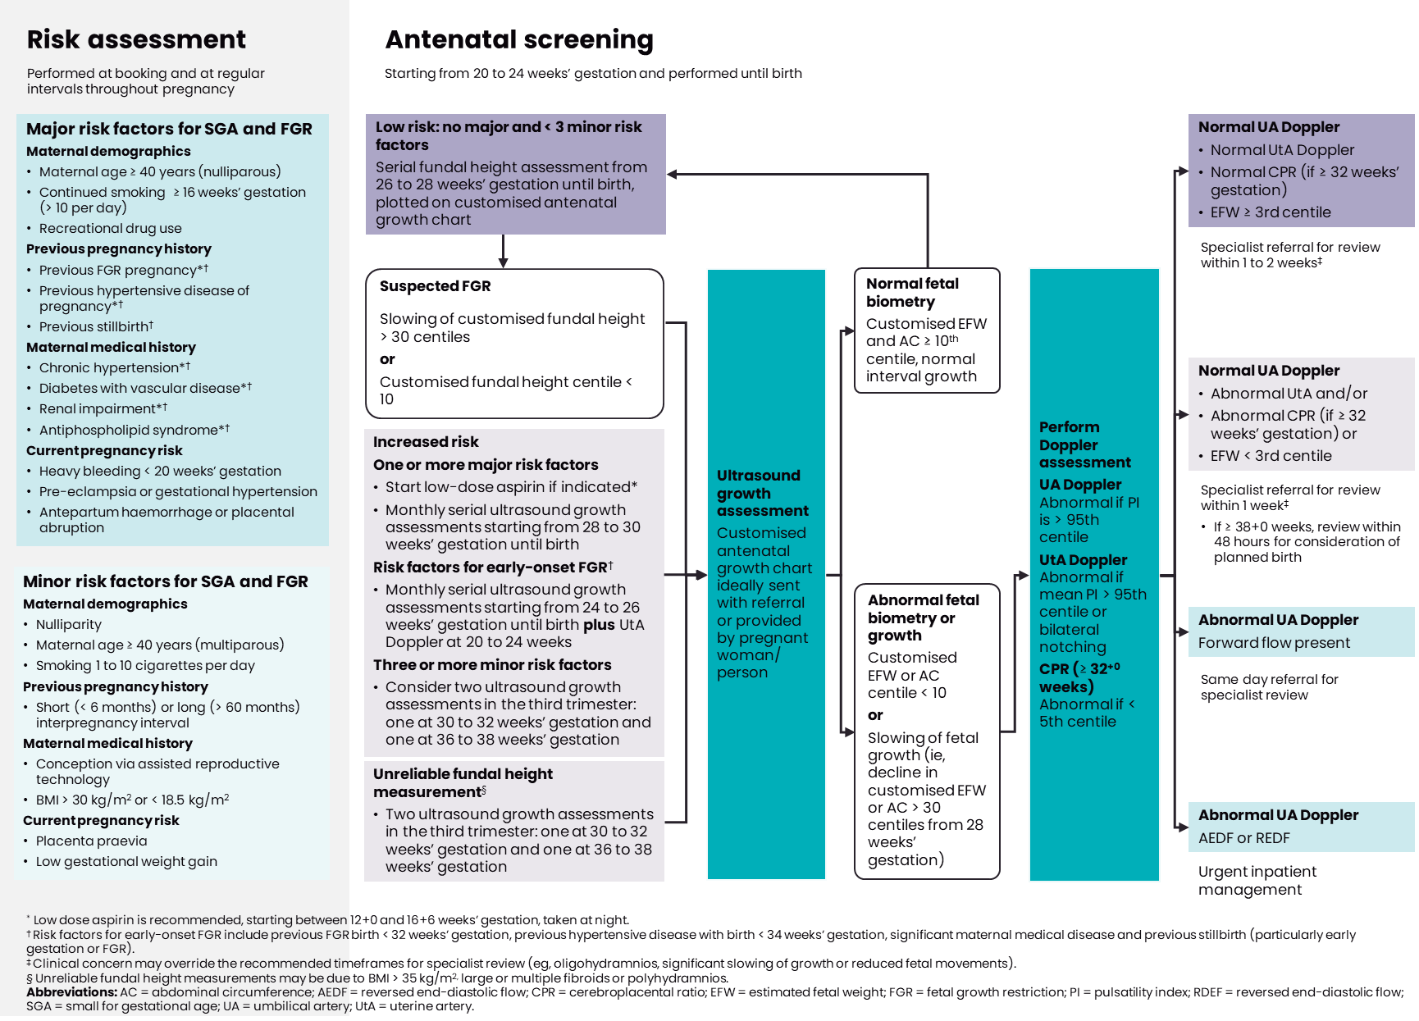

Management of FGR < 32+0 weeks
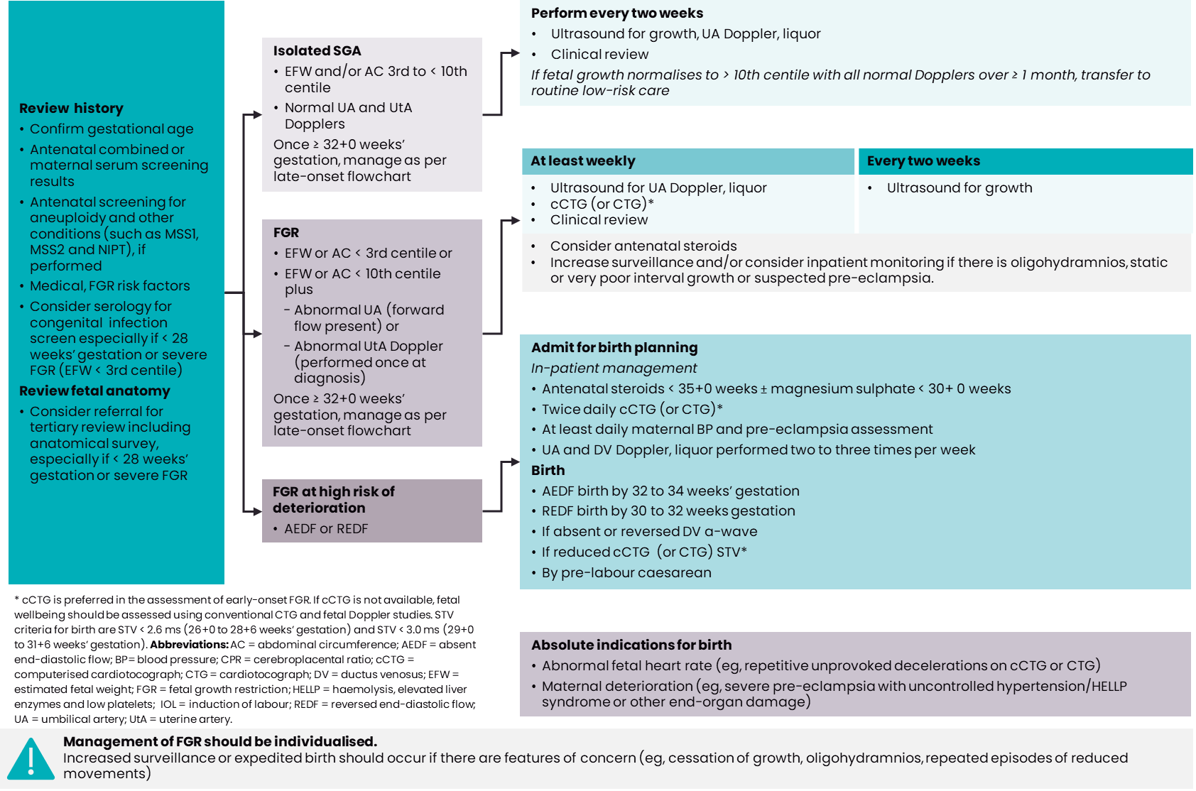

Management of FGR ≥ 32+0 weeks
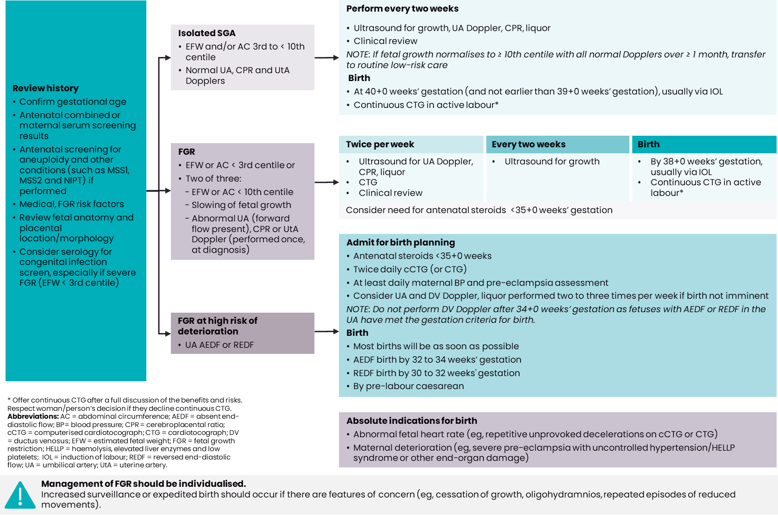

Management of the neonate with FGR

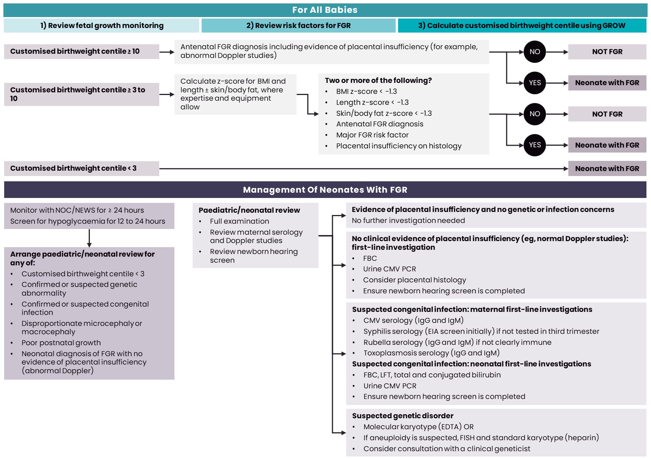

Appendix 1: Abbreviations
AC Abdominal circumference
AEDF Absent end-diastolic flow
CMV Cytomegalovirus
CPR Cerebroplacental ratio
cCTG Computerised cardiotocograph
CTG Cardiotocograph
DV Ductus venosus
EDTA Ethylenediaminetetraacetic acid
EFW Estimated fetal weight
EIA Enzyme immunoassay
FBC Full blood count
FGR Fetal growth restriction
FHR Fetal heart rate
GPP Good practice point
HC Head circumference
HELLP Haemolysis, elevated liver enzymes and low platelets
HIV Human immunodeficiency virus
IgG Immunoglobulin G
IgM Immunoglobulin M
LFT Liver function test
LMC Lead maternity carer
MCA Middle cerebral artery
MoM Multiple of medians
NEWS Newborn Early Warning Score
NIPT Non-invasive prenatal testing
NOC Newborn Observation Chart
NZMFMN New Zealand Maternal Fetal Medicine Network
PAPP-A Pregnancy-associated plasma protein-A
PCR Polymerase chain reaction
PI Pulsatility index
RCT Randomised controlled trial
REDF Reversed end-diastolic velocity
SGA Small for gestational age
STV Short-term variability
UA Umbilical artery
UtA Uterine artery
WHO World Health Organization

Appendix 2: Te reo Māori kupu
hauora Māori Holistic view of health and wellbeing
te ao Māori The Māori worldview
te reo Māori The Māori language
whānau Family (in a broad sense)

References
- LBF McCowan, F Parry, K Groom. M Necas. 2014. Guideline for the Management of Suspected Small for Gestational Age Singleton Pregnancies and Infants After 34 weeks' gestation. Wellington: New Zealand Maternal and Fetal Medicine Network.
- FJ Cowan, CJD McKinlay, RS Taylor, J Wilson, J McAra-Couper, N Garrett, et al. 2021. Detection of small for gestational age babies and perinatal outcomes following implementation of the Growth Assessment Protocol at a New Zealand tertiary facility: An observational intervention study. Australian and New Zealand Journal of Obstetrics and Gynaecology 61(3): 339-46.
- Standards New Zealand Te Mana Tautikanga o Aotearoa. 2021. Ngā Paerewa Health and Disability Services Standard NZS 8134:2021. Wellington: Standards New Zealand.
- SJ Gordijn, IM Beune, B Thilaganathan, A Papageorghiou, AA Baschat, PN Baker, et al. 2016. Consensus definition of fetal growth restriction: a Delphi procedure. Ultrasound in Obstetrics and Gynecology 48(3): 333-9.
- TM MacDonald, L Hui, S Tong, AJ Robinson, KM Dane, AL Middleton, et al. 2017. Reduced growth velocity across the third trimester is associated with placental insufficiency in fetuses born at a normal birthweight: a prospective cohort study. BMC Medicine 15(1): 164.
- Ministry of Health. 2019. New Zealand Obstetric Ultrasound Guidelines. Wellington: Ministry of Health.
- O Hugh, J Gardosi. 2022. A fetal weight projection model to define growth velocity, and validation against pregnancy outcome in a cohort of serially scanned pregnancies. Ultrasound in Obstetrics and Gynecology 60(1): 86-95.
- T Stampalija, J Thornton, N Marlow, R Napolitano, A Bhide, T Pickles, et al. 2020. Fetal cerebral Doppler changes and outcome in late preterm fetal growth restriction: prospective cohort study. Ultrasound in Obstetrics and Gynecology 56(2): 173-81.
- CA Vollgraff Heidweiller-Schreurs, MA De Boer, MW Heymans, LJ Schoonmade, PMM Bossuyt, BWJ Mol, et al. 2018. Prognostic accuracy of cerebroplacental ratio and middle cerebral artery Doppler for adverse perinatal outcome: systematic review and meta-analysis. Ultrasound in Obstetrics and Gynecology 51(3): 313-22.
- Ministry of Health. 2021. The New Zealand Guidelines for Helping People to Stop Smoking Update. Wellington: Ministry of Health.
- Te Whatu Ora Health New Zealand. 2022. Diagnosis and Treatment of Hypertension and Pre-eclampsia in Pregnancy in Aotearoa New Zealand: Te Tautohu, Te Tumahu i te Toto Pōrutu me te Pēhanga Toto Kaha i te Hapūtanga ki Aotearoa: A clinical practice guideline. Wellington: Te Whatu Ora.
- Royal College of Obstetricians and Gynaecologists. 2014. The investigation and management of the small-for-gestational age fetus Green-top Guideline No. 31. London: Royal College of Obstetricians and Gynaecologists.
- NH Anderson, LC Sadler, AW Stewart, EM Fyfe, LM McCowan. 2013. Independent risk factors for infants who are small for gestational age by customised birthweight centiles in a multi-ethnic New Zealand population. Australian and New Zealand Journal of Obstetrics and Gynaecology 53(2): 136-42.
- JG Chung, RS Taylor, JM Thompson, NH Anderson, GA Dekker, LC Kenny, LM McCowan, SCOPE Consortium. 2013. Gestational weight gain and adverse pregnancy outcomes in a nulliparous cohort. European Journal of Obstetrics and Gynecology and Reproductive Biology 167(2): 149-53.
- J Gardosi, B Clausson, A Francis. 2009. The value of customised centiles in assessing perinatal mortality risk associated with parity and maternal size. BJOG: An International Journal of Obstetrics and Gynaecology 116(10): 1356-63.
- PM Dietz, WM Callaghan, R Smith, AJ Sharma. 2009. Low pregnancy weight gain and small for gestational age: a comparison of the association using 3 different measures of small for gestational age. American Journal of Obstetrics and Gynecology 201(1): 53 e1-7.
- GM Buck Louis, J Grewal, PS Albert, A Sciscione, DA Wing, WA Grobman, et al. 2015. Racial/ethnic standards for fetal growth: the NICHD Fetal Growth Studies. American Journal of Obstetrics and Gynecology 213(4): 449 e1- e41.
- T Kiserud, G Piaggio, G Carroli, M Widmer, J Carvalho, L Neerup Jensen, et al. 2017. Correction: The World Health Organization fetal growth charts: A multinational longitudinal study of ultrasound biometric measurements and estimated fetal weight. PLoS Medicine 14(1-3): e1002284.
- N Melamed, A Baschat, Y Yinon, A Athanasiadis, F Mecacci, F Figueras, et al. 2021. FIGO (International Federation of Gynecology and Obstetrics) initiative on fetal growth: best practice advice for screening, diagnosis, and management of fetal growth restriction. International Journal of Gynaecology and Obstetrics 152 Suppl 1:3-57.
- FP Hadlock, RB Harrist, RS Sharman, RL Deter, SK Park. 1985. Estimation of fetal weight with the use of head, body, and femur measurements - A prospective study. American Journal of Obstetrics and Gynecology 151(3): 333-7.
- C Lees, N Marlow, B Arabin, CM Bilardo, C Brezinka, JB Derks, et al. 2013. Perinatal morbidity and mortality in early-onset fetal growth restriction: cohort outcomes of the trial of randomized umbilical and fetal flow in Europe (TRUFFLE). Ultrasound in Obstetric and Gynecology 42(4): 400-8.
- TY Khong, EE Mooney, I Ariel, NC Balmus, TK Boyd, MA Brundler, et al. 2016. Sampling and definitions of placental lesions: Amsterdam Placental Workshop Group Consensus Statement. Archives of Pathology and Laboratory Medicine 140(7): 698-713
- E Pomeroy, JT Stock, TJ Cole, M O'Callaghan, JC Wells. 2014. Relationships between neonatal weight, limb lengths, skinfold thicknesses, body breadths and circumferences in an Australian cohort. PLoS ONE 9(8): e105108.
- JC Wells. 2001. A critique of the expression of paediatric body composition data. Archive of Disease in Childhood 85(1): 67-72.
- I Goswami, N Rochow, G Fusch, K Liu, ML Marrin, M Heckmann, et al. 2016. Length normalized indices for fat mass and fat-free mass in preterm and term infants during the first six months of life. Nutrients 8(7).
- TR Fenton, JH Kim. 2013. A systematic review and meta-analysis to revise the Fenton growth chart for preterm infants. BMC Pediatrics 13:59.
- IE Olsen, ML Lawson, AN Ferguson, R Cantrell, SC Grabich, BS Zemel, et al. 2015. BMI curves for preterm infants. Pediatrics 135(3): e572-81.
- AE Carberry, CH Raynes-Greenow, RM Turner, LM Askie, HE Jeffery. 2013. Is body fat percentage a better measure of undernutrition in newborns than birth weight centiles? Pediatric Research 74(6): 730-6.
- M Shaw, T Lutz, A Gordon. 2019. Does low fat percentage in neonates greater than the 5th centile birthweight increase the risk of hypoglycaemia and neonatal morbidity? Journal of Paediatrics and Child Health 55(12): 1424-8.

Panel members were Dr Ngaire Anderson (Chair), Anna Francis, Dr Chris McKinlay, Claire MacDonald, Horiana Thompson, Katarina Komene, Dr Kirsten Gaerty, Martin Necas, and Dr Rachael McEwing.

