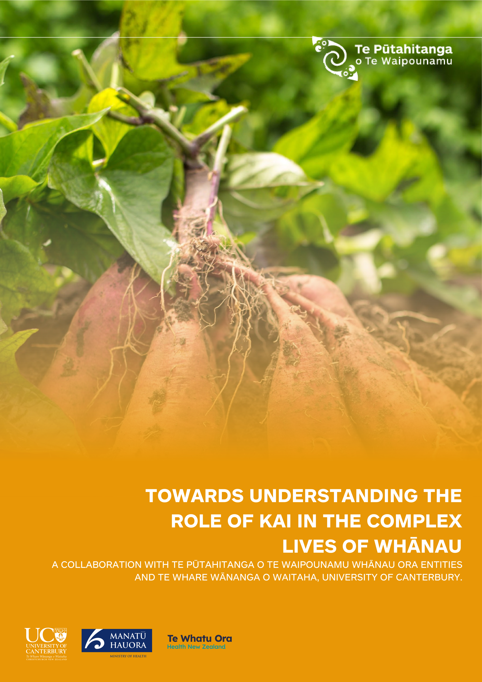

Ki te taha nui, Ki te taha roa, Ko te poupou taakiri tua.
He kapo whai uri, He kapo whai ate.
Ka pakia ki te rangi, Ka toro pai ki te whenua, He hua mate, He hua aro. He puta iti ki te rauuru o te whatu, tai, ora. Ka rea ko te iho, He mataatuatua te taureke, He taura te pouherenga, He tuaiti te marunga o te kapenga, He oho mai rangi.
Nau e IO eee.

To the large side, to the long side, Tis the pillar that glistens from beyond. I am in search of connection lines. I am in search of my core existence.
That which has been embowed with consciousness.
That in which has been bowed to earth.
The sacred knowledge garden that holds esoteric knowledge.

The sacred garden that is physicality.
From this everything springs forth to the myriad Of connections forged within living waters, then the
essence of all that grows.

The ancient symbol has been carved within the ethos of this knowing. The sacred thread is the pillar that brings us all together. The source of this protection is unprecedented. It has been awoken from the heavens.
From the source that is IO Matua kore – the ultimate.

Papa Joe Delamere.

Contents
Executive Summary 3
About Kōanga Kai 6
About this Review 8
Scope of Report 9
Why Kōanga Kai? 10
Mātauranga Māori and Evaluating the Success and Outcomes of Kōanga Kai 12
Community Fieldwork/Methods 14
Initial Assumptions 15
Findings and Insights 16
Conclusion 33
Case Studies 35
References 46

Executive Summary

This study aimed to achieve a deeper understanding of the place of food in the complex lives of whānau, including what ‘eating well’ means, the barriers and enablers to eating well and to understand the perspectives of rangatahi and intergenerational insights about food culture in Aotearoa. This review also aimed to identify and understand how tuakana and teina mentoring relationships can influence behaviour change and improve food literacy.
This qualitative study compared a new māra kai food gardening project, Kōanga Kai, with four other well-established programmes to support access to healthy kai. What the study revealed was when whānau are engaged with creating their own kai solutions, a ripple effect beyond immediate nutrition benefits is achieved, including to a wider sense, a desire to enhance hauora/wellbeing, and mana motuhake/food sovereignty.

The ripple effect demonstrates a determinants-based approach to generating positive health outcomes. Recognising that health determinants are variously classified, the way in which Kōanga Kai engages with the determinants is summarised in the diagram below. We are mindful that determinants-based approaches to health outcomes are both important for creating deep, durable transformation for whānau. It is our hope that this report can contribute to the evidence base for determinants-based approaches and the visibility of determinants-driven intervention logic. In brief, the intervention logic for Kōanga Kai is:
- Whānau are empowered to create māra kai
- Māra kai strengthen the self- determination of whānau and social supports which contribute to positive personal health practices
- Māra kai enhance the quality of nutrition available to whānau, increase food security and decrease financial insecurity

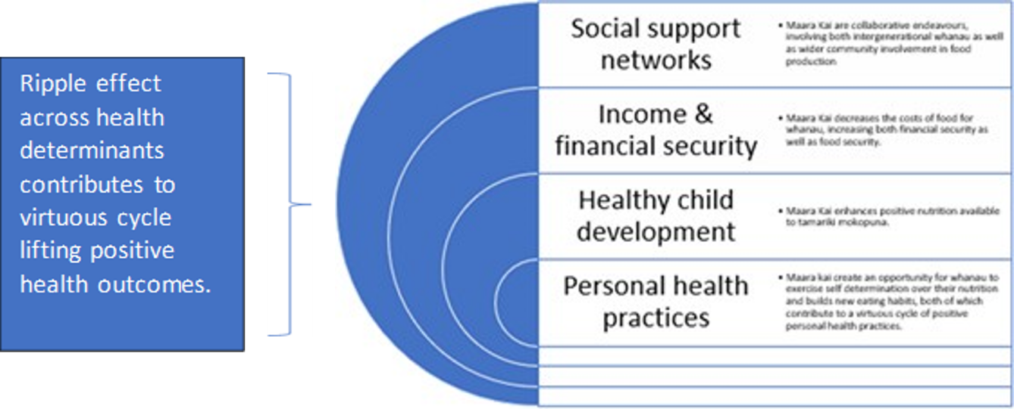
Diagram: The ripple effect demonstrates determinants-based approach

- Whānau feel more confident and empowered about their health journey and are more likely to overcome known health barriers
- Enhanced participation in the health sector, increased quality of nutrition, and more self-efficacy over health decisions decreases incidences or severity of preventable health conditions
- Overtime, there are measurable reduction in negative health outcomes.
This review also importantly suggests that the impact of supporting māra kai, more particularly, growing food, extends far beyond behavioural change around food. The strength of a food growing programme like Kōanga Kai is that it reflects a self- determination approach where whānau members identify what types of māra kai would work best for them. For example, a community approach, māra at home or perhaps both. No one approach fits all participants, therefore, when a programme places whānau at the centre they can best determine what acts of service and which relationships would be resourced in diverse contexts.
Image to right: Kai heroes from Te Waipounamu gather to learn of no-dig plantings at Te Pā o Rakaihautū, a kura in Ōtautahi.
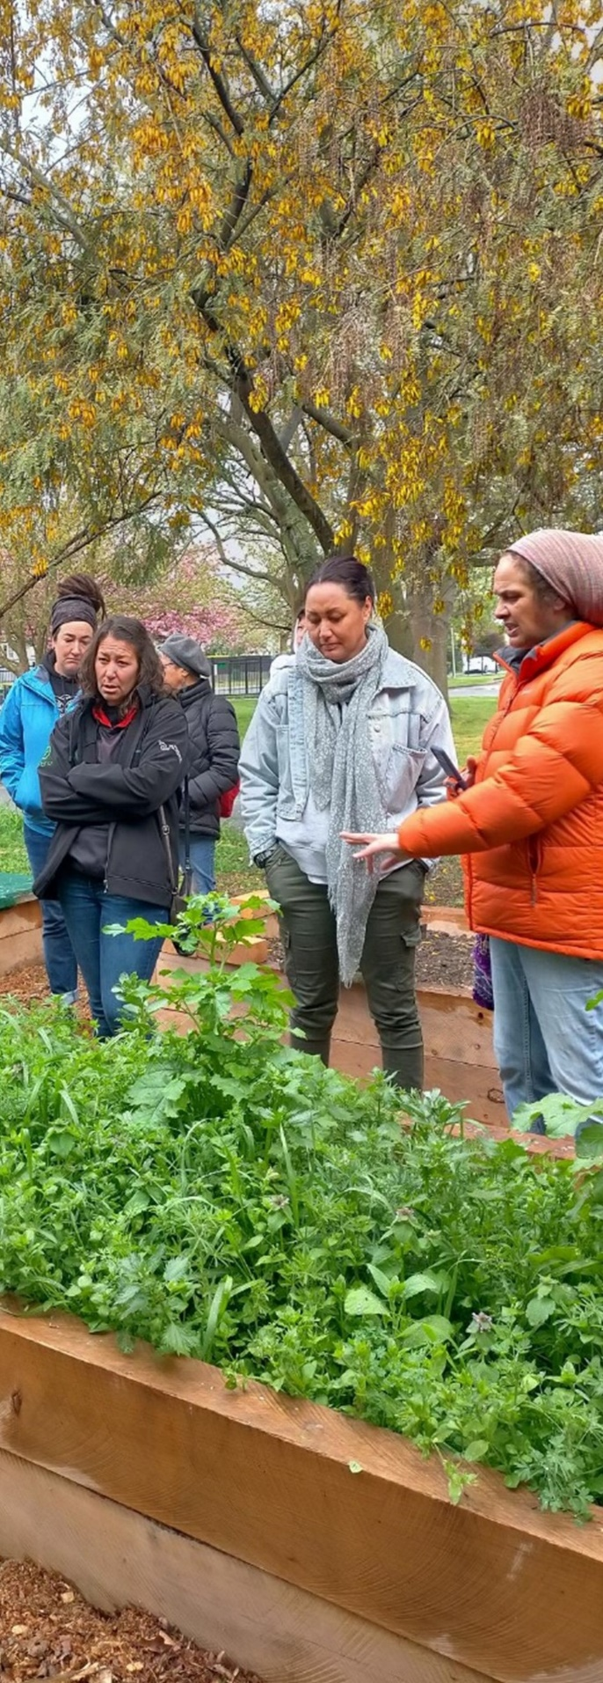
The community gardens/māra kai initiatives reviewed here have had a highly significant impact on identity formation, spiritual and mental hauora/wellbeing, and sense of mana motuhake of those interviewed. This impact was particularly noticeable for rangatahi. There are initial encouraging indications that the māra kai kaupapa also enhanced food security for many whānau. The physical aspect of gardening, creating, and maintaining also contribute to physical activities resulting in increased movement for many.
The findings of this research support an earlier study that identifies the challenges of food in the complex lives of whānau. This includes the availability, the affordability, and the accessibility of fresh foods (Ihi Research, 2022. This problem contributes to chronic health statistics but is also the result of many years of colonisation, from land and knowledge loss, through diverse acts such as the Tohunga Suppression Act, the impact of rapid urbanisation, cultural shame, and associated loss of confidence to participate in contexts of highly individualised ways of living (Moewaka Barnes & McCreanor, 2019).
The Kōanga Kai kaupapa directly addresses an important population health challenge of a sustainable development goal, that of individual and community wellbeing through
building food security. Availability of food, stability of food supply, access and utilisation of food are the four components of food security, and each component critically connects to household and individual well-being as well as planetary health (Charlton, 2016).
While the results of this qualitative study cannot easily be generalised, they indicate that gardening opportunities can begin addressing some of these underlying systemic issues in empowering ways. However, without support from initiatives like Kōanga Kai, which includes resources and mentoring, it is highly unlikely that most of the communities interviewed in this study would have been able to afford to take the risk to set up māra kai. International research indicates that successful Indigenous-led food sovereignty and gardening projects are hard to achieve but very easy to undermine with a lack of funding and recognition. This pathway of food literacy and intake contributes to factors leading to enhance well-being for whānau. It is with food consumption, physical activity, connection, and support that whānau can turn the emphasis and chronic health conditions and habits, to new habits, and support healthy choices when given the resource and knowledge to do so.
In our view, as researchers and reviewers, we have rarely seen such a remarkable programme with such strong community support.

About Kōanga Kai

Kōanga Kai was developed by Te Pūtahitanga o Te Waipounamu, the Whānau Ora Commissioning Agency, in April 2021. This initiative aims to support whānau rangatiratanga by promoting kai security through developing a network of māra kai across Te Waipounamu. Kōanga Kai aims to encourage self-determination and sustainability by encouraging healthy and sustainable kai production practices, influenced by the traditions and mātauranga of tīpuna. The focus is kai production with whānau in charge of creating healthy lifestyles that are environmentally and economically sustainable. This kaupapa supports 25 legal entities including marae, kura, community organisations, and whānau who expressed interest in growing their own kai (see Figure One). Kōanga Kai is founded on the seven pou of the Whānau Ora framework which are: whānau-centred, financially viable, local solutions, intergenerational transmission of te ao Māori through relationships; collective identity and ownership; and holistic (supporting spiritual/te taha wairua, social/te taha whānau, physical/te taha tinana and mental/te taha hinengaro wellbeing/ hauora) and strengths-based approaches for best outcomes for each whānau member.

Figure One. Entities delivering Kōanga Kai initiatives across Te Waipounamu and Wharekauri/Rēkohu.
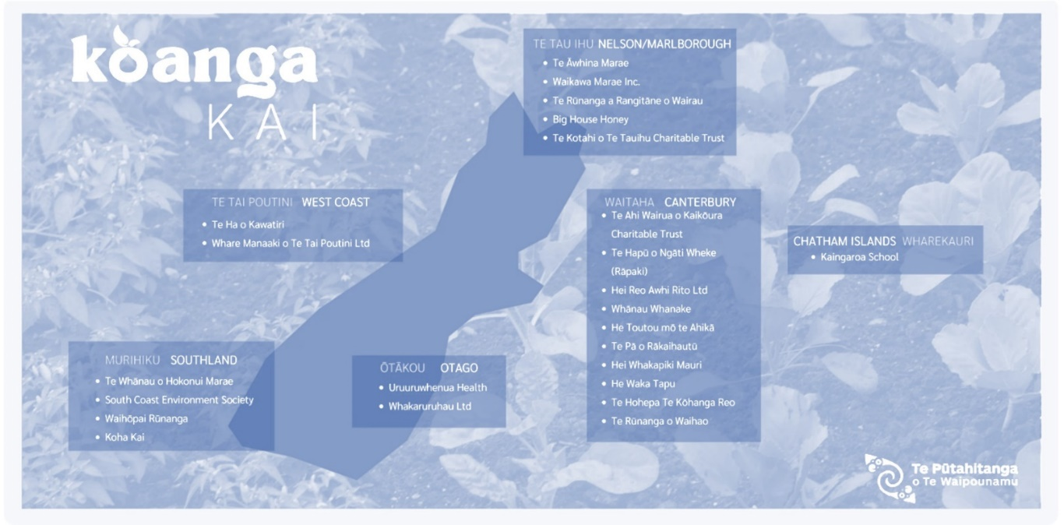

Kōanga Kai provides resources and coaching aimed to empower 419 whānau or the 1,576 individuals including 685 rangatahi under the age of 18 years who participate in communal gardens or create māra kai at home. They are supported with opportunities to take part in learning about planting, hunting, gathering, foraging, producing, preserving, and preparing kai (see Figure Two).

Figure Two: Whānau and community engagement.
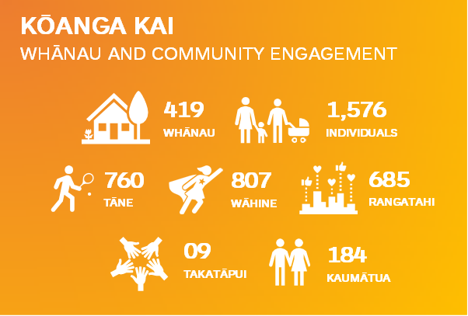

About this Review

This research is a collaboration between Te Pūtahitanga o Te Waipounamu and Te Whare Wānanga o Waitaha/ University of Canterbury to evaluate the impact of the first year of the Kōanga Kai initiative. This is carried out through qualitative interviews, hui, wānanga, case studies and video stories led by Gina-Lee Duncan as Kōanga Kai lead, and Manawa Te Heuheu, researcher. Thanks to the University of Canterbury reviewers: Sacha McMeeking, Arindam Basu, Bronwyn Hayward, Diane Mollenkopf, and Sara Tolbert.
This review builds on Phase One, a desktop review, “Commissioning to Support Healthy Outcomes for Whānau by Ihi Research, Social Change and Innovation (Ihi Research, 2022). That study provided a literature review of the role of kai/food for whānau Māori and indigenous communities. It aimed to identify and “understand barriers that prevent whānau from making good food choices as well as solutions evident in the literature” and to compare the literature with four case studies of Te Pūtahitanga o Te Waipounamu Kōanga Kai initiatives (Ihi Research, 2022). The report findings highlighted complex barriers for whānau to access fresh food in the context of challenging statistics where one in four (28.6%) tamariki Māori live in food-insecure households. This is an indicator of very high health statistics in chronic illness and disease.
The Phase One report highlighted the following issues.

Challenges for whānau
These included the absence of choice in conventional monocultural food systems, which overlook indigenous food systems; cost barriers for healthy food and access to poor quality food at low cost. Challenges also include personal stress due to low incomes and lack of time; alongside deficit discourses that drive shame, reduce motivation, and exacerbate whānau distrust of mainstream health services (Ihi Research, 2022).

Potential for indigenous food sovereignty solutions
Despite these challenges, the literature review also indicated that participating in māra kai can advance intergenerational cultural knowledge as more people learn about traditional approaches to gardening and that strengths-based solutions can be identified through learning about māra kai and māra rongoā, including protection of language and culture through kai and kaitiakitanga practices. Mana and manaakitanga are intertwined through the role of kai and a holistic approach is important for understanding the multidimensional role of kai in hauora and the capacity and capability skills of whānau (Ihi Research, 2022).

Scope of Report
The second review, Phase Two, was planned to gather in-depth qualitative insights from the community about the experience of whānau with a focus on the barriers and enablers of eating well, and the intergenerational effects of food access and choice for whānau. Phase Two specifically addresses four research aims agreed upon with the Ministry of Health:
- To achieve a deeper understanding of the place of food in the complex lives of whānau including what ‘eating well’ means and the barriers and enablers to eating well
- To understand the perspectives of rangatahi and intergenerational insights about food culture in Aotearoa
- To form relationships with whānau/rangatahi during the insights-gathering phase and identify food heroes to bring them along the journey, including identifying how they may influence behaviour change and improve food literacy
- To test our assumptions about the role of kai for whānau by using four Kōanga Kai and four additional projects funded by Te Pūtahitanga o Te Waipounamu Wave funding.

Why Kōanga Kai?

The idea for Kōanga Kai was initially developed in response to the high demand for food vouchers through the Puna Fund - the immediate relief fund offered by Te Pūtahitanga o Te Waipounamu. Near 7,000 individual applicants were provided with kai vouchers to support their immediate household needs during the COVID-19 lockdowns from 2020 to 2021.
The Kōanga Kai initiative was a proposal to increase whānau well-being and resilience in response to the impacts of COVID-19, through the provision of māra kai products and support to whānau in need of assistance. The Kōanga Kai kaupapa sought to create medium to long-term local solutions for whānau, to ensure whānau self-determination was a central pou of the kai supply chain.
The vision for Kōanga Kai is for whānau to be leading traditional, healthy, and sustainable kai production practices in their personal lives. There was a growing concern that providing food vouchers alone was not empowering whānau or supporting whānau self- determination toward creating healthy and sustainable lifestyles. It was important for kaimahi, participants, whānau members and wider community champions to learn from each other. In the context of COVID-19, another aim was to give a sense of support and grow relationships in an environment of potential social isolation.
The Kōanga Kai kaupapa supplemented the Puna model of service to a longer- term approach that focused on whānau self-determination – an investment model that established pathways to work alongside whānau to enable independent and transformational change in the kai supply chain.
Equipping whānau with the physical resources required to establish and maintain a garden in their homes, and provide whānau with the necessary support, guidance, and coaching to successfully produce their own kai, was seen as consistent with a Whānau Ora approach. Therefore, Kōanga Kai sought to shift the long-term response to COVID-19 from a dependency model to one of whānau self-determination.
For indigenous communities, food sovereignty is “regularly expressed as the right and responsibility of people to have access to healthy and culturally appropriate foods, while defining their own food systems” (Blue Bird Jernigan et al., 2021). Blue Bird Jernigan and colleagues argued that there are seven indicators of improving food sovereignty in indigenous communities which included: “access to resources, production, trade, food consumption, policy, community involvement, and culture.” Kōanga Kai aims to empower whānau in the areas of food sovereignty, well-being, and economic and environmental sustainability.
From June 2021, Kōanga Kai began providing physical resources including seeds, soil, planter boxes and raised garden beds, as well as mentorship to help whānau learn how to grow food in their own home. This programme also provided access to other food production practices like hunting, foraging, and preserving. Between July 2021 and October 2022, despite the challenges of lockdown and isolation, over 443 whānau members were engaged in growing their own kai (see Figure Two). The analysis of motivations for participation showed a remarkable desire to take part in the programme despite the constraints of COVID-19 (see Figure Three).
At the beginning of the programme, whānau expressed their desire to identify and/or re-establish connections. Many also expressed curiosity in growing kai, which in turn encouraged kaimahi to understand what motivated whānau participation. In initial kōrero, whānau expressed views about how to shift perspectives about food and wellbeing.
They also shared their values regarding the importance of food to their overall health and understanding of the way food habits and practices create generational normalities or expectations. Exploring the “why” of the desire to grow kai and eat well also informed the study’s interest in how to encourage whānau wellbeing, validating science and mātauranga Māori synergies in ways that acknowledge the interconnectedness of te ao Māori and values of being curious.

Image below: Whānau planting day – Aweko Kai 2022
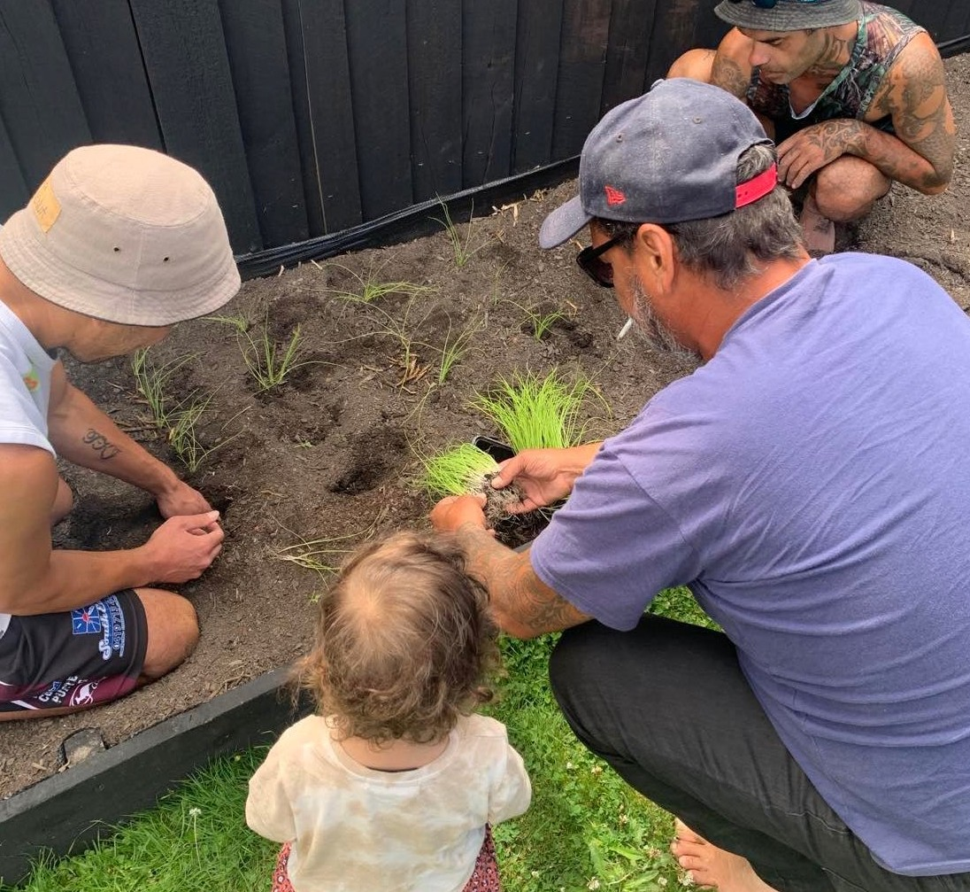

Mātauranga Māori and Evaluating the Success and Outcomes of Kōanga Kai

This research reviews predominantly qualitative research gathered between March 2022 and October 2022 with whānau Māori to capture the complexities of kai/māra relationships, and the outcomes for whānau following investment from Te Pūtahitanga o Te Waipounamu. We begin acknowledging that mātauranga Māori complements western science in key ways, including its wider philosophical emphasis on valued connections and relationships between all things and an emphasis on how people are connected with nature (Ruru and Nikora, 2021). Understanding and drawing on both knowledge systems afford a transdisciplinary approach to our research although it should be noted that they have very different epistemologies (ways of learning).
As a result of our orientation, our approach to understanding the why and how of kai and well-being in the complex lives of whānau is not just focused on understanding the impact of diet and food on health but aims to create a more extensive understanding of the wider, diverse elements emerging from Kōanga Kai which are also valued by whānau.
One scholar (Durie, 2004) refers to both knowledge systems – science and mātauranga Māori as being complementary and not in competition. A braided approach draws on both Mātauranga Māori and Western science allowing studies to transcend the boundaries of individual knowledge systems toward a more holistic approach to understanding the role of food, wellbeing, and sustainability (Macfarlane and Macfarlane, 2019).
Observations by Te Pūtahitanga o Te Waipounamu suggest that there are diverse outcomes from kaupapa when approached and understood through a mātauranga Māori perspective, for example:
- Whānau engage with a kaupapa when there is a direct benefit and it can be undertaken in the safety of their homes or a community in which they are familiar, if all whānau engage, often together, and where the project is strengths-based and encouraging.
- To acknowledge an emphasis on perceived tangible outcomes of taking part in a programme can create daunting expectations that are detrimental to the approach. Often whānau shy away if they feel they have to justify their actions and experiences against external expectations.
- Kaupapa, such as programmes, are sustainable if whānau inclusion is identified by whānau themselves.
- Creating authentic relationships is the foundation of a movement for change.
- Reporting resources such as narratives, wānanga, pūrākau and writings are helpful ways to capture pride and note change by celebrating success together.
The holistic approach of mātauranga Māori means that understanding the essence of success requires recognising a Māori way of “being and engaging in the world” using kawa and tikanga to understand shared world views, concerns, whakapapa, goals, aspirations, and generational experience, as a collective (Charles Royal, 2009; Kia Eke Panuku, 2016). This research aims to gain insight into what will sustain whānau to feel empowered, connected and valued, which is well beyond simply changing how, why and what whānau eat. We are supporting better health outcomes.
Ethical research within indigenous communities must originate from good relations and be grounded in self-determination of indigenous participants (Battiste, 2008; Bishop, 2011), which may look different from western scientific research, where standards of objectivity often require distance from participants, and where the agenda is set by the researcher, separating spiritual bonds from people and place.
However, traditional western methods of research can complement indigenous knowledge where practices work to provide confirmation of evidence (for example, highlighting behaviour change toward desired pathways of influence, or a sense of improved well-being), to inform policy decisions while honouring self-determination. We began from the assumption of needing research and tools that support change and not damage-centred narratives which position whānau as a problem to be fixed (Tuck, 2009). A deficit approach has not positively impacted health outcomes for Māori in the past (Graham & Masters‐ Awatere, 2020). Equally, while it is important to honour the essence of mātauranga Māori, it is also important to respect the dignity of individuals and their sovereignty over data. Therefore, in this study, University of Canterbury Human Ethics permission was also formally sought for interviews with rangatahi supported by a formal agreement on data ownership (UC HREC 2022/83). Insights and pūrākau gathered by Te Pūtahitanga o Te Waipounamu researchers were on the understanding that whānau retain authority and sovereignty over their own data.
It is through a mātauranga Māori lens that whānau come to understand and value natural resources which are imbued with mauri, an intangible and intrinsic value of energy. A hope for Kōanga Kai is that whānau can gain a higher level of understanding through traditional practices including: karakia, design, māra construction, establishment, plantings, maintenance and harvesting, manaakitanga, harvesting by the moon, guidance from the maramataka and indulgence, and through working collaboratively in their environment with each other, in ways that have lasting intergenerational impacts. Igniting the blood memory of many that align with the feeling of self-success and contributing to wellbeing from and within ancestral knowledge being revitalised.
The risk of focusing just on individual health outcomes of the Kōanga Kai initiatives reported here is that it reduces ones appreciation of the wider possible implications for hauora/wellbeing of participation in māra activities. Too narrow a focus risks overlooking the mauri from some elements of the programme development. To avoid this, the model of Tā Mason Durie, Te Whare Tapa Whā: the four strong pillars, is used in this study to inform wider insights about māra kai.

Image below: Whare Manaki o Te Tai Poutini
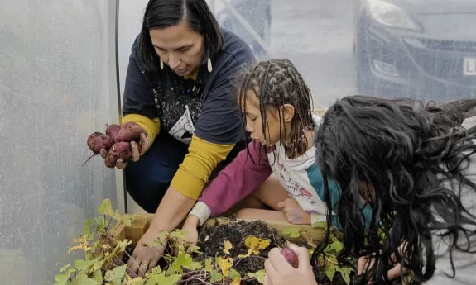

Community Fieldwork/Methods

In Phase Two of the study, community fieldwork was conducted between March and October 2022. This fieldwork and data included:

- Whanau voice surveys from participants conducted by Te Pūtahitanga o Te Waipounamu.
- Three wānanga with 19 rangatahi aged 12 to 22 years held in August and September.
- A Kōanga Kai hui for whānau held on 11-12 October in Waitaha/Canterbury.
- Eight Kai Hero interviews conducted with community māra kai mentors.
- Case studies of implementing Kōanga Kai and gardening programmes were compared to cases of wider kai programmes to identify what helps facilitate access to kai independence. This also enabled us to understand diverse community insights about the role of mātauranga Māori, food security, food literacy, relationships with food, intergenerational relationships, and wellbeing/hauora. The case studies included Kōanga Kai programmes at Waikawa Marae, Picton; Te Āwhina Marae, Motueka; Uruuruwhenua Health, Alexandra; Hei Whakapiki Mauri, Christchurch, and Te Hā o Kawatiri Tai Poutini; Westport; Koha Kai, Invercargill; the café Tātou Coffee shop, and Te Hā o Kawatiri Foodbank.
- Eight mātou kōrero short digital stories prepared to visually capture the impact of Te Pūtahitanga o Te Waipounamu kai initiatives with the aim of promoting healthy lifestyles more widely amongst whānau in Te Waipounamu by reflecting a range of kaupapa, locations, voices, and Whānau Ora outcomes and health issues (Te Pūtahitanga o Te Waipounamu, 2022).

Initial Assumptions

Drawing on a literature review and the Ihi Research report (2022), we began this study with five assumptions, which we also wished to explore in greater depth:
- That community gardens/māra and a range of wider community-led kai initiatives can support identity formation, spiritual and mental hauora/wellbeing, and mana motuhake /food sovereignty (Dunn, 2019; Grey, Muru-Lanning, Jones, & Muru-Lanning, 2020; Hond, Ratima, & Edwards, 2019)
- That food insecurity impacts on whānau resilience, hope and optimism (Beavis et al., 2019).
- That whānau food practices impact manaakitanga, whanaungatanga and kaitiakitanga and food choices across generations (Rangiwai, 2021)
- That whānau, particularly rangatahi can participate meaningfully, in their own health journey (McKerchar, Lacey, Abel, & Signal, 2021)
- That mātauranga Māori can be utilised to address barriers to preferred food choices and support food sovereignty and hauora (McKerchar et al., 2021; Viriaere and Miller, 2018).
We intend to return to reassess and reflect on these assumptions in the conclusion of this research.

Findings and Insights
He Tirohanga Ki Māra Kai
The following discussion considers the four main aims of the research, which were to: understand the place of food in the complex lives of whānau and perspectives of rangatahi and intergenerational insights about food culture in Aotearoa; to form relationships with whānau /rangatiratanga, identify food heroes and to understand how they influence behaviour change and improve food literacy.

An initial survey conducted by Te Pūtahitanga o Te Waipounamu in May 2022 offered several insights about who took part and why (see Figure Three).
Figure Three: What whānau valued about Kōanga Kai projects (n=149)
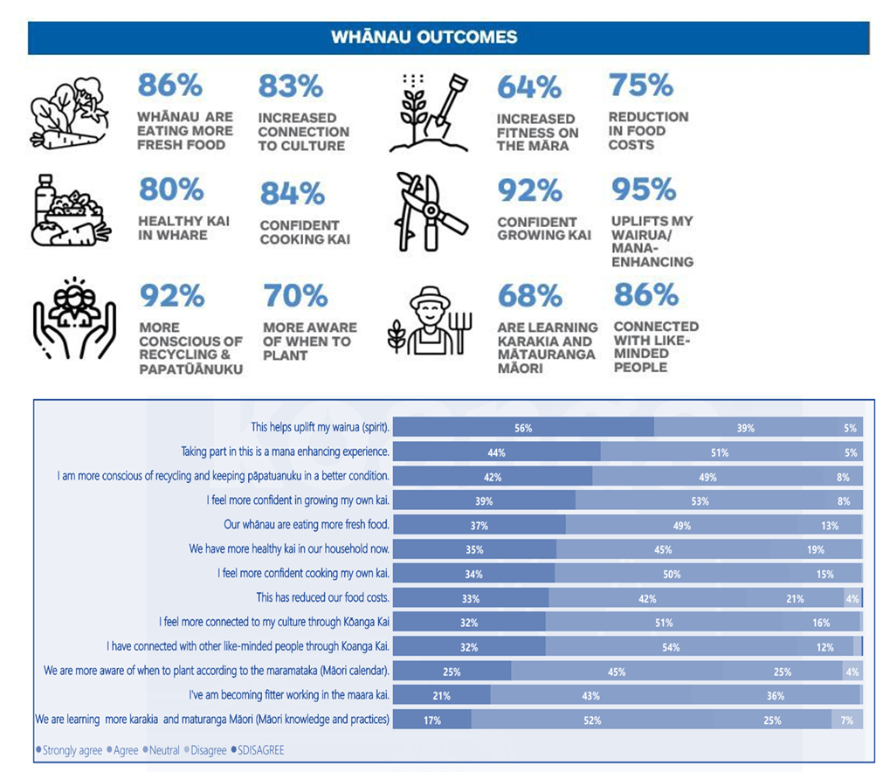

What is striking about the results of the whānau survey conducted by Te Pūtahitanga o Te Waipounamu is that on reflection, the benefits of participating in Kōanga Kai. The most favourable statement was that taking part, ‘helps uplift my wairua’ (95% of all respondents agreed or strongly agreed) and that participation was ‘mana enhancing’ (94% agreed or strongly agreed). While other more instrumental or direct health benefits from gardening including reducing food costs and enabling chances to get fitter were also viewed positively, over half of all participants strongly agreed that participation enhanced their sense of well-being.
This finding differs from the initial responses when whānau were asked why they first chose to participate in Kōanga Kai. These responses indicated the initial drive to take part was simply to grow kai (87 percent of respondents) with just 51% of respondents indicating they expected, “mental health benefits” from taking part. Nevertheless, a sense of hauora, well-being or “uplifted spirit” was also spontaneously noted as a positive outcome in digital stories, hui, and case studies. This finding highlights the wider impacts of whānau participation including feeling empowered, connected, and valued), which are noted in the literature and are well beyond a change in how and/or what whānau eat (Giraud et al., 2021) We turn now to review wider insights from hui, interviews, and case studies to better understand the benefits of participating in the kaupapa that whānau valued and why.

A) Understanding of the place of food in the complex lives of whānau.
Drawing on the hui and interviews, digital stories and case studies helped us shed light on what eating well means for whānau and what barriers and enablers have been identified that impact on eating well.

A.1. Eating well meant different things for people.
It is not surprising that insights from hui, interviews and case studies revealed a range of views about what eating well means. For many, eating well initially prompted replies about eating ‘healthily’, from a range of ‘spray free’ or ‘organic’ food ‘grown in the garden’ or recently harvested. Respondents also said:
“Lots of colours on the plate…Knowing what’s in your kai and knowing where [kai] comes from." (E and N interview)
For others, eating well included how the food was prepared and knowing its food value.
“Hot, nutritious kai." (Koha Kai case study)
Mothers, kuia/grandmothers, and aunties were often mentioned in conversations about encouraging eating as well as the following kōrero shows with rangatahi notes:
W: “Makes me wanna eat healthy. That’s what my Mum tries to do.
T: What to lose weight?
W: Nah not to lose weight. My Mum doesn’t care about that. She’s nice; she just wants me to be healthy. Help my brain work better.
H: And you don’t have to go to hospital all the time.
W: She doesn’t want me to get diabetes like my granddad.
R: And it’s good too, instead of going to get takeaways every night. It’s good to like eat healthy.
H: I feel like an oil bottle when I get takeaways all the time (Wānanga 3).”
As a parent, this mother also reflected on the nutritional benefits of māra kai.
“Before having a garden, eating well was feeding my children well. Me and my [partner] would go without. As long as my children were fed well, I didn’t give a shit. Knowing that we are meant to have five plus a day, we really struggled in our household with vegetables. We still do with the kids still but it’s getting way better. Fruit and veges were a hit and miss. We had a high-carb diet, and lots of pasta; that’s just how we lived. Since having the gardens, I had to start finding ways to add and cook the vegetables otherwise they’d go to waste. I still have a long way to go but we started eating vegetables several nights of the week instead of a meal with vegetables." (Kai Hero interview)
Beyond the nutritional values of kai, nearly all whānau spoken to in this study also said eating well had spiritual and relational meanings. For example, participants spoke about growing and sharing food as a way of expressing manaakitanga. In nearly all hui, interviews, and case studies, some participants referred to whom they eat with, and how they share kai to care for whānau.
“If you can nurture a garden, you can nurture a family." (Uruuruwhenua case study)
“It’s the one time we are all coming together." (E and N interview)
”Spending time together, connecting, seeing the results [with tamariki]." (October Hui)
For others eating well also meant knowing what whenua the food was grown in, especially if there is a connection to land sovereignty.
“Māori land…it tastes better knowing it comes from the marae." (E & N interview)
In many of the responses, we see a concept repeated often. While eating well mattered for health, it was also the transformative well-being experiences of participating in growing and sharing food that was also valued.
“For us, the journey is as important as the result. Kōanga Kai is not only helping us grow and produce kai, it’s a shared experience that is a clear example of rangatiratanga." (Hei Whakapiki Mauri Case-study)
“It supports all kinds of hauora." (Kai Hero interview)
“We have a māra as a special place for men for healing after violence." (October Hui)
“Eating well means sticking around a little bit longer for my kids. That’s my state of mind. There’s no other motivation for me. We need to look after ourselves to look after them.”

A.2. Working in a māra kai is intimately connected to positive intergenerational memories, relationships, whanaungatanga and mātauranga Māori
A range of comments in case studies, digital stories and rangatahi wānanga stressed the importance of cross- generational connections that happened in the process of gardening.
“It’s [the māra kai] a space of connection where whānau can be working with others.” (Digital story)
“Being able to talk with kids about food, and the textures. Our kids are a really important part of our kaupapa …and we make sure we involve them, we brainstorm with them, we ask what they’d like to grow.” (Digital story)
“When I was a kid, I was pushed into the garden and was not that interested, but I learned a lot!" (Interview)
“It’s connecting with one another and creating our own solutions." (Interview)
One of the leads of Hei Whakapiki Mauri explained the importance of intergenerational memories and the interconnected nature of whanaungatanga and mātauranga Māori. Paora (Paul) Poihipi of Te Whānau-ā-Apanui and Ngāti Porou stated:
“[As a child] I was sent back to the East Coast to learn the ways. By the full moon, we got the ground ready and by the new moon, we planted – but I was never allowed to actually plant as a kid. We had to do the crap jobs.”
Paul’s grandparents taught him to grow and harvest kai by the phases of the moon using the maramataka, the Māori lunar calendar. He spent his childhood learning to garden, bottle fruit, preserve fish and hunt.
“We lived in a community of about 100 and most of us were kids. The whole community got together to help each other when it was time to plant, harvest, gather kaimoana, and for the fruit season. We always had a heap of food in the cupboard, unlike when I went back to Mum and Dad’s. I learned things like to always keep the vegetables that were going bad for next year’s planting. The elders would throw them into the kumara pit to keep them dry so we could use the seeds. The old knowledge was to always stash and dry, and to never throw anything away.” (Hei Whakapiki Mauri, 2022).”
These early experiences influenced Paul’s aim to ensure his tamariki and mokopuna learned ‘to grow, gather, and hunt their own.’ His son, now in his thirties, has joined him on possum hunts and diving for kaimoana since his teens. This is no easy feat with his degenerative condition which means he now uses a wheelchair.
“He loves being out doing what I am doing and being outdoors relaxes him; it always has." (Hei Whakapiki Mauri, 2022)

A.3. Complex feelings when food can’t be provided and the costs of gardening
Many whānau of all ages commented on the cost of food, the cost of living and the cost of vegetables. While choosing to garden was seen by many as a good way
to supplement diets with nutritional food, the start-up costs of setting up a garden were noted as a particular barrier to growing food by several participants. Many people said the initial funding from Te Pūtahitanga o Te Waipounamu enabled their whānau to take a risk and get started, which they would not have done otherwise. For example, one participant remarked:
“Buying good quality seeds can be expensive and then there is a frost and whoops, you find all the cucumbers are gone!" (October Hui)
Another put it simply:
“It really matters to have some support to take a risk and give it a go." (October Hui)
Other participants acknowledged the shame of asking for help and the vulnerability of those needing help to build food security. In this context, several kai heroes and whānau members also noted they could not have afforded to undertake the experience of growing kai were it not for the provision of materials.
“Take our marae, we’d never have been able to do it without the funds to set up [a māra kai] but [the funding] was vital. It paid for the boxes, tools, and fencing. The possums are terrible where we are and so getting that set up has meant I hope it can carry on." (October Hui)
Without diminishing any of the positive benefits, one Kai Hero also noted the scalability problem of a home gardening approach which also reflects the ongoing impacts of colonisation and loss of land.
“Food security is in seed security and in the land. We are happy and humbled that through Kōanga Kai we have been able to help whānau by setting up garden beds in their backyards. Nevertheless, small-scale gardening is not going to achieve food security. We need land, we need to govern it ourselves, educate each other, make decisions as a collective, and ensure everyone’s voice is valued." (Kai Hero Interview)

Image below: Hāpori Māra Kai
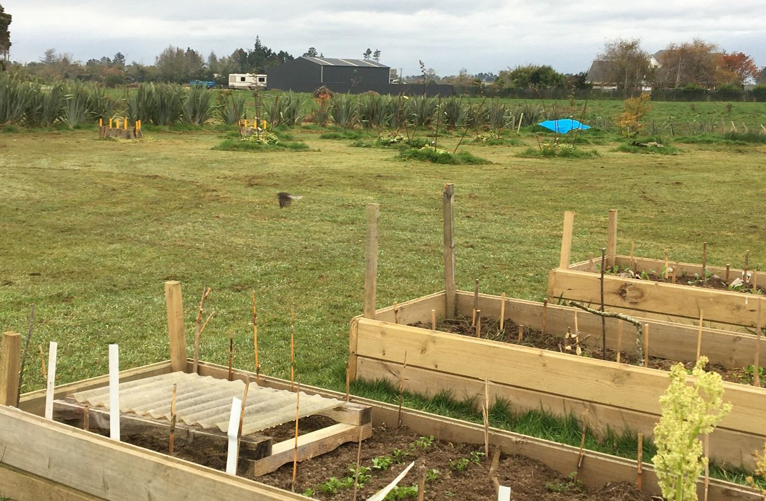

B) Perspectives of rangatahi and intergenerational reflections on food culture in Aotearoa.
Three wānanga were held between August and September 2022 in Waitaha/ Canterbury with 19 rangatahi in total aged 12-22 years to understand the experiences of some of the young people who took part in Kōanga Kai. Like adults, the whakaaro of youth often began with memories of being introduced to gardening at a young age by kuia, parents or other whānau influences.
“My first memory is with Mum. My Mum is into all that kind of stuff. Yeah, I always hung out with her when I was younger, planted things, went out on adventures, doing all kinds of stuff. I was like four, yeah…I first learnt about growing food because my grandparents live on a farm. I learned a lot from them about gardening, when to plant things, and preserving. Also, with my Dad at home, helping in his garden, [and] my Nan and my Poua." (Wānanga Three)
Many rangatahi talked about the value of the time spent together with whānau and the bonding experiences and the satisfaction of the end results. Some noted campaigns like New World’s Little Gardens got people interested in growing food but were costly and not available to many, “and the expense of spending $40 per trip to qualify for a Little Garden.” A number of older youth also described early experiences which they began to appreciate later as they grew older and the Kōanga kai project was a chance to re-engage with this activity but with more independence, enjoyment, and pride.
A: I grew up with my Nana and she had a huge garden. Any available space in the property was used for a garden. I grew up with homegrown produce but as Sophie said, it was more of her telling us to come and weed the garden rather than explaining the process of planting. For me, the garden is something that was seen as a chore, not something that was fun. Hearing about the mahi that they are doing here outside and I’m older, I can appreciate growing your own food." (Wānanga One)
In this way, rangatahi were also reflecting the views of some adults who noted rangatahi pride of ownership and accomplishment through built participation in the Kōanga Kai initiative.
“It has equipped whānau with something to take ownership of and achieve things that they have always wanted to achieve. Every whānau receiving support started the initiative hungry for knowledge. They presented with different levels of skill, enthusiasm, and viewpoint on their sovereignty." (Jade Moana)

B.1. Positive relationships and sense of identity for rangatahi:
For many young people interviewed in this study, the pride and sense of collective action and identity they gained from gardening was striking.
“Yeah, that’s our involvement and it’s become part of the rangatahi space. We have kinda taken over as rangatahi, we choose what to plant and run the planting days, and we connect with the community because we don’t know how to grow our own food but we wanna learn. That’s what sparked it all. None of us knew how to grow food. Maybe our grandparents knew how to but the only memory of it was weeding, and it didn’t really spark that much interest. We want to learn how to grow our own food." (Wānanga One)
“I think community and working together as whānau or extended whānau. It was cool to be out together, like the bonding. But I guess more seeing the results of your earlier work. Months beforehand planting potatoes or kumara, then digging it up later and seeing the actual results of your mahi. When you’re younger you think, “man this is stink, like this kind of boring”. Seeing it turned over and there being results, the virtue of patience I remember being the most valuable, that would kinda be my favourite part of it." (Wānanga Two)
The other side of building a shared space with friends, is that if peers were not taking part this could be a barrier when others were connecting online.
“You get used to doing other stuff, and it’s different when you’re young. You go outside and play but as you get older you’re on your phone all the time, inside watching tv. You don’t wanna go outside and do the mahi. What would you rather do, the technology thing or out in the māra? If all the boys are out there then I’d rather be out there in the māra, but if I’m just by myself I think I’d rather just do it all together with my friends." (Wānanga Two)

B.2. Connecting with animals and the hauora, spiritual and physical benefits of gardening for rangatahi.
Some of the rangatahi mentioned they enjoyed having chickens or other animals on a shared garden.
“I would say that my favourite part actually had more to do with animals more than the māra…but it’s kinda relaxing, planting something you know, it’s like real calm." (Wānanga One)
This brief comment supports the casual, active noticing of nature, especially animals, which wider studies of children and youth have associated with a strong positive impact on well-being that can come from gardening programmes (Harvey et al., 2020).
In their discussion, many rangatahi commented directly on how they felt gardening positively impacted their wellbeing:
“In this moment in my life [what I appreciate the most] is probably taha hinengaro because I have moved into Christchurch for uni. We have a huge garden back home and I’m always in it and always connected to it and I found it quite hard to move to Christchurch. There’s a lot more concrete and everything like that. But this year, I have done all my propagating and seed raising and it’s definitely helped me feel more connected to my life [back home]. Like I’ve found it to be really, really beneficial to my mental health, feeling like I have a connection back to something and I’m not sorta just floating away." (Wānanga Two)
Another example of discussion about the range of spiritual and physical aspects of gardening valued by rangatahi is this kōrero from Wānanga Three:
R: “Taha whānau coz providing the kai for your whānau.
G: So, you’re not just growing it for yourself?
R: Nah, like everyone.
W: Yeah well, it’s a whānau effort.
R: And taha wairua, coz Atua.
H: Taha tinana, get that workout!
W: Taha hinengaro as well coz you gotta know how to do it.
R: Bit of everything aye ….sprinkled.
H: Sprinkle it over everything, create the foundation.
W: Oooooh those words. Yo…when you do the māra kai it makes you at peace, like spiritually. Like it makes you nice and peaceful. Like meditation like calming.
M: Like if you love being in the māra, it’s the feeling of being in there.
G: Do you karakia before getting into the māra?
M: Ae. (others): Kao…sometimes.
M: You gotta do the karakia before you eat so it’s like the same.”

Image below: Left to right: Ruby Gill-Clifford; Preach Temepara; Manawa Te Heuheu; Jordan Wilson; Jayme Benyon.
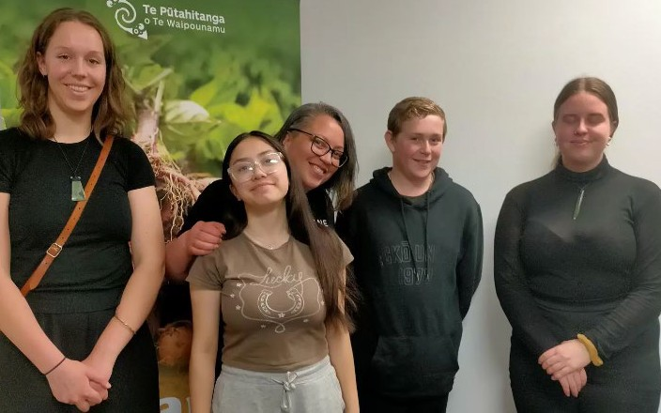

B.3. Barriers of eating well for rangatahi
Like adults, rangatahi remarked unprompted on the costs of food and the time costs of growing kai as this discussion from Wānanga One illustrates:
S: “The [cost of] lettuce. That’s criminal. A: The cost, it definitely impacts. If I had my own house, I would 100% grow my own. J: I spent $8 on a butter the other day. A: I wanna grow salad and things for burgers. Even cucumbers are like $5. I never really thought about the different options available at the supermarket. We had wraps for dinner the other night and all I could get was spinach. Everything was so expensive; it’s like what else do you have you know? It definitely limits the vegetables you can have.
S: But it’s a timing thing as well. It’s much easier to go spend money on groceries and buy all sorts but putting time on the garden and producing something takes a lot longer. It’s easier to go buy a bag of chips than plant seeds and wait a couple of months looking after it.
A: My partner and I have had debates of what’s cheaper, to buy the boneless chicken thighs or cutlets. He says time equals money. The ones on the bone are way cheaper but the time it takes to cut the meat off the bones is you know. So, I think for some people the time versus cost. Some people might see it as taking two months to grow me a lettuce, so is the time worth it in that kind of sense? Spending time caring for the garden might take time away from doing other things." (Wānanga One)
Discussion in wānanga with rangatahi also illustrated the complex relationship many young people have with takeaways and fast food. While many recognised that take-aways may not be healthy they often associated food like KFC and fish and chips with family celebrations, joy, and fun. However, through the garden experience and kōrero with their peers and older people, rangatahi are also developing their thinking about a variety of foods and what eating well means in ways that suggest long-term gardening could enhance food choices (McAleese & Rankin, 2007).
I: “I don’t think there’s anything māra related when it’s Christmas.
W: Sometimes when my whānau get together we have this thing, my family brings the KFC, someone else does the pizza and someone else will bring the fish n chips and we have a massive feed. That’s what we do.
M: Christmas it’s like what W said-one family will get fish n chips, we make the cake and then we buy or make other food like my Nan, she’s a chef. She’s a mean cook [can hear whispering how awesome she is]. She can make sushi and stuff, yeah.
K: Mine’s way more better than theirs. Instead of takeaways we have like food from the supermarket, steak, and chicken wings.
Others: Mmm. Mean.
K: We have coleslaw and lettuce and spinach as well. My Taua makes the best guacamole. Some family brings takeaway and drinks.
Others: Yum guacamole.
T: My whānau has BBQs and stuff, we bring different kinds of food to things. So, my family might make potato salad or tuna salad and bring it to wherever we are having a kai, and every other household will do that. Have like a whole heap of food cos everyone bought their own food from their house.
G: T’s whānau does the crayfish and all of that as well. Her grandfather goes diving so they have all sorts of kaimoana. They’re right into it.
TR: Usually when we have family lunch and stuff, my Nan and that will make hāngī, boil up, creamed paua and raw fish and stuff. Sometimes we have BBQs and fires and that. I don’t eat the salad but yeah.
H: Mine’s just the same as TR’s, but we also get takeaways and stuff as well. Yeah, that’s it.
R: Probably the same as T’s, with the potato salad and that, and BBQ meat patties, all that and like sometimes KFC if it’s a big event.
P: On special occasions, we have horse.
Others: Ooh.
P: It’s just a really hard thing to get sometimes, and chop suey, heaps of it and crab meat, in salads. Yeah, that’s about it." (Wānanga Three)
All of the rangatahi who took part in wānanga expressed interest in continuing to be involved in gardening and to explore the connection between planting, eating, and connecting to seasons and the maramataka. The comments about peers and collective action suggest this interest will be easier to sustain if there is ongoing support to enable collective action with others.

Image below: Te Awhina Marae
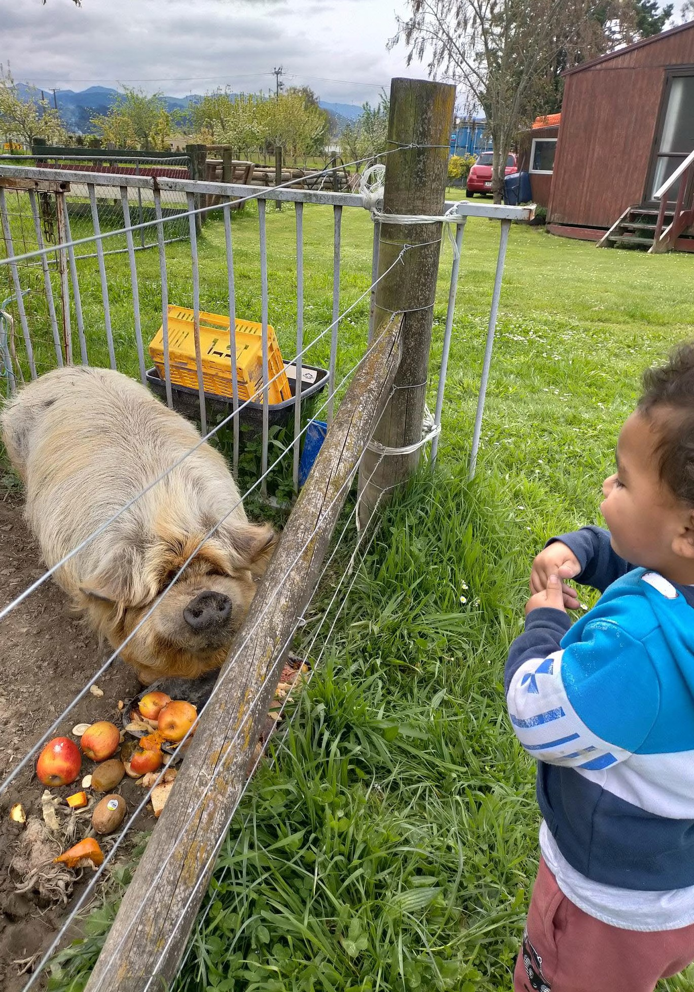

C) Whanaungatanga: understanding the role of relationships with Kai Heroes
Here we discuss the Kai Heroes’ insights on any influence they felt they have on behaviour change, food literacy and hauora. In the course of the implementation of Kōanga Kai, the mahi of the kai heroes as mentors was compromised at times by the challenges of COVID-19 and restrictions limiting ways they could work with Kōanga Kai participants. While the full potential of relationship building, and the influence of food heroes cannot be discerned in these cases, there are promising insights about the importance of having kai heroes. Many kai heroes reflected on the value of support especially for kaumātua and group activities that reduced social isolation.

C.1. Manaakitanga and Whanaungatanga
For many Kai Heroes, growing a garden provides a very real, tangible way to show how they valued and cared for others.
”Some elderly kaumātua commented they felt supported to have a garden and some younger people helping them. It's support mainly…māra has been my place of well-being for a number of years, now I can have that sense I can develop this and share it with others." (Uruuruwhenua Case Study)

C.2. Trust as an enabling condition
Some Kai Heroes and Whānau Ora Kaimahi commented that encouraging eating well required enabling conditions for building whānau-level food security which includes trust. The approach to support and gain trust in a relationship is paramount for whānau to share their concerns, health issues and anxieties. The māra kai physical activities and connections support building on a trusting, non-invasive relationship. Once this is established, support to create good healthy pathways are encouraged by all.
“Building trust has been an integral part of the mahi to develop an understanding of the complexities each whānau face, and their motivation towards growth and change (Te Mahere Whakauka Case Study).”

C.3. Social connection also enables whānau to build their capacity for food literacy, and food sovereignty
Building on the relationships of trust, social connections formed with Kai Heroes appear to encourage learning.
“Every whānau receiving support from J and GG started the initiative hungry for knowledge. They presented with different levels of skill, enthusiasm, and viewpoint on their sovereignty (Kai Hero interview).”
Social connections developed through the māra kai go well beyond food literacy.
“When they were able to meet with whānau, they would often end up spending multiple hours at a time with them. The support role extended further than the garden bed, as many of the whānau were requiring connection with people they could share their struggles with." (Te Mahere Whakauka Case study).
Some participants spontaneously mentioned food sovereignty often in the context of enabling choice and control of access to healthy food.
“How I experience food sovereignty when preparing a meal. Instead of going down to the supermarket or vege shop to purchase a certain vegetable I need, I can go outside and get it instead. Other things are the recent wānanga where we learnt about soaking and sprouting lentils, how to make meals with those and how we can get bulk dried foods like lentils that can be stored for ages and are a staple source of protein and carbohydrates. We learned we can have dried kai in our cupboards, and fresh kai in our māra and we don’t really need the supermarket for so many meals during the month. The seed-saving wānanga was a turning point. There’s a puha patch out the front, from the seeds I sowed in the trays that wānanga." (Kai Hero interview)

C.4. Kai Heroes observations of barriers to eating well and participating in gardening
Kai Heroes also discussed the barriers they observed whānau faced in accessing and growing food. Some of these barriers were mitigated by the Kōanga Kai programme. The first of these was financial.
“The Kōanga Kai kaupapa is unique because there is no other opportunity for whānau to get a garden bed set up without needing money. Supporting local farms and organic producers has become a financial burden." (Digital story)
Some Kai Heroes and whānau felt that government policies during COVID created barriers.
Restrictions on non-vaccinated social activities and social isolation practices meant some of the Kai Heroes felt they were unable to fully support their whānau. This led to experiences of social disconnection for some whānau, including some of the kai heroes. However, at the same time, visiting homes to support Kōanga Kai enabled significant opportunities for socially distanced but very important connections to be re-established especially for kaumātua in some communities (October Hui).

Systemic and historical barriers
Some Kai Heroes identified how food insecurity and lack of sovereignty were caused by long-term structural inequality and the impact of colonisation and loss of land.
“Food insecurity creates poverty and contributes to domestic violence, suicide, poor health, and lack of education. As Māori, we face these burdens more than other communities, hence the need for this kaupapa. When people can’t provide nutritious food to their families, each person is compromised on a holistic level. If a kid wonders whether they will eat each day, that’s a strong indicator of a rough life ahead of them." (Jade Moana)
“Whether the land is owned by local Council, by Māori or by the general public there are myriads of barriers and politics that prevent whānau from accessing it." (Digital story)
Many Kai Heroes also noted the difficulty of growing food when families were renting and did not have access to marae or community gardens. In these cases, being able to provide containers and resources for home gardening was important for many.
“I’m in a rental so I can’t just go digging up the grass. I wanted to continue growing the seeds I had sown in trays, so we bought the black buckets and some soil, and transplanted them in there. My [daughter] then repurposed a plastic drink bottle to label the plants. She picks and chooses when she involves herself. If I try to enforce it, she isn’t interested. She’s a teenager." (Kai Hero Interview)

Urban Lifestyles and Lack of Time
These factors were considered by some Kai Heroes to be a barrier to eating well. Some noted the “smell of KFC is the perfume of this neighbourhood"
(Wānanga Three, October 2022). Others argued that an ‘Uber Culture’ of convenience and instant gratification contributes to people making poor food choices and that urban lives removed from gardening experiences reinforced a disconnect from the seasons and the whenua (Case Study). In interviews with Kai Heroes, several people mentioned the demands of time as a major issue making participation difficult as explained here:
“[The] biggest barrier is time. A lot of couples must work two jobs to make ends meet. Single people have to as well as raising children. Come to the weekend you’re exhausted, and you lack time, you must take care of the house as well. It’s hard. I was a single mum for many years, and I had a big garden and I worked and studied, it was really hard to keep that up, I did it, but it was hard." (Kai Heroes Interview)
In the contexts of these barriers, it was both the Kōanga Kai material resources and the support of mentors, community members and Kai Heroes who helped sustain the māra kai.
Image below: Alexandra Community Māra kai
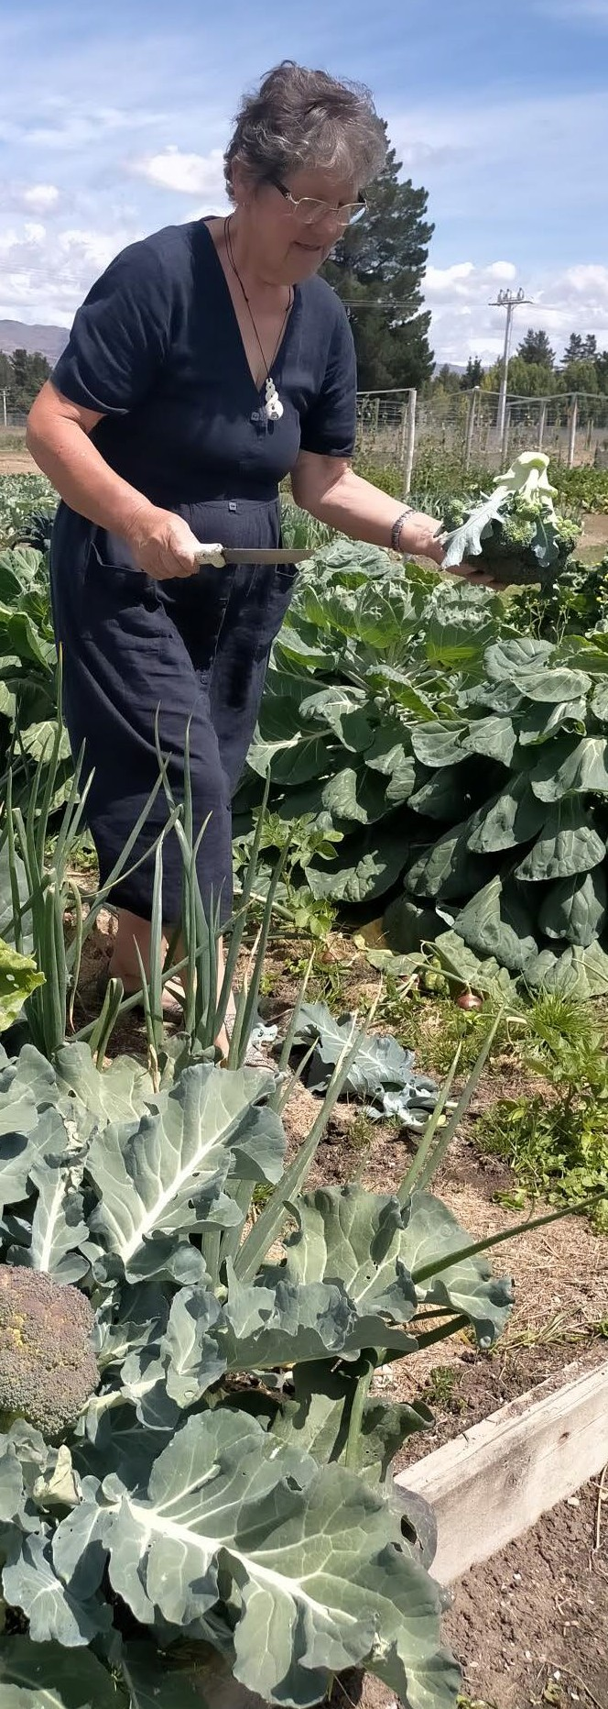

Image below: Te Pā o Rākaihautū tamariki, Christchurch.
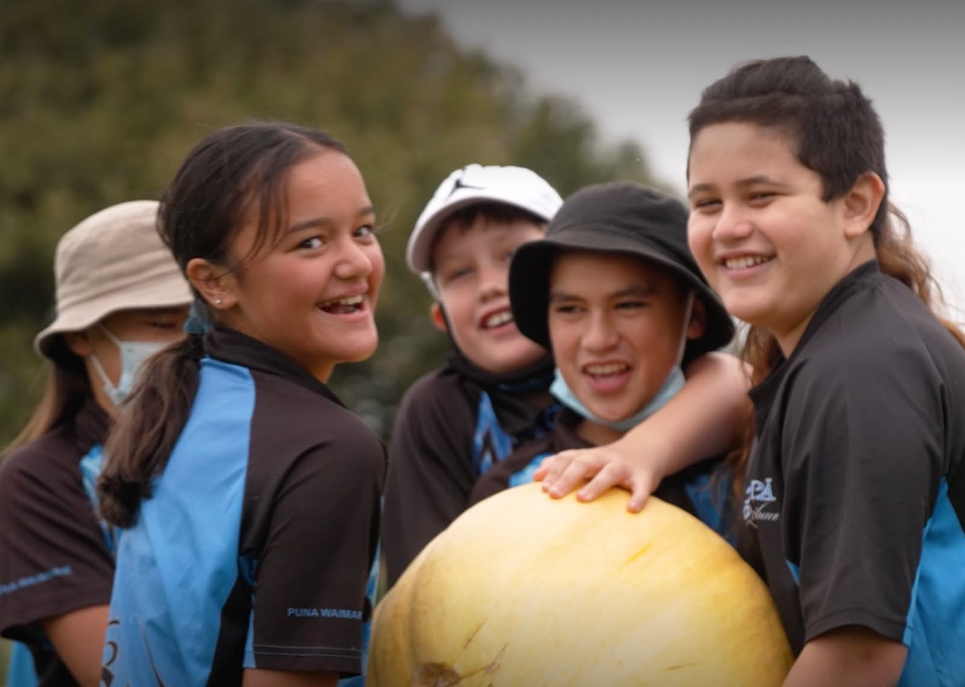

D) Reflecting on our assumptions about the role of kai for whānau
When we began the study, we commenced with a series of assumptions from the literature. Because the findings of this study are qualitative, it is difficult to generalise beyond this study, however, the interviews, hui and digital stories have supported wider findings in the literature and highlighted additional insights for further research.
First, community gardens (māra) and a range of wider community-led kai initiatives do support identity formation, spiritual and mental hauora/wellbeing, and mana motuhake/food sovereignty (Dunn, 2019; Grey et al., 2020; Hond et al., 2019). A number of adults and rangatahi commented on feeling “uplifted” in one case after serious disaster and stress, “happy” and “at one”, while others noted how important having some land to be able to develop a garden over time was, and particularly to feel that kai was grown in whenua connected to a local marae (Digital Story).
Second, many participants indirectly noted that food insecurity impacts on whānau resilience, hope and optimism (Beavis et al., 2019). The impact of COVID-19 was a spur to setting up the programme, in this context, however, having Te Pūtahitanga o Te Waipounamu support the costs of starting a māra kai and cover the risks (failure of crops) mattered especially when learning how to garden.
“I’ve always thought I couldn’t grow food here but when they offered me plants for free and things to grow them in that was fantastic for our whānau as veges are so expensive at least here." (Digital story)
One survey respondent stated:
“I lost my home and everything from the flooding. If it wasn’t for the māra kai I would be drinking and drugging and losing it. The māra kai saved my life!”
The importance of support funding and Kai Heroes cannot be understated because as wider research has shown, there are positive benefits of ‘sustainable gardening and eudemonic well-being, and an impact on the five well-being dimensions (physical, intellectual, spiritual, emotional, and social), particularly when a programme is well established to meet the needs and aims of indigenous communities (Giraud et al., 2021). However, without ongoing “appropriate policies, funding and infrastructure, the impact might remain minimal, volatile and subject to tokenism" (Giraud et al., 2021).
It is worth noting the repeated comments about the effectiveness of this programme. Whānau reported they felt supported to foster their own aspirations by connecting with Kai Heroes and valued Kōanga Kai because it:
- can be flexible in the way they help
- offers knowledge of traditional Māori gardening methods
- can remove obstacles on people’s properties and help bring creative, practical garden bed ideas to fruition
- can help whānau build on skills and interests they already have.
In the context of the caution that inappropriate programmes and policies can be tokenistic (Giraud et al., 2021), it is worth noting that whānau reported a strengthening connection to holistic well-being because of the opportunities including:
- build healthy relationships with kaimahi Māori
- build pro-social relationships in their local community
- enjoy traditional Māori kai/dishes at home more often
- increase the variety in vegetables consumed
- be outside in nature more often
- experience positive shifts in mood by watching flowers and vegetables grow
- develop an understanding of the maramataka and how it applies to growing food and connection to our environment, and whakapapa. Increasing knowledge to our wider hauora
- create long-term health goals pertaining to food literacy and knowledge.
We also found evidence that whānau food practices cultivated in this programme impact manaakitanga, whanaungatanga, kaitiakitanga and food choices across generations (Rangiwai, 2021). Several interviewees of all ages were reminded, through this programme, of experiencing food well-being in working with grandparents, helping in parents’ gardens, and were proud of being able to share produce from the garden and support kaumātua.
“I take [kai from the māra] down to the whare or I offer it to the neighbours. It is important for kaumātua." (Digital story)
“It's cool to see both my tama giving their kaiako food from the māra. I know they feel proud and it’s a really meaningful thing to give someone something you have nourished and grown, and they are always so excited to show off that achievement." (Whānau Voice, October 2022)
Many people also spoke spontaneously about appreciating health impacts of growing food as a whānau, particularly rangatahi, with evidence that they felt they could participate meaningfully in their own health journey (McKerchar et al., 2021).
Despite cost barriers, having support to set up a māra, learning through failure and persisting because of the support of Te Pūtahitanga o Te Waipounamu was an important element of enabling whānau to learn about how mātauranga Māori can be utilised to address barriers to preferred food choices, support food sovereignty and hauora (McKerchar et al., 2015; Viriaere & Miller, 2018).
“The garden is an experiment." (Digital story)

Whakarangatira/whakakoha to feel respected and uplifted
There were other benefits of the māra kai we had not anticipated directly through the literature. The extent to which rangatahi who were involved in gardening spoke about their memories of grandparents being involved in gardening, or were supported by peers or parents and felt respected for taking part was striking:
“It was actually quite cool, me and [my friends] went out for coffee. They had the idea already for me to do something along the lines of garden packs. I had talked to my Mum at home, she grows her own food, and she had said an idea like that too [taking part with others]." (Wānanga One)
“They can share knowledge and skills and feel the contribution/ participation is valued.”
“Harvesting the kai always seems to excite our tamariki and rangatahi!" (Digital story)
“My son loves it, he's really proud. Tells his teachers and is a real advocate for growing vegetables. He eats anything and loves seeing what we get from the garden, he loves tending to it even though he overwaters it sometimes, he really cares for it and that's been great to see" (Whānau Voice Survey, 2022).

Image below: Whānau kai box delivered from Waikawa Marae Picton
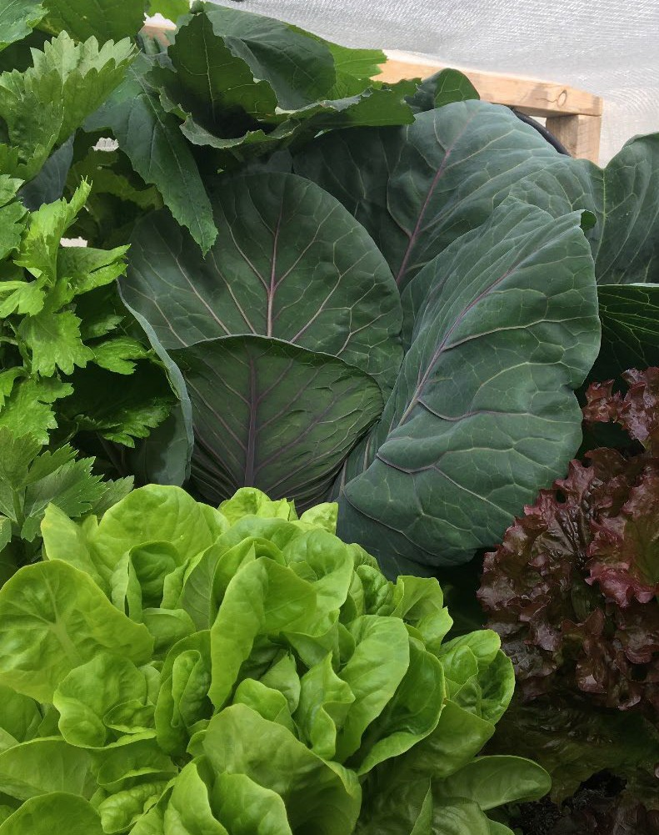

Conclusion

The intention of this kaupapa was initially to support whānau during COVID-19, at a time of need, but the approach of whānau-led participation rapidly extended Kōanga Kai as a more holistic approach to sustaining community wellbeing in ways that research indicates can have a generational impact if such programmes are led by Indigenous communities and adequately resourced (Budowle et al., 2019).
Participants have reported increased awareness of, and access to, more nutritious food, greater understanding of where food comes from, how seeds and materials are sourced, and stronger community relationships alongside a strong sense of uplift and well-being with physical activity and nutrition.
There is a growing desire in the community to participate in the programme and Te Pūtahitanga o Te Waipounamu has a waiting list of over 60 individuals who wish to sign up to Kōanga kai throughout Te Waipounamu. Existing entities are at capacity with 20-30 whānau engaged within each of the 25 entities now, and current human resources and finances are unable to accommodate many more participants. Each entity is encouraged to network ideas through local hui, save seeds, and share methods for enhancing soils so that projects are more self-sustaining and less reliant on funding. At the October hui, some entities reported they are connecting with Ara Poutama Aotearoa – Corrections, with workers providing garden beds, and joining Kōanga kai as individual volunteers.
The ripple effect of successful māra kai, health, and stronger community relationships, is growing by example. To enhance the programme in the future and address the complex barriers to healthy eating identified in this study, the following assistance is needed.
- Resource at a whānau level, to underwrite the risks and costs of establishing māra kai.
- Education and support at a whānau level through Kai Heroes or similar mentors.
- Tracking the holistic impacts of māra, using a Whare Tapa Whā model to document the broader outcomes and Indigenous pathways of connection and impact.
- Building whānau, hāpori, hapu, iwi, and networks through web outreach and hui.
The Kōanga Kai kaupapa has enhanced relationships with whānau and across generations. Through growing and sharing kai, many whānau reported feeling more connected to where they come from, their whakapapa, and the contributions they can make not only to the environment but for themselves and for future generations. All contribute to enhancing whānau in being more aware of their consumptions and how this can increase the desire to live a healthier lifestyle as individuals and as whānau for generations. We leave the last words to a Kai Hero who was asked before she began the māra kai if worrying about her children not eating fresh kai had been a barrier to buying vegetables in the past.
“Yeah, I think so because it [was a worry, that kai] was just going to be wasted, as well as convenience and being tired. I struggle badly with depression. I had a court case and put a bad monster away. It was about survival and so convenience was part of that survival. Gardening has helped with building a reconnection to living healthily. That sense of achievement from growing something yourself is awesome. That’s helping with my mental health heaps. I hope the [Ministry of Health and funders] hear that impact; not, they're wasting money. They're actually really helping people's lives." (Kai Hero)

Ngā mihi maioha to all the participants and whānau who took part in this study and so generously shared their gardens, their insights, and their inspiring stories.
Poipoia te kākano kia puawai.
Nurture the seed and it will blossom.
To learn more about the whānau that have been interviewed, visit our website and browse through some of the written stories and videos we have put together. The videos really capture the spirit and feelings around māra kai and whānau initiatives.
Click below for each digital story
https://www.teputahitanga.org/category/koanga-kai/#archive
Aweko Kai https://youtu.be/5OdjnhKuSBw
Hei Whakapiki Mauri https://youtu.be/DqMvnYCNdB4
Koha Kai https://youtu.be/OQNv1Y6TbiE
Te Hā o Kawatiri https://youtu.be/fzc8TejlkQo
Te Hapū o Ngāti Wheke, Rāpaki https://youtu.be/o_bpBBCnClk
Te Pā o Rākaihautū https://youtu.be/OVgjve-iH8A
Uruuruwhenua https://youtu.be/kDiqmFo9uh8
Waikawa Marae https://youtu.be/bu6bTigAD0E
Whānau Whanake https://youtu.be/ebwwc2Qa59c
Whare Manaaki https://youtu.be/h5FCr2d7A1M

Case Studies
The following case studies are reflections with new and existing entities who have developed garden programmes as Kōanga Kai and four other established kai programmes.

Koha Kai, Invercargill

Koha Kai has been a registered charity since 2015, serving as a vocational education and training service provider for people with disabilities. Koha kai are also first responders for civil emergencies, COVID connectors and food suppliers, supporting those with disabilities to teach others.
Janice Lee launched Koha Kai as a way to provide to support and develop the skills of a small group of people, many of whom were living with disabilities. The initiative has flourished and in the past seven years, there have been big changes.
What started as a pilot programme with a small team responsible for providing ‘hot, nutritious’ lunches to an Invercargill school, has expanded to include a commercial kitchen, three large māra kai and a trainee system that encourages people to gain employment, confidence, and a sense of purpose. Many of the initial trainees in fact, have made significant changes to their lives and are now back working for the organisation.
Janice (Ngāi Tahu, Ngāti Porou) is Pouārahi at Koha Kai and she says that funding from Te Pūtahitanga o Te Waipounamu has been transformative. With the introduction of the Kōanga Kai initiative, they have been able to cement their kaupapa of working with a number of other established community groups like the Murihiku Kai Collective.
This well-established project also began working more recently with Kōanga Kai as an evolving process, which is overseen by Amber-Jade Brass (Ngāti Moetonga, Ngāti Waiora, Tainui).
“We’ve always worked with whānau to encourage them to become more self-sufficient, but Kōanga Kai enables us to be more structured in our approach to the development of horticultural skills to the wider public.”
“We are a kaupapa Māori organisation, but we want to embrace the whole community of Waihōpai and Murihiku, not just Māori. We want to encourage a much wider group of people to learn the skills that will enable them to be self-sufficient with their kai. The more māra kai we have in Invercargill the more people will be able to benefit from better, cheaper kai,” she says. “It is important for the resilience of our community and our whānau that we ensure our region retains or regains its food sovereignty – and becomes more secure around our food systems.”
Koha Kai has three main māra kai including a large market garden at the Korimako Dominican Ecology Centre, plus gardens at Te Wharekura o Arowhenua and a collaborative garden at East Road – which Koha Kai is developing as part of a joint venture with a National Disability Service Provider. The Koha Kai gardeners consist of two full time and two part-time gardeners, and their trainees also look after several kaumātua gardens.
“This gives the kaumātua some company and māra produce and the trainees learn to build relationships and gardening skills. It’s a win for everyone,” Janice says.
“It’s about taking people off the sofa and taking them out to the whenua. Many come with no knowledge at all but we teach them how to grow food, and with the help of Kōanga Kai, we can teach more people how to be independent. We can help them develop the skills they need to be employed in the food sector.
“Half of our own staff are people who have come through our training programme. It changes lives and people feel valued because they have a sense of purpose. It builds confidence and self-esteem. It’s transformative and this is how it should be in the disability sector.”
The Koha Kai community kitchen uses much of the produce from their māra kai to supply nutritious lunches to several schools through the Lunches in Schools Programme. It also makes ready-made meals for the community, which sell at very reasonable prices through social enterprise partner, The Pantry in Invercargill.
“Everything we do at Koha Kai is about creating equity for people in the community in which they live,” says Janice.
“Our core business is that we are a charitable organisation offering vocational education and training services provider for people with disabilities and everything else we now do has stemmed from that.”
“Being a part of Kōanga Kai has been invaluable to us and I want to congratulate Te Pūtahitanga for taking the initiative with this programme – for being so responsive to community needs. It became apparent during the first lockdown back in 2020 that we needed more resilience and resourcefulness through food security and self-sufficiency and Kōanga Kai is a brilliant proactive stepping stone towards building that resilience in the Māori community.”

Uruuruwhenua Health, Manuherikia/Alexandra

For Alva Bennett of Uruuruwhenua Health in Alexandra, Te Pūtahitanga o Te Waipounamu Kōanga Kai initiative has provided the opportunity to watch whānau grow with their gardens.
It is, he says, one of the best projects he has been involved in and he’s seen lives change as a result of it.
Alva (Tūhoe, Te Arawa), has worked at Uruuruwhenua Health for six years, as a Whānau Ora Navigator and in a general capacity, looking after local kaumātua and the māra kai. His work is multi-faceted and in addition to encouraging whānau and kaumātua to establish gardens at their own homes, he also mentors troubled rangatahi (8–12-year-olds) and works with community members who are on probation.
“I work with people aged from 8 to 93. It’s a huge range and some of them have never been near a garden before, so for them to have that contact and to see them flourish as a result is very uplifting,” he says.
Uruuruwhenua has its own māra kai – two plots and a large glasshouse at Alexandra’s community gardens – and although it has been established for a number of years, it was just last year that they became involved with Kōanga Kai.
“We applied for funding so we could establish raised garden beds for kaumātua at their own homes. It’s a perfect initiative and the idea is building momentum fast. It means I can access funding aimed at improving the health and wellbeing of our people.”
Alva says there have been noticeable benefits to whānau and kaumātua, who show improved confidence and a growing sense of pride in their garden achievements and their ability to be increasingly self-sufficient.
“So far we’ve established around a dozen whānau gardens and that really pays off when whānau realise they no longer have to fork out $6 for one cauliflower at the supermarket. They see that same amount could buy them a dozen small cauliflower plants to nurture.”
Alva says the māra kai also gives the probationers a sense of mission and in addition to teaching them how to be self-sufficient, it builds their self-esteem.
“Probationers come and go, and many have never gardened before but once they see the benefits, they usually love it. It gives them a much bigger view on life and what they can achieve. I always like to tell them, if you can nurture a garden, you can nurture a family,” he says.
The probation team has also been learning how to make māra kai planter boxes out of old timber palettes for use in kaumātua gardens; and the Uruuruwhenua gardens are also part of a weekly community garden harvest that contributes fresh produce to the Salvation Army for distribution throughout the wider Alexandra community.
“Our māra kai is a learning centre. We encourage people of all ages to come along and help out and when they see how easy and how pleasurable it is to grow your own food, they are inspired to continue at home.
“Many of our people know their whakapapa lies in gardening and you can see them ‘light up’ when they come to the māra kai. That’s what Kōanga Kai is all about – reconnecting us to the land, to the seasons and helping us become healthy and happy. It’s helped us to make a difference and that’s been overwhelming.”

Hei Whakapiki Mauri, Ōtautahi/Christchurch

Hei Whakapiki Mauri, is a Whānau Ora initiative that brings Māori with disabilities and their whānau together to awhi each other using a Te Ao Māori approach. It supports whānau in ways that go beyond food security and the provision of fresh, healthy kai.
Ruth Jones, Kaiwhakahaere of Hei Whakapiki Mauri, (Ngāti Porou, Rongowhakaata), and her husband Gary Williams (Ngāti Porou), started Hei Whakapiki Mauri to bring tāngata and whānau whaikaha together to tautoko each other and build community. Being Māori first and lifting the mauri of everyone is important to Ruth across all of her mahi and she says the Kōanga Kai initiative has dovetailed perfectly with the Hei Whakapiki Mauri kaupapa.
Ruth, who has a long history as a leader in the disability community of Aotearoa, says COVID-19 has meant their small organisation has had to pivot to enable them to continue to support disabled whānau and Kōanga Kai has played a key role in that.
“The biggest thing to come out of it for us, is that whānau have connected. Some people may only have contact with paid support and they’re often lonely. That’s where Kōanga Kai has been good. Our Māra Kaimahi, Paul Pohipi (Te Whānau-ā-Apanui and Ngāti Porou), has been able to help whānau with their māra and check everyone is okay.”
The original Hei Whakapiki Mauri māra project was the brainchild of Whānau Ora Navigator, Billy Willis (Tainui). Billy, with his partner and fellow Navigator, Waikura McGregor (Ngāi Tahu), supported whānau to create and sustain their own māra using raised garden boxes when needed. Paul now leads the Kōanga Kai programme, which spans six vegetable gardens at the homes of whānau and a large plot at the home of Hei Whakapiki Mauri support worker Andy. Andy and her mother Ngaio donated the vegetable garden space that was previously tended by Andy’s late father. “Ngaio McKee gifted us her late husband’s vegetable garden space and knowing that not all our whānau have the capacity to grow their own garden, we thought this would be a positive way to provide vegetables for people.”
In 2021, Hei Whakapiki Mauri applied to Te Pūtahitanga for Kōanga Kai funding, which has allowed them to begin developing a Manaaki Māra in Woodend, near Christchurch, in addition to the 2020 project.
Paora (Paul) Pohipi also propagates vegetable and flower seedlings. Paul grew up working the whenua alongside his grandparents, holding the plough steady and watching his neighbour’s plant by the new moon. He is now sharing this mātauranga which began first as a way of involving his son who is now using a wheelchair and then with whānau in Ōtautahi the project has expanded with Hei Whakapiki Mauri and Kōanga Kai.
“It’s a very organic thing. Paul’s help is broad and it goes beyond just gardening. For us, it’s all about supporting our disabled whānau.”
“For us, the journey is as important as the result. Kōanga Kai is not only helping us grow and produce kai, it’s a shared experience that is a clear example of rangatiratanga.”

Te Hā o Kawatiri Tai Poutini Kawatiri/Wesport

Te Hā o Kawatiri is a social support organisation in Westport which adopted the Kōanga Kai initiative in September 2021 and reported that in just six months, many whānau have commented on how their lives have significantly changed for the better by taking part in māra kai activities.
Westport is no stranger to natural disasters and if recent major flooding has highlighted anything, it is the need for people to become resilient and self-sufficient.
Richelle Schaper, project manager of the Kōanga Kai initiative at Te Hā o Kawatiri, says recent floods interrupted power supplies, made many homes unliveable and cut road access to the town. Some residents had lost everything.
“That has highlighted the need for food security for our whānau. I’ve always been a strong advocate for establishing māra kai – we’ve had one for the past four years – but recent events have really shown that we need to be prepared for disasters, that we need to learn the skills that will make us self-sufficient,” she says.
Richelle (Te Āti Haunui-a-Pāparangi, Ngāti Kahungunu), says Te Hā o Kawatiri adopted the Kōanga Kai initiative in September 2021 and funding has secured a 30-hour a week paid role, which enables her to better oversee and manage their large māra kai.
“One whānau member told me the relaxed, welcoming nature of the māra had ‘saved her life’ by giving her a respite when she felt unwell. It’s become a space of wellbeing for others and some, who may have only dabbled in gardening previously, have gone home and dug up half their yards to keep growing things,” she says.
“It’s beautiful to see the Kōanga Kai project take hold like that. We had a bit of a slow start but it’s picking up now through word of mouth and it’s wonderful to see whānau developing a sense of purpose, as they grow their own kai – and in many cases, also learn to cook it.”
From the outset, Richelle has wanted to reach as many whānau as possible and although it’s been challenging to fit everything into her busy schedule, she says promotion through the Te Hā community is starting to build momentum.
“You can give a whānau a kai voucher and they can buy low-quality food for their family for a couple of days, but we would much rather give them the resources and skills they need to feed themselves with healthy kai for life.”
Through the Kōanga Kai project, volunteers spend time in the māra learning a range of gardening skills like fertilising soils, mulching, planting seedlings, how to harvest and seed gathering.
“There’s a lot of knowledge sharing and we’re all always learning. A couple of the whānau enjoy harvesting kai from the māra for lunch, making fritters, kamokamo flips, delicious salads. We don’t have a kitchen, but we have an old barbeque that was donated to us. That’s been a massive learning curve for some people – to see just how much you can achieve with so little,” Richelle says.
Māra whānau are encouraged to harvest produce before they leave and many are reporting visiting regularly in their own time, to harvest kai for their tea.
“They awhi us and we manaaki them. That’s how it works here. We get such a buzz out of each other. We’re all learning as we go and we’re now talking about visiting each other’s home māra as well to help each other out and get some inspiration from other gardens. We don’t have the capacity for that yet but it’s lovely to see those conversations taking place.”
“I love gardening and I’ve always wondered about teaching others. Then Kōanga Kai came along and gave me the way. It’s been an incredible opportunity and I love seeing others become inspired by what we’re doing here. I love being able to share my passion with my whānau.”

Te Āwhina Marae, Motueka

Māra kai is not simply about growing a garden. For Una Stephens, of Te Āwhina Marae in Motueka, it’s about so much more, it’s about reconnection to the whenua, nourishing whānau and reigniting mātauranga Māori me ona tikanga, into the daily lives of whānau.
Tikanga Māori forms the basis of Te Āwhina Marae māra kai sustainable practices. Funding from Te Pūtahitanga o Te Waipounamu Kōanga Kai initiative, has enabled the marae to develop a functioning māra kai and create a wānanga space for Kōanga Kai whānau.
Una (Ngāti Rarua, Te Ātiawa, Ngāi te Rangi), is the Kōanga Kai Co-ordinator for the marae and says the māra kai has been an important tool for teaching whānau about good, clean organic kai, spiritual growth, (taha wairua), mental health and wellbeing (taha hinengaro) and physical wellness through mahi (taha tinana).
“Māra kai is my lane, my happy place, I see it as a way for whānau to develop skills, gain knowledge, grow nourishing wholesome food and create sustainable kai-producing practices. They can learn how to bottle, preserve, make delicious kai from the māra, save money, forge relationships and ultimately create a like-minded hāpori.”
“I grew up in a time when every household grew a garden, everyone shared, exchanged and bartered, that’s how I see our future,” she says.
As supermarket prices for fresh fruit and vegetables skyrocket making it unaffordable for families, Kōanga Kai was initiated at a critical time.
The Kōanga Kai contract started in July 2021 and by August, hard-working whānau and friends began repurposing the existing fallow marae māra. The greenhouse was removed, three raised gardens for kaumātua were built, the tunnel house was re-sited, the land cleared, and the soil enriched with organic matter.
“We now have a dual space in which to grow kai for the marae and a functioning work and learn space for our Kōanga Kai whānau," Una says.
“Planning, recruiting, sourcing and organising resources for Kōanga Kai recipients followed. By October we had recruited 17 whānau and in November, we ran our first Kōanga Kai wānanga on planting out seedlings.” “Given the time of year it was important to ensure whānau had kai in the ground and were able to harvest during the summer months and taste the fruits of their labour.”
Feedback from whānau has been encouraging - “I’m saving money by growing my own food;” “Working in my māra makes me feel well;” “My kids are eating kai I grew, yay;” and, “Kids are over salad, too bad it’s on the menu again tonight.” “In keeping with the original Te Pūtahitanga Kōanga Kai kaupapa, it was important to design a plan that reflected what is uniquely Te Āwhina Marae – and to honour the mātauranga me ona tikanga of our tūpuna and create sustainable kai producing practices.”
“I strongly believe a long-term plan gives whānau a solid, well-grounded understanding and knowledge base, that will allow them to thrive, feed themselves, our mokopuna and wider whānau.”
She says that using the marae māra as a work and learn space has allowed them to develop a seasonal plan; June-August focuses on completing jobs in preparation for Spring, September-December is about preparing the māra for planting, growing seedlings, planting out, care and maintenance.
“To date we have successfully completed the first of four wānanga planned for the year, plus two Work and Learn wānanga These are run monthly and decided on by our Kōanga Kai whānau. All wānanga begin with karakia and waiata, and finish with wholesome shared kai. We leave with full puku, full hearts and a desire to come back to mahi some more.”

“Success is not final, failure is not fatal, it is the courage to continue that counts (Winston Churchill).”

Waikawa Marae, Waitohi/Picton

Working around COVID-19 pandemic restrictions proved to be a challenge for Waikawa Marae in 2021, as they set about expanding their existing māra kai but now, with “the fundamentals in place,” they are beginning to see the benefits of their participation in the Kōanga Kai initiative through Te Pūtahitanga o Te Waipounamu.
Marae Coordinator, Renee Love (Te Ātiawa, Ngāi Tahu), says whānau were challenged by COVID-19 restrictions in 2021 and the māra kai project was not as productive as it could have been. “This year though, with irrigation and garden beds in place, and most of our expansion completed, we plan to build on everything we’ve achieved to date,” she says. “We had an existing garden behind the marae, which has always been looked after by Aunty Glenys Paine. That’s still there but during the first round of Kōanga Kai funding, we established more raised beds and a tunnel house in our Kōanga space, and we were also able to provide some whānau with individual home māra, made from mussel floats and premade garden beds. A lot of our people rent their properties, so the mussel float gardens were a good non-permanent solution. “The expanded garden is now becoming a hub for tamariki reconnecting with the marae and for wider community groups to become involved with marae life."
As word spreads of the benefits of being able to pick fresh food from the garden, more whānau are keen to sign up. “We have regular visits from school groups from both Waikawa Bay School and Postschool,” says Renee. “They have their own school gardens, but we also interact. I have visited the schools and they come to the marae to learn about things like composting and making mushroom logs. And we also have seed and seedling planting days.” She says, "Interaction with the kura has been one of the major benefits of the Kōanga Ka initiative. “It’s enabled a lot of tamariki to reconnect with marae life and it’s been great to introduce all of them to the idea of developing their own sustainable food supply at such a young age."
“Marlborough District Council has also funded the local Envirothon group, who are interested in growing their seedlings in the marae tunnel house until their own is established; and the marae has engaged with Marlborough Food and Plant Research, who are keen to be involved in some way.”
“They are considering the possibilities of helping us rejuvenate our orchards– adding things like fruit and nutteries-but that is all still in discussion,” Renee says.
As to the future Renee reports, “We do have big plans and now that we have established the fundamentals, we are keen to focus our second round of Kōanga Kai funding on further expansion of the raised beds and hosting more wānanga. We want to be much more hands-on this year and more focussed on maramataka and the Māori lunar cycle of planting. That was one thing in particular that our whānau felt was really important. She says it has been amazing to watch whānau develop both the marae and their own māra kai and to achieve a more sustainable food supply."
“In addition, the marae has been able to connect with and build new relationships with other community groups–and that’s just in our first year, so who knows how we’ll develop from here. It’s exciting and we certainly couldn’t have achieved any of it without this amazing Te Pūtahitanga initiative.”

Tātou Café, Ōtautahi

The kaupapa of this café and collective which opened in 2021 in Papanui was to create a safe place for whānau to engage. “With this we have coffee, juices and vegan food to sell as well as other friends and whānau have their toi Māori and Pacifica arts and crafts for sale in our gallery space.” It is about “whakapapa, having a space like a home, good vibes no judgments. Homely and more than a shop environment. Creating that it can all be achieved as we are whānau members.”
Tonya has many years of experience in the catering business and Joe has been carving for years, and the creation of this space “was a solution to do something for ourselves, that is consistent with our values and space to show up for opportunities.”
Joe had come back from Australia seven years ago, and having a predominantly vegan diet, was concerned as to how to eat out and engage within the coffee and café culture back in New Zealand, as before he left, he hadn’t known the café culture. His drive towards better eating and feeling well should not be jeopardised by coming home.
Tonya was a larger body size in the past and for mobility and health reasons, and with many years in hospitality wanted to lead by example with Joe, in the promotion of good kai, by being themselves and giving options to whānau in what is available to eat in this way.
With their shop located next to a local diary, they both talk of observing whānau “consistently purchasing pies and sugary drinks from the corner shops, as convenience and habits created by this mentality and availability.”
Tātou is the name of their space in which their desire is to “level up”, with self-sufficiency, wanting to “work for ourselves, as ourselves, while the balance for success is the whānau balance and keeping it realistic.”
Tonya says “I have always dome catering and have a demand on doing so for a lot of Māori providers and agencies, local agencies and within these networks are continuing. There is a resurgence of kai and the awareness that this can support healthier outcomes by being aware of what we eat. We want to do that better for everyone. I also need to keep it small, as there is big demand, and to keep quality and to keep my health well, then I concentrate on being small and doing a good job with quality, not to over compensate to demand.”
For Joe, he feels it is, "important for me to have healthy connections instead of beers, we connect over coffee and vegan foods. Kids and whānau in a Māori safe space that is welcoming and real homey, whakawhanungatanga, and a real business vibe." He notes that vegan food and new food including smoothies, are “really different for many, different to how we were raised."
The shop is furnished by everything from their own home, this being an important space so people can walk in and feel welcomed and pieces adorning walls and tables and even the tables create a conversation, home styles. We have many entities that come in here with their “clients” and it gives a different atmosphere rather than an office space, as when we feel comfortable then we are more likely to share and listen in kōrerorero. Keeping whānau connections, the vision and a balance is their aim for success. Demand on keeping it small, keeping it realistic so we are well. The caf has been open for one-year through the pandemic and they find they have many different people visit and enter. “Our whānau are supported directly here as well, and they mahi for us. Many promote our food. Catering promotes the business externally in Papanui, with organisations that are varied with age. “It’s all about relationships.”
Asked about what eating well means for them, Joe says, “Starting kōrero about a kai. Eating well is being able to feed your whānau with not very much, very little. We do not have the monies, the transportation, barriers to transport to go and get kai that is only accessible to well-developed whānau.” Convenience of kai is an issue Joe identified when a KFC $20 pack is a treat and he feels he had learned to work, but not know how to cook.
Tonya said, I was big and then I applied to have a food stall at Matatini, the Kapa Haka National Competitions, and provided salads, I was nervous about how it was going to be supported. As it was only salads. We sold out by the early afternoon and made (a profit! Our whānau just required the experience and an example of tasty and nutritious kai. “Giving and showing them a different way of home eating, leading by example and creating the exposure and knowledge.”
One aim of the project is to involve rangatahi in working in the cafe.
“It’s hard to get connections for many youth. We give them a safe place to be. In return they ensure our place is safe, even when we are not open.” Some were very quiet with very little confidence, and now can see “how far they have come engaging in customer service, and taking public transport to the café."
“Kids are a part of whānau as well, and they are street smart, we respect them, and they respect us. Every person is respected. It really is a tuakana teina concept of how we roll. A variety of people exposed and comfortability to each person from all parts of life, and this maybe isolation. We only know what we know. We now have three whānau members working in the shop. This is how we can get this working and growing.“
Tonya and Joe also encourage mātauranga Māori, food literacy, or how to cook, grow, by having books, on the tables to view, and read, people koha them. Tikanga, people come in and gift pounamu, wood, resources. The rewena bread Friday is popular. Around the world, every culture has a connection to a bread. This allows everyone to have access to rewana bread which more than often creates a memory and a story, of who made it, where they were at the time.” Every culture celebrates food, but “the colonisation of suppression of our food [means] we are not supported ourselves. We buy Nike shoes, but don’t support our local shoemaker.” The future could include “whānau buying from whānau, fuelling a network.” There could be “vegetable markets hubs in community suburbs. in every pocket, good kai choices, compared to just diaries. We could have that option, but at the moment it is a very limited option.”

Te Hā o Kawatiri Food Bank

Previous studies have shown that food insecurity is a significant issue for communities on the West Coast, particularly for people on low incomes, single parents and the elderly, due to limited availability and unaffordable prices and because growing food can be difficult in the weather conditions (Winter and McKercher 2021). In the last two years, the impact of COVID-19 on food security “has been dramatic especially in South Westland. There has been a 65% increase in the number of Temporary Additional Support (TAS) grants in Westland (58), and for an increase of 17% in the Buller and Grey district” (Winter and McKercher 2021).
For these reasons, Sally Tait helps lead a food bank at Te Hā o Kawatiri which is a programme within the wider māra kai garden project also providing food and gift vouchers for the whānau from staff referrals. They provided 49 food parcels for whānau in October 2022 and in previous months it has been about 39 but there is an increase in referrals from other agencies in the community. In every second pack they add a flyer that has the details of the māra kai garden for interested whānau to learn about that opportunity.
These vouchers are for kai support mostly manaaki kai for people that are in need. “We try our best to get healthy kinds of food, we don’t always have the resource to have fruit and veg but rely on a person in our community, Neil Stevenson, that can access kai from the New Zealand food network which has fresh food. Potatoes and carrots sometimes from them." Sally adds that from her perspective, "We can’t always have just noodles, we need to have food of a quality and that we have a large stock at all times.” Comments from interviews noted that the vision was that, “We want people to be self-reliant, a hand up, not hand out approach. If everyone could have their own gardens in their back yards that would be wonderful. The vision is that nobody goes without." Tait argues, “To be self-reliant if people have had their own gardens and fruit trees to pick from their own yard and sustain their own food cupboard, walk out and pick their own fruit from their back door and not always have to pay the money that unaffordable is” most personal (Tait,p communications, N.d.).
Previous studies have noted the issues of food transport as a problem for the West Coast and Tait confirms that when “roads have closed, it is difficult and means there is often a panic shop, [but] panic buying is not achievable for all people and those get left behind. Even If you have a big garden, it is difficult to help others if the roads are closed. I wish the older generation would [come along for help] but sometimes it’s too hard to ask for help from that older generation. It is a pride thing too, as we work all your life and there is a perspective out there that you should be able to feed yourself.”
For Sally it is, “the cost and the availability of food, that attributes to not being able to eat healthy. And maybe it is an educational thing as well. I grew up meat and veg and now sometimes we know that as we get older it gets a bit heavy and you can reach out and find a whole lot of other stuff that is healthier, doing what we only know is not always the best for us and becomes a bit boring.“ “My nana raised me, and so I had boiled cabbage that turned pink, and now I know that there are other foods that can be done different and hold their nutrition."
Sally’s daughter is a Physical Fitness instructor, “So we learn from each other. The younger generation leave home and go out and learn from their friends about food and other experiences.”
Tait notes that for people to accept support they need to trust first. “We need to build that trust. Baby steps and give support because we want to, not because we feel like they need it. We can’t save the world, but we can give opportunities, and create a relationship.”

References
Battiste, M. (2008). Handbook of Critical and Indigenous Methodologies. In. Thousand Oaks, California: SAGE Publications, Inc. Retrieved from https://methods.sagepub.com/book/handbook-of-critical-and-indigenous- methodologies. doi:https://dx.doi.org/10.4135/9781483385686
Beavis, B. S., McKerchar, C., Maaka, J., & Mainvil, L. A. (2019). Exploration of Māori household experiences of food insecurity. 76(3), 344-352. doi:https://doi.org/10.1111/1747-0080.12477
Bishop, R. (2011). Freeing ourselves. Retrieved from https://go.exlibris.link/bPGxHJCL
Blue Bird Jernigan, V., Maudrie, T., Nikolaus, C. J., Benally, T., Johnson, S., Teague, T., Taniguchi, T. (2021). Food Sovereignty Indicators for Indigenous Community Capacity Building and Health. Frontiers in sustainable food systems, 5. doi:https://doi.org/10.3389/fsufs.2021.704750
Budowle, R., Arthur, M. L., & Porter, C. M. (2019). Growing intergenerational resilience for Indigenous food sovereignty through home gardening. Journal of agriculture, food systems, and community development, 9(B), 145-121. doi:https://doi.org/10.5304/jafscd.2019.09B.018
Charles Royal, T. A. (2009). Mātauranga Māori: An Introduction. Retrieved from https://charles-royal.myshopify.com/products/matauranga-maori-an-introduction
Charlton, K. E. (2016). Food security, food systems and food sovereignty in the 21st century: A new paradigm required to meet Sustainable Development Goals. 73(1), 3-12. doi:https://doi.org/10.1111/1747-0080.12264
Dunn, K. (2019). Kaimangatanga: Maori perspectives on veganism and plant-based Kai. 8(1), 42-65. doi:https://ro.uow.edu.au/asj/vol8/iss1/4
Durie, T. M. (2004). Exploring the Interface Between Science and Indigenous Knowledge. Retrieved from https://www.massey.ac.nz/massey/fms/Te%20Mata%20O%20Te%20Tau/Public ations%20-%20Mason/M%20Durie%20Exploring%20the%20interface%20Between%20Scien ce%20and%20Indigenous%20knowledge.pdf
Giraud, E. G., El-Sayed, S., & Opejin, A. (2021). Gardening for Food Well-Being in the COVID-19 Era. Sustainability (Basel, Switzerland), 13(17), 9687. doi:https://doi.org/10.3390/su13179687
Graham, R., & Masters‐Awatere, B. (2020). Experiences of Māori of Aotearoa New Zealand's public health system: a systematic review of two decades of published qualitative research. Australian and New Zealand journal of public health, 44(3), 193-200. doi:https://doi.org/10.1111/1753-6405.12971
Grey, R.-S., Muru-Lanning, C., Jones, N., & Muru-Lanning, M. (2020). ONCE WERE GARDENERS: Māra and planting protest at Ihumātao. doi:https://doi.org/10.20507/MAIJournal.2020.9.3.4
Harvey, C., Hallam, J., Richardson, M., & Wells, R. (2020). The good things children notice in nature: An extended framework for reconnecting children with nature. Urban forestry & urban greening, 49, 126573. doi:https://doi.org/10.1016/j.ufug.2019.126573
Hei Whakapiki Mauri. (2022). Paora teaches the old ways of gardening by the moon Retrieved from https://www.heiwhakapikimauri.co.nz/panui/2022/3/28/paora- teaches-the-old-ways-of-gardening-by-the-moon
Hond, R., Ratima, M., & Edwards, W. (2019). The role of Māori community gardens in health promotion: a land-based community development response by Tangata Whenua, people of their land. Global health promotion, 26(3_suppl), 44-53. doi:https://doi.org/10.1177/17579759198316
Ihi Research. (2022). Commissioning to support healthy kai outcomes for whānau. Retrieved from https://www.ihi.co.nz/what-we-do/wcommissioningkai
Kia Eke Panuku. (2016). Mātauranga Māori. Retrieved from https://kep.org.nz/assets/resources/site/Voices7-16.Matauranga-Maori.pdf
Macfarlane, A., & Macfarlane, S. (2019). Listen to culture: Māori scholars' plea to researchers. Journal of the Royal Society of New Zealand, 49(sup1), 48-57. doi:https://doi.org/10.1080/03036758.2019.1661855
McAleese, J. D. M. P. H., & Rankin, L. L. P. R. D. F. (2007). Garden-Based Nutrition Education Affects Fruit and Vegetable Consumption in Sixth-Grade Adolescents. Journal of the American Dietetic Association, 107(4), 662-665. doi:https://doi.org/10.1016/j.jada.2007.01.015
McKerchar, C., Bowers, S., Heta, C., Signal, L., & Matoe, L. (2015). Enhancing Māori food security using traditional kai. Global health promotion, 22(3), 15-24. doi:https://doi.org/10.1177/1757975914543573
McKerchar, C., Lacey, C., Abel, G., & Signal, L. (2021). Ensuring the right to food for indigenous children: a case study of stakeholder perspectives on policy options to ensure the rights of tamariki Māori to healthy food. International Journal for Equity in Health, 20(1), 67. doi:https://doi.org/10.1186/s12939-021- 01407-4
Moewaka Barnes, H., & McCreanor, T. (2019). Colonisation, hauora and whenua in Aotearoa. Journal of the Royal Society of New Zealand, 49(sup1), 19-33. doi:https://doi.org/10.1080/03036758.2019.1668439
Rangiwai, B. (2021). Some Brief Notes on Kai Māori. Te Kaharoa, 14(1). doi:https://doi.org/10.24135/tekaharoa.v17i1.359
Te Pūtahitanga o Te Waipounamu. (2022). Koānga kai. Retrieved from https://www.teputahitanga.org/category/koanga-kai/
Tuck, E. (2009). Suspending Damage: A Letter to Communities. Harvard educational review, 79(3), 409-428. doi:https://doi.org/10.17763/haer.79.3.n0016675661t3n15
Viriaere, H., & Miller, C. (2018). Living Indigenous Heritage: Planning for Māori Food Gardens in Aotearoa/New Zealand. Planning, practice & research, 33(4), 409-425. doi:https://doi.org/10.1080/02697459.2018.1519931

Kōanga Kai was launched at the Whānau Ora Symposium held in Dunedin, 8-10 April 2021.

