
Design Guidance Note
  - Technical Guidelines for the Seismic and Structural Design of Hospital Buildings (v1)
  - July 2025

Citation: Health New Zealand | Te Whatu Ora (Health NZ) 2025. Design Guidance Note: Seismic Technical Guidelines for the Design of Hospital Buildings, v1. Wellington: Health NZ.
Published in July 2025 by Health New Zealand | Te Whatu Ora (Health NZ)
PO Box 793, Wellington 6140, New Zealand
ISBN 978-1-991139-43-6 (online)

This document is available at tewhatuora.govt.nz
 | This work is licensed under the Creative Commons Attribution 4.0 International licence. In essence, you are free to: share i.e., copy and redistribute the material in any medium or format; adapt i.e., remix, transform and build upon the material. You must give appropriate credit, provide a link to the licence and indicate if changes were made.

Document Revision Record
Revision | Date of Release | Reason for Revision
0.1 | December 2023 | DRAFT for HEAG Review
0.2 | February 2024 | DRAFT Interim Release for Health NZ Review
0.3 | Various WIP | Working Drafts
0.4 | June 2024 | DRAFT for Health NZ Internal Review
0.5 | August 2024 | DRAFT for Consultation
0.6 | November 2024 | Post-Consultation DRAFT
0.7 | February 2025 | Final draft for Commissioner approval
0.8 | June 2025 | Approved by Commissioner (26 June 2025)
1 | July 2025 | Approved and Operative Version

Disclaimer
Health New Zealand | Te Whatu Ora (Health NZ) does not warrant the accuracy of the guidance note or assume any liability to any third party arising from adherence to, or any use of, the guidance note. Use of the guidance note by any designer, engineer or any other third party does not release or waive the obligations of that designer, engineer or other third party to comply with (a) their contractual obligations to Health NZ or any other party, (b) applicable legislative and regulatory requirements (including the New Zealand Building Code), or (c) applicable codes, guidelines, standards or professional codes/duties. Designers, engineers and other third parties are expected to exercise their own professional and expert judgement in performing their work for Health NZ.

Foreword
Health NZ is building the foundations of a new health system. Delivering a unified, sustainable health system includes:
- Delivering equity for all,
- Embedding Te Tiriti,
- Implementing a population health approach, and
- Ensuring sustainability of the health system.
Nationally consistent design guidance supports fit-for-purpose facility development and provides clear and consistent design expectations. This will streamline development processes and reduce the risk of time and cost overruns.
Providing nationally consistent design guidance which draws upon the wealth of expertise that exists across New Zealand, and guidance that is genuinely informed by the principles of Te Tiriti o Waitangi, will deliver buildings that promote equitable access and respond to the social, cultural and physical needs of all New Zealanders.
This technical guidance is a key document for design teams to follow for all hospital building projects, irrespective of size. It is given effect to by the Health New Zealand Seismic Policy, which requires the seismic performance objectives and criteria in this document to be followed for the design of new buildings and the upgrading of existing buildings.

Acknowledgements
Health NZ Health Engineering Advisory Group
- Andy Thompson (Holmes)
- Jared Keen (Beca)
- Michelle Grant (LGE Consulting)
- Dave Brunsdon (Kestrel Group)
- Ignatius Black (Silvester Clark)
- Paul Campbell (WSP)
- Jan Stanway (WSP)
- Craig Stevenson (Aurecon)
- Nick Traylen (Geotech Consulting)
- Rick Wentz (Wentz Pacific)
Review Input
- Mike Stannard (Kestrel Group)
Health NZ Infrastructure and Investment Group
- Monique Fouwler, Stacey Marsh, Todd Collings and Lisa Moon
Contents
Document Revision Record 2
Disclaimer 2
Foreword 3
Acknowledgements 3
Part A. Background, Project Briefing and Design Process 8
A1. Introduction 9
A1.1. Purpose and objectives of these guidelines 9
A1.2. Intended Audience 10
A1.3. Format of this guide 11
A1.4. Design principles 11
A1.5. Key interfacing guidelines, standards and organisations 13
A1.6. Health NZ Mandatory Requirements 16
A1.7. Masterplanning and Site Context 19
A2. Design Methodology, Phasing, and Compliance 21
A2.1. Design Philosophy 21
A2.2. Design Phases 21
A2.3. Design Roles 28
A2.4. Compliance and Peer Review 30
A3. Documentation and Project Records 33
A3.1. Structural Design Features Report 33
A3.2. Non-Structural Element Seismic Design Strategy 36
A3.3. Embodied Carbon and LCA Reporting 37
A3.4. Geotechnical Reporting 39
Part B. Performance Requirements for Hospital Buildings 42
B1. Classifying Hospital Building Functions and Importance Levels 43
B1.1. Background to Importance Levels for Hospital Buildings 43
B1.2. Medical Service Categories and Importance Levels 44
B1.3. Classifying Link Structures and Independently Located Infrastructure 49
B2. Seismic Performance Requirements 51
B2.1. The Seismic Performance Framework 51
B2.2. Outcome Objectives for Seismic Performance 53
B2.3. Seismic Performance Goals and Limit States for Design 56
B2.4. Structural Robustness Requirements for the ULS Design Limit State 61
B2.5. Descriptions of Physical States for the SLS2 and DCLS Limit States 64
B3. Durability 73
B3.1. Health NZ Requirements for Structural Durability 73
B4. Sustainable Design 75
B4.1. Brief for Emissions reduction targets and Environmental Rating Systems 76
B4.2. Structural Embodied Carbon Emissions 76
B5. Additional Structural Performance Requirements 79
B5.1. Vibration of Floors 79
B5.2. Structural Performance in Fire 86
B6. Structural Requirements for Adaptable Spaces 91
B6.1. Spatial Planning 91
B6.2. Adaptable Floor Structures 92
B6.3. Floor to Floor Height and Ceiling Plenum 94
B7. Alterations to Existing Buildings 96
B7.1. General 96
B7.2. Minor Alterations 100
B7.3. Significant Alterations and Additions 102
B7.4. Changing the Service Functions of an Existing Building 107
B7.5. Applying ANARP 107
B7.6. Compliance and Producer Statements 110
B8. Seismic Assessment and Retrofit Work 111
B8.1. Health NZ Seismic Policy 111
B8.2. Seismic Assessment for Life Safety Purposes 113
B8.3. Evaluating Continued Functionality 114
B8.4. Seismic Retrofit Objectives 116
Part C. Structural and Geotechnical Requirements 118
C1. Design Loadings 119
C1.1. General 119
C1.2. Permanent and Imposed Loading 120
C1.3. Seismic Loading 122
C2. Geotechnical Considerations and Building Foundations 132
C2.1. Introduction 132
C2.2. Geotechnical Investigations 132
C2.3. Geotechnical Analysis 134
C2.4. Role of Ground Conditions in Selection of Structural System 135
C2.5. Foundation Design 136
C2.6. Risk-Based Foundation Selection Approaches and Whole of Life Cost 139
C2.7. Repairability of Foundation Systems 141
C2.8. Design of Retaining Walls 141
C2.9. Slope Considerations 141
C3. Structural Requirements 142
C3.1. Control of Structural Damage from Earthquake 142
C3.2. Design of Physical Interfaces and Seismic Separations Between Buildings 145
C4. Non-structural Elements: Detailing and Structural Support 147
C4.1. General 147
C4.2. Documentation and Process Related Requirements 148
C4.3. General Design Requirements for Non-Structural Elements 156
C4.4. Exterior Cladding 159
C4.5. Lightweight Partition Walls 161
C4.6. Suspended Ceilings 171
C4.7. Suspended Building Services 173
C4.8. Plant and Other Mounted Equipment 177
C4.9. Vertical Transportation (Lifts) 179
C5. Design of Lightweight and Low-rise Hospital Infrastructure 183
C5.1. Scope 183
C5.2. Structural Robustness 184
C5.3. Lightweight Construction Techniques used in non-Specific Engineering Design 187
C5.4. Examples 190
Glossary of terms, definitions, and acronyms 194
References 201
Appendices 207
Appendix 1. Campus Earthquake Resilience (Structural Considerations) 208
1.1. Purpose of this Information 208
1.2. Adjacencies—Managing Physical Risks Posed by Adjacent Structures 208
1.3. Dependencies—Managing Risk to Building Engineering Systems that Pass Through or Near Other Structures 213
Notes 216


Part A. Background, Project Briefing and Design Process

- Introduction
  - Purpose and objectives of these guidelines
The purpose of this document is to provide holistic technical guidance to multi-disciplinary design teams delivering public hospital projects for Health NZ. The two specific areas of focus are general requirements for structural and geotechnical design, and the seismic performance framework (Figure 1). The seismic framework extends an umbrella across all design disciplines that contribute to seismically resilient design of hospitals.
The objective is to increase consistency in approaches and outcomes in these areas and improve the efficiency and effectiveness in the way projects are delivered through the project conception and design process, as well as through construction delivery and commissioning.
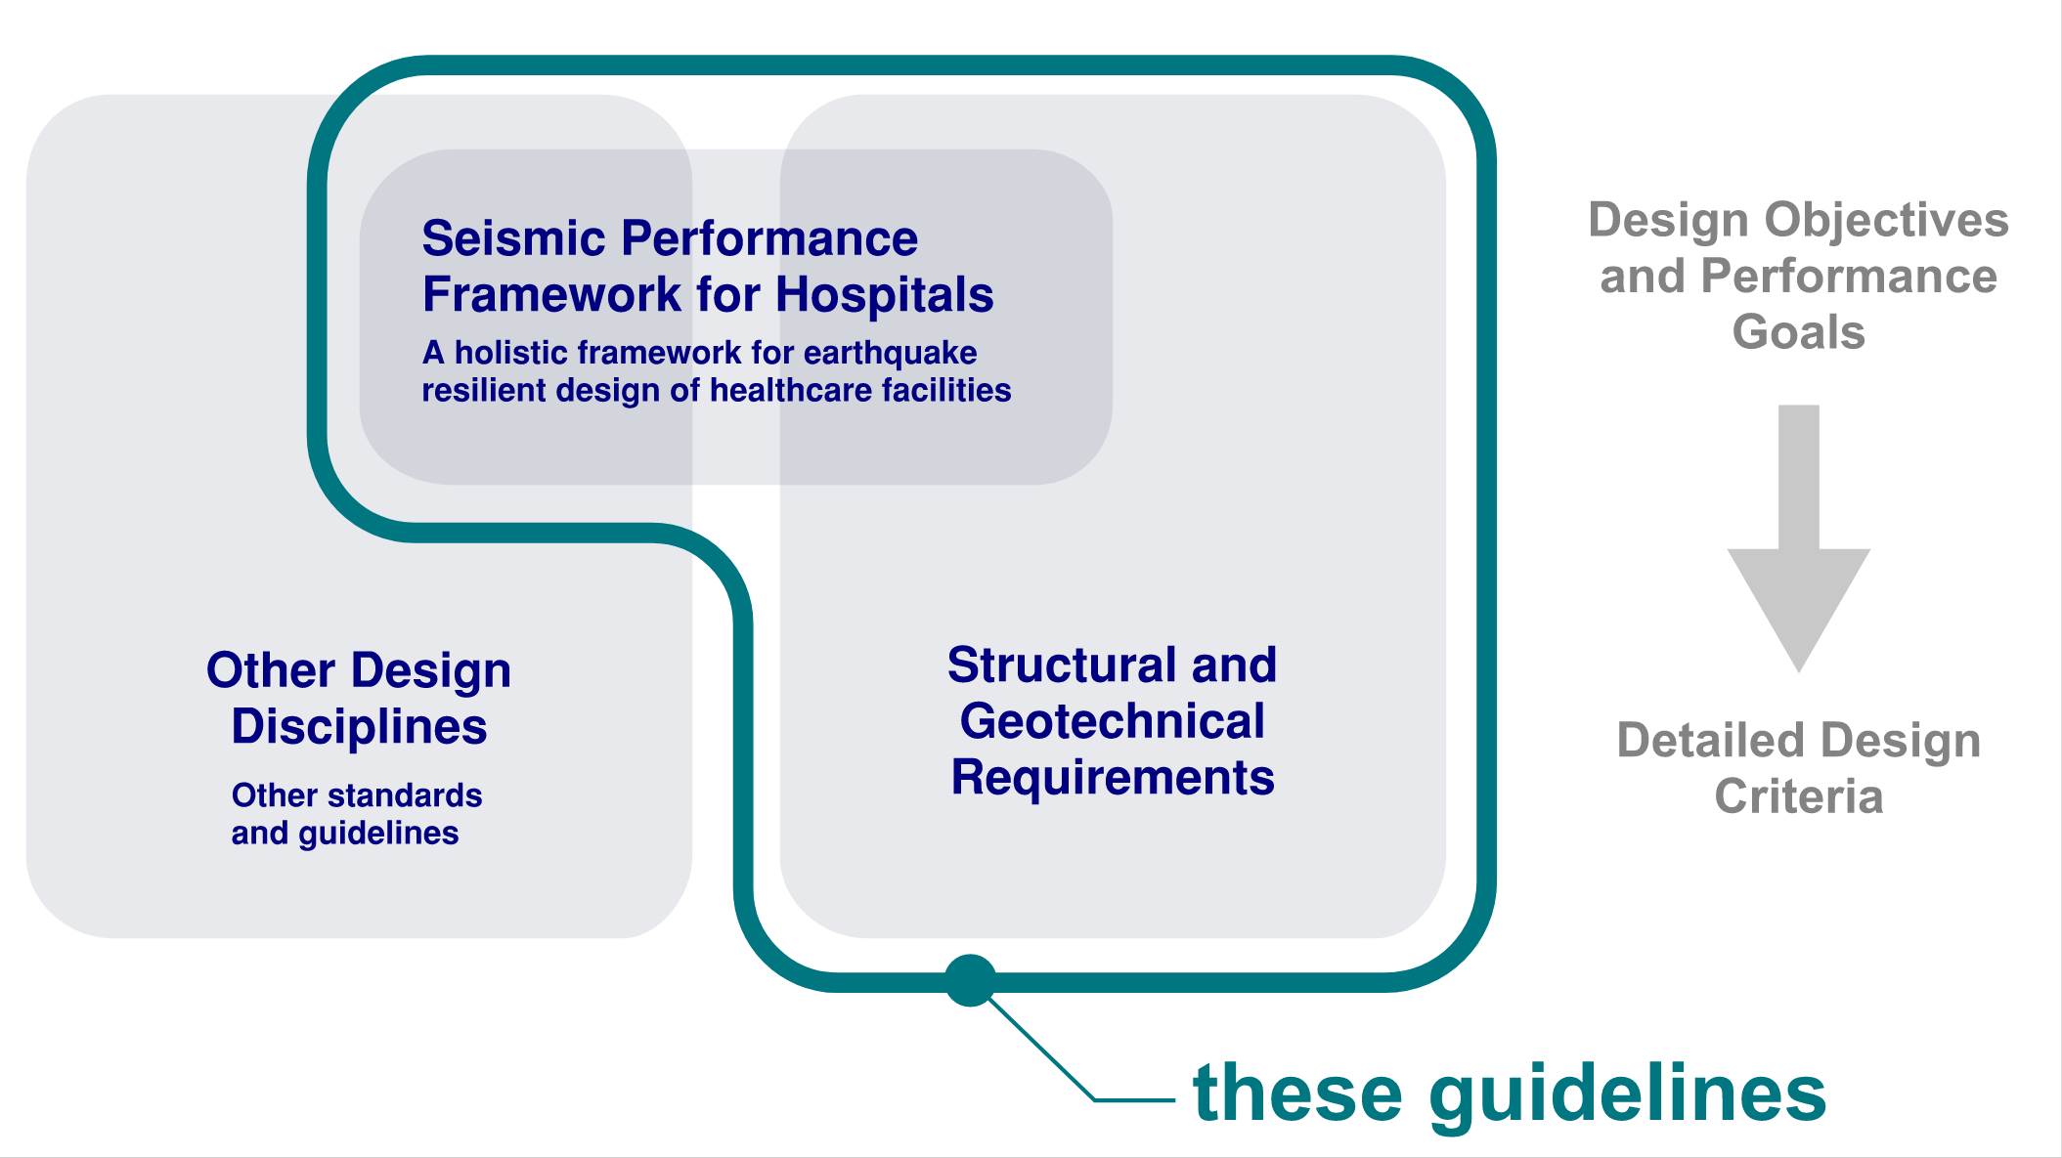
Figure 1: The role of this technical guideline comprising structural and geotechnical requirements, and the overarching seismic performance framework.
This guideline sets the performance standard required by the Seismic Policy of Health NZ for delivery of health services which will also meet, as a minimum, New Zealand Building Code requirements for public hospital buildings, and the New Zealand Government’s commitment to Climate Change action.
This guideline recognises the specialist nature of hospital buildings, and the significant and varied constraints and challenges that these projects face, some of which are unique but most of which are common. It therefore seeks to maximise the value of pooled expertise and experience in health facility delivery for the benefit of all Health NZ projects.
A holistic design response to earthquake resilience
This guideline contains information for all design disciplines collectively responsible for the successful delivery of resilient facilities that are not only safe, but which can continue to fulfil the clinical functions that Health NZ and our communities expect following major earthquakes. It defines the Seismic Performance Framework for all disciplines.
This enables the consistent briefing and definition of seismic performance objectives that are appropriate to a building’s context within a community and hospital campus, its specific clinical functions, and the degree of post-disaster functionality that this context requires.
Specific seismic design and detailing criteria for structural and geotechnical designers (including inputs from these disciplines into the detailing and restraint of non-structural elements) are included in this guideline.
Specific guidance on structural and geotechnical design
This guideline also contains the fuller (non-seismic) structural and geotechnical requirements for hospital buildings. The reason that these are included together with the broader (and multi-disciplinary) seismic performance framework, is the particularly close and constraining relationship that structural and geotechnical design has with earthquake resilience.
Strategies and philosophies for maximising adaptability, flexibility, and clinical performance are often closely interlinked and potentially in tension with methods for delivering high levels of seismic performance, and climate objectives. Therefore, these focus areas are presented together in a single guide.
  - Intended Audience
Parts A and B of this guideline are directed towards multi-disciplinary project teams, project stakeholders and clinical representatives
Part A includes important process and documentation requirements for the structural and geotechnical disciplines. These requirements extend to all team disciplines for aspects related to the seismic performance framework.
Part B defines the performance requirements for hospital buildings relevant to the two focus areas of this guideline. The Seismic Performance Framework is presented here. This will guide strategies for building services design and operation, building enclosure and fitout detailing, and successful coordination and detailing of these elements that aligns with the seismic response of the primary structure in a post-earthquake clinical context.
Part C is directed primarily towards structural and geotechnical engineers
The detail in Part C of this guide is primarily intended for structural and geotechnical engineers. It gives the means by which the performance requirements set out in Part B can be met. It is also intended to assist other parties interacting with structural and geotechnical engineers understand the basis for engineering constraints.
Where appropriate, specific areas of commentary are included to aid in the interpretation and understanding of engineering requirements.
Master planning and Business Case Development
The information in this technical guideline will also be applicable for master planning and business case development. This guideline defines important technical inputs to the processes described in Health NZ ’s Masterplanning Guidance for Public Hospital Facilities.
  - Format of this guide
In general, the content within this guideline is intended to be informative as well as represent best practice recommendations that should be followed in order to meet the requirements of Health NZ projects. Language within the body of the guideline that uses the word should (rather than shall) implies clear intent and a strong recommendation on how the requirements of these guidelines ought to be met. However, there may be other ways in which the objectives can be met.
Parts of this guideline content have specific status as described below:
Health NZ Recommendation: A specific recommendation highlighting Health NZ ’s preferred practice on projects.
Health NZ Requirement: A specific technical requirement for Health NZ projects that must be followed in order to meet the requirements of projects that reference these guidelines—except where expressly modified in the Health NZ Project Technical Brief, or where a specific departure is accepted by the HEAG (or its representative) following the departure process outlined in section A1.6.2 of this guideline on a project basis.
NZBC Requirement: Used to reiterate or clarify a requirement of the NZBC or its Acceptable Solutions or Verification Methods (in which case the specific VM or AS will be noted). These are included to highlight issues that have particular relevance to the subject of discussion and that must be followed to comply with that compliance document.
Specifically defined terms are generally italicised and defined at the rear of the document in the Glossary.
These boxes contain additional commentary in plain language or further technical discussion that is usually used to summarise key messages or clarify the intent behind some of the recommendations or requirements.

  - Design principles
This document is one of a suite of Design Guidance Notes (DGN) being developed by Health NZ to clarify specific requirements supplementary to the Australasian Health Facility Guidelines (AusHFG) for all health facility development projects in Aotearoa New Zealand. Health NZ has described the overarching principles of design for Health Facilities in a New Zealand Health Facility Design Guidance Note (Te Whatu Ora, 2022).
A summary of the main elements are listed below:
Kaupapa Māori. Meaningful engagement with Māori is vital to improving health equity for Māori and ensuring that Treaty obligations are addressed.
Environmental sustainability. Sustainable healthcare infrastructure promotes better health outcomes, lowers emissions, reduces operating costs, promotes efficient use of resources, and assists with meeting responsibilities under the Carbon Neutral Government Programme (CNGP).
Universal design. Effective Universal Design practices ensure that all people can access, use, and understand the environment to the greatest extent possible without the need for adaptations or specialised solutions.
Co-design. Effective co-design practices ensure that specific stakeholder needs are appropriately reflected in the design outcome and that effective facility operation and service delivery are supported.
Futureproofing. Successful futureproofing ensures durability over time while providing initial flexibility of designed spaces, and adaptability.
Site master-planning. Effective site master planning ensures that current and future health infrastructure supports current and future clinical service and asset management requirements and broader community objectives. Facility design should be aligned and integrated with a site masterplan.
Resilience and post-disaster planning. Effective disaster and emergency response planning ensures that healthcare facilities are designed to remain operational during and after natural disasters and pandemics.
Safe and secure environments. Effective design of safe and secure environments supports the safety of all building occupants (including building maintenance access).
Dignity, autonomy, and choice. Effective facility design provides a person with more choices for satisfying personal preferences and requirements.
Therapeutic environment. Effective facility design can contribute to good health outcomes.
For building structural considerations, Health NZ design teams should consider the following additional principles for infrastructure and facility design as a healthcare enabler.
Standardisation. Efficiencies can be gained in standardised approaches to design and construction delivery.
Future spatial flexibility (long life—loose fit). Spaces should be efficient, but not overly bespoke. Generally, this encourages structural forms which are regular and ideally not overly constraining on large areas of floor plate.
Design for now, strengthen if use changes. This “lean design” principle is relevant to the design of hospital facilities which are both cost effective and environmentally sustainable. Designers are encouraged to avoid making potentially unnecessary allowances for all future possibilities in a manner that adds cost or constraint without sufficient certainty that the value will ever be realised. Practical solutions that support adaptability are encouraged. This is an important principle to apply alongside (and sometimes in challenge to) “futureproofing” design principles.
  - Key interfacing guidelines, standards and organisations
Reference to and commentary on the following interfacing guidelines and standards from Health NZ and other organisations are provided in this section.
- The Ministry of Health | Manatū Hauora Service Framework
- Australasian Health Facility Guidelines (AusHFG)
- Health NZ New Zealand Health Facility Design Guidance Notes (and other guidance commissioned by Health NZ).
- New Zealand Building Code Documents
- MBIE/NZGS Earthquake Geotechnical Engineering Practice Modules
- Low Damage Seismic Design Guidelines (under development)
- Code of Practice for the Seismic Performance of Non-Structural Elements (BIP NSE CoP).
- Other Relevant Guidance.
The Ministry of Health | Manatū Hauora Service Framework
The Ministry of Health | Manatū Hauora is the government’s principal advisor on health and disability policy. It is responsible for funding, monitoring and ensuring the sector is compliant with accountability expectations. Health New Zealand |Te Whatu Ora replaced the role of District Health Boards from July 2022, and is responsible for planning and commissioning hospital, primary and community health services.
The Ministry’s Nationwide Service Framework Library (NSFL) contains documents on funding agreements and accountabilities set between Manatū Hauora and Health NZ.
Australasian Health Facility Guidelines (AusHFG)
The fundamental purpose of Health NZ facilities is the delivery of hospital or acute health and community healthcare services. The provision of safe environments from which to deliver these services and maximise health outcomes is paramount.
In this regard, the Australasian Health Facility Guidelines (AusHFG) are a key anchoring reference point, to which these technical guidelines are complimentary. All designers including engineering disciplines are encouraged to develop familiarity with these guidelines, which can be accessed via https://healthfacilityguidelines.com.au/.
Health NZ New Zealand Health Facility Design Guidance Notes
This document is one of a suite of Design Guidance Notes (DGN) being developed by Health NZ to clarify specific requirements supplementary to AusHFG for all health facility development projects in Aotearoa New Zealand. Health NZ has described the overarching principles of design for Health Facilities in the New Zealand Health Facility Design Guidance Note (Te Whatu Ora, 2022).
Other guidance commissioned by Health NZ
The following guidelines and reports have been prepared by or for Health NZ, and are relevant to this document:
- Health NZ Masterplanning Guidance for Public Hospital Facilities
- Health NZ Fire Engineering Design for New Zealand Public Hospitals, Version 1, July 2024 (Te Whatu Ora, 2024)
- Health NZ Building Services Design Guidelines for Public Hospitals (in development)
- The Kestrel Report: Understanding and Improving the Seismic Resilience of Hospital Buildings (Kestrel Group, 2022)
- Public Health Sector Carbon Neutral Government Programme Update, March 2023
New Zealand Building Code Documents
All Health NZ projects are required to comply with the New Zealand Building Code. This guideline sets out additional requirements and clarifications that apply in addition to the requirements of the Building Code.
For structural and geotechnical aspects, the content of this guide assumes that the following compliance documents will form the general basis for design, in most instances.
- Verification Method B1/VM1 (Structure)
- Acceptable Solution B2/AS1 (Durability)
- Earthquake Geotechnical Engineering Practice Modules issued as Section 175 Guidance under the Building Act
This guideline does not preclude the use of other methods for complying with the Building Code, provided that the requirements of the guidelines and their intent are met. Alternative Solutions can be used, for example published Standards which are not yet cited, or where seismic technologies such as base isolation, supplemental damping or other anti-seismic devices are employed. Refer to Section A2.4 for additional information and requirements regarding the definition of compliance pathway.
Refer also to section C1.3 Seismic Loading for specific requirements regarding the revised earthquake actions standard TS 1170.5.
MBIE/NZGS Earthquake Geotechnical Engineering Practice Modules
The Ministry for Business Innovation and Employment (MBIE) in conjunction with the New Zealand Geotechnical Society (NZGS) has published a series of guidelines titled ‘Earthquake Geotechnical Engineering Practice’. Health NZ requires that the MBIE guidelines are followed for state health facilities. These guidelines are listed below:
- Module 1 - Overview of the Guidelines.
- Module 2 - Geotechnical Investigations for Earthquake Engineering.
- Module 3 - Identification, Assessment and Mitigation of Liquefaction Hazards.
- Module 4 - Earthquake Resistant Foundation Design.
- Module 5 - Ground Improvement of Soils Prone to Liquefaction.
- Module 6 - Earthquake Resistant Retaining Wall Design.
Health NZ Requirement: The most recent versions of the Earthquake Geotechnical Engineering Practice Modules shall be followed for Health NZ projects.
An update to Modules 1 and 2 is being progressed to align with the publication of TS 1170.5. Specific reference to these anticipated versions is made by (TS 1170.5 aligned version, once released).
Development of Guidelines for Low Damage Seismic Design
Currently, there is a Low Damage Seismic Design (LDSD) project being run by the Structural Engineering Society of NZ, the Natural Hazards Commission Toka Tu Ake and MBIE. The LDSD project aims to provide designers with a framework to design buildings with more reliable resilience than the NZBC code minimum requirements provides. The framework will deliver a common understanding and communication for seismic performance of everyday buildings. This is achieved through design principles and criteria that can be followed to achieve the desired level of the LDSD performance framework. The first introductory volume of the guide, Low Damage Seismic Design: Benefits, Options and Getting Started was published in December 2024. Volumes 2 and 3 (comprising the performance framework and technical content) remain in development.
A significant amount of research, literature review and foundational work has been completed for the LDSD project and much of this has been used to inform this Health NZ Design Guidance Note.
Whilst some hospital buildings have specialist requirements and do not necessarily fit the everyday build typology of the LDSD focus, effort has been made to ensure the principles of the documents are aligned, particularly around common language and the performance framework. On the future release of the completed LDSD guide, it is intended that future revisions of this guideline will continue this alignment effort, with an expanded framework specific to hospital projects.
Code of Practice for the Seismic Performance of Non-Structural Elements (BIP NSE CoP)
The non-structural element design information in this Design Guidance Note is intended to be read alongside the BRANZ and Building Innovation Partnership (BIP) Code of Practice for the Seismic Performance of Non-Structural Elements (referred to herein as the BIP NSE CoP). This code of practice includes additional general information about the seismic design of non-structural elements and designers are encouraged to refer to it for additional information.
The referenced code of practice (BIP, BRANZ, 2024) has been coordinated with this Design Guidance Note. Designers should refer to the most recent published version.
Other Relevant Guidance
References to other relevant guidance documents are given below. These may be informative, but their inclusion here does not imply a specific recommendation on applicability. The requirements of this document and any mandatory references shall take precedence.
- Seismic Assessment of Existing Buildings – Technical Guidelines for Engineering Assessments (MBIE, EQC, NZSEE, SESOC, NZGS, 2017), (MBIE, EQC, NZSEE, SESOC, NZGS, 2018).
- New Zealand Construction Industry Council (NZCIC) Design Guidelines (NZCIC, 2023).
  - Health NZ Mandatory Requirements
    - Specific Requirements
Specific mandatory requirements that are contained within the body of this document are listed in Table 1 in abbreviated form for ease of reference. Users should refer to the referenced sections for the full requirements.
Table 1: Summary of Health NZ Mandatory Requirements
Section Ref. | Item | Summary
A1.5  C1.3.3  C1.3.4 | Geotechnical Modules | The Earthquake Geotechnical Engineering Practice Modules (most recent version) shall be followed.
A2.2.2 | Seismic Performance Brief | Concept deliverables shall reflect interpretation of the performance brief (with reference to the Project Technical Brief) and present the design response.
A2.2.2 | Concept Optioneering | A minimum number of concept typologies shall be considered; reporting requirements apply.
A2.3.1 | Design Roles | A roles and responsibilities table shall be prepared.
A3.1 | Design Features Report (DFR) | A DFR is required for all projects (all phase deliverables).
A3.1.1 | Building Performance Summary | A Building Movement, Acceleration and Loading Report shall be prepared (generally as an extractable part of the DFR).
A3.2 | NSE Strategy | A NSE Seismic Design Strategy is required (all phase deliverables).
A3.3 | Up-front Carbon Reporting | Up-front Carbon estimates for structural and geotechnical disciplines shall be reported in a standard format at all design phases.
A3.3 | Life Cycle Assessment (LCA) | A verified project LCA is required.
A3.4.1 | NZGD | All geotechnical investigation data for Health NZ projects shall be uploaded to the New Zealand Geotechnical Database.
B2.3.1 | Seismic Performance Framework | All design limit states shown in Table 9 shall be considered, including SLS2 and DCLS as defined in this section and Section B2.5.
B2.4 | Structural robustness | The recommendations of the 2022 Design for Uncertainty Advisory shall be applied, as clarified by the tabulated commentary in this section.
B3.1 | Structural durability | The Specified Intended Life for structural durability purposes shall be 100 years generally, but 50 years for low-corrosion internal environments.
B3.1 | Steelwork coatings | Inputs sufficient for whole-of-life cost analysis shall be prepared to confirm selection of coating system performance criteria.
B5.1 | Vibration of Floors | Evaluate response to footfall-induced vibration, and consider if there are extraordinary areas where other vibration sources may require consideration.
B6.2 | Adaptable design of floor structures | Consider strategies that provide a practical level of adaptability (the “long-life, loose-fit” principle), and weigh these in tension with estimated up-front cost premiums and likelihood of value realisation.
B7.1 | Alterations | All structural and non-structural alterations, refurbishments and major maintenance projects shall follow the decision making process set out in this section for seismic and structural aspects.
C1.3.1 | Seismic Loading (interim requirement) | Health NZ requires design teams consider to the impacts of applying TS 1170.5, once published (whilst continuing to apply NZS 1170.5:2004 as the compliance pathway).
C3.1 | Control of Structural Damage | Damage reduction recommendations of SESOC Interim Design Guidance shall be followed, alongside the clarifications in this section.
C5.2 | Structural robustness in low-rise buildings | Clarification of the structural robustness requirements applicable in B2.4—specific to low rise construction
C5.3 | P21 tested bracing systems | Restrictions and requirements apply to the use of P21 tested bracing systems.

Process-related exemptions for minor or lower risk projects
For practical reasons, some requirements can be reduced on the following project types on a scale/risk basis:
- Low-rise hospital projects that are Importance Level 2 and fall under the Service Category “Other Services – Support” (Section B1.2, Table 2);
- Minor alterations or structural alterations, as defined in Section B7 (but generally excluding significant structural additions);
- Other lower risk projects where specifically identified in the project brief.
For these projects, and with reference to Table 1, the following process-related Health NZ Requirements can be reduced except or as otherwise noted in the project brief:
- A Structural Design Features Report (DFR) complying with Section A3.1 is still required. However, the level of detail should be adapted to the context.
- An NSE Seismic Design Strategy complying with Section A3.2 is still required. However, it is likely to be in the form of a brief statement in the DFR covering the key relevant points.
- Presentation summary sheets of the proposed concept (as part of Concept Design deliverables to Section A2.2.2) are still required. However, presentation of multiple alternative concepts is not mandatory. A record of other typologies and options considered but discarded without rigorous testing (with brief commentary) should be included.
- For minor alterations (Section B7.2), Up-front Carbon reporting for structure (to Sections A2.2 and A3.3) is not mandatory. If the project brief requires an LCA, then allow to provide inputs into that LCA.
- A whole of life cost assessment for steelwork coatings to Section B3.1 is not mandatory but could still be valuable in some contexts.
    - Departures from Health NZ Requirements
Departures from the mandatory requirements contained in this document shall be submitted to the HEAG for assessment. Submissions should include:
- Specific identification of the project to which the requested departure applies.
- Reference to the Health NZ requirement in question.
- The proposed departure.
- The technical basis for the proposed departure.
- The impact of the proposed change, by relevant measures including cost.
- Optional: whether it is considered that the proposed departure ought to apply to other Health NZ projects (or be reflected in an amendment to the guidelines), with commentary.

  - Masterplanning and Site Context
    - General
Health NZ ’s Masterplanning Guidance for Public Hospital Facilities is the key reference document for masterplanning in public healthcare contexts. This Section A1.7 contains additional information relevant to the processes described in that document with specific additional detail relevant to seismic performance, and structural and geotechnical matters. This includes:
- Geotechnical considerations which are important for site selection, and for developing robust business cases that reduce cost uncertainty.
- Alterations and refurbishments to existing buildings (including making design provision for future structural additions, risks and benefits).
- Seismic resilience of hospital campuses
  - Seismic policy considerations for existing buildings.
  - Managing physical risks from adjacent buildings.
  - Site wide dependencies on utilities and engineering systems that pass through or near other structures.
    - Geotechnical Considerations and Site Selection
Prior to embarking on site planning, and then the various building design phases, it is vital that the site and its environs are adequately characterised. This is to identify key site constraints and opportunities that influence planning and design decisions, and to enable an intelligent, holistic approach to the planning of health facilities. Siting can have considerable impacts on cost and performance of hospital buildings and infrastructure.
This geotechnical investigation and assessment must be carried out well in advance of any other design-related activities (including architectural planning). As discussed in Section A3.4, even at site acquisition or master planning stage Health NZ expects geotechnical reporting to provide comprehensive and technically justified advice on all geotechnical aspects of the site, including design data (even if preliminary) for likely feasible foundation types, as well as any advice that might influence the siting of facilities (including on and off site hazards that could compromise access to a facility in the event of an emergency).
A site zonation plan should be provided that identifies any areas of a site that are more, or less, suitable for the siting of buildings or other facilities, as well as identifying any particular geotechnical hazards that might influence the design of buildings or infrastructure.
    - Altering or Refurbishing Existing Buildings
This section applies to any work in existing buildings, including:
- Alterations and additions,
- Refurbishments or major maintenance projects,
- Relocating departments or changing service functions.
When reviewing or developing site masterplans, and when planning specific projects involving existing buildings, teams need to consider how the new work will comply with the Building Code and the requirements of these guidelines, and what level of rigour is applied in reviewing the structural adequacy of the existing unaltered parts of a structure. This may involve application of the as near as is reasonably practicable (ANARP) test in a few different contexts.
Refer to Section B7 (Alterations to Existing Buildings) for a decision-making framework and detailed information on alterations. The decision-making framework in Section B7 needs to be applied even when the work being carried out is largely fitout related and non-structural.
There is also discussion on approaches to development phasing that involve making design provision in new buildings for future structural additions (which has risks and benefits).
Refer to Section B8 (Seismic Assessment and Retrofit Work) for additional information in relation to seismic assessment and retrofit.
    - Campus Resilience
Refer to Appendix 1 for information on the following considerations which can be relevant to site masterplanning.
- Adjacencies: Managing Physical Earthquake Risks Posed by Adjacent Structures
- Dependencies: Managing Earthquake Risk to Building Engineering Systems that Pass Through or Near Other Structures

- Design Methodology, Phasing, and Compliance
  - Design Philosophy
Health New Zealand expects that a holistic approach is taken with the design of its facilities. This is to ensure that the functionality and amenity of such facilities are optimised and meet the performance requirements outlined in this document, while minimising construction, maintenance, and operational costs on a whole-of-life basis.
Design teams therefore need to ensure that there is a good understanding of the overall site before embarking on master planning or concept design. Early technical engagement is required to ensure that the site and its environs are adequately characterised. This is to ensure that key site constraints and opportunities are properly taken account of in planning and design decisions, and to enable an intelligent, integrated approach to the planning of health facilities.
Of particular importance is the early engagement of geotechnical expertise to provide an understanding of site constraints and ground conditions. Informed decisions around the most appropriate structural configuration for buildings should be made once there is a clear understanding of the ground conditions, and in particular the performance of the ground and likely building response, under seismic loadings. Architectural design can then be integrated with the best-fit structural system—that is, a structurally efficient building layout and load resisting configuration, that works most efficiently with the known ground conditions.
  - Design Phases
Design phasing should generally be in accordance with the 2023 NZCIC Guidelines (NZCIC, 2023), as modified by the Health NZ Project Technical Brief.
This guideline contains additional requirements for design phase deliverables relating to:
- The Seismic Performance Framework
- Structural support and restraint of Non-Structural Elements (NSEs)
- NZ Government/Health NZ policies regarding the construction sector’s response to the National Emissions Reduction plan through the Building for Climate Change (BfCC) programme (and the early lead taken by Government led projects).
    - Site Characterisation
Prior to embarking on site planning, and then the various building design phases, it is vital that the site and its environs are adequately characterised. This is to identify key site constraints and opportunities that influence planning and design decisions and to enable an intelligent, holistic approach to the planning of health facilities. This must be carried out well in advance of any other design-related activities. In particular, the following are important pre-planning information-gathering exercises:
- Site topographical plan.
- Site services plan.
- Existing building condition survey, including current floor level survey data.
- Site-wide geotechnical investigation and assessment (including off-site hazards).
- Flood paths.
- Contamination assessment.
The degree of detail in each activity will vary with the size and nature of the facility being considered. For example, a new hospital on a new site will require detailed provision of all the items listed above, including an assessment of off-site risks that, for example, might compromise access to the hospital facility during a crisis event. At the other end of the scale would be a small addition to an existing building on a site, where a topographical survey may not be needed, and the geotechnical assessment could be limited to just the area being developed. However, in all cases early acquisition of this information is important.
    - Concept Design
Concept Design involves the further development and confirmation of the layout and structural typologies which respond to the Health NZ Project Technical Brief, Schedule of Accommodation, and project and site constraints. It confirms and reflects the Performance Requirements of the Project Brief.
Philosophies should be established for the way in which the design will respond to the brief. Strategies to meet the Performance Requirements should be defined (including the Seismic Performance Framework). This phase also represents an opportunity to clarify aspects of the Project Technical Brief, alongside the development of these strategies.
Health NZ Requirement: Concept Design Features Reports shall reflect confirmation of how the Seismic Performance Framework has been interpreted for the purposes of the project. The Concept Design Features Report shall describe in general terms, the philosophy/strategy outlining how the design will meet these performance requirements.
Health NZ Requirement: Multiple structural typologies shall be considered in concept development, with at least one concept considering the use of concentrated bracing elements in the lateral stability system. Summary sheets shall be included with Concept Design deliverables, covering the following:

- Each concept typology (Generally around one sheet per typology)
- Calculation of Up-Front Embodied Carbon for comparative purposes, presenting kg-CO₂-eq on a total and per m² basis (usually one sheet)
- Comparative matrix presenting key differentiators between the concepts (generally limited to one or two sheets)
The audience for the content of the summary sheets should be the design team, including Design Managers and cost planners, project stakeholders and IIG representatives. It is generally expected that the Structural Engineer would be responsible for the compilation of these summaries, obtaining important inputs from Geotechnical Engineers, NSE Seismic Designers and other disciplines impacted by the overall structural concept direction. For the purposes of this Draft Interim Release, project teams may develop their own template for this purpose generally following the intent indicated in Figure 2.
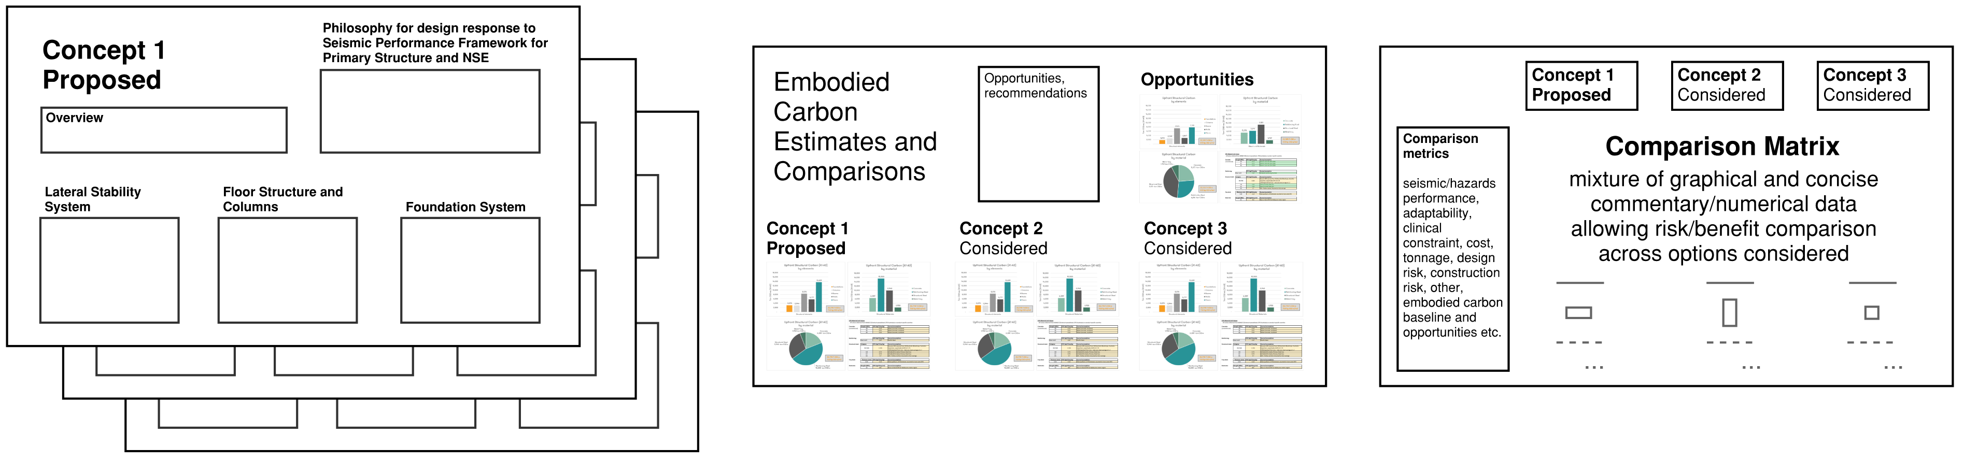
Figure 2: Presentation summary sheets required as part of Concept Design deliverables for Structural and Geotechnical disciplines. Refer to Section A3.3 for additional recommendations on the form of presentation of Up-front Carbon calculations.
Although a number of concepts may be explored, it is generally anticipated that ~3 concept typologies will be carried to the level of development indicated in Figure 2. This should comprise the proposed concept design that the project team is recommending for progression to Preliminary Design developed to the Concept Design level of development in accordance with the CIC Guidelines and the project brief.
It should also comprise a record of the other most promising concept options “considered” (generally at least 1 to 2 additional). These need not be developed to the same CIC Guidelines level of detail. However, they do need to be developed sufficiently to allow comparative (i.e. consistently coarse) calculation of kg-CO₂-eq, general resolution against the schedule of accommodation and fair assessment of other comparative merits.
Where the structural typologies explored have significant influence on spatial planning (possibly to the point of impacting the overall block and stack) then it is expected that the concepts presented will reflect this. However, as noted above, the level of resolution of the plan for other concepts “considered” would not be expected to match that of the “proposed” concept design (nor to a CIC Guidelines Concept Design level of development).
It is helpful to keep a separate record of other typologies and options considered but discarded without rigorous testing with brief commentary.
This guideline does not prescribe the use of any particular typology over another. However, it does require the consideration of multiple typologies and a standard concise format for conveying the final concept design proposed, alongside other concepts considered.
This is important to ensure the appropriate weighing of design constraints and ensuring appropriate visibility and rigour in decision making maximising the chances of effective and linear design execution in subsequent stages. Importantly, it is also intended to aid in data capture for the benefit of future work establishing appropriate targets for embodied carbon minimisation.
Lateral stability systems comprising concentrated bracing elements (braces or walls) are generally the most structurally efficient forms in the absence of other constraints driving lowest structural cost and minimising embodied carbon. This is especially so where low inter-storey displacement targets are part of the strategy for achieving seismic performance objectives.
Notwithstanding the obvious physical constraint associated with the placement of structural bracing core(s) themselves, these typologies can maximise adaptability, depth for reticulation of services, can minimise constraint in other parts of the floor plate, and can reduce the costs associated with non-structural elements.
Although these typologies are common in other parts of the world, including Australia, such approaches are somewhat less common in the modern era of hospital infrastructure in New Zealand, particularly tertiary care facilities (with exceptions). Anecdotally, this is generally put down to a combination of:
- a high desire for adaptable and flexible spaces,
- generally higher seismic bracing requirements, requiring a more intentional location of lateral bracing structure,
- challenges introduced by vertical stacking of different programmes (such as non-clinical areas over clinical spaces) and a desire for stepped floor plates outlines,
- difficulty in accommodating diagonal structure where it could impede views and/or complicate detailing or introduce additional surfaces, intersections of finishes and infection control risks,
- ultimately, difficulty in locating sufficient bays of bracing where they do not impose unreasonable constraint on programme or use of spaces.
The most appropriate structural typology cannot be prescribed, and will ultimately be determined by geographical and geotechnical setting, campus context and masterplan, the schedule of accommodation and in some instances the preferred methods for achieving the required level of earthquake resilience.
At concept and preliminary stages, the expectation is that embodied carbon calculations are managed within respective disciplines—aggregated as necessary by the ESD Consultant. Estimation of the size of elements and their weights and reinforcing contents will also be required. It is acknowledged that a significant degree of judgement will be required given the stage of design and it may be appropriate to represent the uncertainty in such estimates by a range.
Development of a Non-Structural Element (NSE) Seismic Design Strategy
In concept and preliminary design, the NSE Seismic Designer should be working in parallel with other disciplines. An initial Non-Structural Element (NSE) Seismic Design Strategy (described in Section A3.2) should be developed as part of Concept Design work, the importance of this workstream is alluded to in the commentary above, and by its inclusion in the summary sheets indicated in Figure 2. The BIP NSE CoP contains specific information on Concept Design inter-discipline coordination, interfaces, and considerations.
The NSE Seismic Designer should take primary responsibility for developing the strategy document. The strategy itself should reflect the holistic/collective contributions and mutual agreement of the structural and building services engineers, architect, contractor (where their input is available), other affected disciplines and the NSE Seismic Designers own inputs.
Contributing and affected disciplines should develop an understanding of the consequential detailing implications of the NSE Seismic Design Strategy and similarly the benefits and consequences of altering primary structure performance targets to allow different strategies to be explored.
    - Preliminary Design
Development of the Seismic Performance Framework and NSE Seismic Design Strategy
Preliminary Design incorporates the further development and testing of the design response to the Seismic Performance Framework and the NSE Seismic Design Strategy, for the selected concept option. By the completion of preliminary design, this document should capture detailed information about the approach for the seismic design, coordination, and construction of non-structural elements. This should also include a detailed delineation of responsibilities between designers, and with the contractor. The procurement approach will be influenced by these issues.
A detailed list of requirements can be found in Section A3.2.
This work generally continues in parallel with other disciplines with aligned timing of deliverables through the concept and preliminary design phases.
Up-front Embodied Carbon Reporting
At this design stage, Up-front Carbon estimating and summary reporting for structure and geotechnical disciplines can generally remain based on Modules A1 to A3 per MBIE’s BfCC framework, refer to Section B4. Comparative analysis should expand to include Modules A1 to A5 where the transport and construction components are significant and where sufficiently reliable data are available. The modules included must be clearly stated in the presentation of any summaries and must be carried consistently across comparisons.
At Preliminary Design, Up-front Carbon calculations help to identify the most carbon intensive elements and materials. This helps to set the focus of Developed Design particularly towards those areas where design refinement could have the most influence. It also allows teams to begin to identify opportunities around sourcing of materials, and outline specifications.
There will naturally be tensions between minimisation of Up-front Carbon and delivering enduring facilities of a high quality (that meet the performance brief) that are fit for future adaptability under changing uses or modes of care. However, equally important is the collection of data to inform appropriate embodied carbon reduction targets in the future, as well as enable smart choices to be made. Especially early in the design process, where there is more ability to make changes to allow the realisation of opportunities or minimise barriers against embodied carbon minimisation.
In Preliminary Design, teams are encouraged to constructively challenge areas of the performance brief where reasonable compromises are perceived to be available and where doing so could materially influence opportunities to minimise Up-front Carbon.
The flexible design principle of “long life, loose fit” should be applied alongside the lean design principle of “design for use now, and strengthen if use changes”. Both of these principles carry a similar status and should be used to test key design decisions around adaptability for future use, reconfiguration, or alterations and extensions.
    - Developed and Detailed Design
Development of NSE Seismic Design and Coordination
The primary purposes of NSE seismic design activities in Developed Design are:
- to demonstrate the availability of coordinated, cost effective, and buildable solutions to general and congested areas,
- to support cost planning.
Modelling of restraint solutions (to agreed extents and levels of development) generally commences in Developed Design. From this time, the NSE seismic design will normally operate on a lag behind the parent elements, provided sufficient overlap is retained to ensure coordination activity is occurring appropriate to the phase deliverable (prior to the lagged modelling and documentation preparation period). This overlap is crucial to achieve integrated design.
Typically, this lag is several weeks, and should not be more than half a design phase, depending on the scale of the project. NSE Seismic Designers and other team members should mutually agree lag timings that ensure coordinated design solutions are agreed prior to the lag, with lagged activity comprising only documentation preparation (and modelling effort associated with this preparation). The important measure is that the lagged activity should not generate unresolved clashes beyond the acceptable thresholds stipulated by the deliverable stage requirements and BIM execution plans.
Refer to Section C4, Non-structural Elements: Detailing and Structural Support (Section C4.2) for detailed information on Coordination strategies, BIM requirements and managing interfaces between design disciplines.
Up-front Carbon Reporting and Lifecycle Assessment
Health NZ require confirmed measurement and reporting of Up-front Carbon at the completion of design (Modules A1 to A5). Significant projects also require a verified full Life Cycle Assessment (LCA) for the project at the completion of design. For the purposes of this guideline, the overall preparation of measurements that comply with the required methodologies are the responsibility of the ESD Consultant. The measurements will require inputs from the respective design disciplines - refer to Section B4 for requirements.
The Structural Design Features Report should continue to report updated Up-front Carbon summaries for structural and geotechnical disciplines (alongside inputs into the detailed project LCA). This is for ease of tracking progress through design, and for data-collection purposes.
For structural aspects, most inputs required to complete confirmed Up-Front Carbon measurements and full LCA should be available at the completion of Developed Design requiring only review at the completion of detailed design.
However, an important part of developed and detailed design is confirming and committing the material specification. The procurement model for the project and availability of early contractor input will also have some influence on the level of specificity that appropriate for project specifications, and which can be counted for in LCA. This will need to be managed in conjunction with the ESD Consultant responsible for compiling the LCA.
  - Design Roles
    - General
For the purposes of these guidelines, the defined roles and responsibilities should be generally in accordance with the CIC guidelines, as clarified/modified or expanded in the Project Brief. Additionally, specific consideration should be given to allocation of the following scope items and related roles and responsibilities:
- Requirements for embodied carbon calculation and reporting—and any additional efforts associated with the brief requirements in this regard.
- Non-Structural Element (NSE) seismic design scope (further discussion is given in Section A2.3.2 below and C4.2)
- Requirements for other disciplines (particularly structural engineer, architect and building services engineer), when interfacing with the NSE seismic design scope (further discussion is given in Section A2.3.2 below and C4.2)
Health NZ Requirement: The design team shall agree and document a roles and responsibilities table, which shall be included or appended to the Design Features Report. The matrix form of the CIC guidelines (expanded in accordance with the BIP NSE CoP) is recommended.
    - Design Roles Relating to Seismic Design of Non-Structural Elements (NSE)
This document uses the term Non-Structural Element (or NSE) seismic design throughout (in lieu of the common industry term “seismic restraint” or “SR”). Whilst seismic restraint is a core part of the Non-Structural Element (NSE) Seismic Designer(s) role, their inputs extend beyond restraint to many areas of seismic design and performance, including seismic displacement compatibility.
Non-Structural Element (NSE) seismic design is an area of critical importance to a hospital building. Effective design and design management are crucial in achieving two key success factors:
- To deliver on requirements for continued functionality following major earthquakes.
- To deliver design and construction execution efficiently.
Therefore, the requirements of this guideline focus as much on effective design processes as they do design criteria. Whilst many other design roles have clearly defined scopes (either through historic precedent, or through the NZCIC guidelines), NSE seismic design remains an area of evolving scope and responsibilities as it traverses many design disciplines as well as traditional design and construction procurement boundaries.
For most hospital projects, the complexity of buildings systems requires that a seismic designer for all non-structural elements (NSE Seismic Designer) be appointed at the same time as the lead disciplines (building services, architecture, structural engineering) are appointed (i.e. concept design). The NSE Seismic Designer may or may not be from the same organisation as the lead disciplines.
The NSE seismic design will also need to transfer to the contractor during the construction documentation (shop drawing) phase in the same manner as other designs (the BIP NSE CoP contains information on the handover of NSE seismic design to the contractor). This may require novation of the NSE Seismic Designer, depending on project procurement method. Whilst some detailing may occur during construction phase, it is expected that primary coordination with other disciplines is undertaken during the design phases.
A NSE seismic design is required for the following elements:
- Combined reticulated building services
- Plant
- Specialist medical equipment
- Fire sprinkler systems
- Ceilings
- Partitions
- Non-unitised façade (see comment box below)
- Some extraordinary aspects of general Fixed Furniture and Equipment (FF&E) except where absorbed by partition design.
Often these will all be undertaken by a single designer. If they are undertaken by different designers, then a demonstrable means of achieving holistic and coordinated (not independent) design must be provided for in engagements and design process. In all cases, the allocation of NSE seismic design related design responsibilities must ensure that a holistically considered design can be achieved that is coordinated with other disciplines including Structural Engineering, Architectural, Fire Engineering and Services Engineering design roles.
Unitised/modular façade design is typically procured differently. Specification forms a part of the architectural design scope. This may include the appointment of a specialist façade designer during the design phases and is likely to include a component of contractor (or subcontractor) design during the construction phases. These design responsibilities should be clearly articulated. Although façade design is not explicitly covered here, many of the same principles will apply.
Responsibilities of other disciplines when interfacing with the NSE Seismic Designer
The Structural Engineer, Architect, Services Engineer, passive fire protection specifiers and ECI Contractor (if appointed) are required to interface regularly with the Non-Structural Element (NSE) Seismic Designer. Refer to Section C4.2 for detailed information on NSE roles, interfaces with other disciplines, and important matters for resolution in establishing engagements and design process.

In particular:
- Section C4.2.1 sets out detailed responsibilities for the NSE Seismic Designer.
- Sections C4.2.4 and C4.2.5 set out design approach and BIM modelling expectations, including expectations for coordination with the building services engineer and architect.
- Section C4.2.6 details the interface between NSE Seismic Designer and structural engineer, included expectations for structural performance.
  - Compliance and Peer Review
    - General
Demonstrating compliance with the Building Code and these Technical Guidelines is the responsibility of the design team. Assessment and acceptance of Building Consent submissions is the responsibility of the Building Consent Authority (BCA). Health NZ also have interests in the process for working towards demonstrated regulatory compliance and assurance of compliant design.
Peer Review is used to help provide additional assurance of the quality of design work both for Health NZ and for the Building Consent Authority. Peer Review should be generally in accordance with Engineering New Zealand’s Practice Note 2: Peer Review (ENZ, 2018), and may include multiple reviews for distinct purposes:
- The Health NZ Engineering Review process (under development) is outlined in Section A2.4.3, and is focussed on early-stage review of design direction through concept development and preliminary phases.
- Independent Peer Review (where applicable) is outlined in Section A2.4.4 and is more detailed. It should include scope for traditional review of the design for regulatory compliance (Regulatory Peer Review), as well as Specific Peer Review for execution of the design against Health NZ requirements. Early engagement is recommended for significant projects.
Once an independent peer reviewer has been appointed (where applicable) the design team should agree a consenting strategy with the BCA as early as possible. This strategy should clearly state the compliance pathway the design team is nominating. The compliance pathway shall be incorporated into the Design Features Report.
    - Demonstrating Compliance with these Technical Guidelines
A Project Design Features Report (DFR) compiled in accordance with Section A3.1 is the formal means by which compliance with these guidelines is demonstrated. It will also be used as part of demonstrating Building Code compliance for regulatory purposes, alongside the design documents and Producer Statement for Design Review - PS1.
The DFR should refer to these guidelines as forming part of the basis for design (in accordance with the Project Technical Brief) alongside other compliance documents. A specific section in the DFR should provide confirmation in tabular format that the key applicable Health NZ Requirements in this guideline (summarised in Section A1.6.1, Table 1) have been met.
Projects should also make allowances to engage with Health NZ Engineering Review (Section A2.4.3) and Independent Peer Review (Section A2.4.4).
    - Health NZ Engineering Review
Health NZ Review for significant projects
Health NZ intends to develop a design assurance process for significant hospital projects, including engineering review. This process is under development. It is not a Regulatory Peer Review. For the purposes of this Draft Interim Release, respondents should make allowances aligned with the intent set out in this section.
The design team is required to present the Concept and Preliminary designs for review, an approach which is supported by the form of deliverables outlined in Section A2.2 Design Phases.
Design teams should submit the information required in Section A2.2.2 along with the Design Features Report and drawings to Health NZ nominated Reviewers. The documentation to be reviewed should describe a whole-of-project philosophy applied in the design response. This should reflect a coordinated philosophy across health planning, architecture and engineering disciplines.
A key requirement of documentation submitted for Concept and Preliminary Design reviews are to allow clear and simple understanding of the design response to the brief. It will also allow review of scope gaps, and that the level of detail proposed by each discipline's drawings/documentation will deliver a project that meets the client's requirements.
The purpose of the Health NZ Engineering Review is to review the project in the early phases for compliance with the client requirements. This review focuses on ensuring the engineering has taken a cost effective best for project approach whilst it's not too late to make any philosophy changes or whether it is appropriate to consider adjustments to the Project Brief as part of resolving an appropriate design response.
The Health NZ engineering review is separate to, but complementary to, any Regulatory Peer Review such as for building consent purposes. A successful review is a requirement to moving to the next design stage.

    - Independent Peer Review Requirements
Independent Peer Review can be carried out for two reasons:
- Regulatory Peer Review for Building Consent purposes
- Specific Peer Review against the additional requirements of these guidelines and the project brief.
Health NZ anticipate engaging independent peer reviewers for significant projects covering Building Code Clauses B1 and B2 as a minimum, and any project for aspects employing special studies or Alternative Solutions. Detailed guidance on the conduct of independent regulatory peer review is available in SESOC’s Practice Guideline Independent Review of Structural Designs for Building Consent (SESOC, 2010).This scope should extend to include Specific Peer Review for compliance with the requirements of these guidelines and the project brief (ENZ, 2018).
The satisfactory conclusion of reviews should be supported by a statement issued to Health NZ giving an opinion on compliance with this Health NZ Design Guidance Note (Technical Guidelines for the Seismic and Structural Design of Hospital Buildings). This is separate to Producer Statements for Design Review - PS2 issued to Health NZ and the BCA for regulatory compliance purposes. This scope should be confirmed as part of the briefing and engagement process.
The design team should allow to agree the peer review scope with Health NZ for structural and geotechnical aspects at the appropriate project stage (such as during Concept Design) and assist in preparation of a peer review brief and required competencies.
Early Engagement of Independent Peer Review
Early engagement of independent peer reviewers is strongly encouraged, particularly for more significant or complex projects. This is called Concept or Strategic Peer Review (ENZ, 2018) and is good practice to manage design risk.
Early engagement allows opportunity for independent peer reviewers to work towards common agreement to the principles underpinning concept and preliminary design, with constructive challenge—independently of Health NZ Engineering Review.

- Documentation and Project Records
  - Structural Design Features Report
A Design Features Report (DFR) is required for all projects. The preparation of the DFR is the responsibility of the Structural Engineer, with inputs supplied by others as appropriate including Geotechnical and NSE Seismic Design disciplines. The DFR should be prepared at concept phase, even if information is high-level. It should be updated and presented with all subsequent design stages. The DFR shall include, as a minimum:
- Record all agreed performance objectives.
- Roles and responsibilities table (refer Section A2.3).
- Summarise the ground conditions and any geotechnical engineering constraints, with a clear statement identifying the version of the geotechnical report from which this information has been extracted.
- Clearly describe the structural system and philosophy.
- Confirm the means of demonstrating compliance with the Building Code and the requirements of this document, including the Seismic Performance Framework.
- Details of any agreed departures from the requirements of this document.
- Extractable information on building movements and accelerations for NSE design (refer to Section A3.1.1).
- Up-front Carbon reporting in accordance with Section A3.3 and any further required inputs into LCA or the sustainability performance brief for the project.
- Appended Concept Design summary presentation sheets (refer Section A2.2.2).
- Other content recommended in the SESOC template DFR.
Health NZ Requirement: A Design Features Report (DFR) shall be prepared by the Structural Engineer, updated at each design phase milestone, in accordance with industry practice recommendations and the minimum requirements outlined above. The Geotechnical Engineer shall review geotechnical and foundation design aspects for interpretation.
    - Building Movement, Acceleration, and Loading Report for Non-Structural Elements
The DFR should include an extractable Building Movement, Acceleration and Loading Report for Non-Structural Element (NSE) design and coordination. The compilation of this report is the responsibility of the Structural Engineer. However, it is important that the development of the strategy that underlies it reflect project-level decisions with input by all relevant disciplines.
Earthquake Accelerations for NSEs
The Structural Engineer shall provide sufficient information to the NSE Seismic Designer to determine earthquake design accelerations for the restraints. For a simpler building, this might simply be the building characteristics sufficient to determine floor accelerations independently from the Earthquake Loadings Standard.
However, it is preferable for the Structural Engineer to directly provide design accelerations (along with explanation of their derivations). This includes where design teams are proposing to apply the parts and components of TS 1170.5 in a transitional environment under an Alternative Solution pathway. Refer to Section C1.3.1 for specific commentary on this approach.
In situations where the Loadings Standard is less likely to provide a good representation of floor accelerations, designers may wish to specifically derive design accelerations for parts under an Alternative Solution pathway. This includes seismically isolated buildings, buildings with dampers or other devices, or other buildings considered by the designer to warrant Special Study. Designers should apply a rational method supported by the literature, that complies with Section C1.3.1 and present the design accelerations in this section.
Building Movements
The Structural Engineer shall also provide building deformations, including:
- Building deformation envelopes at relevant locations across the floor plan.
- Interstorey drifts (by level) at relevant locations across the floor plan.
- Deformations over seismic gaps.
- Identification of any other building movement joints (including isolation or control joints) or other non-standard deformations that may have relevance for NSE design.
- Graphical presentation of building movements to aid in clarity of interpretation, where deemed appropriate.
- Interpreted building tolerances and clarification on where clearances of any sort are intended for construction tolerance, or for movement allowance.
Building vertical deformations (i.e. from gravity) should be provided along with building lateral deformations (i.e. from earthquakes), sufficiently broken down to communicate construction sequencing and tolerance considerations as appropriate. The BIP NSE CoP (BIP, BRANZ, 2024) has additional information concerning buildings movements relevant for NSE design.
Primary structure allowances for loading imparted by NSEs
Structural loading plans should be included as part of 2D drawing documentation deliverables—reflecting the requirements of the Loadings Standard AS/NZS 1170.1:2002 Permanent, imposed and other actions.
Loading plans should reflect allowances made for permanent actions (G) beyond the self-weight of documented structure, usually referred to as Super-imposed Dead Load (SDL). This includes non-structural floor finishes, screeds and plinths, and permanent fixtures such as fixed partitions and fixed reticulated services. The loading plans should preferably provide clarity as to the proportion of SDL assigned to each of these broad categories (to the extent practical). For the avoidance of ambiguity, documentation should clearly convey where part of the Superimposed Dead Load allowance as stated on the structural loading plans applies to components which are already shown on the structural drawings (such as screeds or wear slabs where these are shown on structural documents).
Loading plans should also reflect distributed and concentrated allowances for Imposed Actions (Q) in accordance with AS/NZS 1170.1:2002 including equipment and plant and including any specifically calculated allowances. They should identify any specifically allocated transport routes for installation, maintenance, or removal of heavy equipment.
It is important to recognise that the AS/NZS 1170.1 reference values for Q represent the gravity action of permanent and imposed loading—which is appropriate for traditional documented loading plans. However, the allowances within NZS 1170.1 do not necessarily represent practical allowances for concentrated loading imparted by the NSE restraints under seismic actions, especially for larger items.
Section C4.2.6 contains requirements for primary structural horizontal systems to be sufficiently robust to allow for the direct fixing of well distributed, lighter-weight NSE’s without placing significant constraints on the placement of these NSE elements or their restraints. This includes expectations for a process for more highly loaded areas to resolve restraint actions via more detailed specific calculations.
The Building Movement, Acceleration and Loading Report for NSE should include specific information that records the generalised allowances that have been made for the elevated concentrated loading from seismic restraint of NSEs to floors, soffits and primary structural framing (where applicable). These allowances should reflect the capacities that have been coordinated and agreed as part of the NSE seismic design process—and should reflect the general capacity of most common floor types (for example) to resist significantly higher points loads than those stipulated by AS/NZS 1170.1:2002.
Refer to Section C4.2.6 for further discussion on coordination of the loading interface between the NSE seismic design and the primary structure design.
The loading allowance summary in this report need not include all specifically calculated capacities for specific arrangements carried out as part of the Primary Structure and NSE seismic design coordination process. It is intended as a formal record of generalised loading allowances that apply generically to broad areas—beyond which specific coordination would be required.
    - Operations and Maintenance (O&M) Manual Inputs
Items relevant to the ongoing operation and maintenance of the facility should be referenced in the DFR and provided for inclusion in project O&M manuals. The following list contains common items (but is not exhaustive):
- Durability maintenance plan.
- Post-earthquake Rapid Assessment Plan (RAP) template inputs, if applicable to a hospital’s Priority Response Agreement (PRA).
- Special maintenance requirements for special structural devices including anti-seismic devices (isolation bearings, dampers and the like).
- Inspection and maintenance of structural movement joints.
- Inclusion (or reference to) structural loading plans, including identified transport routes for heavy equipment installation, maintenance or replacement.
  - Non-Structural Element Seismic Design Strategy
The design of non-structural elements to meet the seismic performance requirements requires a coordinated, holistic, design approach. This approach shall be captured in a Non-Structural Element (NSE) Seismic Design Strategy.
Health NZ Requirement: A Non-Structural Element (NSE) Seismic Design Strategy shall be prepared by the NSE Seismic Designer, updated at each design phase milestone.
Responsibilities for this document are as follows:
- The NSE Seismic Designer should lead the development of this document in Concept and Preliminary Design, updated as necessary in Developed and Detailed design.
- The Structural Engineer should provide overall building movements and accelerations (which should be captured in the Structural Design Features Report).
- The Architect will need to understand the implication of the strategy on detailing of architectural elements, especially partitional and ceilings, in order to document these detailing requirements.
- The Building Services Engineer will need to understand the implication of the strategy on detailing of services, in order to document these detailing requirements.
It is common for the NSE Seismic Design Strategy to have impacts on detailing decisions with important cost or buildability implications. The Cost Consultant and ECI contractor (where available) will need to be informed of these in order to provide appropriate design inputs—part of which will be through the review of this document.
The NSE Seismic Design Strategy should include:
- General structural/services spatial coordination strategies for reticulated services, whilst narrowing in on structural member sizing—tested against other design constraints.
- Delineation of the building into regions where simple proprietary or trapeze type systems can be used, and regions where specifically engineered subframes might be more appropriate.
- Indicative solutions for each region, including general spatial requirements (e.g. depth requirements for frames/trapezes).
- Determination of a strategy specific to plant rooms.
- Articulation of how NSE will accommodate building movements.
- General NSE coordination strategy, including how support/restraint for architectural elements (ceilings/partitions) will interface with building services elements.
- Consideration of where special attention to accessibility for inspection and/or repair may be relevant (in conjunction with other disciplines inputs on operation and maintenance).
- NSE buildability strategy (in conjunction with ECI Contractor if available).
- Determination of holistic restraint design requirements, and requirements for certain elements to restraint others (e.g., if partitions are to be designed to carry ceiling loads, etc.).
- The overall procurement approach, which will be influenced by these and other issues.
See Section C4.2 for more specific information on NSE documentation and BIM deliverables.
    - Façade Seismic Design Strategy
The design of most exterior facades is complex and bespoke. In a similar manner to other NSE, they also require a coordinated, holistic, design approach, though there are typically other parties involved in façade design. An overall project façade movement strategy should be adopted, similar to the Non-Structural Element (NSE) Seismic Design Strategy.
Health NZ Recommendation: A Facade Seismic Design Strategy should be prepared by the Façade Designer, updated at each design phase milestone.
Refer to Section C4.4 for more detailed information on façade design.
  - Embodied Carbon and LCA Reporting
Calculation and reporting of Up-front Carbon is required as an integral part of Concept and Preliminary Design processes and deliverables and should continue to be updated in Developed and Detailed Design phases alongside complete LCA (where applicable). Refer to Section A2.2 for expanded commentary on Up-front Carbon measurement and requirements for presentation, presented in the context of the design process.
For structural and geotechnical disciplines, measures should be included in the Structural Design Features Report alongside summaries of the kg-CO₂-eq unit values that have been applied to measured quantities, and the information source. They should be updated for each milestone phase deliverable, retaining summaries from prior phases for tracking purposes.
Health NZ Requirement: Calculation and reporting of Up-Front Carbon for structural and geotechnical disciplines is a requirement for all design phase deliverables. Up-front Carbon reporting for final phase deliverables shall comply with the methodologies referenced in Section B4.2.
Health NZ require a verified full Life Cycle Assessment (LCA) at the completion of design, carried out by a Competent LCA Practitioner. For the purposes of this guideline, preparation of the project LCA is the responsibility of the ESD Consultant. The LCA will require inputs from the respective design disciplines - refer to Section B4 for requirements.
As noted above, the Structural Design Features Report should continue to report updated Up-front Carbon summaries for structural and geotechnical disciplines (alongside inputs into the detailed project LCA). This is for ease of tracking progress through design, and for data-collection purposes.
Health NZ Requirement: A verified project Life Cycle Assessment (LCA) shall be carried out by a Competent LCA Practitioner¹ with inputs supplied by the relevant disciplines as appropriate.
Reporting Methods
Reporting methods for finalised project embodied carbon calculations and LCAs should follow the requirements of the NZGBC methodologies referenced in Section B4 (NZGBC, 2024).
Projects are additionally encouraged to maintain reporting in alignment with MBIE’s Building for Climate Change Methodology (MBIE, 2020) and the government’s Emissions Reduction Plan as that programme and requirements for reporting on Up-Front Carbon, Whole-of-Life Embodied Carbon and Operational Carbon emissions continues to evolve.
Form of Up-front Carbon Summary Reporting during Design
Figure 3 provides an example format of presentation for breaking down emissions contributions from structural and geotechnical disciplines. The level of detail given is considered generally appropriate for informing Concept to Developed Design phases enabling easy visual interpretation of the significant sources of emissions. Other examples are available, including within SESOCs Top Tips for Low Carbon Design (SESOC, 2024), and various resources or calculation tool outputs referenced in SESOCs Low Carbon Design Resource Map (SESOC, 2024) follow these links to the hyperlinked/printable version or the online interactive version.
A more complete list of the assigned kg-C0₂-eq/kg EPD unit values that underly the calculations would be required in latter phases and for input into final Up-Front Carbon measurements and full LCA and may need to be appended to reporting or calculations. However, it should be possible to summarise the most relevant unit values for presentation purposes.
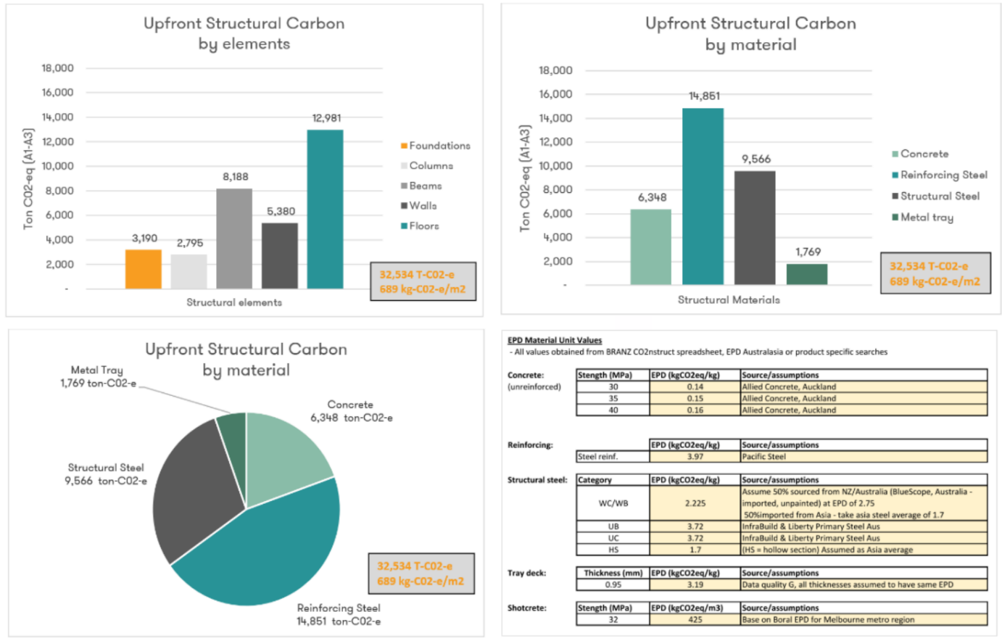
Figure 3: Example format of presentation for Structural Embodied Carbon Modules A1-A3 (excluding “removals” or GWP-stored), representing the general level of detail considered appropriate for Concept through Developed Design.
  - Geotechnical Reporting
The design team should ensure that a comprehensive Geotechnical Report appropriate to the project design phase is provided prior to the commencement of planning and design work for that phase. Reference is made to Earthquake Geotechnical Practice Guidelines, Module 2: Geotechnical Investigations for Earthquake Engineering (2021 or most recent version) which contains guidance on the preparation of geotechnical reports.
Early geotechnical reporting should be updated with any additional stages of investigation, modelling/calculation or advice that are carrying out in the course of design, so that a fully comprehensive, stand-alone geotechnical report is available for each phase of planning and design. Addendum reports, memos and letters are not acceptable in this regard as they complicate project documentation and compromise project archiving for future reference purposes.
Further to that guidance, Health NZ requires the provision of a combined ‘interpretive’ and ‘factual’ geotechnical report (i.e. more than a ‘summary’ or ‘memo’).
Investigative reporting and interpretation
A site plan showing the location of all investigation data points is essential, and where possible this should also depict the location of any proposed buildings. Where appropriate, site geotechnical cross-sections, and site hazard zonation plans (e.g. for Masterplanning purposes) are to be appended to the geotechnical report.
All borelogs, CPT traces, V_{s} profiles, representative liquefaction analysis outputs (showing the location within the soil profile of the liquefiable layers, and their contribution to the hazard), and the like are to be appended to the geotechnical report.
Geotechnical Engineering Advice
Geotechnical reporting at every project stage or phase should provide comprehensive and technically justified advice. The report should comment on geomorphology, soil/rock types and depths, and groundwater. Advice must also be provided on appropriate foundation types, with specific design data for the selection and sizing of foundations appropriate to the stage of design. Typical geotechnical design data and advice includes (but is not limited to) the following examples:
- Foundation capacities and depths (for both shallow and deep foundations),
- Settlements,
- Spring stiffnesses,
- Liquefaction deformations,
- Other seismic deformations,
- Seismic site class,
- Expansive soil properties,
- Slope stability and erosion,
- Retaining wall design parameters,
- Ground improvement,
- Geothermal considerations.
This list is not necessarily comprehensive – engineering advice on any other pertinent geotechnical issues relating to the site or project should be included in the reporting. Conversely, not all of these issues are pertinent for every site.
Health NZ expects this design data and advice to be provided even for the early stages of planning (for example Master Planning), accepting that it may be preliminary and subject to more detailed investigations.
Health NZ Recommendation: Health NZ recommends that geotechnical investigations and primary recommendations are completed by the end of the Preliminary Design Phase.
With reference to Section C2 (Geotechnical Considerations and Building Foundations), advice is to be provided on all potentially feasible foundation solutions, and shallow foundations must be considered in all cases. Health NZ expects engineers to take a well-considered, professional approach to foundation assessment and building design, unconstrained by arbitrary limits or concepts in ‘deemed to comply’ documents such as NZS 3604 or B1/VM4. In this regard, it is important to assess ground deformations across a range of loading cases and consider how a building could be designed to cope appropriately with such deformations, while still complying with the requirements of the Building Act and also the performance requirements outlined in this document.
Seismic design considerations
With reference to Section C1.3.4, seismicity in accordance with MBIE/NZGS Module 1: Overview of the Guidelines (2021 or most recent version) should be considered for all sites anywhere in New Zealand, and a check for the presence of active faults (from the Active Fault Database as well more local / recent information, e.g., fault study commissioned by the local council, if available) is to be made for each project site.
SLS2 analysis cases are to be included in assessment and reporting, including advice on shaking levels where significant ground deformations begin to occur for liquefiable sites, or other ‘step change’ behaviour (e.g. seismically induced sloped deformations). For buildings on potentially liquefiable soils the SLS2 return period should be regarded as ‘indicative’, given that in some cases triggering of liquefaction within a significant portion of the soil column (and which is expected to result in non-trivial building deformation), or other step-change behaviour, may occur at a return period other than 1 in 100/250 years.
Consideration of geotechnical hazards
All other geotechnically-related hazards that could potentially affect the site also are to be addressed in the geotechnical report, for example slope stability, soil creep, rockfall, erosion, tomos, volcanism, geothermal activity.
Accessible summary Information should be provided
A foreword or tabulated summary of key geotechnical aspects of the site, and foundation advice, is to be provided at the beginning of the geotechnical report.
    - The New Zealand Geotechnical Database
All geotechnical factual data collected for a site shall be uploaded to the New Zealand Geotechnical Database (NZGD) as soon as practicable after its collection. This should include any historical data which has been referred to, for example, from investigations carried out for Health NZ on previous projects. All such data is the property of Health NZ and therefore there is no barrier to it being uploaded. Health NZ wishes to avoid the loss of valuable data as a result of design team changes, or the passage of time, and requires that the data is available on the NZGD for any future potential developments.
Health NZ Requirement: All geotechnical factual data collected, or referred to for a site as part of Health NZ projects shall be uploaded to the New Zealand Geotechnical Database (NZGD) as soon as practicable after its collection. Data upload is a pre-requisite for design reviews.


Part B. Performance Requirements for Hospital Buildings

- Classifying Hospital Building Functions and Importance Levels
  - Background to Importance Levels for Hospital Buildings
Building Importance Levels appear in two separate places within the building regulatory system:
- For fire design purposes - in Building Code clause A3,
- For structural design purposes - in the structural loadings standard AS/NZS1170 Part 0.
Although fundamentally the same provisions, there is minor variation between the versions. For structural purposes, Importance Levels apply to Wind and Snow loadings as well as Earthquake.
Importance Levels are described in only high-level terms in both A3 and AS/NZS1170. Many of the categories such as special post-disaster functions are defined by examples, the listings of which are very brief, particularly with respect to health facilities. Furthermore, key terms such as medical emergency, surgery, and emergency treatment services are not defined. For example, surgery has a wider interpretation and application than just in the public hospital system.
The underlying principle behind Importance Levels is the consequence of failure. This consideration can lead to some buildings not requiring the higher categorisation if it can be shown that there would not be an overall loss of functionality to the community if an individual building was unusable.
A strict interpretation of special post-disaster [medical] functions in relation to IL4 is therefore to deal with the medical consequences of the disaster event—for example, dealing with the influx of serious physical injuries and medical trauma of those brought to the hospital (mass casualties comprising fractures, crush injuries, burns, inhalation of dust and harmful substances).
The requirement for a hospital to continue to deliver services to people already in the hospital at the time of the disaster event (in addition to the event-driven special post-disaster functions) can be regarded as more of a service continuity imperative that requires campus-wide resilience thinking and implementation across buildings, infrastructure and other operational aspects.
Part of this wider resilience consideration relates to non-deferrable medical services and functions that cannot be readily displaced or relocated without endangering the health of patients, all at a time of very high surge demand. Inpatients with a range of medical conditions and mobility states will continue to need treatment prior to discharge or with no ability to be discharged.
The heightened difficulty of evacuating large numbers of mobility-impaired or service-dependent patients is another important consideration, and one that needs to be taken into account. The undesirability of having to relocate many of these people at a very challenging time if the ward buildings are damaged beyond a usable state strongly supports the ideal of having robust buildings to enable the delivery of these services to be maintained. This requires going beyond the scope of event-focused special post-disaster functions intended under the Building Code to ensure more appropriate campus-wide resilience.
The following sub-section B1.2 provides guidance on the distinction between buildings housing special post-disaster functions and other functions.
Further commentary on Importance Levels in the hospital context can be found in Section 6.3 of the Interim Health New Zealand Health Infrastructure Unit Report: Understanding and Improving the Seismic Resilience of Hospital Buildings – Technical Report (Kestrel Group, 2022).
  - Medical Service Categories and Importance Levels
The medical services and functions delivered in hospital buildings can be divided into the following three categories:
- Acute Services: Hospitals provide service to the community to deal with the medical consequence of a disaster event. The areas of a hospital having special post disaster function are a subset of acute services (the broader medical classification), and can be split into four sub-categories:
  - Key clinical areas
  - Critical clinical support functions
  - Other specialist functions or services
  - Infrastructure and supplies

This is an explicit requirement within both the NZ Building Code and AS/NZS1170.0 and correlates to Importance Level 4.
- Other Inpatient Facilities: Hospitals will also be required to continue to deliver services to people already in ward facilities at the time of the disaster event, and the wider community after the event, with a focus on services which practically cannot be provided immediately elsewhere in the local community. This may also include some services broadly classified under ‘acute care’, but which are non-emergency and not considered to have a special post disaster function.
Within the building regulatory framework these areas are considered Importance Level 3.
- Other Services – Medical & Support: Areas which do not fall within the above categories. Within the building regulatory framework these areas are considered Importance Level 2.
The following table provides information on service areas and where they relate to the categories above. The design team should confirm via the brief which agreed areas are to be designated as Acute Services, Other Inpatient Facilities, and Other services - Medical or Support.
Aligning Importance Levels and Building Services Categories
Seismic design makes use of Importance Levels (IL4, IL3, IL2) and SLS criteria when designing for post-earthquake functionality, reflected in the Seismic and Structural DGN. Building services design makes use of Building Services Categories (1, 2, 3), reflected in the Building Services Engineering Guide. These are intended to align across guidelines, but where a discrepancy is found, the more onerous condition applies.

Table 2: Categorisation of Clinical areas in accordance with the New Zealand Building Code
Hospital Medical Service Category | Sub-Category | Service or Function | Scope/Comments  Specific Hospital Locations (where applicable)
Acute Services  and essential support services  (special post-disaster functions)  Importance Level 4 | Key Clinical Operational Areas (with a dedicated post-disaster function) | Emergency Dept.
 |  | Operating Theatres | Major acute surgery involving a range of supporting services and facilities
 |  | Intensive Care Unit
 | Critical Clinical Support Functions | Radiology | Medical imaging in support of ED, Acute Operating Theatres and ICU
 |  | Pathology (laboratories) | Services in support of ED, Operating Theatres and ICU incl. blood bank
 |  | Sterilisation | CSSD (central sterilising services unit), or SSU (sterile services unit)
 |  | Bed capacity supporting post-disaster clinical operational facilities | Generally, includes critical care (HDU), recovery and immediate post-operative care, and any additional bed capacity deemed necessary by hospital planners to maintain flow through OT and ED before discharge or transfer to wards (or lower acuity medical assessment units).  Incl. capacity for positive and negative pressure environments, and ventilators.
 | Other Specialist Functions or Services | High acuity maternity and special care for babies | NICU, and birthing/delivery suites located in intentional proximity to operating suites.  Otherwise, refer ‘general maternity’.
 |  | Burns units | Middlemore, Waikato, Hutt and Burwood
 |  | Paediatrics | High end paediatric specialist services provided at Starship (Auckland)
 | Buildings housing Infrastructure and Supplies supporting Acute Services delivery | Water, wastewater, power, data and voice communications | Buildings housing infrastructure services required to support key clinical operation areas (e.g. central plant - boiler room/ energy centre).  Reticulated (trunk) services need to maintain their function at the applicable limit state over their full route. If they pass through other non-IL4 buildings, the critical trunk services should have a low probability of losing function at the appropriate limit state, i.e. SLS2 (1/500 APoE) for critical services generally, or ULS (1/2500 APoE) for earthquake evacuation and life support systems only. This does not require those buildings to be categorised as IL4.
 |  | Medical gases and steam
 |  | Heating, ventilation and air conditioning (HVAC)
 |  | Fire protection systems (independently located fire water tanks)
 |  | Clinical supplies | Incl. pharmacy (storage, not dispensing)
 |  | Solid waste disposal
Other Inpatient Facilities  Importance Level 3 | General wards including children’s wards, general maternity/birthing. | General and/or post-operative medical treatment, monitoring and recovery. Non-emergency acute assessment units. | Hospital buildings with a capacity for more than 50 people overnight.  Includes SCN (special care nursing) for babies and secondary maternity facilities and birthing suites not considered ‘high acuity’.
 | Forensic and Acute Mental Health Wards | Secure inpatient and medical treatment facilities
 | Other Specialist Functions or Services | Spinal unit | Units at Middlemore (Otara) and Burwood
Other Services - Medical  Importance Level 2 | Medical and other surgery | Includes cardiology, oncology, gastroenterology, respiratory, endocrine.  Vascular, plastic surgery, dental, ENT, ophthalmology.  Low occupancy wards. | Non-emergency or elective surgery undertaken in medical facilities other than main operating theatres that are included under IL4.  General wards in hospital buildings (including general maternity/birthing/SCN/ non-emergency acute assessment) with overall inpatient capacity less than 50 people overnight and not classified as Importance Level 3 or 4.
 | Outpatients Clinic | Incl. procedure suites, dialysis, physiotherapy
 | Radiology | Elective or low-acuity imaging and radiology | General radiology and imaging services other than those included under IL4.
 | Laboratories | Routine testing | Incl. Haematology services other than blood bank.
 | Mortuary | Body hold | Alternative arrangements in place for post-disaster situations.
 | Buildings housing Engineering Infrastructure supporting non-Acute (IL2 / IL3) Medical Services | Water, wastewater, fire protection systems and engineering systems required for basic functionality. | Plant/infrastructure and reticulated (trunk) services need to support basic functionality for the buildings they serve at the SLS2 limit state (1 / 250 APoE) over their full route.
Other Services - Support  Importance Level 2 | Kitchen | Catering for inpatients and staff | While kitchen and laundry facilities are key functions at hospitals, it is generally considered that alternative arrangements can be put in place for emergency situations
 | Laundry | Cleaning of laundry required for operating, clinical and ward facilities
 | Storage | Medical supplies and disposable material | Other than supplies required in support of key clinical operational areas
Other Services - Support  Importance Level 2  cont’d… | Community Health | Administration
 | Hospital Management | Administration
 | Hospital Emergency Operations Centre | Base for the Incident Management Team | The Hospital Emergency Operations Centre is not in itself a special post disaster function (unlike a local or regional EOC serving the community). While it is desirable for the primary EOC location to be in a building with a good level of resilience, all hospital EOCs are required to have functioning alternative facilities, and most co-ordination activities can typically be carried out in such locations.
 | Car parking | Car parking structures | Excludes structures providing access for emergency services to IL4 facilities
 | Helidecks | Elevated (e.g. rooftop) helidecks and patient holding bays | Close adjacency benefits day-to-day outcomes. However, alternative arrangements/landing sites are generally available in a post-disaster context therefore no special post disaster function.  Importance Level for helideck design should be at least equivalent to the building supporting the helideck.
 | Other buildings housing Infrastructure for Other Services-Support only. | General plant | Not applicable to central plant buildings also supporting medical services.

Classifying maternity and special care for babies
The term ‘higher acuity’ is used in Table 2 to differentiate between services which are considered to have a higher post disaster criticality, and those which are less critical on the basis that the service is reasonably relocatable.
This document recommends that birthing suites attached to Acute Services facilities (with intentional proximity to operating suites) be classified as Acute Services (Importance Level 4). Continuity of this service as a birthing choice and to manage higher clinical risk indications, and maintenance of this adjacency for emergency transfer, is considered appropriate (if not critical) in a post-disaster context. Therefore, this service is considered to have a critical post disaster function.
Ultimately, it shall be to the judgement of hospital clinical staff in conjunction with Health NZ as to the appropriate classification for birthing suites in Acute Services facilities. This might include more careful consideration of the campus context, the clinical importance of adjacency to operating theatre suites, and therefore whether the service could be considered relocatable if the building was rendered unoccupiable. This ‘high acuity’ classification need not apply to birthing suites in a primary/secondary care setting, nor to general maternity wards.
For special care babies units (SCBU), neo-natal intensive care (NICU) is considered to have a critical post disaster function. Special care nursing (SCN) can be considered to have lower criticality (and is more practically relocatable) and may be categorised as Importance Level 2 or 3 accordingly, similar to maternity wards. The distinctions may be less important where maternity, SCBU (SCN and NICU) and birthing are co-located.
Applying the service-based classifications to buildings
For structural design, Importance Levels normally apply to entire buildings and their parts. This classification would be based on the most critical service delivered from the building. From a structural and geotechnical perspective, this is normally straightforward—with some exceptions for partially adjoined structures.
In principle it may be possible to delineate areas of the building that contain less critical services—and apply reduced performance criteria to non-structural elements and contents correspondingly. However, it is often impractical (and possibly uneconomical) to separate critical areas of a hospital building from non-critical areas without risking compromise in holistic performance.
For Engineers: This means that within a building, it will normally be appropriate to set the Annual Probabilities of Exceedance associated with a given design limit state (Section B2.3.1, Table 6) to match the classification for the building as a whole. This ensures that co-functioning building design elements, such as building fire safety systems and trunk services are not compromised by an inconsistent approach.
The physical state descriptions provide the appropriate recognition for a higher tolerance to damage in less critical areas.
For Health Planners: Notwithstanding the above categorisation of services for engineering and disaster resilience purposes, the following approach is recommended regarding the location and adjacency of health services (informing masterplan options for new buildings and for and continued use or repurposing of existing buildings):
- In the first instance, plan based on health planning requirements, capacity demand, and achieving optimal clinical service delivery (clinical outcomes and operational expenditure). These should be the primary drivers.
- Review against the engineering Service Categories (and Importance Levels), and test how this impacts preferred or alternative options for building massing, block and stack, and building adjacencies. Consider how the continued use or repurposing of existing assets and infrastructure impacts sitewide resilience, and the path towards Health NZ’s medium to long term seismic resilience aspirations as set out in Section B8 (and Health NZ’s accountabilities for health emergency planning for earthquake).
  - Classifying Link Structures and Independently Located Infrastructure
Link Structures
Structurally integral link structures should be assigned the same Importance Level as the building they are connected to.
For Building Code compliance, structurally independent link structures can be assigned an Importance Level independently of the structures that the link serves. However, Health NZ recommended that new link structures are designed to meet Continued Functionality requirements of this document (SLS2) at 1 / 500 APoE levels of shaking, unless the link (and any trunk services it contains) are only serving structures of a lesser Importance Level and Service Category (in which case the APoE can be reduced accordingly). This maintains appropriate overall reliability for continued functionality at a campus level. Refer also to Appendix 1, Section 1.3: Dependencies.
Health NZ Recommendation: Assign new structurally independent link structures their own Importance Level, independently of structures served. Consider SLS2 at a 1 / 500 APoE (unless only structures of lesser Importance Level and Service Category are intended to be served by the link and services it contains, in present and reasonably foreseeable future states).
SLS2 criteria for link structures can generally reflect a higher tolerance to some drift induced superficial damage (to interior wall linings that are not fire or smoke separations, for example). However, the link should be able to function safely after SLS2 shaking and remain clear of obstructions and hazards, especially if it functions as a primary egress route.
Independently Located Infrastructure/Plant/Utilities
Buildings housing plant and utility services servicing hospital buildings are classified to NZS 1170.0, and are included in the Service Category and Importance Level clarifications in Section B1.2, Table 2 above.
Information on the classification and seismic design of pressure equipment (pressure vessels) and their supporting structures (including standalone structures) can be found in:
- Engineering NZ Practice Note 19: Seismic Resistance of Pressure Equipment and its Supports (ENZ, 2019).
- Report prepared for Ministry of Health: Seismic Design Basis Guidance Summary for Storage Tanks-vessels (Beca, 2022).
Refer to Section C1.1.1 regarding selection of Design Working Life for seismic loads.

- Seismic Performance Requirements
The seismic performance framework sets the minimum seismic performance standards required by Health NZ for public hospital buildings—which will also meet, as a minimum, New Zealand Building Code requirements.
Definition of Terms: This guideline uses language and terms related to earthquakes and functional recovery that align with the ongoing development of functional recovery methodologies in North America as part of the 2026 NEHRP Provisions Update cycle (https://www.nibs.org/bssc#puc). This builds on the terms and concepts summarised in the functional recovery options report FEMA P-2090 (FEMA, NIST, 2021). Refer to the Glossary of Terms for definitions.
  - The Seismic Performance Framework
The seismic performance framework provides a pathway starting at broad statements intended to outline what healthcare staff and communities need from hospitals after a major earthquake, and ending with specific engineering design criteria to enable design teams to deliver facilities that meet these requirements.
The framework components (and levels) are indicated in Figure 4.
Figure 4: Seismic Performance Framework Hierarchy

How designers use the framework
The higher levels of the framework are general and expressed in end-user terms (not design requirements). For designers, meeting the requirements of this performance framework is measured by compliance with the engineering design criteria in Part C, applied alongside the design limit states that are defined in Section B2.3.1.
The purpose of Table 3 is to help designers understand what parts of the seismic performance framework design compliance will be measured against.
Table 3: What structural and geotechnical engineers need to do, to comply with the seismic performance framework in this document.
Framework Level |  | What designers need to do to comply |  | Comment
B2.2 | Outcome Objectives | Guidance | - | Use for communication with stakeholders and clinical staff.  Design compliance on a project basis is not measured against the outcome objectives.
B2.3 | Performance Goals for Buildings |  | The engineering limit states are defined in this section (section B2.3.1), alongside the corresponding earthquake hazard levels for each limit state. | Design compliance is not generally measured against the performance goal descriptions.  For the DCLS, target loss levels are indicated, but no loss assessment is not required. The requirements are deemed to be met if the detailed design criteria are followed.
B2.5 | Descriptions of Physical States at DLCS and SLS2 |  | Use the information to make appropriate professional judgements if detailed design criteria are not available.  Consider reviewer inputs and keep Health NZ project teams appraised of any decisions with potentially significant cost or performance impacts. | This information is guidance, providing clear statements of intent. Compliance is not strictly measured against this section.  Where detailed design criteria related to the descriptions (implicit or explicit) aren’t available in Part C or its references, then interpretation should be at the discretion of the designer, considering any inputs made by reviewers. Decisions should be recorded with a simple record of the reasoning.  Health NZ are in the best position to help designers reach decisions where there are significant cost/clinical/performance impacts.
B2.4 | Robustness requirements at ULS | Comply | Designers should comply with the referenced criteria/design guidance. | Designers can submit for a departure (Section A1.6.2), if it is considered that the design criteria are inadequate or unnecessary and the outcome objectives (as clarified by the performance goals and physical state descriptions) can still be met by a different approach.
Part C | Detailed Design Criteria |  | Designers should comply with the detailed design criteria/references, at the corresponding limit states.
  - Outcome Objectives for Seismic Performance
What is a successful outcome following earthquake?
Outcome objectives describe the problem definition and success criteria. Outcome objectives are user-focussed. They should be presented from the point of view of those that use the facilities—clinicians, support staff and health service users. They don’t use engineering language.
The basic life safety objective during the earthquake event itself would be considered by most as a non-negotiable basic objective—even in severe (very rare) earthquakes. However, it is accepted as achieved through proper application of ordinary design provisions and principles of robust design. Therefore, outcome objectives for most hospital buildings are primarily focused on functional continuity of service—especially those containing important services which classify them as Importance Levels 3 or 4 (with reference to Table 2 in Section B1.1).
After a significant earthquake, it is a practical and tolerable reality for facilities to be in a state of reduced functionality. However, they should not have functionality interrupted. This concept is illustrated in Figure 5.
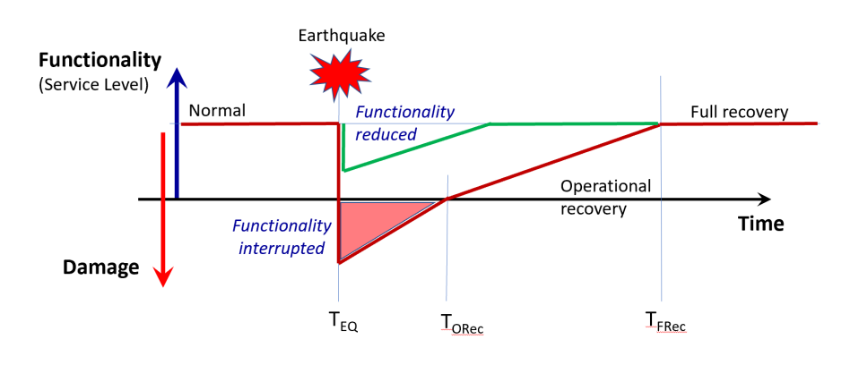
Figure 5: Recovery following a significant earthquake, and the concept of reduced but not interrupted functionality.
With reference to the Hospital Medical Service Categories in Section B1.1, some hospital services (broadly classified as Acute Services) have a specific role in dealing with the medical consequences of the event itself. Being able to deliver this service immediately following an event is crucial.
Most hospitals will also need to continue to deliver basic services to in-patients who are in hospital at the time of the event. Transferring patients can be detrimental to healthcare outcomes (in some cases, life threatening)—and it can also be impractical due to the regional emergency response situation and wider capacity constraints.

In principle, the life safety objective would be common and consistent across all clinical services and building uses. However, the condition of people inhabiting the building has some relevance.
The functionality objective, on the other hand, will have different criteria depending on the type of services being delivered out of the facility.
Health NZ and the New Zealand Government, as a near-perpetual portfolio holder, also have an interest in minimising disproportionate economic losses to healthcare infrastructure following earthquakes. This is good infrastructure asset management practice. It is also simply because carrying out significant repairs or developing replacement facilities is often extremely disruptive to healthcare delivery and wellbeing of staff and users in the context of the longer-term regional recovery. The cost of this work applies challenging competition to the nationwide infrastructure budget. In real world terms this competition compromises the ability to deliver and maintain facilities to meet population service demand.
For Acute Services and Other Inpatient Facilities (Importance Level 3 and 4 facilities), the asset protection objective requires any repairs needed for a full return to normal operations in the longer term to be not just economical, but also practical in the context of continuing normal hospital operations. This makes any specific objective to minimise economic losses somewhat redundant as it becomes implicit in the continued functionality objective.
For all buildings, ongoing disruption to clinical areas for repair work, and significant disruption or compromise in support services and support facilities (even access to basic facilities such as carparking) are significant consequential stressors in a wider earthquake recovery context. There can be wide ranging impacts on wellbeing and effectiveness of service delivery in the longer term.
Minimising losses (asset protection) and ensuring functional continuity of service are deliberately set apart as two distinct objectives, but as the above commentary shows, there are some clear linkages between them.
Summarising the outcome objectives
In the context of earthquake, there are two primary objectives to be considered as follows:
- Life Safety – Protection against loss of life or serious injury, even in severe (very rare) earthquakes.
- Functional Continuity – The ability to continue to provide the services for which the building is intended after a significant earthquake.
There is a secondary objective to be considered as follows:
- Asset Protection – minimise disproportionate economic losses resulting from earthquake, from the overall perspective of nationwide infrastructure budget management.
See Table 4 for a summary of outcome objectives.

Table 4: Summary of outcome objectives in the context of earthquake
Objectives | Acute Services | Other Inpatient Facilities | Other Services - Medical | Other Services - Support
 | Importance Level 4 | Importance Level 3 | Importance Level 2
Life Safety | Low probability of loss of life or serious injury—including to those with a high dependence on medical assistance (care or equipment) for life support. | Low probability of loss of life or serious injury. | Low probability of loss of life or serious injury. | Low probability of loss of life or serious injury.
Functional Continuity | No requirement to evacuate.  Basic functionality and life support continuously maintained.  Full functionality returned within hours. | Very unlikely to require emergency evacuation (for structural safety reasons).  Basic/partial functionality restored within minutes to hours.  Full functionality within weeks. | Very unlikely to require emergency evacuation (for structural safety reasons).  Basic/partial functionality restored within days to weeks.  Full functionality within weeks to months. | Evacuation tolerable (including where resulting from a higher threshold of caution).  High likelihood of a return to basic functionality within weeks to months (or days to weeks for residences).  Shelter in place (residences).
Asset Protection | Avoid damage that would be unreasonably expensive or disruptive to repair, in the context of the ongoing functional requirements that must remain uninterrupted. Decanting of departments not required. | Avoid damage that would be unreasonably expensive or disruptive to repair, in the context of the ongoing basic functional requirements that must remain uninterrupted.  Decanting of departments not required—minor capacity impacts tolerable. |  | Low likelihood of a total loss.  Damage economic and practical to repair without full decant (partial decant tolerable).

  - Seismic Performance Goals and Limit States for Design
How should our facilities perform, to meet these outcome objectives?
Performance goals transcribe the overarching outcome objectives into requirements for buildings—with more specificity on how buildings need to perform under given scenarios. This is used to define engineering design limit states. Performance goals should be considered relative to the categories of services in each area.
Table 5 describes the performance goals for each of the service classifications. It refers to the following operational states listed below (defined in the Glossary of Terms and shown diagrammatically in Figure 6).
- Normal operations (pre-earthquake condition)
- Full functionality
- Partial (basic) functionality
- Shelter in place
- Not occupiable
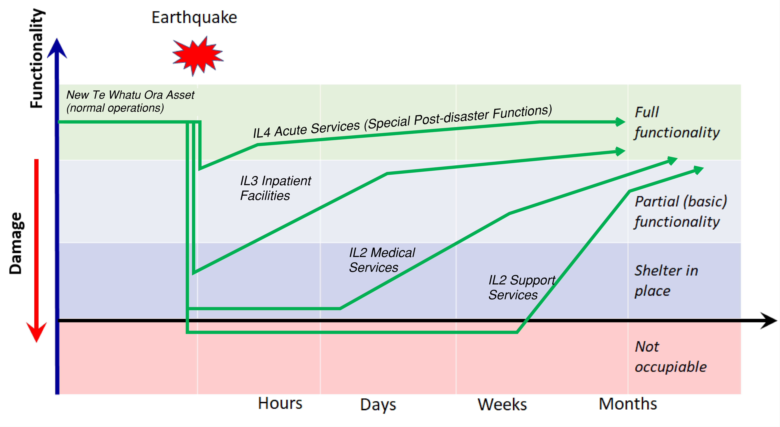
Figure 6: Tolerable reductions in functionality for Health NZ assets following a significant earthquake, and timeframes to full recovery, indicated in graphical form for different asset types (health service categories).
Table 5: Summary of seismic performance goals for hospital buildings
Building Category | Building Performance Goal
 | Life Safety | Functional Continuity | Asset Protection
Acute Services  Importance Level 4 | For structure, and structural support of non-structural elements, as defined by B1/VM1. ^{(Note 1)}  Containment of hazardous substances, and function of basic life support services for in-patients with high medical dependency. | To remain functional immediately following a significant earthquake—reduced but not interrupted.  - Basic life support function continuously operational.  - Full clinical post-disaster function able to continue within minutes to hours.  - Building systems (e.g. services) uninterrupted or reduced operation consistent with clinical objectives.  - Building maintains overall weathertightness, localised manageable exceptions.  - Fire and evacuation systems to be largely functional (some damage is tolerable, provided that in conjunction with appropriate elevated management strategies, risk can be managed).  - Finishes damaged. Localised repairable damage tolerable. Should not incite concern that could lead to unnecessary evacuation^{(Note 9).}  Return to normal operations within an appropriate timeframe ^{(Note 2, 3 & 4).} | Very low likelihood of total economic loss in a severe earthquake.  Very low likelihood of losses from earthquake exceeding 5% of the building replacement costs in a 10-year period.  Containment of wet services.  Repair practical in context of continuing function.  ^{(Note 5)}
Other Inpatient Facilities  Importance Level 3 | For structure, and structural support of non-structural elements, as defined by B1/VM1. ^{(Note 1)}  Containment of hazardous substances. | To retain basic function following a significant earthquake—reduced but not interrupted.  - Basic function able to continue within minutes to hours.  - Fully functional within weeks.  - Building systems (e.g. services) uninterrupted or reduced operation consistent with clinical objectives and timeframes to restore function.  - Building maintains overall weathertightness, localised manageable exceptions.  - Fire and evacuation systems to be largely functional (some damage tolerable, provided that in conjunction with appropriate elevated management strategies, risk can be managed).  - Finishes damage. Localised repairable damage tolerable. Should not incite concern that could lead to unnecessary evacuation. ^{(Note 9)}  Return to normal operations within an appropriate timeframe. ^{(Note 2 & 3)} | Low likelihood of total economic loss in a severe earthquake.  Low likelihood of losses from earthquake exceeding 5% of the building replacement costs in a 10-year period.  Repair practical in context of continuing function.  ^{(Note 6)}
Other Services - Medical and Support  Importance Level 2 | For structure, and structural support of non-structural elements, as defined by B1/VM1. ^{(Note 1)} | Return to basic function within days to weeks (medical services); or weeks to months (other support services). ^{(Note 7)} | Low likelihood of total economic loss in a severe earthquake.  Low likelihood of losses from earthquake exceeding 5% of the building replacement cost in a 10-year period. ^{(Note 8)}

Notes:
[1] Principles of robust design should also be applied to help ensure enduring designs which manage uncertainty in seismic design.
[2] Full functionality in an earthquake recovery context does not mean pre-quake functionality. Reduced functionality is expected or a slight compromise in working conditions, with the focus being on adequate functionality to fulfil post-disaster function.
[3] Full functionality does not imply code compliance. It is expected that some systems will not be code compliant after a large earthquake, however they are expected to maintain minimally adequate performance—this may mean operating under slightly elevated levels of risk which are tolerable for a time under the circumstances, and which might be mitigated by additional management strategies (to mitigate any compromise to parts of fire safety systems, for example). Return to normal operations describes the resolution of these compromises as part of the medium to longer term recovery. Note that in large earthquakes, disruption and return to full function can often be controlled by aspects beyond the building envelope, such as cordons, utility outages, and labour shortages.
[4] For a building with special post-disaster function, functionality must consider potential loss of function due to building performance, external physical factors, and external organisational
[5] Repair work should not require full decant of departments. Minor intermittent capacity restrictions tolerable.
[6] Repair work should not require full decant of departments. Short periods (days to weeks) of reduced capacity tolerable for carrying out repairs.
[7] Reduced rather than interrupted basic functionality is desirable. However, some interruption tolerable.
[8] Partial decant of buildings in this category for carrying out repair work is a tolerable outcome.
[9] Health NZ establish Priority Response Agreements for major Acute Services facilities between facilities staff and local engineers, to facilitate rapid post-earthquake reviews which help maintain confidence to continue to occupy and deliver services out of the facility.
    - Limit States and Hazard Return Periods
How do we link these performance goals into design criteria?
To achieve the reliability of performance described under the performance goals, this guideline translates them into a set of design limit states for engineering design. If the design meets the required design criteria applicable to each limit states at the prescribed annual probability of exceedance (APoE), then the performance goals are deemed to be met.
This does not necessarily preclude designers from following an alternative performance pathway to demonstrate that the performance goals set out in Table 5 can be met—however such an approach is usually impractical. The use of an alternative performance-based design pathway should be treated as a Departure to these guidelines in accordance with Section A1.6.2.
Definition of Limit States, and how these relate to the performance goals
Design limit states are defined to allow specific engineering design checks with the building performance goals. These include the ULS, SLS1 and SLS2 limit states already required by the Building Code, but with clearer definition of the SLS2 limit state. These guidelines extend the SLS2 considerations to all medical services (not only Importance Level 4 facilities) and introduce a Damage Control Limit State (DCLS) for all Health NZ facilities of all Importance Levels.
Serviceability Limit State 1 (SLS1)
This serviceability limit state in AS/NZS 1170.0 is defined around maintaining amenity (function). For seismic design it is predominantly concerned with avoiding disproportionate damage in less strong and more commonly occurring earthquake events—and the high cost of repairs when aggregated across a population and the frequency of these smaller events. Thus, many consider it to be a minimal response to an asset protection objective under small earthquakes. It intends to avoid disproportionate economic losses, albeit setting a relatively low bar.
This guide does not deal with SLS1 any further. Designers are still required to check and meet the requirements of this limit state under the Building Code.
Serviceability Limit State 2 (SLS2)
This limit state is defined around maintaining Continued Functionality after a significant earthquake. The Building Code verification methods apply this limit state to Importance Level 4 facilities with specific post-disaster functions. However, Health NZ (and this guideline) require it to be applied to all their facilities to meet the outcome objectives set out in Section B2.2.
Damage Control Limit State (DCLS)
This limit state is introduced to meet the Asset Protection objective. Meeting this limit does not mean no damage at this shaking level—but it does require damage to be limited and economically repairable. The higher-level engineering objective is usually quantified in terms of maximum acceptable Estimated Annual Losses (EAL) for the building and its elements. For example, assuring a low chance (say 1-10%) of losses from earthquake damage exceeding 5% of the building replacement cost in a 10-year period.
The hazard level and physical state descriptions aligned to this limit state, alongside the ULS robustness and detailing requirements, are deemed to meet the Health NZ requirements for an appropriate level of asset protection—helping ensure the financial burden of earthquake recovery does not apply undue pressure to the nationwide infrastructure budget to the detriment of health service delivery.
Ultimate Limit State (ULS)
This deals with the Life Safety objective by compliance with the Building Code. Health NZ also require principles of robust design to be incorporated, generally following the principles outlined in Earthquake Design for Uncertainty document (NZSEE, SESOC, NZGS, 2022). This is best seismic design practice and helps increase confidence in enduring design safety whilst geological and earthquake sciences continue to evolve. It also helps achieve the Asset Protection objective by reducing the likelihood of total economic loss rare events.
Implicit in the Ultimate Limit State is the consideration of higher levels of shaking than the ULS hazard Annual Probabilities of Exceedance set out in Table 6. This is sometimes explicitly considered through concepts such as a Collapse Avoidance Limit State or Maximum Considered Earthquake (for specific design elements or where special anti-seismic devices are used). This guideline provides no further definition here, but designers are expected to make all necessary considerations following the applicable guidelines and standards.
Table 6: Design limit states and return periods, defining the criteria for meeting Seismic Performance Goals.
Health Service Category | Importance Level | Annual Probability of Exceedance (APoE) for Seismic Hazard
 |  | Damage avoidance (also implying unimpeded continued use) | Asset protection objective | Continued Functionality objective | Life Safety objective
 |  | SLS1 | DCLS | SLS2 | ULS
Acute Services | IL4 | 1 / 25 | 1 / 500 |  | 1 / 2500
Inpatient Wards | IL3 | 1 / 25 | 1 / 250 |  | 1 / 1000
Other Services - Medical | IL2 | 1 / 25 | 1 / 250 |  | 1 / 500
Other Services - Support | IL2 | 1 / 25 | 1 / 250 ^{(Note 1)} | n/a | 1 / 500

Notes:
[1] For carparking structures or for other minor structures as specifically identified in the Health NZ project brief, the non-quantified ‘Level 1’ Low Damage Seismic Design guidelines pathway can be followed as an alternative (once published). In such cases, there is no specific requirement to consider the DCLS.

NZBC Requirement (B1/VM1): The ULS and SLS1 limit states apply to all facilities. Further to this, the minimum requirements of B1/VM1 apply the SLS2 limit state to Importance Level 4 facilities. Performance at the SLS2 should be aligned with the descriptions of physical states in Section B2.5 of this guideline, which provides improved clarity.
Health NZ Requirement: All limit states shown in Table 6 shall be considered. Performance at the SLS2 and DCLS shall be aligned with the descriptions of physical states in Section B2.5 (except where the non-quantified LDSD level 1 pathway is permitted). Table 3 (Section B2.1) clarifies how designers can meet this requirement.
When defining limit states, it is important that the hazard level for demand is defined as well as the type of capacity limit (the reliability in that limit) that is paired against it. The two sides of the equation work together to provide the required level of reliability. AS/NZS 1170.0 defines this information for the Ultimate Limit State for the life safety objective. This guideline provides additional clarification on the types of serviceability limit δ_{l} (and the reliability level that should be used to set the limit) for the Serviceability and Damage Control Limit States. This is done via the Descriptions of Physical States set out in Section B2.5 and the recommended design criteria in Part C.
The APoEs for earthquake hazard assigned to the DCLS in Table 6 are consistent with the Low Damage Seismic Design (LDSD) Guidelines framework. Acute Services are comparable to LDSD Level 3. All other medical services (including inpatient wards) are comparable to LDSD Level 2. The Low Damage Seismic Design framework is focussed primarily on damage, with functionality as a secondary objective. For hospital infrastructure, on the other hand, the primary focus is functionality (SLS2). Therefore, this document contains some differences in the physical state descriptions and associated design criteria (relative to the LDSD Guidelines).
  - Structural Robustness Requirements for the ULS Design Limit State
All structures are required to comply with the Ultimate Limit State requirements of the Building Code Verification Methods and cited standards. This includes the implicit or explicit consideration of higher levels of shaking that is an integral part of the Ultimate Limit State design process—as described in the limit state definitions given in Section B2.3.1. This is a basic code requirement to achieving the Life Safety objectives of the Building Code and this guideline. The same intent must be carried through the application of Alternative Solutions.
Health NZ require robust design principles to be applied. Reference is made to the principles and recommendations given in the Earthquake Design for Uncertainty Advisory (NZSEE, SESOC, NZGS, 2022), and the supporting (and more detailed) recommendations in the SESOC Interim Design Guidance v11 (SESOC, 2022). Robust design recognises the benefits of the following key indicators of good performance from evidence in past significant earthquakes:

- Regularly configured design.
- Ductile detailing.
- Careful consideration of deformation compatibility and tying of components.
- Continuity, completeness, and proportionality of load paths.
The application of the standards and approaches to building configuration and detailing should be done in a way that ensures robust construction is achieved. Reference to each of the key recommendations of the Earthquake Design for Uncertainty Advisory is given in Table 7, with additional commentary on how the recommendations should be applied to Health NZ projects.
Health NZ Requirement: The good practice recommendations of the SESOC Interim Design Guidance (SESOC, 2022) should be followed. Principles of robust design and ductile hierarchy shall be applied that align with the Earthquake Design for Uncertainty advisory (NZSEE, SESOC, NZGS, 2022) as set out in Table 7.
Table 7: Commentary on the application of the Design for Uncertainty Advisory (NZSEE, SESOC, NZGS, 2022) recommendations for robust design.
Reference | Design for Uncertainty Recommendation | Comment
1 | Peer Review | Requirements are outlined in Part A (A2.4)
2 | Structural Regularity | Design teams should prioritise the provision of structural regularity given the project constraints in accordance with the advisory recommendations.
 | Structural redundancy | Multistorey buildings of heavy construction should maintain load paths for lateral resistance in both orthogonal directions as well as global torsional stability in the event of unexpected failure of components of a structural bracing bay.
 |  | The importance of column continuity in multistorey construction should be considered (to all primary columns including those not intended to act as part of a primary lateral load resisting system) especially in braced frame systems.
3 | Ductile Behaviour and Capacity Protected Hierarchy | Detailing for limited ductility (as a minimum) is recommended to primary structure intersections, connections, and stability of potential plastic regions.  The recommendations of the SESOC Interim Design Guidance v11 for conventional systems should be followed (generally described under the “Detailing for Resilience” subheadings).
 | Ductility Demand | Achieved through the requirements of Section C3.1.
4 | Deformation Compatibility and Tying | The recommendations of the SESOC Interim Design Guidance v11 for conventional systems should be followed.
5 | Robustness, continuity, and proportionality of load paths | The recommendations of the SESOC Interim Design Guidance v11 for conventional systems should be followed.
6 | Limiting drift and displacement sensitivity | Achieved through the requirements of Section C3.1, and the recommendations of Section C1.3 regarding the application of TS 1170.5.  Designers are encouraged to consider the benefits of post yield stiffness.
7 | Soil structure interactions | The Earthquake Geotechnical Practice Modules should be followed, alongside the recommendations of the SESOC Interim Design Guidance v11.
8 | Site Specific Hazard Studies | Refer to Section C1.3 Seismic Loading.

The purpose of applying these principles is to ensure that Health NZ as a near-perpetual asset owner develop safe and enduring designs that, because of the way they are configured and constructed, are largely insensitive to aspects such as:
- Continually developing understanding of earthquake hazards over time.
- Future decisions about use (particularly for buildings with lower Importance Levels in their proposed use).
- Tolerance to foundation movements, geotechnical interaction and ground behaviour uncertainties.
- The inherent uncertainties of earthquakes and their effects on the way structures and soils respond.
This document links these requirements most strongly to Ultimate Limit State considerations. However, many of the requirements are in common with those that give far improved expectations of continued functionality and minimisation of damage across a range of earthquake shaking levels.
Whilst design shaking levels are an important part of any structural design process—the catalogue of building collapses shows us that robust and ductile design principles have a greater influence on safety and performance.
Thus, in projects constrained by cost and imperatives to minimise emissions, it is more important to put material and detailing effort into ductile hierarchy (most importantly connections, and potentially columns, for example) than it is to put that material into additional building strength. The latter increases the difficulty and expense in maintaining robust hierarchies of structural behaviour. It may be appropriate to consider increased building strength and/or stiffness as part of a holistic approach for meeting DCLS/SLS2 objectives. However, this approach is discouraged at the ULS. Provided the relevant loading and material standards are complied with, detailing, strength hierarchy and behaviour is more important than overall building strength itself.
This is also an important message in conversations around adaptability for future use, especially where the Life Safety objective is concerned. Design for now, strengthen if use changes (or demonstrate that the detailing obviates the need to).
  - Descriptions of Physical States for the SLS2 and DCLS Limit States
The physical state description is the link between the performance goals and the engineering design criteria. It describes the expected state of each system at a given limit state that would achieve the performance goals.
This section and tabulated physical state descriptions (Table 8) apply predominantly to the SLS2 and DCLS limit states. In most cases, it is the continued functionality objective (SLS2) that is dominating the described requirement, and the asset protection objective (DCLS) will be automatically met. However, there are some exceptions where the asset protection objective has increased relevance, for example, some Importance Level 2 support services that tolerate a level of interrupted functionality.
This table does include some state descriptions which exist to avoid direct life safety risks (such as containment of steam at high pressures). These are clearly marked within the tables and should be met at the ULS design Annual Probabilities of Exceedance (APoEs). In all other cases, the SLS2/DCLS APoEs apply.
Managing the influence of externalities - beyond the project boundary
It is acknowledged that the requirements for some systems extend beyond the project boundary and thus the control of the design team. This includes matters such as site selection (Section A1.7.2), proximity to neighbouring buildings (Appendix 1.2), and public utilities or site trunk services dependency (Appendix 1.3). All have direct relevance to site master planning and business case development. Risks posed by some of these externalities may be able to be mitigated at least to some extent, and the level to which residual risk is managed or tolerated will influence emergency planning.
All system requirements should be considered by project teams (including externalities). Items beyond the team’s control should be captured in project risk registers so that residual risk can be managed by Health NZ and facilities users as part of readiness planning (refer footnote to Structural Design Features Report Section A3.1).

Table 8: Expected Physical States / Requirements
Building Element | Sub-component | Expected Physical States/ Requirements  (SLS2 or DCLS unless noted otherwise)
 |  | Acute Services (IL4) | Other Inpatient Facilities (IL3) | Other Services – Medical (IL2) | Other Services – Support (IL2)
Surrounding environment | Access to building | Largely unimpeded access from damage to other buildings, roadway failure due to landslip above or below (or lack of road network redundancy), etc. |  | No special requirements.
Supply of incoming services | Network/site infrastructure, and emergency backup utilities | Refer to Building Services Systems (below) for specific requirements related to connection to public utilities.
Discharge of outgoing services | Building to public network | Refer to Building Services Systems (below) for specific requirements related to outgoing services.
Primary Structure | Foundations | Manageable absolute settlement relative to surrounding ground, meaning not requiring immediate foundation relevelling nor significantly affecting potential for flooding from overland flow.  Manageable differential settlement meaning not significantly compromising superstructure capacity (as described in subsequent descriptions), and not requiring immediate foundation relevelling for amenity in a return to normal operations. Minor cracking or yielding to concrete foundation members not requiring repair (and recognising the difficulty in inspection).  All services entering and exiting the building shall have their connections (designed to be appropriately flexible and robust) at easily identifiable and accessible locations such that they may be repaired if damaged, without disproportionate works. |  |  | Similar, but foundation relevelling tolerable provided it is practical and economical.
 | Structural Members | Minor damage or yielding to structural members. No significant reduction in capacity, and tolerable residual drift.  Practical and economic to repair for return to normal operations. For concrete members this could include minor cracking and isolated spalling of cover concrete—able to be reinstated by practical extents of epoxy injection or mortar repair and not requiring reinforcing replacement. For structural steel elements, minor permanent distortion but no buckling of plate elements. |  |  | Similar
 |  | Repair work should not require decant of departments. The type and extent of work reasonably anticipated should reflect the difficulty and disruption of repair in operating environments—especially those with in-patient or all-hours clinical functions. Reduced functionality during repair work may be acceptable for short periods (days or weeks). |  |  | Limited decanting acceptable for carrying out repairs tolerable.
 | Floors | Minimal damage. Minor cracking of concrete slabs. No significant spalling. Otherwise, similar to Structural Members.
 | Roof Framing | Generally similar to Structural Members.  Structure retains sufficient stiffness to avoid compromising watertightness of roof enclosure. |  |  | Generally similar, but some modest and practically/economically repairable damage acceptable.
Exterior cladding | Façade, general | Enclosure overall should retain water shedding ability. Minor water ingress acceptable in high wind/ rainfall conditions. Some reduction in air seal tolerable.  Minimal damage to façade panels, no cracked glass. Localised tearing to sealant joints and minor dislocation or damage to flashings. Readily repairable. |  |  | Enclosure overall should retain water shedding ability.  Modest and localised damage to façade systems may occur. Any damage readily repairable, and not leading to further consequential damage to interior.
 | Façade with air tightness requirements. | For example, for clinical isolation or medical biocontainment. Refer Fitout Elements—Partitions. |  | Generally not applicable.
 | Roof sheeting/ membranes | Minor movement/ junction damage only. Watertightness generally maintained. |  |  | Generally similar.
Building Services | Electrical systems | Where practical, supply to provide continuous function.  Supply to return to function in accordance with maximum delay times defined in AS/NZS 3009. | Supply to return to function in accordance with maximum delay times defined in AS/NZS 3009. | Supply to return to function in accordance with maximum delay times defined in AS/NZS 3009. | Minimal physical damage to plant and equipment.
 | Data and Communication Systems | Supply to function continuously. | Supply to return to basic function within minutes or hours. Preference for continuous function where practical. | Minimal physical damage to plant and equipment.
 | Medical gases | Reticulated supply to function continuously. | Reticulated supply to return to function or alternative supply provided within minutes or hours.  Services required to support preservation of life to have redundancy to allow them to retain basic function. | Preference for IL3 level of performance where practical. | Generally not applicable.
 |  | ULS Requirement: Oxygen and medical air to remain available (even if on backup supply) to enable evacuation. |  |  | Generally not applicable.
 |  | ULS Requirement: Containment ⁽⁾ to be maintained at ULS in all areas within the building envelope to avoid direct life safety hazard and fire risk. |  |  | Generally not applicable.
 | HVAC | Supply of systems directly required for post disaster operations or clinical isolation to function continuously.  Remaining systems to return to full function within minutes or hours. | Systems providing pressure differential for clinical isolation continuous basic function (measured pressure differential may be compromised but air flow direction should be maintained).  Remaining systems to return progressively through basic function to full function over the course of days or weeks. (generally prioritising ventilation and air changes over temperature control). |  | No specific requirements.
 | Water supply | Reticulated supply to continue to function continuously.  Tanked water storage provided equal to or greater than 24 hours.  Containment ⁽⁾ to be maintained (to avoid disruption) | Reticulated supply to return to basic function within minutes or hours.  Preference for continuous function where practical.  Tanked water storage preferred.  Containment to be maintained (to avoid disruption) | Reticulated supply to return to basic function within days or weeks. Emergency short term supply available.  Preference for continuous function where practical.  Containment to be maintained (to avoid disruption) | Loss of containment to be minimised (to avoid disproportionate damage)
 | Steam and water >70°C | ULS Requirement: Containment ⁽⁾ to be maintained in all areas regularly occupied by people to avoid direct life safety hazard.
 | Wastewater | Continuously operational. Containment ⁽⁾ to be maintained (to avoid disruption). No severance from utilities connection |  | Containment to be maintained (to avoid disruption and disproportionate damage).  Passive elements continuously operational. Mechanical systems (such as pump stations) return to full function within days or weeks.  All connections accessible (readily excavatable) and resilient to ground movement.
 | Stormwater | Stormwater severance tolerable only where discharge and flow path cannot enter habitable spaces. All connections with risk of severance accessible (readily excavatable) and resilient to ground movement.  Preference for avoiding damage if practical. |  |  | Generally similar.
 | Fire Sprinklers | Refer “Fire Protection”
Plant | General plant | Supply to meet requirements of associated services. Liquid containment ⁽⁾ to be maintained. |  |  | Minimal physical damage to plant and equipment.
 | Liquid retaining tanks | Containment⁽⁾ of tanks in or over building to be maintained (to avoid disruption or disproportionate damage and maintain function). |  |  | Containment of tanks in or over building to be maintained (to avoid disproportionate damage)
 | Generators, on-site potable water supply, UPSs and other plant required in the case of utilities failure. | Refer to Building Services Systems (above), for specific requirements.
Vertical Transportation | Lifts | Negligible damage to lift systems, including guide rails and supporting structure. No residual displacement of car or counterweight.
 |  | Where practical, lifts to remain continuously operational.  Where seismic triggers applied, lift reset function to be available within minutes or hours via priority response agreement with lift supplier. | Lift reset function to be available within hours via priority response agreement with lift supplier.
Fire Protection | Fire sprinkler systems | Supply to return to function within minutes or hours (preference for continuous function if feasible).  Containment ⁽⁾ (avoiding rupture of tanks or piping, and avoiding sprinkler action as a result of earthquake shaking) to be maintained (to avoid disruption). |  | Supply to return to function within days or weeks. Preference for continuous function where practical.  Containment to be maintained (to avoid disruption). | Containment to be maintained (to avoid disproportionate damage).
 | Fire and smoke separations | Damage limited to that which can maintain reasonably adequate passive fire resistance. This means that the level of assurance in the performance of fire safety systems can be reduced compared with newly installed compliant/tested systems. However, there should be reasonable confidence in the expected performance of safety systems to provide basic protection in the event of a credible fire scenario—in conjunction with practical enhanced management strategies.  This will need to deliver the required level of functional continuity (as defined in the Outcome Objectives and Building Performance Goals) until repairs can be carried out as part of a return to Normal Operations. This is indicated graphically in Section B2.2, Figure 6.  Refer also to Fitout Elements—Partitions section.
 |  | Return to normal operations within weeks to months, depending on the severity of the risk compromise. |  | Return to normal operations within weeks to months, depending on the severity of the risk compromise.
Fitout Elements | Ceilings | No ceiling system collapses.  Sporadic local loss of lightweight ceiling tiles—limited to tiles without fittings. No loss of plasterboard or sheet linings. No loss of ventilation grilles and lights. |  |  | No ceiling system collapses.  Some local loss of lightweight ceiling tiles—limited to tiles without sprinklers². No loss of plasterboard or sheet linings, some damage acceptable.
 |  | ULS Requirement: No ceiling system collapses. Heavy in ceiling services remain support/tethered.
 | Lighting | Supply to continue to function continuously. | Supply to return to function within minutes or hours.  Preference for continuous function where practical | Supply to return to function within days or weeks.  Preference for continuous function where practical | Minimal physical damage to plant and equipment.
 | Emergency Lighting | Emergency lighting to provide continuous functionality in accordance with NZBC F6/F8.
 |  | ULS Requirement: Emergency lighting should have some means of functioning for an appropriate period of time following ULS design levels of shaking—allowing safe egress (can exclude egress signage itself, provided wayfinding generally visible).
 | Partitions (general, including adjacent egress paths) | Damage localised, easily repairable and not impacting basic function.  Localised means not all walls should require repair, with most of the damage located around non-standard or stiff wall intersections or areas which are less practical to design for movement tolerance (i.e., the exception rather than the rule).  Easily repairable means mainly limited to cracking in plaster and paint along panel edges, isolated pull through or popping of fasteners. Repair should be predominantly sealant and/or plaster and paint. Repair may require some refixing in a handful of areas but sheet replacement should not be required.
 |  | ULS Requirement: Doors to primary egress routes can be opened. They are not required to be freely operable but must be able to be opened by able persons manually. No collapse of partition systems adjacent egress paths (NZS 1170.5 Part Category P.4), but significant damage tolerable.
 | Partitions in wet areas and partitions providing radiation or RF shielding. | Avoid damage to waterproof membranes behind finishes/linings. Minimal damage to tiles (where applicable).  Maintain support and function of shielding.
 | Partitions requiring air tightness for clinical isolation or biocontainment of potentially airborne hazards. | Essentially undamaged where partitions perform an air tightness function for clinical isolation. However, some compromise may be tolerable if this level of protection is impractical. |  | For negative or positive pressure clinical isolation in low occupancy wards (IL2), no specific requirements.  Containment of high-risk biohazard generally not recommended. | Generally not applicable.
 |  | ULS Requirement: For biocontainment of hazardous substances that pose a direct threat to life safety or pose a significant public health threat, consider maintaining an appropriate threshold of airtightness at ULS; consult with health planning/engineering and clinical staff.
Building Contents | Medical equipment directly used in post disaster function (pendants etc) | Equipment to remain functional. | Generally not applicable.
 | Medical equipment supporting post disaster function (MRIs etc) | Equipment likely to remain functional.  Recalibration to be available within minutes or hours via specifically trained personnel or priority response agreement with supplier. | Generally not applicable.
 | Other medical equipment | Reasonable efforts made to avoid damage |  |  | Generally not applicable.
 | General contents | No specific engineered requirements.
External Service and Landscaping | Vehicle Access | Reasonable vehicle access for ambulances and supply vehicles maintained. |  |  | None

- Durability
  - Health NZ Requirements for Structural Durability
The default 50-year design life is intended to be used to define appropriate Annual Probabilities of Exceedance (APoEs) for loading and should continue to be used for this purpose (refer Section 9 Design Loadings). However, where sensible (without imposing significant cost or embodied carbon penalties) Health NZ want to achieve more durable buildings that recognise the realistic lifespan of hospital buildings and infrastructure.
For new buildings the Specified Intended Life for durability for the primary structure shall generally be taken as 100 years. The 100-year requirement does not apply to low-corrosion internal environments fully enclosed within the building that have historically been shown to perform adequately. For alterations and extensions to existing buildings, designers shall consider these requirements and propose a durability strategy that is consistent with this intent.
Low-corrosion internal environments are defined as an “interior” A1 exposure classification for reinforced concrete structures designed to NZS 3101 (SNZ, 2017) and C1 for structural steel in accordance with TS 3404 (SNZ, 2018). Such Interior A1 and C1 environments can continue to use a 50-year specified life for durability purposes where B2/AS1 is being used for compliance with NZ Building Code Clause B2 Durability.
Health NZ Requirement: The Specified Intended Life of hospital buildings shall be 100 years for durability purposes only. Except that low-corrosion internal environments A1 and C1, defined by B2/AS1 of the NZ Building Code may continue to be designed assuming a 50-year design life.
For concrete elements, the requirement would usually be met through a combination of covers specified in accordance with NZS 3101, and/or appropriate concrete mix design.
For structural steel elements (other than those used in foundations), the requirement would usually be met through use of protective coatings and a maintenance regime. The selection of design life to first major maintenance of the protective systems should consider whole-of-life costs, up-front costs and practical construction related considerations.
The 100-year requirement reflects the realistic life of hospital infrastructure, and the importance of durable design especially in areas which are difficult to inspect, maintain and/or rectify, such as foundations.
Experience shows that reinforcing steel in reinforced concrete slabs and framing wholly contained in normal environments within the building enclosure (on the warm side of the dew point) are durable even in structures that have been in place significantly longer than the common 50-year specified life even where concrete covers are low.
Similarly, for structural steel, even black uncoated steelwork is subject to negligibly low corrosion rates in benign internal environments. Benign internal environments do not include high-risk locations such as where there is a risk of moisture ingress or on the cold side of the dew point and are exposed to repeated cycles of dampness from condensation.
The exclusion (i.e. the continued use a 50-year specified intended life for these elements) is intended to simplify compliance for areas outside the focus of the 100-year durability requirement. It also avoids the potential for concrete slab thicknesses or section sizes in low-risk environments to be increased solely based on the additional cover requirements prescribed in the Acceptable Solutions.
For clarity, the exclusion does not apply to surfaces of concrete members in contact with the ground as defined by NZS 3101 (A1, protected by a damp-proof membrane). These are difficult to inspect and are also deemed higher risk and the 100-year requirement shall continue to comply.
Health NZ Requirement: For selection of performance criteria for coating systems, the structural engineer (in consultation with the architect) shall compile information on coating system options (consideration likely maintenance periods) sufficient to allow whole-of-life cost analysis to be completed by the project cost consultant and recorded as part of project documentation. Cost analysis and decision outcomes shall be referenced in the Structural Design Features Report.
Where structural steel components are deemed to be in locations which are practically inaccessible for maintenance, it will rarely be practical to use normal protective coatings. Strategies will need to be developed to ensure that the specified intended life of 100-years can be met.
Specifiers should apply proportionality principles when determining whether an element is inaccessible for maintenance. In the context of a 100-year Specified Intended Life, “difficult” maintenance may still be practical and proportionate as long as the frequency of such work is low and some means of inspection is plausible.
For example, it is usually practical to expect that lightweight parts of the building enclosure might require replacement over this time period, which would present an opportunity to gain access to parts of primary structure that otherwise remain concealed and are difficult to access. However, it should not require deconstruction of primary structure or heavy cladding, nor disproportionate wastage of material (e.g. cladding material) well before the end of its useful life.

- Sustainable Design
Health NZ supports climate change action. This includes the design of a nationally consistent framework for climate change, service resilience and environmental sustainability approaches. It requires the implementation of a climate sustainability and response plan across the health sector.
Work is needed to outline emissions targets and performance indicators on national, regional, and local levels and also in the building of a database to track targets as well as the operational and embodied carbon emissions of the health sector.
MBIE’s Building for Climate Change (BfCC) programme set a framework for achieving net zero carbon emissions by 2050 (Figure 7). Public sector projects were identified as an opportunity for Government to take the lead in establishing the methods and processes to make the big changes that will be required. It begins with the collection of data through reporting on projects.
Irrespective of targets or aspirations that apply to any specific project, this knowledge enables smart design decisions to be made to minimise emissions.
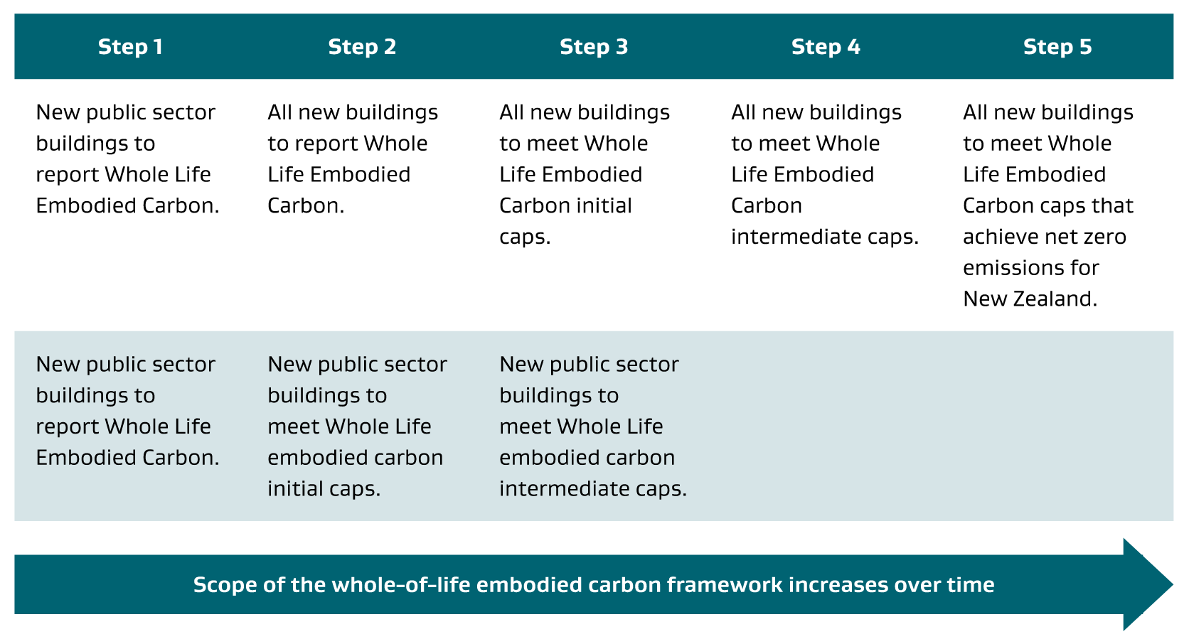
Figure 7: Proposed steps for the implementation of embodied carbon reduction strategies, reproduced from the Building for Climate Change Programme Whole-of-Life Embodied Carbon Emissions Reduction Framework (MBIE, 2020)

  - Brief for Emissions reduction targets and Environmental Rating Systems
Design teams should refer to the Project Technical Brief for specific project requirements in relation to targeted Environmental Ratings (such as Greenstar) and specific emissions reductions targets. Proposed policies are set out in Section 1.10 of the NZ Health Facility Design Guidance Note (Te Whatu Ora, 2022).
The remainder of the requirements in this document relate to the measurement and reporting of carbon emissions data. This supports compliance with specific project brief requirements and allows clear visibility of significant emissions sources to ensure they can be weighed as a factor in decision making. This allows good project decisions to be made, with or without the presence of mandated emissions reductions targets.
The module framework that defines sources of emissions across a buildings life cycle of buildings is shown in Figure 8.
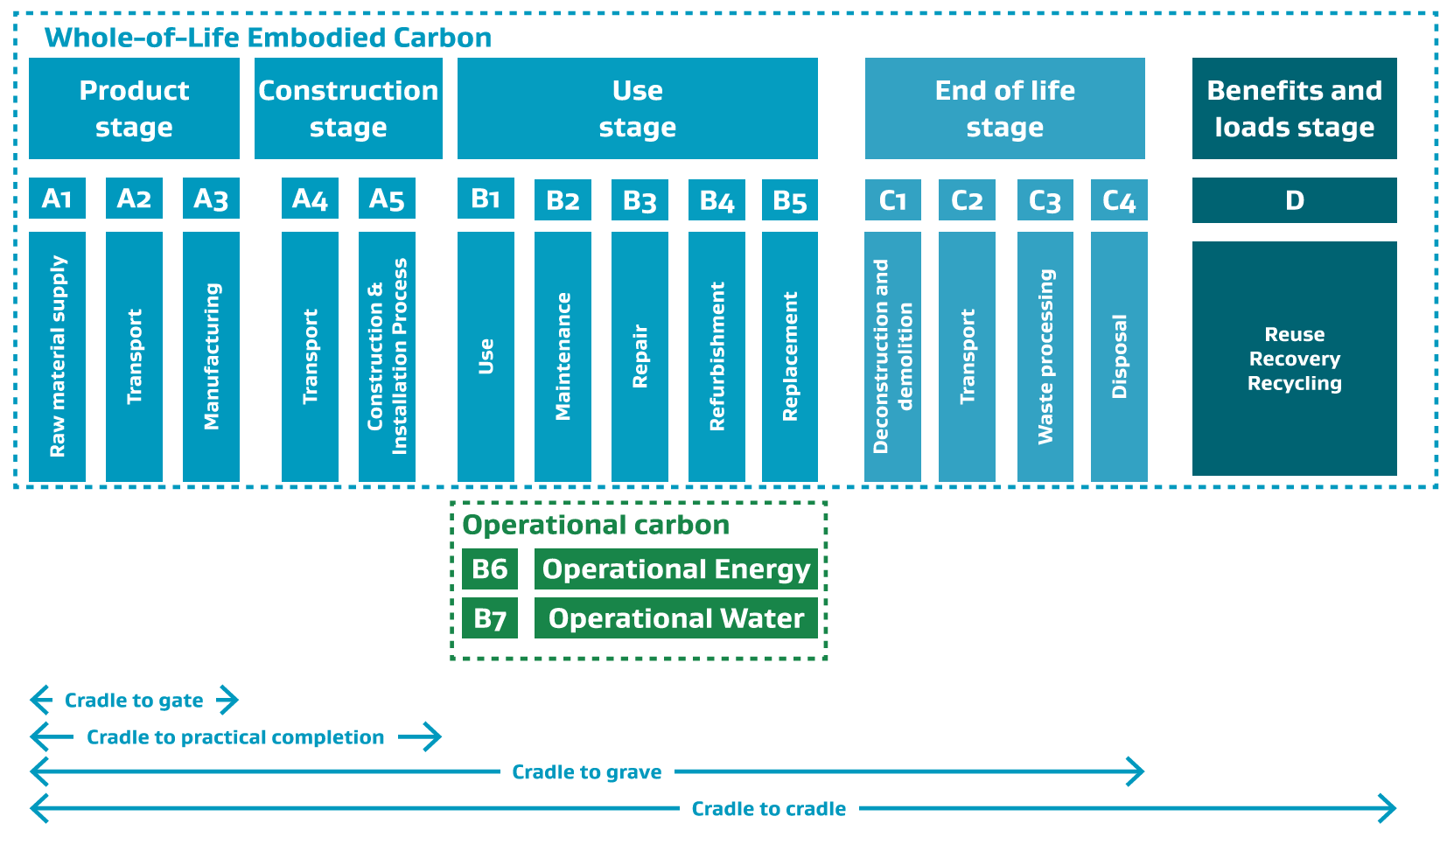
Figure 8: Module framework for life cycle assessment of buildings, reproduced from the Building for Climate Change Programme Whole-of-Life Embodied Carbon Emissions Reduction Framework (MBIE, 2020)
  - Structural Embodied Carbon Emissions
Methodology for calculating emissions (global warming potential)
In general terms, emissions and global warming potential associated with building structures and foundations should be considered in the context of the entire project boundary over its full lifecycle—including embodied and operational emissions. In practical terms, this comprises the following activities:
- Calculation of Up-front Carbon from construction (Modules A1 – A5)
- Estimating Whole-of-Life Embodied Carbon (Modules A to D, excluding B6 and B7)
- Life Cycle Assessment (LCA); (all Modules A to D)
Calculation of Up-front Carbon is straightforward and has one of the largest impacts on global warming potential and the need to reduce emissions now. Its measurement is required for all Health NZ projects (refer to Section A3.3 for requirements). This requirement aligns with the MBIE BfCC framework, and the boundary of the initial mandatory reporting requirements that were proposed. It also aligns with minimum requirements of the NZGBC Greenstar rating tool.
Whole-of-Life Embodied Carbon calculation, and furthermore Life Cycle Assessment (which includes both embodied and operation carbon) is required for significant projects. This ensures any decisions related to minimisation of emissions are made in the context of the whole project, and the whole lifecycle. The value of LCA is also recognised under the NZGBC Greenstar rating tool. LCA helps to ensure sensible decision making but does require assumptions to be made about the latter life cycle stages. It is important that consistent assumptions are applied, and these should be guided by use of the following methodologies:
Health NZ Requirement: For embodied carbon calculation, apply the NZGBC Embodied Carbon Methodology, Version 2.0 - December 2024 (NZGBC, 2024), or most recent version. For Life Cycle Assessment, apply the NZGBC Life Cycle Impacts Calculator Guide, Version 1.0 - May 2023 (NZGBC, 2023), or most recent version.
In lieu of detailed methodologies for Up-front Carbon measurement, Whole-of-Life Embodied Carbon or Life Cycle Analysis (LCA) produced under the MBIE Whole-of-Life Embodied Carbon Emissions Reduction Framework (MBIE, 2020) or the current Emissions Reduction Plan, Health NZ recommend the NZGBC methodology be followed (NZGBC, 2024). This contains detail necessary to guide the application of the methods in practice and select appropriate assumptions for latter lifecycle stages.
In accordance with this methodology, stored Global Warming Potential (GWP-stored) including stored biogenic carbon must be excluded from Up-front Carbon calculations, but can be reported separately. For example, timber sequestration benefits are real (aggregated at scale and provided timber is sourced from managed and replanted forests), but the carbon is absorbed over the timescale of the next regrowth cycle.
Hence, in the presentation of Up-front Carbon calculations, Health NZ require GWP-stored to be calculated independently and reported directly alongside the values which exclude their effect. This is so that its exclusion/separation is immediately clear, and the benefits associated with stored carbon are visible for context, decision making and data-collection. More information can be found in SESOCs Top Tips for Low Carbon Design (SESOC, 2024), and various articles published in the SESOC Journal (e.g. April 2024).
Using Up-front Carbon estimates to inform design
Health NZ recommend that decision making in a design context should be focussed primarily on minimisation of up-front embodied structural carbon, referred to as Up-front Carbon within this guide and the NZGBC methodology. At design completion, the methodology requires Modules A1-A5 to be considered in Up-front Carbon reporting (subject to cut-off rules).
For the purposes of informing early design work, Up-front Carbon can often be simplified to mean Modules A1 to A3 (cradle to gate). However, comparative analysis should expand to include A1-A5 (cradle to practical completion) where the transport and construction components are significant and where sufficiently reliable data are available. The modules included must be clearly stated in the presentation of any summaries—and must be carried consistently across any comparisons. Refer to Sections A2 and A3 for further information on Design Process and Reporting respectively.
The focus on Up-front Carbon is consistent with MBIE’s Whole-of-Life Embodied Carbon Emissions Reduction Framework (MBIE, 2020) and recognises both the complexities and uncertainties of circular economy thinking, and the lag associated with the warming potential of present day emissions—which implies a higher environmental cost from present day emissions (expressed through the concept of a Time Value of Carbon).
However, caution is advised against action to minimise Up-front Carbon emissions which could undermine overarching goals to reduce full life-cycle emissions (cradle to grave—or cradle to cradle). In other words, focus on minimising Up-front Carbon, but keep a weather eye towards Whole-of-Life emissions. For significant projects, the requirement to complete a project Life Cycle Assessment allows these aspects to be kept in view.
- Additional Structural Performance Requirements
  - Vibration of Floors
    - Background
For the majority of buildings, vibration does not govern strength or fatigue but can present a serviceability or amenity concern. For most facilities or service areas vibration acceptability is related to human perception and comfort. The underlying objective is avoiding unreasonable nuisance as it relates to the area’s use, and this is more practically/measurably defined as targeting a low probability of adverse comment.
Some facilities house medical equipment and processes that are sensitive to vibration and may need to be isolated from the floor plate or considered specifically in the design/evaluation of the floor response to vibration to ensure satisfactory operational performance.
For some sensitive equipment (such as MRI), the best mitigation is sensible location of departments as part of early planning, to areas that are less exposed to vibration sources and more easily accommodating of equipment weight and transport routes.
    - Sources of Vibration
Footfall induced vibration
The most common and important internal source of floor vibration is pedestrian traffic. The response to vibration emissions from this source is the primary focus for most floor vibration assessment and member sizing. The floor structure needs to not only be sufficiently strong but should also comply with appropriate comfort and serviceability criteria associated with footfall induced vibration.
Other vibration sources
Other internal vibration sources include mechanical plant, machinery and equipment, such as chillers, air handling units, pumps and fans, waste compactors, generators, and vertical transport systems (lifts). Plant and machinery that potentially generate vibration during operation should have mitigation measures applied at the source if possible, using appropriately specified isolating mounts or other damping measures. The Building Services Engineer is responsible for specifying the equipment vibration isolation and mounting requirements. Where plant or machinery cannot be effectively isolated and is to be accounted for in the design of the floor, then forcing functions and load spectrum generated by the plant will need to be sought from the equipment suppliers.
In some instances (usually limited to sensitive equipment), transmission of significant exterior vibration sources (rail, heavy traffic or helipad) will warrant practical consideration.
Internal demolition and construction activities and external construction activities on nearby sites, such as piling, compactors, rock breakers and tracked excavators can generate vibration levels in existing buildings that have an amenity impact on users and could result in damage to structural elements of a building.
The Contractor is responsible for implementing vibration management and mitigation measures to limit vibration emissions to acceptable levels. Building consent conditions and Construction Noise and Management Plans will typically stipulate the criteria to be achieved. The Structural Engineer may need to consider the use of structural solutions in their design that minimise vibration such as non-vibro/impact piling methods.
    - Vibration Assessment Methodology
General evaluation of footfall-induced vibration
Whilst there are several international guidelines available that provide reliable methodologies for evaluating sensitivity to vertical vibration induced by pedestrian traffic, the use of the following methodologies is recommended:
- SCI Publication P354 Design of Floors for Vibration: A New Approach (Smith, Hicks, & Devine, 2009), or,
- Cement and Concrete Industry Publication CCIP-016 A Design Guide for Footfall Induced Vibration of Structures (Wilford & Young, 2006).
It is acknowledged that these guidelines conservatively assume walking activities produce continuous vibration on floors and this is reflected in the response factor assessment approach. In reality, walking activities are not continuous. Both guides provide for the use of an alternative Vibration Dose Value (VDV) approach. This can be used where the limit relates to comfort/nuisance and allows vibration levels to exceed the limits for continuous vibration where the vibration occurrence is intermittent.
The VDV method of assessment should not be used for critical work environments such as operating theatres, precision laboratories and where sensitive medical equipment is used.
Health NZ Requirement: For footfall induced vibration, floor performance should be evaluated using one of the recommended guideline methods in this section (or equivalent). Performance should target the acceptance criteria in Section B5.1.4, Table 9.
The general expectation is that FEA methods would be applied to most conventional suspended slabs in hospital buildings, given their accessibility via a number of proprietary software packages. The simplified methods can be a useful tool. However, they can be sensitive to assumptions such as modal mass, sometimes giving spurious results even in relatively simple cases, usually warranting the effort of a general FEA method for a more consistent assessment.
Notwithstanding, it may be appropriate in some cases to continue to apply simplified hand/spreadsheet calculation in the guides or common empirical methods, such as light timber framed floors or less critical areas.
Evaluation from mechanically induced vibration or other sources
In most situations, evaluation of footfall induced vibration (targeting appropriate limits) together with acoustic engineering input into spaces housing mechanical plant and their separation from other accommodation will result in floor structures that are sufficiently robust to avoid nuisance from mechanically induced vibration. Further mitigation of perceived mechanically induced vibration can be achieved through appropriate specification of equipment mounting and isolation as part of ordinary practice.
In extraordinary circumstances, such as when sensitive equipment is located near potentially significant vibration sources, specific evaluation may be required, although it is better to avoid these situations through appropriate planning. The methods described in the above guidelines can be applied similarly to mechanically induced vibration. However, this is challenging as it requires definition of the forcing function and resulting load spectrums, and force transmissibility is dependent on mount design (ASHRAE, 2012). Forcing functions (where required) should be supplied by the manufacturer (subject to timing/availability) or otherwise sought via the advice of an appropriate specialist and with input from the services or acoustic engineer.
Health NZ Recommendation: Work with Building Services Engineers and Acoustic Engineers, to identify any extraordinary vibration sources that may warrant specific structural vibration evaluation, such as where sensitive equipment is located near potentially significant vibration sources.
    - Acceptance Criteria
Basic natural frequency limit for occupied suspended floors
The natural frequency of any occupied floor shall be limited to a minimum of 3Hz.
General acceptance criteria for footfall-induced vibration
Current standards and guidelines relate human perception and discomfort to the acceleration of the floor. A series of base curves define a normal “lab-ideal” threshold of human perception which is dependent on frequency. The standards define acceptance criteria (satisfactory vibration levels) in terms of a of multiplying factors that can be applied to these base curves before perception issues arise, that are applicable to a floor’s real-world use. The multiplying factors are used as target limits on the evaluated Response Factor for a floor (R-Factor or R-Value). This is the evaluated weighted floor acceleration divided by the appropriate base acceleration value.
The standards ISO 10137 Bases for the Design of Structures- Serviceability of Buildings and Walkways Against Vibration (ISO, 2007) and BS 6472 Guide to the Evaluation of Human Exposure to Vibration in Buildings (BSI, 2008) give recommended limits to achieve a low probability of adverse comment in general cases. The UK document Health Technical Memorandum HTM 08-01 (Department of Health, 2013) provides further specificity for hospital environments, which the NHS (UK) uses to define its performance requirements. SCI P354 gives comprehensive guidance on both contexts (Smith, Hicks, & Devine, 2009).
Health NZ consider HTM 08-01 to be an appropriate performance benchmark. The suggested limits are reproduced in Table 9 with additional service/function clarifications. For all cases, these limits are based on use with W_{g} frequency weighting.
Table 9: Recommended target values for evaluated Response Factor, R, used with frequency weighting Wg
Service or Function | Recommended Response Factor Limit | VDV Limit (m/s^{1.75})  16hr Day
Plant rooms ⁶ | 10 | n/a
General office and staff spaces ¹  CSSD | 4 to 8 | 0.8
General clinical areas: comprising  ED, ICU, general treatment areas, general laboratories, consulting rooms ², other non-sensitive specialist and support function areas | 4 | 0.4
Wards ³ | 2 | 0.2
General radiology (X-Ray) |  | n/a
Operating theatres ⁴, including interventional radiology and cath-lab.  Other radiology and imaging.  Precision laboratories, audiometric testing booth. | 1 | n/a
Sensitive Medical equipment ⁵ | ≤ 1 typically  (manufacturer to confirm)
Notes:
[1] In practice, it is not anticipated that structural solutions for general adaptable clinical floor plates would delineate between general office and general clinical areas (refer to Section B6.2). However, the less onerous limit for general office may be beneficial when considering the lower inherent damping in open plan office formats (compared with clinical areas which usually have more damping from fitout).
[2] Consulting rooms could consider the more relaxed limits associated with general office (in accordance with HTM 08-01). However, for practical purposes this guide considers them broadly interchangeable with other general clinical areas.
[3] It is appropriate to limit application of the more stringent wards performance criteria to patient rooms (bed locations)—especially in the common situation where bed locations in future alterations would likely remain anchored to certain floor plate areas (such as the daylit facades). Other general ward areas can use the limits recommended for general clinical.
[4] This includes most uses surgical uses of operating microscopes (up to 100 times magnification)—and generally remains suitable for manual control forms of microsurgery where footfall induced vibration sources are considered.
[5] Refer to the guidance and commentary below for special acceptance criteria for sensitive equipment.
[6] The suggested limit for plant rooms (within hospital buildings) intends to provide a basic level of robustness and mitigation against vibration nuisance to adjoining spaces or structure-borne vibration (as opposed to occupants of the spaces themselves), and should be easily met in most cases by floors supporting mounted plant and complying with the robustness requirements of Sections C4.2.6 and C4.8.
The Concrete Centre guide (Wilford & Young, 2006) provides helpful commentary on the application of target acceptance criteria, placing into context the “fuzziness” of the criteria. It points out, paraphrasing BS 6472, that “…achievement of the target levels proposed should result in a low probability of adverse comment (but not zero probability), but at twice these levels, adverse comment may result.”
The criteria relate to human perception and acceptance and therefore significant changes in perceptibility would generally require a change in vibration level of about two. The selection of criteria is therefore a matter of risk/cost balance, and this cannot be laid down rigidly for every circumstance—especially where there is cost associated with achieving a rather vague degree of improvement in subjective performance. Binary pass/fail decisions on the second significant figure should be avoided.
Mechanically induced vibration
Where specifically assessed, acceptance criteria for mechanically induced vibration should target the same limits as those given in Table 9. Mechanical vibration sources are usually continuous and so the VDV limit for intermittent vibration will not apply.
Special acceptance criteria for sensitive equipment
Adherence to the general acceptance criteria listed above (based on footfall excitation) should result in floors that are generally fit for most hospital uses, and users are unlikely to encounter issues with footfall induced vibration that aren’t able to be resolved by other practical measures. However, in some cases, further specific evaluation/analysis may be warranted.
Some specialist equipment and processes (including imaging, microscopy and microsurgery) can be more sensitive to vibration—especially where the vibration source is mechanically induced, i.e. continual oscillation from plant or machinery. Where these uses are to be accommodated, it may be necessary to explicitly design floor systems to meet more stringent acceptance criteria than those based solely on occupant comfort, vision or hand control (which is the basis for the acceptance criteria in Table 9).
Acceptance criteria for sensitive equipment are generally given in terms of velocity rather than acceleration, and are based on the Vibration Criteria (VC) curves or grades (VC-A through VC-E). These curves were originally developed and referred to as the “BBN curves”, promulgated more widely by IEST (IEST, 2005), and have been reproduced in several other forms. Although they are velocity based, SCI P354 (Smith, Hicks, & Devine, 2009) provides acceleration-based limiting Response Factors that can be considered generally equivalent for practical purposes, considering all uncertainties in evaluation of vibration response.
Refer to SCI P354 Table 5.6 for general acceptance criteria for design, and the ASHRAE HVAC Handbook (ASHRAE, 2015) for more detailed descriptions of the types of equipment or process applicable to each VC curve. Equipment suppliers should be consulted for specific limiting criteria (or confirmation of the appropriate VC Curve to apply).
In practice, floors that meet the general performance requirements set out in Table 9 for footfall induced vibration rarely encounter problems with sensitive equipment including most forms of medical imaging. Those that do arise are more likely to occur from mechanically induced continuous vibration (rather than footfall excitation). Health NZ recommend specific evaluation is carried out when sensitive equipment is located near potentially significant vibration sources.
In some circumstances, structure-borne vibration transmission can affect equipment located some distance away from the vibration source. However, similarly, this is rare for structures configured to meet the general footfall-based criteria in in Table 9. It usually occurs in rare cases where there is an unfortunate resonance with a structure and floor mode or between the vibration source and the equipment itself. This is difficult to predict with any accuracy—and can generally be resolved by adjustment to equipment operation or mount design or an alternative simple management strategy. Practical examples of this occurring in New Zealand hospital facilities have generally affected more slender floors which would not have met the basic criteria in Table 9.
In situations where footfall induced vibration is explicitly evaluated against the significantly more onerous criteria suggested in the literature for sensitive equipment, excitation scenarios should consider adjusting pace frequency ranges and reducing walking path lengths to reflect realistic actions of persons within the space that are sensitive to the activity/process being undertaken. Remote non-visible excitation scenarios (for example external corridor excitation) may need to consider a different range.
    - Considerations for Soffit Mounted Equipment
For suspended medical equipment mounted to the soffit of floors above, interpretation is required on the application of the general acceptance criteria in Table 9. The values suggested for each service/function provide a reasonable benchmark and encapsulate the requirements applicable to most suspended equipment that is normally associated with those uses. Notwithstanding, the following considerations should be made in the judgement of appropriate limiting criteria and/or adjustments in methodology.
- The nuisance is not felt vibration, but visual nuisance (such as bouncing monitors), the performance of imaging equipment, and potential the impact on procedures using microscopy or magnification (where such equipment is pendant mounted).
- For footfall induced vibration, the source of vibration is remote, not visible, and generally less able to be managed/controlled (those causing the vibration are on the floor above, and are not sensitive to the activity affected by it). This affects the selection of analysis parameters defining the vibration source.
- If the floor supporting the suspended equipment also houses floor mounted plant such as air handling and pumps (locating plant areas above operating theatre suites is a common approach) then there is a higher chance of direct mechanically induced excitation causing nuisance. This can be problematic for imaging and procedures using magnification.
- For pendants with significant cantilevers, it is difficult to predict when amplification from resonant harmonics might cause issues. Although reasonably rare, these issues can be difficult to resolve if they arise.
- Ideally corridors (for example) would not be located above potentially sensitive directly suspended equipment. However, it is unlikely to be practical to apply such planning constraints in practice.
Soffit mounting equipment of a non-critical nature with due regard to the above considerations is a common and acceptable practice. Examples include:
- Suspended monitors/screens, and general procedure lighting.
- Patient hoists.
- ICU/HDU pendants (power, data, medical gases, monitoring equipment, supplies, and the like).
Soffit mounted equipment with imaging functions or visual magnification can be done, but should be treated more cautiously on case-by-case basis, and the methodology for its assessment adjusted considering the factors listed above.
Strategies for supporting suspended medical equipment is a key decision point in some parts of Acute Services facilities, most notably operating theatre suites, ICU/HDU and various subparts of radiology/imaging. Floor mounted pendant support frames have reasonably common precedent, where beams spanning within the ceiling plenum are used to suspend equipment/pendants, supported by posts located within the partitions (or possibly by the partition framing itself for lighter weight systems). With this approach, the location of vertical support within partitions means the potential for excitation is reduced due to the stiffening effect of partitions themselves, and their damping contribution. In addition, the most likely sources of vibration originate from the floor itself, and thus are more easily managed.
However, the spans and seismic bracing requirements can lead floor mounted support frames to be costly relative to soffit mounted options (especially once frames are adapted to coordinate with partition layouts and openings, components and fixtures, and the contents of the ceiling plenum). In these cases, soffit mounted options should be considered, especially where the floor systems above are heavier/stiffer and less prone to vibration transmission, or where the suspended equipment is of a non-critical nature and less sensitive to vibration.
The decision is likely to be influenced by the NSE Seismic Design Strategy, because the lateral bracing design and approach to accommodating deformations has significant influence on the cost and practicality of floor mounted support frames. The following considerations should be made:
- A coordinated approach to the vertical support and bracing of partition and ceiling systems (possibly benefitting from the integration of partition/ceiling systems with pendant support frames).
- Whether lateral bracing loads on frames are carried by bracing or portal action to the floor on which they are supported, or to posts which span simply between floors (for lateral loads).
- The approach for accommodating lateral building deformations (and limiting the drifts imposed on deformation sensitive components).
- The approach to spatial coordination of other NSE within the ceiling plenum, and their vertical support and bracing.
- Procurement timing of major medical equipment, the adaptability of support framing and timing of equipment selection relative to other construction works.
  - Structural Performance in Fire
The Health NZ Design Guidance Note Fire Engineering Design for New Zealand Public Hospitals contains information on requirements for structural performance in fire and should be referred to. Key aspects for structural engineering audiences are summarised in this section.
It will be useful for Structural Engineers to have general familiarity with the content of the fire engineering design guidance note. However, it is anticipated that document would be applied predominantly by fire engineers (including structure-fire engineering specialists, where appropriate), and requirements for structural design conveyed to structural engineers via the Fire Engineering Brief process (as summarised below).
The intent of this section is to clarify (for structural engineers) the requirements of the Building Code for structural performance in fire, background to some of the requirements relevant to hospital building design, and typical compliance pathways.
Requirements of the New Zealand Building Code
The New Zealand Building Code contains requirements relevant to structural performance in fire in two clauses:
- NZBC Clause B1 Structure (specifically, B1.3.3 requires fire to be included in considerations of structural stability, to meet Building Code objectives).
- NZBC Clause C6 Structural Stability, which contributes to the objectives stated in C1 Protection from Fire.
  - Safeguard people from an unacceptable risk of injury or illness caused by fire,
  - Protect other property from damage caused by fire, and
  - Facilitate firefighting and rescue operations.
Compliance with NZBC Clause B1 can be achieved by applying cited standards in the deemed-to-satisfy B1/VM1. For example, AS/NZS 1170.0 Cl. 4.2.4 (as amended by Section 2.2.4 of B1/VM1) states the combination of actions for the fire design situation at the Ultimate Limit State. Whilst the suite of combination of actions contains the “thermal actions arising from fire”, this action is undefined by AS/NZS 1170 and B1/VM1 (the cited standards only contain various methods to establish fire resistance). Therefore, this action must be defined.
Usually, input on demands is confirmed by the project’s Fire Engineering Brief process (by the Fire Engineering Strategy, or Fire Engineering Report) which is developed by the Fire Engineer. This input via the Fire Engineering Brief process is what allows B1/VM1 to be applied. It also allows any other requirements for structural performance to be conveyed to the Structural Engineer, if necessary, so that the building fire engineering design overall complies with NZBC Clauses C1 to C6.
Considering all objectives of NZBC Clause C Protection from Fire listed above (not just structural aspects), the requirements of Clauses C1 to C6 can be met for ordinary buildings by applying Acceptable Solution C/AS2 or Verification Method C/VM2 (which involves testing a trial concept design through a number of prescribed ‘Design Scenarios’ until an acceptable result is achieved for each scenario). As most hospital buildings are not within the scope of Verification Method C/VM2 nor Acceptable Solution C/AS2, an Alternative Solution is used to demonstrate that the design (as conveyed via the Fire Engineering Brief process) complies with NZBC Clauses C1 to C6. This may include continuing to apply the parts of the available C1-C6 compliance documents (such as C/VM2) that remain applicable and appropriate.
The Fire Engineering Design for New Zealand Public Hospitals Design Guidance Note provides reasonable grounds for Alternative Solutions to Building Code compliance that are aligned with the intent of the available C1 to C6 Acceptable Solutions and Verification Methods and which consider the necessary aspects specific to hospital contexts and its specifically developed Fire Engineering Brief.
NZBC Requirement: For structural stability during and after fire, the structural design shall comply with the requirements of B1/VM1 (or in the case of Alternative Solutions, the performance required by NZBC Clause B1), and shall align with any requirements of the project Fire Engineering Brief related to compliance with NZBC Clause C6.

Pathways for evaluating structural stability during and after fire
Two general methods are available for selecting an appropriate level of structural fire resistance:
- Prescriptive approach
- Performance-based structural fire engineering
Refer to the Health NZ Design Guidance Note Fire Engineering Design for New Zealand Public Hospitals which provides further definition to these two pathways. Performance-based structural fire engineering is a specialist skill that requires extensive knowledge of both structural and fire engineering fields so should only be undertaken by competent and qualified structural fire engineers.
    - Structural Stability During Fire: Background
The purpose of this section is to provide clarity in the scenarios applicable to structural fire design and stability (and the basis for requirements conveyed in the Fire Engineering Brief) and compare this with scenarios intended for the safety of people.
Background to the structural fire design scenario
Structures constructed using common materials (reinforced concrete, structural steel, masonry, and mass timber) are inherently resistant to the routine challenging fire scenarios that are assessed for protection of the building occupants. A fire needs to reach flashover and full development to create the fire conditions which are necessary to significantly degrade structural material strength.
The fire scenarios which threaten structural stability (usually based on full burnout without intervention) occur only when several of the fire systems provided in a hospital building all simultaneously fail to perform as designed or the event is outside the range of the design parameters. A fire needs to start, spread beyond the item ignited to involve other items in a space, grow unsuppressed by the building occupants or a fire sprinkler system, maintain a sufficient source of outside air (such as by breaking windows) and continue growing without firefighter suppression until the enclosure is fully involved in fire. If all these pre-requisites eventuate, the structure can be heated to temperatures which may reduce strength and stiffness.
The occurrence of this type of fire in buildings is rare, a very low probability event treated as an Ultimate Limit State design condition in structural engineering terms (where the consequences of structural failure could be significant, but the likelihood of being exposed to such severe demands is very low). The design process aims to protect life during extreme events by ensuring that the probability of structural collapse is kept to an acceptably low level.
In such a scenario (and amongst other things), large fire-induced structural deformations are expected to occur, but the structure should not collapse. Significant structural damage may occur even when structural load-bearing capacity remains adequate. This ULS condition is distinctly different from more commonly occurring events that are typically mitigated by the operation of at least some of the fire safety systems in a sprinkler-protected building - these are more comparable to serviceability limit state design conditions (in structural design terms).
Verification Method C/VM2 contains information on design scenarios that can be used in ordinary buildings to demonstrate compliance with NZBC Clauses C1 to C6: Protection from Fire. This includes challenging fires that represent credible worst-case scenarios, and a robustness check that requires failure of critical elements of the fire safety system to be considered (if their failure is considered statistically probable). This is to test the vulnerability of the life safety design and inherent redundancy.
Fire sprinkler systems installed in accordance with certain recognised standards are considered sufficiently reliable that C/VM2 does not require their failure to be considered in the robustness check. This means that holistically, for building and fire engineering designs that meet the Building Code objectives to safeguard occupants from unacceptable risk of injury or illness, it is unlikely that the structure will reach temperatures that could cause significant deformations nor affect its stability.
Hospital buildings often require managed evacuation or have other unique features that exclude them from the scope of Verification Method C/VM2. However, the underpinning principles endure. Of key importance is the provision of sufficient reliability and redundancy in fire safety systems (such as through the application of an approach aligned with the intent of C/VM2) which makes it very unlikely that fully involved flashover fires could eventuate.
Notwithstanding, the very high consequence of structural collapse (both in terms of threat to life safety and rescue operations, and the potential for damage and spread of fire to other property including that housing evacuated patients) usually requires the likelihood of this outcome to be further reduced most often by consideration of structural stability for the full duration of burnout. This places less reliance on the active fire safety systems and more reliance on passive insulative protection providing direct protection to the members themselves (i.e. fire service intervention and automatic operation of fire sprinkler systems are typically excluded).
The performance requirement in such a severe ultimate limit state scenario is limited to the avoidance of structural collapse, the tolerance of the fire safety systems to structural damage and deformation does not need to be considered as a design objective if the assessment of structural stability is not reliant upon them.
    - Fire Safety Following Earthquake
The continued functionality objective (achieved through consideration of Serviceability Limit State 2 or SLS2) requires continued building use following a significant earthquake. Neither the Building Code, nor its compliance documents contain specificity around the requirement to explicitly consider fire scenarios immediately following earthquake (either as a result of earthquake or during normal building use following earthquake). However, some level of consideration of safety for continued building use is implied for buildings having requirements for post-disaster functionality (via an SLS2 limit state) and this extends to the buildings fire safety systems.
This document requires designers to consider protection from fire when using a building after a significant earthquake as part of the SLS2 limit state. However, it does not require the same performance standard to be met as that which would be used to comply with Building Code Clauses C1 to C6 in normal conditions. In developing the requirements of these guidelines, the following principles have been considered:
- Redundancy that is present in the fire safety system, means that the failure or partial failure of an element of the fire safety system is unlikely to result in the fire safety system not continuing to meet the objectives of the building code.
- The likelihood that a passive fire or smoke separation will continue to fulfil its function, despite the presence of some damage (dependent on the damage state), whether based on test or a rational assessment of how the element functions and what impact the damage is likely to have on its performance.
- Where an element of the fire safety system could be compromised (either an automatic or mechanical system is not operating or there is reduced confidence in the effectiveness of passive systems due to earthquake damage) the ability to put additional management strategies in place to minimise the risk of ignition or fire spread beyond the source of ignition, and to maintain such strategies until such time as full function is reinstated.
- Mobility of persons in an area, and ability to move patients to a different area if smoke spreads more rapidly than intended, due to damage to smoke separations.
These principles have been considered in the Seismic Performance Framework and the Descriptions of Physical States for the SLS2 and DCLS in Section B2. For non-structural elements forming part of the fire safety systems, they are deemed to be met by application of the requirements in Section C4 Non-structural Elements: Detailing and Structural Support.
For details where explicit design criteria or detailing examples are not available in Part C of this guideline, design teams should apply the above principles, and exercise appropriate professional judgement. This should generally be based on a qualitative assessment of the issues, with input from the fire engineer and the discipline(s) responsible for developing, specifying and inputting into the details.
Statements warranting compliance with Building Code C Clauses following SLS2 levels of shaking are not required, nor are they appropriate, as a risk-based approach is required. The design team should be able to express on reasonable grounds that the expected level of damage to the fire safety systems as a whole (from SLS2 shaking) is unlikely to present a disproportionate risk to the safety of occupants (from fire) that would prevent the building from continuing to be used. Refer to Section C4.5.3 for additional commentary on the application of these principles to the common example of fire performance of engineered slip planes following subjection to earthquake deformations, and the development of acceptable details.
- Structural Requirements for Adaptable Spaces
  - Spatial Planning
Hospital facilities are generally planned and designed to a principle of long life loose fit. This recognises that the specific building uses may need to change over time, due to:
- Changing models of care with time, which can result in desired room or ideal health planning unit sizes growing and shrinking or different adjacencies being desired to create staffing and floor area (GFA) efficiencies or opportunities for sharing space.
- Strategies for managing increases in service capacity, decant and development strategies, and relocation of healthcare services/departments.
Although wholesale changes to a buildings function and fitout are rare in the short to medium term, the provision of regular adaptable spaces are preferred over structural solutions which are overly bespoke to specific planning arrangements or fitouts.
Regular Primary Structural Grids, and alignment with Health Planning Units
To minimise cost and maximise adaptability, structural performance, and ability to standardise façade components, teams should seek to maximise grid regularity to the extent practical, minimising bespoke variance. It is preferable to accommodate lateral stability logically structure within such a grid arrangement or locate concentrated bracing structure at anchored points on plan where they are least likely to impose on efficient planning, and adaptation of fitout in future.
An ability to modulate structural grids with standard health planning units has some merit. Some standard AusHFG health planning units such as the Adult Acute Inpatient Unit provide standard room layouts for common repeatable rooms that are intended to modulate with common structural grids (such as 7.8m or 8.4m).
Design teams should be conscious that some structural typologies can produce columns sizes and structural grid offsets to façade which may encroach on the standard room layouts and challenge common rules around grid and GFA efficiency, especially in higher seismic zones. These factors should be considered as part of concept optioneering and test-fit to ensure such assumptions around common modulations are appropriately tested.
Avoiding reliance on detailed fitout for primary structural support
For most secondary and tertiary healthcare facilities, reliance on fitout for primary vertical or lateral structural support is undesirable. It creates challenges in alterations (or even in facilitating simple design changes during construction). It can introduce compliance risk; and achieving satisfactory load paths can be difficult to execute effectively in many practical construction environments with risk of hidden costs. These construction types also generally involve the use of bracing systems which, whilst inherently robust from an overall structural safety point of view, can be more prone to quicker onset of damage.
Additional commentary and requirements are located in Section C5 Design of Lightweight and Low-rise Hospital Infrastructure.
  - Adaptable Floor Structures
Some principles or strategies commonly considered to improve adaptability of floor plates in healthcare facilities are listed below. They are not exhaustive, nor do any constitute a specific requirement.
It is important to weigh Health NZ ’s desire for adaptability and the ‘long life loose fit’ design principle, with the cost associated with implementing some of these strategies. In many instances, simple and regular adaptable design thinking will incur little premium. In other situations, specific provisioning for maximum adaptability in future uses can incur cost. For example, approaches that add significant amounts of seismic mass can have incremental flow on impacts to foundation structure and lateral stability structure which may or may not be significant depending on the structural typology and project context. It is important to test the cost of future provisioning against the extent of value in provisioning that is likely to be realised.
A converse and similarly important lean-design principle is ‘design for now, strengthen if use changes’ (Watson, 2020). This principle is applied in sustainability contexts but is relevant to both up-front and whole-of-life cost and carbon cost. The principle proposes that the cost in applying blanket future provision can be higher than the cost to strengthen or alter specific areas as needed in the future without such provisions being made. In fact, designers should recognise effort internationally (in general contexts, not specific to healthcare) to reverse trends towards cautious overspecification of floor loads and explore evidence-based reductions in prescribed live loading to manage adaptability and reuse.
In the context of hospital design, significant structural strengthening or alteration is more difficult and Health NZ want to minimise the instances that this is required, but this principle should still be considered in this context. In some instances, it may lead to a more targeted and strategic approach to specific future provisioning that is a better overall use of healthcare infrastructure investment budget, with lower Up-front and Whole-of-Life Embodied Carbon outcomes.
Health NZ Recommendation: Consider strategies that minimise any unreasonable impediment to future adaptability, and weigh these in tension with estimated up-front cost premiums and the realistic extent of value likely to be realised from any specific and potentially costly provisioning that is proposed. Blanket overprovisioning is discouraged.
Example strategies and considerations for improving adaptability of floor plates
- Design for floor loadings that capture the range of uses across a facility and provides a basic minimum flexibility for future reconfiguration (refer to Section C1.2). Adoption of minimum code loading requirement specific to the initial intended use may limit the adaptability of floor plates, notably in respect to ward use.
Strategic approaches to providing adaptability via floor loading should be considered. Often hospital floors that meet vibration and robustness requirements can deliver high local load capacities. This is desirable can be taken advantage of in future adaptations. However, often these loadings need not be accumulated over large areas to the extent that they impact seismic mass, primary column or foundation sizing (as this approach to blanket over-provisioning will usually carry a high structural premium). Instead, Health NZ prefer designers to deliver a design which complies with Design Actions Standards (AS/NZS 1170 Suite) for the initial proposed use, with strategic philosophy to demonstrate that sufficient provision for future adaptability exists, but which avoids blanket over-provisioning where possible. Approaches should be recorded in loading plans and clarified in project documentation (Structural DFR) as appropriate.
- Consider appropriate allowances for heavy equipment and strategies for accommodating transport routes for installation, replacement and maintenance. Transport routes should generally be considered on a point load or moving point load basis (a smeared UDL over the entire route would overestimate the total load).
- Longer span floor systems with minimal vertical obstructions provide spatial flexibility for future configuring. However, floor vibration and beam depth considerations may limit achievable spans. This is generally a higher embodied carbon solution and may also put upwards pressure on floor-to-floor heights.
- Provision of floor systems that accommodate future services reticulation with minimal restrictions or need for structural alterations.
- Consider use of flat soffit floor systems that more readily facilitate fire sealing at firewall slab junctions, particularly with future fitout reconfigurations. This can be more difficult to achieve where troughed or ribbed floor systems such as metal tray decking are utilised.
- Provision of non-structural screeds can provide layout flexibility where set downs may need to be accommodated with any future reconfiguration. This has particular relevance to ward floors where ensuite setdowns may change over the building’s life, or for special areas such as radiology.
However, the use of significant extents of screeds to larger areas such as wards (for example) can have cumulative indirect impacts on structural cost. These impacts can be material, depending on the structural typology. This needs to be approached cautiously and more targeted approaches may be necessary, or a degree of compromise accepted in the future approaches that could be used to achieve falls for wet areas, to avoid adding unnecessary cost.
Special areas (such as radiology) can benefit from setdowns (and screed) to provided adaptability and allow for chasing for supply conduit/cabling. There are recent examples where such historic provisions had been made but not utilised at all in shell fitouts or refurbishments, and the setdowns simply filled in with slab or screed. However, this does come with mass and stiffness benefits that can (and should) be exploited to achieve tighter acoustic and vibration criteria and so this approach can still make sense locally.
- Plant platforms should generally be of concrete construction (with the exception of lightweight roof plant installations) to accommodate present and future plant requirements. Loading allowances should consider concrete plinth requirements (and the potential requirement for vibration isolating mass blocks in some limited instances) in addition to plant loading allowances, (refer to Section C1.2).
  - Floor to Floor Height and Ceiling Plenum
Establishing appropriate floor-to-floor heights is a key project decision in multistorey hospital buildings, with a significant associated cost and construction risk implication.
The decision requires careful balance of up-front construction costs, including buildability risks, and reasonable considerations around maintenance and adaptability. Some costs are directly measurable and quantifiable, for example façade area. Some costs are indirect, such as lateral system member sizes/weights per lineal metre. There are also some potentially hidden costs, or cost risks. Commentary is provided below on key factors to consider.
In multistorey hospital buildings, historical precedent over recent decades has established a common base expectation of 4.2m for ward use, and 4.5 to 4.6m for general clinical use. These are based on the generally accepted ceiling heights as recommended by the Australasian Health Facility Guidelines, and the spatial requirements of ceiling plenums. Valid variations from these values are common. The appropriate floor to floor height will be highly dependent on the structural framing system and floor system, and the type and distribution of the structural lateral stability system. Minimising RL differences with existing buildings that are linked is also a potentially constraining consideration.
In general terms, smaller structural grids (smaller floor spans) and concentrated lateral bracing system types (walls or braced frames) tend to minimise structural depth and constraint on the ceiling plenum and give more opportunity to reduce floor to floor height.
Benefits of increasing floor to floor height
- Reduced congestion in the ceiling plenum (other than bracing, see below). Reduced spatial coordination risk.
- Increased space to accommodate support framing for suspended medical equipment (pendants and/or suspended imaging equipment).
- Potentially increased opportunity for zoning of the ceiling plenum and for the incorporation of standardised and/or modular construction approaches.
Direct cost of increasing floor to floor height
- Façade area, and area of internal partitions (due to increased height).
- Length of vertical structural elements (columns/walls/braces), and length of vertical riser stacks.
Indirect cost of increasing floor to floor height
- GFA required for travel (additional stair risers and possibly additional landings).
- Impact on structural sizes and/or weights, primarily in the structural lateral system and its foundations. This is especially important for moment resisting frames, where increased floor to floor height puts upward pressure on seismic frame beam depths.
- Façade specification (glass specification and mullion sizing for unitised façade), and structural requirements for heavy cladding such as precast concrete panels.
Potentially hidden costs, or cost risks of increasing floor to floor height
- Increased seismic bracing offset for components within the ceiling plenum, increased cost in seismic bracing of suspended services and ceilings.
- Impacts on partition design (and potentially GFA impacts if stud sizes are affected). For part height partitions, the plenum height may impact the bracing system. For full height partitions, the impact depends on the approach to partition framing and the location of deflection head tracks or engineered slip planes (where applicable)—the size of the ceiling plenum may result in a different approach becoming preferred. Wall stud sizes and/or centres could be affected, along with any plenum bracing. Refer to Section C4.5 for more commentary.
- Increased length of braces and potential for clashes for seismic restraint of non-structural elements and services suspended within the ceiling plenum, or increased size/cost in ‘downstand cantilever’ restraint details.
- Length and bracing capacity of droppers, “cotton reels” and the like for suspended monitors, patient hoists, pendants or medical equipment.
- Potential fire protection engineering implications related to the size and contents of the ceiling plenum.

- Alterations to Existing Buildings
  - General
This section applies to any work in existing buildings, including:
- Alterations and additions,
- Refurbishments or major maintenance projects,
- Relocating departments or changing a building’s Service Category.
All new work completed as part of alterations or additions to existing Health NZ buildings is required to comply with the Building Code and the requirements of this guideline (except where Health NZ Requirements are exempted under the relevant subsection of this section).
The extent of structural review required to the existing building as a whole and/or the work area affected (including structural support and restraint of existing non-structural elements) depends on the context and the type of work involved. To guide these requirements, alterations (including changes in use or Service Category) are categorised as follows:
- Minor Alterations, Section B7.2.
- Significant Alterations and Additions: Section B7.3.
- Changing the Service Category or “Use” of an Existing Building: Section B7.4.
These groupings are defined in the relevant sub-sections along with corresponding requirements. The requirements are summarised here in Table 10 and Table 11. Refer to the subsections for commentary.
Health NZ Requirement: For seismic performance aspects, all alterations (including non-structural alterations) shall follow the decision-making flow chart in Figure 9, with a record of decisions and their basis provided in the Structural Design Features Report (DFR).
The Building Act and Regulations also define and contain requirements for Substantial Alterations that will need to be complied with in any alteration. This document does not contain further guidance on requirements for Substantial Alterations under the Building Act beyond the clarification and commentary given below.
Building Act Requirement: Comply with any requirements for Substantial Alterations (as defined by Clause 11 of the Building Regulations), such as Section 133AT of the Building Act for buildings with an Earthquake-prone Building notice.

Note that the distinction between 'minor alterations' and 'significant alterations’ as defined by Health NZ is different from the term Substantial Alterations used in the Building Act. Section 133AT of the Act requires that any buildings with earthquake-prone building notices undergoing Substantial Alterations must also address the seismic issues at the same time, and not delay them until the expiry of the Earthquake-prone Building notice.
Substantial Alterations are defined in Building (Specified Systems, Change the Use, and Earthquake-prone Buildings) Regulations 2005, clause 11 and the threshold is based on the cost of the work compared with the total value of the building. More information can be found at Earthquake-prone buildings: substantial alterations. If the hospital building does have an earthquake-prone building notice and the alterations meet the Substantial Alterations threshold, then the seismic work will also need to be undertaken.
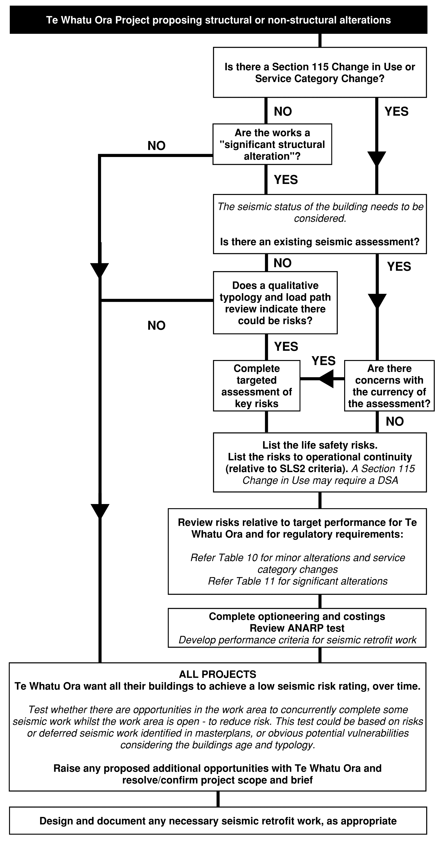
Figure 9: Flow chart for projects involving alterations to buildings (including non-structural alterations). Refer to Sections B7.2 and B7.3 for definitions of “minor alteration” and “significant alterations and additions”.
Table 10: Health NZ ’s performance requirements for existing building performance in minor alterations and/or Service Category changes—subject to consideration of what is as near as is reasonably practicable for each project’s context.
 | Section 115 Change in Use | Alterations or Service Category changes delivering a significant increase in occupancy | Alterations or Service Category changes delivering significantly increased dependency on care | Other minor alterations or Service Category changes
ULS | B1/VM1, ANARP | Low Earthquake Risk, ANARP |  | No specific requirements
SLS2 |  | The new service (and engineering systems servicing the new area) should meet SLS2 performance as defined in these guidelines, ANARP

Table 11: Health NZ ’s performance requirements for existing building performance for significant structural alterations and additions (shown grey)—subject to consideration of what is as near as is reasonably practicable for each project’s context.
 | Significant additions extending vertically (adding floors) | Significant additions extending laterally |  | Adding significant weight/mass or altering primary structure load paths
 |  | Tied, but not reliant on existing structure | Reliant on existing structure
 |  | 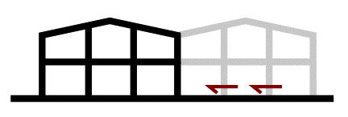 | 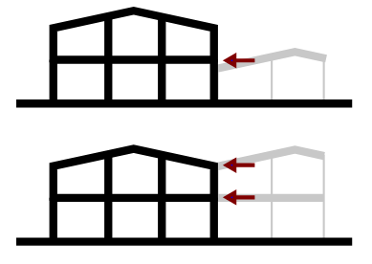 | 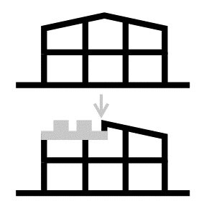
ULS | B1/VM1, ANARP | Section 112 and  Low Earthquake Risk, ANARP¹ | B1/VM1, ANARP¹ | Section 112
SLS2 | The new service (and engineering systems servicing the new area) should enable it to meet SLS2 performance as defined in these guidelines, ANARP

    - Testing opportunities to carry out seismic work as part of minor alterations
Many minor alteration projects, especially those that expose primary structure, create opportunities to complete seismic work in Earthquake Risk buildings more efficiently with minimum cost and wastage from preliminary and general costs (P&G), demolition and reinstatement of building services and finishes. This may not improve the buildings Seismic Rating, but can still have benefits including:
- Reducing the risk profile by addressing local hazards in or near the work area.
- Forming part of staged works that give broader seismic enhancements to the building as a whole (and its Seismic Rating)—over time.
Generally, this would be most applicable to isolated/discrete securing aspects (such as precast floor seating retrofit, roof bracing improvements and anchorage into concrete structure, etc.) that are accessible from within the work area. However, it could involve more extensive retrofit work to Seismic Risk buildings (within the work area) if enough information was available to form the basis for this and there was a forward plan to complete any associated work required outside the alteration area in the future and provided sequencing implications were practical.
Teams should seek any available information on the seismic status of the building being altered and use this to make a recommendation as to whether Health NZ should consider extending the project scope to include seismic work to vulnerable components accessible from within the work area.
If there is no available information on seismic status, then engineers should consider the age and typology of the building, and provide an opinion on whether there are likely to be any vulnerabilities and whether there could be value in further targeted assessment.
Health NZ Recommendation: Use available information on seismic status to test whether there is an opportunity to complete seismic work in the area affected by the works, whilst there is access. If there is no available seismic assessment information, consider, based on the age and typology, whether further targeted assessment could be warranted.
  - Minor Alterations
This guideline defines minor alterations works as any of the following:
- Fitout works (not changing the building’s Service Category as determined by Section B1.2), generally falling within the structural loading allowances made in the original construction and not substantially altering the buildings overall weight or seismic mass,
- Minor primary structural alterations which do not substantively alter global load paths through the building structure or its response/behaviour.
- Minor additions adding small areas of new usable space or mass which are not significant in terms of the overall buildings mass (and therefore wouldn’t materially affect the level of compliance of the existing structure).
  - Small lean-to type awning structures or extensions, or link structures.
  - Rooftop penthouses.
  - Rooftop installations of photovoltaic (PV or solar) roof panels or lightweight plant platforms.
For minor alterations, Section 112 of the Building Act applies generally—which requires the level of compliance of existing structure to be no worse than prior to the alteration.
Any new work being completed as part of the alterations is required to comply with these guidelines and B1/VM1, with a demonstrated load path back to existing primary structure (floors and building frame) for all relevant loading conditions (including gravity, wind and earthquake). This includes confirming that the existing primary structure can support these locally imparted loads by review of the original construction documentation, engineering judgement and specific calculation where necessary.
NZBC Requirement (B1/VM1): All new work being completed as part of the alterations shall comply with B1/VM1, with a demonstrated load path back to existing primary structure for all relevant loading conditions and demonstrated capacity of primary structure to support these imposed loads.
In the case of small minor additions (that are not a Substantial Alteration) Health NZ don’t require the existing primary structure overall to be assessed rigorously in a global sense, nor does its Seismic Rating necessarily need to be known.
It is difficult/impractical to apply strict thresholds due to the many varied contexts, the Building Act does not define them and requires case-by-case assessment. However, total additions within say 10-20% of the respective floor’s mass and within 5-10% of a building’s overall mass (measured relative to the original design intent and construction) represent a range of common precedents that have successfully met this test in the past.
The new work must comply. Calculation that demonstrates sufficient vertical and lateral support for the new work should be carried far enough into the existing building’s principle structural masses (floor or roof diaphragms), such that the additional mass added becomes a sufficiently low proportion of existing.
If in doubt, consider the works as potentially significant alterations or additions and refer to Section B7.3, and the comments in Section B7.5 regarding how to determine what is as near as is reasonably practicable.
Exemption from Documentation Requirements
Refer to Section A1.6.
  - Significant Alterations and Additions
For significant alterations (outside the scope of Section B7.2: Minor Alterations) Section 112 of the Building Act continues to apply as it does for any structural alteration work. However, situations can arise where ensuring compliance of the new work may require part or all of the existing structure to comply as near as is reasonably practicable with B1/VM1, both as a Health NZ requirement as well as a reasonable interpretation of the Building Act.
This guideline defines the following situations as significant alterations or additions, and provides recommended interpretations for each in the subsections that follow:
- Structural additions which add significant occupied space or area, including:
  - Additions extending vertically (adding additional stories to existing structures), thus relying on the existing structure for vertical and lateral support,
  - Additions extending laterally and tying new structure to existing structure, either:
    - without significant reliance on existing structure for vertical or lateral capacity, or;
    - reliant on existing structure for lateral support.
- Other significant alterations, being those that don’t add significant occupied space or area, but either:
  - add significant additional weight or seismic mass to existing structures, or
  - substantively alter global load paths through a building’s structure or its response/behaviour under lateral loading.
Table 12: Types of significant alterations
Significant additions extending vertically (adding floors)  Section B7.3.1 | Significant additions extending laterally  Section B7.3.2 |  | Adding significant weight/mass or altering primary structure load paths  Section B7.3.3
 | Tied, but not reliant on existing structure | Reliant on existing structure

The general stances set out in the following subsections shall be subject to the specific context of each project and would need to be mutually agreed with Building Consent Authorities in their role to assess against the requirements of the Building Act.

    - Additions Which Extend Vertically (Adding Stories)
Consider, especially for lightweight roof penthouses or plant extensions, whether the works can instead be defined as minor alterations to Section B7.2.
Otherwise, the existing structure should be assessed in conjunction with the proposed new works, and should comply with B1/VM1 as near as is reasonably practicable for overall vertical and lateral stability and strength. For the existing structure, this need only apply to primary structure (not compliance of existing secondary and non-structural elements) but does require considering the overall combined stability of the primary lateral and gravity structure under lateral loading.
Generally, material strengths, deformation limits and load and resistance factors should be applied as required by B1/VM1 for consistency. For example, use design strengths R_{d} (φ R) as defined by AS/NZS 1170.0. However, the Assessment Guidelines may be used to assess the deformation capacity of existing components which do not comply with the detailing requirements of new building standards. In all cases, as near as is reasonably practicable principles can be considered.
Applying “no worse than before” instead of B1/VM1
Assessing overall structural stability on the basis that the expected seismic performance is similar to the performance of the original altered structure (justifying below code performance) is unlikely to be appropriate in all but very limited contexts. The performance of the new construction work would not meet the standard required by the Building Code, and Health NZ ’s risk profile would increase.
Such an approach shall only be permitted in direct consultation and explicit agreement with the Health NZ HEAG.
    - Additions Which Extend Laterally
Where there is not significant reliance on existing structure to provide vertical or lateral support
This means the new alteration could support itself vertically and brace itself laterally even if it were not tied to the existing building (applying a level of engineering judgement). It would usually apply when extending a building using a similar form of construction.
In this situation, the obvious alternative is to provide structurally independent buildings. This is probably preferred and more logical unless both the new and the existing structures are similar and modern and the existing structure is expected to perform to Building Code standards (more or less) and where there are clear benefits to tying. However, it is acknowledged that many varied contexts that can arise and so the following stance is presented, should it have relevance.
When extending laterally and tying new structure to existing structure, but without significant reliance on existing structure for vertical of lateral capacity, the minimum requirements are:
- First, test whether structurally independent buildings would be more practical; if not:
- Ensure the lateral behaviour of systems are compatible (and analysed together) and appropriately tied, and,
- That adequate considerations are made at the interface, and,
- That existing structure performance is made no worse to Section 112.
Logically, this would require the existing structure to have a Low-Risk Seismic Grade, at least for primary structure. Otherwise, its potential poorer performance could impart higher demands on the new adjoined structure that have not been allowed for, should it lose any proportion of its lateral capacity. Arguably this need only apply to the existing building’s global lateral capacity, and vertical capacity at the interface, rather than any other localised potential structural weaknesses that might be present. This would ensure existing structure complied to at least the same extent as before, with new structure expected to perform to the minimum standard required by the Building Code.
Where the existing structure provides lateral support to the new extension
Consider, especially for lightweight roof extensions, corridors and link structures, whether the works can instead be defined as minor alterations to Section B7.2.
Otherwise, the existing structure should be assessed in conjunction with the proposed new works, and should comply with B1/VM1 as near as is reasonably practicable for lateral overall stability and for vertical support at the interface. For the existing structure, this need only apply to primary structure (not compliance of existing secondary and non-structural elements) but does require considering of the overall combined stability of all primary lateral and gravity structure and floors under lateral loading.
Generally, material strengths, deformation limits and load and resistance factors should be applied as required by B1/VM1. For example, use design strengths R_{d} (f R) as defined by AS/NZS 1170.0. However, the Assessment Guidelines may be used to assess the deformation capacity of existing components which do not comply with the detailing requirements of new building standards. In all cases, as near as is reasonably practicable principles can be considered.
Refer to the above commentary in Section B7.3.1 under the subheading Applying “no worse than before” instead of B1/VM1. The same restrictions apply here.
    - Adding significant additional weight and/or seismic mass to existing structure, or altering primary structural load paths
This sub-section applies to alterations that don’t significantly increase usable occupied floor area but either:
- Add significant additional weight or seismic mass (i.e. producing non-trivial increases in demand through global load paths which can no longer be considered negligible/minor to Section B7.2), and/or,
- Significantly alter primary structural load paths.
Examples in this category are unlikely to arise often, but could include significant additional areas of plant, or addition of significant amounts of dead load or imposed load to large areas of floor. These would require a more fulsome assessment of their impact on both local and global structural stability, but can still be considered against the principles of Section 112. That is, the level of compliance with B1 Structure should be made no worse than before, and full Building Code compliance of existing structure is not required (other than in the design and detailing of the new work itself). This could require some level of physical strengthening to primary lateral or vertical load resisting structure to ensure that ULS gravity capacity remains justified to Building Code levels, and that lateral stability is not reduced materially.
For seismic aspects, this test can be described in different words as:
- No existing seismic structural weaknesses should be made any worse as a result of the works (i.e. structural weakness that would score <100% NBS, if assessed).
- No new seismic structural weaknesses should be introduced.
Health NZ’s stance is that this type of alteration, approached this way, does not increase the risk exposure to persons or property, and is thus an appropriate application of Section 112 of the Building Act. Alternatively, significant additions of usable and occupied floor area can be more challenging, as applying the same approach could increase exposure to “below code” performance risks. This is why Health NZ’s recommended stance for addition of significant occupiable area under Sections B7.3.1 and B7.3.2 is more onerous, and requires testing against Building Code levels as a starting point.
    - Using Historic Design Allowances (and Future Provisioning) for Significant Structural Additions
Provision of design allowance for significant vertical or lateral structural additions has some precedent in healthcare infrastructure, as a way of managing capacity growth within budget constraints. They continue to be considered as part of major hospital developments. There are examples of those that have been utilised (Figure 10), or partially utilised, as well as those that have not.
Use of historic design provision in existing buildings
Using historic allowances requires review of basis for allowances, in order to demonstrate that the new work complies with the Building Code and these guidelines. In most cases, treatment similar to a significant addition (Sections B7.3.1 or B7.3.2) will apply—the only difference being the likelihood that the existing structure has a higher capacity, given the allowances previously made. The structural engineer responsible for the design of the new additions will be responsible for defining and carrying out sufficient assessment of existing structures capacity, for the purposes of demonstrating compliance of the new work (briefing and engagement will need to be managed accordingly).
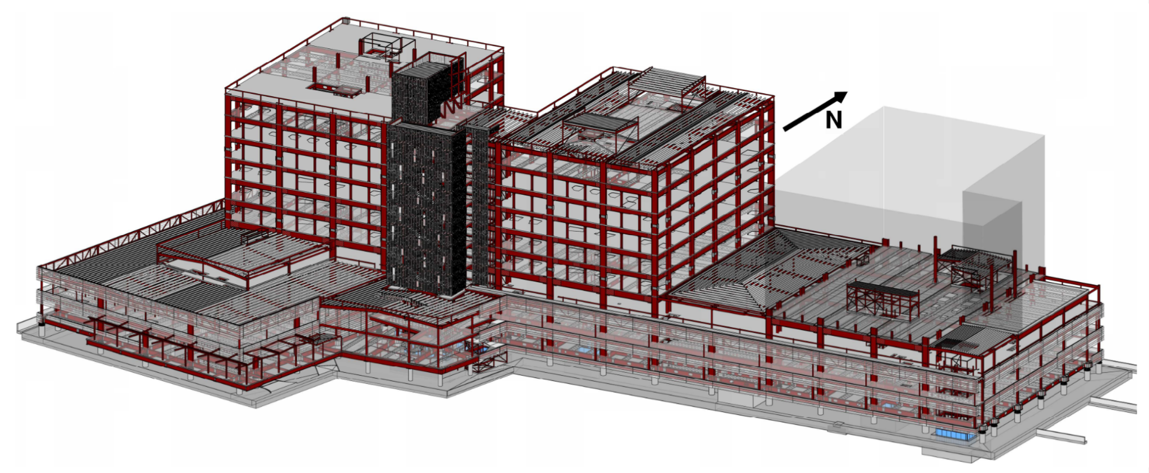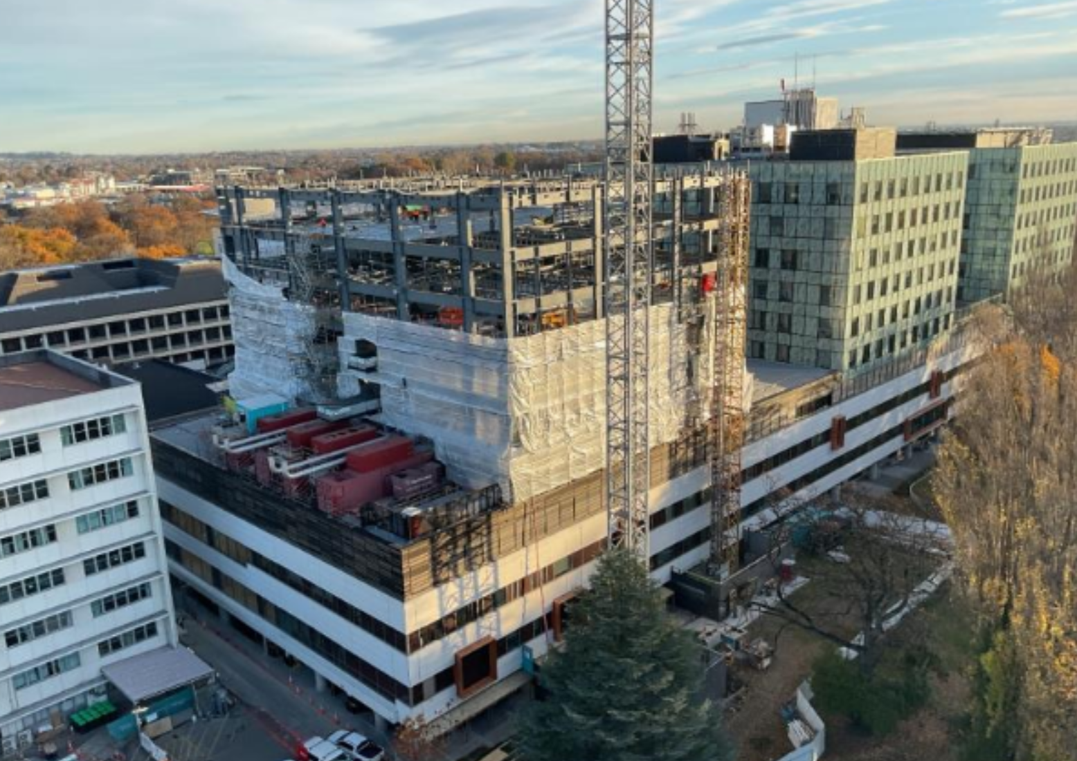
Figure 10: A future design provision (indicated by grey shading), left; being utilised and under construction in 2024 (right). Images courtesy Holmes, Naylor Love.
If there is an intent to maintain reliance on existing Producer Statements to inform (reduce) the level of review, then this is context dependent and various risk, reliance, compliance and liability issues will need to be worked through and agreed with Health NZ, HEAG representatives and the Building Consent Authority.
Provision for future additions in new hospitals
In provisioning for significant future structure (as part of design, or as part of business case or masterplan development), risks exist which are similar to those associated with use of existing historic provisions. These should be considered and conveyed to the design team, and project decision makers, and include:
- Significant difficulty in constructing building additions and alterations to live operating hospital environments. This is proportionately more costly and time consuming, and carries increased risk. Precedent examples exist, and information on these should be sought as part of cost and risk quantification.
- Alternatives such as constructing empty shell space are usually less risky, but incur upfront cost. This approach will also incur Up-Front Carbon emissions before the capacity is required.
- Risk of changes to Building Code compliance documents or engineering practice impacting the effectiveness of the provisioning, potentially increasing the cost of the new work, requiring strengthening to existing, or the acceptance of performance compromises (and associated compliance risks). The latter would be subject to the requirements of the Building Act as applicable to the context.
- Risk of changes to site masterplan reducing the effectiveness of the provisioning.
- Whether or not the provision is used, there are Up-Front Carbon emissions associated with the provisioning itself (where it involves providing additional structural capacity).
Alternative development phasing approaches such as developing site infrastructure vertically, rather than horizontally before extending vertically can minimise these risks.

  - Changing the Service Functions of an Existing Building
As part of hospital master planning, hospital and health planners may consider relocating departments or introducing new services into existing buildings that were not originally planned or designed to support that function.
This could change the overall Service Category that might apply to that building (refer to Section B1.2). This may not necessarily constitute a Section 115 Change of Use for regulatory purposes, but will still require consideration of how the building as a whole will deliver the performance required by the new overall Service Category.
When would different service categories constitute a Section 115 Change of Use?
Regulatory requirements for changes in use are contained within Section 115 of the Building Act 2004, and uses are defined in Schedule 2 of the Building (Specified Systems, Change the Use, and Earthquake-prone Buildings) Regulations 2005. MBIE Building Performance summarise the requirements here. This requires the building to comply as near as is reasonably practicable (ANARP) with Building Code requirements for a number of aspects including structural performance.
Importantly, a Section 115 ‘Change of Use’ only occurs when both:
- the use changes from one use to a new use as defined in the regulations (there are 15 specific uses defined in the regulations), and
- the new use has more onerous or additional Building Code requirements.
Therefore, changing Service Categories that would change the buildings importance level from, for example, IL3 to IL4, does not necessarily change the buildings use, as both may classify as SC (Sleeping Care). In this case Section 115 does not apply, but Health NZ require a similar assessment of the building to deliver the performance required especially for functional continuity in earthquakes. These requirements and decision-making process are set out in Section B7.1.
  - Applying ANARP
Applying ANARP under the Building Act
The term ‘as nearly as is reasonably practicable’ (ANARP) is used in the Building Act for:
- Alterations to existing buildings, Section 112
- Changing the use of buildings, Section 115, and
- Alterations to buildings subject to EPB notice, Section 133AT.
Unless buildings are dangerous, earthquake-prone, are undergoing alterations, or the use is being changed, there is no requirement to upgrade existing buildings or building elements to current code requirements. When alteration work is being carried out or its use is being changed, it is often not practical or economically feasible to fully upgrade the whole building to current building code requirements. This may be because of materials and construction methods used in the past or the form of the structure.
The term ANARP is used to address the degree to which building code compliance is required. ANARP decisions are made by BCAs when issuing building consents or providing owners with written notice about a change of use. They will do this having been provided with documentation on the “degree of risk … balanced against the cost, time, trouble or other sacrifice necessary to eliminate the risk” in comparison to fully complying with the particular code provision.
ANARP decisions to upgrade to code requirements are generally more frequently required for means of escape from fire and for accessibility as they apply when altering existing buildings (Section 112). Changing the use of a building under Section 115 is generally a less frequent occurrence. When this does occur, in addition to fire and accessibility, the building in its new use needs to comply ANARP to structural performance and sanitary facilities of the building code.
MBIE and its predecessors, DBH and BIA, have issued numerous determinations discussing ANARP for specific situations. MBIE has also provided advice on ANARP for alterations, refer https://www.building.govt.nz/building-code-compliance/b-stability/b1-structure/altering-existing-building/demonstrating-and-assessing-compliance-for-buildings-undergoing-alterations. They recommend a 5-step process. The examples are fire related but the same principles can be applied for structural performance.
Step 1: Applicants check what approvals, consents, and extent of documentation is required for the proposed alteration.
Step 2: Applicants consider current and proposed Building Code compliance for the whole building (compliance ‘gap assessment’)
Step 3: Applicants assess ANARP for outstanding fire and accessibility Building Code clauses and requirements (the ‘gaps’)
Step 4: BCA determines whether the proposed alteration complies with the requirements.
Step 5: If required, territorial authorities consider if discretion to proceed with an alteration that does not comply with the alteration’s requirements, per steps above, where they consider, under strict conditions, that certain benefits of partial compliance will outweigh the detriment of not fully complying with all of those requirements.
The areas that comply only on an ANARP basis should be documented and clearly recorded in the final design for future understanding.
A useful extract from the MBIE advice in relation to Steps 3 and 5 is reproduced below in Figure 11 to help illustrate the process of considering how best to balance benefits and sacrifices.
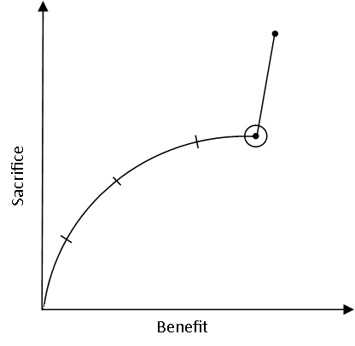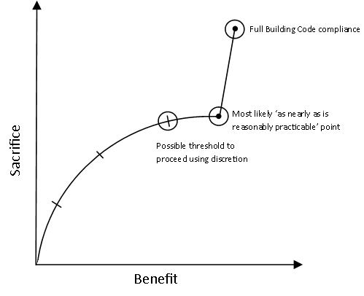
Figure 11: Figure reproduced from MBIEs guidance on Alterations (steps 3 and 5) illustrates that a point is reached where a significant increase in the sacrifice is made for a comparatively small gain in the resulting benefit. This point can usually be considered ANARP.
Applying ANARP to the requirements of this Health NZ DGN
As Health NZ require structural performance to also be considered when changing the service category of the hospital building (refer Section B7.1) as well as any changes of use under the Use schedule in the regulations, structural performance of existing buildings relating to ANARP decisions is likely to need to be considered more frequently for hospitals. The ANARP principles also apply to other parts of this guideline where a practical approach to balancing benefit and sacrifice is needed, including:
- Managing earthquake risk from adjacent buildings (Section A1.7),
- Some aspects defining SLS2 criteria for new buildings (Section B2.5),
- Applying Health NZ ’s seismic policy across its portfolio (Section B8), and establishing targets for voluntary seismic strengthening (on a building-by-building basis),
- Other aspects of hospital alterations, as summarised in Section B7.1, and particularly the extent to which alterations are used as an opportunity to gradually improve seismic resilience (and how far SLS2 considerations are carried).
The process described above (when applying ANARP under the Building Act) would apply similarly, but by mutual agreement between design teams and Health NZ rather than the BCA. In simple contexts the test may not need to be as rigorous as that implied above, as long as a decision is reached on a reasonable basis of information and recorded accordingly.
  - Compliance and Producer Statements
In alterations contexts, clarity in the compliance pathway (as expressed in the Structural Design Features Report) is especially important, and should be established in Concept and Preliminary Design phases and tested through engagement with the Building Consent Authority (BCA) at the earliest practical time.
In general, the following coverage on Producer Statements for Design PS1 for Building Code Clause B1 is expected, which would usually be reflected in Design Review.
- Generally, a mixture of B1/VM1 for new building work and Alterative Solutions supported by referenced guidelines or standards for existing aspects (those aspects requiring assessment to be able to state that the new work complies).
- Reference to Building Act Sections 112, 115, 133 or others as appropriate, with clarifications or exceptions and their basis (by reference to a schedule, if needed).
- Inclusion of a schedule clarifying basis for Alternative Solutions, such as reference to an assessment guideline, and relevant assessment documentation confirming the level of assessment and the performance evaluated and/or targeted for any retrofit aspects.
- Other referenced particulars (including drawings, specifications, and other construction information).

- Seismic Assessment and Retrofit Work
  - Health NZ Seismic Policy
This section contains additional information in support of Health NZ ’s Seismic Policy (Te Whatu Ora, 2024), and should be read in conjunction with that policy document.
Health NZ will at all times meet its obligations under the Building (Earthquake-prone Buildings) Amendment Act 2016.
Health NZ ’s aspirational (long term) seismic resilience goals are:
- For life safety, achieve Low Risk seismic grades throughout hospital building stock.
- For continued functionality, achieve performance aligned as near as is reasonably practicable with the outcome objectives for post-earthquake service continuity and functional recovery.
Health NZ ’s short term operational focus is the safety of occupants
Therefore, the initial focus is the remediation of Earthquake-prone Buildings (including buildings rated as less than 34%NBS that have not been declared Earthquake-prone), where strengthening can practically be undertaken. However, for most acute services buildings, the reality is that the invasive work typically associated with seismic strengthening cannot be accommodated while continuing to deliver medical services.
Priority is typically given to:
- Earthquake-prone Buildings in New Zealand’s high and medium seismic zones; and
- Buildings that would remain less than 34%NBS under 500-year return period ground shaking (Importance Level 2 ); and
- Where seismic assessments and subsequent risk evaluations have identified the potential for structural failure under moderate or significant levels of earthquake shaking (up to 500-year return period).
Health NZ ’s medium term operational focus is improving resilience
This means working towards Health NZ ’s long-term goals of Low Risk for life safety (>67% NBS), and meeting outcome objectives for post-earthquake service continuity and functional recovery.
This involves looking beyond the life safety-focused %NBS ratings to consider buildings that may have SLS2 vulnerabilities, but are required to maintain function and are considered central to a region’s post-disaster response with few practical alternatives or redundancy in service delivery.
These short to medium term objectives should be reflected in site masterplanning (using available assessment information). In some cases, seismic risks could influence development priorities, phasing and decanting strategies. When work is commissioned to repurpose buildings or undertake significant building maintenance or upgrade works, it should include options to undertake seismic retrofit work as part of this, where:
- The seismic resilience goals are not met in the buildings being refurbished, and;
- There is sufficient proportionality between the project size/extent, the scale and extent of seismic retrofit work required, and the costs/benefits of the retrofit work.
This philosophy underpins the approach outlined in Section B7 Alterations to Existing Buildings In some circumstances a staged approach to seismic retrofit may be appropriate, where feasible from a structural sequencing perspective.
Note that when designing (or planning) new buildings, adjacent existing buildings may require seismic improvement work to avoid exposing the new buildings and their occupants to unacceptable risks. Health NZ want to reduce their risk profile over time not increase it. Refer to Appendix 1. Campus Earthquake Resilience (Structural Considerations) for more information.
Defining outcome objectives for continued functionality (SLS2)
For new buildings, the continued functionality objective is achieved via the Serviceability Limit State 2 (SLS2) and the design criteria set out in this guideline. Existing acute services buildings should also be measured against SLS2, but it is unlikely to be practical to meet these requirements in full, especially in the short to medium term. A more contextual focus on the overarching outcome objectives is required. This could take a more regional view of dependencies and redundancies in health service delivery (as opposed to an individual view of a buildings SLS2 compliance).
This may mean targeting SLS2 design criteria in existing assets where they are of critical importance to hospital function (especially where the asset is central to regional disaster response and recovery). However, where it is impractical or disproportionately costly to achieve SLS2 design criteria, being able to reasonably foresee, manage and plan for resulting adverse consequences that could eventuate after a large earthquake may be sufficient. This requires the key risks to be known. It may be possible to meet the outcome objectives for continued functionality this way, regionally, with levels of compromise that are tolerable in the context of cost.
Refer to Section B8.3 for information on methods of assessing and reporting against continued functionality objectives which facilitates this approach.
Where decisions to defer functionality upgrades are made on the basis of regional redundancy, care should be taken to ensure this is adequately reflected in regional hospital emergency management plans.
  - Seismic Assessment for Life Safety Purposes
New seismic assessments
All new seismic assessments should be undertaken in accordance with The Seismic Assessment of Existing Buildings: Technical Guidelines for Engineering Assessments (MBIE, EQC, NZSEE, SESOC, NZGS, 2017), referred to as the Engineering Assessment Guidelines or “EAG”. This includes use of the Technical Proposal to Revise the Engineering Assessment Guidelines for Chapter C5: Concrete Buildings (MBIE, EQC, NZSEE, SESOC, NZGS, 2018). It includes use of any future revised sections to the EAG that are current at the time of assessment and have been released for use.
For the purposes of applying the Building (Earthquake-prone Buildings) Amendment Act 2016, only the “red” version referenced by the EPB Methodology shall be used. This will require the difference in outcome between the “EPB” version, and newer versions of the Engineering Assessment Guidelines (referenced above) to be understood.
Assessors are also referred to the advisory document Seismic Assessment and Retrofit following the Release of TS 1170.5, which is consistent with Health NZ ’s approach to how assessment outcomes should be communicated following the release of this Technical Specification.
Using information from older seismic assessments (pre-2018)
Older seismic assessments using assessment guideline editions prior to the 2017/2018 versions referenced above may be less effective at identifying risks that are important to Health NZ ’s seismic risk management strategy. They are also less likely to have considered secondary and non-structural elements. The currency and validity of such assessment outcomes may need to be considered. The following approaches can be applied in increasing order of time/cost/effort and confidence in outcome (the appropriate level should be selected based on the circumstance).
- Specialist engineering advice engaged as part of masterplanning or business case development that identifies (based on the building(s’) typology and the basis of previous assessment relative to modern methods) some of the most likely issues or risks that could be present.
- Specific Qualitative Drawing and Load Path Review, informed by the prior assessment information, identifying significant risks that are likely to be present (that the previous assessment may not have identified or sufficiently considered).
- Completing further Targeted Seismic Assessment to quantify some of the likely risks identified in a qualitative drawing and load path review.
- Completing a revised Detailed Seismic Assessment.
Levels of assessment, including qualitative, or Targeted Seismic Assessment
As outlined in Health NZ ’s Seismic Policy, Health NZ ’s Seismic Risk Management Strategy will outline the prioritisation of additional seismic assessments, and the form of those assessments (Te Whatu Ora, 2024).
To support their initial/short term focus, Health NZ want to better understand where there may be significant risks in their portfolio that are currently unknown or poorly understood due to gaps in seismic risk information. Therefore, most new assessment work will begin with a first stage Qualitative Load Path and Drawing Review, followed by a subsequent stage of Targeted Seismic Assessment or Detailed Seismic Assessment as and if required.
Qualitative Load Path and Drawing Reviews are similar in principle to comprehensive Initial Seismic Assessments. However, they are carried out specifically in response to Health NZ ’s needs in understanding their risk profile across their portfolio (as opposed to being an Engineering Assessment carried out for the purposes of the Earthquake-prone Building Methodology). Qualitative reviews should describe the buildings typology, identify primary structural load paths, and identify any potential vulnerabilities based on the building’s typology and load path/drawing review. To maximise their value to Health NZ, they usually include a few representative calculations on key areas. This may include:
- Comparison with design loadings and key design assumptions (which may use an IEP form or a similar separate calculation).
- High-level calculation on potentially significant vulnerabilities or detailing deficiencies to coarsely categorise the likely risk.
Targeted Seismic Assessment will most often be used where Health NZ want to understand more about a potentially significant risk identified in a qualitative review, but where full Detailed Seismic Assessment is not considered warranted or necessary. Targeted Seismic Assessment should follow Parts A and C of the Engineering Assessment Guidelines, applied to the restricted scope area of the assessment.
Because of their restricted scope, neither of these forms of assessments on their own can be used to provide an overall Assessed Seismic Rating for a building as a whole, nor would they constitute an Engineering Assessment for EPB purposes.
A Targeted Seismic Assessment in conjunction with an ISA that complies with Parts A and B of the Engineering Assessment Guidelines may meet the requirements of an Engineering Assessment for EPB purposes (if it meets the requirements of the EPB methodology).
  - Evaluating Continued Functionality
Where requested in the Project Brief for Importance Level 4 hospital buildings, seismic assessments should evaluate the likely performance against the continued functionality objective. A continued functionality assessment should be based around the SLS2 criteria defined in Section B2.3.1 (Table 6) as an earthquake scenario (the 500-year earthquake). Assessments for Health NZ should be risk-based and vulnerability focussed, rather than compliance focused—and in practice many aspects of these assessments will be qualitative rather than quantitative. This is especially the case in the shorter term, where Health NZ seeks to gather ‘big picture’ information on resilience risks as rapidly and efficiently as possible to inform prioritisation and investment decision making, rather than a more detailed building-by-building approach.
It can be more difficult to assess continued functionality or damage objectives (compared with assessment of life safety risks in accordance with the Engineering Assessment Guidelines) - especially for non-structural elements. The content of this guideline applicable to SLS2 can be applied, with appropriate judgements made for existing building contexts. Assessors should record the basis for the SLS2 assessment criteria used.
Where a building or element and its non-structural systems is considered unlikely to maintain its continued functionality requirements, discussion on risks should be included in the body of the report. Assessment summaries should list:
- The vulnerability and the physical description of the damage in an SLS2 scenario (a significant earthquake) and its likely consequence, in clear and plain language.
- The criticality of the element or system, and the likely impact to continued functionality of the building’s overall service function.
- The relative ease to access and remediate the element.
- Preferably (to better convey the spectrum of likelihood) whether damage in more moderate earthquakes could also affect continued functionality.
A vulnerability focussed, triage-based approach has been proposed for evaluating non-structural elements as part of a continued functionality assessment, and this is outlined with further background in the Kestrel Report (Kestrel Group, 2022). A technical methodology for this triage-based approach has been further developed, and is planned to undergo trial later in 2024, with the intention of being further developed and made available for wider use. The status of this triage methodology and its pilot application should be considered as part of briefing and scoping of any continued functionality assessments for Health NZ hospital buildings.
For the structural systems themselves, it can be straightforward (from a process perspective at least) to extend an ordinary life-safety focussed seismic assessment to include consideration of structural damage potentially affecting continued functionality, given the knowledge already obtained on structural behaviour. However, the difficulty in estimating onset of structural damage with any accuracy needs to be acknowledged. The content of this guideline can be applied where applicable (such as Sections B2.5 and C3.1), and other references, such as ASCE 41 may be useful. However, presenting the outcomes in the same manner described above in terms of potential vulnerability and the consequence of damage, centred around the 500-year earthquake (indicatively, rather than in absolute terms) is preferred.
The Kestrel Report notes that, with exceptions, it is most commonly non-structural system performance that has been observed to be the greatest vulnerability to continued functionality in previous earthquakes particularly in the hours and days following a significant earthquake (even where some level of structural repair in the longer term may be deemed necessary).
  - Seismic Retrofit Objectives
Health NZ ’s basic minimum performance objective for any seismic retrofit work should reflect the long-term goals stated in Section B8.1. That is, Low-Risk (>67% NBS), and meeting continued functionality objectives as measured by SLS2 (but only as near as is reasonably practicable).
This includes retrofit work that is planned in the short term to remediate buildings which are Earthquake-prone. That is, the same performance objectives stated above should be targeted (not just strengthening so that the building is no longer Earthquake-prone).
In practice, the Low-Risk (>67% NBS) target will not be rigidly enforced as a specific target that covers all circumstances. Health NZ may accept a lower strengthening target where it can be demonstrated that the cost to strengthen to 67% NBS would be disproportionately high. It may also recognise the benefits of a staged approach, which accelerates shorter-term mitigations for significant and low scoring risks, completed ahead of longer-term improvements if this better aligns with overall asset management strategies. This can improve the accessibility of meaningful safety improvements (i.e. their cost effectiveness and practicality) provided the longer picture is kept in view.
Health NZ’s Seismic Policy requires multiple concept options (more than one) to be presented as part of strengthening design development (Te Whatu Ora, 2024). Specific principles that should be applied when testing proposed retrofit schemes against Health NZ ’s basic minimum performance objectives include:
- The proportionality of cost, for a given level of risk reduction.
- Which vulnerabilities are addressed as part of strengthening, and which vulnerabilities remain, and their physical consequences of failure in respect of life safety and continued functionality.
- Favouring approaches to strengthening that are more likely to holistically minimise structural/non-structural damage (such as drift reduction) rather than solely focusing on life safety.
Designing specific elements of strengthening to >100% ULS, or explicitly for a 67% ULS target
In most cases, once committing to retrofitting a deficiency, it best to target the strengthening of that component either so that the deficiency no longer exists at all (where applicable), or such that its capacity aligns with Building Code or B1/VM1 levels (using 100% ULS demands). This should be the aspirational starting objective for most deficiencies (Structural Weaknesses) that fall below the notional performance target of 67% NBS and which the retrofit works seek to remediate. It is a better long-term and enduring approach to risk management, and often makes sense for discrete components, such as precast panel securing, and improvement of stair separations.
However, this approach is unlikely to be practical in all situations. Where there is more proportionate cost/benefit to reduce earthquake loadings to the notional target of 67% NBS (represented by using 67% ULS demands in the design of strengthening), then this can be done. The residual risk still achieves a Low-Risk Seismic Grade and fulfils Health NZ ’s basic minimum objective.
Non-Structural Element Retrofit
In general, it is expected that retrofits on non-structural elements to mitigate continued functionality risks would be undertaken on a prioritised basis, considered at a system level. This would prioritise systems that are considered most seismically vulnerable, most critical to post-earthquake function, and most practical to remediate.


Part C. Structural and Geotechnical Requirements

- Design Loadings
  - General
    - Design Working Life for Loadings
Design Working Life for Building Structures
The Design Working Life for determining loading from natural hazards should generally be 50-years, unless specified otherwise in the Health NZ Project Technical Brief.
This comment is made specifically in relation to the use of the Loading Standards AS/NZS 1170 Suite and the Earthquake Geotechnical Engineering Practice Modules. Users should seek clarification if there is an intent to apply this advice to other documents and seek clarification if necessary.
Although Section B3 of this guideline contains requirements for a longer Specified Intended Life for durability (for some elements), these do not apply to design working life for hazards (wind, snow or earthquake). This guide considers the reliability levels implicit in the Annual Probability of Exceedance for natural hazards at the various limit states to be generally calibrated around the concept of a 50-year notional life—as otherwise clarified/expanded upon within this guideline. Whether or not buildings are demolished and replaced, or whether they are retained for longer, this is taken to represent an “indefinite life” and indefinite risk exposure. Climate risk adaptation matters are handled separately.
Design Working Life for Building Components and Utilities
Similar to buildings, the Design Working Life for determining loading from natural hazards (including wind, earthquake and snow) should be 50-years, unless specified otherwise in the Health NZ Project Technical Brief. This includes engineering systems within buildings, as well as independently housed or located utilities and plant, storage tanks, pressure vessels and the like.
A lower Design Working Life may be assigned only in specific circumstances, where the component or utility in consideration is clearly of a non-permanent nature and where there is no intent to retain or replace it beyond the stated Design Working Life.

This is consistent with the Design Working Life assigned in the derivation of loadings in NZS 4219, and recognises the notion of practically indefinite risk exposure, irrespective of the actual replacement life of an individual piece of equipment. For storage tanks and pressure vessels, additional commentary is available in (Beca, 2022) regarding limitations and implications of a 25-year Design Working Life.
Irrespective of the parameters ultimately selected by tank/vessel designers and the designers of their supporting structures and foundations, it is fundamental that SLS2 be considered consistently with the buildings served, using the earthquake demands specified in Section B2.3.1, Table 6 (1 / 500 APoE for Acute Services).
  - Permanent and Imposed Loading
Permanent Actions (G) (including Superimposed Dead Load SDL)
Permanent actions (G) include the self-weight of documented structure, and additional applied permanent loading usually referred to as Super-imposed Dead Load (SDL). This SDL includes non-structural floor finishes, screeds, nibs and plinths, and permanent fixtures such as fixed partitions, cladding systems and fixed reticulated services. Floor mounted plant is usually considered as an Imposed Load (Q).
SDL Allowances should be mutually agreed with design teams on a project basis, which will be subject to:
- Extent of floor finishes (including any non-structural levelling screeds which may or may not be required as part of achieving floor levelness criteria).
- Extent of non-structural partitions and suspended ceilings, and strategies for reticulated services and suspended plant and medical equipment (including medical pendant support structures).
- Strategies for adaptability (with reference to Section B6.2 Adaptable Floor Structures).
- Considering the extent of rational zonation that may be appropriate to manage localised areas with higher SDL. For example, near risers and primary branches of suspended service clusters.
Refer to Section A3.1 for information on the documentation and communication of Superimposed Dead Load allowances.
Imposed Actions (Q)
Imposed actions (Q) include furniture, movable partitions, shelving, storage, equipment (including general floor mounted plant) and people. Imposed loads shall generally be determined in accordance with the requirements of NZS 1170.1:2002 (SNZ, 2009). Live load reduction can be applied where applicable in accordance with NZS 1170.1:2002 and should be applied in determination of seismic mass. However, it is recommended that ψ_{a} be excluded for gravity design of floor components (such as floor slabs and beams).
Health NZ Recommendation: With reference to Section B6 Structural Requirements for Adaptable Spaces, the basic minimum imposed actions (Q) presented in Table 13 for general areas are recommended (unless otherwise specified in the project brief) and shall be subject to the requirements of NZS 1170.1:2002. Imposed loads shall be identified on loading plans, and should include specifically allocated transport routes for installation, maintenance, or removal of heavy equipment.
Table 13: General recommended minimum imposed loads (Q) for Health NZ hospital buildings, to meet NZS 1170.1 and provide a basic level of adaptability in floor use.
Design Use | NZS 1170.1 Occupancy Category | Recommended min. basic imposed load ¹ |  | Comment
 |  | Dist. Load (kPa) | Pt. Load (kN)
General Clinical, Office | B | 3 | 4.5
Hospital Wards | A2 | 3 | 4.5 | Provides basic adaptability for use as general clinical/office
Operating theatre, general radiology (X-Ray) | B | 3 | 4.5
Circulation areas (normal areas not subject to wheeled vehicles) | C3 | 4 | 4.5 | Limited to circulation cores and adjacent lobby areas ²
Kitchens | B | 5 | 4.5
CSSD, general (central) stores and distribution ³ | E | 5 | 9 | Generally excludes basic shelving and storage rooms within wards, general clinical or office areas.
General plant | E | 5 | 9 | Air handling, pumps and fans, plant room reticulation.
Heavy plant ³ | E | 7.5 | 9 | Chillers, transformers.
Heavy medical imaging (MRI, CT, PET) ³ | E | ≥ 7.5 | t.b.d. | As specifically assessed.
Exterior cooling tower plant platform ³ | E | 7.5 | 10
Lightweight Roof | R1 or R2 | To NZS 1170.1
Heavy (Concrete) Roof | R1 or R2 | 1.5 | 4.5
MME (Major Mechanical or Medical Equipment) access routes | As specifically assessed
Medium or heavy vehicle access, loading, firefighting appliance access, maintenance or EWP access
Significant plant or equipment, such as generators, chillers, UPS and the like ³ | E | ≥ 10 | t.b.d. | As specifically assessed

Notes to Table 13:
[1] Refer to Section C4.2.6 for specification information on Loading Interfaces between Non-Structural Elements and structure—and consideration of additional allowances for loads imparted from NSE seismic restraint systems under seismic conditions.
[2] Circulation spaces within general clinical, office and ward areas are considered part of those overall occupancy categories (A or B), which is appropriate to their overall use and loading. Vertical circulation including stairs and lobby areas adjacent/serving primary circulation cores should be considered as C3 in accordance with NZS 1170.1:2002, (groups of people may congregate and queue at these spaces during evacuation).
[3] The suggested values suit general applications, but NZS 1170.1:2002 could require higher allowances in certain cases, or requires weights of equipment to be specifically determined.
Refer to Section C4.2.6 for specification information on Loading Interfaces between Non-Structural Elements and structure. This includes reference to the general structural loading brief and Loading Plans (generally in accordance with NZS 1170.1:2002 and this section)—and consideration of additional allowances for loads imparted from NSE seismic restraint under seismic conditions.
  - Seismic Loading
    - Interim Requirements on the Application of TS 1170.5 for Seismic Design
Background
In 2022, GNS in conjunction with its project partners released the first significant update to New Zealand’s National Seismic Hazard Model (NSHM) in over two decades. This update is referred to as NSHM 2022, and it is possible that periodic updates may continue to be made to the model on an ongoing basis. Information on the model and its release may be found in the document Interim Advice on the 2022 National Seismic Hazard Model Release (SESOC, NZSEE, NZGS, 2022).
The Seismic Risk Working Group (SRWG) has developed provisions intended for a revision to NZS 1170.5:2004, using the NSHM 2022 as one of its inputs. In summary, the focus of the revised previsions has been:
- an update to the elastic design spectrum for buildings
- new requirements for parts and components
- provisions on the simplified design of structures with rocking structures that meet certain criteria.
In early 2023, Standards New Zealand convened the P1170.5 committee to incorporate the SRWG’s recommended revisions into a new Technical Specification: TS 1170.5. A draft of this Technical Specification was issued for public consultation in early 2024 (DZ TS 1170.5:2024). The comment period has closed, and the committee is reviewing submissions.
When TS 1170.5 is published by Standards New Zealand, MBIE will consider citing the document into the Building Code, probably by an amendment to B1/VM1. There are several steps within the citation process, including impact analysis and further public consultation. Until the published document is cited, use of the document will constitute an Alternative Solution to Building Code compliance. If the document were only used to inform design, and the design was demonstrated to comply in full with the currently cited compliance documents, then it would not need to be the basis for compliance and an Alternative Solution pathway would not be needed for this aspect of the design.
Health NZ supports the consideration of TS 1170 in design
Considering both the robustness of SRWG processes in developing proposals for the new TS 1170.5, and the rigour in its scientific and technical basis, the Health NZ HEAG considers this Technical Specification (once published) to be an appropriate basis for Alternative Solution pathway for seismic loading. Matters concerning timings relative to Health NZ project milestones should be managed on a mutually agreeable and “all reasonable endeavours” basis.
Design teams should engage in early Building Consent pre-application meetings with the Building Consent Authority to discuss Alternative Solution proposals and confirm the compliance pathway.
Health NZ Recommendation: Health NZ does not recommend the use of TS 1170.5 for final design whilst in draft form. During this draft period, Health NZ does want designers to be actively considering how its application could affect the design of projects.
Health NZ may recommend the use of TS 1170.5 by an Alternative Solution pathway, once finalised and published (i.e. not in draft form) and once it has had the opportunity to assess any changes made from the draft. If it is used as the basis for an Alternative Solution (or if it is used to inform the design in any way) designers should keep a view on the impacts of designing to the new TS, relative to NZS 1170.5:2004, and inform project teams.
Health NZ Requirement: Health NZ requires Project Teams to actively engage in the testing of the DZ TS 1170.5:2024 (or the finalised version, once published). This should not require parallel concept design (unless briefed); teams should assess likely impacts on design outcome and design process, and keep Health NZ teams informed. Neither version should be used as the basis for final design unless agreed with Health NZ.
NZBC Requirement: For demonstrating Building Code compliance, designers should not use a mix of provisions between TS 1170.5 and NZS 1170.5:2004. Whether or not B1/VM1 or an Alternative Solution pathway is being followed, one document or the other in its entirety shall be used for the end-to-end determination of design loading for demonstrating Building Code compliance.
The basis for the recommendation to consider TS 1170.5 prior to its citation under the building code is as follows:
- Road testing of the new standard is an important part of the pathway from science to standards developments to engineering practice. It allows for the collection of real practical feedback from practitioners during the latter parts of the consultation processes, to help improve the quality and usability of the end product.
- Alternative Solution pathways for Health NZ projects provide a safe environment for road testing a new standard. This comes from the additional scrutiny provided from robust peer review, and to a lesser extent, the Health NZ review processes (which is less detailed). Both reviews would consider the effectiveness of the new standard in its application to the project context.
- The Seismic Risk Working Group has applied technically rigorous processes in its review of the scientific information, and other inputs (such as risk and policy settings). This is further supported by the P1170.5 committee process and feedback received on the public consultation draft. This provides a high level of confidence in the quality of the document and its suitability for use in practice.
- Use of the document allows Health NZ projects to take advantage of the latest scientific developments in its projects in support of a resilient healthcare system well supported by the technical consensus processes that have formed part of the document’s development to date.
- The above benefits are considered to outweigh the impact of any changes suggested during the proposed Building Code citation process and in fact the road-testing can inform any future adjustments or amendments, if necessary.

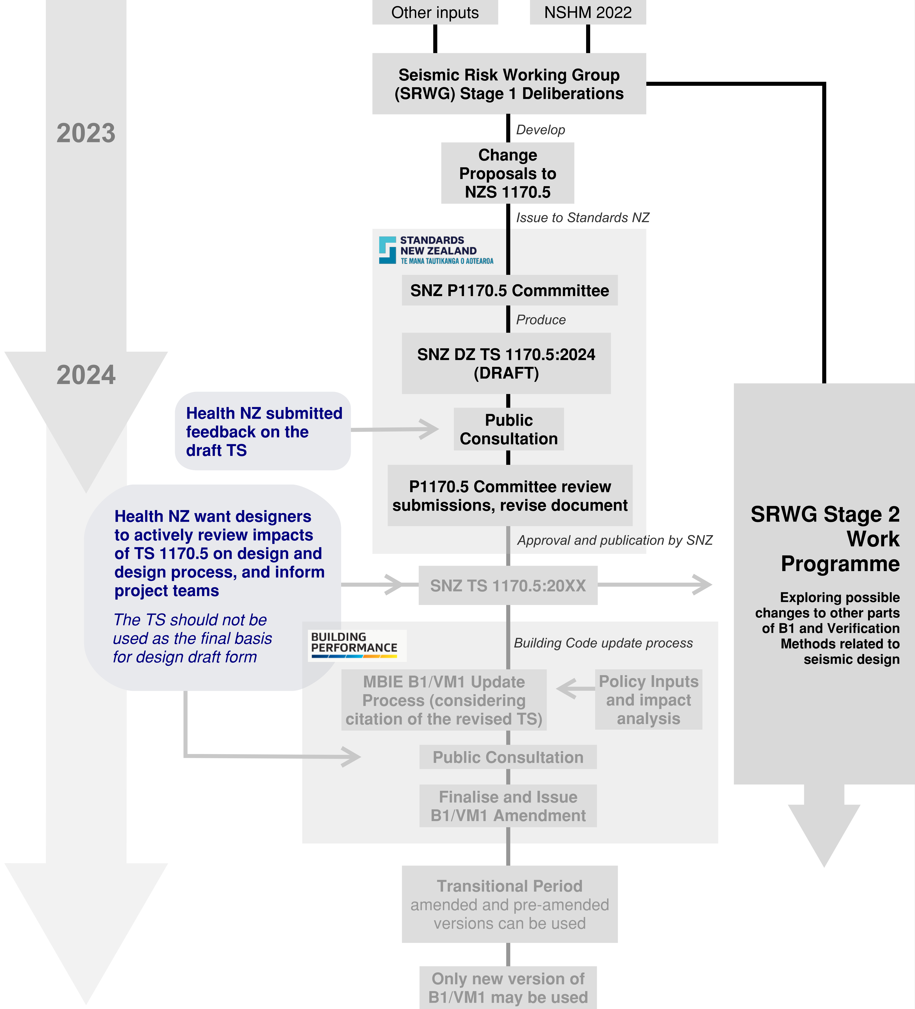
Figure 12: Process for inclusion of NSHM 2022 (and other inputs) into the Building Code, and how Health NZ wants designers to interact with the process. Grey text boxes are future activities yet underway and subject to process change and work priorities.
Applying TS 1170.5 Provisions for Parts and Components
Project teams are specifically advised to test and apply the revised provisions for determining loading on Parts and Components as part of the application of TS 1170.5 described above. The consistent application of TS 1170.5 across the project (i.e. to a building and its parts) is preferred.
Hospital buildings contain significant amounts of plant, equipment, reticulated services and high value contents. The quantum of these contents, the cost of their installation and seismic restraint, and the importance of post-earthquake functionality make Health NZ a major stakeholder in the effectiveness and workability of these provisions. Therefore, Health NZ project teams have an important role in their road testing.
As well as the revised values of reference ground acceleration in TS 1170.5 (compared with the 2004 edition) the provisions for parts and components have been substantively revised. These revisions have drawn heavily on the ATC-120 project (reported in NIST GCR 18-917-43), the revisions to ASCE 7-22 that were informed by this work, as well as further local research efforts. The resulting normative provisions in TS 1170.5 provide a method which is suitable for the design office, but which comprehensively captures the impacts of building and part response in the determination of loading on parts and their restraints.
Importantly, assessed part ductility is a parameter which can have a significant impact on the calculated forces. There is comparatively less data to aid the selection of appropriate values for parts compared with well-established processes to select and define ductility in primary structural design. Therefore, the informative commentary published alongside the normative part of the standard is important to the accelerations calculated for design.
Health NZ Recommendation: Health NZ recommends thorough testing of the revised provisions for determining loading Parts and Components as part of application of TS 1170.5 on projects.
One of the anticipated benefits of the revised parts and components provisions in the TS was to provide some relief against upward trending changes in ground accelerations. The newer provisions were not only more soundly founded than the existing provisions in NZS 1170.5:2004, but were expected to produce lower amplifications in many general cases.
Initial trials of the provisions confirm this to be the case for many aspects, but with some potentially significant and common exceptions. One example is suspended/mounted NSE’s with low assigned part ductility in lower rise buildings (buildings with shorter periods). In these situations, higher amplifications can be calculated unless higher part ductility was deemed appropriate. The manifestation of ductility and damping in non-structural installations (and the extent to which that ductility or damping represents damage or loss in function) can be challenging to quantify and is an area of continuing research. The extent to which nominal amounts of ductility or period shift may reduce the magnitude of resonance assumed in other parameters of the equation is another area of interest.
This is one of the key reasons for encouraging the road testing within project delivery environments for upcoming major hospital projects. Applying appropriate professional skill and outreach is key to achieving resilient outcomes appropriately balanced with cost and buildability.
Initial investigations have highlighted the following areas as most critical for road testing:
- The draft DZ TS 1170.5:2024 specifies (effective) ductility values in table C8.3 of µ_{p}=1.0 for SLS2, and within section 8.6 specifies µ_{p}=1.25 for SLS2. As these are understood to be rather onerous, it is considered desirable to test the impacts of higher (effective) ductility (perhaps µ_{p}=2.0 for SLS2) for robust, lower risk parts.
- The part-reserve capacity factor Ωp is intended to provide some relief to lower risk parts. However as written in the draft of DZ TS 1170.5:2024 this relief does not apply to SLS2. It is considered desirable to understand the benefits of extending Ωp to capture the real reserve capacity of lower risk parts (some of which might be expected to have Ωp > 2.0)
- Section 8.8 prescribes the use of µ_{p}=1.0. it is considered desirable to explore the implications of using part system ductility (rather than µ_{p}=1.0) for lower risk parts.
    - Structural Performance Factor
The structural performance factor, Sp, should be as determined by Verification Method B1/VM1 (NZS 1170.5 and the material design standards).
For the Damage Control Limit State (DCLS), a value of Sp = 0.7 should be used (similar to the Serviceability Limit States as stipulated by NZS 1170.5).
    - Site Classification for Seismic Loading
This section applies to the proposed new site classification system in TS 1170.5. Refer to Section C1.3.1 (Interim Requirements on the Application of TS 1170.5 for Seismic Design)
The probabilistic seismic hazard analysis (PSHA) that underpins the 2022 update of the National Seismic Hazard Model (NSHM 2022) uses V_{s(30)}, which is a measure for the time-averaged shear wave velocity to a depth of 30 m, as the sole parameter for incorporating the effects of site conditions on ground-motion characteristics. The use of V_{s(30)} is common in international seismic loading standards, however, it is not currently used for site classification done in accordance with NZS 1170.5:2004. Importantly, there is no correlation between the NZS 1170.5:2004 site classes and V_{s(30)}; hence it is necessary to specifically determine the V_{s(30)} for a site if deriving elastic site spectra for horizontal seismic loading in accordance with TS 1170.5.
TS 1170.5 contains seven site classes (I through VII) that are based on V_{s(30)}, as well as additional geotechnical requirements and considerations. The additional criteria include limits on the depth of soil cover (in the case of a rock site), and limits on the cumulative thickness of very soft / loose soils based on routinely obtained geotechnical parameters (e.g., undrained shear strength, penetration resistance). The purpose of the additional criteria is to help address situations in which V_{s(30)} alone is not sufficient to capture site characteristics influencing site classification, and to facilitate engineering evaluation and provide some practical insights for site classification.
It is also important to note that for very soft / very loose soils with a V_{s(30)} ≤ 150 m/s (Site Class VII), TS 1170.5 requires that site-specific dynamic site response analyses be undertaken. It is emphasised that the V_{s(30)},-based site classification is solely for the purpose of determination of the elastic site spectra. Otherwise, V_{s(30)} is not an appropriate parameter for site characterization of liquefiable soils or soft soils with high potential for deformation or loss of strength.
There are a variety of direct and indirect measurement methods available to obtain a V_{s} profile.
Health NZ Requirement: The direct measurement of V_{s}, and any site investigation methods used to indirectly measure V_{s} as well as investigation methods for geotechnical assessment in general should be performed in accordance with MBIE/NZGS Module 2: Geotechnical Investigations for Earthquake Engineering (latest version).
Prior to any site investigations being undertaken, it is important that the project structural and geotechnical engineer have a good understanding of the potential sensitivity of the structural design to site class. This will help inform the level of effort required to obtain a site V_{s(30)} – including whether it is important to reduce the measurement uncertainty, or if a default site class can be used.
Health NZ Requirement: The Geotechnical and Structural Engineers are to agree an appropriate level of investigation effort the project requires when obtaining the site classification.
TS 1170.5 provides three methods for determining the V_{s} profile for the site ranging from direct field measurement of V_{s} to a depth of at least 25 m, to “inferring” a V_{s} where the velocity profile is inferred from one or more partial measurements of CPT, SPT or V_{s}. The uncertainties inherent in determining the V_{s} profile are addressed by incorporating bounds of between ± 5% and ±30% depending on the method used. Where the uncertainty in the V_{s} estimate results in a “cross-over” between two or more site classes, then multiple site classes must be adopted. The design spectrum for such cases is taken as the envelope of the design spectra of the relevant multiple site classes based on the estimated range of V_{s(30)} values.
In cases where the site investigation data does not extend to a depth of at least 15 m, a default site class can be used provided that geotechnical and geologic data confirm that very soft soils (Site Class VI or VII) are not present at the site. Alternatively, for Importance Level 1 and 2 structures the design spectrum can be determined by adopting the maximum short-period spectral acceleration max(Sa,s) for Site Classes II, III, IV, V and VI, across all periods, without the need to confirm the absence of Site Class VI / VII soils at the site. This alternative approach is intended to be used primarily for the design of smaller, short-period structures. For larger structures and structures with an Importance Level greater than 2, it is expected that an appropriate level of geotechnical investigation to support the identification of site class will be undertaken.
    - Seismic loads for geotechnical design
For geotechnical assessment of seismically-induced ground deformations (e.g., from liquefaction assessment, lateral spreading, slope instability), the ground motion parameters for the site should be developed in accordance MBIE/NZGS Module 1: Overview of the Guidelines (either 2021, or the TS 1170.5 aligned version once released, as applicable).
Health NZ Requirement: All Geotechnical assessments for seismic design shall be in accordance with MBIE/NZGS Module 1: Overview of the Guidelines (2021, or TS 1170.5 aligned version once released, as applicable).
For routine design projects, it is anticipated that ‘Method 1’ will be sufficient.
Site-specific probabilistic seismic hazard analysis (PSHA – Method 2 in MBIE/NZGS Module 1) and / or site-specific site response analysis (Method 3) may in some cases be appropriate for larger or more complex projects or complex ground conditions, and Method 3 is required for Site Class VII soils if using TS1170.5. The use of site-specific analyses is discussed in more detail in Section 9.3.5.
    - Site-Specific Seismic Hazard Analysis
Site-Specific PSHA
For most projects, it is expected that the parameters required for developing elastic design spectra, and those required for geotechnical assessment (PGA, M) will be determined using the procedures specified in TS 1170.5 (once released). The probabilistic seismic hazard analysis (PSHA) performed within the 2022 National Seismic Hazard Model (NSHM 2022) is based on the best science, updated information, broad scientific consensus, and rigorous internal and external review processes. The Seismic Risk Working Group (SRWG) expended considerable effort assessing the outputs from NSHM 2022 and incorporating them into the design spectra contained in TS1170.5, and these were subsequently reviewed by the Standards Committee for TS1170.5.
Hence, it is considered unlikely that a site-specific PSHA will provide significant benefit in most situations, i.e., the design outputs from a site-specific study would not be expected to materially differ from what would be derived from TS1170.5.
Examples of situations where a site-specific PSHA might be warranted include:
- The discovery of a new earthquake source or a significant change in earthquake source characteristics potentially impacting the site,
- Improved modelling of potentially significant path and / or site effects (e.g., basin effects / depth to hard rock significantly different from that assumed in NSHM 2022),
- Improved input for scenario-based analyses (i.e., through disaggregation of site-specific hazard).
A site-specific PSHA, if performed, should be at least as robust as the PSHA performed within the NSHM which underpins TS 1170.5. It should only be carried out by experienced specialists and in consultation with the Health NZ HEAG. Site-specific studies will also require a rigorous independent peer review.
Refer to MBIE/NZGS Module 1: Overview of the Guidelines (TS 1170.5 aligned version, once released) for a good overview of site-specific PHSA and issues to consider when deciding whether it may be warranted for a project.
Site Response Analysis
For a Site Class VII site (i.e. V_{s(30)} ≤ 150 m/s), a site response analysis will be required to develop the design spectra if using TS1170.5. This is because such ‘low-velocity’ soils are generally not well represented in the ground motion records used to develop the ground motion models (GMMs) used within conventional PSHA (including NSHM 2022).
Carrying out a site response analysis requires determination of a ‘reference condition’ hazard (i.e., elastic response spectrum) representing either outcropping bedrock with V_{s(30)} > 750 m/s (Site Class I) or stiff soil conditions with 450 m/s < V_{s(30)} ≤ 750 m/s (Site Class II) in accordance with TS1170.5. If a site-specific PSHA is available, then the reference condition hazard would be derived from the output of that analysis.
Equivalent linear or nonlinear methods can be used for the analysis, with the former considered sufficient if maximum shear strains are less than 1%. One-dimensional analysis is appropriate for sites with (approximately) horizontal stratification, an absence of significant geometric effects due to sloping bedrock, irregular stratification or topographic features, and for reference condition depths typically less than 100 m. For analysis of liquefiable sites, nonlinear effective stress analysis incorporating the effects of excess pore pressure is appropriate, and the use of such analysis is encouraged in some situations (e.g., assessment of a high importance or complex structure located on ground where the effects of excess pore pressures may be significant).
For 1-D analysis, it is important that one-dimensional ‘soil column’ models be established from the ground surface to the depth of the ‘reference condition’ (i.e., bedrock or stiff soil). A shear wave velocity profile extending to the base layer of the soil column model should be confidently established using Method 1 (direct measurement of V_{s}) in TS1170.5. Site response analyses require good judgement and a good knowledge of the soil properties and profile to bedrock (or sufficiently stiff soil) for the result to be meaningful. The effects of uncertainty in the selected model parameters should be evaluated using appropriate increases or decreases of model parameters around best-estimate values.
Refer to the commentary for sites requiring special considerations in TS1170.5 for specific details regarding the use of, and performing, site response analysis. MBIE/NZGS Module 1: Overview of the Guidelines (TS 1170.5 aligned version, once released) also contains a good overview of site response analysis in general.
2-D and 3-D site response analyses may be useful for sites with significant geometry effects. However, these are highly specialised and no generally accepted guidance is available.
In general, site response analysis (including 1-D analysis) should only be carried out by experienced specialists and in consultation with the Health NZ HEAG—and will be subject to a rigorous independent peer review.
    - Requirements for Parts and Components
Refer to the general commentary in Section A3.1.1, and to Section C1.3.1 for information on the application of TS 1170.5 for parts and components.

- Geotechnical Considerations and Building Foundations
  - Introduction
This section provides an overview of the geotechnical requirements and considerations that need to be addressed for site planning and designing buildings for Health NZ projects. It covers the following topics:
- Geotechnical investigations;
- Geotechnical analysis and modelling;
- Building foundation types and design criteria;
- Risk-based approach and whole of life cost for selecting building foundation systems;
- Repairability and resilience of foundation systems.
The section does not prescribe a single solution for all situations. Rather, it highlights the key factors and challenges that need to be addressed and evaluated in each project.
  - Geotechnical Investigations
A site masterplan should be informed by the presence of potentially significant geotechnical constraints (e.g., liquefaction hazard, unstable slopes) - refer to Section A1.7.2. Furthermore, an important structural design consideration is that the ground conditions should guide the selection of the “best fit” structural system, which will in turn guide the architectural design of the building (refer to Section A2.1).
Appropriate geotechnical investigations are therefore essential for obtaining reliable and representative data. The data is used for assessing the geotechnical hazards that might be present at a site, for assessing the site soil class for seismic design, and for geotechnical analysis, and design of foundation systems. Geotechnical investigations should be carried out in accordance with all relevant standards and codes of practice, in particular, reference should be made to Earthquake Geotechnical Engineering Practice Module 2: Geotechnical Investigations for Earthquake Engineering (2021 or most recent revision).
    - Scope of Investigations
The scope and extent of geotechnical investigations will depend on the size, complexity, and importance of the building, as well as the availability and quality of existing data. At an early stage of a project a sufficient mix of both shallow and deep investigations is expected over a site so that the primary foundation considerations (e.g., shallow vs deep, potential need for ground improvement) can be identified early in the design process. For Master Planning, sufficient investigations should be done over the entire property so that any geotechnical constraints are identified and informed decisions regarding the prudent siting of buildings can be made.
Section 2.4.3 of Earthquake Geotechnical Engineering Practice Module 2 gives some general guidance regarding the density and depth of investigations, as a starting point.
    - Staging of Investigations
Staging of site investigations (progressively undertaking more comprehensive or targeted investigation information, or in other words delaying the acquisition of adequate investigation information to complete the design) should only be done to the extent necessary. As much investigation should be brought forward in the design programme as possible, on the basis that if it is likely to be required at a later stage it should be carried out in conjunction with current investigations. In particular, if there is a possibility that heavy buildings will be part of the project, combined with ground conditions that may limit the use of shallow foundations to support large foundation loads, then the initial investigation should include sufficient deep investigation to enable provision of indicative pile bearing capacities and founding depths. This reduces costs and identifies potential issues, which can have budget implications (e.g., when developing a business case), early in the project.
Where there is a reasonable chance of a potentially significant saving to be made in construction cost, then further stages of investigation may be warranted. For example, consider a site where initial CPT investigations indicate a potentially critical liquefaction issue which may result in the need for significant ground improvement. If a sensitivity analysis shows liquefaction triggering is highly sensitive to the CPT-inferred fines content or plasticity of the liquefiable soils, then further drilling, sampling and lab testing to determine the actual fines content or plasticity may be justified to confirm whether (or to what extent) ground improvement is required.
    - Data Collection
In general, the investigations should provide sufficient information for the following purposes (note that this is not an exhaustive list):
- adequate characterization of the site ground conditions, including thickness, density, strength, stiffness, and (where appropriate) permeability of the relevant layers;
- determination of groundwater levels – including recommended design groundwater level;
- identification and quantification of any potential geotechnical hazards, such as liquefaction, lateral spreading, slope instability, settlement, erosion, expansive soils, tomos, and off-site hazards such as landslide, rockfall and the like;
- assessment of shear wave velocity profile (Vs30) for determination of site class (unless a default site class is to be used);
- likely options for foundation systems;
- geotechnical design criteria including the bearing capacity, settlement, stiffness parameters pile types and capacities, lateral foundation capacities, seismic deformation (e.g., liquefaction deformations, seismic slope deformations).
    - Methodology
The geotechnical investigations should include a combination of desk study, an appropriate combination of shallow and deep investigations, and (where appropriate) laboratory testing, as well as geophysical testing and geotechnical monitoring if required. The methods and techniques used for geotechnical investigations should be suitable for the site conditions and the project objectives. Some of the more common methods and techniques are detailed in Earthquake Geotechnical Engineering Practice Module 2 (it is anticipated that only a small subset of those will be needed on any one project site).
The quality and reliability of the geotechnical data and resulting geotechnical advice depend on the adequacy and accuracy of the geotechnical investigations. The data should be verified and validated by cross-checking different sources and methods where feasible. The data should also be updated and refined as the project progresses and new information becomes available. The data should be presented and interpreted clearly and consistently in the geotechnical investigation report, using appropriate charts, tables, and plans – refer to Section A3.4. As required by Health NZ (Section A3.4.1), all geotechnical factual data collected for a site is to be uploaded to the New Zealand Geotechnical Database (NZGD) as soon as practicable after its collection.
  - Geotechnical Analysis
The purpose of geotechnical analysis is to evaluate the behaviour and performance of the ground and foundation system under various loading conditions.
    - Analysis Methods
Analyses of geotechnical data are to be carried out using recognised methodologies, procedures, and current good practice. Reference should be made in the first instance to the following Earthquake Geotechnical Engineering Practice Modules:
- Module 3: Identification, Assessment and Mitigation of Liquefaction Hazards,
- Module 4: Earthquake Resistant Foundation Design,
- Module 5: Ground Improvement of Soils Prone to Liquefaction,
- Module 6: Earthquake Resistance Retaining Wall Design.
as well as appropriate New Zealand and International Standards. Where non-standard or less well-known methods or procedures are used, these should be based on published, peer-reviewed papers, and clearly referenced.
Geotechnical analyses can be performed using different methods and tools, depending on the level of complexity and detail required. Some of the common methods and tools include:
- closed-form solutions for idealised problems, based on theoretical soil mechanics, such as elastic solutions, and limit equilibrium solutions;
- empirical or semi-empirical method which use observed behavioural correlations, sometimes in conjunction with theoretical soil mechanics, to obtain empirical solutions; and,
- numerical methods that use computational algorithms and software to obtain numerical solutions for more complex problems, such as finite element or finite difference methods.
    - Addressing Uncertainty
In all cases it must be recognised that analytical methods are just mathematical ‘models’, which attempt to represent a particular behaviour of what is a complex natural material – a material for which the composition, strength and stiffness can only be partially, and imperfectly, sampled. For this reason, the geotechnical analyses should recognise and acknowledge the limitations and assumptions inherent in the methodologies and the models used. Furthermore, the results of any geotechnical calculation or assessment should be sense-checked against prior expectations and past performance, where possible. This is especially the case when commercial computational software is used in geotechnical assessments.
Analyses should account for the uncertainties and variabilities in the geotechnical parameters and the loading conditions—particularly where a small change in a parameter (e.g., shear strength, design groundwater level) results in a potentially significant change in result (e.g., static slope stability factor of safety changes from acceptable to unacceptable). This can be achieved by conducting sensitivity analyses or parametric studies. This is in addition to the need to apply appropriate strength reduction factors, or factors of safety. Uncertainties should be clearly communicated to users of the outputs of geotechnical assessments, particularly where the precision of outputs are critical to structural analyses. Where appropriate, limitations and assumptions should be clearly stated, and their implications evaluated and discussed.
    - Documentation
The results of geotechnical analyses should be documented and reported using appropriate figures, tables, and equations. The resulting geotechnical parameters and advice should be communicated clearly and concisely, to provide relevant and useful information for the design of the building (refer to Section A3.4 for specific requirements for geotechnical reporting).
  - Role of Ground Conditions in Selection of Structural System
As discussed in Section A2.1, the ground conditions should inform the selection of the best-fit structural systems for a site, which in turn will inform the architectural design of a building. It is important for the geotechnical engineer to meet with the structural engineer and architect to discuss the potential implication of ground conditions on structural form and foundations.
For example, on sites with soils of modest but adequate bearing capacity for normal shallow foundations, it may be preferable to use a distributed lateral load system (i.e. one that does not concentrate loads into isolated single points) that does not require deep piles solely to resist uplift—as this can result in the entire building needing to go on piles (as mixed foundations are generally not acceptable), or the installation of strand anchors.
If the depth to a competent founding layer is very deep, the considerable costs of either option can increase significantly. It is also very important on such a site to (architecturally) design buildings that are regular in plan shape, to avoid concentration of vertical loads (arising from lateral loading) in any one area—which in particular can arise with angular plan protrusions from buildings etc.
  - Foundation Design
    - General
The selection of foundation systems depends on ground conditions, building characteristics (in particular structural systems to resist lateral loads as discussed in previous section), and performance requirements.
Building foundations can generally be classified into two main categories: shallow foundations and deep foundations. The common types and systems of building foundations are:
- shallow foundations: strip footings, pad footings, raft foundations, mat foundations, shallow timber or concrete ‘piles’;
- deep foundations: deep piles, caissons, micropiles, ground anchors;
- mixed hybrid foundation systems: pile-raft foundations;
- ground improvement: gravel rafts (generally considered to be part of a shallow foundation system), stone columns, grouting, vibro-replacement, vibro-compaction, dynamic compaction, soil mixing, jet grouting (in combination with a shallow foundation system, or effectively act as a deep foundation system).
Building foundations should be designed and constructed to satisfy the following criteria, in order to safely transfer the loads from the building to the ground (while also recognising that they also transfer loads and deformations from the ground to the building):
- Strength: the foundation should have adequate strength to resist ultimate limit state (ULS) loads, such as the dead load, live load, wind load, earthquake load, and other imposed loads.
- Serviceability: the foundation should have adequate stiffness to limit serviceability limit state (SLS) effects, such as settlement, differential settlement, rotation, vibration, and cracking.
- Constructability and Safety: the selection and design of foundations should consider how they will be constructed, with regard to issues such as excavation, installation, testing, and inspection.
- Durability: the foundation should have sufficient durability to withstand environmental and operational conditions, such as moisture, temperature, corrosion, erosion, and fatigue.
- Resilience: the foundation system should provide a reasonable level of resilience or robustness – for example, under seismic loads, foundations should not be the weak link in the structural system, so that otherwise repairable buildings need to be demolished following an earthquake.
- Economy: the foundation system should, to the extent practicable, be optimised with respect to cost and benefit, while meeting the other requirements outlined above.
    - Choice of Foundation Type
All things being equal, shallow foundations are generally preferred over deep foundations. Shallow foundations are generally less costly, and easier to construct than deep foundations. They are also easier to repair or relevel following a deformation-inducing seismic event on, for example, liquefiable ground.
However, shallow foundations will not be feasible or adequate for all sites or structures, depending on the severity of the anticipated ground deformations (particularly under static conditions), and the building weight and configuration. In such cases, deep foundations (or ground improvement) may be necessary to provide sufficient bearing capacity, stability, and stiffness.
    - Mixed Foundation Systems
Mixed foundation systems within the same building footprint are generally not acceptable (e.g. suspended timber floor with slab on grade, or shallow foundations in some areas mixed with deep piles in others), unless the potential for differential movement is insignificant, or suitable allowance is made for differential movement (e.g. strong earthquake shaking leading to differential foundation movement or differential structural response). Such situations may require a specifically designed structural separation or other movement-tolerant feature to be provided over the full height of the structure.
    - NZS 3604 ‘Good Ground’
The simplistic notion of ‘good ground’ was originally developed so that non-engineers could safely make use of the non-specific design standard NZS 3604. This concept is most applicable to small, lightweight, low-rise structures with well distributed vertical and lateral load resistance. The reality is that ground is neither ‘good’ nor ‘bad’—instead, it only has certain engineering characteristics that need to be taken account in the engineering design process.
In particular, in areas of softer ground the concept of ‘good ground’ can be misconstrued as placing often unnecessary restrictions on the use of shallow foundations.
Health NZ fully expects that professional engineers will not regard the notional NZS 3604 ‘good ground’ criteria of 300 kPa as being a barrier to the use of shallow foundations, but rather will use well-considered specific engineering design (SED) for foundations.
    - Settlement-Tolerant Design and NZBC B1/VM4
Clause B1.02 in Appendix B of NZBC Clause B1/VM4 has led over time to a level of confusion amongst practitioners as to the acceptable level of deformations in foundation design. In particular, it has led to the incorrect but widely held belief that compliance with the NZBC requires a settlement limit of 25mm over 6m under SLS loadings. The second half of the sentence that makes up clause B1.02 clearly states however “…unless the structure is specifically designed to prevent damage under a greater settlement”.
Clause 1.0.3 of B1/VM4 states that SLS deformations are not covered in that document. This implies that any solution relating to foundations and SLS are Alternative Solutions. In practice, however, the subsequent comment that introduces Appendix B (‘which may be of assistance’) is generally taken to mean that foundations which can be shown to settle less than 25mm over 6m under SLS loadings established from standard engineering calculations are automatically ‘deemed to comply’ with the requirements of an Acceptable Solution. Following the ‘deemed to comply’ route is however neither compulsory, nor the only means of compliance with the NZBC.
Furthermore, Clause 1.0.5 of B1/VM4 states “This document must not be used to design foundations on loose sands, saturated dense sands or on cohesive soils having a sensitivity greater than 4”. Thus, by definition B1/VM4 excludes design of foundations on many soils in general, and liquefiable soils, in particular.
Health NZ provides the following SLS design requirement clarification, to provide a point of reference against which to evaluate foundation designs for NZBC compliance purposes: This statement complies with the requirements of B1.3.2 of the NZBC, which is the overarching requirement.
NZBC Requirement (Clause B1): Foundation design shall limit the probable maximum differential settlement under serviceability limit state load combinations of AS/NZS 1170.0 (SNZ, 2011), to a level that the building can accommodate with only minor damage that can be readily repaired—while also meeting the performance requirements set out Part B of this document.
    - MBIE Canterbury Foundation Technical Categories
In Christchurch the Foundation Technical Categories (i.e. the ‘TC’ zones) established following the Canterbury Earthquakes were based on detailed observations of ground performance under actual earthquake shaking, and its impact on residential houses. In areas that have not had this level of testing and observation, consideration of other factors that might affect ground performance (e.g. crust thickness, likelihood and effect of liquefaction ejecta, influence of building weight etc.) may also be critical. Additionally, the MBIE Technical Categories were developed for relatively standard lightweight residential houses. There is no implication that MBIE foundation solutions for particular Technical Categories are directly transferrable to buildings that are not of this nature.
While describing the expected liquefaction performance of a site in terms of the MBIE ‘Technical Categories’ can be a useful communication tool, further design thought needs to go into any decisions to adopt standard MBIE Canterbury residential foundation solutions for these designations, as they may not be applicable for the building being considered. In some cases, they may be unconservative, and in other cases they may be too conservative or inappropriate for other reasons.
  - Risk-Based Foundation Selection Approaches and Whole of Life Cost
Where more than one potentially viable option exists, foundation selection should be carried using a risk-based approach, so that capital and potential future repair costs can be compared for various options. This allows an assessment of the most economical solution for the site (noting that other factors may also require consideration in selecting the final option).
The general steps required to carry out a risk-based approach and select the most economical foundation system are shown below:
- Determine the ground deformation characteristics for the site (e.g., differential ground settlement, lateral displacement) which will help determine the range of likely foundation options.
- Determine the range of potential options that could be considered (note that where simple shallow foundations are an obvious option, the process can end at this step). Equally, for sites where ground improvement will not be practical but where shallow foundations would likely undergo unacceptable settlement, deep foundations may be the only feasible option.
- Discard options that would give clearly unacceptable post-disaster functionality relative to the performance requirements summarised in Sections B2.2 and B2.3, (i.e. likely endangering the ability to continue using the building before repairs are carried out).
- For each potential option, estimate the order of magnitude capital costs of constructing the foundation system (e.g., $1M, $3M, $10M). Consider where decanting or managing repair projects in operating hospitals may affect order of magnitude costs.
- For each potential option, assess the probability (i.e. based on the likely return period) and potential severity of damage to the building due to the identified potential ground deformation.
- For each potential option, estimate the order of magnitude of the repair cost for the damage estimated in Step 4.
- Multiply the estimated repair cost by the probability of the damage occurring during the anticipated life of the building. This is the estimated expected repair cost over the life of the building.
- Add the estimated capital construction cost from Step 3 and the lifetime expected repair costs from Step 6.
- Select the foundation system that results in the lowest comparative total lifetime cost –considering any other significant factors as appropriate.
This process will require collaboration between the project geotechnical engineer, structural engineer, and quantity surveyor. An example of this process is indicated in Table 14.
Table 14: Example risk based whole-of-life cost comparison.
Option 1 Shallow Foundations with Reinforced Gravel Raft. Capital Cost $4M
Design Case | SLS1 | DCLS/SLS2 | ULS
RP (yrs) | 25 | 250 | 1000
Probability in 50 years | 0.87 | 0.18 | 0.05
Differential settlement (mm) | 25 | 100 | 250
Repairs (due to foundation deformations) | Some minor ‘cosmetic’ work may be required.  Cosmetic cracking of wall finishes.  Building services  operational.  Weathertight (no  reinstatement work  required). | Re-levelling required to 20% of the floor area using grout injection.  Some replastering and repainting. Sticking doors and windows.  Some repairs to non-structural elements. Some cladding repairs.  Building services readily reinstated.  Fire protection systems readily reinstated.  Weathertightness readily reinstated. | Major repairs required including re-levelling of foundations and floor area (80% of area).  Foundation re-levelling using mechanical lifting and grout injection.  Replacement of some structural elements.  Extensive non-structural repairs. Some service connections to be replaced.  Seismic separations reinstated.  Significant repairs expected to reinstate weathertightness.
Repair Costs | $0.1M | $3M | $30M
Expected Costs | $0.1M | $0.5M | $1.5M
Total | $6.1M ($4M + $0.1M + $0.5M + $1.5M)

Option 2 Deep Piles. Capital Cost $9M
Design Case | SLS1 | DCLS/SLS2 | ULS
RP (yrs) | 25 | 250 | 1000
Probability in 50 years | 0.87 | 0.18 | 0.05
Differential settlement (mm) | 0 | 0 | 25
Repairs (due to foundation deformations) | nil | nil | Some minor ‘cosmetic’ work may be required.  Cosmetic cracking of wall finishes.  Building services operational.
Repair Costs | nil | nil | $0.1M
Expected Costs | nil | nil | $5k
Total | $9M
  - Repairability of Foundation Systems
As a general principle, building foundations should not be the “weak link” in the structural system which could cause an otherwise lightly damaged superstructure to be demolished due to irreparable damage to the foundations.
To the extent practicable, the foundation and building design and construction should take into account foundation accessibility (for both inspections and construction access for repairs), and the potential ability to relevel the building should unacceptable foundation movement occur.
  - Design of Retaining Walls
Lateral earth coefficients, and recommended seismic design parameters are needed for the design of retaining structures, and are to be provided as appropriate (refer to Earthquake Geotechnical Engineering Practice Module 6: Earthquake Resistant Retaining Wall Design for more information). Where sloping ground is present, or surcharge loadings, then due account needs to be taken of the effects that these have on lateral earth pressure coefficients and pressures (which can be considerable).
Full-height drainage blankets, with appropriate base drainage and clean-out ports are required behind all retaining structures – unless pass-through drainage is the only physical option (e.g. for a shotcrete soil nailed wall facing).
It is not uncommon for waterproofing systems for basement retaining structures to fail, and the cost of repairs can then be significant (and in some cases, infeasible due to limited or no access). Therefore, it is preferable for waterproofing reasons to separate the building structure from the retaining structure where possible. If this is not feasible or economical, then careful attention to the selection, design, and application of waterproofing systems is needed. In addition, careful consideration of how it might be accessed for repair in the future (in the event of a failure) is required.
  - Slope Considerations
Any sloping ground needs to be assessed for stability, and potential impacts on buildings and other facilities on a site. This includes slopes and rock faces located outside the site boundary that may influence the development of the site. For simple slopes of modest angle, this might be by way of a simple visual assessment ranging up to a geomorphological assessment. For more significant slopes and complex geology or groundwater, a numerical assessment might be more appropriate, including an assessment of seismic deformations. When carrying out a numerical assessment, due account needs to be taken of the uncertainties in inputs such as soil parameters and groundwater levels, if these have a significant impact on assessed outcomes (refer also to Section C2.3.2).

- Structural Requirements
  - Control of Structural Damage from Earthquake
Content for this section is under development, including through linkages with the Low Damage Seismic Design project, the ATC 145 Project and related research efforts.
In the interim, reference is made to the SESOC Interim Design Guidance: Design of Conventional Structural Systems v11 (SESOC, 2022). In acknowledgment of various efforts underway, this version of the SESOC Interim Design Guidance has included a new level of recommendation: Damage Reduction Recommendation. These are design and detailing improvements supported by referenced literature that can provide significant improvements in performance (as it relates to damage minimisation and repairability of structural damage).
The key recommendations are reproduced for convenience in Table 15. This table includes clarification of the applicable limit state and APoE (defined in accordance with Table 6 of Section B2.3.1) that the recommendation should be applied at. It notes which recommendations are sufficiently covered by other aspects of this guideline.
Health NZ requirement: The SESOC Damage Reduction recommendations shall be applied to Health NZ projects, as clarified in Table 15.
Table 15: Summary of Damage Reduction Recommendations from SESOC Interim Design Guidance v11 (SESOC, 2022) related to primary structure asset protection.
SESOC Section Ref. | Item | Damage Reduction Recommendation  (refer to SESOC for full details) | Applicable Limit State and APoE  (to this guideline)
2.2 | SLS1 | Consider increasing the APoE of the earthquake demands used for SLS1 from 1 / 25 to 1 / 50 . | SLS1
2.2 | Ductility | To minimise the likelihood of requiring structural repair in PPHZs, limit primary structure design ductility to $μ$ ≤ 2.0. | DCLS
2.2 | Residual drift | Limit residual drift to ≤ 0.5% (a method can be found in Section 5.4 of FEMA P-58 (FEMA, 2018). | DCLS
4.1.2 | Ductility | Limit centre-to-centre spacing of stirrup ties in PPHRs should not exceed four times the diameter of any longitudinal bar to be restrained, to help limit damage under moderate ductility to that which can be repaired by epoxy injection only. | n/a  (detailing recommendation)
4.2.1 | Effective Stiffness | Review effective stiffness of walls when determining inter-storey drifts for the DCLS. | DCLS
4.4 | Precast seating | Apply best practice seating to reduce the effects of spalling and minimise effects of support beam rotation (refer to the SESOC guidance). | n/a  (detailing recommendation)
4.4 | Seismic Separations | In precast concrete, apply double structure in preference to sliding joints (due to vulnerability of prestress anchorage). | n/a
4.5 | Sliding joints | Apply good practice and deformation compatibility principles in detailing sliding joints, to ensure sliding is assured and joints will not seize up. | n/a  (detailing recommendation)
5.1.1 | Concurrency | Avoid unconservative combination of actions when considering concurrent actions on columns acting as part of category 2 and category 3 frames (refer also to Section B2.4 of this guideline for ULS robustness requirements). | ULS
5.2.2 | Column-slab isolation | Consider isolating columns from slabs when using ductile steel MRF where practical (i.e., for one-way frames) but recognise the importance of maintaining column lateral and twist restraint in detailing, and consideration of passive fire protection and spatial constraints. | n/a  (detailing recommendation)
5.3  5.4 | Column Continuity | The SESOC Recommendation to use continuous columns including for primary gravity columns (appropriately spliced to maintain continuity) is noted in Section B2.4 Table 7 for ULS redundancy and robustness. It is reiterated here as it can help to minimise damaging drift concentration, especially for braced frame systems. | n/a  (detailing recommendation)
5.4 | CBF drift concentration | Consider limiting the design ductility of ductile conventional concentrically braced steel frame systems to $Type equation here.$ < 1.25 to minimise the potential for inelastic drift concentration in a single storey. | DCLS
5.5 | Composite beams | Avoid use of composite beams where shrinkage and creep strain concentrations (such as from precast floors) could impact performance of shear connectors at ULS or SLS. | n/a  (detailing recommendation)
9.1 | Seismic Joints | Consider increasing seismic gaps where pounding has the potential to cause significant damage. | ULS
9.2 | Seismic Joints | Apply double structure in preference to sliding joints | n/a (detailing recommendation)
10.7 | Ground water pressures | Consider impacts of liquefaction induced ground water pressures for submerged basements. | DCLS/ULS
10.10 | Slabs on grade | Carefully consider the design philosophy for slabs-on-grade in liquifiable areas, in respect to their structural and non-structural functions. | DCLS/ULS
10.11 | Raft and matt foundations | Where applicable, consider the performance benefits (and costs) of sufficiently stiff matt foundations (that act as far as practical as rafts) | All
11.3 | Reoccupation | These aspects are sufficiently considered by the Seismic Performance Framework in this guideline. | n/a
11.4 | Part Ductility | The requirements of this Health NZ Hospital Design Guideline are more comprehensive and should be used in lieu of the general recommendation in the SESOC guideline. | n/a
  - Design of Physical Interfaces and Seismic Separations Between Buildings
The structural interfaces between link structures or adjoined but structurally separate buildings shall be designed to ensure that both structures meet Ultimate Limit State design requirements. This includes all requirements that apply to seismic separation dimensions and ledge supports noting that ledge support conditions are not preferred at these locations (as per Sections B2.4 and C3.1).
For non-isolated new structures, the SESOC Interim Design Guidance, Section 9.1 (SESOC, 2022) can be used to determine the minimum required size of gaps. NZS 1170.5 gives the required dimensions of ledges.
For new isolated structures, the requirements in the NZSEE Guideline for the Design of Seismic Isolation Systems for Buildings (NZSEE, 2019) should be followed. For most isolated building types this is based off CALS maximum displacements unless pounding effects have been explicitly considered. The CALS maximum displacements of the isolated building(s) shall be directly summed with neighbouring building ULS displacements factored in accordance with the SESOC Interim Design Guidance (SESOC, 2022).
Separations between buildings of different Importance Levels
For practical purposes (and to comply with the Building Code), these checks can be based on the displacements calculated for each buildings own Importance Level provided that the exhaustion of seismic separations or ledge supports is unlikely to cause structural damage to the structure of higher Importance Level that could cause any of its structural components to lose support.
If this is cannot be reasonably assured, then displacements of both buildings should be calculated based on the APoE of earthquake shaking applicable to the higher importance level building. However, for this purpose it can generally be assumed that stiffness and strength properties remain the same, irrespective of whether ULS strength or displacement capacity has been exceeded. This means that for ordinary B1/VM1 designs, a relatively simple rescaling and re-calculation of displacements in accordance with NZS 1170.5:2004 Cl. 7.2 is all that is intended.
Separations between new buildings and existing buildings
The same requirements apply as for new buildings. This will require displacements of the existing building to be known or estimated. Irrespective of the building’s calculated Ultimate Capacity and Seismic Grade (if known), the displacements should be calculated for 100% ULS demands from B1/VM1, factored accordingly to the various requirements for separations or ledges.
For this purpose, it can generally be assumed that stiffness and strength properties of the existing building remain the same, irrespective of whether Ultimate Capacity has been exceeded. That is, a relatively simple scaling exercise is all that is intended here—and engineers don’t need to consider how displacements might increase disproportionately if elements started to lose lateral strength beyond the point of Ultimate Capacity. In some cases, an existing building’s possible behaviours may warrant a more rigorous assessment of displacements and displaced profiles and engineering judgement should be applied to all situations.
The existing building will also need to be considered closely adjacent to the new building and risks considered in accordance with Appendix 1 (Section 1.2: Adjacencies).

- Non-structural Elements: Detailing and Structural Support
  - General
The seismic design criteria in this section should be read and applied against the performance requirements of Part B, and in particular the Descriptions of Physical States in Section B2.5.
The content of this section includes Heath New Zealand requirements, as well as general good-practice guidance.
It is intended to be read alongside the Building Innovation Partnership (BIP) Code of Practice for the Seismic Performance of Non-Structural Elements (BIP NSE CoP) (BIP, BRANZ, 2024). This code of practice includes additional general information about the design of non-structural elements and designers are encouraged to refer to it for more detailed information.
The draft version referenced (BIP, BRANZ, 2024) has been coordinated with this Design Guidance Note. Designers should refer to the most recent published version.
Reference documents
Information related to the expected seismic performance of Non-Structural elements can be found in:
- BRANZ - Building Innovation Partnership (BIP) funded project Code of Practice for the Seismic Performance of Non-Structural Elements (referred to as the BIP NSE CoP) (BIP, BRANZ, 2024).
- FEMA P-58-3 Supporting Electronic Materials and Background Documentation (FEMA) https://femap58.atcouncil.org/supporting-materials
Several other codes of practice apply to non-structural element design, including.
- Association of Wall & Ceiling Industries (AWCI) Code of Practice for the seismic design and installation of non-structural internal walls and partitions (AWCI, 2018).
- Association of Wall & Ceiling Industries (AWCI) Code of Practice for Design, Installation and Seismic Restraint of Suspended Ceilings (AWCI, 2015).
For hospital design, the BIP NSE CoP should take precedence as over the AWCI Codes of Practice as it set out an approach aligned to critical facilities such as hospitals. The AWCI Codes of Practice contains useful information describing the minimum requirements for the design of non-structural partitions generally. However, they are primarily targeted towards more conventional buildings and may not be sufficient to meet the seismic performance requirements for hospitals.

  - Documentation and Process Related Requirements
    - Role of the NSE Seismic Designer(s)
The NSE Seismic Designer is responsible for the engineering design, coordination, documentation, and construction monitoring for the seismic restraint of those elements identified within their scope.
The NSE Seismic Designer is expected to play a strategic lead role in in-ceiling coordination (alongside other designers) and in the development of the Non-Structural Element (NSE) Seismic Design Strategy, a key deliverable required under Section A3.2.
The NSE Seismic Designer must be able to demonstrate experience in the design of non-structural elements. This includes sufficient understanding of NSE function to exchange advice with the building services engineer and architect, such that functional continuity requirements can be achieved. It also includes sufficient understanding of seismic design actions (accelerations and deformations) to undertake the restraint design and liaise with the structural engineer.
Producer Statements for Design - PS1 and Construction Review - PS4 are required by Health NZ (and likely by Building Consent Authorities). This should be authored by a suitably experienced Chartered Profession Engineer, expected to be a structural engineer with knowledge of seismic design of non-structural elements, or a specialist in achieving the seismic performance of non-structural elements.
Gravity Support to Non-Structural Elements
Typically, the seismic restraint design scope for non-structural elements does not explicitly include the associated gravity support to those same elements.
The following approach is recommended:
- The NSE Seismic Designer is responsible for the seismic restraint design, and for those parts of a NSE element gravity support inextricably connected to the seismic restraint. The seismic restraint design should look to facilitate easier gravity support design wherever possible.
- Generally, standalone gravity support can be undertaken by the Contractor as a Design and Build element.
- The Design Team should clearly articulate the gravity support (and coordination) strategy for NSE within the design phases.
In cases where gravity support by the design team is considered to add value, it could be undertaken within the design phases. This likely applies to complex areas where on-site determination of trapeze placement may not be practical.
    - Interfaces with other design disciplines
The NSE seismic designer needs to interface with many other design disciplines, and to coordinate for geometry, loading, movements, detailing, and specification.
A detailed description of the expected interfaces in included in the BIP NSE Code of Practice. This is considered good practice and should be followed for all hospital projects.
    - Documentation for NSE Support and Restraint
The following are expected from the Non-Structural Element designer(s). Where project specific requirements conflict with this list, the project specific requirements take precedence.
- NSE Seismic Design Strategy (refer to Section A3.2)
- 2D Drawings. In general, these are expected to be read in conjunction with those of the parent element (services, partitions, ceiling etc). They should therefore align with parent element drawings (for project zoning, nomenclature etc).
- 3D Model. The model is expected to be provided for coordination and information purposes. Refer to Section C4.2.5 for further information on modelling and coordination expectations.
- Specifications. Material specifications shall be provided and coordinated with those of the parent element (services, partitions, ceiling etc).
- Supporting calculations for Building Consent.
- Producer Statements for Design and Construction Review - PS1 and PS4.
    - Design Approach
Combined, Holistic Design
Historically, the design of individual services, of ceilings, and of partitions has been undertaken by different designers, often operating in contractual silos. This rarely leads to best-for-project outcomes as it requires individual restraints to every individual element, with less opportunity for consolidation. Consolidation can reduce site clashes and improve efficiency.
Specific examples include the ability for partitions to resist the additional loads from edge-fixed ceilings, or services sub-frames being able to carry ceiling loads, and ceiling grids with suitable allowances for light equipment loading.
The Non-Structural Element Seismic Design Strategy should set out the holistic considerations for how different NSE restraints interact, and expectations for carrying loads from other NSEs.
This should also consider the future needs of the hospitals and appropriate (reasonable) allowances for future modifications that may rely on the fixing back of new non-structural elements to existing non-structural elements. This could include:
- Partitions designed to resist tributary ceiling loads from adjacent small rooms, and to allow for face fixing of light finishes.
- Engineered frames for services designed to resist loadings from ceilings and services underneath.
- Ceilings designed to resist loads from lighting and lightweight equipment.
The intent of these guiding principles is to create reasonable future flexibility without driving disproportionate costs.
Integration with overall building movement strategy
As well as designing the seismic restraints of NSEs, the NSE Seismic Designer has a key role ensuring that NSE can accommodate building movements as defined and communicated by the structural engineer. This guideline provides information on levels of overall structural movements (interstorey drift) that can improve practicality of NSE design so that this can be considered as part of structural system selection.
The NSE Seismic Designer should work with the architect and building services engineer to ensure that the strategy and the detailing will meet the project performance requirements. This is often most challenging for partitions and their interface with suspended services. Further guidance on these is provided in Sections C4.5 and C4.7.
In-Ceiling Coordination
In-ceiling areas have historically been some of the most challenging areas of projects to coordinate effectively with part of the challenge being visibility of support and restraint systems. Therefore, notwithstanding lead coordination roles defined at a project level, the NSE Seismic Designer should provide key strategic inputs into in-ceiling coordination. This should be specifically addressed within the Non-Structural Element Seismic Design Strategy and should include:
- How lower elements (ceilings, partitions) will obtain their support/restraint past higher elements (services).
- Where it is impossible for lower elements to obtain support/restraint directly past higher elements, what will be done. For example, transfer elements or engineered frames.
- Spatial requirements for supports and bracing.
- Whether services will be consolidated on shared supports, and if so, guidance for doing so.
The NSE Seismic Designer should take an active role in coordination through the developed and detailed design phases, including giving active feedback to parent element designers if a more buildable solution would be achieved by moving parent elements. Because the coordination of seismic restraints is primarily driven by the position of the parent element, projects should agree an active communication and response loop between the NSE Seismic Designer and parent element designers.
In general, many of the rules that experienced designers apply to building design can be applied to ceiling design. Examples include:
- Primary services routes: These can often be reflected into the ceiling by architectural requirements below, for example over primary corridors. These zones can be reinforced by early modelling of restraint-led elements (pre-engineered frames)
- Vertical ‘zoning’ (comparable to overall floor-to-floor build-ups) should be applied within ceilings. This should be used to define horizontal bands that represent preferred zones to place specific services in. Many zones might be shared – for example a lower 200mm zone might be appropriate for ceiling, lighting, and partition deflection heads. An upper zone might be shared between structural beams and piped services and possibly ducted services depending on the strategies adopted for structural depth and perforations.
- Ceiling subgrids. Just as grids are used to define primary structural locations, ceiling subgrids can assist in ceiling coordination. Useful subgrids may include that of the ceiling grid (often 1.2m) to align with ceiling hanger locations, or a multiple of hospital “bed grids” to align with room setout.
    - Coordination and BIM Processes
General modelling approaches for coordination purposes
Refer to the New Zealand BIM Handbook (BIMinNZ, 2023) for terminology and general guidance.
Modelling of NSE restraint generally commences in Developed Design. The modelling of NSE restraint in a similar timeframe to the parent element is critical to the successful coordination of a project. However, it can also represent a considerable challenge for design teams. The following section sets out good practice recommendations to maximise coordination benefits whilst limiting additional design phase effort.
Two different approaches are often appropriate. One for more open areas of buildings where the restraints must follow the parent element, and the other for congested areas where pre-engineered frames are used and need to be modelled early.
Parent element led modelling (open areas with trapezes)
The modelling of most restraints will, by necessity, lag the parent element. This modelling lag might be as short as one week but should be no longer than half of a design phase length.
There will often be a preference by NSE restraint designers to avoid modeling until the parent element is ‘frozen’. However, the restraint is often the most difficult element to coordinate so their early inclusion in the model is essential so it can guide the adjusted placement of parent services or review of strategies. This is, after all, the purpose of an approach which progresses NSE support and restraint design in parallel with project design phases (rather than Design Build).
The NZCIC guidelines requires coordination to be substantially completed within developed design. It should therefore be expected that restraints that govern coordination are included within the developed design phase. A key goal of the NSE restraint modelling in developed design is to ensure building services and architectural in-ceiling modelling occurs with buildability as a primary consideration.
Practical solutions to manage abortive design phase work include the use of LOD100 zones to ‘allocate space’ for restraint early. A well-considered Non-Structural Element Seismic Design Strategy should have zones, rules and approaches for in-ceiling coordination that helps inform the parent element modelers of good practice before they model.
The delivery of formal NSE seismic design documentation (drawings) for both developed design and detailed design will lag behind that of the parent disciplines (building services and architecture). Typically, this is by several weeks, depending on scale of project.
Restraint led modelling (congested areas with pre-engineered frames)
In certain areas, the seismic restraint approach can benefit from the use of pre-engineered frames rather than individual supports. This can be a suitable approach in congested areas such as:
- Plantrooms
- Primary service routes and corridors
- Risers
These generally comprise pre-engineered frames with geometry defined in conjunction with the parent element designer (typically the services engineer) informed by proposed services routing but set out to a regular pattern in advance of detailed services layouts.
As the geometry of these elements is pre-defined, they should be modelled before the associated services are modelled in order to assist building service engineers with buildability considerations.
These frame-type restraints should typically follow a design and modelling programme similar to that for secondary structural elements.
Non-Structural Elements Seismic Restraint BIM requirements
The primary purpose of BIM modelling for NSE restraint is to provide improved coordination, and to provide improved quantity estimation earlier in the project.
BIM models should be developed to LOD200. That is, they should capture the spatial requirement of the restraint sufficient for coordination, and they should provide an easy means to quantify the number of restraint elements in the model. They need not capture detailing.
Coordination should be considered sufficient if the restraint (and its parent element) can be built by a competent tradesperson with minimal interpretation. Note this does not mean clash free. Seismic restraint models (more than other disciplines) are likely to have many minor clashes from restraints clipping other elements. These should be resolvable on site by minor adjustments, and the NSE Seismic Designer should document rules and limits for these minor adjustments. Where they are not resolvable/buildable on site, the NSE Seismic Designer should provide an updated design to the contractor. The flexibility provided in this approach is an important means to allow for the supplier specific substitutions that will likely be made by the contractor.
Quantification means the element data should be readily obtainable from the model, along with metadata describing it. It does not mean those quantities themselves represent the complete quantities for the job. It is extremely likely that the number of restraints in the model at any moment under-represents the total number of restraints required, especially early in a project. Instead, the quantity data should be seen as a useful reference point for the cost consultant.
    - Load Interfaces between Non-Structural Elements and Structure
Compatibility of Loading
A collaborative effort between the NSE Seismic Designer and the structural engineer is needed to ensure drift or acceleration induced NSE force reactions acting on primary structure are compatible and practical.
Health NZ requirement: Primary structural horizontal systems shall be sufficiently robust to allow for the direct fixing of well distributed, lighter-weight NSE’s (general in-ceiling services, ceilings, partitions, and reasonably distributed general plant) without placing significant constraints on the placement of these NSE elements or their restraints. Reasonable allowance should be made for actions due to offsets of the NSE from the primary structure (overturning, typical connection eccentricities etc). This is intended to both facilitate well integrated design, and to allow for good future flexibility of services.
NSE Seismic Designers determine specific reactions from NSE restraint systems on structure as part of the restraint and anchorage design. The structural engineer is responsible for calculating the capacity provided in the primary structure to resist these forces. Both parties are responsible for communicating and collaboratively reviewing this load interface. The structural engineer remains responsible for superimposing loads applied to the structure from other sources.
The following triaged approach can be an effective means of managing this NSE support integration process.
- Allowances for combined NSE gravity and seismic restraint reactions that can be expressed as a generalised allowance.
Most systems in conventional structural materials have capacities to resist concentrated loadings from NSE restraint induced forces under seismic conditions that are well in excess of those stipulated on NZS 1170.1 based loading plans (which are normally representative of gravity loading conditions). In most cases, it is expected that structural engineers should be able to make relatively simple and generalised assessment of structural concentrated load capacities under seismic conditions to demonstrate that restriction to the placement and restraint of NSE to general areas are not required.
A collaborative effort is needed to guide the establishment and magnitude of these generalised floor and roof system capacity allowances in the earlier design phases, and the way they are communicated (in a legible format that both parties can refer to). However, beyond this, generally little interaction is needed beyond a collaborative review that the information being transferred is being interpreted correctly (and that the capacities provided are proving workable).
- A process for resolving restraint actions via more detailed specific calculations.
This relates to items which exceed the generalised allowances referred to above, but which may still be within the capacity of the structure subject to more detailed specific calculation that is specific to the area and loading conditions. For practical purposes, the NSE Seismic Design Strategy, and the structural system selection and corresponding generalised allowances should seek to ensure that the requirement for additional checking is limited to atypical or unusually heavy items. Similar comments apply to (3) regarding timing of inputs to allow specific capacity checks to be completed by the structural engineer.
- The provision of specifically designed structural support where required (or a modification to the primary structural design with specific provision for heavy items).
In some situations, the seismic load case for NSEs may be a governing load case for structural systems requiring specific design for the equipment. This is generally limited to unusually heavy items which can be identified early enough for specific provision can be made to base build structure. This provision should be resolved within the design phases. Examples include:
- Water tanks (depending on their capacity).
- Transformers, chillers and cooling towers.
- Concentrated suspended services on pre-engineered subframes.
- Heavy medical imaging equipment.
- Heavy suspended equipment, such as theatre pendants (suspended from primary structure over, or suspended from floor mounted frames).
These items need to be identified early, and their locations and support configurations agreed earlier than other plant/architectural items due to the impact they have on the primary structure and the disproportionately higher cost of applying structural modifications late in primary structural procurement or during construction.
Often, final sizing of heavy plant will not be available until procurement has been completed (i.e. during the construction phase), so the structural engineer shall make reasonable allowance for plant applied loading in consultation with the Services and NSE Seismic Designer, including local effects such as overturning moments. Where practical, allowances should be made in primary structure design to accommodate construction phase adjustments in heavy plant dimensions, and adaptations in local support arrangements by the NSE Seismic Designer (refer to Section C4.8.2).

Commentary on primary structure design for general distributed NSE
Routine NSE seismic design practice utilises simplifying assumptions for practical reasons and to simplify communication of requirements to installers. This can apply to design assumptions for weight, restraint spacing, potential resonance with primary structure (i.e., parts load derivation), concurrency of loading and ductility. The design impact on the restraint itself is usually minimal and offset by practical construction efficiencies.
However, when these assumptions are compounded with similar simplifying assumptions made by interfacing engineers for primary structure, the outcomes can become materially conservative. This can lead to theoretical scenarios where primary structure - floors and beams have low calculated capacities relative to the assumed NSE restraint loading which poorly reflect the true capacity available.
Structural engineers and NSE Seismic Designers should work together to ensure careful and pragmatic management of simplifying assumptions which achieves the performance requirements but gives enhanced recognition to structural capacities and is better reflective of real loading conditions and performance.
Typically, common structural flooring systems will be able to support direct fixing of well distributed, lighter-weight NSE’s without undue constraint nor the need for much, if any, additional strengthening/bracing. However, lightweight systems, such as light gauge purlin roofs, can often require additional measures to carry and restrain rooftop plant or access structures and suspended NSEs. This can include mixtures of additional bracing, blocking and lacing, additional plywood or panel products and additional secondary steelwork. The cost of this additional secondary structure should be accounted for in determining and costing the appropriate structural system, as it can be significant. The simplicity and improved future flexibility offered by heavier structural systems should be considered. The use of a typical structural flooring system at roof level can be preferable in some areas of larger hospitals and should be considered as an option.

  - General Design Requirements for Non-Structural Elements
    - Seismic Loading and Part Ductility
Refer to Section C1.3.6 Requirements for Parts and Components, and Section A3.1.1 Building Movement, Acceleration, and Loading Report for Non-Structural Elements. Section C1.3.1 provides further interim recommendations on the use of TS1170.5 in a transitional environment including for the design of Parts and Components.
The following general approaches for selection of appropriate part ductilities are recommended (unless otherwise recommended within the respective component sub-sections):
- SLS1: µ = 1.0
- SLS2: µ = 1.25. Note, when using TS1170.5, the µ=1.25 indicated in Cl. 8.6 should be used on the project. (Rather than the µ=1.0 for SLS2 suggested in Table C8.3).
- DCLS: The recommendations given above for SLS2 should be applied.
- ULS: Apply table C8.3 of NZS1170.5 (or TS1170.5 if used on the project). These tables provide ductility recommendations that reflect inherent damping and non-linear behaviour of NSE (which can include slip of fasteners etc). There is limited available research currently available to suggest alternative values.
Larger values of ductility may be justified where a special ductility study or testing has been undertaken, or if supported by developing research.
    - Maintenance and Repairability
Non-structural elements can often be subject to damage at lower levels of shaking than the primary structure.
The design of non-structural elements, the detailing chosen, and their seismic restraints shall be such that repair is not unduly difficult. In general, this means that restraints should be reasonably accessible, and that to gain access to undertake the necessary repairs should not result in significant works being undertaken to the primary structure, nor to the building envelope. Consideration should be given to locating more vulnerable items that may be more prone to damage/require repair following an event at locations that are more easily accessible. For example, locate more vulnerable linear NSE on the lower tier of a shared trapeze.
Often designing for repairability goes hand-in-hand with designing for maintenance. The NSE Seismic Designer should therefore liaise with the services engineer and architect to align with the overall maintenance strategy.
Examples to consider include:
- A wet NSE (e.g. pipe) located above other NSE and the potential for the wet NSE (pipe) to be damaged and an event and cause disproportionate damage to other NSEs.
- A fragile NSE that is more likely to be damage and require remedial work being located above less vulnerable services meaning that the less vulnerable services may be effected to gain access to the damage NSE.
Durability
Where supports/restraints are expected to be replaced if the NSE they are supporting is replaced (e.g. ceiling bracing or service trapeze restraints), these should have the same Specified Intended Life as the NSE they are supporting.
Where supports/restraints are expected to remain in place if the NSE they are supporting is replaced (e.g. combined support frames in plantrooms), these should generally be designed with a Specified Intended Life of 50 years.
    - Supports, Fixings and Anchorage
Supports fixing and anchors should be designed to the appropriate New Zealand standard. There is some ambiguity about anchor design to the New Zealand standards (due to the use of international standard references and transferability of some provisions), and so further recommendations are provided here.
Fixings and Anchor
Selection of Anchors
When selecting the anchor types the NSE design engineer should consider the location where the anchors will fix. They should consult with the structural engineer and agree appropriate fixing locations and strategies.
There is no clear, New Zealand specific, recommendations related to the specification of appropriate seismic qualifications for post-fixed anchors. Engineers will need to satisfy themselves of the appropriateness of selection in any application. The following risk-based approach could be considered:
- Low Risk Anchorage: Many non-structural elements constitute a significantly lower life safety risk than that associated with primary structural elements because they are lightweight (e.g. many ceilings), have high support redundancy (e.g. many linear services), or lower consequence of failure (e.g. floor mounted plant). Category C1 (or ACI 355.2) anchors are generally considered appropriate for low risk applications.
- Higher Risk Anchorage: For higher risk applications, including elements such as suspended heavy plant, there is less support redundancy and/or a higher consequence of failure. Category C2 anchors are generally consider appropriate.
Select and specify seismically qualified concrete anchors for the applicable gravity and seismic loads as follows:
- Design should be to NZS 3101, ACI 318 Appendix D, EOTA TR-045, or EN 1992-4. Note that EN 1992-4 supersedes EOTA TR-045 and should generally be used, however it is not yet referenced by NZS 3101, so should be listed as an Alternative Solution.
- Follow manufacturers recommendations (in particular for installation into proprietary pre-cast and composite metal deck floor systems)
- Fixings into potential plastic hinge zones should be avoided.
- Anchors should be designed elastically. i.e., Assume µ=1.0 for anchors.
It is recommended that if practical, seismic qualified anchors be used for all support fixings. This avoids the risk that a non-qualified anchors are available on site and are used for a seismic application by mistake.
In practice, seismic fixings for some non-structural element support and restraints may not be available. In these instances, the non-structural element designer is expected to provide a design appropriate to the lower levels of validated resilience. This may be done, through redundancy in load path or by providing residual capacity in these elements.
Fixings to Concrete – Qualifications
Concrete anchors (for both seismic and gravity fixings) shall be seismically qualified or designed in accordance with the Standards listed below.
- ETAG 001 Annex E (2013)
  - Seismic Category C1 (for low-risk anchorage only)
  - Seismic Category C2
- ACI 355.2 (equivalent to ETAG 001 Annex E Seismic Category C1 for low-risk anchorage only)
- ACI 355.4
- ICC ES AC308
Assumptions related to concrete cracking
Advice should be sought from the structural engineer as to which concrete elements are likely to remain uncracked during a design level event. As a guide, the following initial assumptions can usually be made:
- Concrete columns and beams (with structural engineer’s agreement): These will often be uncracked concrete. Do not fix within plastic hinge zones as defined by the Structural Engineer, as these can be subject to extreme cracking and spalling.
- Concrete walls: Generally uncracked. (Advice should be sought from the structural engineer about potential hinging zones to avoid)
- Floor slab on grade: Cracked.
- In-situ conventionally reinforced slabs including proprietary composite metal deck floor systems: Uncracked, except in high strain areas. It is generally expected that floor diaphragms should be designed elastically and can be assumed to remain uncracked for the purposes of NSE design. However, exceptions may exist in areas which are highly strained due to deformation compatibility with certain structural systems (for example, link slabs or areas of slab near EBF links). Confirmation should be sought from the structural engineer including identification of any high strain areas.
- Post-tensioned floor systems and prestressed concrete: Uncracked, except at joints between precast units or at high strain areas (as for conventionally reinforced slabs).
- Concrete floors (other than above) and concrete/masonry walls: Uncracked
  - Exterior Cladding
This section provides guidance for exterior cladding. It is primarily intended to cover vertical facades, where the more complex seismic movements occur, but the principles covered here can also be extended to roofs.
    - Parties involved in the exterior cladding design
It is expected that the following parties will be involved in the development of the strategy and coordination of requirements between different disciplines.
The coordination noted in this section is required during the design phase even when the façade is procured through a performance specification:
- Architect. Overall responsibility for the external cladding and interface detailing with ceilings, partition, and other elements.
- Structural engineer. Responsible for structural drifts, aligning these with selected cladding system performance, allowance for structural support of cladding and its connections, and general interface of the cladding with the structure.
- Façade Designer. Responsible for design of the façade system, including weathertightness, airtightness, structural capacity, connections, displacement compatibility, detailing, and coordination with other elements. This role is analogous to the NSE designer for other elements.
There are multiple different approaches to façade procurement that heavily influence who the façade designer is. It may be any combination of the architect, a façade engineer, or a supplier.
For simple projects, the architect will often directly design the cladding system. On more complex projects the responsibilities for specification and design will often be split between architect, façade engineer and multiple suppliers. For every project it is necessary to clarify which party is responsible for each design aspect of the façade.
    - Exterior cladding design strategy and considerations
The stiffness of the primary structure will be a key consideration for the exterior cladding design. A stiff structure will result in smaller inter-storey drifts that in turn will result in less potential damage at differential movement joints and junctions with the primary structure and NSE.
These shall be coordinated with the architect and/or façade designer during the design phases. If the façade design is completed by a supplier after the design phases are complete, the drifts shall be captured in the project facade Performance Specification.
The design team shall confirm the cladding strategy for:
- Gravity support to the cladding system,
- Out-of-plane (wind and seismic) restraint,
- In-plane restraint (seismic),
- Detailing of interfaces to allow for drifts and differential movement,
Further considerations for design and coordination of any glazing aspect of the cladding system are provided in the BIP NSE CoP.
It is common practice for the facade designer to provide out of plane connection restraints of the cladding system at each level the external cladding connects to. As noted in the BIP NSE CoP the out-of-plane capacity of the glazing system is typically a function of the capacity of the extruded aluminium frame, and determining this should be responsibility façade designers (in practice, this is often the architect during the design phases).
The responsibility for designing the out-of-plane capacity of the remaining components of the cladding system shall be confirmed early in the project to ensure the design is appropriately coordinated with the structure and building services.
The suppliers of glazing and/or panel systems, products and materials associated with the exterior envelope should also be consulted with, to understand how their systems or products will perform, in particular in relation to proposed drifts and differential movement at joints.
The design of most exterior facades is complex and bespoke. They require a coordinated, holistic, design approach. An overall project façade movement strategy should be adopted, similar to the Non-Structural Element (NSE) Seismic Design Strategy detailed in Section A3.2.
Health NZ Recommendation: A Facade Seismic Design Strategy should be prepared by the Façade Designer, updated at each design phase milestone.
    - Design Criteria
The façade design must consider two main seismic design aspects:
- Façade element design. This includes considering strength, stiffness, and fixing checks by the façade designer.
- Displacement compatibility. This will require detailed coordination between multiple parties including the structural engineer, architect, façade designer and suppliers.
Façade Drifts
Research has indicated that exterior facades can be subjected to relatively high drifts without significant damage occurring, including loss of glazing. However, other research has also shown that some façade systems can undergo less visible damage at low drifts that can result in leaks occurring.
Damage that could cause leaks are generally considered to be a repairability issue not a functionality issue. They should therefore need not impact the functionality requirements of this document. However, where practical, it is also preferable to minimise post-earthquake repair and associated disruption.
In general, it is expected that a project will need to decide between the following two approaches to façade design:
- Limit structural drifts to levels that will result in acceptable levels of damage to facades including glazing. This typically results in simpler, cheaper external cladding and cladding detailing, and more expensive primary structure.
- Specifically design the external cladding structure so that it can accommodate displacement incompatibility issues without significant damage, while being subjects to higher drifts. This typically results in a more complex external cladding structure, and less expensive primary structure.
The appropriate decision will vary by project but should take account of all aspects of the building that are sensitive to drift including, but not limited to, partition walls and services within risers.
  - Lightweight Partition Walls
    - Description and Performance Requirements
Partitions are one of the more complex interfaces on a project. They should be a key focus of the Non-Structural Element Seismic Design Strategy and the NSE Seismic Designer role (refer Section C4.2.1). This guidance is written with typical plasterboard lined partitions in mind. Designers may be able to infer to other forms of partition wall.
Partitions are defined in the following categories for the seismic performance requirements:
- General partitions
- Fire or smoke separations
- Partitions requiring air tightness for clinical isolation or biocontainment reasons
The requirements for partitions can also generally be applied to ceiling bulkheads.
It is expected that the following parties will be involved in the development of the strategy and resolution of potentially conflicting requirements:

- Architect (Responsible for design of partitions)
- NSE Seismic Designer (Seismic design of partitions and their restraint. Overall coordination of partition seismic performance)
- Structural engineer (Building drifts and interface with structure)
- Service engineer (Interface with services penetrating partitions)
- Fire engineer (Responsible for fire performance of partition)
- Acoustic Engineer (Responsible for acoustic requirements at penetrations)
- Ceiling designer (interface with ceiling. Ceiling type and coordination often by the architect).
Refer to the BIP NSE CoP for further detail on design team member responsibilities.
Partition Movements
Descriptions of Partition Movements
In general, partition lateral movements can be described in three ways:
Out of Plane (Leaning) | Racking (in plane) | Sliding (in plane)
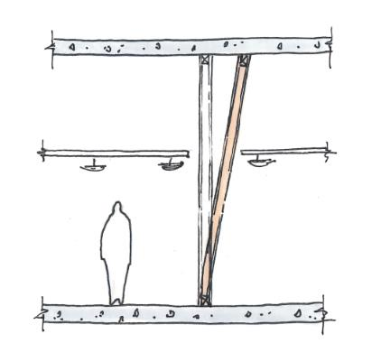 | 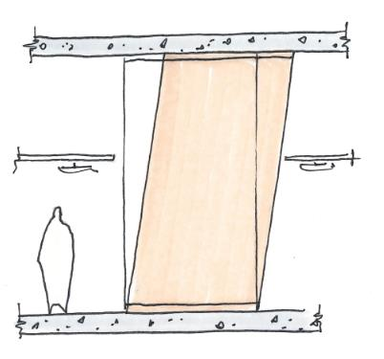 | 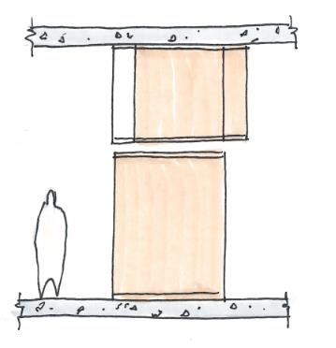

Displacement Incompatibility
Partition movements involve many interfaces, and there can be multiple potential displacement incompatibility locations. The two most common are shown below:
Partition to Partition incompatibility | Partition to Service/Ceiling incompatibility
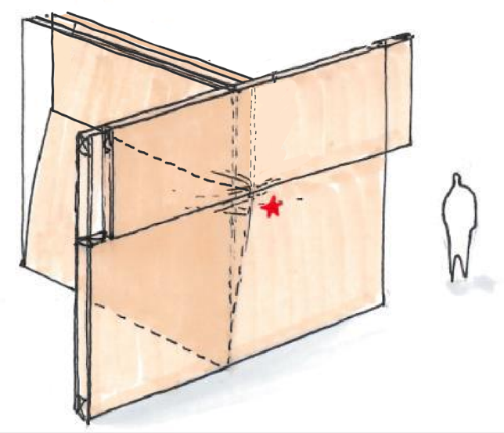 | 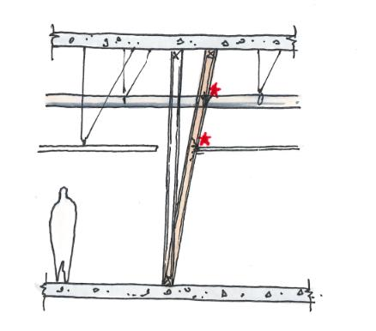
Partition Movement Strategies
There are three common approaches for partition strategies. Each approach has positives and negatives that should be evaluated on a project specific basis. The approach that offers the best overall outcomes for the project should be selected.
“Box type” construction is sometimes used for stand-alone rooms. In this situation the ceiling forms an integrated box with the walls. This makes the wall and ceiling interfaces fairly simple but does result in more complex movement between the ‘box’ and the rest of the building.
Table 16: Partition movement strategies
Aspect | Raking (connected to structure above) | Sliding (just above ceiling level) | Sliding (at level of structure above)
Arrangement | 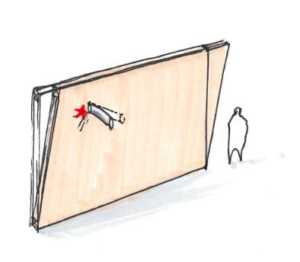 | 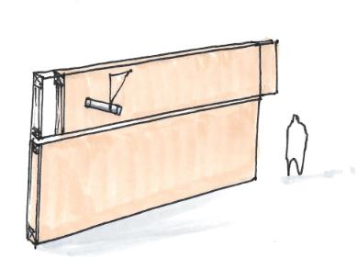 | 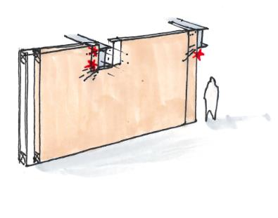
Implication for structure |   Requires very stiff structure. |   Can accommodate flexible structure. | Can accommodate flexible structure.
Ceiling interface | –  Moderate ceiling to partition movements. | Low ceiling to partition movements | High ceiling to partition movement.
Horizontal services interface | (Relatively) low partition to services differential movement | Low partition to services differential movement | High partition to services differential movement
Vertical services interface | NA | High differential movement for vertical services crossing the slip plane | NA
Fire Stopping implications | (Relatively) simple fire stropping | Simple fire stopping | Complex fire stopping
Partition head detailing | Simple partition head detailing | Complex partition head detailing | Complex partition head detailing
Acoustic detailing | Simple acoustic detailing | Complex acoustic detailing | Complex acoustic detailing
Stud size/gauge and centres | Higher stud spans could lead to larger wall stud framing. | Lowest demands on wall stud framing | Higher stud spans could lead to larger wall stud framing.
Out-of-plane support (bracing) | Lowest bracing requirement | Requires more diagonal or cantilevered bracing from slab soffit to brace slip plane | Lowest bracing requirement

    - Design Criteria
In Plane Design Capacity
Whilst the in-plane design of plasterboard lined partitions will often be displacement compatibility (drift) governed, the strength capacity should also be checked. For many non-structural partitions, the loading is sufficiently small for this to be a simple and generalised exercise.
It is common and acceptable practice to rely on the inherent in-plane stability of non-rated partition wall types in low-risk and low-demand configurations within interior fitouts. Walls of a reasonable length will have enough capacity to support themselves in-plane and proportionate extents of intersecting walls out-of-plane (provided adequate top plate connection is made).
The guidance in BRANZ Study Report SR305 Bracing Ratings for non-proprietary bracing walls (BRANZ, 2013) is a practical resource that may assist with appropriate judgements, and this could also be supplemented with information on rated systems (e.g. P21 tested bracing elements) if needed (BRANZ, 2010).
NSE designers will need to identify areas that require checking and/or specific in-plane design due to their relative slenderness, higher than normal imposed loading, or their function in a higher-demand system. This could include “box in box” type construction of specific enclosures (such as MRI enclosures supporting RF shielding, and theatre suites depending on approaches to partition, ceiling, and pendant/equipment support). NSE Designers should also ensure the detailing applicable to partition wall systems and their intersections and restraints is clearly documented, and any areas requiring specific in-plane bracing specification or detailing are identified.
The above guidance is limited to non-structural partitions forming part of interior fitouts. For guidance (and some suggested restrictions) on the use of in-plane capacity of lightweight walls as part of primary structural systems, refer to Section C5 (Design of Lightweight and Low-rise Hospital Infrastructure).
The use of P21-tested plasterboard bracing elements is also generally discouraged for specific situations where significant imposed loads are applied and tolerance to damage is low. Such as theatre suites where equipment, pendant, and hepa filter support framing is enclosed and supported within walls. Specific in-plane design to B1/VM1 should be carried out in order to meet ULS requirements (for heavy parts) and the Continued Functionality (SLS2) objective—as part of a holistic approach to NSE Seismic Design in these areas.
Displacement Compatibility Checks
Designers are also required to undertake displacement compatibility checks to demonstrate that deformations remain within the performance criteria requirements of this document.
Due to the complex interactions between elements, it is not possible to provide a universal set of design criteria. Designers are expected to adopt a combination of first principles approaches, as well as references to available industry publications and research.
Partition Damage States from Imposed Interstorey Drift
A summary of expected partition drift behaviour is provided, with the intention of informing design approaches.
Importantly, these should not be interpreted as primary structure interstorey drift limits. They represent the general levels of damage that might be expected should the interstorey drift be imposed on the partition system and thus could represent a primary structural drift target only if partitions were hard fixed between floors.
As described in other parts of this section, partition systems can be engineered or configured to minimise the proportion of structural drift that is imposed on them. However, it can be impractical (or expensive) to explicitly accommodate all applied deformations, particularly considering wall intersections and interactions with ceilings, services and equipment. This information is intended to aid Structural Engineers and NSE Seismic Designers agree strategies that balance structural efficiency with practical detailing.
It should be possible to accept some areas of damage and still meet the performance goals described in Section B2.3 provided the extent is limited.
The 0.5% drift limit has been adopted on previous hospital projects and is in alignment with other guidance, such as Ministry of Education guidance, the BIP NSE CoP, and Low Damage Seismic Design guidance currently in development. FEMA P-58/BD-3.9.32 testing shows that, for commonly used partition types, this drift is associated with the DS1 damage state, where damage is present, but unlikely to impair function.

Table 17: Descriptions of physical damage states due to in-plane deformation for traditional plasterboard partitions subject to imposed interstorey drift
Limit State and Wall Type | Required Physical State | Recommended Drift Limit | Commentary on the damage state at the recommended drift limit
(Reference only) | Significant Damage | 1.0% | Severe cracking, crushing or out of plane buckling of the gypsum wallboards such that replacement of the wallboards becomes necessary. (FEMA P-58/BD-3.9.32 damage state 2). Deemed unacceptable for hospitals at SLS2.
General partitions.  SLS2/DCLS limit | Damage localised, easily repairable and not impacting basic function.  Localised means not all walls should require repair, with most of the damage located around non-standard or stiff wall intersections or areas which are less practical to design for movement tolerance (i.e., the exception rather than the rule).  Easily repairable means mainly limited to cracking in plaster and paint along panel edges, isolated pull through or popping of fasteners. Repair should be predominantly sealant and/or plaster and paint. Repair may require some refixing in a handful of areas, but sheet replacement should not be required. | 0.5% | Screw pop‐out, cracking of wall board, warping or cracking of tape, slight crushing of wall panel at corners. (FEMA P-58/BD-3.9.32 damage state 1). Aligned to Ministry of Education and LDSD recommendations.
Plasterboard fire separations.  SLS2/DCLS limit | Damage limited to that which can maintain reasonably adequate passive fire resistance.  This means that the level of assurance in the performance of fire safety systems can be reduced compared with newly installed compliant/tested systems. However, there should be reasonable confidence in the expected performance of safety systems to provide basic protection in the event of a credible fire scenario—in conjunction with practical enhanced management strategies.  This will need to deliver the required level of functional continuity (as defined in the Outcome Objectives and Building Performance Goals) until repairs can be carried out as part of a return to Normal Operations. This is indicated graphically in Section B2.3, Figure 6.  Refer also to Fitout Elements—Partitions section. | 0.5% | Screw pop‐out, cracking of wall board, warping, or cracking of tape, slight crushing of wall panel at corners (FEMA P-58/BD-3.9.32 damage state 1). Aligned to median demand data from FEMA P-58/BD-3.9.32.
Partitions requiring air tightness for clinical isolation or biocontainment. SLS2/DCLS requirement | Essentially undamaged where partitions perform an air tightness function for clinical isolation.  However, some compromise tolerable if this level of protection is impractical or where additional flexible air barriers are provided. Refer to the additional commentary in footnote to Table 17. | 0.5%  0.2% | Where (normal) mechanical air control measures are likely to remain active and aid air tightness (or where additional flexible air barriers are provided), similar to fire separations.  Otherwise, ‘essentially undamaged’.
Partitions in wet areas, and partitions providing radiation containment | See commentary below.
(Reference only) | Essentially undamaged | 0.2% | Hairline cracking of wall board or joints, visible screw pop out, light warping or cracking of tape. Damage could be taken for normal wear and tear (FEMA P-58/BD-3.9.32 damage state 0).

Partitions in Wet Areas and providing radiation containment
For wet area membranes, and radiation equipment containment to be fully functional after an earthquake, it is expected these partitions would need to remain ‘essentially undamaged’.
However the drift limits associated essentially undamaged partitions are onerous, and it is generally not economically feasible to achieve these by limiting structural drifts. Project specific alternatives should instead be investigated, including:
- Accept damage to membranes in wet areas, and the need for repair after an earthquake. This may be appropriate for localised wet areas, especially those without critical post-emergency function.
- Use special detailing, box-in-box type construction, or other means to limit partition damage whilst still allowing larger superstructure drifts.
- Large hospital projects are likely to have specialist advice regarding radiation containment requirements. The architect and NSE seismic designer should consult with this specialist to determine a project specific strategy depending on equipment and use.
Weight allowances and imposed loads
Partitions should be designed to accommodate the following:
- General weight allowance for joinery, shelving, drug cabinets, medical equipment, etc: It is recommended that 10kg/m² surface allowance is allowed for partition walls with basic equipment (pictures, TVs etc). In areas that are likely to require significant amounts of shelving, joinery etc, higher loads should be allowed for. Historically loading of approximately 25kg/m² can be required in more heavily loaded areas. Full height shelving fixed to walls can require higher loading. Historically approximately 50kg/m².
- Loading from edge restrained ceilings. Determined on a project specific basis.
- Loading from heavier, non-standard wall mounted equipment. Determined on a project specific basis.
    - Other Design Considerations
Trade-offs between building drift and partition detailing
In general, it is expected that a project will need to decide between the following two approaches to partition design:
- Use traditional partitions and limit structural drifts to acceptable levels of damage of the partitions (and connecting services). This typically results in simpler, cheaper partitions, and more expensive structure.
- Specially design partitions that can accommodate displacement incompatibility issues without damage, whilst be subject to higher drifts. This typically results in more complex, expensive partitions, and less expensive structure.
The appropriate decision will vary by project but should take account of all aspects of a building that are sensitive to drift including, but not limited to, cladding system, services within risers, operability of doors to critical areas.
Partition wall detailing
Deflection head detailing is often complex on hospital projects. The following aspects should be considered in design:
- The use of deflection head tracks located 150-250mm above ceiling level is a commonly adopted and effective means to manage displacement compatibility issues. When using this approach, early detailing coordination between architect, services engineer, and NSE Seismic Designer should be undertaken to consider detailing practicalities and spatial implications.
- Deflection heads should be at consistent level across floor level (as much as possible). Vertical slip joints are required where deflection head heights change, which can add significant cost/complexity and performance risk.
Where full height walls are not required for acoustics or fire rating, they should be avoided to minimise displacement incompatibilities between services and partitions in the ceiling plenum.
Commentary for Fire Stopping and Acoustics
Performance requirements
Refer to Section B5.2 (Structural Performance in Fire) and in particular Section B5.2.2 (Fire Safety Following Earthquake).
Fire rated walls (separations) add further complexity to the partition wall interactions. In particular, the design basis for fire and smoke separations in normal conditions generally utilises prescriptive compliance pathways based on the specification of tested of components and systems. Testing does not usually extend to post-earthquake scenarios and the impact of earthquake induced damage on the performance of the system in fire conditions.
There is not a clearly established means to quantify how well these walls may continue to perform their fire protection function after suffering modest damage, and so a rational assessment is required. Full height wall systems that are subject to imposed drifts which are within the limits of Table 17 are deemed to satisfy the requirements. Otherwise, a rational assessment against the principles of Section B5.2.2 can be made—and further commentary is given below where horizontal slip planes are proposed as part of the solution to this.
Designers should note that full pre-earthquake functionality is not required in the immediate aftermath of earthquakes. However, damage to partition systems that function as fire separations should be controlled so as to satisfy the principles set out in Section B5.2.2, with a pathway for reasonable extents of repair in a return to Normal Operations.

Engineered horizontal movement planes (slip planes)
Depending on the Seismic Design Strategy, engineered slip planes within the ceiling plenum may be considered (see Table 16) in order to allow larger primary structure deformations to be accommodated, without imposing drifts on the partition systems which are greater than the limiting values suggested in Section C4.5.
Priority should be given to the fire safety performance of the detail in normal conditions. Second priority should be given to the likely function of the detail after subjecting to the forces and displacements associated with SLS2 earthquake demands, assessed against the principles listed above (Section B5.2.2).
Health NZ is aware of research proposals which intend to improve the confidence in the performance of common details under fire conditions following earthquake induced deformations, and which may allow the development of standardised approaches which can be used to meet these requirements.
Fire stopping displacement compatibility considerations.
Designers are expected to develop a means to account for displacement incompatibility as it relates to fire stopping, especially for services passing through fire walls.
Further guidance on the interaction of services, restraints, partitions and structure can be found in BRANZ FACTS: Seismically Resilient Non-Structural Elements #4, Seismic clearance at penetrations (BRANZ, 2015).
The displacement incompatibility at fire walls can sometimes be accommodated by accounting for the many small flexibilities that exist within the whole system. These include:
- Flexibility of services between their nearest restraint and the wall. This can often be in the order of 5-10mm. For this reason, services should not be transversely restrained close to partition walls.
- Flexibility in the restraints (to services and to walls). This can often be in the order of 5mm.
- Local wall flexibility. This may include some local damage around stiff services if considered acceptable by the design team. This can often be in the order of 5mm.
- Flexibility of fire stopping. This should be determined in consultation with the fire stopping supply. Typical fire stopping products only provide approximately 5mm of flexibility. Some products are available on the market that provide flexibility up to 20mm, though these need to be specifically discussed with suppliers.
The acceptability (or otherwise) of the fire stopping detailing will be highly dependent on the partition movement strategy (racking, sliding at ceiling, sliding at top) that is chosen.
Fire rated walls that use braces for support should preferably be braced on both sides. This means that one brace will always be on the protected side of the wall, and thus avoids the need for fire rating of braces.
Integrated supported systems for specialist areas containing suspended medical equipment
Some specialist rooms may benefit from specific consideration to integration of lateral and vertical support systems for partitions, ceilings, and suspended medical equipment support framing, (and an adjustment in approach compared with typical areas). This may include:
- Operating theatre suites;
- ICU/HDU;
- Some areas of radiology and imaging.
The strategy for support of suspended medical equipment influences the most pragmatic and buildable solution. Refer to the commentary in Section B5.1.5 (Considerations for Soffit Mounted Equipment).
  - Suspended Ceilings
Suspended ceilings typically fall into one of two categories:
- Exposed grid ceilings – suspended support structure visible (e.g., tile and grid ceilings)
- Concealed grid ceilings - suspended support structure hidden (e.g., plasterboard lined ceilings)
This document primarily considers exposed grid ceilings, though designers may be able to extrapolate to other ceiling types.
    - Design Criteria
Design Strategy and Checks
For general design requirements, refer to the BIP NSE CoP.
The NSE Seismic Designer is expected to develop the design strategy for the ceilings. This should delineate how the checks above are to be undertaken. Often this will involve:
- Direct bracing checks being undertaken by the NSE Seismic Designer
- Ceiling (grid, diaphragm, connection) checks being undertaken by a proprietary ceiling supplier. In this case, the NSE Seismic Designer should:
  - Engage with the architect and proprietary ceiling designers early in the project to select systems with appropriate capacity for the project.
  - Assist the architect with developing an appropriate performance specification that requires the appropriate capacity checks to be undertaken by the supplier and submitted to the project.
- Review submittals from the ceiling supplier for compliance
- Review (or directly design if within their scope) the supporting walls to confirm they have been designed to restrain the ceilings where required.
Ceiling Capacity Validation
There is limited information available from supplier’s detailing capacities of ceiling grids, connections, and overall systems. Some of the information that is available is not supported by appropriate testing or similar validation. Some products on the market may have seismic performance below expectations.
Designers shall take steps to reasonably demonstrate that selected ceiling systems perform as required by the design. For major hospital projects, this is expected to include testing, by a reputable third party, to demonstrate the capacity of the element/system. This testing should be carried out in accordance with AS/NZS 2785:2020 (or for ceilings restrained by partitions walls, ASTM E580 may be used).
All information on any testing completed should be included in the NSE Seismic Design Strategy report.
    - Other Design Considerations
Seismic Securing of Ceiling Tiles
The complete avoidance of tile loss generally requires securing ceiling tiles. This has often been achieved via taping or clipping of the ceiling tiles. However, clipping or taping can preclude straightforward maintenance access to the ceiling plenum.
The need for in-ceiling maintenance is critical in hospitals, so securing systems that limit maintenance (such as clips) are considered undesirable from an operational perspective, and unreliable from a seismic performance perspective (as they are likely to be removed).
Designers are therefore encouraged to explore systems that can secure ceiling tiles without hindering access. Initial research findings as part of the ROBUST programme, suggests that good seismic performance can be achieved with very simple, low-cost systems such Velcro fasteners. Designers are also encouraged to work with suppliers to implement ceiling tile securing systems that also allow for easy maintenance access.
Clipping or taping is considered appropriate where it can be practically achieved without interfering with maintenance requirements. This is particularly true for ceilings where tile loss could adversely impact post-disaster function, such as key egress routes, or where dislodged tiles might damage emergency lighting and sprinkler heads.
Clearances
Ceilings are displacement and acceleration sensitive elements. Where these systems interact with other elements (such as at perimeter walls or across seismic joints) the clearances should be assessed by the designer and specified on the construction documentation.
Ceiling weight allowances
Allowance should be made for the project specific suspended services weight on the ceiling. Appropriate allowance should be developed in conjunction with the services engineer.
The Health NZ recommended minimum loading allowances required for ceilings is as follows:
- For localised gravity load checks, suspended ceilings should be designed for a minimum services load allowance of 3kg/m² (as per NZS 4219) plus 3kg/m² for incidental live loads (as per AS/NZS 2785)
- For seismic load cases, the services load allowance (minimum 3kg/m²) shall be included in the seismic weight of the suspended ceiling. The incidental live load allowance can be taken as zero (as per AS/NZS 2785)
For a hospital, the minimum services load allowance of 3kg/m² may not be sufficient, and advice shall be sought from the services engineer for an appropriate project specific allowance.
Integrated supported systems for specialist areas containing suspended medical equipment
Refer to the corresponding subheading in Section C4.5 (Lightweight Partition Walls) and the commentary in Section B5.1.5 (Considerations for Soffit Mounted Equipment).
  - Suspended Building Services
    - Description and Performance Requirements
Suspended Building Services includes, but is not limited to, linear items such as duct, cable tray and pipework as well as in line or individually suspended items of plant and equipment.
The performance requirements for this element are defined in Section B2 of this document. Refer in particular to the Descriptions of Physical States in Section B2.5 Table 17 for definitions of post-earthquake expectations for individual elements.
    - Design Criteria
Reference documents
Refer to NZS 4219 for general guidance for design of seismic restraint for engineering systems (SNZ, 2009).
The BIP NSE CoP contains general guidance for seismic design of services. This should be followed for hospitals.
Additional requirements to meet elevated performance criteria of hospitals are provided below.
Design Criteria for Elements Requiring Liquid Containment
The performance requirements for many elements include a requirement to maintain liquid containment due to that disruption that loss of containment can cause.
For design purposes, this shall generally be taken as:
- Where liquid containing systems are considered to behave in a nominally ductile manner, limiting system ductility demands to µ=1.25 is considered appropriate. Where systems are known to be ductile, higher ductility limits should not be adopted unless specific testing is available showing that these higher ductilities can be achieved whilst still maintaining liquid containment.
  - This is considered applicable to most modern plastic and metal piping systems.
- Where liquid containing systems are considered to be at risk of brittle behaviour, limiting system ductility demands to µ=1.0 is considered appropriate. Ideally brittle systems would not be used on hospital buildings.
  - This is considered applicable to (for example) water tanks that are not designed for seismic actions.
ULS design requirements for elements imposing a direct life safety hazard
Some systems pose a direct life safety risk due to the hazardous materials they contain. This includes steam pipework, very hot water systems, and hazardous medical gases. For these systems it is important that a loss of containment is avoided at the Ultimate Limit State
This shall be done by:
- Limiting system ductility demands for systems containing materials that impose a direct life safety hazard to µ=1.0 at ULS.
- Unless a special study is undertaken to demonstrate that the system is able to maintain containment of hazardous materials at ULS.
- Where it can be demonstrated, via material standards or NZS 1170.5, that structural performance (S_{p})values less can 1.0 are applicable (i.e. due to system ductility capacity greater than 1.0), these may be used.
It should be noted that this rigorous ductility limit applies to systems that could lead to a direct loss of life should they fail. It does not extend to systems serving an indirect life-safety protection function, for example, sprinkler systems.
    - Other Design Considerations
Clearances between Linear NSE
The are two main reasons to provide clearance between NSEs. Firstly, to prevent NSEs from damaging each other due to collision in a seismic event. Secondly, to prevent NSEs on one restrained system from impacting and imparting additional demand onto the restrained system of a second NSE.
There are clearance requirements indicated in table 15 in NZS 4219. Where possible these clearances should be provided. There may be situations where it is not possible to achieve these clearances.
Where it is not possible to achieve the clearance specified in table 15 in NZS 4219 specific assessment could be carried out that to demonstrate that the risk of damage to the elements is sufficiently low. Whilst there is no formalised methodology for such assessment, it is expected to consider relative displacements, likely force of impact, and robustness of materials.
For NSEs that are supported and restrained on the same frames/trapeze/gravity supports ideally provide 50mm clearance between services. However, this is not as critical as the services will be constrained to similar displacements and will be less likely to impact causing damage.
Interface with Partition Walls
The interface of services with partition walls, especially fire walls or acoustic walls can be complex. Refer to Section C4.5 Lightweight Partition Walls for further commentary.
Integrated supported systems for specialist areas containing suspended medical equipment
Refer to the corresponding subheading in Section C4.5 (Lightweight Partition Walls) and the commentary in Section B5.1.5 (Considerations for Soffit Mounted Equipment).
    - Special Considerations for Fire Sprinkler Systems
Detailed design considerations for sprinkler systems are detailed above. However, there are certain particularities of sprinkler systems that need to be considered.
Seismic Performance vs Compliance
The design of new sprinkler systems is significantly more compliance focused than many other systems. As such, there can be an inclination amongst sprinkler designers and specifiers to expect compliance is maintained after an earthquake. The post-earthquake expectations of Health NZ relate to expected performance, not to compliance.
As defined in the performance requirements section, post-earthquake full functionality does not imply code compliance. It is expected that some systems will not be code compliant after a large earthquake, however they are expected to still maintain reasonably adequate performance—this may mean operating under slightly elevated levels of risk which are tolerable for a time under the circumstances, and which might be mitigated by additional management strategies (to mitigate any compromise to parts of fire safety systems, for example). Return to normal operations describes the resolution of these compromises as part of the medium to longer term recovery. Note that in large earthquakes, disruption and return to full function can often be controlled by aspects beyond the building envelope, such as cordons, utility outages, and labour shortages.
Sprinkler head to ceiling displacement compatibility
The interactions of sprinkler heads with ceilings are extremely important for avoiding significant disruption from loss of containment of the water in the pipework. The sprinkler heads represent a key seismic vulnerability in hospital buildings.
The Fire Engineer, Architect, and NSE Seismic Designer all have a responsibility in coordinating this interface.
It is expected, in all cases, that:
- Flexible droppers to heads shall be provided, and that these shall have ample redundancy to move beyond the calculated differential movements.
- Ceilings and sprinkler pipework shall be designed to have generally compatible movements (for example, both rigidly fixed to floors above).
- Ceilings housing sprinkler heads shall be specifically designed to meet seismic the requirements of the sprinkler system (which will likely be more onerous than the requirements of the ceiling system itself)
- Ceiling tiles housing sprinkler heads shall be clipped, taped, or otherwise detailed so as to avoid damage to the sprinkler heads.
Considerations for minimising post-earthquake leaks
The design of sprinkler piping systems should consider the selection of appropriate brace spacing for horizontal piping as per Table 4.11 of NZS 4541. After the selection of brace spacing, simple but appropriate engineering checks should be performed to ensure that leakage will not occur. NZS 4541 does not provide any guidance on bracing piping segments to avoid leakage as the design criteria behind Table 4.11 is not provided in the Standard. It is recommended that the simple mechanics-based check involving the comparison of plastic moment capacity of piping sections with moment demand from seismic forces be used to check if leakage would occur. This design approach is used by the US Standard for fire sprinkler systems (NFPA 13).
Another design check involves the comparison of force capacity of the proprietary braces and their anchorage with the force demand. It is also recommended that capacity design principles be followed to avoid brittle failure in the components of brace assembly or the anchorage if ductility-based reduction factors are used in the design.

  - Plant and Other Mounted Equipment
    - Description and Performance Requirements
This section applies to plant and other rigidly mounted equipment sat directly on structural floors and fixed directly to those floors. Similar principles can be applied to mounted equipment mounted on other structure such as rooftop plant.
The performance requirements for this element are defined in Section B2 of this document. Refer in particular to the Descriptions of Physical States in Section B2.5 Table 17 for definitions of post-earthquake expectations for individual elements.
    - Design Criteria
Design Checks
The design of floor mounted plant primarily consists of the design of anchorages to the primary structure. Refer to Section C4.3.3 for anchorage design information. Equipment shall be connected to the structure with a minimum of 4 fasteners.
Components that do not have an easily defined centre of gravity require specific design, refer to NZS 4219 Section 4.
Vibration isolated equipment shall be designed in accordance with NZS 4219. Note that amplification effects due to AV mounts and snubbers must be accounted for in the design. This may involve increased demands on anchor connections.
Plinths shall comply with NZS 4219 Section 5.4.
Wall mounted equipment requiring specific design to be as per NZS 4219, Section 3.9
The design of the supporting floor system is the responsibility of the structural engineer. It is expected that the floor systems will be designed to accommodate the reactions from most floor mounted plant without the need for additional localised supports or strengthening. Refer to Section C4.2.6 for further detail.
Particularly heavy plant, such as water tanks or transformers may require supporting beams to distribute their seismic loading. Ideally, this would be done via secondary structural beams designed by the structural engineer, but if project procurement timeframes do not allow for this (due to final positioning of this plant happening in detailed design or later), then these may need to be tertiary beams designed by the NSE Seismic Designer. The project shall determine, as part of the NSE Seismic Design Strategy, the approach to be undertaken for the project.
    - Other Design Considerations
Location and Access
One of the most important considerations for the seismic resilience of plant is their physical location. This includes considerations such as:
- Vulnerable plant or equipment is more resilient if placed at lower levels. Ground level equipment is much easier to repair than roof mounted equipment. It is also subject to lower accelerations.
- Basement areas, especially the lowermost level, can be prone to flooding following earthquakes.
- Liquid tanks are particularly vulnerable, and their failure can cause widespread impacts – especially if they are high in the building above critical facilities.
- Primary service route to plant areas are often highly congested areas. These can be difficult to access, and thus to repair, after an earthquake.
Seismic qualification of equipment for continued functionality following earthquake
The Seismic Performance Framework (Part B) requires some equipment to maintain a level of reliability and continued operability following earthquake, appropriate to its function (as described in the description of physical states in Section B2.5).
Responsibility for the specification of plant (including specification of seismic performance, and which elements of plant are required to maintain functional continuity) lies with the services engineer. The NSE Seismic Designer should provide support to the services engineer in relation to seismic matters.
Details on the appropriate means of seismically qualifying equipment can be found in Health New Zealand’s Building Services Design Guide Note.
Liquid Retaining Tanks
Liquid retaining tanks are often some of the most vulnerable aspects of a hospital building, and their failures have historically resulted in significant disruption. This disruption can be in the form of losing the building services they are associated with, or due to the consequential impacts of liquid spilling into the broader hospital.
The design of liquid retaining tanks should address collapse prevention, loss of support, rupture, or loss of contents at the applicable Limit State.
As well as the design checks associated with most plant (i.e., anchorage checks), liquid retaining tanks shall either:
- Be specifically designed to resist the seismic loads imposed on them, OR
- Be separately restrained by a seismic frame.
The method to be used shall be determined early in the project as part of the Non-Structural Element Design Strategy. This will require the input of the building services engineer and NSE Seismic Designer.
It is unlikely that proprietary thin-wall tanks will be capable of resisting significant seismic actions without supplementary strengthening and/or bracing. (The majority of tank design and construction standards do NOT provide design criteria for superimposed hydrostatic and seismic forces, and require special design consideration where seismic actions apply).
Historically, this is an area that has not been well addressed, and the Cost Consultant should therefore be included in conversations to help understand the impact.
Seismically designed tanks
The seismic design of liquid retaining tanks may be designed in accordance with the NZSEE Study Group recommendations in Seismic Design of Storage Tanks (NZSEE, 2009), or to API 650 13th edition (API, 2021) and to the project design coefficients for NSE. These tanks are typically supplier designed items, and their seismic design requirements will need to be included in the Building Services performance specification. Generally, these specifications should include requirements for fixing/restraining to prevent sliding (without relying on friction between tank and supporting pads) and overturning failure. Generally, seismically designed tanks should include certification from the manufacturer’s CPEng designer.
Due to the specialised nature of the seismic design of liquid retaining tanks, the NSE Seismic Designer is expected assist the services engineer with both the preparation of an appropriate performance specification, and the review of supplier submissions.
Separate Seismic Frame
Where a separate seismic frame is to be provided, this should be designed by the NSE Seismic Designer.
This is generally a less desirable option, as it often ends up more expensive, and with more potential seismic vulnerabilities. However, it may be a necessary approach when seismically rated tanks are not readily available.
Hot Water Cylinders
NZBC G12/AS1 Section 6.11.4 and Figure 14 is an acceptable solution for seismic restraint of hot water cylinders up to 360 litres. Figure 14 is suitable for a seismic lateral force coefficient, C ≤ 3.6 (the maximum obtainable under NZS 4219). Hence the extra centre strap shown in Figure 14 for 200 – 360 litre cylinders is only required where C > 2/3 x 3.6 = 2.4.
  - Vertical Transportation (Lifts)
    - Design Criteria
Design Working Life for Loadings
The Design Working Life for determining loading on lift installations (including seismic loading) should be an ordinary 50-years, representing an indefinite life, in accordance with the Building Code and Section C1.1.1. Whilst the intended lifespan of the lifting equipment itself may be a shorter period (before major maintenance or replacement would be expected), this does not reduce the risk exposure and so a correspondingly low Design Working Life is not appropriate.
Design of lift guide rails and their supporting structure
Refer to EN 81-77 Safety rules for the construction and installations of lifts - Particular applications for passenger and goods passenger lifts - Part 77: Lifts subject to seismic conditions for detailed design requirements (DIN, 2013). NZBC D2/AS1 provides for this as a compliance pathway for B1 Structural Design, as it relates to passenger carrying lifts.
The EN 81 pathway under D2/AS1 is preferred, citing standards EN 81-20, EN 81-50 and EN 81-77 (BSI, 2014) (BSI, 2014) (DIN, 2013). The EN 81 suite will need to be referred to by lift suppliers, as well as by the Structural Engineer responsible for designing structure supporting lift installations as defined by those standards. D2/AS1 contains important clarifications around the way that the EN 81 suite of standards is applied in the New Zealand regulatory environment, including how earthquake loadings should be obtained.
The design of lift rails and their supporting structures can be deflection controlled in some cases. For deflection-controlled elements where earthquake actions are based on Parts and Components loadings and assume ductility, the calculated deflections are the elastic component only. They are required to be scaled by the design ductility to obtain the total deflections for comparison against the limits given in the above standards.
    - Other Design Considerations
Coordination between Structural Engineer and Lift Supplier
The following items are a minimum of those that require direct communication and record of resolution between the Structural Engineer and lift supplier (with reference to the Vertical Transportation specification and input from the project’s vertical transportation engineers as appropriate).
Designing Structure Supporting Lift Installations
- Confirm the compliance pathway (NZS 4332 or EN 81). EN 81 is preferred.
- Confirm the lift supplier has clarity on SLS2 and DCLS requirements which should be contained in the vertical transportation specification.
- Obtain car and counterweight rail seismic loads from lift supplier, as well as other normal/safety gear operation loads (lifting beam Safe Working Loads, hitch/motor beams if needed, machine room loads, dynamic rail/pit loads, and door loads). Confirm any requirements for concurrent application of loads.
- Confirm any suspended lift pits with occupied spaces under are reflected in the lift supplier’s documentation and indicated on the shop drawings (not ‘solid earth’ under). This can affect the required safety requirements for the lift installation (and could require higher pit loads for counterweight safety gear, or other requirements).
- Confirm the design standard used for Earthquake Actions and what part ductility factors have been used for deriving seismic actions, so any necessary adjustments can be made by the Structural Engineer in the design of structure supporting the lift installation.
- Confirm deflection criteria used (and provide clarity on the required deflection scaling where ductility has been assumed, as noted in Section C4.9.1). EN 81 stipulates combined rail and supporting structure limits, which depend on the configuration (presence of car/counterweight safety gear, inclusion of seismic retainers).
When following the EN 81 pathway (preferred) lift guide rail deflection limits under earthquake conditions are specified in EN 81-77, which references EN 81-20 (EN 81-20 supersedes EN 81-1 but the values are the same). They apply to combined deflections of the guide rails and supporting structure and are applied at ULS. The basic value is 5mm for cars or counterweights with safety gear, and 10mm for those without. For earthquake conditions, it is usually interpreted as applying to relative movement between opposing rails that could cause the rails to separate and reduce rolling gear seating.
These values can be difficult to meet for combined rail/support structure deflections in steel framed lift shafts (depending on the applicable Parts and Components loadings).
Therefore, for the ULS, it is recommended designers consider justifying their increase by specifying EN 81-77 seismic retainers to rolling gear on cars and/or counterweights. Structural engineers and vertical transportation engineers should coordinate the inclusion of this requirement in lift specifications. Higher deflections are permitted subject to the geometry of retainers (up to a maximum combined deflection of 40mm). Reliance on retainers is not recommended at the DCLS or SLS2 limit states.
The previous standard NZS 4332 stipulated a 6mm deflection limit for structure supporting lift installations only (i.e. not including rail deflection). It could be practical to continue to apply this 6mm value as a preliminary design allowance for supporting structure only (to more easily separate design responsibilities) and advise the lift supplier accordingly. However as noted above, larger total combined limits are available under EN 81 (especially where seismic retainers are included on rolling gear) and this can be taken advantage of with appropriate lift supplier coordination.
Using supplied lift installation loads for structural limit state design
Generally, the following requirements will apply when incorporating loading requirements from the lift installation supplier with the supporting structure design. Consult with the lift supplier if not clear.
- Lifting Beams, and hitch/motor beams: Requirements are usually presented as a required Safe Working Load (SWL). Treat lifting beam SWL as live load Q, and apply the normal 1.5 load factor as part of a limit state design in addition to the NZS 1170.1:2002 Table 3.4 dynamic factor of 1.25 (ULS Design Action = 1.5 x 1.25 x SWL). Hitch/motor beams usually include dynamic factors from the lift standards, so only need the 1.5 load factor—but this should be queried to lift suppliers if it is unclear.
- Lift pit loads: Treat all loads as live load Q and apply the normal 1.5 load factor for strength design.
The supplied lift pit loads (in tabulated summarised form or on lift shop drawings) should already contain the impact/dynamic factors which are specified in the lift standard. As these are being combined with other gravity/live loads in the structure, the supplied loads under normal operations/safety gear operation are treated as an additional imposed action including impact in accordance with AS/NZS 1170.0:2002 Cl. 4.2.2. This requires taking Q as [Q + Impact]. Therefore, the required design load combination for strength for lift pit design is:
E_{d} = [1.2G + 1.5(ψ_{c}Q_{bldg} + Q_{lift})]
Some information by lift manufacturers/suppliers includes comments such as “loads are already factored”. This comment generally refers to the including of impact or dynamic factors and may not include awareness of the specific requirements of NZS 1170.0 and NZS 1170.1 for load and resistance factored structural design. Therefore, the above combinations are still likely to apply where this comment appears on manufacturer supplied shop drawings.
Functional continuity of lifts following earthquake
The functional continuity requirements for lifts (following earthquakes) are relatively onerous, due to the critical role they play in many hospitals. However, most lifts have a fail-safe system that trips the lift out-of-action should significant displacements occur. This is to ensure that lifts do not continue to travel in a scenario where guide rails may be damaged. Lift systems that continue to operate reliably through and after earthquakes without tripping are not currently readily available.
It is therefore expected that hospitals will need to take an operational approach to provide lift functional continuity. This can be done by via a Priority Response Agreement (PRA) with the lift supplier. These PRAs should include:
- Rapidly respond to the hospital in case of earthquake (target timeframes should be within an hour, ideally sooner)
- Visually inspect lifts and guide rails for damage.
- Reset the lifts for operational use.
Health NZ currently has Priority Response Agreements in place between structural engineering consultancies and a number of major hospitals. Agreements between lift suppliers and hospitals could follow a similar form.

- Design of Lightweight and Low-rise Hospital Infrastructure
  - Scope
This section applies to low-rise hospital buildings of all Importance Levels and Service Categories. This content intends reference to one or two storey facilities (excluding small appendages or rooftop plant platforms and enclosures). However, the scope includes all situations where lightweight construction techniques are proposed as part of the primary structural system supporting floors and the building enclosure. This includes:
- Construction types typically used in one to two storey residential construction (light timber framing, light-gauge steel framing or reinforced masonry).
- 'Light industrial/commercial’ typologies, typically using mixtures of:
  - Steel (structural steelwork or light gauge steel) or timber portal frames,
  - Wall or roof plane cross bracing,
  - Concrete or masonry wall panels (self-supporting or partly supported by steel framing or other lightweight structure),
  - Panel shear walls using plywood or other panel products, and/or panel roof and floor diaphragms.
  - Can include areas of heavy suspended floors or plant platforms.
This section does not apply to non-structural partitions (refer Section C4.5).
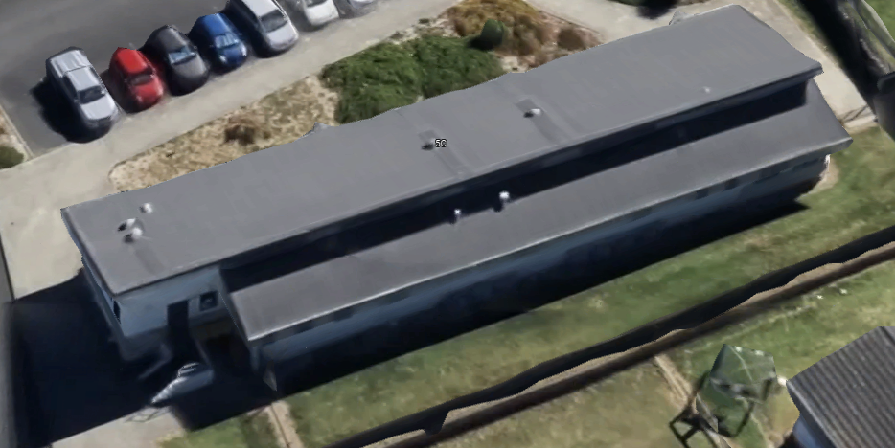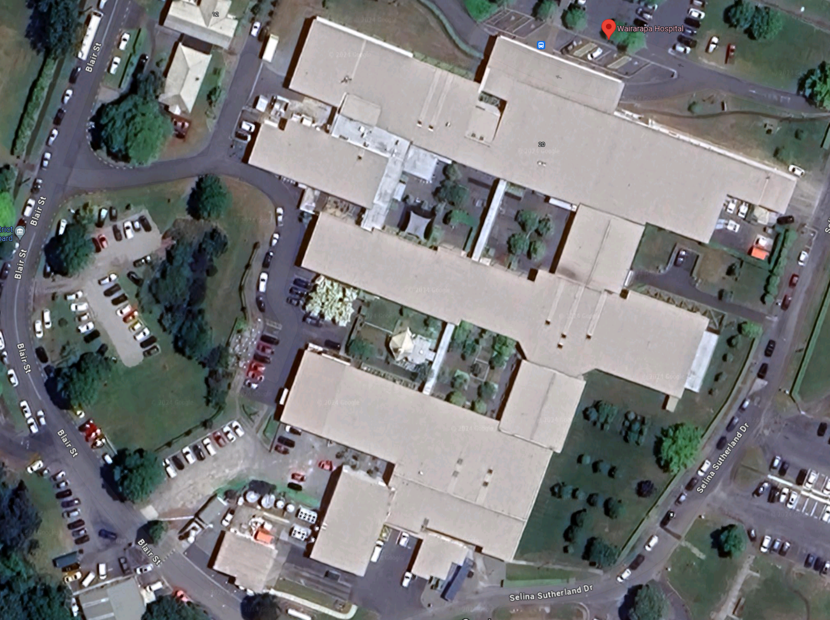
Figure 13: Example of an IL2 Oral Health Centre (dental clinic) generally using NZS 3604 and B2/AS1 (left); and a single storey IL4 Acute Facility, constructed in a mixture of timber framing and structural steelwork (right).
Exemption from Documentation Requirements for Importance Level 2 Support Services
Refer to the commentary to Section A1.6.1.
  - Structural Robustness
The general requirements of the following Sections B2.4 (Structural Robustness Requirements for the ULS Design Limit State) and C3.1 (Control of Structural Damage from Earthquake) continue to apply, as for all Health NZ projects.
The following Building Code and Health NZ Requirements are specifically clarified in the context of low-rise hospital buildings and infrastructure. Specific commentary for common low-rise typologies follows.
NZBC Requirement (B1/VM1): Structures should have a reasonable margin against the assessed performance at the ULS and structural failure associated significant loss of strength or stability, both in terms of strength and displacement.
Health NZ Requirement: All structures, including low rise structures designed to respond elastically at the Ultimate Limit State, shall have the ability to accommodate inelastic deformation. Brittle Structures (as defined by NZS 1170.5:2004) are not permitted.
Connection hierarchy, and detailing
For lateral stability structure, capacity designing key connections such that they can develop plasticity in the connected members and provide robustness and overall system ductility capacity is desirable. This is required where ductility is being relied upon at the Ultimate Limit State. Specific examples include limited ductile moment endplates (SCNZ MEP-G 100/50 Limited Ductile), or bracing connections and compression struts that are designed to develop the capacity of tension only bracing (rather than being sized to resist an analysed design action).
For lightweight structures responding elastically at ULS, some connection types will afford enough inelastic deformation capacity within the connection itself (through their standardised earthquake design procedures) to satisfy robustness requirements and capacity design of connections is not required. This would include Moment End Plates designed to SCNZ R14-1, or connections in timber designed to NZS AS 1720.1:2002 such that ductile mechanisms control the connection capacity.
However, transmitting load between members and between different components of a lateral system where there are not standardised connection types or where there are more complex geometries requires considerably more engineering input to execute well, especially in mixed/hybrid structures. This is especially the case where there is considerable length to a load path or many components to a load path.
The following general recommendations apply:
- Use capacity designed connections in the primary lateral system, or alternatively use design procedures or standardised connection types which provide inelastic deformation capacity beyond the calculated strength.
- Specifically design hold-downs connections to bracing walls and braced bays to develop the lateral capacity of the bracing panel.
- Minimise nodal eccentricities at bracing intersections. Where it is impractical to avoid eccentricities entirely, resolve in equilibrium and ensure the members themselves are of the appropriate type, shape and orientation sized to carry the forces induced by eccentricities along with the primary actions.
- The compression capacity of light-gauge steel purlins can be recognised in parts of roof framing (recognising and resolving all eccentricities present in the load path). However, they should generally not be used as struts as part of the roof’s primary bracings system.
- Generally avoid the use of open sections for eaves struts or collectors where there are high accumulating compression forces, difficulty in assuring appropriate restraint, and difficulty in minimising eccentricities at load transfer into braced bays.
- For simple (nominally pinned) baseplates on concrete slabs or footings supporting primary structural columns, use cast-in anchorage that engages footing reinforcing. Shallow post-installed anchorage should be assessed for its ability to accommodate column base rotation without premature pry out of anchors due to baseplate rigidity.
- Detail and document complex intersections of multiple structural members and bracing components in their full context (instead of relying on interpretation of individual typical details that overlap at a single intersection).
Refer to Section C5.4 for some examples further clarifying this intent, and to the Engineering New Zealand Warehouse Review Findings Report which contains additional examples and useful references (ENZ, 2023).
Regularity and Redundancy
Regular buildings with redundant lateral stability structure generally perform better in earthquakes. The following considerations should be applied.
- Distribute and tie lateral structure sufficiently in each direction such that the removal (failure) of a bracing component would not lead to overall structural instability or torsional instability.
- Minimise the length of roof or floor diaphragm and collector load paths, and concentration of demands, by using distributed vertical bracing elements across a floor plate (which also improves redundancy). This needs to be balanced against a desire to avoid over-constraining spaces but very large floor plates or roof areas with only a few lateral bracing elements should be avoided.
- Consider limiting overall building dimensions and avoiding the need to carry lateral stability loads and tying over long distances. This may involve introducing seismic separations at logical locations.
If large or irregularly shaped floor plates are proposed, then the benefits of providing expansion joints to ground floor slabs (or fully restrained slab reinforcing design) and seismic joints to superstructure should be considered. Example configurations and suggested proportions applicable to low-rise structures are shown in the figures below.
It is important to balance the cost and complexity of introducing superstructure seismic joints against enhanced performance that is realised through regular structural design.
Seismic separations do create upfront cost, area inefficiencies, everyday enclosure performance and maintenance risks. Within reason, longer plan aspect ratios and some irregular plans can perform satisfactorily if the lateral structure is regularly placed and well tied. More engineering consideration will need to be given to proportioning of floor and roof diaphragm ties in such cases. This generally results in the specific provision of additional struts and less reliance on the inherent capacity of purlins and the like (which due to their stability, end connections and eccentricities, are limited in their ability to provide the necessary tying at this scale).
Performance considerations must include ground deformation such as liquefaction induced lateral spread, and differential settlements.
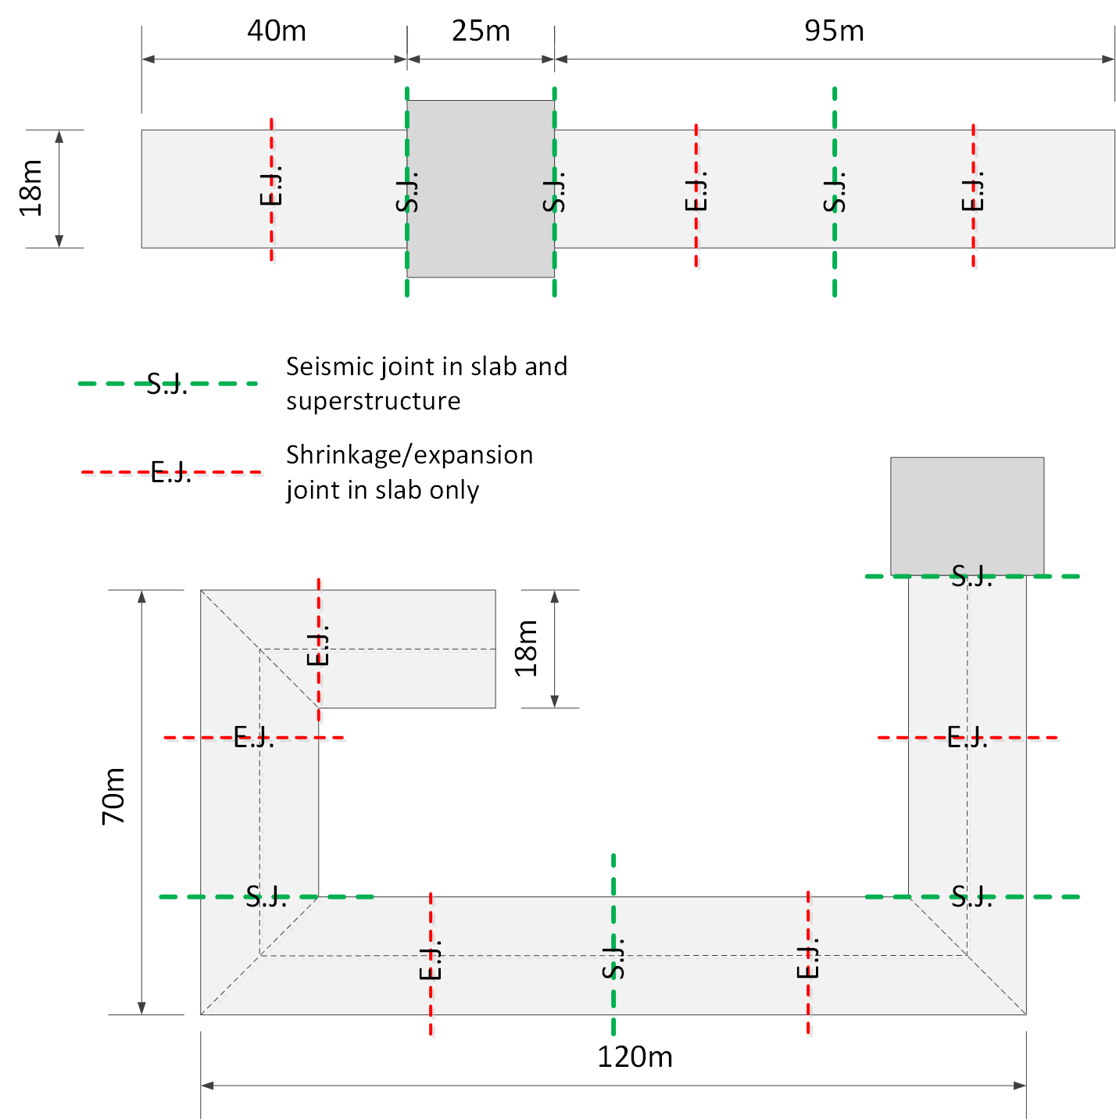
Figure 14: Indicative positioning of expansion joints in floor slabs and seismic joints in superstructures of single storey structures to maximise regularity. Floor slab joints can be minimised by design of fully restrained slab systems, generally requiring higher reinforcing contents to manage crack control.

  - Lightweight Construction Techniques used in non-Specific Engineering Design
    - Background
In low-rise and single storey healthcare facilities, when selecting primary structural systems, many will explore the use of lightweight building techniques commonly used in construction which doesn’t require specific engineering design. In some cases, their application will be outside the defined scope of the Acceptable Solutions (B1/AS1), but designers often consider utilising similar construction techniques with specific engineering design (SED) input. Examples include:
- Applying aspects of NZS 3604 (SNZ, 2011) for light timber framed buildings or NASH Standard Part 2 (NASH, 2019) for light steel framed buildings (whether or not these documents and B1/AS1 are followed as the compliance pathway).
- Use of bracing walls with specifically rated Bracing Unit (BU) capacities using the BRANZ P21 bracing wall test and evaluation procedure (BRANZ, 2010) intended for use with NZS 3604 or the NASH Standard Part 2 both under B1/AS1.
- Reinforced concrete masonry NZS 4210 or NZS 4229 (specifically engineered or not subject to specific engineering design, respectively).
- Hybrid structures using a mixture of materials and standards, often in conjunction with varying extents of structural steelwork.
Health NZ recognise that there can be benefits in using simple construction types with a more widely accessible skill base, and in utilising fitout elements (that are already proposed) for primary structural support as well. However, there are also some significant performance risks and risks in execution that need to be considered, including:
- Understanding appropriate use of P21 tested bracing walls, which is an Alternative Solution to the Building Code for Importance Levels 3 and 4 (Pratchett, 2022).
- The earthquake damage potential of P21 tested bracing systems and plasterboard ceiling diaphragm systems, which are unlikely to meet Asset Protection and Continued Functionality objectives without some special engineering considerations.
- Risk of load path discontinuities from mis-conveyed design intent. This can include over-reliance on “builders work” to adapt details to intersections that are not common (instead of them being specifically engineered and detailed).
- Difficulty in managing alterations in the future and maintaining appropriate levels of compliance. This also includes changes during design or construction that compromise or sever load paths and in practice are often not sufficiently resolved.
    - Considerations and Design Requirements
Damage Minimisation, Load Path Continuity, and Compatibility of Systems
Light framed structures (light steel or timber framed) that make use of P21 tested bracing systems usually rely heavily on energy dissipation from ductility which can result in damage to the wall elements and can reduce their stiffness and their capacity to resist subsequent earthquakes without repair. The Asset Protection and Continued Functionality objectives cannot be demonstrated in these structures by use of P21 ratings alone.
Structures using P21 tested bracing elements also rely on multiple redundancies, alternative load paths and reasonably high levels of symmetry and regularity to perform well (Pratchett, 2022). This makes them less suitable for situations where such redundancies and regularities may not exist. Experience in hospital infrastructure has found that the presence of alternative load paths and redundancies is often heavily compromised by the mixture of common carpentry techniques into more ‘commercial-scale’ shells or roof structures where the level of tying is poorer and not assured to the same extent as buildings constructed entirely in accordance with the intent of standards such as NZS 3604.
In hybrid construction, it is also common to encounter incompatibilities with the performance of P21 tested bracing systems, and other engineered structural bracing systems that are intended to perform in parallel.
Instead, bracing elements including roof diaphragms and all interconnecting components should be specifically and holistically designed in alignment with B1/VM1. This guideline does not necessarily preclude the application of Alternative Solution pathways to aspects of the design if appropriate (such as where capacities are derived from test or Special Studies are being applied). However, these must be applied in accordance with the intent of B1/VM1and this requires specific verification and documentation of all parts of the load path.
Explicit consideration should be given to the levels of ductility accepted in the SLS2 and DCLS limit states, and to the capacity design of non-yielding parts of the load path in ductile systems.
NZBC Requirement: The use of P21 tested bracing elements for primary structural systems outside the scope of B1/AS1 and NZS 3604 (including for Importance Level 3 or 4 facilities) requires specific engineering design and is an Alternative Solution pathway to Building Code compliance.
Health NZ Requirement: P21 tested bracing elements should not be used for primary structural systems in clinical buildings in secondary or tertiary healthcare settings. Bracing elements (including panel bracing elements) should be specifically designed using capacity design principles for non-yielding components, and limitations on design ductility appropriate to the limit state under consideration (including the SLS2 and DCLS limits states).
Health NZ Recommendation: For secondary and tertiary healthcare facilities, opportunistic use of intra-departmental fitout elements for primary structural support of the building enclosure and its floors is not recommended. Specifically engineered structural systems should be provided in which all parts of primary structural load paths are fully detailed and documented in the structural drawings.
Alternative (preferred) design approaches
The preferred alternative is to utilise structural systems supporting building enclosures and floors on a regular/reasonable grid, with any concentrated bracing elements (where used) suitably anchored to parts of the plan where they are least likely to impinge on alterations to fitout, and where their execution in construction can be carefully managed. Refer to Section B6 Structural Requirements for Adaptable Spaces.
Where there is considerable efficiency from utilising intra-departmental fitout elements as primary structure, and this is being proposed as an option, careful consideration of the design and construction execution risks listed above will need to be managed, and this will be scrutinised as part of Health NZ ’s Design Assurance and Engineering Review processes.
Using timber (panel) bracing walls, and panel diaphragms
Where timber shear walls are proposed for primary structure, careful consideration, design and detailing of hold-downs and connections to diaphragms is required, usually requiring consideration of overstrength.
Span and flexibility of ceiling diaphragms, and their interconnection to other components of the lateral stability system needs careful consideration against asset protection and continued functionality requirements. Large span diaphragms with potentially significant in-plane flexibility will be difficult to demonstrate compliance with the performance requirements of this document.

  - Examples
Table 18: Some common examples of poorer practice and recommended improvements
ID | Photograph | Comments | Recommendation
 | 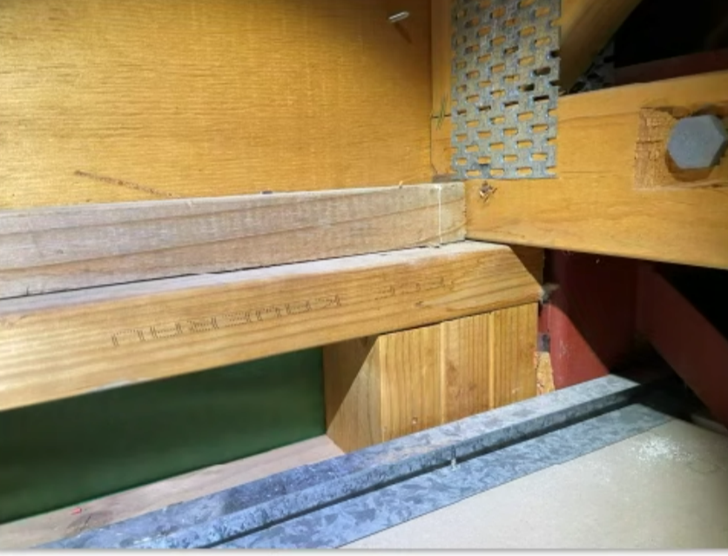  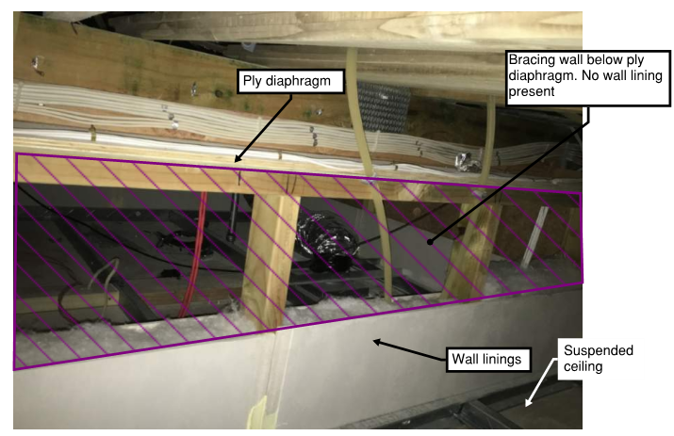 | Load path discontinuity: Bracing wall specified—not fixed off to top plate (and not engaging boundary joist and roof diaphragm), and in case of lower image, not perimeter fixed. High damage risk and potential ultimate strength risk.  Did not sufficiently recognise that the difference in roof makeup and suspended ceiling detailing (compared with typical NZS 3604 application) would create ambiguity to the builder. | Specifically document bracing wall details in context (i.e. including the load path to the roof diaphragm and other intersecting elements).  Reduce reliance on numerous opportunistically placed bracing elements (which create many opportunities for similar deficiencies).  Specify appropriate construction monitoring. However, recognise that most construction monitoring is risk-based, and reliance can be minimised by good design (design for construction execution).
 | 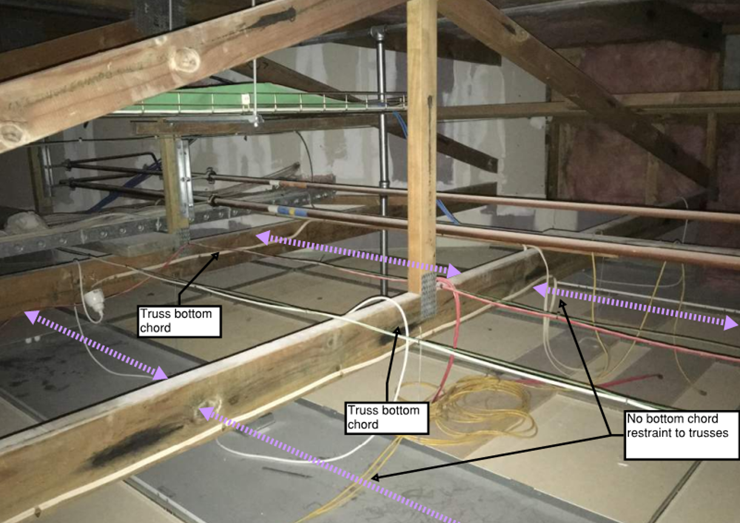 | Generally similar to (1). Suspended ceiling adopted in a building with otherwise relies heavily on NZS 3604 construction.  Suspended ceiling provides no direct restraint, stability or load transfer to truss bottom chord. | Provide clear details on structural plans specifying all bracing system requirements.  Recognise that acceptable solutions (NZS 3604) type systems rely on components which may not be present (such as ceiling joints and/or ceiling diaphragm direct fixed to roof framing or proprietary truss bottom chord) and therefore require specific design.
 | 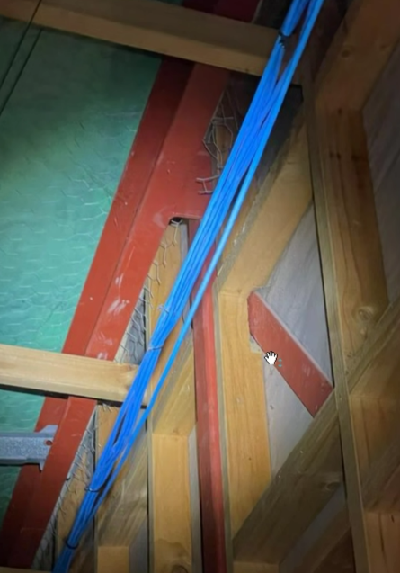 | Poorly proportioned and discontinuous load path from the PFC collector, into the vertical bracing bay via weak axis plate bending and a significant unresolved eccentricity. Damage risk and potential ultimate strength risk.  Poor section selection for an eaves strut which carries significant axial load a long distance and has poor restraint. | Appropriate member selection for eaves strut, such as SHS would requires less restraint (and are materially efficient), and would have more bending capacity to resolve eccentricities that aren’t able to be practically reduced.  Align nodes or specifically engineer for reasonable eccentricities, ensuring forces can pass locally through connection elements, and that members can resolve global equilibrium.
 | 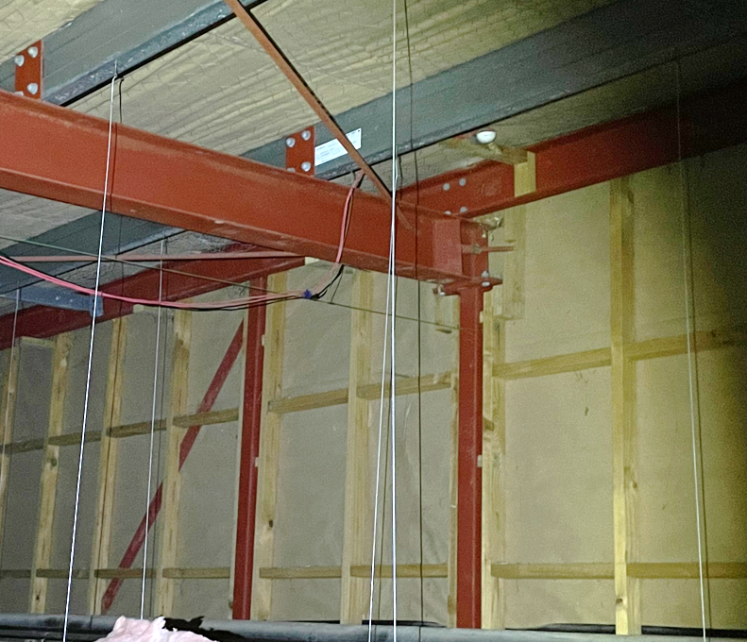 | Large number of eccentricities, and potentially discontinuous load paths. Load paths do exist in this example to resolve eccentricities (if properly proportioned and calculated). However, these are prone to poor design execution (due to calculation and drawing coordination effort involved) and more commonly lead to damage or strength risks than noded connections with better member selection. | Similar to (3).
 | 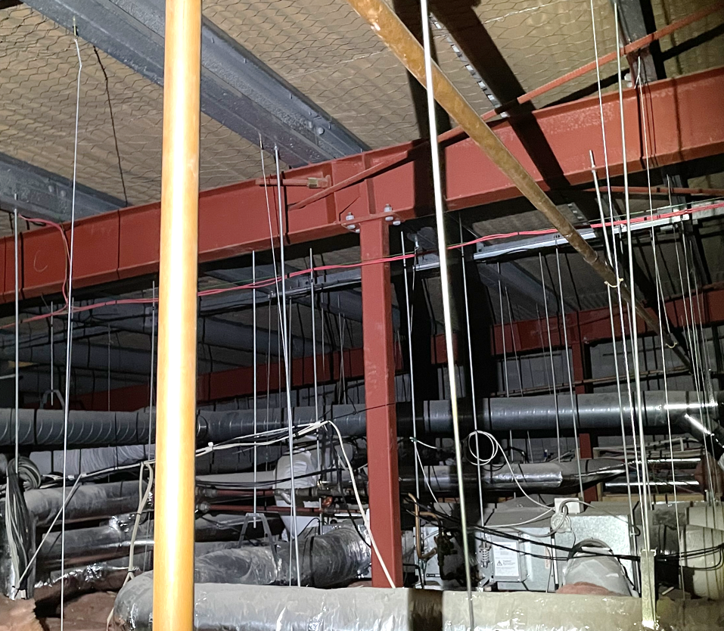 | Eccentric load path from the DHS purlins acting as struts to the roof plane bracing. No fly brace to aid in resolution of eccentricity. Increased damage risk and potential ultimate strength risk. | Provide specific structural members (struts) in an aligned bracing plane and design connections to ensure forces can pass locally through connection elements, and that members can resolve global equilibrium (especially where roof lateral loads are being carried long distances over multiple bays).
 | 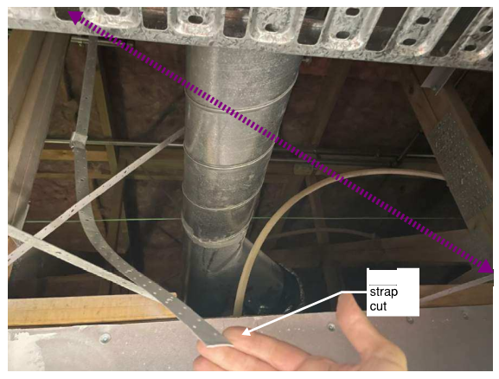 | Structural system selected in isolation, not well coordinated with services installation. Prone to poor execution. | Consider the extent of services required in a hospital ceiling space when choosing design and construction form.  Adopt strategies to plenum structure and bracing that are clear and obvious and unlikely to be compromised in construction or building maintenance and alterations.
 | 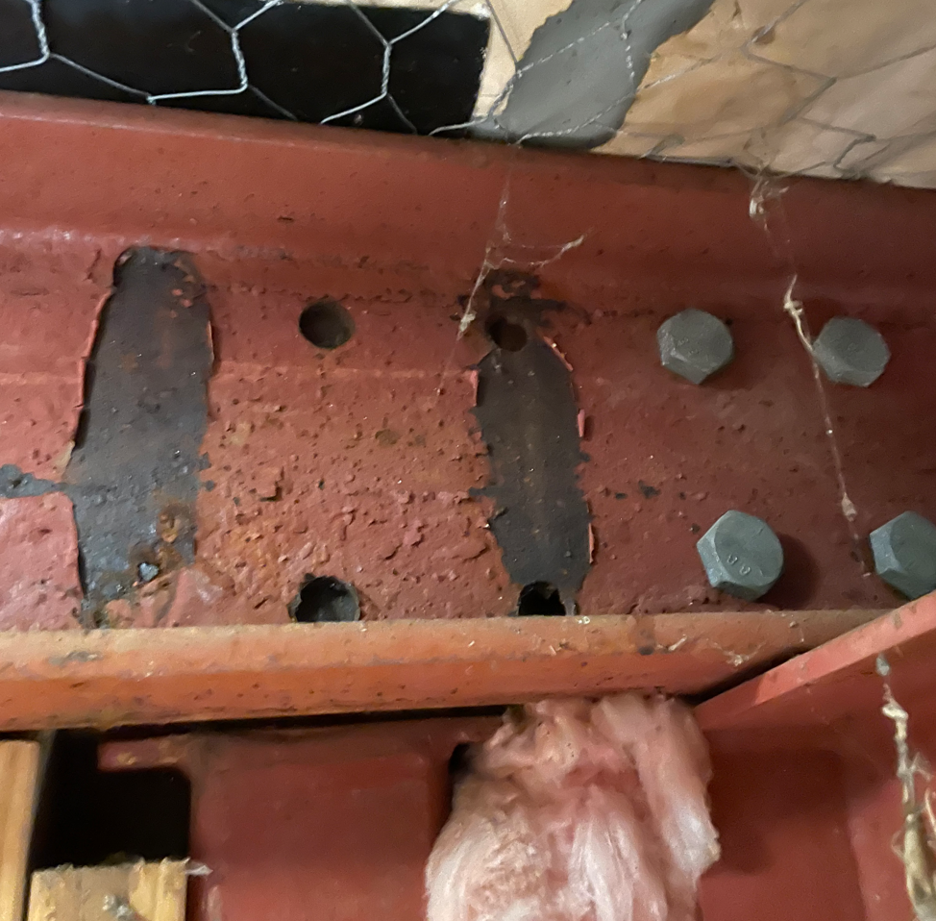 | Early onset of corrosion likely to require premature major maintenance. Poor coating selection, inadequate repair of coatings after site welding (including heat damaged areas). No protection to shot fired nails (which are especially vulnerable due to their small size and accelerated corrosion from galvanic effects). | Correctly assign corrosivity category and protective coating specification in higher risk areas, such as internal damp areas as defined by TS 3404 Tables 2 and 3 (steelwork within the external wall and roof cavity with the steel on the cold side of the dew point). Coordinate with architectural elements. Consider predrill for galvanised bolt fixings (to minimise need for coating repair).


Glossary of terms, definitions, and acronyms

Adjacency (Closely Adjacent): In an earthquake risk context (considering the risk of collapse debris from neighbouring buildings), a building that is situated within a distance generally less than one times its own height generally (or as specifically clarified in Appendix 1) is considered to be closely adjacent to the building or site in question.
APoE (Annual Probability of Exceedance): This term is generally used in preference to expressing earthquake return periods in years, as it better conveys the statistical intent and avoids misinterpretation.
ANARP (As near as is reasonably practicable): A concept used in some sections of the Building Act allowing flexibility in the level of compliance with the Building Regulations (the ANARP test). This document also uses the same term in specific situations that give flexibility to the level of compliance achieved with this guideline’s additional requirements.
Burnout: Defined by NZBC Verification Method C/VM2 as exposure to fire for a time that includes fire growth, full development, and decay in the absence of intervention or automatic suppression, beyond which the fire is no longer a threat to building elements intended to perform loadbearing or fire separation functions, or both.
Carbon: In relation to climate change mitigation and emissions reduction objectives, all terms have the meanings given in the NZGBC Greenstar NZ reference documents, including the following terms used within this document (refer also to Section B4, Figure 8):
Up-front Carbon: Embodied carbon emissions caused by the production of materials, transport of materials to the construction site and construction of the building(s), prior to the building(s) being occupied (Modules A1-A5).
Whole-of-Life Embodied Carbon: Carbon emissions associated with materials and construction processes throughout the whole lifecycle of a building, but excluding Operational Carbon (i.e., excluding Modules B6 and B7). Depending on the standard followed, it may include or exclude Module D (benefits and loads beyond the system boundary).
Operational Carbon: The carbon emissions associated with energy used to operate the building (Module B6), operational water use (Module B7) and fugitive emissions of refrigerants (module B1).
Life Cycle Assessment (LCA): A method for the quantitative evaluation of the potential environmental impacts of a product or service system through its life cycle, defined in this guide by reference to the NZGBC Life Cycle Impacts Calculator Guide (NZGBC, 2023). It includes both Embodied and Operational Carbon.
Containment: As used in Section B2.5 (descriptions of physical states for the DCLS/SLS2) and related sections, and unless noted otherwise, this refers to maintaining the containment of liquid, steam, gas or hazardous contents within tanks/pressure vessels and reticulated services by avoiding rupture of those components (as opposed to containment of spilled hazardous contents from ruptured tanks within bunded areas).
Damage Control Limit State: An additional design limit state, introduced to help control the risk of building damage and losses in earthquakes.
Departure: A departure from the Health NZ Requirements contained in this document, as summarised in A1.6.1 (i.e. a proposed non-compliance). The departure process is described in A1.6.2.
Dependencies: In an earthquake resilience context, this describes dependencies that a building has on sitewide utilities and engineering systems, and public utilities, in order to fulfil its function. These may or may not be beyond the boundary of specific projects.
Design Working Life: As defined in Cl. 1.4 of AS/NZS 1170.0:2002. A ‘reference period’ usually stated in years, which is used to select the probability of exceedance of different design actions.
Earthquake Severity (Intensity) and Frequency: The following descriptors are generally used to convey a sense of the scale and rarity of an earthquake scenario. The use of the term ‘moderate’ is the common/general sense of the word, and not a specific correlation to the legal term ‘moderate earthquake’ defined in the building act for earthquake prone buildings.
Intensity | Frequency | Indicative Annual Probability of Exceedance
Moderate | Infrequent | 1 / 100
Significant | Less frequent | 1 / 500
Major | Rare | 1 / 1000
Severe | Very Rare | 1 / 2500

Egress Routes: For the purposes of this document, and for application of NZS 1170.5, this term refers to primary egress routes. Generally, interpretation should be similar to circulation areas (NZS 1170.1 Occupancy Category C3) as clarified in the note to Table 13 (Section C1.2) and includes the path from vertical circulation shafts to a place of safety outside the building. It excludes general corridors within individual tenancies, departments or wards.
Engineering Assessment Guidelines (EAG): Refer Seismic Assessment.
Environmentally Sustainable Design (ESD) Consultant: Refer to Section A2.3 Design Roles.
Externalities (or external dependencies): A term used in an earthquake resilience and functional recovery context, referring to risks from hazards considered to be “beyond the project boundary” or outside the scope or direct control of a project to eliminate or mitigate.
Façade Designer: The design professional responsible for design of the façade system, as clarified in Section C4.4.1.
Fire Engineering Brief (FEB): The FEB is a process in which relevant stakeholders are engaged at an early stage in the project to agree on the design methodology, and any specific requirements stakeholders may have. Typically, this will involve the preparation of the FEB document at the concept stage, followed by an iterative process to establish and agree the design methodology, inputs and acceptance criteria. The FEB process is set out in the International Fire Engineering Guidelines (IFEG). Refer to the Health NZ Design Guidance Note for fire engineering design.
Functionality: Refer to Operational State which defines levels of functionality.
Health Engineering Advisory Group (HEAG): The nominated technical engineering advisory group for Health NZ.
Health New Zealand | Te Whatu Ora (Health NZ): Replaced the role of District Health Boards from July 2022, and is responsible for planning and commissioning hospital, primary and community health services.
Health NZ Project Technical Brief (project brief): Project briefing documents supplied by Health NZ for the project containing technical requirements.
Health NZ Requirement: A specific technical requirement for Health NZ projects that must be followed in order to meet the requirements of projects that reference these guidelines (refer to Sections A1.3 and A1.6).
Infrastructure and Investment Group (IIG): The group within Health NZ responsible for asset management, investment planning, facility design and advisory and programme/project delivery.
Life Cycle Assessment (LCA): Refer Carbon.
Low Damage Seismic Design (LDSD): A term used in reference to the Low Damage Seismic Design guidelines project and framework, in development (refer to Section A1.5 and to information available online at Low Damage Seismic Design resources | Building Performance (https://www.building.govt.nz/getting-started/seismic-work-programme/seismic-risk-series/low-damage-seismic-design).
Ministry of Health | Manatū Hauora: The New Zealand Government’s principal advisor on health and disability policy. It is responsible for funding, monitoring and ensuring the sector is compliant with accountability expectations.
Minor Alterations: Structural or non-structural alterations works of a minor nature that generally suit simpler application of Section 112—requiring that the level of structural compliance is made no worse than before. Defined in Section B7.2. See also Significant Alterations and Additions.
National Seismic Hazard Model (NSHM): The scientific model that calculates the likelihood and strength of earthquake shaking that may occur in different parts of Aotearoa New Zealand over specified time periods. NSHM 2022 refers to the 2022 revision of the model, available online at GNS – National Seismic Hazard Model (https://www.gns.cri.nz/research-projects/national-seismic-hazard-model/).
NSE Seismic Designer: Non-structural Element Seismic Designer.
Non-Structural Element (NSE) Seismic Design Strategy: A document describing the approach for seismic design and restraint of non-structural elements, and their integration with primary structure. Described in Section A3.2. The document is initiated at concept design.
Operational Carbon: refer Carbon.
Operational State: A description of the operational state of a building, independent of time. The definitions below are given in the context of healthcare infrastructure:
Normal Operations: The building’s pre-earthquake physical and operational state (pre-earthquake safety and functionality). “Full Recovery” is a term defined in FEMA P-2090 (FEMA, NIST, 2021) which describes the return to Normal Operations (the restoration of the building’s pre-earthquake safety and functionality).
Full Functionality: A building for which post-earthquake structural and non-structural capacity is essentially maintained—initially to fulfil a specific post-disaster response function in the immediate aftermath of an event and then eventually to continue the intended functions of the building’s pre-earthquake use. It does not mean there is no damage. A level of compromise in conditions, safety or risk tolerance relative to Normal Operations may be present.
Partial (Basic) Functionality: A building for which post-earthquake structural and non-structural capacity may be reduced, but is sufficiently maintained (or can be restored) to support the basic intended functions of the building’s pre-earthquake use—or a significant enough portion thereof to be useful. It is similar to the term “Functional Recovery” defined in FEMA P-2090 (FEMA, NIST, 2021) which describes the re-establishment of basic functionality and gives additional examples.
Shelter in Place: A building for which post-earthquake non-structural capacity may be significantly reduced—but supports the SPUR definition of “shelter in place” (SPUR, 2012). It is similar to the term “reoccupancy” defined in FEMA P-2090 (FEMA, NIST, 2021). Building services such as HVAC, electrical systems, sewer and water supply may be damaged and unavailable until necessary repairs are completed—necessitating neighbourhood support within walking distance. The structure may be damaged but is still considered safe to occupy and can provide basic shelter. This definition is normally only applied to places of residence.
Not occupiable: A building which is either not safe to occupy or has non-structural damage to the point that it cannot fulfil even basic function and thus has no purpose to occupy.
Primary Structure: The use of the term Primary Structure in this guideline refers to the primary structure required for the vertical and lateral support of a building’s floors and enclosure—and includes floor structure itself and also primary roof framing such as posts, rafters and bracing that supports main structural bays. It excludes the enclosure itself.
Priority Response Agreement (PRA): A best endeavours agreement put in place between hospital facilities staff and local engineers, to facilitate rapid building assessments following significant natural disaster events such as earthquakes.
Probabilistic Seismic Hazard Analysis (PSHA): To be completed. Used to represent broader concept of site-specific hazard analysis, including the concept of site response analysis.
Rapid Assessment Plan (RAP): A document compiled jointly by parties to a Priority Response Agreement (PRA) containing planning, operational and technical information that supports the operation of the PRA for post-earthquake response.
Seismic Assessment: The following definitions apply in relation to Seismic Assessment:
Engineering Assessment Guidelines (EAG) or Seismic Assessment Guidelines: The Seismic Assessment of Existing Buildings, Technical Guidelines for Engineering Assessments (MBIE, EQC, NZSEE, SESOC, NZGS, 2017), including (for non-EPB purposes only) sections that have been revised and issued for use including the Chapter C5 Concrete Buildings: Technical Proposal to revised the Engineering Assessment Guidelines, (MBIE, EQC, NZSEE, SESOC, NZGS, 2018).
Engineering Assessment: An assessment (either an ISA or a DSA) that meets the requirements for an Engineering Assessment in accordance with Section 2 of the Earthquake-prone Building (EPB) Methodology.
Initial Seismic Assessment (ISA): An Initial Seismic Assessment completed in accordance with Parts A and B of the Engineering Assessment Guidelines.
Qualitative Drawing and Load Path Review: A qualitative review of drawings to identify load paths and potential seismic risks, usually supported by some representative calculations (described in Section B8.2).
Targeted Seismic Assessment: Quantitative assessment of certain limited scope areas of a building, such as potentially significant seismic risks identified in a qualitative review, in order to better understand selected key risks (described in Section B8.2).
Detailed Seismic Assessment (DSA): For new assessments, a Detailed Seismic Assessment complying with Parts A and C of the Engineering Assessment Guidelines. For existing assessments, this may also refer to a Detailed Seismic Assessment completed to a different guideline or prior edition of the Engineering Assessment Guidelines.
Seismic Grade, Seismic Rating or Earthquake Rating: As defined by the Engineering Assessment Guidelines (MBIE, EQC, NZSEE, SESOC, NZGS, 2017).
Seismic Risk Working Group (SRWG): A group of experts including MBIE, initially established in 2020 to consider how the findings of the NSHM update could be integrated into the building regulatory system, and who now guide MBIE’s ongoing Seismic Risk Work Programme.
Service Category: The overall groupings of medical service and function categories that determine overall structural/geotechnical and seismic performance requirements in this document defined in Section B1 Classifying Hospital Building Functions and Importance Levels. They are also used to determine the Importance Level.
Significant Alterations and/or Additions: Significant alterations or additions that must comply with Section 112 (no worse than before), but may also require further consideration of the level of compliance of existing structure in order to demonstrate that the new work complies and can be supported, defined in Section B7.3. Refer also minor alterations. This is not the same as Substantial Alterations term used in the Building Act (refer below).
Site Response Analysis: A method for determining ground motion parameters at a site, using a combination of site-specific probabilistic hazard analysis and specific modelling of the soil profile to consider site specific amplifications. Refer to MBIE/NZGS Earthquake Geotechnical Practice Module 1.
Specified Intended Life: Specified Intended Life of the building, having the meaning given in Section 113 of the Building Act. In relation to a building, it means the period of time, as stated in the application for a building consent or in the consent itself, for which the building is proposed to be used for its intended use.
Substantial Alterations: A value-based threshold defined in the Building (Specified Systems, Change the Use, and Earthquake-prone Buildings) Regulations 2005, clause 11, for the purposes of Section 133AT of the Building (Earthquake-prone Buildings) Amendment Act 2016.
Ultimate Capacity: As defined by the Engineering Assessment Guidelines (refer Seismic Assessment).
Up-front Carbon: Refer Carbon.
Whole-of-Life Embodied Carbon: Refer Carbon.


References

API. (2021). API 650:2020 Welded Tanks for Oil Storage, 13th Edition Inc. Errata 1. American Petroleum Institute.
ASCE/SEI. (2022). ASCE/SEI 7-22 Minimum Design Loads and Associated Criteria for Buildings and Other Structures. American Society of Civil Engineers.
ASHRAE. (2012). Practical Guide to Seismic Restraint: Second Edition. American Society of Heating, Refrigerating and Air-Conditioning Engineerings, Inc.
ASHRAE. (2015). ASHRAE Handbook - HVAC Applications, SI Edition (Chapter 48 - Noise and Vibration Control). ASHRAE.
AWCI. (2015). Code of Practice for Design, Installation and Seismic Restraint of Suspended Ceilings - Version 1, October 2015. Association of Wall & Ceiling Industries.
AWCI. (2018). Code of Practice for the seismic design and installation of non-strutural internal walls and partitions - 1st Edition, July 2018. Association of Wall & Ceiling Industries.
Beca. (2022). Seismic Design Basis Guidance for Storage Tanks-vessels - Rev. 1, July 2022. Beca Limited.
BIMinNZ. (2023). The New Zealand BIM Handbook, Fourth Edition (v4.1) 2023. BIMinNZ, NZ Institute of Building.
BIP, BRANZ. (2024). Code of Practice for the Seismic Performance of Non-Structural Elements (BRANZ ER95) - Version 2.1, September 2024. Building Innovation Partnership.
BRANZ. (2010). P21 A wall bracing test and evaluation procedure. Building Research Association of New Zealand.
BRANZ. (2013). Study Report SR 305 (2013) Bracing ratings for non-proprietary bracing walls. Building Research Associated of New Zealand.
BRANZ. (2015). Seismically Resilient Non-structural Elements #4 - Seismic Clearance at Penetrations. BRANZ Facts. Retrieved from https://www.branz.co.nz/pubs/branz-facts/non-structural-elements/
BSI. (2008). BS 6472-1:2008 Guide to evaluation of human exposure to vibration in buildings: Vibration sources other than blasting. British Standards Institute.
BSI. (2014). BS EN 81-20:2014 Safety Rules for the Construction and Installation of Lifts - Part 20: Passenger and goods passenger lifts. Brussels: British Standards Institution/European Committee for Standardisation.
BSI. (2014). BS EN 81-50:2014 Safety Rules for the Construction and Installation of Lifts - Part 50: Design Rules, Calculations, Examinations and Tests of Lift Components. Brussels: British Standards Insitution/European Committee for Standardisation.
Department of Health. (2013). Health Technical Memorandum HTM 08-01: Acoustics. Department of Health/NHS (UK). Retrieved from https://www.england.nhs.uk/wp-content/uploads/2021/05/HTM_08-01.pdf
DIN. (2013). DIN EN 81-77:2013 Safety Rules for the Construction and Installation of Lifts: Lifts Subject to Seismic Conditions. Berlin: DIN/European Committee for Standardisation.
ENZ. (2018). Practice Note 2: Peer Review - Version 2, April 2018. Engineering New Zealand.
ENZ. (2019). Practice Note 19: Seismic Resistance of Pressure Equipment and its Supports - Version 5, December 2019. Engineering New Zealand.
ENZ. (2023). Warehouse Review Findings Report, February 2023. Engineering New Zealand.
FEMA. (2018). FEMA P-58-1 Seismic Performance Assessment of Buildings: Volume 1 - Methodology (Second Edition). Washington, D.C.: Federal Emergency Managment Agency.
FEMA. (2023). FEMA P-2055-2 Recommendations for Cordoning Earthquake-Damaged Buildings. Federal Emergency Management Agency.
FEMA. (n.d.). FEMA P-58-3 Seismic Performance Assessment of Buildings: Volume 3 - Supporting Electronic Materials and Background. Federal Emergency Management Agency. Retrieved from https://femap58.atcouncil.org/supporting-materials
FEMA, NIST. (2021). FEMA P-2090/NIST SP-1254 Recommended Options for Improving the Built Environment for Post-Earthquake Reoccupancy and Functional Recovery Time, Final Report, January 2021. Federal Emergency Management Agency, National Institute of Standards and Technology.
IEST. (2005). Recommended Practice RP-012: IES-RP-CC012.2 Considerations in Clean Room Design (Appendix C). Institute of Environmental Sciences.
ISO. (2007). ISO 10137:2007 Bases for Design of Structures - Serviceability of buildings and walkways against vibrations. International Organization for Standardization.
Kestrel Group. (2022). Understanding and Improving the Seismic Resilience of Hospital Buildings, Summary and Technical Reports, 3 June 2022. Wellington: Kestrel Group.
Mason Industries. (2016). Seismic Restraint Guidelines: 11th Edition, January 2016. Mason Industries.
MBIE. (2018). Managing Buildings in an Emergency: Guidance for decision makers and territorial authorities - Ver. 1, June 2018. Ministry of Business, Innovation and Employment.
MBIE. (2020). Whole-of-Life Embodied Carbon Emissions Reduction Framework. Wellington: Ministry of Business, Innovation and Employment.
MBIE. (2022). Whole-of-Life Embodied Carbon Assessment: Technical Methodology, February 2022. Ministry of Business, Innovation and Employment.
MBIE. (2024). Low Damage Seismic Design - Volume 1: Benefits, Options and Getting Started, December 2024. Ministry of Business, Innovation and Employment. Retrieved from https://www.building.govt.nz/getting-started/seismic-work-programme/seismic-risk-series/low-damage-seismic-design
MBIE, EQC, NZSEE, SESOC, NZGS. (2017). The Seismic Assessment of Existing Buildings, Technical Guidelines for Engineering Assessments, Initial Release July 2017. Wellington: Ministry of Business, Innovation and Employment.
MBIE, EQC, NZSEE, SESOC, NZGS. (2018). Concrete Buildings C5, Technical Proposal to Revise the Engineering Assessment Guidelines, Vers. 1A, November 2018. Wellington: Ministry of Business, Innovation and Employment.
NASH. (2019). NASH Standard Part 2:2019 Light Steel Framed Buildings. National Association of Steel-Framed Housing Inc.
NZCIC. (2023). NZCIC Design Guidelines 2023. New Zealand Construction Industry Council. Retrieved from https://nzcic.co.nz/resources/nzcic-guidelines/
NZGBC. (2023). Life Cycle Impacts Calculator Guide, Version 1.0 - May 2023. New Zealand Green Building Council.
NZGBC. (2024). NZGBC Embodied Carbon Methodology, Version 2.0 - December 2024. New Zealand Green Building Council.
NZGS, MBIE. (2021). Earthquake Geotechnical Earthquake Practice Modules 1-6, Rev. 1, November 2021. Wellington: New Zealand Geotechnical Society, Ministry of Business, Innovation and Employment.
NZSEE. (2009). Recommednations of a NZSEE Study Group on Seismic Design of Storage Tanks, November 2009. New Zealand Society for Earthquake Engineering.
NZSEE. (2019). Guideline for the Design of Seismic Isolation Systems for Buildings - June 2019 Draft for Trial Use. New Zealand Society for Earthquake Engineering.
NZSEE, SESOC, NZGS. (2022, August). Earthquake Design for Uncertainty: Advisory, Rev. 1. Retrieved August 24, 2022, from https://www.nzsee.org.nz/db/PUBS/Earthquake-Design-for-Uncertainty-Advisory_Rev1_August-2022-NZSEE-SESOC-NZGS.pdf
Pratchett, M. (2022). Using P21-tested Bracing Units Outside the Scope of NZS 3604, September 2022. Engineering New Zealand.
SESOC. (2010). SESOC Practice Guideline: Independent Review of Structural Designs for Building Consent. Strutural Engineering Society of New Zealand.
SESOC. (2022). Interim Design Guidelines: Design of Conventional Structural Systems v11, October 2022. Strutural Engineering Society of New Zealand.
SESOC. (2024). SESOC Low Carbon Design Resource Map. SESOC Sustainability Task Force. Retrieved from https://www.sesoc.org.nz/wp-content/uploads/2024/05/SESOC_BRANZ_Resource_Map_Printable.pdf
SESOC. (2024). Top Tips for Low Carbon Design, v1, May 2024. SESOC Sustainability Task Force. Retrieved from https://www.sesoc.org.nz/wp-content/uploads/2024/05/SESOC-Top-Tips_-V1-2024.pdf
SESOC, NZSEE, NZGS. (2022, October). Interim Advice on the 2022 National Seismic Hazard Model Release. Retrieved October 4, 2022, from https://www.nzsee.org.nz/db/PUBS/2022-NSHM-Advisory_Rev1.0_October-2022-SESOC-NZSEE-NZGS.pdf
Smith, A. L., Hicks, S. J., & Devine, P. J. (2009). SCI P354: Design of Floors for Vibration: A New Approach (Revised Edition, February 2009). Steel Construction Institute (UK).
SNZ. (2000). AS/NZS 2785:2000 Suspended Ceilings - Design and Installation. Wellington: Standards New Zealand.
SNZ. (2009). AS/NZS 1170.1:2002 Inc. Amd. 1-2 Stru tural Design Actions - Part 1: Permanent, Imposed and other actions. Standards New Zealand.
SNZ. (2009). NZS 4219:2009 Seismic Performance of Engineering Systems in Buildings. Wellington: Standards New Zealand.
SNZ. (2011). AS/NZS 1170.0:2002 Inc. Amd. 1-5 Structural Design Actions - Part 0: General Principles. Standards New Zealand.
SNZ. (2011). NZS 3604:2011 Timber-framed buildings. Standards New Zealand.
SNZ. (2017). NZS 3101:2006 Inc. Amd. 1-3 Concrete Structures Standard. Standards New Zealand.
SNZ. (2018). SNZ TS 3404:2018 Durability Requirements for Steel Structures and Components. Standards New Zealand.
SPUR. (2012). Spur Report 01/2012 Safe Enough to Stay. San Fransisco: San Francisco Bay Area Planning and Urban Rescue Association. Retrieved from https://www.spur.org/sites/default/files/2013-09/SPUR_Safe_Enough_to_Stay.pdf
Te Whatu Ora. (2022). NZ Health Facility Design Guidance Note DGN V2.0: NZ Health Facility Design, September 2022. Te Whatu Ora. Retrieved from https://www.tewhatuora.govt.nz/publications/health-facility-design-guidance-note/
Te Whatu Ora. (2024). Fire Engineering Design for New Zealand Public Hospitals - Design Guidance Version 1, 1 July 2024. Te Whatu Ora.
Te Whatu Ora. (2024). Te Whatu Ora Seismic Policy HNZ7001, February 2024. Te Whatu Ora | Health NZ, Infrastruture and Investment Group.
Te Whatu Ora, Te Aka Whai Ora. (2022). Te Pae Tata Interim New Zealand Health Plan, October 2022. Te Whatu Ora - Maori Health Authority, Te Aka Whai Ora - Health New Zealand.
Watson, N. (2020, August). Lean Design: 10 things to do now. The Structural Engineer, pp. 12-14.
Wilford, M. R., & Young, P. (2006). CCIP-016 A Design Guide for Footfall Induced Vibration of Structures. The Concrete Society, UK on behalf of the Cement and Concrete Industry Publications Forum.


Appendices

Appendix 1. Campus Earthquake Resilience (Structural Considerations)
  - Purpose of this Information
The content in Parts A to C of this guideline are generally applied in the context of an engagement to carry out a single building or alteration project. The reference information in this appendix is intended to support wider considerations around campus resilience. It is expected that the information will be referenced by:
- Masterplanning teams, and specifically, by structural and geotechnical engineers providing advice as part of masterplanning work or business case development (refer to Section A1.7 Masterplanning and Site Context).
- By engineers giving advice to hospital emergency management teams, when updating emergency planning for earthquake scenarios.
- By design teams on projects, when making specific decisions that impact sitewide resilience or managing/highlighting risks that are outside the project scope boundary.
  - Adjacencies—Managing Physical Risks Posed by Adjacent Structures
    - General
It is important to consider how the earthquake performance of adjacent buildings or structures can affect earthquake performance and risk across a hospital campus. These considerations are especially important as part of masterplanning and business case development. This is the best time to review earthquake risks related to building adjacencies (across various options) and allows project scopes and timeframes to be defined accordingly.
Section 1.2 deals with physical risk (to people) posed by adjacent buildings or structures. The wording generally refers to buildings—but can apply similarly to some other large structures, such as tall chimneys. External dependencies to network utilities, and dependencies on services and engineering systems in or passing through other buildings in a hospital campus are discussed in Section 1.3.
Closely adjacent buildings or structures
This document defines buildings as closely adjacent when the distance between the buildings (excluding canopies) is less than a distance generally equivalent to the maximum height of either building (refer Figure 15). The Building Code does not require consideration of adjacencies, but Health NZ’s interests in hospital resilience mean the physical risks posed by closely adjacent structures should be given some consideration.
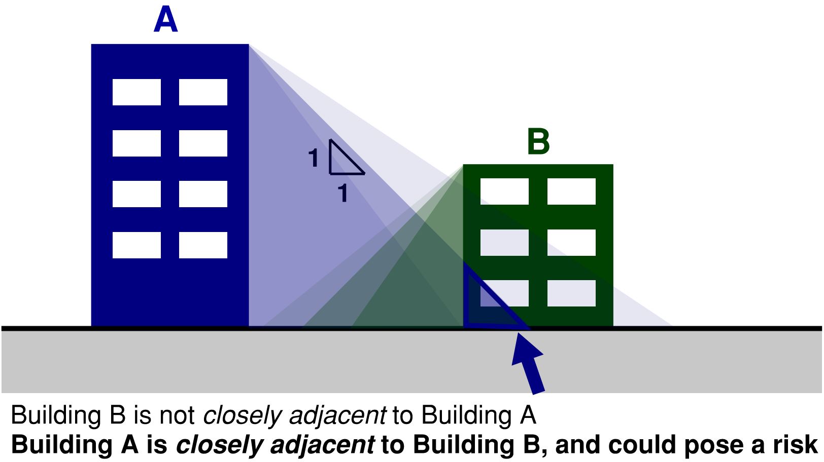
Figure 15: Definition of an adjacent building for earthquake risk assessment (using a 1:1 height ratio as a starting point). Building A poses a risk to building B, as it could present a hazard if it were significantly damaged or if it collapsed in an earthquake. Refer to text and footnote for comments on the height ratio (which can be reviewed).

From a masterplanning process perspective, adjacency risk only needs to be explored in any depth where there are concerns about an adjacent building’s seismic status. Otherwise, the low likelihood of failure would preclude any need to review further.
Where there are concerns, the appropriate value for the height to horizontal distance ratio will depend on the plausible mode(s) of failure. Rather than a prescribing a fixed rule for the ratio, a more reasonable risk-based approach is appropriate. Engineers providing advice are encouraged to qualitatively assess (for example via a drawing review) plausible modes of failure, and be guided by information in FEMA P-2055-2 (FEMA, 2023). There is no expectation of any attempt to explicitly quantify collapse modes and capacities in any detail.

For physical earthquake risk, two distinct risks need to be considered and managed.
- The life safety risks posed by debris hazards from the closely adjacent building to occupants of the building in consideration (if elements of the closely adjacent building were to fail).
- The risk to functional continuity, if the closely adjacent building was significantly damaged in an earthquake (but had not collapsed), and a Rapid Assessment (or any subsequent post-earthquake assessment) required barricading or restricted access to all or part of building under consideration due to an unacceptable failure risk posed by the closely adjacent building.
    - Managing Life Safety Risks
Life safety risks can be assessed using ordinary existing building seismic assessment processes (Section B8 Seismic Assessment and Retrofit Work) and noting the comments above regarding level of detail (the starting point should generally be qualitative risk identification). Rather than use the closely adjacent building’s overall Assessed Seismic Rating (%NBS) and Seismic Grade, it is important to be clear about the most likely physical consequences of any potential Structural Weaknesses—and which of those could potentially affect the building under consideration (and the likelihood that they could fail, as represented by their %NBS score).
Constructing new buildings in proximity to existing buildings that are an earthquake risk can increase the risk exposure of the new building. For example, if Building A in Figure 15 was an Earthquake Risk building, and a new building B was built in its shadow, it could increase the number of people exposed to the hazard. Although the Building Act does not have a mechanism to consider this, Health NZ want to reduce their earthquake risk profile over time—not increase it. Therefore, structural (or external façade) hazards potentially threatening new adjacent buildings should ideally achieve a Low-Risk Seismic Grade.
Instead of retrofitting a closely adjacent Earthquake Risk building, it could also be possible to provide some mitigating features to the building in consideration, to minimise the chance that collapse debris from a closely adjacent Earthquake Risk building could cause injury or disproportionate structural damage.
Health NZ Recommendation: When planning new infrastructure (a new building), the earthquake risk posed by closely adjacent existing buildings should be mitigated by prioritising retrofit or other risk mitigation strategy, so that any weaknesses with physical consequence potentially affecting the new infrastructure have a Low-Risk Seismic Grade (≥ 67% NBS), as near as is reasonably practicable and within a reasonable time frame.
Low Risk means having an Earthquake Rating ≥ 67% NBS (IL_), determined by the buildings Ultimate Capacity as defined by the Engineering Assessment Guidelines, using the Importance Level of the closely adjacent building. Use of Importance Level 2 could be an appropriate compromise considering individual life safety risk on more comparable terms with normal buildings.
Although the risk objective relates to collapse (or failure of external façade elements) the functional requirement is deliberately defined in terms of Ultimate Capacity ordinarily used in assessment, and no attempt to estimate collapse capacity more accurately is implied.
The use of the term as nearly as reasonably practicable in this context of this specific requirement refers not only to a degree of reasonable flexibility in risk tolerance, but also to the rigour applied in assessment. Refer to Section B8.2 for information on levels of seismic assessment. Depending on the level of seismic assessment information that is available, desktop level engineering advice may be sufficient at masterplanning stage. In some situations, a fuller Qualitative Drawing and Load Path Review could add value where there are gaps in information. The assessment level should be proportionate to the significant uncertainties involved, and although further Targeted Assessment could be warranted in some cases, it is not necessarily the expectation that this would be undertaken at masterplanning stage.
    - Managing Risks to Functional Continuity
This section is specifically focussed on physical risk to persons (for utility and engineering system dependencies, refer to Section 1.3). Risks to functional continuity require realistic post-earthquake emergency management scenarios to be considered as part of the Serviceability Limit State 2 (SLS2) concept. If a closely adjacent building is significantly damaged in an earthquake, placarding, cordoning or barricading could be necessary which restricts use to part or all of a building with post-disaster functions. This is due to life safety risks posed by the adjacent building if it were to sustain significant structural (or external non-structural) damage. This is a realistic risk in constrained hospital campuses and reduces confidence in meeting functional continuity requirements.
When considering this scenario, it is important to remember that a building’s Ultimate Capacity (assessed in accordance with the Seismic Assessment Guidelines) does not represent collapse, nor are the assessment guidelines an accurate predictor of performance. Engineers will need to need to form an opinion on the level of shaking that is likely to cause a building to sustain damage that could significantly impact (reduce) its capacity to resist future earthquakes and thus would be reasonably likely to receive a yellow or red placard with subsequent cordon recommendations. If this is greater than the demand used for the SLS2 Limit State (Table 6, Section B2.3.1), then the risks to functional continuity are sufficiently low.
For modern/new buildings, this damage state can be taken as 100% ULS shaking (i.e. the minimum Ultimate Limit State design capacity of the building). Properly detailed modern buildings (even those reliant on ductility) should be able to withstand these levels of shaking and still retain a sufficient proportion of their original capacity to resist subsequent earthquakes or large aftershocks.
For other existing buildings, this damage state could be the assessed Ultimate Capacity, or it could be a lower value if there are concerns that both:
- The onset of significant primary structural damage could occur at levels of shaking well below the buildings assessed Ultimate Capacity, and,
- That damage could significantly reduce the buildings capacity to resist future earthquakes.
Teams should apply as nearly as is reasonably practicable principles. Where it is not considered practical to meet the SLS2 performance requirements by retrofitting a closely adjacent building to meet the above requirements within a reasonable timeframe, other mitigation or management strategies will need to be considered (including through emergency scenario planning) which would enable the necessary post-disaster functions to be fulfilled and the continued functionality requirements of this guideline to be met.
Health NZ Recommendation: To minimise risks to continued functionality following earthquakes, the level of shaking that may cause a closely adjacent existing building to sustain damage that could significantly reduce its capacity to resist subsequent earthquakes should be greater than (or as near as is reasonably practicable to) the demand used for the SLS2 Limit State for the building under consideration (Table 6, Section B2.3.1).
Similar comments apply as for life safety risks, in terms of levels of engineering assessment or review considered appropriate to meet this requirement.
Having Priority Response Agreements (PRA) in place between engineers and hospitals, and developing Rapid Assessment Plans (RAP) for clinically important buildings, will help to manage continued functionality risk. These arrangements reduce the time taken to make decisions regarding continued use of buildings and provide important reassurance to building users.
    - Planning Adjacencies Between New Buildings
Where there are close adjacencies proposed between two new buildings that will be constructed in accordance with the Building Code (and these guidelines), Health NZ have no further requirements. The Importance Levels ordinary applicable to each building’s Service Category (minimum Importance Level 2) can apply. The requirements for managing life safety and functional continuity risks (as set out above) are deemed to be met.
A modern (new) hospital building designed in accordance with the Building Code and these guidelines, would not be expected to sustain levels of damage under Ultimate Limit State design levels of shaking (at least 1/500 APoE) that would significantly reduce its capacity to resist subsequent earthquakes or aftershocks—and therefore it is unlikely to require any restriction on use to buildings in its immediate surroundings.
Whilst the building itself may still require assessment and some repair (and may or may not have sustained non-structural damage), it is unlikely it would present a risk to continued functionality to a neighbouring Importance Level 3 or 4 building as a close adjacency.
    - Design of Physical Interfaces and Seismic Separations Between Buildings
Refer to Section C3.2 which contains these requirements, including minimum dimensions for offsets between buildings that need to be considered. This may have implications for building set out and massing.
  - Dependencies—Managing Risk to Building Engineering Systems that Pass Through or Near Other Structures
Sitewide “trunk” reticulated services and engineering systems that serve hospital buildings with earthquake functional continuity requirements are labelled as dependencies. That is, satisfactory building performance is dependent on performance of sitewide services and engineering systems. Lifeline utilities that supply hospitals are considered external dependencies.
The services may pass through other buildings on campus with lesser performance requirements. This includes existing buildings that may not currently meet the standard that the Building Code requires of new buildings and infrastructure.
The presence of dependencies does not determine the Service Category or Importance Level of other structures that these services pass through.
These classifications should be based on the Service Category of each building individually (to Sections B1.2 and B1.3). However, the risks to functional continuity do need to be considered including any access requirements that need to be maintained for the service to function.
In resilient design of utilities and engineering systems, the following key principles are applied. The two bold bullets are the focus of this section.
- Reliability and redundancy in public utilities (external dependencies beyond the site, and usually outside a project’s scope boundary).
- Reliability of individual services or parts of an engineering system, including:
  - The ruggedness of the equipment or services themselves and their internal workings,
  - Their direct structural support and restraint,
  - Risks to the operation and maintenance of services from the performance of structures housing it or surrounding it.
- Redundancy - a key part of engineering systems design, applied by building services engineers to achieve adequate system reliability and resilience.
Refer to Health NZ ’s Building Services Design Guidelines for Public Hospitals (in development) and consider the following structural and geotechnical inputs.
Structural and seismic requirements for trunk services and engineering systems and the structures that contain them
To ensure appropriate reliability to individual services and engineering systems, services should be adequately seismically restrained, and not exposed to undue risk from buildings or structures. In practice, this means considering the following:
- For new services installations, non-structural element (NSE) seismic design (the design of direct seismic restraints and their anchorages) over the full route should meet the requirements of the highest Service Category or Importance Level of buildings served by the systems. This includes any other neighbouring services supported commonly or adjacent along the same route where failure or loss of support could impact the systems being considered.
- Assessment of existing trunk services and their direct seismic restraint and anchorage can focus on continued functionality risks only, i.e. consider SLS2 predominantly (1/500 APoE for those serving Importance Level 4 buildings). ULS may require consideration for earthquake evacuation and life support systems—see the comment box below.
- Failure of structures containing critical trunk services, should have a low probability of causing loss of function to the critical trunk service, at the appropriate limit state (i.e. SLS2 for critical services generally (1/500 APoE for those serving Importance Level 4 buildings), or ULS for earthquake evacuation and life support systems only.
New buildings designed to the appropriate cited standards have a low probability of collapse well beyond ULS shaking, therefore this should not generally impose a higher ULS performance requirement on new buildings, no matter their importance level.
However, existing buildings containing the services or those closely adjacent to them should ideally have a Low-Risk Seismic Grade. This applies to any potential structural weaknesses which could materially affect operation or access to the services depended on. Where this is impractical or has not yet been achieved, it should be assumed that in a significant earthquake, there is a higher chance of the service being severed or maintenance access being compromised. Services Engineers should give additional specific consideration to how this informs redundancy requirements or other appropriate mitigations.
Structural Engineers and NSE Seismic Designers should work with services engineers to understand which services are important to delivering continued functionality, and which trunk service routes these requirements should apply to (with reference to the descriptions in Section B2.5, Descriptions of Physical States for the SLS2 and DCLS Limit States).

On many campuses, trunk services run in basements or tunnels under older, existing buildings. Often, these locations may remain relatively protected even in scenarios where the superstructure sees significant damage. The trunk services may have a low likelihood of losing function even as the superstructure exceeds its ultimate capacity, due to inherent resilience of some substructures and of some trunk services.
Where this resilience cannot be adequately achieved, it is likely that redundancy in the services will instead need to be provided (especially for services that facilitate earthquake evacuation and short-term life support in the buildings served).
Specific consideration should be given to locations where services enter and exit buildings, services trenches and tunnels, particularly the likely post-earthquake accessibility of such locations for repair. Foundation and geotechnical performance and differential movements can concentrate damage at these locations. This includes proposals to locate services in subgrade under buildings (rather than in accessible trenches) which requires careful review.

Notes
……………………………………………………………………………..…………………………
……………………………………………………………………………..…………………………
……………………………………………………………………………..…………………………
……………………………………………………………………………..…………………………
……………………………………………………………………………..…………………………
……………………………………………………………………………..…………………………
……………………………………………………………………………..…………………………
……………………………………………………………………………..…………………………
……………………………………………………………………………..…………………………
……………………………………………………………………………..…………………………
……………………………………………………………………………..…………………………
……………………………………………………………………………..…………………………
……………………………………………………………………………..…………………………
……………………………………………………………………………..…………………………
……………………………………………………………………………..…………………………
……………………………………………………………………………..…………………………
……………………………………………………………………………..…………………………
……………………………………………………………………………..…………………………
……………………………………………………………………………..…………………………
……………………………………………………………………………..…………………………
……………………………………………………………………………..…………………………
……………………………………………………………………………..…………………………
……………………………………………………………………………………………………….
……………………………………………………………………………..…………………………
……………………………………………………………………………..…………………………


In the case of Module 1, use the version that aligns with the earthquake actions standard being used.
Up-front Carbon refers to Modules A1 to A5. However, for practical reasons, estimates can usually be limited to Modules A1 to A3 for the purposes of guiding the Concept and Preliminary Design Phases. The focus of this commentary is structural and geotechnical disciplines, considered in the context of embodied and operational carbon emissions for the project as a whole. Refer to Section B4 for additional information.
For seismic performance, this should include a summary (in bullet or tabulated form, as appropriate) listing any significant residual risks from externalities that could impact the building/project meeting the Seismic Performance Framework in this document (i.e. considered to be outside the “project boundary”, or beyond the ability of the project team to control)—allowing this to be uplifted to project risk registers. This is important information to convey to Health NZ and facilities users as part of hospital emergency and readiness planning. Refer Appendix 1 (Section 1.3:Dependencies) and B2.5 for additional commentary.
This information, and information on foundation system selection and analysis approach should be reviewed by the Geotechnical Engineer for interpretation, with a record of such review having taken place.
Refer to Section B4 and the Glossary of Terms for definition of Up-front Carbon.
This could include, for example, a Greenstar Accredited Professional.
Refer to the commentary on maternity services following this table for clarification of the term ‘high acuity’ which should be confirmed with clinical/hospital input.
Refer Appendix 1 (Campus Earthquake Resilience) and specifically 1.3 (Dependencies) for additional information on managing sitewide dependencies on plant, engineering systems and reticulated services.
AS/NZS1170.0 includes a reference under IL3 to Emergency medical and other emergency facilities not designated as post-disaster. This reference is however not included in Building Code Clause A3.
For elevated helidecks serving Acute Services facilities with a specific post-disaster function, suitable alternatives (landing sites and patient transfer) should be identified as part of hospital emergency planning.
Further technical commentary is in preparation on the Importance Level classification of structures with adjoined adjacencies, such as multiple buildings on common/adjoined foundations or basement structures.
With the exception that the limit states definitions in Section B2.3.1 are mandatory.
This is the same approach as the Low Damage Seismic Design Guidelines.
Considering uncertainties in earthquake performance and how real earthquake scenarios are managed, Health NZ encourage simple, qualitative and pragmatic interpretations of the information provided.
Full functionality does not mean assets aren’t damaged—it’s an ability to deliver the post-disaster services for which the building is intended.
Ability to perform basic intended functions might include, for example, the ability to deliver elective surgery (albeit some compromise in conditions or operating procedures and/or operating at a reduced capacity may be tolerable).
For support services, evacuation could be due to a combination of lesser level confidence in continued safety, paired with higher abundance of caution (given the lower consequences of a managed building evacuation). It could also be due to physical damage observed by staff or assessing engineers following the event which warrants further review or evaluation before occupancy is considered appropriate. Although not preferred, either of these outcomes would be considered tolerable in the context of support services (but not for Acute Services or Inpatient Facilities).
The Shelter in Place objective (and places of residence in general) are not the focus of this guide and are not given specific attention in the remainder of the guide.
Full functionality refers initially to specific post-disaster response functions in the immediate aftermath of an event and then eventually to the ability to continue the intended functions of the building’s pre-earthquake use in the longer-term recovery. It does not mean no damage.
Additional clarity on this point is provided in Table 3, Section B2.1.
Unless noted otherwise, the usage of the word containment in this section (and related design criteria) refers to maintaining the containment of liquid, steam, gas or hazardous contents within tanks/pressure vessels and reticulated services by avoiding rupture of those components in their structural design and seismic support and restraint design (as opposed to containment of spilled hazardous contents from ruptured tanks within bunded areas). The requirement to maintain containment could be for direct safety reasons, the need to maintain function of the service, or the desire to avoid disruption or disproportionate damage from the spilled contents. Refer also to Engineering NZ Practice Note 19: Seismic Resistance of Pressure Equipment and its Supports (ENZ, 2019).
Public utilities are an externality which generally lie beyond the boundary of individual projects. Where possible, design teams should work with utilities providers in a stakeholder capacity to maximise the resilience of the network utilities supply in alignment with the performance goals in this document. The connection to public mains and entry of utilities to the building is within the project’s boundary and should be robustly configured and maintained operational.
Regulatory decisions about acceptable timeframes return to an ANARP compliant state after an earthquake (Normal Operations) lie with local authorities and currently lacks fulsome guidance. The Health NZ requirement is to ensure the required extent of operations (e.g., Basic or Full Functionality) can continue for a time under tolerable risk compromises. This should be assessed against the expected performance of safety systems, and under the expected levels of damage. This can then be followed by a return to Normal Operations (meaning as-near-as reasonably practicable to fully functioning fire safety systems) economically and within the timeframes indicated.
The complete avoidance of tile loss generally requires taping or clipping of all tiles. This can be impractical as it precludes straightforward maintenance access to the ceiling plenum. As a minimum, strategies for securing tiles should ensure any tiles containing fittings such as sprinkler heads, lighting and electrical fittings, ventilation diffusers and the like cannot become dislodged. Furthermore, the potential dislodging of non-secured tiles should have a low likelihood of affecting adjacent tiles with fittings—especially those supporting emergency lighting, and sprinkler heads. Refer to Section C4.6.
This should also help to avoid damage that might distress occupants and/or erode confidence in safety.
Any relaxation should be consulted with health planning/engineering and clinical staff. Opportunities could be via the inclusion of a supplementary flexible air barrier, or the likelihood of being able to demonstrate the required direction of flow between spaces (by smoke pencils) rather than maintain strict requirements for measurable pressure differential before repair. By this measure, the minor damage described as “tolerable” for general partitions should be a relatively limited compromise to basic function in practical terms. But some repair may be needed to help restore measured pressure differentials to the required levels before a return to Normal Operations. An “essentially undamaged” state might also be desirable for infection control purposes—but this is probably unnecessarily onerous.
Refer to the current effective amendment of B1/VM1 section 2.2.4 for the clause that replaces NZS 1170.0 Cl. 4.2.4.
It is common, (unless advanced methods of structure-fire analysis are being applied) to use the Fire Resistance Rating from the NZBC C Clauses to define the demand, confirmed by the project’s Fire Engineering Report.
For practical purposes, the established FEB process is considered to form part of the standard means of demonstrating compliance with the NZBC for most hospital building projects.
An appropriate ANARP position could involve reviewing and managing only those structural weaknesses where the consequence of failure could affect the new addition or altered area.
Alternatively, structurally disconnect the structures and provide independent buildings. Consider any earthquake risks from the existing structure as a closely adjacent building to Appendix 1 (Section 1.2).
Applies to aspects of existing structure that provide primary structural support to the new work, or could affect the ability of primary structure to continue to provide support.
For Buildings with an Earthquake-prone Building notice, the alteration work will need to be tested against the value-based definition of Substantial Alteration in the Building (Specified Systems, Change the Use, and Earthquake-prone Buildings) Regulations 2005, clause 11, to determine whether Section 133AT of the Building (Earthquake-prone Buildings) Amendment Act 2016 applies.
Refer Building Act, s.114 and Building (Specified Systems, Change the Use, and Earthquake-prone Buildings) Regulations 2007 Schedule 2 for Use categories.
Gallen J, High court judgement Auckland City Council v NZ Fire Service, 19 October 1995.
Determinations 2008/006, 2008/016, 2008/004, 2009/027, 2009/070, 2009/079, 2009/117, 2010/004, 2010/028, 2010/043, 2015/070. Note that determinations are building specific.
Using Importance Level 2 measures relative risk to individual life safety comparably to an ordinary commercial or residential building.
This recommendation is under review but may be considered by Design Teams. This document focusses on achieving Performance Goals in large earthquakes through the DCLS and SLS2 Limit States—the Health NZ minimum requirement for the SLS1 APoE remains 1 / 25 (in accordance with Table 6 of Section B2.3.1).
For clarity, this limit only considers damage avoidance to primary structure (minimizing the likelihood of intolerable residual drift from a post-earthquake capacity and amenity perspective). It is likely that lower limits on peak drifts will need to be considered at the DCLS/SLS2 limit states to achieve the broader requirements for overall building performance, asset protection, continued functionality and protection of NSE (as set out in other parts of this guideline).
Explicit assessment of pounding effects (used to justify reduced displacement range) is discouraged—behaviour and performance following contact is generally understood to be poor and there is low confidence in the ability to capture effects adequately through modelling.
The methods for evaluating seismic separations in the Assessment Guidelines (MBIE, EQC, NZSEE, SESOC, NZGS, 2017) apply only to assessment of existing conditions and are not intended to be applied to the setout and construction of new adjacencies.
This risk is managed separately, by evaluating the risk of existing building adjacencies to Appendix 1 (Section 1.2).
Whilst selecting C1 anchors may be viewed as unconservative according to the reference ground acceleration thresholds given in table 5.1 of ETAG 001, this recommendation is appropriately aligned with its intent when adopting elastic loading and deriving loads directly from AS/NZS 1170.5, especially as applied to light-weight and low risk applications. Category C1 is generally equivalent to ACI 355.2.
The EN 81 standards cited by the NZBC D2/AS1 and referenced in this document have been further revised. Structural engineers should consult with vertical transportation engineers regarding the current versions of these standards and consider any aspects that may be relevant to design and coordination with lift suppliers—to ensure that supporting structure design is both compliant to D2/AS1 and compatible with the lift installation.
Users should note that the Structural Design Standards (including NZS 3101 and NZS 3404) have distinct and different definitions for primary and secondary structure, for the purpose of provisions within those standards.
A basic value of 1.5 times the height is suggested in barricading advice given in Appendix 5 of MBIE Guidance Managing Buildings in an Emergency, (MBIE, 2018) and international practice historically as described in FEMA P-2055-2 Recommendations for Cordoning Earthquake-Damaged Buildings (FEMA, 2023). However, this is a conservative value applicable predominantly to unreinforced masonry construction. Smaller distances can be appropriate depending on the parts of the building that could fail and the size of the potential material pile. Values smaller than one times the height could applied with specific review against the principles in the MBIE document and further detailed information contained in FEMA P-2055-2 (with due regard to their application being “before the fact” rather than the document’s intended post-earthquake context).

