

Achieving the Health Targets

High Level Implementation Plans

July 2024 – June 2027





Health targets focus on cancer treatment, childhood immunisation, emergency departments and wait times for first specialist assessments and elective treatment.

Published in September 2024   
by Health New Zealand I   
Te Whatu Ora

ISBN 978-1-99-106778-4

This document is available   
**at** [tewhatuora.govt.nz](https://www.tewhatuora.govt.nz/)



# Minister’s foreword

New Zealanders deserve to know that if they or a loved one become unwell, they will receive the healthcare they need, when they need it.

This publication is a major milestone in delivering on the Government’s commitment to delivering timely access to quality healthcare for all New Zealanders, to extend life expectancy and quality of life.

Clear targets are key to driving that vision forward and to improving the performance of the health system.

The Government’s five health targets, which came into effect on 1 July 2024, are tightly focused on faster cancer treatment, increased childhood immunisation, shorter stays in emergency departments and shorter wait times for first specialist assessments and elective treatment.

Targets focus resources, attention, and accountability on the outcomes that really matter. Targets save lives.

Achieving these ambitious targets requires careful planning, new models of care and clinical leadership. The implementation plans in this publication are vital because they provide the detail and milestones needed for us to deliver on them over the next three years.

I expect the health system to be held accountable to these plans. Regular and transparent reporting against these targets will demonstrate to New Zealanders how the system is performing.

However, numbers on a page can’t and won’t be the only way New Zealanders will see change in the health system. Every New Zealander should experience the change for themselves in the quality of care they receive.

We will have achieved our goal when fewer New Zealanders are becoming seriously ill with vaccine-preventable diseases, they are seen sooner when they come to the emergency department in need of urgent care, and they receive a timely diagnosis and the right treatment, when they need it.

These targets won’t be easy to achieve, but this Government is unapologetically ambitious and outcomes focused.

We are committed to delivering the public services that New Zealanders deserve, and as Health Minister, I am committed to achieving timely access to quality healthcare.

**Hon Dr Shane Reti**

Minister of Health.

# From the Commissioner

I am pleased to be part of the release of the Government’s health targets, which I believe will achieve better health outcomes for all New Zealanders.

This is not the first time I have been involved with health targets. In my experience, having clear and unambiguous health targets, and paying attention to them, makes it possible to greatly reduce waiting times.

In my view, the safest wait is the shortest wait.

I know that waiting times are also a real concern for New Zealanders. This is something the renewed focus through health targets will help us to improve upon. Every patient, family and community in New Zealand needs and deserves access to the best possible care and treatment in a timely and accessible way.

In tackling the targets, there is a need for us to change the way in which the health system operates. We are in the process of resetting the way in which we operate, primarily to address unacceptable waiting times for assessment and treatment. This is not just about emergency departments and hospitals – it is about making changes to the flow of patients across the entire health system.

In my view, our health system needs to go through these changes so that it is set up to deliver more quickly for the people of New Zealand.

You deserve to see a GP when you need to. You should be able to rely on an ambulance getting to you quickly. You should feel confident you can access any health or mental health advice, support or treatment as soon as you need it. We know that this is not always the case today.

We have a committed, compassionate and highly skilled health workforce, but they are not always well supported by our current system. The changes that are enabled through the Health NZ reset, together with a focus on achieving the health targets, will make it much easier for the frontline to do what they do best: deliver timely, quality and compassionate care to patients, families and communities.

Naturally, it will take time to reduce waiting times and achieve the other health targets, but it will be worth waiting for.

**Professor Lester Levy**

Health NZ Commissioner.

# Introduction

These five targets will support the delivery of better health outcomes for New Zealanders and help improve the performance of our health services across the country.

In recent years, immunisation rates for children have dropped, people are facing longer delays accessing cancer treatment, emergency department wait times have risen and wait times for a first specialist assessment and elective treatment have increased.

The targets are ambitious and performance against them has been well below expectations for some time. Achieving the required improvements will be challenging and will take time.

This document sets out how we plan to make demonstrable progress in the short and medium term to drive improved performance and deliver timely access to quality healthcare.

We will publish our results every quarter, to ensure every New Zealander has access to information on how their health system is performing.

More information on the health system targets, including the targets set for mental health and addiction, can be found here: [www.health.govt.nz/new-zealand-health-system/health-system-targets](http://www.health.govt.nz/new-zealand-health-system/health-system-targets)

Information on the wider programme for Government targets can be found here: [www.dpmc.govt.nz/our-programmes/government-targets](http://www.dpmc.govt.nz/our-programmes/government-targets)

|  |  |  |  |  |
| --- | --- | --- | --- | --- |
| Health Target Areas | | | | |
|  |  |  |  |  |
| Faster cancer treatment | Improved immunisation for children | Shorter stays in emergency departments | Shorter wait times for first specialist assessment | Shorter wait times for elective treatment |

# More information about the targets

**Faster cancer treatment**

**90%** of patients to receive cancer management within 31 days of the decision to treat

* The faster cancer treatment target is intended to drive rapid access to health services for patients with cancer and the delivery of better co-ordinated, faster quality care.
* The target has been lifted from 85 per cent to 90 per cent of people managed with 31 days. This will help ensure hundreds more people each year have their cancer managed in a more timely way.
* Health NZ is working with the Cancer Control Agency and its regional cancer networks to understand the differences between locations and what plans are in place to improve performance.

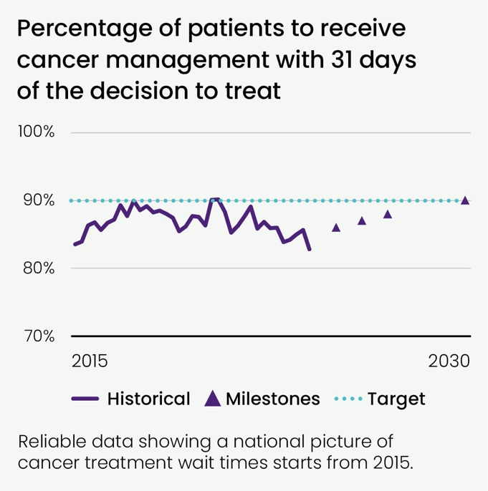

**Improved immunisation for children**

**95%** of children fully immunised at 24 months of age

* Vaccination is one of the most cost-effective health interventions. Timely immunisations ensure children are protected against harmful and avoidable diseases.
* The 95 per cent target for childhood immunisations aligns Aotearoa
* New Zealand with other countries such as Australia, the UK and Canada and is supported by evidence that it provides effective immunity of the population.
* Health NZ has an immunisation recovery plan. The Ministry of Health and Health NZ meet weekly to review progress. There is significant potential across primary care and other providers to increase delivery.

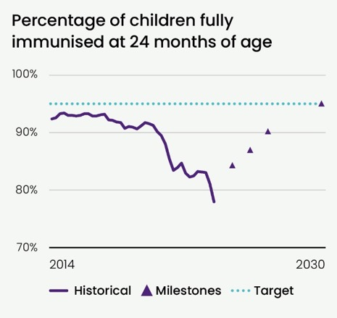



**Shorter stays in emergency departments (ED)**

**95%** of patients to be admitted, discharged or transferred from an ED within six hours

* The time people spend in ED is a barometer for how the whole system is working to support patients and their whānau through their journey.
* The current level of performance reflects that our hospitals are often full and community services, like primary care and aged residential care, are at, or close to, capacity.

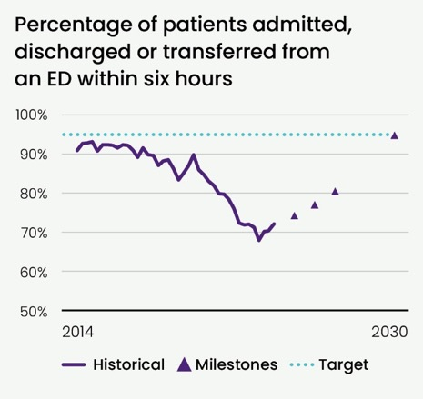

* Our growing and ageing population will continue to add to the pressure on these services.
* The success of this target requires improvements in managing the flow of patients through our EDs and hospitals, supporting people to get care in the community rather than in EDs where possible, and ensuring there are aged residential care beds or home support for people who need them when discharged.
* Improving our ED and hospital performance in acute care is essential. New Zealanders have a strong expectation that they will receive clinical assessment and treatment in a reasonable time.
* The shortest wait is the best wait.



**Shorter wait times for first specialist assessment (FSA)**

**95%** of people wait less than four months for a first specialist assessment

* New Zealanders have a strong expectation that they will receive clinical assessment and treatment in a reasonable time.
* Increases in our waitlists reflect population growth challenges, including increasing complexity of health conditions and aging, compounded by COVID-19 impacts, and ongoing specialist workforce shortages. There is also considerable variation geographically and across health specialties in how long people are waiting.

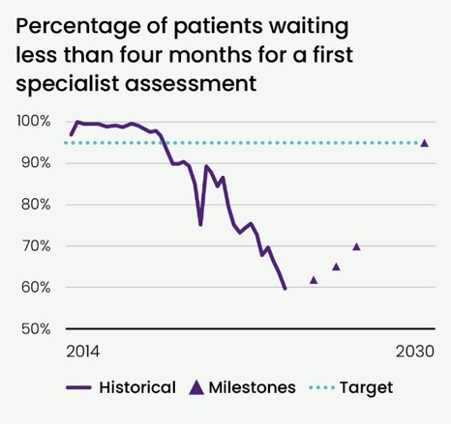

* It is important that people have greater certainty about their conditions and whether they need further treatment.
* People on our waitlist continue to have their clinical needs and risks monitored and their treatment is reprioritised if their clinical need changes.
* However, managing the large waitlist is putting pressure on primary care and hospitals, so it is important that it is reduced over time as resources allow.
* Around 36 per cent of people who have an FSA are found to need subsequent treatment, like surgery.
* Health NZ is looking to its clinical networks to develop criteria to be used across Aotearoa New Zealand to assess people on our waitlists. It is important to us that people can access the same standard of care, consistently, no matter where they live.



**Shorter wait times for elective treatment**

**95%** of people wait less than four months for elective treatment

* The growth and increased complexity in acute patients using hospital beds and clinical resources like ICU is one key factor to being able to address long waitlists through current system settings.
* Health NZ has successfully focused recent efforts on seeing non-acute patients who have been waiting the longest and is close to having no one waiting longer than 12 months for elective treatment.

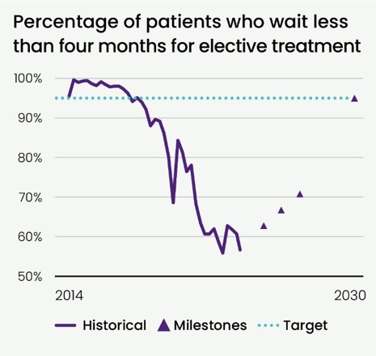

* This provides confidence that we can continue to bring our waiting list down.
* There continues to be variation in access to, and delivery of, hospital and specialist services by district, region, ethnicity and clinical specialty.
* Resolving this will require Health NZ to move our resources or support people to travel further to receive necessary treatment.
* Health NZ has active programmes in place to improve theatre utilisation, hospital flow initiatives to improve theatre capacity, recruit staff, review clinical access criteria, implement clinical networks, utilise private capacity, and incentivise performance in regions and districts via funding and accountability measures.

# The plan

The following pages show how we intend to make progress towards achieving these targets by 2030 and hit the milestones set out in the Government Policy Statement on Health (GPS).

|  |  |  |  |  |
| --- | --- | --- | --- | --- |
|  | **Faster cancer treatment** | | | |
| **2030 Health Target** | | **2024-27 GPS performance milestones** | | |
| 90% | of patients to receive cancer management within 31 days of the decision to treat | 2024/25 | 2025/26 | 2026/27 |
| 86% | 87% | 88% |

|  | **July 2024– June 2027** | | |
| --- | --- | --- | --- |
| **Initiatives** | **Y1** | **Y2** | **Y3** |
| **Action 1. Address unwarranted variation in access to care** | | | |
| Develop **national standards and operating model** to address unwarranted variation across the country.  Increased capacity for allogeneic stem cell transplantation at Auckland, Wellington and Christchurch.  Create regional integrated radiation oncology services to meet demand and drive down variation in intervention rates.  Phased approach to wider distribution of ambulatory chemotherapy to local sites. |  |  |  |
| Develop **consistent national clinical pathways** to ensure timely access to relevant diagnostics and treatment.  Increase access to community radiology services for GPs to support early diagnosis.  Community Pathway in place for faecal immunochemical testing (FIT) to improve early diagnosis of bowel cancer.  Testing for symptomatic pathway for patients on the non-urgent waitlist to be evaluated with five districts, with full implementation across the country.  Quality improvement programmes developed to address variation within Cancer Control Agency Optimal Cancer Care Pathways.  Deploy increased access to stem cell therapy through a national pathway. |  |  |  |  |  |
|  |  |  |  |  |  |
| **Action 2. Improve infrastructure** | | | |
| Undertake **planning to expand and replace linear accelerators (LINACs)** across the country as part of long-term capital programme.  Increase LINAC machine capacity across the country.  Tranche two LINACs business cases agreed for development providing three new LINACs to meet projected demand and machines being run in line with international standards. |  |  |  |
| **Action 3. Improve data and digital tools** | | | |
| Work with the Cancer Control Agency to **improve data collection, standardisation, and visibility** across the cancer continuum to support clinical decision making, and provide individuals with access to their health information. |  |  |  |
| Develop **an operational performance framework** that enables a real-time view of cancer services to support operational delivery and cancer service planning. |  |  |  |
| **Action 4. Strengthen the cancer workforce** | | | |
| Develop a **national cancer workforce plan** that reflects cancer service planning and new models of care and provides adequate training places to meet projected demand. |  |  |  |
| Improve **recruitment and retention of the cancer workforce** (e.g. bolster priority workforces such as radiation therapists and senior medical officers via international recruitment, expand advanced practice models of care for nursing and allied health). |  |  |  |

|  |  |  |  |  |
| --- | --- | --- | --- | --- |
|  | **Improved immunisation for children** | | | |
| **2030 Health Target** | | **2024-27 GPS performance milestones** | | |
| 95% | of children fully immunised at 24 months of age | 2024/25 | 2025/26 | 2026/27 |
| 84% | 87% | 90% |

|  | **July 2024– June 2027** | | |
| --- | --- | --- | --- |
| **Initiatives** | **Y1** | **Y2** | **Y3** |
| **Action 1. Increase targeted and opportunistic immunisation for priority populations** | | | |
| **Expand the vaccinator workforce** to provide accessible immunisation services for our  priority populations through opportunistic vaccinations. Examples include.  investment in Well Child Tamariki Ora, general practice, Hauora Māori partners, Pacific partners and Whānau Awhina Plunket midwifery services  authorise pharmacists to become ‘Whole of life vaccinators’  public health nurses. |  |  |  |
| **Establish processes for ensuring hospital inpatient and outpatient delivery of immunisations** to expand vaccinator workforce and increase access to opportunistic vaccination. Partner with regions to establish processes / support. |  |  |  |  |  |
| Improve and enhance a cohesive **newborn enrolment system** to support timely  access to immunisations. Key partners include maternity services, midwives,  general practice, hauora providers, Pacific providers and hospital birthing units. |  |  |  |  |  |
| **Action 2. Enabling best practice immunisation efforts** | | | |
| Invest in general practice to support best practice **pre-call and re-call activity** to provide six-week immunisations and in primary health organisations to provide local co-ordination support |  |  |  |
| **Re-establish Clinical Oversight Group** to provide guidance and advice to immunisation sector and support successful implementation of initiatives |  |  |  |
|  |  |  |  |
| **Action 3. Increase whānau and community engagement** | | | |
| Implement health promotion activities, including social marketing campaigns, that are created based on insights and evidence to ensure they are fit-for-purpose and effective. Codesign with priority communities. |  |  |  |
| Invest in community action and engagement approaches that are holistic, whānau centred and build trust to support uptake of childhood immunisation. |  |  |  |
| **Action 4. Increase workforce capacity and capability** | | | |
| **Enhance current outreach immunisation service** that is nationally consistent, regionally delivered, and effectively co-ordinated through national principles, to assist providers in prioritising high risk groups to reduce inequity.  This includes fully **implementing the childhood immunisation prioritisation matrix**. |  |  |  |
| Implement the **Enabling Pharmacies Project** to onboard pharmacies through a streamlined process to deliver childhood immunisation. This commenced in April 2024 and will be a phased implementation across three years. This will leverage the growth of the pharmacy vaccinator workforce and increase options for whānau to access immunisation. |  |  |  |
| **Redesign of vaccinator training** and support services to enhance workforce capacity and capability, with particular focus to increase access for high needs groups. This will be implemented by quarter three 2024/25. |  |  |  |
| **Streamline and simplify vaccinator authorisations** through implementing a national vaccinator portal and rationalising the authorisation pathway. This will make it easier for healthcare workers to become vaccinators and support equitable workforce growth across the country. Data will be captured over 2024/25 and 2025/26 as part of the two-yearly vaccinator authorisation renewal cycle. |  |  |  |
| **Action 5. Improve data and technological capability** | | | |
| Progress **digital solutions** to reduce administrative burden, support opportunistic and agile immunisation delivery, enable strategic programme planning, provide accurate and current vaccination status information, enable individuals to self-manage vaccination needs, enable quality systems, and support clinical decision making e.g.  Aotearoa Immunisation Register  Vaccinator Authorisation Portal  newborn enrolment service integration via Whaihua. |  |  |  |
| **Ensure data-sharing agreements are in place** with hauora Māori partners, Pacific health partners, and Iwi Māori Partnership Boards. This will enable access to data that supports regional and local immunisation uptake initiatives and ensure outreach and follow up services are targeted to priority communities. |  |  |  |

|  |  |  |  |  |
| --- | --- | --- | --- | --- |
|  | **Shorter stays in emergency departments** | | | |
| **2030 Health Target** | | **2024-27 GPS performance milestones** | | |
| 95% | of patients to be admitted, discharged or transferred from an emergency department within six hours | 2024/25 | 2025/26 | 2026/27 |
| 74% | 77% | 80% |

|  | **July 2024– June 2027** | | |
| --- | --- | --- | --- |
| **Initiatives** | **Y1** | **Y2** | **Y3** |
| **Action 1. Improve patient flow through hospitals** | | | |
| Implement **standardisation of Integrated Operations Centres** in hospitals. |  |  |  |
| Implement ability to safely **discharge patients seven days a week** through criteria-led discharge. |  |  |  |  |  |
| Embed **escalation pathways for complex discharge** in each district to free up hospital capacity. |  |  |  |  |  |
| Understand the reasons for **delayed discharge** of inpatients who are medically fit, and **action elimination of barriers**. |  |  |  |  |  |
| Establish **short stay units** and **discharge lounges**. |  |  |  |  |  |
|  |  |  |  |  |  |
| **Action 2. Enabling primary care to treat more patients in the community** | | | |
| Support **multidisciplinary teams in primary care**, including greater utilisation of allied  health professionals to reduce likelihood of ED presentation and enable discharge from ED. |  |  |  |
| Continue to fund **access to virtual healthcare** (e.g. Ka Ora, National Telehealth Service) as an alternative / additional source of advice for patients in urgent need. |  |  |  |
| **Extend Primary Options for Acute Care** schemes to provide GPs with options other than ED presentations (e.g. diagnostics). |  |  |  |
| **Divert people with lower acuity needs** from EDs to urgent care centres or telehealth. |  |  |  |
| **Connect low acuity Pacific patients who present to ED with primary and community providers** via nursing, social work, and cultural navigators. |  |  |  |
| Minimise transports to ED **by increasing ambulance ‘hear and advise’ and**  **‘see and treat’ rates**. |  |  |  |
| **Action 3. Stabilise urgent care provision** | | | |
| Develop **a fit-for-purpose funding model to ensure consistent access to urgent care** across the country that is responsive to ED pressures. |  |  |  |
| **Redesign rural unplanned care provision** and **review rural hospital sustainability**. |  |  |  |
| **Action 4. Strengthening our workforce** | | | |
| **Stabilise and grow the urgent care, nursing, acute medical and surgical, midwifery, and allied health workforces** (e.g. via the Return to Midwifery programme). |  |  |  |
| Invest in **improved international recruitment activity** via the International Recruitment Centre. |  |  |  |

|  |  |  |  |  |
| --- | --- | --- | --- | --- |
|  | **Shorter wait times for first specialist assessment** | | | |
| **2030 Health Target** | | **2024-27 GPS performance milestones** | | |
| 95% | of patients wait less than four months for a first specialist assessment | 2024/25 | 2025/26 | 2026/27 |
| 62% | 65% | 70% |

|  | **July 2024– June 2027** | | |
| --- | --- | --- | --- |
| **Initiatives** | **Y1** | **Y2** | **Y3** |
| **Action 1. Increase delivery of FSAs by increasing output** | | | |
| Release capacity by **eliminating unnecessary follow-ups** through developing alternative outpatient models of care.  Patient-directed, rather than automatic, follow-ups.  Default follow-up pathways.  Virtual and remote monitoring.  Telehealth. |  |  |  |
| **Lift number of people seen** through improved clinic utilisation, clinic scheduling to treat long-waiters (e.g. optimising in-clinic productivity, weekend clinics, regional transfers).  Uplift of FSAs to meet milestones.  FSA Turn Rate maintained >1.1 to ensure total waitlist reduction continues. |  |  |  |  |  |
| **Expand the workforce that is able to provide first assessment appointments** through the development of new models of care and purchase units.  New Purchase Unit codes that capture activity undertaken by all workforces not just medical i.e. nursing, Allied Health (e.g. physiotherapy, optometry). |  |  |  |  |  |
| **Action 2. Increase timely access to planned care** | | | |
| Institute **standard operating procedures for measurement and monitoring** of long-waiters for all New Zealanders with a focus on high need groups.  Increase scheduling in order. |  |  |  |
| Each district to establish **patient-level action plans** for long-waiters. |  |  |  |
|  |  |  |  |
| **Action 3. Address unwarranted variation in access to planned care** | | | |
| Deploy **nationally consistent waitlist management guidelines** to tackle unwarranted variation between districts and implement appropriate prioritisation strategies for high need patients.  National Planned Care Patient Pathway in priority service areas embedded.  Reduction in FSA cancellations. |  |  |  |
| Deploy **nationally consistent access thresholds** to remove unwarranted variation between districts supported by clinical networks.  National access thresholds confirmed and deployed across orthopaedics, eye health, otorhinolaryngology and cardiology. |  |  |  |
| **Action 4. Ensure continued validation of FSA waitlist** | | | |
| Deploy processes for **nationally consistent communications to patients** to ensure transparency, manage expectations, and ensure all patients on elective treatment waitlists continue to require intervention and matching the communication necessities of patients with high needs.  Expected wait time dashboard live across all districts.  Standard patient communications with Elective Services Patient Flow Indicators (ESPI2) patients embedded across all districts.  Data quality and waitlist validation are part of all districts’ usual business. |  |  |  |
| **Action 5. Extend clinical pathways and partnerships with primary and community providers** | | | |
| Ensure consistent, clinically-driven **access to community referred radiology**.  Radiology stabilisation phase completed (phased multi-year deployment).  95% of patients referred for MRI, CT, ultrasound, echocardiogram seen within 42 days. |  |  |  |
| **Maintain and expand Health Pathways** to support management of patients in primary care.  Community musculoskeletal pathway and funding agreed for national deployment.  Reduction in referrals to hospital-based orthopaedic services. |  |  |  |
| Evaluate, and **extend alternative clinical pathways** that release capacity within hospitals for increased FSA and diagnostic delivery (hospital musculoskeletal pathway, fecal immunochemical testing pathway, bariatric pathway).  Increase in conversion rate from FSA to orthopaedic surgical waitlisting.  Reduction in colonoscopy referrals.  Evaluation of bariatric pathway pilot and extension decision. |  |  |  |

|  |  |  |  |  |
| --- | --- | --- | --- | --- |
|  | **Shorter wait times for elective treatment** | | | |
| **2030 Health Target** | | **2024-27 GPS performance milestones** | | |
| 95% | of patients wait less  than four months for  elective treatment | 2024/25 | 2025/26 | 2026/27 |
| 63% | 67% | 71% |

|  | **July 2024– June 2027** | | |
| --- | --- | --- | --- |
| **Initiatives** | **Y1** | **Y2** | **Y3** |
| **Action 1. Increase delivery of elective treatments** | | | |
| **Optimise theatre use and surgical throughput** by using nationally consistent performance dashboards, production planning, and operational management to:  drive down hospital-initiated day of surgery cancellations  drive down late starts >60 mins  drive down early finishes >60 mins  increase theatre utilisation  maximise the ringfenced elective sites as a key area of focus. |  |  |  |
| Commission **new assets that increase bed and theatre capacity** for planned care delivery on confirmation of budgets, including:  Tōtara Haumaru (120 beds, 8 additional theatres)  Wellington Hospital Inpatient Bed expansion (12 beds)  Counties Manukau Health park (4 additional theatres). |  |  |  |  |  |
| **Enhanced ability** to treat more patients and maintain focus on long-waiters.  Uplift delivery of treatment to meet year one milestones.  Treatment Turn Rate maintained to ensure total waitlist reducing. |  |  |  |  |  |
| **Increase outsourcing and pilot training approaches** with private providers to utilise sector capacity and grow our long-term surgical workforce:  Increase number of orthopaedic, non-orthopaedic and cataract outsourced surgeries. |  |  |  |  |  |
| **Action 2. Increase timely access to planned care** | | | |
| Institute **standard approaches to measurement and monitoring** of treatment long-waiters to meet the needs of all New Zealanders with a focus on high need groups. |  |  |  |
| Each district to establish **patient-level action plans** for long-waiters. |  |  |  |
|  |  |  |  |
| **Action 3. Address unwarranted variation in access to planned care** | | | |
| Deploy **nationally consistent waitlist management guidelines** to remove unwarranted variation between districts and high need groups.  Embed National Planned Care Patient Pathway.  Reduce patient-initiated surgical cancellations. |  |  |  |
| Deploy **nationally consistent access thresholds and clinical prioritisation tools** to remove unwarranted variation between districts, regions and ensure equity of access for high need groups.  National access thresholds confirmed and deployed across orthopaedics, eye health, otorhinolaryngology and cardiology. |  |  |  |
| **Action 4. Ensure continued validation of FSA waitlist** | | | |
| Deploy processes for **nationally consistent communications to patients** to ensure transparency, manage expectations, and ensure all patients on planned care waitlists continue to require intervention.  Expected wait time dashboard live across all districts.  Embed standard communications with patients waiting for elective treatment across all districts.  Embed waitlist validation and data quality as usual business practice across all districts. |  |  |  |
| **Action 5. Extend clinical pathways and partnerships with primary and community providers** | | | |
| Ensure consistent, clinically-driven **access to community referred radiology**. |  |  |  |
| Develop, evaluate, and / or **extend alternative clinical pathways that reduce pressure on surgical and diagnostic waitlists** (e.g. FIT testing for symptomatic pathway to prioritise endoscopy access).  Year one (five-district) deployment of community FIT for symptomatic testing. |  |  |  |



|  |
| --- |
| **Copyright information** |
| **CCBY** |
| This work is licensed under the Creative Commons Attribution 4.0 International licence. In essence, you are free to: share i.e., copy and redistribute the material in any medium or format; adapt i.e., remix, transform and build upon the material. You must give appropriate credit, provide a link to the licence and indicate if changes were made. |

[www.tewhatuora.govt.nz](http://www.tewhatuora.govt.nz/)

[](https://www.govt.nz/)