


Design Guidance and Assurance Framework
  - Version 1.4

Citation: Te Whatu Ora – Health New Zealand. 2023. Design Guidance and Assurance Framework. Wellington: Te Whatu Ora – Health New Zealand.
Published in March 2023 by Te Whatu Ora – Health New Zealand
PO Box 793, Wellington 6140, New Zealand
ISBN 978-1-99-106722-7 (online)

This document is available at tewhatuora.govt.nz
 | This work is licensed under the Creative Commons Attribution 4.0 International licence. In essence, you are free to: share i.e., copy and redistribute the material in any medium or format; adapt i.e., remix, transform and build upon the material. You must give appropriate credit, provide a link to the licence and indicate if changes were made.

- Foreword
Health New Zealand |Te Whatu Ora is building the foundations of a new health system. Delivering a unified, sustainable health system includes:
- Delivering equity for all,
- Embedding Te Tiriti,
- Implementing a population health approach, and
- Ensuring sustainability of the health system.
The health estate has an important role to play in delivering these objectives, and infrastructure investment will deliver on the aspirations set out in Te Pae Tata.
Providing nationally consistent design guidance, drawing on the wealth of expertise that exists across New Zealand, guidance that is genuinely informed by the principles of Te Tiriti o Waitangi, will deliver buildings that promote equitable access, that respond to the social, cultural and physical needs of all New Zealanders.
Nationally consistent design guidance, and transparent design assurance processes also support standardised, faster and more efficient infrastructure delivery processes, improving the sustainability of the health system, and building construction sector confidence in hospital development processes.
Thank you to everybody who contributed to producing this Design Guidance and Assurance Framework.
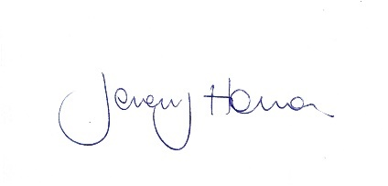
Jeremy Holman
Chief Infrastructure and Investment Officer
Infrastructure and Investment Group
Health New Zealand | Te Whatu Ora
- Executive summary
Nationally consistent design guidance and assurance processes will support fit-for-purpose facility development, that supports equity and sustainability objectives. Providing clear and consistent design expectations will streamline development processes and reduce the risk of time and cost overruns.
This framework sets out processes that will ensure that patients and their whānau, staff and key stakeholders can contribute to developing agreed guidance, using the Australasian Health Facility Guidelines as a base, and developing New Zealand | Aotearoa specific guidance to meet our unique needs.
Developing New Zealand | Aotearoa specific guidance, developed in partnership with tangata whenua, will support health facility designs that reflect te Ao Māori priorities.
Assurance processes to support consistent application of the guidance are also set out here; the processes drive standardisation, while providing approval pathways for local and innovative solutions, where required.
The guidance and assurance processes are designed to be continuously improved, with lessons learned, and post-occupancy evaluation information feeding into guidance reviews and updates. Post occupancy reviews will not only seek input from clinicians and facility managers, but will also include input from patients and their whanau, to amplify lived experience in developing and reviewing facility design guidance.

Contents
1 Foreword 3
2 Executive summary 4
3 Working Group 7
4 Consultation 8
5 Revision History 8
6 Objectives 9
7 Scope 9
8 Context 11
9 Benefits 12
10 Design Guidance 14
10.1 Introduction 14
10.2 The Australasian Health Infrastructure Alliance (AHIA) 15
10.3 Australasian Health Facility Guidelines (AusHFG) 16
10.4 New Zealand Design Guidance Notes (DGNs) 16
10.5 Guidance development 17
10.6 Consultation 18
10.7 Impact 18
10.8 Updates 19
10.9 Roles 19
10.10 Innovative solutions 20
10.11 Continuous improvement 20
10.12 Audience 20
11 Design Assurance 22
11.1 Introduction 22
11.2 Scope 23
11.3 Desktop Review 24
11.4 Full Review 24
11.5 Timing 25
11.6 Process 25
11.7 Full DA Template 27
11.8 Governance Report 28
11.9 Close-out 28
11.10 Timeframe 28
11.11 Deviations and innovations 28
11.12 Design Authority 30
11.13 Continuous improvement 31
Appendix A – Design Assurance Threshold Tool 32

- Working Group
This framework was developed in consultation with a Working Group including representatives set out in the table below:
Name | Title | Agency
Andy Savin | Clinical Health Planner & Project Manager | Klein Architects
Melanie Walsh | Technical Director – Building Services | Beca
Laura Aileone | Principal Advisor, Primary and Community | Te Aki Whai Ora – Māori Health Authority
Sole Labbe Hubbard | Service Design Business Analyst, Digital Strategy and Investment | Te Whatu Ora
Margo Kyle | Principal Advisor, Service Planning | Te Whatu Ora
Justin Kennedy-Good | Director, Ara Manawa | Te Whatu Ora, Te Toka Tumai, Auckland
Christine Corin | Programme Manager, Facilities and Infrastructure | Te Whatu Ora, Waitaha, Canterbury
Dr. Debbie Wilson | Principal Advisor – Sustainability, Health Asset Management and Analysis | Te Whatu Ora
Matt Johns | Head of Projects, Facilities & Development | Te Whatu Ora, Te Toka Tumai, Auckland
Allan Johns | Director, Facilities & Development | Te Whatu Ora, Te Toka Tumai, Auckland

- Consultation
The draft was provided to the agencies listed below, from 14-20th February 2023.
Agency/Group
Te Aka Whai Ora
Pacific Health (Te Whatu Ora)
New Zealand Health Design Council
DIG – Investment Delivery Group (Te Whatu Ora)
MHIP (Te Whatu Ora, Infrastructure and Investment Group)
Infrastructure Investment Planning (Te Whatu Ora, Infrastructure and Investment Group)
Data and Digital (Te Whatu Ora)
Infrastructure Procurement (Te Whatu Ora, Infrastructure and Investment Group)
- Revision History
Version | Date | Author | Description of changes
1.0 | Jan 18, 2023 | Facility Design and Advisory Team | Initial draft.
1.1 | Feb 10, 2023 | Facility Design and Advisory Team | Response to Working Group feedback.
1.2 | March 10, 2023 | Facility Design and Advisory Team | Response to consultation feedback.
1.3 | March 24 | Facility Design and Advisory Team | Response to Te Whatu Ora ELT feedback.
1.4 | September 2025 | National Facility Design Advisory and Assurance team | Health New Zealand references and design assurance revision and general update.

- Objectives
Design guidance and assurance processes help Health New Zealand | Te Whatu Ora deliver consistent, fit-for-purpose health facilities across New Zealand | Aotearoa. Providing guidance helps design teams to develop facilities that not only deliver on functionality and affordability expectations but increasingly sets out pathways for Health NZ | Te Whatu Ora facilities to support health equity outcomes and reflect te Ao Māori priorities in health infrastructure.
Improved design assurance processes will provide early feedback for project teams, building confidence that project funding is meeting functional, operational and strategic goals, and reducing the risk of project delays and cost overruns. By setting out clear design expectations and standardised solutions, where project teams are supported through assurance processes, we expect faster and more efficient design processes, with reduced risk during delivery phases.
The guidance is based on research and broad consultation and tested through decades of application in trans-Tasman projects. Establishing formal consultation processes will give consumers and industry an opportunity to contribute to design guidance and assurance processes, that suit the New Zealand | Aotearoa context. Feedback processes that value the voice of consumers will inform guidance for when we plan and design health services and will ensure that we have mechanisms in place to be held to account.
Health facility design processes will still require professionals to weave together inputs from:
- clinical service plans (local and regional)
- models of care
- regulations
- site specific requirements (e.g. building condition)
- territorial authority’s District Plans, and
- consultation with key stakeholders such as user groups, tangata whenua, clinicians, staff, data and digital teams and territorial authorities.
Design guidance sets out what Health New Zealand |Te Whatu Ora expects from designers. Assurance processes test alignment to the guidance, to ensure that health infrastructure expenditure will deliver on expected health outcomes.
- Scope
Design guidance and assurance processes won’t replace professional services such as engineering and architectural services, and it won’t replace regulations such as the New Zealand Building Code.
While design guidance is freely available for designers to use for any health care facilities, Health New Zealand | Te Whatu Ora assurance processes don’t apply to:
- private health facilities
- non-government aged care facilities
- private medical practitioners and associated consulting rooms
- pharmacies (retail and stand-alone)
- support residential facilities
- residential housing
Low risk public health projects should comply with guidance, but project teams and/or facilities and maintenance teams can monitor alignment (rather than the National Facility and Design Advisory and Assurance team).

- Context
This is one of a number of infrastructure frameworks being developed, as Health New Zealand | Te Whatu Ora establish a nationally led view of infrastructure investment. This framework should be used in conjunction with other infrastructure frameworks, as they are finalised.
Where the frameworks potentially overlap (e.g. with digital infrastructure development), the infrastructure and investment teams involved will collaborate to ensure that guidance is coordinated and led by the appropriate team.

As we come together as national agencies, there is an opportunity to share resources like facility design expertise. The design and assurance framework will establish mechanisms to gather and communicate the wealth of facility design expertise that exists across New Zealand | Aotearoa so that designers have easy access to tried and tested design solutions.
A consistent, national approach will improve our ability to deliver high quality healthcare facilities, affordably. Agreeing on a national approach will improve equity outcomes, where, over time, patients and their whānau can expect the same quality healthcare facilities, no matter where they live.
Developing a standardised response (to improve efficiency and reduce risk) won’t prevent design teams from responding to local voices and local conditions. While striving to support consistent, affordable, high-quality facilities, the framework will also build channels to hear, and respond to, the voices of patients and their whānau, clinicians, tangata whenua and local communities.

- Benefits
Providing health facility design guidance, supported with collaborative assurance processes, ensures that projects not only meet Health New Zealand | Te Whatu Ora strategic health objectives, but also cost and quality standards.
Guidance and assurance processes are designed to provide effective support early in a project life (master planning/test of fit, concept plan, and preliminary design), so that project teams can build on best practice, and identify roadblocks and cost considerations as early as possible. Assurance processes (to check against guidance) early in the design process reduce the risk of rework, or poor alignment with functional or strategic outcomes.
Clear design guidance, with transparent assurance processes, will give project teams and governance groups certainty and confidence at each stage of the design. The guidance and assurance processes also ensure that the right technical assessments (e.g. geotechnical site analysis) are carried out, before committing to more extensive design processes.
While the design guidance and assurance processes are mainly developed to improve new-build outcomes, the guidance is relevant for staff managing existing healthcare facilities. It covers important standardised features such as door widths for access and security, ceiling finishes for infection prevention and control, and specialised plumbing specifications in renal facilities for example.
Design guidance and assurance can also optimise future use of the health estate. Master planning guidance ensures that project teams respond to a holistic, long-term plan for organising facilities at each hospital campus. Master planning is a key (and complex) design decision-making process in health facilities, where capital decisions can have long-term impacts on functional outcomes and operating costs. For example, a site with a large number of dispersed small buildings will be more expensive to heat, clean and keep secure, and harder for staff, patients and their whānau to navigate, particularly where accessibility is an issue.
In conjunction with asset management information, and health service planning, effective master plans can provide the foundation for long term investment planning. Setting out the master plan standards will ensure that there is a nationally consistent approach, that draws on international and industry best practice. (See Health New Zealand | Te Whatu Ora Master Planning Guidance document Masterplanning-guidance-FINAL-1-1.docx )
Improved design guidance supported by robust assurance processes will deliver consistent, value-for-money facilities. Consistent design outcomes will support a range of benefits for key stakeholder groups, as shown in the diagram below.
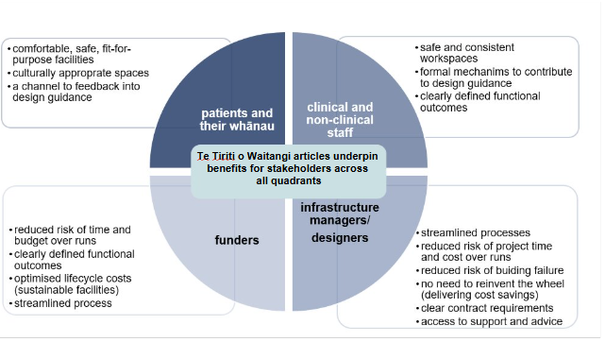
Guidance and assurance will be developed and updated through a process of continuous improvement, with clinicians, patients and their whānau, tangata whenua and local communities feeding back into design guidance through established channels; ensuring that lived experience informs guidance is a priority. This will support facility designs that continue to evolve to meet the changing health needs of our communities.

- Design Guidance
  - Introduction
This Framework establishes design guidance as the basis for public health facility project briefs in New Zealand | Aotearoa.
Providing design guidance early in a project enables designers, contractors, project managers and funders to deliver an effective result, quickly and consistently. For example, national design guidance centralises and front loads consultation processes, saving time on projects. Frontloading the consultation will ensure that consistent, tested designs can be developed efficiently (drawing on expertise from across Health New Zealand | Te Whatu Ora, tangata whenua, clinicians, property teams and other key stakeholders reviewing and contributing to projects through normal project consultation processes.
Additional benefits of guidance include:
- setting out key project parameters (floor area, adjacencies, finishes, etc) giving a good idea of project costs and viability, early in a project; and
- supporting strategic, long-term use of the health estate by guiding effective master planning.
There are two parts to the design guidance:
- Australasian Health Facility Guidelines (AusHFG), which is augmented by
- New Zealand specific design guidance.
All Health New Zealand | Te Whatu Ora capital projects are required to follow this guidance and use the AusHFG and New Zealand Guidance Notes as the basis for facility, department and room planning and design. It is mandatory for design teams to develop solutions that are aligned with AusHFG and New Zealand specific design guidance.
Where projects require solutions that aren’t addressed in the guidance, or an innovative solution is available, project specific design solutions will be considered (alongside any cost benefit analysis), and the guidance updated, as appropriate.
Aligning with design guidance doesn’t remove any requirement to comply with New Zealand regulations (e.g., the New Zealand Building Code, or food safety requirements). The guidance augments existing design inputs, including regulations, site constraints and user requirements. The diagram below sets out the hierarchy of considerations in the design process.

  - The Australasian Health Infrastructure Alliance (AHIA)
Health New Zealand | Te Whatu Ora, participates in the Australasian Health Infrastructure Alliance (AHIA) which is made up of public health authorities across Australia and New Zealand. Collectively the nine jurisdictions provide funding for the Australasian Health Facility Guidelines (AusHFG). The Guidelines have now been in use for over a decade across Australasia and have been tested through billions of dollars of trans-Tasman hospital investment.
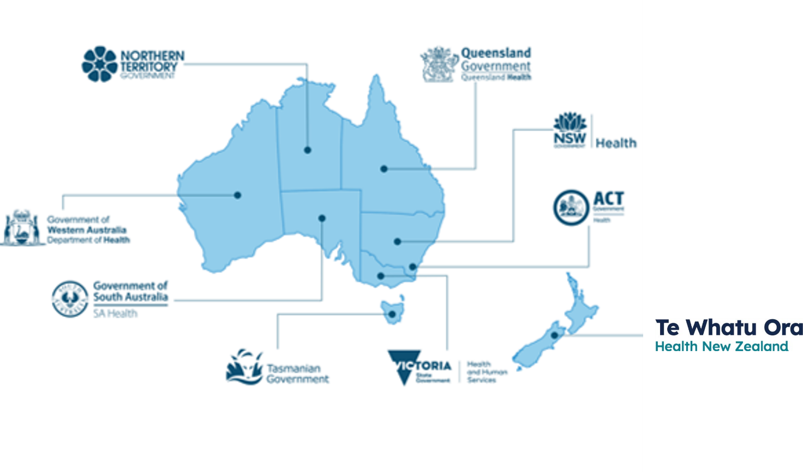
  - Australasian Health Facility Guidelines (AusHFG)
The AusHFG enable health facility planners and designers to use a common set of guidelines for the base elements of health facilities, with standard room layouts available in common BIM formats. The Australasian guidance provides general advice including:
- health facility briefing and planning
- design for access, mobility, safety and security
- infection prevention and control, including pandemic preparedness planning
- spatial benchmarking
- building services and environmental design
- project Implementation.
The AusHFG also provides specific advice about laying out departments (Health Planning Units), and standard rooms (Standard Components), including room data and layout sheets, generic specifications for engineering services, finishes, furniture, fixtures, equipment, room areas and departmental schedules of accommodation.
AusHFG content is developed to reflect the range of conditions in each of the AHIA jurisdictions, including New Zealand | Aotearoa. Our local subject matter experts (clinical and non-clinical) participate in consultation processes including Expert Review Groups, consultant review processes, and reviewing drafts.
AusHFG content will increasingly include and reflect New Zealand conditions, as this consultation framework is implemented.
  - New Zealand Design Guidance Notes (DGNs)
New Zealand | Aotearoa specific design guidance is developed when the need won’t be met by AusHFG guidance (or won’t be met within the required timeframe).
Design parameters that are specific to New Zealand | Aotearoa will include cultural, environmental, legislative and geographic considerations, like:
- working with tangata whenua in design processes, and acknowledging kaupapa Māori design principles
- meeting equity objectives
- responding to the geotechnical, seismic and climatic conditions at Health New Zealand | Te Whatu Ora sites
- regulations (like fire engineering requirements)
- meeting New Zealand’s Carbon Neutral Public Sector objectives.
There is potential to develop agreed construction details and product specifications in the future, where this will reduce risk of building failure, and speed up design processes.
  - Guidance development
Both AusHFG guidance and New Zealand specific DGNs are drafted based on the evidence available, revised in response to expert review feedback, and updated when impacts such as cost, sustainability, accessibility and adaptability have been taken into account. The diagram below sets out the process for developing DGNs in New Zealand (which mirrors the process for developing AusHFG).

DGNs are drafted based on the best available information. Health New Zealand | Te Whatu Ora holds a record of the evidence base for each decision; the information we hold is:
- fact checked, publicly available, and sense checked by experienced practitioners
- ethical (e.g., obtained with informed consent, and without harm)
- up to date and relevant
- auditable.
Sources include international standards and guidance, New Zealand policy, our post-occupancy evaluation database (which includes lived experience feedback from patients and their whānau), industry and Non-Government Organisation (NGO) best practice guidance and standards, and regulations.
Where there is no existing evidence, we explore sources like: learnings from similar industries, and primary research (using human-centred design principles, or new post occupancy evaluation for example).
  - Consultation
Expert Review Group membership varies according to the guidance topic, but formal consultation processes will increasingly involve a range of stakeholders, including:
- Voice for consumers
- Tangata whenua
- Pacific Health
- Health design practitioners
- Health facility planners
- Infection prevention and control
- Facility / property and asset managers
- Non-clinical support (e.g., security, equipment pool and cleaning contractors)
- Operations and logistics managers
- Clinicians
- Whaikaha – Ministry for Disabled People
- Te Tari Mātāwaka – Ministry for Ethnic Communities
- Data and Digital providers
- Technical advisory services (e.g., engineering).
Contributing to drafting processes might involve, multi-disciplinary review groups, targeted interviews or focus groups, and / or reviewing drafts.
  - Impact
Key impacts of both AusHFG and New Zealand specific guidance will be considered before introduction, including:
- staff safety and wellbeing
- patient and whānau experience
- clinician experience
- clinical functionality (including pandemic readiness)
- capital cost
- operating costs
- buildability, durability, risk management, maintainability, infection prevention and control and safety in design
- sustainability
- Te Tiriti o Waitangi, and tikanga Māori
- contribution to system transformation
While it may not be simple to weigh the relative merits of capital cost vs sustainability/operating cost outcomes (for example), we expect the formal process to make these trade-offs explicit and transparent.
Innovative design solutions may be tested through trials or pilot programmes, before formal DGNs are issued.
  - Updates
AusHFG and New Zealand specific guidance is updated on a 3-5 year cycle, but reviews can be brought forward when:
- there is a technological change
- there is a new or emerging risk (e.g., pandemic, building/material failure)
- there is a new opportunity (e.g., equity, sustainability, efficiency)
- a New Zealand specific gap is identified in AusHFG guidance.

Updates that occur before the commencement of a project’s Concept design phase, should be incorporated into the project.
Updates made after this point should be considered for inclusion, in discussion with the project Governance group. A gap analysis and impact for the project should be identified and documented in the project design report.
  - Roles
AusHFG and DGNS don’t replace professional services provided by Architects and Engineers (for example), who lead the response to the Functional Design Brief, and navigate regulatory and planning requirements, but guidance does set out what Health New Zealand | Te Whatu Ora, as a client, expects.
We expect guidance to help designers to establish design fundamentals quickly, enabling them to use their expertise to address project specific and/or complex issues.
  - Innovative solutions
Guidance doesn’t replace the need to work collaboratively with project-specific stakeholders, like tangata whenua, territorial authorities or user groups. Where design solutions or innovations are proposed and significantly deviate from AusHFG or New Zealand DGNs, project teams must follow the process outlined in Section 11.11.
Project teams are responsible for identifying deviations and signalling these to the Project Director.
  - Continuous improvement
The National Facility Design Advisory and Assurance Team supports evidence-based design improvements. While guidance is updated on a 3-5 year cycle to keep up to date with changing technological, social and environmental conditions, guidance will be continuously improved by feedback loops (including post occupancy evaluation and alternative design solutions approved by the Design Authority).
The National Facility Design Advisory and Assurance Team maintain a database of post-occupancy review findings and lessons learned, to influence and improve future design guidance. This can include the performance of systems, fixtures and finishes, through to feedback on patient and whānau experiences of our healthcare facilities. Recurring issues identified through assurance processes will also form part of the lessons-learned dataset and be used to drive improvements in the guidance.
Design guidance and assurance processes and collateral will also be continuously improved, in response to feedback from facility users such as staff, patients and their whānau, and facilities managers. Supporting designers to adopt the guidance, and building relationships to understand how it is being adopted (and if not, why not) will ultimately deliver a robust set of design guidance.
Feedback mechanisms will include participating in industry forums, collaborative design assurance processes, post occupancy reviews and maintaining and analysing a database of facility design queries.
  - Audience
The National Facilities Design Advisory and Assurance Team will proactively update stakeholders when DGNs are developed or updated. Existing communication channels are in place for AusHFG updates, which will be amplified through Infrastructure and Investment Group stakeholder channels in New Zealand | Aotearoa.
Establishing consistent, formal channels will improve buy-in, and build confidence that the AusHFG and DGNs are the foundation for health facility design in New Zealand | Aotearoa. Proposed mechanisms include:
- anticipating new design guidance with early communications to stakeholders
- releasing DGNs on the Health New Zealand | Te Whatu Ora external facing website
- supporting new design guidance with training
- reaching core stakeholder groups through industry forums and e-newsletters.
Existing design advisory functions will continue to build awareness of the guidance, supporting improved uptake from project initiation.
Special care will be taken to provide in-flight projects with relevant design guidance as early as possible, with clear, realistic guidance about timeframes for implementation. The objective is to support delivery, and signal change as early as possible.

- Design Assurance
  - Introduction
Design Assurance (DA) is a mandatory review of qualifying Health New Zealand |Te Whatu Ora capital works projects to provide assurance on design documentation, process, quality and completeness.
The purpose of DA is to support project design teams to:
- deliver affordable, consistent, efficient, high-quality, and effective health facility design
- ensure that the design meets the project’s intended functional requirements and scope
- understand Health New Zealand | Te Whatu Ora expectations
- support alignment with design guidance
- foster project tracking and transparency of deviations
- promote standardisation and improve the design process
- provide a project design phase Governance reporting mechanism.

The DA review assesses:

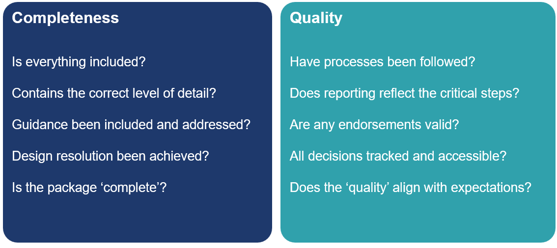

Assurance is provided in three ways.
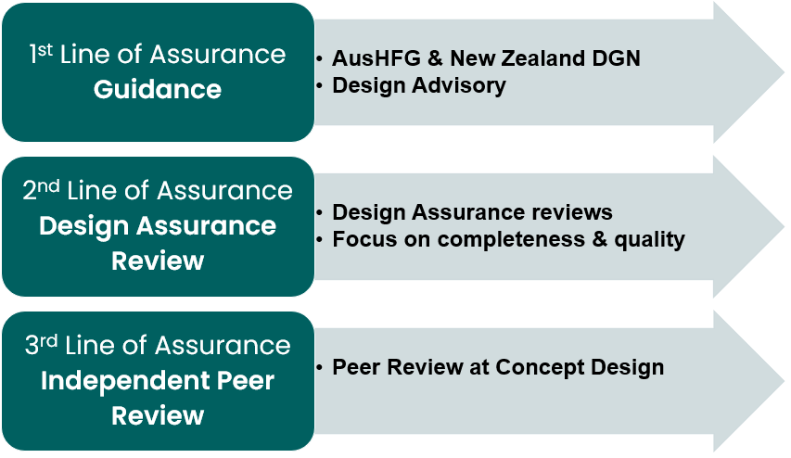
  - Scope
DA is required for new buildings and significant refurbishments including alterations to existing buildings. Where a building is repurposed (e.g. converted from a ward to an office space), the repurposed facilities must meet the requirements for the new occupancy type.
Minor renovations, maintenance and cosmetic upgrades (like-for like) are not covered by the DA processes, but design proposals should be aligned with AusHFG and NZ DGN.
DA is tailored to suit the size and complexity of the project, with resources targeted to the highest value, most complex projects.
The DA Threshold Tool is used to determine the review type. See Appendix A.
The following diagram illustrates this process.
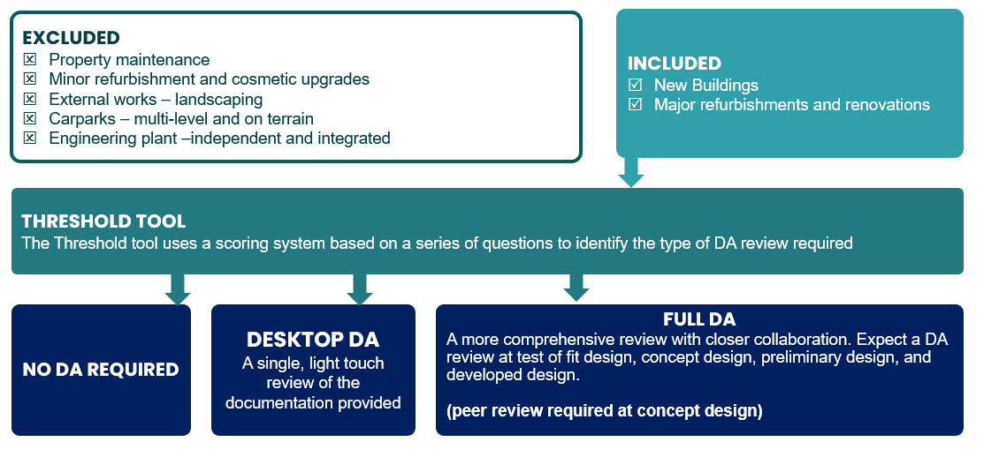

  - Desktop Review

The desktop DA review for less complex projects, is a high-level tailored assessment of the design processes that have been integrated within the project. It is usually undertaken at Concept Design.
Available project design phase documentation is reviewed and a report that includes recommendations for consideration by Project Governance is provided.
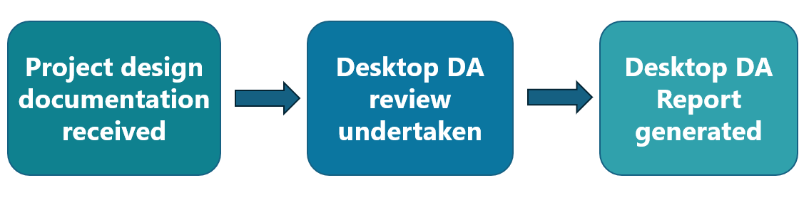
  - Full Review
The full DA review for complex, larger scaled projects, is process and evidence based and is guided by the appropriate design phase DA template item list.
It is not a design review but assesses in detail, the design processes that have been integrated within the project.
An independent Peer Review is undertaken at Concept Design and provides a deep dive, expert assessment of the design proposal.

  - Timing
DA reviews are undertaken at the completion of:
- Concept Design
- Preliminary Design
- Developed Design.
Further DA project support may be provided to suit the project phase e.g. Business Case – Test of Fit and Masterplans.
  - Process
The following process is used to commence a DA review:
- Make contact with the National Facility Design Advisory and Assurance Team
facility.design@tewhatuora.govt.nz

- Use the DA Threshold Tool to establish the type of DA review that will be required (see Appendix A)

- Project DA Initiation Meeting and ongoing support.
Once a review is commenced, the DA process is detailed below:
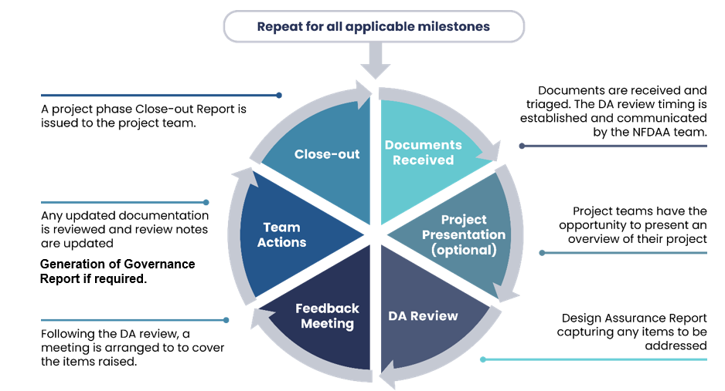
The full DA review is a collaborative and interactive process, which includes the exchange of the DA template between the project design and the National Facility Design Advisory and Assurance teams.
A peer reivew is required at concept design to examine the detail of the design proposal.
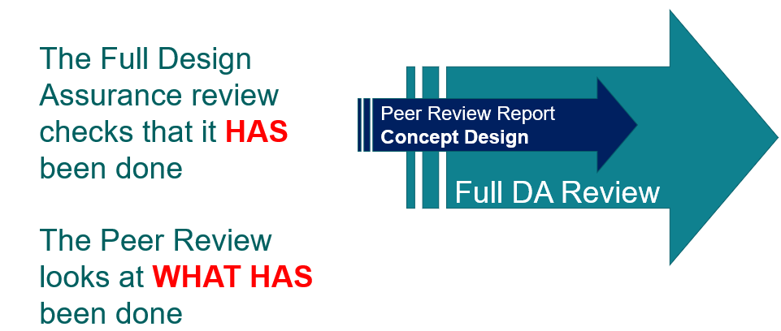

Required project documentation is identified at the top of the design phase DA template.
For example, the following information is required for the Concept Design DA review.
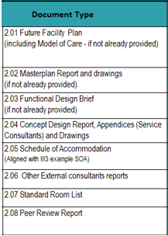
If documentation is absent or incomplete, the project team will complete the document set as soon as possible. The DA process may be stalled until such time that all information is available.

  - Full DA Template
The full DA template includes assessment items that relate to,
- New Zealand Design Guidance Note
- alignment with guidance and includes Environmental Sustainable Design targets
- Architecture
- Architectural design processes
- Schedule of Accommodation
- Management of the project and design response to the brief
- Standardisation
- integration of standardisation strategies within the project.
Assessment system
Assessment is based on the quality and completeness of the documentation and whether the project meets Health New Zealand | Te Whatu Ora objectives.
The report includes commentary and recommendations as well as a colour rating system as follows.
Legend - Review outcome
C | Completed
W | Work in Progress
N | Not completed

Report and Feedback Meeting
The full DA Report is issued to the project design team ahead of the Feedback Meeting where items are discussed and the template is updated accordingly.
The project team will respond to the Action Items, with concise notes showing how the issues have been addressed. Each comment should:
- refer to specific drawings and reports
- provide supporting information, keeping comments concise and factual
- highlight key decision rationale.
The Feedback Meeting is an opportunity to discuss the amber and red items indicated in the project DA review report. Actions items arising from this meeting are provided to the project design team for completion before the DA review may be closed out for the specific design phase.
Where further assurance information is required, the National Facility Design Advisory and Assurance team will re-issue the report and include any Action Items for the project design team to complete.
  - Governance Report
A DA Governance Report may be generated, if the DA items have not been sufficiently resolved (item status remains at amber and/or red) during the review process.
Project risk and impact on outcome is identified for discussion at the project Governance Meeting.
For DA close out, the Governance Group decisions are to be communicated back to the National Facility Design Advisory and Assurance Team.
  - Close-out
The review will be closed out when the DA items are sufficiently resolved for the project and the National Facility Design Advisory and Assurance Team are confident to provide assurance for the project to proceed to the next design phase.
  - Timeframe
Every effort is made to ensure that the DA review process is undertaken in a timely manner.
The following table provides approximate timeframes for each DA review type.
 | Document  Assessment | Review period  (indicative) | Feedback  (Feedback meeting, review of Action items, Governance Report & DA Close out) | Total
Desktop review | .5 -1 days | 1 - 5 days | 1 day (if required) | 1 - 7 days
Full review | 1-3 days | 5 -10 days | 1 - 3 days | 7 -16 days
  - Deviations and innovations
Deviations from the guidance (AusHFG and / or New Zealand Guidance) should be identified and reported.
Where projects offer solutions that contradict the guidance, or present an innovative solution, these proposals will be considered on a project-by-project basis.

Minor deviations include
1: A change to the project briefed area or fit-out that does not affect the clinical and/or operational function of the room, Examples:
  - Relocation or substitution of furniture & fixtures
  - Area deviations of less than 10% of AusHFG standard components
2: A change to the AusHFG percentage allocation for departmental circulation, travel & engineering (T&E)
Major deviations include
proposals that do affect the clinical and/or operational function of a room or space such as:
  - Additional rooms / spaces not specified in the relevant AusHFG HPU.
  - Deleted rooms / spaces from those listed in the relevant AusHFG HPU.
  - Area deviations of greater than 10% of AusHFG standard components
  - Additional FFE items or engineering solutions not specified as optional in the room Data Sheet for a standard component.
  - Deletion of any major FFE item or engineering services not specified as optional on the room Data Sheet for a standard component.
  - Non-conformance with design guidance provided in the AusHFG / DGN in relation to access, safety, security, and infection prevention & control.
  - Non-conformance with the Health New Zealand DGN in relation to seismic, sustainability and cultural design principles.
The following diagram demonstrates the Health New Zealand process for the management of project deviations
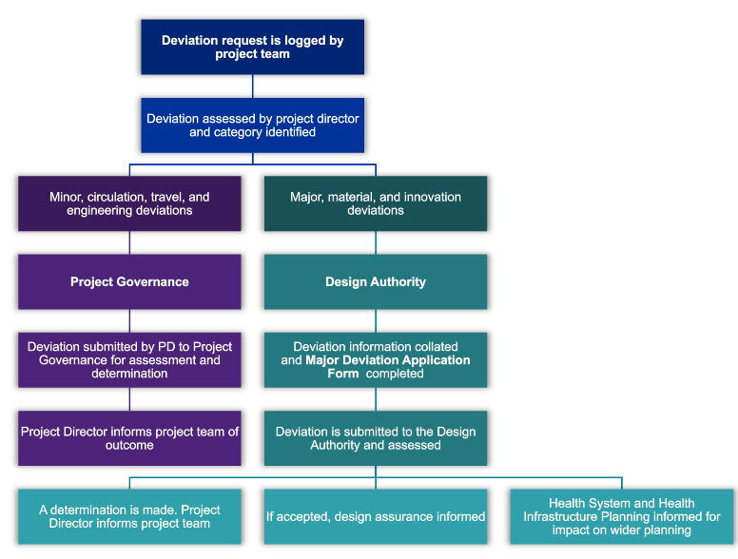

Deviations are to be tracked and recorded in the remarks / comments section of the Schedule of Accommodation (area and room location changes) as well as the Room Data Sheets (changes to room briefing requirements)
A Design Authority – Major Deviation Application Form is to be submitted for major, material and innovation deviations.
  - Design Authority
The Design Authority will assess and make determinations on major, material and innovation deviation requests.
Each item will be assessed by subject matter experts and decisions communicated to the Project Director and National Facility Design Advisory and Assurance team. Determinations that impact on system level health and infrastructure planning will be communicated to both Planning, Funding and Outcomes and the Infrastructure and Investment Groups.
The following process is required for major deviations:
- Noted item reported by the health planner or architect to the Project Director
- Project Director will complete the Design Authority – Major Deviation Application Form and forward to the Design Authority via the National Facility Design Advisory and Assurance team email address facility.design@tewhatuora.govt.nz
- The Design Authority will make a determination and feedback to the Project Director via the National Facility Design Advisory and Assurance team.

  - Continuous improvement
Lessons learnt through the design guidance and assurance process, project advisory queries and post occupancy reviews will inform future guidance and projects as indicated in the following diagram.
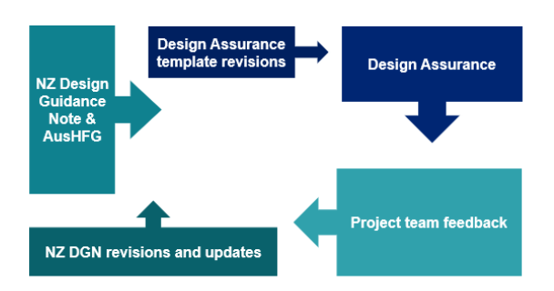

Appendix A – Design Assurance Threshold Tool
The table below outlines the criteria that will determine the type of design assurance process required (desktop or full design assurance review).
Note: the following projects are excluded from the design assurance process and do not need to be processed through this table:
- External works including landscaping and roading.
- Carparks – on-grade and multi-level buildings.
- Independent and integrated engineering plant projects.
- Refurbishment projects that are solely limited to refinishing and replacement of like-for-like including general maintenance. (eg: painting & vinyl upgrade / lift replacement etc)
Design Assurance Review - threshold questions | Item value | Score  3-7 | Score  8-10
1: Project Budget?  up to $10M (n = 1)  $10 – 50M (n = 3)  $50M and over (n = 5) | 5, 3 or 1 | Desk-top DA Review | Full DA Review
2: Does the project include new build, partial new build or alter the existing layout and / or change the function of an existing space?  (if yes =2, no =0) | 2 | Desk-top DA Review | Full DA Review
3: Will the project engage an architectural lead consultant team?  (if yes =1, no =0) | 1 | Desk-top DA Review | Full DA Review
4: Will the project follow a typical design process including full design stages and stakeholder participation?  (if yes =2, no =0) | 2 | Desk-top DA Review | Full DA Review
Total Score

Building Information Modelling

