Design Authority – Major Deviation Application Form
  - < Add Project Identity #, project name and proposed deviation name>

Project Location | <Add Region and Health Campus / Facility >
Project Description | <Add content>
Project scope | <Add information from Functional Design Brief relating to number of nominated points of care / patient spaces (bed / chair), procedural / treatment spaces, workstations, clinical and staff support and required amenities>
Proposed deviation description | <Add content>
Supporting document/s file names | <Add all relevant documents file names in support of this application>
Project Design Team | <Provide details – Architect and relevant Building Services Engineering Consultant/s and other Consultants as relevant>
Name and role of person/s completing Section 2 | <Add content>

Contents
1 Information for applicants 4
1.1 What is a major deviation? 4
1.1.1 Material deviation? 4
1.1.2 Innovation 5
1.2 Application to the Design Authority process 5
2 Major deviation information 6
2.1 Background and relevant ‘Guidance’ 6
2.2 Description of proposed deviation 6
2.3 Evidence, consultation, & expert advice 6
2.4 Rationale and benefits 6
2.5 Identified risk 7
2.6 Capital cost impact 7
2.7 Operational cost impact 7
2.8 Programme impact 7
2.9 Summary 7
3 Design Authority consultation and meeting summary 8
Notes / consultation 1 9
<Add relevant heading> 9
Actions 9
Notes / consultation 2 10
<Add relevant heading> 10
Actions 10
Meeting 1 11
<Add Meeting Title> 11
Notes 11
Actions 11
Meeting 2 12
<Add Meeting Title> 12
Notes 12
Actions 12
4 Design Authority Determination 13
4.1 Outcome summary 13
5 Ongoing impact for HNZ facilities 14
5.1 Impact summary 14
5.2 Actions and close-out 14

- Information for applicants
Thank you for submitting your request form.
Health New Zealand (HNZ) infrastructure projects are required to develop solutions that are aligned with the Australasian Health Facility Guidelines (AusHFG) and New Zealand specific design guidance.
For situations where Project Design Teams (PDT) may choose to deviate from this guidance, a prescribed process has been developed to report and assess the impact, risk and advantages that may be achieved.
Based on the understanding of AusHFG and NZ Design Guidance as best practice, Deviation Requests for major items must therefore be
• Evidence based.
• Risk assessed
• Justified
  - What is a major deviation?
A major deviation is a proposal that affects the clinical and/or operational function of a room or related functional spaces, including:
- Additional rooms / spaces not specified in the relevant AusHFG Health Planning Unit (HPU).
- Deleted rooms / spaces from those specified in the relevant AusHFG HPU.
- Briefed and/or designed spatial variations of more than 10% in comparison to the relevant recommended AusHFG room size.
- Additional Furniture, Fixtures and Equipment (FF &E) items or engineering solution not specified as optional in the Room Data Sheet for a standard component.
- Deletion of any major FF &E item or engineering services not specified as optional on the Room Data Sheet for a standard component.
- Non-conformance with design guidance provided in the AusHFG / DGN in relation to access, safety, security, and infection prevention & control.
- Non-conformance with the Health NZ DGN in relation to seismic, sustainability and cultural design principles.
    - Material deviation?
Material deviations are defined as a proposed departure from a commonly used building material that may impact budget, service scope, future flexibility, occupant safety and/or programme.
    - Innovation
This may be defined where projects require solutions that aren’t addressed in the guidance, or an innovative solution is available. Project specific design solutions will be considered (alongside any cost benefit analysis), and the guidance updated, as appropriate.
  - Application to the Design Authority process
- PDT are requested to complete the front page (project information) and Section 2. Application and reference files to be sent to facility.design@tewhatuora.govt.nz
- Application is triaged by National Facility Design, Advisory and Assurance team and forwarded to Design Authority for review. This step may involve several meetings as well as consultation with subject matter experts.
- Determination is made by Design Authority and Project Director is informed of outcome.
- Health System and Health Infrastructure Planning informed of impact on wider HNZ planning.
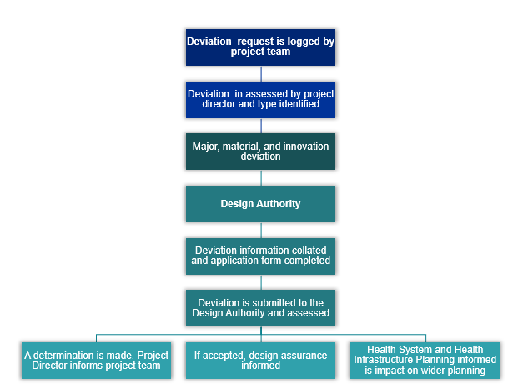
- Major deviation information

  - Background and relevant ‘Guidance’
Guidance. In 2-3 paragraphs, provide a concise summary of critical background and contextual information that is important for readers to understand. For example:
- What is the current guidance relating to this item?
- What is the background and relevance as to why this deviation is being proposed.
- Indicate any legislative or compliance requirements.

  - Description of proposed deviation
Guidance. The reader needs to easily understand what is being suggested. The proposed deviation needs to be clearly described with reference to technical documents as required. This section should state how and where the proposed deviation is different from the Guidance. Images and diagrams may be added to complement the text.

  - Evidence, consultation, & expert advice
Guidance. The reader needs to understand what literature, discussions and expert opinions have been gathered to support the proposed deviation.

  - Rationale and benefits
- Guidance. The development of health facility design guidance process requires rigorous and comprehensive consultation with users - including clinical, non-clinical staff, patients and their whānau – to ensure that facilities are fit-for-purpose, safe, and consistent.
To depart from the guidance requires significant and tangible. benefits for the project.
Rationale and benefits for the proposed departure should be clearly described, evidence based and justified. Comparison information between the two options (Guidance and proposed deviation) should be included.

  - Identified risk
Guidance. Conversely to item 2.4 - Rationale and benefits, PDT should clearly describe all potential identified risks. These risks should be ranked (low, medium and high risk)
  - Capital cost impact
Guidance. The reader needs to understand what the capital cost difference will be as compared to following the Guidance.
  - Operational cost impact
Guidance. The reader needs to understand what the operational cost difference will be as compared to following the Guidance.

  - Programme impact
Guidance. The reader needs to understand what the impact to the project programme will be if this deviation is adopted for the project.

  - Summary
Guidance. In 2-3 paragraphs, provide a concise summary in support of why the proposed deviation should be incorporated. Information should clearly outline the evidence / rationale, justification and benefits to HNZ. Identified risks should also be mentioned with commentary relating to the considered impact for HNZ facilities and delivery of health services.
- Design Authority
consultation and meeting summary
Design Authority delegates | Names | Job title

Notes / consultation summary | Date | Subject | Outcome

Design Authority Meeting summary | Date | Subject | Outcome

Notes / consultation 1
Date:
Subject:

<Add relevant heading>
This is paragraph text.
- Numbered paragraph
- Numbered paragraph
  - Indented paragraph
  - Indented paragraph

Actions
Details | Follow-up

Notes / consultation 2
Date:
Subject:

<Add relevant heading>
This is paragraph text.
- Numbered paragraph
- Numbered paragraph
  - Indented paragraph
  - Indented paragraph

Actions
Details | Follow-up

Meeting 1

<Add Meeting Title>
Location:
Date: |  | Time:
Chairperson |  | Minutes by:
Attendees:

Item no: | Details | Attachments | Speaker

Notes
This is paragraph text.
Numbered paragraph
Numbered paragraph
Indented paragraph
Indented paragraph

Actions
Details | Who

Meeting 2

<Add Meeting Title>
Location:
Date: |  | Time:
Chairperson |  | Minutes by:
Attendees:

Item no: | Details | Attachments | Speaker

Notes
This is paragraph text.
Numbered paragraph
Numbered paragraph
Indented paragraph
Indented paragraph

Actions
Details | Who

- Design Authority Determination
  - Outcome summary
Guidance. In 2-3 paragraphs, summarise the following information,
- The process that has been followed to reach the decision.
- The decision that has been made.
- Why the decision has been made.
- Any other related and relevant information.

Based on the above information, the Design Authority aggrees that this deviation be <accepted / not accepted> with the follwing caveats < insert as required>
Signed
Date | Name/s | Role | Signature

- Ongoing impact for HNZ facilities

  - Impact summary
Guidance. In 2-3 paragraphs, summarise the following information,
- Will this deviation be related to this project only or should it be adopted across all HNZ similar facilities
- What will be the ongoing impact/s if this deviation is adopted across all HNZ similar facilities (eg; cost, programme, operational, future flexibility)
- What guidance needs to be updated. When will this be likely to occur and in the interim, how will this information be communicated across HNZ IIG, AusHFG, suppliers and the health design industry?
- Other impacts

  - Actions and close-out
The following table includes the required actions that need to occur to effectively record and socialise the agreed deviation. This information should remain current until all items have been close-out.

Date | Action | Responsibility | Status

