The Investigation and Surveillance of Poisoning and Hazardous-substance Injuries
  - Guidelines for Public Health Officers

Citation: Te Whatu Ora – Health New Zealand. 2024. The Investigation and Surveillance of Poisoning and Hazardous-substance Injuries: Guidelines for Public Health Officers. Wellington: Te Whatu Ora – Health New Zealand.
This document has been revised from the version published in March 2019 by the Ministry of Health, PO Box 5013, Wellington, New Zealand.
Published in January 2024 by Te Whatu Ora – Health New Zealand
PO Box 793, Wellington 6140, New Zealand
ISBN 978-1-99-106781-4 (online)
This document is available at tewhatuora.govt.nz
This work is licensed under the Creative Commons Attribution 4.0 International licence. In essence, you are free to: share ie, copy and redistribute the material in any medium or format; adapt ie, remix, transform and build upon the material. You must give appropriate credit, provide a link to the licence and indicate if changes were made.

Acknowledgements
Te Whatu Ora gratefully acknowledges the contributions to the previous versions of these guidelines by Auckland Regional Public Health Service, Catherine Tisch, Institute of Environmental Science and Research Limited, Dr Deborah Read, Dr Gillian Durham, Dr Jill McKenzie (MidCentral District Health Board), Julie Chambers (Safekids), Noel Watson (Hawke’s Bay District Health Board), Dr Richard Hoskins, Stephanie Shepherd (Taranaki District Health Board), and Dr Wayne Temple and Lucy Shieffelbien (National Poisons Centre).

Preface
These guidelines focus on human health risk and health-impact assessment, and are designed to provide a systematic framework for the investigation and surveillance of chemical-exposure incidents. They provide background information about legislation, stakeholders, systems of surveillance and reporting requirements, and sources of further information about chemical injuries. In addition, they provide a recommended framework for chemical-injury notifications that sets out a response related to the likely level of risk to health, together with consideration of how risks may be evaluated, managed and communicated. These guidelines follow a similar format to Te Whatu Ora guidelines on management of spraydrift, asbestos, and lead.
Section 74 of the Health Act 1956 requires health practitioners to notify the medical officer of health of cases of listed notifiable diseases, in particular lead absorption equal to or in excess of 0.24 μmol/L and poisoning arising from chemical contamination of the environment. The Hazardous Substances and New Organisms Act 1996 (HSNO Act 1996) requires hospitals and medical practitioners to notify hazardous-substances injuries to the medical officer of health.
Originally published in 2009, these guidelines were updated in 2015 to take account of the introduction of the Hazardous Substances Disease and Injury Reporting Tool as the mechanism by which to notify cases. These guidelines were further revised in 2016 to take account of the requirement under section 199 of the Health and Safety at Work Act 2015 (HSW Act 2015) for a medical officer of health to advise WorkSafe New Zealand (WorkSafe) of work-related notifiable diseases or hazardous substances injuries.
Minor updates were made in 2019 regarding changes in the regulations for managing hazardous substances under both HSNO Act 1996 and HSW Act 2015, and the establishment of Fire and Emergency New Zealand (formerly the New Zealand Fire Service Commission) under the Fire and Emergency New Zealand Act 2017. The 2023 updates are administrative in nature and recognise the 2022 health sector reforms and the establishment of Te Whatu Ora.
When dealing with complaints, it is important for investigating authorities to act promptly, to remain impartial and to show consideration to all parties. The issue of chemical exposure and its possible effects can be very contentious, and it is important to ensure that all those involved have equal opportunity to be heard and to have their concerns documented and considered. Speed of resolution of issues, and fair and appropriate feedback to all parties are also important.

Contents
Acknowledgements 3
Preface 3
Introduction 7
Background 7
Purpose of the guidelines 7
Risk assessment part 1: Hazard identification 10
Hazardous substance 10
Manufactured article 12
Risk assessment part 2: Dose-response and exposure assessment 13
Dose-response 13
Risk communication and risk management 19
Risk communication 19
Risk management 20
How to use the graded response protocol and investigation forms 28
A test of poisoning 43
Statutory notifications 45
Poisonings and hazardous-substances injury notifications 45
Guidelines on asbestos, lead, mercury, agrichemical spraydrift incidents, and fires 47
Lead notification requirements 48
Summary of notifications 49
Roles and responsibilities 50
Agencies with roles and responsibilities 50
The role of the Ministry of Health 51
The role of Te Whatu Ora / the National Public Health Service 51
The role of public health officers 53
The role of the Ministry for the Environment 54
The role of regional councils 54
The role of territorial authorities (city and district councils) 55
The role of the Environmental Protection Authority 56
The role of WorkSafe New Zealand 57
The role of the Ministry of Business, Innovation and Employment (Trading Standards) 58
The role of Fire and Emergency New Zealand 59
The role of the Civil Aviation Authority 59
The role of the Accident Compensation Corporation 60
The role of the National Poisons Centre 60
The role of industry federations and associations 60
Conclusion 61
Bibliography 62
Appendix 1: Complaint and investigation forms 63
How you can copy the forms and adapt them for your own use 63
Complaint and investigation form for hazardous-substances injuries* 64
Exposure/illness form 68
Event/incident form 72
Appendix 2: Process for addressing complaints regarding products that may contain a hazardous substance 76
Appendix 3: WorkSafe notification form 78
Appendix 4: National organisations contact list 80
Glossary 81

Introduction

Background
These guidelines provide practical advice for investigating and addressing complaints and notifications about poisoning arising from chemical contamination of the environment and hazardous-substances injury that are legally required under the Health Act 1956 and the HSNO Act 1996. The guidelines contribute to the assessment of human health risk or health impact by providing a systematic procedure for responding to and investigating chemical or hazardous substance complaints and notifications.
As these guidelines also include those substances that may not be covered by the HSNO Act 1996 (ie, a substance may not be classified as a hazardous substance under the HSNO Act 1996), the term ‘chemical’ is used in a way consistent with the Health Act 1956 in connection with ‘poisoning arising from chemical contamination of the environment’ as a notifiable disease. The terms hazardous substance and chemical are used interchangeably in these guidelines.

Purpose of the guidelines
The guidelines are to support to public health officers who investigate complaints of chemical or hazardous-substances injury, and notifications of poisoning arising from chemical contamination of the environment (referred to as chemical exposure incidents) in non-occupational settings. People may be exposed in non-occupational settings in and around home or outdoors. These guidelines should also be used whenever a hazardous-substance injury in an occupational environment is notified to a public health officer.
These guidelines also offer advice on coordination with other agencies, such as regional councils, territorial authorities, Environmental Protection Authority (EPA), WorkSafe New Zealand (WorkSafe) and the Ministry of Business, Innovation and Employment (MBIE) Trading Standards. The guidelines are designed to be compatible with investigations carried out by these agencies.
Use of these guidelines will assist with:
- Determining the health risk of a chemical exposure incident and whether further investigation is required
- Appropriate advice on managing the consequences of the incident, including risk communication
- Improving public education and providing information to support programmes and interventions to prevent injury by, and/or unintentional exposure to, hazardous substances.
Guidance is provided to public health staff on the systematic recording of data on chemical complaints and incidents, and associated exposures and illnesses. This will help to:
- Facilitate investigations of alleged incidents
- Provide data to local authorities for policy and plan development, monitoring and evaluation, and enforcement of the Resource Management Act 1991
- Provide evidence for enforcement action under other legislation (eg, the HSNO Act 1996, the Health Act 1956, and the HSW Act 2015)
- Facilitate epidemiological research
- Assist with the provision of feedback to primary health organisations and the National Public Health Service on local issues around chemical injuries, and help public health officers fulfil their responsibilities under the Health Act 1956, HSNO Act 1996, and HSW Act 2015.
All complaints that relate to a substance (ie, whether or not it is considered hazardous under the HSNO Act 1996) should be recorded, irrespective of whether:
- Anybody has been exposed and
- The incident will be investigated.

Exclusions
These guidelines exclude:
- Radioactive substances
- Class 6.2 infectious substances
- Some manufactured articles (eg, products which may contain hazardous substances but are not themselves considered hazardous under the HSNO Act 1996)
- Contamination of food (or water) and finished dose medicines.

Risk analysis
A public health risk-analysis model is outlined in A Guide to Health-impact Assessment (Ministry of Health 1998) and forms the basis for these guidelines. There are three sequential steps in the process of decision-making regarding risk:
            - Risk assessment
            - Risk communication, and
            - Risk management.

Risk assessment part 1: Hazard identification

Hazardous substance
Under the HSNO Act 1996, a hazardous substance is any substance that meets or exceeds the threshold level specified in Hazardous Substances (Minimum Degrees of Hazards) Notice 2017 for any of the following hazardous properties:
- Explosiveness
- Flammability
- Ability to oxidise
- Corrosiveness
- Toxicity (including chronic toxicity)
- Ecotoxicity, with or without bioaccumulation.
A ‘chemical’ is commonly defined as ‘any substance used in or resulting from a reaction involving changes to atoms or molecules’.
The HSNO Act 1996 does not define the term ‘chemical’ but it does define the term ‘substance’ as:
              - Any element, defined mixture of elements, compounds, or defined mixture of compounds, either naturally occurring or produced synthetically, or any mixtures thereof
              - Any isotope, allotrope, isomer, congener, radical, or ion of an element or compound which has been declared by the Authority, by notice in the Gazette, to be a different substance from that element or compound
              - Any mixtures or combinations of any of the above
              - Any manufactured article containing, incorporating, or including any hazardous substance with explosive properties.
It is important to note that not all chemicals are of equal concern. Toxicity, potential health hazard, and pattern of use vary between chemicals, depending on the route of exposure or whether exposure is to vulnerable population groups. Given the very large number of chemicals used in the home and the wider environment, a comprehensive description of their properties and hazards is not possible within the scope of these guidelines. Sources of information that will provide this detail on specific chemicals or classes of chemicals are given below.

Trade name and active ingredient lists
If a trade name and active ingredient list for approved substances is required, contact EPA (www.epa.govt.nz or 0800 429 7827 or email: hazardous.substances@epa.govt.nz). The manufacturer, supplier or importer should also be able to provide additional information.

Safety data sheets
CHEMFIND is a website database that gives users 24-hour access to up-to-date chemical information on hazards identification, product composition, first aid measures, chemical spills, and more. It is a valuable resource for public health staff responding to chemical incidents and emergencies and assists them in performing their duties as health protection and HSNO enforcement officers.
Manufacturers and distributors can also usually provide safety data sheets for their products. The name and contact details of the manufacturer or chemical distributor can be found on the product label. Often there will be a contact number listed.
Safety data sheets vary considerably in the quantity and quality of information provided. Therefore, it may be appropriate for the investigating officer to obtain additional information on the active ingredient(s) in the product.

Information services
Electronic databases such as TOXINZ, ATSDR toxicological profiles, Medline, PubChem, Hazardous Substances Data Bank, TOXLINE, CANCERLINE, Commonwealth Agricultural Bureaux Abstracts (CAB Abstracts), CHEMICAL ABSTRACTS SEARCH (CAS-ONLINE), AGRICOLA, BIOSIS (Biological Abstracts), Science Citation Index (Sci Search), and CHEMFIND provide useful and detailed technical and toxicological information on chemical compounds. Some useful chemical and general toxicology library references include:
- Environmental Health Criteria series published by the World Health Organization, Geneva.
- Gosselin RE, Smith RP, Hidge HC. 1984. Clinical Toxicology of Commercial Products. Fifth edition. Baltimore: Williams and Wilkins.
- Kreiger R (ed). 2010. Handbook of Pesticide Toxicology. San Diego: Academic Press.
- Turner J (ed). 2016. The Pesticide Manual. 17th edition. Thornton Heath, United Kingdom: British Crop Protection Council and Royal Society of Chemistry (now available online).
Books such as the Handbook of Pesticide Toxicology, The Pesticide Manual, and Clinical Toxicology of Commercial Products are available in major libraries in New Zealand.

National Poisons Centre
The National Poisons Centre (NPC) maintains an extensive, clinically-oriented database (TOXINZ) that contains information and treatment guidelines for the management of poisoned patients. While TOXINZ is not intended to be an exhaustive chemical database, it contains more than 190,000 documents with information on chemical products, pharmaceuticals, plants and hazardous creatures. It has New Zealand-specific trade names, household products, plant and animal species. TOXINZ is accessible to public health staff through their web portal. In addition to TOXINZ, the NPC maintains an extensive toxicology library and has access to a range of other databases and information sources, both nationally and internationally. Clinical toxicologists are available 24/7 to provide consultation to health professionals and can be accessed by calling 0800 764 766 (0800 POISON) and asking to speak with the on-call toxicologist.

Manufactured article
A manufactured article may contain substances that may pose a risk to public health. The HSNO Act 1996 classifies a manufactured article as a ‘substance’ if it contains, incorporates or includes any hazardous substances with explosive properties. The implication of this is that manufactured articles containing or incorporating hazardous substances with properties other than explosiveness are not considered to be substances under the HSNO Act 1996. Because of this very limited interpretation in the HSNO Act 1996, the EPA has developed a protocol that assists in deciding on whether a manufactured article is a ‘substance’ (https://www.epa.govt.nz/assets/Uploads/Documents/Hazardous-Substances/Guidance/Manufactured-articles-info-sheet.pdf).
Appendix 2 summarises the protocol on how public health staff should deal with a complaint relating to a manufactured article.

Risk assessment part 2: Dose-response and exposure assessment

Dose-response
Estimates of the range of exposures likely to arise in a variety of situations are based on relevant studies of chemical exposure that may be the subject of complaints. There are wide ranges of uncertainty in all of the estimates. Uncertainty arises partly from the inherent variability in natural processes affecting chemical exposures, and partly from the lack of a complete understanding of all these processes. Estimates should be based on as much data as possible and interpreted with some allowance for error.
Measuring the risks associated with chronic exposure to chemicals is difficult. The health significance of the exposures can be assessed by comparison with toxicologically based benchmarks, such as acceptable daily intake (ADI) or tolerable daily intake (TDI), and reference dose (RfD) or reference concentration (RfC) for humans. The ADI, TDI, RfD and RfC are estimated amounts that, when taken into the body every day for a lifetime, are not expected to cause adverse health effects. Such comparisons may be useful in that they may show that exposures are unlikely to be of any health significance.
The approach set out here may be used at varying stages of responding to an incident or complaint, such as:
- When information become available about the chemicals used (eg toxicity and exposure pathways), and a decision is required on whether further investigation, possibly including sampling, is appropriate
- To identify the most likely major routes of exposure, and develop advice on how to minimise these
- To interpret results of analyses.
For example, during the painted apple moth spraying programme in Auckland, a person was reported to have suffered from anaphylactic shock which was attributed to the corn starch component of the spray. The corn starch component of the spray could be considered a ‘poison’. Corn starch is a chemical (Chemical Abstracts Service [CAS] Registry Number: 9005-25-8). Because corn starch fits the definition of a chemical, it follows that corn starch exposure by way of aerial spraying had such an adverse effect that it could be considered to be a poisoning arising from chemical contamination of the environment. Corn starch is not a hazardous substance under the HSNO Act 1996.

Comparison of estimated exposures to health criteria
The health significance of any estimated exposure requires assessment by comparison with a suitable toxicologically based criterion, guideline or standard, which should be for the particular substance(s) in question. Generally, comparison with acceptable daily intakes (ADIs) for food intakes is suggested here, but these values are very conservative. Estimated exposures several times the ADI are still unlikely to have significant health effects.
The Pesticide Manual (Turner 2016) gives ADIs established by the Joint Meeting on Pesticide Residues of the World Health Organization and Food and Agriculture Organization for a high proportion of pesticides. Other toxicity information is also provided which can be useful where an ADI has not been established.
Drinking-water is regulated by Taumata Arowai, and covered by the Water Services Act 2021 and the Water Services (Drinking Water Standards for New Zealand) Regulations 2022. For drinking-water, the estimated exposure can be compared with the Maximum Acceptable Value (MAV) from the Water Services (Drinking Water Standards for New Zealand) Regulations 2022. It should be noted, however, that for short-term exposures, the MAV values may be even more conservative than ADIs, since the MAVs also assume that only a minor proportion (about one-fifth) of total pesticide intake occurs through water consumption.
The United States Environmental Protection Agency’s Integrated Risk Information System (IRIS) is an electronic database (www.epa.gov/iris) containing information on human health effects that may result from exposure to various substances in the environment.
The reference dose (RfD) and reference concentration (RfC) provide quantitative information for use in risk assessments for health effects known or assumed to be produced through a non-linear (possibly threshold) mode of action.
Oral slope factors and inhalation unit risks are the descriptors that characterise the weight of evidence for human carcinogenicity. If a non-cancer end-point is established, RfD and RfC values may be used.
Tolerable exposure limits (TEL) are set by New Zealand’s EPA under section 77B of the HSNO Act 1996 for a substance with toxic properties. However, it should be noted that at this time the EPA has not established TEL for most toxic substances. Regulation 13.17 of the Health and Safety at Work (Hazardous Substances) Regulations 2017 provides that: ‘A PCBU with management or control of work using a class 6 substance must ensure that it is not used in a manner that results in a concentration of the substance in an environmental medium that exceeds the tolerable exposure limit set for the medium’.

Modes of human exposure
There is continued anxiety among the general public about the possible adverse effects on health of toxic chemicals found in food, in consumer goods such as cosmetics, and in the environment. Humans are exposed to a variety of contaminants through the air they breathe, water and beverages they drink, food they eat, and materials that contact their skin. These events may occur indoors and outdoors. People are often uncertain about whether their exposure to chemicals is giving rise to chronic poisoning.
The principal modes of human exposure are ingestion, inhalation and skin contact. These can occur through contamination of:
- Food
- Air
- Soil
- Water.

Sources and potential exposure

Chemicals in household products
Many products found in the kitchen, bathroom, garage or utility shed are chemical in nature and potentially hazardous, especially to children. Many products used in home and hobby activities emit a wide array of volatile organic compounds. These products include:
- Personal items such as scents and hair sprays
- Household products such as finishes, rug and oven cleaners, paints and lacquers (and their thinners), paint strippers, and pesticides (see below)
- Dry-cleaning fluids
- Building materials and home furnishings
- Graphic and craft materials including glues and adhesives, permanent markers and photographic solutions.
Organic chemicals vary greatly in their ability to cause health effects, from those that are highly toxic to those with no known health effect. As with other pollutants, the extent and nature of the health effect will depend on many factors, including level of exposure and length of time exposed. The United States Environmental Protection Agency’s Total Exposure Assessment Methodology (TEAM) studies found levels of about a dozen common organic pollutants to be two to five times higher inside homes than outside, regardless of whether the homes were located in rural or highly industrial areas.
In homes, the most significant sources of volatile organic compounds (the most common is formaldehyde) are likely to be plywood, particle board and other pressed-wood products, which are often held together with formaldehyde-based resins. Products containing formaldehyde such as wood panels, latex, new carpets, carpet backings, and some textile products may release volatile organic compounds and irritating vapours. Inhalation is likely to be the principal source of exposure of the general population to formaldehyde. Formaldehyde and formaldehyde derivatives are present in a variety of consumer products to protect the products from spoilage by microbial contamination. Formaldehyde is also used as an antimicrobial agent in hair preparations, lotions (eg, suntan lotion and dry skin lotion), mouthwashes, hand cream, bath products, mascara and eye makeup, cuticle softeners, nail creams and shaving creams. Available data on effects following ingestion of or skin exposure to formaldehyde are limited.
Most pesticides contain chemicals that can be harmful to people, animals or the environment. Skin exposure is the most common type of exposure, since the skin is easily exposed when handling pesticides. Inhalation is less common, but it is still a potential source of exposure particularly if users do not follow label instructions about respiratory protection. Ingestion occurs when users eat, smoke or drink around pesticides or forget to wash their hands after use. Ingestion after contact with treated surfaces is particularly relevant to preschoolers because of their hand-to-mouth behaviour. Even though hands and forearms are most subject to exposure, other parts of the body (eyes, abdomen, groin) absorb pesticides more quickly. The eyes and skin may also be affected by the corrosive effect of many chemicals.

Air pollution
Types of suspended particulate matter include diesel exhaust particles; coal fly ash; wood smoke; mineral dusts such as coal, asbestos, limestone and cement; metal dusts and fumes; acid mists; and pesticide mists. Gaseous pollutants include sulphur compounds such as sulphur dioxide, carbon monoxide, nitrogen compounds such as nitric oxide, organic compounds such as hydrocarbons, volatile organic compounds, polycyclic aromatic hydrocarbons, and halogen derivatives such as aldehydes.
The extent of the health effects of air pollution depends on actual exposure. Young children and elderly people may travel less during the day than working adults, and their exposure may therefore be closely related to air-pollution levels in their homes.

Indoor air pollution
Since most people spend a majority of their lives indoors, the quality of indoor air is a major area of concern. Sources of indoor air pollution include oil, gas, kerosene, coal, wood and tobacco products, emissions from unflued gas heaters and other unvented gas appliances; and building materials and furnishings such as asbestos-containing materials, damp carpets, household cleaning products and lead-based paints.

Outdoor air pollution
Outdoor air pollution is caused mainly by the combustion of petroleum products or coal by motor vehicles, industry and power stations. Pollution can also originate from industrial processes that involve dust formation (for example from cement factories and metal smelters) or gas releases (for instance, from chemical production). Major vehicle emissions include particulate matter, nitric oxide and nitrogen dioxide, carbon monoxide, and organic compounds.

Water pollution
Chemicals can enter waterways from a point source or a non-point source. Chemical water pollution can create health risks, because such waterways are often used directly as drinking-water sources or are connected with shallow wells used for drinking water. Waterways also have important roles in washing, cleaning and recreation.
Drinking contaminated water is the most direct route of exposure to pollutants in water. The actual exposure via drinking water depends on the amount of water consumed. People living in hot areas and people engaged in heavy physical work tend to drink larger amounts. Inhalation exposure to volatile compounds during hot showers, and skin exposure while bathing or using water for recreation are also potential routes of exposure to water pollutants.

Contaminated sites

Residential setting including clandestine methamphetamine laboratories
Routes of human exposure to contaminants in residential settings include:
- Ingestion of contaminated soil
- Ingestion of contaminated water
- Consumption of contaminated produce
- Inhalation of gaseous and dustborne contaminants
- Skin absorption through contact with soil.
The most common routes of exposure are direct ingestion, inhalation of volatiles and dusts, and ingestion of potable ground water. Skin absorption, plant uptake and migration of volatiles into basements may also contribute to the risk to human health from exposure to specific contaminants in a residential setting. In dry conditions, contaminated soil particles can become airborne dusts, leading to further contamination by air.
Short-term exposures to high concentrations of chemical vapours used in a methamphetamine laboratory may cause severe health problems or even death. Those who are directly involved in the ‘cooking process’, their families and first responders are at highest risk of acute health effects from chemical exposure. Routes of exposure include inhalation and skin absorption resulting in lung damage and chemical burns. People who later use a former methamphetamine laboratory would likely be at risk from residues of methamphetamine and other chemicals.

Non-residential setting
Early childhood centres and preschools (and primary schools to a lesser extent) potentially provide situations that are comparable to residential sites in terms of soil access by young children. However, from a population perspective far more children can be exposed to contamination in an early childhood centre or preschool than would occur in a residential setting.

Risk communication and risk management

Risk communication
Community perception of risk is not based on technical risk assessment alone. Public recognition of risk, in contrast to risk assessment based on probabilities prepared by experts, includes intuitive risk perception. The characteristics of such perception are related to concepts of fairness, familiarity, future and present ‘catastrophe potential’, and people’s outrage at involuntary exposures to hazards not of their making.
Hazards arising from chemical exposure in the home environment, where people expect to be safe, are hazards that will be judged by the public from more than a scientific risk-assessment perception. Comparisons with common risks, such as road-traffic crashes, will generally not convince a person who feels that they (or their child) are at risk. Involuntary exposures that may cause an illness at some unknown time in the future, in a way that is still not understood, and for which there may be little hope of a cure, are particularly alarming.
Effective risk communication is more likely to be achieved if:
- A careful and sensitive explanation is given to improve the level of understanding of the risk
- The feelings of dread towards chemical exposure are recognised and efforts made to help those concerned come to terms with those feelings before making decisions
- There is an appropriate urgency and level of response to hazards that may affect a large number of people (especially children).
In general:
- Younger adults and individuals with higher levels of education tend to have better technical, scientific and medical knowledge about hazards
- People tend to simplify complex and uncertain information into ‘rules of thumb’
- People attempt to impose patterns on random events
- People overestimate the frequency of rare events and underestimate the frequency of common events
- Individuals taking voluntary risks tend to be over-confident and believe they are not subject to the same risk as other individuals
- Individuals forced to take involuntary risks overestimate the risk, and are often unwilling to believe ‘acceptable risk’ criteria set by national and international agencies
- People tend to use past life experiences to relate to new situations, which affects their perception of the new situation.
Risk communication needs to be a two-way process, as described in A Guide to Health-impact Assessment (Ministry of Health 1998). It needs to be done in such a way that people are informed and guided in the actions they take, while knowing that the experts are taking account of, and acting on, their concerns.

Risk management
Priorities for managing risk should be based on risk assessment but should also consider public perception of risk. The possible risk-reduction options must be evaluated, including the social, economic and cultural implications of each.
This could be achieved along two lines:
- The control of actions and events that can translate a chemical-exposure hazard into a chemical-exposure risk
- The removal or containment of the chemical-exposure hazard.
Chemical exposures in non-occupational settings may vary greatly. A protocol for the investigation and management of such exposures should aim to provide a response that is graded according to the likely harm. It is intended to help guide decisions on whether to undertake further investigations of particular complaints and incidents, but should certainly not be the sole determinant of such decisions. Exposures are likely to be several orders of magnitude less than the current permissible workplace exposures.

Graded response protocol
Chemical-exposure incidents do not always create a health hazard. The risk of developing health effects depends on the nature and scale of the chemical exposure. A graded response is based on the following three elements:
Hazard
↓
Linking event or action causing exposure
↓
Risk, and who is affected and in what way
More fully, these are:
- the nature and scale of the chemical exposure and the corresponding potential to be a risk to human health
- mechanisms that may open pathways of exposure to create risk
- the nature of the risk in terms of probability, likely consequences, persons affected, and the degree of risk each may face. The existing state of health of each individual will influence likely consequences for them.
When you receive a complaint, record the details on the appropriate complaint and investigation form. Data (which may be from more than one complaint or notification) can be evaluated and a decision made on whether an investigation is warranted. Figure 1 summarises the general processes for dealing with complaints of chemical-exposure incidents, as a flowchart.

Figure 1: Overview of the process from receipt of a complaint or notification to investigation and outcome
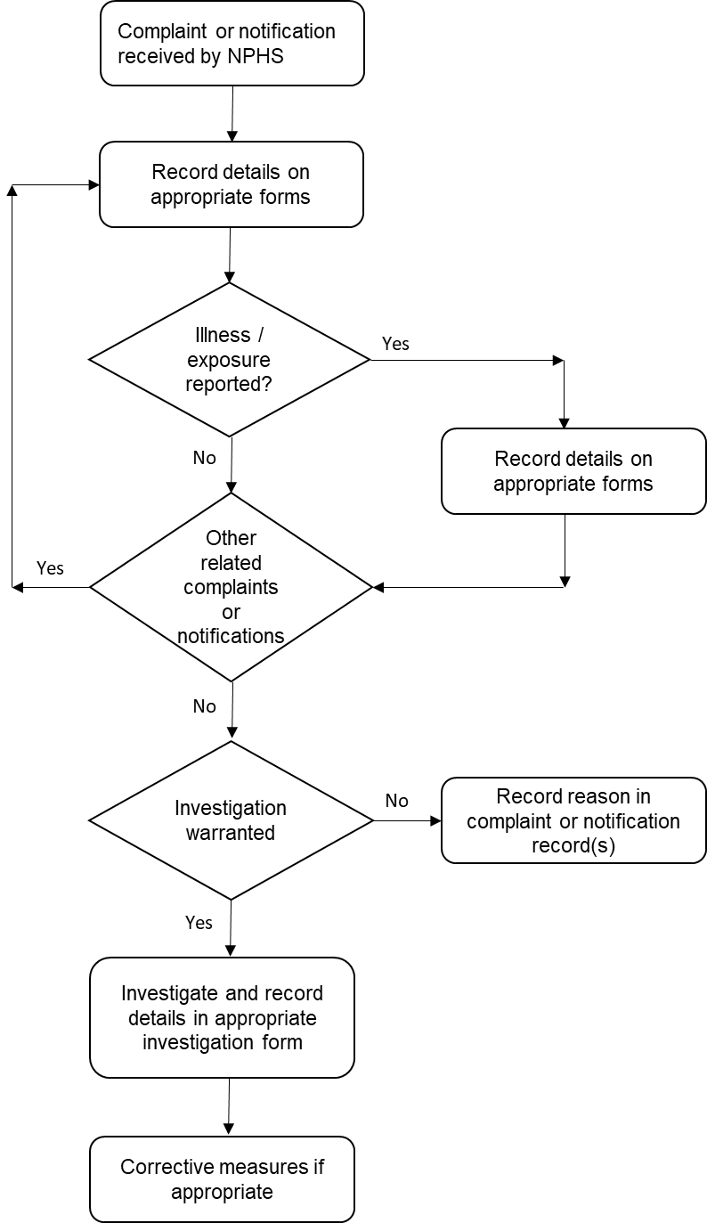

Notification of diseases or injuries under the Health Act and HSNO Act are entered into the Hazardous Substances Disease and Injury Reporting Tool (HSDIRT).

Investigation
Investigations may arise from Health Act and HSNO Act notifications. Situations where investigation occurs include:
- Non-occupational lead absorption notifications
- Notifications are unusual/significant
- Notifications associated with a type of or specific substance show an increasing trend over time
- There is a breach of the HSNO Act or Health Act.
- Notifications are about priority substances (eg, lead, substances involved in childhood poisonings).
The next section includes guidance on factors to consider when deciding whether to investigate.
If an investigation is carried out, data on the event/incident that precipitated the complaint(s) or notification(s) will be obtained and entered on the complaint and investigation form. At the end of the investigation process it will be necessary to decide whether further action (such as a prosecution, referral to other authorities, or a requirement for particular precautionary measures to be put in place) is appropriate.

Summary of the graded response protocol
Step 1: Receiving and processing the complaint(s)
Step 2: Decision to investigate further
Step 3: The investigation
Step 4: Decision on action required.
Almost always, the first indication that there has been a chemical-exposure incident will come in the form of a complaint or notification. These may come from members of the public, doctors (reports from doctors may be notifications under the Health Act or the HSNO Act) or local government agencies.
Whenever a complaint or notification of a chemical-exposure incident is received by a public health officer, the information received is recorded. This includes information on individuals who have been exposed and possibly made ill as a result of that exposure. Several separate complaints or notifications may be received as a result of a single chemical-exposure incident, and the information for each (and associated exposures and illnesses) is separately recorded. Figure 2 illustrates the purposes and relationships of the event/incident, complaint and illness/exposure records.
After receiving a complaint or notification, the next step is to decide whether to investigate further (and/or whether to involve other authorities). The medical officer of health will decide whether an investigation is required, depending on the nature of the exposure of the substance involved. It is anticipated that most HSNO Act notifications will not require follow up but may lead to national or local investigation based on trend data.
At the end of the investigation it is necessary to decide whether further action (such as a prosecution, a referral to other authorities or a requirement for particular precautionary measures to be put in place) is appropriate. When dealing with Health Act or HSNO Act notifications, the Hazardous Substances Disease and Injury Reporting Tool (HSDIRT) requires the public health officer to assign a case status of definite, probable, possible, not a case, or insufficient information to assign case status. Guidance is provided for assigning case status in the User’s Guide for Public Health Officers available at: http://www.ehinz.ac.nz/assets/Other/HSDIRT-PHU-Users-Guide-2017-Released-May2017.pdf
Figure 2: Data flow, records and notification structure
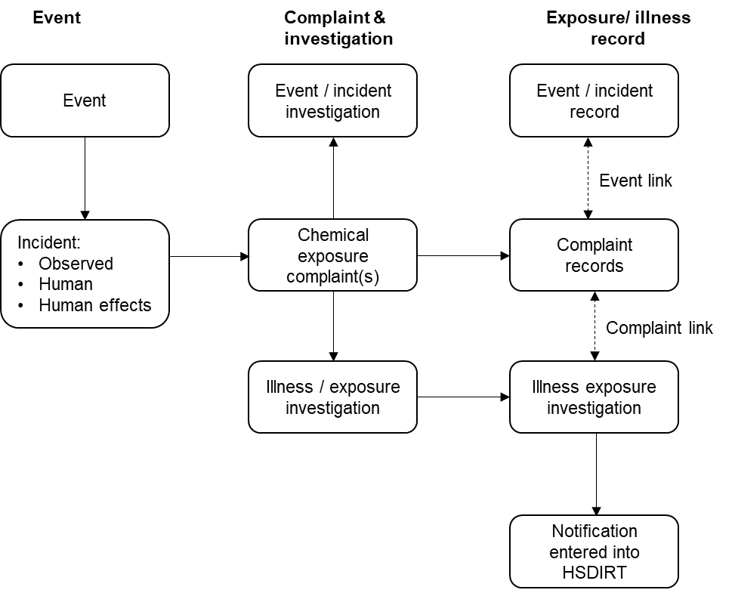

Unique numbers are assigned to each record investigated by public health staff. Each number indicates whether it is a complaint, exposure/illness, or event/incident record, and the date/year of investigation.
If the investigation results in a probable or confirmed case, HSDIRT is completed and the information is sent to Massey University’s Centre for Public Health Research (CPHR). Only public health staff are able to view named case information entered into HSDIRT. Data from all public health services are collated and analysed by CPHR for the annual Hazardous Substances Surveillance System reporting and use by policy makers.
Anonymised data may also be made available to legitimate researchers for ethically approved epidemiological studies. Non-identifiable aggregated data may also be provided to local and national agencies, such as regional councils and territorial authorities, to assist with investigations.
An overview of HSDIRT is illustrated in Figure 3.

Figure 3: Overview of HSDIRT
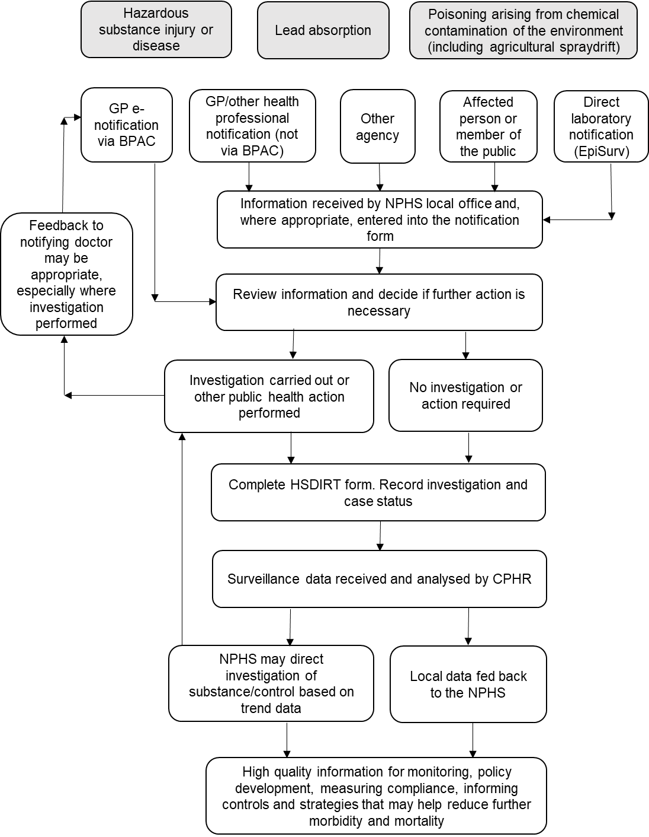
Adapted from Hazardous Substances Disease and Injury Reporting Tool: A User’s Guide for Public Health Officers (May 2017).
Two scenarios may result in making a notification.

1. Complaint investigation (including some cases) using the graded response protocol
Complete the appropriate complaint and investigation form (see Appendix 1). In a case of probable or confirmed hazardous-substances injury or disease enter into HSDIRT. Note that for lead absorption, a confirmed blood lead level of ≥0.24 µmol/L is required. The HSDIRT may be used by public health staff to collate all individual complaints of hazardous substance injury or disease, irrespective of whether each case is ultimately classified as probable or confirmed, to indicate public health service workload. “Not a case” and “insufficient information to assign case status” classifications are excluded from CPHR’s data analysis.

2. Case notification
When a patient presents to primary care with suspected hazardous substances injury or disease, the General Practitioner (GP) is able to electronically notify the medical officer of health via the HSDIRT. If the GP notification is not received electronically or comes from another source, public health staff enter it into HSDIRT. Public health staff complete further data fields as required, and assigns case status. Figure 4 illustrates the GP notification process. Note that an investigation may or may not follow. Refer to Appendix 1 for the complaint and investigation forms.
Figure 4: HSDIRT GP notification process
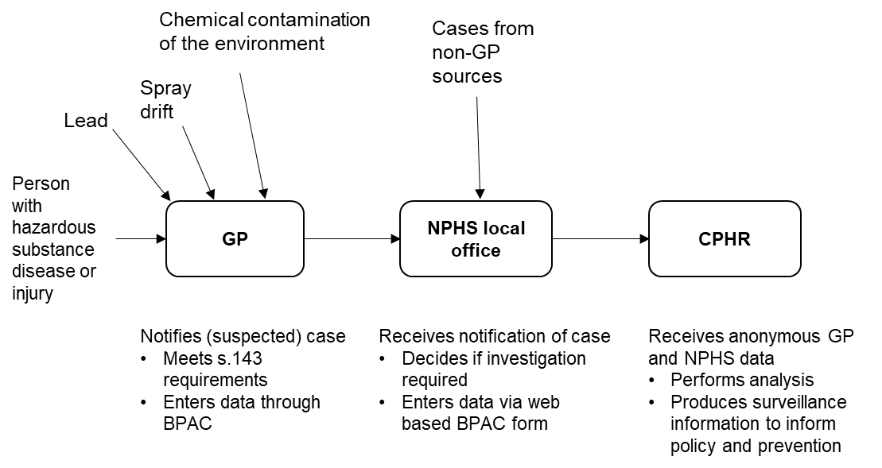
Adapted from the HSDIRT Frequently Asked Questions (April 2021).

How to use the graded response protocol and investigation forms
On the complaint and investigation form (Appendix 1) enter the information and decisions corresponding to the graded response protocol.
The principle is to grade the response to the level of hazard.
In practice, while Step 1 will always be completed, Steps 2, 3 and 4 will be completed only if appropriate.

Step 1: Receive and process the complaint
In each local public health service, the initial contact point for chemical-exposure complaints should be designated (and the staff appropriately trained) in advance. The initial contact-point designation may rotate among several people to ensure that there is always somebody available.
The designated contact person(s) should have a good telephone manner, be able to reliably record data received over the telephone, and have good judgement and initiative. They need not necessarily be a health protection officer, but they should have ready access to health protection officers and the medical officer of health.

Collecting complaint or notification data
Complaints to the National Public Health Service will usually be made by telephone. The initial information collected will generally be the complainant’s impressions of the incident. These details are usually subjective and further investigation may be needed to check accuracy. Nonetheless, data should be recorded in the form in which it is received. Details collected from the complainant need to cover what was observed and where, whether anyone was exposed or made ill, and any other damage that occurred. The suggested procedures below are based on that assumption.
Telephone operators in local public health services should be trained to recognise callers who are calling to complain about (or notify) a chemical-exposure incident, and should at any time know who the appropriate contact person is. On occasion, however, complaints may be received by other means, such as letter, fax or email, in which case appropriate (but generally minor) modifications may need to be made to the suggested procedures.
When a hazardous-substance injury informant makes telephone (or direct) contact with the designated contact person within the public health service, the following procedure would generally be appropriate.
            - Thank the caller for calling and advise that:
              - The information collected will be used in assessing whether there is any public health risk so that appropriate action can be taken if necessary
              - Only designated staff have access to the information provided
              - Their name will be kept confidential, unless they give permission for it to be released.
            - Explain that there is a special procedure for recording data on chemical-exposure incidents, so you would like to ask a series of questions. Advise that they will be able to add any extra information that they think is relevant.
            - Ask the appropriate questions in sequential order and record the information received.
            - Record information on the complaint section of the investigation form. For every individual who the informant advises was directly exposed (and is possibly ill as a result), record data on the exposure/illness record section of the form.
            - At the end of the specified questions give the caller an opportunity to supply any additional information that they think relevant, thank them for calling and advise that someone from the public health service will get back to them shortly.
            - Supply a photocopy of the paper forms to the appropriate health protection officer.
            - Check with the health protection officer as to what, if any, further action (eg, an investigation) is taking place. Record the information in the complaint and investigation form.
            - If there is a field investigation involving a visit to the site of the alleged chemical exposure, then more information may need to be added to the record. This may be done either by the designated contact point or by the officer carrying out the investigation, but responsibility for entering such data should be clearly designated.
Details are recorded under four main subheadings on the form: location, details, management, and investigation. For Health Act and HSNO Act notifications some of these details should be entered into the HSDIRT, if the notifying doctor did not already do this.

Location
Record fundamental information, including contact details for the informant and the geographic location of the site affected.
Details to be recorded include:
- The name of the person in the public health service recording the information
- The name, address and telephone number of the informant
- The date and time of the complaint or notification to the public health service
- The type of informant (eg, member of the public, government agency, doctor, other health practitioner, media,)
- The address of the area where exposure has occurred
- The affected location type (eg, private residence, public area, school, workplace, childcare centre)
- The name of the owner of that property and the property name, if not a private residence.

Details
This records information about the extent and circumstances of the incident, as perceived by the informant, including:
- How the chemical incident was first detected (eg, by sight, smell, physical contact)
- A brief description of the chemical-exposure incident
- The date and time of the chemical-exposure incident
- What (if anything) the informant believed the chemical to be
- Whether prior notice of chemical application was given and, if so, how and when the notification took place
- If applied by air, the aircraft registration number (if noted)
- Whether the property on which a spraying operation was taking place was uphill or downhill from, or level with, the exposure site
- The type of water supply to the house (such as roof collection, town supply, well or bore, spring, other).

Management
This records the names of any individuals exposed (and possibly made ill), and the decision on whether to take any further action. Further action may include a field investigation and/or referral to another agency. Details include:
- Whether further action, such as a field investigation, was considered to be warranted
- The event/incident record number, when a field investigation takes place and is linked (through the event/incident record) to the complaint or notification record (although it cannot be changed from this record)
- When no further action is necessary, the reason for that decision
- The name of any other agency the complaint or notification was referred to
- The name(s) of any person(s) believed to have been exposed (for each name recorded, an exposure/illness record will automatically be opened).

Investigation
This records information on the investigation of the site where the hazardous-substance exposure occurred (not the investigation of the actual event that led to the injury occurring – that is the subject of the event/incident record). This page will only be needed if a field investigation is carried out (as recorded on the Management page). Details recorded on the investigation page are:
- The name(s) of the investigating officer(s)
- The date of the investigation
- Whether samples (eg, water, air or soil) were taken for analysis
- The results of any analyses
- Conclusions of the investigation
- Whether further action was required.
The public health officer should also check whether the regional council or unitary authority has a regional plan that makes the application of chemical(s) a permitted activity subject to conditions, and if so, what they are, and whether the alleged operator has resource consent to undertake the activity, subject to conditions. Conditions of consents and rules in regional plans may include those relating to effects on human health.

Collecting exposure/illness information
For each individual alleged by the informant to have been exposed, whether or not they experienced symptoms or illness as a result, details (including any biological results) should be recorded in a separate exposure/illness record.
No exposure/illness record can stand on its own. It must come from and be linked to a complaint or notification record, so information on the precipitating incident is available. Aggregation of exposures/illnesses under a complaint or notification record also captures the inter-relatedness of cases of exposure and illness. This is important. For example, five separate illnesses that are linked to five separate complaints or notifications associated with the same incident could have a quite different interpretation from that of five illnesses that are related to a single complaint or notification. Linkage of individual exposure and illness records to a complaint or notification record also enables identification of individuals similarly exposed who did not experience the illness. This could be important in deciding whether there is a cause-and-effect relationship.
Within the exposure/illness record, details are recorded under four main subheadings (pages): personal, symptoms, risk factors, and diagnosis.
Initial details for the exposure/illness record will be obtained from the original informant. However, it may be necessary to interview the exposed/ill person (or a caregiver) to complete the form, particularly if illness is alleged to be associated with the exposure. In some cases it will be necessary to approach the person’s medical practitioner to obtain medical details.
Although most exposure/illness records will be based on the informant interview, subsequent investigation may reveal others who claim to have been exposed or made ill. Separate exposure/illness records will need to be created for these people. This can be done by entering the names of these people onto the management page of the complaint or notification record.
The details needed on each page of the exposure/illness record are described below.

Personal
This page records personal data for the individual affected and links this record to the complaint or notification record (and any associated event/incident record).
- The name of the person recording the details will appear as a default from the corresponding name on the location page of the complaint or notification record.
- The name of the person exposed or ill will be inserted from the complaint record (management page). The address of the informant from the complaint or notification record will be inserted as a default for the address of the person affected.
Other information to be collected includes:
- Date of birth of the person exposed/ill
- Sex of the person exposed/ill
- Ethnicity (Census categories) of the person exposed/ill
- Current main occupation of the person exposed/ill
- Where the exposed/ill person was at the time of the exposure (for example, inside the house, in the garage, outside in the garden)
- The activity that the exposed/ill person was engaged in at the time of the exposure (such as mowing the lawn, driving, playing at school)
- How the exposure was experienced (for example, felt on skin or clothing)
- Whether the person experienced symptoms or illness that they associated with the exposure (this item opens the subsequent pages in this record).

Symptoms
This page records any symptoms of illness that the person associated with the exposure. Data will only be entered onto this page if it is specifically indicated on the personal page that symptoms or illness were associated with the exposure. Symptoms are recorded using a series of check boxes (see Appendix 1 Complaint and investigation forms for details). A box should only be checked if symptoms were experienced.

Risk and protective factors
As with the symptoms page, this page should only be completed if symptoms/illness were experienced. This page extends the questions about symptoms, but also covers risk factors and protective factors that may have either been responsible for the symptoms/illness experienced or affected susceptibility to the chemical exposure.
Other details recorded on this page are:
- How long ago the symptoms were first noticed
- The most severe symptom
- Whether tissue or fluid samples were taken for analysis
- The results of such analyses
- Whether the person affected normally suffers from asthma, skin allergies, hayfever, migraine, eczema, and/or other chronic diseases
- Any medicines being taken prior to the exposure
- Whether the person is pregnant
- Whether the person is breastfeeding
- The usual health status of the person (eg, excellent, good, fair, poor)
- Whether the person had any illnesses prior to the exposure
- The average number of cigarettes smoked per day (smoking is related to a possible route of exposure)
- Whether the person drinks alcohol (eg, adverse reaction to alcohol can be provoked by exposure to hydrogen cyanamide).

Diagnosis
This page also only opens if symptoms or illness are noted. The page mainly records information that will be available if a doctor has been consulted. It also includes the final conclusions of the investigating officer in relation to the possibility of a cause-and-effect relationship between exposure and illness.
Details recorded include:
- Whether a medical practitioner or any other health practitioner was consulted
- Doctor’s (or other health practitioner’s) name and address (required because there may be follow-up with the health practitioner; the person with symptoms needs to be advised that this follow-up may occur, and their consent is needed)
- Diagnosis
- Whether the illness is systemic or local
- Overall severity of the symptoms (mild, moderate, severe, systemic/local)
- Whether the symptoms were consistent with an effect of the chemical(s)
- Overall conclusions of the investigating officer in regard to the association between illness and the exposure.

Step 2: Decision to investigate further
Within the National Public Health Service, levels of authority for decision-making and responsibility for taking action to deal with chemical incidents – with clear lines of accountability – should be assigned in advance. Some officers might specialise in dealing with such incidents, so that experience and responsibility is not spread too thinly.
Once one or more chemical-exposure complaints or notifications have been received and details recorded, it is necessary to decide whether to proceed with a field investigation of the incident. This is necessarily a local decision and must take into account local circumstances.
Once details related to one or more complaints (and associated exposures/illnesses) have been recorded in the investigation form, the designated contact person who recorded the information should give a printout of the form to the appropriate health protection officer (or medical officer of health).
The officer responsible for dealing with a complaint or notification should follow established procedures for ensuring the appropriate response, and, as appropriate, should consult or convene the response team. The first task is to decide on the appropriate action.
The three main possible actions are:
- Take no further action
- Refer to another agency (possibly in conjunction with a public health investigation)
- Begin an investigation (with or without referral to another agency).
Factors that should be considered in deciding what action to take include:
- Whether people were reported as actually exposed, or whether environmental contamination was simply observed
- The number of people exposed
- Whether exposed people reported symptoms or illness associated with the chemical exposure
- Whether there was possible contamination of food, water supply or air
- The nature of the non-target area affected (eg, a school or early childhood centre would be of particular concern)
- The number of separate complaints or notifications about the same incident
- The level of local concern, or potential for such concern to occur
- The availability of investigative resources
- The time interval between the incident and the complaint or notification.

No further action
Considerations that might influence such a decision are:
- A lack of human exposure
- Only one complaint or notification received (depending on the nature and seriousness of the complaint or notification)
- If the complaint is likely to be frivolous
- No water, soil or air contamination potential
- A low level of public concern
- A lack of available investigative resources
- Symptoms not associated with those expected from the alleged contaminant.
When a decision is made that no further investigation is necessary, the reason should be documented and the decision should be endorsed by the medical officer of health or the principal/senior health protection officer.

Referral to another agency
Information on the roles of other agencies in chemical-exposure incidents is provided under Roles and Responsibilities. An up-to-date list of appropriate contact people in those agencies should be maintained by the public health service. Similarly, those agencies should be aware of who to contact in the local public health service, if they become aware of a chemical-exposure incident.
Incidents that involve dangerous operation of an aircraft during aerial spraying should be referred to the Civil Aviation Authority.
Local agreement should have been reached with other agencies, including WorkSafe, MBIE (Trading Standards), the regional council, and territorial authorities, in regard to criteria for referral of complaints to those agencies. In addition, there is an advantage in establishing with those agencies agreed written protocols for procedures to be adopted for joint investigations, including establishment of the lead agency in any such joint action.
If a complaint or notification is to be referred to another agency (whether or not the public health officer is intending also to investigate), the consent of the complainant or affected person should first be sought, unless not required by statute.
A summary sheet of the information provided by the informant (or a copy of the complaint record) should be forwarded to the appropriate agency or agencies. Generally, information passed on to other agencies should not include illness information from the exposure/illness records.
The information should be referred in writing to the appropriate agencies, and the referral should be followed up with a phone call to check that it has reached the appropriate person. As far as possible, the public health officer’s investigation should be coordinated with the other agencies that will be carrying out investigations.

Further investigation
Considerations influencing a decision to carry out further investigation include:
- Illness associated with exposure reported
- More than one person exposed
- Exposure having occurred in a sensitive area (eg, a school)
- More than one separate complaint or notification received
- Soil, water or air contaminated
- Appreciable public concern
- Investigative resources available.

Step 3: The investigation
A public health officer’s investigation of a chemical-exposure incident may include:
- A field visit with staff from other agencies to:
- Inspect the property onto which the chemical was applied and where contamination occurred, as identified by the informant(s)
- Interview people identified as exposed (either with or without associated illness)
- Interview the chemical operator (for ongoing application) and review any records of the environmental contamination
- Collection of biological and environmental samples for laboratory analysis of residues (if appropriate)
- Information requests to medical practitioners (with patient consent) about people who consulted their doctors.
If an incident is claimed to have caused illness in a number of people, a cross-sectional epidemiological study may be considered, if resources are available. Te Whatu Ora may also provide assistance if required.
When carrying out investigations, it is important to remain impartial and to show consideration to all parties. Speed of resolution of issues and fair and appropriate feedback to all parties is important.

Appointment of an investigation team leader
It is important that a leader be appointed for each incident investigation. This may always be the same person if one person is given responsibility for investigating all such incidents. The responsibilities of the investigation leader would include:
- Coordinating the investigation team
- Seeing the investigation through to completion
- Informing and liaising with other investigating agencies
- Collecting the appropriate information, including technical and toxicological information on the chemicals implicated
- Collecting environmental samples and referring them for analysis (if appropriate)
- Ensuring that data from the investigation are recorded
- Maintaining a complete physical file of documents from the investigation
- Advising the informant(s) of the outcome of the investigation and action (if any) taken, and why
- Ensuring follow-up action is taken (if appropriate).

Visiting the site where the chemical was applied
Ideally, investigations should be conducted jointly by representatives of all involved agencies, including the local public health service. However, this will often not be practicable, and is not a reason to delay the investigation.
The owner or manager of the property where the application of the chemical took place should be contacted by phone to arrange a visit, including a face-to-face interview (although there may be circumstances in which an unannounced visit is appropriate). A request should also be made to interview (if possible during the same visit) the operator who applied the chemical, if that person is not the owner/manager.
The purpose of the site visit and the interview should be made clear in advance: to obtain information on the chemical being used, the site and method of application, and other information that might be relevant to assessing the complaint(s) or notifications. It must be reiterated that the source of the contaminant is not necessarily the most obvious possibility.
The names of the officer(s) who will be making the site visit(s) and the agencies they represent should be advised in advance.
The name of the complainant or affected person should not at any time be divulged on, unless the complainant or affected person has given their permission to do so.
If during the investigation, information indicates that an ongoing operation is likely to be dangerous, a warranted HSNO enforcement office may serve a compliance order (under section 104 of the HNSO Act 1996) requiring a person to cease an operation that has, or is likely to have, an adverse effect on the health and safety of people or the environment. However, public health HSNO enforcement officers are not given the powers under section 104 of the HSNO Act 1996, and so an investigating officer may wish to inform other regulatory agencies that have related powers under the HSNO Act 1996 or other legislation.
Public health HSNO enforcement officers should contact their manager if they consider there is a need for the exercise of any statutory powers that they have not been authorised to use under the HSNO Act 1996. The manager will discuss with Te Whatu Ora, which may then provide specialised assistance and/or refer the matter to an appropriate agency/individual with powers to take action.

Visiting the site affected by the chemical
The investigation ideally takes place in the presence of the complainant or affected person. This will provide an opportunity to collect additional details to complete any gaps in the complaint record.
If appropriate, environmental samples may be collected under section 103A of the HSNO Act 1996 to confirm whether contamination has occurred. This is at the discretion of the public health officer. Collection of samples is specialised. If prosecution is possible, then the full details of the technique by which the sample was collected must be recorded. Environmental samples may include:
- Water samples, particularly if drinking water is possibly contaminated
- Soil samples
- Air samples
- Other possibly contaminated items.
During the visit it is a good idea to draw an A4 approximate scale map or map of the location where the contamination took place, using Geographic Information System (GIS). This map should include the following as appropriate:
- Where the contamination occurred
- The target area for the application
- Any roads, property boundaries and buildings
- An arrow indicating the path of the contamination
- The sampling locations and sample numbers of any environmental samples
- The location of the exposed people at the time the contamination occurred
- An indication of the relevant topography
- Any other relevant feature(s).
Taking photographs, as permitted under section 103A of the HSNO Act 1996, will often be appropriate as well.

Interviewing exposed/ill cases
During the initial complaint report, information on each person believed to have been exposed is recorded on an exposure/illness record. Often, particularly when symptoms or illness have occurred, the complainant will not know all the information that is sought. In such cases it would be appropriate to interview the exposed/ill people themselves as part of the investigation.
Interviews with people exposed/ill should be arranged by phone, if possible, and conducted as soon as reasonably possible. If it is intended to take biological samples, the following information should be taken into consideration. With the exception of suspected lead exposure, public health staff should not automatically intend to take biological samples. Whether to take samples or not depends on test availability and what is known about the substances being tested for, such as half-life and background reference range. In most cases, biomonitoring data do not provide information on the timing, sources or routes of exposure. For chemicals that remain in the body for shorter periods, biomonitoring data may be much more difficult to interpret. Timing and duration of exposure become critical to the interpretation. For many chemicals, expert advice should be sought before biological sampling (such as from the Institute of Environmental Science and Research Limited or from a medical toxicologist at the National Poisons Centre).
When conducting the interview, the investigating officer should refer to the exposure/illness record and confirm all details supplied by the complainant, as well as filling in the gaps. Interviewees should be assured that all information collected will be kept confidential to those conducting the investigation and involved in any subsequent prosecution.
Interviews with anyone under the age of 16 should take place only in the presence of a caregiver.
If a person with symptoms or illness associated with their exposure has consulted with a doctor, written permission to contact the doctor to discuss the diagnosis should be requested from the patient (or a caregiver, if appropriate).
Non-invasive urine collection is preferable to blood sample collection. However, if a blood test is justified, advise the exposed person that they should arrange this as soon as possible with their medical practitioner.
Additional advice on environmental and biological sampling are detailed in Appendix 2 of The Investigation and Surveillance of Agrichemical Spraydrift Incidents: Guidelines for Public Health Units (Ministry of Health 2007).

Collecting event/incident information
Data on the incident collected during the field investigation will be recorded in an event/incident record on the investigation form. Once an event/incident record has been created, it can be linked to each of the corresponding complaint or notification records.
During the interviews and property inspections, information should be recorded on the event/incident section of the investigation form. Any notes made at the time should be retained on file in case a prosecution is taken.
Within the event/incident record in the investigation form, details are recorded under three main subheadings (pages): location, chemicals and management.

Location
This records the name(s) of the investigating officer(s) as well as basic information to do with the application, such as:
- The incident number
- The name of the local public health service
- Name(s) of investigating officer(s)
- The date of the investigation
- The address of the property where the chemical application took place
- The territorial authority that contains this property
- The name, address and telephone/fax numbers of the owner (or manager) of the property
- The operator name and address
- Whether the operator is an approved handler
- Whether or not the operator is a controlled licensee.

Chemical
This records information on the chemicals involved in the incident, including:
- The trade name of each separate product included in the chemicals
- The type of formulation for each trade name product
- The chemical classification of each trade name product
- The list of active ingredients and their percentages in the formulation for each trade name product.

Management
This records:
- The conclusions from the investigation
- Any follow-up actions initiated
- Recommendations
- Related complaints or notifications. The associated complaint records are linked from a field on this page by selecting from complaint records that are currently unlinked to any event/incident record.

Evaluation of information collected
During the course of an incident investigation, including the interviews with the complainant(s) or affected person(s) and the operator (if applicable), information will be collected in order to answer key questions.
- Did environmental chemical contamination actually occur?
- Did the owner/manager of the property take all reasonable precautions to minimise environmental chemical contamination?
- Did the operator take all reasonable precautions to minimise environmental chemical contamination?
- What else could have been done?
- Is there evidence that the law has been broken?
These questions can only be answered after fully taking into account the information relating to the particular incident. As circumstances will vary widely, only general guidance can be given here. It is suggested that, at the least, particular consideration be given to:
- The consistency of the information received from the informant with the details obtained from the investigation, including details from the interview of the property owner/manager and the operator (eg, to confirm whether chemical application actually took place during the alleged period of exposure)
- Whether the chemical was being used according to label instructions (eg, application rate)
- Whether there was physical evidence of environmental contamination
- The qualifications and experience of the operator
- Whether the application log was up to date
- The consistency of any symptoms/illness with what is known about the chemical, and whether the exposure could have been sufficient to cause such symptoms; whether symptoms/illness could have other causes, such as medications or infection
- Other factors as appropriate.

Step 4: Decision on action required
Once information has been collected and evaluated, and questions answered, then the appropriate follow-up action needs to be considered. Such consideration should take into account any related history of complaints and/or incidents. Possible follow-up actions include one or more of the following.

Take no further action
This may be the case if no corroborative evidence could be found to substantiate a complaint from a single individual. On rare occasions, complaints have been found to be frivolous or malicious.

Caution the operator
This would be appropriate if there is no prior history of such problems and the incident could have been avoided with a little more care.

Require the operator to take appropriate measures to prevent similar occurrences
This might be appropriate if, for example, poorly maintained equipment contributed to the incident, there had been improper disposal of chemicals, or prior notice to neighbours would have helped to avoid problems.

Refer to another agency for possible action
This is likely to be appropriate if bylaws, or legislation administered by other agencies, had apparently been violated.

Initiate a prosecution
This would be appropriate if, for example, there was a prior history of similar problems, or if there was evidence that the incident had been caused by gross negligence resulting in a significant public health problem.
Information may be provided to complainants, or other interested parties, on how to minimise exposure and document an incident if they or their property are exposed to chemical contamination in the future. This could be in the form of an information sheet (or pamphlet).

A test of poisoning
Symptoms of poisoning and findings are classified into major, intermediate and minor categories. The major, intermediate and minor criteria are allocated 10, 5 and 2 points, respectively (Table 1). The total points are used to determine the likelihood that the patient’s symptoms are the result of poisoning. Table 2 shows the number of points required and the probability of being poisoned due to chemical exposure.
Table 1: Criteria for poisoning
Description | Points
The patient has both body levels of the chemical in excess of that which has been associated with toxic effects, and objective biological markers of the poisoning effect being considered and that are characteristic of the chemical. | 10
The patient has symptoms and findings that are both characteristic of the chemical and that can either be precipitated or aggravated by the chemical, or relieved by specific antidotes to the chemical. | 10
The patient has had an appropriate exposure to the chemical and/or the chemical has been measured in the subject environment at levels that have been associated with toxic effects. | 5
The patient has either body levels of the chemical in excess of that which has been associated with toxic effects or objective biological markers of the poisoning effect being considered and that are characteristic of the chemical. | 5
The patient has symptoms and findings that are characteristic of the chemical. | 5
The patient has symptoms and/or findings that have a clear temporal relationship to an exposure to the chemical and that resolve within the expected timeframe after the exposure ceases. | 2
The patient has symptoms and/or findings that cannot be explained by alternative mechanisms, or alternative mechanisms that can cause the same symptoms and findings have been reasonably excluded. | 2

Table 2: Likelihood of adverse health effects due to poisoning
Number of points | Probability of chemical poisoning
2–4 | The chemical is unlikely to be the cause of the patient’s symptoms, signs or findings.
5–8 | The chemical is possibly the cause of the patient’s symptoms, signs or findings.
9–14 | The chemical is probably the cause of the patient’s symptoms, signs or findings.
15–20 | It is highly probable that the chemical is the cause of the patient’s symptoms, signs or findings.
Greater than 20 | The chemical is almost certainly the cause of the patient’s symptoms, signs or findings.

Statutory notifications

Poisonings and hazardous-substances injury notifications
Poisonings and hazardous-substances injury notifications are currently required by three different laws.

Hazardous Substances and New Organisms Act 1996
Section 143 of the HSNO Act 1996 requires hospitals and medical practitioners to notify hazardous-substances injuries to medical officers of health. In turn, the medical officer of health is required to supply information about the notified injury (excluding person-identifiable data) to Te Whatu Ora for reporting to the Minister of Health. Section 143 of the HSNO Act 1996 does not differentiate between non-occupational and occupational exposures. Therefore, notifications are required for both modes of exposure.

Health Act 1956
Section 74 of the Health Act 1956 requires health practitioners to notify medical officers of health of lead absorption equal to or greater than 0.24 μmol/L for non-occupational exposures. Similarly, notification of poisoning arising from chemical contamination of the environment is required.
The following definitions relate to poisoning arising from chemical contamination of the environment.
- ‘Poison’ is defined in the Oxford English Dictionary to mean: ‘any substance that can impair function, cause structural damage, or otherwise injure the body’. Poisoning does not need to be fatal, or to require admission to hospital.
- A ‘chemical’ is defined as ‘any substance used in or resulting from a reaction involving changes to atoms or molecules’.
- ‘Contamination’ is defined as the act or process of contaminating, or the state of being contaminated. To ‘contaminate’ is to ‘make impure especially by touching or mixing; pollute’.
- The term ‘environment’, as defined in the Resource Management Act 1991, includes:
- Ecosystems and their constituent parts, including people and communities
- All natural and physical resources
- Amenity values
- The social, economic, aesthetic, and cultural conditions which affect the matters above or which are affected by those matters.
Based on this definition, the Health Act 1956 provision is potentially much broader than the section 143 notification requirements under the HSNO Act 1996. That is, it could pick up any adverse health effect (‘poisoning’) attributable to any form of chemical contamination of the environment. Note that investigation of chemical contamination of the environment (generally acute) would follow a disease investigation, if warranted.

Health and Safety at Work Act 2015
Under section 199 of the Health and Safety at Work Act 2015, medical officers of health are required to notify WorkSafe of work-related notifiable disease or hazardous substances injury in situations where a medical officer of health receives –
(a) A notification under section 74 of the Health Act 1956 of a notifiable disease that he or she reasonably believes arises from work
(b) A notification under section 143 of the Hazardous Substances and New Organisms Act 1996 of an injury caused by a hazardous substance that he or she reasonably believes arises from work.
Under the HSW Act, the medical officer of health must, as soon as practicable after receiving the notification, –
(a) Advise WorkSafe of the notification; and
(b) Provide WorkSafe with the following information:
(i) The name of the person who suffers or suffered from the notifiable disease or injury caused by the hazardous substance; and
(ii) The nature of the disease or injury.
To notify WorkSafe, email (healthsafety.notification@worksafe.govt.nz) or post a completed WorkSafe notification form (Appendix 3). Except when providing the information required under (b)(i) and (ii) above, the medical officer of health must comply with the Privacy Act 2020 and any relevant code of practice issued under that Act when providing personal information.
If the person has exposure from both non-occupational and occupational sources and investigation is needed, the public health officer WorkSafe will carry out separate investigations according to their responsibilities and liaise with each other, or a joint investigation.

Guidelines on asbestos, lead, mercury, agrichemical spraydrift incidents, and fires
Specific guidelines exist for:
- Asbestos: The Management of Asbestos in the Non-occupational Environment: Guidelines for Public Health Officers (Te Whatu Ora 2023a). URL: https://www.tewhatuora.govt.nz/our-health-system/environmental-health/hazardous-substances/asbestos/
- Lead: The Environmental Case Management of Lead-exposed Persons: Guidelines for Public Health Officers (Te Whatu Ora 2024). URL: https://www.tewhatuora.govt.nz/our-health-system/environmental-health/hazardous-substances/lead/
- Mercury: The Environmental Case Management of Mercury Exposed Persons: Guideline for Public Health Officers (Te Whatu Ora 2023b). URL: https://www.tewhatuora.govt.nz/publications/the-environmental-case-management-of-mercury-exposed-persons/
- Agrichemical spraydrift: The Investigation and Surveillance of Agrichemical Spraydrift Incidents: Guidelines for public health units (Ministry of Health 2007). URL: www.health.govt.nz/publication/investigation-and-surveillance-agrichemical-spraydrift-incidents
- Major fires: Response to Urban and built Environment Fires: Guidelines for Public Health Officers (Te Whatu Ora 2023c). URL: https://www.tewhatuora.govt.nz/our-health-system/environmental-health/hazardous-substances/fire-and-smoke/
- Wildfires: Response to Wildfires: Guidelines for Public Health Officers (Te Whatu Ora 2023d). URL: https://www.tewhatuora.govt.nz/our-health-system/environmental-health/hazardous-substances/fire-and-smoke/
Those guidelines should be followed when investigating, reporting and notifying such complaints. The details contained in those guidelines are not repeated in this document.

Lead notification requirements
Under Schedule 2 of the Health Act 1956 only blood lead levels ≥0.24 µmol/L arising from the non-occupational environment are recorded in the HSDIRT.
Second and subsequent blood lead levels should not be entered into the HSDIRT unless further investigation of a level of ≥0.24 µmol/L is performed or there is more than 12 months between blood tests, in which case a new notification should be completed.
See flow diagram for lead absorption notification (Figure 5).
Notification of a person with an elevated blood lead level as a result of occupational lead exposure is covered by the HSNO Act. For practical purposes the blood lead level of an exposed worker is regarded as elevated if it meets the threshold given in the Health Act, which is ≥0.24 µmol/L, as no level is specified in the HSNO Act. Blood-lead levels ≥0.24 µmol/L arising from the occupational environment are notified in the HSDIRT.
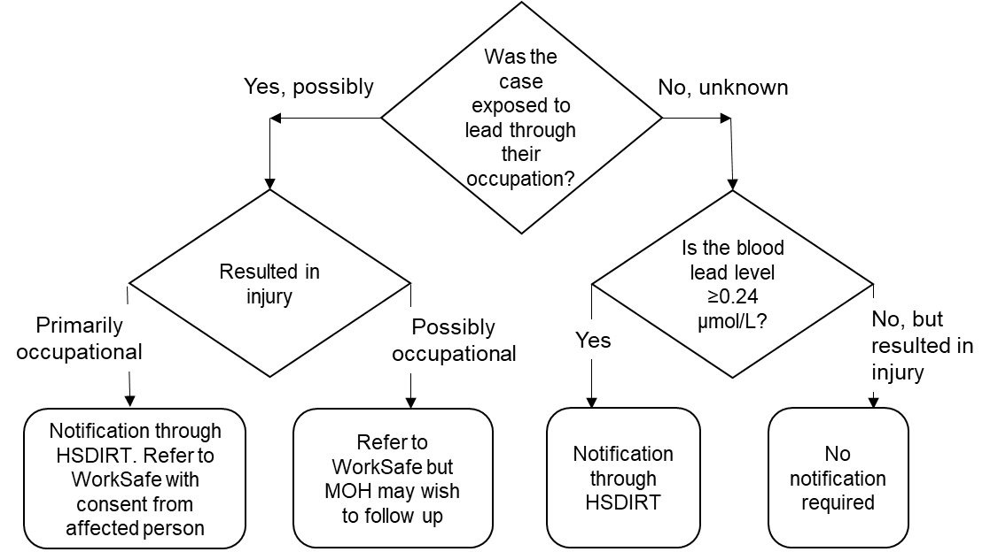
Figure 5: Flow diagram for lead-absorption notification

Summary of notifications
To summarise, notifications are required in the following situations.

Health Act 1956
- Lead absorption ≥0.24 μmol/L for non-occupational exposures.
- Poisoning arising from chemical contamination of the environment (eg, adverse health effects from the Bacillus thuringiensis kurstaki (Btk) gypsy moth eradication programme).

HSNO Act 1996 – occupational and non-occupational exposures
- Hazardous-substances injuries including occupational lead absorption.
- Spraydrift complaints.
- Poisoning from manufactured articles considered to be hazardous substances under the Act.
All notifications are entered into the HSDIRT.

Health and Safety at Work Act 2015
Medical officers of health are required to notify WorkSafe of work-related notifiable disease or hazardous substances injury in situations where a medical officer of health receives –
- A notification under section 74 of the Health Act 1956 of a notifiable disease that he or she reasonably believes arises from work
- A notification under section 143 of the Hazardous Substances and New Organisms Act 1996 of an injury caused by a hazardous substance that he or she reasonably believes arises from work.

Roles and responsibilities

Agencies with roles and responsibilities
Agencies involved in the management of chemical-exposure incidents, and setting and enforcing controls on hazardous substances include:
- Te Whatu Ora (including the National Public Health Service)
- Regional councils
- Territorial authorities (district and city councils)
- Environmental Protection Authority
- Ministry for the Environment
- Civil Aviation Authority
- WorkSafe New Zealand
- Accident Compensation Corporation
- Ministry of Business, Innovation and Employment (Trading Standards)
- Fire and Emergency New Zealand
- Industry federations and associations.
Roles and responsibilities must be considered in three contexts:
- The regulatory agency with statutory authority to bring about remedial action
- The person or organisation taking remedial action
- Agencies with statutory functions to ensure that the facts are established and the best advice is made available.
Chemical-exposure incidents need to be investigated collaboratively to avoid duplicated effort and wasted resources and to ensure the most effective statutory response.
An understanding of the roles and responsibilities of other national and local government agencies is important in facilitating efficient and effective local management of chemical-exposure complaints and incidents.

Good communication links between key agencies are important. These should be established or reinforced, and regularly maintained to allow for efficient and effective sharing of information and resolution of issues.

The role of the Ministry of Health
Manatu Hauora – the Ministry pf Health develops policy related to public health obligations in relation to hazardous substances and products and appoints statutory officers including HSNO public health officers.
- MedSafe (Medicines and Medical Devices Safety Authority): is part of Manatū Hauora and is responsible for finished dose medicines, dietary supplements and natural remedies. It also includes the Regulator for psychoactive substances.
- Office of Radiation Safety: is part of Manatū Hauora and is responsible for ionising radiation including administering and implementing the Radiation Safety Act. 2016

The role of Te Whatu Ora / the National Public Health Service
Te Whatu Ora’s National Public Health Service implements policy and statutory responsibilities at a national, regional and local level under the HSNO Act and the Health Act. It is responsible for ensuring that the provisions of the HSNO Act are complied with where it is necessary to protect public health. This responsibility overlaps with many other enforcement jurisdictions under various Acts. Te Whatu Ora has a wider role in the management of public health risks from exposures to hazardous substances and products that may be outside the HSNO Act.
- Te Whatu Ora staff support the actions of other agencies if there is likely to be a public health risk from the use of products and substances. For example, this may include monitoring recalls and referring non-compliance to EPA for compliance action, releasing joint media statements to warn the public of unsafe products, etc. The roles cover hazardous substances and products that pose a risk to public health, including products and substances that may fall outside the HSNO Act but pose a risk to public health. Responsibilities of public health officers include (but are not limited to):
- Investigating notifications of hazardous substances injuries and poisoning from chemical contamination of the environment
- Participating in the Hazardous Substances Injury Surveillance System and other notifiable condition surveillance systems
- Investigating complaints and, where appropriate, enforcing the relevant Acts and Regulations
- Ensuring sufficient numbers of public health HSNO officers are employed to deliver the work programme, and that these officers attend hazardous substances training at least every three years
- Maintaining effective risk management strategies and response plans for emergency situations involving hazardous substances, including deliberate chemical contamination and chemical fires, and including at designated points of entry and other international air and sea ports
- Liaising with HSNO enforcement agencies and participating on the HazMat Coordination Committee (or equivalent body) on priorities for hazardous substances control including representing public health interests at HazMat Coordination Committee meetings
- Receiving annual reports on methyl bromide fumigations
- Seeking to develop a Memorandum of Understanding (MoU) (or equivalent) with other agencies, e.g. EPA, WorkSafe New Zealand, local authorities
- Raising public awareness of the risks of environmental and non-occupational exposures to hazardous substances, environments and products, e.g. providing public health advice and information, advising on the safe management of hazardous substances and products, and advising on the safe management of asbestos and lead in the non-occupational environment
- Advising, encouraging and/or assisting territorial authorities and Regional Councils to identify potentially contaminated sites, implement health impact assessment systems, determine appropriate land use controls for contaminated sites, ensure appropriate advice is provided to manage any public health risk.

Health Act 1956
Section 74 of the Health Act 1956 requires health practitioners to notify the medical officer of health of cases of notifiable diseases. Section B of the second schedule of the Health Act 1956 includes as notifiable diseases, lead absorption ≥0.24 μmol/L for non-occupational exposures, and ‘poisoning arising from chemical contamination of the environment’.

Hazardous Substances and New Organisms Act 1996
Under section 143 of the HSNO Act 1996, all diagnosing medical practitioners, including those working in hospitals, have to report injuries caused by hazardous substances to the medical officer of health.
Local public health services may often be the first to be made aware of a concern about a chemical-exposure incident. Preliminary investigations (as set out in the graded response protocol) should establish the responsible persons and any need to pass information on to others.

The role of public health officers

Initial response and preliminary assessment
- Receive record and interpret queries and concerns.
- Identify the cause of concern or complaint, the location and associated parties.
- Provide initial response and support to concerned persons.

Inspection, hazard evaluation and risk assessment
- Identify individuals or groups at risk.
- Identify compounding risks (eg, occupational exposure to chemicals).
- Identify sources and types of chemicals implicated and pathways of exposure.
- Collect samples if appropriate.
- Interpret laboratory results if appropriate.
- Assess the likely health risk from the information collected.

Information and risk communication
- Explain how the risk should be managed, in consultation with other relevant agencies.
- Consult with property owners and occupiers.
- Refer information to the regulatory agency that has statutory authority to bring about remedial action.

Management plans
- Assist other agencies to determine appropriate action including, if necessary, the design of appropriate abatement and exposure-control strategies.
- Subject to the approval of the regulatory agency, advise property owners and occupiers on the implementation of the management plan.
- Monitor the implementation of the public health aspects of the plan.
- Maintain communication and cooperation with other agencies and parties (recognising privacy).
- Evaluate the effectiveness of the management plan.
- Encourage enforcement by the appropriate regulatory agency.

Reporting requirements and evaluation of outcomes to identify further prevention issues
The public health officer may also consider health-promotion initiatives aimed at increasing awareness of the safe use of hazardous substances.

News media
Unless other arrangements have been made, media liaison should be carried out by the communications advisor(s) with an appropriate spokesperson from the public health service, in consultation with other agencies as appropriate.

The role of the Ministry for the Environment
The Ministry for the Environment is responsible for developing the HSNO Act 1996 and associated regulations and any subsequent amendments to these.
Under the Resource Management Act 1991 (RMA), the Ministry for the Environment provides national guidance for regional councils and unitary authorities to manage the air, soil and water discharges in their regions. The Ministry for the Environment does not have a formal enforcement role; this role has been delegated to regional councils and unitary authorities.

The role of regional councils
The role of regional councils includes the control of the use of land for the purpose of preventing or mitigating any adverse effects, including effects of the use of hazardous substances (section 30 of the RMA). Section 2 defines a hazardous substance as including, but is not limited to, any substance defined as a hazardous substance under section 2 of the HSNO Act 1996.
The RMA requires each regional council to develop a regional policy statement for the purpose of managing, in a sustainable manner, the natural and physical resources of that region. The RMA also allows for the development of regional plans. Regional councils must ensure that their plans are consistent with national and regional policy statements or other regional plans.
Regional councils may be able to use the general duty provision (section 17) on any person to avoid, remedy or mitigate any adverse effect on the environment arising from an activity. Enforcement or abatement proceedings may be taken in some circumstances. Enforcement orders (Environment Court) or abatement notices (enforcement officer) may be issued, requiring a person to stop, or prohibiting a person from starting, anything that is or is likely to be:
- Noxious
- Dangerous
- Offensive
- Objectionable.
Similar action may require a person to do certain things to avoid, remedy or mitigate adverse environmental effects.
Many regional councils operate a permanent 24-hour helpline for environmental emergencies. In some regions, however, the investigation and management of chemical-exposure incidents is contracted out to the district or city council.
Te Whatu Ora encourages communication between public health services and regional councils. For instance, if a regional council receives any spraydrift complaint that may affect public health, it is strongly recommended that this be notified to the National Public Health Service.

The role of territorial authorities (city and district councils)

Hazardous Substances and New Organisms Act 1996
Territorial authorities have an enforcement role under the HSNO Act 1996 in premises not covered by other enforcement agencies (eg, private dwellings or public places). The HSNO Act 1996 places minimum controls on hazardous substances that are specific to their hazards and that cover their entire lifecycle. These controls constitute minimum performance requirements that have to be met under the RMA. Councils may place additional and/or more stringent requirements on the storage, use, disposal or transportation of hazardous substances for the purposes of the RMA, to meet site-specific requirements or location characteristics. For example, a resource consent may set lower tolerable exposure limits (ie, more conservative) and/or greater separation distances to take into account local needs, such as a nearby school or a high-density community.

Health Act 1956
Under section 23 of the Health Act 1956, territorial authorities have responsibilities to improve, promote and protect public health within the district. These include making regular inspections to ascertain whether any nuisances or conditions are offensive or likely to be injurious to health, and to secure abatement of those nuisances or conditions. Territorial authorities are required to appoint environmental health officers and other officers as necessary to carry out these functions. Territorial authorities may make bylaws for the purpose of protecting public health.
Section 29 of the Health Act 1956 specifies the circumstances in which an activity can be regarded as a nuisance: generally when it is ‘offensive or likely to be injurious to health’. District Court action to abate nuisances that are not abated voluntarily is authorised by sections 32 to 35 of the Act. Section 34 enables certain territorial authority officers to act immediately without resorting to the courts. Works undertaken by a territorial authority to abate a nuisance may result in costs being recovered from the owner or occupier. It should be noted that any person can lay information regarding a nuisance. However, a nuisance has to exist before any action can be taken and accordingly, is not an effective means of preventive action.

Resource Management Act 1991
Under section 31 of the Resource Management Act 1991, the functions of territorial authorities include the control of any actual or potential effects of land use and land development, including prevention or mitigation of any adverse effects of the use of hazardous substances. This allows territorial authorities to provide in their district plans for management of the hazards arising from the use of chemicals. District plans need to be consistent and compatible with regional plans, but may be more restrictive.
Within most territorial authorities, environmental health officers are responsible for environmental issues such as chemical contamination of the environment.

The role of the Environmental Protection Authority
The Environmental Protection Authority (EPA) is responsible for administering the HSNO Act 1996. The purpose of the HSNO Act 1996 is to protect the environment and the health and safety of people and communities, by preventing and managing the adverse effects of hazardous substances and new organisms. In exercising all functions, powers and duties under this Act, the EPA must take into account public health.
The EPA has a new compliance and enforcement role around ensuring importers and manufacturers of hazardous substances:
- Have a HSNO approval
- Have the right label, packaging and safety data sheets for their substances
- Comply with the rules around the allowable limits of certain hazardous substances within products
- Comply with the ban on persistent organic pollutants
- Comply with information requirements.

The role of WorkSafe New Zealand

Health and Safety at Work Act 2015
WorkSafe New Zealand (WorkSafe) is responsible for enforcing of provisions under the HSW Act 2015. WorkSafe may investigate to determine whether the HSW Act 2015 has been complied with. WorkSafe staff have experience and expertise in investigation of hazards or incidents arising from incorrect or negligent use of chemicals in the workplace.
A workplace is defined in the HSW Act as:
(a) A place where work is being carried out, or is customarily carried out, for a business or undertaking; and
(b) Includes any place where a worker goes, or is likely to be, while at work.
This includes people’s homes if a contractor is carrying out work there.
It is advisable that public health services establish a procedure for the transfer of information to WorkSafe.

Hazardous Substances and New Organisms Act 1996
WorkSafe is an enforcement agency under the HSNO Act 1996 to ensure that the provisions of the Act in respect of disposal an ecotoxic controls are enforced in any workplace. WorkSafe is also responsible for ensuring that the provisions of the HSNO Act 1996 are enforced in, on, at, or around any distribution system, gas installation, or gas appliance.

Gas Act 1992 and Electricity Act 1992
The Energy Safety team at WorkSafe implements the Gas Act 1992 and the Electricity Act 1992 and are responsible for:
- Safeguarding people and property from the dangers of gas and electricity
- The safety of gas and electrical appliances and installations
- The safety of gas supply
- The safety of electricity supply and transmission generating systems
- The quality and measurement of gas and electricity.

The role of the Ministry of Business, Innovation and Employment (Trading Standards)
MBIE (Trading Standards) is responsible for administering the Consumer Guarantees Act 1993 and the Fair Trading Act 1986. The purpose of standards developed under the Fair Trading Act 1986 is to prevent or reduce the risk of injury. In addition, MBIE (Trading Standards) can:
- Suggest modifications to make a product safe
- Request that unsafe products be removed from sale
- Assist companies to recall unsafe products.
As a measure of last resort MBIE (Trading Standards) can:
- Recommend mandatory standards for products or services
- Ban unsafe products
- Order a compulsory recall of an unsafe product.
Neither Manatū Hauora or Te Whatu Ora have powers to take action on health complaints relating to a number of products, in particular products and manufactured articles not covered by the HSNO Act 1996. To deal with such complaints, an MOU was signed between Manatū Hauora, MBIE (Trading Standards) and EPA. If the manufactured article is not considered to be a hazardous substance and is therefore not covered by the HSNO Act 1996, MBIE (Trading Standards) will deal with complaints and take appropriate action.

The role of Fire and Emergency New Zealand

Fire and Emergency New Zealand Act 2017
Under the Fire and Emergency New Zealand Act 2017, Fire and Emergency New Zealand (FENZ) has the lead function of responses to hazardous substance incidents (to stabilise or render safe), and additional function of promoting safe handling, labelling, storage and transportation of hazardous substances. FENZ is the lead agency for all hazmat responses. In addition, FENZ has the power to deal with any other substance that is not a hazardous substance that is released or has the potential to be accidently released, for example a large spill of milk from a tanker that may be heading for a stream.
The role of public health officers is to give advice to FENZ, as the lead agency, on matters affecting public health (and only on public health risk management).
FENZ has an additional responsibility to chair the National Hazmat Coordination Committee (NHCC) who acts as a consolidated group to discuss hazmat incidents and plans, whilst the Regional Hazardous Substances Technical Liaison Committees provide technical advice to support FENZ in hazmat responses.

The role of the Area Hazmat Coordination Committee
The Area Hazmat Coordination Committee (AHCC) is an area-based committee, formed at the discretion of the FENZ Area Manager in response to local agency requests. Its membership will include public health officers. The AHCC will discuss hazmat incidents and plans, and review hazmat incident responses. It meets on a basis determined by the committee. Public health staff should be represented on each committee.

The role of the Civil Aviation Authority
The Civil Aviation Authority (CAA) is responsible with establishing civil aviation safety and security standards in New Zealand. The CAA also monitors adherence to those standards and is responsible for enforcement proceedings. The CAA carries out aviation accident and incident investigations and is also responsible for managing civilian pilot, aerodrome and aircraft licensing in New Zealand.
The CAA is the designated agency responsible for enforcing the hazardous substances provisions of the HSNO Act 1996 in or on any aircraft.

The role of the Accident Compensation Corporation
Section 8 of the Accident Compensation Act 2001 provides cover for personal injury, including through a gradual process or disease occurring in relation to employment. This may apply for a gradual process or disease as a result of chemical exposure during employment.
Under section 20 of the Accident Compensation Act 2001, cover extends to personal injury that is caused by an accident not necessarily in relation to employment, and to personal injury that is caused by a gradual process or disease arising in relation to employment. Under section 6, the definition of an accident includes chemical absorption through the skin within a defined period of time not exceeding one month.

The role of the National Poisons Centre
The National Poisons Centre (NPC) is a 24-hour, nationwide service that answers enquiries from health professionals and the general public concerning acute poisoning and the effects of chemicals, pharmaceuticals, household products, occupational and environmental toxins, and biological hazards. The 24-hour telephone number is 0800 POISON (0800 764 766). The specialist poisons information staff have expertise in toxicology, medical toxicology, chemistry and pharmacy.
The NPC is currently an important point of contact for members of the public and is able to provide referral advice to appropriate regional agencies.

The role of industry federations and associations
Industry federations and associations establish industry standards and represent industry interests to local and central government. The level of regional activity of different federations and associations will depend to a large extent on the activities of local farmers, growers and contractors.
Relevant industry federations and associations include Aviation New Zealand, Responsible Care New Zealand, Animal and Plant Health Association of New Zealand, Federated Farmers of New Zealand, Pest Management Association of New Zealand, Civil Contractors New Zealand, and the New Zealand Forest Owners Association. These organisations’ names generally reflect their sectors of interest. Their contact details are in Appendix 4.

Conclusion
A number of agencies and organisations are involved directly or indirectly with the management of hazardous substances and the investigation of chemical-exposure incidents under a variety of statutes. Local public health services are encouraged to consider setting up local investigation teams with other agencies, to identify local roles and responsibilities and establish local processes. Public health officers should be represented on each AHCC formed at the discretion of the FENZ Area Manager in response to local agency requests.

Bibliography
Gorman D. 1997. Diagnosis of Chemical Poisoning. Report of a working party established by the Australasian Faculty of Occupational Medicine. Auckland: Royal Australasian College of Physicians.
Gosselin RE, Smith RP, Hidge HC. 1984. Clinical Toxicology of Commercial Products (5th ed). Baltimore: Williams and Wilkins.
Kreiger R (ed). 2010. Handbook of Pesticide Toxicology. San Diego: Academic Press.
Massey University. 2017. Hazardous Substances Disease and Injury Reporting Tool: A user’s guide for public health units. Wellington: Massey University.
Ministry of Health. 1998. A Guide to Health-impact Assessment Guidelines for Public Health Services. Wellington: Ministry of Health.
National Poisons Information Service. 2004. TOXBASE. Carbon monoxide.
Ministry of Health. 2007. The Investigation and Surveillance of Agrichemical Spraydrift Incidents: Guidelines for public health units. Wellington: Ministry of Health.
Te Whatu Ora – Health New Zealand. 2024. The Environmental Case Management of Lead-exposed Persons: Guidelines for Public Health Officers. Wellington: Te Whatu Ora. URL: www.tewhatuora.govt.nz/our-health-system/environmental-health/hazardous-substances/lead/
Te Whatu Ora – Health New Zealand. 2023a. The Management of Asbestos in the Non-occupational Environment: Guidelines for Public Health Officers. Wellington: Te Whatu Ora. URL: www.tewhatuora.govt.nz/our-health-system/environmental-health/hazardous-substances/asbestos/
Te Whatu Ora – Health New Zealand. 2023b. The Environmental Case Management of Mercury Exposed Persons: Guideline for Public Health Officers. Wellington: Te Whatu Ora – Health New Zealand. URL: www.tewhatuora.govt.nz/our-health-system/environmental-health/hazardous-substances/mercury/
Te Whatu Ora – Health New Zealand. 2023c. Response to Urban and Built Environment Fires: Guidelines for Public Health Officers. Wellington: Te Whatu Ora – Health New Zealand. URL: https://www.tewhatuora.govt.nz/our-health-system/environmental-health/hazardous-substances/fire-and-smoke/
Te Whatu Ora – Health New Zealand. 2023d. Response to Wildfires: Guidelines for Public Health Officers. Wellington: Te Whatu Ora – Health New Zealand. URL: https://www.tewhatuora.govt.nz/our-health-system/environmental-health/hazardous-substances/fire-and-smoke/
Turner JA (ed). 2016. The Pesticide Manual (17th ed). Thornton Heath, United Kingdom: British Crop Protection Council and Royal Society of Chemistry.

Appendix 1: Complaint and investigation forms

How you can copy the forms and adapt them for your own use
To adapt the forms, download and save the document onto your hard drive so you can easily print and adapt the forms to suit individual cases.
You may also find it useful to copy parts of the text from the graded response protocol and other material into the forms.
The following guidelines contain complaint and investigation forms for these specific situations:
- Lead – The Environmental Case Management of Lead-exposed Persons: Guidelines for Public Health Officers (2024) available at:
www.tewhatuora.govt.nz/our-health-system/environmental-health/hazardous-substances/lead/
- Mercury – The Environmental Case Management of Mercury Exposed Persons: Guideline for Public Health Officers (2023) available at: www.tewhatuora.govt.nz/our-health-system/environmental-health/hazardous-substances/mercury/
- Asbestos – The Management of Asbestos in the Non-occupational Environment: Guidelines for Public Health Officers (2023) available at:
www.tewhatuora.govt.nz/our-health-system/environmental-health/hazardous-substances/asbestos/
- Environmental Spraydrift – The Investigation and Surveillance of Agrichemical Spraydrift Incidents: Guidelines for public health units (2007) available at:
www.health.govt.nz/publication/investigation-and-surveillance-agrichemical-spraydrift-incidents

Complaint and investigation form for hazardous-substances injuries*
Complaint (Part 1 of 4)
Complaint number:¹ |  |  |  | File number:
Local public health service: |  |  |  | Recorded by:
Complainant details
First name:
Surname:
Address:
Local authority:
Phone:
Date reported: |  | / |  | /
Time reported:
Complainant type: | Doctor or other health professional
 | Government agency
 | Member of the public
 | Reporter, other
Incident location
Address from which chemical exposure presumably occurred:
Type of location:  (tick one) | Private residence
 | Public area
 | School
 | Workplace
 | Childcare centre
 | Other: specify
Name of property owner:
* To investigate hazardous-substances exposures that may or may not have led to an injury.
1 For example, 20151 (year 2015, complaint number 1).

Complaint details (Part 2 of 4)
How was the chemical first detected? |  | Sight |  | Symptoms
 |  | Felt on skin or eyes |  | Other
 |  | Smell |  | Residue on surfaces
 |  | Physical injury
Document your findings if the chemical is unknown

Complaint management (Part 3 of 4)
Management and conclusions
Action taken: (tick one)
Field investigation warranted
No further action
Event number:
Referred to another agency (list):
Related exposures/illnesses or injuries:
 | Event/incident number |  |  |  |  |  |  |  |  |  |  | Name of person affected
Complaint investigation (Part 4 of 4)
Investigation
Date of investigation: |  |  |  | / |  |  | / |  |  |  | Investigating officers:
Is chemical contamination evident? |  | Yes |  |  |  |  |  |  |  |  | First name |  |  | Surname
 |  | No
 |  | Too early to say
Samples taken for analysis: |  |  | Air |  |  |  |  |  |  |  | Soil
 |  |  | Water |  |  |  |  |  |  |  | Other
Results of analyses:
Other relevant details:
Conclusion of investigation:
Further action required:

Exposure/illness form
Exposure/illness personal (Part 1 of 4)
Exposure/illness number:
Local public health service:
Complaint number:
Investigating officers:
 | First name | Surname
Case details
First name:
Surname:
Address:
Phone number:
Date of birth:
Sex:
Ethnicity:  (tick one) |  | European
 |  | NZ Māori
 |  | Pacific groups
 |  | Other
Main occupation:
Exposure definition
Where (when exposed):
Activity engaged in:
What was experienced? |  | Visible mist or cloud: |  |  | Felt on skin or eyes:
 |  | Smell: |  |  | Other:
Were symptoms of illness experienced from the exposure
or specific injuries sustained from the exposure?

Exposure/illness/injuries symptoms (Part 2 of 4)
Why was the case notified?
Did the case have any symptoms suggestive of hazardous-substance injury? If yes, list all symptoms.
Was the case hospitalised (and why) did the case receive treatment?

Risk/protective factors: exposure/illness medical history (Part 3 of 4)
Outcome (complete if symptoms experienced from the exposure)
Date symptoms were first noticed:
Time symptoms were first noticed:
Length of exposure, eg, months, years:
Most severe symptom:
Samples collected for analysis: | Blood: |  |  | Clothing:
 | Urine: |  |  | Skin swab:
 |  |  |  | Other physical surface:
Results of analyses:
Medicines taken prior to exposure:
Individual risk/protective factors
Do you suffer from ...? | Skin allergies: |  |  | Migraine:
 | Hayfever: |  |  | Eczema:
 |  |  |  | Asthma:
If you suffer from any chronic diseases list these:
Are you currently pregnant?
Are you currently breastfeeding?
Usual health status:  (tick one) | Excellent |  |  | Fair
 | Good |  |  | Poor
If alcohol consumed prior to exposure (number of drinks)
If you are a smoker (average number of cigarettes smoked per day)

Exposure/illness diagnosis (Part 4 of 4)
GP/health professional consulted
First name:
Surname:
Address:
Have the details been confirmed with the GP?
GP’s diagnosis:
Management and conclusions | Acute:¹ |  |  | Systemic:
 | Chronic:² |  |  | Local:
 | Intermittent:
Have these symptoms resolved?
If so, date symptoms resolved:
and time symptoms resolved:
Symptoms/illness consistent with the known effects of the chemical exposure? | Yes
 | No
 | Unsure
Conclusions of the investigating officer:
1 Abrupt onset.
2 Indefinite duration.

Event/incident form
Event/incident location (Part 1 of 3)
Incident number:
Public health service:
File number:
Investigating officers:
 | First name | Surname |  |  |  | Investigation date
Incident location
Address:
Local authority:
Person in charge of the property
First name:
Surname:
Address:
Status:  (tick one) |  | Owner
 |  | Manager
 |  | Tenant
Phone: |  |  |  |  | Fax:
Operator name and address
First name:
Surname:
Address:
Is the operator licensed or not:  (tick those that apply) |  | Licensed to use controlled substances:
 |  | Certified approved handler and/or approved filler:
 |  | Not licensed:
 |  | Other registration:

Event/incident location (Part 2 of 3)
What form of chemical was involved in the injury/exposure? Use a new section for each product.
 |  |  |  |  | Active ingredients |  | Concentration
Trade name: |  |  |  |  |  |  |  |  |  | %
Dilution rate: |  | (times diluted) |  |  |  |  |  |  |  | %
 |  |  |  |  |  |  |  |  |  | %
Formulation type: (tick one) |  |  |  |  | Chemical classification: (tick one)
Emulsifiable concentrate |  |  |  |  | Cleaner
Aqueous concentrate |  |  |  |  | Cosmetic
Wettable powder |  |  |  |  | Pesticide
Microencapsulate |  |  |  |  | Volatile organic compounds
Dust |  |  |  |  | Solvent
Granules |  |  |  |  | Paint
Other |  |  |  |  | Toxic gas
 |  |  |  |  | Laundry preparation
 |  |  |  |  | Animal remedy
 |  |  |  |  | Other
 |  |  |  |  | Active ingredients |  | Concentration
Trade name: |  |  |  |  |  |  |  |  |  | %
Dilution rate: |  | (times diluted) |  |  |  |  |  |  |  | %
 |  |  |  |  |  |  |  |  |  | %
Formulation type: (tick one) |  |  |  |  | Chemical classification: (tick one)
Emulsifiable concentrate |  |  |  |  | Cleaner
Aqueous concentrate |  |  |  |  | Cosmetic
Wettable powder |  |  |  |  | Pesticide
Microencapsulate |  |  |  |  | Volatile organic compounds
Dust |  |  |  |  | Solvent
Granules |  |  |  |  | Paint
Other |  |  |  |  | Toxic gas
 |  |  |  |  | Laundry preparation
 |  |  |  |  | Animal remedy
 |  |  |  |  | Other
 |  |  |  |  | Active ingredients |  | Concentration
Trade name: |  |  |  |  |  |  |  |  |  | %
Dilution rate: |  | (times diluted) |  |  |  |  |  |  |  | %
 |  |  |  |  |  |  |  |  |  | %
Formulation type: (tick one) |  |  |  |  | Chemical classification: (tick one)
Emulsifiable concentrate |  |  |  |  | Cleaner
Aqueous concentrate |  |  |  |  | Cosmetic
Wettable powder |  |  |  |  | Pesticide
Microencapsulate |  |  |  |  | Volatile organic compounds
Dust |  |  |  |  | Solvent
Granules |  |  |  |  | Paint
Other |  |  |  |  | Toxic gas
 |  |  |  |  | Laundry preparation
 |  |  |  |  | Animal remedy
 |  |  |  |  | Other

Event/incident location (Part 3 of 3)
Management and conclusions
Conclusions from the investigation:
Action initiated:
Recommended further action:
Related complaints:
 | Number | Name | Date

Appendix 2: Process for addressing complaints regarding products that may contain a hazardous substance
1. | Public initiate complaint
2. | If the product is a food, dietary supplement or food container, it should be referred to the Ministry for Primary Industries (MPI).
3. | If the product is a medicine-related product or herbal remedy, it should be referred to MedSafe.
4. | If the product is radioactive, it should be referred to the Office of Radiation Safety.
5. | If a product has resulted in allegations of effect on personal health in or from a place of work, it should be referred to WorkSafe.
6. | In all other cases, liaison between the parties is as follows.

Te Whatu Ora / National Public Health Service | MBIE  (Trading Standards) | EPA
If Te Whatu Ora / the National Public Health Service is the initial contact regarding a complaint involving a product containing a hazardous substance, if necessary they will contact the EPA (if necessary) to ascertain whether the product is subject to the HSNO Act 1996. If the product is subject to the HSNO Act 1996, then Te Whatu Ora will be the lead agency responsible if the product is found to be a public health risk.  If the product is not regulated under the HSNO Act 1996 but is nevertheless found to be a risk to public health, Te Whatu Ora / the National Public Health Service will pass on complaints to MBIE (Trading Standards) health officers do not have the mandate to recall the product. | If MBIE (Trading Standards) is the initial contact regarding a complaint involving a product containing a hazardous substance that is alleged to have caused adverse human health effects, the complaint will be referred to Te Whatu Ora and EPA. | If EPA is the initial contact regarding a complaint that is relevant to MBIE (Trading Standards), that complaint will be referred to MBIE (Trading Standards) following discussions with MBIE (Trading Standards).  EPA will provide specialist toxicological advice and support as requested by MBIE (Trading Standards) and Te Whatu Ora.

7. | Complaint records and evidence held by any party are shared in a manner that respects the confidentiality of the information and the privacy of individuals involved.
8. | Prosecution: When any agency has completed an investigation, the decision whether or not to start legal proceedings rests entirely with that agency.

Appendix 3: WorkSafe notification form
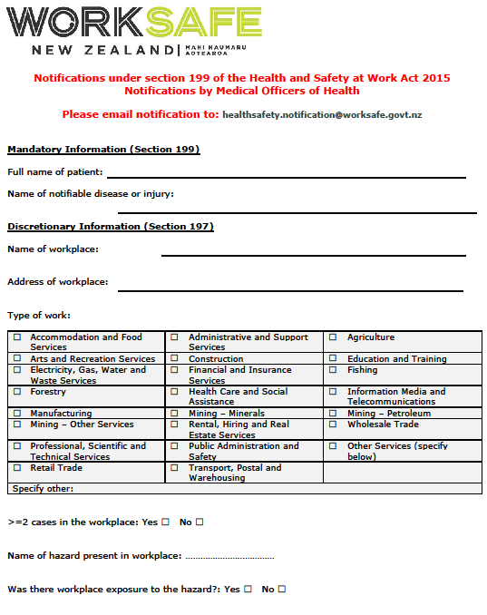

Appendix 4: National organisations contact list

Animal and Plant Health Association of New Zealand  PO Box 5069  Wellington, 6140  Phone: 027 432 8196  animalplanthealth.co.nz | New Zealand Forest Owners Association  PO Box 10986  WELLINGTON 6143  Tel (04) 473 4769  Email: nzfoa.org.nz  www.nzfoa.org.nz
Aviation New Zealand  Level 5, 5 Willeston Street  WELLINGTON 6011  Tel (04) 472 2707  www.aviationnz.co.nz | Civil Contractors New Zealand  PO Box 12013  WELLINGTON 6144  Tel 0800 692 376  civilcontractors.co.nz
Federated Farmers of New Zealand  PO Box 715  WELLINGTON 6140  Tel 0800 327 646  Email: 0800@fedfarm.org.nz  www.fedfarm.org.nz | Responsible Care New Zealand  PO Box 5557  WELLINGTON 6011  Tel (04) 499 4311  Email: info@responsiblecarenz.com  www.responsiblecarenz.com
Pest Management Association of New Zealand
PO Box 133215 Eastridge
AUCKLAND 1146
Tel 0800 476 269
Email: info@pmanz.nz
pmanz.nz

Glossary
µg | Microgram or one millionth of a gram (sometimes written as mcg)
µmol | Micrometre or one millionth of a metre (also known as micron)
ACC | Accident Compensation Corporation
ADI | Acceptable daily intake for pesticide residues in food, determined by toxicological data estimating safe consumption levels over a lifetime of daily exposure and incorporating a safety factor of at least 10
AHCC  ATSDR | Area Hazmat Coordination Committee  Agency for Toxic Substances and Disease Registry
Biomarker | A measurement, typically a chemical, biochemical or other biological parameter, that reflects an interaction between a living organism and an environmental agent, which could be biological, chemical or physical
Biomonitoring | Measuring the actual levels of suspected environmental chemicals in human tissues and fluids
BPAC | Best Practice Advocacy Centre Inc
CAA | Civil Aviation Authority
Chemical | Any substance used in or resulting from a reaction involving changes to atoms or molecules
Complaint | Any advice to the National Public Health Service (usually to local public health officers) by any person that a chemical-exposure incident may have occurred
Contamination | The act or process of contaminating, or the state of being contaminated – to ‘contaminate’ is to ‘make impure especially by touching or mixing; pollute’
CPHR | Centre for Public Health Research
EPA | Environmental Protection Authority
Event | the intended application of the chemical that precipitated the incident
Exposure | Concentration or amount of a particular agent that reaches a target organism, system or (sub)population in a specific frequency for a defined duration
GIS | Geographic Information System
GP | General Practitioner
Hazard | A source or situation of potential harm
HSDIRT | Hazardous Substances Disease and Injury Reporting Tool
HSW Act | Health and Safety at Work Act 2015
HSNO | Hazardous Substances and New Organisms Act 1996
Incident | The circumstances leading to one or more complaints or notifications of chemical exposure
MBIE | Ministry of Business, Innovation and Employment
MOU | Memorandum of understanding
MPI | Ministry for Primary Industries
NCEA | National Centre for Environmental Assessment
NPC | National Poisons Centre
Poisoning | Any substance that can impair function, cause structural damage, or otherwise injure the body – it does not need to be fatal, or to require admission to hospital
Public health officer | An officer working in the National Public Health Service (eg, health protection officer, or a medical officer of health)
RfC | Reference concentration
RfD | Reference dose
Risk | The probability of harmful consequences arising from a hazard together with a measure of the scale or severity of the harmful consequence. In qualitative terms, the risk may be said to have a probability that is ‘high’ or ‘low’ or another chosen term. In quantitative terms, the probability can range from zero (no possible harm) to one (certainty that harm will occur). The scale and severity of the harm may be characterised by the numbers of people affected and the sort of harm (eg, death or serious injury)
Risk assessment | The systematic acquisition and evaluation of information that enables the probability, scale and severity of the risk to be described
Risk management | All actions of a management nature that are designed to minimise risk to levels acceptable to the person(s) exposed to the risk
RMA | Resource Management Act 1991
TDI | Tolerable daily intake
TEAM | Total exposure assessment methodology
TEL | Tolerable exposure limit
WHO | World Health Organization

The HSNO Act 1996 refers to injury, but for practical purposes, this also includes disease associated with exposure to a hazardous substance.
A substance is any element, defined mixture of elements, compounds or defined mixture of compounds either naturally occurring or produced synthetically or any mixtures thereof.
ADI is an estimate of the amount of a substance in food or drinking-water, expressed on a body-weight basis that can be ingested daily over a lifetime without appreciable health risk.
TDI is analogous to ADI. The term ‘tolerable’ is used for agents that are not deliberately added, such as contaminants in drinking-water.
RfD is defined as an estimate of the dose of daily exposure to a substance (with uncertainty spanning perhaps an order of magnitude) for a human population (including sensitive subgroups) that is likely to be without an appreciable risk of deleterious effects during a lifetime.
RfC is defined as an estimate of the concentration of daily exposure to a substance (with uncertainty spanning perhaps an order of magnitude) for a human population (including sensitive subgroups) that is likely to be without an appreciable risk of deleterious effects during a lifetime.
Both are available at https://www.legislation.govt.nz
Slope factor is the cancer risk (proportion affected) per unit of dose. It is the US EPA’s terminology for describing how potent a compound may be in causing cancer based on studies conducted on animals and human studies when available.
Unit risk is defined as the upper-bound excess lifetime cancer risk estimated to result from continuous exposure to an agent at a concentration of 1 µg/L in water or 1 µg/m³ in air.
Tolerable exposure limit means the limit on the concentration of a substance (or any element or compound making up the substance) with toxic properties in an environmental medium as set in accordance with section 77B of the HSNO Act 1996 or EPA notices.
Any substance or mixture intended for preventing, destroying, repelling or mitigating any pest (including but not limited to insect, rodent, nematode, fungus, weed).
Due to discharges from a single source, such as an industrial site.
Involves many small point sources that combine to cause significant pollution.
These substances may accurately be identified when the system has enough data to develop a list.
Could be statutory or non-statutory notification.
HSDIRT is an electronic tool accessible in certain patient management systems which gives general practitioners an easy mechanism to notify cases.
WorkSafe is responsible if the operator is a worker, such as a farmer, agricultural sprayer, pest-management operator.
Adopted from Gorman D (1997).
Communicable diseases are included (eg, zoonotic and bloodborne diseases where a person is infected at their workplace). Food workers with enteric diseases that are not acquired at their workplace, but who pose a potential food safety risk at work are not included; they are dealt with by the Food Act 2014.

