Clinical Performance Metrics

1 July – 30 September 2023

Citation: Te Whatu Ora – Health New Zealand. 2023. Clinical Performance Metrics: Wellington: Te Whatu Ora – Health New Zealand.
Published in December 2023 by Te Whatu Ora – Health New Zealand
PO Box 793, Wellington 6140, New Zealand
ISSN 3021-1433

This document is available at tewhatuora.govt.nz
This work is licensed under the Creative Commons Attribution 4.0 International licence. In essence, you are free to: share i.e., copy and redistribute the material in any medium or format; adapt i.e., remix, transform and build upon the material. You must give appropriate credit, provide a link to the licence and indicate if changes were made.

System continues to face pressures
The Clinical Performance Metrics provide data and information on the change in performance for key measures between the current and previous year. These key measures were agreed by the Board of Te Whatu Ora in December 2022 and endorsed by the previous Minister of Health. They have been published by Te Whatu Ora since December 2022. This report covers the first quarter of 2023/24 compared with the same quarter for 2022/23.
Hospital specialist and primary care services are under pressure with increasing demand for services as the population continues to grow, including net migration increase. As it grows it also ages and the number of people with chronic and complex conditions also increases. People over 80 years of age use up to 10 times more hospital bed days than other adults, and this is the fastest growing proportion of the population.
Increasing capacity in the health workforce, primary care services and our hospital and specialist capacity to meet the needs of our communities is our focus. Building this capacity to provide timely primary care and address long wait times and waitlists for specialist care will take time as new staff are trained or recruited from overseas and additional capacity is created.
There is a particular focus on ensuring rural and remote populations are able to access support and services. The rollout of the new telehealth primary care service will help to alleviate pressure faced by rural services by providing 24/7 access to a nurse or GP.

Clinical Performance Metrics
Data presented in this document shows information on 11 out of 12 clinical metrics for Te Whatu Ora for the period July to September 2023 compared with July to September 2022. It is presented in visual bar-graph form to enable ease of comparison between years. Eight of the 12 clinical metrics are performance measures included in our accountability documents (Statement of Intent/Statement of Performance Expectations). These measures are also presented in Te Whatu Ora’s substantive quarterly performance reports (also published on our website), specifically:
1. Immunisation Coverage at 24 Months
2. Ambulatory sensitive (avoidable) hospital admissions 0-4 Years
3. Ambulatory sensitive (avoidable) hospital admissions 45-64 Years
4. Mental Health Wait Times
5. Acute Bed Days
6. People waiting more than 4 months for a First Specialist Assessment
7. People waiting more than 4 months for Planned Care
8. Shorter Stays in Emergency Departments

The remaining four clinical performance metrics are:
9. Emergency Department Presentations
10. Cancer Treatment Wait Times
11. Planned Care Waiting >365 days
12. Emergency Department Admissions
Clinical performance metric 12 is not published in this report due to ongoing challenges with validating the data. We are working to gain consensus on a meaningful definition for this metric, to ensure it is applied consistently across the districts.
The 12 clinical performance metrics aim to measure how the health system across the country is performing, providing the opportunity to develop local health solutions to address local health issues. They also include metrics for cancer, acute and planned care. The metrics allow us to measure performance over time with consistency.
This report now includes breakdowns by ethnicity where possible. Ethnicity data is sourced from prioritised ethnicity in the National Health Index system, and for Ambulatory Sensitive Hospitalisations and Acute Bed Day rates, matched to prioritised ethnicity in Stats NZ Usual Resident Population projections.
All performance data provides a snapshot in time and there will be variances depending on when data is uploaded on any given day. Data for the quarter one period was extracted on 10 December 2023. While Te Whatu Ora has taken all reasonable steps to ensure the information contained in this report is accurate and complete, it accepts no liability or responsibility for the manner in which the information is used or subsequently relied on.
Data presented is collected at district level via national collection applications and compiled in a national data platform. Graphs are created from the data platform. Data validation is done at both national and district level, by clinical and data teams, subject matter experts, and those involved in the creation of the report.
The term “district” is used through this report and refers to the geographic boundaries covered by former District Health Boards (DHBs).
Te Whatu Ora aims to provide geographic breakdowns, where possible, to enable people to compare results across the country and we are currently working with inherited datasets that are aligned to former DHBs. As we move ahead, Te Whatu Ora will give further consideration to the best groupings and catchments of data, within the context of a single organisation, including what terminology is best to use.

1 Immunisation Coverage at 24 Months
Coverage is calculated as the percentage of children who turned two years of age during the period who are recorded as fully immunised for their age on the National Immunisation Register (NIR). This includes having all scheduled vaccines between birth and age two years. The measure excludes children for whom vaccination has been declined by parents or guardians, or those that have opted out of the national immunisation register.
Children fully immunised for age at 24 months by district of service
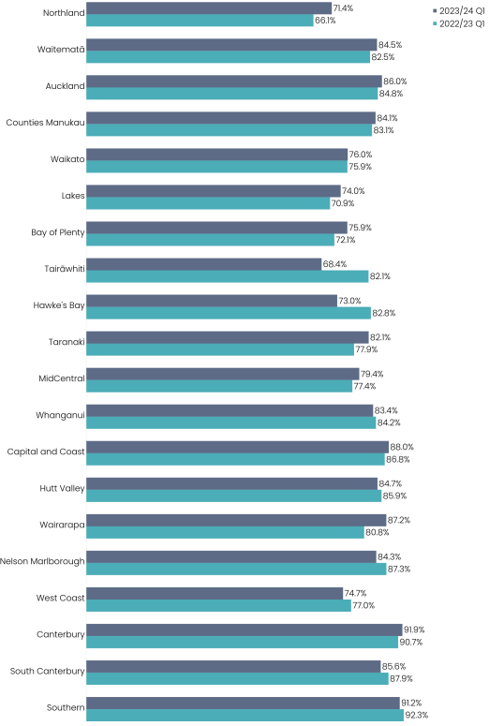

Children fully immunised for age at  24 months - National 2023/24 Q1 | Children fully immunised for age at  24 months - National 2022/23 Q1
83.0% | 82.2%
* The national result for quarter four 2022/23 was 83.1%

Children fully immunised for age at 24 months by prioritised ethnic group
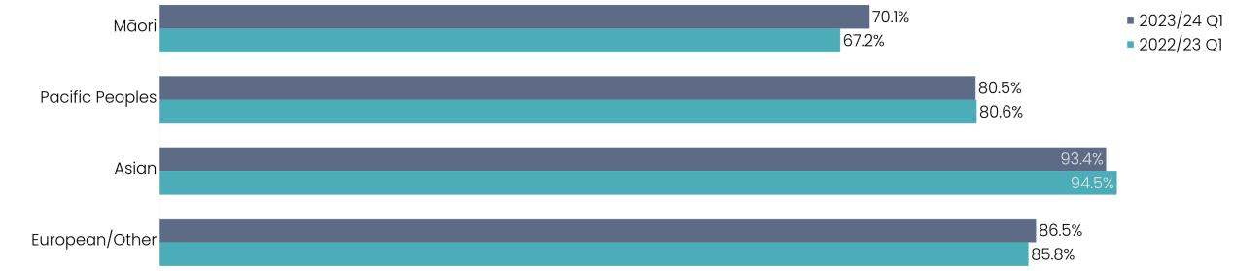

In order to lift immunisation rates, Te Whatu Ora is focused on enabling system design and the implementation of the Immunisation Taskforce recommendations. Improving rates requires a fundamental shift in placing Māori, Pacific and Tāngata whaikaha | Disabled people at the centre of any redesign of the immunisation system to create more flexible and culturally focused models of care that address current equity gaps.
Childhood immunisation rates in Aotearoa New Zealand for children at 24 months have shown a small improvement in the quarter July to September 2023 compared to the same quarter in 2022 (83.0% versus 82.2%), including a 2.9% increase for Māori. Rates for the Asian population decreased slightly over the same period. Twelve districts (up from seven last quarter) show improvement on the previous year.
Note: Source of data is the National Immunisation Register database.

2 Ambulatory sensitive (avoidable) hospital admissions, 0-4 years
Ambulatory sensitive (avoidable) hospital admissions are a group of mostly acute admissions that are considered potentially reducible through interventions deliverable in a primary care setting. Results are presented as a rate per 100,000 population, i.e. the number of avoidable admissions to hospital for children aged between 0 and 4 years divided by the number of children aged between 0 and 4 years in the population x 100,000.
Ambulatory sensitive (avoidable) hospital admissions per 100,000 Children (age 0-4) by district of domicile
Ambulatory sensitive (avoidable) hospital admissions per 100,000 Children (age 0-4) - National  12 months to September 2023 | Ambulatory sensitive (avoidable) hospital admissions per 100,000 Children (age 0-4) - National  12 months to September 2022
7,635 | 6,183
* The national result for the 12 months to June 2023 was 7,752

Ambulatory sensitive (avoidable) hospital admissions events per 100,000 children (age 0-4) by prioritised ethnicity

Nationally the rate of Ambulatory sensitive (avoidable) hospital admissions for 0–4-year-olds has increased significantly (23%) when comparing the year to September 2022 and the year to September 2023, although the rate has reduced when compared to June 2023 (7,752). The largest increases were seen in Northland (54%), Waitematā (51%), Auckland (38%), Whanganui (38%) and Capital, Coast and Hutt (31%), with a decrease in one area - Wairarapa.
Although rates have increased for all ethnicities, the rate for Māori has increased the least (14%). Similar to quarter four, there is another large increase in Ambulatory sensitive (avoidable) hospital admissions rates for Pacific Peoples of 29%.
Note: Source of data is the national collections NMDS (inpatient events) compared to the population (Stats NZ population projections). This metric is not yet available with an ethnicity breakdown that includes Asian. District results for Tairāwhiti and West Coast for the 12 months to September 2023 are not available due to system upgrades underway.

3 Ambulatory sensitive (avoidable) hospital admissions, 45-64 years
Ambulatory sensitive (avoidable) hospital admissions are a group of mostly acute admissions that are considered potentially reducible through interventions deliverable in a primary care setting. Results are presented as a rate per 100,000 population, i.e. the number of avoidable admissions to hospital for adults aged between 45 and 64 years divided by the number of adults aged 45-64 years in the population x 100,000.
Ambulatory sensitive (avoidable) hospital admissions per 100,000 adults (age 45-64) by district of domicile

Ambulatory sensitive (avoidable) hospital admissions per 100,000 Adults (Age 45-64) - National 12 months to September 2023 | Ambulatory sensitive (avoidable) hospital admissions per 100,000 Adults (Age 45-64) - National 12 months to September 2022
3,761 | 3,605
* The national result for the 12 months to June 2023 was 3,739

Ambulatory sensitive (avoidable) hospital admissions per 100,000 adults (age 45-64) by prioritised ethnicity

Nationally the aged-standardised Ambulatory sensitive (avoidable) hospital admissions rate for 45–64-year-olds increased by 4% when compared between the year to September 2022 and September 2023. The rate increased for almost all districts except Waikato, Hawke’s Bay, Taranaki and Canterbury.
Whanganui continues to have the highest rates for 45–64-year-olds at a rate of 6,113 per 100,000 adults.
Note: Source of data is the national collections NMDS (inpatient events) compared to the population (Stats NZ population projections). This metric is not yet available with an ethnicity breakdown that includes Asian. District results for Tairāwhiti and West Coast for the 12 months to September 2023 are not available due to system upgrades underway.

4 Mental Health Wait Times
This measure reports the proportion of young people (aged under 25) who have been referred to and seen by a specialist mental health service within three weeks of referral. Waiting times are counted from the time the first referral is received, either by a Te Whatu Ora service or community provider, to first face-to-face contact with a mental health professional.
Under 25-year-olds accessing specialist mental health services within 3 weeks of referral by district of service
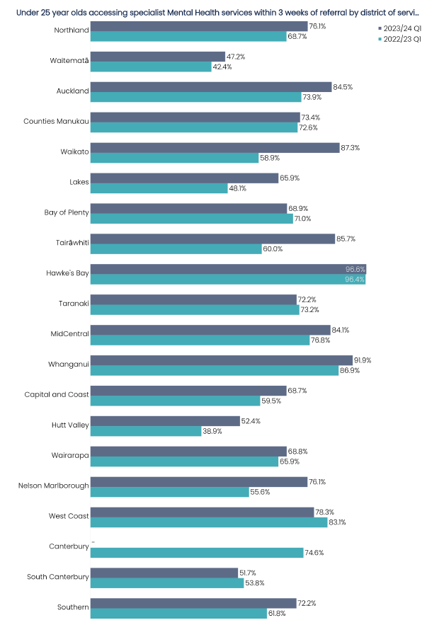
Under 25-year-olds accessing  specialist mental health services  within 3 weeks of referral - National  12 months to September 2023 | Under 25-year-olds accessing  specialist mental health services  within 3 weeks of referral - National  12 months to September 2022
71.9% | 65.8%
* The national result for the 12 months to June 2023 was 68.3%

Under 25-year-olds accessing specialist mental health services within 3 weeks of referral by prioritised ethnicity
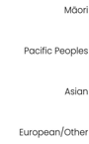
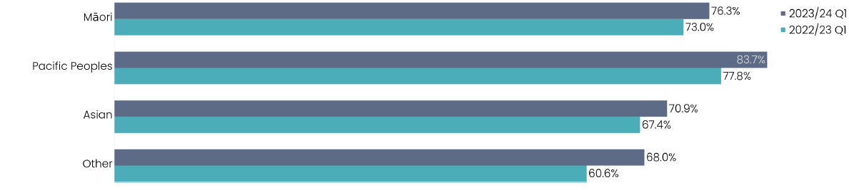

Overall, the proportion of young people accessing specialist mental health services within three weeks of referral improved by 6.1% in the year to September 2023 compared to the previous year. Improvements were seen in all reported ethnicities.
Almost all districts show improved access to youth mental health services compared to the previous year. Four districts show a decline in performance during the period (Bay of Plenty, Taranaki, South Canterbury and West Coast).
Note: Source of data is the mental health national collection PRIMHD. With effect from July 2023, the data presented for this measure will include updated data for the two latest 12-month periods, ending with the relevant quarter. Previously published data has been removed and replaced with the latest information. Due to reporting issues, data for Canterbury for the 2023 period is not available and therefore excluded from District and National reporting.

5 Acute Bed Days
Acute bed days are the number of days a person spends in hospital, following an acute admission. The acute bed days rate is presented as the number of bed days for acute hospital stays per 1,000 population, age standardised. This measure is intended to reflect demand for acute inpatient services on the health system.
Acute bed day rate per 1,000 population by district of domicile

Acute Bed Days per 1,000 population - National 12 months to September 2023 | Acute Bed Days per 1,000 population – National 12 months to September 2022
419 | 405
* The national result for the 12 months to June 2023 was 440

Acute bed day rate per 1,000 population by prioritised ethnicity

Nationally, the number of acute bed days per 1,000 population increased by 3.5% in the year to September 2023, compared to the year to September 2022. The largest percentage increase was South Canterbury (17.2%) followed by Lakes district. The increase is shown across all ethnic groups with Pacific people showing the greatest increase of 4.6%, which was again, lower than last quarter.
Work is underway to understand in more detail the drivers for system increases. The capacity and availability of services in the community, including primary care and age residential care are important to prevent the need for acute hospital care, and avoid unnecessary stays in hospital.
Note: Source of data is the national collections NMDS (inpatient events) compared to the population (usual resident population from Stats NZ). This metric is not yet available with an ethnicity breakdown that includes Asian. District results for Tairāwhiti and West Coast for the 12 months to September 2023 are not available due to system upgrades underway – this will impact the national total for this quarter by 1.4%.

Measures Six and Seven
The following two measures in the report are the way we measure wait times for people accessing specialist medical and surgical services for non-urgent issues that do not need immediate care (also referred to as “planned care”). Our goal is that people should not wait longer than four months for the two key stages of treatment.
The diagram below shows the standard treatment pathway and the points at which we measure wait times:
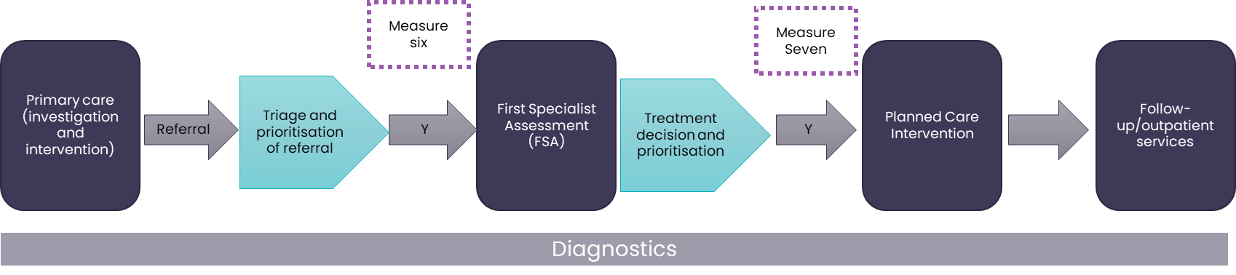

6 People waiting more than 4 months for a First Specialist Assessment
This measures whether districts are meeting the required performance standard at a number of key decision or indicator points on the person’s journey through the Planned Care system. First Specialist Assessment wait times refers to patients waiting longer than four months for their first specialist assessments.
People waiting more than 4 months for a First Specialist Assessment
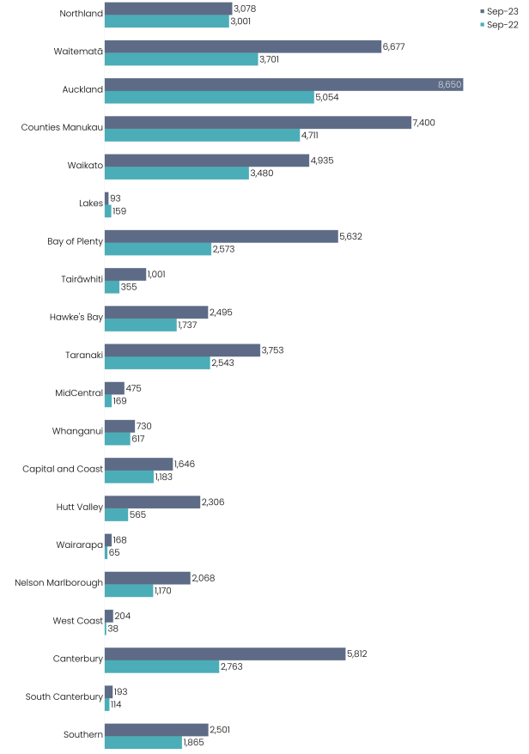

People waiting more than 4 months for a First Specialist Assessment - National  September 2023 | People waiting more than 4 months for a First Specialist Assessment - National  September 2022
59,817 | 35,863
* The national result for quarter four 2022/23 was 51,274 (compared with Q4 2021/22 which was 35,080)
The target wait time for people to receive a first specialist assessment is 4 months from the date of referral. Increasing demand for first specialist assessments is not being met by an increasing capacity.
Nationally there has been an increase in the number of patients waiting more than four months for first specialist assessments (from 35,863 in September 2022 to 59,817 in September 2023). There has been a steady increase of an estimated 1,200 per month since January 2021.
The number of first specialist assessment appointments increased by 3.27% in the last year. The most significant increases have occurred in attended first specialist assessments and follow-up appointments for Māori and Pacific patients.
The growth in the number of patients waiting for a first specialist assessment reflects that referrals for first specialist assessments are greater than our capacity to treat. The specialties with the highest growth in accepted referrals are cardiology, plastics, haematology and renal medicine.
Detailed work is underway to identify how Te Whatu Ora can safely and effectively respond to this increasing demand, including balancing the current focus on reducing long waiters against those with clinical need. This work will be informed by Clinical Networks currently being established.
Note: Source of data is the National Collection for first specialist assessments which is not at patient level; we cannot provide an ethnicity breakdown of this measure from this collection.

7 People waiting more than 4 months for Planned Care
This measures whether districts are meeting the required performance standard at a number of key decision or indicator points on the person’s journey through the Planned Care system. Planned Care wait times refers to patients given a commitment to treatment but not treated within 4 months. The goal is to ensure no patients with this status remain untreated after 4 months.
People waiting more than 4 months for Planned Care
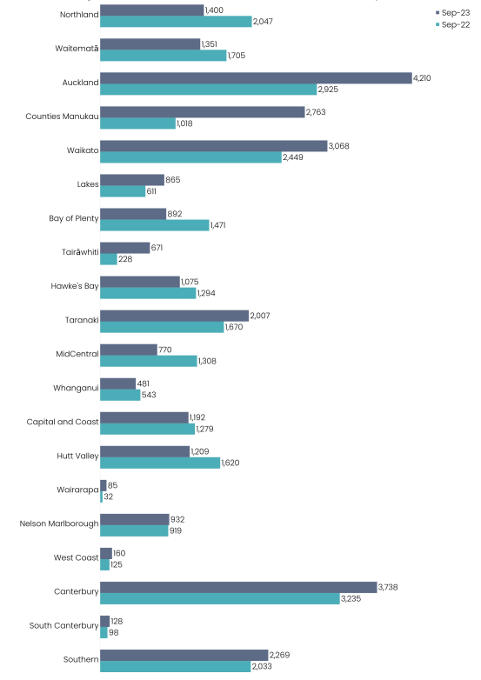
People waiting more than 4 months for Planned Care - National September 2023 | People waiting more than 4 months for Planned Care - National September 2022
29,266 | 26,610
* The national result for quarter four 2022/23 was 28,095
Overall, the number of patients waiting longer than four months for treatment has increased from 26,610 in September 2022 to 29,266 in September 2023. Performance improved in eight districts (Northland, Waitemata, Bay of Plenty, Hawke’s Bay, MidCentral, Whanganui, Capital and Coast, and Hutt Valley). The largest increases of people waiting were seen in Counties Manukau, Auckland, and Waikato.
There has been concentrated effort to reduce the number of people waiting more than 365 days for surgery. This has been achieved with an increase in planned care activity, having returned to similar levels experienced in 2019. The ratio of people being treated, to those being added, has moved to being greater than 1, since April 2023. This means that more people are being treated than added. This additional effort has gone to long waiting patients to clear the backlog.
A detailed programme of work is underway to identify the further interventions that can be achieved and the impact this will have for all patients waiting for interventions.
Note: Source of data is the national collection National Booking Reporting System (NBRS).

8 Emergency Department Presentations
Emergency Department (ED) presentations reflects the number of people who present to an emergency department.
Emergency Department presentations by district of service
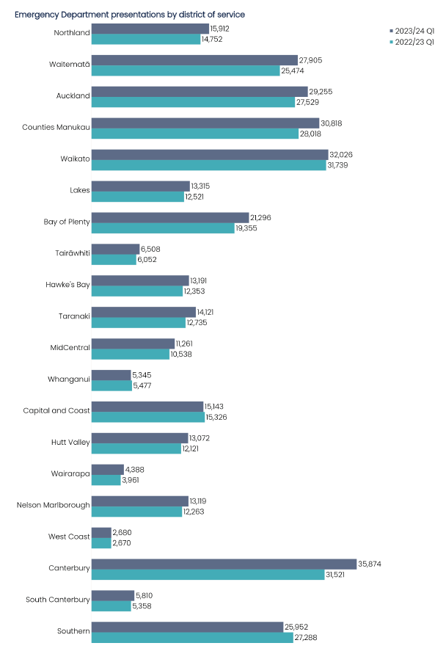

Emergency Department presentations - National 2023/24 Q1 | Emergency Department presentations - National 2022/23 Q1
336,991 | 317,051
* The national result for quarter four 2022/23 was 331,220

Emergency Department presentations by prioritised ethnicity
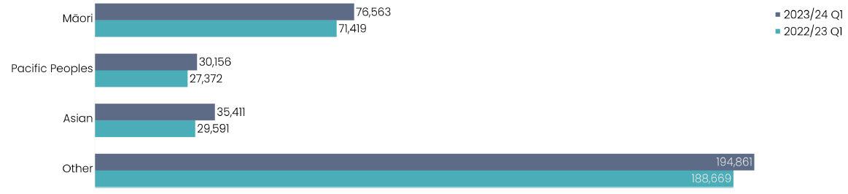
Nationally, ED presentations have increased by 6.3% between the two periods (from 317,051 to 336,991). Nearly all districts show an increase in presentations except Whanganui, Capital and Coast and Southern. ED presentations for Asian people grew by 19.7% with 5,820 more presentations in quarter one 2023/24 than the same period last year. Māori and Pacific presentations also grew by 7.2% and 10.2% respectively.
ED presentations are driven by population growth, an ageing population and more people with complex conditions. This increase has been particularly significant in Canterbury where changes to Accident & Medical Care in the community has resulted in more people presenting to the ED.
A range of initiatives were trialled in the 2023 winter plan and the evaluation is still underway. More detailed planning is also underway to identify capacity in primary care, accident and medical centres and community services.
Note: Source of data for all districts is the National Non-admitted Patient Collection (NNPAC). This measure excludes patients presenting directly to an Acute Assessment Unit (AAU) or via ED where the only input in ED was triage and patients who did not wait to be seen.

9 Shorter Stays in Emergency Departments (EDs)
This measure reports the proportion of patients who were admitted, discharged, or transferred from an ED within six hours. This measure excludes those people who presented to ED in error as well as those who did not wait to be seen.
Shorter stays in Emergency Departments (<6 hours) by district of service
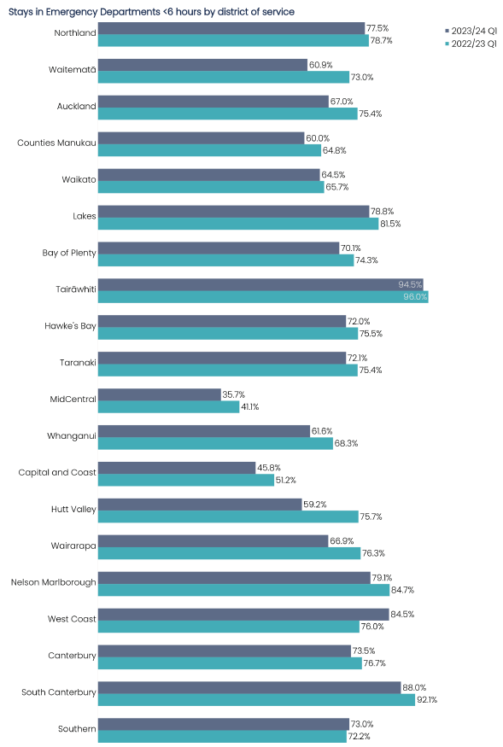

Stays in Emergency Departments <6 hours - National 2023/24 Q1 | Stays in Emergency Departments <6 hours - National 2022/23 Q1
67.6% | 72.3%
* The national result for quarter four 2022/23 was 71.2%

Shorter stays in Emergency Departments (<6 hours) by prioritised ethnicity
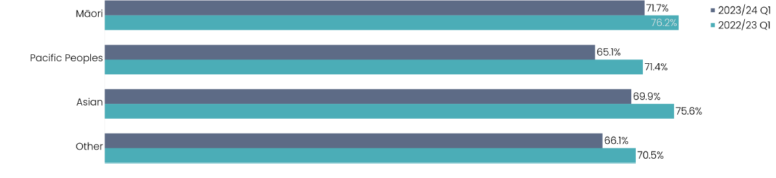
Our Emergency Departments are designed to provide urgent care for those most in need when they need it. There is increasing evidence that both long stays and overcrowding in Emergency Departments are linked to negative clinical outcomes and distress for people and their whānau. There has never been sustained achievement of Shorter Stays in ED in the public health system since its introduction in 2009/10. Performance tends to be better in our rural hospitals. Our provincial and urban hospitals face the same challenges.
The achievement of Shorter Stays in ED is significantly impacted upon by the availability of hospital beds. Analysis shows that the Shorter Stays in ED for admission patients is significantly worse than patients who are discharged. Currently hospital inpatient occupancy in our inpatient beds regularly exceeds 90-95%, which is too high for improved patient flow.
A detailed work programme is underway, alongside plans to improve capacity in hospital and specialist services, to implement programmes that will continue to improve flow and release inpatient beds to accommodate acutely admitted patients.
Nationally, the proportion of ED stays under six hours decreased by 4.7% (compared to July to September 2022). West Coast and Southern were the only districts which showed improvement. Performance for all ethnic groups decreased (4.5% for Māori, 6.3% for Pacific, 5.7% for Asian and 4.4% for European/other ethnicities).
Note: Source of data is National Non-admitted Patient Collection (NNPAC). This measure excludes patients presenting directly to an Acute Assessment Unit (AAU) or via ED where the only input in ED was triage and patients who did not wait to be seen.

10 Cancer Treatment Wait Times Within 31 Days
This measure shows the proportion of eligible cancer patients who receive their first treatment within 31 days of a decision to treat by a health professional. The days are counted from the decision to treat date to the delivery of their first treatment.
Cancer Treatment Wait Times within 31-days by district of service
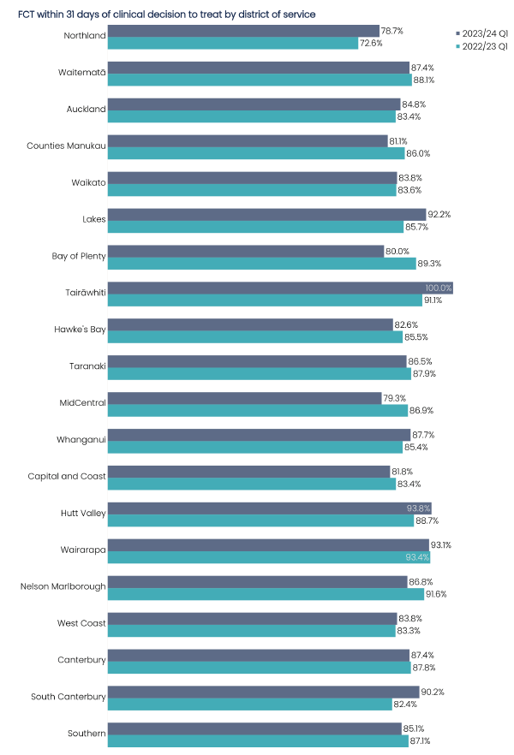
DATA REQUIRES FURTHER VALIDATION.
Cancer Treatment Wait Times within  31 days - National 2023/24 Q1 | Cancer Treatment Wait Times within  31 days - National 2022/23 Q1
84.8% | 85.9%
* The national result for quarter four 2022/23 was 84.0%

Cancer Treatment Wait Times within 31 days by prioritised ethnicity
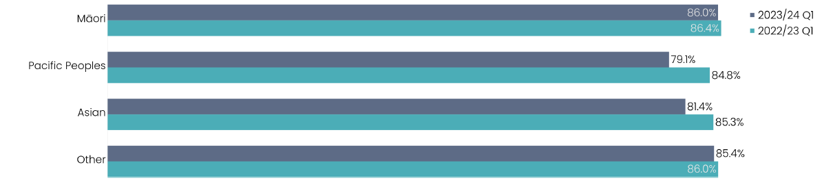
Cancer treatment wait times is an important measure of access to treatment. The target for this measure is 85%. Ensuring equity through the cancer pathway and ensuring all New Zealanders, regardless of ethnicity have the same performance from the system. Analysis shows that the variation over the last few quarters is within normal statistical variation, and therefore not material.
Although the target is close to being met, Te Whatu Ora has prioritised improvement in cancer service delivery. This includes establishing the National Clinical Cancer Network, which will see Te Aka Whai Ora, Te Whatu Ora, and Te Aho o Te Kahu work in partnership to ensure there is collaboration across all levels of care. Workforce, diagnostics and equipment are key areas of focus to improving our timely cancer service delivery.
Classification number: (Review date: )

Classification number: (Review date: )

Nine districts improved this quarter compared with quarter one 2022/23 (Northland, Auckland, Waikato, Lakes, Tairāwhiti, Whanganui, Hutt Valley, West Coast, and South Canterbury).
Note: Source of data for all districts is the Cancer Treatment national collection. Reporting is for a three-month period rather than a rolling six months as previously reported. Data for Hawke’s Bay has been withheld as further validation is required.

11 Planned Care: Long wait times for treatment
This measure reports the total number of people in each district who have been waiting on a planned care waitlist for a procedure for more than 365 days from the time they were ready for treatment.
Long wait times (> 12 months) for treatment by district of service
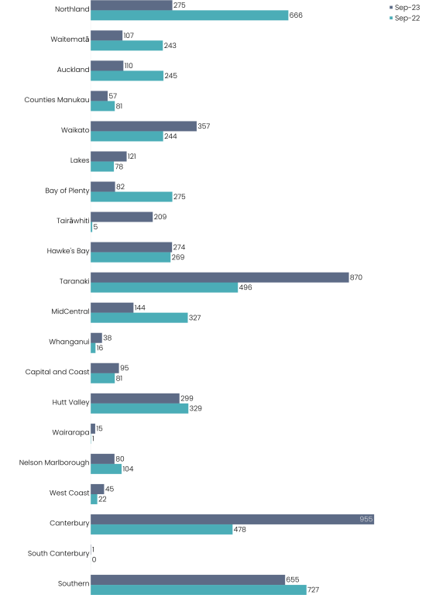
DATA REQUIRES FURTHER VALIDATION.

The Planned Care Taskforce was set up in May 2022 to provide advice on actions to improve equity, increase access and reduce waiting lists for planned care. In October a multi-year implementation programme commenced, to implement recommendations on reducing waitlists, managing this in an equitable way and ensuring national consistency of clinical prioritisation.
The Taskforce prioritised, with the Government, clearing the backlog of people waiting more than 365 days.
There has been focused effort to deliver more planned care through our public hospital, private hospital and primary settings. This has been supported by collaboration across regions and districts, and other targeted initiatives to increase planned care capacity such as theatre optimisation, clinical pathways, and clinical prioritisation.
Part of this work is to ensure that there was transparency across all waiting lists and an understanding of the rate at which people move in to the greater than 365 day waiting list. As a consequence, Waikato and Canterbury have had an increase in those waiting over 365 days even though the volume of work has been increasing.
Note: Source of data is the national collection National Booking Reporting System (NBRS). There are known data issues in NBRS for Taranaki district for 2023 data for which has been withheld, a national total has not been provided for this reason.

