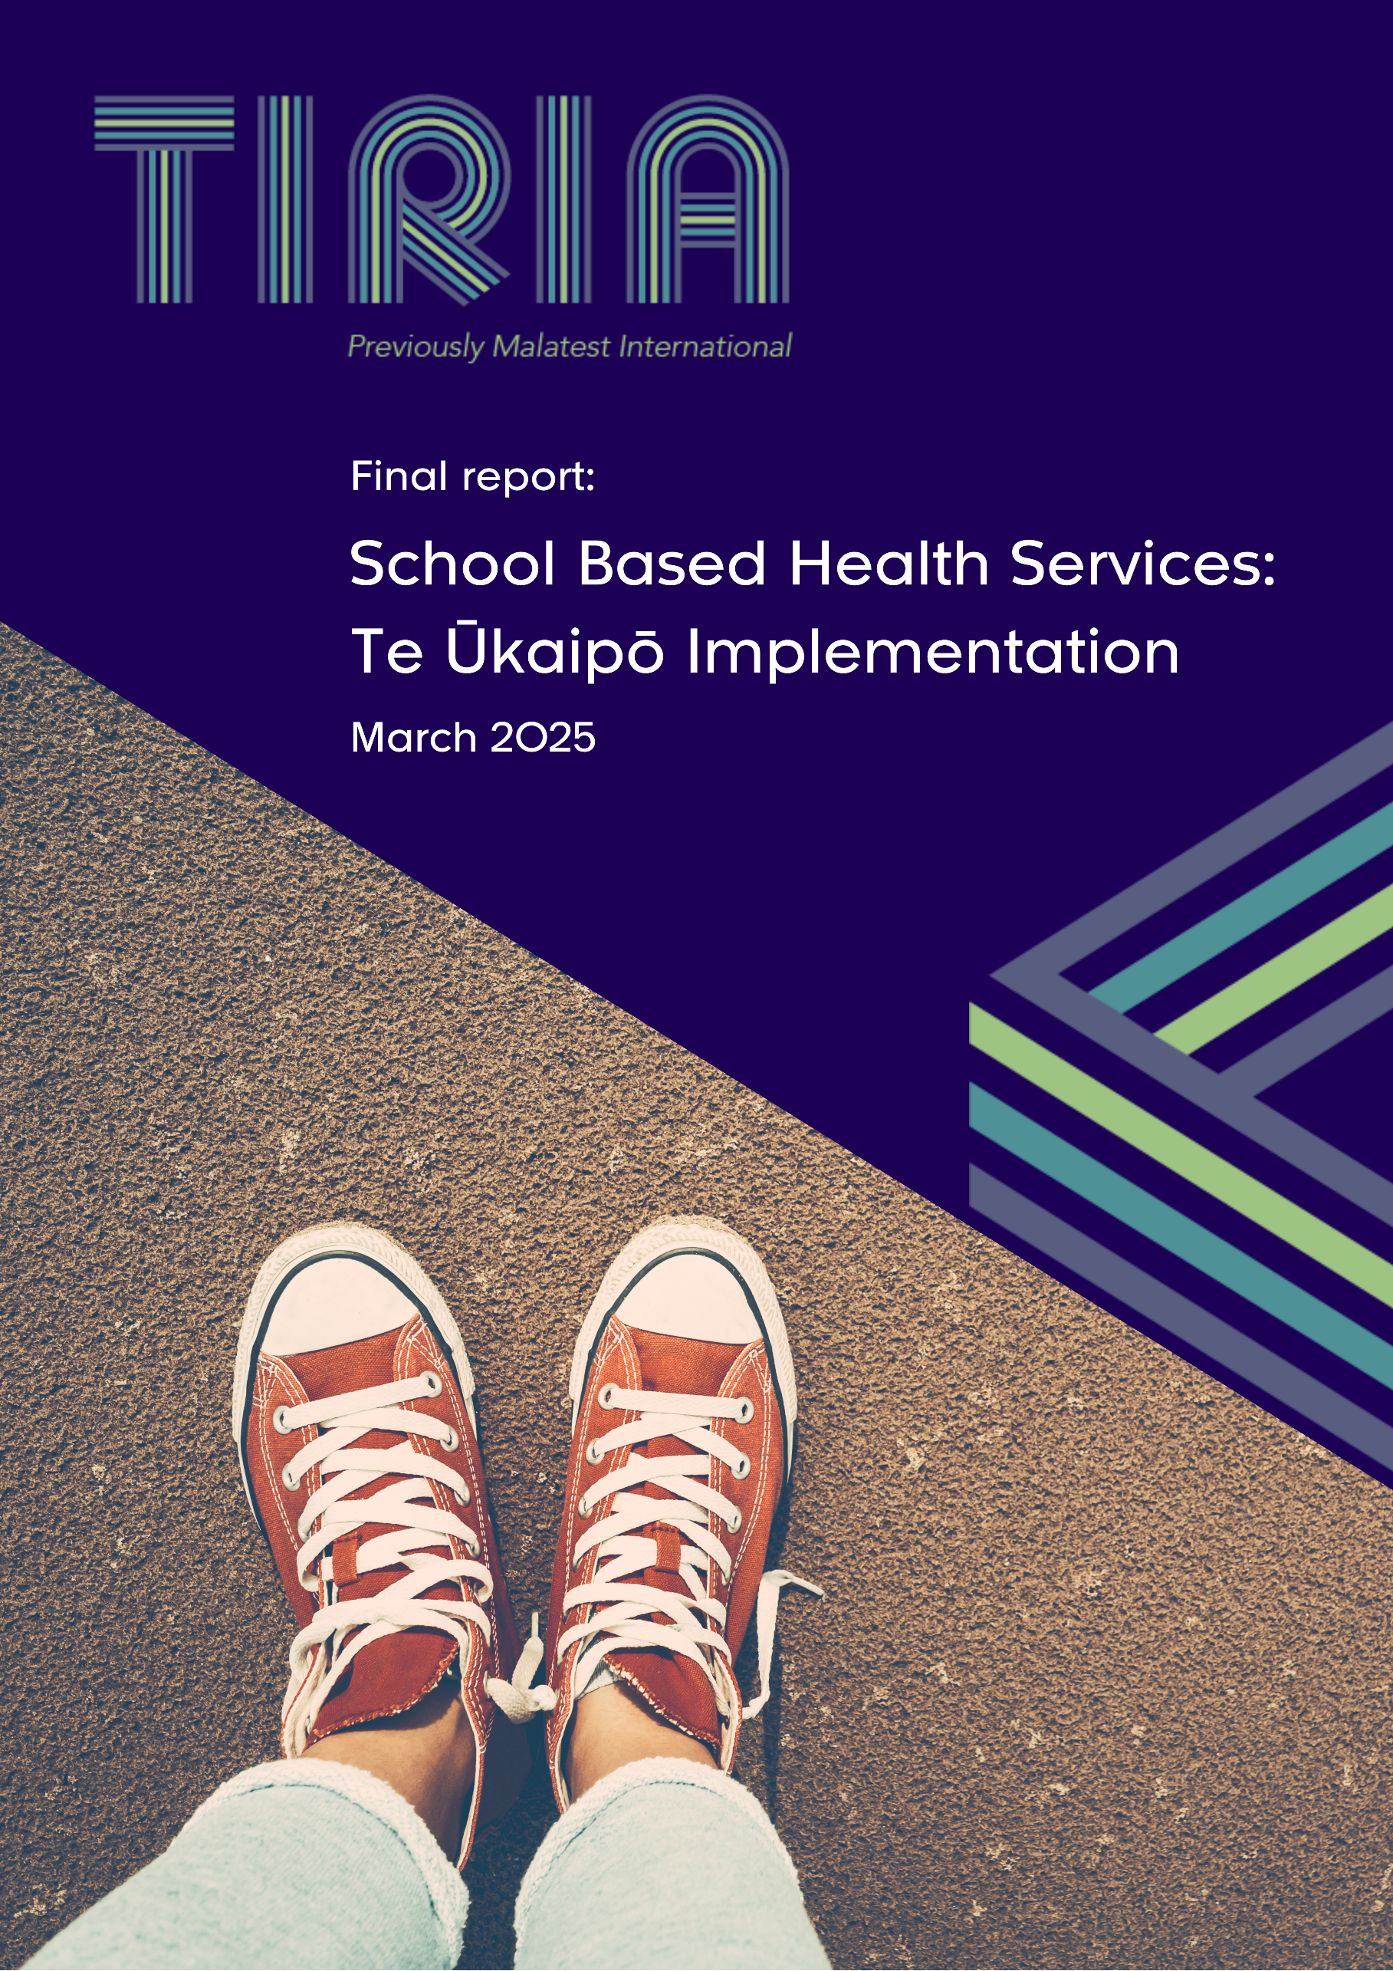

Acknowledgements
We would like to acknowledge and thank everyone who took part in this evaluation, with special thanks to the ākonga for their valuable contributions. Their insights have been essential in the development and delivery of School Based Health Services and we appreciate the time they gave to sharing their perspectives throughout the evaluation process.
Table of contents
Executive summary 1
1. Background 7
1.1. Rationale for School Based Health Services (SBHS) 7
1.2. SBHS enhancements programme 8
1.3. Terminology used in this report 9
1.4. Te Ūkaipō Wānanga Programme 9
2. The evaluation 11
2.1. Purpose of this evaluation 12
2.2. This report 14
2.3. Strengths and limitations 14
3. Overview of the implementation journey 15
4. Te Kore: Awareness and comfort 17
4.1. Feedback on the experience of the Wānanga programme 17
4.2. Building awareness of the value of Te Ūkaipō 18
4.3. Recommendations to support kaimahi move from Te Kore to Te Pō 19
5. Te Pō: Applying knowledge in practice 22
5.1. Stage of implementation 22
5.2. Understanding how to apply the values to practice 22
5.3. Practice context for kaimahi 23
5.4. Enablers and barriers to change 25
5.5. Recent changes to practice consistent with Te Ūkaipō 26
5.6. Changes prompted by the introduction of Te Ūkaipō 28
5.7. Moving from Te Pō into Te Ao Mārama 30
6. What worked: Examples of success 33
7. Te Ao Mārama: Embedding practice changes 38
7.1. Embedding practice change 38
7.2. Embedding and sustaining Te Ao Mārama 38
8. Summary of key findings and recommendations 40
8.1. Summary of findings 40
8.2. Summary of recommendations 42
Appendix 1: Whanonga Pono, Values 45
Appendix 2: Evaluation frameworks 46

Executive summary
Background
School Based Health Services (SBHS) is a nurse-led primary care service available in decile one to five mainstream secondary schools, Kura Kaupapa, Special Character schools, Teen Parent Units (TPUs) and Alternative Education sites (Alt-Eds) nationally. SBHS currently supports around 300 schools with approximately 115,000 students and 150 kaimahi. The service takes a holistic approach to supporting ākonga with a wide range of issues, including acute and chronic physical health conditions, mental health and wellbeing, sexual health, alcohol and other drug abuse, school engagement, teenage pregnancy and accident and emergency presentations.
SBHS began as a Ministry of Education initiative called Healthy Community Schools. Responsibility later transferred to the Ministry of Health – Manatū Hauora (MOH) and is now managed by Te Whatu Ora | Health New Zealand (Te Whatu Ora). Enhancement and expansion of SBHS was a key initiative under the Budget 2019 ‘Taking Mental Health Seriously’ package. The current SBHS enhancements programme (2020-2024) focuses on integrating Te Ūkaipō values framework (Appendix 1) into service delivery, with the potential to be applied to the broader youth health and wellbeing sector. The enhancements programme includes Te Ūkaipō Wānanga, which trains kaimahi to deliver care aligned with Te Ūkaipō values.
The evaluation
The MOH commissioned TIRIA (formerly Malatest International) to provide evaluation and quality improvement insights on SBHS from 2020 to 2024. This report, which forms part of that evaluation, focuses on the early implementation of Te Ūkaipō values framework within SBHS and builds on findings from previous workstreams and TIRIA reports. The evaluation aims to address the following key questions:
Te Kore | Te Pō | Te Ao Mārama
- How well did the wānanga strengthen kaimahi understanding of Te Ūkaipō values?  - What did kaimahi see as the potential benefits – for themselves, ākonga and kura tuarua? | - How well did kaimahi understand how to apply Te Ūkaipō in their practice?  - What changes did kaimahi plan to make?  - What did kaimahi do to implement Te Ūkaipō?  - What barriers/challenges did kaimahi and kura tuarua encounter in making changes to their practice? How were they overcome?  - How well do challenges alight with the SBHS evaluation framework including Te Ūkaipō values and measures? | - How did the changes made affect the experience of SBHS for ākonga, whānau, kaimahi and kura tuarua?  - How did ākonga, whānau, kaimahi and kura tuarua benefit from the implementation of Te Ūkaipō?
This report is based on information gathered from 21 stakeholder interviews, including 12 kaimahi, eight ākonga, three school staff and one MOH regional staff member.
Key findings and recommendations
Kaimahi typically progress through four stages – awareness, comfort, confidence and competence – reflecting increasing depth in understanding and confidence applying Te Ūkaipō values. Their implementation journey may begin at any stage, depending on their prior knowledge and experience. However, without ongoing support, it is possible for kaimahi progress to plateau or reverse.
- Awareness: Kaimahi begin recognising the value of Te Ūkaipō, though engagement is limited.
- Comfort: Kaimahi develop an initial understanding of Te Ūkaipō values but may feel unsure about how to apply them in practice.
- Confidence: Kaimahi actively apply Te Ūkaipō values and as their confidence grows, they become more intentional in how they apply the values.
- Competence: Kaimahi demonstrate a strong and adaptable application of Te Ūkaipō values.
Te Kore: Awareness and comfort
Overall, kaimahi feedback on the wānanga programme was positive, with key strengths including engaging facilitators, a marae setting that encouraged meaningful discussions, and trusting team relationships that fostered open dialogue. Some kaimahi suggested extending the wānanga to two days to allow more time for engaging with tikanga Māori concepts.
Kaimahi started the wānanga with varying levels of cultural awareness. For those with limited exposure to te ao Māori, it provided valuable insights into tikanga Māori and the practical application of Te Ūkaipō. Some kaimahi initially viewed Te Ūkaipō as Māori-specific, highlighting the need to reinforce its relevance across diverse settings. A small number were resistant, either perceiving the wānanga as unnecessary or believing they were already applying Te Ūkaipō values. However, even kaimahi with a strong cultural understanding found the programme beneficial as a refresher, deepening their approach to values such as whakapapa and whanaungatanga in their work with ākonga, whānau, colleagues, and support services.
Supporting kaimahi to transition from Te Kore to Te Pō requires practical guidance, ongoing cultural competency development and workload support. The recommendations are:
 | Recommendation | Details
1 | Strengthen cultural capability in te ao Māori and increase awareness of existing cultural support. | A deeper understanding of the foundation of Te Ūkaipō in te ao Māori will give kaimahi the confidence to apply it meaningfully in various contexts.
2 | Emphasise the universality of Te Ūkaipō values. | Ensuring kaimahi understand that Te Ūkaipō values apply across different communities and settings will support confident adaptation in practice.
3 | Review the length and delivery format of the wānanga. | Refining the balance of online and in-person elements and extending the wānanga timeframe may help kaimahi engage more deeply and reduce information overload.

Te Pō: Applying knowledge in practice
The implementation of SBHS and Te Ūkaipō varied across settings, influenced by different models, school contexts, and kaimahi backgrounds. What was seen as progress in one setting was considered a new initiative in another. While many kaimahi understood Te Ūkaipō values, applying them—particularly in non-Māori contexts—was challenging. Strong leadership, organisational support, and alignment with holistic approaches helped enable change, but varying school buy-in, confidentiality considerations, and resource constraints created barriers. Scheduling wānanga during school holidays allowed for greater participation but meant opportunities for immediate reflection and planning for changes were limited by competing demands, such as supporting ākonga through winter illnesses.
Kaimahi responses to the wānanga varied also. Some had already integrated Te Ūkaipō-aligned practices before attending, with the wānanga affirming their holistic, relationship-centred approach. Others took steps to create more inclusive spaces, strengthen referral networks, and incorporate more te reo Māori and cultural practices.
Supporting kaimahi to transition from Te Kore to Te Pō requires more practical guidance, greater collaboration between stakeholders, be they Te Whatu Ora, MOE, the wider school community, or whānau, and addressing resource constraints. The recommendations are:
 | Recommendation | Details
4 | Provide more practical guidance around how Te Ūkaipō values can be applied across diverse settings. | Kaimahi need specific, practical strategies to integrate the values into clinical settings that are meaningful and manageable.
5 | Strengthen the collaboration between Te Whatu Ora and MOE to support the integration of Te Ūkaipō. | A coordinated approach across health and education sectors will reinforce Te Ūkaipō as an enabler of learning not a disruption.
6 | Support a whole-school approach to integrating Te Ūkaipō. | Encouraging schools and whānau to embrace Te Ūkaipō will create a more supportive environment for kaimahi and support long-term change.
7 | Strengthen whānau engagement strategies. | Kaimahi need practical strategies for working effectively with whānau, including managing situations where ākonga prefer to maintain privacy.
8 | Manage workload and resource limitations. | Recognising kaimahi capacity limits and ensuring appropriate resourcing will support sustainable implementation of Te Ūkaipō
Learnings from the case study
The case study explored how Te Ūkaipō values were implemented in a TPU to support ākonga with diverse and sometimes complex needs. Interviews with kaimahi, TPU staff and ākonga provided valuable insights which may offer guidance and inspiration for implementing Te Ūkaipō in other settings. The case study highlighted the importance of:
- Trusted relationships with kaimahi, which help ākonga feel safe accessing support.
- Flexibility in healthcare, including warm handovers, improves support access.
- Addressing barriers like cost and travel ensures ākonga can access care in respectful, comfortable settings.
- Tailored support, such as gender-specific provider referrals, increases comfort and control.
- Navigating healthcare systems is crucial for empowering ākonga in self-advocacy.
- Acknowledging life experience, including hardships, helps provide appropriate support.
- Understanding health exists within broader challenges means addressing social factors that are shaping outcomes.
Te Ao Mārama: Embedding practice changes
To support the sustainable practice changes and ensure they are embedded, ongoing support should be provided regularly to reinforce key concepts and maintain momentum. Establishing a comprehensive onboarding system for kaimahi is also recommended. This ensures a consistent understanding of Te Ūkaipō values across kaimahi. Additionally, addressing challenges related to referral services is important. Addressing these areas will help ensure the continued success of Te Ūkaipō. The recommendations are:
 | Recommendation | Details
9 | Explore options for regular ongoing support. | Regular refresher training or follow-up sessions will help sustain learning, reinforce key concepts and support kaimahi in maintaining practice changes.
10 | Develop an onboarding system for new kaimahi. | Ensuring kaimahi receive consistent training and support will help embed Te Ūkaipō values across teams.
11 | Address challenges related to access to referral agencies. | Addressing challenges in connecting ākonga with appropriate services will ensure Te Ūkaipō can be fully applied in practice.

Conclusions
The key messages are:
- The implementation of Te Ūkaipō is ongoing, with not all kaimahi having completed the wānanga. Among those who have attended the wānanga, the application of theory to practice is happening at different paces across the country, reflecting different levels of readiness for implementation.
- Kaimahi have expressed strong support and enthusiasm for Te Ūkaipō, noting that it aligns well with their current practices, enhances their work and provides value.
- While many kaimahi are familiar with the values underpinning Te Ūkaipō, applying them in practice, particularly in non-Māori contexts, remains a challenge. Additional support is needed to bridge this gap and support more meaningful application of values.
- There is an opportunity to enhance kaimahi understanding and application of Te Ūkaipō values by providing more resources and increasing awareness of existing resources, including:
  - Ongoing professional development and a structured onboarding process to sustain learning, reinforce key concepts and support new kaimahi to integrate Te Ūkaipō into their practice.
  - More practical examples, demonstrating how Te Ūkaipō values can be adapted to different contexts.
  - Strengthened collaboration between Te Whatu Ora, MOE and schools to support the integration of Te Ūkaipō.
- While the feedback from schools and ākonga in this report is limited, it has been overwhelmingly positive, suggesting Te Ūkaipō (and the wider SBHS programme) is having a positive impact on ākonga.

Before, it was like a dark cloud over me. Now, I feel like the rain has gone away …
Really helpful to feel like I’m not on my own. It’s not such a dark and scary place anymore. (Ākonga)

Background

Rationale for School Based Health Services (SBHS)
Delivering health and wellbeing services in schools has the potential to reduce barriers and provide ākonga with health care many would not otherwise receive. Delivery of preventative care and improvements in mental health are identified as benefits of similar school based health services. Other outcomes include improved school engagement and increased academic success.
In Aotearoa New Zealand, SBHS are nurse (kaimahi) led primary healthcare services offered in decile one to five mainstream secondary schools, Kura Kaupapa, Special Character schools, Teen Parent Units and Alternative Education sites (Alt-Eds) nationally, although not available in all settings.
SBHS aims to take a holistic approach to supporting ākonga. The most common issues for which support is provided include but are not limited to, acute and chronic physical health conditions, mental health and wellbeing, sexual health, alcohol and other drug abuse, school engagement, teenage pregnancy and accidents and emergencies. Kaimahi provide clinical primary health care (student-requested and clinician-initiated), referrals to required services and support health promotion campaigns. SBHS has evolved over time. The timeline below (
Figure 1) presents key milestones in its development and rollout.
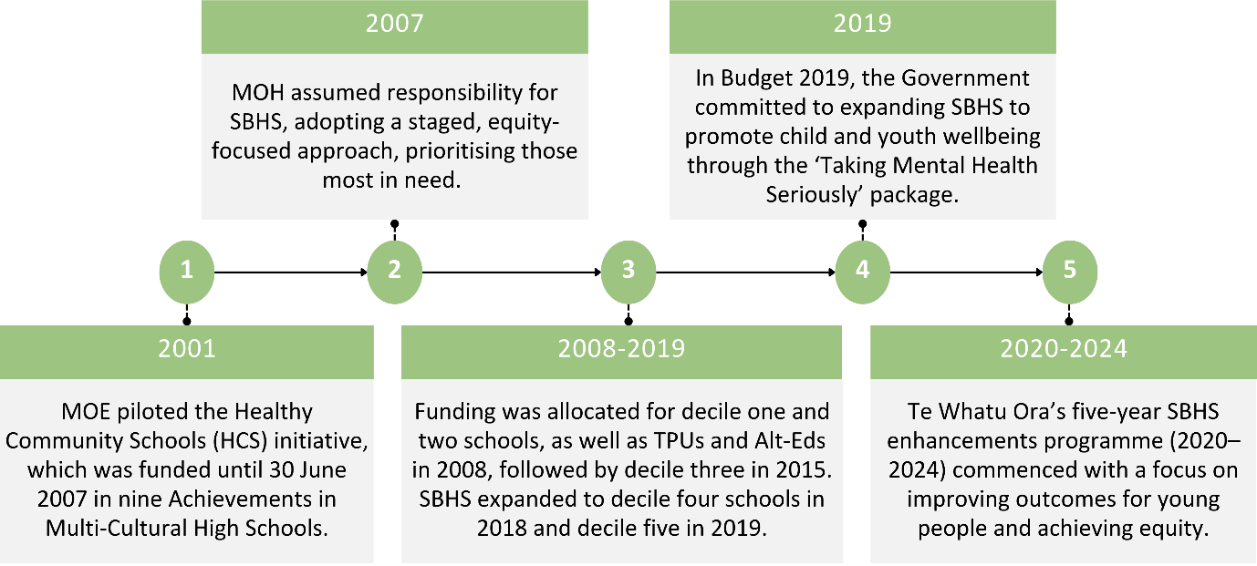
Figure 1: Timeline of key milestones in the development of SBHS

SBHS enhancements programme
The five-year SBHS enhancements programme (2020-2024) is focused on developing the new Te Ūkaipō vision and values framework (Te Ūkaipō) alongside processes and structures that build on previous SBHS work.
What is Te Ūkaipō
Te Ūkaipō vision and values framework underpins the SBHS enhancements programme (2020-2024) and reflects te ao Māori values and principles, Te Tiriti o Waitangi principles, He Korowai Oranga (Māori Health Strategy) and Whakamaua: Māori Health Action Plan.

It incorporates nine kaupapa Māori whanonga pono (values) with corresponding whakataukī (proverb), which guide the commissioning and delivery of SBHS. This Māori-centred approach enhances the ākonga experience of SBHS and ensures services are culturally relevant, inclusive and equitable.
Te Ūkaipō is grounded in mātauranga Māori (Māori knowledge systems). While it is a Māori-centred framework, its values are universal (see Appendix 1 for a description of the values). This allows kaimahi to apply the framework in ways that are meaningful and relevant to the diverse cultural and contextual needs of ākonga and their schools. Kaimahi are encouraged to consider how they connect with, support and develop ākonga in ways that align with their specific context. Depending on the needs of ākonga or the school, it may also be appropriate to incorporate other cultural elements, such as a Pacific language, Muslim prayer or adaptation for ākonga with diverse learning needs, that reflect their values and identities.
The three phases for embedding Te Ūkaipō are briefly outlined in Figure 2.
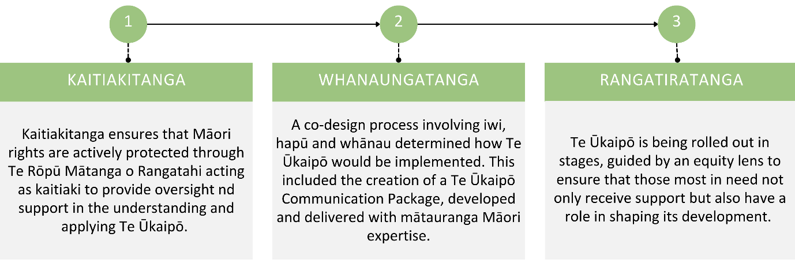
Figure 2: Phases of embedding Te Ūkaipō

Terminology used in this report
For this report, the following terms are used to describe key educational settings and roles:
- Ākonga refers to students.
- Kaimahi refers to the clinicians, including registered nurses, public health nurses, nurse prescribers and nurse practitioners, who deliver SBHS.
- Nurse educator refers to someone responsible for educating and training kaimahi.
- Kura tuarua and schools are used interchangeably and refer to schools that teach students in Years 9 and above, including mainstream secondary schools, Kura Kaupapa, Special Character schools, TPUs and Alt-Eds.
- TPUs refer to Teen Parent Units.
- Alt-Eds refer to Alternative Education sites.

Te Ūkaipō Wānanga Programme
Te Ūkaipō Wānanga Programme aimed to prepare SBHS kaimahi to implement Te Ūkaipō. It aimed to enable SBHS health practitioners, including kaimahi, counsellors, funders and planners to understand the Māori-centred approach to service delivery, apply Te Ūkaipō as a model of care in their practice and enhance the experience of ākonga in SBHS.
Te Ūkaipō Wānanga Programme launched in October 2023 and will run until June 2025. Wānanga participants began by completing an eLearning package in Māori, English or both before attending the wānanga. They then completed in-person wānanga divided into areas aligned with iwi rohe. The wānanga were replicated for Te Whatu Ora District Leads. Wānanga are culturally inclusive, grounded in kaupapa Māori, guided by tikanga Māori and enriched with te reo Māori.
By December 2024, 240 participants had attended ten wānanga across all four Health NZ Districts (Figure 3), with an additional five being planned or finalised.
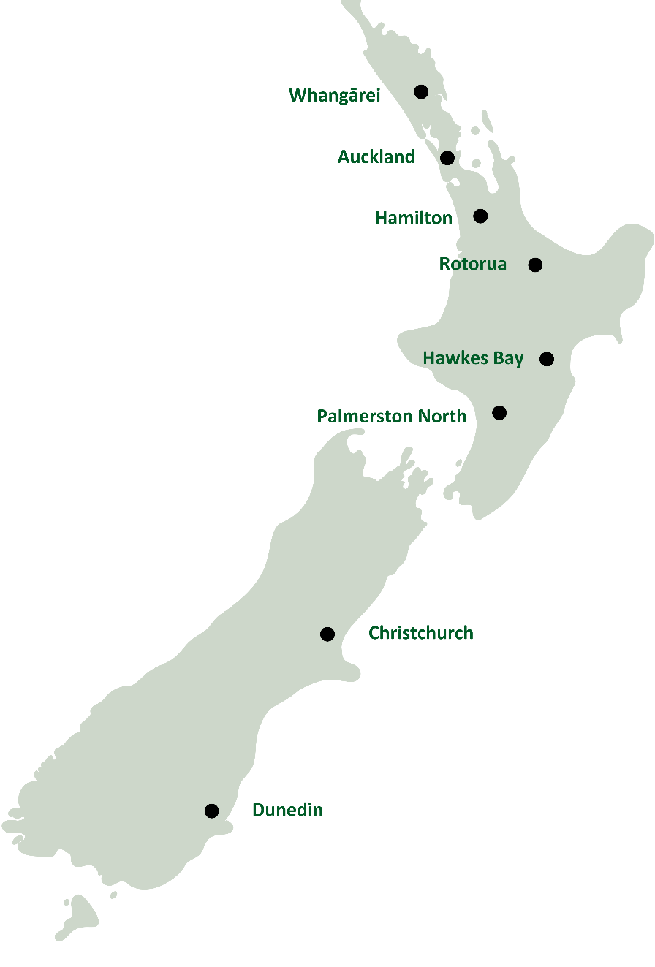
Figure 3: Regions where the wānanga have been held to date

The evaluation
The Ministry of Health – Manatū Hauora (MOH) commissioned TIRIA (previously Malatest International) to provide evaluation and quality improvement insights of SBHS from 2020 to 2024. In 2022, TIRIA published a formative evaluation report that synthesised national and international evidence on SBHS, contextualised SBHS in New Zealand and described its delivery.
This report, also part of the 2020 to 2024 evaluation commissioned by MOH, focuses on the early implementation of Te Ūkaipō and builds on work from the other workstreams. Key components of this evaluation include Te Ūkaipō vision and values framework and the evaluation frameworks (see Appendix 2).

Purpose of this evaluation
The evaluation will address the following questions:
Te Kore | Te Pō | Te Ao Mārama
- How well did the wānanga strengthen kaimahi understanding of Te Ūkaipō values?  - What did kaimahi see as the potential benefits – for themselves, ākonga and kura tuarua? | - How well did kaimahi understand how to apply Te Ūkaipō in their practice?  - What changes did kaimahi plan to make?  - What did kaimahi do to implement Te Ūkaipō?  - What barriers/challenges did kaimahi and kura tuarua encounter in making changes to their practice? How were they overcome?  - How well do challenges alight with the SBHS evaluation framework including Te Ūkaipō values and measures? | - How did the changes made affect the experience of SBHS for ākonga, whānau, kaimahi and kura tuarua?  - How did ākonga, whānau, kaimahi and kura tuarua benefit from the implementation of Te Ūkaipō?

Ethics
The New Zealand Ethics Committee approved the ethics application and the evaluation followed ANZEA best practices in evaluation and Māori and Pacific research guidelines. All data collected were stored in a de-identified form. Reporting protected participant confidentiality and privacy by anonymising information reported. The approach adhered to the principles of Māori data sovereignty.

Information collection
Information collection was initially planned for February to April of 2024. However, the delayed rollout of Te Ūkaipō Wānanga Programme meant kaimahi had not yet completed the training. When data collection commenced between September and November 2024, most kaimahi had minimal time to plan or implement practice changes. Data collection focused on kaimahi from Auckland, Hawke’s Bay and Northland who completed wānanga in late 2023 and early 2024 (Table 1). Interviews were in-depth, conducted by video conference and recorded with participant consent. All stakeholders had the option of being interviewed in te reo Māori, English or both.
Deloitte distributed a post-wānanga online survey to kaimahi who had completed the wānanga training. Twenty participants expressed interest in being contacted. All 20 were invited to participate, with nine responding. Interviews were conducted with these nine participants, three of whom were accompanied by a colleague during their interview.
One case study was conducted after being nominated by the relevant clinician during their interview. We carried out data collection in-person with permission from school leadership.
Table 1: Number of stakeholders interviewed (count of individuals – many interviews were in a group setting)
Role | Region | Number interviewed
Kaimahi (registered nurses, public health nurses, nurse educators) | Northland, Auckland, Hawkes Bay | 12
MOE regional staff | National | 1
Case study – ākonga | TPU | 5
Case study – staff | TPU | 3

Analysis
We analysed information from interviews thematically using the structure provided by the evaluation logic model and framework. The themes are presented according to the life-cycle continuum of Tē Ūkaipō – Te Kore, Te Pō and Te Ao Mārama, with a focus on identifying areas for improvement.
The Life Cycle of Te Ūkaipō
Te Kore, described in te ao Māori as the realm of possibility and infinite potential, is considered the beginning of the journey in Te Ūkaipō and seen as a space of potentiality. Te Pō is described as a place devoid of light and known in te ao Māori as the night realms. In Te Ūkaipō, it is the space of uncertainty, self-reflection and inquiry. Te Ao Mārama, described as the place of understanding and potential realisation, is a time to celebrate the movement and the completion of this moment in the Te Ūkaipō journey while encouraging its continuation.

This report
This report presents findings drawn from interviews with kaimahi in the early stages of Te Ūkaipō implementation. The implementation process is ongoing and many participants had only recently (within the past three-months) completed the Te Ūkaipō Wānanga Programme. More key themes and opportunities to apply the learnings from the wānanga are expected to emerge over time.
While all recommendations relate to SBHS, some may extend beyond the scope of Te Whatu Ora and/or the SBHS team. Change in these areas would require collaboration with other agencies, including MOE and community organisations.

Strengths and limitations
The evaluation was strengthened by:
- The inclusion of different perspectives, which enabled a deeper understanding of Te Ūkaipō implementation and delivery across different settings.
- Māori evaluation leads whose understanding of Māori contexts, worldviews and values facilitated a nuanced analysis of the findings.
- Open communication between the evaluation team and Te Whatu Ora, which provided opportunities to highlight and discuss preliminary findings to inform strategic thinking and planning.
The evaluation was limited by:
- The early stage of Te Ūkaipō rollout and wānanga, which limited the ability to gather school staff, ākonga and whānau feedback. Kaimahi and schools were reluctant to participate in the evaluation because they wanted more time to implement change and realise the benefits.
- The findings represent the views and experiences of those who participated but do not necessarily reflect the experiences of all kaimahi.

Overview of the implementation journey
The figure below illustrates how kaimahi typically progress through implementing Te Ūkaipō values based on their insights. This journey moves through distinct stages – awareness, comfort, confidence and competence – each reflecting increasing depth of understanding and application in practice.
There are members of our team who are using Te Ūkaipō, who are using whanaungatanga etc. and there are those who are still getting their heads around it. We are all at different levels. (Kaimahi)
This framing, shared by kaimahi during interviews, highlights the progression while recognising that regression can occur, particularly if ongoing support is not maintained or complacency sets in. Encouraging self-reflection alongside ongoing support could also help kaimahi stay aligned with Te Ūkaipō. Their implementation journey may begin at any stage depending on their prior knowledge and experience. Understanding these stages can help kaimahi and MOH identify where they currently sit and what is needed to progress further.
Beyond the structured support provided to kaimahi (described in section 1.4), several other factors influence progress, including kaimahi familiarity with tikanga Māori, other work commitments and access to additional supports.
Awareness: Recognising the value of Te Ūkaipō
Kaimahi may initially be unfamiliar or uncertain about the relevance and benefits of integrating Te Ūkaipō values into their practice. Without this understanding, engagement may be limited. Introducing the framework in a way that connects with their existing knowledge and values is key to fostering openness to applying Te Ūkaipō.
Comfort: Building familiarity with the values
In this early stage, kaimahi develop an initial understanding of Te Ūkaipō values but may feel unsure about how to apply them in practice. Limited confidence in tikanga Māori, te reo Māori, or culturally responsive approaches can create hesitancy. Providing opportunities to engage in a safe and supportive way helps build familiarity and ease in applying these values.
Competence: Embedding the values
Kaimahi demonstrate a strong and adaptable application of Te Ūkaipō. They integrate its values seamlessly into their work, drawing on tikanga Māori and other culturally responsive practices to strengthen relationships and enhance outcomes. Regular engagement—such as using te reo Māori, connecting via whanaungatanga or incorporating cultural traditions—reinforces their connection to these values, ensuring their approach remains authentic and sustainable.
Confidence: Applying knowledge in practice
At this stage, kaimahi actively engage with Te Ūkaipō, incorporating its values into their daily interactions. Practical learning opportunities help build their confidence in culturally grounded approaches, whether through tikanga Māori, other cultural frameworks, or broader relationship-centred practice. As their confidence grows, they become more intentional in how they apply these principles to support ākonga and their whānau in different contexts.

Te Kore: Awareness and comfort
Te Kore is about building kaimahi theoretical understanding of Te Ūkaipō, the core values, their significance in a Māori-centred service approach and their broader application. It lays the groundwork for transitioning into a more active, practical engagement with Te Ūkaipō in Te Pō and Te Ao Mārama.

Feedback on the experience of the Wānanga programme
Wānanga feedback collected by Deloitte
The wānanga programme provider (Deloitte) gathered feedback at multiple points throughout the programme, enabling facilitators to adapt the wānanga based on participant insights. This feedback led to more group work and kōrero, supporting participants to better explore how Te Ūkaipō is applied in practice.
Almost all participants felt confident explaining Te Ūkaipō to ākonga or colleagues. Deloitte found that a small number of participants (fewer than five) strongly felt the training was unnecessary. Additionally, Deloitte suggests that some participants viewed the wānanga as a reiteration of the online learning modules and recommended either reducing the wānanga or the modules.

Feedback from kaimahi was consistent with the feedback provided directly to the wānanga provider. Kaimahi generally provided positive feedback on the wānanga, highlighting key strengths including:
- Engaging facilitators: Kaimahi praised the facilitators for their engaging presentation style and ability to create a supportive learning environment. They effectively embodied the values of Te Ūkaipō throughout the wānanga, incorporating activities like karakia and demonstrating manaakitanga in their interactions.
The presenters were dynamic, they created a safe space. They challenged you in really helpful ways. It was probably the best training I've been on in a long time. (Kaimahi)
- The marae setting: Kaimahi felt the marae setting was important, as hosting the wānanga at a marae created a welcoming environment that encouraged meaningful discussions about practice and areas for improvement.
- Trusting relationships: The trusting relationships within teams created a supportive atmosphere where kaimahi felt they could be more open and honest. One team, for example, noted the benefits of being the only group in the wānanga. Their previously established relationships enabled them to have free and frank discussions about each of the values.
The length of the wānanga was challenging for some. The wānanga was commonly described as information overload, with some participants recommending a two-day format to allow adequate time to engage with and understand te reo Māori and tikanga Māori concepts, particularly for those who may be new to working within a Māori cultural framework.
Reviewing the wānanga format and delivery, such as extending its duration and adjusting the balance of online and in-person elements, will help prevent information overload and provide greater opportunities for deeper learning, particularly for those less familiar with working within a Māori cultural framework.

Building awareness of the value of Te Ūkaipō
The interviewed kaimahi started the wānanga programme with different levels of cultural awareness.
Two kaimahi began with a low-level background knowledge of or comfort with te ao Māori. This included a kaimahi who was an immigrant to New Zealand. Another kaimahi had grown up in New Zealand but had less exposure to te ao Māori in their personal and professional lives. One kaimahi, while familiar herself with te ao Māori, spoke about her colleagues being less familiar. Some nurse educators also noted that some kaimahi had limited familiarity with te ao Māori.
Some found the wānanga programme gave them valuable insight into tikanga Māori. The wānanga was an eye-opener, providing greater insight into tikanga Māori that they were unfamiliar with. One kaimahi said they knew the expectations about implementing Te Ūkaipō and the wānanga helped them better understand what works culturally. For one kaimahi who had grown up in New Zealand, the culture comes almost naturally, but the wānanga gave a clearer sense of how to apply these values in their work.
Some kaimahi saw Te Ūkaipō as Māori-specific. This view was expressed when kaimahi did not initially see how Te Ūkaipō fit into their school environment. The wānanga addressed this issue, but a small number of kaimahi continued to hold this view after the wānanga, highlighting the need for more effort to demonstrate its relevance across diverse settings. Some kaimahi viewed Te Ūkaipō as being most relevant to Māori ākonga and Māori settings due to its foundation in mātauranga Māori. Some kaimahi approached its application more literally, focusing on its Māori-specific elements, how it applies to Māori ākonga or within Māori settings, rather than how the values can be meaningfully integrated across diverse practice settings. For example, having te reo Māori signage in a predominantly Pacific school could feel tokenistic. This approach often stems from a misunderstanding of the potential application of Te Ūkaipō Te Reo value. The value is about the role of language in fostering identity and belonging, not just how te reo Māori fosters identity and belonging. In this context, using Pacific languages alongside te reo Māori could have been more meaningful for Pacific ākonga.
A small number of kaimahi were initially resistant to Te Ūkaipō. They either did not see the need to adopt new approaches to change their practice or believed they were already applying the values; in both cases, they saw the wānanga as redundant. Kaimahi acknowledged that a small number of colleagues were initially a little bit grumpy, questioning the need to adopt new approaches when they were confident in their current practice or voicing frustration about the redundancy of the training, feeling as though they were re-learning concepts they were already familiar with. Kaimahi noticed a change of heart in most of these colleagues after they participated in the wānanga.
Kaimahi with a strong cultural understanding found the wānanga programme valuable as a refresher. The content reinforced existing practices and motivated them to continue delivering care with cultural sensitivity. While many kaimahi said it strengthened and affirmed their existing practice, those who recognised its values as universal were more confident adapting it to their practice settings.
Some kaimahi who were already familiar with the values said the wānanga gave them a more nuanced understanding. As one kaimahi reflected, the wānanga made them critically reflect on values like whakapapa and whanaungatanga and how to adapt them to modern contexts, such as working with ākonga who also value confidentiality. They felt encouraged to engage with the values on multiple levels. For example, whakawhanaungatanga not only applied to their work with ākonga, but also applied to building stronger relationships with whānau, colleagues and local support services.
I don't think there were any values that were challenging [to understand], but I've had to adjust the traditional way I've thought of some of them to the youth space. (Kaimahi)

Recommendations to support kaimahi move from Te Kore to Te Pō
When supporting kaimahi to transition from Te Kore to Te Pō it is important to emphasise the universality and relevance of Te Ūkaipō beyond Māori settings. Strengthening cultural capability in te ao Māori will provide kaimahi with the knowledge and confidence to adapt it across different settings and communities.
Recommendation 1: Strengthen cultural capability in te ao Māori for broader application and increase awareness of existing cultural support. Te Ūkaipō is grounded in te ao Māori. Deeper understanding of te ao Māori would equip kaimahi with the knowledge and confidence to adapt the values meaningfully in other contexts, such as supporting Pacific ākonga, promoting inclusion for LGBTQIA+ communities or supporting neurodiverse ākonga. This was particularly important for kaimahi less familiar with Māori culture. Greater awareness of existing support is also needed, as not all kaimahi are aware of what is available – some suggested support that already exists.
This might include:
- Continuing to provide professional development that builds on the knowledge and skills gained from the wānanga to help sustain momentum. For example, opportunities to access cultural mentors, particularly for kaimahi who need hands-on help to deepen their understanding and confidence, and for cluster groups where there is no internal cultural expertise.
- Improving awareness and use of the Dropbox platform so more kaimahi can benefit from existing resources.
- Integrating cultural practices like pōwhiri, mihi whakatau and waiata into routine work activities to normalise these practices and create opportunities to learn by doing.
Recommendation 2: Emphasise the universality of Te Ūkaipō values. While grounded in te ao Māori, Te Ūkaipō values are relevant across different settings and communities. Emphasising their broad relevance will help kaimahi confidently adapt and apply these values to their practice regardless of the setting. This might include:
- Communications that illustrate how Te Ūkaipō can be applied in diverse education settings and contexts to:
- Support identity, belonging and inclusive environments for LGBTQIA+ ākonga
- Recognise sign language as essential to Deaf identity and inclusion
- Strengthen connections with youth subcultures (hip-hop, environmental activism)
- Create safe, inclusive spaces for neurodiverse ākonga.
- Facilitate peer learning opportunities where kaimahi can share how they have successfully applied Te Ūkaipō in various settings.
Te Whatu Ora has engaged a kaitiaki (coordinator) to support kaimahi in embedding Te Ūkaipō into their practice, including:
- Strengthening the relationships between kaimahi and Deloitte.
- Identifying champions who can model and potentially support other kaimahi.
- Supporting kaimahi while recognising that the ongoing relationships will be with their colleagues, ‘champions’, and mentors/clinical leads/managers.
Recommendation 3: Review the length and delivery format of the wānanga. Review the length and delivery format of the wānanga to ensure kaimahi have adequate time for in-depth participation. This could involve adjusting the balance between online and in-person elements and extending the wānanga to a multi-day format. This could help mitigate information overload and provide opportunities for deeper learning, particularly for those less familiar with working within a Māori cultural framework.

Te Pō: Applying knowledge in practice
Te Pō represents the shift from understanding Te Ūkaipō in theory to embedding its values in daily practice.

Stage of implementation
Many kaimahi said they had not yet made changes because they had only recently participated in the wānanga programme. Competing demands, such as winter illnesses, also made it difficult to focus on potential changes. For some, the timing of the wānanga during the school holidays meant that kaimahi went straight into a busy term without the opportunity to reflect on or plan changes, which they expected to address during the next school holiday.

Understanding how to apply the values to practice
While many kaimahi reported a strong understanding of the values underpinning Te Ūkaipō, many also experienced difficulties moving from understanding to application. The wānanga and e-learning material examples were often in a Māori context. Providing more concrete and universal examples of how to apply Te Ūkaipō in practice would support kaimahi application of Te Ūkaipō and help ensure the values are integrated in meaningful and manageable ways. This echoes feedback received by Deloitte, who took steps to incorporate more case studies with practical examples of how to implement Te Ūkaipō.
I think that’s what most people struggled with. They loved the theory; they fully bought into it or already had bought into it, but then they struggled to connect the theory with reality. (Kaimahi)
Familiarity with te ao Māori and tikanga Māori often made it easier for kaimahi to move towards adapting and applying the values to their everyday work.
Balancing relationships between whānau and ākonga. Kaimahi recognised that involving whānau often led to better outcomes for ākonga and they were eager to strengthen these connections. However, they identified two barriers. First, if ākonga did not consent to whānau involvement, kaimahi had to respect their confidentiality. Second, school processes sometimes made it difficult to engage whānau, not just for individual cases but more broadly, at times creating barriers to sharing information about Te Ūkaipō and public health messages.
Challenges balancing whānau engagement with ākonga expectations for confidentiality and limited resources made implementation challenging. More practical guidance about applying Te Ūkaipō in different contexts and strong support structures would help kaimahi implement Te Ūkaipō more effectively.
Familiarity with holistic approaches. Kaimahi working in Alt-Ed, TPUs and other settings where ākonga have high and complex needs were used to working in an integrated and collaborative way. Kaimahi working in these settings were more able to adapt to holistic frameworks like Te Ūkaipō because the broader approach to health and wellbeing and emphasis on collaboration among school staff, kaimahi and referral services aligned well with their existing ways of working.

Practice context for kaimahi
SBHS kaimahi work within a range of different SBHS models and education settings with variation in:
- Working environments: While PHOs or primary/community health care services were the most common employer by school, just under half (42%) of the total FTE allocated to SBHS were employed by schools. See
- Table 2 for a detailed description of employment models for SBHS.
- Education settings: SBHS is funded by Te Whatu Ora in decile one to five secondary schools, kura, TPUs and Alt-Eds, although it is not available in all these settings. As of June 2024, there were 113,003 Year 9 and above (Y9+) students enrolled in Decile 1-5 schools.
- Professional qualification: The SBHS workforce is primarily composed of registered nurses (67%), and nurses account for 94% of FTEs. Of schools which reported having a second kaimahi, the most common profession was a General Practitioner (GP) (44.1%), followed by a registered nurse (38%).

Table 2: Employment models for SBHS workforce (Source: SBHS District Reports, January – June 2024)
Employer type | % of schools | % of SBHS FTE
DHBs: DHBs used the funding to directly employ and/or allocate public health nurses to clinician roles in schools. Clinicians can benefit from full-time employment by working across a combination of schools. DHBs allocate SBHS schools to public health nurses and supplement their SBHS hours by spreading them across multiple schools or allocating time to other public health nurse roles. DHBs also have access to additional resources and funding pools that enable them to better meet the needs of the workforce. | 38% | 25%
Primary/community health care services or PHOs: PHOs or primary/community health care services contracted clinicians to work in schools and, sometimes, contracted nurse educators to support clinicians. The clinicians benefit from the support and infrastructure available from within a health care organisation like access to health IT, supervision and internal networks with other healthcare professionals. | 39% | 30%
Schools: Some schools are funded directly by DHBs to employ a clinician. In this model, the clinician is dedicated to the school and the school controls who works within their school. This enables schools to select clinicians familiar with their community or with similar demographic profiles. | 14% | 42%
NGOs: Some DHBs contracted NGOs to employ some or all of the clinicians. Examples included Youth One Stop Shops with other health contracts, kaupapa Māori organisations delivering social services and other health and social service providers. Using NGOs allowed DHBs to fill in gaps in their own coverage, whether they were geographic or related to the clinician expertise (for example contracting a kaupapa Māori NGO to deliver SBHS in kura because they had Māori clinicians fluent in te reo). | 9% | 4%
Differences in settings, professional qualifications and employers create variation in the barriers and enablers for implementing Te Ūkaipō and expectations around the potential impacts of the programme. What might have been an existing practice before Te Ūkaipō in one setting could be a significant new improvement resulting from Te Ūkaipō in another.
For example, some kaimahi described making clinical spaces more welcoming by putting up multi-lingual posters after the Te Ūkaipō wānanga. This was one way to make services more relevant and welcoming for ākonga. That was already in place in some schools to make SBHS more accessible but was a step forward for some kaimahi as a result of Te Ūkaipō.

Enablers and barriers to change
Kaimahi identified enablers and barriers to implementing change related to their working environments, school environments and their own backgrounds.
Familiarity with holistic approaches. Kaimahi working in Alt-Ed, TPUs and other settings where ākonga have high and complex needs were used to working in an integrated and collaborative way. This prepared them to adapt the holistic approach of Te Ūkaipō. They already promoted a broader approach to health and wellbeing and emphasised collaboration with school staff and referral services.
Employment as part of a healthcare team. Kaimahi who were part of a broader healthcare team had access to additional support and found it easier to move towards practice change.
Support from leadership: Some described how having a team leader who championed Te Ūkaipō regionally helped ensure all kaimahi could make changes to their practice. For example, including Te Ūkaipō as a standing agenda item at cluster meetings helped keep everyone accountable and provided opportunities to reflect regularly on its application.
Relationships between school and kaimahi. Strong relationships between school staff (such as counsellors, cultural advisors, deans and pastoral leaders) and kaimahi helped implement changes. Strong relationships were characterised by the use of shared resources and regular communication, such as the use of shared online documents (e.g. Google Docs) to flag students of concern. This ongoing collaboration allowed kaimahi to check in with ākonga of concern, allowing for emerging concerns to be addressed promptly.
I feel comfortable having the conversations with those rangatahi [young people] because our pastoral leader at school has a working Google document, and if there are students of concern in any year group, it gets flagged. I check that every week, so if there are things that come up in the students I see regularly, I'll take that opportunity to check in with them as well. (Kaimahi)
Implementing changes was more challenging where kaimahi worked in isolation from school staff. If schools do not understand why kaimahi are working to change their practice, they may hinder implementation. For example, by restricting access to kaimahi or resisting efforts to make consultation spaces inviting, out of concern ākonga will see it as a space that’s an alternative to being in class. Since COVID-19, schools have placed a stronger focus on attendance and there is sometimes a perception that Te Ūkaipō interferes with this.
The senior leadership team and the teaching culture are barriers for me to do a lot of things … because I’ve been busy, they made a unilateral decision to say no student can see me without seeing the Dean first, and the Dean's going to decide if they're sick or not. Now, that's ridiculous. It's a barrier. It's very intimidating, especially for the junior kids. (Kaimahi)
Alignment of school values with Te Ūkaipō. Schools with a shared approach to student wellbeing made it easier for kaimahi to implement Te Ūkaipō. While there may not have been a deep understanding of Te Ūkaipō, the shared focus on values such as whanaungatanga, whakapapa and manaakitanga meant schools naturally reflected Te Ūkaipō values in their engagement with ākonga.
However, the introduction of Te Ūkaipō to schools was inconsistent. Not all kaimahi introduced Te Ūkaipō and without a national strategy for engagement, schools varied in their awareness. Some kaimahi shared the framework with school leadership and staff, but many schools appeared to lack a clear understanding, making it harder to implement Te Ūkaipō effectively.
Resource challenges: Some kaimahi saw Te Ūkaipō as an additional responsibility within an already demanding role. Balancing what they saw as new expectations with existing duties was perceived as a challenge, especially in environments where time and resources were already stretched thin.
It’s been a perfect storm. With winter, I’m seeing double the number of students I’d normally see. Te Ūkaipō is not my top priority. I could be doing things in my time off, but … boundaries. (Kaimahi)

Recent changes to practice consistent with Te Ūkaipō
Some kaimahi reported they had already ticked off changes suggested during the wānanga, as they were already practicing in ways consistent with Te Ūkaipō values. Many of the changes were also described in the 2022 Formative Evaluation Report, showing continuity in approach and ongoing commitment to improving ākonga experiences. For example:
Improving physical space
- 2022 findings: The physical location and layout of SBHS are important in creating an environment that fosters positive experiences and engagement for ākonga.
- 2024 implementation example: I switched my [consultation] space up to be more youth-oriented. I have useful stuff for them to read on the wall and things like that. Prior to that, I just put up whatever I had, but now I think a lot harder about the language of posters and what type of stuff goes in and around the clinic. (Kaimahi)
Supporting privacy
- 2022: Services offered multiple access points, including bookings, drop-ins and text contact.
- 2024 – We’ve got doors that close and now we try and play music in the waiting room to flush out the noise so that students feel comfortable coming to see us from a privacy aspect. (Kaimahi)
Expanding health promotion
- 2022 - Efforts ranged from informal conversations to structured sessions, aiming to improve health literacy and empower ākonga to navigate healthy systems.
- 2024 – With the whooping cough outbreak we’ve got at the moment, she was able to talk into that, same with the meningitis outbreak. (TPU staff)
Including ākonga voice
- 2022: Many schools had student wellbeing groups that could provide a ākonga perspective on the services delivered under SBHS.
- 2024: We use a survey. I've got a QR code that I have on the front of the door. I'm always encouraging them to fill out a survey and we send it out as well throughout the year, just to see if we get some feedback. It doesn't always happen, but we get some stuff back. (Kaimahi)

Changes prompted by the introduction of Te Ūkaipō
This section explores the changes kaimahi have made as part of the Te Ūkaipō shift and their wānanga experience. These include feeling affirmed in their holistic, relationship-centred approach, creating more welcoming and inclusive spaces, strengthening referral networks and integrating more te reo Māori and cultural practices into their work. Kaimahi also feel empowered to address holistic health needs, while ākonga are supported to exercise rangatiratanga for their wellbeing.
Legitimised holistic, relationship-centred practices. For many kaimahi, Te Ūkaipō did not mean introducing new ways of working but instead validated or reinforced their existing approach. One kaimahi noted that it finally feels like someone understands youth health. Before, they had been criticised for doing too much, like going beyond clinical duties to provide small acts of care, such as bringing a ākonga their favourite comfort food during a difficult time. They reflected that Te Ūkaipō gave them confidence that these practices aligned with a recognised framework and contributed to better outcomes for ākonga.
I had a young person who I had been working with for over a year and had been through a horrific sexual assault. This one day was a particularly hard one, so I asked, is there a comfort food I can get you? …I got hauled over the coals by my colleagues, who said, ‘you shouldn’t be doing that kind of thing’. It’s those little things that no one in Western medicine puts any value on. With Te Ūkaipō, I can say, ‘actually, there’s a theoretical framework I’m working from, and it’s proven to support healthier outcomes for young people’. … Some days are so f**ked up that there’s literally nothing you can clinically do … you have to think outside the box and now I have Te Ūkaipō. (Kaimahi)
A similar sentiment was expressed by another kaimahi who adapted their approach by engaging with ākonga in more informal settings such as the school quad, going for a walk outside, or throwing a basketball around. They recognised that ākonga might not be comfortable sitting there with face-to-face eye contact, talking about intimate things. This shift from a traditional clinical setting to a more relational and flexible approach reflects how Te Ūkaipō supports relationship-based practices, prioritising connection over maintaining the status quo.
Created more welcoming spaces. Kaimahi reflected on how to make ākonga feel valued and supported, especially in formal settings where they might feel out of place. Recognising that the physical environment plays a significant role in creating comfort and trust, they have introduced small but meaningful changes like placing saris over the couch, putting posters up and offering fidget toys to help ākonga relax during appointments.
Sometimes you just sit down and you think, ‘okay, haere mai, come in’, and you're not thinking about what the space is like. So, I have made a concerted effort to make it a really cool space. I put saris over the couch, stuck some posters up and had the fidget toys [available]. Definitely, all of us thought we should make a bigger effort to manaakitanga and create a welcoming space. (Kaimahi)
Created more inclusive spaces. Kaimahi understanding of manaakitanga has broadened beyond hospitality and offering physical comfort to fostering an environment where ākonga can fully engage without feeling out of place. This has led to kaimahi making deliberate changes to create more inclusive environments. In one example, kaimahi secured a van and put up rainbow stickers and multilingual posters, demonstrating a conscious effort to celebrate diversity and ensure ākonga feel respected and valued.
In some of the school clinics, their sick bays are very small rooms, or you’re just shoved in a little store room. [Name] was able to push for a van. Now we can take the van to these spaces. We've thought about how we create manaakitanga in this space so that our young people can feel valued. We’ve got some rainbow banners to stick in there. We've got posters that have different languages on them. So, being inclusive, rather than just being a space that's clinical. Manaakitanga, I thought, meant you make someone a cup of tea. But it's way more than that. It’s creating the space where that rangatahi is valued. (Kaimahi)
Kaimahi have already noticed that when ākonga feel safe and supported, they are more likely to open up about their concerns.
When young people feel safe, supported, cared for and loved, what might start as a minor issue can turn into a bigger disclosure. They open up because they feel respected. (Kaimahi)
Empowered to address holistic health needs. Kaimahi highlighted the complex needs of ākonga, noting that Te Ūkaipō empowered them to look beyond immediate health needs to broader factors affecting wellbeing. This approach enabled kaimahi to address underlying issues, such as food security, life skills and other personal circumstances, rather than focusing on symptoms. For ākonga, this created a safe, caring environment, encouraging them to open up about other challenges. By shifting the focus to the root causes of these issues, Te Ūkaipō contributed to improved health outcomes and enhanced overall support for ākonga.
Something that has come out of trying to implement Te Ūkaipō and really getting to know them and what’s on top for them is that some of these young people say, ‘We have food in the house, but I don’t know how to cook that. Mum works the night shift and I don't know what I'm going to make my siblings for dinner’… You make the assumption that they do have food at home or they are being looked after by whoever is meant to be caring for them, but what’s come out of Te Ūkaipō is that I’m not just there for their cut or graze. What else is going on [beneath the surface]? (Kaimahi)
Strengthened referral networks. Kaimahi prioritised building strong relationships with referral services to ensure ākonga get the help they need beyond what the school can offer. By fostering trust and consistent communication with these services, they have seen a higher success rate in referrals. This focus on building relationships has allowed them to better meet the needs of ākonga, particularly when more specialised support is required. However, these strengthened relationships with referral agencies have also highlighted challenges such as lack of support services, service at full capacity or services that are not easily accessible due to distance or transport issues, which are discussed further in Section 7.1.
Integrated more Māori language and practices into interactions. Many kaimahi reported incorporating more Māori language and practices into the workplace, both with ākonga and colleagues. This included taking formal te reo Māori classes, normalising Māori kupu as operational language, learning karakia and waiata, and practising with cluster groups and colleagues. While they may not use these in every interaction with ākonga, they saw regular practice as a way to build confidence. Over time, this would help them feel more comfortable and prepared when called on to use these skills.
I've seen the growth within our team because now we're intentionally implementing things like karakia to build confidence. Now those resources are in the kete [basket] for staff to refer back to and it's a safe space for us to practice together. (Kaimahi)
Empowered ākonga through rangatiratanga. One kaimahi adapted their assessment approach to allow ākonga to lead conversations rather than kaimahi sticking to a fixed set of questions. This shift gets documented in clinical notes, where kaimahi explicitly state that the ākonga led the conversation, ensuring that their voice remains central.

Moving from Te Pō into Te Ao Mārama
To support the transition from Te Pō to Te Ao Mārama, more guidance is needed to help kaimahi apply Te Ūkaipō values across diverse settings. Greater collaboration between MOH, Te Whatu Ora and MOE will help address misconceptions that Te Ūkaipō might hinder rather than support education. A whole-school approach will ensure Te Ūkaipō values are embedded beyond individual kaimahi. Future wānanga should include practical strategies for engaging whānau while respecting ākonga privacy and finally, addressing workload and resource constraints is important to ensure kaimahi can implement changes effectively.
Recommendation 4: Provide more practical guidance around how Te Ūkaipō values can be applied across diverse settings. There is a loud call for direction on how Te Ūkaipō values can be implemented into everyday clinical practice in a way that is both meaningful and manageable. This might include:
- Developing and sharing case studies that show how Te Ūkaipō has been applied in different settings. Case studies could include scenarios from different settings, showcasing how the values were implemented in each setting.
- Encouraging kaimahi to share effective examples of implementation to build collective knowledge of best practices, motivate others to apply the values in their own work and demonstrate how similar challenges have been navigated.
Recommendation 5: Strengthen the collaboration between Te Whatu Ora and MOE to support the integration of Te Ūkaipō. By working more closely together, both sectors can send a consistent message that Te Ūkaipō supports education, not hinders it. This will help address concerns some school staff may have, such as thinking that Te Ūkaipō is being used as an excuse for students to skip class or that it distracts from learning. A unified approach will make it easier to implement Te Ūkaipō values when they are widely adopted across the education sector.
Recommendation 6: Support a whole-school approach to integrating Te Ūkaipō. For kaimahi to confidently implement Te Ūkaipō values, it is important that the wider school community (leadership, staff and whānau) understand and support them. When the whole school embraces the values, it creates a more supportive environment for kaimahi to incorporate them into their practice. A whole-school approach also ensures that Te Ūkaipō is not dependent on a few people to drive and maintain change. This could include:
- Providing resources to help kaimahi explain Te Ūkaipō to the wider school community. This could include sharing information about Te Ūkaipō through newsletters, school notices and emails to keep people informed.
- Creating a resource hub where schools can access information about Te Ūkaipō and practical suggestions for making changes, allowing them to learn and implement ideas at their own pace.
- Encouraging the alignment of Te Ūkaipō with existing school values by showing how it’s concepts like whanaungatanga can match existing values such as family connection, even if they use different language.
- Sharing success stories so the school community can learn from real-life examples and see the positive impact of Te Ūkaipō in action.
Te Whatu Ora is exploring ways to engage directly with MOE and schools to promote a greater understanding of SBHS and how Te Ūkaipō aligns with their values. Future communications will prioritise strengthening relationships with the wider school community to promote Te Ūkaipō as part of a collaborative approach (between health and education) to student wellbeing.
Recommendation 7: Strengthen whānau engagement strategies in the wānanga to build kaimahi confidence working with whānau. Future training should provide kaimahi with practical strategies and examples that support whānau involvement while maintaining ākonga privacy. Acknowledging the challenges nurses face when ākonga choose not to involve their whānau and providing tools for navigating this is important.
As part of the Child and Youth Wellbeing Strategy, Te Whatu Ora launched He Tuinga Aroha, a campaign for ākonga Māori and their whānau, highlighting the protective benefits of strong communication within families. Including resources like this could help kaimahi navigate conversations with ākonga and their whānau more effectively.
Recommendation 8: Manage workload and resource limitations. Kaimahi already work at full capacity, making planning or implementing new practices difficult. The extra workload involved in introducing Te Ūkaipō changes adds to this with limited time and resources, making it even more challenging. This might include:
- Allocating dedicated time for planning and implementing Te Ūkaipō practices.
- Providing additional funding to support the implementation would ensure schools can adopt these changes without impacting other areas of the kaimahi budget. A modest investment in this area could help reduce future costs by improving ākonga wellbeing and easing the pressure on other support services.

What worked: Examples of success
The case study below highlights the implementation of Te Ūkaipō values within a TPU, drawing on interviews with kaimahi (2), TPU staff (3) and ākonga (5). The TPU, which supports ākonga with diverse needs and levels of whānau support, offers a holistic support system through a team of professionals, including SBHS kaimahi, social workers and a counsellor. At the time of the case study, the TPU was supporting 20 ākonga, including a few males. The TPU prioritises a holistic model integrating physical, mental and social wellbeing.
Suzy, a Māori nurse practitioner and kaimahi at the TPU for eight years, lives in the community she serves. She also works at several local high schools and kura kaupapa, providing consistent and reliable care to ākonga.
Suzy and her team took part in the first wānanga, which also served as a trial run, helping the deliverers refine their approach. Since all the participants were part of the one clinical team, they were able to go straight into the kaupapa rather than build up the comfort and security and safety first. Suzy also contributed to developing the training material, giving her more time than others to familiarise herself with Te Ūkaipō.
While her manager did not attend the wānanga, they have been very supportive. After the wānanga, her team introduced regular waiata practices, incorporated karakia into meetings and now use quarterly team hui to identify and discuss how Te Ūkaipō values are applied in practice. Given there were a number of non-Māori in their team, these steps were important in developing the confidence and competence of everyone so the theory they had learnt in the wānanga could flow into their practice. For Suzy, Te Ūkaipō values were already familiar – being Māori and having grown up in a predominantly Māori community, she had lived them long before learning about them formally – It all makes so much sense to us, perhaps because we grew up with these values. (Suzy)


Teen Parent Unit
Case Study

A holistic approach
The TPU’s holistic ethos aligned with the values of Te Ūkaipō, recognising that wellbeing encompassed education and physical, mental, and social wellbeing.
Suzy played a key role in supporting the wider wellbeing of ākonga. She often acted as a bridge from the TPU to community services. As a nurse practitioner, she also provided direct advice to ākonga and their whānau.
In a recent example, an ākonga came in with cellulitis after missing a week of school. They had no adult support at home. Suzy stepped in, making sure the ākonga got the care they needed to focus at school.
A number of ākonga also seek Suzy’s advice for issues like sick pēpē and vaccinations, particularly when they cannot get GP appointments because the doctors are too busy.
For many ākonga, accessing healthcare was about knowing where to go and knowing how to navigate the system. Not all ākonga have a safe or reliable adult in their lives to teach them.
Suzy helped them with the practical parts of accessing healthcare, including how to call and make a dentist appointment and enrol with a GP. Suzy also helped with what to ask when they saw a doctor. A TPU staff member described how the ākonga often did not have some of the basic life skills their peers took for granted, but had experienced more of life’s hardships.
Ākonga did not need to make an appointment to see Suzy. Her office had two doors. One opened directly from the learning space, providing easy access for those who felt comfortable using it. The other allowed them to approach Suzy without having to walk into the classroom. This setup ensured ākonga could access care discreetly and without any added stress.
A key part of Suzy’s work was addressing the deep mistrust ākonga and whānau had toward the healthcare system. Ākonga often arrived with experiences of not being listened to or taken seriously, shaped by intergenerational distrust. Before offering care, Suzy must first build trust. As one ākonga shared:
“Having that safe space is really important because that allows you to open up, but you want to be able to open up in your own time. So having that patience, being able to talk about anything—not just the health stuff—but building that relationship first, so that you’re confident to talk about the health stuff, knowing that she’s available.” – Ākonga
Health challenges sat alongside food insecurity, overcrowded homes, and other daily stresses for many ākonga. Suzy ensured they were connected to the right doctors who would listen and take them seriously. As one TPU staff member put it:
“She has the relationships within the community, she knows the right place for our students to go, where they’re going to be listened to and have their needs met.” – TPU staff
Te Ūkaipō values demonstrated:
- Aroha – Love & Compassion
- Rangatiratanga – Autonomy
- Whakapapa – Identity
- Manaakitanga – Nurturing
- Ōritetanga – Equality
Holistic support: A comprehensive approach that integrates health, education, and social wellbeing enables ākonga to thrive in all aspects of life.
Building trust: Many Māori have experienced generations of being dismissed or ignored by the health system. A patient, relationship-based approach helps rebuild trust and ensure ākonga feel heard and respected.
Navigating healthcare systems: Teaching ākonga how to book appointments, enrol with a GP, and advocate for themselves in medical settings is a crucial part of ensuring long-term access to care.
Accessible healthcare: Creating multiple access points to services ensures ākonga can access support in a way that feels comfortable and respectful.
Acknowledging life experience: While some ākonga may lack what many consider ‘basic’ life skills, they have often experienced more hardship and responsibility than their peers. Services should acknowledge this complexity when supporting ākonga.
Health in the context of wider challenges: Food insecurity, housing instability, and other social factors shape health outcomes. Effective healthcare must be responsive to these realities, ensuring ākonga receive the wraparound support they need.

TPU Ākonga
Case Study

Rebuilding trust in healthcare
Before meeting Suzy, Marlene often avoided seeking help for her mental and physical health. A previous breach of confidentiality at a doctor’s office left her in an unsafe situation, and without a supportive whānau, she struggled to access care.
Over time, Suzy’s gentle, understanding, and patient approach helped Marlene rebuild trust in healthcare. Suzy eventually connected her with a local GP who shared the same values and approach to youth health, ensuring Marlene received the care she needed in a safe and supportive environment.
One of the most important things Suzy did was accompany Marlene to her mental health appointments. Having Suzy there eased her anxiety about repeatedly retelling her story. Suzy also provided options, such as bringing another support person, which helped Marlene feel more in control.
Now, Marlene feels confident managing her health and taking her child to the doctor. She described herself as so much better and credits Suzy for empowering her towards independence.
With the support of Suzy and the TPU staff, Marlene has also found independent accommodation, which she describes as giving her safety, stability, and consistency.
“I probably would have dropped out of school. I wouldn’t have the confidence to get the proper healthcare that I need. I just can’t imagine my life, thinking what it is now, without Suzy.” – Marlene
Te Ūkaipō values demonstrated:
- Tino Uaratanga – Potential
- Rangatiratanga – Autonomy
- Whakapapa – Identity
- Te Reo – Language
Trusted relationships matter: Long-term, consistent relationships with kaimahi help rangatahi feel safe accessing support.
Flexibility: Healthcare that adapts to the needs of rangatahi, including warm handovers to appropriate providers, improves access to support.


TPU Ākonga
Case Study

Overcoming barriers to healthcare
For Aroha, accessing healthcare was often difficult due to cost, long travel distance and the challenge of finding time with a toddler in tow. Past experiences left her feeling unheard by doctors, particularly when discussing sensitive health concerns.
Having Suzy on-site provided her with free, approachable healthcare in a familiar and convenient setting. With pēpē cared for during school hours, she could focus on her own wellbeing.
Suzy created a safe and supportive space for Aroha, ensuring she felt listened to and respected.
When Aroha expressed discomfort with male doctors, Suzy arranged a warm handover to a female GP.
Through Suzy’s support, Aroha accessed the care she needed and gained the confidence to advocate for herself in the healthcare system.
“I was able to get a lot of answers and a lot of follow-up. She put me in touch with [female GP] so I can get the proper care that I need now.” – Aroha
Te Ūkaipō values demonstrated:
- Aroha – Love & Compassion
- Ōritetanga – Equality
- Whakapapa – Identity
Addressing barriers: Identifying barriers like cost, travel and childcare ensures ākonga can access care when needed.
Tailored support: Offering options, such as gender-specific providers, helps ākonga feel comfortable and in control.

Te Ao Mārama: Embedding practice changes

Embedding practice change
Kaimahi and nurse educators identified key supports for embedding practice changes, including refresher training, a structured onboarding process for new kaimahi, whole teams participating in wānanga together and addressing the availability of services for referrals.
Refresher training and onboarding: Nurse educators emphasised the importance of supporting kaimahi to sustain wānanga learning once they returned to work. Follow-up sessions after the wānanga would help to maintain momentum. A common request was refresher training to reinforce key concepts and kaimahi appreciated the opportunity to access additional cultural mentoring. Nurse educators were concerned responsibility to keep [Te Ūkaipō] alive may fall on their roles.
Nurse educators also thought a Te Ūkaipō onboarding system for new kaimahi was important to build a consistent understanding of Te Ūkaipō values across their teams.
It’s about sustainability because there are so many programmes out there that have been available, but it’s like you’re taught all this, and then there’s nothing afterwards. That’s what’s been so good about having [Kaitaki Coordinator] employed, so she can come to the cluster groups and make herself available. (Nurse educator)
Encouraging whole teams to attend: Kaimahi wanted their managers to attend the wānanga as well so they could support Te Ūkaipō across their teams. Managers needed to understand Te Ūkaipō so they could support kaimahi and align organisational goals with Te Ūkaipō outcomes.
Access to referral services: The holistic approach central to Te Ūkaipō emphasises caring for the whole ākonga, making timely and appropriate referral services important. However, kaimahi reported limited availability of local services and long wait times hindered their ability to connect ākonga with the holistic care Te Ūkaipō envisioned. Without adequate referral options, kaimahi could struggle to follow through on their intended care. Addressing gaps in referral services—whether by advocating for better service availability, strengthening community networks, improving referral processes, or finding alternative support channels—is an important part of embedding the holistic approach of Te Ūkaipō.

Embedding and sustaining Te Ao Mārama
Recommendation 9: Explore options for regular ongoing support. Sustaining learning and progress from the wānanga could be strengthened by regular ongoing support such as refresher training or follow-up sessions. These sessions could reinforce key concepts, maintain momentum and ease the burden on nurse educators by sharing the responsibility. Examples include:
- Allocating dedicated time for follow-up sessions to ensure kaimahi can revisit and reflect on key learnings.
- Continuing to provide professional development that builds on the knowledge and skills gained from the wānanga to help sustain momentum.
- Integrating ongoing support sessions with existing professional development to avoid creating additional workload for kaimahi.
Recommendation 10: Including Te Ūkaipō in onboarding systems for new kaimahi. Ensure new kaimahi have a consistent understanding of Te Ūkaipō values and how to apply them including training on the values, practical examples of their application and ongoing support to reinforce learning.
Recommendation 11: Address challenges related to access to referral agencies. Some kaimahi faced challenges accessing referral services for ākonga due to long travel distances or waiting lists. Finding local solutions, like strengthening partnerships with community-based services or providing more support in remote areas, could help ākonga and their whānau get the help they need when needed. Without these support structures, kaimahi may find it harder to apply Te Ūkaipō values effectively, which could diminish their impact over time.

Summary of key findings and recommendations

Summary of findings
Te Kore: Awareness and comfort
Te Kore is about deepening kaimahi theoretical understanding of Te Ūkaipō, the core values, their significance in a Māori-centred service approach and their broader application. Kaimahi implementation journeys may begin at any stage, depending on their prior knowledge and experience. Progress is also dependant on practice settings and contexts and the availability of ongoing support.
Overall kaimahi feedback on the delivery of the wānanga programme was positive, highlighting key strengths such as engaging facilitators, a setting (marae) that encouraged meaningful discussions and trusting team relationships which enabled free and frank discussion. However, some kaimahi suggested extending the wānanga to two days to allow more time for engaging with tikanga Māori concepts. Kaimahi feedback is important for ensuring the programme content remains relevant, responsive and effective in meeting kaimahi and ultimately ākonga needs.
Kaimahi started the wānanga programme with different levels of cultural awareness. For kaimahi with lower awareness of te ao Māori, the wānanga provided valuable insights into tikanga Māori. Some viewed Te Ūkaipō as Māori-specific, highlighting the need to demonstrate its relevance across all settings and with all young people. A small number of kaimahi were initially resistant, either not seeing the need to adopt new approaches or believing they were already applying the values.
Kaimahi with strong cultural understanding still found the wānanga programme valuable as a refresher for their existing knowledge. Some also said the wānanga deepened their understanding of the values, encouraging a more nuanced approach to values like whakapapa and whanaungatanga, applying them with ākonga, whānau, colleagues and support services.
A shared point of feedback across kaimahi was the desire for more practical guidance about applying Te Ūkaipō in different contexts and strong support structures to help kaimahi implement Te Ūkaipō more effectively.
Te Pō: Applying knowledge in practice
The wānanga programme was ongoing and kaimahi who have participated are in the early stages of making changes to their practice. It was too early to assess how well the changes aligned with the SBHS evaluation framework and Te Ūkaipō values.
Progress so far and the enthusiasm and support from kaimahi for Te Ūkaipō suggest good alignment with Te Ūkaipō values. As implementation continues and kaimahi move through the stages of Te Kore, Te Pō and Te Ao Mārama a clearer picture of alignment with the framework will emerge.
The extent of changes following the wānanga varied. Many kaimahi had not yet made changes following the wānanga, with competing demands and the timing of the wānanga during school holidays limiting opportunities for reflection and planning.
While many kaimahi understood the values, they also found it challenging to apply them in practice, particularly in non-Māori contexts. SBHS kaimahi come from different backgrounds and practice in different models, education settings. These factors influenced how kaimahi applied Te Ūkaipō. Making practice changes depended on kaimahi moving past a general understanding of the values to understanding how to apply them in their own unique settings.
Strong leadership from employers and colleagues enabled practice change. Familiarity with te ao Māori, holistic approaches and working in schools that aligned with Te Ūkaipō values also made implementing the values easier. Lower levels of buy-in from schools, challenges balancing whānau engagement with ākonga expectations for confidentiality and limited resources made change more difficult.
Kaimahi described the impact of Te Ūkaipō on their practice. Where kaimahi had made changes, they aligned with Te Ūkaipō values on inclusivity and creating culturally safe environments. Some had already ticked off changes suggested during the wānanga, as they were already practicing in ways consistent with Te Ūkaipō values. Others kaimahi had made changes as a direct result of the wānanga or intended to implement change. Many felt affirmed in their holistic, relationship-centred approach and took steps to create more welcoming and inclusive spaces, strengthen referral networks and integrate more te reo Māori and cultural practices into their work. Some reported feeling more empowered to address holistic health, while others noted that ākonga were better supported to make decisions about their wellbeing. Examples of planned but not yet implemented changes included involving whānau and getting ākonga feedback, showing a commitment to whanaungatanga and ongoing reflection and growth.
More guidance was needed to help kaimahi apply Te Ūkaipō values across diverse settings. Greater collaboration between MOH, Te Whatu Ora and MOE will help address misconceptions that Te Ūkaipō might hinder rather than support education. A whole-school approach will ensure Te Ūkaipō values are embedded beyond individual kaimahi. Future wānanga should include practical strategies for engaging whānau while respecting ākonga privacy and finally, addressing workload and resource constraints is important to ensure kaimahi can implement changes effectively.

Learnings from the case study
The case study explored how kaimahi implemented Te Ūkaipō values in a TPU supporting ākonga with varied and sometimes complex needs. Interviews with kaimahi, TPU staff and ākonga provided valuable insights that may offer guidance and inspiration for implementing Te Ūkaipō in other settings. The case study highlighted the importance of:
- Trusted relationships with kaimahi, which help ākonga feel safe accessing support
- Flexibility in healthcare, including warm handovers, improves support access
- Addressing barriers like cost and travel ensures ākonga can access care in respectful, comfortable settings
- Tailored support, such as gender-specific provider referrals, increases comfort and control
- Navigating healthcare systems is crucial for empowering ākonga in self-advocacy
- Acknowledging life experience, including hardships, helps provide appropriate support
- Understanding health exists within broader challenges means addressing social factors shaping outcomes.
Te Ao Mārama: Embedding practice changes
Establishing a comprehensive onboarding system for kaimahi could ensure a consistent understanding of Te Ūkaipō values. Ongoing support should be provided regularly to reinforce key concepts and maintain momentum. Additionally, addressing challenges related to referral services is important as long travel distances and waiting lists have hindered some kaimahi in delivering timely care. Addressing these areas will help ensure the continued success of Te Ūkaipō.

Summary of recommendations
These recommendations are designed to support kaimahi in their journey from Te Kore through Te Pō and into Te Ao Mārama, helping to embed Te Ūkaipō values into everyday practice. Some recommendations may extend beyond the scope of the MOH and Te Whatu Ora, requiring collaboration with other agencies, including the MOE and community organisations to ensure successful implementation.
 | Recommendation | Details
Moving from Te Kore into Te Pō
1 | Strengthen cultural capability in te ao Māori and increase awareness of existing cultural support. | A deeper understanding of the foundation of Te Ūkaipō in te ao Māori will give kaimahi the confidence to apply it meaningfully in various contexts.
2 | Emphasise the universality of Te Ūkaipō values. | Ensuring kaimahi understand that Te Ūkaipō values apply across different communities and settings will support confident adaptation in practice.
3 | Review the length and delivery format of the wānanga. | Refining the balance of online and in-person elements and extending the wānanga timeframe may help kaimahi engage more deeply and avoid information overload.
Moving from Te Pō into Te Ao Mārama
4 | Provide more practical guidance around how Te Ūkaipō values can be applied across diverse settings. | Kaimahi need specific, practical strategies to integrate the values into clinical settings that are meaningful and manageable.
5 | Strengthen the collaboration between Te Whatu Ora and MOE to support the integration of Te Ūkaipō. | A coordinated approach across health and education sectors will reinforce Te Ūkaipō as an enabler of learning not a disruption.
6 | Support a whole-school approach to integrating Te Ūkaipō. | Encouraging schools and whānau to embrace Te Ūkaipō will create a more supportive environment for kaimahi and support long-term change.
7 | Strengthen whānau engagement strategies. | Kaimahi need practical strategies for working effectively with whānau, including managing situations where ākonga prefer to maintain privacy.
8 | Manage workload and resource limitations. | Recognising kaimahi capacity limits and ensuring appropriate resourcing will support sustainable implementation of Te Ūkaipō
Sustaining Te Ao Mārama
9 | Explore options for regular ongoing support. | Regular refresher training or follow-up sessions will help sustain learning, reinforce key concepts and support kaimahi in maintain practice changes.
10 | Develop an onboarding system for new kaimahi. | Ensuring kaimahi receive consistent training and support will help embed Te Ūkaipō values across teams.
11 | Address challenges related to access to referral agencies. | Addressing challenges in connecting ākonga with appropriate services will ensure Te Ūkaipō can be fully applied in practice.

Appendix 1: Whanonga Pono, Values
Tino Uaratanga – Potential – “I have potential”
We recognise the unique potential of each rangatahi.
Wairua – Spirituality – “I am essential”
We acknowledge wairua-based practices as a way to restore and enhance Hauora.
Aroha – Love & Compassion – “I matter”
We lead with compassion and understanding and actively demonstrate this through our mahi.
Whanaungatanga – Connection to Others and Self – “I am connected”
We are passionate about our meaningful connection. Connection to each other, to te taiao, to our whānau, schools and most of all, connection with ourselves.
Rangatiratanga – Autonomy – “I have self determination”
We listen to the individual needs of rangatahi and empower them to make choices for themselves.
Whakapapa – Identity – “I belong”
We respect all whakapapa and value the power of knowing where we come from.
Te Reo – Language – “I have mana”
We love Te Reo Māori! No matter how little or how much we understand, we speak and write it as often as possible, and we ensure pronunciation is correct – always.
Manaakitanga – Nurturing – “I am valued”
We value the exchange of supporting and caring for others and the inner reward that it brings.
Ōritetanga – Equality – “I am equal”
We believe that all people are of equal worth and are entitled to equal respect.

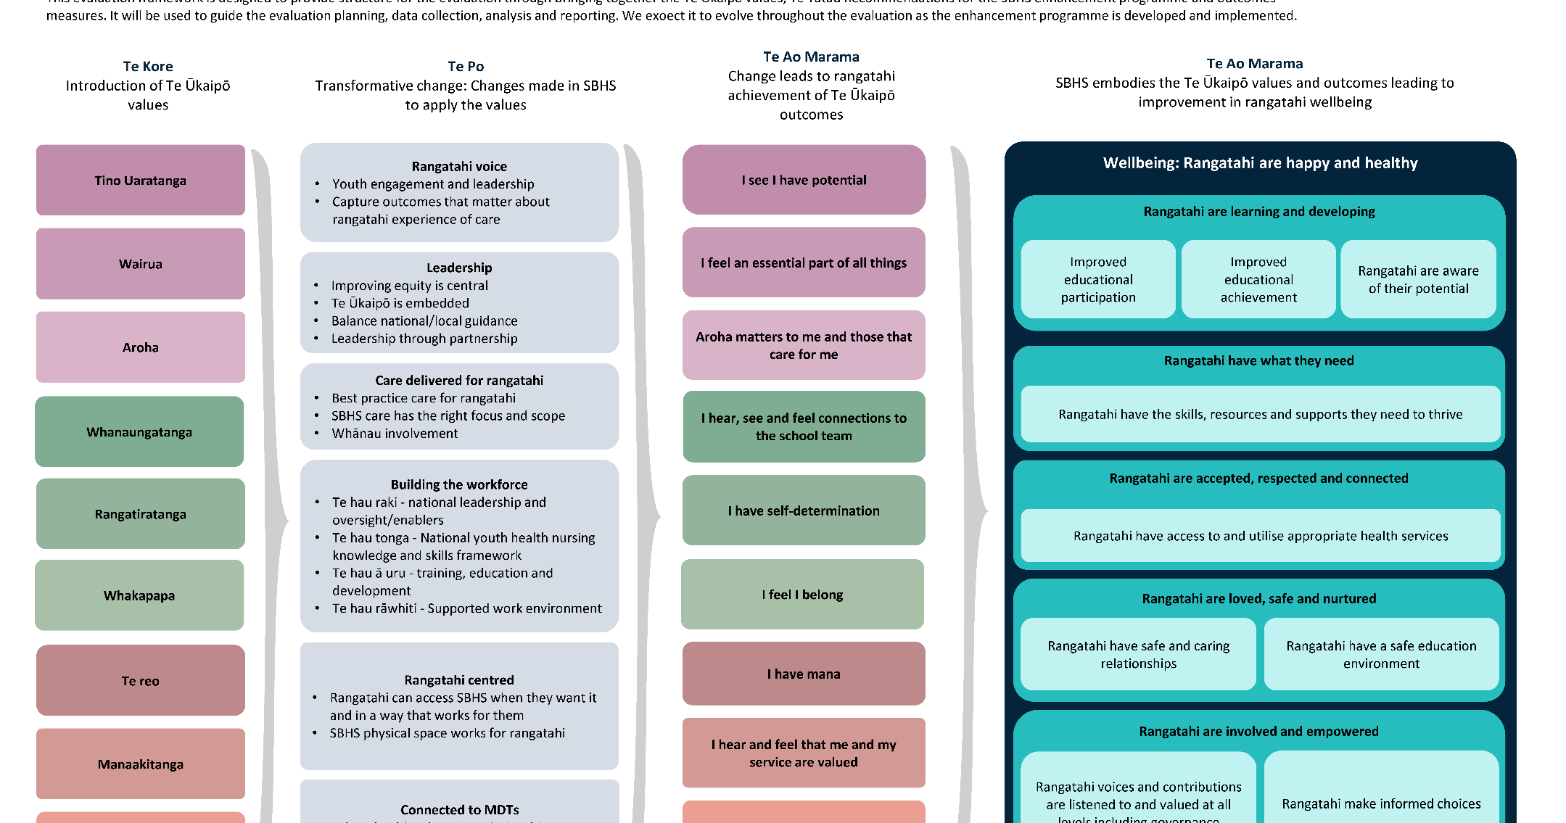
Appendix 2: Evaluation frameworks
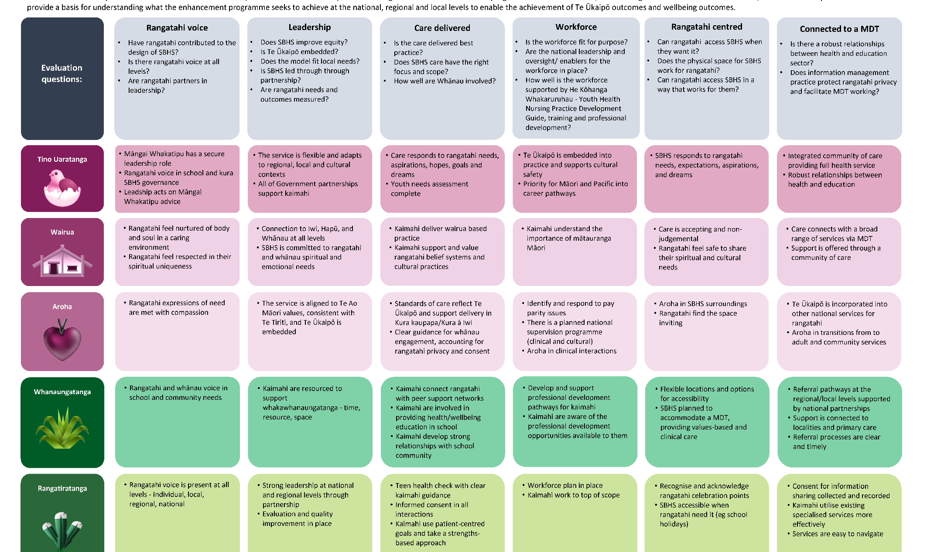
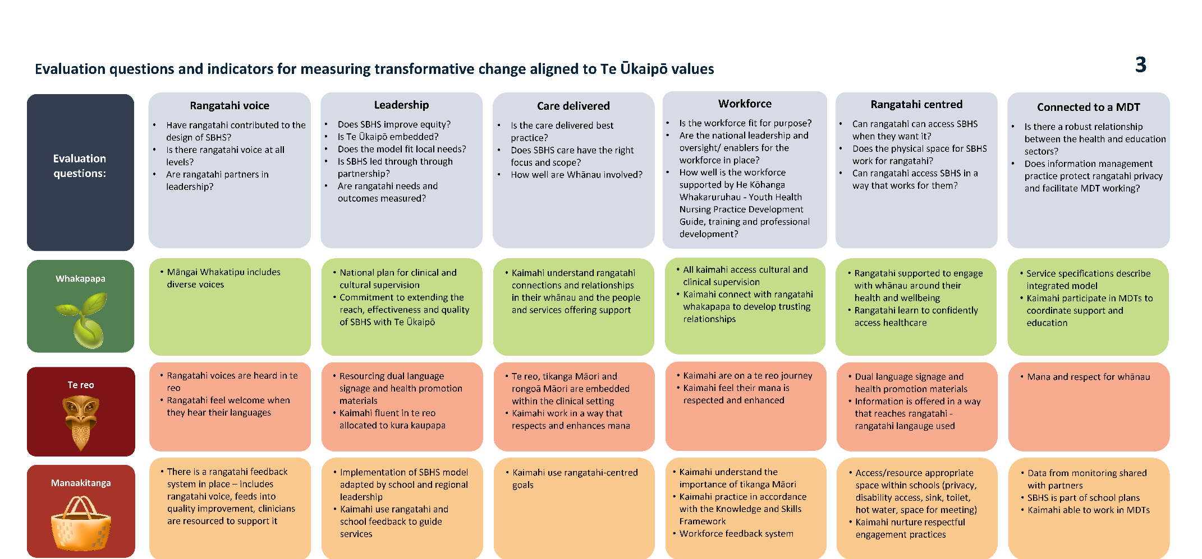

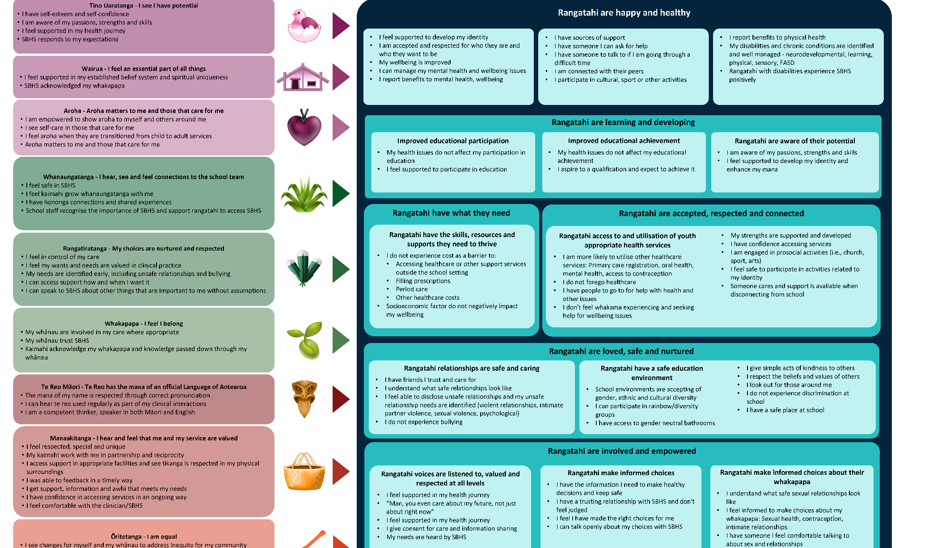

McNall, M., Lichty, L., & Mavis, B. (2010). The impact of school-based health centers on the health outcomes of middle school and high school students. American Journal of Public Health, 100(9), 1604-1610.
Woods, B., & Jose, P. E. (2011). Effectiveness of a school-based indicated early intervention program for Māori and Pacific adolescents. Journal of Pacific Rim Psychology, 5(1).
Walker, S. C., Kerns, S. E., Lyon, A. R., Bruns, E. J., & Cosgrove, T. (2010). Impact of school-based health center use on academic outcomes. Journal of Adolescent Health, 46.
Te Whatu Ora | Health New Zealand (2022). School based health services. Formative evaluation 2022. https://www.tewhatuora.govt.nz/assets/For-health-professionals/Clinical-guidance/Specific-life-stage/Youth-health/School-based-health-services/SBHS-Formative-Evaluation-2022.pdf
The SBHS enhancements programme has seven main streams: partnership and communications, embedding of Te Ūkaipō into SBHS and youth health services, evaluation, workforce development, model of care, data and information, and commissioning and funding.
Te Whatu Ora | Health New Zealand (2023). School-based health services: Evaluation framework and logic overview – July 2023. https://www.tewhatuora.govt.nz/assets/For-the-health-sector/Specific-life-stage/Youth/SBHS/SBHS-evaluation-frameworks-July-2023.pdf
https://www.nzethics.com/
https://anzea.org.nz/
The region has been omitted to maintain anonymity, while the type of kura tuarua has been included to provide context.
Te Whatu Ora | Health New Zealand & Te Rōpu Matanga O rangatahi. (2024). Te Ūkaipō Wānanga Update November 2024. Unpublished.
Feedback was collected through multiple channels, including an online survey immediately after the wānanga, followed by semi-structured kōrero sessions (60-90 minutes) and one month and six months later.
The Decile system has since been replaced by the Equity Index (EQI) in the education sector, however, SBHS continues to use deciles as the necessary policy work to support the transition from deciles to EQI is yet to be completed.
SYHPANZ (2023). Report on current state of School Based Health Services workforce, Aotearoa New Zealand. Te Whatu Ora. https://www.tewhatuora.govt.nz/assets/For-the-health-sector/Specific-life-stage/Youth/SBHS/Report-on-Current-State-of-SBHS-Workforce-February-2023.pdf
This report refers to District Health Boards as the data was originally collected under the DHB system. Since then, DHBs have been replaced by four regions under which sits the former DHBs.
Malatest International. (2022). Formative evaluation report: School Based Health Services. Ministry of Health. https://www.tewhatuora.govt.nz/assets/For-health-professionals/Clinical-guidance/Specific-life-stage/Youth-health/School-based-health-services/SBHS-Formative-Evaluation-2022.pdf
All names in the case study have been changed.

