Self-management Support for People with Long-term Conditions

Citation: Ministry of Health. 2016. Self-management Support for People with Long-term Conditions (2nd edn). Wellington: Ministry of Health.
First published in November 2014, 2nd edition February 2016
by the Ministry of Health
PO Box 5013, Wellington 6145, New Zealand
ISBN 978-0-947491-65-9 (online)
HP 6353
This document is available at health.govt.nz

This work is licensed under the Creative Commons Attribution 4.0 International licence. In essence, you are free to: share ie, copy and redistribute the material in any medium or format; adapt ie, remix, transform and build upon the material. You must give appropriate credit, provide a link to the licence and indicate if changes were made.

Contents
Acknowledgements iv
Overview 1
1 Introduction 2
Health care priorities for self-management support 2
Chronic care model 2
2 Self-management in context 4
Multimorbidity 4
Equity 4
Self-management 5
Self-management support 5
Principles of self-management support 5
Self-management education 6
3 Self-management in practice 7
Stages of self-management support and education 7
Use of technology solutions 8
Expected outcomes of self-management programmes 8
Components of self-management support 8
Care planning 11
Measuring outcomes 13
4 Conclusion 14
References 15
Appendix 1: A population approach to planning care for LTCs 17
Appendix 2: Examples of current programmes and approaches 18
Appendix 3: Diabetes-specific self-management support 20

List of Tables
Table 1: Key stages for support 7
Table 2: ABCs of care planning for optimising care 12
Table 3: Some measures for LTC outcomes 13

List of Figures
Figure 1: Alliance Health Plus Self-management Practice Model 2013 11
Figure 2: Six steps in care planning 11

Acknowledgements
The Ministry of Health would like to acknowledge Dr Janine Bycroft and Pat Flanagan for sharing their skills and knowledge both during the 2015 workshop series and in the review of this paper.

Overview
Long-term conditions (LTC) are any ongoing, long-term or recurring conditions that can have a significant impact on people’s lives (NHC 2007). Supporting people with LTCs to manage their conditions becomes more important as the population ages and people are increasingly managing more than one condition. Self-management support can be viewed in two ways: as a portfolio of techniques and tools that help patients choose healthy behaviours; and as a fundamental transformation of the patient–caregiver relationship into a collaborative partnership (Health Foundation 2011).

Any self-management support must:
- be appropriate for the person with the LTC and their family and whānau
- be developed in partnership with the person with the LTC
- focus on reducing inequities in health.

This paper was developed as the result of three sector workshops in 2015 to share best practice and innovation for the primary and community health sectors. It includes definitions of key terms related to LTCs, as well as links to examples of current work in New Zealand. It has been written as a background paper for funders, planners and practitioners in New Zealand. Appendix 3 contains diabetes specific additional information.

1 Introduction
The prevalence of long-term conditions (LTCs) is rising in New Zealand and many people have several LTCs. Related terms for LTCs are ‘non-communicable diseases (NCDs)’ and ‘chronic conditions’. LTCs include diabetes, cancers, cardiovascular diseases, respiratory diseases, mental illness, chronic pain, chronic kidney disease, dementia and others. Supporting people to self-manage is a critical part of coping with the growing burden of long-term conditions.

Health care priorities for self-management support
Although there is a wide range of self-management approaches, some overarching principles apply to all of them.
- Patient centred: Self-management support programmes should empower people with LTCs to take a leading role in their care planning (as they are able to) and support them to work in partnership with their health care professionals to set goals and action plans.
- Psychological support: It may be necessary to provide psychological support so that people can self-manage.
- Cultural relevance: Programmes should be culturally sensitive and appropriate for diverse ethnic groups.
- Systematic follow-up: Primary care providers should undertake clinical assessment and follow-up care.

Chronic care model
The chronic care model, developed in the United States by Ed Wagner (Wagner et al 1996) forms the basis of a model to deliver health care for people with long-term conditions. It describes care for people with long-term and chronic conditions in the community, with six key interdependent components: community resources, health system support, self-management support, delivery system design, decision support and clinical information systems.

At the heart of the model is an informed, active patient supported by a proactive primary care team working together to develop and implement a personalised care plan. Patient activation is ‘an individual’s knowledge, skill, and confidence for managing their health care’ (Hibbard et al 2005). It is closely related to health outcomes. When people with long-term conditions are more highly activated, they are more likely to engage in positive health behaviours and to manage their health conditions more effectively. Interventions such as self-management education programmes have been shown to improve patient activation (Hibbard and Gilburt 2014).

Recent versions of the chronic care model have acknowledged the increasing use and importance of eHealth such as mobile technology, electronic records and virtual communities (Gee et al 2015).

Internationally, self-management is recognised as one of the critical components in improving health care for people with LTCs (Singh 2005; Tsai et al 2005; Zwar et al 2006). It is fundamental to the health and wellbeing of people with LTCs, and enables the health system to make the best use of increasingly scarce resources.

People with long-term conditions spend only a few hours each year in contact with health services. For the rest of the time, they are ‘self-managing’ their conditions (Lhussier et al 2013). Appendix 1 summarises a possible population approach to planning care for LTCs, which identifies different levels of health need and the appropriate care response for each level.

2 Self-management in context
Some people take issue with the term ‘self-management’ because it could suggest a focus on the ‘self’ as an individual at the expense of important social contexts, particularly family and whānau. Self-management theory, however, takes a holistic view that gives priority to engaging with people with LTCs within their wider social context. This approach is in keeping with the views of Māori, Pacific and South Asian peoples, who emphasise interdependence rather than personal independence.

Self-management support has been identified as one of the 10 characteristics that contribute to a high-performing chronic care system (Ham 2010). This section discusses and defines self-management and self-management support, along with multimorbidity, equity and self-management education as terms that are closely linked to these concepts. This background information sets the context for the next section, which focuses on self-management in practice.

Multimorbidity
Many long-term conditions are more common in older people. As more people live longer, New Zealand is likely to have more people with two or more LTCs (multimorbidity). In the 2012/13 New Zealand Health Survey, nearly one in four adults reported two or more LTCs. While fewer people reported three conditions (6.4 percent) and four or more conditions (3.7 percent), the true prevalence is likely to be higher across all categories because the survey covered only a limited number of conditions (Ministry of Health 2014, p 204).

Research has shown that some individuals with multimorbidities give more attention to managing a dominant illness and less attention to their other conditions. However, some studies have shown that multimorbidity improves patient self-management (Bratzke et al 2015). For people with multimorbidity, a person-centred and integrated approach to supporting management is particularly important.

Equity
Equity is the absence of avoidable or remediable differences among groups of people, whether those groups are defined socially, economically, demographically or geographically. One ongoing task is to reduce inequalities in the self-management support that health professionals provide. The aim is to achieve equitable care, which is ‘care that does not vary in quality because of personal characteristics such as gender, ethnicity, geographic location and socioeconomic status’ (Institute of Medicine 2001). A recent discussion paper identifies eliminating health literacy barriers as an essential ingredient in the effort to increase health equity (Logan et al 2015).

It is important to keep records of who is offered self-management support so that groups over-represented in prevalence statistics are involved in support services that meet their needs. Tools for reviewing and assessing care from an equity perspective are available.

See Equity of Health Care for Māori: A framework (www.health.govt.nz/publication/equity-health-care-maori-framework).

Self-management
‘Self-management’ refers to any way in which a person with an LTC manages their condition by themselves. Learning and practising self-management is an ongoing process; it is not achieved in a single step. Self-management is a continuum of learning experiences and opportunities, where a person with an LTC and their family and whānau work in collaboration with carers and health professionals.

Self-management is about enabling people with LTCs to ‘make informed choices, to adapt new perspectives and generic skills that can be applied to new problems as they arise, to practice new health behaviours, and to maintain or regain emotional stability’ (Lorig 1993).

The seven Principles of Self-Management are an important part of the Flinders Program™ (Flinders Human Behaviour and Health Research Unit 2006). They identify a ‘good’ self-manager as someone who:
- knows about their condition
- follows a treatment plan (care plan) agreed with their health professionals
- actively shares in decision-making with health professionals
- monitors and manages signs and symptoms of their condition
- manages the impact of the condition on their physical, emotional and social life
- adopts lifestyles that promote health
- has access to support services and has the confidence and ability to use them.

Self-management support
Supporting self-management involves educating people about their condition and care and motivating them to care for themselves better. Self-management support can be viewed in two ways: as a portfolio of techniques and tools that help patients choose healthy behaviours; and as a fundamental transformation of the patient–caregiver relationship into a collaborative partnership (Health Foundation 2011). Through self-management support and good-quality clinical care, people get the full range of support they need to manage the physical, emotional and social impact of their LTCs at different ages and stages of their lives (Health Foundation 2015).

Principles of self-management support
Twelve evidence-based practices and processes that improve self-management support in primary care are:
- brief targeted assessment
- evidence-based information to guide shared decision-making
- use of a non-judgemental approach
- collaborative approach to setting priorities and goals
- collaborative problem solving
- self-management support by diverse providers
- self-management interventions in diverse formats
- patient self-efficacy
- active follow-up
- guideline-based case management for selected patients
- links to evidence-based community programmes
- multifaceted interventions (Battersby et al 2010).

Self-management education
‘Self-management education’ (SME) is a systematic intervention that teaches a person to actively participate in self-monitoring (of physiological processes) and/or decision-making (managing) relating to their condition/s. It recognises that, if an individual is to continue to self-manage their condition/s over the long term, they must be able to collaborate with their health care providers and use problem-solving skills.

SME provides people with LTCs with the knowledge, skills and motivation they need to make decisions. It also increases their capacity and confidence to apply these skills in daily life.

Providers of SME must tailor the content and skill-training components of SME to the individual patient. Factors to consider are the types of LTC and recommended therapy, the patient’s ability, potential barriers to self-management, the patient’s motivation for learning and change, the patient’s culture, the patient’s literacy level, and available resources.

3 Self-management in practice
This section outlines the stages and the principles of self-management support, expected outcomes of self-management programmes and the components of self-management support. For information requirements for people who are self-managing diabetes in particular, see Appendix 3.

Stages of self-management support and education
Both self-management support and SME can be provided for individuals and their family and whānau or in a group setting.

The Long Term Conditions Alliance (now Health and Social Care Alliance Scotland) has identified several key stages where people need support (Long Term Conditions Alliance 2008). Table 1 summarises these stages, along with the issues for and impact of self-management.

Table 1: Key stages for support
Key stage | Issues for self-management | Impact of self-management
Diagnosis | By this point, symptoms may already have seriously affected people’s life and ability to manage.  People feel challenged about their place in the world and the reality of their situation. | Helps people come to terms with their diagnosis.  Is a key way of helping people to reconnect with themselves and others.  Helps people make better decisions about treatment options.
Living for today | People need information and skills to maintain optimum wellbeing.  People are at serious risk of social exclusion. | Supports people to navigate an often difficult journey.  Challenges social exclusion by helping build bridges back to society and social roles.
Progression | People experience a cycle of illness and wellbeing as their conditions fluctuate.  Symptoms become increasingly severe.  People struggle to get additional support during flare-ups.  They may lose some capacity. | Helps to avoid flare-ups or minimise their extent.  Enables people to recognise early warning signs and react effectively.  Tackles psychological impact of flare-ups or progression.  Supports changing needs.
Transitions | People move between services, sometimes to different levels/types of support.  They are dealing with multiple needs/ conditions and therefore a range of services.  It is often a stressful time, which can have serious impact, including on person’s conditions. | Supports people to manage transition processes.  Maintains focus on people’s needs so that services are organised around these.  Provides people with control at a time when this can be undermined.
End of life | This difficult time involves complex challenges.  Death may be premature.  People may have to cope with symptoms of the condition along with the challenges of end of life. | Supports people to meet a range of challenges and maintain control.  Addresses broader needs eg, emotional, family and lifestyle.

Use of technology solutions
Web-based and mhealth solutions are available to provide self- management education and self-management support. For example, mobile technology can be used to provide information and motivation for self-management (Whittaker et al 2013). Patients may also see patient portals as a tool to support self-management (Letford et al 2014).

Expected outcomes of self-management programmes
Self-management programmes should help people with LTCs to live longer, healthier, more independent lives. Other expected outcomes are that:
- people with LTCs work in partnership with their health care providers
- people with LTCs share information with their health care providers and make informed decisions about their care
- health care providers support people with LTCs to navigate information, services and resources.

Components of self-management support
As well as providing advice to individuals about managing their LTCs, programmes supporting patient self-management emphasise goal setting and problem solving skills. Such programmes reinforce the individual’s central role in managing their condition, with a key focus on health care providers responding to people’s questions and needs.

The four essential components in self-management support programmes are:
- health literacy
- cultural relevance
- behaviour change
- the role of the health professional in supporting self-management.

Each of these components is discussed below.

Health literacy
Health literacy, from the patient’s perspective, is the cornerstone in enabling people to make informed choices and take care of their own health. A person with good health literacy can get, process and understand basic health information and services, and can therefore make appropriate health decisions (Ministry of Health 2010). More specifically, with good health literacy, they can:
- understand and interpret health information provided in written, spoken and digital form
- understand instructions written on prescribed medicine containers and consent forms
- understand a health professional’s verbal advice and explanations
- navigate complex health systems
- communicate with health professionals, including by describing symptoms accurately and asking relevant questions
- find relevant information needed to make choices and decisions.
Health professionals have a pivotal role in improving health literacy. They must tailor their style of communication to individuals with LTCs (and their family and whānau). If they are culturally competent and strive to understand people’s health beliefs and preferences, health professionals will improve the quality of their health interactions and consequently the health literacy of their patients.

However, people with LTCs and individual health professionals cannot address health literacy on their own. Health care providers such as district health boards and primary health organisations play a critical role in supporting health professionals and people with LTCs and their families and whānau to develop health literacy.

For more information on health literacy, see the following Ministry of Health publications:
- Health Literacy Review: A guide (www.health.govt.nz/publication/health-literacy-review-guide)
- A Framework for Health Literacy (www.health.govt.nz/publication/framework-health-literacy).

Cultural relevance
Any self-management programme, particularly if it is a group programme, must be culturally appropriate. People with LTCs should have access to self-management support that is relevant to the ethnicity they identify with.

For Māori, a programme underpinned by kaupapa Māori approaches enriches the environment for effective learning. It focuses on:
- tinorangatiratanga – self determination
- taonga tuku iho – cultural aspirations
- ako Māori – culturally preferred ways of learning
- whānau – the extended family members and their influence and support
- kaupapa – the collective philosophy of the members of the group (Smith and Reid 2000, pp 9–11).

The Ministry of Health has a free online foundation course in cultural competence for all people working in the health sector (http://learnonline.health.nz/course/category.php?id=84).

Behaviour change
Along with health literacy education, people need programmes to support them to change their health behaviour. In self-management programmes, the five essential elements to changing health behaviour are:
- active involvement in problem solving, goal setting and written action plans (especially for conditions where the risk of deterioration is high)
- lifestyle changes, including eating a healthier diet, being physically active and stopping smoking
- informed decision-making
- medication management
- stress management and positive mental health.

Health professionals should recognise and address the potential barriers to changing health behaviour, which will be different for each individual.

Some people with LTCs need broader support to deal with challenges related to the wider determinants of their health, such as social and economic conditions. Health navigators, kaiawhina or other support workers can provide support such as social support.

The role of health professionals in supporting self-management
For effective self-management, health professionals must ask themselves the following question at every meeting with a person with an LTC: What can we do (as health care providers and a health system) to support, enable and facilitate this person and their family and whānau to manage more effectively, safely and appropriately at home?

In a self-management approach, health professionals need to change their behaviour (Mudge et al 2015), as well as the person and their family and whānau. They must take a collaborative approach to care planning based on mutual respect and trust.

A health professional can contribute to and support behaviour change by:
- providing information that helps people with LTCs to make informed decisions and set goals for themselves
- encouraging people to participate actively in their self-management by acknowledging that they are experts in their own lives
- supporting people with LTCs to attend supported self-management groups, where they are available
- advocating for the creation of self-management support groups, where they are currently not available
- ensuring that self-management is culturally appropriate
- following up with people after they have participated in self-management education programmes, to optimise and support their learning
- following up initial self-management education with regular updates and opportunistic learning as needed
- providing optimal health care
- referring people to appropriate support agencies as needed.

Primary health care providers – in particular, general practice teams – play a key role in giving people with LTCs access to self-management support. However, to provide effective self-management support, nurses and general practitioners need to be part of a wider multidisciplinary team. A multidisciplinary team can include general practitioners or primary health care nurses, Māori providers, Pacific providers, community pharmacists, community mental health workers, allied health professionals and medical specialists.

As part of a multidisciplinary team, a general practice team needs to encourage people to attend self-management support programmes and groups, and follow up and connect with community providers as needed. Clinicians also can gain the support they need to share control with patients.

People with LTCs will have different levels of engagement with a multidisciplinary team, depending on their own individual needs.

Care planning
Personalised care planning is a tool that enables people with LTCs to self-manage. It encourages them to choose their treatment goals and to work with clinicians to identify their specific needs for treatment and support. Together the patient and clinician make decisions, set goals and undertake action planning, with the aim of working out priorities agreeing realistic objectives, solving problems and identifying sources of support. With effective care planning, some aspects of the patient’s physical and psychological health and their ability to manage their condition can improve (Cochrane 2015).

Figure 1 below describes the care planning approach developed and tested at Alliance Health Plus in 2013 (Flanagan et al 2014). Another tool available is the Common Core Principles to Support Self Care – a self care training manual and a questionnaire that can be used to help an individual take responsibility for their own health and wellbeing (Skills for Care 2015).

Figure 1: Alliance Health Plus Self-management Practice Model 2013
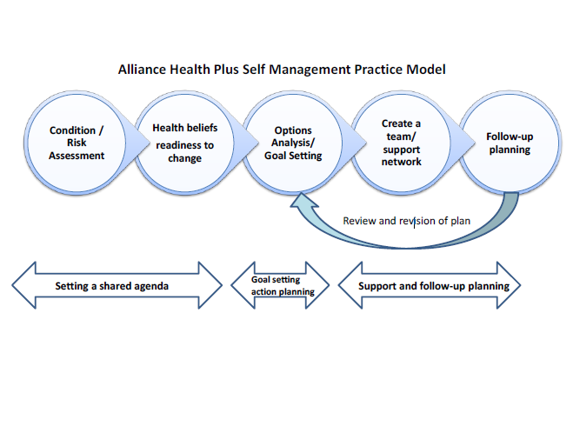
Source: Flanagan et al (2014)

Figure 2 sets out six steps in the care planning process.

Figure 2: Six steps in care planning
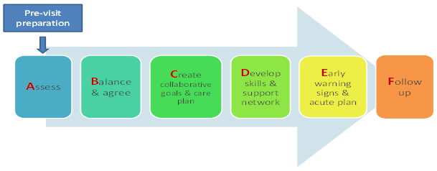
Care Planning ABCs’ Model created by Health Navigator NZ. More resources visit www.hn.org.nz

Table 2: ABCs of care planning for optimising care
Assess | Balance and agree | Create | Develop | Early warning signs | Follow-up
Assess risk | Balance patient and clinical perspectives  Agree priorities | Create a care plan and share with wider multi-disciplinary team | Develop self-management skills | Ensure patient understands their red flags and has a written action plan for earlier response | Planned and proactive follow-up
Assess medication concordance | Optimise medical management | Collaborative goal setting (patient’s choice) and action planning | Build support network | Blue card for COPD patients  Chest pain plan, pain plan, etc | Frequent phone calls / visits in initial phase (approximately 1-2 weekly)
Assess self-management capacity | Based on shared decision making and agenda setting | IT platform to enable 24/7 access to care plan (by HPs and patient) | PHQ 2 screen for depression and anxiety | Rescue meds at home – antibiotics ± steroids for COPD etc | ACP conversations as appropriate
Assess for unhelpful health beliefs | Wherever possible, simplify medication regimes (what and when meds taken) | Same page care  Updated in real time so up to date and enable more timely decisions | Use ‘closing the loop’ to check understanding | Also known as an acute plan | Frequency reduces as skill and confidence increase and barriers addressed
Source: Dr Janine Bycroft and Pat Flanagan (2014).

Measuring outcomes
Measuring outcomes of self-management programmes is complex. Sustainable, measurable outcomes can be identified at an individual or a system level.

At an individual level, outcomes include access to services and participation, care planning, self-rated wellness or efficacy, medication adherence, condition-specific health status, level of patient activation, and achievement of patient goals.

At a system level, outcomes include ambulatory sensitive hospitalisation (ASH) rates, readmission rates, use of patient portals and premature mortality. Table 3 provides examples of measures for LTC-related outcomes.

Table 3: Some measures for LTC outcomes
Outcome | Possible measure | Source
Whole of system integration | Ambulatory sensitive hospitalisations | Ministry of Health
Reduced premature mortality | Years of life lost | Ministry of Health
Life expectancy | Measured annually | Statistics NZ
Medication adherence | Prescriptions filled 3 out of 4 quarters | Health Quality and Safety Commission
Patient activation | Patient activation measure (PAM) | Hibberd et al 2014
Chronic illness care | Assessment of chronic illness care (ACIC) – system level | www.improvingchroniccare.org
 | Patient assessment of chronic illness care (PACIC) | www.improvingchroniccare.org
Level of self-management | Partners in Health Scale | www.flinders.edu.au/medicine/sites/fhbhru/self-management.cfm
Health education impact | Health education impact evaluation questionnaire (HeiQ) | www.deakin.edu.au/health/research/phi/heiQ.php
Primary care self-management support | PCRS tool | Robert Wood Johnson Foundation Diabetes initiative
Risk behaviours | Smoking cessation | NZHS

4 Conclusion
People with the most to gain from being supported to self-manage are those with the greatest health burden, or those facing the worst outcomes. While concentrating on those with the greatest level of need at the top of the care planning pyramid (Appendix 1), health professionals must be careful to:
- support those with less need but greater potential for deterioration
- keep those with the least need as well as possible.

It is also useful to consider the stage of people’s health and disease course – see Table 1. With limited resource, you can prioritise the people with the most to gain from support by knowing your population and classifying them according to their level of risk.

References
Battersby M, Von Korff M, Schaefer J, et al. 2010. Twelve evidence-based principles for implementing self-management support in primary care. Joint Commission Journal on Quality and Patient Safety 36(12): 561–70.
Bratzke LC, Muehrer RH, Kehl KA, et al. 2015. Self-management priority setting and decision-making in adults with multimorbidity: a narrative review of literature. International Journal of Nursing Studies 52(3): 744–55.
Bycroft J, Flanagan P. 2014. URL: www.assets.healthnavigator.org.nz/2014/04/CarePlanningworkshopCountiesManukauApril2014-updated17April14.pdf
Cochrane. 2015. Personalised care planning for adults with chronic or long term health conditions (Review). Coulter A, et al. The Cochrane Collaboration, The Cochrane Library 2015, issue 3.
Flanagan P, Moffat J, Healey K, et al. 2014. Learnings from a project to develop a generic self-management care plan for long-term conditions. Alliance Health Plus.
Flinders Human Behaviour and Health Research Unit. 2006. The Flinders Program™. URL: www.flinders.edu.au/medicine/sites/fhbhru/self-management.cfm (accessed 14 September 2014).
Gee PM, Greenwood DA, Paterniti DA, et al. 2015. The eHealth Enhanced Chronic Care Model: a theory derivation approach. Journal of Medical Internet Research 17(4): e86.
Ham C. 2010. The ten characteristics of the high performing chronic care system. Health Economics, Policy and Law 5: 71–90.
Health Foundation. 2011. Helping People Helping Themselves: A review of the evidence considering whether it is worthwhile to support self management. London: Health Foundation.
Health Foundation. 2015. A Practical Guide to Self-management Support: Key components for successful implementation. London: Health Foundation.
Hibbard JH, Mahoney ER, Stockard J, et al. 2005. Development and testing of a short form of the Patient Activation Measure. Health Services Research 40(6): 1918–30.
Hibbard JH, Gilburt H. 2014. Supporting People to Manage their Health. London: The King’s Fund.
Institute of Medicine. 2001. Crossing the Quality Chasm: A new health system for the 21st century. Washington DC: The National Academies Press.
Letford K, Humphrey G, Day K. 2014. An exploration of the potential for patient portals to improve self-management of long term conditions. HINZ 2014 Conference and Exhibition, 10–12 November 2014, Auckland, New Zealand.
Lhussier M, Eaton S, Forster N, et al. 2013. Care planning for long term conditions: a concept mapping. Health Expectations 18: 605–24.
Long Term Conditions Alliance. 2008. Self Management Strategy for Long Term Conditions. Scotland: Scottish Government.
Lorig K. 1993. Self-management of chronic illness: a model for the future (self care and older adults). Generations 17: 11–14.
Ministry of Health. 2010. Kōrero Mārama: Health literacy and Māori. Wellington: Ministry of Health.
Ministry of Health. 2014. Health and Independence Report. Wellington: Ministry of Health.
Mudge S, Kayes N, McPherson K. 2015. Who is in control? Clinicians’ view on their role in self management approaches: a qualitative metasynthesis. BMJ Open 5: e007413.
NHC. 2007. Meeting the Needs of People with Chronic Conditions. Wellington: National Health Committee.
Singh D. 2005. Transforming Chronic Care: Evidence for improving care for people with long-term conditions. Birmingham: Health Services Management Centre, The University of Birmingham.
Skills for Care. 2015. Common Core Principles to Support Self Care. URL: www.skillsforcare.org.uk/Skills/Self-care/Self-care.aspx (accessed 14 January 2016).
Smith LT, Reid P. 2000. Māori Research Development: Kaupapa Māori principles and practices: A literature review. Wellington: Te Puni Kōkiri.
Tsai A, Morton S, Mangione C, et al. 2005. A meta-analysis of interventions to improve care for chronic illnesses. American Journal of Managed Care 11(8): 478–88.
Wagner EH, Austin BT, Von Korff M. 1996. Organizing care for patients with chronic illness. The Milbank Quarterly 74(4): 511–44.
Whittaker R, Bramley D, Carter C, et al. 2013. A comprehensive approach to self management support for diabetic patients and clinicians, Health Informatics New Zealand Conference,
27–29 November 2013, Rotorua, New Zealand.
Zwar N, Harris M, Griffiths R, et al. 2006. A Systematic Review of Chronic Disease Management. Sydney: Australian Primary Health Care Research Institute, School of Public Health and Community Medicine, University of New South Wales.

Appendix 1:
A population approach to planning care for LTCs
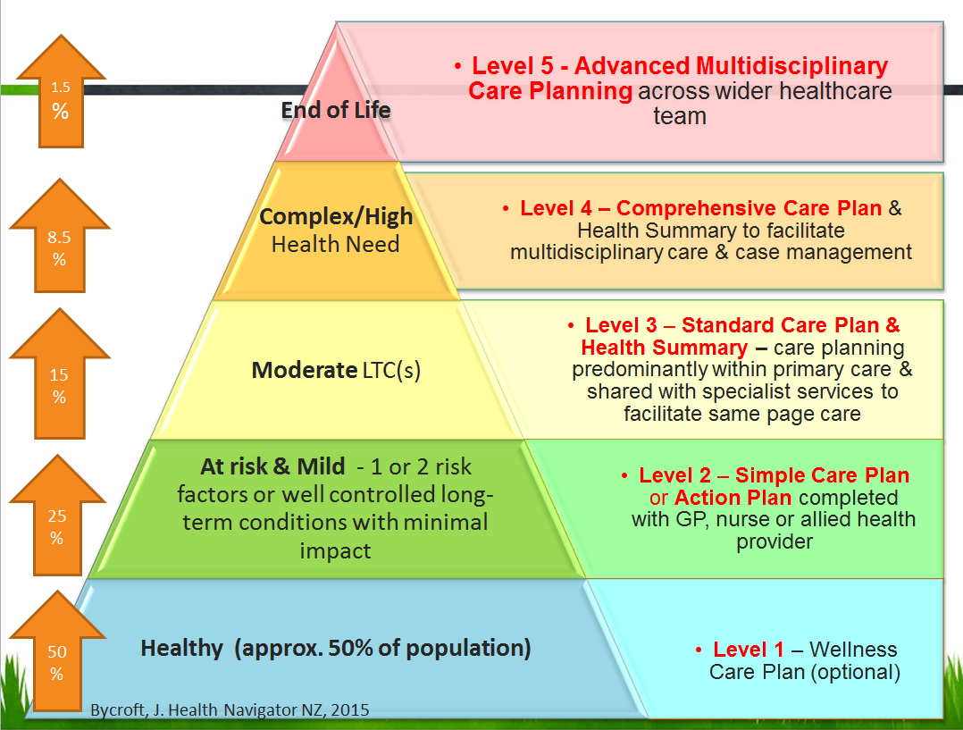
Source: J Bycroft, Health Navigator NZ, 2015.

Appendix 2:
Examples of current programmes and approaches

Self-management groups
Piki te Ora – Six-week Stanford chronic disease self-management programme at Whanganui DHB.
Contact: Anne Kauika, email anne.kauika@wrpho.org.nz
www.wrpho.org.nz/documents/self_management_workshop.pdf

Kia Kaha – Self-management for mental health incorporating peer support. Led by East Health.
Contact: Leona Didsbury, Senior Health Psychologist and Self-Management Trainer, East Tamaki Healthcare, email Leona@ethc.co.nz

Integrated approaches
Choose Change –- Auckland Region Sports Trusts (led by Harbour Sport) lifestyle intervention for people with prediabetes.
Contact: Jay Martin, Active Communities Manager, email jaym@harboursport.co.nz

Healthy Village Action Zones – an innovative framework for collaborative action by key stakeholders and Pacific communities, joining together to improve health outcomes for Pacific peoples.
Contact: Faimafili Tupu, Healthy Village Action Zones Manager, tel 09 630 9943 ext 26470 or email FaimafiliT@adhb.govt.nz

Energize Practices – primary care practice staff supported to trial a variety of methods to encourage in-practice healthy lifestyle coaching. Led by Waikato Sports Trust
Contact: Stephanie McLennan, email stephm@sportwaikato.org.nz

At-risk individuals programme
Counties Manukau DHB comprehensive programme of wraparound services for people with complex/multiple long-term conditions
www.countiesmanukau.health.nz/blogs/introducing-the-at-risk-individuals-programme

Counties Manukau Self Management Support Campaign Manaaki Hauora
Contact: Diana Dowdle, email Diana.Dowdle@middlemore.co.nz

Practice based
Alliance Health Plus – care planning approach
www.hiirc.org.nz/page/49789/learnings-from-a-project-to-develop-a-generic/?q=care%20planning&highlight=care%20planning&section=13825

Links for support
Checklist for change: primary care practices – in Flanagan P et al. 2014. Learnings from a project to develop a generic self management care plan for long term conditions, pp 42–43, URL: www.hiirc.org.nz/page/49789/learnings-from-a-project-to-develop-a-generic/?q=care%20planning&highlight=care%20planning&section=13825

Appendix 3:
Diabetes-specific self-management support
This document addresses self-management for LTCs in general; however, some aspects of self-management are specific to diabetes. Additionally, different types of diabetes, including type 1, type 2 and gestational diabetes, are discrete conditions requiring different self-management skills across the lifespan.

People with diabetes require specific information to make informed decisions on self-management. This includes:
- information on living with diabetes, including:
- managing high and low blood glucose levels
- diet, including managing carbohydrate, fat and sugar intake
- the importance of regular physical exercise and how to adjust insulin and carbohydrate accordingly
- controlling diabetes before, during and after exercising
- knowledge of diabetes-specific medications, including:
- information about individual medications for managing a person’s own diabetes
- information about potential future medications
- information on the risks of non-adherence to medicine schedules
- awareness of diabetes-specific complications and how to prevent them, including:
- cardiovascular disease, and the need for regular monitoring and lifestyle advice to manage this risk
- renal disease, and the need for regular monitoring to manage this risk
- peripheral neuropathy, and the need to regularly undergo foot checks
- retinopathy, and the need to regularly undergo retinal screening
- depression, and the need for psychological support
- sexual dysfunction
- information on clinical parameters, including:
- blood glucose levels (HbA1c)
- blood pressure
- blood lipid levels (cholesterol)
- microalbuminuria.

Health care providers should prioritise self-management support for people:
- newly diagnosed with type 2 diabetes
- with diabetes failing to achieve clinical targets despite trying for 6–12 months
- with diabetes with persisting clinical issues (eg, hypoglycaemia or weight gain)
- with diabetes who are at high risk of complications.

Dietary, exercise and lifestyle information can be suitable for inclusion in a programme created for people with prediabetes; however, diabetes-specific self-management support content is not appropriate for them.

For more information, see the following Ministry of Health publications:
- Living Well with Diabetes: A plan for people at high risk of or living with diabetes 2015–20 (www.health.govt.nz/publication/living-well-diabetes)
- Quality Standards for Diabetes Care Toolkit 2014 (www.health.govt.nz/publication/quality-standards-diabetes-care-toolkit-2014).

NCDs are conditions that are not acquired by transmission between people. NCDs and LTCs overlap significantly; for example, many NCDs are long-term in nature, and LTCs and NCDs share many lifestyle-related risk factors. They are not identical, however; for example, some LTCs, such as hepatitis, are communicable. The terms are sometimes used interchangeably. NCDs is more commonly used in international contexts such as by the World Health Organization. This report refers to LTCs for simplicity. The emphasis, though , is not on the term used but rather on addressing the challenges arising from the changing patterns of disease: the rise of conditions that are related to unhealthy lifestyles (both acute and long-term) and of conditions that are long term (whether preventable or not).

