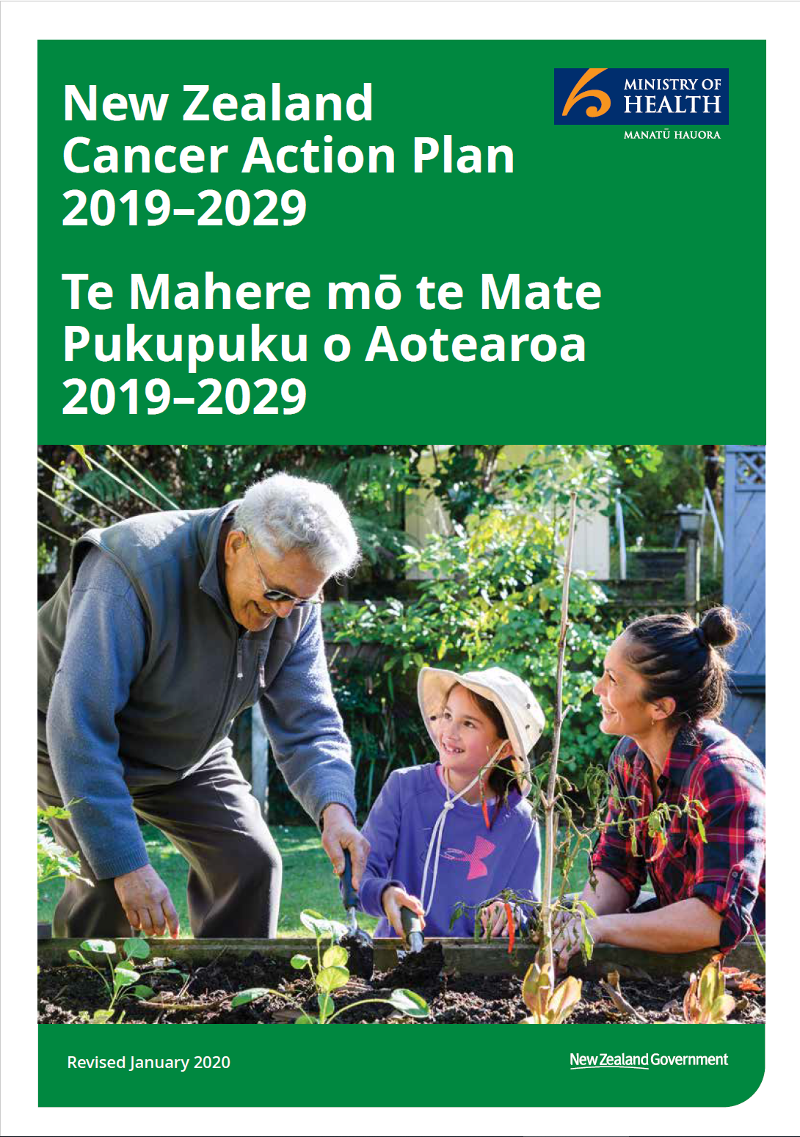

Citation: Ministry of Health. 2019. New Zealand Cancer Action Plan 2019–2029 – Te Mahere mō te Mate Pukupuku o Aotearoa 2019–2029. Revised January 2020 Wellington: Ministry of Health.
Published in January 2020 by the Ministry of Health PO Box 5013, Wellington 6140, New Zealand
ISBN 978-1-98-859766-9 (online)
HP 7314
This document is available at: health.govt.nz

This work is licensed under the Creative Commons Attribution 4.0 International licence. In essence, you are free to: share, ie, copy and redistribute the material in any medium or format; adapt, ie, remix, transform and build upon the material. You must give appropriate credit, provide a link to the licence and indicate if changes were made.

Minister of Health’s foreword – He kupu whakataki nā Te Minita Hauora

Delivering on cancer prevention and care – ‘every person, every time’
Most New Zealanders will be affected by cancer in their lifetime – either directly, or through friends or family members.
This comprehensive plan sets us on a path to better cancer prevention, treatment and care in New Zealand over the next 10 years, so that New Zealanders living with cancer have access to high quality care no matter who they are, or where they live.
‘Every person, every time’ – it’s about ensuring every person affected by cancer has the best outcome possible. It means better prevention, earlier detection and ensuring all New Zealanders have modern and consistent cancer treatment. This plan, combined with other key government initiatives addressing mental health and wellbeing, ensures support is accessible and reflects people’s cultures and needs.
Māori are 20 percent more likely to get cancer than non-Māori, and nearly twice as likely as non-Māori to die from cancer. Mental health service users, people with multiple health conditions and Pacific peoples also have poorer survival. We cannot accept this. New Zealanders deserve a world-class system with better outcomes for all.
Budget 2019 included funding to increase the number of Māori and Pacific people in the health workforce, to improve cultural competency and better respond to and recognise the needs of these populations. This Government has taken action in these three areas already.
The Plan has four main goals.
- New Zealanders have a system that delivers consistent and modern cancer care.
- New Zealanders experience equitable cancer outcomes.
- New Zealanders have fewer cancers.
- New Zealanders have better cancer survival, supportive care and end-of-life care.
Strong leadership and collective accountability across the sector are essential. To ensure this, we are establishing a Cancer Control Agency which will sit in the Ministry of Health. A Chief Executive of the Cancer Control Agency will be appointed and a National Cancer Control Network will ensure consistent high standards across New Zealand.

I recognise more must be done. Some priorities and actions are already under way, such as increased investment in cancer medicines and new linear accelerators for the regions.
We must continually strive to be better, to help more people and to do more for those with cancer and their whānau.
When the former Minister of Health, Dame Annette King, launched New Zealand’s first Cancer Control Strategy in 2003, she said the Strategy encouraged government and non-government providers to work closely together to achieve long-term change.
Collaboration is still vital to achieve improvements for the future of cancer care in New Zealand.
I thank everyone who has contributed to this plan, especially those who have had direct experience of cancer. Your input has been invaluable.
I look forward to implementing the Cancer Action Plan so that we can deliver for people living with cancer – ‘every person, every time’.

Hon Dr David Clark
Minister of Health

Director-General of Health’s foreword – He kupu whakataki hoki nā Te Kaitohu-Matua Hauora

Kia ora koutou katoa
The Ministry of Health is committed to ensuring we have a sustainable system that enables New Zealanders to have fewer cancers, better survival rates and equitable outcomes. We’re committed to ensuring all New Zealanders have access to quality cancer care regardless of where they live, or who they are. We’ve engaged with sector leaders and stakeholders to develop this cancer action plan, bringing together the voices of the sector as well as people with lived experience of cancer.
I want to acknowledge all those organisations, groups and individuals who have provided input into the plan. It reflects what we’ve heard from a wide range of organisations, clinicians and consumers. We’ve sought wider sector and community input to ensure we’ve got it right.
All New Zealanders will benefit as a result of the proposed improvements to our system. We are specifically focusing on Māori, Pacific peoples, those who live in rural and highly deprived areas, those with mental illness and disabled people as our priority populations. These groups currently have worse cancer outcomes than other New Zealanders and this is unfair.
To deliver the plan effectively, we need strong and accountable leadership that brings together key stakeholders to improve and deliver cancer care across the system. The Cancer Control Agency will provide strong governance at all levels, set priorities, inform investment decisions and monitor progress on the plan. The Cancer Control Agency will also work closely with the Ministry of Health to ensure we achieve the overall aims of the plan. We will continuously review and update the plan to ensure it continues to meet the needs of all New Zealanders.
I am excited about and committed to the priorities and actions outlined in this plan. Its successful implementation will help ensure we have a health system that delivers the same high-quality outcomes and wellbeing for all New Zealanders.
Ngā mihi

Dr Ashley Bloomfield
Director-General of the Ministry of Health

Acknowledgments – Mihi
The Ministry of Health engaged with a number of cancer-sector stakeholders in developing New Zealand Cancer Action Plan 2019–2029 – Te Mahere mō te Mate Pukupuku o Aotearoa 2019–2029. We acknowledge and thank all who contributed their expertise.

Whakataukī
Kua tawhiti kē tō hāerenga mai Kia kore e hāere tonu
He nui rawa āu mahi
Kia kore ai e mahi tonu

You have come too far Not to go further
You have done too much Not to do more
Nā Tā Hēmi Hēnare – Sir James Hēnare
Contents

Minister of Health’s foreword – He kupu whakataki nā Te Minita Hauora III
Director-General of Health’s foreword – He kupu whakataki hoki nā Te Kaitohu-Matua Hauora V
Acknowledgments – Mihi VI
Our challenge: Representing the consumer – Te Wero: Hei kanohi mō te tangata 1
About the New Zealand Cancer Action Plan 2019– 2029 – Te Mahere Mate Pukupuku o Aotearoa 2019–2029 2
Moving forward together – Kia hāere ngātahi 3
Cancer in New Zealand – Mate pukupuku ki Aotearoa 4
Our commitment to the Treaty of Waitangi – Kia paiheretia Te Tiriti o Waitangi 9
Achieving equity – He mana taurite 10
Outcomes – Ngā huanga 11
Outcomes framework – Te pou huanga 13
Prioritisation framework – Te pou whakaarotautanga 14
Prioritisation framework – Te pou whakaarotautanga 15
Outcome 1: New Zealanders have a system that delivers consistent and modern cancer care – Te huanga 1: He pūnaha atawhai 16
Outcome 2: New Zealanders experience equitable cancer outcomes – Te huanga 2: He taurite ngā huanga 27
Outcome 3: New Zealanders have fewer cancers – Te huanga 3: He iti iho te mate pukupuku 32
Outcome 4: New Zealanders have better cancer survival, supportive care and end-of- life care – Te huanga 4: He hiki ake i te o ranga 44
References 65

List of Figures
Figure 1: Age-standardised disability-adjusted life years lost per 100,000, all neoplasms, both sexes, selected countries, 1990–2016 5
Figure 2: Provisional New Zealand cancer registration rates, 2017, selected cancers, Māori vs non-Māori, non-Pacific 6
Figure 3: Provisional New Zealand cancer mortality rates, 2016, selected cancers, Māori vs non-Māori, non-Pacific 7
Figure 4: Provisional New Zealand cancer registration rates, 2017, selected cancers, Pacific vs non-Pacific, non-Māori 7
Figure 5: Provisional New Zealand cancer mortality rates, 2016, selected cancers, Pacific vs non-Pacific, non-Māori 8

Our challenge: Representing the consumer – Te Wero: Hei kanohi mō te tangata
(Cancer Consumer NZ)*

Kia ora koutou katoa.
We can all expect to be affected by cancer to some extent at some stage in our lives, either directly or indirectly. For this reason, this plan is about and for all of us. Ultimately the impact of cancer is and will be felt most by those diagnosed with
the disease and by their families/whānau, friends and colleagues. Cancer affects all aspects of our lives – our personal wellbeing, our participation in community life, our workplace productivity and the financial stability of our families.
Currently people affected by cancer – both those diagnosed and the people who care for them – will face challenges as they navigate their way through a complex system of care. Their voices and stories need to be heard. We need a cancer plan that is first and foremost about people rather than illness. People living with cancer say that they feel they are treated like a set of symptoms rather than as a person.
This plan needs to be adaptive and responsive to all New Zealanders. New Zealand has more diverse populations than ever before. We want the same outcomes for our populations regardless of ethnicity, socioeconomic status or geographical location. People affected by cancer need information and services tailored to their needs and cultural values. We aspire to have person-centred care that is flexible and compassionate.
The perspectives of people affected by cancer is a critical component for driving change. Actively embracing these perspectives and those of our caregivers in the planning, development and delivery of cancer services is crucial in informing and shaping cancer control initiatives, on a par with clinical effectiveness and safety.
The cancer care system should have a greater focus on the needs of those it intends to serve – people affected by cancer. We need better access to health services that are provided in a way that is fair for all; that are coordinated around our needs across the continuum of care; that are co-produced; that respect our preferences; and that are safe, effective, timely and affordable. Together we can change the cancer landscape; strive to prevent cancer; and work to improve treatment, health and wellbeing, experiences and outcomes for all of us affected by a cancer journey.

* Cancer Consumer NZ provides the voice of lived experience in the design of cancer-care pathways, systems and tumour standards to the Ministry of Health.

About the New Zealand Cancer Action Plan 2019– 2029 – Te Mahere Mate Pukupuku o Aotearoa 2019–2029
The New Zealand Cancer Action Plan 2019–2029 (the plan) is for all New Zealanders affected by cancer. Cancer services in New Zealand will be delivered with humanity, compassion and dignity.
The plan is guided by four overarching principles:
- equity-led
- knowledge-driven
- outcomes-focused
- person and whānau-centred.
The plan enables the Cancer Control Agency, the Ministry of Health, the sector and all those affected by cancer to work collaboratively to prevent cancer and improve detection, diagnosis, treatment and care after treatment.
We need effective planning, skilled management and informed governance to deliver the outcomes in this plan. This plan sets out the actions we need to take over the next 10 years and beyond. Work on the priority actions has commenced. The plan is a living document. The Cancer Control Agency and the Cancer Control Agency Advisory Council will continuously review and assess the plan to ensure our efforts stay relevant to the needs and aspirations of all New Zealanders.

Moving forward together – Kia hāere ngātahi
The New Zealand Cancer Control Strategy 2003 first set the direction for managing cancer control activities in New Zealand (Ministry of Health 2018a). The goals and objectives of the Strategy remain relevant.
Through significant investments, we have seen improvements in cancer outcomes. New Zealand’s tobacco control programme has led to reduced smoking rates. In some cases, there have been decreases in cancer incidence, such as in cervical cancer (Smith et al 2017). This is linked to our efforts in prevention via human papilloma virus (HPV) immunisation and our ability to detect precancerous lesions through the cervical screening programme.
In 2017/18, 13.1% of adults smoked, compared with 18% in 2006/07

Cervical cancer incidence was 56% lower in the period 2009–2013 than in the period 1985–1989

Cancers such as melanoma, breast and prostate have an 80% or more five-year survival rate
Our overall cancer survival rates are also improving. This could be a result of better diagnostics (eg, positron emission tomography– computed tomography (PET-CT) and advanced magnetic resonance imaging scans), more timely diagnosis and more effective and standardised treatment, including the availability of new surgical, radiotherapeutic and pharmaceutical options. Access to palliative care has also improved, ensuring people affected by cancer have an improved quality of life.
New Zealanders can expect that most cancers will be managed long-term as a chronic, but treatable, disease.
While we have made good progress towards achieving the goals of the 2003 Strategy, we can strive to do better – particularly to achieve equitable outcomes for all New Zealanders. At a time when there are many changes and challenges facing cancer control in New Zealand, we need to renew our commitment and reinvigorate our approach to preventing and managing the disease.

Cancer in New Zealand – Mate pukupuku ki Aotearoa

Cancer is the leading cause of death in New Zealand. It accounts for nearly one-third of all deaths (Ministry of Health 2016b). In 2016, 24,086 people were diagnosed with cancer; an increase of 21 percent since 2007 (Ministry of Health 2018c). New Zealand has an ageing and growing population, so we anticipate this trend will continue. By 2040, the number of diagnoses is predicted to double to around 52,000, or 142 people a day (Bray et al 2018).
In 2016, 66 people in
New Zealand were told they had cancer every day

In 2016, there were 17.2 million cancer cases worldwide; an increase of 28% over the past decade

Overall, mortality rates decreased from 140.6 deaths (standardised rate per 100,000) in 2004 to 122.6 in 2016
The increasing incidence of cancer and better cancer survival will have a growing economic, social and emotional impact. This includes the indirect costs to people and their whānau through time away from work when a cancer is diagnosed and long-term disabilities from the impacts of treatment, which may affect employment. The demand for treatment and post-treatment services will put increasing pressure on health care.

Global performance and how New Zealand compares
The impact of cancer in New Zealand, measured in terms of disability-adjusted life years (DALYs) lost is similar to that in comparator countries (World Health Organization 2019a). Generally, age-adjusted DALYs lost per 100,000 people is declining over time, largely reflecting reducing age-specific cancer mortality rates.
Despite this, in most countries, including New Zealand, the overall number of cases will continue to increase due to growing and ageing populations.

Figure 1: Age-standardised disability-adjusted life years lost per 100,000, all neoplasms, both sexes, selected countries, 1990–2016
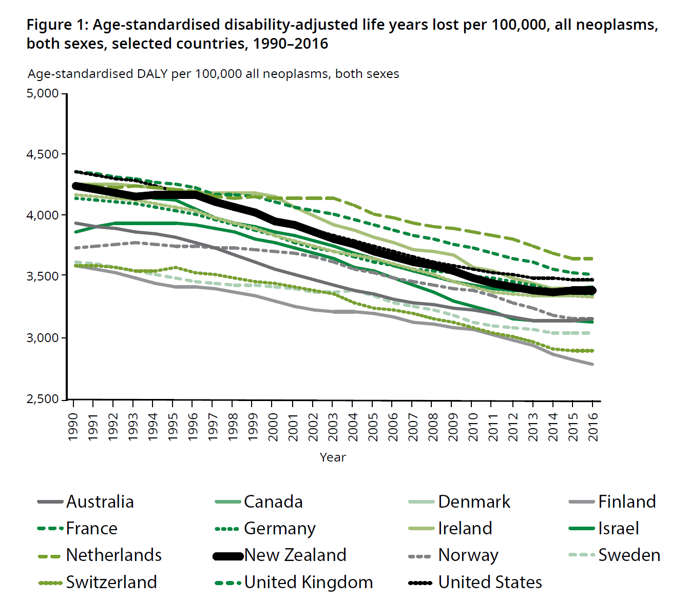
It is particularly concerning that incidence rates of colorectal cancer and melanoma in New Zealand rank among the highest worldwide.
Internationally, survival trends are generally increasing. New Zealand’s five-year survival rates remain among the highest in the world for most cancers, along with the United States, Canada, Australia, Finland, Iceland, Norway and Sweden (Allemani et al 2018). However, recent research suggests that our survival rates from cancer may be falling behind those of our comparable countries and not improving at the same rate as elsewhere (Figure 1). It is time to take action to ensure we do not fall behind.

Cancer patterns in New Zealand
Cancer outcomes vary within New Zealand; some population groups fare much worse than others (eg, Māori, Pacific peoples, people who live in rural and deprived areas, people with a mental illness and disabled people).
Māori are 20 percent more likely to get cancer and nearly twice as likely to die from cancer as non-Māori (see Figure 2 for cancer registration rates and Figure 3 for mortality rates). Once diagnosed, Māori have worse survival rates for almost all cancers (Soeberg et al 2012).
(Note: rates for the sex-specific cancers (prostate, cervix, ovary etc.) are calculated using the total population, not the sex-specific population.)

Figure 2: Provisional New Zealand cancer registration rates, 2017, selected cancers, Māori vs non-Māori, non-Pacific
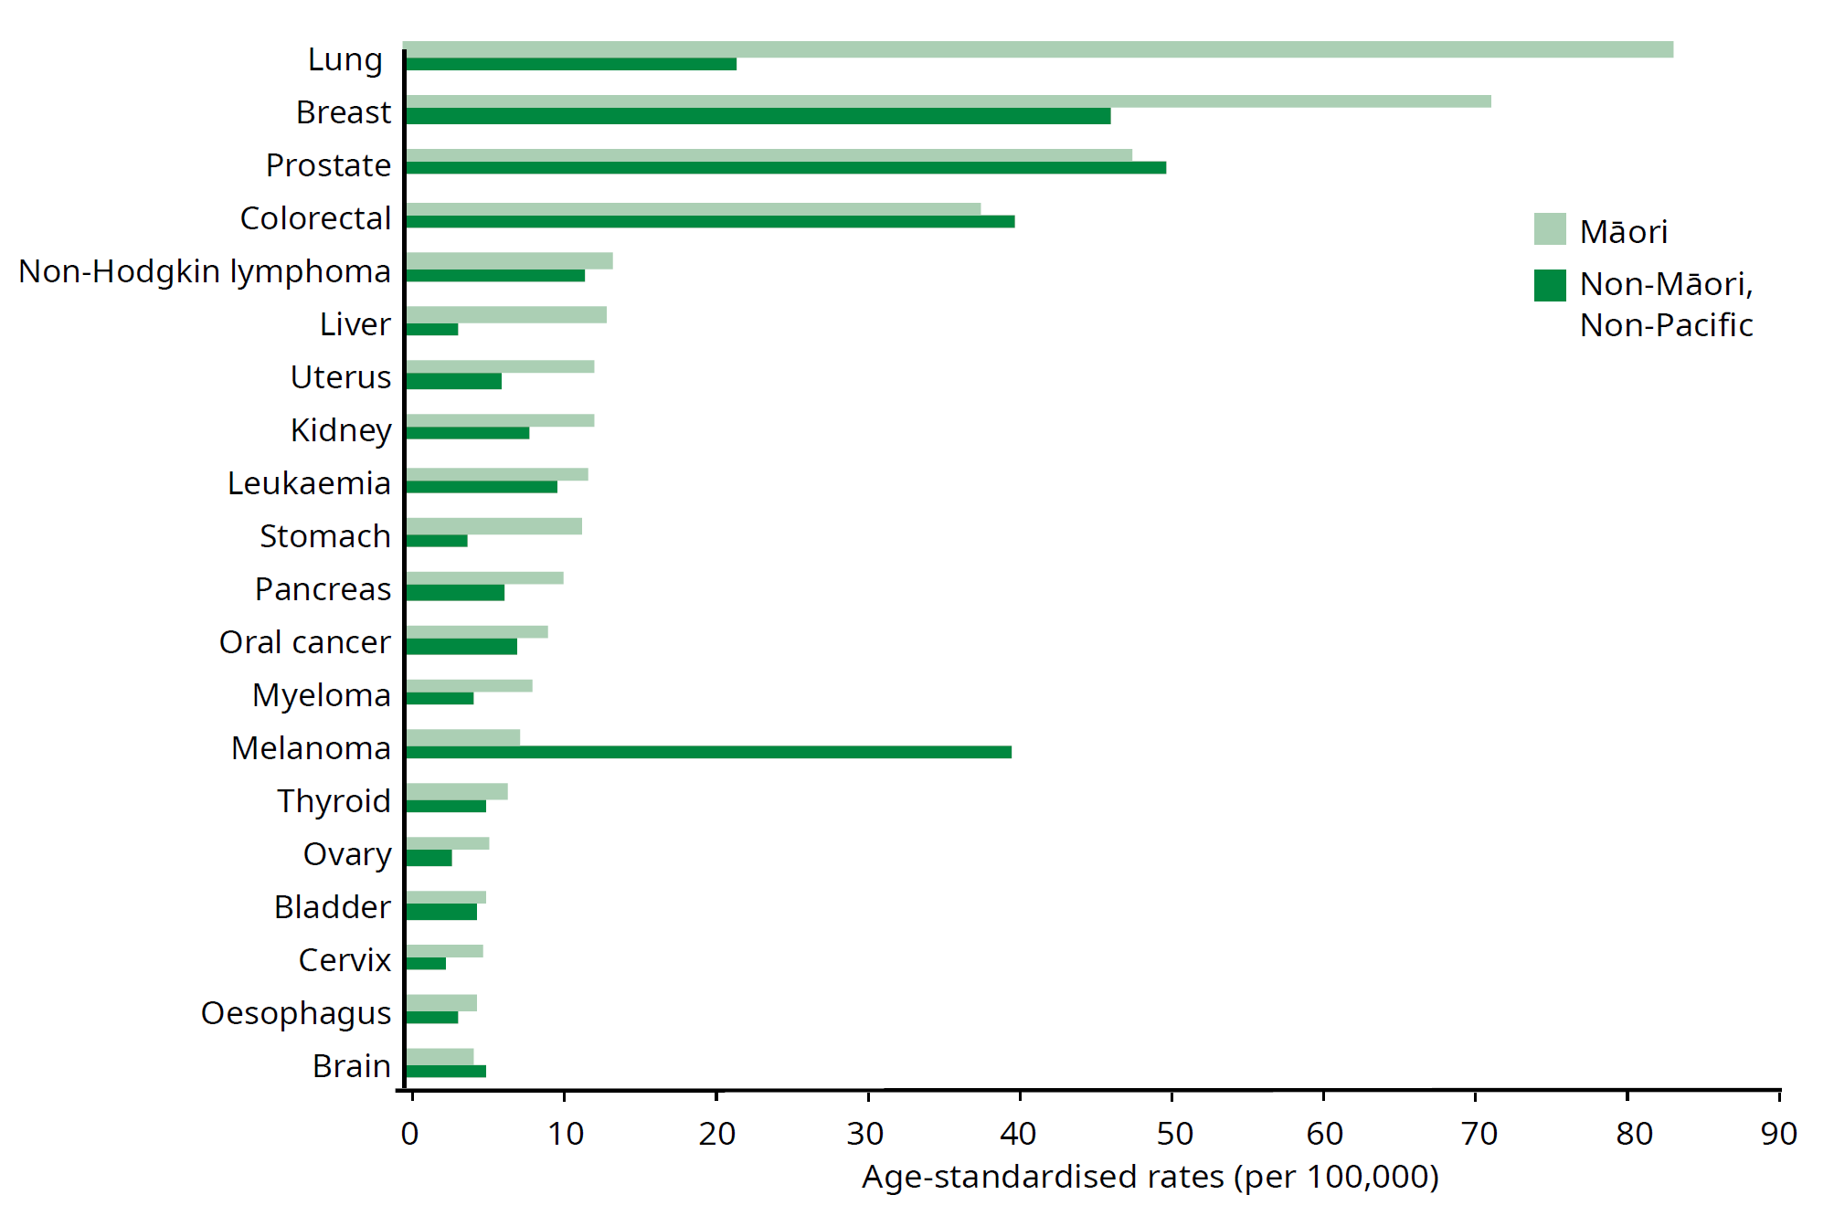

Figure 3: Provisional New Zealand cancer mortality rates, 2016, selected cancers, Māori vs non-Māori, non-Pacific
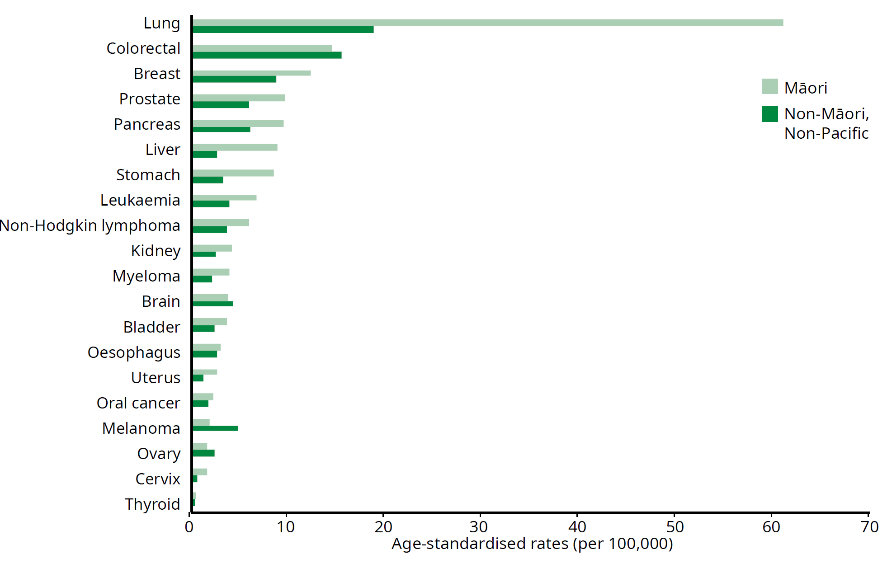
Pacific peoples also have higher incidence and mortality rates for a number of cancers compared with non-Pacific, non-Māori (see Figure 4 for cancer registration rates and Figure 5 for mortality rates; caution is needed when interpreting these graphs as several age-standardised rates have fewer than 30 events).

Figure 4: Provisional New Zealand cancer registration rates, 2017, selected cancers, Pacific vs non-Pacific, non-Māori
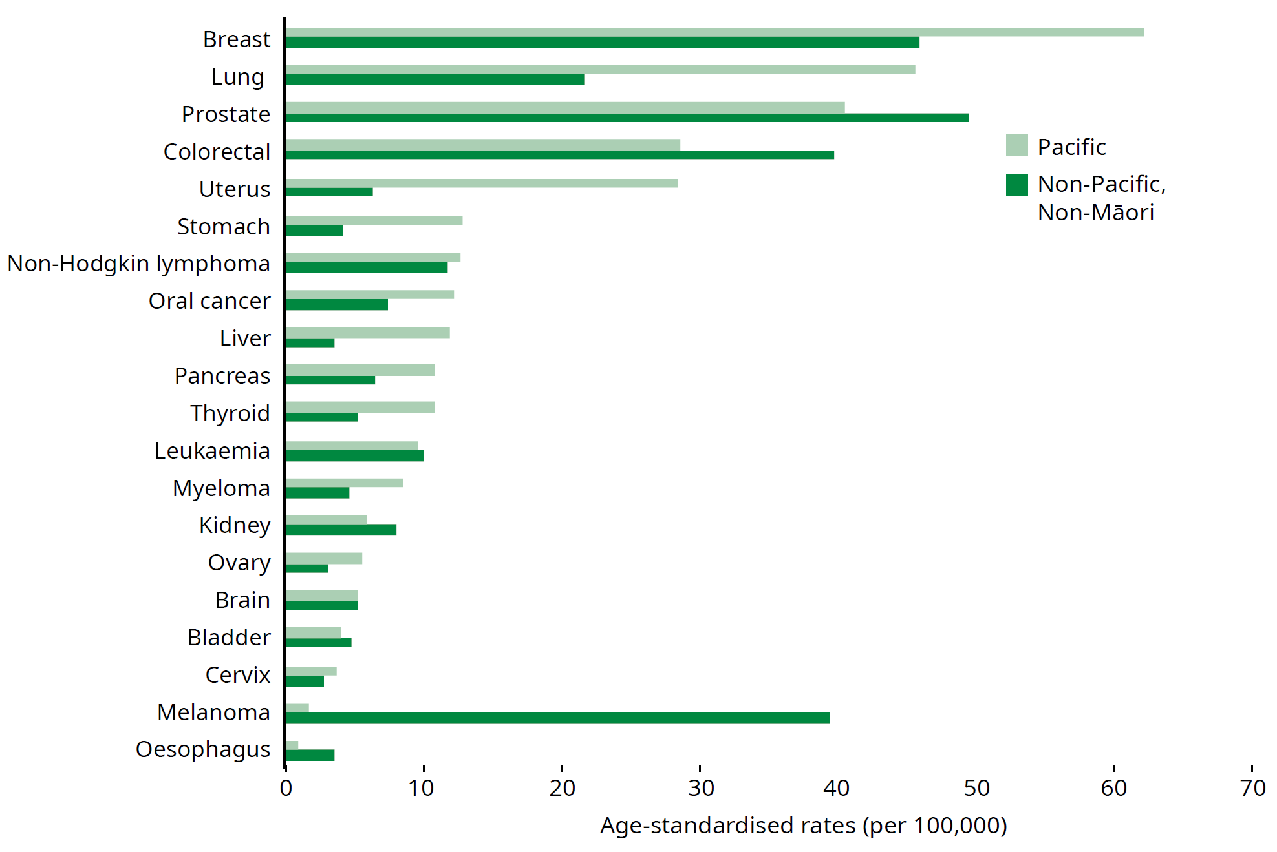

Figure 5: Provisional New Zealand cancer mortality rates, 2016, selected cancers, Pacific vs non-Pacific, non-Māori
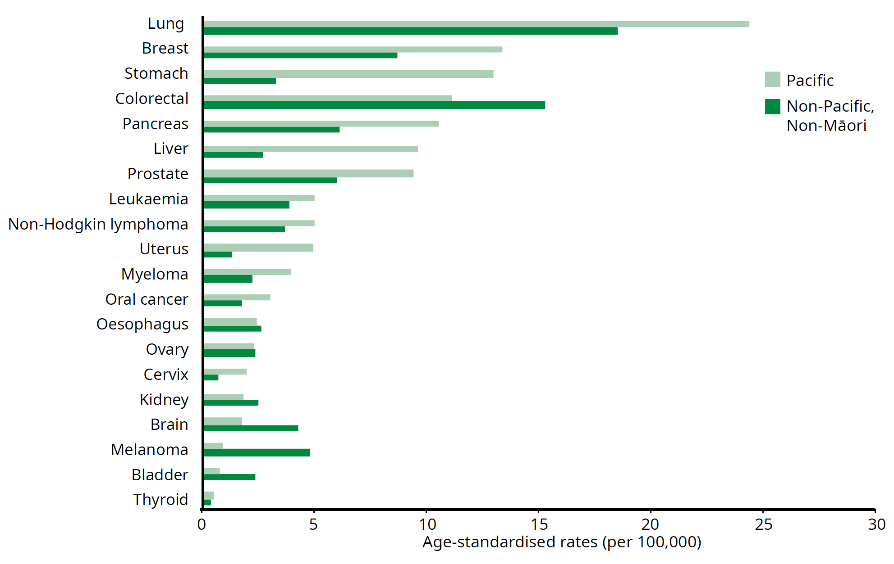
People living in more socioeconomically deprived areas of New Zealand are more likely to develop cancer and less likely to have their cancer detected early than people living in less deprived areas (Robson et al 2010).
Disabled people have higher health risks and poorer life outcomes compared with non-disabled people; in the context of cancer, there is evidence that they experience lower screening rates and higher levels of comorbidities. There is evidence that disabled people may have worse cancer survival for a number of cancers than non- disabled people (McCarthy et al 2007).
People experiencing mental illness and/or addiction have higher cancer mortality; research indicates that this can be explained by reduced access to screening, delayed identification and unequal access to cancer treatment (Cunningham et al 2015).
New Zealand does not have substantive evidence that indicates cancer outcomes are poorer for rural populations; however, international data suggests there is a link between living rurally and poorer outcomes at all stages of cancer care, including delays in diagnosis. We know that access to health care services, including cancer services, is an issue for people living in rural communities. We need to undertake
further research and analysis and improve our measurement of rurality itself (Fearnley et al 2016) to better understand the relationship between rurality and cancer outcomes.
We can significantly improve health outcomes by improving access to appropriate health and disability services. Every system, policy, service, process and health professional plays a role in actively reducing these disparities.

Our commitment to the Treaty of Waitangi – Kia paiheretia Te Tiriti o Waitangi
Te Tiriti o Waitangi (the Treaty of Waitangi) provides an imperative for the Crown to protect and promote the health and wellbeing of Māori, including responding to Māori health aspirations and meeting Māori health needs.
The Ministry is committed to honouring the Crown’s special relationship with Māori under Te Tiriti o Waitangi. The Ministry will work in partnership with tangata whenua and support tangata whenua-led processes, actions and decision-making. We will undertake specific actions to ensure equitable outcomes for tangata whenua and will ensure that tangata whenua world views, values and wairuatanga (spirituality) are present in our work.
New Zealand is a signatory to the United Nations Declaration on the Rights of Indigenous Peoples (UNDRIP). Article 24 of the declaration states:
Indigenous peoples have the right to their traditional medicines and to maintain their health practices, including the conservation of their vital medicinal plants, animals and minerals. Indigenous individuals also have the right to access, without any discrimination, to all social and health services.
Indigenous individuals have an equal right to the enjoyment of the highest attainable standard of physical and mental health. States shall take the necessary steps with a view to achieving progressively the full realization of this right.
Te Puni Kōkiri is developing a plan to drive and measure New Zealand’s progress towards meeting the objectives of the UNDRIP articles (Te Puni Kōkiri 2019).
Given that Māori have the poorest overall health status in New Zealand and are significantly disadvantaged in terms of health inequities, it is essential that we ensure the rights and meet the needs of Māori people.
This plan aims to recognise and respect the rights of our tangata whenua as laid out in the UNDRIP.

Achieving equity – He mana taurite
The Government has a strong focus on achieving equity of outcomes and contributing to wellness for all; particularly Māori and Pacific peoples.
The Ministry’s definition of equity underpins this plan:
In Aotearoa New Zealand, people have differences in health that are not only avoidable but unfair and unjust. Equity recognises different people with different levels of advantage require different approaches and resources to get equitable health outcomes (Ministry of Health 2019a).
In applying this definition, the Ministry and the Cancer Control Agency aim to align their work with their Te Tiriti o Waitangi obligations and go beyond just remedying disadvantage and reducing inequities, enabling Māori to flourish and develop and lead their own goals for health and wellbeing. Linking this plan with the Māori Health Action Plan (currently being developed) will enable us to coordinate action to achieve the aims of He Korowai Oranga – Māori Health Strategy.
Achieving equity for Pacific people is also a priority. Linking with this plan in with the work of the Pacific Health Action Plan (currently being developed) will enable us to better understand and meet the needs of Pacific peoples, their families and their communities.
The Ministry’s definition of equity will drive the coordinated and collaborative effort that we need to achieve equitable cancer outcomes for all New Zealanders across the cancer continuum. Achieving equity for Māori will require us to carefully consider how our systems are designed and accessed and to innovate in areas that are currently underserving some populations. This will improve the system in general.

Outcomes – Ngā huanga
There are four outcomes we want to achieve in delivering this plan.
Outcome 1: New Zealanders have a system that delivers consistent and modern cancer care – Te huanga 1: He pūnaha atawhai
New Zealanders should expect to receive high-quality cancer care services now and in the future. To make our health care systems future-proof, we need an approach that involves strong governance, accountability and stewardship. To continue to lift our performance in cancer care, we need to ensure we have strong national leadership, a skilled and sustainable workforce and the right information to make the best decisions possible.

Outcome 2: New Zealanders experience equitable cancer outcomes –
Te huanga 2: He taurite ngā huanga
All New Zealanders should experience the best treatment and care, regardless of where they live or who they are. This is critical to ensure we achieve equitable cancer outcomes for all our people.
We will develop service models that better support Māori and Pacific peoples to improve their outcomes. We will partner with different population groups and support our workforce to carry out culturally responsive care and enable an equal chance of success. Essential to this is increasing the number of Māori and Pacific people in the cancer health workforce, as well as developing cultural safety across the wider workforce. A key action from this outcome is the development of a mātauranga Māori framework for delivering this plan.

Outcome 3: New Zealanders have fewer cancers – Te huanga 3: He iti iho te mate pukupuku
Investment in the prevention of cancer will ultimately make the largest contribution to reducing the burden of cancer in New Zealand and to achieving equity in outcomes.
As a country, we must place renewed value and importance on preventing cancer. We must develop a more supportive environment to enable New Zealanders to thrive and enhance their health and wellbeing. We want to develop policies to support an environment where New Zealanders can make healthy choices.

Outcome 4: New Zealanders have better cancer survival – Te huanga 4: He hiki ake i te oranga
Surviving many cancers is dependent on early diagnosis and a cancer care system that is well coordinated, information-rich, focused on improving outcomes and can respond in a timely, effective and appropriate way.
By ensuring New Zealanders receive timely, high-quality person- or whānau-centred cancer care, we can lift our survival rates and achieve our specific equity goals. Ensuring person- or whānau-centred care for supportive, palliative and end-of-life care will enable optimal wellbeing for people affected by cancer and their whānau.
We need a cultural shift in the way we deliver health services to all New Zealanders, particularly for Māori, Pacific people and other priority populations, to better reflect the needs and values of our communities. We need to continue to strive to deliver modern and consistent care. It is essential to address the socio-economic and environmental factors that influence cancer awareness among our whānau and communities, to ensure they make the best decisions they can about their health.

Outcomes framework – Te pou huanga
The following graphic presents the basis of our plan – its principles, its four key outcomes and key areas within each outcome area that we will focus on to achieve our goals.
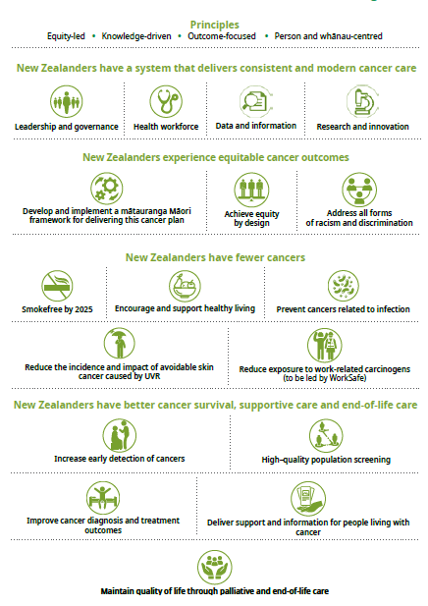

Prioritisation framework – Te pou whakaarotautanga
‘Prioritisation’ refers to the way we make decisions about what health and disability services or interventions to fund for the benefit of New Zealanders with the resources available. It is about managing existing services effectively, as well as making decisions about what new services to fund.
When we make prioritisation decisions, we look at the evidence and then aim to allocate or reallocate resources to services that are more effective in improving health and independence and achieving equity. Our prioritisation decisions also consider the timing of allocation or reallocation.
We will develop a specific prioritisation framework to support national decision-making about priorities for cancer on an ongoing basis.
Elements relevant for prioritisation of interventions could include:
- meeting our obligations under Te Tiriti o Waitangi
- addressing the total burden of disease and for priority populations to improve health equity
- the total health impact of interventions
- value for money
- the total cost of interventions
- the capacity of the health sector to implement interventions.

Outcome 1: New Zealanders have a system that delivers consistent and modern cancer care – Te huanga 1: He pūnaha atawhai

New Zealanders should expect to receive high-quality cancer care services now and in the future. To make our health care systems future-proof, we need an approach that involves strong governance, accountability and stewardship. To continue to lift our performance in cancer care, we need to ensure we have strong national leadership, a skilled and sustainable workforce and the right information to make the best decision possible.
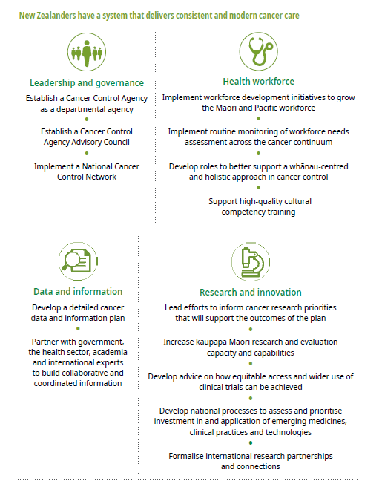

Leadership and governance
- Establish a Cancer Control Agency as a departmental agency
- Establish a Cancer Control Agency Advisory Council
- Implement a National Cancer Control Network
We need strong leadership and governance at multiple levels, to ensure accountability, oversight and progress on delivering outcomes.
Influential and respected leadership will bring diverse stakeholders together and promote effective working relationships. Effective leaders will share knowledge, skills, expertise and responsibilities to deliver the actions needed to improve the outcomes of all people affected by cancer.
While we know that all stakeholders are committed to making a positive difference, the existence of multiple groups with different functions, purposes and investment priorities can impede progress at all levels.
To deliver the plan effectively, we must:
- prioritise strong and accountable clinical and non-clinical leadership
- prioritise Māori leadership and partnership at all levels of the system
- encourage consumer leadership, engagement and co-design
- establish a governance structure that has the mandate to prioritise and inform investment across the continuum
- implement a national cancer control network.

Establish a Cancer Control Agency in the Ministry of Health
From 1 December 2019, the Government established the Cancer Control Agency, a departmental agency within the Ministry of Health which will provide strong national leadership for and oversight of cancer control. The Cancer Control Agency has its own Chief Executive, accountable directly to the Minister of Health for delivery on the cancer action plan.
The Agency is the preferred approach to providing the strong central leadership required to strengthen and improve cancer control in New Zealand. It provides the best balance between ensuring a specific focus and leadership for cancer control while maintaining the essential integration of cancer services with the wider health system. For example, currently about 50 percent of curative cancer treatment is a result of surgery, which is an integral part of wider hospital care – cancer surgery is undertaken in the same theatres and with the same staff as non-cancer surgery.
On the prevention side, many initiatives such as preventing smoking and supporting people to stop smoking are part of wider prevention initiatives led by the Ministry and other agencies.
The Cancer Control Agency will take a whole-of-system focus on preventing and managing cancer and will oversee system-wide prioritisation and coordination of cancer care in New Zealand. It will consider how to get the best value from our existing cancer care investment, make decisions on nationally agreed aspects of cancer control and advise the Government about new services to improve cancer system performance and practice improvements.
The Cancer Control Agency will develop initiatives and be accountable for ensuring the transparency of progress towards the goals and outcomes in this plan. It will monitor progress of the plan through regular public reporting. The Cancer Control Agency will also ensure there is a clear direction for efforts to reduce cancer incidence and improve cancer outcomes in New Zealand, as outlined in the plan.
The Cancer Control Agency will:
- implement the plan and the National Cancer Control Programme
- have a strong focus on achieving equity of outcomes and contributing to wellness for all, particularly Māori and Pacific peoples, who currently experience poorer cancer outcomes.
In addition, immediate steps have been taken to strengthen national governance and leadership of cancer control.

Establish a Cancer Control Agency Advisory Council
The management of cancer is complex and involves every aspect of our cancer services. Many agencies and bodies within the health system are involved in some aspect of cancer control and care. These include those involved in prevention, health promotion, screening, diagnosis, cancer care and palliative care. It also involves
non-governental organisations (NGOs), iwi and Pacific providers, primary health organisations, laboratories, radiology services, cancer screening providers, district health boards (DHBs), private providers, PHARMAC, the Health Promotion Agency (HPA), hospices, mental health providers, community health services and coordinators of travel and accommodation.
The Cancer Control Agency Advisory Council will include clinical and non-clinical cancer leaders and will be advised by broad-based clinical and consumer reference groups. These groups will support the Chief Executive of the Cancer Control Agency in their role.

Implement a National Cancer Control Network
We will create a National Cancer Control Network (the Network) that combines the four regional cancer networks as part of the Cancer Control Agency. The Network will support the implementation of the national programme to ensure consistent service delivery across the country while maintaining local innovation.
We will continue to support the National Child Cancer Network and the Adolescent and Young Adult Cancer Network.

Health workforce
- Implement workforce development initiatives to grow the Māori and Pacific workforce
- Implement routine monitoring of workforce needs assessment across the cancer continuum
- Develop roles to better support a whānau-centred and holistic approach in cancer control
- Support high-quality cultural competency training
People affected by cancer require diverse, sustainable, quality, whānau-centred care. To provide this, we need a workforce with a wide range of skills, competencies and experiences, including cultural competence.
The sector has outlined several significant workforce issues.
- There are overall shortages in many areas of the workforce, including medical, nursing and allied health.
- Workforce requirements need to be accurately modelled and forecasted to support delivery to an increasing number of people with cancer and align with new models of care, including Māori health models.
- There are insufficient numbers of trained Māori and Pacific health care professionals to provide appropriate care for these priority populations. The Government will need to consider future investment in growing and developing the Māori and Pacific workforce to better meet the needs of Māori and Pacific peoples.
- There is a requirement to strengthen and support the current health workforce.

Implement workforce development initiatives to grow the Māori and Pacific workforce
High-quality cancer care depends on the workforce’s ability to provide competent, trusted inter-professional care that is aligned with patients’ needs, values and preferences (Levit et al 2013).
Evidence shows Māori treating and working with Māori results in better health outcomes for Māori. Māori constitute 15 percent of the population, but account for less than 4 percent of the active medical workforce, and less than 7 percent for nursing and allied health workforces.
Robust and forward-thinking workforce planning is fundamental to current and future demands. We need to take proactive measures to strengthen Māori and Pacific peoples’ participation in the workforce and address the current disparities.
The Ministry is currently focusing on growing the Māori and Pacific health and disability workforce and creating environments in which they both can thrive.

Implement routine monitoring of workforce needs assessment across the cancer continuum
Long-standing issues including critical workforce shortages affect health and disability services. Future work must consider the capability, capacity and culture of our current workforce and enhance the wellbeing of that workforce.
The Ministry is using data and intelligence to inform workforce planning, which will measure the shortages with the current and future workforce.
Alongside this work, we need to focus on expanding or changing scopes of practice to align with new and changing models of care (eg, nursing roles in radiation oncology and nurse endoscopists) and targeting resources to meet future needs.
The Ministry must continually scan for future trends and innovations that might affect how we provide cancer care. Initial work needs to focus on:
- defining the requirements of the cancer control workforce
- clearly understanding the current state of that workforce
- identifying shortages and prioritising focus areas
- workforce populations most at risk of the effects of an ageing workforce (eg, 43 percent of nurses are over 50).

Develop roles to better support a whānau-centred, holistic approach in cancer control
There are challenges in accessing cancer services at all levels, particularly for Māori and other priority populations. Access to high-quality cancer care can have a substantial impact on cancer health outcomes.
We need to better enable people to access cancer services by developing roles that can provide support at various points in the pathway – from diagnosis to living well with and beyond cancer. These roles should incorporate Māori and Pacific models of wellbeing and philosophical and practical approaches to better meet the needs of Māori and Pacific peoples. The mātauranga Māori framework will support this work.

Support high-quality cultural competency training
New Zealand has a diverse population. It can be challenging for health care systems and providers to create and deliver services that meet the social, cultural and linguistic needs of all New Zealanders. Ensuring the acceptability of cancer services has been identified as a key means of addressing social inequities in cancer outcomes (World Health Organization 2019b) (IARC report, 2019).
Health care should be based on people’s needs rather than professional or service boundaries. We must embed Māori and Pacific cultural competencies and whānau- centred values-based practice in education and training packages, which should include training in unconscious bias (Ministry of Health 2019d).

Data and information
- Develop a detailed cancer data and information plan
- Partner with government, the health sector, academia and international experts to build collaborative and coordinated information
We need to ensure that everyone – including people affected by cancer, communities and health care providers – has the information they need to make the best decisions they can.
Information on people with cancer is currently created and stored by a range of local practitioners, clinics, hospitals and non-government providers. Building a view of a patient pathway is therefore manual and resource intensive. Establishing a reliable and accurate picture across a cancer type, region or demographic group is very challenging and reduces our ability to compare outcomes. This gap has driven the development of multiple standalone databases and registries across the sector.
We must develop a pragmatic approach to achieving the vision of comprehensive, accessible and accurate information to support the delivery of quality care across the cancer patient pathway. Better information supports empowered decision-making, not just for clinicians, policy makers and researchers, but also for patients, when they decide on a cancer pathway that best meets their individual needs.

Develop a detailed cancer data and information plan
We will develop a data and information roadmap that will:
- identify and understand the priority cancer data and information needs of key stakeholders
- understand how to support the implementation of digital technology that can help deliver care in more clinically and cost-effective ways to improve equity
- implement and support an integrated standards-based approach to the collection, retrieval and linkage of high-quality, comparable data at all stages of cancer care, including post-cancer care
- ensure timely distribution of relevant and accurate cancer data and information that addresses identified priorities and addresses our obligations under Te Tiriti o Waitangi
- develop a sustainable approach to ensure rapid access for stakeholders to data and information that enables them to develop actionable insights
- develop a policy and pathway that drives coordination, prioritisation and consistency of approach to cancer information systems to support patient-centred and coordinated care.

Partner with government, the health sector, academia and international experts to build collaborative and coordinated information
Information is crucial in helping people make informed decisions based on cancer diagnosis, management and prognosis.
The whole sector must collaborate to achieve coordinated cancer intelligence. We need to work with a range of partners across government, the heath sector and academia to achieve our goals.
Within the cancer sector and research communities we need to increase our involvement in benchmarking opportunities, including through established international programmes that build global knowledge.
It is important for New Zealand to have a role in shaping the global cancer agenda. For example, our approach to identifying, monitoring and addressing ethnic inequities in cancer care and outcomes is pioneering and instructive from a global perspective.

Research and innovation
- Lead efforts to inform cancer research priorities that will support the outcomes of the plan
- Increase kaupapa Māori research and evaluation capacity and capabilities
- Develop advice on how equitable access and wider use of clinical trials can be achieved
- Develop national processes to assess and prioritise investment in and application of emerging medicines, clinical practices and technologies
- Formalise international research partnerships and connections
High-quality cancer research and innovation drive evidence-based practice improvements across the cancer continuum and the wider health system.
Research and innovation are essential to reduce the burden of cancer (eg, in the areas of prevention and early detection) and to improve treatment outcomes and the quality of life of people affected by cancer.

Lead efforts to inform cancer research priorities that will support the outcomes of the plan
Cancer research directions should complement the broader New Zealand Health Research Strategy 2017–2027 (Ministry of Business Innovation and Employment 2017). We need to coordinate New Zealand-wide cancer research so that it can inform priority areas of cancer care, improve clinical practices and reduce the incidence and impact of cancer for Māori, Pacific peoples and other priority populations.
To deliver the plan effectively, we must:
- assess and implement evidence-based research and innovative findings in a timely manner
- partner effectively with the health sector to assess, prioritise and deploy technologies that are respectful and responsive to the preferences, needs and values of our communities
- facilitate research that is relevant and innovative to cancer control and identify areas where specific research is needed in a timely manner
- develop and support kaupapa Māori research, monitoring and evaluation
- develop and support Pacific research, monitoring and evaluation
- better understand and implement evidence-based supportive and palliative care research to reduce the impact of cancer.
Increase kaupapa Māori research and evaluation capacity and capabilities
Kaupapa Māori is a theoretical framework that ensures cultural integrity is maintained when analysing Māori issues. Kaupapa Māori is grounded in mātauranga Māori as it derives from te reo and tikanga Māori. It provides both tools of analysis and ways of understanding the cultural, political and historical context of Aotearoa (Pihama 2015).
The cancer care sector and cancer health research community have outlined the significant issues they face, including a lack of investment in Māori research and evaluation capacity and capabilities. To effectively deliver the plan we must continue to develop and support kaupapa Māori research, monitoring and evaluation.

Develop advice on how equitable access and wider use of clinical trials can be achieved
The cancer care sector has clearly outlined the significant issues it faces, including inequities in participation in clinical trials. Research and innovation must inform evidence-based interventions to support healthy lifestyles and reduce inequities for people affected by cancer, including through equitable participation and increased use of clinical trials to determine if new treatments or new ways of using existing therapies, diagnostic tests, preventive or supportive interventions are safe and effective.
To effectively deliver the plan we must understand and remove barriers to participation in cancer clinical trials with a focus on ensuring innovative and equitable access. Improving availability of clinical trials and access to them should be a core function of specialised cancer care services.

Develop national processes to assess and prioritise investment in and application of emerging medicines, clinical practices and technologies
Research and innovation must inform evidence-based interventions to improve outcomes and achieve equity for people affected by cancer. This includes genomics and other molecular technologies that need to be accelerated, enhanced and nationally coordinated. Such technologies provide new opportunities for research into the genetic and molecular profile of cancers particularly if there is a therapeutic implication. There needs to be appropriate consultation with pathologists and other key groups at the point where targeted therapies are being considered for approval and an appropriate timeframe within which to develop and validate the appropriate companion tests new drug approvals require.
Research will support the development of more effective diagnostic approaches and new pathways for personalised medicine, tailored to a person’s genetic make-up and the characteristics of their disease. The cancer care sector has outlined issues including long lead-in times to translate research findings into policy and practices for emerging medicines, clinical practices and technologies.

Formalise international research partnerships and connections
New Zealand is recognised internationally for its strength in research and innovation. With these strengths, we can make a valuable contribution to improving health experiences and outcomes both nationally and internationally.
International research findings are an important source of new knowledge, but we need to be able to combine them with New Zealand-based cancer research and adapt them to the New Zealand context. Some vital information can only be obtained through New Zealand research, particularly in the area of the significant disparities in the incidence of and survival from some cancers between different population groups within New Zealand.
New Zealand currently works with international research partners and will continue to strengthen connections with these and other groups, such as the International Agency for Research on Cancer (IARC).

Outcome 2: New Zealanders experience equitable cancer outcomes – Te huanga 2: He taurite ngā huanga

All New Zealanders should experience the best treatment and care, regardless of where they live or who they are. This is critical to ensure we achieve equitable cancer outcomes for all our people.
In Aotearoa New Zealand, people experience differences in health that are not only avoidable but unfair and unjust. To achieve equitable health outcomes, people with different levels of advantage require different approaches and resources.
This Plan is equity-led, with a strong focus on achieving equitable outcomes and contributing to wellness for all, particularly Māori and Pacific peoples. Priority populations also include those who live in rural and highly deprived areas, those with mental illness and disabled people.
Hei Āhuru Mōwai, the National Māori Cancer Leadership Aotearoa, was established in 2012 and will continue to work in partnership with the Cancer Control Agency to accelerate action to ensure that Māori experience high-quality, equitable cancer care.
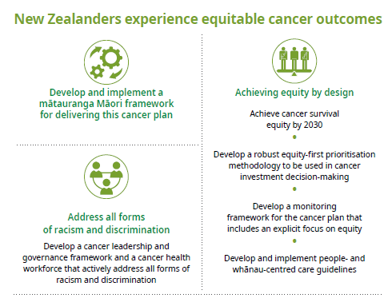

Develop and implement a mātauranga Māori framework for delivering this cancer plan

A mātauranga framework articulates priorities, actions and aspirational and achievable outcomes centred in Māori worldview norms. Whānau and Māori communities will co-design such a framework for the purposes of this plan; it will have a focus on the diverse and complex realities that whānau Māori exist within.
Responding to Māori health aspirations is a Tiriti o Waitangi obligation and achieving equity in health outcomes for Māori is a core focus of this plan. He Korowai Oranga – Māori Health Strategy provides the framework for achieving pae ora – healthy futures. Everyone contributing to the delivery of this plan must work together towards achieving pae ora.
Along with ensuring kaupapa Māori input across all action areas, this plan commits to working with iwi, hapu, whānau and Māori communities to develop and implement a mātauranga Māori framework for preventing cancers and delivering cancer services in partnership with the Crown.
The plan also recognises that Māori models of service delivery will benefit all New Zealanders, as they promote holistic approaches that place people and their whānau at the centre.

Achieving equity by design
- Achieve cancer survival equity by 2030
- Develop a robust equity-first prioritisation methodology to be used in cancer investment decision-making
- Develop a monitoring framework for the cancer plan that includes an explicit focus on equity
- Develop and implement people- and whānau-centred care guidelines

Achieve cancer survival equity by 2030
In New Zealand, there are stark inequities in the prospect of surviving cancer. For example, Māori with cancer are more likely to die (and to die sooner) than non-Māori with cancer (Soeberg et al 2012; Robson 2010). This highlights that the system is not working effectively for some groups (Hill et al 2013).
Since inequities in survival are sensitive to system-level interventions, particularly in terms of access to early detection and best-practice treatment, they are almost certainly avoidable. A well-resourced approach and improved health care system
could eliminate inequities in cancer survival over time. It is an explicit goal of this plan to achieve equity in cancer survival for all New Zealanders.
The first objective will be to achieve equity in cancer survival for Māori compared with non-Māori New Zealanders, given the enduring and strong inequities in cancer survival suffered by Māori and our obligations under Tiriti o Waitangi (Gurney et al 2019).

Develop a robust equity-first prioritisation methodology to be used in cancer investment decision- making
To meaningfully address the inequities in cancer incidence, survival and provision of palliative care for Māori and other groups, we need to prioritise certain approaches and resources. We will develop an equity-first methodology to prioritise the allocation of new resources and the reallocation of existing resources and activities in a way that works towards achieving equity in cancer outcomes.

An initial set of criteria may aim to prioritise investments that:
- build understanding of equity problems through smart data, analytics, research and rich insight
- enable people across the health and disability sector to optimise the performance of the cancer care system for Māori and other groups facing inequities
- foster innovation and trial, evaluate and expand services that are responsive to the needs of people affected by cancer
- weave an equity focus into all cancer-related services and activities.

Develop a monitoring framework for the cancer plan that includes an explicit focus on equity
The monitoring framework for this plan and the data, analytics and insights that underpin it are critical in achieving equity in survival and supportive and end-of-life care. The monitoring framework will allow us to monitor progress, support research into actions that can potentially address inequities and evaluate new and existing programmes and services.
It will require:
- data sets that contain multidimensional and granular information, so we can disaggregate along population group lines
- analytical outputs that show trends over time, identify equity gaps and allow us to consider data from a patient’s perspective.

Develop and implement people- and whānau-centred care guidelines
Whānau-centred care places whānau at the centre of policies and services. It has an emphasis on collective rather than individual thinking. Whānau-centred care is culturally grounded and holistic. It places whānau at the centre of decision-making and empowers them to lift their wellbeing. Whānau-centred care encourages collaboration and integration across all of health.
The concept of whānau ora is a key component of He Korowai Oranga – Māori Health Strategy. It is about supporting Māori whānau to achieve their maximum health and wellbeing. Whānau ora is driven by a focus on whānau being self-managing, living healthy lifestyles and confidently participating in te ao Māori and in society. It is a key element of pae ora and is an important part of setting the foundations for healthy futures. Whānau ora is an example of whānau-centred policy and approaches in action.
We must ensure that whānau have every opportunity to be more involved in a person’s health care. Evidence shows that when whānau are involved, decisions are better, wellbeing and health outcomes improve and resources are allocated more efficiently. Ensuring people and whānau have stronger voices in their own care and respecting whānau aspirations for health and wellbeing will help people live better and make the health system equitable and more effective.

Address all forms of racism and discrimination
- Develop a cancer leadership and governance framework and a cancer health workforce that actively address all forms of racism and discrimination

Develop a cancer leadership and governance framework and a cancer health workforce that actively address all forms of racism and discrimination
A critical element in addressing racism and discrimination is the creation of a workforce that is culturally competent, responsive and well placed to deliver whānau- centred care that meets the needs of people affected by cancer, enabling the cultural safety of them and their whānau.
One key way of achieving such responsiveness is to increase the diversity of the workforce, preferably to a point where it reflects the diversity of the people it serves. To this end, this plan will support initiatives that:
- provide opportunities for Māori and Pacific peoples to choose health as a career
- create culturally responsive practices for and with Māori (hauora Māori competencies) and Pacific peoples across the workforce.
To achieve equity, leadership needs to be present and effective all the way through the system. In terms of equity, effective leaders should:
- have a clear vision for equity
- create meaningful partnerships, including with community leaders and providers
- manage the risks of perceived special treatment and champion explicit messages concerning fairness
- ensure action is meaningful, aligned with that of other agencies and not tokenism.

Outcome 3: New Zealanders have fewer cancers – Te huanga 3: He iti iho te mate pukupuku

Prevention of cancer could be the biggest contributor to improving overall cancer outcomes, as well as achieving equity. It is estimated that around 40 percent of health loss from cancers is potentially preventable (Centers for Disease Control and Prevention 2014). We can better support New Zealanders to reduce their risk of developing some cancers. However, not all cancers can be prevented. For example, there are currently no known preventive strategies for the vast majority of blood cancers.
Tobacco smoking, excess weight, drinking alcohol, unhealthy eating, workplace risks, physical inactivity, chronic infection and harmful ultra-violet radiation (UVR) exposure are the leading preventable and modifiable risk factors for cancers. Generally, New Zealanders have a low awareness of cancer risks beyond smoking and sun exposure.
Working to address modifiable risk factors will have a powerful impact on population health and reduce health inequities (Ministry of Health 2018c). Risk factors are shaped by the socioeconomic, political and physical environments and are an important consideration for prevention.
Reducing the risk of cancer will also reduce the risk of many other chronic conditions, including heart disease, type 2 diabetes, stroke, some musculoskeletal disorders and chronic respiratory diseases.

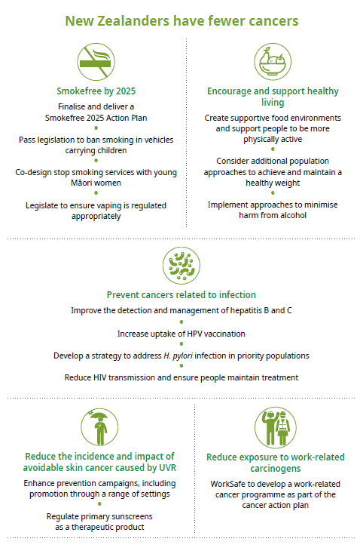

Smokefree by 2025
- Finalise and deliver a Smokefree 2025 Action Plan
- Pass legislation to ban smoking in vehicles carrying children
- Co-design stop smoking services with young Māori women
- Legislate to ensure vaping is regulated appropriately
Tobacco smoking causes a significant level of health loss through preventable disease and premature death in New Zealand. It contributes to over 80 percent of lung cancer and is also a contributory risk factor in several other cancers.
New Zealand has a long history of introducing initiatives to reduce smoking rates. The tobacco control programme is made up of a range of initiatives, including prohibiting sales to under-18-year-olds, restricting advertising and product display, requiring standardised packaging, creating smokefree areas, taxing tobacco, the use of social marketing and offering stop-smoking services and subsidised stop-smoking medicines.
31.3% of Māori and 20% of Pacific peoples smoke daily
People living in the most deprived areas are almost three times as likely to smoke daily
Rural areas have a higher proportion of smokers than urban areas
The collective impact of these initiatives has reduced smoking rates and tobacco consumption over the last decade. The rate of daily smoking for adults decreased from 18 percent in 2006/07 to 13.1 percent in 2017/18. However, disparities in smoking rates still exist.
The collective impact of these initiatives has reduced smoking rates and tobacco consumption over the last decade. The rate of daily smoking for adults has decreased from 18 percent in 2006/07 to 13.1 percent in 2017/18. However, disparities in smoking rates still exist.
Despite the declining rates in smoking, our Smokefree 2025 goal will be challenging to achieve. We need to foster a supportive environment in which young New Zealanders do not start smoking and smokers are supported to stop.

Finalise and deliver a Smokefree 2025 Action Plan
In 2019, the Government agreed to develop a Smokefree 2025 Action Plan that will reflect a comprehensive, supportive approach to encourage people not to start smoking and support those who are smoking to stop.
In line with international evidence, the plan will be comprehensive and multi-faceted; it will aim to achieve the Smokefree 2025 goal equitably for all population groups in Aotearoa.
The Smokefree 2025 Action Plan will build on existing successful interventions and identify what other measures will best help us achieve a smokefree New Zealand by 2025.
While the plan is being developed, a range of initiatives are already under way.

Pass legislation to ban smoking in vehicles carrying children
Parliament are currently considering the Smoke-free Environments (Prohibiting Smoking in Motor Vehicles Carrying Children) Amendment Bill.

Co-design stop smoking services with young Māori women
Our approach to reduce the smoking rates for New Zealanders has been based on international best practice. These approaches have had a significant effect for most groups, but the smoking rates for Māori remain high.
The Ministry has recently taken a new approach (client insights) to the problem of high Māori smoking rates, particularly through the search for a deeper understanding of some of the people at the centre of this issue, particularly among young Māori women.
In the project ‘Addressing the challenge of young Māori women who smoke’, the Ministry used data, evidence and insights to find out about the barriers affecting young Māori women’s ability to quit smoking. It published good practice guidance on the subject in July 2019 (Ministry of Health 2019e).
Stop smoking services are now being asked to use this guidance to design and deliver services.

Legislate to ensure vaping is regulated appropriately
New Zealand urgently needs legislation to regulate vaping products that supports smokers to switch to a less harmful alternative while protecting children and young people from access to and use of these products.
The Smoke-free Environments (Vaping) Amendment Bill is expected to be introduced within this Parliamentary term.

Encourage and support healthy living
- Create supportive food environments and support people to be more physically active
- Consider additional population approaches to achieve and maintain a healthy weight
- Implement approaches to minimise harm from alcohol
Attaining and maintaining a healthy weight, healthy eating, physical activity and limiting alcohol are important for wellbeing and decreasing the risk of many cancers and other chronic conditions.

Create supportive food environments and support people to be more physically active
The Ministry’s Eating and Activity Guidelines (Ministry of Health 2018a) provide advice on healthy eating and being physically active, reducing the risk of cancer. The Ministry recommends that adults do at least five hours of moderate (or two and a half hours of vigorous) physical activity per week (Ministry of Health 2018a).
The Ministry encourages supportive food environments through healthy food and drink policies across a range of settings including DHBs, other health providers, government agencies and education settings. In a wider context, government agencies will work together to support people to eat well and to be healthier.
The Ministries of Health and Education, together with Sport New Zealand, are implementing Healthy Active Learning, a Government initiative that will provide support to early learning services, kura and schools to adopt and implement healthy food and water-only policies, to encourage and support physical activity and review and update health and physical education curriculum resources.
Sport New Zealand and the Ministry of Health are initiating a cross-agency approach: Everybody Active Everyday; Tama Tū, Tama Ora, to increase population levels of physical activity (including active play, walking and cycling for transport, sport and recreation) by making the healthy choice the easy choice.
Other options being investigated include reducing children and young people’s exposure to advertising and sponsorship of alcohol, foods and drinks, particularly those high in saturated fat, salt and sugar.

Consider additional population approaches to achieve and maintain a healthy weight
There is strong evidence that excess weight increases the risk of several cancers. As people generally gain weight gradually, regular monitoring of weight, along with eating well and being more physically active, provides the best opportunity to address this risk. Health providers can identify excess weight gain trends early, and through appropriate advice and support, prevent further weight gain.
The Clinical Guidelines for Weight Management in New Zealand Adults (Ministry of Health 2017b) and the Clinical Guidelines for Weight Management in New Zealand Children and Young People (Ministry of Health 2016a) present a four-stage pathway designed to facilitate clinical decision-making for prevention, early identification, investigation, management and support in this area. The guidelines are supported by public resources and include advice on sleep, nutrition and physical activity.
Other work includes implementing the Ministry’s evidence-based population health advice on healthy eating and physical activity and maintaining and updating eating and activity guidelines to service the population. Work is already under way in the areas of Health Star Ratings and food labelling (Ministry of Health 2018b). Other options include considering pricing policies to support healthy eating.

Implement approaches to minimise harm from alcohol
Alcohol can increase the risk of certain types of cancers. International evidence suggests that the more alcohol a person consumes, the higher their risk of developing alcohol-related cancers (World Health Organization 1998). In 2007, alcohol was estimated to account for 4 percent of all cancer deaths in people under 80 years of age in New Zealand (Connor et al 2017).
In 2017 one in five adults (20%) drank alcohol in a way that could harm themselves or others
Men were more than twice as likely to be hazardous drinkers than women, after adjusting for age
Māori and people living in deprived areas are more likely to drink hazardously than non-Māori and people living in less deprived areas (Ministry of Health 2017a)
Combining alcohol and smoking may result in an even higher risk of mouth and throat cancers (Hashibe et al, 2009). Alcohol may also contribute to weight gain, as it is high in calories; excess body weight and obesity increases the risk of several cancers.
International evidence suggests that reducing the accessibility of alcohol and alcohol advertising are among the most effective ways to reduce harm from alcohol, including the risk of cancer. As part of this, we need to consider and explore pricing strategies. We also need mechanisms to increase awareness of the risks of alcohol; for example, effective warning labels, community education initiatives, alcohol screening and social marketing campaigns. Such mechanisms can support people to make more informed choices about alcohol consumption.

Prevent cancers related to infection
- Improve the detection and management of hepatitis B and C
- Increase uptake of HPV vaccination
- Develop a strategy to address H. pylori infection in priority populations
- Reduce HIV transmission and ensure people maintain treatment
Viruses and bacteria can cause cancer or increase the risk of developing cancer. Protection against these infectious diseases and monitoring of people with these conditions to enable early detection of cancer are important in reducing the risk. Certain treatments and vaccines are aimed at addressing these infections and preventing associated cancers.

Improve the detection and management of hepatitis B and C
Hepatitis B and C are viral infections that can be transmitted via blood (for example, by sharing needles or through blood transfusions) and body fluids and cause inflammation of the liver. They are the leading causes of liver cancer in New Zealand and hepatitis C is the leading reason for liver transplantation.
Hepatitis B and C are viral infections that can be transmitted via blood (for example, by sharing needles or through blood transfusions) and body fluids and cause inflammation of the liver. They are the leading causes of liver cancer in New Zealand, and hepatitis C is the leading reason for liver transplantation.
As of 31 December 2018, hepatitis B immunisation coverage for 12 month- olds was 92%
An estimated 110,000 people in New Zealand have chronic hepatitis B; many of these people may be unaware they have the disease, due to the latent nature of the virus. Hepatitis B has no cure, although an effective vaccine is available.
In 2014, 50,000 New Zealanders were estimated to have hepatitis C (Gane et al 2014). Since then, approximately 6,500 New Zealanders with hepatitis C have been cured, through either clinical trials or PHARMAC-funded treatment.
New Zealand is one of 194 countries that adopted the World Health Organization’s Global Health Sector Strategy on Viral Hepatitis in 2016; this has the overarching goal to eliminate viral hepatitis as a public health threat by 2030 (World Health Organization 2016).
In response, the Ministry has worked in collaboration with a cross-sector working group to develop a National Hepatitis C Action Plan. Sector review of the draft plan is under way and implementation planning has commenced. Following analysis of feedback and final changes, the Ministry will seek approval to publish a finalised plan (Ministry of Health 2019c).

Increase uptake of HPV vaccination
HPV is the most common sexually transmitted infection. There are many different types of HPV, some of which can cause health problems including cervical, anal, mouth and throat and penile cancers.
In New Zealand, the overall HPV immunisation coverage in 2018 for girls born in 2004 was 68% (66% for Māori, 78% for Pacific people, 76% for Asian people and 65% for other ethnic groups)
The first line of defence against HPV-related cancers is to prevent infection through immunisation, early detection and treatment of precancerous cervical lesions (see ‘High- quality population screening’ below for details on the Cervical Screening Programme).
The HPV vaccine is recommended for those aged 9 to 26 years; school immunisation programmes and general practices offer it to students in year 8. Over 300,000 New Zealanders have been immunised against HPV.
The availability of vaccines that protect against the most important strains of the HPV virus and the removal of precancerous lesions from the cervix means that cervical cancer is preventable. It is likely to be the first cancer to be effectively eliminated. This goal is within reach in New Zealand through a comprehensive cervical cancer prevention programme, which includes primary prevention (through HPV immunisation) and secondary prevention (through screening, early detection and treatment). The cervical cancer mortality rate for Māori women is greater than for non-Māori women. Reducing equity gaps for all (and in particular for Māori) is a key focus for the HPV immunisation programme; work on how to address equity gaps in this area is currently in progress.

Develop a strategy to address H. pylori infection in priority populations
H. pylori is a type of bacteria that can live in the stomach and can cause ulcers. For some people, it can cause stomach cancer. Many people contract H. pylori in childhood and most do not know they have it. The risk factors are:
New Zealand’s rate of H. pylori infection is lower than in many other developed countries; the average rate is 19%. By ethnicity, the rate is 35% for Māori, 30% for Pacific peoples, 24% for Asian people, 19% for Indian people and 8% for New Zealand Europeans.
- living in a home with many other people
- lack of clean water
- low socioeconomic status.
There is now good evidence internationally that detecting and treating H. pylori in people who are not displaying symptoms of that infection reduces the risk of stomach cancer in later life (Ford et al 2014).
Currently there is no coordinated programme to detect and manage people with this infection; however, there is the potential to introduce an H. pylori ‘detect and treat’ programme. Other management strategies may also be useful, such as addressing household crowding and in the future, new vaccines

Reduce HIV transmission and ensure people maintain treatment
Human immunodeficiency virus (HIV) damages the immune system. In New Zealand, HIV is transmitted predominantly through unprotected sexual contact and sharing of injecting equipment. New HIV diagnoses are continuing to decline for a second year since a concerning peak in 2016, in which the numbers were the highest in New Zealand history.
People living with HIV have a substantially higher risk of some types of cancer compared with people living without HIV of the same age. Maintaining treatment, being knowledgeable about other viruses that can cause cancer, stopping smoking and screening are all factors that can lower the risk of HIV-related cancers developing.
Over the last two decades, treatment has helped people with HIV live longer. This means that people living with HIV must also be aware of their risk of developing other types of cancer, which increases as they age.

Reduce the incidence and impact of avoidable skin cancer caused by UVR
- Enhance prevention campaigns, including promotion through a range of settings
- Regulate primary sunscreens as a therapeutic product

Enhance prevention campaigns, including promotion through a range of settings
New Zealand has relatively high UVR levels compared with other countries. Youth and outdoor workers have been identified as a priority population, as evidence shows they are at greater risk of sunburn (overexposure to UVR).
Over the years, New Zealand has implemented several environmental and social methods to reduce the public’s exposure to UVR, such as ‘sun smart’ programmes in schools. The Cancer Society of New Zealand, the HPA and local councils have taken the lead in such initiatives.
Evidence suggests that the best ways to reduce New Zealand’s skin cancers rates are primary prevention and early diagnosis. The cancer control sector developed the New Zealand Skin Cancer Primary Prevention and Early Detection Strategy 2017 to 2022 to help inform programmes and activities that can reduce the incidence and impact of skin cancer in New Zealand (Health Promotion Agency and Melanoma Network of New Zealand 2017).

Regulate primary sunscreens as a therapeutic product
Currently, sunscreens are a cosmetic and are regulated under the Hazardous Substances and New Organisms Act 1996, under its Cosmetics Products Group Standard. This standard is set by the Environmental Protection Authority to manage risks associated with the product or its ingredients.
Youth were sunburned at a higher rate than adults aged 55 years and over (Health Promotion Agency 2016)
The rate of people who were sunburned in the last year was 15% for people aged 18–54 years in 2016, compared with 22% in 2013
The rate of youth who got sunburned decreased from 20% to 17% over the same three years
Claims for UV protection are covered by the Fair Trading Act 1986. Sunscreen is also covered by a voluntary standard (a joint Australian and New Zealand standard AS/NZS 2604:2012).
However, sunscreen is within the definition of a ‘therapeutic product’ in the draft Therapeutic Products Bill. Further work is required to determine the best approach to regulating sunscreen under the therapeutic products scheme, but the intention is that they are included.

This will ensure New Zealanders have access to quality products. When combined with other sun smart measures such as wearing sunhats and providing sunshade in public spaces, it will give optimal protection from the sun.

Reduce exposure to work-related carcinogens
- WorkSafe to develop a work-related cancer programme as part of the cancer action plan

WorkSafe to develop a work-related cancer programme as part of the cancer action plan
Work-related cancer causes an estimated 400 deaths per year in New Zealand; an estimated 8,200 disability-adjusted life years (DALYs) are lost annually from cancers caused by work. This represents 16 percent of all work-related disease. Based on modelling, lung, mesothelioma and breast cancers comprise 90 percent of the estimated work-related cancer disease burden (WorkSafe 2019).
WorkSafe New Zealand is the country’s primary workplace health and safety regulator. It is designing a programme to reduce exposure to work-related carcinogens as part of its overall work-related health action plan. The programme will focus on reducing exposures to carcinogens and airborne risks. This is because the airborne exposures that cause the majority of work-related cancers also cause other respiratory conditions. These airborne risks include asbestos, silica dust, diesel engine exhaust and other combustion products, dusts and chemicals. WorkSafe’s programme will also consider other working conditions identified as possibly carcinogenic, such as night shift work and sun exposure.

Outcome 4: New Zealanders have better cancer survival, supportive care and end-of- life care – Te huanga 4: He hiki ake i te o ranga

Surviving many cancers depends on early diagnosis and an overall system that is well coordinated; focused on improving outcomes and information-rich; and that can respond in a timely, effective and appropriate way. The health system must treat people and not just the illness.
In 2011/12, the calculated price of registered cancers was $880 million, compared with $511 million in 2008/09. That year, colorectal cancer contributed the most costs (14.7%), followed by breast cancer (14.4%), prostate cancer, lung cancer, non-Hodgkin’s lymphoma and leukaemia (each contributing 5–7%)
By ensuring New Zealanders receive person- and whānau-centred cancer care that is appropriately timed and of high-quality, we can lift our survival rates. Ensuring person- or whānau-centred care for supportive, palliative and end-of-life care will enable optimal wellbeing for people affected by cancer and their whānau.
We need a cultural shift in the way we deliver health services, to better reflect the needs and values of our community and deliver modern and consistent care. We need to raise awareness of cancer among our whānau and communities, to ensure they make the best decisions they can about their health.
Within this cultural shift, we also need to promote a healthy attitude towards death and dying from cancer, to normalise this within the range of cancer outcomes and to support patients and whānau through this process.
Primary health is the hub of the system and has a central role to play in early detection, management of chronic conditions and comorbidities as well as supporting people to live well with and beyond cancer.
Cancer care will continue to experience pressure from the rising number of people with cancer, increasing comorbidity, new technology and new drugs, increasing specialisation and increasing awareness of and demand for supportive care.
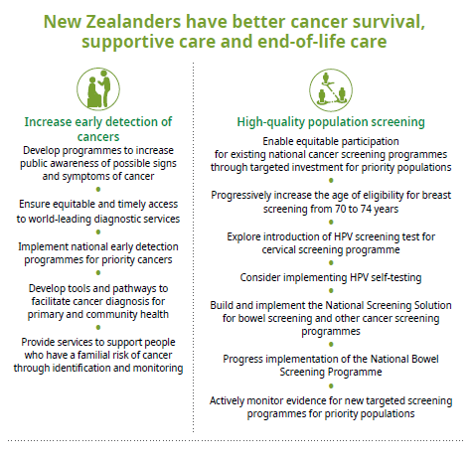
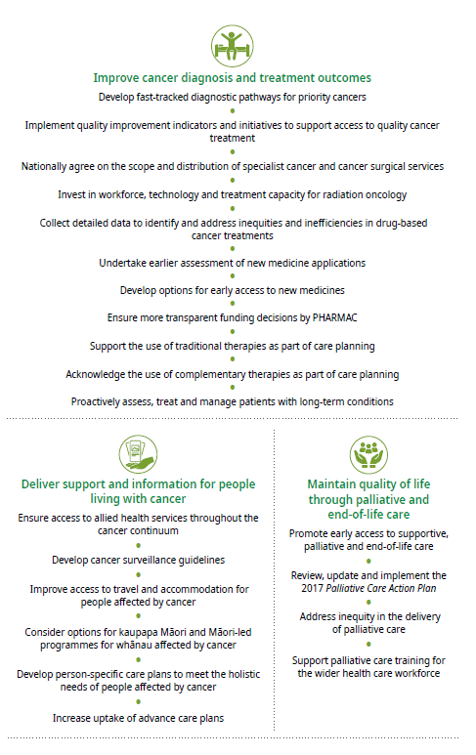

Increase early detection of cancers
- Develop programmes to increase public awareness of possible signs and symptoms of cancer
- Ensure equitable and timely access to world-leading diagnostic services
- Implement national early detection programmes for priority cancers
- Develop tools and pathways to facilitate cancer diagnosis for primary and community health
- Provide services to support people who have a familial risk of cancer through identification and monitoring
We need to ensure better support for our whānau and communities to receive timely, appropriate care and have the information they need to make the best decisions they can about their health. Early detection means recognising the possible signs and symptoms of cancer at the earliest possible stage and ensuring people get symptoms checked. Early detection enables treatment to be more effective and potentially less complex.
Survival at one and five years following treatment is much higher if cancer is detected at an early stage
For example, one-year survival for colorectal cancer is 97.7% if detected early (ie, at stage one) but falls to 43.9% if the cancer is detected late (ie, at stage four)
Lung cancer follows the same pattern: one-year survival is 87.3% for stage one disease, but only 18.7% for stage four (Hawkes 2019)
Access to primary health is at the heart of an effective, equitable public health system. This is particularly important for people with cancer, where early detection and appropriate intervention is effective in improving outcomes.
In 2017/18, approximately 15 percent of New Zealanders experienced barriers to accessing primary health, for reasons including the cost of appointments and prescriptions and non-financial barriers such as time off work, carer obligations and lack of transport.
Several initiatives have aimed to reduce such barriers to accessing primary health, including extending cheaper primary health visits to greater proportions of the population. Additionally, children under 14 years old now receive free visits to primary health. However, inequities persist.
- Access to general practice for Māori and Pacific peoples is worse compared with access for non-Māori, non-Pacific people.
- Māori and Pacific peoples are less likely than non-Māori, non-Pacific people to be diagnosed at earlier stages of the disease for several types of cancer.
- Māori and Pacific peoples have a lower five-year chance of survival for most cancers than non-Māori and non-Pacific people; some of this disparity in outcome can be explained by stage of disease at diagnosis.
- People living in more socioeconomically deprived areas are less likely to have their cancer detected early, compared with people living in less deprived areas.
- Māori and Pacific peoples are more likely to be diagnosed with cancer via the emergency department.
- People in rural communities face greater challenges including the costs of access to health services and specialist treatments.
• People with mental health and/or addiction issues are less likely to have their cancer detected early, compared with people without these issues.

Develop programmes to increase public awareness of possible signs and symptoms of cancer
We need to provide greater support and education to New Zealanders to give them the ability to make the best health decisions for themselves and their whānau, and provide people with the knowledge, skills and confidence to use cancer health information effectively (such as information on early cancer signs and symptoms). We need stronger engagement between the primary health sector and the community, to facilitate earlier diagnosis of cancer.
To promote cancer information, we need a multi-layered programme involving actions at grass-roots levels, partnering with primary health care, NGOs and Māori and Pacific health workers and providers to ensure a community approach.
NGOs play an important role in supporting the actions of this plan and promoting public awareness of the signs and symptoms of cancer, due to their work with people and whānau in community settings.

Ensure equitable and timely access to world-leading diagnostic services
To achieve world quality cancer care, New Zealand must have consistent, high-quality diagnostic services, particularly pathology and radiology services. These services provide critical input at nearly every stage of a person’s cancer journey.
Currently, there is an inconsistent national approach to developing and implementing cancer pathology, including genetics and genomics testing. We need a coordinated approach to ensure that in addition to making targeted therapies available, there is a considered approach to the accessibility of genomic tests to assess the eligibility of these medicines.
Radiology services are essential for the early diagnosis and staging of cancer. There is significant national variation in terms of DHB capability, funding and access to radiology. This is both in the community for primary care and by hospital-based specialist services. There needs to be a willingness to reflect on and challenge existing models that may contribute to equity gaps. Incorporating strategies for radiology services to accommodate and provide timely diagnostic pathways for priority populations is essential.

Implement national early detection programmes for priority cancers
We need to develop national early detection programmes for priority cancers where these are indicated by evidence. The National Lung Cancer Working Group is developing an integrated approach to early detection through a designated programme with four components:
- a public awareness campaign
- education for health professionals
- improved clinical pathways
- monitoring to evaluate effectiveness.
We will consider this approach for other cancers.

Develop tools and pathways to facilitate cancer diagnosis for primary and community health
We need to support and partner with primary and community health services to help them effectively manage patients who present with cancer-related concerns and provide consistent, accessible care. A strong and robust knowledge base is central to ensuring that such services make the best decisions in consultation with individual patients. Services require the best available tools to assess patients’ symptoms accurately and identify those who require more urgent investigation.
Primary and community health services face challenges regarding access to diagnostic tests. A survey of New Zealand primary health physicians showed that their access to direct diagnostic tests were limited and took more time than in most other International Cancer Benchmarking Partnership jurisdictions (Htun et al 2017), showing that prompt access to diagnostic tests must be a priority.

Provide services to support people who have a familial risk of cancer through identification and monitoring
New Zealanders need access to familial cancer services, including screening of at- risk whānau members. As an example, the New Zealand Familial Gastrointestinal Cancer Service provides support to help identify and manage people with inherited gastrointestinal cancer. An equivalent service does not exist for women who have inherited the breast cancer (BRCA) gene mutation and are at high risk of developing breast and ovarian cancer. We will consider establishing such a service.

High-quality population screening
- Enable equitable participation for existing national cancer screening programmes through targeted investment for priority populations
- Progressively increase the age of eligibility for breast screening from 70 to 74 years
- Explore introduction of HPV screening test for cervical screening programme
- Consider implementing HPV self-testing
- Build and implement the National Screening Solution for bowel screening and other cancer screening programmes
- Progress implementation of the National Bowel Screening Programme
- Actively monitor evidence for new targeted screening programmes for priority populations
Organised population screening programmes play an important role in helping prevent and detect cancers at earlier, more treatable stages.
National screening programmes are in place for breast and cervical cancers and national screening for bowel cancer is being rolled out across New Zealand. These programmes are for large groups of the population who appear well and do not have symptoms. Screening looks for early signs that a cancer may develop or is already present. The cervical and bowel screening programmes also act as prevention programmes, because they detect and facilitate the removal of precancerous lesions that might develop into cancer.

Enable equitable participation for existing national cancer screening programmes through targeted investment for priority populations
There is variation in the uptake of New Zealand’s three screening programmes across different population groups, which has widened health inequities and contributed to reduced survival rates. Barriers to accessing screening services lead to unfair differences in screening participation and inequitable outcomes.
The screening programmes will work towards achieving equitable participation through a focus on priority populations via primary health and targeted outreach activities. We will develop a plan to assist and support people to participate in screening.
Current examples of ways to increase participation in screening among Māori and Pacific peoples include targeted active follow-up on invitations, tailored health promotion, primary health involvement in promoting participation and engagement with community groups, churches and marae.

Progressively increase the age of eligibility for breast screening from 70 to 74 years
BreastScreen Aotearoa provides mammogram screening for breast cancer in women aged 45–69 years. The programme has resulted in a reduction of approximately 30 percent in breast cancer mortality for women. Recent evidence shows there may be a mortality benefit to providing regular organised breast screening to women aged 70–74 years.
In 2017 and 2018,
participation in BreastScreen Aotearoa for women aged 45–69 years was 65.7% for Māori and 72.6% for non-Māori. The coverage target is 70%
The breast cancer mortality benefit is currently less for Māori women, because they have lower participation coverage. Alongside progressively increasing the age for breast screening, work will continue on achieving equity for all population groups in the existing age range, particularly for Māori women.

Explore introduction of HPV screening for the cervical screening programme
The National Cervical Screening Programme is available to all women in New Zealand between 20 and 70 years old. The screening test checks for abnormal cell changes to the cervix, thereby reducing the risk of women developing cervical cancer.
From 2016 to 2018, participation in the National Cervical Screening Programme for women aged 20–69 years was 63.8% for Māori and 71.5 % for non-Māori. The
coverage target is 80%
Since the introduction of the programme, the incidence of cervical cancer in New Zealand has decreased by approximately 50 percent and mortality has decreased by 60 percent. Māori women are almost twice as likely to get cervical cancer and almost three times as likely to die from it compared with non-Māori women.
Subject to additional funding, the Ministry is considering replacing the current cytology test in the screening programme with the HPV test which prevents, through earlier detection of precancerous abnormalities, more cases of cervical cancer.

Consider implementing HPV self-testing
The Ministry is also seeking to be able to provide women with the option of self- testing. HPV self-testing can be done on a self-taken vaginal sample; this has the potential to improve screening coverage. Recent research shows that HPV self-testing could be a more acceptable option to Māori women, who currently have low participation rates in the screening programme (Adcock et al 2019). This may also be an acceptable method of screening for many people who may find it preferable to current methods.

Build and implement the National Screening Solution for bowel screening and other cancer screening programmes
The National Screening Solution (NSS) is critical in managing participant pathways, monitoring and evaluating screening programmes and maintaining fail-safe mechanisms along the screening pathway.
The NSS is a flexible and extendable IT solution and it will support the National Bowel Screening Programme (NBSP) in the first instance. We need to consider extending the NSS for BreastScreen Aotearoa and the National Cervical Screening Programme as the current IT systems supporting these programmes are not fit for purpose.

Progress implementation of the National Bowel Screening Programme
The NBSP provides faecal immunochemical test screening for bowel cancer and precancerous lesions in people aged 60–74 years free of charge. In England, bowel screening is expected to provide about a 16 percent reduction in mortality from bowel cancer (Logan et al 2012).
The NBSP is available in MidCentral, Hutt Valley, Wairarapa, Waitemata, Southern, Counties Manukau, Nelson Marlborough, Hawke’s Bay, Lakes and Whanganui DHBs. The Ministry will continue to roll it out gradually across the country. This approach allows DHBs time to prepare for the extra investigations and treatments that flow from a screening programme. When it is available in all areas, the programme will invite about 700,000 people for screening every two years. It is expected to detect around 500 to 700 cancers a year in the early stages of the roll-out.
Achieving equitable outcomes in the bowel screening programme is a priority. While there will be positive health gains for both Māori and non-Māori, the overall health gains from the programme in its current form will be greater for non-Māori. A similar inequity is likely for Pacific peoples. The highest priority recommendation emerging from a hui with Māori health experts was to extend the age range for screening for Māori to 50–74 years of age. The Ministry is currently considering this.
We have allocated approximately $78 million to get the programme running and to cover the cost of establishing a National Coordination Centre and four regional centres. The centres started operating late in 2017. The roll-out of the NBSP is expected to be complete by June 2021.

Actively monitor evidence for new targeted screening programmes for priority populations
The National Screening Advisory Committee (NSAC) periodically reviews the evidence for new population screening programmes and assesses scientific evidence against established criteria to decide whether a screening programme is recommended.
The NSAC will continue to review emerging evidence for the introduction of new targeted screening programmes in New Zealand, for the following three areas.

Lung cancer screening
Lung cancer is a leading cause of death in New Zealand; the highest incidence is among Māori. There is some evidence to support regular screening for people at high risk of lung cancer using low-dose computed tomography (CT). If lung cancer is found at an earlier stage, when it is small and before it has spread, it is more likely to be successfully treated. In this regard, we need to further analyse recently completed European research and New Zealand-based research.

H. pylori screening
H. pylori can cause long-lasting inflammation in the stomach and stomach ulcers. This can lead to the development of stomach cancer. Information on the current prevalence of H.pylori and the acceptability, costs and uptake of the available tests for H.pylori, including the antibiotic resistance of differing strains, will enable us to consider whether to introduce a ‘detect and treat’ programme in New Zealand.

Prostate cancer screening
Routine population-based screening for prostate cancer in men without symptoms is not recommended in New Zealand at present. The harm of treating men who are incorrectly diagnosed with prostate cancer outweigh the benefits of general screening for asymptomatic men. The NSAC will continue to carry out evidence-based assessments as new research becomes available.
The Ministry developed an online tool called Kupe to facilitate informed and shared decision-making between men, their whānau and their primary health practitioners about prostate screening. The Ministry will review and update Kupe to ensure it gives balanced information on the harms and benefits of prostate screening.

Improve cancer diagnosis and treatment outcomes
- Develop fast-tracked diagnostic pathways for priority cancers
- Implement quality improvement indicators and initiatives to support access to quality cancer treatment
- Nationally agree on the scope and distribution of specialist cancer and cancer surgical services
- Invest in workforce, technology and treatment capacity for radiation oncology
- Collect detailed data to identify and address inequities and inefficiencies in drug-based cancer treatments
- Undertake earlier assessment of new medicine applications
- Develop options for early access to new medicines
- Ensure more transparent funding decisions by PHARMAC
- Support the use of traditional therapies as part of care planning
- Acknowledge the use of complementary therapies as part of care planning
- Proactively assess, treat and manage patients with long-term conditions
Treatment of cancer is complex and varies by cancer type and stage at diagnosis, as well as the age of the person undergoing treatment, their general health status and the presence of comorbidities.
New Zealanders should have equitable access to timely, person- and whānau-centred, high-quality cancer treatment. In this regard, we have made good progress in some areas, but still need improvement in others, particularly in terms of achieving equity and national consistency.

Develop fast-tracked diagnostic pathways for priority cancers
A key component of any attempt to reduce inequity in cancer care needs to include improved access to a timely and accurate diagnosis. Delays in cancer diagnosis may occur throughout the diagnostic pathway. Delays may be detrimental, leading to advanced stage at diagnosis and poor prognosis. We need to develop innovative person-centred initiatives to speed up access to diagnosis and partner with primary health services to reduce or prevent delays.
Monitoring the timeliness of the pathway from primary health through to diagnosis could help us identify and address delays and allow us to understand the impact of delays on the provision of radiology and pathology services.

Implement quality improvement indicators and initiatives to support access to quality cancer treatment
Over the coming years, the demographic changes in our population will bring an increasing demand for cancer therapies; more people than ever will require access to high-quality cancer treatments and services that ensure the best possible outcomes.
Cancer treatment providers are increasingly adopting personalised, targeted therapies based on the results of molecular testing in certain cancer types. Where appropriate, it is important that New Zealand considers the implementation of evidence-based molecular testing technologies, particularly when the results of such testing have implications for defined treatment options.
We have established a project to collect stage data (classifying disease extent) and improve the existing collection of clinically (non-pathological) and pathologically diagnosed cancer data at a national level from 1 July 2020 through the Ministry collection processes.

Standards of care
A standard of care describes what good quality care is and reflects our commitment to achieving equity, national consistency and person-centred care for people and their whānau with cancer.
We will develop an online person-centred standard which will describe the level of support that all people with cancer can expect on their cancer journey, driving nationally consistent, equitable care. Quality care includes good communication, so the standards of care will help ensure people get the information they need at the right time, care coordination and access to psychosocial support services.

Develop quality performance indicators
Cancer services are complex; people often receive services from multiple providers in both the public and private sector and from different DHBs who provide specialist services.
To address the variation in services across New Zealand, we need to agree on measures and report appropriate data to show exactly where services vary between DHBs and groups and to understand what is driving this variation.
This work involves identifying and developing quality performance indicators for each different type of cancer, with close collaboration with clinicians, other experts and people affected by cancer.
The first set of Quality Performance Indicators (QPIs) was developed for bowel cancer and published in March 2019: Bowel Cancer Quality Improvement Report (Ministry of Health 2019b). The Ministry is currently developing QPIs for other cancers, for example prostate and lung cancer. In this first phase, our focus is on measuring clinical outcomes from existing data collections.

Patient experience
In New Zealand, people affected by cancer should expect high-quality care that meets and respects their emotional, psychological, spiritual and social needs at every stage. How people experience health care is just as important as the treatment they receive.
We want people affected by cancer, health workers and providers and others to have easily accessible, timely information about the quality of service being delivered in New Zealand. We are planning to develop patient-reported measures to capture patient voices and ensure the voices of Māori, Pacific peoples and other priority populations are heard. These measures will provide a more direct route for patients to drive improvement in cancer services based on their experience and outcomes.

Children, adolescents and young adults with cancer
In New Zealand, existing plans and strategies prioritise cancer services for children, adolescents and young adults. The National Child Cancer Network (NCCN) and the Adolescent and Young Adult (AYA) Cancer Network play a part in these plans and strategies, bringing together a range of stakeholders, including children, adolescents and young adults affected by cancer, their whānau, cancer service providers and NGOs to develop and deliver appropriate programmes of work. These programmes include work on standards of care, person and whānau experiences, shared-care models and identifying and addressing inequities.
There is much to learn about how services are developed with and provided to these patient groups, especially in relation to improving survival rates and eliminating inequities. This plan does not describe the existing initiatives led by the NCCN and AYA networks; however, we note that most of the priorities described in the plan will also benefit these patient groups. Any new initiatives aiming to specifically improve outcomes and experiences for children, adolescents and young adults affected by cancer must be codesigned with patients and whānau. The NCCN and AYA networks are well placed to facilitate this, with appropriate resourcing.

Nationally agree on the scope and distribution of specialist cancer and cancer surgical services
Cancer treatment is increasingly complex, both because of advances in personalised and targeted treatments and because of the growing incidence of comorbid chronic diseases. The safe provision of some cancer treatments requires highly specialist staff, high-volume centres or specific equipment.
We need to strengthen the capacity of the cancer system in New Zealand to deliver high-quality, people- and whānau-centred, integrated, multidisciplinary care, with a focus on reducing unwarranted variations. Well-integrated cancer services with robust service links between primary, secondary and tertiary health, including improved access to transport and accommodation and more timely referral pathways will help us achieve this.
Where clinically appropriate, services should be planned and delivered at a local level. Where there is evidence that regional or national services produce better outcomes, we should develop appropriate pathways to facilitate this. To ensure nationally consistent optimal outcomes, we need to develop specialised units or ‘hubs of excellence’. There may be benefits in some relatively rare cancers being treated at a specialised national unit.

Invest in workforce, technology and treatment capacity for radiation oncology
Radiation therapy techniques and delivery technologies continue to develop globally. Adopting more advanced radiotherapy techniques requires investment and staff training, within a workforce that already faces significant pressures.
The recent Government announcement to invest in replacement linear accelerators will build on and support service sustainability. As part of this we will determine the locality for both replacement and additional linear accelerators where it is viable. The Ministry and wider health sector will prioritise workforce, technology and treatment capacity for radiation oncology.
We will review and update the National Radiation Oncology Plan 2017–2021 to ensure radiation oncology services are future proofed and sustainable. This review will also look at future investment priorities for additional linear accelerators, including where these are best located and the services required to support the additions, given projected future demand.
The New Zealand Radiation Oncology Collection was developed by the Radiation Oncology Working Group in partnership with the Ministry. It is a national collection of public and private radiation oncology treatment data used by the Ministry, DHBs, regional cancer networks and treatment centres for clinical benchmarking, health equity analysis, understanding and reducing variation and capacity planning.

Collect detailed data to identify and address inequities and inefficiencies in drug-based cancer treatments
The phrase ‘systemic anti-cancer therapy’ (SACT) refers to a group of drug-based cancer treatments comprising chemotherapy agents alongside targeted therapies, immunotherapy, hormones and supportive care medicines to reduce side-effects. People with blood cancers for example rely on access to drug treatments, such as cytotoxic chemotherapy, antibody therapy, targeted agents and immunotherapy.
The SACT New Zealand project, launched in late 2018, will develop a detailed database of information on patients receiving SACT across New Zealand, to identify and reduce variation, enhance equity of access and support resource planning. Phase 1 of this project requires the development of national data and regimen definitions to create a solid foundation for the subsequent capture of meaningful and comparable data at the national level. We will undertake this as a priority action.

Undertake earlier assessment of new medicine applications
From January 2020, PHARMAC proposes to assess funding applications for new cancer medicines in parallel with Medsafe’s safety assessment process (rather than waiting for Medsafe approval). The aim is to reduce the overall time for new cancer medicines to be assessed by Medsafe and PHARMAC and so shorten the time it takes for a cancer medicine to reach PHARMAC’s list of options for potential funding.
While this change will speed up the assessment process, it will not necessarily result in more cancer medicines being funded.

Develop options for early access to new medicines
As a priority, the Government has agreed to a work programme allowing the Ministry to work with PHARMAC to explore options and provide advice on how to address the complex challenges of enabling earlier access to new cancer medicines.

Ensure more transparent funding decisions by PHARMAC
As a priority, PHARMAC is committed to making its funding decisions faster, clearer and simpler. To this end, it is currently:
- clarifying the stage of all applications in the decision-making process and the basis of its decisions to fund
- working to publish recommendations from its expert clinical advisors earlier
- providing people with more clarity about applications that do not result in the medicine being funded
- looking to close funding applications no longer being actively considered.
PHARMAC launched a new online application system (PHARMconnect) in August 2019 to simplify the process of making and tracking funding applications.

Support the use of traditional therapies as part of care planning
Rongoā Māori (the Māori traditional healing system) is informed by a body of knowledge that has the enhancement of Māori wellbeing at its core. Providing safe and quality rongoā care to patients is paramount to the wellbeing of Māori communities.
Traditional healing has been long used by Pacific peoples to help in their recovery. It involves taking a holistic approach to treating the person, where their mental, emotional, physical and spiritual wellbeing are looked after together, rather than as separate parts.
We need to undertake further research into the use and disclosure of traditional therapies and their possible interaction with other treatments and develop guidance to support health professionals working with patients who use such therapies.

Acknowledge the use of complementary therapies as part of care planning
Complementary therapies may be used together with conventional evidence-based systemic treatments to support and enhance a person’s quality of life, help control side effects such as pain and fatigue and improve wellbeing. However, some may not be recommended during treatment for cancer, as they could interfere with treatment and/or worsen side effects.
We need to undertake further research into the use and disclosure of complementary therapies and their possible interaction with other treatments and develop guidance to support health professionals working with patients who use such therapies.

Proactively assess, treat and manage patients with long-term conditions
Comorbidities, or long-term conditions in addition to cancer, such as diabetes, heart disease or mental illness, are common among people affected by cancer and, as our population ages, are becoming even more so. Comorbidities are also a driver of inequities and unevenly distributed within populations, particularly for Māori and Pacific peoples and people from low socioeconomic groups. We need to undertake more work particularly within primary health settings to proactively manage the comorbidities of people with cancer.
Comorbidity potentially affects the development, stage at diagnosis, treatment and outcomes of people with cancer. Despite the intimate relationship between comorbidity and cancer, there is limited consensus on how to record, interpret or
manage comorbidity in the context of cancer. Patients with comorbidity have poorer survival and quality of life and higher health care costs (Sarfati et al 2016).
In the context of comorbidity, we need to improve the evidence base for patients with comorbidity, further develop clinical tools to assist decision-making, improve integration and coordination of care and develop clinicians’ skills in primary health and secondary services.

Deliver support and information for people living with cancer
- Ensure access to allied health services throughout the cancer continuum
- Develop cancer surveillance guidelines
- Improve access to travel and accommodation for people affected by cancer
- Consider options for kaupapa Māori and Māori-led programmes for whānau affected by cancer
- Develop person-specific care plans to meet the holistic needs of people affected by cancer
- Increase uptake of advance care plans
More people are living with and beyond cancer. Support for people affected by cancer is essential to improving overall outcomes from cancer care.
Anecdotally, patients report experiencing a loss of support at the point when their treatment in secondary and tertiary care ends – yet support at this stage is crucial to ensure the benefits of treatment are maintained and complications are avoided. Fast and appropriate re-entry into secondary care is essential in the event of cancer recurring.
Primary and community services play an essential role in supporting people affected by cancer. Primary and community providers generally have long-term relationships with people with cancer and their whānau, from their initial diagnoses through referral and after their interaction with secondary and tertiary health services.

Ensure access to allied health services throughout the cancer continuum
Allied Health, Scientific and Technical Professionals (AHPs) are a diverse group of professionals who have a significant positive impact on the lives of people living with and beyond cancer in terms of their quality of life, physical fitness, wellbeing, mental health, fatigue, communication, mobility, function, nutritional status and pain. AHPs such as medical imaging technologists, medical radiation technologists and medical physicists are integral to diagnostic and treatment of cancer.
AHPs offer effective prevention strategies that support self-care, self-management and prevention of the late effects of cancer treatment. It is essential that individuals and whānau who are affected by cancer have access to and understand the benefits of AHPs throughout the cancer continuum.

Develop cancer surveillance guidelines
Follow-up and surveillance for recurrence, late effects and new cancers are components of post-treatment recovery. They can include follow-up appointments, blood tests and X-rays. We will develop cancer-specific follow-up and surveillance advice alongside development of the standards of care. Follow-up and surveillance activities need to involve primary health expertise, to ensure appropriate shared care arrangements.
Secondary and tertiary hospital cancer services must collaborate with primary and community health providers to ensure the transition from hospital care to primary care to meet the needs of the individual. We need to ensure follow-up and surveillance that is person-centred, focuses on risk and is supported by holistic needs assessment and individual care plans.

Improve access to travel and accommodation for people affected by cancer
Individuals may need to spend time away from home in a centre of expertise for some highly specialised and/or complex treatment. Before and after that specialised treatment, patients should receive support locally, through primary and community health and local hospitals. We need to ensure that people receive the benefit of specialist expertise combined with local access. For this to work, we need to improve people’s access to transport and accommodation.
The National Travel Assistance (NTA) Scheme is designed to help with transport and accommodation costs for people who need to travel long distances, or often, for specialist hospital treatment. The Ministry has recently reviewed the scheme and commenced a programme to improve it as a priority, including through reviewing the national policy to ensure that it is clear and supports best practice.
The Ministry is currently updating the guidance document for the NTA scheme, to provide education and support to coordinators and others administering the scheme. It will also include a review of the NTA scheme data and consider automating the application and claiming process. The aim of the update is to reduce the current variability of access to the scheme and achieve equity.
The Ministry will work with the NTA Scheme to ensure that the Scheme is in line with best practice treatment and supports any changes made to cancer services.

Consider options for kaupapa Māori and Māori-led programmes for whānau affected by cancer
Current approaches to cancer prevention and management inadequately address the needs of Māori. The emphasis on the individual ignores the multidimensional role of whānau within Māori communities. The Ministry will further explore opportunities for kaupapa Māori programmes for whānau affected by cancer, in conjunction with our mātauranga Māori framework (discussed in Outcome 2).

Kaupapa Māori practices are driven by Māori, and focus on issues of concern to Māori, using methods and practices that recognise tikanga (Māori knowledge). Kaupapa Māori affirms wellness as a collective aspiration. Community-level health interventions, underpinned by kaupapa Māori approaches to design and delivery, have the potential to improve health outcomes for Māori.

Develop person-specific care plans to meet the holistic needs of people affected by cancer
Holistic, survivorship care plans provide a record of a person’s diagnosis and the treatment received, potential late and long-term effects arising from the cancer and its treatment, recommended follow-up and strategies to help the person remain well.
They are used to improve communication between people affected by cancer, their primary health providers and their secondary health cancer teams and provide useful information and support for whānau.
In October 2018, the Cancer Society of New Zealand, in partnership with the Central Cancer Network and the Cancer Nurses College (Cancer Nurses College 2019) developed a cancer survivorship consensus statement for New Zealand. The statement has a strong focus on equity and Te Tiriti o Waitangi, quality of life, care planning, accessing information, follow-up and surveillance, rehabilitation and resilience.

Increase uptake of advance care plans
Advance care planning (ACP) is a process through which people, their whanau and health care providers plan for a person’s future health care and needs. It is relevant across all stages of the cancer continuum and for all New Zealanders but is particularly helpful to support the provision of someone’s palliative and end-of-life care. We need to normalise the use of advance care planning and increase public and workforce awareness about the use of, and uptake of, ACP across the health sector, government and community agencies and among older people.
‘Kia kōrero/Let’s talk advance care planning’ is a campaign that encourages people to plan for their future health care. The campaign is part of the ACP programme managed by the Health Quality & Safety Commission and supported by DHBs.

Maintain quality of life through palliative and end-of-life care
- Promote early access to supportive, palliative and end-of-life care
- Review, update and implement the 2017 Palliative Care Action Plan
- Address inequity in the delivery of palliative care
- Support palliative care training for the wider health care workforce
While much progress has been made in the area of cancer treatment, the reality is that not all cancers are curable, and many people will ultimately die from their cancer. To minimise the burden of the disease on people with an incurable cancer, such people should have timely access to high-quality palliative care regardless of the care setting, where they live, their age, their ethnicity or their socioeconomic situation.
Specialist palliative care services should be available to provide expert care to those who need it, and to support primary palliative care services. We need to strive for equity of access and quality care.
Palliative care is care for people of any age with a life-limiting or life-threatening condition. It aims to improve a person’s quality of life until death by addressing their physical, psychosocial, spiritual and cultural needs and supporting their whānau and other caregivers through the illness and after death.
At the heart of any cancer diagnosis is the person and their whānau. While they navigate the cancer continuum, it is important to keep this focus.

Promote early access to supportive, palliative and end- of-life care
Early access to supportive and palliative care in the management of treatment related side effects, even for curative treatments, is important for people who have life- threatening or life-limiting conditions. Supportive, palliative and end-of-life care must be responsive to the changing preferences and priorities of people with advanced illness and their whānau.
The benefits of early integration of palliative care are well established. Earlier palliative care is associated not only with an improvement in symptom control, quality of life and patient experience but also with significant cost savings for the health system, which can attribute to a combination of a reduced length of stay and reduced intensity of stay. However, in many cases people still only access palliative when all hope of cure or disease control has been lost. This needs to change.

Review, update and implement the 2017 Palliative Care Action Plan
The 2017 Palliative Care Action Plan outlined priority actions for development of palliative care within New Zealand. However, uptake of this plan across New Zealand has been ad hoc and inconsistent. The plan commits the Ministry of Health to working alongside stakeholders to assess progress on the Palliative Care Action Plan at a national level and to refresh the actions accordingly.
The Ministry undertakes to work with the palliative care sector to ensure these refreshed actions are implemented for the benefit of New Zealanders at any stage of their cancer journey.

Address inequity in the delivery of palliative care
There is anecdotal evidence that Māori do not receive the benefits of a palliative approach early enough and do not equitably access palliative care services that are available. The reasons for this are complex and they are likely due in part to the fact that current palliative care models of care do not specifically address Māori needs and the differing views on death and dying by held Māori.
Palliative care should be provided in a way that meets the unique needs of individuals from particular communities or groups. These include Māori, children and young people, migrants, refugees and those in isolated communities.
A recent Ministry of Health publication found factors at every level – system, organisational, patient and whānau – have the potential to influence access to palliative care for Māori patients and their whānau (Ministry of Health 2014). Key improvement measures include strengthening the Māori focus and presence within palliative care services.

Support palliative care training for the wider health care workforce
All health care professionals in the field of cancer care require an appropriate level of knowledge and skill in palliative and end-of-life care. Education on such care for all health care professionals should include symptom management, the psychosocial needs of patients and the vital communication skills required to produce goals of care for the patient and their whānau at all stages of their illness from diagnosis to end-of- life care.

References
Adcock A, Cram F, Lawton B, et al. 2019. Acceptability of self-taken vaginal HPV sample for cervical screening among an under-screened Indigenous population. Australian and New Zealand Journal of Obstetrics and Gynaecology 59(2): 301–7.
Allemani C, Matsuda T, Di C, et al. 2018. Global surveillance of trends in cancer survival 2000–14 (CONCORD-3): analysis of individual records for 37 513 025 patients diagnosed with one of 18 cancers from 322 population-based registries in 71 countries. Lancet 391(10125): 1023–75.
Bray F, Ferlay J, Soerjomataram I, et al. 2018. Global cancer statistics 2018: GLOBOCAN estimates of incidence and mortality worldwide for 36 cancers in 185 countries. CA: A Cancer Journal for Clinicians 68(6): 394–424.
Cancer Nurses College. 2019. Cancer Nurses College. URL: https://www.nzno.org.nz/groups/colleges_sections/colleges/cancer_nurses_college (accessed 19 November 2019).
Centers for Disease Control and Prevention. 2014. Up to 40 percent of annual deaths from each of five leading US causes are preventable. URL: https://www.cdc.gov/media/releases/2014/ p0501-preventable-deaths.html (accessed 18 November 2019).
Connor J, Kydd R, Maclennan B, et al. 2017. Alcohol-attributable cancer deaths under 80 years of age in New Zealand. Drug and Alcohol Review 36(3): 415–23.
Cunningham R, Sarfati D, Stanley J, et al. 2015. Cancer survival in the context of mental illness: a national cohort study. General Hospital Psychiatry 37(6): 501–6.
Fearnley D, Lawrenson R, Nixon G. 2016. ‘Poorly defined’: unknown unknowns in New Zealand Rural Health. New Zealand Medical Journal 129(1439): 77–81.
Ford AC, Forman D, Hunt RH, Yuan Y, Moayyedi P. Helicobacter pylori eradication therapy to prevent gastric cancer in healthy asymptomatic infected individuals: systematic review and meta-analysis of randomised controlled trials. BMJ 2014; 348: g3174.
Gane EJ, Deray G, Liaw YF, et al. 2014. Telbivudine improves renal function in patients with chronic hepatitis B. Gastroenterology 146(1): 138–46 e5.
Gurney J, Campbell S, Jackson C, et al. 2019. Equity by 2030: Achieving equity in survival for Māori cancer patients. New Zealand Medical Journal in press (due for publication 29 November 2019).
Hashibe M, Brennan P, Chuang SC, et al. 2009. Interaction between tobacco and alcohol use and the risk of head and neck cancer: pooled analysis in the International Head and Neck Cancer Epidemiology Consortium. Cancer Epidemiology and Prevention Biomarkers 18(2): 541–50.
Hawkes N. 2019. Cancer survival data emphasise importance of early diagnosis. BMJ 364: l408.

Health Promotion Agency. 2016. Sun Exposure Survey 2016 Methodology Report. Wellington: Health Promotion Agency. URL: https://www.hpa.org.nz/research-library/research-publications/ sun-exposure- survey-2016-methodology-report (accessed 19 November 2019).
Health Promotion Agency, Melanoma Network of New Zealand. 2017. New Zealand Skin Cancer Primary Prevention and Early Detection Strategy 2017 to 2022. Wellington and Auckland: Health Promotion Agency, Melanoma Network of New Zealand. URL: https://www.sunsmart.org.nz//sites/default/files/documents/FINAL-Strategy-2017-to-2022.PDF (accessed 18 November 2019).
Hill S, Sarfati D, Robson B, et al. 2013. Indigenous inequalities in cancer: what role for health care? ANZ Journal of Surgery 83(1–2):36–41.
Htun HW, Elwood JM, Ioannides SJ, et al. 2017. Investigations and referral for suspected cancer in primary care in New Zealand – A survey linked to the International Cancer Benchmarking Partnership. European Journal of Cancer Care 26(3): e12634.
Levit LA, Balogh E, Nass SJ, et al. 2013. Delivering High-quality Cancer Care: Charting a new course for a system in crisis. Washington, DC: National Academies Press.
Logan RF, Patnick J, Nickerson C, et al. 2012. Outcomes of the Bowel Cancer Screening Programme (BCSP) in England after the first 1 million tests. Gut 61(10): 1439–46.
McCarthy EP, Ngo LH, Chirikos TN, et al. 2007. Cancer stage at diagnosis and survival among persons with Social Security Disability Insurance on Medicare. Health Services Research 42(2): 611–28.
Ministry of Business, Innovation and Employment and Ministry of Health. 2017. New Zealand Health Research Strategy 2017–2027. Wellington: Ministry of Business, Innovation and Employment and Ministry of Health. URL: https://www.health.govt.nz/publication/new-zealand- health-research-strategy-2017-2027 (accessed 15 November 2019).
Ministry of Health. 2010. Unequal Impact II: Māori and Non-Māori Cancer Statistics by Deprivation and Rural–Urban Status, 2002–2006. Wellington: Ministry of Health. URL: https://www.health.govt.nz/publication/unequal-impact-ii-maori-and-non-maori-cancer-statistics-deprivation-and-rural-urban-status-2002-2006 (accessed 14 November 2019).
Ministry of Health. 2013. Cancer Control Strategy 2003. Wellington: Ministry of Health. URL: https://www.health.govt.nz/publication/new-zealand-cancer-control-strategy (accessed 15 November 2019).
Ministry of Health. 2014. Palliative Care and Māori from a Health Literacy Perspective. Wellington: Ministry of Health. URL: https://www.health.govt.nz/publication/palliative-care-and-maori- health-literacy-perspective (accessed 19 November 2019).

Ministry of Health. 2016a. Clinical Guidelines for Weight Management in New Zealand Children and Young People. URL: https://www.health.govt.nz/publication/clinical-guidelines-weight- management-new-zealand-children-and-young-people (accessed 19 November 2019).
Ministry of Health. 2016b. Health Loss in New Zealand 1990–2013: A report from the New Zealand Burden of Diseases, Injuries and Risk Factors Study. Wellington: Ministry of Health URL: https://www.health.govt.nz/publication/health-loss-new-zealand-1990-2013 (accessed 19 November 2019).
Ministry of Health. 2017a. Annual Data Explorer 2016/17: New Zealand Health Survey (Data File). URL: https://www.health.govt.nz/publication/annual-update-key-results-2016-17-new-zealand- health-survey (accessed 25 July 2019).
Ministry of Health. 2017b. Clinical Guidelines for Weight Management in New Zealand Adults. Wellington: Ministry of Health. URL: https://www.health.govt.nz/publication/clinical- guidelines-weight-management-new-zealand-adults (accessed 19 November 2019).
Ministry of Health. 2018a. Eating and Activity Guidelines. URL: https://www.health.govt.nz/our- work/eating-and-activity-guidelines (accessed 18 November 2019).
Ministry of Health. 2018b. Health and Independence Report 2017. Wellington: Ministry of Health. URL: https://www. health.govt.nz/publication/health-and-independence-report-2017 (accessed 18 November 2019).
Ministry of Health. 2018c. New cancer registrations 2016. URL: https://www.health.govt.nz/ publication/new-cancer-registrations-2016 (accessed 18 November 2019).
Ministry of Health. 2019a. Achieving equity. URL: https://www.health.govt.nz/about- ministry/what-we-do/work-programme-2018/achieving-equity (accessed 19 November 2019).
Ministry of Health. 2019b. Bowel Cancer Quality Improvement Report 2019. Wellington: Ministry of Health. URL: https://www.health.govt.nz/publication/bowel-cancer-quality-improvement- report-2019 (accessed 18 November 2019).
Ministry of Health. 2019c. Development of a National Hepatitis C Action Plan. URL: https:// www.health.govt.nz/our-work/diseases-and-conditions/ hepatitis-c/development-national- hepatitis-c-action-plan (accessed 18 November 2019).
Ministry of Health. 2019d. He Korowai Oranga: Māori Health Strategy. Wellington: Ministry of Health. URL: www.health.govt.nz/ourwork/populations/Māori-health/he-korowai-oranga (accessed 15 November 2019).

Ministry of Health. 2019e. Ka Pū te Ruha, ka Hao te Rangatahi – Good practice guidance for stop smoking services. Wellington: Ministry of Health. URL: https://www.health.govt.nz/publication/ ka-pu-te-ruha-ka-hao-te-rangatahi-good-practice-guidance-stop-smoking-services (accessed 18 November 2019).
Pihama L, Tiakiwai SJ, Southey K (eds). 2015, Kaupapa Rangahau: A Reader, A Collection of readings from the Kaupapa Rangahau Workshop Series (2nd ed). Hamilton: Te Kotahi Research Institute. URL: https://researchcommons.waikato.ac.nz/handle/10289/11738 (accessed 15 November 2019).
Robson B, Purdie G, Cormack D. 2010. Unequal Impact II: Māori and Non-Māori Cancer Statistics by Deprivation and Rural–Urban Status, 2002–2006. Wellington: Ministry of Health. URL: https://www.health.govt.nz/publication/unequal-impact-ii-maori-and-non-maori- cancer-statistics- deprivation-and-rural-urban-status-2002-2006 (accessed 25 June 2019).
Sarfati D, Koczwara B, Jackson C. 2016. The impact of comorbidity on cancer and its treatment.
CA: A Cancer Journal for Clinicians 66(4): 337–50.
Smith MA, Edwards S, Canfell K. 2017. Impact of the National Cervical Screening Programme in New Zealand by age: analysis of cervical cancer trends 1985–2013 in all women and in Māori women. Cancer Causes & Control 28(12): 1393–404.
Soeberg M, Blakely T, Sarfati D, et al. 2012. Cancer Trends: Trends in cancer survival by ethnic and socioeconomic group, New Zealand 1991–2004. Wellington: University of Otago and Ministry of Health.
Te Pou o te Whakaaro Nui. 2014. The physical health of people with a serious mental illness and/ or addiction: An evidence review. URL: https://www.tepou.co.nz/resources/the-physical-health- of-people-with-a-serious-mental-illness-andor-addiction-an-evidence-review/515 (accessed 7 November 2019).
Te Puni Kōkiri. 2019. Developing a plan on New Zealand’s progress on the United Nations. Wellington: Ministry of Māori Development. URL: https://www.tpk.govt.nz/en/a-matou-mohiotanga/cabinet-papers/develop-plan-on-nz-progress-un (accessed 14 November 2019).
World Health Organization. 1998. Alcohol drinking. IARC Monographs on the Evaluation of Carcinogenic Risks to Humans. IARC Monographs on the Evaluation of Carcinogenic Risks to Humans 44: 1–378.
World Health Organisation. 2016. Global Health Sector Strategy on Viral Hepatitis 2016–2021. URL: https://www.who.int/hepatitis/strategy2016-2021/ghss-hep/en/ (accessed 18 November 2019).
World Health Organization. 2019a. Metrics: Disability-Adjusted Life Year (DALY). URL: https://www.who.int/healthinfo/global_burden_disease/metrics_daly/en/ (accessed 19 November 2019).
World Health Organization. 2019b. Reducing Social Inequalities in Cancer: Evidence and Priorities for Research. IARC Scientific Publication 168.
WorkSafe. 2019. Work-related Health Estimates. Wellington: WorkSafe. URL: https://worksafe.govt.nz/ dmsdocument/5540-work-related-health-estimate s-report (accessed 18 November 2019).

