Management of Atypical Endometrial Hyperplasia and Early-Stage Low Risk Endometrial Cancer in Patients Not Suitable for Surgery
  - New Zealand Gynaecologic Cancer Group Guideline
Released 2023
Citation: Te Whatu Ora – Health New Zealand. 2023. Management of Atypical Endometrial Hyperplasia and Early-Stage Low Risk Endometrial Cancer in Patients Not Suitable for Surgery. Wellington: Te Whatu Ora – Health New Zealand.
Published in September 2023 by Te Whatu Ora – Health New Zealand
PO Box 793, Wellington 6140, New Zealand
ISBN 978-1-99-106752-4 (online)
This document is available at tewhatuora.govt.nz
This work is licensed under the Creative Commons Attribution 4.0 International licence. In essence, you are free to: share ie, copy and redistribute the material in any medium or format; adapt ie, remix, transform and build upon the material. You must give appropriate credit, provide a link to the licence and indicate if changes were made.

Contents
Introduction 4
Exclusions 4
Initial Assessment 5
Histopathology 6
Biomarkers in the diagnosis of Atypical Endometrial Hyperplasia 6
Management - see Figure 1 7
Surveillance/ Follow Up 8
Standards 9
Outcomes for baseline data 9
Updating the guidelines 9
Figure 1 10
Management of Atypical Endometrial Hyperplasia and Early-Stage Low Risk Endometrioid Adenocarcinoma of the Endometrium in Patients Not Suitable for Surgery 10
Appendix 1. Histopathology 11
1. At initial diagnosis 11
2. Reporting guidelines for surveillance biopsies following progesterone treatment 12
▪ Criteria: 12
▪ Reporting categories: 12
▪ Example report: 12
References 14

Introduction
Endometrial cancer is the commonest gynaecological malignancy in Aotearoa. Endometrioid adenocarcinoma is the predominant histological type, for which atypical endometrial hyperplasia is the precursor. Atypical endometrial hyperplasia is also known as endometrioid intraepithelial neoplasia. The standard treatment for atypical endometrial hyperplasia is total hysterectomy, bilateral salpingectomy with washings and individualised consideration given to removal of ovaries.
There is a risk of co-existing endometrial cancer in those diagnosed with atypical hyperplasia on endometrial sampling (32.6%; 95% CI: 24.1%, 42.4%).¹ The rate of progression to endometrial cancer in those with atypical endometrial hyperplasia is 82.3 per 1,000 person-years (95% CI 39.3, 172.6), equivalent to 8.2% per year.¹
This guideline discusses situations where a patient’s medical or surgical comorbidities prohibit safe standard surgical treatment.

Exclusions
- High grade endometrial cancers (all types other than grade 1 or 2 endometrioid or mucinous).
- Patients under direct care of a Gynaecology-Oncology service.
- Patients who choose to have non-surgical treatment for fertility preservation. Please refer to separate guidelines on fertility preserving management of atypical endometrial hyperplasia and early-stage low risk endometrial cancer.

Initial Assessment
All patients with suspected endometrial hyperplasia should undergo:²
- A clinical assessment and examination
- Transvaginal pelvic ultrasound
- Endometrial sampling with either:
- Aspiration endometrial sampling (eg Pipelle) at the initial clinic visit OR
- Hysteroscopy, dilatation and curettage, if
- An aspiration sample is not successful or considered insufficient for histopathological diagnosis
- Focal or multifocal endometrial pathology (such as polyps) is suggested on imaging
- Symptoms persist despite medical treatment
Note: In suitable candidates, outpatient hysteroscopy is recommended over a procedure under general anaesthesia.

Histopathology
The diagnosis can be difficult and review by a specialist gynaecological pathologist is recommended. Depending on regional circumstances and availability of pathologists with expertise in gynaecological pathology, atypical endometrial hyperplasia histology should be peer reviewed in the pathology department or discussed in a general gynaecology multidisciplinary meeting (MDM).
See Appendix 1 for guidelines for histopathological reporting of atypical endometrial hyperplasia following non-surgical treatment.
As much as possible, molecular classification as per ProMisE & ESGO/ESTRO guidelines should be used when diagnosing endometrial cancer.³

Biomarkers in the diagnosis of Atypical Endometrial Hyperplasia
In New Zealand, biomarker study of atypical endometrial hyperplasia is not currently standard practice. The World Health Organization suggests immunohistochemistry for loss of PTEN, PAX2 and other markers may assist with diagnosis of atypical endometrial hyperplasia.⁴ The diagnostic decision should still be morphology based in cases where the immunoprofile does not support diagnosis of atypical endometrial hyperplasia.

Management - see Figure 1
- Patients with a confirmed diagnosis of early-stage low risk endometrial cancer should undergo a pelvic MRI, CXR, and their results reviewed at a Gynaecology-Oncology MDM. These steps are not necessary for patients with a new diagnosis of atypical endometrial hyperplasia alone.
- A gynaecological surgical and anaesthetic review is recommended to formally assess and document each patient’s individual peri-operative risks related to a potential hysterectomy.²
- Non-clinical factors, such as loco-regional technical limitations due to body mass index, previous surgical history, and intensive care unit availability, should not limit access to surgery. Referral to another centre should be considered if surgery could be achieved elsewhere.
- Counselling and documentation of standard and alternative management options should include written documentation and provision of a patient information booklet.
- Non-surgical management options include:²
- Levonorgestrel-releasing intrauterine device 52 mg; or
- Oral megestrol acetate 160 – 320 mg/day; or
- Oral medroxyprogesterone acetate 400 – 600 mg/day
- Radiation therapy is an option for patients with endometrial carcinoma and should be discussed in a Gynaecology-Oncology MDM (at diagnosis and progression).
- Non-surgical treatment selection should consider comorbidity profile, compliance, side-effects, and patient preference.
- Adjuncts such as weight loss (green prescription, dietitian referral, bariatric surgery) and management of other risk factors such as diabetes should be included and documented.
- Patients should be offered psychological and cultural support

Surveillance/ Follow Up
- Routine surveillance is not recommended in asymptomatic people who are not considered suitable for surgical treatment. Treatment response does not need to be assessed in asymptomatic patients.
- Discharge to GP may be considered in people who are asymptomatic. Those under GP care should be provided with clear written information about their care plan and a contact number for secondary services (for patient initiated rapid access back to secondary care services).
- If optimisation of medical risk factors would improve the perioperative risk profile, active measures should be taken to achieve this, followed by a repeat anaesthetic assessment to re-assess suitability for surgical treatment (hysterectomy is gold standard treatment).
- Referral back to secondary services is indicated if, while on treatment, there is development of symptoms suggestive of persistence or progression (bleeding/pain/new masses). Repeat imaging and endometrial resampling can be considered by secondary services during re-assessment.
- Those who have persistent disease and/ or ongoing symptoms may be offered an additional form of progestogen therapy (eg adding high dose oral medroxyprogesterone acetate if initially treated with a levonorgestrel-releasing intrauterine device).
- Where people with an initial diagnosis of atypical endometrial hyperplasia have progressed to develop endometrial cancer, they should be referred to the regional Gynaecology-Oncology MDM (with MRI and CXR, see above).
- In case of persistent symptoms despite optimal non-surgical treatment (high dose oral progestogen and a levonorgestrel-releasing intrauterine device) radiation may be considered in those with a diagnosis of endometrioid adenocarcinoma (via Gynaecology-Oncology MDM referral).

Standards
All those undergoing non-surgical treatment for atypical endometrial hyperplasia or early stage low risk endometrial cancer due to medical comorbidities should have an anaesthetic review to formally document perioperative risk precluding surgical management.

Outcomes for baseline data
- Proportion of people who have non-surgical treatment of atypical endometrial hyperplasia and early-stage low risk endometrial cancer due to medical comorbidities.
- Survival at 6, 12, 24 months, and 5 years

Updating the guidelines
These guidelines will be reviewed in 36 months from publication and updated as required.

Figure 1

Management of Atypical Endometrial Hyperplasia and Early-Stage Low Risk Endometrioid Adenocarcinoma of the Endometrium in Patients Not Suitable for Surgery
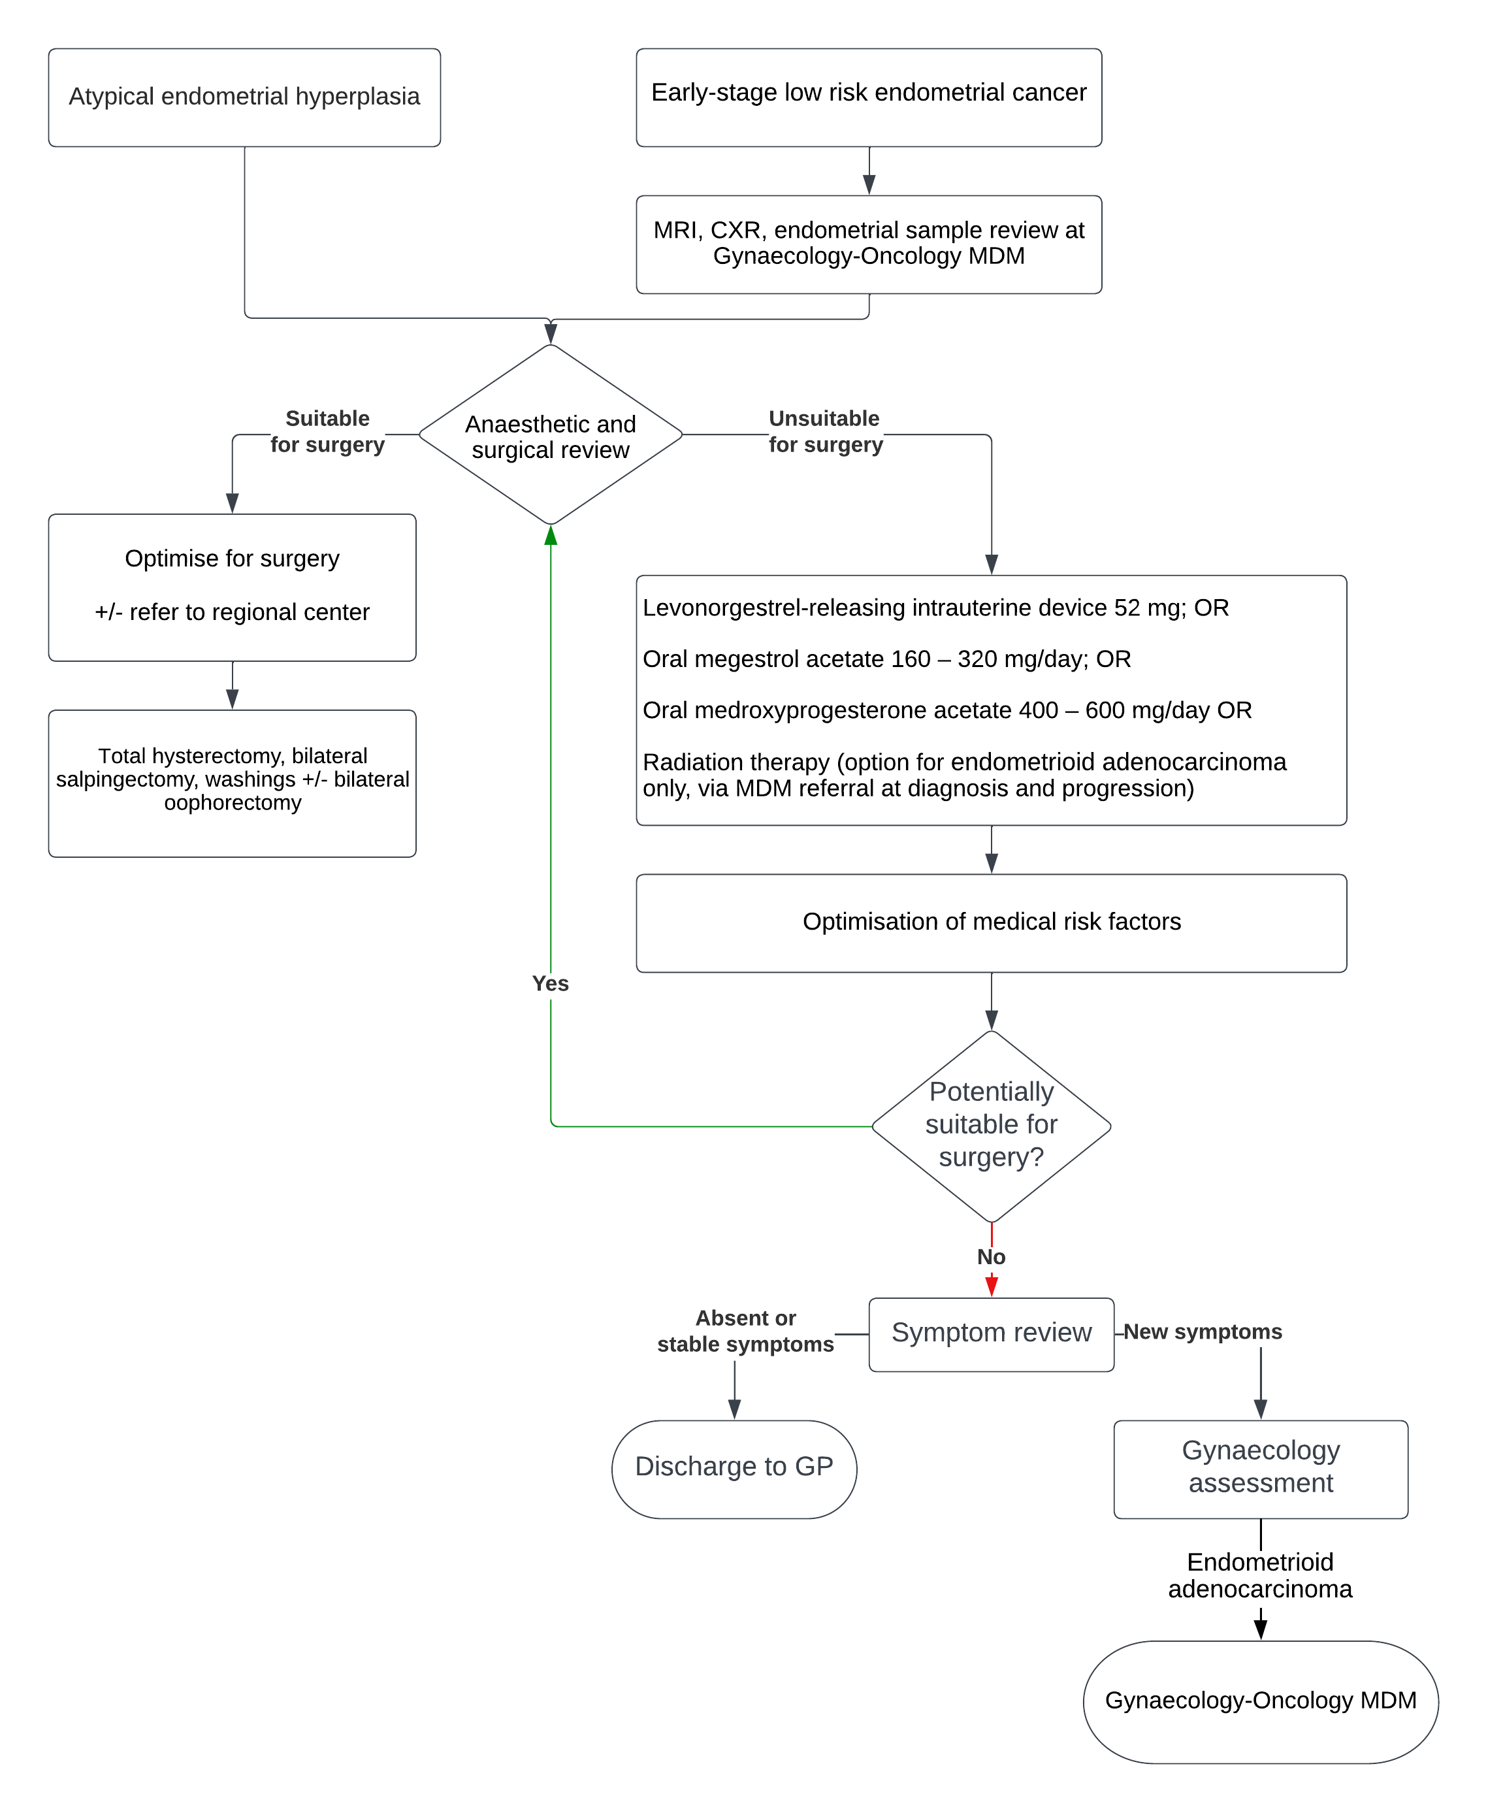

Appendix 1. Histopathology

At initial diagnosis
Endometrial hyperplasia can be divided into three different risk categories. Only the high-risk entities (category 1) are covered by these guidelines.
Category 1: High (≥ 20%) risk of concurrent or subsequent endometrioid adenocarcinoma
- Atypical endometrial hyperplasia
- Complex papillary proliferation is equivalent to atypical endometrial hyperplasia, especially when extensive
Category 2: Conditions in which there is a proposed increased risk of atypical endometrial hyperplasia/ endometrioid adenocarcinoma of variable degree⁵⁻⁷
- Squamous morular metaplasia
- Papillary proliferation of the endometrium (PPE) (simple or focal)
- Mucinous metaplasia
These findings in isolation may not represent increased risk of developing endometrial cancer but depend on their extent and associated glandular complexity.
Management and follow up for the lesions in this category should be tailored to the degree of risk suggested by the reporting pathologist.
Category 3: Low risk (<5%) of concurrent or subsequent endometrioid adenocarcinoma
- Endometrial hyperplasia without atypia
Refer to separate guideline for tailored management of this condition.

Reporting guidelines for surveillance biopsies following progesterone treatment
There is no international consensus regarding how to report these at present. The treatment goal is complete gland atrophy in 9-12 months. It is necessary to review the prior biopsy to assess for whether the abnormality is responding.
Criteria first proposed by Wheeler et al,⁸ and later validated by Mentrikoski⁹ and Penner,¹⁰ are widely used. Special criteria exist for the diagnosis of atypical endometrial hyperplasia and endometrioid adenocarcinoma in this setting; the usual criteria for diagnosis are too strict as progesterone downgrades the appearance of the residual disease.
The presence of any one of the below criteria (either architectural or cytological) predicts the failure of progesterone treatment if present at 7-9 months.⁸

Criteria:
- Architectural atypia even if normal cytology
- Papillary branching
- Crowded glands or irregular and crowded glands
- Cribriform glands
- Cytologic atypia, even if normal architecture
- Nucleoli
- Coarse chromatin

Reporting categories:
- Residual atypical hyperplasia/malignancy (NO or minimal treatment effect)
- Partial histological response to treatment
- Complete histological response to treatment (NO residual atypical hyperplasia/malignancy)

Example report:
Diagnosis: Residual progestin treated endometrial glandular abnormality present consistent with partially suppressed AEH/EAC.
Comment: The degree and amount of abnormalities are less than the prior biopsy which was reviewed for direct comparison.
Alternatively, the criteria proposed by Ganesan et al¹⁰ may be used, see Table 1
Table 1: Morphologic features and treatment implications of the categories provided in Ganesan et al.¹¹
Category | Morphologic features: glands | Morphologic features: stroma | Treatment implications
Negative for residual hyperplasia/ carcinoma | Well-separated, inactive glands  Minor glandular  Irregularity or dilatation  Focal nuclear enlargement that appears reactive or degenerative  No cytologic atypia | Stromal decidual change | Treatment has been effective, and can end  Follow-up to ensure that there is no recurrence
Residual hyperplasia with treatment effects | Foci of crowded glands and/or papillary architecture. Squamous metaplasia may be prominent  No cytologic atypia | Stromal decidual change | Treatment is working but further treatment is needed
Residual atypical hyperplasia with treatment effects | Foci of crowded glands and/or papillary architecture  Cytologic atypia present* | Stromal decidual change | Treatment is working but further treatment is needed
Atypical hyperplasia/ endometrial carcinoma without treatment effects | Atypical hyperplasia/ endometrioid carcinoma without stromal decidual change | No stromal decidual change at the site of gland crowding^ | The atypical hyperplasia/ endometrioid carcinoma is not responding to progesterone treatment⁺
None of the above (describe changes)
* Where the residual glands are confluent enough to warrant a diagnosis of carcinoma in the presence of treatment effects; use “Residual carcinoma with treatment effects.”
^ Stromal decidual change may be seen in non-hyperplastic areas.
⁺ This may be because the atypical hyperplasia/endometrioid carcinoma has become independent of hormonal influence.

References
- Doherty MT, Sanni OB, Coleman HG, Cardwell CR, McCluggage WG, Quinn D, Wylie J, McMenamin ÚC. Concurrent and future risk of endometrial cancer in women with endometrial hyperplasia: A systematic review and meta-analysis. PloS one. 2020 Apr 28;15(4):e0232231.
- Concin N, Matias-Guiu X, Vergote I, Cibula D, Mirza MR, Marnitz S, Ledermann J, Bosse T, Chargari C, Fagotti A, Fotopoulou C. ESGO/ESTRO/ESP guidelines for the management of patients with endometrial carcinoma. International Journal of Gynecologic Cancer. 2021 Jan 1;31(1).
- Rodolakis A, Scambia G, Planchamp F, Acien M, Di Spiezio Sardo A, Farrugia M, Grynberg M, Pakiz M, Pavlakis K, Vermeulen N, Zannoni G. ESGO/ESHRE/ESGE Guidelines for the fertility-sparing treatment of patients with endometrial carcinoma. Human Reproduction Open. 2023;2023(1).
- Herrington CS (Ed). WHO Classification of Tumours Female Genital Tumours (5th ed.). International Agency for Research on Cancer; 2020 Sep.
- Crum CP, Haefner HK, Peters WA (Eds). Diagnostic Gynecologic and Obstetric Pathology (3rd ed, Chapters 17 and 18) Philadelphia, PA Elsevier Inc. 2018.
- Ip PP, Irving JA, McCluggage WG, Clement PB, Young RH. Papillary proliferation of the endometrium: a clinicopathologic study of 59 cases of simple and complex papillae without cytologic atypia. The American Journal of Surgical Pathology. 2013 Feb 1;37(2):167-77.
- Liu D, Chen T, Yu K, Li J, Wang S, Ma X, Zhu Q, Ning Y, Wang Y. A 2-tier subdivision of papillary proliferations of the endometrium (PPE) only emphasizing the complexity of papillae precisely predicts the neoplastic risk and reflects the neoplasia-related molecular characteristics—a single-centered analysis of 207 cases. Virchows Archiv. 2022 Oct;481(4):585-93.
- Wheeler DT, Bristow RE, Kurman RJ. Histologic alterations in endometrial hyperplasia and well-differentiated carcinoma treated with progestins. American Journal of Surgical Pathology. 2007 Jul 1;31(7):988-98.
- Mentrikoski MJ, Shah AA, Hanley KZ, Atkins KA. Assessing endometrial hyperplasia and carcinoma treated with progestin therapy. American Journal of Clinical Pathology. 2012 Oct 1;138(4):524-34.
- Penner KR, Dorigo O, Aoyama C, Ostrzega N, Balzer BL, Rao J, Walsh CS, Cass I, Holschneider CH. Predictors of resolution of complex atypical hyperplasia or grade 1 endometrial adenocarcinoma in premenopausal women treated with progestin therapy. Gynecologic Oncology. 2012 Mar 1;124(3):542-8.
- Ganesan R, Gilks CB, Soslow RA, McCluggage WG. Survey on Reporting of Endometrial Biopsies From Women on Progestogen Therapy for Endometrial Atypical Hyperplasia/Endometrioid Carcinoma. International Journal of Gynecological Pathology. 2022 Mar 1;41(2):142-50.

* Lower doses of oral medroxyprogesterone acetate may be considered to reduce side-effects, but doing so must be balanced against a possible increase in risk of treatment failure and should therefore be discussed with the patient.

