Fertility-preserving Management of Early Endometrial Cancer
  - New Zealand Gynaecologic Cancer Group Guideline
Released 2023
Citation: Te Whatu Ora – Health New Zealand. 2023. Fertility-preserving Management of Early Endometrial Cancer. Wellington: Te Whatu Ora – Health New Zealand.
Published in September 2023 by Te Whatu Ora – Health New Zealand
PO Box 793, Wellington 6140, New Zealand
ISBN 978-1-99-106751-7 (online)
This document is available at tewhatuora.govt.nz
This work is licensed under the Creative Commons Attribution 4.0 International licence. In essence, you are free to: share ie, copy and redistribute the material in any medium or format; adapt ie, remix, transform and build upon the material. You must give appropriate credit, provide a link to the licence and indicate if changes were made.

Contents
Introduction 4
Exclusions 4
Initial Assessment 5
Imaging and MDM referral 5
Decision making process 6
Treatment 6
Surveillance - see Figure 1 7
Definitive treatment 8
Auditable Standards 8
Outcomes for baseline data 8
Updating the guidelines 8
References 10

Introduction
Endometrial cancer is the commonest gynaecological malignancy in Aotearoa. Endometrioid adenocarcinoma is the predominant histological type, for which atypical endometrial hyperplasia is the precursor. The standard treatment for endometrial cancer is total hysterectomy, bilateral salpingectomy with washings and individualised consideration given to removal of ovaries.
Surgical treatment results in a permanent loss of fertility. For those who have not completed childbearing and wish to maintain fertility, medical management with a levonorgestrel-releasing intrauterine device, or oral progestogen may be considered.
The reported effectiveness of fertility-sparing treatment of early endometrial cancer and atypical endometrial hyperplasia range from 57% to 100%.¹ The feMMe trial demonstrated prospectively the effectiveness of the levonorgestrel-releasing intrauterine device with six-month pathological complete response rates of 43% for endometrial adenocarcinoma.²
Fertility-sparing surgical treatment (hysteroscopic resection) is considered experimental and requires specific training and is therefore beyond the scope of this guideline.

Exclusions
- High grade endometrial cancers (all types other than grade 1 or 2 endometrioid or mucinous) and those that are mismatch repair deficient (MMRd).
- Patients under direct care of the Gynaecology-Oncology service.
- Patients with Lynch syndrome.
- Patients who have non-surgical management based on surgical risk and comorbidities. Please refer to the separate guideline on management of atypical endometrial hyperplasia and early-stage low risk endometrial cancer in patients not suitable for surgery.

Initial Assessment
All patients with confirmed or suspected grade 1 or 2 endometrial cancer should undergo:³
- A clinical assessment and examination
- Transvaginal pelvic ultrasound
- Endometrial sampling with either:
- Aspiration endometrial sampling (eg Pipelle) at the initial clinic visit; OR
- Hysteroscopy, dilatation and curettage, if
- An aspiration sample is not successful or considered insufficient for histopathological diagnosis
- Focal or multifocal endometrial pathology (such as polyps) is suggested on imaging
- Symptoms persist despite medical treatment
- An MRI (CT abdo-pelvis if patient unable to undergo MRI).
- A chest- X-ray.
As much as possible, molecular classification as per ProMisE & ESGO/ESTRO guidelines should be used when diagnosing endometrial cancer.⁴
Note: In suitable candidates, outpatient hysteroscopy is recommended over a procedure under general anaesthesia.

Imaging and MDM referral
All patients diagnosed with endometrial cancer in New Zealand should have their endometrial tissue sample and imaging reviewed at a Gynaecology-Oncology multidisciplinary meeting.
MRI ascertains depth of myometrial invasion for low grade cancers to confirm the provisional early stage (IA). Patients with higher suspected stages or higher grades are not candidates for fertility preservation. MRI should follow a locally agreed endometrial specific radiology protocol.
Options of treatment are discussed during the Gynaecology-Oncology multidisciplinary meeting, with supporting clinical information from the referring clinician (comorbidities, parity, goals).

Decision making process
Patients should be counselled about their treatment options, their realistic chances to conceive, and the risks of treatment failure by the Gynaecologist managing the patient.
Patients should be informed that non-surgical management is a non-standard approach, and they should be willing to accept close surveillance. They should be informed of the recommendation for surgical treatment (total hysterectomy and bilateral salpingectomy, washings +/- bilateral oophorectomy) in case of treatment failure and/or after pregnancies.
Early referral to fertility services is recommended, regardless of body mass index and age, including public and private options. Access to publicly funded fertility services need to be equitable. Assisted reproduction is associated with higher live birth rates.^{5,6}
Cardiovascular and metabolic risk factors should be assessed and addressed.

Treatment
Treat for a duration of at least 12 months with:
- Levonorgestrel-releasing intrauterine device 52 mg; or
- Oral megestrol acetate 160 – 320 mg/day; or
- Oral medroxyprogesterone acetate 400 – 600 mg/day*
Choice of medical treatment should consider compliance, side-effects, and patient preference.
Gonadotropin-releasing hormone analogues also show a satisfactory response rate when used alone, and in combination with intrauterine progestin therapy and may be considered.⁴
Adjuncts such as weight loss (green prescription, dietitian, bariatric surgery) and management of other risk factors such as diabetes should be considered.
Patients should be offered psychological and cultural support.
There is currently no role for endometrial cancer resections outside of research trials.

Surveillance - see Figure 1
Endometrial sampling is recommended at 6 and 12 months after treatment initiation.
Response is defined as an adequate endometrial sample negative for atypia or malignancy within 12 months of starting treatment.
An adequate aspiration endometrial sample (such as a Pipelle biopsy) is suitable at 6 months. Hysteroscopy with endometrial sampling is suggested at 12 months (prior to pursuing fertility).
Response to treatment within 12 months:
- Pregnancy is associated with a reduced risk for endometrial cancer recurrence, and therefore pregnancy must be encouraged (and treatment withdrawn) upon confirmation of response.
- 6 monthly surveillance should continue whilst not pregnant.
- Where disease recurs after an initial response, total hysterectomy
and bilateral salpingectomy, washings +/- bilateral oophorectomy should be proposed as the first option. If endometrial carcinoma has been identified at any stage during follow up, the patient should be re-referred to the regional Gynaecology-Oncology multidisciplinary team.
Non-responders to treatment:
- Those who have not responded by 6 months may be offered an additional form of progestogen therapy (eg high dose oral medroxyprogesterone acetate if initially treated with a levonorgestrel-releasing intrauterine device).
Those who do not respond within 12 months, should be recommended a total hysterectomy, bilateral salpingectomy, washings +/- bilateral oophorectomy.

Definitive treatment
Definitive treatment by means of a total hysterectomy, bilateral salpingectomy, washings +/- oophorectomy is recommended once family is complete or if fertility is unable to be achieved.
If definitive treatment is not possible or is declined by the patient:
- Continue treatment with a progestogen.
- Patients should be counselled about risks and benefits of continuing with non-definitive treatment (risk of treatment failure and recurrence of cancer).
- Following evidence of histological regression of disease (two consecutive adequate endometrial samples, 6 months apart, negative for atypia or malignancy), long-term follow up with endometrial biopsy every 12 months is recommended in this situation; with earlier resampling if the patient develops symptoms suggestive of recurrence.

Auditable Standards
All women/people with endometrial adenocarcinoma wishing to have fertility preserving treatment should:
- Receive written advice on modifiable risk factors
- Be offered a referral to fertility services
- Have at least two negative endometrial samples prior to withdrawal of hormonal treatment in an attempt at conception

Outcomes for baseline data
- Proportion of women/people with endometrial carcinoma choosing a fertility preserving treatment option
- Proportion of responders and non-responders to treatment at 6, 12 and 24 months
- Proportion of those still on medical treatment 5 years after initial diagnosis
- Pregnancy rate and live birth rate at 12, 24 months and 5 years
- Hysterectomy rate at 6, 12, 24 months, and at 5 years

Updating the guidelines
These guidelines will be reviewed in 36 months from publication and updated as required.
Figure 1
Fertility Preserving Management of Early Endometrial Carcinoma
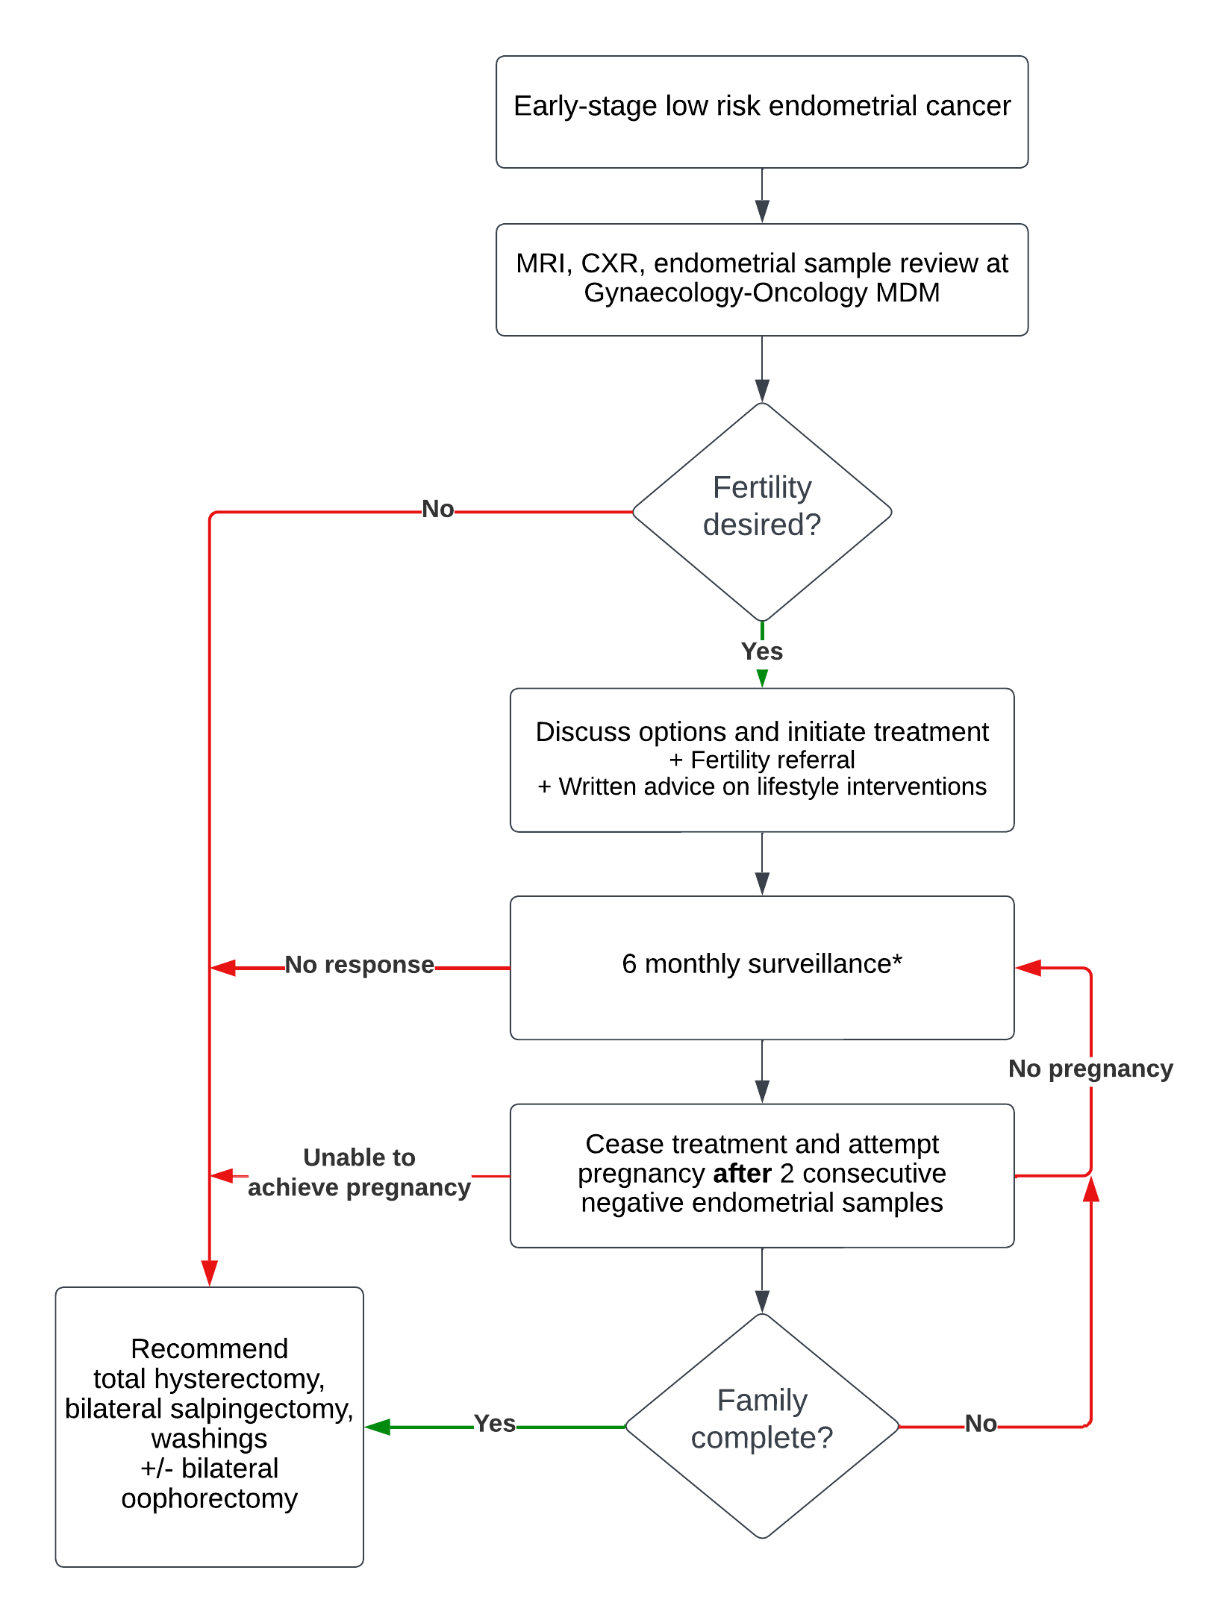
* If no response to treatment after 6 months, consider offering an additional form of progestogen therapy (ie high dose oral progestogen concurrently with a levonorgestrel-releasing intrauterine device)

References
- Piatek S, Michalski W, Sobiczewski P, Bidzinski M, Szewczyk G. The results of different fertility-sparing treatment modalities and obstetric outcomes in patients with early endometrial cancer and atypical endometrial hyperplasia: Case series of 30 patients and systematic review. European Journal of Obstetrics & Gynecology and Reproductive Biology. 2021 Aug 1;263:139-47.
- Janda M, Robledo KP, Gebski V, Armes JE, Alizart M, Cummings M, Chen C, Leung Y, Sykes P, McNally O, Oehler MK. Complete pathological response following levonorgestrel intrauterine device in clinically stage 1 endometrial adenocarcinoma: Results of a randomized clinical trial. Gynecologic Oncology. 2021 Apr 1;161(1):143-51.
- Concin N, Matias-Guiu X, Vergote I, Cibula D, Mirza MR, Marnitz S, Ledermann J, Bosse T, Chargari C, Fagotti A, Fotopoulou C. ESGO/ESTRO/ESP guidelines for the management of patients with endometrial carcinoma. International Journal of Gynecologic Cancer. 2021 Jan 1;31(1).
- Rodolakis A, Scambia G, Planchamp F, Acien M, Di Spiezio Sardo A, Farrugia M, Grynberg M, Pakiz M, Pavlakis K, Vermeulen N, Zannoni G. ESGO/ESHRE/ESGE Guidelines for the fertility-sparing treatment of patients with endometrial carcinoma. Human Reproduction Open. 2023;2023(1).
- Harrison RF, He W, Fu S, Zhao H, Sun CC, Suidan RS, Woodard TL, Rauh-Hain JA, Westin SN, Giordano SH, Meyer LA. National patterns of care and fertility outcomes for reproductive-aged women with endometrial cancer or atypical hyperplasia. American Journal of Obstetrics and Gynecology. 2019 Nov 1;221(5):474-e1.
- Gallos ID, Yap J, Rajkhowa M, Luesley DM, Coomarasamy A, Gupta JK. Regression, relapse, and live birth rates with fertility-sparing therapy for endometrial cancer and atypical complex endometrial hyperplasia: A systematic review and metaanalysis. American Journal of Obstetrics and Gynecology. 2012 Oct 1;207(4):266-e1.

* Lower doses of oral medroxyprogesterone acetate may be considered to reduce side-effects, but doing so must be balanced against a possible increase in risk of treatment failure and should therefore be discussed with the patient.

