Fertility-preserving Management of Atypical Endometrial Hyperplasia
  - New Zealand Gynaecologic Cancer Group Guideline
Released 2023
Citation: Te Whatu Ora – Health New Zealand. 2023. Fertility-preserving Management of Atypical Endometrial Hyperplasia. Wellington: Te Whatu Ora – Health New Zealand.
Published in September 2023 by Te Whatu Ora – Health New Zealand
PO Box 793, Wellington 6140, New Zealand
ISBN 978-1-99-106750-0 (online)
This document is available at tewhatuora.govt.nz
This work is licensed under the Creative Commons Attribution 4.0 International licence. In essence, you are free to: share ie, copy and redistribute the material in any medium or format; adapt ie, remix, transform and build upon the material. You must give appropriate credit, provide a link to the licence and indicate if changes were made.

Contents
Introduction 4
Exclusions 4
Initial Assessment 5
Histopathology 6
Biomarkers in the diagnosis of Atypical Endometrial Hyperplasia 6
Decision making process 7
Surveillance - see Figure 1 8
Definitive treatment 9
Auditable Standards 10
Outcomes for baseline data 10
Updating the guidelines 10
Appendix 1. Histopathology 12
Diagnosis 12
Refer to separate guideline for tailored management of this condition. 12
Criteria: 13
References 15

Introduction
Endometrial cancer is the commonest gynaecological malignancy in Aotearoa. Endometrioid adenocarcinoma is the predominant histological type, for which atypical endometrial hyperplasia is the precursor. Atypical endometrial hyperplasia is also known as endometrioid intraepithelial neoplasia. The standard treatment for atypical endometrial hyperplasia is total hysterectomy, bilateral salpingectomy with washings and individualised consideration given to removal of ovaries.
Surgical treatment results in a permanent loss of fertility. For those who have not completed childbearing and wish to maintain fertility, medical management with a levonorgestrel-releasing intrauterine device, or oral progestogen may be considered.
There is a risk of co-existing endometrial cancer in those diagnosed with atypical hyperplasia on endometrial sampling (32.6%; 95% CI: 24.1%, 42.4%).¹ The rate of progression to endometrial cancer in those with atypical endometrial hyperplasia is 82.3 per 1,000 person-years (95% CI 39.3, 172.6), equivalent to 8.2% per year.¹
The reported effectiveness of fertility-sparing treatment of early endometrial cancer and atypical endometrial hyperplasia range from 57% to 100%.² The feMMe trial demonstrated prospectively the effectiveness of the levonorgestrel-releasing intrauterine device with six-month pathological complete response rates of 82% for atypical endometrial hyperplasia.³
Fertility-sparing surgical treatment (hysteroscopic resection) is considered experimental and requires specific training and is therefore beyond the scope of this guideline.

Exclusions
- Patients under direct care of the Gynaecology-Oncology service.
- Patients who have non-surgical management based on surgical risk and comorbidities. Please refer to the separate guideline on management of atypical endometrial hyperplasia and early-stage low risk endometrial cancer in patients not suitable for surgery.

Initial Assessment
All patients with suspected endometrial hyperplasia should undergo:⁴
- A clinical assessment and examination
- Transvaginal pelvic ultrasound
- Endometrial sampling with either:
- Aspiration endometrial sampling (eg Pipelle) at the initial clinic visit; OR
- Hysteroscopy, dilatation and curettage, if
- An aspiration sample is not successful or considered insufficient for histopathological diagnosis
- Focal or multifocal endometrial pathology (such as polyps) is suggested on imaging
- Symptoms persist despite medical treatment
Note: In suitable candidates, outpatient hysteroscopy is recommended over a procedure under general anaesthesia.

Histopathology
The diagnosis can be difficult and review by a specialist gynaecological pathologist is recommended. Depending on regional circumstances and availability of pathologists with expertise in gynaecological pathology, atypical endometrial hyperplasia histology should be peer reviewed in the pathology department or discussed in a general gynaecology multidisciplinary meeting.
See Appendix 1 for guidelines for histopathological reporting of atypical endometrial hyperplasia following non-surgical treatment.

Biomarkers in the diagnosis of Atypical Endometrial Hyperplasia
In New Zealand, biomarker study of atypical endometrial hyperplasia is not currently standard practice. The World Health Organization suggests immunohistochemistry for loss of PTEN, PAX2, and other markers may assist with diagnosis of atypical endometrial hyperplasia.⁵ The diagnostic decision should still be morphology based in cases where the immunoprofile does not support diagnosis of atypical endometrial hyperplasia.

Decision making process
Patients should be counselled about the risks of underlying malignancy, subsequent progression to endometrial cancer, and risk of treatment failure.
Patients should be informed that non-surgical management is a non-standard approach, and they should be willing to accept close surveillance. They should be informed of the recommendation for surgical treatment (total hysterectomy and bilateral salpingectomy, washings +/- bilateral oophorectomy) in case of treatment failure and/or after pregnancies.
Early referral to fertility services is recommended. Assisted reproduction is associated with higher live birth rates.^{6,7}
Cardiovascular and metabolic risk factors should be assessed and addressed.
Treatment
Treat for a duration of at least 12 months with:
- Levonorgestrel-releasing intrauterine device 52 mg; or
- Oral megestrol acetate 160 – 320 mg/day; or
- Oral medroxyprogesterone acetate 400 – 600 mg/day
Choice of medical treatment should consider compliance, side-effects, and patient preference.
Adjuncts such as weight loss (green prescription, dietitian, bariatric surgery) and management of other risk factors such as diabetes should be considered.
Patients should be offered psychological and cultural support.

Surveillance - see Figure 1
Endometrial sampling is recommended at 6 and 12 months after treatment initiation.
Response is defined as an adequate endometrial sample negative for atypia or malignancy within 12 months of starting treatment.
An adequate aspiration endometrial sample (such as a Pipelle biopsy) is suitable at 6 months. Hysteroscopy with endometrial sampling is suggested at 12 months (prior to pursuing fertility).
Response to treatment within 12 months:
- Pregnancy is associated with a reduced risk for disease recurrence, and therefore pregnancy must be encouraged (and treatment withdrawn) upon confirmation of response.
- 6 monthly surveillance should continue whilst not pregnant.
- Where disease recurs after an initial response, total hysterectomy
and bilateral salpingectomy, washings +/- bilateral oophorectomy should be proposed as the first option, and where endometrial carcinoma has been identified at any stage, referral made to the regional Gynaecology-Oncology multidisciplinary team.
Non-responders to treatment:
- Those who have not responded by 6 months may be offered an additional form of progestogen therapy (eg high dose oral medroxyprogesterone acetate if initially treated with a levonorgestrel-releasing intrauterine device).
- Those who do not respond within 12 months, should be recommended a total hysterectomy, bilateral salpingectomy, washings +/- bilateral oophorectomy, and where endometrial carcinoma has been identified, be referred to the regional Gynaecology-Oncology multidisciplinary team.

Definitive treatment
Definitive treatment by means of a total hysterectomy, bilateral salpingectomy, washings +/- oophorectomy is recommended once family is complete or if fertility is unable to be achieved.
If definitive treatment is not possible or is declined by the patient:
- Continue treatment with a progestogen.
- Patients should be counselled about risks and benefits of continuing with non-definitive treatment (risk of treatment failure and progression to cancer).
- Following evidence of histological regression of disease (2 consecutive adequate endometrial samples, 6 months apart, negative for atypia or malignancy), long-term follow up with endometrial biopsy every 12 months is recommended in this situation; with earlier resampling if the patient develops symptoms suggestive of recurrence.
See Appendix 1 for guidelines for histopathological reporting of atypical endometrial hyperplasia post-treatment.

Auditable Standards
All women/people with atypical endometrial hyperplasia wishing to have fertility preserving treatment should:
- Receive written advice on modifiable risk factors
- Be offered a referral to fertility services
- Have at least two negative endometrial samples prior to withdrawal of hormonal treatment in an attempt at conception

Outcomes for baseline data
- Proportion of women/people with atypical endometrial hyperplasia choosing a fertility preserving treatment option
- Proportion of responders and non-responders to treatment at 6, 12 and 24 months
- Proportion of those still on medical treatment 5 years after initial diagnosis
- Pregnancy rate and live birth rate at 12, 24 months and 5 years
- Hysterectomy rate at 6, 12, 24 months, and at 5 years

Updating the guidelines
These guidelines will be reviewed in 36 months from publication and updated as required.

Figure 1
Fertility Preserving Management of Atypical Endometrial Hyperplasia
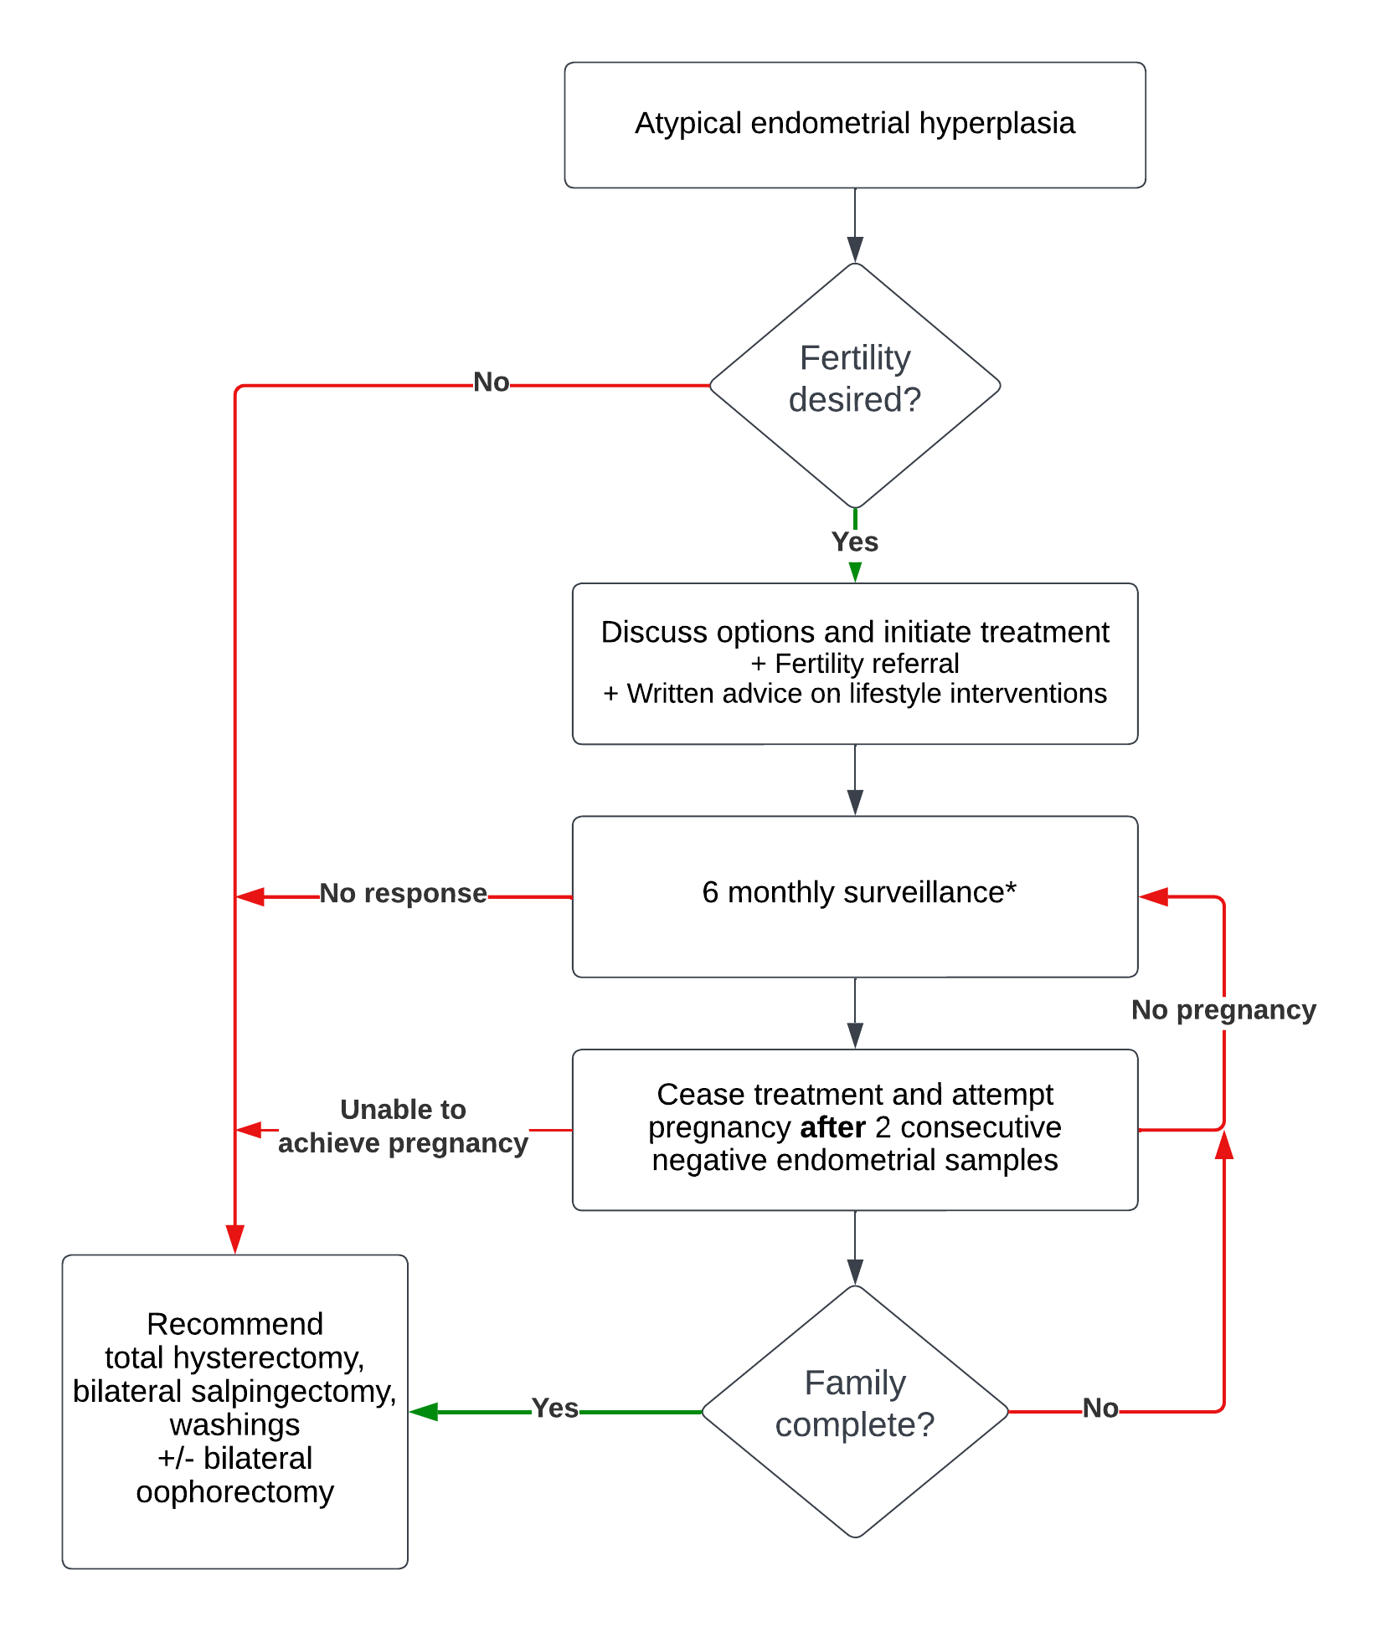
* If no response to treatment after 6 months, consider offering an additional form of progestogen therapy (ie high dose oral progestogen concurrently with a levonorgestrel-releasing intrauterine device)

Appendix 1. Histopathology

At initial diagnosis
Endometrial hyperplasia can be divided into three different risk categories. Only the high-risk entities (category 1) are covered by these guidelines.
Category 1: High (≥ 20%) risk of concurrent or subsequent endometrioid adenocarcinoma
- Atypical endometrial hyperplasia
- Complex papillary proliferation is equivalent to atypical endometrial hyperplasia, especially when extensive
Category 2: Conditions in which there is a proposed increased risk of atypical endometrial hyperplasia/ endometrioid adenocarcinoma of variable degree8-10
- Squamous morular metaplasia
- Papillary proliferation of the endometrium (PPE) (simple or focal)
- Mucinous metaplasia
These findings in isolation may not represent increased risk of developing endometrial cancer but depend on their extent and associated glandular complexity.
Management and follow up for the lesions in this category should be tailored to the degree of risk suggested by the reporting pathologist.
Category 3: Low risk (<5%) of concurrent or subsequent endometrioid adenocarcinoma
- Endometrial hyperplasia without atypia
Refer to separate guideline for tailored management of this condition.

- Reporting guidelines for surveillance biopsies following progesterone treatment
There is no international consensus regarding how to report these at present. The treatment goal is complete gland atrophy in 9-12 months. It is necessary to review the prior biopsy to assess for whether the abnormality is responding.
Criteria first proposed by Wheeler et al,11 and later validated by Mentrikoski12 and Penner,13 are widely used. Special criteria exist for the diagnosis of atypical endometrial hyperplasia and endometrioid adenocarcinoma in this setting; the usual criteria for diagnosis are too strict as progesterone downgrades the appearance of the residual disease.
The presence of any one of the below criteria (either architectural or cytological) predicts the failure of progesterone treatment if present at 7-9 months.11

Criteria:
- ARCHITECTURAL ATYPIA EVEN IF NORMAL CYTOLOGY
- Papillary branching
- Crowded glands or irregular and crowded glands
- Cribriform glands
- CYTOLOGIC ATYPIA, EVEN IF NORMAL ARCHITECTURE
- Nucleoli
- Coarse chromatin
- Reporting categories:
a. Residual atypical hyperplasia/malignancy (NO or minimal treatment effect)
b. Partial histological response to treatment
c. Complete histological response to treatment (NO residual atypical hyperplasia/malignancy)
- Example report:
Diagnosis: Residual progestin treated endometrial glandular abnormality present consistent with partially suppressed AEH/EAC.
Comment: The degree and amount of abnormalities are less than the prior biopsy which was reviewed for direct comparison.
Alternatively, the criteria proposed by Ganesan et al14 may be used, see Table 1
Table 1: Morphologic features and treatment implications of the categories provided in Ganesan et al. ¹⁴
Category | Morphologic features: glands | Morphologic features: stroma | Treatment implications
Negative for residual hyperplasia/ carcinoma | Well-separated, inactive glands  Minor glandular  Irregularity or dilatation  Focal nuclear enlargement that appears reactive or degenerative  No cytologic atypia | Stromal decidual change | Treatment has been effective, and can end  Follow-up to ensure that there is no recurrence
Residual hyperplasia with treatment effects | Foci of crowded glands and/or papillary architecture. Squamous metaplasia may be prominent  No cytologic atypia | Stromal decidual change | Treatment is working but further treatment is needed
Residual atypical hyperplasia with treatment effects | Foci of crowded glands and/or papillary architecture  Cytologic atypia present* | Stromal decidual change | Treatment is working but further treatment is needed
Atypical hyperplasia/ endometrial carcinoma without treatment effects | Atypical hyperplasia/ endometrioid carcinoma without stromal decidual change | No stromal decidual change at the site of gland crowding^ | The atypical hyperplasia/ endometrioid carcinoma is not responding to progesterone treatment⁺
None of the above (describe changes)
* Where the residual glands are confluent enough to warrant a diagnosis of carcinoma in the presence of treatment effects; use “Residual carcinoma with treatment effects.”
^ Stromal decidual change may be seen in non-hyperplastic areas.
+ This may be because the atypical hyperplasia/endometrioid carcinoma has become independent of hormonal influence.

References
- Doherty MT, Sanni OB, Coleman HG, Cardwell CR, McCluggage WG, Quinn D, Wylie J, McMenamin ÚC. Concurrent and future risk of endometrial cancer in women with endometrial hyperplasia: A systematic review and meta-analysis. PloS one. 2020 Apr 28;15(4):e0232231.
- Piatek S, Michalski W, Sobiczewski P, Bidzinski M, Szewczyk G. The results of different fertility-sparing treatment modalities and obstetric outcomes in patients with early endometrial cancer and atypical endometrial hyperplasia: Case series of 30 patients and systematic review. European Journal of Obstetrics & Gynecology and Reproductive Biology. 2021 Aug 1;263:139-47.
- Janda M, Robledo KP, Gebski V, Armes JE, Alizart M, Cummings M, Chen C, Leung Y, Sykes P, McNally O, Oehler MK. Complete pathological response following levonorgestrel intrauterine device in clinically stage 1 endometrial adenocarcinoma: Results of a randomized clinical trial. Gynecologic Oncology. 2021 Apr 1;161(1):143-51.
- Concin N, Matias-Guiu X, Vergote I, Cibula D, Mirza MR, Marnitz S, Ledermann J, Bosse T, Chargari C, Fagotti A, Fotopoulou C. ESGO/ESTRO/ESP guidelines for the management of patients with endometrial carcinoma. International Journal of Gynecologic Cancer. 2021 Jan 1;31(1).
- Herrington CS (Ed). WHO Classification of Tumours Female Genital Tumours (5th ed.). International Agency for Research on Cancer; 2020 Sep.
- Harrison RF, He W, Fu S, Zhao H, Sun CC, Suidan RS, Woodard TL, Rauh-Hain JA, Westin SN, Giordano SH, Meyer LA. National patterns of care and fertility outcomes for reproductive-aged women with endometrial cancer or atypical hyperplasia. American Journal of Obstetrics and Gynecology. 2019 Nov 1;221(5):474-e1.
- Gallos ID, Yap J, Rajkhowa M, Luesley DM, Coomarasamy A, Gupta JK. Regression, relapse, and live birth rates with fertility-sparing therapy for endometrial cancer and atypical complex endometrial hyperplasia: A systematic review and metaanalysis. American Journal of Obstetrics and Gynecology. 2012 Oct 1;207(4):266-e1.
- Crum CP, Haefner HK, Peters WA (Eds). Diagnostic Gynecologic and Obstetric Pathology (3rd ed, Chapters 17 and 18) Philadelphia, PA Elsevier Inc. 2018.
- Ip PP, Irving JA, McCluggage WG, Clement PB, Young RH. Papillary proliferation of the endometrium: a clinicopathologic study of 59 cases of simple and complex papillae without cytologic atypia. The American Journal of Surgical Pathology. 2013 Feb 1;37(2):167-77.
- Liu D, Chen T, Yu K, Li J, Wang S, Ma X, Zhu Q, Ning Y, Wang Y. A 2-tier subdivision of papillary proliferations of the endometrium (PPE) only emphasizing the complexity of papillae precisely predicts the neoplastic risk and reflects the neoplasia-related molecular characteristics—a single-centered analysis of 207 cases. Virchows Archiv. 2022 Oct;481(4):585-93.
- Wheeler DT, Bristow RE, Kurman RJ. Histologic alterations in endometrial hyperplasia and well-differentiated carcinoma treated with progestins. American Journal of Surgical Pathology. 2007 Jul 1;31(7):988-98.
- Mentrikoski MJ, Shah AA, Hanley KZ, Atkins KA. Assessing endometrial hyperplasia and carcinoma treated with progestin therapy. American Journal of Clinical Pathology. 2012 Oct 1;138(4):524-34.
- Penner KR, Dorigo O, Aoyama C, Ostrzega N, Balzer BL, Rao J, Walsh CS, Cass I, Holschneider CH. Predictors of resolution of complex atypical hyperplasia or grade 1 endometrial adenocarcinoma in premenopausal women treated with progestin therapy. Gynecologic Oncology. 2012 Mar 1;124(3):542-8.
- Ganesan R, Gilks CB, Soslow RA, McCluggage WG. Survey on Reporting of Endometrial Biopsies From Women on Progestogen Therapy for Endometrial Atypical Hyperplasia/Endometrioid Carcinoma. International Journal of Gynecological Pathology. 2022 Mar 1;41(2):142-50.

Lower doses of oral medroxyprogesterone acetate may be considered to reduce side-effects, but doing so must be balanced against a possible increase in risk of treatment failure and should therefore be discussed with the patient.

