Case Studies on Equity Volume I
  - How the testing and supply team demonstrate equity in action
Citation: Te Whatu Ora – Health New Zealand. 2023. Case Studies on Equity Volume I: How the testing and supply team demonstrate equity in action. Wellington: Te Whatu Ora – Health New Zealand.
Published in February 2023 by Te Whatu Ora – Health New Zealand
PO Box 793, Wellington 6140, New Zealand
ISBN 978-1-99-106711-1 (online)
This document is available at tewhatuora.govt.nz
This work is licensed under the Creative Commons Attribution 4.0 International licence. In essence, you are free to: share ie, copy and redistribute the material in any medium or format; adapt ie, remix, transform and build upon the material. You must give appropriate credit, provide a link to the licence and indicate if changes were made.

Contents
Equity in Action 4
Case Study 1: We Need a Practical Equity Plan 6
Case Study 2: Amplifying Community Voices Through Providers 9
Case Study 3: Improving Testing for the Disability Sector 12
Case Study 4: Making Masks Accessible for Students 15
Case Study 5: Responding to an SOS from the Housing Forum 18
Case Study 6: Making Testing Communications to the Māori Disability Community Accessible and Timely 21
Case Study 7: Access to Supervised RATs for Priority Populations 23
Case Study 8: Access to COVID-19 Antivirals for Rural Communities 26
Case Study 9: Commissioning in an Agile Way 29
Case Study 10: Māori Provider Distribution Channel (MPDC) 32
RAT Collection Sites 34

Equity in Action

Putting equity principles into practice
These case studies are practical examples of equity in action. They are intended for health professionals and government agencies looking to put principles of equity into practice when working with NGOs, communities and stakeholders.

Challenges
Challenges brought about by COVID-19 have highlighted the health inequities that impact Māori, Pacific disabled people and at-risk communities. These impacts include inequitable access to suitable health care, limited access to testing and supplies, engagement challenges, and delivery of timely and accessible information.

Our aim
In the first six months of 2022, the Testing and Supply team worked in local communities to deliver practical solutions, fast. Our primary objective has been to strengthen and resource community providers and their networks. Working with these providers has enabled us to better support vulnerable communities.

The case studies
These case studies summarise the Testing and Supply team’s work to improve equitable outcomes for priority populations from January to June 2022.
Key results during this period were:
- 8-point action plans developed for Māori, Pacific, Disability and at-risk groups
- Establishment of an early adopter provider panel
- 9 million masks distributed through community partners (May-June 2022)
- 120 Iwi - Māori providers given access to the PPE Portal
- 68 transitional housing providers given access to the PPE portal
- 89 community providers doing supervised RATs
- 12 million RATs distributed to community partners via the provider network
- 130 contracted agreements in place to support specific equity activity within 6 months – over 50 % of these agreements are with Iwi - Māori providers
- 1000 + community partners accessing the Māori Provider Distribution Channel
- Progressing access of antivirals to rural communities
- Collaborating on communications with the disability sector
We’ve used the Double Diamond design framework to discover and define problems, and develop and deliver solutions.
This approach has enabled us to identify and implement practical solutions to some of the key equity challenges our most vulnerable communities face.

The importance of trust
Our approach of delivering solutions at pace came about through necessity. Successes outlined in the case studies were based on four main principles:
- Community-centric focus
- Collaboration and connection
- Communicating with stakeholders regularly
- Common sense
Underpinning this approach is the importance of trust:
- Trust built by being authentic and pragmatic
- Creating conditions that enable providers to respond to communities at pace knowing they are supported.

8-point plans
Our 8-point action plans have put priority populations at the heart of decision making. Building trust and working together to develop sustainable solutions has been critical in engaging with Māori, Pacific, disability and other vulnerable communities who are at risk of poorer outcomes or increased community transmission due to COVID-19.
This strategy should put equity at the centre of the decision making… The testing strategy must develop sustainable solutions to engage effectively with Māori, Pasifika and other vulnerable communities who are at risk of poorer outcomes or increased community transmission due to COVID-19.
– Recommendation 1 - A Rapid Review of COVID-19 Testing in Aotearoa New Zealand (October 2021)

Case Study 1: We Need a Practical Equity Plan
Challenge | We Need a Practical Equity Plan | Key Stakeholders
Discover | The Situation  In October 2021, the Murdoch Review recommendations on COVID-19 testing activities were released. These recommendations highlighted the absence of demonstrable equity gains. More deliberate efforts were needed to advance equitable outcomes within Testing and associated workstreams. | COVID-19 Testing  Technical Advisory Group
Define | The Problem/s Focused On  Lack of a practical, integrated plan  Lack of visibility of equity work across the team  Limited engagement with stakeholders, particularly community providers  Varying levels within the team of understanding and knowledge of how to put equity in action | Testing Team (MoH)  Supply Team (MoH)  Community providers
Develop | Possible Practical Solutions  Undertake discovery workshops with a range of stakeholders, particularly providers  Move from a centralised model of control to a collaborative approach with community providers and key stakeholders | Testing Team (MoH)  Supply Team (MoH)  Community providers
Deliver | What We Did  Engaged stakeholders through workshops and key informant interviews  Developed a plan that was activity focused  Connected with agency partners  Identified levers (policy, resource and relationships within the authorising environment) | Testing Team (MoH)  Supply Team (MoH)  COVID-19 Response  Māori Dir. (MoH)  Pacific Health (MoH)  Disability Dir. (MoH)  Provider network  Agency partners
Outcome | Created equity plans (8-Point plan) for Māori, Pacific, disability and at-risk groups that anchor equity outcomes for Testing and Supply teams. They explicitly recognise a commitment to ensuring we actively integrate equity into our functions of leading, connecting, supporting and delivery. | 8 Point Plan premised on equality-focused strategy

Māori and Pacific providers could do so much more if they were at the table from the start… rather than working with a lead around their necks.
- Te Puea Winiata – Turuki Healthcare CE

Case Study 2: Amplifying Community Voices Through Providers
Challenge | Amplifying Community Voices Through Providers | Key Stakeholders
Discover | The Situation  Community providers criticised government for introducing COVID-19 response activities that appeared to be a catch-all for everyone, including priority populations. The lack of social, cultural and community context within the COVID-19 response contributed to exacerbating inequities and disengagement from some public health measures. | Community Providers  Community Stakeholders
Define | The Problem/s Focused On  Limited engagement with key stakeholders, particularly community providers  No formal mechanism to engage community providers for advice from the start  Officials not having a level of understanding of community and provider context  Working at pace used as an excuse to not engage communities appropriately | Testing Team (MoH)  Supply Team (MoH)  Community providers
Develop | Possible Practical Solutions  Undertake discovery workshops with a range of stakeholders, particularly providers  Engage community providers, stakeholders and agencies to obtain insights into problems and potential solutions | Testing Team (MoH)  Supply Team (MoH)  Community providers
Deliver | What We Did  Contracted Māori (3), Pacific (3) and disability (2) providers to be part of the early adopter provider panel to help co-design, test and adapt initiatives before wider roll out  Established Māori and Pacific leads within the team to maintain critical relationship in the community and across lead agencies | Testing Team (MoH)  Supply Team (MoH)  Procurement (MoH)  Community providers  Lead agencies
Outcome | The early adopter provider panel has helped inform:  A national Supervised RATs service specification for 89 community providers  A communications process for Māori disability providers  Broader antiviral access for Māori, Pacific and rural communities  The appropriateness of testing modalities for vulnerable groups  Development of the Māori and Pacific provider distribution channels | 8 Community Providers contracted to the early adopter provider panel

It is indeed very satisfying and in most cases a relief to see the expressions on peoples’ faces when we deliver them food, RATS and masks. Thank you to all who have made it possible for us to help our people in their time of need.
- Community Provider
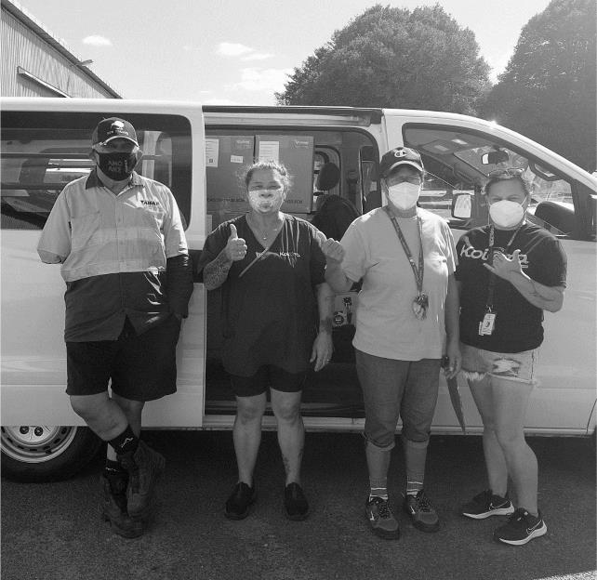

Case Study 3: Improving Testing for the Disability Sector
Challenge | Improving Testing for the Disability Sector | Key Stakeholders
Discover | The Situation  Government agencies were criticised for their lack of leadership and visibility in the disability community. Issues included lack of engagement, funding, workforce and effective communications. This led to a disgruntled disability sector panning the overall COVID-19 response. Testing was identified as one of the areas of concern. | Minister Sepuloni  Officials  Disability advocates  Service Users  Human Rights Commission
Define | The Problem/s Focused On  The PCR nasal swab was intolerable for some disabled people  Messaging to promote testing was not accessible and timely  Lack of a formal engagement mechanism with disability sector | Community providers  Disability Provider  Organisation (DPO)  Testing (MoH)  Officials  Service Users
Develop | Proposed Practical Solutions  Identify a testing modality to trial with Early Adopter providers  Develop a collaborative communications approach with Māori providers working with disability service users  Develop a specific plan to advance equitable access for the disability community | Testing (MoH)  Disability Directorate  DPMC  Procurement  DPOs  Māori providers
Deliver | What We Did  Contracted three early adopter providers to trial an alternative testing modality  Co-created rapid communications guidelines to develop video and collateral at pace for Māori disability communities  Developed the Advancing Equitable Access – 8-point action plan focused on the disability community  Activated an assisted channel to respond with 24 hours | Testing Team (MoH)  Supply Team (MoH)  Procurement (MoH)  Community providers  Lead agencies
Outcome | Active engagement with the disability sector to work through challenges, and co-creation of ideas and approaches | Established a process for trialling testing modalities with the disability sector

Your team has worked well with us and gained from the valuable contribution made by whānau hauā to improve clinical practice and engagement.
There’s still heaps to do, particularly among Māori with disabilities; but recognising the competencies needed by health authorities and the workforce to address inequities, is significant progress.
- Disability Health Provider
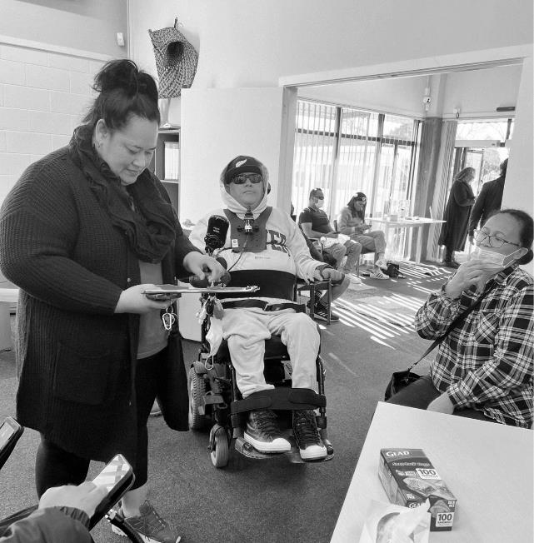

Case Study 4: Making Masks Accessible for Students
Challenge | Making Masks Accessible for Students | Key Stakeholders
Discover | The Situation  School absenteeism due to COVID-19 increased disproportionately for Māori and Pacific students. Schools (primary and secondary) including Kura and Kohanga worried about the wellbeing of students and staff. Emerging issues included digital exclusion, financial hardship, mental health and social isolation, all of which contribute to learning barriers. | Schools  Families  Kura  Kohanga
Define | The Problem/s Focused On  Students without access to masks were unable to attend school  Staff were unable to create a safe environment in the classroom | Supply Team (MoH)  Equity CVIP Team (MoH)  Provider network  Key informants from education sector
Develop | Proposed Practical Solutions  Support communities to access PPE locally  Encourage local campaigns to promote good public health measures  Remove any cost barriers and promote assisted channel pathways | Supply Team (MoH)  Equity CVIP Team (MoH)  Procurement (MoH)  Healthcare Logistics (HCL)  Provider network  Key stakeholders from education sector
Deliver | What We Did  Co-designed distribution channels with HCL and provider networks to push out RATs, mask, wipes and gloves via localised community networks throughout the country  Encouraged community partners including schools to pull PPE from this provider-led channel and act as messengers to promote the channel locally | Testing Team (HNZ)  Provider network  Healthcare logistics
Outcome | Community resilience and preparedness strengthened  Schools equipped to create safe learning environments for students | 9 Million masks have been distributed to community partners (May – June)

We express our gratitude for the donation of face masks and wipes. Students and staff will benefit from these. We continue to be vigilant while COVID-19 is still at large in the community.
- School Principal

Case Study 5: Responding to an SOS from the Housing Forum
Challenge | Responding to an SOS from the Housing Forum | Key Stakeholders
Discover | The Situation  The Housing Forum, consisting of lead community providers chaired by Minister Woods, highlighted the need for easy access to RATs to protect staff and vulnerable families. There was a view that MoH officials and DHBs were withholding stock from housing providers because they were not providing health-specific services. | Supply Team (MoH)  Care in the Community  Team (MoH)  Minister Woods  Minister Davidson  MHUD officials  Community Housing  Providers
Define | The Problem/s Focused On  The high number of transitional housing providers who did not have access to the PPE portal despite these providers supplying a suite of health, disability and social services to priority populations.  Slow delivery of urgent deliveries due to pressure on the courier network. | Housing Forum  Supply Team (MoH)  Care in the Community  Team (MoH)  Healthcare Logistics
Develop | Proposed Practical Solutions  Onboard transitional housing providers to have their own access to PPE  Ask community providers to pull on existing channels in the meantime | Supply Team (MoH)  Healthcare Logistics  Community Providers
Deliver | What We Did  Attended the Housing Forum to give regular weekly updates and provided a direct contact for providers with queries  Onboarded PPE portal access to 68 transitional housing providers  Arranged for urgent RAT deliveries to housing providers through channels such as the Māori Provider Distribution Channel | Supply Team (MoH)  Healthcare Logistics  Health  Māori Provider  Distribution Channel
Outcome | Providers have direct access to PPE through the portal  Improved urgent delivery times  Strengthened relationship between HUD, MoH and community providers | 68 Transitional Housing providers have access to PPE portal

Thanks for being pragmatic and your awhi for supporting the housing providers during a challenging time.
- Housing Forum

Case Study 6: Making Testing Communications to the Māori Disability Community Accessible and Timely
Challenge | Making Testing Communications to the Māori Disability Community Accessible and Timely | Key Stakeholders
Discover | The Situation  The Human Rights Commission’s report Inquiry into the Support of Disabled People and Whānau During Omicron highlighted significant concerns with the government’s response to the pandemic for the disabled community, including official communications from government agencies. Problems were exacerbated in Māori disability communities. | Minister Sepuloi  Testing Team (MoH)  Disability advocates  End Users  Human Rights Commission
Define | The Problem/s Focused On  Written text not being the primary communication platform for many whānau hauā  Messaging to promote testing was not accessible and timely | Testing Team (MoH)  Community providers  NRHCC  End Users  Te Roopu Wairora  Turuki Health  CCS Disability
Develop | Proposed Practical Solutions  Work with the Māori disability provider Te Roopu Wairoa on a collaborative approach to collateral for the trial of the Lollisponge PCR test | Testing Team (MoH)  Te Roopu Waiora  DPMC
Deliver | What We Did  Co-created rapid communications guidelines to develop video and collateral to promote and support uptake of new testing modalities for the disability sector  Made a simple video at pace in response to Te Roopu Waiora’s request for testing guidance in the form of kanohi ki te kanohi, or face-to-face dialogue, through video | Testing Team (MoH)  Te Roopu Waiora  DPMC  NRHCC  Turuki Health  CCS Disability
Outcome | We made the first step in an iterative process with the Māori disability sector on co-designing more engaging communications material for new testing modalities | Established a process to rapidly develop communications to support the disability sector
We have provided the Ministry several recommendations on what could be improved, including involving iwi Māori from the outset to develop responsive communications, and using pre-existing channels within Māori communities to circulate the messaging to disabled Māori stakeholders and families.
- Tania Kingi – Te Roopu Wairoa CE
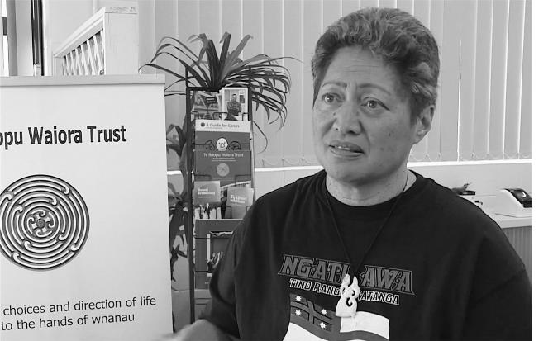

Case Study 7: Access to Supervised RATs for Priority Populations
Challenge | Access to Supervised RATs for Priority Populations | Key Stakeholders
Discover | The Situation  Demand for RATs was rapidly increasing and access models available via GPs, community pharmacies and DHB’s did not cater to the needs of vulnerable communities, namely Māori, Pacific and rural. There was also some confusion on why, who, when and where people could receive supervised RATs. | Iwi-led organisations  Māori providers network  Pacific providers network
Define | The Problem/s Focused On  Challenges of rurality, operating hours, unconscious bias, and clinical workforce shortage  Perception that supervised RATs could only be conducted by a clinician within a health provider setting | Testing Team (MoH)  Community providers
Develop | Proposed Practical Solutions  Mobilise supervised RATs into the community through a range of providers  Provide training and liaison support  Test the approach through early adopter providers | Testing Team (MoH)  Community providers
Deliver | What We Did  Trialled supervised RATs through four community providers (Māori, Pacific and rural)  Undertook an EOI process and commissioned 89 community providers to undertake supervised RATs in various community settings  Developed processes and collateral to support supervised tests, including an assisted channel to support the reporting of RAT results for the digitally excluded | Testing Team (MoH)  Te Haa  Pasifika Futures  Limited  Te Aroha Kanarahi  Trust  Southseas Healthcare  Supply (MoH)  Procurement (MoH)
Outcome | Strengthened community response and resilience  Over 21,000 supervised RATs completed by community providers | 89 community providers can do supervised RATs

A key part of our role is critically thinking about how we incorporate an equity lens in the funding process and create the right conditions. This helps us commission the right community partners so we can maximise positive outcomes.
- Procurement Lead

Case Study 8: Access to COVID-19 Antivirals for Rural Communities
Challenge | Access to COVID-19 Antivirals for Rural Communities | Key Stakeholders
Discover | The Situation  With the release of anti-viral medications in Aotearoa, there was a need for information and access to be provided to Māori communities. Inequitable access to anti-virals was more acutely felt by rurally isolated Māori communities and providers, such as the Matakaoaa community in Te Araroa. | Manaaki Matakaoa  Health New Zealand  Pharmac  Testing and Supply (MoH)  Care in the Community  (MoH)
Define | The Problem/s Focused On  Geographical distance to clinicians impacting access to medications  Access criteria to anti-viral medications for rurally isolated Māori communities wasn’t appropriate  Relationships between GPs, Pharmacies, Health NZ, Pharmac and communities | Manaaki Matakaoa  Testing and Supply (MoH)  Pharmac  Care in the Community (MoH)
Develop | Proposed Practical Solutions  Work with key stakeholders to influence the access criteria for anti-viral medications and to create a tailored approach for prescribing and dispensing | Manaaki Matakaoa  Testing and Supply (MoH)  Pharmac  Care in the Community (MoH)
Deliver | What We Did  Worked with Pharmac to influence the access eligibility and criteria for anti-viral medicines  Worked with Manaaki Matakaoa to create an approach to make anti-viral medicines more accessible  Created clear information for Māori communities about anti-viral medicines | Manaaki Matakaoa  Testingand Supply (MoH)  Pharmac  Care in the Community (MoH)
Outcome | A rural Māori community provider was given access to anti-viral medications under new accessibility criteria  Influenced Pharmac’s updated access criteria for antiviralCOVID-19 treatments | Influencing access criteria to anti-viral treatment for Māori and Pacific communities

Our success hinges on direct, critical relationships within the health system - To have people that respect and relate to your situation has relieved our burdens significantly. We don’t expect every problem to be instantly solved, but we do appreciate being heard, authentic efforts being made, and feeling like we have champions in the system sharing the burden with us.
- Tina Ngata – Manaaki Matakaoa Lead

Case Study 9: Commissioning in an Agile Way
Challenge | Commissioning in an Agile Way | Key Stakeholders
Discover | The Situation  Contracting for COVID-19 services was criticised by community providers for not targeting priority populations, despite the strategic intent of doing so. This was a disconnect for providers, who could not meet the needs of their communities. | Procurement (MoH)  Community providers  Testing Team (MoH)  Supply Team (MoH)
Define | The Problem/s Focused On  Equity not being a key focus in procurement processes  Lack of Māori and Pacific community providers on the AOG panel, leading to frequent, urgent EOIs and tenders  Difficulty in funding providers working outside a typical health remit | Procurement (MoH)  Testing Team (MoH)  Supply Team (MoH)  Community providers  Sector operations
Develop | Proposed Practical Solutions  Invite Procurement to participate in provider engagement processes to build relationships  Identify lead providers to participate in trials and distribution | Procurement (MoH)  Testing Team (MoH)  Supply Team (MoH)  Community providers
Deliver | What We Did  Tagged existing funding pool to support equitable outcomes  Created conditions of high trust for contracting  Made equity a key anchor in commissioning activity  Worked with procurement lead to manage relationships with providers | Testing Team (MoH)  Supply Team (MoH)  Procurement (MoH)  Community providers  Sector Operations
Outcome | Contracted 29 Māori and 4 Pacific providers to form the provider-led distribution channels  Commissioned 8 early provider adopters to participate in trials  Commissioned 89 community providers to do supervised RATs.  Over $20 million tagged for equity activity Jan – June 2022 | 130 contracted agreements in place within 6 months to support specific equity activity

We love being a part of this distribution group. We still have a steady stream of people requesting RATs which is awesome. We hope this can continue to expand and we can offer more additional services and supplies to our Eastern Bay Of Plenty community.
- Lee Colquhoun – Te Puna Ora o Mataatua
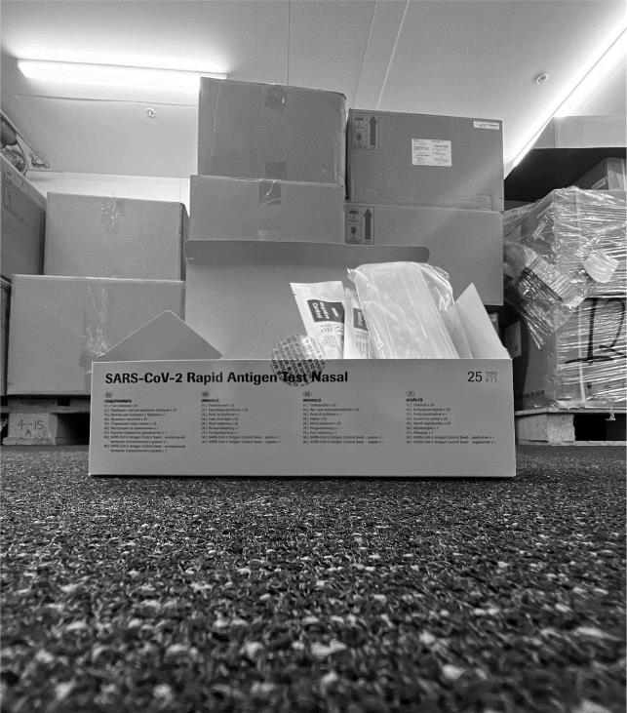

Case Study 10: Māori Provider Distribution Channel (MPDC)
Challenge | Māori Provider Distribution Channel (MPDC) | Key Stakeholders
Discover | The Situation  COVID-19 highlighted existing health inequalities for Māori communities. There was growing concern that the distribution model for RATs and PPE would not provide Māori communities with sufficient coverage at the pace required. | Iwi led organisations  Māori providers network  Pacific providers network
Define | The Problem/s Focused On  Equitable access to PPE and RATs for Māori  Strained relationships between community providers and the Ministry of Health (now Health NZ)  The lack of a connected network of Māori community providers | Supply Team (MoH)  Community providers  CVIP Equity Team (MoH)  Māori Directorate (MoH)
Develop | Proposed Practical Solutions  Identify lead providers to be part of a new Māori distribution channel  Resource providers to provide this function  Onboard Māori health and disability providers to have PPE portal access  Create PPE templates and shift Māori health providers to these so they can access appropriate PPE | Supply Team (MoH)  Community providers  CVIP Equity Team (MoH)  Healthcare Logistics
Deliver | What We Did  Co-designed with Healthcare Logistics and the provider network a Māori Provider Distribution Channel to distribute RATs, masks, wipes and gloves through local community networks  Encouraged other community partners to pull PPE from this provider-led channel  Onboarded Iwi – Māori health and disability providers to our PPE portal access | Testing Team (MoH)  Supply Team (MoH)  Procurement (MoH)  CVIP Equity Team (MoH)  Healthcare Logistics
Outcome | Coverage for Māori is 95.4% (target was 90%)  Onboarded over 120 new Māori providers to have access to PPE portal  Created a Māori provider-led distribution channel  Created a model for the Pacific Provider Distribution Channel  Requests from communities can now be actioned within 24 hours | 1000+ community partners accessing the MPDC  12 million RATs distributed to community partners
It is indeed very satisfying and in most cases a relief to see the expressions on peoples’ faces when we deliver them food, RATs and masks. Thank you to all who have made it possible for us to help our people in their time of need.
- Community Provider

RAT Collection Sites
96.5% of the general population are within a 20min drive of a collection site
95.4% of Māori are within a 20min drive of a collection site
RAT Collection sites and 20min drive time catchment areas
