|  |  |  |
| --- | --- | --- |
|  | **All District Health Boards** | |
| **HOME AND COMMUNITY SUPPORT SERVICES**  **COMMUNITY HEALTH, TRANSITIONAL AND SUPPORT SERVICES**  **(District Health Board Funded)**  **TIER TWO SERVICE SPECIFICATION** | | |
| **STATUS:**  Approved by DHB GMs Planning and Funding (February 2020) to be used for the transitional nationwide description of services to be provided. It will be compulsory to use this service specification when purchasing this service from 2022 when DHBs have confirmed they are using the new Home and Community Support Services casemix model. | | **TRANSITIONAL** |
| **Review History** | | **Date** |
| First Published on NSFL | | 2020 |
| Consideration for next Service Specification Review and the replacement of the Purchase unit codes | | Within five years |

Note: Contact the Service Specification Programme Manager, Ministry of Health [nsfl@health.govt.nz](mailto:nsfl@health.govt.nz) for queries about this service specification.

Nationwide Service Framework Library web site <http://www.nsfl.health.govt.nz>

Contents

Background 4

1 Key Documents 4

2 Service Users 5

3 Service Exclusions 5

4 Service Objective 6

4.1 General 6

4.2 Māori Health objectives 6

5 Service Description 6

5.1 Hours of service provision 6

5.2 Restorative casemix model overview 7

5.3 Service delivery requirements 7

6 Service Processes 8

6.1 Service access 8

6.2 Provider management of referrals 9

6.3 Service response times for described activities 9

6.4 Individual support plan 10

6.5 Client Consent, Assessment and Review 11

6.5.1 Consent 11

6.5.2 Monitoring and review of client progress 11

6.5.3 Assessments and reassessments 11

6.6 Process for outside of service hours 12

6.7 Clients requiring high and very high intensive support 12

6.8 Case Management and Flexible Service Provision 13

6.9 Client Discharge Processes 13

6.9.1 Planned discharge 13

6.9.2 Discharge Criteria 13

6.9.3 Disputed Discharges 14

7 Workforce Development 14

7.1 General 14

7.2 Support workers 14

7.3 Registered health professionals 14

7.4 Workforce diversity 15

8 Service Linkages 15

9. Quality Requirements 16

9.1 Legislative requirements 16

9.2 Audit 17

9.3 Quality improvement and risk management systems 17

10 Purchase Unit Codes 19

11 Reporting and Monitoring 20

11.1 Reporting to the Ministry of Health 20

11.2 Reporting to the DHB Funder 20

12. Technology and Data Requirements 22

12.1 General 22

12.2 Data sharing 22

12.3 Data collection 22

Appendix 1: Casemix Algorithms 24

Non-Complex Algorithm Utilising the InterRAI Contact Assessment Tool 24

Complex Algorithm Utilising the InterRAI Home Care Assessment Tool 25

Appendix 2: Review and Assessment Regime 26

Appendix 3: Service Allocation Tool 27

Appendix 5: Key Terms and Processes 28

**HOME AND COMMUNITY SUPPORT SERVICES**

**(DISTRICT HEALTH BOARD FUNDED)**

**COMMUNITY HEALTH, TRANSITIONAL AND SUPPORT SERVICES**

**TIER TWO SERVICE SPECIFICATION**

**HOP1009, HOP1010**

The Tier Two service specification for Home and Community Support Services (HCSS) is used for purchasing services for older people who have support needs because of an age-related condition.

So that the total service requirements are explicit, this service specification is also to be used in conjunction with the Tier One Community Health, Transitional and Support Services service specification[1] that contains generic principles and content common to all the tiers of specifications below it.

# Background

HCSS services are required to work cooperatively with representatives of bodies such as contracted providers, allied health, primary health care, needs assessment and service coordination (NASC) and district health board (DHB) Health of Older People portfolio managers. These bodies will work within an integrated management framework consisting of a strategic steering group and an operational integrated management group established at the commencement of the contracted service period and meet regularly.

The integrated management groups are responsible for ensuring integrated, coordinated and responsive HCSS service delivery with a focus on continuous improvements within a ‘best for person, best for system’ framework. The HCSS Operations Manual has been developed to support the integrated management groups throughout implementation strategic direction and operational delivery of this service.

# 1 Key Documents

The Tier Two HCSS service specification is supported by the National Framework for Home and Community Support Services[2] that provides the overarching guidance for publicly funded home and community support services to ensure national consistency of the commissioning, delivery and evaluation.

The strategic links for HCSS are New Zealand Health Strategy[3], the Healthy Ageing Strategy[4], He Korowai Oranga Māori Health Strategy[5], the New Zealand Framework for Dementia Care[6], the New Zealand Carers’ Strategy[7] and Te Ara Whakapiri[8] and the New Zealand Disability Strategy.

HCSS are a key component of achieving the long-term vision of the Healthy Aging Strategy by supporting older people to live well, age well and have a respectful end of life in age-friendly communities.

# 2 Service Users

Service Users are defined as clients for the purposes of this service specification.

Most clients will be over 65 or aged 50 to 64 years with age related needs. Clients are people who are eligible for long term publicly funded healthcare and that have been assessed using an appropriate interRAI assessment tool and:

1. have support needs because of an age-related condition aged over 65 years
2. are aged 50 to 64 years, and like in age and interest
3. are people receiving services for ACC funded short term services or
4. are receiving Mental Health and Disability Support Services (DSS)[9], and who also require Health of Older People Home Support services for age related needs to continue concurrently
5. have support needs that are likely to last greater than 6 months.

# 3 Service Exclusions

The following people will be excluded from this service where there are duplicate services that are already funded by the DHBs under other service specifications, by other government agencies or the Ministry of Health who:

* are funded for Home Support Services by Accident Compensation Corporation (ACC) (except for 2c. Service Users, above)
* receive Mental Health and Disability Support Services (except for 2d. Service Users, above)
* are funded for Long Term Supports – Chronic Health Conditions services
* in DHB funded aged residential care facilities
* reside outside the DHB’s region, including those on holiday
* receive household only assistance for people who do not have a current community services card
* have an individualised funding allocation of home and community support services.

# 4 Service Objective

## 4.1 General

The purpose of HCSS is to provide older people with restorative client-centred, culturally appropriate and responsive support that maintains or enhances the functional ability, health and social connectivity or to provide support at end of life for existing clients in the community.

## 4.2 Māori Health objectives

These requirements are in addition to the generic requirements for Māori Health in the Tier One Community Health, Transitional and Support Services service specification.

The Provider will work within the Pae Ora framework of He Korowai Oranga Māori Health Strategy, and seek to provide care and support that promotes:

Whānau ora – healthy families

Mauri ora – healthy individuals

Wai ora – health environments

Pae Ora provides a platform for Māori to live with good health and well-being in an environment that supports a good quality of life. It encourages everyone in the health and disability sector to work collaboratively, to think beyond narrow definitions of health, and to provide a high-quality and effective service.

The Provider’s policies and practices will demonstrate measurable benefit to Māori, including demonstration of:

* services that will equitably and directly deliver on Māori health priorities
* workforce training focused on the delivery of services to Māori including the service’s understanding of Māori principles/tikanga
* client and whānau feedback on how they believe the Provider has delivered in relation to Māori values and beliefs
* linkages with the local Māori community and how these are enhanced; and
* processes to include engagement and input from Māori into service delivery management and ongoing improvement and development of the service.

# 5 Service Description

## 5.1 Hours of service provision

The Service will be accessible 24 hours, seven days a week, as appropriate to meet client needs. In usual circumstances, inside service hours are between 7.00 am and 10.00 pm or by negotiation, seven days a week. It is not expected that support services will be delivered by support workers between 10.00 pm and 7.00 am. Service times (eg, between 7am and 9am) will be determined in response to the client’s current and evolving needs in consultation between the Provider, the client, their carer, and whānau.

Inside service hours the client, referrers and support workers will be able to make direct contact with a Provider representative. Responses to queries will be available Monday to Sunday between the hours of 7.00 am and 10.00 pm. The Provider is expected to have a process to screen and allocate urgency to messages. This expectation includes all forms of message including but not exclusive to; phone, text and email.

## 5.2 Restorative casemix model overview

The National HCSS restorative model uses a casemix methodology to group people with similar levels of assessed need together to support equitable resource allocation. The eligible population is initially screened by a NASC coordinator using a Service Allocation Tool (SAT) to determine level of complexity. There are two complexity groups: Non-Complex and Complex.

The interRAI assessment outcomes scores are used to determine and allocate client casemix. The clinical decision tree algorithms (with descriptors for both non-complex and complex population groups) are provided in Appendix 1. The casemix algorithms enable Providers to identify clients that can be reabled/restored, or alternatively supported to maintain or extend their level of functional ability and wellness.

Using a restorative approach, the Provider will work in partnership with the clients to develop and agree SMART[10] goals and document these in the clients’ individual support plan. To facilitate achievement of the client’s SMART goals, Providers will continuously deliver services that include activities of interRAI assessment, reassessment, client centred individual support planning, resource allocation, clinical oversight, case management, service review, personal care and support, and household management.

The Provider will review the individual support plans regularly, based on complexity as described by case-mix level. Where clients experience a change in wellbeing and/or functional ability, services are adjusted to the new level of need and the client’s SMART goals amended. If the support needs of the client have changed significantly requiring an on-going change to resource allocation a re-assessment is completed to identify the casemix level. Alternatively, the reassessment may determine that the client cannot be safely supported in the community and requires an alternative arrangement. The Provider will continue providing support as outlined in the client’s individual support plan until discharge, which occurs when the client is no longer at home.

## 5.3 Service delivery requirements

The Provider will actively collaborate with NASC, primary care, secondary care, community providers and aged-related residential care to deliver services to achieve the strategic objectives of the service as outlined below:

* Engage and work with both formal and natural supports to facilitate client goal attainment and where appropriate discharge clients who can manage independently with appropriate community and/or family support in place.
* Work with a proactive restorative/reablement focus using flexible service delivery to optimise client independence taking a ‘doing with’ as opposed to ‘doing for’ approach where appropriate
* Deliver responsive and flexible services that meet fluctuation in client health and support needs from service entry to service exit. This may require working more closely with whānau, hospice, community health specialist nurses and primary care during times of unstable need or at end of life.
* Provide services that facilitate ‘falls prevention’ through support activities that improve strength and balance consistent with current evidence or as advised by an allied health professional.
* Promote and improve health literacy and knowledge for older people, their informal carers, whānau, and for the HCSS workforce; including sharing of informational resources such as advanced care plans (ACP)[11], Live Stronger for Longer leaflets[12], Dementia NZ fact sheet: Information for Friends and Family[13].
* Liaise with the NASC coordinator if end of life, respite care, carer support, day activity, palliative care or residential care is required.
* Complete case management as required to ensure clients access the supports they need from, natural supports, other providers and the wider community as required.
* Deliver services to facilitate integration across the health system, including, but not limited to integration with primary and secondary health services.
* Services are provided at the client’s place of residence and at other community-based sites, as appropriate.

# 6 Service Processes

## 6.1 Service access

Access to this service is by referral to the DHB NASC from an appropriate DHB specialist service, general or nurse practitioners, practice nurses, iwi providers or specialist community health team nurses. Self-referral for assessment may also occur.

Initial screening of referrals by the NASC uses a SAT to determine level of complexity. The SAT can be found in Appendix 3.

Clients choose, or are referred to, their preferred Provider based on the contractual arrangements with the funder. The Provider is responsible for completing interRAI Contact Assessments for the non-complex population, Home Care assessments are generally completed by the NASC coordinator. To avoid duplication of effort the Provider may complete some complex assessments in agreement with the NASC coordinator.

Within the described access framework, people requiring ‘household only’ management services can only access this service if they hold a current community service card (CSC) and have no available able-bodied natural support. Non-CSC holders may be required to contribute to partial or full costs of care or choose an alternative provider. More detailed guidance is provided in the HCSS Operations Manual.

## 6.2 Provider management of referrals

The Provider will establish and maintain effective communication links with primary and secondary health services, and the NASC cordinator, to achieve a responsive and informed referral management processes. This may be inclusive of involvement in discharge planning for existing clients referred during an inpatient episode of care.

In adherence with legislative requirements the Provider will ensure an occupational safety and health risk assessment is undertaken and documented at the earliest opportunity in relation to the specific services to be delivered. See the Tier One Community Health, Transitional and Support Services service specification for the client Risk Assessment Framework.

## 6.3 Service response times for described activities

The response time for each referral will be based on the client’s level of contextual risk (Appendix 4) assessed from the information given with the referral. It is intended that the response times enable clients’ needs to be met with the best use of available resource.

| **Service Process** | **Response time and description of activities to be completed** |
| --- | --- |
| Referrals confirmation and processing | The Provider will provide the referrer electronic confirmation of the receipt of referrals within one working day.  Referrals will be processed by the Provider within one working day. |
| Initial contact/service Implementation –  Non-Complex Clients (Low Risk) | Initial contact and appointment booked with client within three working days of acceptance of referral.  Contact assessment and service implementation within five working days of acceptance of referral. |
| Initial contact/service implementation  Complex Clients (Moderate Risk) | Initial contact and appointment booked with client within two working days of acceptance of referral.  Service implementation within two working days of acceptance of referral or 3 working days if natural supports in can provide necessary interim support. |
| Initial contact/service implementation  Complex Clients (High Risk) | Initial contact and service implementation within 24 hours of acceptance of referral. |
| Existing Client returning home from hospital/ED/Hospital  Avoidance Service (eg, CREST, START, etc) | Services to the existing client to recommence within 48 hours of acceptance of referral unless the client is High Risk whereby services must recommence within 24 hours.  The DHB is to ensure the Provider Registered Health Professional (RHP) is involved in discharge planning to determine Provider service allocations meet new temporary needs on discharge. |
| Client’s individual support plan | The individual support plan is fully developed at time of service implementation except for High Risk clients who require interdisciplinary input where it is completed and agreed prior to service implementation.  The service plan is reviewed and amended as clinically indicated (change of medications, deterioration in health status) or due to a change in personal circumstances (primary carer no longer able) or as a result of a review. |
| Client’s service review | Reviews are scheduled from date of service implementation and must occur as scheduled (Appendix 2) or clinically indicated. The review section (HCSS Operations Manual) details the minimum activity Providers must undertake to complete a review. |
| Significant change of client ability or condition requires reassessment | For complex clients the Provider may request the NASC coordinator to reassess the client if there has been a significant change to their abilities, which may result in a new casemix allocation. |
| Client discharge | When a client is transferred or discharged from the service, and accesses other appropriate services, the Provider will transfer or discharge without avoidable delay or interruption |

## 6.4 Individual support plan

Client centred goal-based service planning informs the Individual support plan. The Provider will work with the client and their whānau to:

* understand the living situation including natural supports
* explore what is important to them
* understand what is meaningful to them
* understand the interRAI assessed support needs of the client.

A SMART goal format is used, where the Provider and client and family whānau agree goals that are focused towards maintaining or increasing independence where possible and that are aligned with their restorative or reablement potential. Goals will also support clients to be involved in normal social activity.

Where clients are frail and/or require end of life support the goals of the individual support plan will reflect this transition of need and focus on support activities that promote clinical safety, dignity and comfort to align where possible to the clients advanced care plan/wishes. End of life care will be delivered in line with Te Ara Whakapiri.

The Provider will ensure the individual support plan documents how the service will be delivered flexibly to ensure clients use natural supports, whānau, or technological aids to meet their agreed goals.

Individual support plans provide sufficient detail for support workers to understand the support interventions required for clients to be able to achieve their goals.

A clear escalation pathway is documented within the individual support plan to manage situations where arrangements for support are uncertain or do not occur as planned. This may include processes for support to be provided by their carer or whānau and will ensure information on how to contact emergency services if required. The ‘Stop and Watch tool’ (HCSS Operations Manual) provides a framework that supports workers and whānau to identify what must be escalated to a service coordinator.

## 6.5 Client Consent, Assessment and Review

### 6.5.1 Consent

The Provider will seek written informed consent from clients at service commencement in adherence to the Code of Health and Disability Services Consumers’ Rights 1996 and other relevant legislation (see link to section 12 Legislation). Consent will be regularly revisited at times while the client is in contact with the service.

If the client’s enduring power of attorney for health and welfare has been activated, then this is documented, and this person provides consent on behalf of the client.

### 6.5.2 Monitoring and review of client progress

The Provider is responsible for on-going monitoring and review of client progress towards achieving the goals established in the individual support plan and for ensuring the services are responsive and flexible enough to meet current and evolving needs as they occur. A full assessment and review schedule to support this process is attached in Appendix 2 and must be adhered to.

Reviews (refer to the HCSS Operations Manual) are scheduled when the individual support plan is developed. The purpose of the review is to measure client progress against SMART goals, observe if there are any clinical indications for a change in support provision, further assessment or greater transdisciplinary team input. The outcome of a review may require the individual support plan to be modified or redeveloped or the client may be ready for discharge. The risk assessment[14] will be revised during the scheduled client review/reassessment and/or repeated as services change.

### 6.5.3 Assessments and reassessments

The Provider will complete assessments and reassessments for all non-complex clients who are referred to the service.

The Provider may also complete some assessments for complex clients. This will be agreed with the DHB Funder and NASC coordinator and include specified parameters indicating when these are undertaken (eg, rurality). Provider and NASC services will ensure access to sufficient complex client assessments for Provider RHPs to maintain interRAI HC assessment competency (See HCSS Operations Manual).

The Provider RHP may complete or facilitate a clinical assessment by a primary care clinician to establish any reversible cause where there:

* is an unexplained or gradual decrease in function (eg, mobility/transfer skills to a degree that places significant pressure/distress on the carer/whānau)
* is an unplanned episode of acute care
* is an unexplained and/or sudden increased need for home and/or carer support
* are clear risks in the client’s ability to stay at home and socially involved in their community.

Where reversibility is unlikely the Provider may refer clients to the NASC for assessment. For non complex clients where the Contact Assessment shows an Assessment Urgency Score of 5 or 6 clients will be referred to NASC. The RHP will exercise clinical judgement to determine if clients require a referral to NASC where contact assessments show an urgency score of 4.

## 6.6 Process for outside of service hours

Outside of service hours (after 10.00 pm and before 7.00 am) clients, health professionals and workers must be able to leave messages for the service which will be responded to as appropriate on an urgent or non-urgent basis. The urgency of call is defined by immediate safety and need of the client. The Provider has a system in place to retrieve, process and act on urgent messages early the next day.

## 6.7 Clients requiring high and very high intensive support

There is a group of clients that present with complexities requiring significantly more resources than the casemix allocation methodology allows for. Providers will continue to deliver services to clients with intensive support needs that:

* may be short term as part of an intensive rehabilitation programme, or
* longer term to prevent further decline, admission to aged residential care or to support clients who require end of life care and support.

This client group has a broad range of intensive support needs that require case management to bridge multiple interconnected needs across health, disability and /or social and whānau groups. Their high and complex needs may be stable or non-stable, and this will determine the frequency of review by the NASC: monthly for unstable and three- monthly for those who are stable. To identify clients with intensive support a robust process of assessment and review with trans-disciplinary team input is provided by the Decision Framework: Clients with high needs requiring intensive supports (see the HCSS Operations Manual).

Some clients with high and very high support needs may be eligible to have a member empoloyed to deliver their allocated package of care. When this is required the Provider will employ the family carer on merit using usual employment practices.

## 6.8 Case Management and Flexible Service Provision

Through mutual agreement by the clients wider integrated healthcare team (which may include primary care, social sector agencies, DHB based community health specialists, NASC and HCSS Providers), the most appropriate person will be nominated to undertaken case management activities as described in appendix 5. This may include the Providers RHP.

## 6.9 Client Discharge Processes

### 6.9.1 Planned discharge

Some clients will successfully regain their functional ability and independence. Where this occurs, the Provider will use safe consistent practices drawing on a combination of assessment and clinical support tools to flexibly deliver services, reducing service allocations as clients regain independence and eventually discharging them from the service.

For these clients the Provider will have on-going and early discussions with NASC, the client and their whānau to ensure reduction in service provision leading up to discharge and the discharge itself is well planned and expected.

Providers are required to have a formal process for discharging clients. As a minimum this will include discussion with clients to confirm the last date of service, a documented discharge letter outlining referrals made to other services and how these can be accessed, activities to be continued in the home, and what to do if they feel they are not coping and need the service restarted.

Unless there are exceptional circumstances (see disputed discharges) the Provider will give 14 days’ notice of the intent to discharge and discharge the client five days after the end of service.

### 6.9.2 Discharge Criteria

The Provider will initiate and continue discussions with client and their whānau and NASC to ensure a safe and timely discharge.

Clients will be discharged from the service when they:

* no longer wish to receive the service
* cease to meet the service access criteria
* choose to transfer to another service Provider
* transfer to age residential care
* transfer to another DHB region
* are deceased
* changing domicile
* have new natural supports in home
* have met service goals and restored to independence
* cannot safely remain at home.

### 6.9.3 Disputed Discharges

The contracted Provider may withdraw services for an existing client because the service is no longer necessary or due to inappropriate client or whānau behaviour, non-compliance or for health and safety concerns that pose a risk to staff. Should this be necessary, and the family dispute the discharge decision, the Provider and NASC coordinator will peer review the client case and rationale for the decision. If service provision cannot be continued while resolution is sought, the DHB Funder must be notified immediately to be able to manage any risks to the client.

The Provider and the NASC Manager will work with the client and whānau to agree the way forward. If the situation cannot be resolved at this level it will be referred to the DHB Funder who will act as an arbitrator if an appeal is requested.

# 7 Workforce Development

## 7.1 General

The Provider develops and maintains a capable, diverse, experienced, culturally aware and well-trained workforce to deliver this service to clients with diverse levels of assessed clinical complexity and support needs.

The Provider workforce will be developed and deployed so that support staff knowledge and competency level can be matched to client complexity needs across the service area.

The Provider will have a casemix/caseload mechanism in place to ensure fair and safe allocation of clients at a safe staffing level.

## 7.2 Support workers

All support workers will have attained NZQA New Zealand Certificate in Health and Wellbeing – Level 2, within 12 months of commencement.

Support workers will have access to and be supported to complete further professional development, including training to attain the New Zealand Certificate in Health and Wellbeing level 3 and 4 in accordance with the Care and Support Workers Pay Equity Settlement Act.[15]

## 7.3 Registered health professionals

Registered Health Professionals (RHP) will have a current practicing certificate as required under the Health Practitioners’ Competence Assurance Act 2003 and the Health Social Workers Registration Act (2003) and relevant professional authorities for self-regulated professions. RHPs will work within their scope of practice and may provide an outline of delegated duties for the support workers.

RHP will receive training to understand the HCSS service model, with a particular focus on understanding casemix and service allocation methodology.

Client assessments must be completed by trained RHP interRAI assessors who meet the ‘Criteria for Training and Workforce Requirements’ as listed in the Ministry of Health’s interRAI National DHB Project Implementation Plan (2008-2012). The Provider RHP will meet competency requirements to complete interRAI Home Care (if requirement is agreed by NASC) and Contact assessments and write and review individual support plans using the interRAI assessment information (refer to the HCSS Operations Manual).

## 7.4 Workforce diversity

The Provider ensures services are provided by a workforce that is reflective of the communities in which they provide services and has active strategies to attract more Māori and Pacific staff and staff of other ethnicities and minority groups (eg Lesbian, Gay, Transitioning, Questioning or intersex) to health roles as reflected by the community service area. Where possible the client will be matched with support staff of the same culture who can speak in the same language as the client as required. Clients are supported to access interpreter services as required including New Zealand Sign Language for the Deaf.

# 8 Service Linkages

See Tier One Community Health, Transitional and Support Services service specification Section 8, Service Linkages.

Key linkages between the Provider and other entities are critical to the effective delivery of seamless and integrated HCSS and to maintain social connections for clients. Key linkages will be established with:

* **The client’s primary health care provider** –the Provider will ensure they develop specific protocols and policies to strengthen communication directly with client’s general practitioner (GP) or nurse practitioner (NP) and practice nurse. The Provider will communicate with the GP/NP or practice nurse about clients with high and complex needs in regard to any service risks or deterioration in the client’s well-being.
* **NASC/Care manager** – the Provider will establish an effective and collaborative working relationship with the NASC service to facilitate timely responses and access to other services and to ensure continuing two-way communication regarding service requests/referrals and client support needs.
* **Secondary health care** – the Provider will develop and nurture relationships that promote integrated client pathways with DHB services, district/community nursing and allied health services, older people’s health specialist services including specialist nurses who work in mental health.
* **Community agencies/voluntary sector** – the Provider will establish and sustain effective relationships with other organisations and individuals involved in assisting clients and their carer/whānau to address their goals, needs and risks. This may include:
* local Māori networks, kaumātua groups, marae, whānau groups and Māori health providers
* Alzheimer’s New Zealand and/or Dementia New Zealand
* support groups and consumer advocacy groups
* cultural and disability networks
* accredited community providers of strength and balance classes
* interpreter services including New Zealand Sign Language
* meals on wheels or equivalent, and support with supermarket orders/deliveries
* community based Non Government Organisaitons (NGOs) including those providing mental health services.
* **Emergency response coordinators** – the Provider will establish relationships with district wide emergency planning/coordination entities (for example WREMO[16]) for a coordinated emergency response to emergencies such as flooding and earthquakes, in addition to developing individual emergency response plans; and ensure contact information is updated regularly.

The Provider will also need to supply evidence when required (for example in the event of an external audit) of effective linkages to support clients link to the wider community, involving Māori, Pacific, disability groups, providers of strength and balance classes and other support networks and advocacy groups.

# 9. Quality Requirements

Refer to the Tier One Community Health, Transitional and Support Services service specification for Quality Requirements for General, Access and Acceptability.

## 9.1 Legislative requirements

The Provider’s services are governed by NZ Regulations and Legislation, including:

* Health and Disability Commissioner (Code of Health and Disability Services Consumers’ Rights) Regulations 1996
* New Zealand Public Health and Disability Act 2000
* Health (Infectious and Notifiable Diseases) Regulations 1966
* Health (Retention of Health Information) Regulations 1996
* Health and Safety in Employment Regulations 1995
* Human Rights Regulations 1993
* Privacy Act 1993
* Health Practitioner Competence Assurance Act 2003
* Health and Disability Services (Safety) Act 2001
* Health Information Privacy Code 1994
* Home and Community Support (Payment for Travel between Clients) Settlement Act 2016
* Support and care workers (Pay Equity) settlement Act 2017
* Crimes Act 1961 (duty of care Section 151).

## 9.2 Audit

The Provider must hold and maintain current certification against Home and Community Sector Standard 8158:2012. The Provider must also be compliant with NZS 4121:2001 for accessibility. Certification audits will be completed by a designated audit agency. All certification audit reports and associated progress reports will be provided to the DHB Funder as soon as finalised.

## 9.3 Quality improvement and risk management systems

The Provider must have a documented quality improvement and risk management system in place that reflect continuous quality improvement principles.

The quality of the Provider’s services will be measured as the extent to which they are:

* delivered safely
* are highly effective
* client and whānau centred
* delivered in timely way
* delivered flexibly and efficiently.

The Provider must deliver the service in accordance with the outputs to achieve the expected outcomes as set out in the table below.

| **Quality Indicators** | **Service output** | **Expected qualitative and quantitative outcomes:** |
| --- | --- | --- |
| **Quality and safety** | Complaints management system that aligns with the agreed Complaints Categorisation (2015)[17]  Sector standard compliance maintained.  Adverse and sentinel events are measured.  Professional Body standard requirements are met. | * as per the Health and Disability Requirements. * proactive management of complaints, including providing an update to those involved in making the complaint when the complaint is resolved. * interRAI assessment competency achieved and retained. * continued certification against sector standards. * all professional staff are supported to meet professional body requirements for practice and maintain an annual practicing certificate. |
| **Client experience** | Restorative and maintenance HCSS for complex and non-complex clients.  interRAI assessments completed.  Adherence to Medication Management guidelines[18].  Communication management systems.  Measurement of client experience. | * reduced duplication of assessment for people with non-complex needs. * same Provider where possible when dual care arrangements exist (eg Accident Compensation Corporation). * positive changes in casemix over time for some reversible non-complex clients. * client satisfied with ability to communicate with you in a timely way. * service delivery responsive and appropriate for client need. * where specific times requested by the client cannot be staffed, the nearest possible service time is agreed with the client. * client experience survey. |
| **Referrer experience** | Communication systems that enable effective and direct communication.  Proactive collaboration in health system integration and Non-Government Organisation forums. | * referrers satisfaction with communication and responsiveness of contact with the Provider. * escalation of issues to the Provider is be transparent, with documented outcomes. * communication occurs regularly and as required with referrers, primary care and consumer advocacy groups. |
| **Best value from resources** | Clients are supported to remain in their own home with HCSS targeted to meet need. | * utilisation patterns reflect client complexity. * delivery of HCSS results in people staying in their own homes longer. * interRAI CAPs show improvements over time (see HCSS Operations Manual). |
| **Equity** | Service is appropriate for all ethnicity groups. | * client diversity reflects population diversity. * workforce reflects population diversity. * outcomes for clients are fair and equitable across ethnic groups. |
| **Integration** | Service Provider actively participates in health system integration management.  Active collaboration and problem-solving regarding IT integration. | * HCSS participation in discharge planning. * engagement in health system integration development. * client information appropriately shared and available for primary care Providers to access. |
| **Workforce sustainability** | Staff training in Career Force Level 2, 3 and 4.  Workforce planning anticipates and responds to risk of insufficient workforce to deliver as HCSS requirements demand. | * training levels are achieved to required standard. * staff turnover is monitored and reduced where possible. * RHPs are engaged in peer review. |
| **Natural supports** | Presence in community facilitates client participation in local activities and interest groups. | * individual support plans detail how the client uses available natural supports to achieve goals and social connectivity. |

Further to this above, the Providers continuous quality improvement strategy will involve a best practice approach to organisational management including consumer rights, entry to services, human resource management, exception reporting and complaints management, and service planning and delivery.

# 10 Purchase Unit Codes

Purchase Unit (PU) codes are defined in the joint DHB and Ministry’s Nationwide Service Framework Purchase Unit Data Dictionary. The following PUs codes apply to this Service.

| **PU Code** | **PU Description** | **PU Definition** | **PU Unit of Measure** |
| --- | --- | --- | --- |
| HOP1009 | Household Support Services for People with Age Related Disability | The service provides assistance with tasks normally performed in and around the home to enable eligible people with age related disability to remain in or to return to their own home / private accommodation in the community. | Hour |
| HOP1010 | Personal Care Services for People with Age Related Disability | Provides assistance with personal hygiene and the range of tasks required to support daily living to enable eligible people with age related disability to remain in or return to their own home / private accommodation in the community. | Hour |

|  |  |
| --- | --- |
| **Unit of Measure** | **Unit of Measure Definitions** |
| Hour | Number of hours provided. |

NOTE: The above PUs will be replaced by a new PU code(s) when all DHBs have transitioned to the casemix funded HCSS model described in Appendix One. This casemix model does not require that services be purchased in hourly units of measure.

# 11 Reporting and Monitoring

## 11.1 Reporting to the Ministry of Health

The Provider is required to report detail about workforce for pay equity and paid family carers to the Ministry of Health until July 2022.

## 11.2 Reporting to the DHB Funder

All certification audit reports and associated progress reports will be provided to the DHB Funder as soon as finalised.

The Provider is to complete monitoring, analysis and benchmarking activities working collaboratively with the DHB Funder to evaluate the service programme against whole of system measures as described in the National Framework for HCSS. The detail of these arrangements will be agreed at a local level within the HCSS Integrated Strategic Steering Group. Guidance is provided in the HCSS Operations Manual about the reporting required to support a continuous quality improvement approach.

The table below provides the reporting required by DHB Funders to monitor and measure the performance of the service. The Provider will provide the set of reporting information as requested by the DHB’s Contract Manager (a reporting template and guidance is provided in the HCSS Operations Manual).

#### **Outcomes indicator definitions and counting rules**

**Missed Visit:** The service cannot respond to meet the needs of a client: Include if: a support worker does not turn up, scheduling error, if a visit is rescheduled without agreement from client. Exclude: if Client is out at time of visit, client initiates or is comfortable with rescheduling agreed time in advance.

**Proportion (%) of support workers trained:** Number and percentage of staff by qualification level at end of quarter Support workers highest qualification should be included and counted only once

| **Objective** | **Method** | **Outcome indicator specification** | **Report type** | **Frequency** |
| --- | --- | --- | --- | --- |
| Clients maintain or improve their independence | Service responsiveness meets requirements | Total number of clients discharged to Aged Residential Care | Excel | Monthly |
| Number and percentage of reviews completed of total due by casemix level | Excel | Monthly |
| Number and percentage by type of assessment and reassessments completed (Ca or HC) of total due by casemix group | Excel | Monthly |
| Total number of clients discharged to independence | Excel | Monthly |
| Total number of clients discharged because deceased | Excel | Monthly |
| Total number of clients discharged because changing domicile | Excel | Monthly |
| Total number of clients discharged because have new natural supports in the home | Excel | Monthly |
| Total number and percentage of high risk clients have services implemented within 24-hour from acceptance of referral | Excel | Monthly |
| Clients have a positive experience and satisfied with service | Client satisfaction survey | Number of surveys completed as proportion of total clients. Narrative of feedback received (positive and negative), and corrective actions taken where negative | Excel  Narrative | Quarterly |
| Services are delivered when agreed and expected | Service responsiveness meets requirements of 6.3 of the service specification | Number of missed visits | Excel | Monthly |
| Percentage of missed visits as proportion of total visits | Excel | Monthly |
| Number and percentage of visits incurring exceptional travel funding | Excel | Monthly |
| Number of new staff by designation within the quarter | Excel | Quarterly |  |
| Number and percentage of staff by ethnicity as a proportion of total staff (if small numbers consider identifiability of data) | Excel | Quarterly |
| Number and percentage of total support worker staff on guaranteed hours | Excel | Quarterly |
| Number and percentage of staff by qualification level at end of quarter | Excel | Quarterly |

# 12. Technology and Data Requirements

## 12.1 General

The Service Provider’s Information Technology Systems will comply with the system requirements described in national and HISO Ethnicity Data Protocols (2017)[19], including the Health Records NZS 8153:2002. The Home and Community Support Sector Standard NZS 8158:2012[20], the Health Act 1956, the Health (Retention of Health Information) Regulations 1996 and the Health Information Privacy Code 1994. The Service Provider’s IT Systems will support electronic information processing, interfaces and workflows specifically interRAI software.

## 12.2 Data sharing

To support the objectives of service the DHB and Providers will work together with Primary Health Organisations and General Practices and other community-based providers towards identification and exploration of data sharing opportunities that will benefit the care and outcome of their clients. In undertaking any such data sharing arrangements, they must be cognisant of the confidential nature of client data and obligations to appropriately protect clients’ rights to confidentiality.

## 12.3 Data collection

The Provider will use electronic information systems to collect information as set out in the table below to demonstrate access and ability, recording, reporting and facilitate sharing of demographic information, referral management, service review and service delivery data per client.

| Client Information | **Service Information** | **Provider Information** |
| --- | --- | --- |
| Client NHI  Client Name  Client Date of Birth  Client Gender  Client Ethnicity  Contact Details  Emergency Contact Details  Next of Kin/Carer  Date of referral to service  Known previous medical history/ diagnosis  Accepted/rejected (case made active)  Client by allocated casemix level  Details including contact details  Residence Type Known Access/Safety Issues  Preferred Language  Iwi Affiliation  Clients’ GP name, practice address, phone number.  GPs’ PHO name and address.  Client’s Pharmacy name and address | Assessor/reviewer name(s) and contact details by client  Assessment/review information generated from NASC  Date referral accepted  Date of first visit  Date of client’s service(s) implemented  Date client service(s) stopped (discharge) and reason (page 13)  Review dates by casemix  Reassessment dates by casemix  Date of discharge, reason and where to  Date of death  Workforce training information.  Contact with other agencies.  Missed visits (definition in footnote) | Hours of service delivered by NHI |

**ENDS**

# Appendix 1: Casemix Algorithms

## Non-Complex Algorithm Utilising the InterRAI Contact Assessment Tool

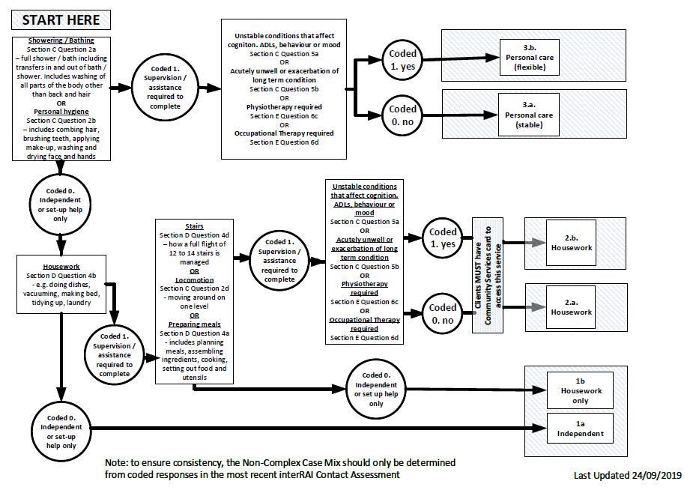

Complex Algorithm Utilising the InterRAI Home Care Assessment Tool 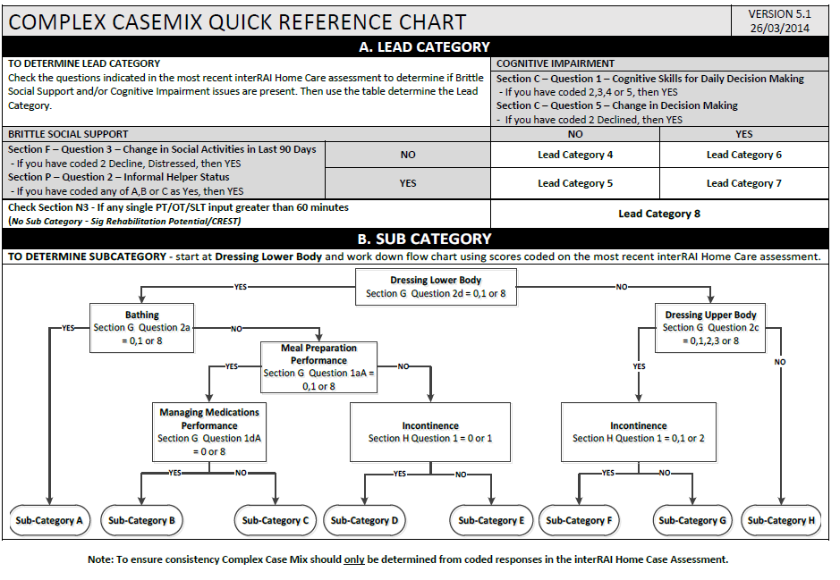

# Appendix 2: Review and Assessment Regime

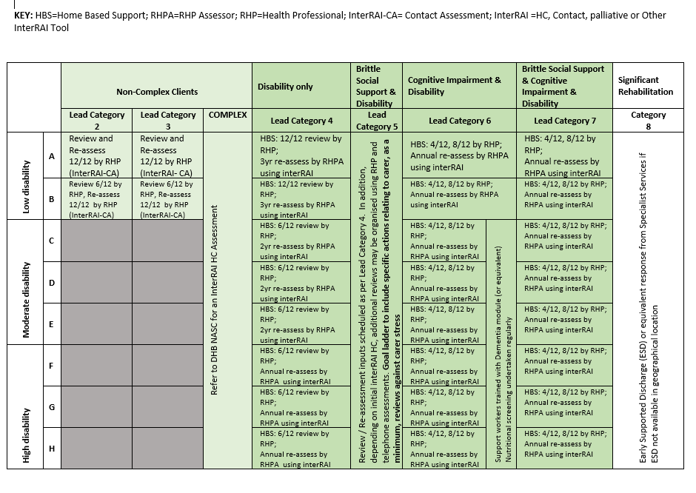High Cost Intensive Support packages: clients in any casemix group that require intensive support packages over 21 hours will have an interdisciplinary review arranged by the NASC. Review will occur monthly for unstable and three monthly for stable.

# Appendix 3: Service Allocation Tool

|  |  |
| --- | --- |
| Lead Issue | **Screening Question** |
| 1. Cognitive impairment | Does the client have a cognitive impairment that affects their everyday life through a decreased ability to think, concentrate, remember ideas and make safe decisions? |
| 1. Progressive neurological condition | Does the client have a progressive neurological condition such as Parkinson’s Disease, Multiple Sclerosis or Huntington’s Disease that requires daily support? |
| 1. Carer stress | Is the client’s carer unable to continue caring for the client or feeling overwhelmed or distressed and/or there is abuse and neglect concerns? |
| 1. Dressing | Does the client require ongoing/long-term physical assistance with daily dressing of their lower body? (does not include application or removal of compression hosiery). |
| 1. Medication Management | Does the client require ongoing/long-term verbal or physical assistance in managing their own medications? |
| 1. Mood | Does the client have fluctuating anxiety, low mood, other mental illness or experience chronic pain that significantly impacts on daily living? |

**Appendix 4: Contextual Risk Rating for Response Time**

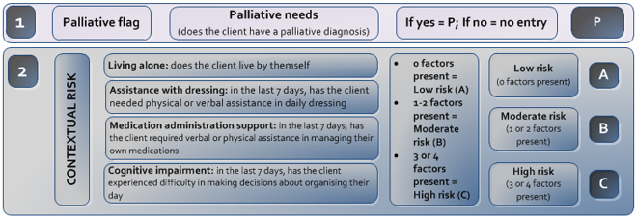

# Appendix 5: Key Terms and Processes

| Service Term or Process | **Definition or process description** |
| --- | --- |
| Person | The use of the term “People” or “Person” refers to people living in the community who are referred to the NASC to receive the services described in this specification. |
| Client | The term client refers to a person who has been screened and is eligible to receive the services described in this specification. i.e. The Service User. |
| Referral | A formal request to the NASC to determine if a person is eligible for the services described in this specification. |
| Initial Client Visit | The first face to face visit where assessment / plan of service discussed, and individual support plan agreed |
| Clinical Assessor | A registered health professional employed by either the Provider or the Needs Assessment Service Co-ordination Service organisation (NASC) that is responsible for completing the interRAI Contact or Homecare or other interRAI assessment. |
| SMART Goals | An aspiration or target, or objective or future condition that the client wishes to achieve to improve, maintain or prevent decline in functional ability, to improve social connectivity or achieve specific health outcomes (for example confidence in self-management of long-term conditions). Goals should be:  **S** – specific, **M** – measurable, **A** – agreed upon, **R** – realistic, **T** – time-based |
| Service Allocation Tool | Also abbreviated to ‘SAT’. It is a screening tool that comprises five questions to determine client complexity and service level access. |
| Casemix | This is a system that classifies people into groups with similar levels of assessed need and resource utilisation. |
| Casemix allocation | The process by which clinical assessors determine which case mix group a client belongs to, based on the outcomes of either the Contact or Home Care Assessment. |
| interRAI Assessment | A comprehensive clinical assessment, which focuses on a person’s level of functional ability. It is specifically designed to show the assessor opportunities for improvement and/or any risks to the person’s health, which then forms the basis of a care plan. The interRAI assessment tools used within this service are the Contact and Home Care assessments. |
| Re-assessment | Provider and NASC assessors are required to complete repeat assessments of clients as clinically indicated or as set out in the Review and Reassessment regime (pg. 25) |
| Care plan | This is the process that responds to the completed assessment findings (such as ‘CAPs’ ‘CHESS’ and ‘MAPle’ ‘Outcome Scores’) by developing an appropriate plan of care. The Care Plan is generated using the interRAI software at the completion of an InterRAI and the information in the care plan is used by the Provider to develop a service plan. |
| Service Implementation | The first day that the support service is delivered into the home of a client by a support worker implementing the requirements of the individual support plan. |
| Natural Supports | the resources inherent in the community, including personal associations and relationships, that enhance the wellbeing and security of clients. Natural supports usually involve family members, friends, neighbours and acquaintances. Some clients have few natural supports and may need support to develop these connections. |
| Individual Support Plan | The Providers develop client centred goal-based individual support plans in partnership with clients. The purpose of the Individual support plan is to provide clear guidance to support staff about:   * activities they need to complete to support clients to achieve set goals * what needs to be escalated to the attention of the RHP * the estimated time it should take for them to complete the activities of the individual support plan and expected time between reviews. * hazards are identified and describe how they are mitigated * the contingency plan in the case of emergencies   The support plan is owned by the client, can be made available to be shared with the wider support team. |
| Household management | The activities required to maintain the living environment as ‘safe and sanitary’. This could include but not limited to vacuuming, cleaning of bathroom and kitchen areas, changing of bed linen and support with laundry. This does not include, cleaning of windows, high cleaning, outdoor maintenance, cleaning of any additional rooms, dusting, cleaning of ornaments and additional cleaning considered beyond that required to maintain ‘safe and sanitary’ living conditions. |
| Personal Care | Activities of Personal Care include:   * support with bathing or showering * support with personal grooming, for example shaving, brushing teeth * support with toilet access and use * support with transfers, in accordance with manual handling guidelines * support with dressing and undressing * support with application of creams and lotions, following guidelines where applicable. |
| Stop and Watch | An early warning communication tool that support workers and/or whānau can use to alert the service co-ordinator if they notice something different in a resident’s daily care routine. |
| Flexible service delivery | Services are planned in such a way that enables flexible service delivery. Support can be increased if the client is temporarily unwell or reduced if they regain functional ability. A client does not need to be reassessed or have a change in Casemix allocation because of the short-term nature of the flex. |
| Client service review | Reviews are scheduled when the individual support plan is developed. The purpose of the review is to evaluate and measure client progress against SMART goals, observe if there are any clinical indications for a further assessment or greater Interdisciplinary team input. The outcome of a review may require the individual support plan to be modified or redeveloped.  Following a review, the service allocation may:   * remain the same with same service allocation * remain the same but with a change to the mix of services * be decreased with a decrease in service time and support activities provided * be increased with an increase in resource allocation * be discontinued with Provider initiating a formal discharge process * be insufficient, indicating there is a need for a re-assessment. The Provider will flex the service as appropriate to ensure the client is safe and supported until the reassessment occurs. |
| Needs Assessment and Service Co-ordination (DHB NASC) | These organisations are funded by DHBs. Their roles are to determine service eligibility, assess the person’s support needs, make service allocations and co-ordinate support services to meet those needs. NASC co-ordinate such services, but do not themselves provide the services. They manage referrals to Providers, other Interdisciplinary team members including primary care. |
| Case management | Case management is a client and whānau centred collaborative process of assessment, planning, coordination, evaluation and advocacy that sees the client’s wider health and social sector team take an integrated approach to service delivery. A designated lead RHP who understands the client’s wider health and social needs is nominated by the clients integrated healthcare team and acts as the key point of contact to facilitate the client/whānau to navigate the wider healthcare team. The lead RHP may be, but is not limited to, a Provider RHP, NASC assessor, primary care nurse or dementia navigator. |
| Service coordination  (NASC) | Service coordination is about planning a person’s care based on their goals and support needs and sharing information with everyone who helps to care for the person. It is performed collaboratively with a person and their whānau and likely includes all of the following:   * educating and supporting the person and their carer * helping the person access community care and support services * talking with health and community care providers * planning what services might be needed in the future |
| Service co-ordinator (Provider) | Service co-ordination activities carried out by Provider staff including   * matching support staff with required competency and level of training to meet the complexity needs of the client; * Acting as a conduit between clients, support staff, registered health professionals and external agencies; * Completing activities of client case management; * Assisting in the recruitment, employment, management and training of support workers, * rostering and scheduling staff; * developing and maintaining relationships with referring agencies, and * monitoring and reviewing the quality of service provision including completion of some client reviews.   These activities are incorporated into staff roles so that services can be delivered efficiently to optimise resource utilisation and to ensure enough service flexibility to address regional needs (for example. rurality) |
| Registered Health Professional | The Health Practitioners Competence Assurance Act 2003 (the Act) provides a framework for the regulation of health practitioners to protect the public where there is a risk of harm from professional practice. Registered health professionals (RHP) may include, physiotherapists, occupational therapists, registered nurses and social workers.  In this service the RHP is responsible for delivering services on behalf of a service Provider. This includes the provision of direct care or support services to the client and covers all staff who are employed or contracted. Activities completed by the provider RHP may include:   * interRAI assessments, * case management including facilitating an integrated approach to client support from primary and secondary care. * writing and review of support services and individual support plans, * direction, delegation and supervision of non-regulated staff. |
| Support Worker | Provider staff who help patients at home with tasks such as showering and dressing, housework such as cleaning, ironing, meal preparation and assistance, medication oversight and supporting clients with rehabilitation in areas supporting strength and balance and walking exercises, and attendance at social groups. |
| Interdisciplinary Team (IDT) | A team of health professionals from different disciplines and work places work together with the client, to undertake assessments, diagnosis, and plan interventions through goal-setting and the creation of an individual support plan. The client and their whānau and carers are involved in discussions as appropriate. |
| Medication Support | Provider support worker staff assist and/or prompt a client to self-administer medicines as prescribed and as documented in the individual support plan. |
| Medication Administration | The Provider has determined that the client is unable to safely administer their own medication and does not have reliable whānau support to assist them. The support staff physically assists the client to safely administer medication as per the individual support plan developed by the Registered Nurse[21]. |
| Risk assessment | Process undertake to determine the level of risk associated with support provision. A Risk Assessment Framework supports DHB NASC and contracted Providers with this process. The risk framework can be found in the Tier One Community Health, Transitional and Support Services (DHB funded) service specification. |
| Integrated Management Framework | HCSS services are required to operate integrated management framework composing of strategic and operational integrated management groups consisting or representatives from contracted providers, allied health, primary health care NASC and DHB HCSS contract managers. More detail is provided in the HCSS Operations Manual. |

1. www://nsfl.health.govt.nz/service-specifications/current-service-specifications/community-health-transitional-and-support
2. National Framework for Home and Community Support Services (HCSS) Ministry of Health August 2020. www.health.govt.nz/publication/national-framework-home-and-community-support-services-hcss
3. www.health.govt.nz/publication/new-zealand-health-strategy-2016
4. www.health.govt.nz/our-work/life-stages/health-older-people/healthy-ageing-strategy-update
5. www.health.govt.nz/our-work/populations/maori-health/he-korowai-oranga
6. www.health.govt.nz/publication/new-zealand-framework-dementia-care
7. www.msd.govt.nz/about-msd-and-our-work/work-programmes/policy-development/carers-strategy/index.html
8. www.health.govt.nz/publication/te-ara-whakapiri-principles-and-guidance-last-days-life
9. Disability: The Ministry of Health’s definition of ‘person with a disability’ for the purpose of accessing funded disability support services Service Coverage Schedule www/nsfl.health.govt.nz/accountability/service-coverage-schedule is ‘a reduction in independent function to the extent that a person has been assessed as requiring support services due to an age related or a personal health condition’. These responsibilities are split between DHBs and the Ministry of Health. Funders also have specific criteria that determine eligibility for specific supports.
10. SMART GOALS S- specific, M - measurable, A - agreed upon, R - realistic, T - time-bound.
11. www.hqsc.govt.nz/assets/ACP/PR/ACP_Plan_print_.pdf
12. www.livestronger.org.nz/
13. www.dementia.nz/files/infosheet/about_dementia_3_info_for_family_nz.pdf
14. Refer to relevant service specifications nsfl.health.govt.nz/service-specifications/current-service-specifications/community-health-transitional-and-support
15. www.legislation.govt.nz/act/public/2017/0024/28.0/DLM7269154.html
16. Wellington Region Emergency Management Office (WREMO) www://wremo.nz/
17. [www.hcha.org.nz/news/complaints-categorisation-guidance-available](http://www.hcha.org.nz/news/complaints-categorisation-guidance-available).
18. www.health.govt.nz/publication/medication-guidelines-home-and-community-support-services-sector
19. www.health.govt.nz/publication/hiso-100012017-ethnicity-data-protocols
20. www.health.govt.nz/publication/auditing-requirements-home-and-community-support-sector-standard-nzs-81582012
21. Draft Medication Guidelines for the HCSS Sector 2017