What should you do when the ethnicity in your PMS is different from what is on the NHI for an existing patient or when the ethnicity on the enrolment form is not the same as what is on the NHI for a new patient?
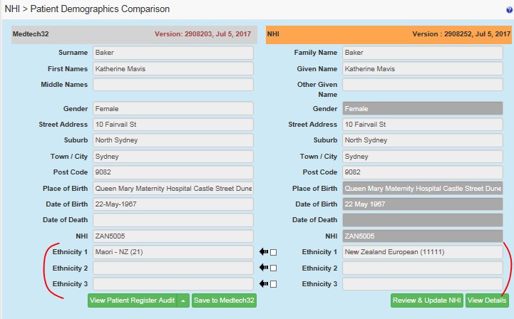

- Enter the person’s ethnicity from the answer they gave on their enrolment form. For existing patients you should review the most recent enrolment form you have for them.
- If
- your patient did not answer the ethnicity question on their enrolment form
- you do not have an enrolment form for your patient
- the enrolment form the patient completed did not have the standard ethnicity question
put a reminder into your system to get your patient to complete an enrolment form next time they are in the clinic.
- Enter the ethnicity from the enrolment form into the NHI first
- go to the NHI compare and update page
- click the review and update NHI button
- open the Other Demographics section
- enter all the ethnicities the person has ticked or written in their form. Remove any from the NHI that do not appear on the patients form.
- then click the save button
- go back to the compare screen and then click save to medtech

The Standard Ethnicity Question
A person enrolling with your practice will complete an enrolment form. On the form somewhere they will answer the ethnicity question. The ethnicity question should look something like this
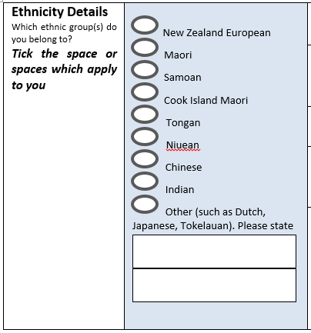
The question reads ‘Which ethnic group(s) do you belong to? Tick the space or spaces that apply to you’ There are the 8 ethnicities named as above and there is room to enter one or more ethnicities in a space labelled ‘other, such as Dutch, Japanese, Tokelauan. Please state’

Examples

Example 1 Multiple responses
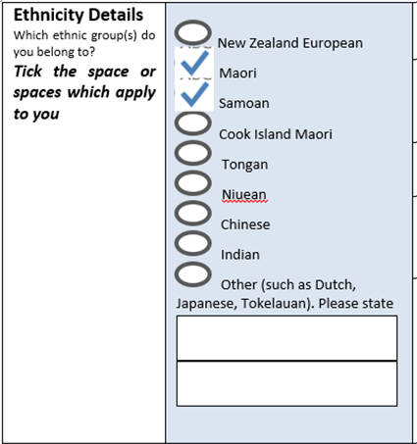
First update the NHI ethnicities
Click the NHI button and from the compare screen 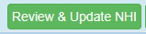 . Open up the 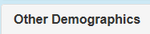 section
Enter the ethnicities
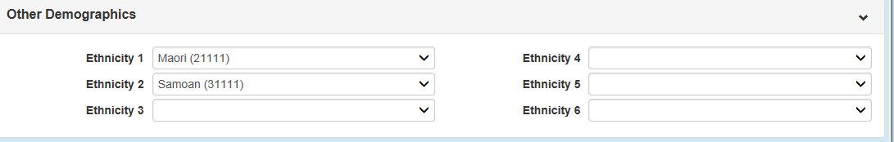
Click the update button
Tick the boxes on the compare screen to update the Medtech ethnicity fields
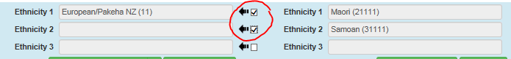
And 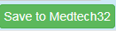. Both the Name1 tab and the More4 tab will be updated.
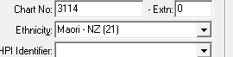
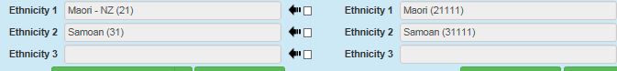

Example 2 Fijian Indian
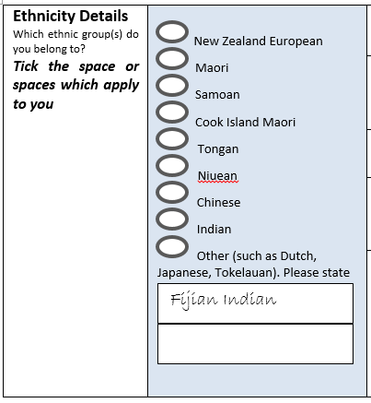
First update the NHI ethnicities.
Go to the Review and Update NHI – Other demographics section and enter the ethnicity
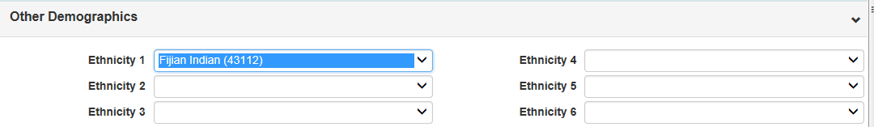
Click the update button
Tick the boxes on the compare screen to update the Medtech ethnicity fields
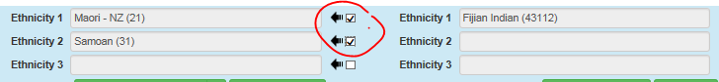
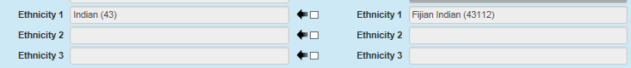
Note that a Fijian Indian response like the one above is different from
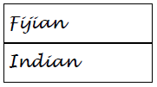
These would be entered as
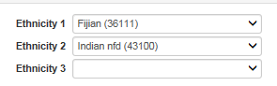

Example 3 New Zealander
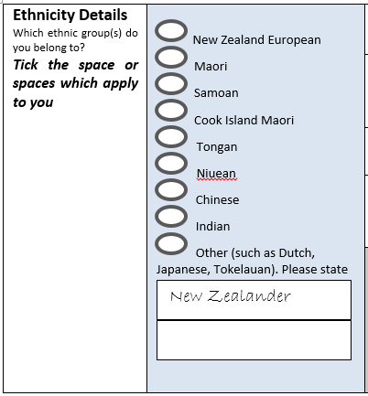
First update the NHI ethnicity.
Go to the Review and Update NHI – Other demographics section and enter the ethnicity
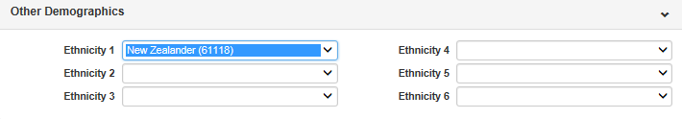
Click the update button
Tick the boxes on the compare screen to update the Medtech ethnicity fields
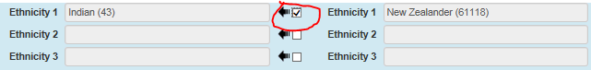
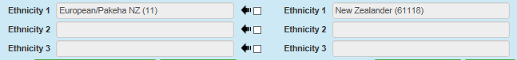
Note that a ‘New Zealander’ response is different from a ‘New Zealand European’ response. If someone ticks the New Zealand European box you should select the New Zealand European option from the list.
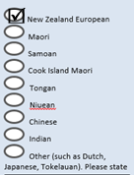
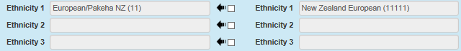
Note that both New Zealander (61118) and New Zealand European (11111) update in Medtech as European/Pakeha (11)

Example 4 More than 3 responses
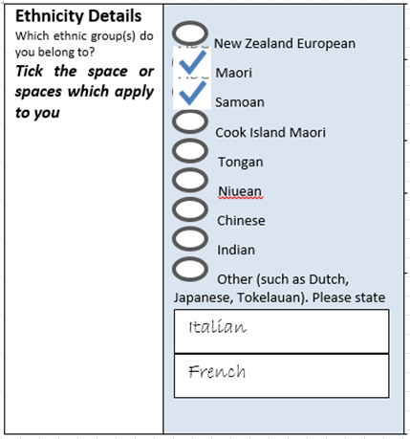
First update the NHI ethnicities.
Go to the Review and Update NHI – Other demographics section and enter the ethnicities
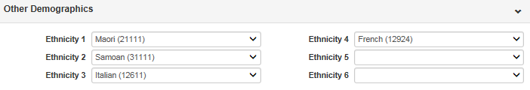
Click the update button
Tick the boxes on the compare screen to update the Medtech ethnicity fields
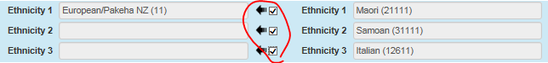
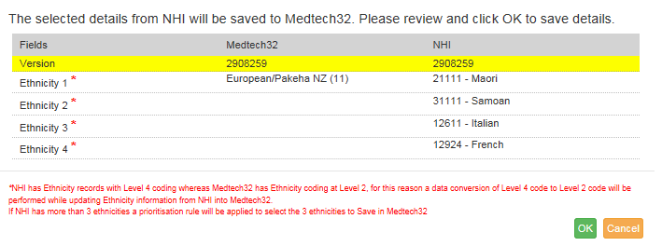
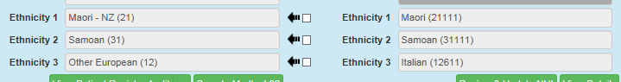
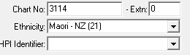
The NHI lists all the ethnicities, the Registration Details screen will show only 3 ethnicities. The PMS software considers all the ethnicities entered on the NHI and uses the Ethnicity Data Protocol Prioritisation table to select the 3 ethnicities to retain in the PMS.
So no matter what order the ethnicities are entered in the NHI the Medtech ethnicities will contain the top 3 prioritised ethnic groups.
So if Maori is added as the 4th one on the NHI it will always show in Medtech as the first.
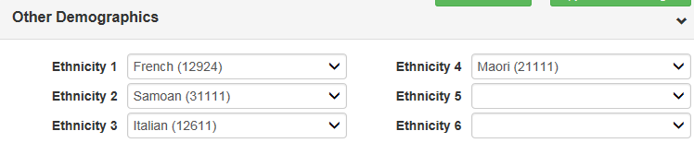
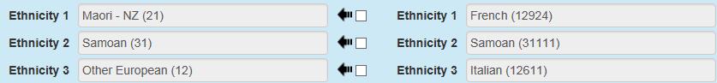

Example 4 Response that doesn’t appear in the NHI drop down list
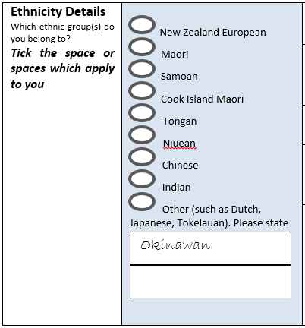
If you try to update Okinawan in the Review and Update NHI – Other demographics section you will not find it in the drop down list.
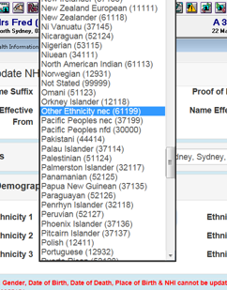
To find the correct way to classify this response you can use one of the following tools

Ministry of Health developed tool
Go to this link http://refraction.nz/eths and click 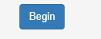
Enter ‘Okinawan’ in the place provided and the correct classification will appear in the grey area below
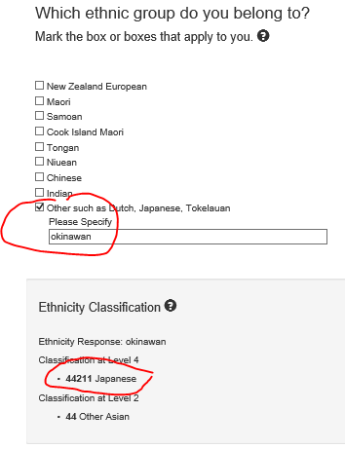

Statistics NZ codefinder
Go to this link http://www.stats.govt.nz/tools_and_services/classificationcodefinder.aspx, select ethnicity classification, enter ‘okinawan’ as a keyword, clock Go and the correct classification will show in the results
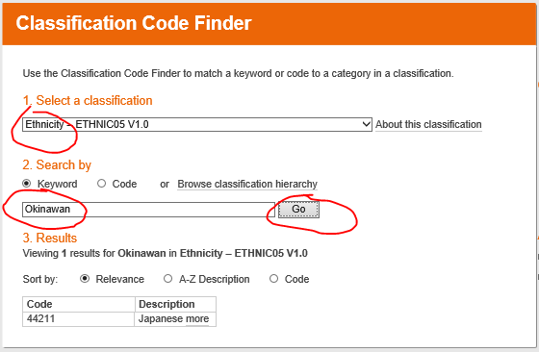

Enter ‘Japanese’ in the Registration details page and update the NHI as in the above examples
