Overarching Guide
Health Facility Strategic and Functional Design Brief

Citation: Health New Zealand | Te Whatu Ora. 2024. Overarching Guide: Strategic and Functional Design Brief. Wellington: Health New Zealand | Te Whatu Ora.
Published in March 2024 by Health New Zealand | Te Whatu Ora
PO Box 793, Wellington 6140, New Zealand
ISBN [Insert] (print)
ISBN [Insert] (online)
This document is available at healthnz.govt.nz
This work is licensed under the Creative Commons Attribution 4.0 International licence. In essence, you are free to: share i.e., copy and redistribute the material in any medium or format; adapt i.e., remix, transform and build upon the material. You must give appropriate credit, provide a link to the licence and indicate if changes were made.
For any queries or communication about this document, please contact: facility.design@health.govt.nz

Contents
Document Control and Endorsement 4
Navigating this document 5
1 Introduction 6
2 Purpose 6
2.1 Artefact 2: Health Facility Strategic Brief 7
2.2 Artefact 3: Health Facility Wide Practice and Approaches 7
2.3 Artefact 4: HPU Functional Design Brief 7
2.4 Exclusions 8
3 Planning Context 9
3.1 Australasian Health Facility Guidelines 9
3.2 New Zealand Health Facility Design Guidance 10
3.3 National Frameworks and Key Planning Documents 10
4 Document Development 12
4.1 Collaborative Development and Responsibilities 12

Document Control and Endorsement
Document name | Overarching Guide – Health Facility Strategic and Functional Design Brief
Document owner | Health New Zealand | Te Whatu Ora – Infrastructure and Investment Group
Primary Author | Jacobs – Rhonda Johnson, Annabele Frazer, Cath Lewin, Angela Mills

Navigating this document
This Health Facility Strategic and Functional Design Brief Guidance Note is the first of a suite of four guidance artefacts. The purpose of each of the artefact documents are outlined below:
Artefact 1: Strategic and Functional Design Brief Guide provides general context, guidance, and background to the strategic and functional design briefing process and document development.
Artefact 2: Health Facility Strategic Brief Template Guide identifies the required components that should be in every Health Facility Strategic Brief prepared for Health New Zealand as a minimum. It provides an overview of the project, service planning context, cultural narrative, project design principles and the health facility functional capacity requirement for points of care.
Artefact 3: Health Facility Wide Practice and Approaches Template Guide
The Health Facility Practice and Approaches will identify operational approaches and associated design requirements that are consistent across the health facility. Inputs only include those that differ from approaches described in the New Zealand Health Facility Design Guidance or Australasian Health Facility Guidelines (AusHFG).
Artefact 4: Health Planning Unit Functional Design Brief Template identifies the required components that should be in every Health Planning Unit (HPU) Functional Design Brief report prepared for Health New Zealand as a minimum. Individual HPU Functional Design Briefs are required for each HPU identified within the scope of the project.
Written content provided in black text is to be retained and provides lead in narrative relevant to the section.
Written content in blue text in a blue box provides guidance or text examples for the required output as a guide to the author. Content guidance and blue boxes should be deleted. Example content may be reviewed, edited, or deleted as relevant.

Introduction
Health New Zealand Infrastructure and Investment Group (IIG) provides a project delivery framework outlining the project investment and delivery lifecycle. This process guides the prioritisation, planning, design, and delivery of health facility projects in Aotearoa New Zealand.
Phase 1: Define identifies Strategic and Functional Design Briefing and development of the Schedule of Accommodation as essential briefing documents to inform Test to Fit and Concept Design phases.
Figure 1: The Project Investment and Delivery Cycle
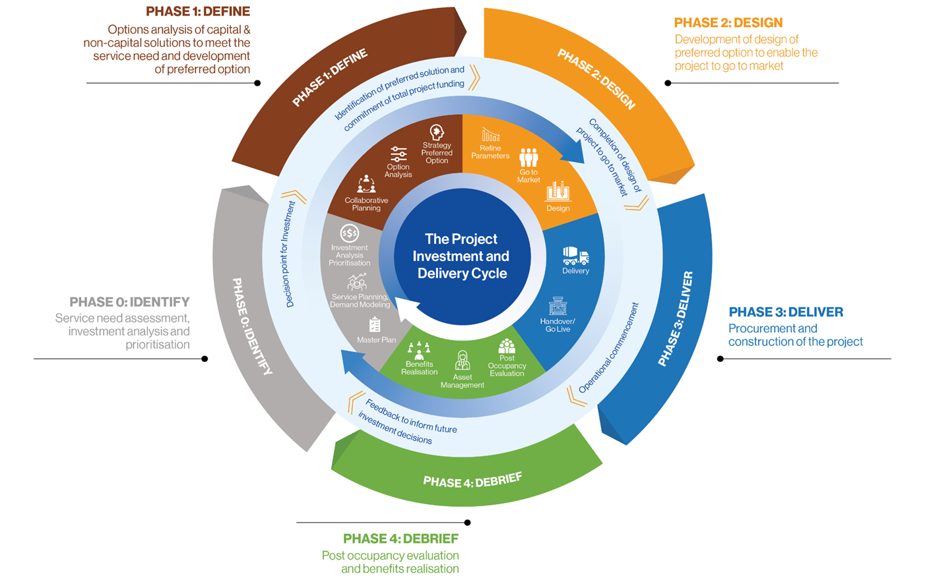

Purpose
The purpose of strategic and functional design briefing documents is to inform a multi-disciplinary team of planners, designers, and technical service providers, of the future scope, needs, and enabling elements needed for a reinvigorated, sustainable health service and its new or repurposed facilities.
The documents describe the scope of services required which are informed by forecasted demand modelling and a forward lens of how services are planned to be delivered in the future. This is informed by research, an understanding of technology developments and complex medical equipment advances, in addition to evolving clinical practice trends. The documents capture innovation in building services, materials and construction methods that are proven to have a positive impact on care and service delivery.
The Health Facility Strategic Brief, Facility Wide Practice and Approaches, and Functional Design Brief documents must capture and portray information simply for the understanding and interpretation by the broader project and design teams.
Artefacts 2, 3 and 4 must be completed for every health facility project in Aotearoa New Zealand. Template Guidance is provided for each document.

Artefact 2: Health Facility Strategic Brief
The Health Facility Strategic Brief introduces the project strategic context and intended health facility approaches. It must describe the:
- Project background and scope
- Local cultural narrative
- Service planning inputs including future facility profile and point of care requirement
- Project design principles
- Health facility flows
- Facility wide functional relationships
Artefact 2: Health Facility Strategic Brief Template Guide is designed to capture information relevant to a project where more than one HPU is included in scope. This removes any need to repeat information within each HPU Functional Design Brief, which should be avoided. (Where there is only one HPU in project scope this information should be consolidated and provided as one HPU FDB document).

Artefact 3: Health Facility Wide Practice and Approaches
The Health Facility Wide Practice and Approaches document should only include content that is specific to the health facility project and where identified approaches are a departure to those outlined in the Australasian Health Facility Guidelines (AusHFG) or New Zealand Health Facility Design Guidance Note (NZDGN).
If necessary, project teams may insert additional headings or sub-headings. If a heading does not apply to your project, please write not applicable (N/A) to make the reader aware the heading was considered.

Artefact 4: HPU Functional Design Brief
Each Health Planning Unit (HPU) Functional Design Brief provides detailed information specific to the HPU. It must include:
- Service description
- Model of care
- HPU specific approaches, practices, and flows
- Identified change opportunities
- Functional relationships
- Design requirements
- Description of accommodation requirements
- Schedule of Accommodation.
If necessary, project teams may insert additional headings or sub-headings to ensure the HPU is comprehensively described. If a heading in the FDB does not apply to your project, please write not applicable (N/A) to make the reader aware the heading was considered.
Artefact 4: HPU Functional Design Brief Template Guide is designed to capture information relevant to each HPU only. Project teams designing health facility projects in Aotearoa New Zealand must prepare separate FDBs for each HPU within the project scope.

Exclusions
The Health Facility Strategic Brief, Facility Wide Practice and Approaches, and HPU Functional Design Briefs are not intended to include all information relevant to the proposed project. They are not a:
- Business case
- Clinical Service Plan (CSP) or Future Facility Profile (FFP)
- Justification for clinical services planning
- Formal Model of Care document
- Practice and Approaches document
- Technical or Architectural Brief
- Replacement of the New Zealand Health Facility Design Guidance Note

Planning Context
The New Zealand Health Facility Strategic and Functional Design Briefs must be developed in conjunction with an in depth understanding of the Australasian Health Facility Guidelines (AusHFG) and New Zealand Health Facility Design Guidance Note (NZDGN).
The structure and content of the New Zealand Health Facility Strategic and Functional Design Briefs have been developed in an effort not to duplicate guidance and direction already provided in the AusHFG and NZDGN. The NZDGN is provided as supplementary guidance to the AusHFG suite of documents, describing where exceptions exist to AusHFG guidance to meet the specific requirements of the New Zealand context.
The relationship and hierarchy of these health facility design guidance artefacts are described in Figure 2, highlighting this document within.
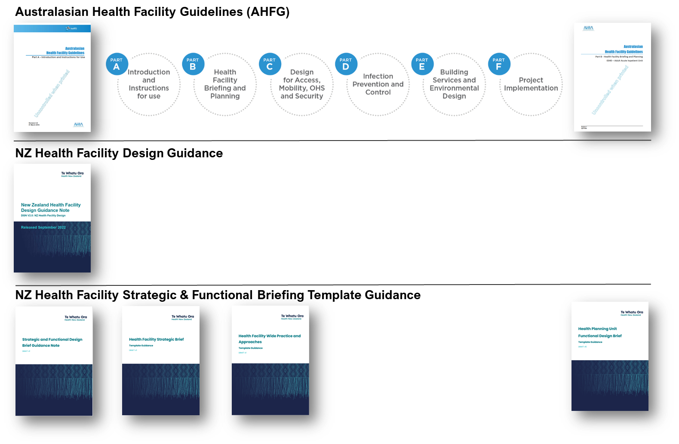
Figure 2: Relationship of Health Facility Design Guidance Documents

Australasian Health Facility Guidelines
Health New Zealand requires project teams to use the Australasian Health Facility Guidelines (AusHFG) and associated Schedules of Accommodation (SoA) as the basis for briefing and designing individual HPUs. The language, content and codes used in the FDB and SoA should align with the AusHFG.
AusHFG Standard Components provide detailed design guidance for most rooms and spaces within health facilities (e.g., consulting rooms and bedrooms). The default room is the AusHFG Standard Component (SC) room, unless stated otherwise in the FDB.
The requirement to use AusHFG is not intended to restrict innovation. Where the function or size of spaces differs from the AusHFG Standard Component description, or the required room does not exist in the AusHFG Standard Components, project teams should describe it in the Specific Design Requirements section of the FDB. It should also be identified in the SoA as an AusHFG Standard Component Derived (SC-D) room or a Non-Standard room (NS).

New Zealand Health Facility Design Guidance
The Infrastructure and Investment Group – National Facility Design, Advisory and Assurance Team (NFDAA) provide direction, guidance and design resources that enable efficient, effective, and fit-for-purpose design and delivery of health facilities in New Zealand.
The NFDAA team assists Health New Zealand in the establishment of standardised approaches to key aspects of health facility briefing, design and delivery. The team actively develop and review design guidance, work with the Australasian Health Facility Guidelines (AusHFG), and undertake design assurance reviews.
The NFDAA team is the relationship holder with the Australasian Health Infrastructure Alliance (AHIA) in the development and review of the AusHFG for the NZ context.
Any NZ specific cultural or environmental influences not taken into consideration are outlined in the New Zealand Health Facility Design Guidance Notes which aims to provide design guidance relevant to the NZ context which is not already included in any element of the AusHFG. The NZ DGN should be read in conjunction with the AusHFG.
The NFDAA team provide a range of resources and templates to support project planning delivery found here: https://www.tewhatuora.govt.nz/our-health-system/infrastructure-and-investment/facility-design-guidance-resources/

National Frameworks and Key Planning Documents
Health infrastructure planning is part of a broader system of health service planning and delivery that serves all Aotearoa New Zealand’s people and communities. It is essential to consider the broader planning context in the planning and delivery of health facility projects.
The development of Health Facility Strategic Briefs, Facility Wide Practice and Approaches, and Functional Design Brief documents should be linked to and reflective of the overarching goals and directives outlined in national, regional, and local strategies and planning documents.
It is imperative to avoid repetition by refraining from restating information present in these key planning documents. It is expected that these documents may be referenced and succinctly summarised where beneficial. This approach ensures that Strategic and Functional Design Brief development remains in alignment with established guidelines.
Key national strategies and planning documents may include but are not limited to:
- Te Tiriti o Waitangi – The Treaty of Waitangi
- Pae Ora (Health Futures) Act 2022
  - The New Zealand Health Strategy
  - Pae Tū: Hauora Māori Strategy
  - Te Mana Ola: The Pacific Health Strategy
  - The Women's Health Strategy
  - The Health of Disabled People Strategy
  - The Rural Health Strategy
- Te Pae Tata Interim New Zealand Health Plan
- Te Mauri o Rongo | The New Zealand Health Charter
- Kia Manawanui Aotearoa – Long-term pathway to mental wellbeing
- Oranga Hinengaro System and Service Framework
- Nationwide Service Planning
- Specific Service Stream Planning
- Relevant Network Plan
- Future Facility Profile
- Local Cultural Narrative
- Data & Digital Strategy & Framework
- Local Data & Digital Blueprint

Document Development
Project teams should consult with identified relevant stakeholders involved in the operation of the Health Facility and HPU’s through a series of Project User Group (PUG) meetings, within the governance structure of the Project.

Collaborative Development and Responsibilities
Historically, Health Facility Strategic Briefs, Facility Wide Practice and Approaches, and Functional Design Brief documents have been authored by Health Planners in consultation with identified stakeholders through a process of PUG meetings.
A renewed approach aims to strengthen collaboration and meaningful participation with Treaty Partners, Hospital & Specialist Services (HSS), with a requirement to evidence collaboration with Te Aka Whai Ora – Māori Health Authority stakeholders.
This collaborative effort will be led by project Health Planners through facilitation of PUG meetings and coordination of document inputs whilst respecting the value of stakeholder’s time.

Artefact 2: Health Facility Strategic Brief
Project Health Planners will lead Health Facility Strategic Brief development providing guidance and assistance to HSS stakeholders, and facilitation of PUG meetings. The Project Health Planner will be responsible for the final report deliverable and will:
- Collate, document and format all document inputs
- Document project design principles
- Document functional relationships
Infrastructure and Investment Group leads will provide documented inputs to the following Health Facility Strategic Brief sections:
- Project background and scope
HSS Lead and Te Aka Whai Ora Stakeholders will provide documented inputs to the following Health Facility Strategic Brief sections:
- Service planning inputs including facility point of care requirement
- Future trends and innovation
- Health facility wide operational flows
- Health facility wide change management opportunities

Artefact 3: Health Facility Wide Practice and Approaches
Project Health Planners will lead document development providing guidance and assistance to HSS stakeholders, and facilitation of PUG meetings. The Project Health Planner will:
- Document innovation and technology
- Document health facility wide practice and approaches
HSS Lead and Te Aka Whai Ora Stakeholders will provide documented inputs to Health Facility Wide Practice and Approaches where these are specific to the project health facility only.

Artefact 4: HPU Functional Design Brief
Project Health Planners will lead Functional Design Brief development providing guidance and assistance to HSS stakeholders, and facilitation of PUG meetings.
The Project Health Planner will:
- Collate, document and format all document inputs
- Develop graphics informed by stakeholder inputs including Patient Journey, External Functional Relationships, and Internal HPU Functional Groupings.
- Document identified functional relationships
- Document HPU specific practice and approaches
- Provide a description of HPU accommodation requirements
- Develop HPU Schedule of Accommodation (SoA) informed by AusHFG and PUG inputs referring to the NFDAA SoA Technical Guidance Note and Example found here: https://www.tewhatuora.govt.nz/our-health-system/infrastructure-and-investment/facility-design-guidance-resources/

HSS Lead and Te Aka Whai Ora Stakeholders will provide documented inputs to the following Functional Design Brief sections:
- Service overview
- Service specific policies, standards, and guidelines
- Identification of future service trends and innovation
- Future workforce profile
- Identification of change management opportunities

Cultural Engagement
Mana Motuhake (self-determination and control over one’s destiny) is a founding principle of Te Tiriti o Waitangi. Early consultation and engagement is essential. Involving mana whenua from project initiation supports Māori self-empowerment and enables an authentic collaborative design approach. The FDB must be developed in collaboration with and endorsed by mana whenua in addition to clinical and non-clinical stakeholders relevant to the project scope and associated HPU.
Although some topics within the development of the FDB may not require cultural input, mana whenua must be given visibility over the entire process to determine what is culturally relevant and what is not.

