1.0 Completing the Design Assurance template

Background
The intention of the design assurance review is to look at completeness of documentation and process. To ensure that project design teams support the design assurance process, it is important to clearly articulate what will be reviewed so that project design teams have a clear understanding of what is expected.
This document outlines those requirements and provides guidance as to how to complete the project template for a full design assurance review.
Contents
Background 1
Purpose of completing the design assurance template 2
Why do we ask to see this information? 2
When do we expect to see this information? 2
What do we expect to see as part of design assurance review? 3
Step 1 - Refer to suggested example 3
Step 2 - Complete the project design team comment and status indicator sections 3
Step 3 - What items need to be completed? 4
Step 4 - DA template completion and document package issue to IIG Facility Design and Advisory team 4
Questions or further assistance? 5

Purpose of completing the design assurance template
The purpose of completing the design assurance (DA) template is to:
- demonstrate that the project design team have considered and addressed key project design processes and deliverables
- assist the Facility Design and Advisory team (FDA) find the required information within the documentation package
- establish consistent project design process considerations for Te Whatu Ora infrastructure projects
- establish a standardised format for Te Whatu Ora project design documentation.

Why do we ask to see this information?
Te Whatu Ora expects project design teams to provide consistent design documentation. The DA Template provides project design teams the opportunity to demonstrate that they have followed and fulfilled the requirements for each design phase.
Viewing this material as part of the DA process provides us with the confidence that the correct processes are evident for the project.

When do we expect to see this information?
Once requested, the project DA template file will be issued by the FDA to the project design team. The DA template should be completed by the project design team for each of the following design phases.
ü Test of Fit
ü Concept Design
ü Preliminary Design
ü Developed design

What do we expect to see as part of design assurance review?
Evidence of consistent level of documentation, sound process and decision tracking/transparency is important; so that key information may be captured, analysed, and reported.
The following steps describe what is required by project design teams when completing the DA template.

Step 1 - Refer to suggested example
At completion of the appropriate design phase and in anticipation of an upcoming DA review, project design teams are requested to refer to DA template example as well as the “How to” tab for tips, typical content extent, and suggested response style.
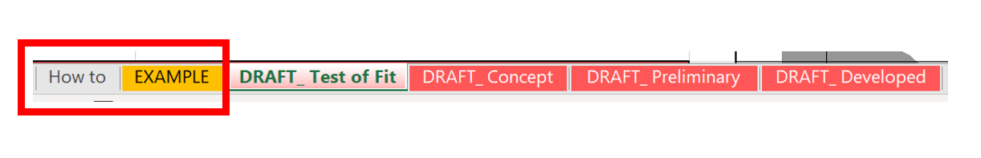

Step 2 - Complete the project design team comment and status indicator sections
Project design teams are to complete the watermelon-coloured sections for the required design stage tab in a similar style as described in the DA example tab (step1).
This includes completing the project design team comments as well as the status indicator (column J) as a self-assessment tool, which indicates whether the task is complete (C), work in process (W) or not complete (N)
Note, the project design team comments field is not to be used to explain how the item has been addressed, but rather, to reference where this information is located in your issued design pack.
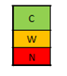

Step 3 - What items need to be completed?
Project design teams are to complete the watermelon-coloured sections that either are or may be required as noted in column D for the appropriate design phase.
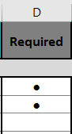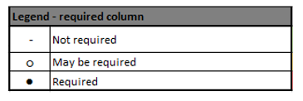

Step 4 - DA template completion and document package issue to IIG Facility Design and Advisory team
Project design teams are to send the completed DA template and required design phase documentation to facility.design@health.govt.nz.
(example noted below is the documentation list required for Concept Design (Columns D-F)
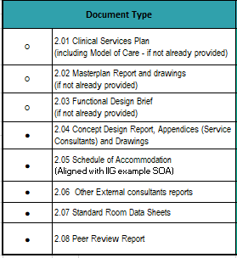

Questions or further assistance?
For any questions, please contact facility.design@health.govt.nz and one of the Facility Design and Advisory team will be in touch.

