 | Ministry of Health Aide Memoire
To: | Hon Tony Ryall, Minister of Health
From: | Stuart Powell
Date: | 25 June 2013 | Report number: | 20130474

National Telehealth Services Programme

Purpose
This Aide Memoire provides you with information on the National Telehealth Services Programme Cabinet paper that will be considered by the Social Policy Committee on Wednesday 26 June 2013.

Advice
This paper is delivering on the 2011 manifesto, to roll out a comprehensive telephone advice service and asks Cabinet to agree to develop a national telehealth service that will:
- Provide the public with better access to high quality health information and improved sign posting to appropriate local services. It will offer an enhanced range of services e.g. smart phone apps, a symptom checker and communication via text and email.
- Have significant benefits in reducing pressure on afterhours primary care, ambulance services and hospital emergency departments by making telehealth advice more accessible, and encouraging patients to use community based health care services and self-care, where appropriate.
- There are no financial implications arising from the development of the national telehealth service, which will be established out of existing financial provisions. However, potential enhancements to this service may be considered in the future, such as the addition of General Practitioners and pharmacists.

Appendix 1 outlines how we have considered the implications arising from Novapay and the Government’s ICT strategy in developing this proposal.

Next Steps
The next step is for the Ministry to test the market for a national telehealth service by publishing a Registration of Interest (ROI) by the end of July 2013. Ambulance 111 and PlunketLine services will not be included in this procurement process.
The ROI is being undertaken to enable the market to come up with a range of innovative solutions and arrangements for a national telehealth service which will deliver efficiencies through rationalising back-end functions, and improving linkages with primary care and ambulance services.
The national telehealth service will be implemented by December 2014.

Contact person: Stuart Powell, Manager, National Health Board, National Services Purchasing Phone [REDACTED]

APPENDIX 1: NOVOPAY AND GOVERNMENT ICT STRATEGY

In developing this proposal we have actively considered the lessons arising from Novopay and the implications of the recent release of the Government ICT strategy

While the development of national telehealth service will not involve the development of a large ICT project, the lessons from Novopay around working with users upfront to get a robust service design before proceeding have led us to:
- Work with the National Health Board funded New Zealand Telehealth Forum,
- review international experience and liaise with personnel involved in selected telehealth services, and
- undertake a ROI to foster innovative service designs.

Our intention is to build off and optimise existing infrastructure and utilise government ICT standards in providing a multi-channel telehealth service the public can interact with via telephone, internet, text, email and apps, such as a symptom checker. We will:
- Expect providers of the national telehealth service to be able to provide a telephony platform that manages all aspects of telephone and computer integration from a single platform via telephone, web chat, email and text.
- build off the success of the Ministry’s “Your Health” section on its website in developing an internet presence. This is a popular, fast growing section (see graph below) and expecting over 1 million visits this financial year. Any internet site will comply with government IT guidelines.
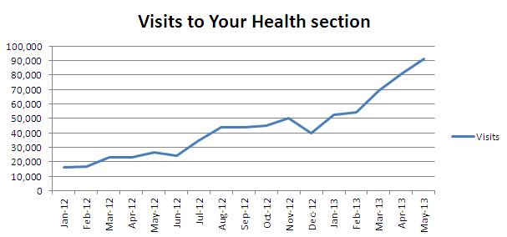
- optimise existing products and tools. We are currently are trialling a symptom checker with our existing provider and would expect to utilise this in the future.
- leverage off the work undertaken by National IT Board to provide secure communication of health information between patients, district health boards and primary health organisations to support a range of innovative projects, such as eReferrals.

