Hira Programme Update September 2023

These regular pānui aim to keep everyone with an interest in the Hira Programme up-to-date on our latest programme activities. This includes consumers, whānau and communities, health professionals, digital health suppliers, and others with an interest in digital health.

Thank you to the many groups and individuals who are so generous with their time, support, and advice as we continue towards our Hira goal of empowering people to see, manage, and contribute to their health and wellbeing information.

Ngā mihi nui

Ray Delany
Hira Programme Director

Hira will deliver:

- A New Zealand patient summary – an app/website allowing healthcare consumers/whānau to see their health information in one place and update some of it
- A platform allowing healthcare providers to access and update patient data held in different databases
- A secure, carefully controlled digital ecosystem enabling vendors to build apps for healthcare consumers, whānau and providers, to help people manage their own health

In this update

- Snapshot of latest Hira projects
- Hira connector plane build underway
- Responsible use of health information integral to Hira

Snapshot of latest Hira projects

By mid-2024, the Hira Programme is aiming to have the New Zealand patient summary (based on the HISO International Patient Summary) available to consumers and healthcare providers. The NZ patient summary will enable access to some essential health information, including:

  - demographics
  - medicines
  - vaccination status
  - entitlements (initially Community Services Card)
  - lab results
  - other data from primary care (to be confirmed, for example, allergies and conditions)

Additional datasets will be added over time, as we work towards delivering a personal health record.

A large number of varied projects are currently underway to put in place the infrastructure to make this possible. We highlight some of these projects below.

- The National Health Index (NHI) core application programming interface (API) update for healthcare consumers is now available on Hira Marketplace. The API will enable people to update information such as their email and physical address, and preferred name, using their My Health Account login.
- Work is underway to build the Hira connector plane, which will provide a single, secure point of access to application programming interfaces that are supported by Hira. The connector plane is foundational to Hira – it is the technology that will enable health information to be securely accessed, shared and updated. There is more information about the connector plane in the item below.
- Following a request for proposals (RFP) process, a provider for the events notification service will be confirmed soon. The service will let healthcare providers know when information relating to a patient has changed (such as their address) or when they have had an interaction with the healthcare system (for example, they have been seen at an emergency department). The notifications are IT system to IT system.

Hira connector plane build underway

Providing access to the New Zealand patient summary will be made possible through the Hira connector plane. It is the connector plane that will enable the information making up the patient summary to be securely accessed, shared and updated.

Work is underway to build the connector plane, to provide a single, secure point of access to application programming interfaces (APIs) that are supported by Hira.

Hira technology and delivery director Gerard Keenan explains how the components of the connector plane work together to enable secure, approved access to data.

“Supporting developers to build innovative applications that use the Hira APIs is a key part of Hira, and the developer portal is integral in achieving this,” he says.

“The developer portal contains information on the APIs, how to use them, and provides access to test systems and data. This allows developers to safely build their application together with a workflow to enable access to production data to be requested.

“Importantly, it can also allow access to information and multiple APIs, streamlining the process when more than one API is needed to build a solution.”

Gerard says once the application has been approved, the API gateways facilitate access to the data.

“The gateways work with the connector plane to validate the application and login credentials to ensure appropriate access is being provided. Auditing and reporting take place at the same time.”

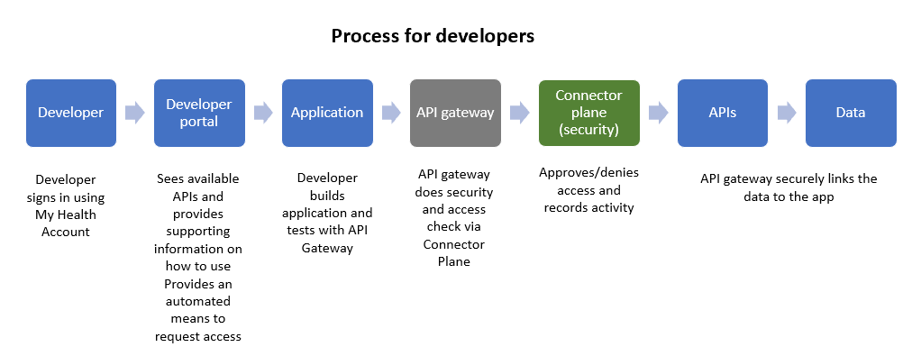

Once the developer has an approved application, the process is simpler for the healthcare consumer.

They simply login to their application using their My Health Account and in the background the API gateway and connector plane validate the request and provide access to the data.

“Of course the consumer won’t be aware of what is happening in the back end,” says Gerard. “They will login, and – assuming access is allowed – will then be linked to their data.”

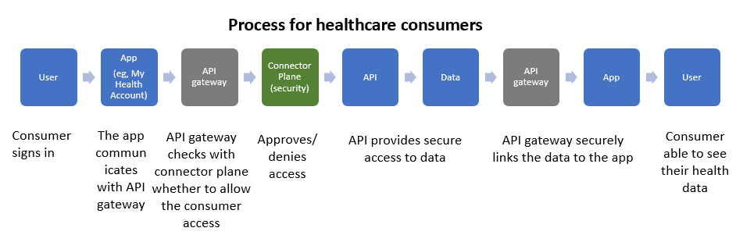

Gerard says the success of the Hira connector plane will be measured by how easy it is to use.

“We must have a practical, simple system, that supports equity of access. We need to make sure vendors have equal opportunities to access APIs; and that innovation is encouraged.”

The Hira team is currently focusing on ensuring strong privacy and security features are built into the connector plane. An RFP process has been completed, and approval given to move to commercial discussions. The aim is to have the system in production later this year.

Responsible use of health information integral to Hira

The Hira Programme has a strong focus on information governance.

Hira principal legal advisor, privacy, Amanda Mark says the Hira team is proactively designing the responsible use of data into Hira. This is combined with a strong focus on ensuring clinicians can access the information they need to provide good care.

“In my previous role as Waitemata District’s general counsel, I saw first-hand the importance of good information governance. Maintaining the confidence and trust of both clinicians and consumers that good privacy controls are in place and adhered to is so important. Clear and robust frameworks for access to information and a shared understanding about access to information and use and disclosure is essential to maintaining trust.”

New Zealand patient summary

Hira tranche one, which completes in mid-2024, is delivering a New Zealand patient summary, which will mean healthcare consumers can log in to a website or app and see their health information in one place and update some of it.

Amanda says the Hira information governance team is carefully designing privacy settings so people can safely and securely access their information, share it with their whānau if they wish, and enable trusted access by healthcare providers. The underlying security and access framework and privacy settings are being carefully designed by the Hira legal, privacy and security experts.

“This means our team is working on thoroughly understanding the New Zealand privacy legislation. You wouldn’t want someone you don’t trust to access your sensitive health information, so we are building in trust and privacy controls from the beginning.”

In tranche one, Hira is also delivering a secure, carefully controlled digital ecosystem so vendors can build apps for healthcare consumers, whānau and providers, to help people manage their own health.

Security and privacy by design

To ensure sensitive health information is safely and securely managed, the Hira team is building in security and privacy ‘by design’, and focusing on interoperability through clear data management, data privacy and security standards.

Current areas of work, that will be complete by mid-2024, include:

A vendor onboarding data access agreement and risk framework

Hira will publish the expectations on external organisations who want to access or use data in apps or systems. Any access to data is securely controlled, with consumer privacy and consent built in.

Additions to HISO guidance and standards

Clear, easily implementable privacy and security guidance and tools will be added to the existing HISO standards on how to access and use data in a responsible way. Data management policies will be published to ensure data is interoperable, standardised, contextualised and enriched.

Privacy impact assessments for the Hira platform and data products and services

Privacy impact assessments for all parts of Hira that deal with personal data will be published. This means we are transparent with New Zealanders about how their personal health data is being protected. We are working closely with regulators (the Office of the Privacy Commission and the Government Chief Privacy Officer) to ensure we are designing privacy controls in the right way.

Questions or comments

We welcome your feedback, input and questions about Hira – please email us on contact@hira.health.nz.

Please also let us know if you would like to be added to the list of subscribers who are alerted when these monthly updates are published.

