Hira Programme Update December 2023

Kia ora and welcome to the Hira Programme December Update. These regular pānui aim to keep everyone with an interest in the Hira Programme up to date on our latest programme activities.

Wishing everyone a safe and restful break, and a happy New Year.

Ngā mihi nui

Gerard Keenan
Director Hira Programme and Technology Enablers

Hira will deliver:

- A New Zealand patient summary – an app/website allowing healthcare consumers/whānau to see their health information in one place and update some of it.
- A platform allowing healthcare providers to access and update patient data held in different databases.
- A secure, carefully controlled digital ecosystem enabling vendors to build apps for healthcare consumers, whānau and providers, to help people manage their own health.

In this issue

- IPS-athon at Digital Health Week NZ 2023 a resounding success
  - The New Zealand Patient Summary
- Snapshot of latest projects
- InterSystems becomes an early adopter of National Health Index FHIR API
- National events notification service will improve health information accuracy
- Survey to help understand FHIR training needs
- Questions or comments

IPS-athon at Digital Health Week NZ 2023 a resounding success

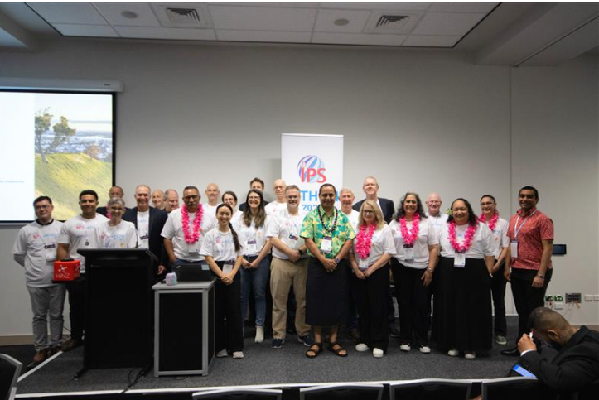
Members of the IPS-athon planning team, track leads and personas, including K'aute Pasifika Trust, the Pasifika community, Te Whatu Ora, HL7 and others.

One hundred and forty health software developers, service designers, clinicians and others with an interest in digital health took part in the fully-booked International Patient Summary-‘athon’ held as part of the recent HiNZ (Health Information NZ) Digital Health Week in Hamilton.

The IPS-athon was a joint undertaking from HL7 New Zealand and the Health Information Standards Organisation (HISO). The two-day event focused on building health data and information interoperability across Aotearoa and Oceania using the International Patient Summary (IPS). The aim was to feed into the development of the New Zealand Patient Summary (NZPS) – a set of core personal health information being adapted from the IPS.

Following the pōwhiri, attendees were given a problem statement, vision and goal and asked to develop solutions. They incorporated Pacific personas and health practitioners into their discussions, planning, and development of a NZPS product based on the IPS standards.

Attendees were asked to create a patient summary for the main persona –Iosefa Fuimaono, a 78-year-old Samoan man with several health issues and who spoke Samoan as his first language. Iosefa and other personas from his whānau were acted out by members of K’aute Pasifika Trust and the local community.

Iosefa is looked after by his fa’afafine (transgender) daughter Cindy, with Dr Tama and nurse Geena - also part of the care provided by K’aute Pasifika in Hamilton. These personas showed the challenges for Iosefa and his aiga/family in accessing health services and information to support their care and wellbeing.

Working in different topic groups or ‘tracks’, participants began to build solutions, based on the Fast Healthcare Interoperability Resources (FHIR) application programming interface (API) and SNOMED CT – standards that underpin the IPS. FHIR is a set of rules and specifications for exchanging electronic healthcare data. It is designed to be flexible and adaptable, so it can be used in a wide range of situations and with different healthcare information settings. SNOMED CT is a clinical terminology standard, which puts a code and name to all health conditions, situations and interventions.

FHIR inventor Grahame Grieve – also known as the father of FHIR – was a track lead, alongside other experts from the standards community and health software industry. There was a ‘spotlight’ talk on a specific topic each hour.

By the end of the two days, a working version of a patient summary set to international standards, had been created for Iosefa, and that was scannable via a QR code. Progress was also made towards a model for a patient story (“My Story”). A patient story helps set out what is usual for a person, how to support them, and what they want known about them up front.

HISO chair and Te Whatu Ora Group Manager for Data and Digital Standards Alastair Kenworthy says it was a remarkable two days, and showed what could be achieved when you had experts, innovators and people with lived experience in the same room, working on the same task.

“The New Zealand patient summary will see the international standard adapted to our unique settings, while offering full interoperability with other nations using the same standard for core personal health information. We will recognise any other countries’ patient summary built using the same standards.

“We don’t have all the answers, and implementation of standards is always a challenge. We need input across the health sector, using all our capability, to ensure we travel together in the right direction. The IPS-athon has been a great start. Ultimately, it’s about making peoples’ lives and health better.”

John Carter, HL7 New Zealand Chair and Te Whatu Ora interoperability expert, highlighted the importance of digital health as a tool that must be part of the solution for healthcare.

“Standards such as FHIR are enablers for the consistent sharing of health data and information, so people have more input into and control over their own healthcare. Healthcare providers will have a much wider range of information on which to base treatment and care.

“I’m proud and thankful for everyone who took part in the IPS-athon – the largest such event ever held in Aotearoa. We went beyond the usual HL7 technical workshop to connect deeply with patients and caregivers. By creating an IPS document for Iosefa, and showing how it could be shared with his whole care team – all using different computer systems – we met our goals and laid a path for future events.”

The New Zealand Patient Summary

The suggested composition of the NZ Patient Summary is shown below. It is a New Zealand adaption of the IPS with extensions that reflect our local nuances and cultural needs.

By mid-2024, the Hira Programme is aiming to have the New Zealand patient summary (based on the HISO International Patient Summary) available to consumers and healthcare providers. The NZ patient summary will enable access to some essential health information, including:

- demographics
- community dispensed medicines
- vaccination status
- entitlements (initially Community Services Card and High Use Health Card)
- laboratory results (initially COVID-19)
- other data, for example, allergies and conditions.

Additional datasets will be added over time, as we work towards delivering a personal health record.

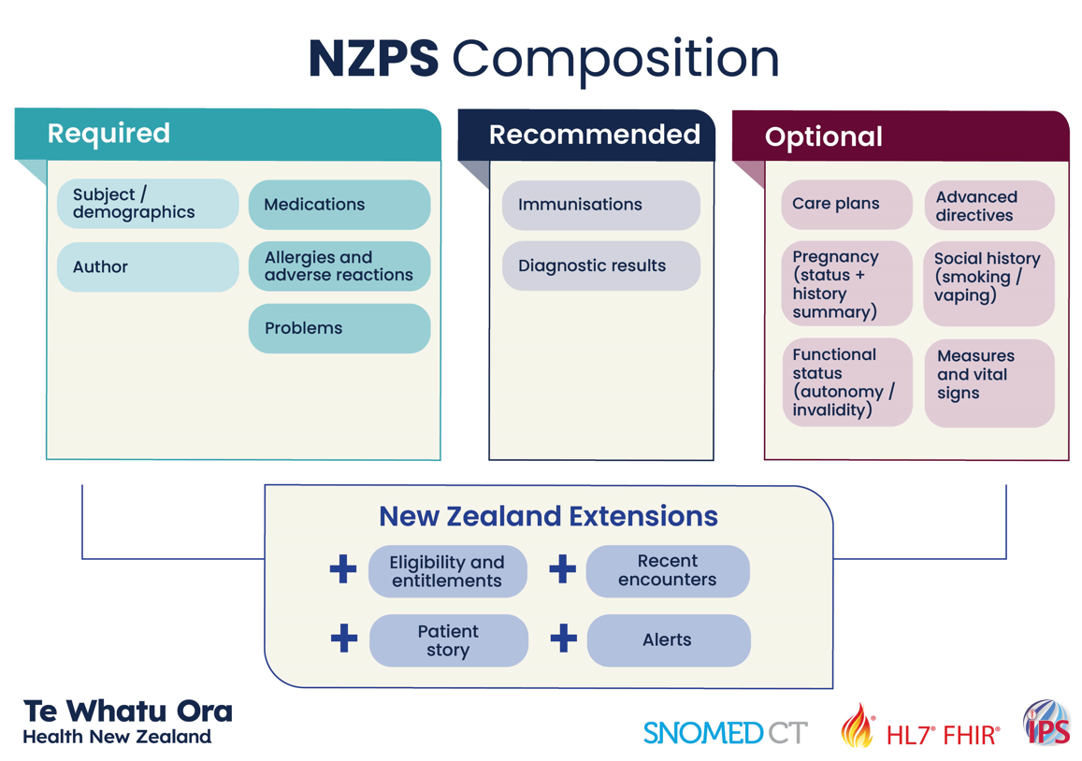

Snapshot of latest projects

- Te Whatu Ora released My Health Record in early December 2023. My Health Record is a secure website giving people access to their immunisation records, including COVID immunisations and test results, dating back to 2005. Many will also be able to access immunisation records for their tamariki. My Health Record is the first step to giving New Zealanders access their own health information online. Over time, more information will be available, such as current and past medications, lab results, and community services and high use card entitlements. Access to this health information is enabled by the interoperability being put in place by the Hira Programme.
- The Hira Connector Plane is in production, and will be available to the wider sector early in 2024. It is a critically important component of the Hira goal of providing secure access to health information. The Connector Plane enables information to be connected via application programming interfaces (APIs). Different APIs will be released over time including demographics, immunisations, medicines, and laboratory results. Components of the Connector Platform currently in development include an integration platform, which will provide connectivity services and host APIs; and a developer portal, which will have information on APIs and how to use them and give developers access to test systems and data.
- The NZ Health Terminology Service (NZHTS) continues to extend its list of code systems and value sets, with over 40 companies now using the service. New content includes the latest release of the SNOMED NZ Edition (released in October) as well as all International Patient Summary (IPS) code systems and value sets needed for the recent IPS-athon.
- The My Health Account team has completed adult-to-adult delegated representative functionality, which is now available for integration with apps. This function allows an approved delegate to access another person’s account.
- Work is underway on developing reference implementations that can be used by developers for Te Whatu Ora-published APIs and services. A reference implementation is a program that demonstrates the interaction with a service through an API. The reference implementations for Hira will provide an example of how apps can integrate with My Health Account and consume data from FHIR APIs via the Hira Connector Plane and API Marketplace for display to individuals via a web app.

InterSystems becomes an early adopter of National Health Index FHIR API

InterSystems, a creative data technology provider, has become an early user of the Hira Programme’s application programming interfaces (APIs) developed by Health New Zealand – Te Whatu Ora using the HL7® FHIR® health data sharing standard.

APIs enable two or more computer programs to communicate with each other using a set of definitions and protocols. The Hira Programme is driving the move to using FHIR-based APIs for interoperability to enable New Zealanders to access their health information securely wherever it is stored.

Brian Biggs, customer relations and sales director for InterSystems New Zealand, says the company found out that new API functionality was being developed by Te Whatu Ora when his team started the discovery phase of a major patient administration system project.

InterSystems is delivering the patient administration system for Te Toka Tumai Auckland, part of Te Whatu Ora. Serving multiple facilities, including Auckland City Hospital, Starship Children’s Hospital and several community organisations, the system is due to go live in mid-2024.

“Our long-term goal was always to use the National Health Index API, but in any project of this scale, it can be a risk relying on technology that doesn’t quite exist yet,” says Biggs. “So, we started to work with Te Whatu Ora data and digital identity team, who were developing the NHI API, with a view to InterSystems being early adopters.

“Together, we took the theory and started to discuss how certain scenarios would be handled – for example, how we would work with patients – and put it in the real world.”

Biggs gives the example of managing the identity of a person only known by one name (a mononym) rather than a first name and a surname.

“Currently, the legacy NHI needs a first name and a last name. So, we needed to determine what would happen with the new service when someone had a mononym. The specification said to treat any single name as a mononym. Many systems, including ours, need at least a surname – but treating a single surname as a mononym may have impacts, including with patient identification, in downstream systems.

“These were the types of conversations we were having,” says Biggs. “We were very excited by the level of engagement we had with the Te Whatu Ora team – they were very pragmatic, open and collaborative.”

Biggs says using the FHIR-based APIs has several benefits for Te Toka Tumai Auckland’s new patient administration system, including the ability to reconcile data within the wider information systems environment.

The FHIR (Fast Healthcare Interoperability Resources) standard is a set of rules and specifications for exchanging electronic healthcare data. It is designed to be flexible and adaptable for use in various settings and with different healthcare information systems.

“We will know when a patient’s data was last accessed from the NHI, for example, and FHIR enables us to access other relevant information,” he says. “As well as demographic information, data is retrieved from the National Enrolment Service on the individual GP and GP practice a patient is enrolled with. Data is shared using Health Provider Index identifiers for the individual (HPI-CPN) and the facility (HPI-Fac).

“FHIR enables us to do multiple things at the same time. Whereas historically, you could just do one thing and then another, now you can pull them together into a bundle. Using FHIR resources, we can intuitively and seamlessly provide access to different services in the background without the user having to be aware of the complexities involved.”

The increased reliability and consistency of data will make a big difference to hospital administrators, says Biggs. And, because the patient administration system is the backbone of Te Toka Tumai Auckland’s healthcare information systems, there will be other benefits.

“The system will also benefit patients because the data that other healthcare information systems hold about them will be more up-to-date and reliable.”

Biggs says the InterSystems team appreciates the opportunity to work with Te Whatu Ora and run the NHI API through real-life scenarios.

“The team at Te Whatu Ora has been genuinely wanting our feedback, and being able to be an early adopter will pay longer-term dividends. It is great for the project, but more importantly, great for the sector.”

Te Whatu Ora Hira Programme Industry Engagement Director Russell Craig says the programme is very pleased with the outcomes of the partnership.

“InterSystems is in the vanguard of those adopting modern FHIR APIs as part of the digital transformation of our health system – transformation being enabled by Hira and other strategic initiatives such as the National Data Platform.

“As Hira continues to build Te Whatu Ora API-management capabilities and releases more FHIR APIs into production, we are looking forward to many more health digital service suppliers following in InterSystems’ footsteps.”

About InterSystems

Established in 1978, InterSystems provides next-generation solutions for enterprise digital transformations in the healthcare, finance, manufacturing and supply chain sectors. Its cloud-first data platforms solve interoperability, speed and scalability problems for large organisations around the globe. For more information, please visit InterSystems.com.

National Event Management Service will improve the flow of health information

The National Event Management Service (NEMS) is currently being piloted. The pilot, due for completion in December 2023, focuses on delivering a ‘proof of value’ that will then be scaled into a production environment early next year.

NEMS will let healthcare providers know when information relating to a patient has changed (such as their address) or when they have had an interaction with the healthcare system (for example, they have been seen at an emergency department). The notifications are IT system to IT system.

Gerard Keenan, Director Hira Programme and Technology Enablers, says the service will enable the right data to get to the right people at the right time – improving the currency and accuracy of health data and information.

“Each day there are over 700,000 data changes across the health system. For example, someone might change their address, be admitted to hospital or, sadly, pass away. This information is captured in one healthcare information system – such as a hospital’s patient administration system in the case of an admission. However, not all healthcare providers that need this information are alerted.

“This happens because of our diverse systems and technologies, and lack of interoperability standards.

“With NEMS, the update is made once, in one system – the publishing system; and then communicated to the other systems – subscriber systems. Information systems subscribe to events, which they get when there has been a change in a person’s information linked to their National Health Index (NHI) number.

“Healthcare providers subscribe to the changes and events most relevant to them, and data changes and healthcare interactions are broadcast to all subscribing systems simultaneously.”

Gerard says the benefits of the service are multiple.

“Healthcare providers have much better visibility of what’s happening to patients and are notified of interactions outside their direct healthcare setting – for example, if a patient has gone to an afterhours clinic, or they could be notified that a patient has received an abnormal result, and contact them to discuss the next steps.

“Updated information can be fed directly into health subscribers' systems using an API, and healthcare providers will need to spend far less time updating data manually.”

The work on the national events management service is being led by Te Whatu Ora Data and Digital, within the Hira Programme. Solace is the publish-subscribe message broker being used.

Survey to help understand FHIR training needs

Te Whatu Ora and HL7 New Zealand are carrying out a survey to add to our understanding of FHIR capability. The survey will help us understand the FHIR training programmes and resources needed to meet the health sector's needs.

FHIR is a health interoperability standard for digital interfaces that supports easy and meaningful exchange of health data. Hira will enable health information to be securely accessed through FHIR APIs, so using and understanding FHIR is essential for digital health industry partners interacting with Hira.

If you are a provider or consumer of healthcare data and use or plan to use FHIR functionality, we would be very grateful if you would complete the survey. It takes about five minutes and will help us increase the understanding of FHIR capability in New Zealand.

Questions or comments

We welcome your feedback, input and questions about Hira – please email us on contact@hira.health.nz.

Please also let us know if you would like to be added to the list of subscribers who are alerted when these updates are published.

