HISO 10024.2:2017

Medical Device Terminology and Identification Standards
Published June 2017

Document information
HISO 10024.2:2017 Medical Device Terminology and Identification Standards
ISBN 978-1-98-850243-4 (online)
Published in June 2017 by the Ministry of Health
Health Information Standards Organisation (HISO) standards are published by the Ministry of Health for the New Zealand health and disability sector
This document is available at http://www.health.govt.nz/our-work/ehealth/digital-health-standards-and-governance/health-information-standards
Contributors
Pharmaceutical Management Agency (Pharmac)
Ministry of Health
New Zealand Health Partnerships
New Zealand Universal List of Medicines
Creative Commons licence
This work is licensed under the Creative Commons Attribution 4.0 International licence. In essence, you are free to: share ie, copy and redistribute the material in any medium or format; adapt ie, remix, transform and build upon the material. You must give appropriate credit, provide a link to the licence and indicate if changes were made.
Keeping standards up-to-date
HISO standards are regularly updated to reflect advances in health information science and technology. See the Ministry of Health website at health.govt.nz for information about the standards development process. We welcome your ideas for improving this standard. Email standards@health.govt.nz or write to HISO, Ministry of Health, PO Box 5013, Wellington 6145.

Contents
1 Introduction 1
1.1 Overview 1
1.2 Strategic context 1
1.3 Kinds of medical device 2
1.4 SNOMED CT 2
1.5 GS1 standards 3
1.6 Key recommendations 3
2 Background 4
2.1 Medicines terminology 4
2.2 Medical device identifiers 5
2.3 Medical device terms in SNOMED CT 5
3 Extending the standards to medical devices 6
3.1 Information needs 6
3.2 Selected terminology and identification standards 6
3.3 Implementation steps 7
3.4 Use case scenarios 7
4 Linking clinical and supply chain identifiers 10
4.1 Principles for linking SNOMED CT and GTINs 10

Introduction
This document provides direction on the new information standards required for accurate and consistent description and identification of medical devices in New Zealand.
It originates from a proposal by Pharmac, the Ministry of Health and the New Zealand Universal List of Medicines management team to the Health Information Standards Organisation (HISO) in February 2016.
The Medicines Terminology Recommendations Report published in 2009 led to establishing the New Zealand Medicines Terminology and New Zealand Universal List of Medicines. This new document sets out the standards necessary to establish equivalent resources for medical device information.

Overview
This document provides direction on the chosen information standards to enable all medical devices and medical device types – from wound care products to wearable devices, prostheses, implantable devices and diagnostic and therapeutic equipment – to be properly described and identified for all clinical and supply chain purposes in the New Zealand health and disability sector.
This extends to the medical device domain essentially the same identification principles and standards that have existed for medicines in New Zealand since 2011. In summary, this means adopting these two international standards:
- Global Trade Item Number (GTIN) as the standard for medical device identification in the supply chain and for product traceability
- SNOMED CT as the standard for medical device terminology in clinical documentation and for clinical decision support.
Using these complementary standards in this way will ensure that medical devices can be safely and effectively prescribed, dispensed, administered and used in health care. A common language for information sharing is essential for patient safety and effective clinical use.
On the supply side, these standards will ensure that medical devices can be properly catalogued, ordered, distributed and tracked. Without a common approach there will remain difficulties in sharing information to support procurement, contract and budget management.
The international standards outlined here will address these needs and replace proprietary and non-standard medical device coding methods.

Strategic context
The New Zealand Health Strategy sets the context for the introduction of medical device terminology and identification standards. In the projected future state:
- Medical devices including wearables are options for everyone
- Consistent and accurate medical device information is always available
- The regulatory environment supports the ready uptake of medical devices and therapeutic products
- Processes and systems for medical device management are streamlined and user friendly.
Events over the last few years have resulted in a much greater national focus on the management and use of medical devices, primarily in the hospital setting but increasingly at home and in the community. Pharmac is responsible for managing public expenditure on hospital medical devices as the government agency that provides New Zealanders with funded access to pharmaceuticals.
There is an ever greater focus on collective approaches to district health boards’ supply chain activity, including around medical devices.
The planned New Zealand electronic health record system – a single source of truth for core personal health information – will document the medical devices used by the person, alongside information about their medications, allergies and adverse reactions, medical conditions and care plan.
The New Zealand Universal List of Medicines and the New Zealand Formulary already include some classes of medical device.
Future changes to the regulation of medical devices in New Zealand will need to align with the needs of the wider sector in regards to medical device terminology and identification.

Kinds of medical device
A medical device is defined to be any physical object that is useful for diagnostic or therapeutic purposes. As such it includes any physical object that is used in relation to patient care that is not a medicine, including:
- registered medical devices such as orthopaedic implants, arterial stents and pacemakers
- medical devices, sometimes referred to as appliances, such as colostomy bags and catheters
- medical devices used in community settings such as needles and test equipment
- medical devices used in hospital settings such as peritoneal dialysis equipment and supplies
- medical devices such as diagnostic scanners and therapeutic nuclear medicine machines
- in-vitro diagnostic devices
- equipment such as hospital beds that may need to be recorded as relevant to patient care.
The scope of interest in medical devices is broad, potentially covering everything that comes into contact with the patient in health care. Pharmac is interested in hospital medical devices and equipment whereas the electronic health record will document any personal medical device or device used with a therapeutic purpose.

SNOMED CT
SNOMED CT is the endorsed terminology standard for clinical information systems and electronic health records in New Zealand. SNOMED CT is developed by the International Health Terminology Standards Development Organisation (IHTSDO), of which New Zealand is one of 28 member countries.

GS1 standards
GS1 is an international not-for-profit association with member organisations in over 100 countries, including New Zealand. The GS1 system of standards is the most widely used supply chain standards system in the world. GS1 GTINs are globally unique identifiers for manufatured products. Worldwide, about 90 percent of pharmaceuticals have a GTIN.

Key recommendations
The key recommendations made in this document are to:
- Use GTIN as the medical device identifier for supply chain purposes
- Support and participate in international efforts to develop unique device identifier (UDI) standards using GTIN as the device type identifier
- Support the SNOMED International project to develop a common medical device model and terminology using SNOMED CT
- Establish a SNOMED CT based medical device terminology for decision support and clinical documentation in New Zealand
- Record GTIN and other UDI data elements in clinical and other systems for product traceability
- Recognise NZULM as the source for the linkage between the SNOMED CT based medical device terminology and GTIN.

Background
The health sector is already well-advanced on a path towards having both a clinical information standard and a supply chain standard for sharing medicines and medical devices information.

Medicines terminology
On the clinical side is the New Zealand Medicines Terminology, a common language based on SNOMED CT for the medicines approved for use and available in New Zealand.
The diagram shows the concept model thats enables each medicine to be precisely named and described in the New Zealand Medicines Terminology, from the most generic concept (eg paracetamol) to the most specific (eg Panadol 500 mg tablet: film-coated, 20 tablets, blister pack), with levels in between.
Every instance of each of the seven concept types has its own SNOMED CT numeric identifier and a unique descriptive name: 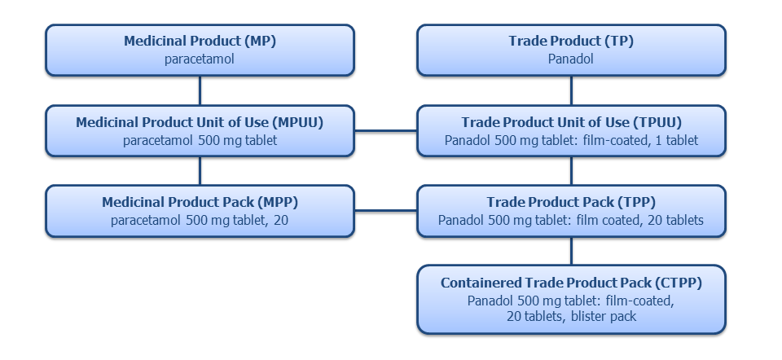
The New Zealand Medicines Terminology is a foundational resource for quality medicines information, providing:
- a standardised terminology with agreed editorial rules
- a single approach to clinical coding for medicines across the sector
- an ability for information to be provided at a general concept level and cascaded down to individual products
- an ability for data to be collected at a granular level and aggregated for data analysis
- a tool to support clinical decision making, including interaction and contraindication checking and alerts.
Building on this resource, the New Zealand Universal List of Medicines adds government funding and subsidy information from the Pharmaceutical Schedule, regulatory and safety information from the New Zealand Medicines and Medical Devices Safety Authority (Medsafe) and data from suppliers to provide comprehensive and standardised information about medicines.
In turn, information from the New Zealand Universal List of Medicines is used by the New Zealand Formulary and in frontline electronic medication management systems.

Medical device identifiers
On the supply chain side we have GTINs from international standards body GS1, designed to identify physical products. Each GTIN identifies a product type of which many essentially identical instances can be manufactured.
GTINs are most commonly rendered as linear or 2D barcodes. They can also be machine-read as radio frequency identification (RFID) tags and in other ways. Each of the following three barcode formats encapsulates a GTIN:
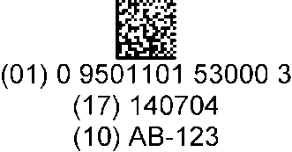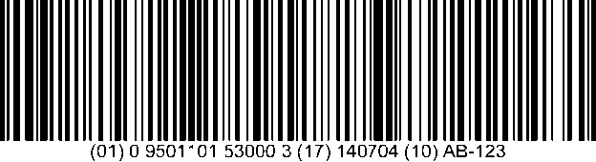
The barcode in the leftmost example represents a GTIN alone, while each of the other two barcodes encodes a unique device identifier (UDI) combining a device identifier (DI) that is the GTIN and a production identifier (PI) that includes batch number, expiry date and serial number. The DI component represents the medical device type while the PI component identifies the individual manufactured instance of such a product.
The Joint Initiative Council on SDO Global Health Informatics Standardisation is presently working on a UDI standard for its members, who include IHTSDO, GS1, HL7 and ISO TC 215. UDIs assist in identifying counterfeit products, facilitating recall processes and improving users’ ability to distinguish between devices that are similar in appearance but serve different functions.
Medical device manufacturers in the United States register their products in the Global Unique Device Identification Database (GUDID) administered by the Food and Drug Administration (FDA). The GUDID contains product information that includes the device identifier and flags indicating which production identifier data elements appear on the device label.
The GUDID allows manufacturers to use the Global Medical Device Nomenclature (GMDN) to categorise and describe each device in reasonably structured terms. SNOMED CT includes all GMDN terms .
GMDN is used to code medical devices registered in the WAND database for legal supply in New Zealand.

Medical device terms in SNOMED CT
Here is an example of a medical device hierarchy in SNOMED CT:
Medical dressing (physical object)
Bandage device (physical object)
High compression (extensible) bandage (physical object)
High compression bandage 10 cm (physical object)
…

Extending the standards to medical devices
While the New Zealand Medicines Terminology was originally designed for medicines information, over time it has been stretched to enable the sharing of information on every kind of product in the Pharmaceutical Schedule. This includes some non-medicines such as nutritional products, inactive products (cream bases) and a number of medical devices such as blood glucose test strips, condoms and wound care products.
However, Pharmac, consumers, suppliers, district health boards and the Ministry of Health are starting to have a much greater need for quality information in relation to medical devices:
- The Pharmaceutical Schedule is rapidly expanding to include medical devices – 2500 medicines and 20,000 medical devices are currently listed, and the rapid growth in devices will only continue
- The New Zealand electronic health record will need to include details on many kinds of medical device used by the patient, including home monitors, wearables, prostheses and implantable devices
- Clinical decision support tools will guide the use of medical devices with individual patients – for example, the New Zealand Formulary could have information and functions supporting the rational use of wound care products, which are often expensive and incorrectly used.

Information needs
The sector’s needs for standards in relation to medical device information are essentially the same as those in respect of medicines:
- a standardised terminology with agreed editorial rules
- a single approach to clinical coding for medical devices across the sector
- an ability for information to be provided at a general concept level and cascaded down to individual products
- an ability for data to be collected at a granular level and easily aggregated for data analysis
- a tool to support clinical decision making, including interaction and contraindication checking and alerts.
Therefore we propose a similar approach to medical device terminology and identification standards as that already in place for medicines. This will allow medicines and devices to be treated as similarly as possible for both clinical documentation and supply chain purposes.

Selected terminology and identification standards
Under this approach the recommended key standards are:
- SNOMED CT as the base standard for medical device terminology and clinical documentation
- GTIN as the standard medical device identifier for the supply chain and product traceability.
Many health sector information systems will soon be spanning both medicines and medical devices, and having the underlying information standards as closely aligned as possible is the sensible approach. However, using the New Zealand Medicines Terminology to represent medical devices is not a practical way forward. While the description of medicines has relatively few variables (active ingredient, form and strength), medical devices can have much higher levels of clinically-relevant variation. For example, cardiovascular guide wires vary by the type of core, length, thickness, strength and type of tip. Similarly, wound dressings vary by the size, absorption capacity, adherence, sterility and antimicrobial features. A trial using the New Zealand Medicines Terminology to represent a subset of medical devices has highlighted the shortcomings.
Therefore, the proposal is to establish a medical device terminology that is SNOMED CT based and shares some elements with the New Zealand Medicines Terminology, but adds a range of medical device specific variables to support the known medical device use cases.

Implementation steps
The recommended steps to implement this approach are as follows:
- A new medical device terminology will be adopted or created, built on SNOMED CT. The devices portion of the Pharmaceutical Schedule will be translated into this format and use the Containered Trade Product Pack as the clinically relevant control point at which funding and procurement decisions are made by Pharmac.
- The scope of the New Zealand Universal List of Medicines will be extended to include medical devices, and will bridge the clinical and supply sides by linking each Containered Trade Product Pack with the associated GTINs.
- Transaction data such as pharmacy dispensing records will include a combined set of data elements from the Containered Trade Product Pack and the UDI, including the SNOMED CT concept identifier, GTIN, batch number, expiry date and product serial number.
- Product labels will be required to include machine-readable UDIs based on GTINs. As above, the New Zealand Universal List of Medicines will be the reference point that provides the necessary link between the GTIN and the associated Containered Trade Product Pack.

Use case scenarios
The following use case scenarios illustrate how a SNOMED CT based medical device terminology and a GTIN based system of UDIs would be applied in practice.
- Dispensing a medical device in a community pharmacy | A patient presents a barcoded prescription to a community pharmacy for a medical device  The pharmacist scans the prescription and downloads details down from the electronic prescription service  The pharmacist selects the prescribed product from the shelf and scans the GTIN, batch number, expiry date and other UDI data elements contained in the product barcode  The dispensary software has a mapping from GTINs to SNOMED CT that is maintained in the New Zealand Universal List of Medicines  The dispensary software references the relevant SNOMED CT identified entities, confirms that the scanned physical product matches the prescribed item and identifies relevant Pharmaceutical Schedule restrictions (limitations on use, subsidy status)  The dispensary software submits transaction information, including SNOMED CT identifiers and the UDI, and this is stored in the electronic health record.
- Implantation of a medical device in a hospital procedure | A patient needs a hip replacement  The implanted device carries a barcoded label carrying a UDI  Immediately before the operation the device label is scanned  After surgery the new implant is documented in the electronic health record  The electronic health record includes the condition treated, the type of procedure and the medical device types involved – all represented as SNOMED CT concepts – plus physical product information, including the GTIN, batch number, expiry date and other relevant data elements from the UDI.
- Implanted device recall | An alert is raised on a batch of cardiac stents and hospitals need to recall patients for monitoring  Hospitals search the electronic health record for patients provided with that batch of stents (using GTIN and batch number) to identify affected patients.
- Consumable recall | A batch of blood glucose test strips is subject to a patient-level recall and community pharmacists are notified  A community pharmacist queries their dispensary software to identity and contact the patients who were provided stock of that specific batch (identified by GTIN and batch number).
- National contracts | Pharmac awards 90% exclusivity to one brand of sterile dressings in public hospitals  The device terminology identifies which products are covered by this arrangement to support procurement decisions by district health boards  The device terminology allows public hospitals and Pharmac to monitor purchases at both a granular and aggregate level to monitor compliance.
- Allergy alerts | A patient in hospital for wound management has a pre-existing latex allergy recorded in the electronic health record  A nurse scans wound care products prior to use on the patient  Substances information in the device terminology indicates that the selected product has a latex based adhesive and the nurse is alerted.
- Contraindication alerts | A patient is in hospital for management of recurrent venous ulcers  The patient has a diagnosis of congestive heart failure, which is recorded in the problem list component of the electronic health record  A clinician begins the process of prescribing compression hosiery for the patient  The prescribing system identifies that congestive heart failure is a contraindication for compression hosiery and alerts the clinician.

Linking clinical and supply chain identifiers
SNOMED CT and GTIN are clearly complementary systems for describing medicines and medical devices. SNOMED CT focuses on the conceptual aspects that are important to clinical practice –details and amount of active ingredients, for example – whereas the GTIN and the associated UDI production data elements identify each physical product for supply chain purposes, including labelling, cataloguing, ordering, distributing and so on.
Given their respective roles, SNOMED CT and GTIN can be linked in the New Zealand Universal List of Medicines to create reference data serving both clinical and supply chain purposes. This linkage occurs between the Containered Trade Product Pack and the set of associated GTINs.
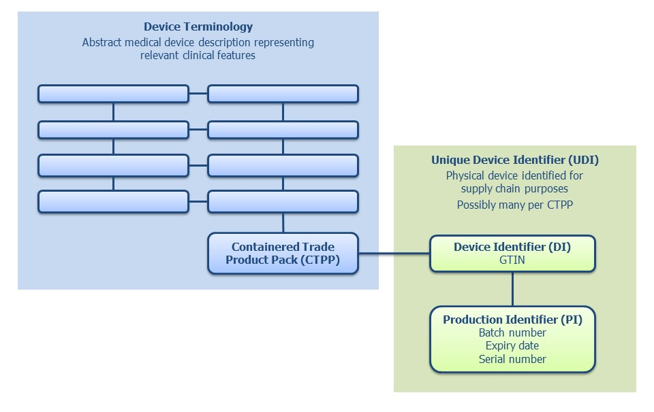

Principles for linking SNOMED CT and GTINs
Further to the above, this document encompasses draft international principles and guidance for linking SNOMED CT and GTINs in medicines information and, by extension, in medical device information.
IHTSDO and GS1 have collaborated to develop these principles for the benefit of their common user communities. New Zealand has been involved in this project and endorses the results.

- Use case for the linkage | - Link SNOMED CT and GTINs for clinical and supply chain harmonisation  - Define use cases for the linkage  - Be clear about what the use case and linkage will and will not support  - Identify a SNOMED CT subset for each use case which then forms the basis for the linkage.
- Governance | - Put in place an open and transparent governance process that includes all stakeholders in using and maintaining the linkage  - Identify key partners and stakeholders and their responsibilities  - Assign a responsible owner or steward for the linkage, with identified and agreed responsibilities
- Technical | - Based on the use case, have an editorial policy for developing, maintaining and updating the linkage between SNOMED CT and GTINs  - Editorial rules should include managing one-to-many and many-to-one relationships in a consistent and safe manner  - Assert the map direction for each use case (SNOMED CT to GTIN, GTIN to SNOMED CT or bi-directional)  - Define a standard distribution format for linkage information.
- Manufacturers | - Have a national agreement with manufacturers to provide data for the linkage table that is accurate, up-to- date and reliable  - Identify key drivers to gain conformance from manufacturers, eg regulation, trading etc.
- Quality assurance and safety | - Have a system for managing duplicates of GTINs and identical products having different GTINs  - Have an error reporting system for users of the linkage table with agreed timelines for responses and updates  - Ensure users have access to the validation process between manufacturer and GS1 allocated codes.
- Documentation | The following documentation on linking SNOMED CT and GTINs should be made available in the public domain:  - Editorial policy  - Technical specification of the linkage model  - Process for maintaining and updating the linkage  - GTIN allocation rules  - Quality assurance process and verification for the linkage  - Technical specification of the release format for the linkage  - User and implementation guidance for using SNOMED CT and GTINs together.

