Interoperability roadmap
Accelerating the shift to a fully interoperable
digital health ecosystem
HISO 10083:2020
September 2020
Acknowledgements
Global Digital Health Partnership
New Zealand Health IT
Australian Digital Health Agency
HISO committee: Zeeman van der Merwe (Accident Compensation Corporation), Rebecca George (Health Informatics New Zealand), Karen Blake (Health Alliance), Stanil Stanilov (Standards New Zealand), John Carter (Clanwilliam Health), Dr Nader Fattah (Think Hauora), Alastair Kenworthy (Ministry of Health)
SNOMED® and SNOMED CT® are registered trademarks of International Health Terminology Standards Development Organisation
This document references the HL7® FHIR® standard. HL7, FHIR and the FHIR [FLAME DESIGN] are the registered trademarks of Health Level Seven International and their use does not constitute endorsement by HL7
GS1 and the GS1 logo are registered trademarks of GS1 AISBL
Citation: Ministry of Health. 2020. HISO 10083:2020 Interoperability roadmap: Accelerating the shift to a fully interoperable digital health ecosystem. Wellington: Ministry of Health.
Published in September 2020 by the Ministry of Health
PO Box 5013, Wellington 6140, New Zealand
ISBN 978-1-99-002920-2 (online)
HP 7432
Health Information Standards Organisation (HISO) standards are published by the Ministry of Health for the New Zealand health and disability sector.

This document is available at health.govt.nz
This work is licensed under the Creative Commons Attribution 4.0 International licence. In essence, you are free to: share ie, copy and redistribute the material in any medium or format; adapt ie, remix, transform and build upon the material. You must give appropriate credit, provide a link to the licence and indicate if changes were made.

Foreword
Kei te koa ahau ki te whakaatu i tēnei mahere ara
It’s very pleasing to present our interoperability roadmap for a modern, digitally-enabled and data-driven health and disability system in Aotearoa New Zealand.

A more joined-up system will improve equity and pae ora, or healthy futures, for New Zealanders, and help us honour the Māori-Crown partnership under Te Tiriti o Waitangi.

It’s about a better experience of the health and disability system for all who use it or work in it.

The roadmap embraces digital inclusion, trust and the innovative direction set by the Strategy for a Digital Public Service.

Interoperability is a key part of the Ministry’s digital health strategic framework and the national health information platform ecosystem we’re collectively building. Our roadmap accelerates work already underway, including the response to COVID-19, and aligns to recommendations in the Health and Disability System Review.

As kaitiaki of data and digital standards for the health and disability system, the Health Information Standards Organisation (HISO) will set the standards we need and promote their adoption.

The Ministry will look at the barriers and settings, including incentives, that will drive alignment across the health and disability system to the interoperability requirements outlined in this roadmap, as well other parts of government such as social and education services.

The roadmap was developed after extensive consultation with clinical, industry and community stakeholders, and partner government agencies. We are confident our thinking on interoperability is aligned with the best internationally, through relationships with our neighbours in Australia and as a member nation of the Global Digital Health Partnership and SNOMED International.

Our roadmap sets out bold and practical steps that we will take – together – over the next two years.

Shayne Hunter
Deputy Director-General, Data and Digital

Contents
Introduction 1
The change we are making 3
Our four themes 6
Connecting and identifying 7
Using the same languages 10
Unblocking access to Data 14
Enabling Joined-Up Services 19
Timeline 22
It’s a collective journey 23
Case studies 27
Health information standards 29
References 33

Kupu whakataki

Introduction
Our roadmap for accelerating the shift to a fully interoperable digital health ecosystem
Interoperability is essential to an integrated, collaborative and innovative health and disability system and healthy futures for all New Zealanders. The better data that interoperability makes possible will lead to the better evidence and insights needed to achieve equity in health outcomes.

This document presents our roadmap for accelerating the shift to a fully interoperable digital health ecosystem that enriches the experience for consumers and the health and disability workforce through better connectedness and use of information.

The Global Digital Health Partnership defines interoperability as the ability to transfer meaning of information within and between systems and products without special effort by the user.

Interoperability ensures common meaning in a joined-up system and provides the data resources for development of innovative digital services and apps that support patients and health professionals.
Global Digital Health Partnership interoperability white paper

Interoperability ensures that health information can be accessed by patients and consumers, health workers, carers and whānau anywhere, anytime and anyhow. The quality of interoperability extends to interconnected products, services and workflows that create a better experience for everyone involved.

As a consumer, I am known to the system and don’t need to repeat my health story. I can use my preferred communication channels, I can share data captured by wearables and home monitors with health care providers.
NZHIT Vision and Charter for Interoperability

Interoperability matters whether data is personally identifiable or anonymous, atomic or aggregated, and whether related to direct care, population health, service innovation, or research. Data may be structured or unstructured, static or dynamic, transient or persistent, stored or streamed.

We may be used to thinking about interoperability in terms of information that identifies and describes people and their care, but increasingly we must deal with digital images, audio and video, and data captured by sensors from physical processes. This new world encompasses waveform data, genome sequences, proximity and geolocation data, data from advanced modalities and the internet of things, and social media data. Consumer-generated data will soon considerably outweigh all the data from other sources.

This document has been developed with input from clinical, industry and community stakeholders, using workshops, consultation and research. We acknowledge the following work and present an amalgam of the best current thinking on how to do interoperability.

- NZ Health IT (NZHIT) Vision and Charter for Interoperability, 2017
- Health Sector Architects Group workshops, 2017-19
- US Office of the National Coordinator for Health IT (ONC) Interoperability Roadmap, 2017-20
- Australian Digital Health Agency National Health Interoperability Principles, 2020
- Health and Disability System Review, 2019-20

Better information supports better decisions, leading to better health and wellness. Not sharing health information leads to clinical risks and inefficiencies.
Australian Digital Health Agency

Our roadmap has four interwoven themes.

■ Connecting and identifying
● Using the same languages
▲ Unblocking access to information
 Enabling joined-up services

Under each of these headings, we describe the current situation, what we’ll look to shift to, how we’ll do this, and what great looks like in five years.

We outline the need for change, present case studies, and set out a timeline of practical steps over the next two years for our collective journey. We look at the planned changes by functional area and the projects that will take them forward. Mechanisms and incentives to promote and enforce adoption of the key standards for interoperability are described.

And we close by describing the leading role that HISO will play in determining the standards we need and charting their adoption.

This is a living document and we plan to update it annually. We will track progress against the milestones set out and report quarterly. We welcome your feedback.

Te panoni ka hanga e tātou

The change we are making
The need for interoperability is ever increasing to enable a person-centred and joined-up system
Digital health can transform the outcomes and experience of consumers if information is shared seamlessly. A human-centred approach to creating a smart and equitable health and disability system underpins the Digital Health Strategic Framework developed by the Ministry of Health.

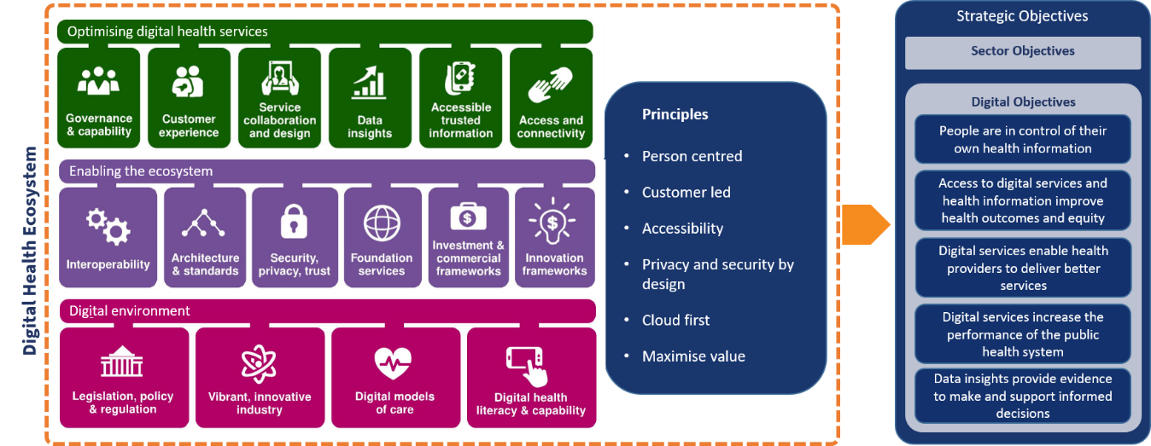

The needs of consumers, the health and disability workforce, researchers and industry will drive the development and implementation of the digital health ecosystem and the capabilities it supports.

Interoperability is positioned as one of the ecosystem’s central enablers, given effect through standards, guidelines and resources for interoperability.

National health information platform ecosystem
The planned national health information platform ecosystem will give consumers and providers a new level of access to information across all points of care and parts of the health and disability system.

The first tranche of delivering the national health information platform ecosystem will include key foundations and enablers within the strategic framework on which future digital health products and services can be built. Interoperability will be a vital part of ecosystem delivery.

The National Health Information Platform will provide a powerful platform for data integration and interoperability across the health and disability system.

Health and Disability System Review Final Report

Pae Ora – healthy futures for Māori
As kaitiaki of the health and disability system, the Ministry of Health has an important leadership role to play in creating an environment that enables Māori to live healthier lives.

He Korowai Oranga: Māori Health Strategy and its implementation plan Whakamaua: Māori Health Action Plan 2020-25 are underpinned by the Ministry’s contribution to the Crown meeting its obligations under Te Tiriti o Waitangi, and set out to achieve Pae Ora – healthy futures for Māori. Pae Ora is a holistic concept combining mauri ora, whānau ora and wai ora – healthy individuals, families and environments.

Digital offers an unprecedented opportunity to accelerate the achievement of Māori aspirations. Emerging technologies, digital tools and the pace of change mean the wellbeing outcomes sought by the Crown and Māori could be achieved much faster than we ever anticipated.

Strategy for a Digital Public Service

Interoperability is essential to Pae Ora by enabling digital health ecosystem capabilities that serve Māori. With the objective data that a better-connected system produces, we can ensure that insights and evidence are used to identify inequity and protect and build the knowledge base for Māori health and wellness, including mātauranga Māori.

Data provides the evidence and understanding around whether the system and services are working or not.

Whakamaua: Māori Health Action Plan stakeholder engagement feedback

The action plan also states the importance of adopting innovative technologies and increasing access to services such as telehealth and telemonitoring that streamline patient pathways and provide continuity of care for Māori individuals and their whānau. This is another call for interoperability.

Māori data is a taonga that must be respected, understood and protected in a digital world, in the context of digital inclusion and data sovereignty.

Digital Inclusion Blueprint

Guiding principles
Our approach to interoperability is shaped by the following principles, the first version of which was published in 2018 as the Commitment to New Zealand Health Interoperability.

- No blocking: We are custodians of New Zealanders’ health and disability data and will make it available to others whenever consistent with the other principles and permitted by law. We will not unreasonably block or hinder access to data.
- Data sharing: New Zealanders will have access to their own data. Data will be shared across the health and social care continuum to support clinical decision making and enable the provision of the right care, in the right place, at the right time, by the right people.
- Standards: We will implement agreed national interoperability standards and policies and adopt recognised practices related to health and disability data, including privacy, security, information governance and service management.
- Common capabilities: We will use agreed national information common capabilities such as identity, directory and health record services. We will use certain key systems of record as recognised sources of truth.
- Adaptive system: We will ensure that high quality, anonymised information can flow freely to enable an adaptive and data-driven health and disability system, with support for mātauranga Māori.

Leading the changes
This document sets a direction of travel and a roadmap of planned steps for accelerating the shift to a fully interoperable digital health ecosystem.

Some of the forecast change is in scope for the national health information platform ecosystem, with its own investment and commercial frameworks, while other parts will be delivered separately.

Standards will be crucial, and we expect to drive adoption of the required standards through policy, regulation, contracts, promotion, education and other incentives.

We will address barriers to interoperability, whether they relate to cost, legal impediments, workflow issues, governance or other concerns.

During the coming months we will be determining the best mix of options and providing clear guidance to the sector.

Ō mātau kaupapa e wha

Our four themes
Four interwoven themes guide our work towards a fully interoperable digital health ecosystem
These four themes are about connecting and identifying, using the same languages, unblocking access to data, and enabling joined-up services.

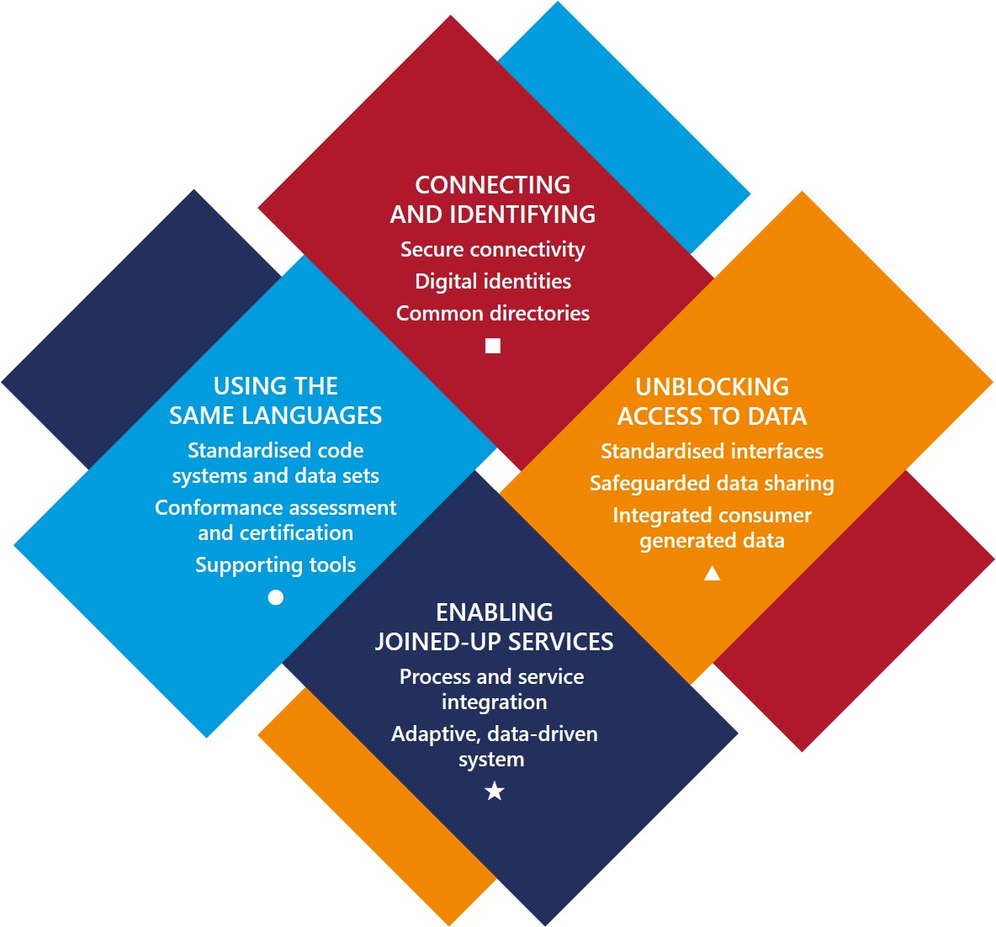

Under each of these headings, we describe the current situation, what we’ll look to shift to, how we’ll do this, and what great looks like in five years. And we signpost the changes we will make over the next two years to start the journey.

Connecting and identifying
Connecting to the ecosystem and identifying its actors are the first steps to secure communication and interoperability
These are the indispensable requirements for interoperability, enabling trusted parties to connect, identify themselves, securely transact, and access digital health services.

The people-powered theme goes hand in hand with digital technologies. Using tools like telehealth systems and smartphone apps, health and disability services can engage with people wherever they are located.
NZ Health Strategy

Current situation
There are different levels of connectivity around the country and a digital divide in access to online services for consumers.

National health information systems are hosted on a closed network that limits their reach to providers and consumers.

Key foundational services the National Health Index (NHI) and the Health Provider Index (HPI) are in place but lack modern APIs. The HPI system behaves as an identification system but not the true directory it needs to be.

Patient portals provide consumers with a point of connection to their own health information, linked by NHI number, but presently offer limited online services.

We’ll look to shift to
■ Secure internet-based connectivity
■ Digital identities for consumers and all health and disability workers
■ Common directories of providers and services.

We will open the environment to become internet-based, mobile-friendly, cloud-first, user-centred and always-on. Consumers and health workers will have an excellent experience through the ability to connect and transact using their own choice of device.

Fundamental to this will be a mature approach to security. The expectation is for security by design across the ecosystem. The Health Information Security Framework will be extended to cybersecurity standard from encryption to zero trust architecture and biometrics.

A focus on digital inclusion will ensure that consumers have affordable and low-friction access to digital health services. The Digital Inclusion Blueprint sets the basic requirements and outcome measures for everyone, including recognition of Te Ao Māori and Māori digital inclusion-related issues and aspirations.

Consumers, health workers and services will have digital identities with which to communicate and transact. Standardised authentication, access control and consent systems will ensure privacy and security in digital interactions. We will participate in development of the Digital Identity Trust Framework.

The Digital Identity Trust Framework is intended to be a regulatory regime and accreditation framework for digital identity service providers, ensuring that consumers have a choice of identity provider and can transact securely.

Internet-facing application programming interfaces (APIs) for foundational digital services, including the NHI and HPI systems, will be the default.

5G technology will provide the ultra-low latency, high bandwidth and massive device connectivity for new apps, devices and digital services. Bluetooth, GPS (global positioning system), near-field communication, barcodes and RFID (radio frequency identification) will be supported alongside internet protocols. Equipment and medical devices will be uniformly identified and interconnectable.

How we’ll do this
■ Move from closed networks to secure internet communication and replace legacy integration with modern protocols
■ Establish a digital identity framework for consumers and health workers
■ Set cybersecurity standards and establish security infrastructure using material from recognised sources such as the Open Web Application Security Project® (OWASP)
■ Build out foundational identity and directory systems and support third-party directory services
■ Enhance the HPI system to encompass all health workers, including kaiāwhina and the non-registered workforce
■ Fully integrate the HPI system with the New Zealand Business Number (NZBN)
■ Introduce Global Location Numbers (GLNs) for facilities, service points and supply points
■ Establish standards-based NHI and HPI APIs using the HL7® FHIR® standard
■ Determine standards for connecting smart devices to the ecosystem.

Key milestones
JUL20 |  | ■ Finalised NHI and HPI data set and API specifications  JAN21 |  | ■ NZBN introduced to HPI  JUL21 |  | JAN22 |  | ■ NHI API on internet use mandatory  JUL22
 | OCT20  ■ Draft NHI and HPI data set  and API specifications published |  | APR21  ■ Internet-facing NHI and HPI APIs deployed  ■ Digital identity framework published |  | OCT21  ■ Conformity assessment introduced  for NHI and HPI API integration |  | APR22  ■ HPI extended to kaiāwhina and non-registered health workers

Connecting and identifying

What great looks like
Consumers enjoy an excellent experience by having the connectivity and digital presence to allow fast, convenient and equitable access to digital services and their own health information via personal devices.

All health and disability services are supported by consumer-facing digital channels.

Health professionals experience an immersive, fully connected workplace, with open digital communication channels to patients and colleagues and fingertip access to digital resources.

Health facilities are smart, interconnected environments with fully integrated equipment and information systems.

Using the same languages
The same terminologies, code systems and data standards must be used everywhere for health data to be properly communicated
Our goal of sharing information that can be commonly interpreted and understood is called semantic interoperability. Patient data must be represented in standard ways so that it can be shared and reused without loss of meaning.

The ability of health care providers to use shared information with commonly understood meaning is a precondition for safe, coordinated, team-based care and positive patient experiences.
Global Digital Health Partnership

Current situation
The goal that shared data should be complete, accurate and coherent is not always met today.

The absence of recorded digital information in some settings detracts from direct care and a whole-of-system picture.

The unstructured data that predominates cannot always be used to drive safe and efficient care.

A patchwork of different data standards exists across the sector. Key terminology and code set standards have been determined but their adoption level is low.

Standards are made harder to implement because they lack tooling support.

A tide of consumer-generated data is bringing with it a completely new set of standards that we do not properly recognise.

We’ll look to shift to
● Standardised terminologies, code systems and data sets
● Conformity assessment and product certification against standards
● Supporting tools and resources for code systems and data sets.

How we’ll do this
● Implement common identity, demographic and eligibility code sets in all foundational services and national systems
● Accelerate the move to key international standards for terminology and replace legacy approaches
● Develop data standards for core personal health information
● Support published standards with test data sets and open source tools
● Establish a conformity assessment and product certification process
● Build an online data dictionary and terminology service and publish our national code sets online
● Modernise the national collections to align with the new standards
● Foster a standards community of health professionals, service designers, software developers, data analysts, researchers and others.

National standardised data sets and interoperability standards should be agreed and implemented so that data properly flows across the system and supports better clinical outcomes, empowered consumers and data-driven decision-making.
Health and Disability System Review Final Report

We are committed to SNOMED CT as our principal standard for terminology. We will accelerate the system-wide move to SNOMED and retire legacy terminologies and code sets. Most urgently, we will complete the upgrade from Read codes to SNOMED in primary care, leading the interagency R2S stewardship group.

SNOMED CT is the universal system of health and social care terminology that is a standard for actionable information and interoperability here and in forty other countries.

To use SNOMED will be a paramount requirement for all investment in health information systems and clinical decision support tools. Our SNOMED national release centre operation will be stepped up to reinforce this.

To play our part as SNOMED International moves to continuous releases, distributed authoring and community content development, we will share our authoring platform and open the SNOMED NZ Edition to co-production with accredited partners. We will introduce a national terminology service and value set authority, and supply implementers with a free and open source terminology server in-a-box solution, packaged with our latest SNOMED release.

Local SNOMED content will include consumer-friendly terms in English and te reo Māori to promote patient engagement and health literacy.

The NZ Universal List of Medicines (NZULM) and NZ Formulary™ will continue to be enhanced as foundational services, steering towards complete use of SNOMED and its tools and APIs with each project. We will follow the example of the NHS Digital Unified Test List to fully digitise with SNOMED underpinnings the NZ Pathology Observation Code Sets (NZPOCS).

For product management and supply chain automation, we will implement the set of automatic identification and data capture (AIDC) NZ Standards, along with Global Trade Item Number (GTIN) based unique device identification (UDI) standards.

A trans-Tasman e-invoicing project will employ the Peppol (pan-European public procurement online) interoperability framework. We will explore its early adoption in the health and disability system.

A certification process in a high trust environment should reduce the cost of demonstrating technical compliance repeatedly.
NZHIT Vision and Charter for Interoperability

We will work with health providers and their industry partners to introduce conformity assessment and certification processes that set specific requirements for each product class. Certification will be linked to procurement and contracting, and early adopters will be incentivised.

Our standards will be supported by tools and materials that make them easy to use and implement – for example, the use of terminology services and natural language processing. Terminology and code set updates will be released on a regular cycle.

We will publish a straightforward set of data requirements for core personal health information, starting with immunisations, medications, allergies and adverse reactions. Using the JIC Patient Summary Standards Set and forthcoming GDHP Global Master Standards Guide as reference points, we will publish our specifications in a user-friendly, technology-neutral format, following the example of the US Core Data for Interoperability (USCDI).

Generally, we will limit our statements of requirement to the essentials and create micro standards that can be easily tried out, iterated and uniformly adopted. We will continue to participate in all-of-government projects to define common data content requirements for public services.

Organisations are required to align their inpatient, emergency care, mental health discharges and outpatient letters to nationally published specifications.
NHS Standard Contract

We will establish co-stewardship of data standards with medical colleges, national clinical networks and other stakeholders, such as the Royal College of Pathologists of Australia, National Pathology and Laboratory Round Table, NZ Microbiology Network and Emergency Department IT (EDIT), following something of the approach of the UK’s Professional Records Standards Body.

We will cultivate a community around our principal standards for interoperability, using the HISO Kōrero and SNOMED NZ Hui Tuwhera open forums. New standards will be launched with education, developer days and share-a-thons. An online standards resource centre at standards.digital.health.nz will promote collaboration and a community approach to standards development. All data set specifications will be migrated to an online format.

Key milestones
JUL20 |  | ● Online data dictionary established  ● Online terminology service established  JAN21 |  | ● Core personal health data set specifications finalised  ● SNOMED mandatory in EDs  ● Patient portal content and display standards published  JUL21 |  | ● NZULM and NZ Formulary integration mandatory in primary care  JAN22 |  | ● Read codes withdrawn from primary care  ● SNOMED extended to outpatient data in national collections  JUL22
 | OCT20  ● SNOMED NZ Edition and NZPOCS release |  | APR21  ● SNOMED NZ Edition and NZPOCS release  ● Draft specifications  for core personal health data set published |  | OCT21  ● SNOMED NZ Edition and NZPOCS release  ● Publish national code sets online |  | APR22  ● SNOMED NZ Edition and NZPOCS release  ● Conformity assessment for core personal health data set introduced

Using the same languages

What great looks like
Consumers are empowered by information and consequent understanding about their health and wellness.

Clinical workflows save time by having coherent information and data-driven clinical decision support at every step.

Data about patient experience and outcomes is used across all settings to improve services and models of care.

Unblocking access to Data
We will unblock access to trusted health data wherever it is located and make it available in a safe and controlled way
For consumers to have access to their own information and for clinicians to have all relevant information about the patient, the data held at source must be readily accessible. To fulfil this requirement, we need to agree both the technical mechanisms and the rules and safeguards that govern access, data portability and personal control.

Better interoperability and data sharing could be achieved relatively quickly by using technology to source and connect data from across different non-compliant source systems and present it in a coherent, standardised way.
Health and Disability System Review Final Report

Current situation
Consumers often must retell their health story at every encounter. Fragmented information systems do not make it easy for providers to get a coherent view of a person’s health status and work together in a seamless way.

While pockets of interoperability exist, outdated messaging, forms-based and document-oriented modes of information sharing hold sway. Key integration specifications that should be publicly available are not.

Patient information in many places is locked behind proprietary and obscure interfaces or not surfaced at all.

We lack a cohesive framework to determine what information can be shared.

Consumer-generated data from the wearables, monitors and apps that people use exists in a disconnected space from provider-collected data.

- Much patient information is not in machine-readable formats
- Organisations do not see it as a requirement to routinely share data
- Many contracts do not clearly set out data and interoperability requirements
- Consumers are frustrated that consent is fragmented and ad hoc
Health and Disability System Review Interim Report

We’ll look to shift to
▲ Standardised interfaces across all trusted data sources
▲ Mechanisms, rules and safeguards for personal control over health information
▲ Integration of consumer-generated data with provider-collected data.

The provider must ensure that its major clinical information systems enable data to be accessible to other providers as structured information via open interfaces.
NHS Standard Contract

Health information systems will be modular and designed for interoperability from the outset. Access to data must not be blocked by either the data custodian, the platform or the app.

Data is effectively decoupled from any one provider’s system and made securely available to other systems, with the right safeguards.

Consumers have ready access to and control over their personal health information. Safeguards are in place to ensure that health information is always treated with sensitivity and presented in context via the right channels to consumers.

Industry partners have the certainty to be able to commit to the lasting standards that will be recognised in the marketplace.

A community exists around open APIs, promoting innovation and allowing for the creation of low-cost, add-on products and services, such as clinical decision support tools, from different developers.

Patients can upload data from wearables, devices and monitors via APIs to trusted platforms and providers. Apps published on commercial platforms can interoperate and exchange data with local systems.

We see a future where agencies prioritise the creation of open APIs and components, standards, and data sets to allow agencies, businesses, NGOs and others to reuse data, transactions and rules.
Strategy for a Digital Public Service

How we’ll do this
▲ Drive an open standards and open source approach to interoperability
▲ Build an API infrastructure as part of the digital health ecosystem, mainly using the FHIR® standard
▲ Require APIs on all new systems and retrofit APIs to renewable existing systems, including key national systems
▲ Publish an open API participation agreement to promote investment in APIs and an API marketplace
▲ Establish a record locator service that securely indexes health information from trusted sources to make it accessible in a controlled way
▲ Create a pool of reusable integration components, algorithms and program code around our foundational services and national health information platform
▲ Publish standards and develop a proof of concept for data portability.

As a Digital 9 nation, New Zealand shares a commitment to open standards and open source. Accordingly, we will promote open standards and open source in the health and disability system as a means to interoperability.

Open APIs allow functionality and data held in one system to be made readily available to another, regardless of supplier or architecture, following the principle of different on the inside but same on the outside. Not only for new builds, APIs can be retrofitted to existing repositories, decision support tools and message brokers to open them to the ecosystem.

An open API participation agreement will set the agreed rules of engagement for the subscribers to each API and its developers.
At a technical level we have for many years endorsed the FHIR® standard for exchanging health data via RESTful APIs and will invest in tools that allow projects to build, maintain and publish nationally agreed FHIR artefacts.

As parties to the FHIR community process, we will use the FHIR R4 International Patient Summary Implementation Guide and related specifications as starting points for national health information platform work to set API standards for medicines, allergies and adverse reactions, health conditions, immunisations, procedures, medical devices, diagnostics, vital signs, functional status, care plans, advance directives and risk factors. By following international standards, we ensure that NZ-built solutions are compatible with the popular global consumer health platforms.

We will support a model-driven approach to software development by publishing technology-neutral data set specifications that can be fed into the FHIR resource design process. This approach allows other toolchains and methodologies such as openEHR to be used in software development.

Projects for the NHI and HPI API changes, National Immunisation Register (NIR) replacement and the national health information platform will develop the FHIR profiles and implementation guides they need and publish them via a national registry.

We will work with industry partners to grow the pool of certified FHIR developers, using the available HL7 International courses.

Our position on openEHR
openEHR tools and detailed clinical models are welcome in the environment, but they will not be delivered by national programmes nor positioned as HISO standards. Previously, under our now-withdrawn reference architecture for interoperability, openEHR had a level of endorsement, but FHIR is now more prominent and this is where our efforts will go.

Data portability will be enabled by APIs that allow consumers to move their own health information between patient portals, platforms and apps. We will follow the example of Australia’s mobile gateway to set API requirements covering content, protocols, security, consent, presentation and data governance. We will look at candidate standards for patient-generated data and establish national guidelines.

We will implement an easily-understood information sharing model based on personal control and care relationships. We will equip health agencies with a practical information sharing template agreement that adheres to the Health Information Privacy Code and Data Protection and Use Policy and respects social licence and Māori data sovereignty.

A conformity assessment and certification framework will ensure all new digital services conform to the required standards and properly integrate with national digital services. We will also set guidelines for managing and integrating consumer-generated data.

We will investigate an emerging token-based scheme for information sharing that builds on the previously-endorsed XDS registry-repository model and promises to become an important standard for data portability. One candidate to test this approach is a consumer-controlled health record, derived from GP2GP patient notes transfer.

Key milestones
JUL20 |  | ▲ FHIR registry established for open API development  ▲ NZePS integration mandatory  JAN21 |  | ▲ Draft specifications for data portability published  JUL21 |  | ▲ Data portability specifications finalised  JAN22 |  | ▲ Record locator service established  JUL22
 | OCT20  ▲ Draft open API participation agreement published |  | APR21  ▲ Open API participation agreement finalised |  | OCT21  ▲ Conformity assessment for integration with foundational service APIs introduced |  | APR22

Unblocking access to information

What great looks like
End-to-end information flow supports the patient journey for a transformed user experience. Coordinated, team-based models of care make the best use of information, aided by real-time clinical decision support.

Consumer health apps and wearables can safely and securely integrate with ecosystem data resources.

APIs breathe new life into existing systems and preserve investment.

A skilled developer workforce exists to meet the demand for new solutions in New Zealand and for export, building our reputation as a leader in health interoperability.

Enabling Joined-Up Services
Interoperability enables new consumer-centred services that span multiple providers to deliver new models of care
Health services are being transformed by technology, changing what, how, where and when services are provided. New models of care demand more effective information sharing between providers and around every consumer’s interactions with the health and disability system. Products and services for patient self-management will be most valuable when neatly integrated with the rest of system.

A key component of the kotahi te tīma (one team) theme is true integration of services across the health sector and with other agencies to support improved health and wellbeing outcomes.
NZ Health Strategy

Current situation
In most parts of the country the lack of interoperability makes it difficult to create joined-up services around the consumer.

Regional clinical data repository, e-referral, e-order, transfer of care and shared care solutions have been built to different standards around the country and cannot interoperate in most cases.

Providers find it difficult to reuse information from the clinical workflow for analytics and to improve services.

We have no systematic way to measure the level of interoperability across the sector.

We’ll look to shift to
 Process and service integration around the consumer
 Support for new technologies and new models of care
 An adaptive, data-driven system.

We are aiming for an open and modular approach to interoperability that encourages collaboration, reduces duplication and maximises resources to create the best possible experience for consumers and providers.

Building on semantic interoperability we will create the conditions for process and service interoperability. The ecosystem will enable providers to work in concert to deliver new and joined-up integrated care services to consumers.

Interoperability will also be key to harnessing the potential of new health and data sciences, from genomics to machine learning. Publicly available data sets will inform the development of new products, services, models of care and treatments.

New Zealanders experience joined-up care that shows different organisations and professionals working as one team. We have well-designed and integrated pathways for the journeys people take through our health and disability system.
NZ Health Strategy

How we’ll do this
 Define standards for e-referral, transfer of care and shared care plans
 Establish an interoperability maturity model and regularly assess functionality, standards, adoption level and governance
 Collaborate with other agencies on joined-up health and social services
 Create the conditions to further develop and integrate clinical decision support tools such as the NZ Formulary and HealthPathways™
 Use the FAIR data principles and OMOP common data model for interoperability in health data analytics
 Provide tools to automate or semi-automate the translation of SNOMED clinical data to ICD-10/ICD-11 codes for statistical reporting.

An interoperability maturity model will enable health care providers and their industry partners to measure themselves and assess opportunities for innovation.
Australian Digital Health Agency

We are participating in the GDHP initiative to determine a Global Interoperability Maturity Model and plan to adopt the result.

The FAIR Data Principles are a set of guiding principles for data producers and data custodians to make data assets findable, accessible, interoperable and reusable for research.

The Observational Health Data Sciences and Informatics (OHDSI) programme is an international collaborative on health data analytics. Participating countries and jurisdictions contribute anonymised data in a standard format using the Observational Medical Outcomes Partnership (OMOP) Common Data Model (CDM). An open source library of analytic routines can be used to perform data analysis on this global resource.

Key milestones
JUL20 |  | JAN21 |  |  Interoperability maturity model introduced  JUL21 |  | JAN22 |  |  Automated SNOMED to ICD-10 translation  JUL22
 | OCT20   FAIR data principles introduced |  | APR21   Draft specifications for e-referral, transfer of care and shared care plans |  | OCT21   Finalised specifications for e-referral, transfer of care and shared care plans |  | APR22   OMOP common data model for analytics introduced

Enabling joined-up services

What great looks like
Patients and consumers enjoy an excellent experience from a properly interconnected system. From making an appointment to managing a long-term condition, processes are person-centred, data-efficient and streamlined. Digital channels support integrated health and social services.

Health care providers and their industry partners use plug-and-play platforms and apps to offer tailored, evidence-based solutions.

Clinical decision support and consumer information tools like the NZ Formulary and HealthPathways™ are routinely integrated with frontline clinical information systems and consumer apps.

New digital health services can be easily and safely developed, trialled and rolled out at scale. Clinical trials are easily identified. Proven innovations from New Zealand and overseas are picked up quickly and uniformly implemented.

Rārangi wā
Timeline
This consolidated timeline shows the major steps towards interoperability that we have planned over the next two years.

⚑ Interoperability roadmap published  JUL20 |  | ■ NHI and HPI data set and API specifications published  ● Online data dictionary and terminology service established  ▲ FHIR registry established for open API development  ▲ NZePS integration mandatory  JAN21 |  | ■ NZBN introduced to HPI  ● Patient portal content and display standards published  ● SNOMED mandatory in EDs   Interoperability maturity model introduced  ⚑ Updated minimum requirements for digital health services  JUL21 |  | ● NZULM and NZ Formulary integration mandatory  ▲ Data portability specifications published  JAN22 |  | ■ NHI API on internet use mandatory  ● Read codes withdrawn from primary care  ▲ Record locator service established   Automated SNOMED to ICD-10 translation  JUL22
 | OCT20  ● SNOMED NZ Edition and NZPOCS release (six-monthly)  ▲ Open API participation agreement published   FAIR data principles introduced |  | APR21  ■ Internet-facing NHI and HPI APIs deployed  ■ Digital identity framework published  ● Specifications for core personal health data set published  ⚑ Guidance on compliance and incentives to drive the changes |  | OCT21  ▲ Conformity assessment for integration with foundational service APIs   Specifications for e-referral, transfer of care and shared care plans published |  | APR22  ■ HPI extended to kaiāwhina and non-registered health workers   OMOP common data model for analytics introduced

■ Connecting and identifying  ● Using the same languages  ▲ Unblocking access to information   Enabling joined-up services | ⚑ Other key signposts

He hīkoi ngātahi

It’s a collective journey
The shift we are making will touch many parts of the health and disability system and involve many players
The practical steps to interoperability outlined in this roadmap will need to be progressed in partnership with the networks, projects and communities that have responsibility and authority in different functional areas. Consumers, health professionals and other end users will need to be fully part of this.

Achieving interoperability will be a collaborative and ongoing process that draws on the goodwill, expertise, knowledge and investment of a wide cross section of stakeholders.

NZHIT Vision and Charter for Interoperability

The Global Digital Health Partnership has prioritised patient access to personal health information, transitions of care, medicines management, diagnostic imaging and laboratory reports as areas where its member states see the most opportunity to remove barriers to interoperability. We will pursue initiatives in each of these areas and several more where there is national benefit.

- Personal health information
- Patient portals and personal health apps
- Pathways, referrals and shared care plans
- Primary care, acute care and community services
- Integrated health and social services
- Medicines and devices information
- Pathology and laboratory orders and reports
- Diagnostic imaging orders and reports
- Supply chain and product management

Our aim is to measurably lift interoperability under each of these headings every year. In the following pages we set out practical steps towards a target experience for consumers and the workforce, linked once more to our four themes.

■ Connecting and identifying
● Using the same languages
▲ Unblocking access to information
 Enabling joined-up services

Personal health information
 | Develop data standards for the core personal health information needed across all settings for safe and effective care and self-management  Consumers have standardised personal health information that tells their health and wellness story  Providers have the most important information available when they see patients | ■ Zero-rated data  ● Data standards for core personal health information

Patient portals and personal health apps
 | Develop patient portal APIs as the trusted access point to personal health information and services  Consumers can communicate with providers and use wearables, monitors and apps that connect to the ecosystem  Providers can communicate with patients via digital channels and share information | ■ Zero-rated data  ● Patient portal content and display standards  ▲ Data portability standards  ▲ Standardised patient portal APIs

Pathways, referrals and shared care plans
 | Implement common e-referral and shared care plan standards, and clinical decision support and care coordination tools  Consumers have a digital health pathway they can use to track and schedule their interactions  Providers have standardised tools to select the right pathway and to coordinate care for the patient | ● SNOMED-coded health and disability pathways  ▲ Exposed referral and booking interfaces   E-referral, e-transfer of care and shared care plan standards   Interconnected e-referral systems   Pathways interoperable with e-referral systems

Primary care, acute care and community services
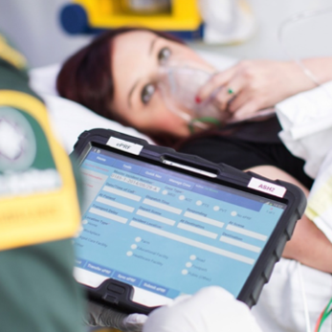 | Use interoperability to support the recommended transformation of data sharing across Tier 1 services  Consumers receive the best evidence-based care when quality information is used  Providers have the precise and standardised data needed for clinical decision support, new models of care, and measuring outcomes | ● Read codes to SNOMED migration in primary care  ● SNOMED implementation in emergency care  ● Consumer-friendly terms in English and te reo Māori  ▲ Primary care data service APIs

Integrated health and social services
 | Continue to invest in integrated health and social digital services like SmartStart and Te Hokinga ā Wairua End of Life in partnership with other agencies  Consumers have convenient access to joined-up digital health and social services  Providers can share consented information with other agencies to deliver joined-up public services | ● Coded child health assessment  ▲ APIs for integration between health and social care services   Support for Life Events digital services   Support for the Social Sector Event Record and integrated health and social care pathways

Medicines and devices
 | Further develop NZULM and NZ Formulary as interoperable clinical decision support resources and extend to medical devices  Consumers are fully informed and supported in safe use of medicines and devices  Providers are effectively guided in prescribing and administering all therapeutic products | ● Consumer medicines data standard  ● NZULM data, display and API standards  ● NZ Formulary codification  ● Medical device terminology  ▲ NZULM and NZ Formulary APIs   NZ Formulary integration in all clinical systems

Pathology and laboratory orders and reports
 | Enhance pathology and lab information standards to improve clinical workflow and patient engagement. Move to fully structured pathology reporting  Consumers experience a more convenient test process and can track their results  Providers can easily select and order tests, review results and effectively communicate them | ■ Internet-based messaging  ● Laboratory e-orders standard  ● Structured pathology reporting standard  ▲ FHIR APIs for lab orders and reports  ▲ Fully digital NZPOCS with API

Diagnostic imaging orders and reports
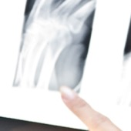 | Standardise diagnostic radiology ordering, reporting and image sharing  Consumers have more control over the diagnostic process and have access to images and reports  Providers have streamlined processes around radiology and convenient access to images | ■ Internet and cloud-first approach  ● Radiology e-orders standard  ● Standards for structured radiology reports and medical image management  ▲ Record locator services and virtual repositories for reports and images

Supply chain and product management
 | Implement the agreed national AIDC standards to achieve interoperability in supply chain processes  Consumers receive safe and effective care, supported by quality products and equipment  Providers are supported by safe and efficient supply chain processes and equipped for practice with properly identified products and equipment | ● Unique device identification (UDI) standards  ● Health product and service catalogue standards  ▲ Health product and service catalogue APIs   Interconnected regulatory, procurement and supply chain systems

Ngā mātai take

Case studies
There are examples of interoperability working well today that can guide our future efforts
Here are five examples of what good looks like today.

- Structured data in ambulance patient record system
- Personal health information API
- Pathway tools and e-referrals
- Read codes to SNOMED migration in primary care
- SNOMED for real-time data analytics

Structured data in ambulance patient record system
Paramedics with St John and Wellington Free Ambulance use the tablet-based app called ePRF (electronic patient report form) to record their clinical impressions and interventions as part of the patient care workflow. The software makes it easy to create a concise SNOMED-coded data set that can be communicated at transfer of care to the emergency department, accident and medical centre, GP or another provider.

Personal health information API
Canterbury DHB and Pegasus Health have developed a FHIR API for secure access to patient information in the South Island regional electronic health record system HealthOne, which collects data from all GPs, pharmacies and other providers. This standards-based API is now a main integration point for the regional clinical portal Health Connect South and a growing number of applications.

Pathway tools and e-referrals
The HealthPathways platform and the regional e-referral system are helping to enable joined-up community and hospital care in the South Island. These interlinked systems enable the clinician to use coded data about the patient’s medical conditions to match them to the right pathway. APIs expose pathway functionality and enable referrals and orders to be generated at points in the pathway.

Read codes to SNOMED migration
The Ministry of Health, Accident Compensation Corporation, Ministry of Social Development and TAS have worked with DHBs and primary care networks to enable the move to SNOMED in primary care, replacing legacy Read codes. Driven by the interagency R2S stewardship group, each agency has adapted its own systems to be able to receive SNOMED-coded data – in particular, personal injury claims and work capacity forms – removing barriers to interoperation.

SNOMED for real-time data analytics
Canterbury DHB is using SNOMED and natural language processing to mark up and index clinical documentation, enabling search on keywords, medical concepts, clinical codes and colloquial terms. Clinical documents are quickly located, with relevant text highlighted for review. The marked-up data is used to drive real-time analytics on service utilisation to make the patient experience more convenient and safer. Clinicians’ time is saved through real-time resource planning and data-enabled decision making.

Paerewa pārongo hauora

Health information standards
National leadership on standards
and their adoption is vital to achieving our interoperability goals
In New Zealand, the Health Information Standards Organisation (HISO) is kaitiaki of data and digital standards for the health and disability system, responsible for determining the standards that will have national effect and driving their adoption.

HISO will make interoperability a central focus of its work programme to ensure there is the best possible standards support for this roadmap in terms of people, processes, relationships and outputs.

HISO committee
The HISO function centres on a Ministry of Health committee whose members are drawn from across the health and disability system, with links to DHBs, PHOs, the clinical community, software industry, international standards bodies, Standards NZ and other government agencies.

Who we work with
HISO leads an open, consensus-based standards development and adoption process in partnership with clinical and business stakeholders. Hallmarks of the HISO approach are openness, collective efforts and a focus on adoption. To meet the challenge around interoperability, HISO will have a strengthened role and new ways of working.

HISO partners extensively with national programmes, health agencies, professional bodies, clinical networks, industry bodies and other standards organisations in a model of co-production and co-stewardship of standards. Current examples include projects with the Te Aho o Te Kahu (Cancer Control Agency), ESR, TAS and NZ Health Partnerships.

HISO’s connection to the international standards world is reflected in our active involvement with the Global Digital Health Partnership, HL7 International, SNOMED International, GS1 and ISO TC/215, as well as New Zealand and Australasian medical, nursing and allied health colleges and networks, and close relationships with the Australian Digital Health Agency and Australian Government Department of Health.

In New Zealand, HISO partners with DHBs, PHOs, ACC, Ministry of Social Development, Oranga Tamariki, Social Wellbeing Agency, Ministry of Business, Innovation and Employment, Standards New Zealand, Stats NZ, Government Chief Digital Officer and other government agencies, statutory bodies and NGOs. NZHIT, Health Informatics NZ (HINZ) and the Clinical Informatics Leadership Network (CiLN) are represented on the HISO committee.

The way we work
HISO governs the full standards lifecycle from the initial concept for a new standard to its eventual full adoption and periodic renewal. Conformity assessment and certification processes are being introduced to support implementation.

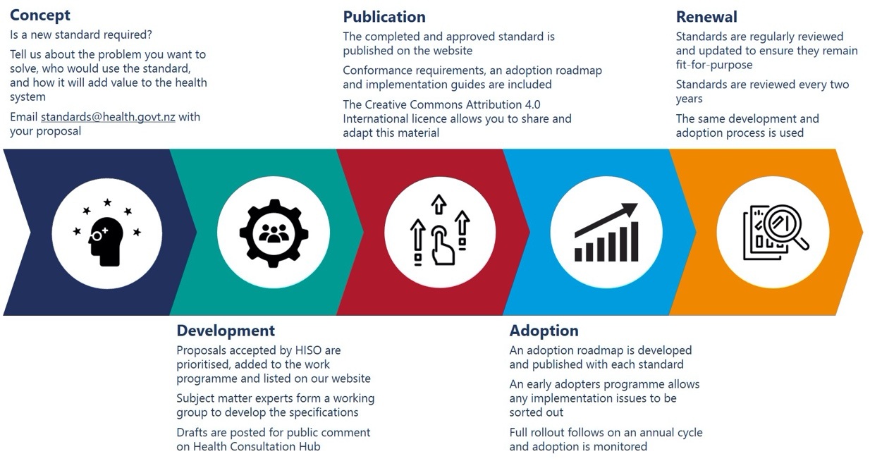

HISO will back up adoption of its standards with digital tools, materials and education to help implementers. HISO Kōrero and SNOMED NZ Hui Tuwhera are the monthly open forums we run to keep everyone informed about our standards, tools and services.

Further, we are working to ensure that data and digital standards carry the same importance as other industry standards that health providers and their industry partners are expected to comply with.

We are exploring a variety of means to drive conformity and compliance with our standards.

- Statutory: Laws and regulations used to mandate the use of standards
- Policy: Policies and rules used to promote standards use within an organisation
- Contractual: Ranging from broad accountability mechanisms like the Crown Funding Agreement and PHO Services Agreement to individual contracts with suppliers
- Accreditation: Recognition of an organisation as meeting governing industry standards and practices
- Certification: Applicable to products and services that are demonstrated to meet defined minimum requirements
- Promotion and education: Used to motivate organisations and individuals to use standards
- Funding incentives: Offered to early adopters of standards, for example.

Standards artefacts
Each HISO standard is defined by its particular purpose and scope and is issued an identifying number and title. A well-designed standard represents a coherent set of requirements and complements other standards or can be layered with them.

HISO standards are published by the Ministry of Health under a Creative Commons Attribution 4.0 International licence on our standards portal.

Each interoperability standard will comprise a specification and related artefacts of different kinds.

📜 Specification | Definitions, technical specifications, implementation guides and other documentation conveying the requirements of the standard and referencing the relevant regulations and national or international standards
🌐 Adoption roadmap | Published as part of the standard to describe how full adoption will be achieved, with a timetable
🔨 Tools and materials | Supporting tools and materials, such as data dictionaries, terminology services, registries and conformity assessment tools
⚠ Standards notice | A notice issued by HISO that gives effect to a standard and sets out key conformity requirements and dates, in line with the adoption roadmap
☑ Conformity requirement | Checklist of conformity assessment requirements for implementers of the standard

Relationships with other standards bodies
HISO maintains relationships with the national and international bodies whose standards for interoperability we most depend on. Statements of endorsement for these standards appear in HISO documents and on our website.

International Standards Organisation (ISO) standards are widely referenced in HISO documents. ISO/TC 215 is the technical committee for health informatics

Standards NZ is the national member of ISO and publishes New Zealand Standards. The HISO committee includes a Standards NZ representative

StatsNZ produces data content requirement specifications for managing New Zealanders’ information

New Zealand is a founder member of SNOMED International, owner and developer of the SNOMED CT® health and social care terminology

GS1 Standards® for automatic identification and data capture are key to supply chain and product information. GS1 New Zealand is the local representative

HL7 International® publishes HL7 Standards® for health messaging, APIs and electronic health records. HL7 New Zealand is the local affiliate

The Joint Initiative Council (JIC) for Global Health Informatics Standardisation produces harmonised sets of standards from SNOMED, HL7, GS1 and its other members

New Zealand is a member country of the Global Digital Health Partnership and participates in the interoperability workstream

References
Strategy for a Digital Public Service. 2019. https://www.digital.govt.nz/assets/Strategy-for-a-Digital-Public-Service.pdf

Data Strategy and Roadmap for New Zealand. 2018. https://www.data.govt.nz/about/data-strategy-and-roadmap-setting-the-direction-for-new-zealands-data
Digital Inclusion Blueprint. 2019. https://www.digital.govt.nz/digital-government/digital-transformation/digital-inclusion/digital-inclusion-blueprint

Health and disability system review – Interim report – Hauora manaaki ki Aotearoa whānui: Pūrongo mō tēnei wā. 2019.
https://systemreview.health.govt.nz

Health and Disability System Review – Final Report – Pūrongo Whakamutunga. 2020. https://systemreview.health.govt.nz/final-report

New Zealand Health Strategy. 2016. https://www.health.govt.nz/publication/new-zealand-health-strategy-2016

NZHIT. Vision and Charter for Interoperability. 2017. https://www.nzhit.nz/resources

Global Digital Health Partnership. Empowering Health Through Interoperability. 2018. https://www.gdhp.org/media-hub/news_feed/gdhp-reports

Global Digital Health Partnership. Advancing Interoperability Together Globally. 2019. https://www.gdhp.org/media-hub/news_feed/gdhp-reports

Joint Initiative Council. Setting the stage for the future – Enabling the digital transformation of healthcare. 2020. http://www.jointinitiativecouncil.org/white.paper.asp

Australian Digital Health Agency. National Health Interoperability Principles. 2020. Unpublished document.

Office of the National Coordinator for Health IT (ONC). Interoperability Roadmap. 2017. https://www.healthit.gov/topic/interoperability/interoperability-roadmap

Canada Health Infoway. Clinical Interoperability and Standards. https://www.infoway-inforoute.ca/en/solutions/clinical-interoperability-and-standards

UK National Audit Office. 2020. Digital transformation in the NHS. https://www.nao.org.uk/report/the-use-of-digital-technology-in-the-nhs

